
 | Alphabet Soup:  wireless standards

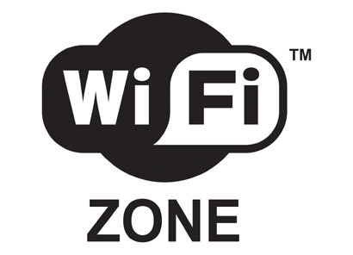 | Networking without cocktails or wires:  Wi-Fi, WLANS, PANS, WANS and MANS

Wi-Fi
Wi-Fi (sometimes written Wi-fi, WiFi, Wifi, wifi) is a trademark for sets of product compatibility standards for wireless local area networks (WLANs). Wi-Fi, short for "Wireless Fidelity", was intended to allow mobile devices, such as laptop computers and personal digital assistants (PDAs) to connect to local area networks, but is now often used for Internet access and wireless VoIP phones. Desktop computers can use Wi-Fi too, allowing offices and homes to be networked without expensive wiring. Many computers are sold today with Wi-Fi built-in; others require adding a Wi-Fi network card. Other devices, such as digital cameras, are sometimes equipped with Wi-Fi.
A person with a Wi-Fi-enabled device can connect to a local area network when near one of the network's access points. The connection is made by radio signals; there is no need to plug the device into the network. If the local area network is connected to the Internet, the Wi-Fi device can have Internet access as well. The geographical region covered by one or several access points is called a hotspot. The range of an access point varies. The access point built into a typical Wi-Fi home router might have a range of 45 m (150 ft) indoors and 90 m (300 ft) outdoors.

Specifications
Wi-Fi is based on the IEEE 802.11 specifications. There are currently four deployed 802.11 variations: 802.11a, 802.11b, 802.11g, and 802.11n. The b specification was used in the first Wi-Fi products. The g and n variants are the ones most often sold as of 2005.
Wi-Fi specifications
Specification | Speed | Frequency  Band | Compatible  with
802.11b | 11 Mb/s | 2.4 GHz | b
802.11a | 54 Mb/s | 5 GHz | a
802.11g | 54 Mb/s | 2.4 GHz | b, g
802.11n | 100 Mb/s | 2.4 GHz | b, g, n
In most of the world, the frequencies used by Wi-Fi do not require user licenses from local regulators (eg, the Federal Communications Commission in the US). 802.11a equipment, using a higher frequency, has reduced range, all other things being equal.
The most widespread version of Wi-Fi in the US market today (based in IEEE 802.11b/g) operates in the 2,400 MHz to 2,483.50 MHz. It allows operation in 11 channels (5 MHz each).
New standards beyond the 802.11 specifications are currently in the works and offer many enhancements, anywhere from longer range to greater transfer speeds. One example is 802.16 WiMAX, with a range of several miles and data rates of up to 70Mbs. 802.16a permits operation between 2 and 11 GHz, so there may eventually be some interoperability between 802.11 units and some 802.16a units.
Definition: Mbps or Mb/s | Mbps is not to be confused with MBps (megabytes per second). Also see Kilo, mega, giga, tera, peta, and all that.  Mbps stands for millions of bits per second or megabits per second and is a measure of bandwidth (the total information flow over a given time) on a telecommunications medium. Depending on the medium and the transmission method, bandwidth is also sometimes measured in the Kbps (thousands of bits or kilobits per second) range or the Gbps (billions of bits or gigabits per second) range.

Advantages of Wi-Fi
- Unlike packet radio systems, Wi-Fi uses unlicensed radio spectrum and does not require regulatory approval for individual deployers.
- Allows LANs to be deployed without cabling, potentially reducing the costs of network deployment and expansion. Spaces where cables cannot be run, such as outdoor areas and historical buildings, can host wireless LANs.
- Wi-Fi products are widely available in the market. Different brands of access points and client network interfaces are interoperable at a basic level of service.
- Competition amongst vendors has lowered prices considerably since their inception.
- Many Wi-Fi networks support roaming, in which a mobile client station such as a laptop computer can move from one access point to another as the user moves around a building or area.
- Many access points and network interfaces support various degrees of encryption to protect traffic from interception.
- Wi-Fi is a global set of standards. Unlike cellular carriers, the same Wi-Fi client works in different countries around the world (although may require some software configuration).

Disadvantages of Wi-Fi
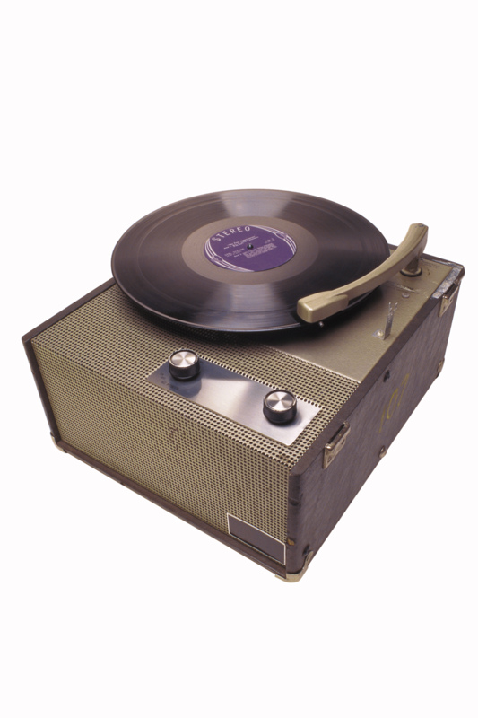
- Use of the 2.4 GHz Wi-Fi band does not require a license in most of the world provided that one stays below the local regulatory limits and provided one accepts interference from other sources, including interference that causes your devices to no longer function.
- Legislation/regulation is not consistent worldwide; most of Europe allows for an additional 2 channels over those allowed for b and g; Japan has one more on top of that - and some countries, like Spain, prohibit use of the lower-numbered channels. Furthermore some countries, such as Italy, used to require a 'general authorization' for any WiFi used outside the owned premises; or required something akin to operator registration. For Europe; consult http://www.ero.dk for an annual report on the additional restriction each European country imposes.
- The 802.11b and 802.11g flavors of Wi-Fi use the 2.4 GHz spectrum, which is crowded with other equipment such as Bluetooth devices, microwave ovens, cordless phones (900 MHz or 5.8 GHz are, therefore, alternative phone frequencies one can use to avoid interference if one has a Wi-Fi network), or video sender devices, among many others. This may cause a degradation in performance. Other devices that use these microwave frequencies can also cause degradation in performance.
- Closed access points can interfere with properly configured open access points on the same frequency, preventing use of open access points by others.
- Power consumption is fairly high compared to other standards, making battery life and heat a concern.

Unintended and Intended use by outsiders
The default configuration of most Wi-Fi access points provides no protection from unauthorized use of the network. Many business and residential users do not intend to secure their access points by leaving them open to users in the area. It has become etiquette to leave access points open for others to use just as one can expect to find open access points while on the road. Most Wi-Fi community networks are based on free access and freely sharing bandwith.
Measures to deter unauthorized users include suppressing the AP's service set identifier (SSID) broadcast, only allowing computers with known MAC addresses to join the network, and various encryption standards. Older access points frequently do not support adequate security measures to protect against a determined attacker armed with a packet sniffer and the ability to switch MAC addresses. Harmless recreational exploration of other people's access points has become known as wardriving, and the leaving of chalk graffiti describing available services as warchalking.
It is also common for people to unintentionally use others' Wi-Fi networks without specific authorization. Operating systems such as Windows XP and Mac OS X automatically connect to any nearby wireless network, depending on the network configuration. A user who happens to start up a laptop in the vicinity of an access point may find the computer has joined a network without any visible indication. Moreover, a user intending to join one network may instead end up on another one if the latter's signal is stronger. In combination with automatic discovery of other network resources this could theoretically lead wireless users to send sensitive data to the wrong destination.

Security
WiFi equipment could be used to steal personal information (passwords, financial information, identity information, and so on) transmitted from Wi-Fi users, if sensible protections are not used.
The first and most commonly used wireless encryption standard, Wired Equivalent Privacy or WEP, has been shown to be easily breakable even when correctly configured. Most wireless products now on the market support the Wi-Fi Protected Access (WPA) encryption protocol, which is considered much stronger, though some older access points have to be replaced to support it. The adoption of the 802.11i standard (marketed as WPA2) makes available a rather better security scheme — when properly configured. As of mid-2005, both Microsoft Windows XP and Mac OS X support WPA2, but on newer equipment only. While waiting for better standards to be available, many enterprises have chosen to deploy additional layers of encryption (such as VPNs) to protect against interception.
Some report that interference of a closed or encrypted access point with other open access points on the same or a neighboring channel can prevent access to the open access points by others in the area. This can pose a problem in high-density areas such as large apartment buildings where many residents are operating Wi-Fi access points.
Large corporations are often concerned about the security risk posed to a secure company network by an unauthorized wireless access point, also known as a rogue access point. With the advent of inexpensive wireless routers available at consumer electronics stores, employees sometimes connect an unauthorized access point out of ignorance or malice, thereby exposing the secure corporate network to anyone who may be "wardriving" nearby. To alleviate the potential risk of rogue access points, some large organizations have begun (as of 2005) to install wireless intrusion detection systems. These systems are designed to monitor the premises for wireless signals and immediately report the presence of any unauthorized access points.
Adapted from http://en.wikipedia.org/wiki/Wi-Fi

Wireless Usage Scenarios by Technology
Wireless Standard | Application Category | Usage Scenario
Bluetooth | Wireless Personal Area Networking (WPAN) | • I want to instantly connect my notebook computer to another Bluetooth enabled notebook to transfer a file.  • I want to collaboratively work on a document where meeting participants use notebooks that are wirelessly connected via Bluetooth.  • Using a Bluetooth enabled, wireless headset, I want to listen to a CD playing on my notebook computer while it is in my briefcase.  • I often travel to a remote site and want to walk up to a shared printer, connect and print a document without having to physically connect using a standard printer cable.  • I want to connect to the Internet via a cellular phone without having to take my telephone out of my briefcase
802.11b | Wireless Local Area Networking (WLAN) | • I want to always be connected to my corporate LAN while moving about in my office building or campus.  • Usage demands that I have access to corporate network data at performance levels equivalent to a wire based LAN connection.
Cellular Technologies (GSM) | Wireless Wide Area Networking (WWAN) | • I want access to e-mail and web resources while traveling away from the home office.
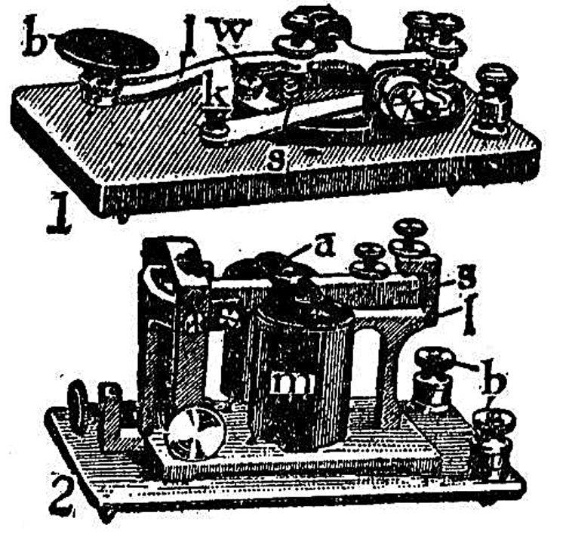
Excerpted from Tutorial-Reports.com

Wireless LAN  (wlan) | 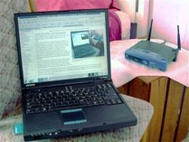

A wireless LAN or WLAN is a wireless local area network that uses radio waves as its carrier: the last link with the users is wireless, to give a network connection to all users in the surrounding area. Areas may range from a single room to an entire campus. The backbone network usually uses cables, with one or more wireless access points connecting the wireless users to the wired network.
Originally WLAN hardware was so expensive that it was only used as an alternative to cabled LAN in places where cabling was difficult or impossible. Such places could be old protected buildings or classrooms, although the restricted range of the 802.11b (typically 30ft.) limits its use to smaller buildings. WLAN components are now cheap enough to be used in the home, with many being set-up so that one PC (a parent's PC, for example) can be used to share an internet connection with the whole family (while retaining access control at the parents' PC).
Early development included industry-specific solutions and proprietary protocols, but at the end of the 1990s these were replaced by standards, primarily the various versions of IEEE 802.11 (Wi-Fi) and HomeRF (2 Mbit/s, intended for home use).
The lack of default security of Wireless connections is fast becoming an issue where many Broadband (ADSL) connections are now offered together with a Wireless Basestation/ADSL Modem/firewall/Router access point. Further, many laptop PCs now have Wireless Networking built in (cf. Intel 'Centrino' campaign) thus eliminating the need for an additional plug-in (PCMCIA) card. This might even be enabled, by default, without the owner ever realizing it, thus 'broadcasting' the laptop's accessibility to any computer nearby.
The basic security used for a WLAN was originally Wired Equivalent Privacy (WEP), but this was shown to provide minimal security due to serious weaknesses. The alternate Wi-Fi Protected Access (WPA) security protocol was later created to address these problems. Since then software solutions such as SSL, SSH, and various types of software encryption have become the preferred methods of securing wireless information transmission.
Modern operating systems such as Linux, Mac OS, or Microsoft Windows XP as the 'standard' in home PCs make it very easy to set up a PC as a Wireless LAN 'basestation' and using Internet Connection Sharing allows all the PCs in the home to access the Internet via the 'base' PC. However, lack of expertise in setting up such systems often means that someone nearby, such as a next-door neighbor, may also share the internet connection. This is typically without the wireless network owner's knowledge; it may even be without the knowledge of the user (the neighbor) if his computer automatically selects a nearby wireless network. Nowadays it has become etiquette to leave wireless access points open for others to use just as one expects to find open access points while on the road. This freely sharing of bandwidth is the basis of free wireless community networks which are often considered the future of the internet.
The frequency which 802.11b operates at is 2.4GHz, which can lead to interference with cordless phones on the same frequency. If one wants to use a cordless telephone on the same premises, one should ensure that the cordless set uses a different frequency, such as 900Mhz or 5.8 Ghz. However, any wireless router has the ability to operate in different channels. Using channel 11 is most often the best situation for a wireless access point.

Personal Area Network  (PAN) | 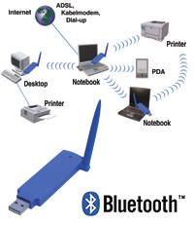
A personal area network (PAN) is a computer network used for communication among computer devices (including telephones and personal digital assistants) close to one person. The devices may or may not belong to the person in question. The reach of a PAN is typically a few meters. PANs can be used for communication among the personal devices themselves (intrapersonal communication), or for connecting to a higher level network and the Internet (an uplink).
Personal area networks may be wired with computer buses such as USB and Firewire. A wireless personal area network (WPAN) can also be made possible with network technologies such as IrDA and Bluetooth.

Wireless
A Bluetooth PAN is also called a piconet, and is composed of up to 8 active devices in a master-slave relationship (up to 255 devices can be connected in 'parked' mode). The first Bluetooth device in the piconet is the master, and all other devices are slaves that communicate with the master. A piconet typically has a range of 10 meters, although ranges of up to 100 meters can be reached under ideal circumstances.

 | Wide Area Network:  WAN or WWAN

Wide area network
A wide area network or WAN is a computer network covering a wide geographical area, involving a vast array of computers. This is different from personal area networks (PANs), metropolitan area networks (MANs) or local area networks (LANs) that are usually limited to a room, building or campus. The best example of a WAN is the Internet.
Wireless WANs cover a much more extensive area than wireless local area networks (WLANs). Unlike WLANs, which offer limited user mobility and instead are generally used to enable the mobility of the entire network, WWANs facilitate connectivity for mobile users such as the traveling businessman. In general, WWANs allow users to maintain access to work-related applications and information while away from their office.
In wireless WANs, communication occurs predominantly through the use of radio signals over analog, digital cellular, or PCS networks, although signal transmission through microwaves and other electromagnetic waves is also possible. Today, most wireless data communication takes place across 2G cellular systems such as CDMA, PDC and GSM, or through packet-data technology over old analog systems. Although traditional analog networks, having been designed for voice rather than data transfer, have some inherent problems, some 2G (second generation) and new 3G (third generation) digital cellular networks are fully integrated for data/voice transmission. With the advent of 3G networks, transfer speeds should also increase greatly.
WWAN connectivity requires wireless modems and a wireless network infrastructure, provided as a fee-for service by a wireless service carrier. Portable devices receive communications as the connected wireless modems and wireless networks interact via radio waves. The modem directly interfaces with radio towers, which carry the signal to a mobile switching center, where the signal is passed on to the appropriate public or private network link (i.e., telephone, other high speed line, or the Internet). From here, the signal can be transferred to an organization's existing network.
Similarly, WWANs can communicate with the Internet. For small devices such as handhelds and mobile phones, a universal specification known as wireless application protocol (WAP) exists to facilitate the delivery and presentation of Web content. The request for Web content is sent through the wireless network to a WAP gateway, where it is processed and the required information is retrieved and returned. WAP supports most wireless networks and mobile device operating systems.
As with wireless LANs, wireless WANs have many interference problems related to their reliance on terrestrial radio networks. Inclement weather conditions, rugged terrain and other naturally occurring conditions can cause prolonged latency and other disruptions to a radio channel. Nevertheless, wireless WANs have many intrinsic benefits, namely enhancing productivity through real-time information access.

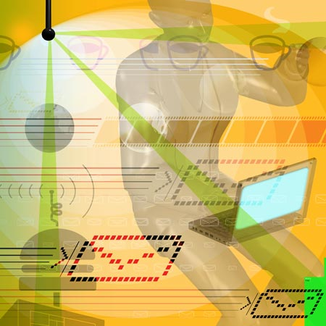 | 802.11something
IEEE 802.11

IEEE 802.11 or Wi-Fi denotes a set of Wireless LAN standards developed by working group 11 of the IEEE LAN/MAN Standards Committee (IEEE 802). The term is also used to refer to the original 802.11, which is now sometimes called "802.11legacy."

The 802.11 family currently includes six over-the-air modulation techniques that all use the same protocol, the most popular (and prolific) techniques are those defined by the a, b, and g amendments to the original standard; security was originally included, and was later enhanced via the 802.11i amendment. Other standards in the family (c–f, h–j, n) are service enhancement and extensions, or corrections to previous specifications. 802.11b was the first widely accepted wireless networking standard, followed (somewhat counterintuitively) by 802.11a and 802.11g.

802.11b and 802.11g standards use the unlicensed 2.4 gigahertz (GHz) band. The 802.11a standard uses the 5 GHz band. Operating in an unregulated frequency band, 802.11b and 802.11g equipment can incur interference from microwave ovens, cordless phones, and other appliances using the same 2.4 GHz band.

802.11 legacy

The original version of the standard IEEE 802.11 released in 1997 specifies two raw data rates of 1 and 2 megabits per second (Mbit/s) to be transmitted via infrared (IR) signals or in the Industrial Scientific Medical frequency band at 2.4 GHz. IR remains a part of the standard but has no actual implementations.

The original standard also defines Carrier Sense Multiple Access with Collision Avoidance (CSMA/CA) as the media access method. A significant percentage of the available raw channel capacity is sacrificed (via the CSMA/CA mechanisms) in order to improve the reliability of data transmissions under diverse and adverse environmental conditions.

At least five different, somewhat-interoperable, commercial products appeared using the original specification, from companies like Alvarion (PRO.11 and BreezeAccess-II), Netwave Technologies (AirSurfer Plus and AirSurfer Pro), Symbol Technologies (Spectrum24), and Proxim (OpenAir). A weakness of this original specification was that it offered so many choices that interoperability was sometimes challenging to realize. It is really more of a "meta-specification" than a rigid specification, allowing individual product vendors the flexibility to differentiate their products. Legacy 802.11 was rapidly supplemented (and popularized) by 802.11b.

802.11b

The 802.11b amendment to the original standard was ratified in 1999. 802.11b has a maximum raw data rate of 11 Mbit/s and uses the same CSMA/CA media access method defined in the original standard. Due to the CSMA/CA protocol overhead, in practice the maximum 802.11b throughput that an application can achieve is about 5.9 Mbit/s over TCP and 7.1 Mbit/s over UDP.

802.11b products appeared on the market very quickly, since 802.11b is a direct extension of the DSSS (Direct-sequence spread spectrum) modulation technique defined in the original standard. Hence, chipsets and products were easily upgraded to support the 802.11b enhancements. The dramatic increase in throughput of 802.11b (compared to the original standard) along with substantial price reductions led to the rapid acceptance of 802.11b as the definitive wireless LAN technology.

802.11b is usually used in a point-to-multipoint configuration, wherein an access point communicates via an omni-directional antenna with one or more clients that are located in a coverage area around the access point. With high-gain external antennas, the protocol can also be used in fixed point-to-point arrangements, typically at ranges up to eight kilometers (km) although some report success at ranges up to 80–120 km where line of sight can be established. This is usually done in place of costly leased lines or very cumbersome microwave communications equipment.

802.11b cards can operate at 11 Mbit/s, but will scale back to 5.5, then 2, then 1 Mbit/s (a.k.a Adaptive Rate Selection), if signal quality becomes an issue. Since the lower data rates use less complex and more redundant methods of encoding the data, they are less susceptible to corruption due to interference and signal attenuation. Extensions have been made to the 802.11b protocol (e.g., channel bonding and burst transmission techniques) in order to increase speed to 22, 33, and 44 Mbit/s, but the extensions are proprietary and have not been endorsed by the IEEE. Many companies call enhanced versions "802.11b+". These extensions have been largely obviated by the development of 802.11g, which has data rates up to 54 Mbit/s and is backwards-compatible with 802.11b.

802.11a

The 802.11a amendment to the original standard was ratified in 1999. The 802.11a standard uses the same core protocol as the original standard, operates in 5 GHz band, and uses a 52-subcarrier orthogonal frequency-division multiplexing (OFDM) with a maximum raw data rate of 54 Mbit/s, which yields realistic net achievable throughput in the mid-20 Mbit/s. The data rate is reduced to 48, 36, 24, 18, 12, 9 then 6 Mbit/s if required. 802.11a has 12 non-overlapping channels, 8 dedicated to indoor and 4 to point to point. It is not interoperable with 802.11b, except if using equipment that implements both standards.

Since the 2.4 GHz band is heavily used, using the 5 GHz band gives 802.11a the advantage of less interference. However, this high carrier frequency also brings disadvantages. It restricts the use of 802.11a to almost line of sight, necessitating the use of more access points; it also means that 802.11a cannot penetrate as far as 802.11b since it is absorbed more readily, other things (such as power) being equal.
802.11a products started shipping in 2001, lagging 802.11b products due to the slow availability of the 5 GHz components needed to implement products. 802.11a was not widely adopted overall because 802.11b was already widely adopted, because of 802.11a's disadvantages, because of poor initial product implementations, making its range even shorter, and because of regulations. Manufacturers of 802.11a equipment responded to the lack of market success by improving the implementations (current-generation 802.11a technology has range characteristics much closer to those of 802.11b), and by making technology that can use more than one 802.11 standard. There are dual-band, or dual-mode or tri-mode cards that can automatically handle 802.11a and b, or a, b and g, as available. Similarly, there are mobile adapters and access points which can support all these standards simultaneously. Image:Table of phy rates.jpg

802.11g

In June 2003, a third modulation standard was ratified: 802.11g. This flavor works in the 2.4 GHz band (like 802.11b) but operates at a maximum raw data rate of 54 Mbit/s, or about 24.7 Mbit/s net throughput like 802.11a. It is fully backwards compatible with b and uses the same frequencies. Details of making b and g work well together occupied much of the lingering technical process. In older networks, however, the presence of an 802.11b participant significantly reduces the speed of an 802.11g network.

The 802.11g standard swept the consumer world of early adopters starting in January 2003, well before ratification. The corporate users held back and Cisco and other big equipment makers waited until ratification. By summer 2003, announcements were flourishing. Most of the dual-band 802.11a/b products became dual-band/tri-mode, supporting a, b, and g in a single mobile adaptor card or access point.

While 802.11g held the promise of higher throughput, actual results were mitigated by a number of factors: conflict with 802.11b-only devices (see above), exposure to the same interference sources as 802.11b, limited channelization (only 3 fully non-overlapping channels like 802.11b) and the fact that the higher data rates of 802.11g are often more susceptible to interference than 802.11b, causing the 802.11g device to reduce the data rate to effectively the same rates used by 802.11b. The move to dual-mode/tri-mode products also carries with it economies of scale (e.g. single chip manufacturing). For the consumer, dual-band/tri-mode products ensure the best possible throughput in any given environment.

The first major manufacturer to use 802.11g was Apple, under the trademark AirPort Extreme. Cisco joined the game by buying up Linksys, an early adopter, and also offers its own wireless mobile adaptors under the name Aironet.

802.11n

In January 2004 IEEE announced that it had formed a new 802.11 Task Group (TGn) to develop a new amendment to the 802.11 standard for local-area wireless networks. The real data throughput is estimated to reach a theoretical 540 Mbit/s (which may require an even higher raw data rate at the physical layer), and should be up to 10 times faster than 802.11a or 802.11g, and near 40 times faster than 802.11b. It is projected that 802.11n will also offer a better operating distance than current networks.

Security

In 2001, a group from the University of California, Berkeley presented a paper describing weaknesses in the 802.11 WEP (wired equivalent privacy) security mechanism defined in the original standard; they were followed by Fluhrer, Mantin, and Shamir's paper entitled "Weaknesses in the Key Scheduling Algorithm of RC4". Not long after, Adam Stubblefield and AT&T publicly announced the first verification of the attack. In the attack they were able to intercept transmissions and gain unauthorized access to wireless networks.

The IEEE set up a dedicated task group to create a replacement security solution, 802.11i (previously this work was handled as part of a broader 802.11e effort to enhance the MAC layer). The Wi-Fi Alliance announced an interim specification called Wi-Fi Protected Access (WPA) based on a subset of the then current IEEE 802.11i draft. These started to appear in products in mid-2003. 802.11i (aka WPA2) itself was ratified in June 2004, and uses the Advanced Encryption Standard, instead of RC4, which was used in WEP and WPA.

 | Bluetooth

Bluetooth is an industrial specification for wireless personal area networks (PANs).
Bluetooth provides a way to connect and exchange information between devices like personal digital assistants (PDAs), mobile phones, laptops, PCs, printers and digital cameras via a secure, low-cost, globally available short range radio frequency.
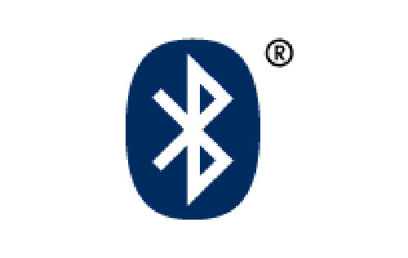
Bluetooth lets these devices talk to each other when they come in range, even if they are not in the same room, as long as they are within up to 100 metres (328 feet) of each other, dependent on the power class of the product. Products are available in one of three power classes:
- Class 3 (1 mW) is the rarest and allows transmission of 10 centimetres (3.9 inches), with a maximum of 1 metre (3.2 feet)
- Class 2 (2.5 mW) is most common and allows a quoted transmission distance of 10 metres (32 ft)
- Class 1 (100 mW) has the longest range at up to 100 metres. This class of product is readily available.
The specification was first developed by Ericsson, and was later formalized by the Bluetooth Special Interest Group (SIG). The SIG was formally announced on May 20, 1999. It was established by Sony Ericsson, IBM, Intel, Toshiba and Nokia, and later joined by many other companies as Associate or Adopter members. Bluetooth is also IEEE 802.15.1.

About the name

Contrary to popular belief, the name Bluetooth has nothing to do with blue teeth.
The system is named after a Danish king Harald Blåtand (Harold Bluetooth in English), King of Denmark and Norway from 935 and 936 respectively, to 940 known for his unification of previously warring tribes from Denmark, Norway and Sweden. Bluetooth likewise was intended to unify different technologies like computers and mobile phones. The Bluetooth logo merges the Nordic runes analogous to the modern Latin H and B. This is the official story; however, the actual Harald Blåtand that was referred to in naming Bluetooth was most probably the liberal interpretation given to him in The Long Ships by Frans Gunnar Bengtsson, a Swedish best-selling Viking-inspired novel.
In April, 1998, Intel and Microsoft formed a consortium between themselves and IBM, Ericsson, Nokia, Toshiba and Puma Technology and adopted the code name Bluetooth for their proposed open specification.

General information
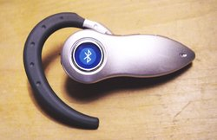
The latest version currently available to consumers is 2.0, but few manufacturers have started shipping any products yet. Apple Computer, Inc. offered the first products supporting version 2.0 to end customers in January 2005. The core chips have been available to OEMs (from November 2004), so there will be an influx of 2.0 devices in mid-2005. The previous version, on which all earlier commercial devices are based, is called 1.2.
Bluetooth is a wireless radio standard primarily designed for low power consumption, with a short range (up to 400 meters [1], ) and with a low-cost transceiver microchip in each device.
Cell phones with integrated Bluetooth technology have also been sold in large numbers, and are able to connect to computers, PDAs and, specifically, to handsfree devices. The standard also includes support for more powerful, longer-range devices suitable for constructing wireless LANs.

Bluetooth applications

- Wireless Networking between desktops and laptops, or desktops in a confined space and where little bandwidth is required
- Bluetooth peripherals such as printers, mice and keyboards
- Transfer of files (images, mp3s, etc) between mobile phones, PDA's and computers via OBEX
- Certain low-end mp3 players and Digital Cameras to transfer files to and from computers
- Bluetooth headsets for mobile phones & Smartphones
- Some testing equipment is bluetooth enabled
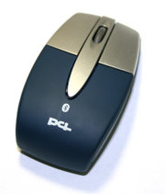
- Medical applications - Advanced Medical Electronics Corporation is working on several devices
- Certain GPS receivers transfer NMEA data via Bluetooth
- Bluetooth car kits - Acura was the first motor vehicle manufacturer to install handsfree Bluetooth technology in the 2004 Acura TL. Later on BMW added it as an option on its 3 Series, 5 Series, 7 Series and X5 vehicles. Since then, other manufacturers have followed suit, with many vehicles, including the 2004 Toyota Prius and the 2004 Lexus LS 430. The Bluetooth car kits allow users with Bluetooth-equipped cell phones to make use of some of the phone's features, such as making calls, while the phone itself can be left in a suitcase or in the boot/trunk, for instance.
- Certain data logging equipment transmits data to a computer via Bluetooth.
- For remote controls where infrared was traditionally used.

Technical information
A Bluetooth device playing the role of the "master" can communicate with up to 7 devices playing the role of the "slave". At any given time, data can be transferred between the master and one slave; but the master switches rapidly from slave to slave in a round-robin fashion. (Simultaneous transmission from the master to multiple slaves is possible, but not used much in practice). These groups of up to 8 devices (1 master and 7 slaves) are called piconets. Either device may switch the master/slave role at any time.
The Bluetooth specification also allows connecting two or more piconets together to form a scatternet, with some devices acting as a bridge by simultaneously playing the master role in one piconet and the slave role in another piconet. These devices have yet to come, though are supposed to appear within the next two years.


Air interface
The protocol operates in the license-free ISM band at 2.45 GHz. In order to avoid interfering with other protocols which use the 2.45 GHz band, the Bluetooth protocol divides the band into 79 channels (each 1 MHz wide) and changes channels up to 1600 times per second. Implementations with versions 1.1 and 1.2 reach speeds of 723.1 kbit/s. Version 2.0 implementations feature Bluetooth Enhanced Data Rate (EDR), and thus reach 2.1 Mbit/s. Technically version 2.0 devices have a higher power consumption, but the three times faster rate reduces the transmission times, effectively reducing consumption to half that of 1.x devices (assuming equal traffic load).
Bluetooth differs from Wi-Fi in that the latter provides higher throughput and covers greater distances but requires more expensive hardware and higher power consumption. They use the same frequency range, but employ different multiplexing schemes. While Bluetooth is a cable replacement for a variety of applications, Wi-Fi is a cable replacement only for local area network access. A glib summary is that Bluetooth is wireless USB whereas Wi-Fi is wireless Ethernet, both operating at much lower bandwidth than the cable systems they are trying to replace.
Many USB Bluetooth adapters are available, some of which also include an IrDA adapter.

Future Bluetooth uses
One of the ways Bluetooth technology may become useful is in Voice over IP. When VOIP becomes more widespread, companies may find it unnecessary to employ telephones physically similar to today's analogue telephone hardware. Bluetooth may then end up being used for communication between a cordless phone and a computer listening for VOIP and with an infrared PCI card acting as a base for the cordless phone. The cordless phone would then just require a cradle for charging. Bluetooth would naturally be used here to allow the cordless phone to remain operational for a reasonably long period. In May 2005, the Bluetooth Special Interest Group (SIG) announced its intent to work with UWB manufacturers to develop a next-generation Bluetooth technology using UWB technology and delivering UWB speeds. This will enable Bluetooth technology to be used to deliver high speed network data exchange rates required for wireless VOIP, music and video applications.
Bluetooth may also be used for remote sales technology, allowing wireless access to vending machines and other commercial enterprises.

Security concerns
In November 2003, Ben and Adam Laurie from A.L. Digital Ltd. discovered that serious flaws in Bluetooth security may lead to disclosure of personal data (see http://bluestumbler.org). It should be noted however that the reported security problems concerned some poor implementations of Bluetooth, rather than the protocol itself.
In a subsequent experiment, Martin Herfurt from the trifinite.group was able to do a field-trial at the CeBIT fairgrounds showing the importance of the problem to the world. A new attack called BlueBug was used for this experiment.
In April 2004, security consultants @Stake revealed a security flaw that makes it possible to crack into conversations on Bluetooth based wireless headsets by reverse engineering the PIN.
This is one of a number of concerns that have been raised over the security of Bluetooth communications. In 2004 the first purported virus using Bluetooth to spread itself among mobile phones appeared for the Symbian OS. The virus was first described by Kaspersky Labs and requires users to confirm the installation of unknown software before it can propagate. The virus was written as a proof-of-concept by a group of virus writers known as 29a and sent to anti-virus groups. Because of this, it should not be regarded as a security failure of either Bluetooth or the Symbian OS. It has not propagated 'in the wild'.
In August 2004, a world-record-setting experiment (see also Bluetooth sniping) showed that with directional antennas the range of class 2 Bluetooth radios could be extended to one mile. This enables attackers to access vulnerable Bluetooth-devices from a distance beyond expectation.(class 1. acessories have maximal distance 100meters. comunication with this standart (unaltered) device it is not possible farther than 100meters. so such a concern about "beyond exeption" is not true. receiver and transmiter needs to achive same distance otherwise conection is not posssible. )
In June 2005 Yaniv Shaked and Avishai Wool published the paper "Cracking the Bluetooth PIN1", which shows both passive and active methods for obtaining the PIN for a Bluetooth Link. The passive attack would allow a suitably equipped attacker to eavesdrop on communications and spoof if they were present at the time of initial pairing. The active method makes use of a specially constructed message that must be inserted at a specific point in the protocol, to make the master and slave repeat the pairing process. After that the first method may be used to crack the PIN. This attack's major weakness is that it requires the user of the devices under attack to re-enter their PIN during the attack when their device prompts them to. Also, this active attack will most likely require custom hardware, as most commercially available Bluetooth Devices are not capable of the timing necessary.
In August 2005, police in Cambridgeshire, England, issued warnings about thieves using Bluetooth-enabled phones to track other devices left within parked cars. Police are advising users to ensure any mobile networking connections are de-activated if laptops and other devices are left in this way.
Bluetooth uses the SAFER+ waleed algorithm for authentication and key generation. The E0 stream cipher is used for encrypting packets.

Adapted from "http://en.wikipedia.org/wiki/Bluetooth"



Faster Than a Speeding Bullet!
internet2

Internet2

Internet2 or UCAID is a non-profit consortium that develops and deploys advanced network applications and technologies, mostly for high-speed data transfer. It is led by 207 US universities and partners from the networking and technology industries (such as Comcast, Intel, Sun Microsystems, and Cisco Systems). Some of the technologies it has developed include IPv6, IP multicasting and quality of service.
Internet2 members created the Abilene Network and are a major supporter of the National LambdaRail project.

Mislabeling of Internet2
In light of a recent series of lawsuits filed by the RIAA against university students attending several of the major participants in Abilene, there has been a recent trend in the media to report on a network called "Internet2." Some sources go so far as to suggest Internet2 is a network wholly separate from the Internet. This is misleading since Internet2 is in fact a consortium and not a computer network. It is possible that many news sources have adopted the term Internet2 because it seems like a logical name for a next-generation Internet backbone. Articles that reference Internet2 as a network are in fact referring to the previously mentioned Internet backbone known as the Abilene Network. This forms a high-speed backbone by deploying many of the technologies developed by Internet2. Abilene is not an isolated network and its members are usually accessible in some way through the public Internet.
Adapted from http://en.wikipedia.org/wiki/internet2


Let My Software Go:

the open source software movement

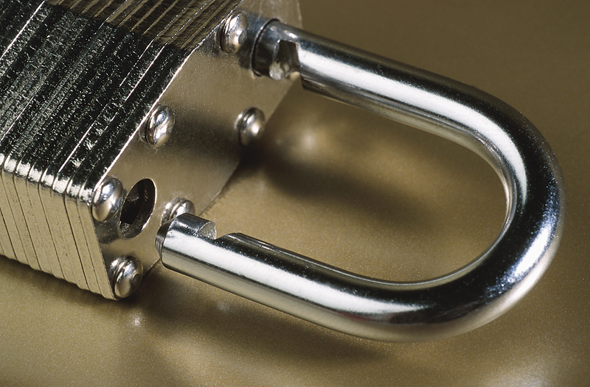 | Open Source
Open source software refers to computer software and the availability of its source code as open source under an open source license to study, change, and improve its design.
A group of individuals presented "open source" to relabel free software as open-source software, for such software to become more mainstream in the corporate world. Software developers may want to publish their software with an open-source software license, so that anybody may also develop the same software or understand how it works. Open-source software generally allows anybody to make a new version of the software, port it to new operating systems and processor architectures, share it with others or market it. The advantage of open source is to let the product be more understandable, modifiable, duplicatable, or simply accessible, while it is still very marketable.
The Open Source Definition, notably, presents an open-source philosophy, and further defines a boundary on the usage, modification and redistribution of open-source software. Software licenses grant rights to users which would otherwise be prohibited by copyright. These include rights on usage, modification and redistribution. Several open-source software licenses have qualified within the boundary of the Open Source Definition. The most prominent example is the popular GNU General Public License (GPL). While open source presents a way to broadly make the sources of a product publicly accessible, the open-source licenses allow the authors to fine tune such access.

Terminology

The "open source" label came out of a strategy session held in Palo Alto in reaction to Netscape's January 1998 announcement of a source code release for Navigator (as Mozilla). A group of individuals at the session included Todd Anderson, Larry Augustin, John Hall, Sam Ockman, Christine Peterson and Eric S. Raymond. They used the opportunity before the release of Navigator's source code to clarify a potential confusion caused by the ambiguity of the word "free" in English. The 'open source' movement is generally thought to have begun with this strategy session. Many people, nevertheless, claimed that the birth of the Internet, since 1969, started the open source movement, while others do not distinguish between open source and free software movements.
The Free Software Foundation (FSF), started in 1985, intended the word 'free' to mean "free as in free speech" and not "free as in free beer." Since a great deal of free software already was (and still is) free of charge, such free software became associated with zero cost, which seemed anti-commercial.
The Open Source Initiative (OSI) was formed in February 1998 by Eric S. Raymond and Bruce Perens. With at least 20 years of evidence from case histories of closed development versus open development already provided by the Internet, the OSI presented the 'open source' case to commercial businesses, like Netscape. OSI hoped that the usage of the label "open source," a term suggested by Peterson of the Foresight Institute at the strategy session, would eliminate ambiguity, particularly for individuals who perceive "free software" as anti-commercial. They sought to bring a higher profile to the practical benefits of freely available source code, and they wanted to bring major software businesses and other high-tech industries into open source. Perens attempted to register "open source" as a service mark for OSI, but that attempt was impractical by trademark standards. Meanwhile, Raymond encouraged Netscape to adopt the "open source" label. Netscape released its Navigator source code as open source, with favorable results.
Critics have said that the term "open source" fosters an ambiguity of a different kind such that it confuses the mere availability of the source with the freedom to use, modify, and redistribute it. Developers have used the term Free/Open-Source Software (FOSS), or Free/Libre/Open-Source Software (FLOSS), consequently, to describe open-source software that is freely available and free of charge.

Open source model

In his 1997 essay The Cathedral and the Bazaar [RAY2000], Eric Raymond suggests a model for developing OSS known as the Bazaar model. Raymond likens the development of software by traditional methodologies to building a cathedral, "fully crafted by individual wizards or small bands of mages working in splendid isolation" [RAY2000]. He suggests that all software should be developed using the bazaar style, which he described as "a great babbling bazaar of differing agendas and approaches."
In the Cathedral, model development takes place in a centralized way. Roles are clearly defined. Roles include people dedicated to designing (the architects), people responsible for managing the project, and people responsible for implementation. Traditional software engineering follows the Cathedral model. F.P. Brooks in his book The Mythical Man-Month advocates this sort of model. He goes further to say that in order to preserve the architectural integrity of a system, the system design should be done by as few architects as possible.
The Bazaar model, however, is different. In the Bazaar model, roles are not clearly defined. Gregorio Robles suggests that software developed using the Bazaar model should exhibit the following patterns:
- Users should be treated as co-developers. The users are treated like co-developers and so they should have access to the source code of the software. Furthermore users are encouraged to submit additions to the software, code fixes for the software, bug reports, documentation etc. Having more co-developers increases the rate at which the software evolves. Linus’ law states that, "Given enough eyeballs all bugs are shallow." This means that if many users view the source code they will eventually find all bugs and suggest how to fix them. Note that some users have advanced programming skills, and furthermore, each user's machine provides an additional testing environment. This new testing environment offers that ability to find and fix a new bug.
- Early Releases. The first version of the software should be released as early as possible so as to increase one's chances of finding co-developers early.
- Frequent Integration. New code should be integrated as often as possible so as to avoid the overhead of fixing a large number of bugs at the end of the project life cycle. Some Open Source projects have nightly builds where integration is done automatically on a daily basis.
- Several Versions. There should be at least two versions of the software. There should be a buggier version with more features and a more stable version with fewer bugs. The buggy version (also called the development version) is for users who want the immediate use of the latest features, and are willing to accept the risk of using code that is not yet thoroughly tested. The users can then act as co-developers, reporting bugs and providing bug fixes. The stable version offers the users fewer bugs and fewer features.
- High Modularization. The general structure of the software should be modular allowing for parallel development.
- Dynamic decision making structure. There is a need for a decision making structure, whether formal or informal, that makes strategic decisions depending on changing user requirements and other factors.

Most well-known OSS products follow the Bazaar model as suggested by Eric Raymond. These include projects such as Linux, Netscape, Apache, the GNU Compiler Collection, and Perl to mention a few. SourceForge, which maintains that it is the largest repository of Open Source code and applications available on the Internet, had 102,818 Open Source projects as of writing. These projects are all undertaken based on the Bazaar model.

Open-source license
Open-source licenses define the privileges and restrictions a licensor must follow in order to use, modify or redistribute the open source software. Open source software includes software with source code in the public domain and software distributed under an open-source license.
Examples of open source licenses include Apache License, BSD license, GNU General Public License, GNU Lesser General Public License, MIT License and Mozilla Public License.

Open source movement
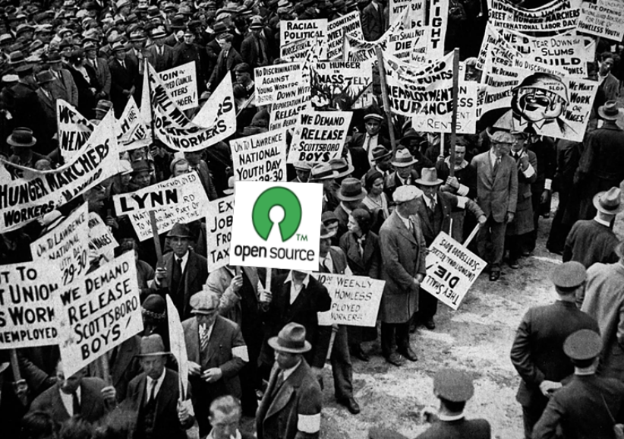
The open source movement is a large movement of computer scientists, programmers, and other computer users that advocates unrestricted access to the source code of software. It grew out of licenses such as BSD, the ubiquitous access to Unix source code at universities. The line between the open source movement and the free software movement is somewhat blurry. Both are founded in the hacker culture. Mostly, the Free software movement is based upon political and philosophical ideals, while open source proponents tend to focus on more pragmatic arguments. Openness is a term that has evolved now to refer to projects that are open to anyone and everyone to contribute to, before and/or after the actual programming. Both groups assert that this more open style of licensing allows for a superior software development process (when compared to closed source), and therefore that pursuing it is in line with rational self-interest. Free software advocates argue that "freedom" is a paramount merit that one should prefer even in any cases where proprietary software has some superior technical features.
Proponents of the open source development methodology claim that it is superior in a number of ways to the closed source method. Some, notably Eric S. Raymond, go so far as to suggest that the open source methodology is able to produce higher quality software than any other methodology or technique. Raymond has written a series of works exploring this theme, including The Cathedral and the Bazaar and Homesteading the Noosphere.
Open source advocates point out that as of the early 2000s, at least 90 percent of computer programmers are employed not to produce software for direct sale, but rather to design and customize software for other purposes, such as in-house applications. According to advocates, this statistic implies that the value of software lies primarily in its usefulness to the developer or developing organization, rather than in its potential sale value -- consequently, there is usually no compelling economic reason to keep source code secret from competitors. Open-source advocates further argue that corporations frequently over-protect software in ways actually damaging to their own interests, for reasons ranging from mere institutional habit through reflexive territoriality to a rational but incorrect evaluation of the tradeoffs between collecting secrecy rent and the quality and market payoff of openness.
Open source is a term that is applied to the entire concept that the creation and organization of knowledge is best created through open and cooperative efforts—this movement, variously called "open content" or "free culture," has been expressly endorsed by advocates of OSS, including Linus Torvalds who said "The future is 'open source everything.'"

Open source vs. closed source
The open source vs. closed source (alternatively called proprietary development) debate is sometimes heated.
Making money through traditional methods, such as sale of the use of individual copies and patent royalty payment, is more difficult and sometimes impractical with open-source software. Some closed-source advocates see open source software as damaging to the market of commercial software. This complaint is countered by a large number of alternative funding streams such as:
- giving the software for free and instead charge for installation and support (used by many Linux distributions)
- make the software available as open-source so that people will be more likely to purchase a related product or service you do sell (e.g. Openoffice.org vs StarOffice)
- cost avoidance / cost sharing: many developers need a product, so it makes sense to share development costs (this is the genesis of the X Window System and the Apache web server)
Studies about security in open-source software versus closed-source software show that closed-source software have fewer advisories but open-source software usually has less time between flaw discovery and a patch or fix. Advocates of closed source argue that since no one is responsible for open-source software, there is no way to know whether it has been fixed. Open-source advocates argue that since the source code of closed-source software is not available, there is no way to know what security vulnerabilities or bugs may exist.

Open source vs. free software
The definition of open source software was written to be almost identical to the free software definition. There are very few cases of software that is free software but is not open source software, and vice versa.
The difference in the terms is where they place the emphasis. Free software is defined in terms of giving the user freedom. This reflects the goal of the free software movement. Open source highlights that the source code is viewable to all and proponents of the term usually emphasize the quality of the software and how this is caused by the development models which are possible and popular among free software/open source software projects.

Participants in OSS development projects
Participants in OSS development projects fall broadly into two categories. There are the Core and the Peripheral.
The Core or Inner Circle are developers who modify codes that constitute the project.
The Peripheral are usually made up of users who use the software. They report bugs, and suggest fixes.
The participants may then be further divided into the following.
- Project leaders who have the overall responsibility (Core). Most of them might have been involved in coding the first release of the software. They control the overall direction of individual projects.
- Volunteer developers (Core / Periphery) who do actual coding for the project. These include:
  - Senior members with broader overall authority
  - Peripheral developers producing and submitting code fixes
  - Occasional contributors
  - Maintainers who maintain different aspects of the project
- Everyday users who perform testing, identify bugs, deliver bug reports, etc. (Periphery)
- Posters (Periphery) who participate frequently in newsgroups and discussions, but do not do any coding.

Influence on other fields
The open source movement has been the inspiration for increased transparency and liberty in other fields. For example the release of biotechnology research by CAMBIA, and the encyclopedia named Wikipedia. The open-source concept has also been applied to media other than computer programs, e.g., by Creative Commons. It also constitutes an example of user innovation (see for example the book Democratizing Innovation).
Open Cola is another idea inspired by the open source movement. Soft drink giants like Coke and Pepsi hold their formulas closely guarded secrets. Now volunteers have posted the recipe for a similar soda drink on the internet. The taste is said to be comparable to that of the standard beverages.

Advocates
Leading open source advocates include Brian Behlendorf, Tim O'Reilly, Eric Raymond, Linus Torvalds, Mitch Kapor and Paul Vixie. Others that advocate open source software, but do so under its original name "free software" include Alan Cox, Jimbo Wales, and Eben Moglen. Bruce Perens is a prominent figure that uses both terms.
Richard Stallman, the founder of the free software movement in 1983, does not want his name associated with the term open source due to its philosophical rejection that computer users deserve freedom.
Leading open source critics include Bill Gates.

Prominent projects and organizations
- Apache Software Foundation, Debian, Eclipse Foundation, FreeBSD, GNU, JBoss, Linux, Mozilla Foundation, NetBSD, ObjectWeb, OpenBSD, OpenOffice.org, Open Source Development Labs, Open Source Initiative, Python, SourceForge, Chandler (PIM)

I Know What You Took Last Night:
radio frequency identifiers (RFID)

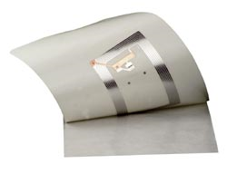

 | Signs of the Apocalypse  RFID

Radio Frequency IDentification (RFID) is an automatic identification method, relying on storing and remotely retrieving data using devices called RFID tags or transponders. An RFID tag is a small object that can be attached to or incorporated into a product, animal, or person. RFID tags contain antennas to enable them to receive and respond to radio-frequency queries from an RFID transceiver. Passive tags require no internal power source, whereas active tags require a power source.

History of RFID tags
It has been suggested that the first known device was an espionage tool invented by Léon Theremin for the Russian Government in 1945. This is not quite the case: Theremin's device was a passive covert listening device, not an identification tag. The technology used in RFID has been around since the early 1920's according to one source (although the same source states that RFID systems have been around just since the late 1960s).
A similar technology, the IFF transponder, was invented by the British in 1939, and was routinely used by the allies in World War II to identify airplanes as friend or foe.
Another early work exploring RFID is the landmark 1948 paper by Harry Stockman, entitled "Communication by Means of Reflected Power" (Proceedings of the IRE, pp1196-1204, October 1948). Stockman predicted that "...considerable research and development work has to be done before the remaining basic problems in reflected-power communication are solved, and before the field of useful applications is explored." It required thirty years of advances in many different fields before RFID became a reality.

Types of RFID tags
RFID tags can be either active or passive.
Passive RFID tags have no internal power supply. The minute electrical current induced in the antenna by the incoming radio frequency signal provides just enough power for the tag to transmit a response. Due to limited power and cost, the response of a passive RFID tag is brief — typically just an ID number (GUID). Lack of an onboard power supply means that the device can be quite small: commercially available products exist that can be embedded under the skin. As of 2005, the smallest such devices commercially available measured 0.4 mm × 0.4 mm, which is thinner than a sheet of paper; such devices are practically invisible. Passive tags have practical read distances ranging from about 10 mm up to about 6 metres.
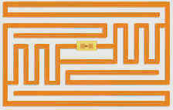
Active RFID tags, on the other hand, have an internal power source, and may have longer range and larger memories than passive tags, as well as the ability to store additional information sent by the transceiver. At present, the smallest active tags are about the size of a coin. Many active tags have practical ranges of tens of metres, and a battery life of up to 10 years.
Because passive tags are cheaper to manufacture and have no battery, the majority of RFID tags in existence are of the passive variety. As of 2004, these tags cost from US$0.40 at high volumes. Universal RFID tagging of individual products will become commercially viable at very large volumes of 10 billion units per year, driving production cost to less than US$0.05 according to one manufacturer. Current demand for RFID integrated circuit chips is not close to supporting that price. Analysts from independent research companies Gartner and Forrester Research agree that a price less than $0.10 (production volume of one billion units) is achievable in 6–8 years, thus limiting near-term prospects for widespread adoption of passive RFID. Other analysts believe such prices are achievable within 10-15 years.
While the cost advantages of passive tags over active tags are significant, other factors including accuracy, performance in certain environments such as around water or metal, and reliability make the use of active tags very common today.
There are four different kinds of tags commonly in use. They are categorized by their radio frequency: low frequency tags (125 or 134.2 kHz), high frequency tags (13.56 MHz), UHF tags (868 to 956 MHz), and microwave tags (2.45 GHz). UHF tags cannot be used globally as there aren't any global regulations for their usage.
There are some transponder devices and contactless chip cards which deliver a similar function.

The RFID system
An RFID system may consist of several components: tags, tag readers, edge servers, middleware, and application software.
The purpose of an RFID system is to enable data to be transmitted by a mobile device, called a tag, which is read by an RFID reader and processed according to the needs of a particular application. The data transmitted by the tag may provide identification or location information, or specifics about the product tagged, such as price, color, date of purchase, etc. The use of RFID in tracking and access applications first appeared during the 1980s. RFID quickly gained attention because of its ability to track moving objects. As the technology is refined, more pervasive and possibly invasive uses for RFID tags are in the works.
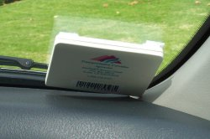
In a typical RFID system, individual objects are equipped with a small, inexpensive tag. The tag contains a transponder with a digital memory chip that is given a unique electronic product code. The interrogator, an antenna packaged with a transceiver and decoder, emits a signal activating the RFID tag so it can read and write data to it. When an RFID tag passes through the electromagnetic zone, it detects the reader's activation signal. The reader decodes the data encoded in the tag's integrated circuit (silicon chip) and the data is passed to the host computer for processing.
Take the example of books in a library. Security gates can detect whether or not a book has been properly checked out of the library. When users return items, the security bit is re-set and the item record in the Integrated library system is automatically updated. In some RFID solutions a return receipt can be generated. At this point, materials can be roughly sorted into bins by the return equipment. Inventory wands provide a finer detail of sorting. This tool can be used to put books into shelf-ready order.

Current usage
- Talking Prescriptions - 13.56 MHz tags are being placed on prescriptions for Visually Impaired Veterans. The Department of Veterans Affairs Outpatient pharmacies are now supplying the tags with label information stored inside that can be read by a battery powered, talking prescription reader. This reader speaks information such as: Drug Name; Instruction; Warnings; etc.
- Low-frequency RFID tags are commonly used for animal identification. Pets can be implanted with small chips so that they may be returned to their owners if lost. Beer kegs are also tracked with LF RFID. Two RFID frequencies are used in the United States: 125 kHz (the original standard) and 134.2 kHz (the international standard).
- High-frequency RFID tags are used in library book or bookstore tracking, pallet tracking, building access control, airline baggage tracking, and apparel item tracking. High-frequency tags are widely used in identification badges, replacing earlier magnetic stripe cards. These badges need only be held within a certain distance of the reader to authenticate the holder. The American Express Blue credit card now includes a high-frequency RFID tag, a feature American Express calls ExpressPay.
- UHF RFID tags are commonly used commercially in pallet and container tracking, and truck and trailer tracking in shipping yards.
- Microwave RFID tags are used in long range access control for vehicles.
- RFID tags are used for electronic toll collection at toll booths with California's FasTrak, Illinois' I-Pass, the expanding eastern state's E-ZPass system, The "Cross-Israel Highway" (Highway 6), Philippines South Luzon Expressway E-Pass and Central Highway (Autopista Central) in Chile. The tags are read remotely as vehicles pass through the booths, and tag information is used to debit the toll from a prepaid account. The system helps to speed traffic through toll plazas.
- Sensors such as seismic sensors may be read using RFID transceivers, greatly simplifying remote data collection.
- Precise and milimeter accurate location sensing of RFID is possible by adding a low cost photosensor.
- In January 2003, Michelin began testing RFID transponders embedded into tires. After a testing period that is expected to last 18 months, the manufacturer will offer RFID enabled tires to car makers. Their primary purpose is tire-tracking in compliance with the United States Transportation, Recall, Enhancement, Accountability and Documentation Act (TREAD Act).
- Some smart cards embedded with RFID chips are used as electronic cash, e.g. Octopus Card in Hong Kong and the Netherlands and United Kingdom (In the form of the London Underground Oyster Card) to pay fares in mass transit systems and/or retails.
- Starting with the 2004 model year, a Smart Key option is available to the Toyota Prius and some Lexus models. The key fob uses an active RFID circuit which allow the car to acknowledge the key's presence within 3 feet of the sensor. The driver can open the doors and start the car while the key remains in a purse or pocket.
- In August 2004, the Ohio Department of Rehabilitation and Correction (ODRH) approved a $415,000 contract to evaluate the personnel tracking technology of Alanco Technologies. Inmates will wear wristwatch-sized transmitters that can detect if prisoners have been trying to remove them and send an alert to prison computers. This project is not the first such rollout of tracking chips in US prisons. Facilities in Michigan, California and Illinois already employ the technology.

RFID mandates
Wal-Mart and the United States Department of Defense have published requirements that their vendors place RFID tags on all shipments to improve supply chain management. Due to the size of these two organizations, their RFID mandates impact thousands of companies worldwide. The deadlines have been extended several times because many vendors face significant difficulties implementing RFID systems. In practice, the successful read rates currently run only 80%, due to radio wave attenuation caused by the products and packaging. In time it is expected that even small companies will be able to place RFID tags on their outbound shipments.
Since January, 2005, Wal-Mart has required its top 100 suppliers to apply RFID labels to all shipments. To meet this requirement, vendors use RFID printer/encoders to label cases and pallets that require EPC tags for Wal-Mart. These smart labels are produced by embedding RFID inlays inside the label material, and then printing bar code and other visible information on the surface of the label.

Human implants
Implantable RFID chips designed for animal tagging are now being used in humans as well. An early experiment with RFID implants was conducted by British professor of cybernetics Kevin Warwick, who implanted a chip in his arm in 1998. Applied Digital Solutions proposes their chip's "unique under-the-skin format" as a solution to identity fraud, secure building access, computer access, storage of medical records, anti-kidnapping initiatives and a variety of law-enforcement applications. Combined with sensors to monitor body functions, the Digital Angel device could provide monitoring for patients. The Baja Beach Club in Barcelona, Spain uses an implantable Verichip to identify their VIP customers, who in turn use it to pay for drinks. The Mexico City police department has implanted approximately 170 of their police officers with the Verichip, to allow access to police databases and possibly track them in case of kidnapping.
Amal Graafstra, a Washington state native and business owner, had a RFID chip implanted in his left hand in early 2005. The chip was 12 mm long by 2 mm in diameter and has a basic read range of two inches (50 mm). The implant procedure was conducted by a cosmetic surgeon, although the name of the doctor was not released. When asked what he planned to do with the implant Graafstra responded:
Because I'm writing my own software and soldering up my own stuff, pretty much anything I want. Well, more accurately, anything I have the time and inspiration to do. Ultimately though, I think true keyless access will require an implantable chip with a very strong encryption system; right now I’m only looking at this type of thing in a personal context.
—One Small Step For Hand—The Present Tense

Potential uses
RFID tags are often envisioned as a replacement for UPC or EAN barcodes, having a number of important advantages over the older barcode technology. They may not ever completely replace barcodes, due in part to their relatively higher cost. For some lower cost items the ability of each tag to be unique may be considered to be overkill, though it would have some benefits such as the facilitation of taking inventory.
It must also be recognised that the storage of data associated with tracking goods down to item level will run into many terabytes. It is much more likely that goods will be tracked at pallet level using RFID tags, and at item level with product unique rather than item unique barcodes.
RFID codes are long enough that every RFID tag may have a unique code, while current UPC codes are limited to a single code for all instances of a particular product. The uniqueness of RFID tags means that a product may be individually tracked as it moves from location to location, finally ending up in the consumer's hands. This may help companies to combat theft and other forms of product loss. It has also been proposed to use RFID for point of sale store checkout to replace the cashier with an automatic system which needs no barcode scanning. However this is not likely to be possible without a significant reduction in the cost of current tags. There is some research taking place into ink that can be used as an RFID tag, which would significantly reduce costs. However, this is some years from reaching fruition.

Gen 2
An organization called EPCglobal is working on an international standard for the use of RFID and the Electronic Product Code (EPC) in the identification of any item in the supply chain for companies in any industry, anywhere in the world. The organization's board of governors includes representatives from EAN International, Uniform Code Council, The Gillette Company, Procter & Gamble, Wal-Mart, Hewlett-Packard, Johnson & Johnson, Checkpoint Systems and Auto-ID Labs. Some RFID systems use alternative standards based on the ISO-classification 18000-6.
The EPCglobal gen 2 standard was approved in December 2004, and is likely to form the backbone of RFID tag standards moving forward. This was approved after a contention from Intermec that the standard may infringe a number of their RFID related patents. It was decided that the standard itself did not infringe their patents, but it may be necessary to pay royalties to Intermec if the tag were to be read in a particular manner. EPC Gen2 is short for EPCglobal UHF Generation 2.

Patient identification
In July 2004, the Food and Drug Administration issued a ruling that essentially begins a final review process that will determine whether hospitals can use RFID systems to identify patients and/or permit relevant hospital staff to access medical records. The use of RFID to prevent mixups between sperm and ova in IVF clinics is also being considered.
Also, the FDA recently approved the country's first RFID chips that can be implanted in humans. The 134.2 kHz RFID chips, from VeriChip Corp., a subsidiary of Applied Digital Solutions Inc., can incorporate personal medical information and could save lives and limit injuries from errors in medical treatments, according to the company. The FDA approval was disclosed during a conference call with investors.
Some in-home uses, such as allowing a refrigerator to track the expiration dates of the food it contains, have also been proposed, but few have moved beyond the prototype stage.

Traffic and positioning
Another proposed application is the use of RFID for intelligent traffic signs called Road Beacon System or RBS. It is based in the use of RFID transponders buried under the pavement that are read by an onboard unit (OBU) in the vehicle which filters the different traffic signs and translates them into voice messages or gives a virtual projection using a HUD (Heads-Up Display). Its main advantage compared with satellite-based systems is that road beacons do not need digital mapping associated with them, as long as they provide traffic sign symbol and actual position information by themselves. RFID road beacons are also useful for complementing satellite positioning systems in places like tunnels or indoors.

Security
A primary security concern surrounding RFID technology is the illicit tracking of RFID tags. Both personal location privacy and corporate/military security may be violated if tags may be read arbitrarily. This is of particularly concern in the context of ongoing efforts to embed electronic product code (EPC) RFID tags in consumer products.
Duplication, or cloning of RFID tags is another security concern. Because many RFID tags can be scanned at a distance and without the tag holder's knowledge, they may be vulnerable to unauthorized duplication. This is of particular concern when RFID tags are embedded into proximity cards which are used to access buildings. It is also a problem when RFID is used for payment systems, as in the case of contactless credit cards, the ExxonMobil Speedpass, and in RFID enhanced casino chips. Speedpass in particular used a tag manufactured by Texas Instruments that incorporated a weak, proprietary encryption scheme. In 2005, researchers from RSA Labs and Johns Hopkins University reverse engineered the algorithm and were able to clone Speedpass tags [11].
One major challenge in securing RFID tags is a shortage of computational resources within the tag. Standard cryptographic techniques require more resources than are available in most low cost RFID devices. Many security measures have been proposed for RFID in the academic literature. Several low strength cryptographic solutions have been proposed, including hash locks, backward channel XORing, third party privacy agents, and LPN authentication. RSA Security has patented a prototype device that locally jams RFID signals by interrupting a standard collision avoidance protocol, allowing the user to prevent identification if desired. Various policy measures have also been proposed, such as marking RFID tagged objects with an industry standard label.

Controversy
How would you like it if, for instance, one day you realized your underwear was reporting on your whereabouts?
— California State Senator Debra Bowen, at a 2003 hearing
The use of RFID technology has engendered considerable controversy and even product boycotts. The four main privacy concerns regarding RFID are:
- The purchaser of an item will not necessarily be aware of the presence of the tag or be able to remove it;
- The tag can be read at a distance without the knowledge of the individual;
- If a tagged item is paid for by credit card or in conjunction with use of a loyalty card, then it would be possible to tie the unique ID of that item to the identity of the purchaser; and
- The EPCglobal system of tags create, or are proposed to create, globally unique serial numbers for all products, even though this creates privacy problems and is completely unnecessary for most applications.
Most concerns revolve around the fact that RFID tags affixed to products remain functional even after the products have been purchased and taken home, and thus can be used for surveillance and other nefarious purposes unrelated to their supply chain inventory functions. Although RFID tags are only officially intended for short-distance use, they can be interrogated from greater distances by anyone with a high-gain antenna, potentially allowing the contents of a house to be scanned at a distance. Even short range scanning is a concern if all the items detected are logged in a database every time a person passes a reader, or if it is done for nefarious reasons (e.g., a mugger using a hand-held scanner to obtain an instant assessment of the wealth of potential victims). With permanent RFID serial numbers, an item leaks unexpected information about a person even after disposal; for example, items that are resold or given away can enable mapping of a person's social network.
Another privacy issue is due to RFID's support for a singulation (anti-collision) protocol. This is the means by which a reader enumerates all the tags responding to it without them mutually interfering. The structure of the most common version of this protocol is such that all but the last bit of each tag's serial number can be deduced by passively eavesdropping on just the reader's part of the protocol. Because of this, whenever RFID tags are near to readers, the distance at which a tag's signal can be eavesdropped is irrelevant; what counts is the distance at which the much more powerful reader can be received. Just how far this can be depends on the type of the reader, but in the extreme case some readers have a maximum power output (4 W) that could be received from tens of kilometres away.
The potential for privacy violations with RFID was demonstrated by its use in a pilot program by the Gillette Company, which conducted a "smart shelf" test at a Tesco in Cambridge. They automatically photographed shoppers taking RFID-tagged safety razors off the shelf, to see if the technology could be used to deter shoplifting.
In another study, uncovered by the Chicago Sun-Times, shelves in a Wal-Mart in Broken Arrow, Oklahoma, were equipped with readers to track the Max Factor Lipfinity lipstick containers stacked on them. Webcam images of the shelves were viewed 750 miles (1200 km) away by Procter & Gamble researchers in Cincinnati, Ohio, who could tell when lipsticks were removed from the shelves and observe the shoppers in action.
In January 2004 a group of privacy advocates was invited to METRO Future Store in Germany, where an RFID pilot project was implemented. It was uncovered by accident that METRO "Payback" customer loyalty cards contained RFID tags with customer IDs, a fact that was disclosed neither to customers receiving the cards, nor to this group of privacy advocates. This happened despite assurances by METRO that no customer identification data was tracked and all RFID usage was clearly disclosed.
The controversy was furthered by the accidental exposure of a proposed Auto-ID consortium public relations campaign that was designed to "neutralize opposition" and get consumers to "resign themselves to the inevitability of it" while merely pretending to address their concerns.
The standard proposed by EPCglobal includes privacy related guidelines for the use of RFID-based EPC. These guidelines include the requirement to give consumers clear notice of the presence of EPC and to inform them of the choice that they have to discard, disable or remove EPC tags. These guidelines are non-binding, and only partly comply with the joint statement of 46 multinational consumer rights and privacy groups.
In 2004, Lukas Grunwald released a computer program RFDump which with suitable hardware allows reading and reprogramming the metadata contained in an RFID tag, although not the unchangeable serial number built into each tag. He said consumers could use this program to protect themselves, although it would also have significant malicious uses.

Passports
A number of countries have proposed to implant RFID devices in new passports, to facilitate efficient machine reading of biometric data. Security expert Bruce Schneier said of these proposals: "It's a clear threat to both privacy and personal safety. Quite simply, it's a bad idea." The RFID-enabled passport uniquely identifies its holder, and in the proposal currently under consideration, will also include a variety of other personal information. This could greatly simplify some of the abuses of RFID technology, and expand them to include abuses based on machine reading of data such as a person's nationality. For example, a mugger operating near an airport could target victims who have arrived from wealthy countries, or a terrorist could design a bomb which functioned when approached by persons from a particular country.
The US State Department initially rejected these concerns on the grounds that they believed the chips could only be read from a distance of 10 cm (4 in), but in the face of 2,400 critical comments from security professionals, and a clear demonstration that special equipment can read the test passports from 30 feet (10 m) away, as of May 2005 the proposal is being reviewed.
The Pakistan Passport Authority has started issuing passports with RFID tags.

Driver's licenses
The US state of Virginia has considered putting RFID tags into driver's licenses in order to make lookups faster for police officers and other government officials. The Virginia General Assembly also hopes that by including the tags, false identity documents would become much harder to obtain. The proposal was first introduced in the "Driver's License Modernization Act" of 2002, which was not enacted, but as of 2004 the concept was still under consideration.
The idea was prompted by the fact that several of the September 11 hijackers held fraudulent Virginia driver's licenses. However the American Civil Liberties Union has noted that in addition to being a risk to privacy and liberty, the RFID proposal would not have hindered the hijackers, since the false documents they carried were valid, officially issued documents obtained with other false identification. The weakness in the system is not failure to validate documents in the field, but failure to verify identity before issuing them.
Under the proposal, no information would be stored on the tag other than a number corresponding to the holder's information in a database, only accessible by authorized personnel. Also, to deter identity thieves one would simply need to wrap one's drivers' license in aluminium foil.

The mark of the beast?
There has been discussion within part of the Christian community that RFID tagging could represent the mark of the beast mentioned specifically in the Book of Revelation (see Revelation 13:16). This subject is studied by those Christians interested in the fields of eschatology (last things) and dispensationalism. Previously, other forms of identification such as credit cards and UPC codes had been suggested as candidates for the mark.
Adapted from http://en.wikipedia.org/wiki/RFID"

