JET PROPULSION LABORATORY

Submitted to the TeleRobotics Intercenter Working Group (TRIWG)
Meeting to be held at KSC, March 1-3, 1995

MICRO LANDER DEXTEROUS MANIPULATOR

C. E. Tucker Dr. Y. Bar-Cohen D. Henderson
Mechanical Systems Space Materials Science & Space Materials Science
Development/352 Engineering/355 & Engineering/355
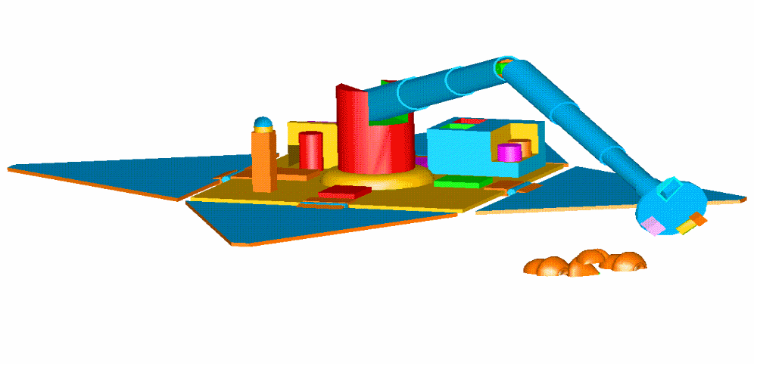

ABSTRACT

This proposal outlines the development of an ultra light microlander dexterous manipulator arm, and tool set for 1998 and 2001 Mars Surveyor (MS) science activities. For these missions to conduct surface science, the ability to collect/analyze samples, move/inspect surface features and deploy/position instruments has been identified. Unfortunately Mars Surveyor landers are extremely mass, volume and power constrained and the desired addition of a manipulator may not be viable due to downsizing limits inherent with current technology. To meet these mission constraints, a manipulator must be developed with small volume stowing capability and low mass. The proposed manipulator develops advanced materials and actuator concepts and combines them with a unique mechanical design to achieve these goals. As part of this proposed activity, advanced high torque micromotors, composite materials and deployable structures will be developed and combined with an advanced control system to support the Mars Surveyor Science and other lander based missions.

1. OBJECTIVES

1.1 Develop the technology needed to design a light weight and low power micro lander dexterous
manipulator that can be stowed into a small volume and configured for multiple scientific applications in a Mars environment.

1.2 Build a breadboard manipulator using advanced solid state actuators, composite materials and a unique mechanical configuration. Build a multiple function end effector for Mars Surveyor (MS) surface
science missions. Use advanced control technologies to conduct a joint demonstration with the Mars Exploration Technology/Sample Evaluation/Acquisition Testbed (MET/SEAT) task and perform tests in a simulated Mars environment.

1.3 Transfer manipulator, actuator and tool technologies to the Mars Surveyor
1998 and 2001 Programs.

2. JUSTIFICATION

2.1 Mars Surveyor Application Opportunities - A series of Mars Lander missions are planned as part of the NASA Mars Exploration Initiative. Launches start in 1998, 2001, 2003, and continuing through the next decade. Each of these missions will have a small mass/power/volume/cost budget for sample acquisition and science analysis. Because of this mass constraint, innovative compact, light weight sample acquisition and instrument systems will be required. There is an expected need for manipulators to deploy instruments for preliminary in-situ characterization of Martian surface chemistry and to support sample collection for instruments on-board the Landers.

The emphasis for the '98 Lander is on detection of water, characterization of volatiles, active oxygen species, oxidation states of paramagnetic ions, and detection of possible organics from soil, minerals and rocks. This information will be important in assessing the history of formation and evolution of Mars with emphasis on the fate of the volatiles. Eventually, it is hoped to carry out a Mars Sample Return mission, which will require innovative sample collection and storage systems. Based on what is known so far, it appears that:

(1) Sampling will be Lander (not Rover) based.

(2) Mechanisms deployed by the Lander will take samples, by limited degree of freedom manipulation of a robot arm in the near field, and/or coring below the Lander site. Use of a robotic arm will initially emphasize grasping, scooping and instrument placement (e.g., APX or camera) and will evolve to probing and actively controlled sample extraction (e.g., core-drill, chip, scrape).

(3) The sampling system for an in situ project will be similar to that for a sample return project, the difference being that in the former case, samples are analyzed with instruments on the Lander, while in the latter case, samples are processed and loaded into cans in a carousel and transferred to a sample return capsule.

2.2 Science Benefits- Autonomous manipulators can provide the means to collect and support the analysis of indigenous Martian materials. The scientific contribution of such capabilities can be the determination of the water and rare gases content on Mars leading to the determination of the conditions prevailing in the nebula 4.5 bya (billion years ago). The analysis of the volatile and water inventory on Mars is a major issue and can help the Mars mission unravel many mysteries associate to its formation and deliver a major triumph for space science.

Strong arguments have been made for believing that there is still a great deal of water locked up as subsurface ice at high latitudes of Mars. The upper 2 km of the cratered uplands at high latitudes (>30o) may contain ice in amounts that exceed the porosity, estimated to be 10-20%. It would appear desirable to test this conclusion by appropriate sampling and analysis in a Mars surface mission. Such testing will not require returning samples to Earth, but will require manipulator sample collection for in situ water analysis.

2.3 Technology Relevance For Future NASA Flight Projects - During the progressive phases of this program, pro-active efforts will be made to identify launch opportunities for the technologies developed. From a system standpoint, a light weight science manipulator can applied to future lunar, comet and asteroid lander missions. Individual technologies such as chemical joint locks, simplified mechanisms and solid state actuators can provide significant mission benefits in terms of mass, power and size Specifically in regards to actuators, applications include: restowable optical cover mechanisms, deployment mechanisms for antennas and solar panels, real-time compensation for thermal expansion in space and articulation of optical devices. Overall development of micro-mechanical technology is critical to support future low cost micro-satellites, spacecraft and lander missions.

3.0 APPROACH

3.1 Micro Lander Dexterous Manipulator Concept - A miniature 5 Degrees of Freedom (DOF) dexterous manipulator will be developed with a low mass (less than 4 kg), consume low power (less than 10 w during movements) and with the capability to reach up to 2 m, 360 degrees from the Lander for sample acquisition and other tasks. An arm-end science platform will be designed for instrument mounting and support tools as needed for specific science missions (e.g.; APX, camera, claw scoop, arm end deployable stabilizer, core drill etc.). The simplest sampling systems will employ a single degree-of-freedom scoop to pick up surface soil and weathered pebbles and deposit the sample for lander analysis. To obtain such a manipulator several technologies will be developed to support the design and fabrication of prototype and a breadboard. These technologies include: solid state actuation, compact stowing, and the use of composite materials to construct the manipulator. While each of these technologies are in use by various industries, several challenges will need to be address to adapt them to operate in a Mars environment. Each of the challenges are manageable and they will be discussed herein.

3.2 Technical Challenges

3.2.1 Mechanical Design - The constraints of the Mars Lander mission in terms of volume available during launch restrict the available space for stowing the manipulator prior to use. Several possible configuration will be considered with primary emphasis directed toward a gas deployed carbon-composite telescopic structure which offers light weight and compact stowage. Efforts will be made to maintain a simplified design to minimize mass while insuring a high reliability. In this regards, the challenging development of a multi-staged/soft-stop gas deployment subsystem to replace conventional spring-damper deployment subsystem is of great interest. The manipulator arm design, actuation, construction materials and control specifications will be analyzed to provide stiffness, stability and controllability of the arm and its attachments. Joint mounted composite springs will be developed to counterbalance the arm and minimize actuator loads. Also, a multifunction attachment set located at the end of the arm will also require the development of a standard mechanical and electrical interface to allow flexible selection of scientific instruments.

3.2.2 Actuators - The use of conventional electric motors to actuate a robotic arm necessitates gear reduction, provide limited performance/size characteristics and has low temperature constraints. Solid state motors were recently introduced in Japanese consumer products (autofocus lenses), which have significant potential for space applications. A schematic description of a solid state rotary motor principle of operation is shown in Figure 1. These motors can be miniaturized, consume low power and have the following characteristics: high torque density at low speed; high holding torque; simple construction; can be made in annular shape (for optical application, electronic packaging and wiring through the center); quite operation and quick response.
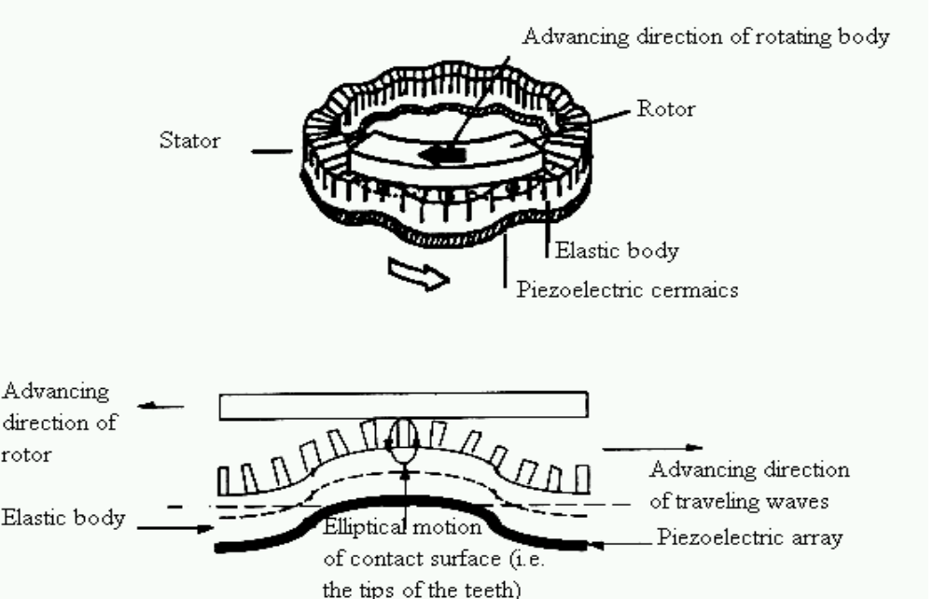

Figure 1
Schematic description of the operation principle of a solid state rotary motor.

While these motors have been used commercially they were not been used yet for any application that is related to space technology. Further, they are designed for intermittent actuation at ambient temperatures. The challenges to applying these motors to actuate a manipulator arm are to develop a motor with optimized characteristics that can operate at Mars environment. Another element that would require attention is the issue of the motorÕs life time performance as a result of potential wear of the rotor/stator interface.

3.2.3 Materials - A major challenge will be to develop an all-composite manipulator. High modulus composite materials offer tremendous weight advantages over metals for tubular structures such as the manipulator arm. However, typical composite tubular designs usually include bonded metallic fittings which represent a large mass fraction of the overall structure. Elimination of metallic fittings can lead to a significant mass reduction. In addition to an all composite design, a resin/catalyst telescopic locking bond joint will be developed to further minimize mechanisms and improve manipulator strength and stiffness.

3.3 Technical Approach

A fully tested and characterized advanced technology manipulator arm will be developed for deployment from a small planetary Lander. A detachable science platform and tool set will be developed to utilize the functionality of the manipulator in support of surface science. The breadboard manipulator will be tested in a simulated Mars environment to insure suitability for future mission applications. Advanced actuator and materials technology will be employed to increase manipulator dexterity while decreasing power, volume and mass.

This proposed task will be coordinated with the integrate advanced control technologies developed by the SEAT task. Baselined against existing flight qualified technologies applied to a Mars Surveyor (MS) sized manipulator arm, a 30% volume reduction, a 60% mass reduction and 30% power reduction have been established as end goals. Future lander dexterous manipulator applications include: sample acquisition, core drilling, science instrument surface placement and recovery. Technology developed by this task will resolve serious micro-manipulator issues facing scientists and designers of future micro Lander based missions. In this regards, we will actively involve potential users in defining the baseline functional parameters and mission applications. 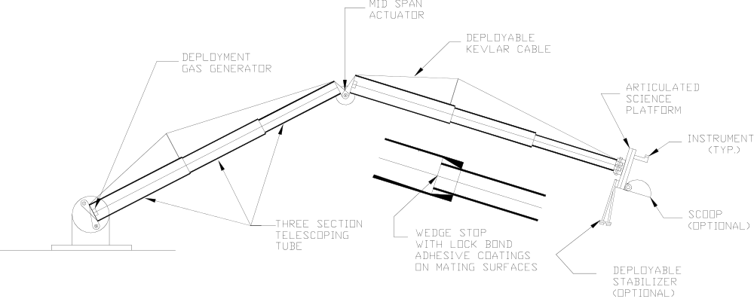
Figure 2
Manipulator and Science Platform Concept

3.3.2 Mechanical Development: Primary activities will center around the design of a simplified and lightweight manipulator concept which is optimized and seamlessly integrated with material and actuator developments. A prototype and breadboard manipulator will be designed and built to physically verify the overall performance and capabilities.

The baseline manipulator approach is shown in Figure 2 and has the following design features:

¥ Telescopic composite construction for small stowed volume and low weight
¥ Gas generator pressure deployment for light weight and reliability.
¥ Locking bond adhesive coated wedge joints for reliability, low weight and improved stiffness
¥ Standardized articulated science instrument platform for mission flexibility
¥ Piezo actuators for low power and weight
¥ Optional Kevlar rigging for low weight optimization
¥ Variable height and mounting orientation for maximum mission flexibility

A standardized rotary science instrument platform with additional Degrees of Freedom (DoF) will be fabricated from composite materials. The platform will be outfitted with a science tool set consisting of a scoop, claw, shallow core drill, rock grinder and stabilizer strut. If available, test instruments from the science community will also be integrated. When completed, manipulator and populated science platform will be characterized through a series of tests. System testing will include, launch vibration, impact and control system operation in a Mars environment.

3.3.3 Development of Solid State Motors (SSM) - JPL jointly with MIT will develop the required solid state motor technology, prototype motors for performance evaluation and breadboard motors for the actuation of the manipulator. A motor optimization analytical model [1] will be developed incorporating space related parameters, such as, temperature, heat transfer and dissipation, friction and dynamic analysis of the rotor/stator interaction at the interface and motor performance. Also, materials issues will be studied including the coefficient of thermal expansion, material friction/wear as well as the characteristics of the piezoelectric element that provides the driving mechanism. JPL's Section 355 lab will be used to evaluate the performance of these motors at a wide range of mechanical loads at vacuum and cryogenic temperatures. The activation electronics and servo drive will be examined to ensure low mass and low power drive electronics. The critical issues related to the design, fabrication and operation of such motors are identified in FYÕ95. The development of the motors will be conducted in four subtasks:

Development of Analytical Model - An analytical model to a priori predict rotary SSMs steady state and transient performance will be developed to allow design of space-worthy motors and experiments will be made to verify the predications. The model will address the major components that are responsible for the motor operation, i.e. stator, rotor, interface, and motor performance. Preliminary analysis of this nonlinear, coupled rotor-stator dynamic model has demonstrated the potential to predicting motor steady state and transient performance as a function of critical design parameters (e.g., interface normal force, tooth height, and stator radial cross section).

Materials Analysis and Determination of Baseline - The materials and design of the SSM determines the motor efficiency and its ability to operate effectively in a vacuum over a broad temperature range down to cryogenic temperatures. Effective interface materials (e.g., diamond coating) will be selected to assure longer durability and improved friction capability at broad range of temperatures. The above analytical model will be modified to incorporate parameters that affect operation of the motors in space environment. The model will be used to establish criteria for selection of the critical active and passive materials for the construction of the motor. Preliminary data have been acquired in a recent study of linear Inchworm motors for the Pluto-Fast-Flyby project (conducted jointly by JPL's Sections 355 and 382 with UCLA).

Design, Fabrication and Performance Testing of the Motors - A series of prototype solid state motors will be constructed and their characteristics (e.g., stall torque, power consumption, efficiency, stability, positioning accuracy, thermal and vacuum effects, effect of mechanical loads, etc.) will be studied. Test results will be compared with the analytical model predications to validate its accuracy and determine the required corrections for fabrication of breadboard motors.

Evaluation of SSM Control System - The design of the electronic driver circuits and motor configurations will be analyzed to determine the necessary modifications to reduce potential complexity while assuring compact size and low power consumption of the drive circuit. A servo-drive analysis will be made to allow feedback control of the SSM and assuring high precision positioning.

3.3.4 Materials Development: To create a stiff yet light weight stowable arm, several areas of material development are needed. Baselining composite hinges and joints in the manipulator arm design provides a significant mass reduction over metallic fittings. In addition, compared to metallics, the low coefficient of thermal expansion inherent in carbon fiber reinforced composites will reduce the thermal distortion of the arm. To achieve this, JPL will design and prototype the arm using high modulus carbon reinforced polycyanate composites. Currently, to fabricate the thermal enclosure for Mars Pathfinder, a 78 msi M55J fiber reinforced composite tape is being used. It is envisioned that this material or another higher modulus fiber will be used for the arm. The advantage of using the M55J composite is the large property database and design allowables that already exists.

It is currently envisioned that a locking mechanism will be needed following the deployment of the arm. For a multifold arm, this locking mechanism may be a simple flexible composite "spring" that will be compressed during launch and spring back to lock the extended arm. Another locking alternative for the telescopic arm is a long life resin system that has a catalyst encapsulated in glass microballoons. As the tubes complete their deployment, they will drive into a wedge stop. The surface of the wedge stop will be coated with a resin that has been combined with catalyst filled microspheres. When released, the adhesive resin and catalyst system will react and lock-bond the joint for use.

3.4 Level 1 Demonstration Milestones/Deliverables

This RTOP started in January 1995 and is being performed as a four years program with a level 1 demonstration at the end of each fiscal year. The following describes the milestones and deliverables for each year of the program.

FYÕ95 - Deliverable: A non-stowable MS sized prototype manipulator with three degree of freedom will be designed, fabricated and tested at the end of the first year. Current MS performance goals include; Reach: 2.0 m/360 degrees, Mass: less than 5 kg, Operating Power: less than 10 watts, Stowed Volume: 15 cm X 15 cm X 40 cm. The MS manipulator will be assembled using qualified but unproven Mars Pathfinder MicroRover actuators and tested to establish a performance benchmark for future development. Compared to existing flight qualified technologies, a 10-20% reduction in mass and power is anticipated. During FY 95, a collaborative effort will be established with industry and universities to develop advanced actuators. In addition, manipulator requirements will be established to provide flexible yet positive performance parameters to obtain program objectives.

FYÕ96 - Deliverable: By the end of the second year, the prototype manipulator will be upgraded with prototypeadvanced actuators and demonstrated using an advanced SEAT control system and prototyped tool set. Actuator technology developed during this period is expected to provide an additional mass and power reduction of 10-15% over the previous baseline. Actuator testbed components will be designed and tested under Mars operating conditions (-100 C, 10 torr, dust). Also during this period, a new optimized structure, science platform and preliminary tool set will be designed to allow fabrication, integration and test of a 5 DOF breadboard arm to occur the following year. In addition to lightweight actuators, advanced composites, bearings and lubrication will be evaluated.

FYÕ97 - Deliverable: At the close of this year, a newly designed breadboard manipulator will be fabricated and demonstrated with advanced actuators, materials, science platform and tool set. During this period, improved force and feedback technologies developed by the SEAT task will be integrated with the manipulator and tested. Low temperature operation and feedback loops will be verified. In addition, a small core drill be fabricated and separately characterized prior to manipulator integration.

FYÕ98 - Deliverable: As the fourth year ends, themanipulator system will be optimized and demonstrated in a Mars simulated environment. A final report will be published. Compared to the three degrees of freedom baseline, a 50 % volume reduction, a 50% mass reduction and a 30% power reduction is anticipated. Primary activities of this period will center around systems optimization, characterization and environmental testing. Initial vibration characterization of a coredrill and feedback to the control system are expected be of significant interest. The manipulator will be tested with tools and instrument simulators to determine the system's performance envelope. At the end of this period, a summary report will be completed to insure that the developed technology is accessible to support multi-task operations for future mission use.

4.0 FUNDING/SCHEDULE OVERVIEW

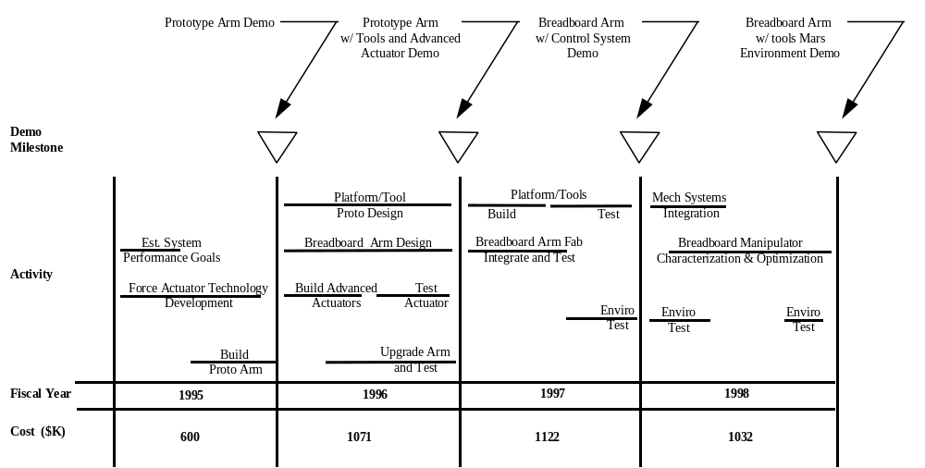

5.0 PARTICIPANTS

The proposed dexterous manipulator will be developed by JPL with support from composite manufactures. The solid state actuator will be developed jointly with MIT. Efforts will be made to involve an industry partner in a cooperative agreement in order to establish a solid state motor manufacturing capability in the USA. Burleigh Instruments, THK and Allied Signal are currently being considered. Prior cooperation with Burleigh Instruments in the development of a piezoelectric Inchworm linear motor that operates at cryogenic temperatures for the Pluto-Fast-Flyby Preproject will serve as a model for this partnership.

6.0 COMMERCIALIZATION POTENTIAL

Environmentally qualified solid state motors and lock-bond coatings have been identified as potential technical spin-offs from this program. Motor applications include; actuators for commercial aircraft, spacecraft, automotive and consumer products. Lock-bond joint technology can be applied to a variety of consumer assembled products and space structures.

7.0 FACILITIES

JPL
¥ ROBOTICS TEST LABORATORY: This RTOP will co-locate its test activities within the MET/Sample Evaluation/Acquisition Testbed (SEAT) Test Facility. Co-location within this existing laboratory will decrease costs and improve coordination between the mechanical and control activities.
¥ ACTUATOR TEST LABORATORY: Actuators Characterization laboratory is available to measure the electrical, mechanical (displacement) and thermal performance of actuation materials and devices under controlled conditions. A large number of electrical parameters can be analyzed in the 10 Hz to 32 MHz frequency range using a Schlumbeger Impedance Analyzer Model 1260. For temperature control at vacuum conditions a custom modified Janis ST-400 system is used to perform tests at high vacuum up to 10-8 torr at a temperature range from 77K to 450K. To activate actuators, a series of function generators and amplifiers are available. To determine the static and dynamic performance of the solid state motors under vacuum and cryogenic temperatures a mechanical testing machine was procured from SATEC (expected delivery in March 95). This lab was established adjacent to the Nondestructive Evaluation Lab which has extensive state-of-the-art capabilities for the determination of the integrity of actuators.
¥ MECHANICAL TEST LABORATORIES: A materials laboratory and environmental test facilities are available to support development of composite structures. All mechanical tests will be performed at JPL.

MIT
¥ Design of the motor and room temperature performance characterization will be performed in the MIT Space Engineering Research Center (SERC). SERC was established by NASA as the university center for the development of controlled structures technology for space. SERC has extensive project experience in active device development including 2 flight experiments and several terrestrial testbeds in controlled structures and precision optical systems. The Center has available state-of-the-art dynamic and static structural analysis equipment and extensive capability for data acquisition and device instrumentation using strain gages, accelerometers, force transducers, and laser shape determination equipment ranging to nanometer level resolution. In addition, SERC has facilities for material characterization under load conditions including transduction, stiffness, and dielectric testing of active materials at temperatures from 200 to 670K and voltage levels of +10KV.

8.0 PRINCIPAL INVESTIGATORS

Curtis E. Tucker is the task lead and chief mechanical engineer for this task.
He is a technical group supervisor in the Mechanical Systems Development Group/Section 352 and has 17 years of JPL experience in mechanical development and management of hardware tasks. His most current project assignments include lead mechanical engineer for the Mars Oxidents Experiment (MOx), mechanical task manager for the NASA Scatterometer (NSCAT) instrument and the lead engineer for preliminary development of astronaut equipment for the Wide Field Planetary Camera/Hubble Telescope service mission.

Dr. Yoseph Bar-Cohen is the Advanced Actuation Principal Investigator for this Task. He is a member of the Technical Staff and is responsible for the Advanced Actuation Technologies at the Materials Science and Engineering Section of JPL. Since joining JPL in 1991, he has established state-of-the-art Active Materials Characterization and NDE Labs. He received his Ph. D. in Physics from the Hebrew University at Jerusalem, Israel, in 1979. He has more than 23 years experience in areas of sensors, active materials and NDE, including his positions at the Israel Aircraft Industry, SRL at the Air Force Materials Laboratory and McDonnell Douglas Corporation. He originated the use of linear solid state motors for the articulation of the scanning mirror of the PFF pre-project phase. He is currently developing solid state rotary motors for the Micro Lander Dexterous Manipulator. He is the author of more than 100 publications and holds many patents. He is also an Adjunct Professor at the University of California, Los Angeles (UCLA).

Douglas Henderson is responsible for the development of composite structures at the Materials Science and Engineering Section. He has more that 16 years experience in defining and developing novel tooling concepts and manufacturing processes. He has been involved in producing cocured and secondary bonded complex geometry composites. He has extensive background in design and development of both metallic and composite inserts and their incorporation into structural composite applications, e.g. , joints and hinges. He published several technical papers on composite manufacturing concepts and processes and he taught classes on this subject at California State University, Northridge. He received B. S. degree in Chemistry from California State Polytechnic University,Pomona.

Dr. Nesbitt W. Hagood IV is the Charles Stark Draper Assistant Professor of Aeronautics and Astronautics at MIT where he previously earned his B.S. (1985), M.S. (1988), and Ph.D. (1991) degrees. Professor Hagood is a member of AIAA, ASME, and the SPIE. He is currently a technical chairman in the SPIE 1994 Smart Structures and Materials Conference and member of the editorial board on the IOP Journal of Smart Materials and Structures. He has published material on piezoelectric actuation in several technical journals and is currently writing a book entitled, Piezoelectric Active Structures, to be published by Technomics Publishing Co. in the Fall of 1995. His primary research interest is in development of active material systems and devices. He currently holds two patents in the area of solid state actuation and is co founder of a startup company for the commercialization of active device technology.

9.0 REFERENCES

1. N. W. Hagood and A. McFarland, "Modeling of a Piezoelectric Rotary Ultrasonic Motor," SPIE Paper no. 2190-52, Smart Structures and Materials 1994: Smart Structures and Integrated Systems, Nesbitt Hagood, Editor, SPIE Proc. Vol. 2190, 1994, pp. 814-828.

