TCAS II CHANGE PROPOSAL (CP)

DATE: | 03 | / | 29 | / | 99 | No.: | 98

TCAS II Version: | DO-185A (v7) | X | Other (Specify)

MOPS Function Area: | Surveillance |  | Display Req’ts |  | CRS | X

 | CAS Pseudocode | X | Test Suites |  | Other

Priority: | URGENT | X | Necessary |  | Optional

CP Type: | ERROR | X | Enhancement |  | Evaluation Request

 |  |  | Editorial (Logic) |  | Editorial (Text)

Description of Problem/Issue:
During TCAS flight testing nuisance failures of the barometric altitude credibility monitor have been observed. They have occurred during vertical rate maneuvers approaching 1g in acceleration. This is in excess of the standard RA maneuver that Air Transport category aircraft are likely perform. However, it is not unlikely that business jets and military aircraft with TCAS would perform maneuvers such as this on a regular basis.

Discussion with Mitre indicates that the baro altitude credibility monitor was designed to handle approximately ½ g accelerations maximum.

It is believed that if not corrected this monitor design will result in regular occurrences of TCAS system failures during climbout and during resolution advisories where the pilot responds aggressively.

Proposed Resolution:

Intruder altitude tracking was affected similarly.

Constants only changed in Pcode and CRS. Changes attached.

Three new tests, EN04TS49.dat, EN03TS79.dat, and EN03TS80.dat, were produced to cover the CRS transitions 3.92-C2, 3.98-C2, and 3.57-C1, respectively. The RWG verified that the tests do, in fact, cover these transitions. TSIM was updated with the constant modifications and used to produce an updated set of expected outputs and transition files for all existing tests. The updated expected outputs were successfully compared to the outputs generated by several of the TCAS manufacturer’s implementations.

Requester: | Aaron Reinholz

Organization: | Rockwell Collins

DISPOSITION OF CHANGE PROPOSAL (Per RWG):
DATE OF DISPOSITION | 8 | / | Apr | / | 1999

Rejected |  |  | Deferred |  |  | [Review Date: |  | / |  | / |  | ]

Accepted | X |  | Modified |  |  | Withdrawn

DISPOSITION OF CHANGE:

On Hold |  | Designing |  | Testing |  | Done | X | [Date: |  | / |  | / |  | ]

Final Approval of Changes:

Signature: | Kathryn W. Ybarra, RWG Chair
Date: | 21 | / | Apr | / | 1999

CRS Changes For Altitude Credibility Modifications

Page 149 – From Addendum: State Switch_Own_Tracker, Abbreviation CREDIBLE_INIT_CHECK.
In line 3, change 35.0 ft to 65.0 ft (CREDZADC) and change 10 to 5 (MAXSOFT).

Page 151 – State Own_Tracker_Softness, Figure 2-27 and Description.
Remove states 2, 6, 7, 8, 9, and 10. Add arrow for default entry state to state 5. Remove arrow showing the 4 to 5 transition. Reverse direction of arrow from state 5 to the bar connector so that it points from the bar connector to state 5 (thus indicating the ANY to 5 transition as well as the 4 to 5 transition). In line 7 of Note: Description, change “value of 2” to “value of 3”.

Page 152 – State Own_Tracker_Softness, Transition 1.
Change the state transition from ANY → 10 to ANY → 5.

Page 153 – State Own_Tracker_Softness, Transition 2.
Remove the state transitions for 2 → 3, 5 → 6, 6 → 7, 7 → 8, 8 → 9, and 9 → 10.

Page 154 – State Own_Tracker_Softness, Transition 3.
Remove the state transitions for 3 → 2, 6 → 5, 7 → 6, 8 → 7, 9 → 8, and 10 → 9.

Page 409 – Macro Own_Altitude_Coast.
In line 1 of Definition, change 35.0 ft to 65.0 ft (CREDZADC). In Abbreviation SOFTNESS_FACTOR, remove lines for softness factors 2, and 6 through 10 which coorespond to Own_Tracker_Softness states 2, 6, 7, 8, 9, and 10.

Page 448 – Macro VT_Credible_Report(T,DZM,TSTART,TDAT,ZD,QUANT).
In line 4 of Definition, change 20 ft/s to 30 ft/s and change 8 ft/s² to 20 ft/s².

Page 654 – APPENDIX A, CONSTANT DEFINITIONS.
Change the value of CREDACCDIV from 8.0 ft/s² to 20 ft/s².
Change the value of CREDZADC from 35.0 ft to 65.0 ft.
Change the value of CREDZDERR from 20 ft/s to 30 ft/s.

Page 656 – From Addendum –APPENDIX A, CONSTANT DEFINITIONS.
Change the value of MAXSOFT from 10 to 5.
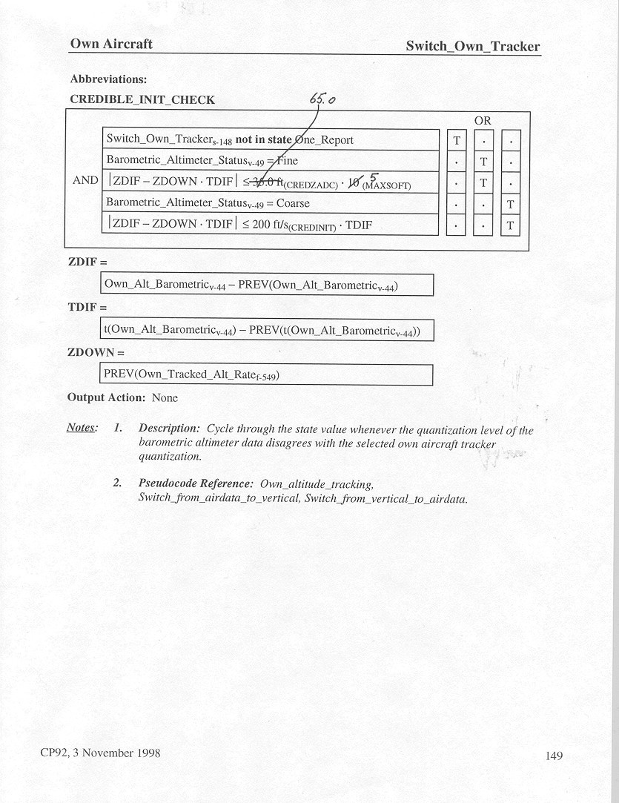

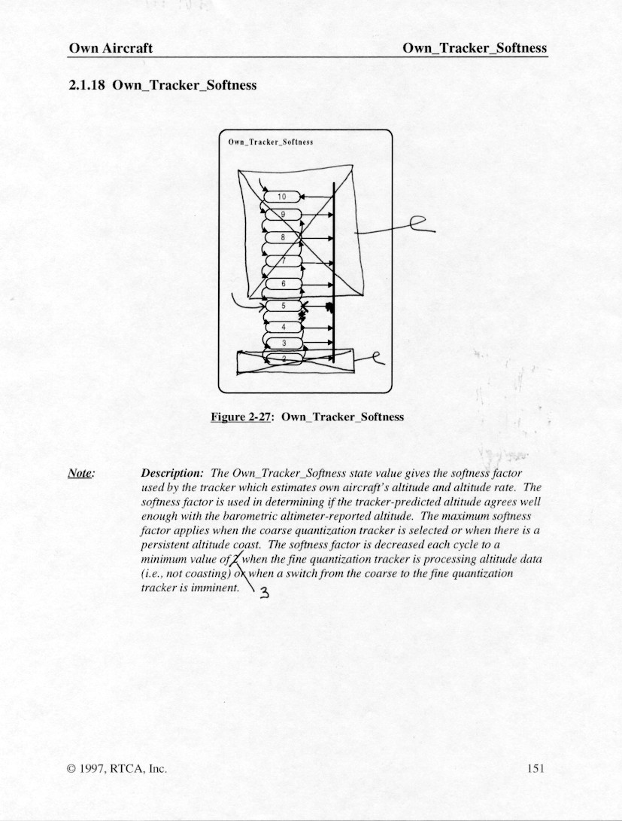
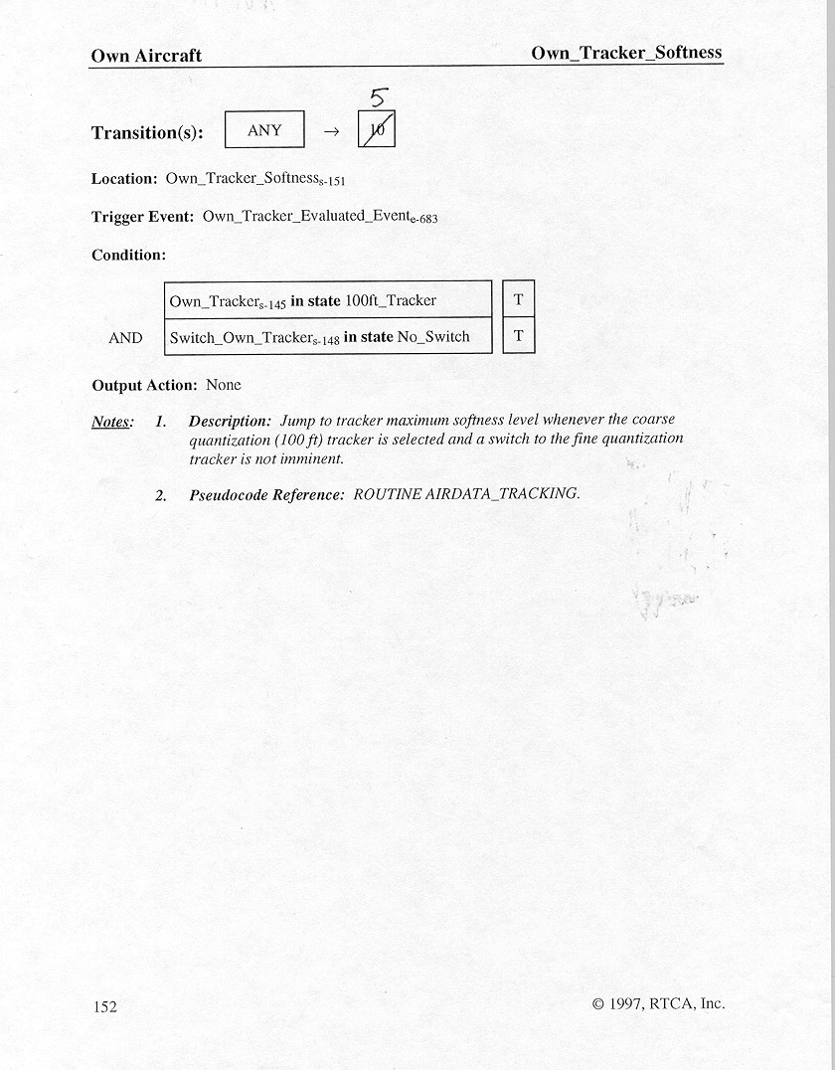
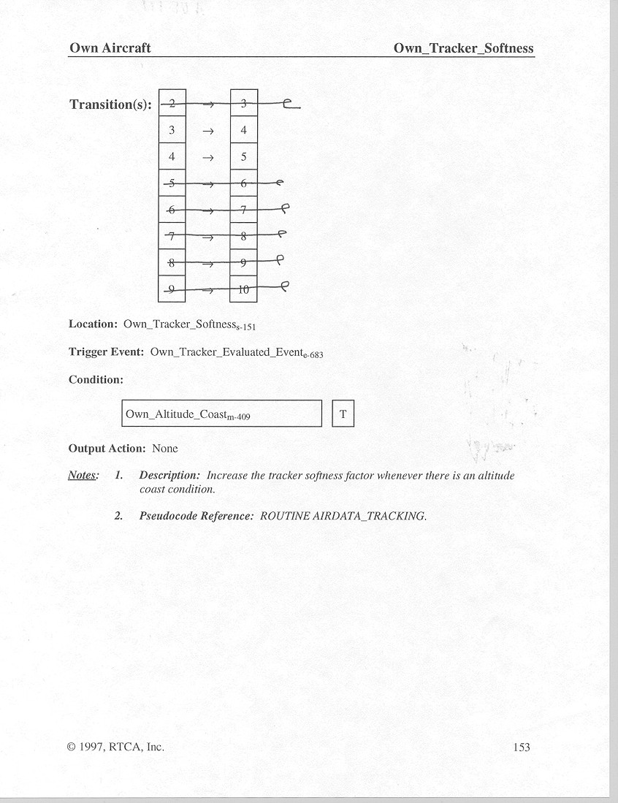

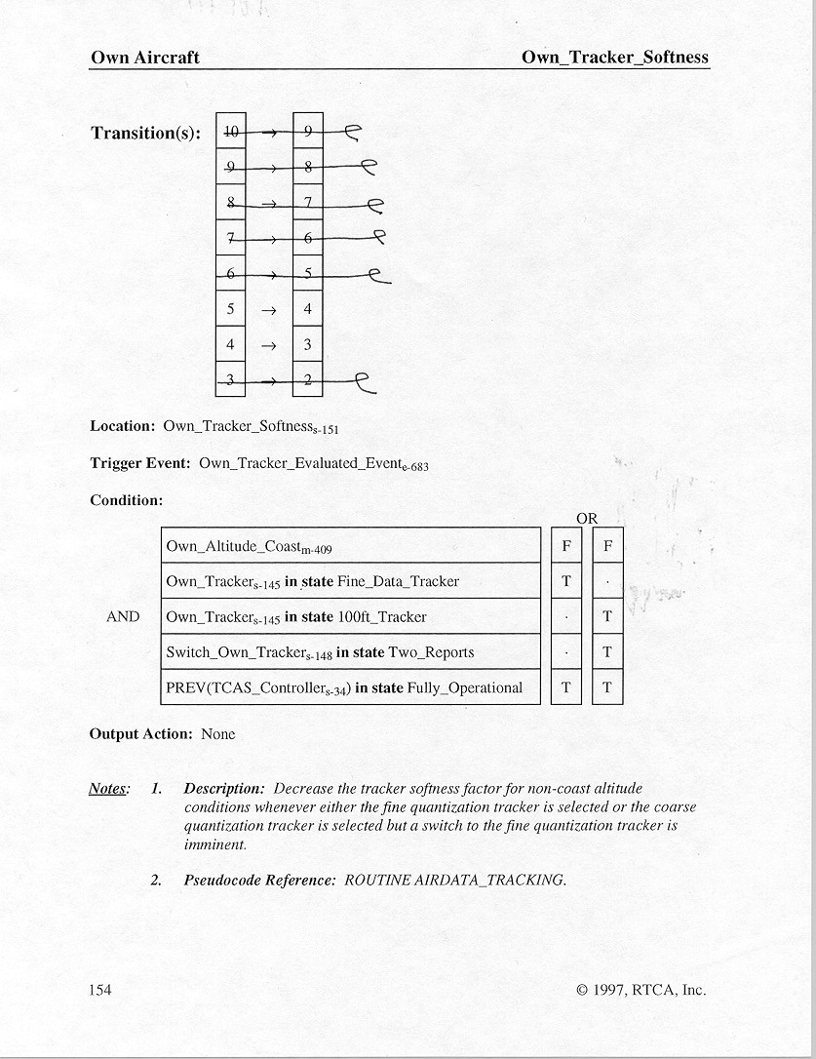

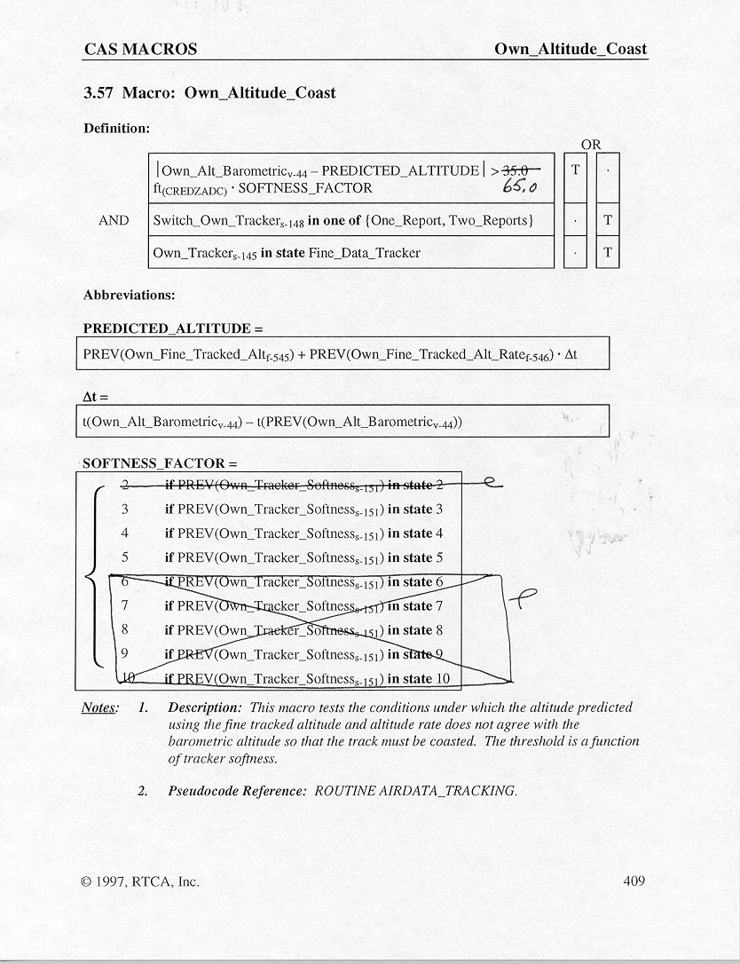

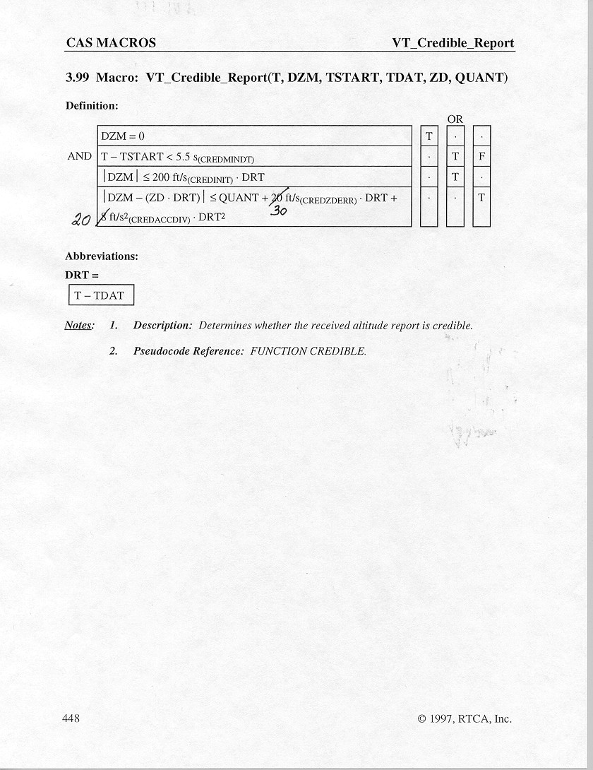

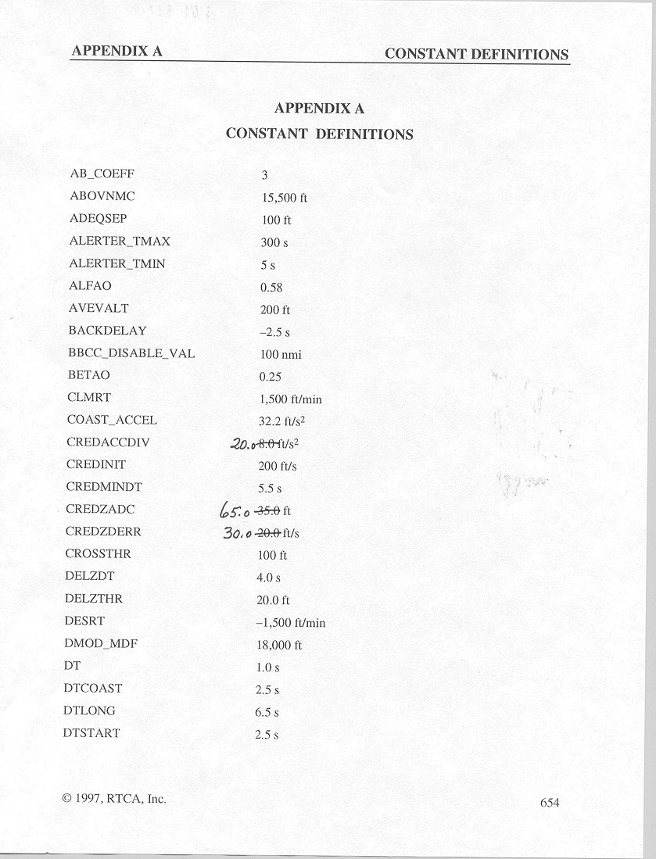
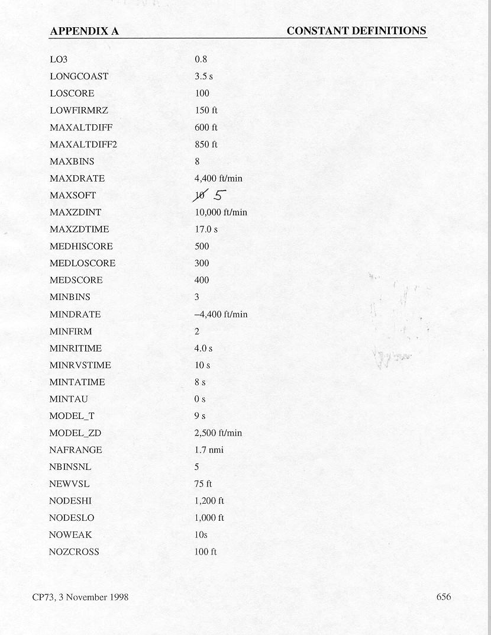

CONSIDER_INCREASE 6 RESVAR.select_advisory
TCAS Pseudocode Change Proposal Form

Date of Change: 8 April 1999 Submitted By: R. Lejeune

Pseudocode Version Modified: Version 7

Pseudocode Pages Affected (Name of TASK, ROUTINE, FUNCTION, PROCESS, etc. and page numbers. Indicate whether page is high- or low-level pseudocode (H or L):

Appendix A, pages A-5 and A-12.

Description of Change:

The parameters of the credibility windows used by the airdata-tracker, the 100-ft altitude tracker and the 25-ft altitude tracker are changed to widen the windows and ensure that altitude measurements during aircraft accelerations up to 1.25g will be accepted and that track will be maintained during such maneuvers.

SRS Change Proposal Form Cross Reference:

Not available

Reason for Change (with PTR/CRF number if applicable):

See attached documents.

Reference Documentation:

CRF24 and CRF257

Attach "Before" and "After" Pseudocode pages

Approval Checklist:

Reviewer 1 Reviewer 2
• Changes are accurate _________ _________
• Changes are consistent _________ _________
• Pseudocode standards are met _________ _________

Reviewer 1___________________________________ Date ______________

Reviewer 2___________________________________ Date ______________

CONSIDER_REVERSE 8 MACVAR.multiaircraft
CONT_REVERSE 8 MACVAR.multiaircraft
CONVERGE_SEP 8 MACVAR.multiaircraft
CORRECTIVE_CLM 2 G.display
CORRECTIVE_DES 2 G.display
COSB 4 TRACKVAR.horizontal
COV(2,2) 2 ITF.mdf
COV(2,2) 4 TRACKVAR.horizontal
CREDACCDIV2 2 PN.credibility 8 ft/s2
CREDINIT 2 PN.credibility 200 ft/s
CREDMINDT 2 PN.credibility 5.5 s
CREDZADC 2 P.track 35 ft
CREDZDERR 2 PN.credibility 20 ft/s
CREFNO 2 ITF.identity
CREFPTR(100) 2 G.cross_reference
CROSSING 2 TO_DISP_AURL.additional_aural
CROSSING_RA 2 G.broadcast
CROSSTHR 2 P.general 100 ft
CROSSTHRL 2 P.general 100 ft
CUR_SENSE 6 RESVAR.modeling
CURRENT_SENSE 8 MACVAR.multiaircraft
CVC 2 INTENT_TO_THREAT.RA_intent
CVC 3 RCV_VAR.message
DBINS 4 TRACKVAR.vertical
DELAY 6 RESVAR.modeling
DELT 4 TRACKVAR.vertical
DELZ 4 TRACKVAR.vertical
DELZDT 2 PN.no_transition 4 s
MAXSOFT 2 P.track 10
MAXZDINT 2 P.detect 10000 ft/min
MAXZDTIME 2 PN.transition 17 s
MDF_HIT_COUNT 2 ITF.mdf
MEDHISCORE 2 P.traffic 500
MEDLOSCORE 2 P.traffic 300
MEDSCORE 2 P.traffic 400
MID 2 INTENT_TO_THREAT.RA_intent
MID 3 RCV_VAR.message
MIN_NOM_SEP 8 MACVAR.multiaircraft
MIN_PTS_FOR_SWITCH 2 P.track 3
MIN_REV_SEP 8 MACVAR.multiaircraft
MIN_RI_TIME 2 P.model 4 s
MINBINS 2 PN.alpha_beta_tracker 3
MINDRATE 2 P.seladv – 4400 ft/min
MINFIRM 2 P.eval 2
MININITHFIRM 2 P.mdf 3
MINRVSTIME 2 P.model 10 s
MINSOFT 2 P.track 2
MINTATIME 2 P.traffic 8 s
MINTAU 2 P.delay 0 s
MNSIGDPX 2 P.mdf 0.7
MNVR_SHTDWN_TM 2 P.mdf 10
MODC 2 S.identity
MODC 2 ITF.capability
MODEC_FLAG 4 TRACKVAR.vertical
MODEL_T 2 P.model 9 s
MODEL_ZD 2 P.model 2500 ft/min
MTB 2 INTENT_TO_THREAT.RA_intent
CONSIDER_INCREASE 6 RESVAR.select_advisory
CONSIDER_REVERSE 8 MACVAR.multiaircraft
CONT_REVERSE 8 MACVAR.multiaircraft
CONVERGE_SEP 8 MACVAR.multiaircraft
CORRECTIVE_CLM 2 G.display
CORRECTIVE_DES 2 G.display
COSB 4 TRACKVAR.horizontal
COV(2,2) 2 ITF.mdf
COV(2,2) 4 TRACKVAR.horizontal
CREDACCDIV2 2 PN.credibility 20 ft/s2
CREDINIT 2 PN.credibility 200 ft/s
CREDMINDT 2 PN.credibility 5.5 s
CREDZADC 2 P.track 65 ft
CREDZDERR 2 PN.credibility 30 ft/s
CREFNO 2 ITF.identity
CREFPTR(100) 2 G.cross_reference
CROSSING 2 TO_DISP_AURL.additional_aural
CROSSING_RA 2 G.broadcast
CROSSTHR 2 P.general 100 ft
CROSSTHRL 2 P.general 100 ft
CUR_SENSE 6 RESVAR.modeling
CURRENT_SENSE 8 MACVAR.multiaircraft
CVC 2 INTENT_TO_THREAT.RA_intent
CVC 3 RCV_VAR.message
DBINS 4 TRACKVAR.vertical
DELAY 6 RESVAR.modeling
DELT 4 TRACKVAR.vertical
DELZ 4 TRACKVAR.vertical
DELZDT 2 PN.no_transition 4 s
MAXSOFT 2 P.track 5
MAXZDINT 2 P.detect 10000 ft/min
MAXZDTIME 2 PN.transition 17 s
MDF_HIT_COUNT 2 ITF.mdf
MEDHISCORE 2 P.traffic 500
MEDLOSCORE 2 P.traffic 300
MEDSCORE 2 P.traffic 400
MID 2 INTENT_TO_THREAT.RA_intent
MID 3 RCV_VAR.message
MIN_NOM_SEP 8 MACVAR.multiaircraft
MIN_PTS_FOR_SWITCH 2 P.track 3
MIN_REV_SEP 8 MACVAR.multiaircraft
MIN_RI_TIME 2 P.model 4 s
MINBINS 2 PN.alpha_beta_tracker 3
MINDRATE 2 P.seladv – 4400 ft/min
MINFIRM 2 P.eval 2
MININITHFIRM 2 P.mdf 3
MINRVSTIME 2 P.model 10 s
MINSOFT 2 P.track 3
MINTATIME 2 P.traffic 8 s
MINTAU 2 P.delay 0 s
MNSIGDPX 2 P.mdf 0.7
MNVR_SHTDWN_TM 2 P.mdf 10
MODC 2 S.identity
MODC 2 ITF.capability
MODEC_FLAG 4 TRACKVAR.vertical
MODEL_T 2 P.model 9 s
MODEL_ZD 2 P.model 2500 ft/min
MTB 2 INTENT_TO_THREAT.RA_intent

Roland Lejeune
31 March 1999

Proposed Change to the Airdata-Tracker Credibility Window

Rockwell-Collins recently identified an issue with the altitude tracker used in TCAS II Version 7 to track own aircraft altitude when finely quantized altitude measurements are available. This tracker is referred to as the airdata-tracker in the Version 7 pseudocode.

Issue

During a flight test in which the pilot responded very aggressively to a Climb RA (post-flight data analysis showed that the vertical acceleration reached 1.0g for a very short time), the airdata-tracker declared the altitude measurements “not credible” during the acceleration. The track was then coasted. The track continued to coast until the altitudes measurements were re-captured by the credibility window 19 seconds later.

The MOPS require that TCAS be taken down by the System Performance Monitor when the own aircraft track is coasted for 5 seconds. Thus, if a similarly aggressive maneuver was executed by a pilot during an operational flight, the TCAS function would be terminated. This would not only result in a serious nuisance, since a TCAS unit taken down by the System Performance Monitor needs to be pulled off the airplane and sent to maintenance, but could also raise a safety issue, if the TCAS function was terminated during an RA.

Background

Originally, the CAS logic did not include a specific credibility check for own aircraft altitude. A comment in the pseudocode simply stated that the credibility of the altitude measurements should be checked before being passed to the tracker, presumably by the System Performance Monitoring function. In May 1996, the Requirements Working Group decided that the credibility check of altitude measurements supplied by the airdata computer (or other source of finely quantized altitude measurements) should be performed by the logic itself (altitude tracker) rather than by the System Performance Monitor. CRF257 was generated to address this new requirement. However, the specific requirements to which the credibility check should be designed were left wide open.

A first credibility check intended to capture altitude measurements corresponding to a vertical acceleration of up to 0.35g was implemented in the logic. (The largest acceleration assumed by the logic when a pilot responds to an RA is 0.35g.) Shortly thereafter, the value of one credibility check parameter (CREDZADC) was slightly increased to improve the ability of the airdata-tracker to maintain track during short vertical accelerations of up to 0.5g.

The purpose of the credibility check is to ensure that bad altitude measurements (i.e., measurements having a measurement error much larger than that anticipated in the tracker design) will not be passed to the tracker. Altitude tracks recorded during the TCAS Transition Program and analyzed by the FAA Technical Center were found to have a few, rare bad measurements characterized by very larger errors (3,000 to 5,000 ft). However, comments made by one avionics manufacturer indicated that a measurement error as small as 300 ft was seen on at least one occasion. In the absence of further characterization of bad altitude measurements, the design of the credibility window should thus be aimed at rejecting bad measurements characterized by measurement errors as small as 300 ft.

Discussion

A few simulations were performed with the currently specified credibility window (parameters: CREDZDAC = 35 ft; MINSOFT = 2; MAXSOFT = 10). They confirmed that, with the current credibility window, the airdata-tracker was capable of maintaining track during accelerations reaching 0.5g for a short duration (change in vertical rate no greater than 3,000 fpm) when none of the altitude measurements are bad. However, the airdata-tracker starts failing to properly maintain track when the acceleration increases beyond 0.5g, or even when a maximum acceleration of 0.5g is maintained for more than about 2 seconds (resulting in a change in the vertical rate larger than 3,000 fpm). Also, the ability of the current credibility window to capture a good measurement following a bad one is relatively poor when the bad measurement happens to occur in the middle of a moderate to large acceleration. In short, these new performance simulations confirmed that a further widening of the credibility window was necessary to raise the probability that the track for own aircraft will be maintained during an aggressive maneuver.

Analysis

The attached spreadsheet contains a quick analysis of the sizing of the credibility window. The analysis is based on a worst-case scenario.

In this worst-case scenario, own aircraft initially descends at 6,000 fpm, then, after a short time, reverses its vertical rate with an acceleration that builds up at the high rate of 8 ft/s³ (jerk) to a maximum acceleration of 40 ft/s² (1.25g). The first 4 columns of the spreadsheet show the time, acceleration, vertical rate, and altitude for every second of this short scenario.

The next four columns show the response of an alpha-beta tracker similar to that specified for the airdata-tracker. Note that in this simple spreadsheet model, the measurements, which are the same as the true altitudes, do not include a measurement error.

The column entitled "residual" shows the build up of the tracker lag during the acceleration. The maximum residual (difference between the measured altitude and the predicted altitude) is 130 ft. To maintain track during this scenario, the credibility window should thus be sized so as to accommodate a residual of at least 130 ft. In fact, the credibility window should be somewhat larger than that in order to simultaneously accommodate an adequate amount of random measurement error (or noise). Assuming a worst random measurement error standard deviation (sigma) of 10 ft and aiming at a 3-sigma margin leads to a credibility window with a half-width of at least 160 ft.

A credibility window with a half-width of 160 ft will in fact not be quite sufficient. Indeed, the error in the predicted altitude, which is one component of the residual, is the result of not only the tracker lag accumulated during the acceleration but also of the random error in the tracked vertical rate (which itself is caused by the random measurement errors on the previous cycles). Increasing the window half-width by another 20 to 30 ft should accommodate the latter source of error. This leads to a credibility window with a half-width of about 180 ft to 190 ft.

Note that a credibility window with a half-width of about 180 ft will accommodate an even large acceleration (>1.25g) when the standard deviation of the measurement random error is less than the assumed 10 ft. However, a scenario with an acceleration that is worse than the one assumed in this analysis is hard to imagine for the simple reason that, in the physical world, the acceleration itself cannot increase instantaneously, but needs to be gradually built up (jerk).

In the above scenario, a constant jerk of 0.25g/s has been assumed. Even with such a large jerk, it takes 5 seconds to reach an acceleration of 1.25g. By the time this acceleration is reached, the accumulated change in the vertical rate (since the beginning of the acceleration) is already 4,800 fpm. Keeping the 1.25g acceleration for 1.0 second, then reducing the acceleration back down to zero with the same 0.25g/s jerk, results in a total change in the vertical rate of 12,000 fpm. A scenario worse than that would probably not be credible. In fact, this worst-case scenario may very well already be somewhat beyond the envelope of what would be considered an “aggressive” aircraft maneuver in a civilian airspace.

The next issue to be considered in designing the credibility window is its ability to capture a good measurement following a bad one. The worst time for a bad measurement to occur is on the cycle where the residual would normally be the largest (if the measurement was good). This happens at time 12 seconds in the worst-case scenario. When the bad measurement is rejected, the track is coasted (i.e., the vertical rate estimate is not updated), which causes the tracker lag to increase even further. In the worst-case scenario, a rejected measurement at time 12 seconds results in a residual equal to 228 ft on the next cycle. Thus, to ensure with a high probability that a good measurement on that cycle will be captured by the credibility window, the window half-width should be at least 228 ft. In reality, a window half-width of about 260 to 270 ft will probably be necessary to accommodate the two sources of additional random errors discussed above.

Finally, the question of how large the window should be at track initialization needs to be examined. For this purpose, the following worst-case scenario is defined. The aircraft has a maximum climb rate of 9,000 fpm when the track is initialized and the second measurement is a bad one. How wide should the window be to capture the third measurement? The altitude displacement over 2 seconds at that vertical rate is 300 ft. This suggests that the credibility window half-width should be of the order of 300 + 1.41*30 = 340 ft to accommodate the random measurement errors in the first and third measurements.

How should the current credibility window in the Version 7 pseudocode be modified? To summarize the above considerations, the credibility window should have a half-width of about 180 to 190 ft when track softness (inverse of track firmness) is at its minimum, a half-width of about 260 to 270 ft following one track coast, and a half width of about 340 ft when softness is at its maximum. These three requirements can be met with the following credibility window parameters: CREDZADC = 65 ft, MINSOFT = 3, and MAXSOFT = 5. This combination of parameters results in a credibility window with a half-width of 195 ft when softness is minimum, 325 ft when softness is maximum, and 260 ft in-between.

Testing Requirements

The operation of the airdata-tracker is, for all practical purposes, independent of the remainder of the CAS logic. The interface between the airdata-tracker and the remainder of the logic is simple and straight-forward. The airdata-tracker receives altitude inputs from some barometric altitude measuring device (airdata computer or gyro), estimates the altitude and vertical rate of own aircraft on each tracking cycle, and passes these two estimates to the remainder of the logic. The airdata-tracker does not receive any input or feedback from the logic; it does not have multiple modes of operations that depend on the states of the logic. Thus, a comprehensive type of end-to-end testing of the proposed change that would involve the entire CAS logic is not absolutely necessary.

New Safety Study simulations and new Operational Evaluation simulations are similarly not absolutely necessary in this case. Neither the scenarios used in the Safety Study simulations nor those used in the Operational Evaluation simulations have aircraft maneuvering with accelerations larger than 0.5g. The current airdata-tracker with the current credibility window tracks such maneuvers without problem. Therefore, the proposed credibility window change would not affect the result of these simulations.

Given the above considerations, the following testing was performed. Simulation-based testing was performed at the module level using the airdata-tracker (with the proposed credibility window) and a driver capable of generating quantized altitude measurements that include an adequate amount of random measurement error (maximum quantization level = 10 ft; maximum error sigma = 10 ft). Altitude profiles with maximum accelerations between 0.5g and 1.25g (0.5g, 0.75g, 1.0g, and 1.25g) were simulated. Simulated accelerations were built up gradually (maximum jerk = 0.25g/s). For each profile, three cases were simulated. In the first case, all measurements were good; in the second case, an isolated bad measurement was introduced at the worst possible time; and in the third case, two successive bad measurements were introduced starting on a cycle randomly selected in an interval beginning 8 cycles (seconds) before the beginning of the acceleration and ending 8 cycles (seconds) after the end of the acceleration. (Note that this interval is centered on the period of acceleration and includes the worst possible cycle for a bad measurement to occur.)

Simulations were performed both for the worst-case scenario used in the analysis and for a less extreme scenario in which the aircraft is initially in level flight. Simulations were also performed to test the initialization performance of the proposed credibility window. The results of all these simulations are summarized in an attached spreadsheet. They show that, for the worst-case scenario simulated, the proposed design was able to maintain track 100% of the time for all maximum accelerations up to 1.25g when none of the altitude measurements were bad. They also show that the ability of the tracker to maintain track when one isolated bad measurement occurs at the worst possible time or when two successive bad measurements occur at a random time remains very good for accelerations of less than 1.0g and fairly good for accelerations of 1.0g or more.

Note: In this analysis, a track is considered “maintained” when fewer than 5 successive altitude measurements are rejected by the credibility window. When testing the ability of the window to capture a good measurement following two successive bad ones, the first bad measurement is generated at least 8 cycles prior to the end of the simulated track to allow sufficient time for determining whether the track has been maintained or not. The geometry of the simulated scenarios is such that, when the credibility window rejects the first good measurement following one or more bad ones, it continues to reject the following good measurements as well.

The ability of the credibility window to reject bad measurements was examined as follows. In a first set of simulation runs, bad measurements were simulated by adding 1,000 ft to the true altitude. Given the size of the credibility window such bad measurements are always rejected. Then, the amount of error defining a bad measurement was progressively reduced and the percentages of tracks maintained throughout were compared to those obtained when the error defining a bad measurement was 1,000 ft. Identical performance was taken to indicate that all bad measurements were correctly rejected. Identical performance was obtained for all acceleration scenarios with the following error magnitudes:
- one isolated bad measurement: +200 ft and –400 ft,
- two successive bad measurements: +600 ft and –600ft.

Identical performance was obtained for all initialization scenarios with the following error magnitudes:
- one isolated bad measurement: +400 ft and –600 ft,
- two successive bad measurements: +400 ft and –600ft.

Note that the tracker lag causes the rejection performance of the credibility window to depend on the sign of the error when one isolated bad measurement is generated at the worst possible time.

Under much more common operating conditions, when the vertical rate of own aircraft is constant or when a mild vertical acceleration is taking place (0.25g or less), the credibility window, which has a half-width of 195 ft when softness is at its minimum and 260 ft after one cycle of coasting, would reject all isolated bad measurements and all pairs of successive bad measurements characterized by a positive or negative error of 300 ft or more. (The maximum tracker lag accumulated during a sustained 0.25g acceleration is equal to 17 ft.)

Credibility Window Analysis
initial altitude (ft) = |  |  |  |  |  |  |  |  |  | 10000 |  |  |  |  |  | alpha = |  |  |  | 0.58
initial vertical rate (fpm) = |  |  |  |  |  |  |  |  |  | -6000 |  |  |  |  |  | beta = |  |  |  | 0.25
max. acceleration (ft/s2) = |  |  |  |  |  |  |  |  |  | 40
max. jerk (ft/s3) = |  |  |  |  |  |  |  |  |  | 8
final vertical rate (fpm) = |  |  |  |  |  |  |  |  |  | 6000
time  (s) |  | accel (ft/s2) |  |  | rate  (ft/s) |  |  | altitude  (ft) |  |  |  |  | Residual  (m) |  |  |  | z_track  (ft) |  |  |  |  |  | zd_track  (ft/s) |  |  |  |  | z_predict  (ft)
0 | 0 |  |  | -100 |  |  | 10000 |  |  |  |  |  |  | 10000 |  |  |  |  |  |  | 0 |  |  |  |  |  | 10000
1 | 0 |  |  | -100 |  |  | 9900 |  |  |  |  | -100 |  | 9900 |  |  |  |  |  |  | -100 |  |  |  |  |  | 9800
2 | 0 |  |  | -100 |  |  | 9800 |  |  |  |  | 0 |  | 9800 |  |  |  |  |  |  | -100 |  |  |  |  |  | 9700
3 | 0 |  |  | -100 |  |  | 9700 |  |  |  |  | 0 |  | 9700 |  |  |  |  |  |  | -100 |  |  |  |  |  | 9600
4 | 0 |  |  | -100 |  |  | 9600 |  |  |  |  | 0 |  | 9600 |  |  |  |  |  |  | -100 |  |  |  |  |  | 9500
5 | 0 |  |  | -100 |  |  | 9500 |  |  |  |  | 0 |  | 9500 |  |  |  |  |  |  | -100 |  |  |  |  |  | 9400
6 | 0 |  |  | -100 |  |  | 9404 |  |  |  |  | 4 |  | 9402 |  |  |  |  |  |  | -99 |  |  |  |  |  | 9303
7 | 8 |  |  | -92 |  |  | 9320 |  |  |  |  | 17 |  | 9313 |  |  |  |  |  |  | -95 |  |  |  |  |  | 9218
8 | 16 |  |  | -76 |  |  | 9256 |  |  |  |  | 38 |  | 9240 |  |  |  |  |  |  | -85 |  |  |  |  |  | 9155
9 | 24 |  |  | -52 |  |  | 9220 |  |  |  |  | 65 |  | 9193 |  |  |  |  |  |  | -69 |  |  |  |  |  | 9124
10 | 32 |  |  | -20 |  |  | 9220 |  |  |  |  | 96 |  | 9179 |  |  |  |  |  |  | -45 |  |  |  |  |  | 9135
11 | 40 |  |  | 20 |  |  | 9256 |  |  |  |  | 121 |  | 9205 |  |  |  |  |  |  | -15 |  |  |  |  |  | 9190
12 | 32 |  |  | 52 |  |  | 9320 |  |  |  |  | 130 |  | 9266 |  |  |  |  |  |  | 18 |  |  |  |  |  | 9283
13 | 24 |  |  | 76 |  |  | 9404 |  |  |  |  | 121 |  | 9353 |  |  |  |  |  |  | 48 |  |  |  |  |  | 9401
14 | 16 |  |  | 92 |  |  | 9500 |  |  |  |  | 99 |  | 9459 |  |  |  |  |  |  | 73 |  |  |  |  |  | 9531
15 | 8 |  |  | 100 |  |  | 9600 |  |  |  |  | 69 |  | 9571 |  |  |  |  |  |  | 90 |  |  |  |  |  | 9661
16 | 0 |  |  | 100 |  |  | 9700 |  |  |  |  | 39 |  | 9684 |  |  |  |  |  |  | 100 |  |  |  |  |  | 9783
17 | 0 |  |  | 100 |  |  | 9800 |  |  |  |  | 17 |  | 9793 |  |  |  |  |  |  | 104 |  |  |  |  |  | 9897
18 | 0 |  |  | 100 |  |  | 9900 |  |  |  |  | 3 |  | 9899 |  |  |  |  |  |  | 105 |  |  |  |  |  | 10003
19 | 0 |  |  | 100 |  |  | 10000 |  |  |  |  | -3 |  | 10001 |  |  |  |  |  |  | 104 |  |  |  |  |  | 10105
20 | 0 |  |  | 100 |  |  | 10100 |  |  |  |  | -5 |  | 10102 |  |  |  |  |  |  | 103 |  |  |  |  |  | 10205
21 | 0 |  |  | 100 |  |  | 10200 |  |  |  |  | -5 |  | 10202 |  |  |  |  |  |  | 101 |  |  |  |  |  | 10303
22 | 0 |  |  | 100 |  |  | 10300 |  |  |  |  | -3 |  | 10301 |  |  |  |  |  |  | 101 |  |  |  |  |  | 10402
23 | 0 |  |  | 100 |  |  | 10400 |  |  |  |  | -2 |  | 10401 |  |  |  |  |  |  | 100 |  |  |  |  |  | 10501
24 | 0 |  |  | 100 |  |  | 10500 |  |  |  |  | -1 |  | 10500 |  |  |  |  |  |  | 100 |  |  |  |  |  | 10600
25 | 0 |  |  | 100 |  |  | 10600 |  |  |  |  | 0 |  | 10600 |  |  |  |  |  |  | 100 |  |  |  |  |  | 10700

Performance Results for the Proposed Credibility Window (I)
Window parameters: |  |  | CREDZADC | 65
 |  | MINSOFT | 3
 |  | MAXSOFT | 5
1. Worst-case Scenario (Vertical Rate Changed from -6,000 to 6,000 fpm)
Test | Test Conditions |  |  |  |  |  |  |  |  | Maximum Acceleration (g)
Case | Jerk (g/s) | Sigma (ft) | Quant. (ft) | 1 Bad Meas | 2 Bad Meas | 0.25 | 0.5 |  | 0.75 |  | 1.00 |  | 1.25
1 | 0.25 | 2 | 1 | no | no | 100 | 100 |  | 100 |  | 100 |  | 100
2 | 0.25 | 2 | 1 | yes | no | 100 | 100 |  | 100 |  | 100 |  | 100
3 | 0.25 | 2 | 1 | no | yes | 100 | 100 |  | 100 |  | 92 |  | 83
4 | 0.25 | 5 | 1 | no | no | 100 | 100 |  | 100 |  | 100 |  | 100
5 | 0.25 | 5 | 1 | yes | no | 100 | 100 |  | 100 |  | 100 |  | 82
6 | 0.25 | 5 | 1 | no | yes | 100 | 100 |  | 100 |  | 90 |  | 77
7 | 0.25 | 10 | 1 | no | no | 100 | 100 |  | 100 |  | 100 |  | 100
8 | 0.25 | 10 | 1 | yes | no | 100 | 100 |  | 100 |  | 88 |  | 63
9 | 0.25 | 10 | 1 | no | yes | 100 | 100 |  | 97 |  | 89 |  | 80
10 | 0.25 | 2 | 10 | no | no | 100 | 100 |  | 100 |  | 100 |  | 100
11 | 0.25 | 2 | 10 | yes | no | 100 | 100 |  | 100 |  | 100 |  | 81
12 | 0.25 | 2 | 10 | no | yes | 100 | 100 |  | 100 |  | 92 |  | 85
13 | 0.25 | 5 | 10 | no | no | 100 | 100 |  | 100 |  | 100 |  | 100
14 | 0.25 | 5 | 10 | yes | no | 100 | 100 |  | 100 |  | 98 |  | 83
15 | 0.25 | 5 | 10 | no | yes | 100 | 100 |  | 100 |  | 93 |  | 76
16 | 0.25 | 10 | 10 | no | no | 100 | 100 |  | 100 |  | 100 |  | 100
17 | 0.25 | 10 | 10 | yes | no | 100 | 100 |  | 100 |  | 85 |  | 55
18 | 0.25 | 10 | 10 | no | yes | 100 | 100 |  | 97 |  | 89 |  | 85
19 | 0.125 | 10 | 1 | yes | no | 100 | 100 |  | 100 |  | 100 |  | N/A
20 | 0.125 | 10 | 1 | no | yes | 100 | 100 |  | 100 |  | 99 |  | N/A
21 | 0.125 | 5 | 10 | yes | no | 100 | 100 |  | 100 |  | 100 |  | N/A
22 | 0.125 | 5 | 10 | no | yes | 100 | 100 |  | 100 |  | 100 |  | N/A
23 | 0.125 | 10 | 10 | yes | no | 100 | 100 |  | 100 |  | 100 |  | N/A
24 | 0.125 | 10 | 10 | no | yes | 100 | 100 |  | 100 |  | 100 |  | N/A
Note 1: The numbers in the last five columns are the percentages of tracks that were maintained throughout the scenario
Note 2: N/A indicates that the specified maximum acceleration cannot be reached in the scenario
Performance Results for the Proposed Credibility Window (II)
Window parameters: |  |  | CREDZADC |  | 65
 |  | MINSOFT |  | 3
 |  | MAXSOFT |  | 5
2. Less Extreme Scenario (Vertical Rate Changed from 0 to 6,000 fpm)
Test | Test Conditions |  |  |  |  |  |  |  |  |  |  |  |  | Maximum Acceleration (g)
Case | Jerk (g/s) | Sigma (ft) |  | Quant. (ft) |  | 1 Bad Meas |  | 2 Bad Meas |  | 0.25 |  | 0.5 |  |  | 0.75 |  |  | 1.00 |  |  | 1.25
1 | 0.25 | 5 |  | 1 |  | yes |  | no |  | 100 |  | 100 |  |  | 100 |  |  | 100 |  |  | N/A
2 | 0.25 | 5 |  | 1 |  | no |  | yes |  | 100 |  | 100 |  |  | 100 |  |  | 100 |  |  | N/A
3 | 0.25 | 10 |  | 1 |  | yes |  | no |  | 100 |  | 100 |  |  | 100 |  |  | 100 |  |  | N/A
4 | 0.25 | 10 |  | 1 |  | no |  | yes |  | 100 |  | 100 |  |  | 100 |  |  | 100 |  |  | N/A
5 | 0.25 | 5 |  | 10 |  | yes |  | no |  | 100 |  | 100 |  |  | 100 |  |  | 100 |  |  | N/A
6 | 0.25 | 5 |  | 10 |  | no |  | yes |  | 100 |  | 100 |  |  | 100 |  |  | 100 |  |  | N/A
7 | 0.25 | 10 |  | 10 |  | yes |  | no |  | 100 |  | 100 |  |  | 100 |  |  | 100 |  |  | N/A
8 | 0.25 | 10 |  | 10 |  | no |  | yes |  | 100 |  | 100 |  |  | 100 |  |  | 100 |  |  | N/A
Note 1: The numbers in the last five columns are the percentages of tracks that were maintained throughout the scenario
Note 2: N/A indicates that the specified maximum acceleration cannot be reached in the scenario
3. Initialization Scenario
Test | Test Conditions |  |  |  |  |  |  |  |  |  |  |  |  | Vertical Rate (fpm)
Case | Jerk (g/s) | Sigma (ft) |  | Quant. (ft) |  | 1 Bad Meas |  | 2 Bad Meas |  | 6,000 |  | 7,000 |  |  | 8,000 |  |  | 9,000 |  |  | 10,000
1 | N/A | 5 |  | 1 |  | yes |  | no |  | 100 |  | 100 |  |  | 100 |  |  | 100 |  |  | 75
2 | N/A | 5 |  | 1 |  | no |  | yes |  | 100 |  | 90 |  |  | 78 |  |  | 81 |  |  | 73
3 | N/A | 10 |  | 1 |  | yes |  | no |  | 100 |  | 100 |  |  | 100 |  |  | 100 |  |  | 63
4 | N/A | 10 |  | 1 |  | no |  | yes |  | 100 |  | 90 |  |  | 79 |  |  | 81 |  |  | 72
5 | N/A | 5 |  | 10 |  | yes |  | no |  | 100 |  | 100 |  |  | 100 |  |  | 100 |  |  | 61
6 | N/A | 5 |  | 10 |  | no |  | yes |  | 100 |  | 93 |  |  | 79 |  |  | 81 |  |  | 72
7 | N/A | 10 |  | 10 |  | yes |  | no |  | 100 |  | 100 |  |  | 100 |  |  | 100 |  |  | 54
8 | N/A | 10 |  | 10 |  | no |  | yes |  | 100 |  | 90 |  |  | 79 |  |  | 81 |  |  | 77
Note 1: The numbers in the last five columns are the percentages of tracks that were maintained throughout the scenario

Roland Lejeune
4 April 1999

Proposed Change to the 100-ft and 25-ft Altitude Tracker Credibility Window

The proposed change widens the credibility window used by both the 100-ft and the 25-ft altitude trackers. Its purpose is to ensure that altitude reports generated during a vertical accelerations of up to 1.25g will be accepted, and thus, that track will be maintained on aircraft performing such maneuvers.

Background

The Requirements Working Group (RWG) agreed in March 1999 to widen the credibility window of the alpha-beta tracker used to track own aircraft altitude (airdata-tracker) to ensure that the tracker would be able to maintain track on own aircraft during a 1.25g vertical acceleration (see Change Proposal to the Airdata-Tracker Credibility Window). This change prompted a re-examination the credibility window used by the 100-ft and 25-ft altitude trackers. Two considerations motivated the additional effort. First, since the 100-ft tracker is used in some TCAS installations to track own aircraft altitude (when the only source of altitude information available is the altitude encoder of the Mode A/C transponder), the same track maintenance requirements driving the design of the airdata-tracker should also drive the design of the 100-ft tracker. Second, since high performance aircraft are not limited to playing role of own aircraft, but can also act as intruders to other TCAS-equipped aircraft, the capabilities of the altitude trackers used to track intruders should match those of the altitude tracker used for own aircraft.

New simulations performed with both the 100-ft and the 25-ft altitude trackers using the same worst-case scenario used to verify the track maintenance performance of the airdata-tracker (see Change Proposal to the Airdata-Tracker Credibility Window and below) revealed that neither tracker was able to maintain track on an aircraft maneuvering with a sustained acceleration greater than 0.5g. In light of these results, the RWG agreed that a change to the credibility check of the 100-ft and 25-ft altitude trackers was necessary.

Test Conditions

The worst-case scenario used to verify the track maintenance performance of the altitude trackers is as follows. The tracked aircraft initially descends at 6,000 fpm, then, after a short time, reverses its vertical rate with an acceleration that builds up at the high rate of 8 ft/s³ (jerk) to a maximum acceleration of 40 ft/s² (1.25g).

Since the function of associating successive altitude reports with intruders is performed by the surveillance subsystem of TCAS and the function of the 100-ft and 25-ft altitude trackers is limited to estimating altitude and altitude rate, the notion of track maintenance is vague when applied to these trackers. However, it is clear that neither tracker would fulfill its function of providing accurate altitude and altitude rate estimates if the credibility check was to reject many successive valid altitude reports. In the absence of a precise set of requirements, it seemed reasonable to adopt the same track maintenance criterion that was used in the analysis of the airdata-tracker. Specifically, a track is considered “maintained” when fewer than 5 successive altitude measurements are rejected by the credibility window.

The purpose of the credibility check is to ensure that bad altitude reports (i.e., reports containing an erroneous altitude measurement or reports mis-correlated by the surveillance function) will not be passed to the tracker. Statistics characterizing bad reports are not available; however, it is generally agreed that the credibility check should be designed to reject isolated bad reports with an altitude error of 300 ft or more whenever possible.

Analysis

The width of credibility window used by the 100-ft and 25-ft altitude trackers once the track has been initialized (i.e., after the first 5 seconds of the track’s live) is controlled by two parameters, CREDZDERR, which characterizes the largest credible error in the altitude rate estimate, and CREDACCDIV2, which characterizes the largest credible instantaneous acceleration. The current values of these two parameters are CREDZDERR = 20 ft/s and CREDACCDIV2 = 8 ft/s². Note that CREDACCDIV2 in fact corresponds to one-half of the largest credible acceleration during which the tracker is required to maintain track.

The new requirement for maintaining track during an acceleration of up to 1.25g strongly suggests that the value of CREDACCDIV2 should be changed to 20 ft/s². It also suggests that the value of CREDZDERR may also have to be increased. A first set of simulations were performed after changing the value of CREDACCDIV2 as indicated, but without changing the value of CREDZDERR. They showed that the ability of the 100-ft tracker to maintain track during accelerations peaking at 1.25g was still weak (of the order of 70%). As a result, an increase to the value of CREDZDERR seemed desirable.

Thus, the proposed change is to increase the values of CREDZDERR and CREDACCDIV2 as follows: CREDZDERR = 30 ft/s and CREDACCDIV2 = 20 ft/s².

Plots of the current and proposed windows as a function of the number of successive coasts are shown in Figure 1. A plot of the credibility window used in Version 6.04A is also shown. A “coast” is here defined as a tracking cycle during which the track is coasted (i.e., the altitude rate estimate is not updated) because either no altitude report was received or the received altitude report was deemed not credible and therefore rejected. Since all credibility windows are symmetric with respect to zero, it is sufficient and convenient to plot their half-widths instead of their total widths.

As the plot indicates, the ability of the credibility window to reject bad altitude reports with an altitude error of 300 ft is limited to two successive bad reports, or one bad report following one missing report. Following the second coast, the half-width of the credibility window becomes larger than 300 ft. However, the latter fact was also true with the credibility window used in Version 6.04A.

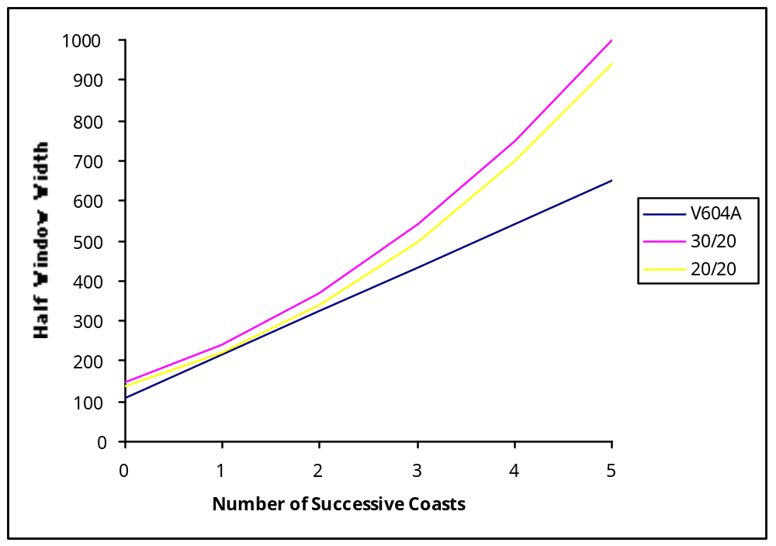
Figure 1. Current and Proposed Credibility Windows

Simulation Results

The simulation results obtained with the proposed credibility window using the worst-case scenario and various accelerations are shown in the attached spreadsheet. Simulation results were also obtained for a less extreme scenario in which the aircraft is initially level, then accelerates to a vertical rate of 6,000 fpm.

As for the testing of the airdata-tracker (see Change Proposal to the Airdata-Tracker Credibility Window for further details), the track maintenance performance of the 100-ft and 25-ft trackers were examined under three different conditions: (1) no bad altitude report, (2) one bad altitude report at the worst possible time, and (3) two successive bad altitude reports starting on a cycle randomly selected in an interval beginning 8 cycles (seconds) before the beginning of the acceleration and ending 8 cycles (seconds) after the end of the acceleration. (In these simulations, a bad altitude report was a report with a 5,000 ft error.)

Performance Results: Proposed 100 ft Tracker Credibility Window (I)
Window Parameters |  |  | CREDINIT = |  | 200 |  | (unchanged)
 |  | CREDZDERR = |  | 30
 |  | CREDACCDIV2 = |  | 20
1. Worst-case Scenario (Vertical Rate Changed from -6,000 to 6,000 fpm)
Test | Test Conditions |  |  |  |  |  |  |  |  |  |  |  | Maximum Acceleration (g)
Case | Jerk (g/s) | Sigma  (ft) | Quant. (ft) |  | 1 Bad Meas |  | 2 Bad Meas |  | 0.25 |  | 0.5 |  |  | 0.75 |  |  | 1.00 |  |  | 1.25
1 | 0.25 | 2 | 100 |  | no |  | no |  | 100 |  | 100 |  |  | 100 |  |  | 100 |  |  | 100
2 | 0.25 | 2 | 100 |  | yes |  | no |  | 100 |  | 100 |  |  | 100 |  |  | 100 |  |  | 100
3 | 0.25 | 2 | 100 |  | no |  | yes |  | 100 |  | 100 |  |  | 100 |  |  | 100 |  |  | 100
4 | 0.25 | 5 | 100 |  | no |  | no |  | 100 |  | 100 |  |  | 100 |  |  | 100 |  |  | 100
5 | 0.25 | 5 | 100 |  | yes |  | no |  | 100 |  | 100 |  |  | 100 |  |  | 100 |  |  | 100
6 | 0.25 | 5 | 100 |  | no |  | yes |  | 100 |  | 100 |  |  | 100 |  |  | 99 |  |  | 99
7 | 0.25 | 10 | 100 |  | no |  | no |  | 100 |  | 100 |  |  | 100 |  |  | 100 |  |  | 100
8 | 0.25 | 10 | 100 |  | yes |  | no |  | 100 |  | 100 |  |  | 100 |  |  | 100 |  |  | 100
9 | 0.25 | 10 | 100 |  | no |  | yes |  | 100 |  | 100 |  |  | 100 |  |  | 99 |  |  | 96
10 | 0.125 | 2 | 100 |  | yes |  | no |  | 100 |  | 100 |  |  | 100 |  |  | 100 |  |  | N/A
11 | 0.125 | 2 | 100 |  | no |  | yes |  | 100 |  | 100 |  |  | 100 |  |  | 100 |  |  | N/A
12 | 0.125 | 5 | 100 |  | yes |  | no |  | 100 |  | 100 |  |  | 100 |  |  | 100 |  |  | N/A
13 | 0.125 | 5 | 100 |  | no |  | yes |  | 100 |  | 100 |  |  | 100 |  |  | 100 |  |  | N/A
14 | 0.125 | 10 | 100 |  | yes |  | no |  | 100 |  | 100 |  |  | 100 |  |  | 100 |  |  | N/A
15 | 0.125 | 10 | 100 |  | no |  | yes |  | 100 |  | 100 |  |  | 99 |  |  | 98 |  |  | N/A
Note 1: The numbers in the last five columns are the percentages of tracks that were maintained throughout the scenario
Note 2: N/A indicates that the specified maximum acceleration cannot be reached in the scenario

Performance Results: Proposed 100 ft Tracker Credibility Window (II)
Window Parameters |  |  | CREDINIT = |  |  | 200 |  | (unchanged)
 |  | CREDZDERR = |  |  | 30
 |  | CREDACCDIV2 = |  |  | 20
2. Less Extreme Scenario (Vertical Rate Changed from 0 to 6,000 fpm)
Test | Test Conditions |  |  |  |  |  |  |  |  |  |  |  |  | Maximum Acceleration (g)
Case | Jerk (g/s) | Sigma  (ft) | Quant. (ft) |  |  | 1 Bad Meas |  | 2 Bad Meas |  | 0.25 |  | 0.5 |  | 0.75 |  | 1.00 |  | 1.25
1 | 0.25 | 2 | 100 |  |  | no |  | no |  | 100 |  | 100 |  | 100 |  | 100 |  | N/A
2 | 0.25 | 2 | 100 |  |  | yes |  | no |  | 100 |  | 100 |  | 100 |  | 100 |  | N/A
3 | 0.25 | 2 | 100 |  |  | no |  | yes |  | 100 |  | 100 |  | 100 |  | 100 |  | N/A
4 | 0.25 | 5 | 100 |  |  | no |  | no |  | 100 |  | 100 |  | 100 |  | 100 |  | N/A
5 | 0.25 | 5 | 100 |  |  | yes |  | no |  | 100 |  | 100 |  | 100 |  | 100 |  | N/A
6 | 0.25 | 5 | 100 |  |  | no |  | yes |  | 100 |  | 100 |  | 100 |  | 100 |  | N/A
7 | 0.25 | 10 | 100 |  |  | no |  | no |  | 100 |  | 100 |  | 100 |  | 100 |  | N/A
8 | 0.25 | 10 | 100 |  |  | yes |  | no |  | 100 |  | 100 |  | 100 |  | 100 |  | N/A
9 | 0.25 | 10 | 100 |  |  | no |  | yes |  | 100 |  | 100 |  | 100 |  | 100 |  | N/A
Note 1: The numbers in the last five columns are the percentages of tracks that were maintained throughout the scenario
Note 2: N/A indicates that the specified maximum acceleration cannot be reached in the scenario
3. Initialization Scenario
Test | Test Conditions |  |  |  |  |  |  |  |  |  |  |  |  | Vertical Rate (fpm)
Case | Jerk (g/s) | Sigma (ft) | Quant. (ft) |  |  | 1 Bad Meas |  | 2 Bad Meas |  | 6,000 |  | 7,000 |  | 8,000 |  | 9,000 |  | 10,000
1 | N/A | 2 | 100 |  |  | yes |  | no |  | 100 |  | 100 |  | 100 |  | 100 |  | 100
2 | N/A | 2 | 100 |  |  | no |  | yes |  | 100 |  | 100 |  | 100 |  | 100 |  | 100
3 | N/A | 5 | 100 |  |  | yes |  | no |  | 100 |  | 100 |  | 100 |  | 100 |  | 100
4 | N/A | 5 | 100 |  |  | no |  | yes |  | 100 |  | 100 |  | 100 |  | 100 |  | 100
5 | N/A | 10 | 100 |  |  | yes |  | no |  | 100 |  | 100 |  | 100 |  | 100 |  | 100
6 | N/A | 10 | 100 |  |  | no |  | yes |  | 100 |  | 100 |  | 100 |  | 100 |  | 100
Note 1: The numbers in the last five columns are the percentages of tracks that were maintained throughout the scenario

Performance Results: Proposed 25 ft Tracker Credibility Window (I)
Window Parameters |  |  | CREDINIT = |  | 200 |  | (unchanged)
 |  | CREDZDERR = |  | 30
 |  | CREDACCDIV2 = |  | 20
1. Worst-case Scenario (Vertical Rate Changed from -6,000 to 6,000 fpm)
Test | Test Conditions |  |  |  |  |  |  |  |  |  |  |  | Maximum Acceleration (g)
Case | Jerk (g/s) | Sigma  (ft) | Quant. (ft) |  | 1 Bad Meas |  | 2 Bad Meas |  | 0.25 |  | 0.5 |  | 0.75 |  | 1.00 |  | 1.25
1 | 0.25 | 2 | 25 |  | no |  | no |  | 100 |  | 100 |  | 100 |  | 100 |  | 100
2 | 0.25 | 2 | 25 |  | yes |  | no |  | 100 |  | 100 |  | 100 |  | 100 |  | 100
3 | 0.25 | 2 | 25 |  | no |  | yes |  | 100 |  | 100 |  | 100 |  | 100 |  | 100
4 | 0.25 | 5 | 25 |  | no |  | no |  | 100 |  | 100 |  | 100 |  | 100 |  | 99
5 | 0.25 | 5 | 25 |  | yes |  | no |  | 100 |  | 100 |  | 100 |  | 100 |  | 99
6 | 0.25 | 5 | 25 |  | no |  | yes |  | 100 |  | 100 |  | 100 |  | 100 |  | 99
7 | 0.25 | 10 | 25 |  | no |  | no |  | 100 |  | 100 |  | 100 |  | 93 |  | 87
8 | 0.25 | 10 | 25 |  | yes |  | no |  | 100 |  | 100 |  | 100 |  | 93 |  | 87
9 | 0.25 | 10 | 25 |  | no |  | yes |  | 100 |  | 100 |  | 97 |  | 94 |  | 92
10 | 0.125 | 2 | 25 |  | yes |  | no |  | 100 |  | 100 |  | 100 |  | 100 |  | N/A
11 | 0.125 | 2 | 25 |  | no |  | yes |  | 100 |  | 100 |  | 100 |  | 100 |  | N/A
12 | 0.125 | 5 | 25 |  | yes |  | no |  | 100 |  | 100 |  | 100 |  | 100 |  | N/A
13 | 0.125 | 5 | 25 |  | no |  | yes |  | 100 |  | 100 |  | 100 |  | 100 |  | N/A
14 | 0.125 | 10 | 25 |  | yes |  | no |  | 100 |  | 100 |  | 100 |  | 100 |  | N/A
15 | 0.125 | 10 | 25 |  | no |  | yes |  | 100 |  | 100 |  | 99 |  | 98 |  | N/A
Note 1: The numbers in the last five columns are the percentages of tracks that were maintained throughout the scenario
Note 2: N/A indicates that the specified maximum acceleration cannot be reached in the scenario

Performance Results: Proposed 25 ft Tracker Credibility Window (II)
Window Parameters |  |  | CREDINIT = |  |  | 200 |  | (unchanged)
 |  | CREDZDERR = |  |  | 30
 |  | CREDACCDIV2 = |  |  | 20
2. Less Extreme Scenario (Vertical Rate Changed from 0 to 6,000 fpm)
Test | Test Conditions |  |  |  |  |  |  |  |  |  |  |  |  | Maximum Acceleration (g)
Case | Jerk (g/s) | Sigma  (ft) | Quant. (ft) |  |  | 1 Bad Meas |  | 2 Bad Meas |  | 0.25 |  | 0.5 |  | 0.75 |  | 1.00 |  | 1.25
1 | 0.25 | 2 | 25 |  |  | no |  | no |  | 100 |  | 100 |  | 100 |  | 100 |  | N/A
2 | 0.25 | 2 | 25 |  |  | yes |  | no |  | 100 |  | 100 |  | 100 |  | 100 |  | N/A
3 | 0.25 | 2 | 25 |  |  | no |  | yes |  | 100 |  | 100 |  | 100 |  | 97 |  | N/A
4 | 0.25 | 5 | 25 |  |  | no |  | no |  | 100 |  | 100 |  | 100 |  | 100 |  | N/A
5 | 0.25 | 5 | 25 |  |  | yes |  | no |  | 100 |  | 100 |  | 100 |  | 100 |  | N/A
6 | 0.25 | 5 | 25 |  |  | no |  | yes |  | 100 |  | 100 |  | 100 |  | 97 |  | N/A
7 | 0.25 | 10 | 25 |  |  | no |  | no |  | 100 |  | 100 |  | 100 |  | 100 |  | N/A
8 | 0.25 | 10 | 25 |  |  | yes |  | no |  | 100 |  | 100 |  | 100 |  | 100 |  | N/A
9 | 0.25 | 10 | 25 |  |  | no |  | yes |  | 100 |  | 100 |  | 98 |  | 98 |  | N/A
Note 1: The numbers in the last five columns are the percentages of tracks that were maintained throughout the scenario
Note 2: N/A indicates that the specified maximum acceleration cannot be reached in the scenario
3. Initialization Scenario
Test | Test Conditions |  |  |  |  |  |  |  |  |  |  |  |  | Vertical Rate (fpm)
Case | Jerk (g/s) | Sigma  (ft) | Quant. (ft) |  |  | 1 Bad Meas |  | 2 Bad Meas |  | 6,000 |  | 7,000 |  | 8,000 |  | 9,000 |  | 10,000
1 | N/A | 2 | 25 |  |  | yes |  | no |  | 100 |  | 100 |  | 100 |  | 100 |  | 100
2 | N/A | 2 | 25 |  |  | no |  | yes |  | 100 |  | 100 |  | 100 |  | 100 |  | 100
3 | N/A | 5 | 25 |  |  | yes |  | no |  | 100 |  | 100 |  | 100 |  | 100 |  | 100
4 | N/A | 5 | 25 |  |  | no |  | yes |  | 100 |  | 100 |  | 100 |  | 100 |  | 100
5 | N/A | 10 | 25 |  |  | yes |  | no |  | 100 |  | 100 |  | 100 |  | 100 |  | 100
6 | N/A | 10 | 25 |  |  | no |  | yes |  | 100 |  | 100 |  | 100 |  | 100 |  | 100
Note 1: The numbers in the last five columns are the percentages of tracks that were maintained throughout the scenario

