2000-01-5520
Initial Evaluation of CDTI/ADS-B for Commercial Carriers: CAA’s Ohio Valley Operational Evaluation
Vernol Battiste and Rose Ashford
NASA Ames Research Center
Baltazar Oscar Olmos

MITRE Center for Advanced Aviation System Development
Copyright © 2000 Society of Automotive Engineers, Inc.

Abstract

Flight activities during the Cargo Airline Association’s Ohio Valley Operations Evaluation (OpEval) were focused on near-term Cockpit Display of Traffic Information (CDTI) applications. Seven CDTI applications were ranked from highest to lowest priority, and the first two, Enhanced Visual Acquisition for “See & Avoid”, and Enhanced Visual Approaches, were evaluated during OpEval. Five other applications were demonstrated. For the Enhanced Visual Acquisition and Enhanced Visual Approach applications, a detailed, comprehensive operational concept document was prepared. The operational concept and the associated CDTI requirements were tested during OpEval. Both pilots and controllers reported that the CDTI augmented the visual acquisition and visual approach tasks and improved pilot awareness of surrounding traffic. Additionally, the results suggest operational performance benefits in the form of enhanced spacing awareness and a potential reduction in the misidentification of aircraft called out by ATC. No overriding human factors issues were revealed that would negatively impact operational approval of these two applications for traffic environments similar to OpEval. Flight crews identified three issues, display integration, clutter, and head down time, which need to be considered as we proceed with the design and use of CDTI. One potential issue raised by the controllers that needs to be addressed, is that of flight crews initiating unwarranted requests from ATC.

INTRODUCTION
In July 1999, an initial evaluation of a prototype CDTI that depicts surveillance information regarding surrounding traffic was conducted at Airborne Airpark in Wilmington, Ohio. Twelve aircraft operated by three member airlines of the Cargo Airline Association (CAA) flew an intensive series of flight trials providing a basis for evaluating near-term CDTI applications and data link technologies. The flight test was accomplished in partnership with the FAA’s Safe Flight 21 program, the MITRE Center for Advanced Aviation System Development, NASA, DoD, and other industry and academic partners [1].

The flight trials were focused on evaluation of near-term CDTI applications that can be implemented without significant changes to ATC procedures. These applications have been identified by RTCA and are described in the Automated Dependent Surveillance-Broadcast (ADS-B) Minimum Aviation System Performance Specification (MASPS), RTCA DO-242, and the CDTI MOPS [2,3]. The flight scenarios were designed to enable evaluation of flight crew and controller performance, operational procedures and benefits, and data link technical performance for these applications. The evaluation is intended to support operational approval of the CDTI for these near-term applications, and be sufficiently comprehensive that, although significant future effort will be required for certification, there should be no unresolved “show stoppers.”

This paper describes the human factors data collection program, together with the ensuing analysis. Other accomplishments of OpEval include data link evaluation, radar and ADS-B track analysis of aircraft spacing with and without the CDTI, and ATC voice tape analysis of message frequency and content. A complete description of OpEval and these results can be found online at www.faa.sf21.gov [4].

Much of the development work to design the flight scenarios was conducted at the Integration and Interaction Laboratory (I-Lab) operated by MITRE. The I-Lab is a medium-fidelity simulation facility including both flight deck and ATC environments. It was used to develop specific test scenarios and procedures for evaluating the CDTI. During the final I-Lab simulation, the test scenarios were “flown”, and the human factors data collection process verified.

CDTI Applications Evaluated
Application priorities were (highest to lowest priority):[5]
- Evaluate Enhanced Visual Acquisition for “See & Avoid”
- Evaluate Enhanced Visual Approaches
- Demonstrate Airport Surface Situation Awareness
- Demonstrate Enhanced In-Trail (or lead) Climb/In-Trail Descent
- Demonstrate Station Keeping
- Demonstrate Departure Spacing
- Demonstrate Final Approach Spacing

The Enhanced Visual Acquisition application was intended to aid flight crews in visually acquiring proximate traffic, and in increasing overall traffic awareness. Pilots using a CDTI will continue their normal visual scan with an additional aid to where to focus their attention. The CDTI serves as an enhancement for the visual acquisition of traffic, including ground vehicles, thus improving safety and efficiency of flight operations. A major expected benefit of the CDTI is reacquisition, or maintaining acquisition of previously acquired traffic. RTCA developed a detailed Operational Concept document for the Enhanced Visual Acquisition application, including flight crew and controller roles and procedures, and CDTI requirements. The operational concept was used to design flight scenarios that would allow us to evaluate the application’s benefits, and assess flight crew and controller performance and acceptance.

The Enhanced Visual Approach application was intended to augment a normal visual approach by providing additional traffic information that will allow the flight crew to determine traffic position, identification, ground speed and track. The CDTI is expected to reduce the probability of loss of visual contact, and aid judgment of closure and encounter geometries. An Operational Concept document was similarly developed for this application. The OpEval implementation of Enhanced Visual Approaches also included two additional CDTI tasks beyond a standard visual approach. First, when responding to an ATC traffic call-out, the pilot could include the call sign of that traffic. In addition, the flight crews, once cleared for the visual approach, were tasked with visually closing-up spacing on the lead aircraft using the CDTI. This is considered a VMC implementation of the final approach spacing application.[8]

The lower priority applications were demonstrated to show feasibility during OpEval, but without integration into a fully operational context, as well as allowing for only limited data collection. In particular, the Airport Surface Situational Awareness application was hampered by lack of an airport map on the display, although data was obtained for this application from all the participating aircraft.
CDTI
The prototype Cockpit Display of Traffic Information (CDTI) that was used for OpEval is shown in Figure 1. The display primarily depicts the position of proximate traffic with respect to ownship. Two sources of traffic information were available at OpEval: ADS-B and Traffic Information Service (TIS). ADS-B is a surveillance system whereby the GPS position and altitude (obtained from an altitude encoder or air data computer) of an airborne vehicle, and GPS position of ground vehicles, is periodically blind broadcast, along with the sender’s identification. The broadcast may then be received by any vehicle or ground station, allowing for determination of the sender’s position relative to the receiver. TIS is a ground-based data link service by which an aircraft’s position as determined by Mode S surveillance radar is re-broadcast to the ownship’s Mode S transponder and again may be used to determine the aircraft’s position relative to the ownship. Unlike ADS-B, TIS includes an alerting algorithm in the event the aircraft is considered a threat to the ownship. TIS tracks Mode A, C or S equipped aircraft within approximately 55 nautical miles of the Mode S ground radar sites and uplinks traffic within five nautical miles and +/- 1,200 feet of the ownship and any other tracked traffic considered to be a threat.[6,7]

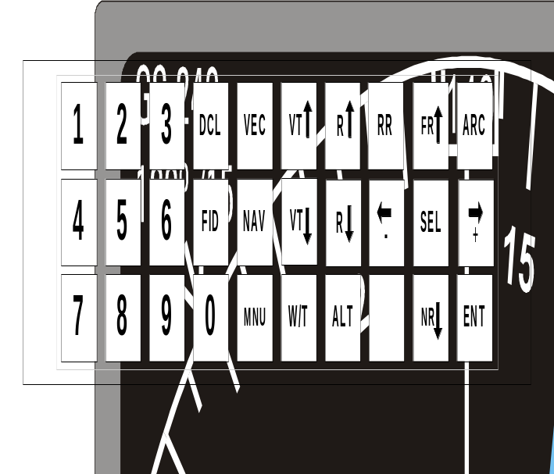 Figure 1: UPS-AT CDTI and Control Panel

As shown in Figure 1, the ownship is depicted by a white triangle with the actual location of the ownship at the apex. ADS-B ‘targets’ are depicted by cyan chevrons, and TIS targets as cyan “bullets”. Both targets “point” in the direction the traffic is moving and are accompanied by a data tag including relative or absolute altitude in 100’s of feet, an ↑ or ↓ arrow if the target is climbing or descending more than 500 feet per minute, and aircraft identification for ADS-B targets. The CDTI was configurable, with ranges from 0.5 to 320 nautical miles, and allowing for the ownship to be centered on the display or three quarters of the way down from the top, and presented both with and without the compass rose. A TIS traffic alert occurred when the ground station determined the target to be a threat to the ownship. This is depicted by the target turning yellow and flashing, together with the voice alert “TIS traffic”.

Keyboard Functions
The major functions of the keyboard are listed below. Some other functions are available, but could not be evaluated at OpEval and are not discussed here.

Altitude Range
Defines the altitude range in 100’s of feet above and below ownship where targets will be displayed. It is accessed through the menu “MNU” key.

Map Range “R↑, R↓”
Adjusts the display range from 0.5, 1. 2. 5. 10, 20, 40, 80, 160 to 320 nautical miles.

Display Mode Control “ARC”
Cycles through display options with ownship centered on the display or 3/4 down from the top, and with or without the compass rose.

Altitude Key “ALT”
Toggles between relative altitude or pressure altitude on displayed targets.

Vector Key “VEC”
Toggles between viewing and not viewing ground track vectors.

Select Key “SEL”
Highlights the nearest ADS-B target. Depressing the FR↑ key highlights the next farther ADS-B target, while depressing the NR↓ key highlights the next nearer ADS-B target. The selected target changes color from cyan to green and an augmented data block is presented in the lower left portion of the display.

Graphic Closure Indicator “GCI”
This is available on selected targets only and is accessed by toggling the ← and → keys. When the selected target is moving away from the ownship at 5 knots or greater, the GCI appears as a thickened bar on the target’s ground track vector. Conversely, if the target is converging on the ownship by 5 knots or greater, the thickened bar appears behind the target symbol. GCI’s are not shown for relative speeds less than 5 knots.

De-clutter Key “DCL”
Toggles between viewing and not viewing the data tags, ground track vectors and range ring.

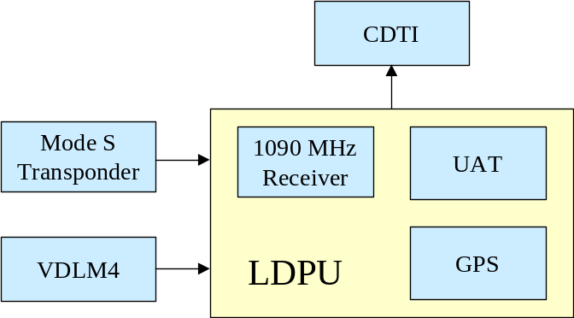
Figure 2: CDTI Display System Schematic.

Link Data Processor Unit (LDPU)
The primary function of the LDPU is to fuse surveillance data from TIS and ADS-B so that only one target is presented on the CDTI, even though surveillance information may have been received from more than one source. The LDPU also receives the ownship GPS position for display on the CDTI. Part of the purpose of OpEval was to evaluate the candidate data links. Mode S 1080 MHz and Universal Access Transceiver (UAT) were evaluated. Very High Frequency Data Link Mode 4 (VDLM4) was not available.

Flight Scenarios
Four DC-9’s, operated by Airborne Express, and eight Boeing 727’s, four each operated by United Parcel Service and Federal Express, participated in the flight test and human factors data collection. Several other aircraft including a Boeing 757 operated by NASA and a Navy P-3 Orion, participated in OpEval, and provided CDTI “targets”, but were not part of the human factors data collection effort. The DC-9’s were operated with a normal two-person crew, consisting of captain and first officer. The B-727’s were operated with a normal three-person crew consisting of captain, first and second officers. The CDTI was located forward of the throttles on both aircraft, slightly towards the captain’s side. Due to the seating arrangement, the second officer in the B-727 was unable to reach the CDTI keyboard, and his or her view of it may have been restricted. The flight test was conducted at Airborne Airpark in Wilmington, Ohio on July 10, 1999. The airfield consists of two parallel runways with 3,400 feet separation and has an operating control tower. Dayton Approach and Indianapolis Center controlled the surrounding airspace.

Eight of the twelve participating aircraft were assigned to the “Low” flight scenarios designed for evaluation of the two high priority applications, Enhanced Visual Acquisition and Enhanced Visual Approaches. These aircraft conducted multiple approaches to the two parallel runways, four aircraft in the traffic pattern for each runway, and each approach ending in a go-around initiated at about 200 feet AGL (see Figure 3). Since not all of the twelve aircraft were equipped with fully operating CDTI’s, equipped aircraft were assigned first to the “Low” flight scenarios to maximize data collection for the two high priority applications to be evaluated. Human factors observers flew on all eight of the “Low” flight scenarios to maximize data collection.

During the low flight scenarios, the flight crews contacted Dayton Approach after departure. After radar contact, Dayton approach vectored the aircraft back to the final approach course; providing vectors for cross wind, downwind, base, and initial turn to final. When each flight crew reported either their traffic to follow on final, or the airport, in sight, they were cleared for a visual approach. Dayton Approach also called out any relevant traffic during each approach. The flight crew’s task during each approach was to use the CDTI in visually acquiring traffic in their vicinity, both as part of their normal scan and after an ATC traffic call. They were also asked to utilize the CDTI to evaluate the spacing between their aircraft and the traffic ahead, and to reduce spacing to a distance that was comfortable and that would support a safe landing behind the traffic.

To aid in assessing the impact of CDTI on visual approaches and approach spacing, a data collection matrix was developed. Each flight crew was expected to complete seven visual approaches over the course of the flight period. The first approach was considered a familiarization flight. For the remaining six approaches, two were flown without the aid of the CDTI and four with the CDTI. The collection of baseline data was either the first two or final two visual approaches, and was randomized among flight crews.

Weather conditions at Wilmington did not permit visual approaches during the morning flight period. However, visibility improved during the day, and visual approaches were flown during the afternoon session. 91 visual approaches were then flown, 23 Baseline (no CDTI) and 68 with the CDTI. The initial plan had been to conduct 96 approaches, 32 Baseline and 64 CDTI, for the whole day. Since the visibility during the afternoon remained pretty much constant, we were able to gather sufficient data for meaningful analysis, although it is somewhat limited by the lack of baseline data.

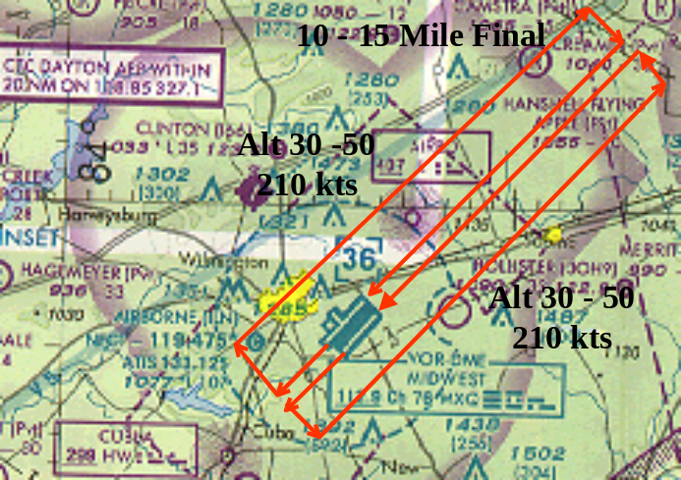Figure 3: Low Altitude Flight Profile.

For the “High” flight scenarios designed to demonstrate the lower priority applications, one aircraft had an inoperative CDTI, and on another, the CDTI was only partially operating. Both aircraft appeared as targets for the remaining aircraft with operating CDTI’s so we were able to demonstrate the “High’ flight applications, Station Keeping and Enhanced In-Trail Climb/In-Trail Descent, and Lead Climb/Lead Descent. Human factors observers flew on one of the fully equipped aircraft, and pilot opinion data was collected from another equipped aircraft, so we were able to collect sufficient data for demonstration purposes. FAA observers also flew on two of these aircraft, and although they were not part of the human factors data collection effort, individual opinions from those observers are reported in this paper.

The flight crew’s task during both the station keeping and the in-trail climb and descent was to maintain 15 +/- 1 nautical mile in trail spacing behind the traffic they were following during the “round robin” flight from Wilmington to Wilmington (see Figure 4). Flight crews were not expected to visually acquire the traffic, but to select the traffic on the CDTI, and to utilize the information provided on the CDTI display to maintain the appropriate distance. Crews only performed the spacing task during the straight segments of the flight, not during turns.

Both “Low” and “High” flight aircraft participated in data collection for Airport Surface Situational Awareness while taxiing on the airport surface.

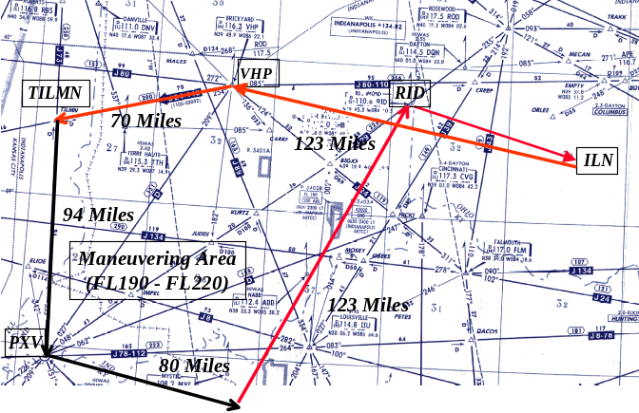
Figure 4: High Altitude Flight Profile.

Human Factors Evaluation
The objective of the human factors evaluation was to determine flight crew and controller performance with, and acceptance of, the CDTI. The observers recorded visual acquisition time and visual acquisition performance both with and without the CDTI. Questionnaires were administered to both flight crews and controllers after the flight test was completed and structured debrief sessions were conducted. The flight crew questionnaire included CDTI feature preferences and elicited opinions on the usefulness of the CDTI for the evaluated and demonstrated applications as well as workload and other issues. The ATC questionnaire included controller experience with handling CDTI-equipped aircraft.

Flight Crew Human Factors Observers
Human factors observers were selected and trained to record the flight crew’s performance with and without the CDTI during the OpEval flights

Observer training was conducted in the following areas:

- The role of CDTI in the air traffic environment
- The objectives and goals of the operational evaluation
- UPS Aviation Technologies CDTI (features, operational capability)
- The structure of visual approaches at an air carrier hub operation
- The prescribed crew and ATC roles and procedures, during visual approaches and en-route cruise flight
- Video presentation of type specific aircraft cockpits and procedures (B-727 for FedEX, UPS, and DC-9 for Airborne Express) for visual approaches and en-route cruise flight
- The flight deck data collection procedures for low altitude and en route flights
- Use of data collection apparatus and procedures (flight deck and debrief/questionnaire)

The observers took notes on specially designed observer data collection forms, administered the post-flight questionnaire, and debriefed the flight crews after the test scenarios were completed. The observer records were used to support the collection of:

- Response time to each traffic call
- Assessment of CDTI use during visual traffic acquisition
- Assessment of the impact of CDTI on normal cockpit duties

The observer protocol for collecting visual acquisition performance data on the flight deck was to code as an acquisition any recognition of traffic in sight by the crew; through inter-cockpit verbal or non-verbal communications, or verbal reports to ATC. Flight deck observers were asked to encode the visual acquisition performance (strategies) into five categories. The five categories were: (1) visual only no CDTI, (2) visual first then CDTI, (3) CDTI first then visual, (4) both - order unknown, and (5) CDTI only no visual. The first category is descriptive of the currently used visual acquisition strategy, where the flight crew searches the visual scene for known and unknown traffic, with or without an ATC traffic call without the aid of a traffic display. The second strategy supports the use of the traffic display to confirm a visual sighting of traffic. The third approach suggests that the flight crews utilize the traffic display to support the visual search; locating the traffic on the display, then searching the visual scene for the traffic. The fourth category allows the observer to code the acquisition when they are not able to determine the order, visual or CDTI first, used by the flight crew. The fifth category suggests a method of maintaining general situational awareness of traffic not in sight, but in the general area and is not recorded as a visual acquisition.

Training: Flight Crews and Controllers
Flight crews received training in the purpose, limitations and operations of a CDTI the morning of the day before OpEval. They were briefed on the flight scenarios and other OpEval requirements (safety, contingency planning, etc.) that afternoon.

Controllers were asked to conduct operations as normal (i.e., no specific training was required). However, they were asked to point out all relevant traffic and to vary the order in which each aircraft conducted the visual approach. This was done to prevent each aircraft from following the same aircraft on every approach. Two of the three controllers who participated in OpEval also participated in the I-Lab simulations.

Flight Crew Post Event Questionnaire
Pilot opinion ratings were gathered during the post-flight debriefing, after each crew completed their post flight duty requirements. The questionnaires were completed prior to a structured interview and the combined activity lasted about one hour. Each question was designed to elicit specific information from the flight crews on the usefulness of individual features and functions of the CDTI, and the impact of the CDTI on specific flight-related tasks. Items in the questionnaire were scaled from 1 to 3 or from 1 to 5 to support a Likert scale analysis. Additionally, a selection of “Not Applicable/Did Not Use” was an available choice.

For specific features of the display, crews were asked to rate the ease of use of each individual feature, from easy to use, OK to use and difficult to use. These ratings were translated into 1 – easy, 2 – OK, and 3 difficult to support the comparison. The neutral point of 2.0 was used as an anchor to evaluate all 1 to 3 ratings and those found to be significantly (p<0.05) above or below 2.0 on a two-tailed t-test were indicated as a positive or negative response by the group on that specific feature or function.

Additionally, flight crews were asked to provide opinions on the impact of the CDTI on specific flight related tasks, particularity, the impact of information presented on the CDTI during visual traffic acquisition, visual approach, departure spacing, in-trail and lead climbs and descents, and station-keeping. Questions related to these tasks were presented in a 1-5 Likert scale format with the lower portion of the scale having negative statements (strongly disagree), the upper portion having positive statements (strongly agree) and the middle of the scale having a neutral statement (neither agree or disagree).

A final set of questions in the questionnaire asked the flight crews to summarize their overall experiences with and without the CDTI information during OpEval. The anchor for the lower portion of the summary questions was “excellent”, “poor” for the upper portion, and “OK” for the middle.

Crew responses to each question were translated into numeric values from 1 to 5, or 1 to 3 and analyzed using a two-tailed t-test. Flight crew opinions were compared to the neutral response for each question and those found to be significantly (p<0.05) above or below the neutral point are reported as a positive or negative response by the group.

I-LAB Simulations
The objectives of the I-Lab simulations were to develop the application-specific procedures and scenarios that were flown during the OpEval flights. The intent was to test and validate all OpEval activities in the I-Lab before the actual flights at Wilmington. The I-Lab simulations included both the flight deck and ATC environments. The I-Lab simulations were also used to support prototype design and development activities. Additional objectives of the I-lab simulations were to assist in the development and testing of the data collection process, and to familiarize observers and controllers with developed procedures. The I-Lab simulation environment is composed of a simulator cockpit, a computer-generated visual scene, and controller station. The Wilmington Ohio flight environment (e.g., navigation aids, visual scene) was modeled in support of this simulation.

Flight Deck
The I-Lab cockpit simulation is configured to approximate the performance of a twin engine, transport category airplane. The cockpit simulation is a fixed based, glass cockpit coupled to a projection visual system that provides a view of the external visual scene. The flight dynamics and performance approximate those of the Boeing 757. The system uses side stick controls coupled with an autopilot to control vertical and lateral flight. Thrust control is accomplished through a pilot-selectable auto throttle system, or manually through the thrust levers. Cockpit displays are software generated and are modeled to be similar in form and function to the displays installed on the Boeing 747-400. The Electronic Flight Instrument System (EFIS) displays include a Primary Flight Display (PFD) of attitude, airspeed, altitude and vertical rate information for basic aircraft control, and a mode-selectable Nav Display (ND) which depicts lateral navigation information in a plan view map. The CAA CDTI information and related display features are presented on the ND using the Map mode. The CAA CDTI control panel is located on the center console between the two pilots.

Visual Scene
The visual scene encompasses a 150⁰ lateral by 40⁰ vertical field of view using a single screen front-view projection system with a refresh rate of 30 Hz. Targets appearing on the traffic display are correlated with visible traffic in the out-the-window view. The terrain for the visual scene was built using the Defense Mapping Agency’s (DMA) Digital Terrain Elevation Data (DTED) and accuracy was ensured through the use of the National Oceanic and Aerospace Administration (NOAA) airport obstruction charts.

ATC
The cockpit is linked to a controller station that is composed of a combined TRACON and Tower position. ATC communications are accomplished using headsets and microphones in the simulator. The pseudo pilots positions are provided with a voice party line to simulate ATC and pilot communications of other aircraft.

Results
This section summarizes the flight deck and controller data accumulated during the OpEval process, which includes the initial I-Lab OpEval simulations. Inferences and conclusions drawn on this data are discussed in the final section of the paper. Additionally, summaries of flight reports from other observers are included, two from the FAA and one from a Navy P-3, all flying the “High” flight scenarios. These are not part of the structured data collection effort.

I-Lab OpEval Simulation Results
The primary objective of the I-Lab simulation activity was to develop the application-specific procedures, scenarios, and briefing materials that were to be conducted at OpEval. The intent was to “fly” the OpEval scenarios in the I-Lab before the actual flights at Wilmington. Secondary objectives of the I-Lab simulation were to assist in the development and testing of the data collection process and to familiarize flight crews, OpEval controllers, and observers with the scenarios. The following is a summary of the outputs from the I-Lab simulations:

- Finalized low and high altitude flight profiles
- Familiarized Dayton controllers and subset of CAA crews with OpEval flight profiles
- Developed flight procedures and phraseology (i.e., flight maneuver cards)
- Finalized Human Factors observational data collection protocol
- Developed Flight Crew Mission Guide

Enhanced Visual Acquisition
The CDTI enhanced visual acquisition application is a capability that was expected to aid pilots in visually acquiring other proximate traffic in the out the window (OTW) view as well as increasing their traffic awareness. Pilots using a CDTI were expected to continue their visual scan but would have an additional aid to visually acquire other aircraft by focusing their attention to a specific area. This method of acquiring visual traffic is expected to reduce the visual search time. The CDTI would serve as an enhancement for the visual acquisition of traffic including ground vehicles, thus improving the safety and efficiency of flight operations. During OpEval, visual acquisition data was collected throughout all flight maneuvers in the traffic pattern and during departure/arrival phases. A major expected benefit of Enhanced Visual Acquisition is reacquisition, or maintaining acquisition of previously acquired traffic.
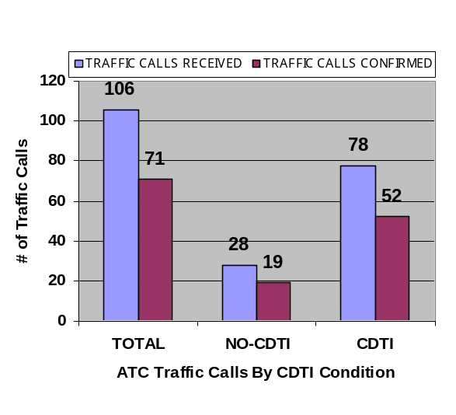
Visual Acquisition Performance- Flight Deck Observations
Figure 5:Visual Acquisition Summary Data.
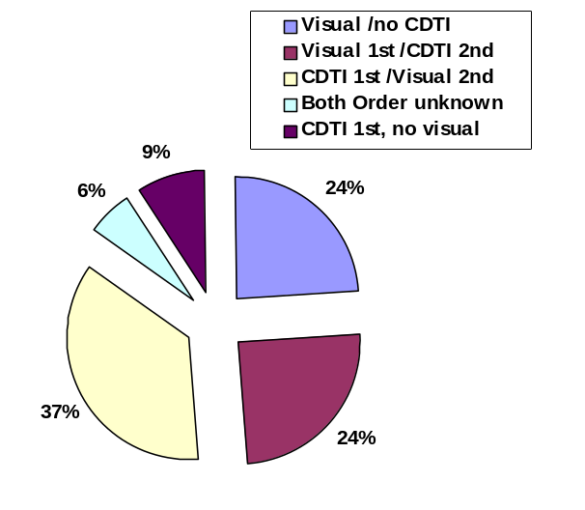Visual acquisition performance as recorded by the observers is summarized in the following figures. Figure 5 shows that observers recorded a total of 106 ATC traffic calls, and that 71 of those calls were confirmed by the flight crew as traffic sighting. In total, flight crews reported about 67% of ATC traffic calls in sight. The percentages were approximately the same for the baseline/no CDTI and CDTI conditions.
Figure 6:Distribution of Traffic Acquisitions without an ATC Traffic Call - Total number of acquisitions confirmed and coded n = 33).

Figure 6 shows that prior to an ATC call, flight crews utilized a variety of strategies during visual traffic acquisition. To acquire traffic in the visual scene prior to an ATC traffic call, crews referenced the CDTI then located the traffic in the OTW visual scene 37% of the time, followed by visual search only and visual plus CDTI 24% of the time each, and CDTI no visual 9% of the time. Figure 7 suggests that after an ATC traffic call, flight crewmembers utilized the standard method of searching the OTW visual scene for locating traffic 46% of the time, followed by CDTI plus visual search 26% of the time, visual plus CDTI 19%, and CDTI no visual 7% of the time.

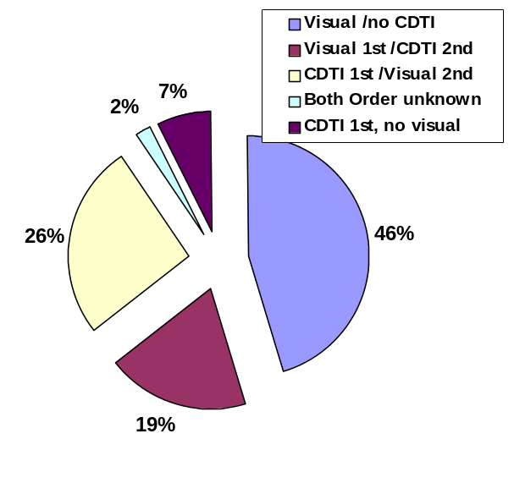During the oral debrief crews suggested that their utilization of the CDTI in support of visual traffic acquisition improved with experience. To evaluate these assertions we compared visual acquisition performance for the first six approaches to performance for the remaining approaches. Figure 8 shows that acquisition performance improved by 10.8% over the period of evaluation.
Figure 7:Distribution of Traffic Acquisitions After ATC Traffic Call - Total number of acquisitions confirmed, and coded n = 42.

Flight Crew Questionnaire and Debrief Data (Visual Acquisition)
Flight crew members rated the CDTI as aiding them significantly in visually acquiring traffic, before and after an ATC traffic call (mean rating of 4.8 and 4.9
respectively on a scale of 1 to 5, (p<.05, df 23). They also reported that maintaining an awareness of multiple traffic targets was less difficult when using the CDTI (mean rating with CDTI, 4.8, p<.05 df 23; without CDTI, mean rating of 1.25, p<.05, df 23). Flight crew members agreed that there was a good match between the physical location of traffic, ATC reported traffic position, and CDTI traffic position (mean ratings of 4.8 and 4.8 respectively, p<.05, df 23). Crews also rated the “Select” function as useful for visual traffic acquisition and for maintaining an awareness of traffic (mean rating 4.4, p<.05, df 20). However, three flight crew members, 2 in the high altitude group (DC-9) and 1 captain (B-727) in the low altitude group reported not using the select function.

Flight crews did not rate display clutter as being a problem during visual acquisition (mean rating 3.04, p> .05, df 23). They did rate head down time as being a problem during visual traffic acquisition (mean rating 3.625, p< .05, df 23). During the debrief, when asked if the CDTI helped or hindered visual acquisition performance, flight crews generally confirmed their earlier rating that the CDTI was an aid. One flight crewmember suggested that when using the CDTI to acquire traffic, “you know exactly where to look.” Crews also commented during the debriefing that:

- During visual approaches (visibility > 5 miles) CDTI aided visual acquisition, especially for small aircraft.
- During ILS approaches (visibility < 5 miles) the CDTI increased flight crew confidence in their ability to maintain an awareness of the exact position of traffic, even when traffic transitioned in and out of obscurations.
- Having the aircraft category and position information on the CDTI helped in verifying ATC traffic calls, and that this type of information also aided in identifying traffic prior to an ATC traffic call.
- 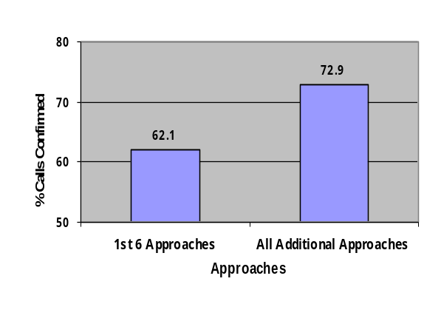The CDTI allowed them to recheck the position of traffic without requesting this information from ATC; a potential reduction in workload for both the flight crew and ATC. They also reported that the CDTI increased the efficiency of the out the window traffic scan; a potential workload reduction for the flight crews.
Figure 8:Percentage of Calls Confirmed During Visual Approaches.
- The CDTI aided in planning and workload management, intra-cockpit communication, and maintaining an awareness of multiple aircraft during marginal visual meteorological conditions.
- Their ability to utilize the CDTI in support of visual acquisition improved with experience and that unlike the TCAS traffic display, the traffic symbology on the CDTI provides instantly discernible heading information.
- Head down time and clutter were problems and that the display needs to be integrated into existing displays to prevent task saturation.

Flight Crew Workload
Flight crews were asked to rate the ease of use for each CDTI setting that was used during visual traffic acquisition. Overall, flight crews reported that each function was easy to use (value of 1 = easy, 2 = OK, 3 = difficult, Table 1). The table also shows that some features (ALT and GCI) were used by less than half of the flight crewmembers.

Feature | t (all p<.05) | df | mean | n
Altitude Range | -4.27 | 16 | 1.35 | 26
Map Range | -10.11 | 19 | 1.15 | 26
ARC | -10.11 | 19 | 1.15 | 26
ALT | -2.84 | 11 | 1.33 | 26
VEC | -6.28 | 14 | 1.13 | 26
SEL | -3.55 | 18 | 1.42 | 26
GCI | -2.40 | 12 | 1.46 | 26
G DCL | -5.44 | 16 | 1.23 | 26
Table 1: Flight Crew Workload for CDTI Setting during Visual Acquisition

The table shows, in the degrees of freedom column, the number of flight crews (df+2) that used each function. Second officers on the B-727 aircraft normally reported not using each function, however this was not always the case. The difference between “n” (total in the sample) minus the df plus 2 equals the number of flight crew members that did not utilize each function (n-(df+2)=not used/not applicable).

Evaluate Enhanced Visual Approaches
In response to the post-flight questionnaire, a majority of flight crews agreed that the CDTI aided in overall traffic awareness (mean rating 4.88 compared to a neutral value of 3, p<.05 df 23), and in closing to a final approach spacing, which was comfortable and appropriate (mean rating 4.54, p<.05, df 23). Crews also agreed that the selected target feature of the CDTI provided enough information (mean rating 4.50, p<.05, df 23) and that the workload for gauging the distance behind the lead aircraft was acceptable (mean rating 4.58, p<.05, df 23). Flight crews did not find the workload acceptable for gauging the distance behind the lead aircraft on final without the CDTI (mean rating 2.65, p>.05, df 22). Flight crews rated the CDTI as aiding crew duties during visual approaches (mean rating 4.29, p<.05, df 23). Flight crews rated as neutral or mixed the use of the CDTI to: estimate when the lead aircraft was over the landing threshold (mean rating 3.17, p>.05, df 22); estimate when the lead aircraft was touching down (mean rating 3.59, p>.05, df 21); when lead traffic was clearing the runway (mean rating 3.14, p>.05, df 20); or that the CDTI aided in completing checklist (mean rating 2.61, p>.05, df 22). Flight crews rated that using the CDTI during visual approach increased head-down time (mean 3.58, p<.05, df 23).

In the post-flight debrief, crews suggested that they currently do not try to gauge exact distances, but try to maintain the spacing interval that exists when ATC clears them for the approach. Flight crews also agreed that using the CDTI during visual approaches increased head down time, but when asked if the CDTI helped or hindered operations during visual approach, the majority said that it helped. The following is a summary of crew comments on how the CDTI helped during visual approaches:

- Allowed us to tighten up our approach
- Very useful for acquiring and re-acquisition of traffic
- Display of ground speed and distance information reduced the workload of following traffic
- Increased situational awareness in busy visual traffic pattern
- Supported re-checking the position of traffic without consulting ATC
- Improved our awareness of ATC traffic pattern objectives
- Using the system to support flight deck objectives improved with experience - for example, our confidence in maintaining a desired interval during the approach.

Flight crews also reported some issues with the current system. Crews reported that the presentation of TIS information produced false and/or fused targets, and occasionally data tags appeared to swap. Crews reported that head down time was a problem and suggested that it was easy to become fixated on the CDTI. Flight crews reported that the location of the display, not in their primary visual scan, made it difficult to integrate the CDTI into their normal scan pattern. And due to the placement of the display in the cockpit, additional intra-cockpit communication was required. Finally, crews reported that they could not determine when a lead aircraft was over the landing threshold, but could determine when the aircraft touched down. Flight crews suggested that to perform other more precise tasks (e.g., determining when traffic was over the landing threshold), an airport surface map would be required. A number of the issues identified by flight crews were known and accepted due to the fact that the initial prototype was developed to support visual traffic acquisition, and general situational awareness, not traffic alerts and ground/airport surface operations.

Flight Crew Workload
Flight crews were asked to rate the ease of use of each CDTI setting that was used to visually acquire traffic during visual approaches. Table shows that for the flight crews that used each function, they rated each as easy to use. The table also shows the number of flight crews (df+2) that used and did not use (n-(df+2)each feature. Second officers on the B-727 aircraft normally reported not using each function, however this was not always the case.

Feature | t (all p<.05) | df | mean | n
Altitude Range | -5.79 | 15 | 1.19 | 24
Map Range | -10.1 | 19 | 1.15 | 24
ARC | -10.1 | 19 | 1.15 | 24
ALT | -2.84 | 11 | 1.33 | 24
VEC | -6.28 | 14 | 1.13 | 24
SEL | -4.98 | 18 | 1.32 | 25
GCI | -3.56 | 10 | 1.27 | 23
DCL | -4.01 | 17 | 1.33 | 24
Table 4: Flight Crew Workload for CDTI Setting During Visual Approaches.

Demonstrate Airport Surface Situation Awareness
This application of CDTI enables flight crews to observe surface traffic positions on a real-time display and, along with any available visual cues and radio communications, infer intent with respect to surface or airborne movements. While on the airport surface, the CDTI would be used to increase situational awareness in the flight deck by supplementing visual acquisition, identification, and tracking. For OpEval, the “see-and-avoid” procedure was still the primary means of conflict avoidance. Even though both high and low flight aircraft were asked to comment on the use of the CDTI to support surface situational awareness, data collected for this application are regarded as for demonstration only due to lack of a surface map. In order to demonstrate surface situational awareness, all ADS-B equipped aircraft and ground vehicles left their transponders on while on the airport surface to provide targets.

Flight Crew Questionnaire and Debrief Data
Flight crews rated the CDTI as aiding in supporting traffic awareness during airport surface operations (on a scale of 1 to 5, mean rating 3.8, p<.05, df=24). The system was also rated as aiding in locating ground traffic (mean 3.7, p<.05, df =23), maintaining an awareness of airborne traffic (mean rating 4.4, p <.05, df=25), and distinguishing between ground and airborne traffic (mean rating 4.0, p<.05, df=23).

Flight crews rated the system as not significantly enhancing their awareness of aircraft clearing the runway when in they were in the takeoff position (mean rating 3.44, p>.05,df=14), or their awareness of traffic and vehicles on parallel taxiways (mean rating 3.2, p>.05,df=22). They also reported that while operating on the surface, the CDTI did not significantly aid in locating traffic visually (mean rating 3.54, P>.05, df 26). Flight crew opinions were mixed on the impact of CDTI on head down time (mean rating 3.2, p>.05, df=26), however they agreed that display clutter was a problem during surface operations (mean rating 3.6, p<.05, df=25). Flight crews rated the use of the CDTI as not increasing the time available for other crew duties (mean rating 2.5, p<.05, df=25), nor for performing flight crew check list (mean rating 2.5, p<.05, df=25).

Flight Crew Workload
Flight crews were asked to rate the ease of use of each CDTI setting used to enhance airport surface situation awareness, and with only one exception, Graphic Closure Indicator, they rated each feature easy to use. Table 5 provides mean crew ratings for each CDTI feature.

Features | t | df | mean | n
Altitude Range | -5.41 | 17 | 1.26 | 25
Map Range | -9.27 | 20 | 1.18 | 26
ARC | -7.3 | 20 | 1.18 | 26
ALT | -3.65 | 14 | 1.31 | 24
VEC | -5.78 | 18 | 1.25 | 25
Select key | -5.55 | 19 | 1.29 | 26
GCI | -1.21 | 14 | 1.75 | 26
DCL | -3.74 | 18 | 1.4 | 26
Table 5: Flight Crew Workload for Airport Surface Situation Awareness.
Demonstrate Departure Spacing
Although there was no requirement to maintain any prescribed spacing during the departure phase of the high altitude mission, flight crews reported that they used the CDTI to support general traffic awareness and to maintain an awareness of the other aircraft conducting the high altitude mission.

Flight Crew Questionnaire and Debrief Data
Flight crews rated the CDTI as aiding in supporting traffic awareness during departure/climb (on 1-5 scale, mean rating 4.6, p<0.05, df=4). The crews adjusted the CDTI range settings to increase traffic awareness (mean rating 4.75, p<0.05,df=3).

Flight Crew Workload
Flight crewmembers were asked to rate the ease of use of the following CDTI settings, used during departure/climb-out. Table 6 shows that for those that used the feature, the feature was rated as easy or OK to use. The table also shows the number of crewmembers that used or did not use each feature.

Feature | Easy to use | OK to use | Difficult to use | Not used
Altitude Range | 2 | 2 | 0 | 1
Map Range | 3 | 1 | 0 | 1
ARC | 4 | 0 | 0 | 1
ALT | 1 | 0 | 0 | 4
VEC | 1 | 1 | 0 | 3
SEL | 2 | 1 | 1 | 1
GCI | 0 | 0 | 1 | 4
DCL | 2 | 1 | 1 | 1
Table 6: Flight Crew Responses for CDTI Settings during departure/climb-out.
Demonstrate Station Keeping
OpEval Flight crews used the CDTI equipment in order to safely conduct Instrument Flight Rules (IFR) in-trail constant spacing for extended periods of time. For the OpEval, all station-keeping maneuvers were performed in a radar environment, with radar separation being maintained throughout the maneuvers. The spacing criterion for these maneuvers was 15 nautical miles (nmi) +/-1 nmi which emulates new oceanic separation standards, but is well beyond the required minimum radar separation of 5 nmi. No new ATC procedures were evaluated, but the performed maneuvers and the associated collected data will support development of procedures for both radar and non-radar en route airspace.

Results of Flight Crew Questionnaire and Debrief Data
Five crews were sampled on the following items. They rated the workload required to achieve (on 1-5 scale, mean rating 4.6, n=5), and maintain 15+/- 1 nautical mile during station-keeping as acceptable, and that minimal effort was required to keep the traffic to follow (mean rating 4.2, n=5), and other traffic (mean rating 4.0, n=5) displayed on the CDTI. They rated that the CDTI aided in determining the spacing from the traffic to follow during station-keeping (mean rating 4.8, n=5), and that using the CDTI for station keeping aided in supporting traffic awareness (mean rating 4.6, n=5). Of the crewmembers sampled, three reported that the select target feature was used to ID the traffic to follow (mean rating 4.3, n=3), and to ID other traffic (mean rating 4.3, n=3). The other two crewmembers reported not using the select target feature. Three flight crewmembers reported using the GCI, and rated that using the feature to gauge the selected closure/separation trends was easy (mean rating 2.7) According to their rating, the GCI did not provide sufficient detail about the selected traffic closure/separation trends (mean rating 2.3). The other two crewmembers sampled reported not using the GCI.

Flight Crew Workload
Flight crewmembers were asked to rate the ease of use of the following CDTI settings, used during the station-keeping task. Table 7 shows that for those individuals that used each feature, a majority reported the features to be easy or OK to use. The table also shows the number of crewmembers that used or did not use each feature.

Feature | Easy to use | Ok to use | Difficult to use | Not used
Altitude Range | 2 | 0 | 1 | 2
Map Range | 3 | 1 | 0 | 1
ARC | 3 | 1 | 0 | 1
ALT | 1 | 0 | 0 | 4
VEC | 1 | 1 | 0 | 3
SEL | 1 | 2 | 0 | 2
GCI | 0 | 0 | 1 | 4
DCL | 2 | 1 | 1 | 1
Table 7: Flight Crew Responses for Station Keeping.
Demonstrate Enhanced In-Trail (or Lead) Climbs/Descents (ITC/ITD)
The CDTI enhanced ITC and ITD procedures are designed to allow a trailing aircraft to climb or descend through a leading aircraft’s altitude. The CDTI will be used for distance and closure rate determinations and the trailing aircraft will then execute an ITC or ITD. During OpEval, aircraft were performing these maneuvers within a previously coordinated block of airspace so pilots performed these climbs/descents at their own discretion (i.e., contact with ATC is not required). As was discussed with the station-keeping application, the OpEval en route maneuvers were performed in a radar environment, with radar separation being maintained at all times. The ITC/ITD maneuvers were also performed at 15 nmi. In addition to performing the ITC or ITD, the flight crew was also tasked to simultaneously maintain 15 nmi. Again, no specific new ATC procedures were evaluated (e.g., no ITC checklist, phraseology, or communication with lead aircraft), but the performed maneuvers and associated collected data will support development of procedures for both the radar and non-radar en route airspace.

Flight Crew Questionnaire and Debrief Data
Five crewmembers (two, DC-9, and three, B-727) participated in the post flight data collection effort for in-trail lead climbs and descents. When asked, a majority of flight crews (4 of 5) reported “no” differences in the usefulness of the CDTI settings for maintaining separation during an in-trail climb or descent. Flight crews rated as minimum the effort required to keep the traffic to follow displayed on the CDTI during climb or descent (on 1-5 scale, mean rating 4.4). One flight crew, three of the five pilots that completed the questionnaire, rated the select target feature as useful to ID the traffic to follow (mean rating 4.3, n=3), and to ID other traffic (mean rating 4.3, n=3). Crewmembers did not rate the usefulness of the GCI as high in gauging closure/separation trends during climbs and descents (mean rating 3.3, n=3). One flight crew reported not using the select target or GCI features during this phase of the mission. The flight crews rated as acceptable the workload to achieve and maintain separation for station keeping (15 +/- 1 nmi) during climbs and descents. (mean rating 4.2, n=5; and mean rating 4.2, n=5, respectively). The crewmembers rated the CDTI as aiding in supporting traffic awareness for station keeping during climbs and descents (mean rating 4.2, n=5).

Flight Crew Workload
Flight crews were asked to rate the ease of use for each CDTI setting that was used to assist in maintaining separation during in-trail climbs and descents. For those flight crews that used each function, Table 8 shows crew ratings for each feature. The Second officer on the B-727, who rated each feature as not used may not have had access to the control panel.

Feature | Easy to use | Ok to use | Difficult to use | Not used
Altitude Range | 2 | 0 | 1 | 2
Map Range | 2 | 2 | 0 | 1
ARC | 2 | 2 | 0 | 1
ALT | 1 | 1 | 0 | 3
VEC | 0 | 0 | 0 | 5
SEL | 0 | 2 | 0 | 3
GCI | 0 | 0 | 1 | 4
DCL | 2 | 0 | 1 | 2
Table 8: Flight Crew Responses for CDTI Settings During In-Trail Climbs/Descents.
Flight Crew Response to CDTI Display Ergonomics
CDTI Color and Symbology
Crews rated the color-coding used on the CDTI as appropriate (mean rating 4.04, p<.05, df=26) and consistent with other flight deck displays (mean rating 3.70, p<.05, df 26). They rated as helpful the unique traffic symbols used to identify ADS-B and TIS traffic (mean rating 4.0, p<.05, df=24). However, two crews, using the first generation displays, reported the color used to code ground traffic was a problem. They suggested that the color brown was difficult to see on the display, and that the use of brown for ground traffic should be revisited.

CDTI Features
The flight crews rated the Flight ID (FID) data tags as easy to understand (mean rating 4.45, p<0.05, df=21), and the additional information provided in the selected target data block (e.g., range, ground speed) as also useful and easy to understand (mean rating 4.72, p<0.05, df=24). Crews rated the altitude information presented on the display as easy to understand (mean rating 4.48, p<0.05, df=23) and 19 of the 26 flight crews surveyed reported a preference for the relative altitude format. This presentation is consistent with the TCAS presentation of altitude information. When crews were asked about their use of the graphic closure indicator, the majority rated the ground speed information in the selected aircraft data block as more useful for understanding closure rate (mean rating 4.58, p<0.05, df=18). Flight crews were mixed or neutral when asked whether when the ground track vectors are displayed (VT key) and aircraft are in a turn, that the actual flight path and the displayed track are different (mean rating 2.86, p>0.05, df=20), which they are. Flight crews were also mixed or neutral on the impact (positive or negative) on their performance of the capability to independently select the ground track vector time and the range map scale (mean rating 2.83, p>0.05, df=17).

CDTI Control Panel
Flight crew members rated the CDTI control panel as easy to use (mean rating 3.65, p<0.05, df=22), and rated inputs that required button cycling as easy to make (mean rating 3.78, p<0.05, df=22). They rated the labels on the keys as clearly identifying the key’s function (mean rating 3.75, p<0.05, df=23), but some crew members suggested that the keyboard was too complex. Crews rated the keys on the keyboard to be appropriately spaced (mean rating 3.78, p<0.05,df=22) and sized for accurate and comfortable use (mean rating 3.74, p<0.05, df=22), and that feedback was adequate (mean rating 3.64, p<0.05, df=22), but that sensitivity and feedback could be improved.

CDTI Location and Readability
Flight crew members rated as adequate the symbols used for ownship (mean rating 3.92, p<0.05,df=25) and other ADS-B traffic (mean rating 4.15, p<0.05, df=25), as well as the readability of text (mean rating 4.15, p<0.05, df=25). Flight crews were mixed or neutral on the adverse impact of ambient light on the resolution of the CDTI screen (mean rating 2.73, p>0.05, df=25). Flight crews were mixed or neutral that the reach required to access the CDTI from their seat was acceptable (mean rating 3.05, p>0.05, df=21). Crew opinions were mixed when asked if visual access to the information on the CDTI was equivalent to other flight deck displays (mean rating 3.48, p>0.05, df=24), 14 reported that it was, while 12 reported that it was not. When asked if the CDTI control panel was conveniently located for use crews ratings were mixed (mean rating 3.38, p>0.05, df=23), 14 crew members reported that it was, while 13 reported that it was not. When asked if the viewing angle to discern information on the CDTI was equivalent to other displays the crew ratings again were mixed(mean rating 3.28, p>0.05,df=24), 14 reported that it was, while 13 reported that it was not.

Transfer of Training between TCAS and CDTI
Flight Crews were asked to comment on their ability to transfer skills and knowledge from their experience with TCAS to their use of a CDTI system. The majority of flight crews reported that there would be a positive transfer between the two systems and that the transfer should be relatively easy as they gained more experience with the system. Flight crews suggested that the transition between the two systems should be transparent, and that the CDTI improved situational awareness by providing traffic direction, call sign, aircraft category, and speed. Flight crews suggested that the information provided by the CDTI better supported visual traffic acquisition, however, they also suggested a need for the traffic collision avoidance information provided by TCAS.

Questionnaire CDTI System Summary
A majority of crewmembers agreed that overall the CDTI System was an aid to: (1) high altitude departure flight (on a scale of 1 to 3, mean 1.6); (2) station keeping (mean rating 1.2); (3) in-trail or lead climbs and descents (mean 1.4); (4) visual approach (mean 1.4, p<.05, df=24); and (5) visual acquisition (mean 1.4, p<.05, df=23). Crews ratings were mixed on the use of CDTI as an aid to surface awareness (mean rating 2.88, p>.05, df=24).

ATC Response to CDTI
This section briefly describes how the participating controllers perceived CDTI to affect their work. The controller questionnaire contained questions about how CDTI affected five controller job factors:

- Maintaining a safe and efficient traffic flow
- Maintaining attention and situation awareness
- Prioritizing
- Providing control information
- Communicating.

Maintaining a safe and effective traffic flow
None of the controllers gave any negative ratings (the lowest was 4) or wrote any negative comments in support of their ratings. The three participating controllers’ responses to the first question indicated that CDTI had a positive effect on maintaining a safe and efficient traffic flow during OpEval. Each wrote a supporting comment:

- After a pilot used the wrong call sign for traffic to follow, the controller corrected the error.
- On two successive departures, the controller called traffic to follow on the crosswind leg, and the aircraft followed the traffic without incident.
- The controller reported having to issue less speed information to pilots after issuing their visual approach clearances.

A related question asked the extent to which (if any) the actions of pilots with CDTI facilitated their normal air traffic control activities. The controllers’ responses indicated that their activities were moderately facilitated; also, the controllers found the difficulty of OpEval nearly the same as routine control operations for similar numbers and types of aircraft and weather.

Maintaining attention and situation awareness
The controllers indicated that CDTI had very little effect on maintaining their (the controllers’) attention and situation awareness. The only comment was that the controller’s situation awareness was the same with CDTI as without it. A related question was how the pilot’s use of traffic call signs obtained from the CDTI affected the controllers’ situation awareness. The controllers responded that their situation awareness was somewhat improved.

Prioritizing
The controllers indicated that CDTI had a slight positive effect on providing control information. One comment was that the use of CDTI allowed the controller to call traffic earlier than normal, thus making better use of the controller’s time.

Providing Control Information
The controllers indicated that the use of CDTI had a positive effect on providing control information. The three supporting comments stated that:
- CDTI improved the aircrews’ situation awareness, so the controllers felt more certain that they were following the correct traffic (two controllers made this comment).
- Pilots using CDTI were better able to maintain their own spacing.

Communicating
The controllers indicated that CDTI had a moderately positive effect on communicating. Two controllers noted that pilot use of the call sign of traffic to follow was beneficial and increased their certainty that the aircraft was following the correct traffic.

Flight Reports
During the High flight profiles, several FAA observers were present on two CAA aircraft: Their observations regarding the OpEval flights were documented in two flight reports, which are not included in the human factors data analysis above, but which are summarized below. Additionally, a Navy P-3 flight crew participated and their flight report is also presented below.

FAA Flight Report (1)
The first report documented the following list of issues which this observer suggested should be addressed in future CDTI implementations:
- The ground clutter for the ADS-B targets was excessive and completely obliterated the airport environment. A mechanism needs to be developed to minimize the ground clutter while in flight. The following suggestions were offered in the report to help minimize display clutter:
- The “GND” indication that was displayed with the surface targets could be removed.
- Flight ID’s of surface targets could be removed while airborne and displayed when weight is on wheels.
- The size of the surface targets could be reduced while airborne and then returned to normal size when weight is on wheels.
- The designated landing runway could be displayed on the CDTI and aircraft that are potential surface incursions could be highlighted on the display.
- The TIS limitations and deficiencies need to be corrected and enhanced. Three TIS self-alerts were observed during the OpEval flight. The report stated that while the TIS tracks did provide an increased degree of overall traffic situation awareness, the large number of nuisance/false TIS alerts may reduce some of that benefit and should be minimized.
- In some instances, there were erroneous ground/air indications of surrounding traffic. That is, aircraft on the surface were sometimes displayed as airborne and vice versa. Enhancements should be provided to minimize these occurrences.
- The CDTI display on one of the DC–9 aircraft had several display anomalies (e.g., TEST button not functional, SEL function inoperative) and a general recommendation was made to gather data during an In-Service Evaluation to begin identifying CDTI reliability.
- Some of the flight crews had questions regarding the operation of the CDTI that were not fully addressed in the CDTI Pilot Guide. As a result, the pilot’s guide should be reviewed and modified to help clarify flight crew uncertainties and questions that were raised during OpEval.

FAA Flight Report (2)
The second flight report documented the following issues, some of which were also identified in Flight Report 1. The observer also suggest that these issues should be addressed in future CDTI implementations:
- The use of aircraft call signs may require additional training and formalization of communication protocols and should be considered as part of future flight evaluations.
- The TIS limitations and deficiencies need to be corrected and enhanced. Two TIS false alerts were observed during the OpEval flight.
- Symbology inconsistencies were observed and should be addressed in future implementations. Specifically, the NAV information on the CDTI was not consistent with the ICAO waypoint naming convention and system.
- Some of the flight crews had questions regarding the operation of the CDTI (e.g., function of left/right arrow keys) that were not fully addressed in the CDTI Pilot Guide. As a result, the pilot’s guide should be reviewed and modified to help clarify flight crew uncertainties and questions that were raised during OpEval.
- Procedures should be developed to optimize pilot use of the CDTI. The following areas were mentioned in the report:
- Recommendations are needed on when it is appropriate to use which mode (e.g., ARC mode vs. compass rose).
- General guidance on the appropriate ground track vector length (e.g., 30 seconds, 1 minute) based on the flight phase would be helpful.
- Develop procedures for station keeping for both straight and level and turning portions (e.g., crossing a VOR) of the application.

NAVY P-3 Flight Report
NAVAIRSYSCOM’s (PMA-209) Communications, Navigation, and Surveillance/Air Traffic Management Integrated Product Team requested that NAWCAD Patuxent River integrate the Automatic Dependent Surveillance Broadcast (ADS-B) system into an aircraft to support a flight demonstration of this new technology. The test aircraft was a NP-3C, BuNo 158204. The flight demonstration, held on 10 July 1999, was coordinated and led by the Cargo Airlines Association with support from the Federal Aviation Administration. Total P-3 test time was 2 hr of flight testing during which a cooperative target, an FAA Convair 560, was used as truth data in evaluating the Cockpit Display of Traffic Information (CDTI). Flight test was conducted in the airspace surrounding the Airborne Express facility at Wilmington Airfield.

The ADS-B suite was composed of a Mode S data link transponder, a VHF data link Mode-4 transponder, a CDTI display and associated keypad Control Panel, and a Link and Display Processor Unit (LDPU) containing embedded dual 1090 MHz receivers, dual Universal Access Transceivers, and a GPS receiver. A Navigation Avionics Platform Integration Emulator (NAPIE) provided own aircraft pressure altitude and heading data to the CDTI by interfacing with the P-3 avionics. The CDTI and Control Panel were located in the cockpit, and the remaining equipment was located on a rack in the P-3 cabin. The P-3 ground/air control relay provided the weight-on-wheels discrete which was necessary because aircraft on the ground sent out a different squitter than airborne aircraft, and the CDTI depicted ground traffic in brown and airborne traffic in blue. The landing gear position discrete, provided by an operator-controlled switch at the project rack for this test, triggered the CDTI to display ground targets only when landing gear was extended. The LDPU recorded its internally generated own aircraft position information along with target information collected on each separate data link. The NAPIE digitally recorded own aircraft position, altitude, airspeed and heading information on a Jaz data storage drive. Additionally, a GP-KS102 video camera and Hi 8mm recorder were installed in the cockpit and navigation station to record the CDTI and to capture associated Interior Communications System (ICS) and radio transmissions.

The main focus of this test was a Human Factors evaluation of the CDTI-to-pilot interface. The methods used in the Human Factors evaluation of the ADS-B system included direct observation during the flight, post-flight debriefing, post-flight questionnaire, and analysis of flight test video and audiotapes. Post-flight analysis of own aircraft and target aircraft heading, position, and ground speed revealed that these CDTI parameters were relatively accurate.

The ADS-B system performed very well in the stated objective of helping pilots achieve improved situational awareness and in increasing visual acquisition of other aircraft while in flight. Aircrew did not feel that the CDTI improved their situational awareness on the ground due to the fact that the display was extremely cluttered and many of the displayed targets overlapped each other.

Overall, the pilots found the CDTI very intuitive and the majority of the functions performed as described in the CDTI Pilot’s Guide. The aircrew found setting up the CDTI to be relatively easy, with the exception of the keypads on the Control Panel, which were too small for gloved fingers, and the changing of altitude display limits which was rather cumbersome due to the number of keypad entries necessary. Since the CDTI accurately displayed the location of own-ship and target aircraft, the pilots were comfortable in using the CDTI for in-trail separation and station-keeping. Targets were depicted in the correct colors and with the features described in the CDTI Pilot’s Guide. The most serious issue found was that, on several occasions, the CDTI incorrectly placed an ADS-B target on the CDTI and displayed it for several seconds. The United Parcel Service Aviation Technologies was investigating this anomaly at the time this report was written. The CDTI was configured to request Traffic Information Services data for the flight, but the data were intermittent, inaccurate, and inconsistent with the ADS-B targets displayed.

An operational concern of the pilots was that while display of flight ID’s was very useful, it also creates the possibility of confusion and distraction if either ATC or pilots start to use the other aircraft’s call sign in calling out traffic. In addition, with the wealth of information displayed on the CDTI, pilots may tend to anticipate ATC instructions and take on the role of the controller. Finally, pilots need to be aware that not every aircraft is equipped with ADS-B and will not be displayed on the CDTI.

Generalization of the Results
The data collected during OpEval are from to one day of flying with 12 aircraft and caution needs to be exercised in extrapolating the results to more general situations. The major limitations on the data result from the test scenarios not representing line flight operations (e.g., multiple approaches in place of a single approach after cruise flight, and go-arounds instead of full stop landings), and that the CAA’s CDTI implementation is not representative of future implementations, integrated with other flight displays. Controllers were also asked to help evaluate the CDTI by calling out relevant traffic as much as possible. This may have impacted some results, especially analysis of voice communications.

Before OpEval, both pilots and controllers expressed concern over the potential for confusion resulting from one flight crew using the call sign of another aircraft. Pilots are highly attuned to their own call sign, and might assume that any transmission including their call sign was for them. Resolving this confusion might add to the pilot’s workload, to frequency congestion, and to controller workload. From the controller’s perspective, they might not be sure if the call was from the call sign aircraft or from another aircraft about the identified aircraft, again increasing frequency congestion and workload while the confusion was resolved. Augmenting these concerns were reports of those situations actually occurring during some of the I-Lab simulations. As a result of the simulation work, communications procedures were developed for OpEval to minimize call sign confusion. Again, these procedures may limit generalization of results if final procedures are different from those used at OpEval.

CONCLUSIONS AND IMPLICATIONS
OpEval provided a unique opportunity to evaluate the CDTI in an operational flight environment. A considerable amount of flying time was achieved, allowing for the collection of a large quantity of subjective data. Both flight crews and controllers were very willing to share their experience and opinions after the event, resulting in a wealth of opinion data which has provided valuable insight into the benefits and issues surrounding the use of CDTI for the evaluated and demonstrated applications. Collectively, a review of the data revealed no “showstoppers” that would indicate serious obstacles towards the implementation of CDTI for the applications evaluated and demonstrated at OpEval. Comments from both flight crews and controllers were generally positive, although the data did not always support their positive opinions. Overall, flight crews agreed that the CDTI aided visual acquisition, visual approaches, station keeping, in-trail climbs/descents, and high-altitude departure flights.

The human factors observer reports of visual acquisition performance with and without the CDTI are consistent with the flight crew’s assertions that the CDTI was an aid to visual acquisition (Figures 6 and 7). Figure 6 shows that in the absence of an ATC traffic call, flight crews acquired traffic 76% of the time using the CDTI, either before, after, or without acquiring the traffic OTW. Only 24% of the time was traffic acquired without the aid of the CDTI. After an ATC traffic call (Figure 7), almost half the responses are OTW visual acquisitions only, but CDTI was still used for acquisition in the remaining responses, including 33% of the total responses where traffic is first acquired on the CDTI. This suggests that while many responses to an ATC call are traditional OTW visual acquisitions, the CDTI is still a significant aid in that process.

Flight crews identified three issues, which need to be considered as we proceed with the design and use of CDTI to support visual traffic acquisition and other ADS-B applications. Crews identified display integration, clutter, and head down time as issues that need to be addressed in future CDTI implementations.

Flight crews reported that the location of the display, outside the primary visual scan, made it difficult to integrate into their normal scan, and that this location may have caused additional intra-cockpit communication. Intuitively, integrating the CDTI with the NAV display in a glass-cockpit aircraft should improve CDTI usability and reduce head-down time; however, this remains to be demonstrated. Regardless, flight crews reported the present CDTI implementation to be effective as an aid to visual acquisition, either with or without an ATC traffic call, and that maintaining awareness of multiple traffic targets was less difficult with the CDTI. This would suggest that the CAA’s initial CDTI implementation, on a stand-alone display, was adequate for both the enhanced visual acquisition and enhanced visual approach applications.

Some crews did identify issues with the location of the CDTI. It was difficult for the second officer in B-727 aircraft to see and use the CDTI which was located forward of the throttles, and he or she could not reach it without leaving his or her seat. The DC-9 First Officers also had less access to the CDTI, which was located nearer to the Captain’s side. The impact of the placement of the display will depend on flight crew procedures for operation of the CDTI. Overall, the display location required flight crews to develop alternatives to their usual cockpit scan to include the CDTI and make use of the information being presented.

In general, display clutter was reported to be manageable during airborne operations, even in the relatively densely populated low flight scenarios where aircraft were conducting visual approaches. Display clutter was, however, especially evident during airport surface operations, where a large number of targets were located in close proximity. The combination of large target and data tag size, and no airport surface map, contributed to a number of adverse remarks about the CDTI’s usability on the airport surface. Since the CDTI was not designed for use on the airport surface, these adverse comments are not surprising. A surface map will be added to the CDTI and evaluated in future Operational Evaluations.

Many flight crews commented on the increase in head down time while using the CDTI, while at the same time suggesting it was an effective aid to visual acquisition and visual approaches, both currently out the window tasks. One possible explanation for this reported increase in heads down time is that flight crews were relatively inexperienced with the CDTI and received only moderate instruction in its operation. There was, however, some evidence that flight crews’ confidence in and efficiency with the CDTI improved over the course of the day. This would suggest that the increased head down time may be mitigated with training and experience.

Overall, flight crew response to CDTI color, symbology and features was positive. Flight crews reported all CDTI settings used during visual acquisition and visual approaches “easy to use” and all functions except GCI “easy to use”. The statistical analysis shows that the responses overall were closer to “easy to use” than “OK to use”, and that the difference between the “easy to use” response and the “OK to use” response was statistically significant. Half or fewer of those responding for all applications except surface situational awareness used the ALT and GCI features. Second Officers in the B-727 generally reported not using all functions. These results indicate that, while the keyboard functions may not be optimal, flight crews were able to use the CDTI effectively even in high workload phases of flight.

Acknowledgments
The authors would like to express their appreciation to all those individuals involved in the data collection efforts during OpEval. The authors would also like to acknowledge the AATT Program for supporting the OpEval CDTI/ADS-B evaluation.
References
- RTCA Free Flight Select Committee issued the “Joint Government/Industry Roadmap for Free Flight Operational Enhancements” in August 1998.
- RTCA. (1998). Minimum Aviation System Performance Standards (MASPS) for Automatic Dependent Surveillance Broadcast (ADS-B), DO242, Washington, D.C.
- RTCA (1999). Guidance for Initial Implementation of Cockpit Display of Traffic Information (CDTI). DO-243, Washington, D.C.
- FAA (2000). SafeFlight 21 Master plan. Washington, D.C.
- Olmos, B. O., Mundra, A. D., Cieplak, J. J., Domino, D. A., and Stassen, H. P. (1998). Evaluation of near-term Applications for ADS-B/CDTI Implementation. Proceedings of SAE/AIAA World Aviation Congress, Warrendale, PA: Society for Automotive Engineers, Inc.
- Horvath, S., Damschem, P., and Schulte, C. (1998). ADS-B CDTI Pilot Guide – PD1257. Cargo Airline Association, Washington, D.C.
- RTCA (In Press) Minimum Operational Performance Standards for Cockpit Display of traffic info. Washington, D.C.
- Abbott, Terrence S. (1985). A Compensatory Algorithm for the Slow-Down Effect on Constant-Time-Separation Approaches. NASA Technical Paper 2386, Langley, VA.

