USDA Foreign Agricultural Service
GAIN Report

Global Agriculture Information Network
Template Version 2.09

Voluntary Report - public distribution
Date: 11/16/2005
GAIN Report Number: TH5118
TH5118
Thailand
Product Brief
Non-Alcoholic Beverage Report
2005

Approved by:
Russ Nicely, Acting Agricultural Counselor
U.S. Embassy, Bangkok
Prepared by:
Pacrim Associates Ltd., and Emily Eischen

Report Highlights:
The non-alcoholic beverage market in Thailand has significant growth potential because of present low per capita consumption. Additionally, due to an expansion in the number of "off- sale" outlets such as convenience stores and hypermarkets, non-alcoholic beverages are available to a larger portion of the population. It is a competitive market where many companies use aggressive advertising to gain market share. The two fastest growing sectors are Green Tea and milk. Growth in these areas is driven partially by the augmented health consciousness of Thai consumers.

Includes PSD Changes: No
Includes Trade Matrix: No
Unscheduled Report
Bangkok [TH1]
[TH]

Section I. Executive Summary 4
Section II. Market Overview and Shares 4
A) Market Prospects By Sector 5
2) Fruit and Vegetable Juice Demonstrates Consistent Growth 5
3) Bottled Water Grows Slightly 6
4) Carbonated Drink Manufacturers Respond to Market Change 6
5) RTD Tea Craze Is Fastest Growing Segment 7
6) RTD Coffee Competes With Freshly Made Coffee 7
8) Milk Consumption Continues To Grow 8
B) Market Size- Growth of Imports and Domestic Production 9
1) Carbonated Drinks Market 9
2) Bottled and Mineral Water 10
3) Fruit and Vegetable Juice 11
4) Functional Drinks 12
5) RTD Green Tea 13
6) RTD Coffee 14
7) Beverages in Powdered or Concentrated Form 14
8) Milk 14
Section III. Advantages and Challenges 15
Section IV. Market Sector Opportunities and Threats 16
A) Carbonated Drinks and Bottled Water 16
B) Fruit/Vegetable Juice 17
C) Functional Drinks 17
D) RTD Tea and Coffee 17
Section V. Consumption 17
A) Market Trends- Next Five Years 17
1) Carbonated Drinks 17
2) Fruit and Vegetable Juice 18
3) Bottled Water 18
4) Functional Drinks 18
5) RTD Tea 18
6) RTD Coffee 18
7) Milk 18
8) Soy Beverages 19
9) Rice Based Beverages 20
10) Corn Based Beverages 20
Section VI. Policy/ Market Access Issues Effecting Non-Alcoholic Beverages 22
A) General Issues Effecting Non-Alcoholic Beverages 22
B) Food Regulations 23
C) Tariff Rate Quotas 24
D) Labeling Requirements 25
Section VII. Marketing 26
A) Costs and Prices 26
B) Suggested Entry Strategies 28
Section VIII. Contacts Thailand 29
A) USDA Thailand 29
B) Retail 30
C) Hotels and Resorts 32
D) Restaurants 35
E) Institutional and Catering 37
F) Food Service Importers 38
G) Beverage Importers 39
H) Regulatory Contacts 41
I) Miscellaneous Useful Contacts 42
Section IX. Thailand’s Leading Non-Alcoholic Beverage Producers Profiles 43
1) Thai Dairy Industry Co., Ltd. 43
2) Malee Sampran Public Company Limited 44
Manufacturing Business Unit 44
Malee Brand Business Unit 44
3) Serm Suk Public Co., Ltd. 45
4) Foremost Friesland (Thailand) Pub Co Ltd 46
5) Dutch Mill Co., Ltd. 46
6) Uni-President (Thailand) Ltd. 47
7) Lactasoy Co., Ltd. 48
Phanwana Mahasup/ Assitance Marketing Manager 48
7) The Universal Food Public Co., Ltd. 48
Export Market 49
8) CP-Meiji Co., Ltd. 49
9) Tipco Foods (Thailand) Public Company Limited 50
10) Nestle Thailand Co., Ltd. 51
11) Ampol Food Processing Limited 51

Section I. Executive Summary

The aim of this report is to provide an understanding of the market for non-alcoholic beverages including carbonated drinks, functional drinks, energy drinks, canned, fresh fruit and vegetable juice, smoothies, bottled water, ready to drink or fresh tea and coffee, dairy and non-dairy drinks in Thailand. This report divides the market into HRI/Food Service, Retail and Food Processing from information available from information available from January to June 2005. The exchange rate used for the report is USD 1= 40 THB. Thailand’s non-alcoholic beverage market can be divided into the following sectors: carbonated drinks, fruit and vegetable juice, bottled water, functional drinks, ready-to-drink (RTD) tea and coffee, powdered concentrates and traditional Thai drinks. Free trade agreements have had a minimal impact on the non-alcoholic beverage market.

The non-alcoholic beverage market in Thailand has significant growth potential because of present low per capita consumption. Additionally, due to an expansion in the number of “off sale” outlets such as convenience stores and hypermarkets, non-alcoholic beverages are available to a larger portion of the population. Through these outlets RTD (Ready To Drink) beverages have flourished, especially Green Teas, three-in-one coffees and bottled water. It is a competitive market where many companies use aggressive advertising to gain market share. Growing health concerns of Thai consumers has driven growth in Green Tea, fruit and vegetable juices; cereal based drinks, but has caused a decline in carbonated beverages. Many Thai consumers seek high quality products and trust beverage US standards. Some windows for US export entry are in powdered beverages and fruit and vegetable juice concentrates.

Section II. Market Overview and Shares

The total non-alcoholic beverage market value in 2004 was over USD 1.6 billion with a growth rate of five percent from 2003. Around 42 percent of this is derived from the carbonated drinks segment. Meanwhile, sales volume is estimated to reach more than 3.8 billion liters. Industry growth in 2004 is a result of growing awareness of health issues among Thai consumers. Increasing popularity of RTD green tea, fruit and vegetable juice is in line with the level of consumers’ disposable incomes and made possible through major advancements in the cold chain throughout Thailand. The industry has high potential for growth because of a positive trend of growing consumer demand for some product types, especially healthy drinks. However, Thailand’s per capita consumption level is still low at only around 60 liters.

Recently, non-alcoholic beverage suppliers have spent larger budgets doing aggressive advertising and promotional activities in an attempt to capture greater market share and improve sales performance. In addition, the rapid expansion of the modern retailing sector, such as discount stores, hypermarkets and convenience stores has also driven growth of the non-alcoholic beverage market. Effective distribution strategies are important for market players to stimulate sales performance and increase market share.

For beverages in powdered or concentrated form, instant coffee has the highest share in the segment with around 69 percent of market share. Instant tea is achieving 1.2 percent growth, malt based beverages remain flat in the market and plant based hot drinks hold one percent.

The major suppliers of non-alcoholic beverages foresee growth of the industry for 2005 at the same rate as 2004. Many suppliers aggressively advertise and launch new products in the market to capture sales.

Further information on the Thai retail food market is included in: ‘Thailand: Retail Food Sector, 2004’. This report is available on the Internet at www.fas.usda.gov; search using the report’s reference number, TH 4143. Further information on the Thai food service market is included in: ‘Thailand: HRI Food Service Sector, 2005’. This report is also available on the Internet at www.fas.usda.gov; search using the report’s reference number, TH 5019. Additionally, at the same site, further information on the Thai food processing sector is included in: ‘Thailand: Food Processing Sector, 2005’.

A) Market Prospects By Sector

The following table examines non-alcoholic beverages by sector.

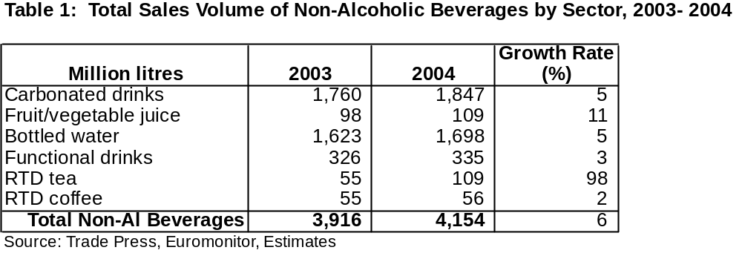
1) Carbonated Drinks Segment Flat

Thailand’s carbonated drinks segment is flat, which can be attributed to growth in the ‘healthy’ drinks market. Thai consumers are more concerned with health issues and are moving away from carbonated drinks and towards beverages perceived as healthy alternatives, such as ready-to-drink (RTD) green tea, fruit and vegetable juice, dairy based beverages, and cereal based drinks. This has eaten into the carbonated drinks share of the overall non-alcoholic beverages market and the growth rate of this sector has slowed down. Most carbonated beverage producers have added non-carbonated production lines to handle the change of consumer behavior.

Because there is an increased number of players in the healthy drinks market some fruit and vegetable juice drink manufacturers have responded to the market by adding new products such as green tea, corn milk, and black sesame in soymilk drinks. To capture sales from very health conscious consumers some producers have also launched sugar-free formulations of fruit and vegetable juice and RTD green tea product.

2) Fruit and Vegetable Juice Demonstrates Consistent Growth

Fruit and vegetable juice drinks have demonstrated a growth rate of 10.7 percent, reaching around 109 million liters in 2004. Continued growth of over 10 percent is forecast for 2005. The fruit and vegetable juice market has benefited from the growing trend of consumer health consciousness and development of the cold chain. It has made entrance of foreign retailers into the market possible over the past five years. Many fruit and vegetable juice suppliers have added new products and various flavors to stimulate sales. Some of them have responded to the green tea craze by adding green tea flavor to their fruit and vegetable juice.

3) Bottled Water Grows Slightly

The bottled water market accounts for around 44 percent of all non-alcoholic beverage consumption by volume in the Thai market, increasing by 4.6 percent during the previous year. Rapid expansion of hypermarkets and convenience stores helps to drive market performance and enlarge market size. Besides the expansion of hypermarkets and convenience stores, home and office delivery has grown rapidly in recent years. We estimate that 50 percent of the bottled water market is for home and office delivery.

Meanwhile, the carbonated beverage sector still accounts for a significant volume of the total non-alcoholic beverage market at around 41 percent; though its market share has been eaten up by other non-alcoholic beverages (Chart 1). Total sales growth by volume still averages five percent per year and is now up to 1.85 million liters. Thailand’s climate and marketing activities used by players are the main factor boosting consumption volume.

Bottled water has become a significant item in daily life due to the changing lifestyles of Thai consumers with increasing health perceptions. Sealed and well-packaged bottled water with official certification for safety consumption has become an essential item for many of these health conscious consumers.
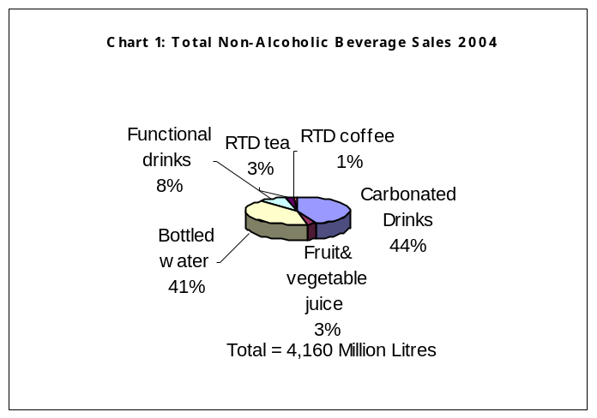

4) Carbonated Drink Manufacturers Respond to Market Change

Though the market share is declining for carbonated drinks the modernization of the retail industry, increased effectiveness within the distribution system and consumer’s increasing disposable income should provide further opportunity for the sector. Carbonated drinks are still a first choice for many consumers due to Thailand’s tropical weather.

Major carbonated drink producers have aggressive advertising strategies to increase brand loyalty through continuous television advertising and marketing activities. For example, Serm Suk, the ‘Pepsi’ bottler and distributor has implemented music and sport marketing strategies extensively during the past decade. Serm Suk also launched new products: Lipton Wave Green Tea and Yeo’s Soy Beverage into the market. Yeo’s soy beverage, while popular in Malaysia and Singapore, did not succeed in penetrating the Thai market.

Coca-Cola (Thailand) also responded to market changes by launching its first non-carbonated fruit juice brand, called Qoo at the end of 2002. Its local bottler and distributor-Thai Pure Drinks has invested more than USD 2.5 million in its Rangsit factory to support the production of the new beverage. The introduction of Qoo follows Coca-Cola’s strategy of moving the company towards a total beverage company, offering customers a variety of choices. Qoo is the second non-carbonated drink introduced in Thailand by Coca-Cola after Nam Thip brand water.

5) RTD Tea Craze Is Fastest Growing Segment

Thailand is currently going through a ‘green tea craze.’ Products as diverse as throat lozenges, noodles, chewing gum, sanitary napkins, ice cream and even inner-soles for shoes are marketed with claims of the alleged wondrous properties of green tea. Growth of RTD tea is from booming sales of RTD green tea based on the perceived health benefits of green tea. RTD tea has shown dramatic growth continuously from 2002-2005 with competitive pricing and significant promotional expenditure.

In September 2001, the first bottled and canned green tea was introduced in Thailand by Uni-President under the Unif brand. During its first year after its launch, Unif gained almost USD 650,000 in sales. Since then other beverage firms have joined the bandwagon, for a piece of the action. The RTD green tea market grew from USD 650,000 in 2001, when Unif was the sole player, to USD 10.2 million in 2002, USD 75 million in 2003, and USD 150 million in 2004. The sector is expected to grow up to USD 250 million in 2005 before an eventual decline.

Local studies with or without scientific basis have concluded that green tea helps prevent tooth decay, decreases the incidence of cancer, increases blood vessel and heart muscle elasticity, and expands the trachea, which are marketed as important. In 2004-2005 both new and existing companies have become increasingly active in this sector with the introduction of new flavors and extensive advertising. More players are expected to enter the market rapidly because of an incredibly fast growing market that will eventually have a downturn and dramatic consolidation. New players include TTC Siam Drinking Water, and a major bottled water supplier who launched its Siam Green Tea in January 2005 with an expectation to gain 10 percent market share in the first year. Previously, only Unilever’s Lipton brand was well known in the RTD tea sector. Then Unif, Nestle’, Oishi, Tipco, and Sencha entered the RTD tea market with the introduction of different flavors.

6) RTD Coffee Competes With Freshly Made Coffee

RTD coffee sales growth is limited by fast growing fresh ground coffee consumption that can be found in coffee shops and with small vendors throughout the country. Coffee shops, small vendors, and kiosks of both local and foreign franchises (Doi Tung, Baan Rai, Denchai, Amazon, and Starbucks) serve freshly made coffee to consumers at acceptable prices together with convenience and attractive packaging. Thai consumers tend to prefer consuming freshly made coffee rather than RTD coffee, even though it is more expensive.

RTD coffee sales have followed the aggressive expansion of franchised freshly made coffee outlets that have expanded into department stores and major petrol stations. As a result, RTD coffee sales for 2004 were estimated at around 56 million liters with growth at only 1.77 percent from 2003 (Table 1).

RTD coffee sales in 2005 are expected to continue growing at the same rate as 2004, though the RTD coffee players have promoted their products aggressively through mass media advertising offering special promotions.

7) Functional Sector Dominated by Energy Drinks

In 2003, the overall functional drink sector benefited from the significant growth of energy drinks, which increased 14 percent by volume. Meanwhile, sports drink volume growth was only four percent, as they were perceived as a less useful beverage compared to alternative non-alcoholic beverages for health conscious consumers. In addition, sports drink sales were directly impacted by government advertising on television clarifying that sport drinks contain only some basic minerals and are not necessary for health, as marketed by energy drink producers in their advertising campaigns.

In 2004, the growth rate of the overall functional drinks sector sales volume dropped to three percent (Table 1) as government action in restricting energy drinks advertised on television during sports programs took effect, despite producers efforts.

The energy drink sector is dominated by two major players, TC Pharmaceutical Industry (Red Bull brand) and Osotspa (Lopvitan, Shark, and Magnum brands). Others small players are Champ Thai (Wrangler) and Carabao Daeng the latest player to enter the market just for a few years ago. Osotspa has used different brands to penetrate different customer groups.

The sports drinks market value has increased by 4-5 percent, up to USD 87.5 million in 2004. The growth of sport drinks is a result of the growing number of health conscious people that exercise on a regular basis. Sport drink suppliers have introduced their products as a helpful supplement for people whose mineral level has been reduced as a result of participating in sporting activities. However, most producers who have both energy and sport drinks still concentrate their marketing activity on energy drinks rather than sport drinks, due to its higher market value.

8) Milk Consumption Continues To Grow
Domestic raw milk production in Thailand has achieved almost 20 percent growth annually over the past 10 years due to Government policies relating to the promotion of dairy farming. Around 90 percent of total raw milk is processed as pasteurized or UHT milk. The remaining milk is used to produce yogurt, ice cream and cheese. Thailand has insignificant imports of liquid milk, but does export some processed liquid milk to Indonesia, the Philippines, Cambodia, Myanmar, and Singapore. Skim milk powder and anhydrous milk fat is blended with local raw milk to increase dairy solids and fat in the milk.
Despite local production Thailand remains a dairy deficit country and thus imports approximately 70,000 MT of skim milk powder each year to make up the deficit. While some imported skim milk powder is used in food processing (up to 8,000 MT in the bakery sector), the majority is used to produce recombined milk in the form of sweetened condensed milk, evaporated milk or UHT milk.

Table 2 shows the supply and demand of fluid milk increasing continually since 1999. Domestic consumption in 2003 was around 700,000 tons, having increased by 3.5 percent from the previous year.
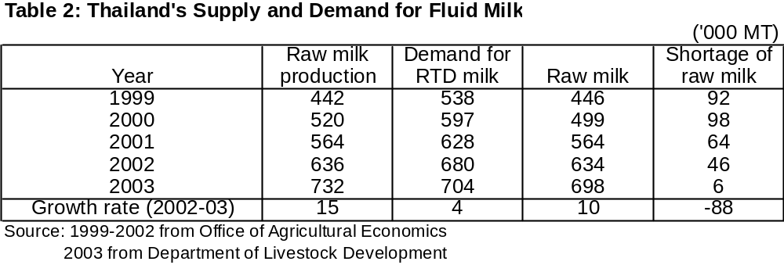

B) Market Size- Growth of Imports and Domestic Production

Thailand’s non-alcoholic beverage market experiences cross competition between the sectors as players relate themselves to the industry as a whole, rather than limiting themselves in any one category.

1) Carbonated Drinks Market
Information in this section will be mostly in value terms.

In 2004, total market value of the carbonated drink market was around USD 750 million. The carbonated drinks market in Thailand includes two segments: - cola and flavored carbonated drinks. The cola segment accounts for 77 percent of the carbonated drinks market value, the remaining 23 percent or around USD 175 million is the flavored carbonated drink segment. The imported segment is negligible. European origin pink lemonade for use in hotel mini-bars is imported in small volumes. A list of importers is included at the end of this report.

There are two major players in the Thailand carbonated drink market: Serm Suk and Thai Pure Drinks. Serm Suk produces and distributes carbonated drinks under various brands including Pepsi, Mirinda, and 7-Up. Meanwhile, Thai Pure Drinks produces and distributes products under Coca-Cola, Sprite, Fanta, and Schweppes throughout most of Thailand, except in the 14 provinces in the southern area of the country controlled by Haad Thip. Pepsi claims to be the market leader in the cola segment with a 63 percent share of the total value in 2004. The remaining balance belongs to Coca-Cola.

For the flavored drink segment, Fanta of Thai Pure Drinks is the market leader with around a 70 percent share, followed by Mirinda of Serm Suk with a market share of 25 percent. The remaining five percent of the flavored drink segment belongs to small players such as Green Spot and Birley.

Rivalry in the sector is high due to its high margin. Major players’ marketing strategies have been focused on continuous advertising and sales promotions; especially during the summer when sales volume is the highest. New products or new flavors are also used to stimulate consumer demand and provide alternatives to consumers, as there is little brand loyalty in the market. Superstars and sport advertising are usually used to gain market share from teenage people. In addition, good relations with retailers, together with fast delivery are also important to succeed in the market. Market share is more closely related to distribution than consumer preference. A consumer may order ‘Coke’ or ‘Pepsi’, but they are served whichever of the two brands that the outlet stocks.
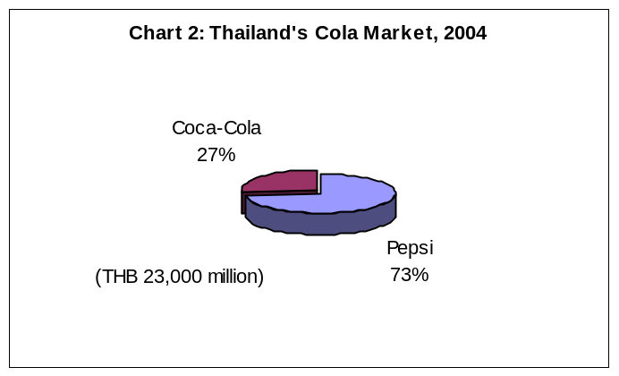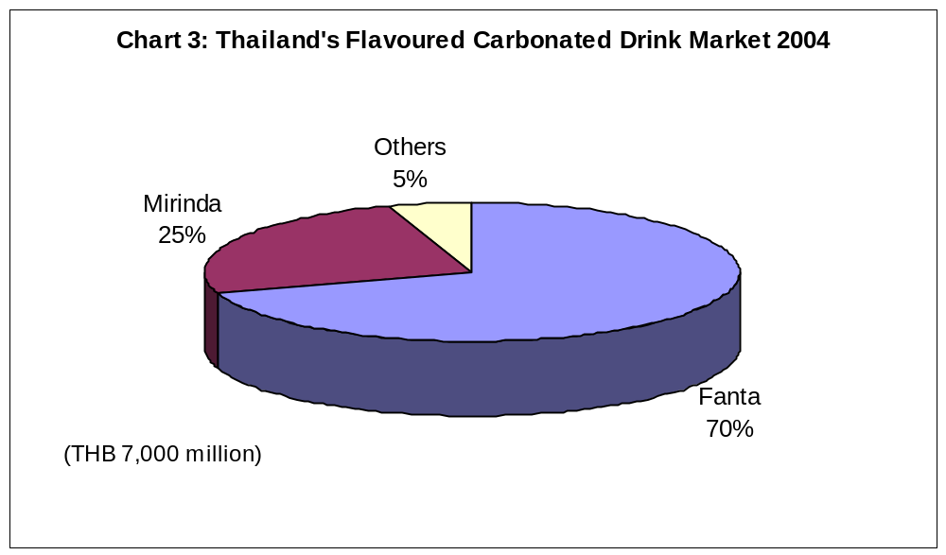

2) Bottled and Mineral Water

Total market value of the bottled and mineral water segment is around USD 250 million. Around 90 percent of the market value or USD 225 million belongs to bottled drinking water and the remaining USD 25 million is mineral water.

The numerous bottled water companies competing in this market are extremely different. There are three major categories of bottled-water companies:

• Smaller or larger firms created to market one special brand of bottled water,
• Soft drink companies that have entered the growing bottled water market, and
• Companies providing tap water with extensive know-how in water purification.

Major players in the market are Singha of Boon Rawd Brewery, Crystal of Serm Suk, Namthip of Thai Pure, Siam of TTC Siam Drinking Water, Sprinkle of M Water, Minere and Neptune of Nestle, and Aura of Dharaniphiphat. Imports previously composed the majority of mineral water available in the market until the late 1990’s when local production decimated a once sizeable import market.

Singha is the market leader with around 60 percent market share; followed by Crystal at around eight percent, and Namthip at five percent. Siam drinking water claims fourth position in the market with a share of around five percent or USD 11.3 million. Remaining market shares belong to other small local players including vending machine companies that offer an alternative way for consumers to save on the cost of drinking water by selling refills at conveniently located self-service vending machines.
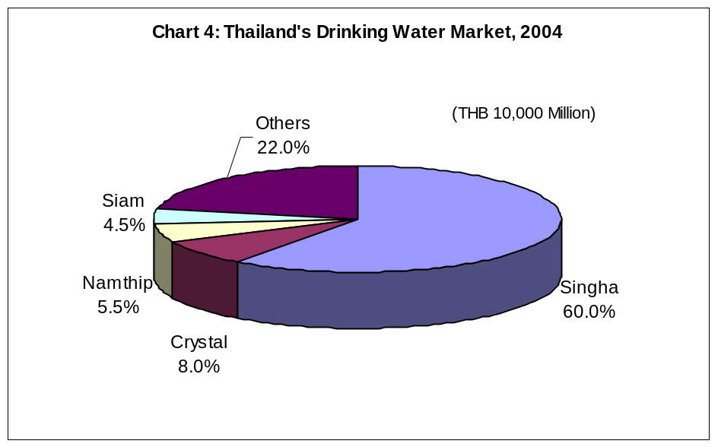

3) Fruit and Vegetable Juice

Local brands have controlled the majority of the fruit and vegetable juice market due to price advantages compared to imported brands. This segment of the market is most open to imports of U.S. fruit and vegetable juice concentrates.

The value of Thailand’s fruit juice market in 2004 was USD 90 million. Of this amount, 100 percent fruit juice accounts for USD 45 million, 25-50 percent fruit juice USD 10 million, and less than 25 percent fruit juice USD 32.5 million. The 100 percent fruit juice market value has grown by 17 percent from 2003.

Tipco F & B claimed that its share of the high-end segment of 100 percent fruit and vegetable juice has increased from 32 percent in 2003 to 43 percent in 2004. The remaining market belongs to Unif at 21 percent, Malee 16 percent, UFC 6 percent, Nestle 5 percent, Chaba 4 percent, and others 5 percent. Tipco has done intensive marketing and has launched new packaging and flavors in the market. The company plans to double its production capacity in 2005 to maintain its leading position in the premium fruit and vegetable juice segment. Unif ranks as the biggest share holder in the medium sector (25-99 percent juice), followed by Tipco and Malee. The low-end sector is comprised of many small private labels with mass competition among other kind of drinks. The opportunity for U.S. exporters is to provide fruit concentrates. A list of major fruit-juice re-combiners is included with this report.

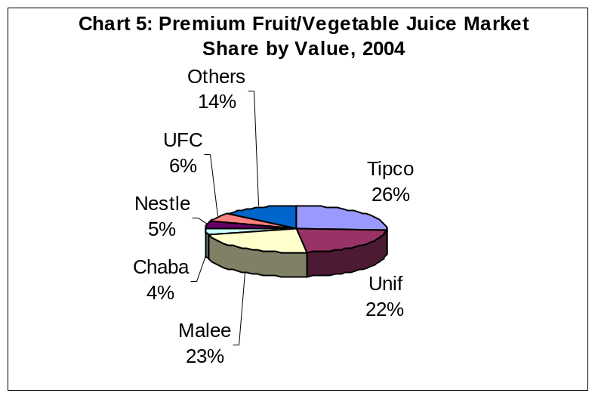

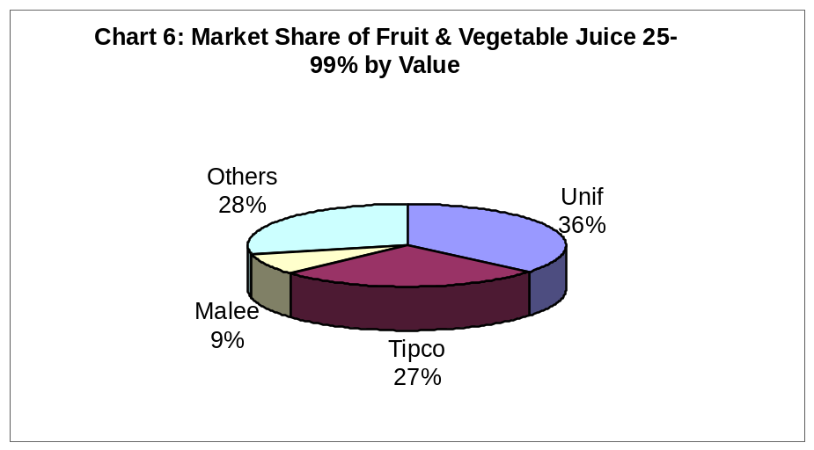

4) Functional Drinks

The functional drinks market includes two segments: energy drinks and sports drinks. Most of the players in the market supply both energy and sport drinks. However, they seem to focus their marketing on energy drinks rather than sports drinks because the sports drink market value is only USD 75-100 million, compared to USD 350 million for the energy drinks market. As a result, rivalry in the energy drink segment is higher.

An ‘energy drink’ is one specifically marketed as providing ‘energy’, which is often in the form of a protein or caffeine. In the energy segment in 2004, the total market value of energy drinks was over USD 350 million with only five percent growth due to government restrictions on advertising and caffeine content. The Thai government prohibits energy drinks to advertise qualifications and advantages of the products, so major players have turned to advertising brand image instead. The caffeine content is also limited for energy drinks while there is no caffeine limitation in cola drinks or RTD coffee.

Red Bull brand, of TC Pharmaceutical Industry, is the market leader with an export value of over USD 225 million, which is over 95 percent of the country’s export value. Its current share is 54 percent. Another major player is Osotspa that launched several brands including M150, Lipovitan, Shark, and Magnum for different target markets. The company launched a canned energy drink called MMAX in 2003 with an expectation to tap first-time drinkers. The energy drinks market reached saturation point with growth at only three percent in 2004. The company believes that new generation consumers are reluctant to drink traditional drinks and they will be confident holding MMAX cans. Osotspa’s current share is 34 percent. Carabao Dang, the newest major player entering the market in 2002 had 12 percent share. Carabao Dang is produced by SPM and distributed by Serm Suk.

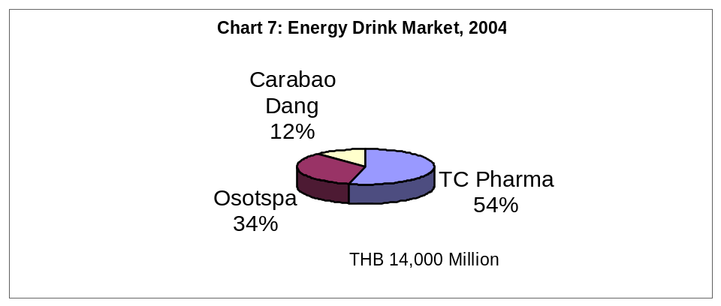
A ‘sports drink’ is one that specifically claims to provide a health benefit to a consumer. The sports drink market was valued at between USD 75 and 100 million in 2004. Sponsor’s (TC Pharmaceutical Industry) share accounts for 70 percent of the total market, followed by M-Sport (Osotspa) 20 percent, and Gatorade (Serm Suk) 10 percent.

Gatorade is a premium brand selling at USD 50 cents per bottle compared to Sponsor that sells only USD 20 cents per bottle. Its bottler, Serm Suk, has an excellent distribution network.
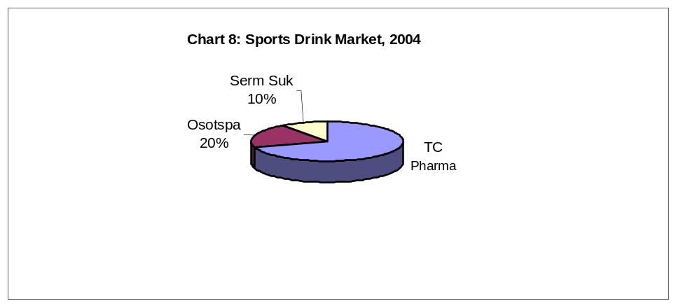

5) RTD Green Tea

The total value of the RTD green tea market in 2004 was around USD 150 million, increasing from USD 75 million in 2003. RTD green tea is the fastest growing segment in the Thai non-alcoholic beverages market; its value was only USD 10 million, or 74 percent of the total RTD tea market in 2002.

In 2004, Uni-President was the market leader with a share of 45 percent that included 40 percent Unif brand and another five percent from Chaleewang brand. Second is Oishi green tea, occupying 33 percent with sales revenue of around USD 50 million in 2004. They expect to increase to USD 87.5 million in 2005 in line with total market growth. Sencha brand of Ajinomoto holds six percent.

6) RTD Coffee

The Thai market for coffee is valued over USD 315 million. This is comprised of instant coffee and three-in-one earning USD 170 million, RTD coffee with USD 82.5 million, and fresh ground coffee at USD 82.5 million.

The popularity of fresh ground coffee has eaten up the RTD coffee segment during past five years. As a result, the RTD coffee growth is not outstanding compared to other RTD drinks. Major players are Nescafe and Birdy brand of Ajinomoto, with shares of 35 and 30 percent respectively. The remaining share is divided among other local small players.

7) Beverages in Powdered or Concentrated Form

The market for beverages in powdered or concentrated forms for home or HRI food-service use grew eight percent in 2004 to USD 325 million. Overall growth of beverages in powdered or concentrated forms benefited from the performance of coffee, tea and other beverages, with coffee playing the most significant role in terms of sales. This is an area where U.S. beverages are likely to be competitive. Instant coffee has the highest share in the segment with around 69 percent market share. Nescafe is the major brand with 86 percent of the coffee market. Instant tea is achieving 1.2 percent growth, as the major growth in tea consumption is in RTD green tea. Malt based beverages remain flat in the market. Milo and Ovaltine are two major brands for this sector. Plant based hot drinks hold one percent.

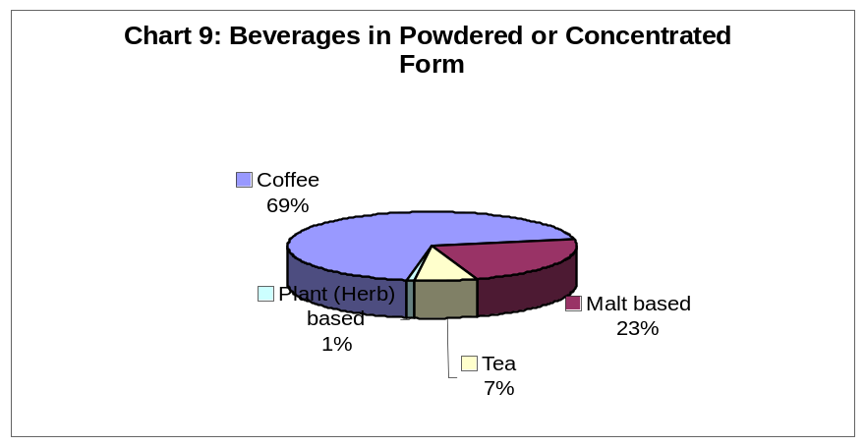

8) Milk
Most domestic raw milk in Thailand is processed for RTD milk. According to the Department of Industry, the number of the factories registered for producing dairy products was 152 factories in 2004.
The size of the ready-to-drink milk sector was around USD 500 million in 2004 and is estimated to increase by five percent in 2005. This sector experienced strong growth in the past, mainly due to greater access to refrigeration in the rural areas and more effective distribution channels. This sector is rather fragmented and is populated with small companies that do not have significant market presence. Key players in this sector are Foremost Friesland, CP Meiji, Nongpho Dairy Cooperative, Nestle, Thai Dairy Industry, and Dairy Farming Promotion Organization. (See Table 3). UHT milk has the highest share in the market with around 64 percent of the whole milk market due to its longer shelf and less developed cold chain. The major manufacturers are Foremost, Nong Pho Ratchburi Dairy Cooperative, and Thai Dairy Industry. Pasteurized milk represents 33.5 percent of the milk market. The major manufacturers are C.P. Meiji, Foremost Friesland, Dutch Mill, and Nong Pho Ratchburi Dairy Cooperative. Sterilized milk represents only 2.5 percent of the milk market. Nestle, Thai Dairy Industry, and Dutch Mill are the major manufacturers. Quotas protect the Thai industry from fresh milk imports. Growth in import quotas has` been matched by increases in the market demand for milk.

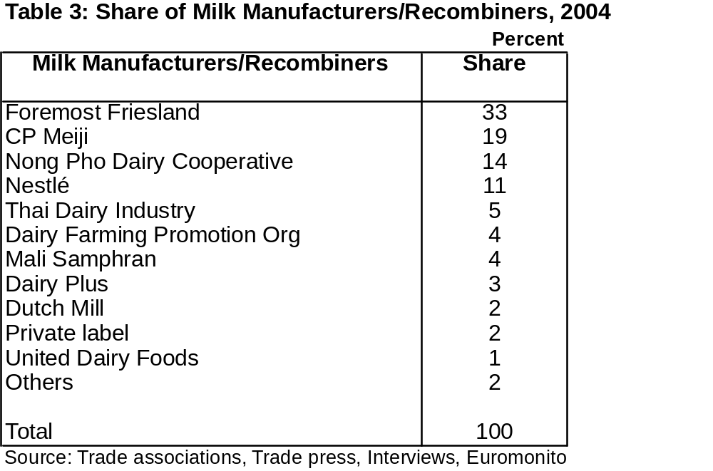

Section III. Advantages and Challenges

Advantages | Challenges
Locally sourced ingredients for U.S. branded beverages must meet U.S. specifications | Carbonated drinks segment dominated by locally produced products
Local carbonated beverage producers are looking for non-carbonated alternatives to add to their product range | Japanese non-carbonated beverage producers have positions in the market
Increasing health awareness among Thai consumers | High competition among drink and beverage market sectors
Increasing number of educated consumers, confident to try something innovative | Competition very high for RTD, powdered, roasted and retail coffee. Market already saturated
Large market for imported fruit and vegetable juice concentrates | RTD tea market already saturated
Brand image is the most important factor in marketing energy drinks | Functional sports beverages have failed to find a substantial market
Energy drinks well established in the market | Consumer health preference derived from perception rather than science
Consumers trust health claims approved by U.S. FDA | Purchasing of alternative beverages closely linked to disposable income
Thai market has grown to include major provincial centers | Plant and herbal based beverages are traditionally made from herbs specific to Thailand
Major improvements in Thai ‘cold chain between 2000-2005 | Year round supply and consistent pricing required by Thai importers
Milk now a component of the Thai diet | Thai FDA approval process time consuming and lacks transparency
Consumers willing to pay a premium for imported products | Market uncertainty and unwillingness to take risks before conclusion of Thai – U.S. FTA
Thailand continues to import dairy solids to cover milk deficit | Thailand has lowest per capita beverage consumption in Southeast Asia

Section IV. Market Sector Opportunities and Threats

Distribution within the Thai non-alcoholic beverage market can be divided into two major channels: ‘off-trade’ such as convenience stores, supermarkets, hypermarkets, independent food stores and local stores and ‘on-trade’ such as public houses, bars, nightclubs, restaurants and hotels.

The total shares of non-alcoholic beverage sales through these two channels are almost equal, but off-trade channel involvement seems to increase annually. In 2004, the off-trade channel accounted for 45 percent of the total non-alcoholic beverage sales value. The remaining 55 percent is sold through on-trade channel.

Off-trade volume sales have increased from 40 percent in the previous two years mainly due to fast growing of modern retail outlets, especially modern supermarkets and hypermarkets. Product distribution is very effective due to the expansion of convenience stores throughout the country.

A) Carbonated Drinks and Bottled Water

On-trade sales play an important role in the carbonated drinks and bottled water sector. In 2004, carbonated drinks and bottled water sales value through on-trade channel were estimated at around 56 percent and 51 percent respectively. These high sales are because Thai consumers generally drink carbonated drinks and bottled water when they are eating out rather than in-house.

In 2004, carbonated drinks sales through the off-trade channel were 44 percent of total carbonated drinks sales. Many consumers still drink carbonated drinks only for special occasions due to health concerns. However, many households always have carbonated drinks in their refrigerator. Expansion of modern retail outlets and heavy advertising by carbonated drink suppliers has lead consumers to drink carbonated drinks regularly at home. Bottled water sales through the off-trade channel are 49 percent of total bottled sales value. Convenience stores have increased their distribution share due to rising numbers of outlets.

B) Fruit/Vegetable Juice

Fruit and vegetable juice is mainly sold through the off-trade channel. We estimate that off-trade sales of fruit and vegetable juice accounted for 55 percent in 2004.

C) Functional Drinks

Functional drinks are sold mostly through independent food stores and petrol station shops, as most consumers tend to be workers such as truck drivers and laborers. Independent food stores are the leading distribution channels for functional drinks, with an estimated 50 percent share. Convenience stores are expected to distribute around 25 percent of the market value. The remaining 20 percent is sold through supermarkets and hypermarkets.

D) RTD Tea and Coffee

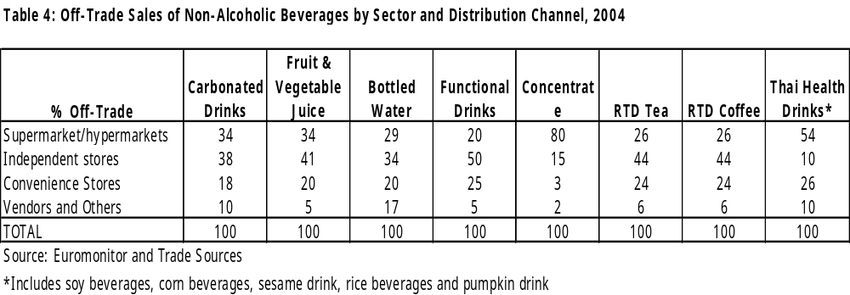Independent food stores are also a major distribution channel for RTD tea and coffee with 44 percent share by value. Around 26 percent of RTD tea and coffee sales value are sold through supermarkets and hypermarkets. Convenience shares around 24 percent of off-trade sales value.

Section V. Consumption

A) Market Trends- Next Five Years

Both on-trade and off-trade sales are predicted to increase continuously. However, off-trade sales are expected to increase at 5-8 percent, higher than on-trade sales growth due to the aggressive expansion of modern off-trade outlets such as convenience stores, supermarkets, hypermarkets, and petrol station outlets, which are widespread through the country, particularly in regional cities. This supports distribution effectiveness together with product availability of non-alcoholic beverages including carbonated drinks, bottled water, fruit and vegetable juice, functional drinks, RTD tea, RTD coffee, and local specialty drinks (soy, rice and cereal beverages).

1) Carbonated Drinks

Carbonated drinks will continue to grow at a slower growth rate compared to past records and when compared to growth of fruit and vegetable juice sales. Thailand has the greatest potential for growth in Asia due to low per-capita soft-drink consumption. Only 100 bottles a year per person are consumed compared with 500 bottles in Australia and almost 200 bottles in the Philippines. Carbonated suppliers are likely to increase the frequency of marketing activities to stimulate consumption of non-alcoholic beverages to keep up with the growth of non-carbonated drinks; 3-4 percent annual growth is expected from 2005-2010.

2) Fruit and Vegetable Juice

Fruit and vegetable juice is estimated to show high growth of over 10 percent from 2005-2010. Sales of fruit and vegetable juice are expected to increase continuously due to consumers switching from carbonated drinks to more healthy drinks. Consumers are increasingly concerned with the quality of products and good packaging. Medium to high-end consumers will shift from homemade fruit juice product vendors to well- packaged fruit and vegetable drinks.

3) Bottled Water

Thai consumers want safe and hygienic bottled drinking water. Consumers buy bottled water because it is perceived as a healthy alternative to other beverages. Bottled water with good packaging will increase in popularity. Increasing numbers of convenience stores and consumers’ health consciousness will drive up sales of bottled water with expected growth around 5-7 percent during 2005-2010. Meanwhile, rivalry in the market will increase as many beverage producers have launched their own brands with a lower pricing strategy. Even large discount stores have launched their own brands in the market at a lower price.

4) Functional Drinks

The energy drink market is expected to grow at rate of only 2-3 percent from 2005-2010 due to government restrictions on energy drink advertising and growing consumer health consciousness. Intense competition among energy drink suppliers will continue due to its large market value. Most suppliers will continue try to expand their market to teen consumers with new packaging or even new brands.

5) RTD Tea

RTD green tea will continue to grow in 2005. From 2005-2010, we see contraction in an already over-heated segment, followed by consolidation and failure of many players.

6) RTD Coffee

The RTD coffee market is reaching a saturation point as the popularity of fresh made coffee continually increases. Availability of fresh ground coffee together with increasing health conscious is expected to limit growth of the market.

7) Milk

Increasing consumer spending, health awareness with regards to dairy content, as well as continued aggressive marketing campaigns from players and the public sector are significant factors that will boost growth in total sales of the milk market. Successes in an ambitious national school milk program over many years combined with major improvements in the cold chain across the country have seen the milk market boom.

Retail sales volumes and the value of milk have increased continuously year by year; its growth rate is fast as RTD green tea and fruit juice (see Tables 6 and 7).
In Thailand, the government school milk program has played a key role in promoting milk consumption in the country as a whole. Total milk consumption rose from eight liters per person per year in 1993 to 12 liters per person in 1997 and continues to grow, but at a slower rate. Currently, per capita milk consumption is up to 14 liters a year. A generation of milk-drinkers is out of school and the country has a functioning dairy industry. School milk consumption in Thailand is around 30 percent of overall milk consumption.
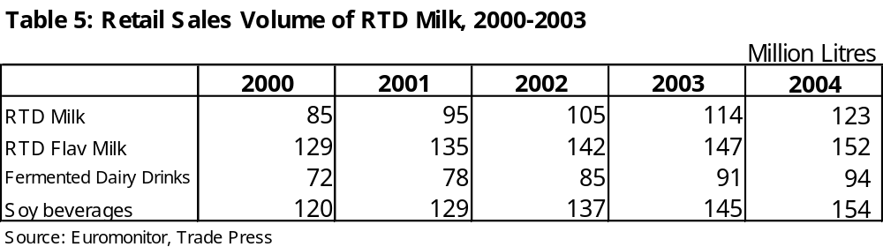The government campaign to encourage people to drink milk on a regular basis is a major growth driver in dairy product sales. Milk is expected to continue its expansion in line with growing consumer demand driven by public and private campaigns. In addition, growth in the total sales volume of milk continues to benefit from an increase in the number of supermarkets and hypermarkets, widening the geographical coverage across the country. These supermarkets and hypermarkets are competing with each other, offering an ‘everyday low price’ strategy in both food and non-food products. As a result, consumers tend to gain from this aggressive retail competition and are able to consume products with seasonal lower prices, including packaged milk products.
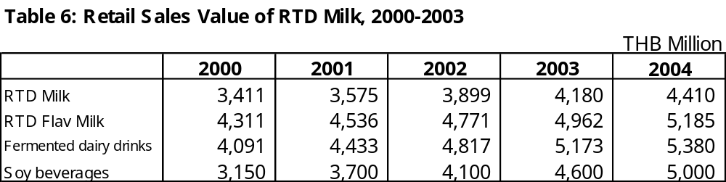

8) Soy Beverages
Soy beverages are considered to be a healthy dairy alternative. Soy beverages captured 85-90 percent of the overall dairy-alternatives market. The remainder belongs to drinks made from rice, oats, and corn. Soy beverages currently have around 25 percent market share in the overall market for milk and milk alternatives, rising from only 14 percent in 1998. It is estimated that its value in 2004 grew by around 10-15 percent to USD 125 million.
In the past, there was not much rivalry in the soy beverage market because there were only two major manufacturers; Green Spot (Vitamilk) and Lactasoy. Newer players include Serm Suk, branded 'Yeo', Dutch Mill (DNA) and Nestle (SoyPlus). Growth of the market was spurred by the entry of Serm Suk’s ‘Yeo’ soy beverage brand into the market in late 1999. The ‘Yeo’ brand made its first debut by proclaiming itself a 100 percent soy beverage, however, the company has already ceased producing ‘Yeo’ in 2004 due to unsuccessful performance. Another boost was the entry of Dutchmill 'DNA' soy beverage drink brand into the fray last August. Besides the expansion of the domestic market, the export market for Thai soy beverages is attractive due to its continued increases in sales, particularly in Singapore and Malaysia. Thailand is a producer of soybeans, but production is less than 300,000 MT annually. Thai soybean demand is almost 2.0 million tons annually. Less expensive imports from South America, especially Brazil, are threatening the U.S. market share of Thai soybean imports.
Green Spot, the producer and distributor of Vitamilk and V-soy is the leader of the soy beverage market with around 70 percent share. The next is Lactasoy with 20 percent share, followed by Dutch Mill with DNA, at 2-3 percent share.
Further information on the Thai market for soybeans is included in: ‘Thailand: Oilseeds and Products Annual, 2005’ which is available on the Internet at www.fas.usda.gov, search using the report’s reference number, TH 5047.

9) Rice Based Beverages

Rice based beverages are produced from young rice. They were launched into the market as an alternative to milk both in pasteurized and UHT form (natural, chocolate, and vanilla flavors). The rice beverage market value in 2004 was around USD 7.5 million. Major players in the market include ‘Lady Sirin’ of P Green Herb, Sriruean of Far East Home Made, D-rice of Thanyathip, and Mechieang of Somboon factory. Mechieang controls the market with a share of around 80 percent. Lady Sirin, Sriruean, and D-Rice have equal shares of three percent each while Supreme rice accounts for 10 percent.
Further information on the Thai market for rice is included in: ‘Thailand: Grain and Feed Annual, 2005’ available on the Internet at www.fas.usda.gov; search using the report’s reference number, TH 5030.

10) Corn Based Beverages

Corn based beverages are made from fresh corn grains. Fresh corn beverages are produced locally by small vendors, and are available throughout the country in PET bottles. There are three big producers in the market: Malee, Tipco, and Corn Fresh. The total market for cereal drinks is around USD 11.8 million, of which USD 4.5 million is for corn-based beverages.

Cereal drinks sales are not motivating other new players to enter the market because the segment is relatively small with low growth. This will not stop corn-based beverage producers from entering the market, with corn-based beverages likely to cannibalize market share from other cereal drinks. There is considerable room for beverages containing peas or pulses in this market.

Further information on the Thai market for corn is included in: ‘Thailand: Grain and Feed Annual, 2005’ which is available on the Internet at www.fas.usda.gov; search using the report’s reference number, TH 5030.

B) Demographics and Consumer Purchasing Habits

Consumption has grown steadily in Thailand since recovering from the 1997 currency crisis. (See Table 4, below). Demand for non-alcoholic beverages in regional centers in Thailand is growing at a significantly faster pace than in Bangkok. Developments of large hypermarkets, particularly Lotus and Big C, have seen an efficient cold-chain spread across the country. The variety of non-alcoholic beverages in regional centers is equal to that in similar stores in Bangkok. Despite disruption to tourism from the December 2004 tsunami and civil unrest in the three border provinces, demand for non-alcoholic beverages in the five southernmost Thai provinces of Satun, Songkhla, Pattani, Narathiwat and Yala is growing at a significantly faster rate than the rest of the country. Previously, local entrepreneurs bought goods in neighboring provinces and transported the goods in for sale in small stores.
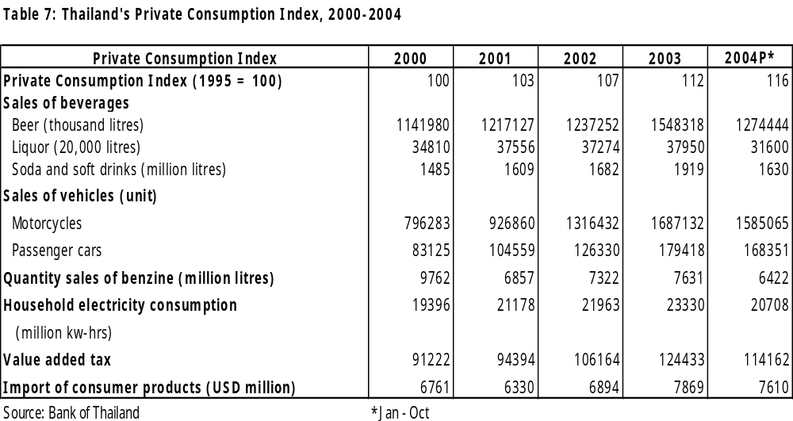

- Coffee

Coffee consumption in Thailand reached 130 cups per person per year in 2004. This compares with 150 cups in the Philippines and 167 cups in Malaysia. Three-in-one instant coffee (coffee with non-dairy creamer and sugar added) has shown continuous growth up to 40 percent from 2003 to USD 62.5 million. For roasted coffee Nescafe remains dominant in the market, with 80 percent share, Birdy from Ajinomoto, eight percent, followed by Moccona and Khao Chong, six percent and four percent respectively.

Coffee growers have been focusing on boosting domestic sales, as exports have been falling in volume and international prices have been weak. Exports now account for 10 percent of coffee grown in Thailand, compared with 70 percent in 1989. Coffee-shop chains, both local and international have been expanding, and Nestle has become the first international company to use a local coffee-processing plant in Chachoengsao. The coffee grower’s association has set up the company Coffee Farmer with a factory in Chumphon province to process coffee beans into packaged gourmet coffee as well as three-in-one instant coffee, the latter product was introduced in July 2003, and has been selling well. Moreover, premium grade instant coffee has increased by 5 percent from 2003, to USD 5 million.

The market for tealeaves and tea bags in Thailand is small compared to other kinds of hot drinks such as coffee or malt based products. At present, Thais consume approximately 1-2 kg per person, per year. The value of the Thai tea market is approximately USD 12.5-15 million, which is low compared to the newly growing market of RTD tea.

The tea market in Thailand can be divided into three categories: Chinese tea 80%, herbal tea 10%, and special grade tea 10%. Chinese tea has long been present in Thailand, and growth in this area is quite steady. The herbal tea market is growing in response to health conscious consumers. Because Thailand has many local varieties of herbal plants there are various types of herbal products in this area. The major producers of herbal tea are small Thai companies. One example is Ranong tea, a well-known tea brand in Thailand. There are two main players in Thailand’s tea market, Lipton tea (Unilever) 67%, Nestea (Nestle) 19%, other brands 14%. In 2005, Nestle and Unilever have focused more on RTD tea.

Malt-based hot drinks have been sold in Thailand for over 30 years. Ovaltine and Milo are the two major beverages. The market is static, increasing by 1.5 percent in 2004. Ovaltine holds 68 percent of the market.

Plant-based hot drinks represent a value of USD 2.5 million. In the past, the main consumers of herbal hot drinks were in the older age segments. However, this trend is changing as Thais become more conscious of the benefits of herbal remedies, especially digestive remedies, medicated skin care, cold and weight reduction products. The products in this sector include roselle (flower), galangal, ginger, safflower, sesame, tamarind, and various herbs that have been transformed to instant beverages.

Section VI. Policy/ Market Access Issues Effecting Non-Alcoholic Beverages

A) General Issues Effecting Non-Alcoholic Beverages

In general, Thailand has complied with its WTO obligations with regard to non-alcoholic beverages. Imported dairy ingredients are a notable exception. Although Thailand has fixed its bound rates, the applied tariff rates in many cases are lower than the WTO bound rates. Thailand maintains tariff-rate quotas for some agricultural products. Thailand has been a member of the ASEAN (Association of Southeast Asian Nations) Free Trade Area, called AFTA, since 1991. AFTA set up preferential applied tariffs between Thailand and other ASEAN countries on most agricultural products, with levels currently between 0-5 percent.

In addition to the WTO and AFTA, Thailand is entering into regional and bilateral trade negotiations that will allow improved access to new markets overseas. Similarly, Thailand’s trading partners will have greater access to the Thai market. Thailand launched bilateral free trade with China on specific products (fresh vegetables and fruits) in 2003 under the auspices of the ASEAN-China Free Trade Area. Thailand concluded and signed a comprehensive free trade agreement with Australia in late 2004 and New Zealand in 2005. As a result, tariffs for most agricultural products imported from these two countries have been reduced. In addition, Thailand is moving ahead to conclude bilateral free trade negotiations with the United States, Japan, South Korea, India and Bahrain.

Given that FTA negotiations between Thailand and the U.S. are still pending, the implementation of free trade areas with other agricultural exporting countries, particularly China, Australia and New Zealand, will negatively impact U.S. agricultural exports to Thailand in the short term. The most affected forms of non-alcoholic beverages include, dairy products, and raw ingredients such as fruits and vegetables and dry ingredients used in local production of non-alcoholic beverages.

In the Thai market for non-alcoholic beverages, the Thai – Australian FTA will have the following effects:

• Thailand immediately eliminated the previous tariffs on infant formula (5%), lactose (up to 20%), casein and milk albumin (10%),

• Thailand provided an immediate additional quota for Australia of 2,200 MT for skim milk powder and 120 tons for liquid milk and cream, expanding by 17% at five-yearly intervals until 2025, when all tariffs and quotas will be eliminated, and

• Thailand agreed to phase out the tariffs for other milk powder and concentrates in 2020.

For the Thai market for non-alcoholic beverages, the Thai – New Zealand FTA will have the following effects:

• Tariffs on infant milk formula (currently 5%), casein (5%), lactose (up to 10%) and protein concentrates (5%) will be eliminated on implementation,

• Tariffs on buttermilk (5%), and milk protein concentrates (5%) will be removed by 2009, and

• The 18% tariff on whole milk powder will drop to 15% on implementation and phase out by 2020.

Further information on U.S. agricultural trade issues with Thailand are included in: ‘Thailand: Trade Policy Monitoring Annual, 2005’, which is available on the Internet at www.fas.usda.gov; search using the report’s reference number, TH 5026.

B) Food Regulations

Thailand’s food industry is governed by the Food Act of 2522 (1979) and subsequent laws stipulated by the Ministry of Public Health. In general, imports of food for sale in the kingdom require an import license and standard labeling according to domestic regulations. Product registration is required only for specifically controlled food. Some agencies of the Ministry of Agriculture and Cooperatives monitor the import of such certain food products as meat, fruits and vegetables through import permits and phytosanitary or sanitary certificates. In addition, 23 agricultural commodities are subject to the tariff-rate-quota system administered by the Ministry of Commerce. Categories relevant to non-alcoholic beverages are as follows

No. | Type of Food | Remarks
I. | Specifically-Controlled Food | - For food imports for sale, import license, product registration and labeling approval are needed.
3 | Modified Milk for Infants
4 | Flavored Milk
5 | Cultured Milk
6 | Milk
7 | Drinking Water in Sealed Containers
9 | Other Milk Products

II. | Standardized Food | - For food imports for sale, import license and labeling approval are needed. As for table salt, no labeling approval is needed.
10 | Coffee
60 | Mineral Drinks
80 | Tea
10 | Soybean Milk in Sealed Containers
18 | Mineral Water

In addition, Ministerial Notification No. 193, 2543 (2000), ‘Method of Food Manufacturing and Equipment for Manufacturing Food and Food Storage, has been applied to all domestic manufacturers and imported suppliers of 54 types of products. The covered products under this regulation effecting non-alcoholic beverages are:

Infant food and uniform food for infant and children
Supplementary food for infant and children
Modified milk for infant and uniform modified milk for infant and children
Drinking water in sealed containers
Beverages in sealed containers
Food in sealed containers
Cow’s milk
Cultured milk
Flavored milk
Milk products
Tea
Coffee
Natural mineral water
Vinegar
Mineral drinks
Soybean milk in sealed containers

Domestic manufacturers of these products are obligated to comply with the method of food manufacturing, tools and equipment for manufacturing food, and food storage according to the Good Practice in Food Manufacturing laws for general sanitation. Meanwhile, any importer of the covered products must present an equivalent certificate of GMP for certain factories or plants, which manufacture those products in line with the Thai GMP Law.

For U.S. food products, Thai FDA officials agree that U.S. practices are acceptable under the present Thai GMP Law. Accordingly, any simple statement/certificate that is endorsed by U.S. government agencies will be acceptable. The statement may contain sayings like ‘the food product is manufactured by U.S. processing plant which is subject to 21CFR part 110’.

C) Tariff Rate Quotas

Thailand was permitted tariff rate quotas on several items. The Department of Foreign Trade, Ministry of Commerce is monitoring the imports of these products and requires that any importer must apply for an import permit. The covered commodities under the TRQ system relevant to non-alcoholic beverages are as follows:

Milk | Tea
Flavored milk | Rice
Skim milk | Soy beans
Coffee bean | Instant coffee

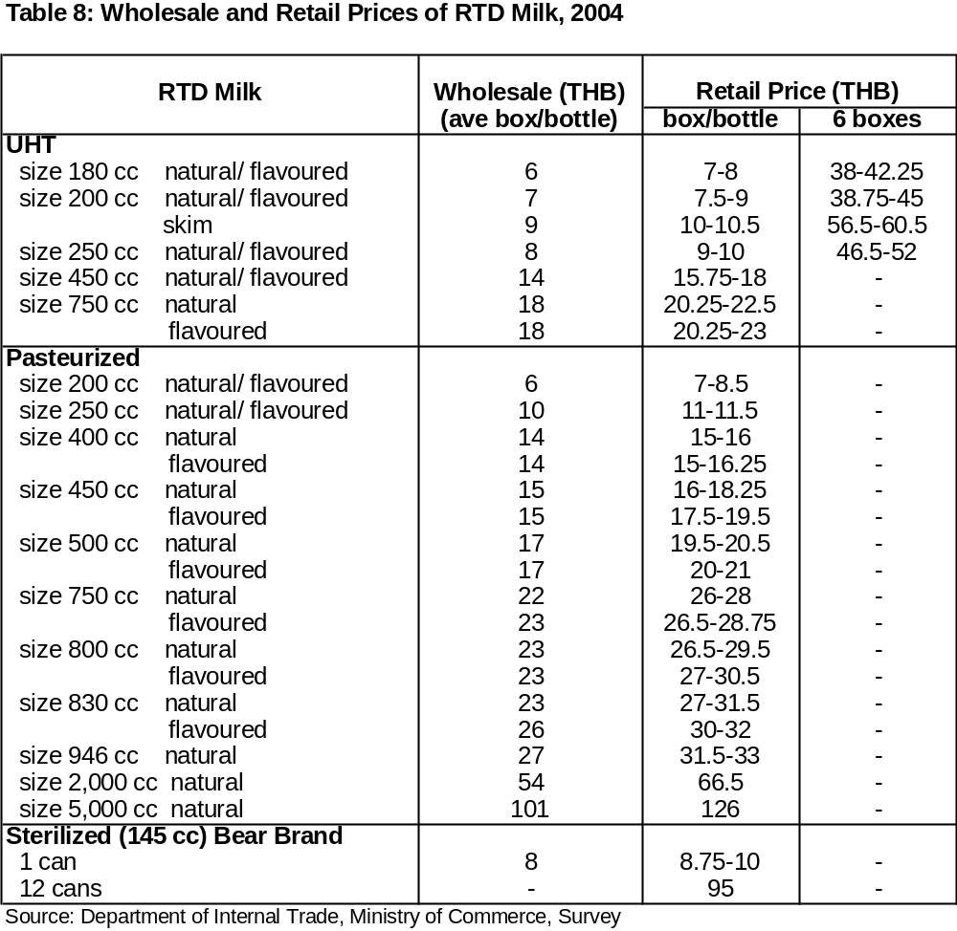

D) Labeling Requirements

Labeling requirements for coffee are stipulated in Ministerial Notification No. 276 of 2540 (1997), and labeling requirements for tea are stipulated in Ministerial Notification No. 277 of 2540 (1997).

Further information on Thailand’s food and agricultural import regulations and standards are included in: ‘Thailand: FAIRS Product Specific Country 2004’, which is available on the Internet at www.fas.usda.gov ; search using the report’s reference number, TH 4079.

Section VII. Marketing

A) Costs and Prices

Cost and pricing information from point of market entry to point of sale changes rapidly. Thailand is a relatively free market, with some exceptions. Examples of local retail pricing of various non-alcoholic beverages in June 2005 are included in the following tables.

Wholesale and retail prices of UHT, pasteurized, and sterilized milk are shown in Table 8. UHT and pasteurized milk prices are almost the same while sterilized milk is more expensive mainly due to its packaging cost.

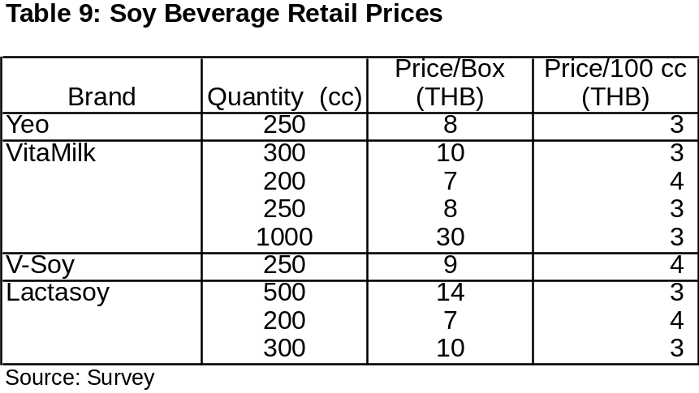
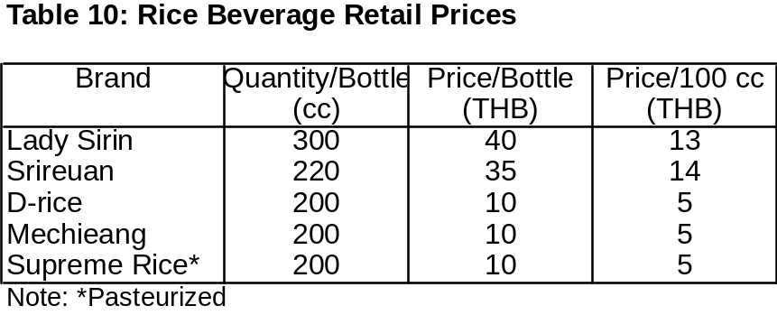
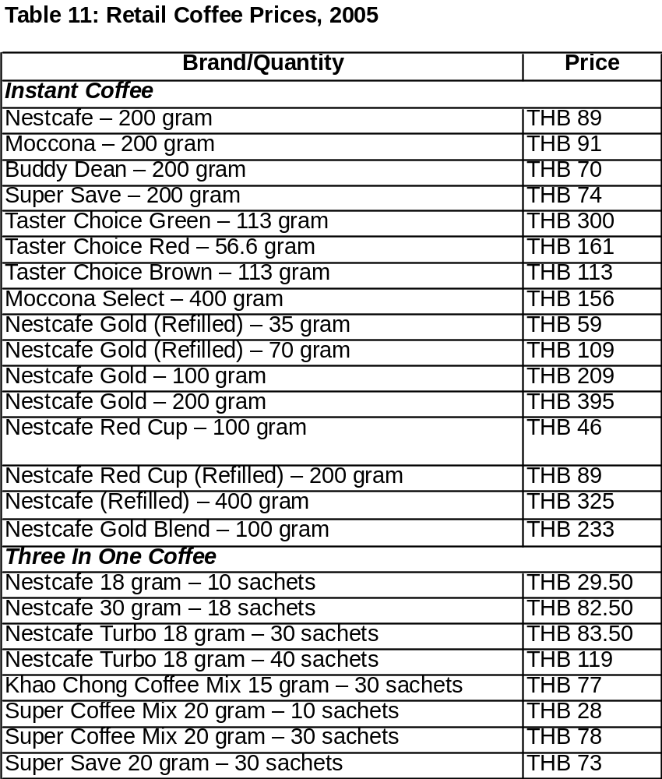

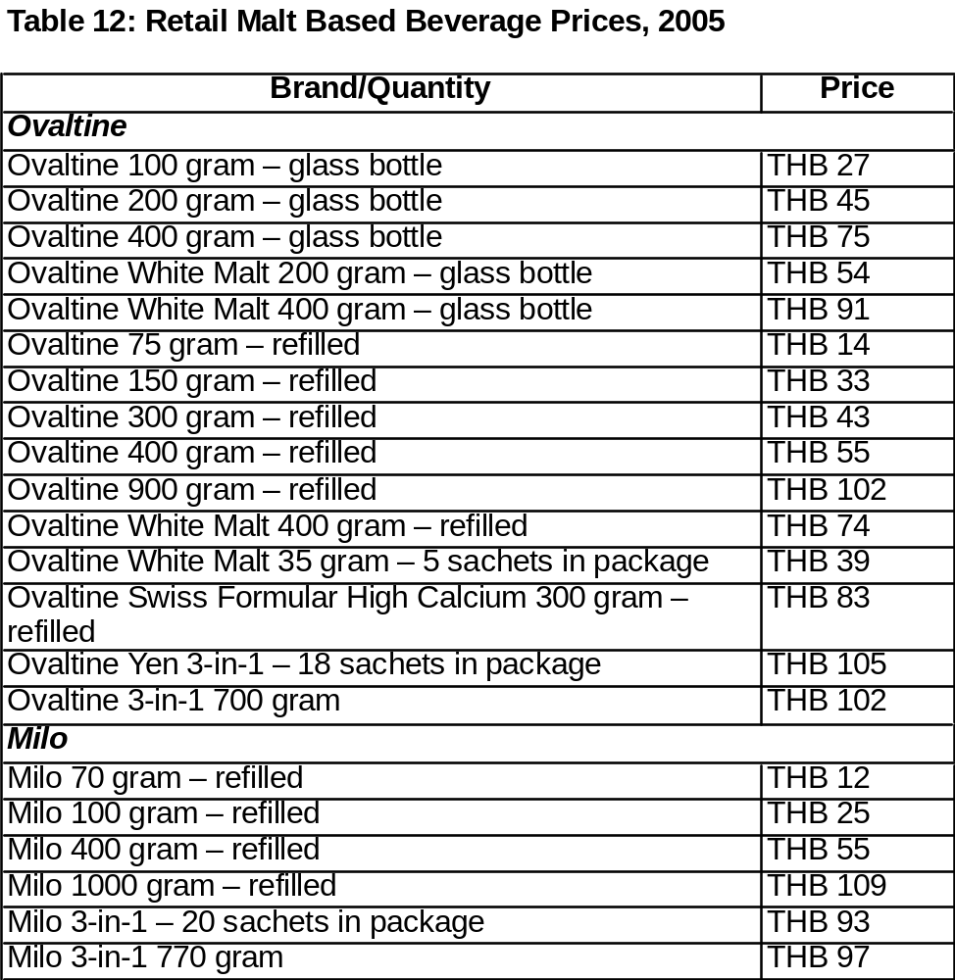

B) Suggested Entry Strategies

There are several ways for U.S. suppliers to enter the Thai market. Probably the most effective way is to appoint a reputable and experienced local importer or distributor. Local firms will have a good understanding of the market and know how to make direct contact with importers, end users, government officials and other key contacts. A good local importer/distributor can also provide valuable support in arranging meetings and promotional events, translating technical information, placing advertisements in local trade publications and other marketing and sales activities. Trade shows are also effective ways to promote new products. Food Ingredients Asia, Food and Hotel Asia, the International Food and Hospitality Show and other food and beverage shows, in Thailand, Singapore and elsewhere in Southeast Asia, are usually well attended by Thai beverage companies. See www.usdathailand.org for further details of recommended shows.

U.S. market development cooperators are also active in Thailand and other Southeast Asian countries. These groups offer many marketing opportunities for U.S. firms including trade team visits, technical seminars, local promotional events, and other activities. Cooperators with active programs in Thailand and other regional countries include the U.S. Grains Council, U.S. Meat Export Federation, U.S. Dry Pea and Lentil Council, U.S. Dairy Export Council, various U.S. fruit and nut associations, as well as several state and regional groups such as WUSATA, SUSTA, and MIATCO. See contacts at the end of this report.

Direct contact with local food service importers is the best entry strategy for U.S. exporters. Normally hotels and resorts do not import food directly in volumes attractive to U.S. exporters. It is easier for hotels and resorts to order from food service companies because they specialize in providing high quality U.S. products to the five-star hotel and restaurant industry. Restaurants such as fast food chains or family style restaurants also order and purchase imported food from food service companies or from their affiliate companies who act as their distributors. Five star hotels and resorts are highly recommended for U.S. exporters. International food restaurants located in prime areas of Bangkok, Chiang Mai, Samui Island, Phuket and Phi Phi island are secondary recommendations for U.S. exporters. Direct contact with Thai Airways International’s catering department is highly recommended.

The best way for U.S. exporters to sell to Thai supermarkets, super-centers and hypermarkets is to directly contact importers and distributors. U.S. exporters should be aware that many multi-national retailers in Thailand charge listing fees or a listing allowance for new products. The fee will be charged in accordance with a formula based on the number of retail outlets and SKU.

The best way for U.S. exporters to sell ingredients to Thai beverage manufacturers is to directly contact the manufacturer. A list of beverage manufacturers is included with this report.

Section VIII. Contacts Thailand

A) USDA Thailand

For general information on exporting non-alcoholic beverages or other food and agricultural exports to Thailand, please see Thailand: Exporter Guide Annual, 2004’. This report is available on the Internet at www.fas.usda.gov; search using the report’s reference number, TH 4123.

For specific information on non-alcoholic beverages contact:

U.S. Department of Agriculture, Foreign Agricultural Service

The Foreign Agricultural Service in Bangkok maintains up-to-date information covering non-alcoholic beverage import opportunities in Thailand and would be pleased to assist in facilitating U.S. exports and entry to the Thai market. Questions or comments regarding this report should be directed to following:

Local:  Office of Agricultural Affairs  U.S. Embassy  120-122 Wireless Road  Bangkok 10330 Thailand | U.S. Mail:  Office of Agricultural Affairs  U.S. Embassy, Box 41  APO AP 96546
  Tel: | +662-205-5106
  Fax: | +662-255-2907
  E-mail: | agbangkok@fas.usda.gov
  Website: | www.usdathailand.org

B) Retail

Siam Makro Company Limited
3498 2nd Fl., Lard Prao Rd
Klongchan, Bangkapi
Bangkok 10240, Thailand
Tel. +662 704-7000 / 375-7000
Fax. +662 375-8866
Contact person: Mr Philip Cox, Food Director (Dry Grocery)
Email: pwcox@siammakro.co.th
Contact person: Mr. Louis Lin, Food Director (Fresh Food)
Email: lin@siammakro.co.th

Big C Supercenter Co., Ltd
Fl 7 Univest Building
89/36 Rajadamri Road
Lumpini, Pathumwan
Bangkok 10330, Thailand
Tel. +662 655-5813
Fax. +662 655-5801-2
Contact person: Mr. Yves Braibant, CEO
Contact person: Ms. Jaruwan Thamgaesorn, Director of Fresh Merchandise Division

Ek-chai distribution System Co., Ltd (Tesco Lotus Hypermarket)
Modernform Tower
699, Srinakrarin Rd, Suanluang
Bangkok 10250, Thailand
Tel. +662 722-9640/79
Fax. +662 722-9637
Contact person: Mr Jeff Adams, CEO
Contact person: Mr. David Horton, VP Fresh Food Development
Email: david.horton@th.tesco.com
Contact person: Ms. Saijai Warrawatpreecha, VP Grocery Management – Food
Email: saijai.warrawatpreecha@th.tesco.com

Central Food Retail Co., Ltd. (Tops Supermarket)
6th-7th Floor Central Plaza Office Tower
1693 Paholyothin Road
Lard Yaow, Jatujak
Bangkok 10900
Tel. +662 937-1700
Fax. +662 937-1711
Contact person: Mr. Ian Pye, President
Email: pyian@tops.co.th
Contact person: Chiranun Poopat, VP/Buying & Merchandising and Marketing
Email: pochiranun@tops.co.th

Cen Car Ltd (Carrefour Global Sourcing)
14th Floor Q. House Sathorn Building
11 South Sathorn Road, Tungmahamek,
Sathorn, Bangkok 10120
Tel. +662 625-4444 Fax. +662 677-3354-5
Contact person: Mr. Jean Paul Khaou, Food Manager
Email: Jean_Paul_Khaou@carrefour.com
The Mall Group (The Mall (Home Fresh Mart)/Emporium/Siam Paragon)
1909 Ramkhamhaeng Road
Huamark, Bangkapi
Bangkok 10240, Thailand
Tel. +662 310-1000 / 318-8925
Fax. +662 315-6605 / 318-8923
Contact person: Mr Pira Asawapirom, Chief Merchandising Officer

Siam Jusco
129 Ratchdapisek Rd
Dindaeng, Bangkok 10320, Thailand
Tel. +662 246-7026/7031
Fax. +662 245-8760, 246-5985
Contact person: Mr Takashi Takani, Managing Director

Foodland Supermarket Co., Ltd
2675 Lard Prao 95
Wangthonglarng, Bangkok 10310, Thailand
Tel. +662 932-2948
Fax. +662 539-0837
Contact person: Mr Supamit Surongsain, Asst. Vice President Marketing
Email: foodland@loxinfo.co.th

Tang Hua Seng Department Store
289 Sirinthorn Rd
Bangbamru, Bangplad
Bangkok 10700, Thailand
Tel. +662 434-0448
Fax. +662 434-6057
Contact person: Mr Viroj Chunprathipthong, Managing Director

Villa Market JP Co., Ltd
591/1, 4-5 Sukhumvit Rd
Klongton, Klongtoey
Bangkok10110, Thailand
Tel. +662 662-0372-6
Fax. +662 259-1077
Contact person: Mr Surapong Poosanakhom, Managing Director
Contact person: Mr. Pisit Poosanakhom, Executive Director
Email: pisit@villamarket.com

CP 7-Eleven Co., Ltd
313 CP Tower, 20th Fl.
Silom Rd, Bangkok 10500, Thailand
Tel. +662 677-9000
Fax. +662 638-2680
Contact person: Mr. Korsak Chairasmisak, CEO
Mr Piyawat Thitasathavorakul, Managing Director

Siam Familymart
139 Robinson Building
5th Fl Ratchdapisek Rd
Dindaeng, Bangkok 10320, Thailand
Tel. +662 254-1650/1
Fax. +662 255-8573
Contact person: Ms. Sarinya Ardvichai, Category Manager – Food, Merchandise Division
Email: sarinya.a@familymart.co.th

C) Hotels and Resorts

Amari Watergate Hotel
847 Petchburi Rd.
Pratunam, Rajthevi
Bangkok
Tel : 662-653-9000
Fax : 662-653-9045
Contact : Mr. Sanjog Modgil, Director of Food & Beverage
E-mail : fb@atrium.amari.com
Website : www.amari.com

Amari Atrium Hotel
1880, New Petchburi Road,
Huay Kwang, Bangkapi
Bangkok 10320
Tel: 662-718-2000
Fax: 662-718-2004
Contact: Mr. Sanjog Modgil, Director of Food & Beverage
E-mail : fb@atrium.amari.com
Website: www.amari.com

Bangkok Marriott Resort and Spa Hotel
257 Charoennakorn Road,
Bangkok 10600
Tel: 662-476-0022
Fax: 662-477-0811
Contact: Russell Paine, Director of Food & Beverage
E-mail :
Contact : John Westoby, Director of Operations
E-mail : jwestoby@minornet.com
Website: www.marriotthotels.com/bkkth

Banyan Tree Bangkok
21/100 South Sathorn Road,
Sathorn, Bangkok 10120
Tel: 662-679-1200
Fax: 662-679-1188
Contact: Scott Murray, Director of Food and Beverage
E-mail: scott.murray@banyantree.com
Website: www.banyantree.com

Conrad Hotel
All Seasons Place,
87 Wireless Road,
Bangkok 10330
Tel: 662-690 9999 Fax: 662-690 9000
Contact: Nattapol Khajornsripitak, Executive Assistant Manager
E-mail: nattapol@conradbangkok.com
Website: www.conradhotels.com
Dusit Thani Hotel
946 Rama IV Road,
Bangkok 10500
Tel: 662-236-9999
Fax: 662-236-6400
Contact: Thitikorn Pitchan, Assistant F&B Manager
E-mail: thitikorn.d@dusit.com
Website: www.dusit.com

Four Seasons Hotel
155 Rajadamri Road,
Bangkok 10330
Tel: 662-250-1000
Fax: 662-253-9195
Contact: Lubosh Barta, Director of Food and Beverage
E-mail: lubosh.barta@fourseasons.com
Website: www.fourseasons.com/bangkok

Grand Hyatt Erawan Bangkok
494 Rajdamri Road,
Bangkok 10330
Tel: 662-254-1234
Fax: 662-254-6286
Contact: Chris Conway, Director of Food and Beverage
E-mail: chris.Conway@hyattintl.com
Website: www.bangkok.hyatt.com

Intercontinental Bangkok Hotel
973 Ploenchit Rd., Lumpini
Bangkok 10330
Tel : 662-656-0444
Fax : 662-656-0555
Contact : Kym Barter
E-mail: kym_barter@interconti.com
Website: http://bangkok.intercontinental.com/

JW Marriott Hotel
4 Sukhumvit Road, Soi 2,
Bangkok 10110
Tel: 662-656-7707 Fax: 662-656-7711
Contact: Mr. Stefan Gruber, Food and Beverage Director
E-mail: Stefan.gruber@marriotthotels.com
Website: www.marriott.com

Montien Hotel Bangkok
54 Surawongse Road
Bangkok 10500
Tel : 662-233-7060
Fax : 662-234-8060
Contact : Mr. Piyawin Sukondhavich
E-mail: fbbkk@montien.com
Website : www.montien.com

Peninsula Hotel
333 Charoennakom Road
Klongsan Bangkok 10600
Tel: 662-861-2888
Fax: 662-861-1112
Contact: Mr. Joseph Sampermans, Director of Food and Beverage
E-mail : jsampermans@penninsula.com
Website: http://bangkok.peninsula.com

Royal Orchid Sheraton Hotel
2 Captain Bush Lane, New Road,
Siphya, Bangkok 10500
Tel: 662-266-0123
Fax: 662-236-8320
Contact: Dario Orsini, Director of Food and Beverage
E-mail : Dario.orsini2@sheraton.com
Website: www.royalorchidsheraton.com/

Shangri-La Hotel
89 Soi Wat Suan Plu,
New Road, Bangrak,
Bangkok 10500
Tel: 662-236-7777
Fax: 662-236-8579
Contact: Mr. Thomas Schmitt-Glaeser, Director of Food and Beverage
E-mail : Thomas.Schmitt-glaeser@shangri-la.com
Website: www.shangri-la.com

Sheraton Grande Sukhumvit Hotel
250 Sukhumvit Road
Bangkok 10110
Tel: 662-653-0333
Fax 662-653-0400
Contact: Dennis J. Thouvard, Director of Food and Beverage
E-mail : denis.thouvard@starwoodhotels.com
Website: www.sheratongrandesukhumvit.com

Sofitel Central Plaza Hotel
1695 Phaholyothin Rd,
Chatuchak, Bangkok 10900
Tel: 662-541-1234
Fax: 662-541 1087
Contact: Wuthisak Pichayagan, Food and Beverage Manager
E-mail : fboffice@chr.co.th
Website: www.centralhotelsresorts.com

Sukhothai Hotel
13/3 South Sathorn Road,
Bangkok 10120,
Tel: 662-344-8888 Fax: 662-287-4980
Contact: Anne-Marie Houston, Executive Assistant Manager of Food and Beverage
E-mail : anne-marie@sukhothai.com
Website: www.sukhothai.com

Tawana Ramada Hotel
80 Surawongse Rd.
Bangkok
Tel : 662-236-0361
Fax : 662-236-3738
Contact : Mr. Chatchawarn Hiranyaman
E-mail : twn99@tawanahotel.com
Website : www.tawanahotel.com

The Oriental Hotel
The Oriental, Bangkok 48 Oriental Avenue,
Bangkok 10500
Tel: 662-659-9000
Fax: 662-659 0000
Contact: Eric Weber, F&B Manager
E-mail : ericw@mohg.com
Website: www.mandarin-oriental.com/bangkok

D) Restaurants

13 Coins Restaurant
13 Coins Towers Ltd.
525/3 Ratchadapisek Road,
Huaykwang, Bangkok 10310
Tel: 662-274-1219
Fax: 662-274-1218
Contact: Somchai Nitiwanakul, Managing Director

Bourbon St. Bar and Restaurant
Texxan Co., Ltd.
29/4-6 Behind Washington Theatre
Sukhumvit Soi 22,
Bangkok 10110
Tel: 662-259-0328/9
Fax: 662-259-4318
Contact: Douglas B. Harrison, Managing Director
Website: www.bourbonstbkk.com

Hamilton’s Steak House
Dusit Thani Hotel
946 Rama IV Road,
Bangkok 10500
Tel: 662-236-9999
Fax: 662-236-6400
Contact: Thitikorn Pitchan, Assistant F&B Manager

Hard Rock Café
424/1, 424/3-6 Siam Square Soi 11
Pathumwan, Bangkok 10330
Tel: 662-251-0792/94
Fax: 662-254-0832
Contact: James Choong, General Manager
Website: www.hardrockcafe.co.th

Outback Steakhouse
OBS Restaurant Thailand Limited.
2nd Floor Siam Discovery Center
Rama 1 Road, Pathumwan
Bangkok 10330
Tel: 662-658-0202
Fax: 662-658-0204
Contact: Ajay Verma, Proprietor

Neil’s Tavern Restaurant
58/4 Soi Ruam Rudee,
Wireless Road, Bangkok 10330
Tel: 662-256-6874-6
Fax: 662-650-9740
Contact: Pipat Pitsanusakorn, Managing Director

New York Steakhouse
2nd Floor, JW Marriott Hotel
4 Sukhumvit Road, Soi 2,
Bangkok 10110
Tel: 662-656-7707
Fax: 662-656-7711
Contact: Mr. Stefan Gruber, Food and Beverage Director

Park Avenue Steak House
Panumas Marketing & Distribution Co., Ltd.
G/F, Mercury Tower,
540 Ploenchit Road,
Bangkok 10330
Tel: 662-658-7722/3
Fax: 662-658-7892
Contact: Panumas Pornvarakorn, Proprietor

Roses Are Red (Steak and Seafood Restaurant)
413/5 Sukhumvit Soi 55
(Between Thonglor 23-25) Bangkok
Tel: 662-392-1881-2
Fax: 662-392-4530
Contact: Triphong Kohengkul, Managing Director

S & P Syndicate Public Company Limited
457-457/6 Soi Sukhumvit 55 Vadhana
Bangkok 101110
Tel: 662-381-3412
Fax: 662-381-2790

Seafood Palace International (Seafood Market and Restaurant)
Euro Emporium Co., Ltd.
348 Sukhumvit Road., Asoke Sq.,
Bangkok 10110
Tel: 662-653-1145-8, 653-3900/5
Fax: 662-653-1149
Contact: Nucha Kathapithak, General Manager

Tony Roma’s
Mas Millennium (Thailand) Ltd.
87 Sukhumvit Road, Ground Floor,
Nai Lert Building
Klongtoey, Wattana
Bangkok 10110
Tel: 662-254-2912
Fax: 662-254-1326
Contact: Raymond Chow, General Manager

E) Institutional and Catering

Compass Group Services Co., Ltd.
100/1 Vorasombat Building, 11, Rama 9 Rd.,
Huaykwang, Bangkok 10320
Tel: 662-247-5720-5
Fax: 662-247-5726
Contact: Hugues Reveille, Managing Director
M.L. Chaninprom Kamalasana, Purchasing Manager

Thai Airways International Plc.
Bangkok International Airport,
Donmuang, Bangkok 10210
Tel: 662-697-1128
Fax: 662-504-4057
Contact: Suchada Tiyavanich, Duty Manager Procurement Section

Siam Flight Services Ltd.
Bangkok International Airport
Vipavadee-Rangsit Road,
Donmuang, Bangkok 10210
Tel: 662-996-8881 ext. 150
Fax: 662-996-8889
Contact: Charunan Ratana-arporn, Purchasing Manager

Gate Gourmet (Thailand) Ltd.
71 Chaengwattana Road,
Kwaeng Talad Bangkhen,
Khet Laksi, Bangkok 10210
Tel: 662-521-8200-5
Fax: 662-521-1164
Contact: Kanyanan Chullabut, Purchasing Manager

Impact Arena Exhibition and Convention Center Muang Thong Thani
99 Popular Road, T. Banmai,
A. Pakkred, Nonthaburi 11120
Food and Beverage Department
Tel: 662-504-5050
Fax: 662-504-4444
Contact: Chawanich Sirisinghol, Food and Beverage Director

Bangkok International Trade and Exhibition Center
8 Bangna-Trad (Km.1),
Bangna, Bangkok 10260
Tel: 662-749-3939 Fax: 662-749-3959
Contact: Dana Caron, Food and Beverage Director
F&B International Co., Ltd.
Queen Sirikit National Convention Center
60 New Rachadapisek Road, Klongtoey,
Bangkok 10110
Tel: 662-229-3213
Fax: 662-229-3174
Contact: Anake Boontham, Food and Beverage Manager/Acting General Manager

F) Food Service Importers

Fine Food International Co., Ltd.
524/26 Soi 19 Rama 9 Road,
Huay Kwang, Bangkapi,
Bangkok 10310
Tel. 662-319-5274-5
Fax. 662-319-7352
E-mail: finefood@loxinfo.co.th
Contact: Pairat Rodjanaporn, Managing Director

Intermarco Co., Ltd.
50 Hajana Village
Srisena Rd., Phuket 83000
Tel. 66-076-253-024
Fax. 66-076-216-425
Contact: Ron Brandon, Managing Director

Pan Food Co., Ltd.
3388/7 Sirirat Bldg. 2nd Floor,
Rama IV Rd., Klongton, Klong-Toey
Bangkok 10110
Tel. 662-671-5093, 672-7982
Fax. 662-671-8454
E-mail: panfood@hotmail.com
Contact: Vutikorn Daomanee, Managing Director

Siam Food Services
2439 Old Paknam Railway Rd.
Prakhanong, Klongtoey,
Bangkok 10110
Tel. 662-240-4000 ext. 101
Fax. 662-671-8591
E-mail: pn@siamfoodservices.com
Contact: Pieter Nuboer, CEO

Superior Quality Food Co., Ltd.
50 Soi Pattanakarn 20,
Suanluang, Suanluang District,
Bangkok 10250
Tel. 662-720-0641-3
Fax. 662-720-0644
E-mail: nittokai@hotmail.com
Contact: Supharat Laopranichon, Managing Director
Tohkaiya Company Limited
33/89-90 Moo 10, Thepharak Rd.,
K.M. 16, Bangplee,
Samutprakarn 10540
Tel. 662-312-1861-2, 752-5506-7
Fax. 662-750-7370
E-mail: Email:ssloo@tohkaiya.com
Contact: S.S. Loo, Managing Director

Don’s Foods Co., Ltd.
48/5 Sai yuan Road, Moo7,
Tambon Rawai, Muang, Phuket 83130
Tel:66-76-289-314
Fax: 66-76-289-319
E-mail: dontek@loxinfo.co.th
Contact: Donal D. Battles, Managing Director

G) Beverage Importers

Ambrose Wine Limited
3/Flr., Bangkok Business Center,
29 Sukhumvit 63 Road (Ekamai),
Klongton Nue, Wattana,
Bangkok 10110
Tel. 662-714-2531-40
Fax. 662-714-2545
E-mail: wisanp@ambrosewine.com
Contact: Mr. Wisan Pijibandan, Marketing Director

Bangkok Beer and Beverage Co., Ltd.
193/54 Lake Rajada Office Complex
14th Floor, Rajadapisek Road, Klongtoey,
Bangkok 10110
Tel. 662-661-9446-7
Fax. 662-661-9448
E-mail: pc@bbb.co.th
Contact: Mr. Pongchalerm Chalermsaphayakorn, Executive Director

Bangkok Liquor Co., Ltd.
3/1 Convent Road, Silom,
Bangkok 10500
Tel. 662-674-7901/2
Fax. 662-212-6890
E-mail: kiti@bangkokliquor.com
Contact: Mr. Kitti S.Chaikul

BJC Marketing Co., Ltd.
99 Soi Rubia, Sukhumvit 42 Road,
Phrakanong, Klongtoey,
Bangkok 10110
Tel. 662-367-1111
Fax. 662-712-2241
Email: bjcwine@berlijucker.co.th
Contact: Praphol Vongsrivongse, Acting General Manager
Cannon Pacific Co., Ltd.
188/3 Soi Sukhumvit 63 (Ekamai),
Klongton Nua,
Bangkok 10110
Tel. 662-391-6318
Fax. 662-391-6320
Contact: Mr. Ekachai Mahaguna, Managing Director

Cititex Enterprises Co., Ltd.
40/29 Moo 5, Karnchanapisek Road,
Bangbon, Bangkok 10150
Tel. 662-895-1761
Fax. 662-895-3958
Contact: Mr. Sithisak Chatamornwong, Managing Director

California Wine Co., Ltd, The
498-504 Sukhumvit 22, Besides Washington Theatre,
Sukhumvit Road, Klongton,
Bangkok 10110
Tel. 662-260-5794-5
Fax. 662-260-5807
Contact: Mr. Sorasit Wongsantivanich, General Manager

Diethelm & Co., Ltd.
2439 Old Paknam Railway Road,
Klongton, Klongtoey,
Bangkok 10110
Tel. 662-672-5535-39 Ext 101
Fax. 662-672-2569
E-mail: kritkasp@spd.diethelm.co.th
Contact: Mr. Kritkasem Panyarachun, Sales & Marketing Manager, Food/Special Products Div.

Global Premium Wine Co., Ltd.
295 Rama 3 Road, Bangkorlaem,
Bangkok 10120
Tel: 662-689-0441-3
Fax: 662-689-0200
E-mail: info_globewine@yahoo.com

Italthai Industrial Co., Ltd.
2 Soi Soonvijai 3, New Petchburi Road,
Bangkapi, Huaykwang,
Bangkok 10320
Tel. 662-318-1617-22
Fax. 662-314-1809
E-mail: erik@italthaicellar.com
Contact: Mr. Erik Cornetet, Deputy Group Manager

Nicolas B.C. Co., Ltd.
36/9-10 Chaengwattana Road,
Thungsonghong, Laksi,
Bangkok 10210
Tel. 662-982-7178 Fax. 662-982-7760
Contact: Mr. Jajarindr Saochin, Managing Director
Splendid Surplus Co., Ltd.
27/17-18 Petchkasem Road,
Nongkhaem, Luksong,
Bangkok 10160
Tel. 662-807-4074
Fax. 662-807-4073
Contact: Mr. Thanis Potchapornkul, Managing Director

Vanichwathana (Bangkok) Co.,Ltd.
41 Anuwong Road,
Bangkok 10100
Tel. 662-222-2450
Fax. 662-224-8042
Mr. Vichai Kanchanasevee, Assistant Managing Director

V&K Inter Group Company
140/1 Soi Sukhumvit 4,
Sukhumvit Road, Klogntoey,
Bangkok 10110
Tel. 662-656-8030/5
Fax. 662-656-8182/3
Contact: Mr. Dominique Forey, Managing Director
Mr. Kittipong Dechaampai, Managing Director

Wine Gallery
9/8 Sukhumvit Soi 44,
Klongton, Klongtoey,
Bangkok 10110
Tel. 662-261-4602 Fax. 662-261-4536
Contact: Ms. Wantana Loakulrak, General Manager

H) Regulatory Contacts

Food and Drug Administration
Ministry of Public Health
Ms. Chitra Setha-udom
Director
Food Control Division
The Food and Drug Administration
Tivanont Road, Muang
Nonthaburi 11000
Tel. (662) 590-7178
Fax (662) 591-8460
E-mail: schitra@fda.moph.go.th

Mrs. Jureerat Horkiatti
Assistant Director
Group of Pre-Marketing Control
Food Control Division
The Food and Drug Administration
Tivanont Road, Muang
Nonthaburi 11000
Tel. (662) 590-7195 Fax (662) 591-8460
E-mail: schitra@fda.moph.go.th
Inspection Division
The Food and Drug Administration
Tivanont Road, Muang
Nonthaburi 11000
Tel. (662) 590-7323
Fax (662) 591-8477
E-mail: food@fda.moph.go.th

Department of Medical Sciences, Ministry of Public Health
Food Analysis Division
Department of Medical Sciences
Soi Bumratnaradul Hospital
Muang, Nonthaburi 11000
Tel. (662) 951-0000 Ext. 9561
Fax (662) 951-1023

I) Miscellaneous Useful Contacts

American Chamber of Commerce
Diethelm Tower A 7th Floor
93/1 Wireless Road
Lumpini, Pathumwan, Bangkok 10330
Tel. (662) 251-9266/7, 251-1605, 651-4473
Fax (662) 255-2454
E-mail: info@amchamthailand.com

U.S. Dairy Export Council
Southeast Asian Representative Office
Pacrim Associates Limited
11/14 Soi Ruam Rudee
Wireless Road
Bangkok 10330
Tel. (662) 689-6311
Fax (662) 689-6314
E-mail: usdec@pacrimassociates.com

U.S. Dry Pea And Lentil Council
AgriSource Co.,Ltd.
No. 416, 4 th Fl., Ambassador’s Court
76/1 Soi Langsuan
Ploenchit Road
Bangkok 10330
Tel. (662) 251-8655/6, 251-8669, 251-8772
Fax (662) 251-0390
E-mail: agsource@loxinfo.co.th

American Soybean Association
Thailand Representative
59/43 Baan Klangmuang
Ladprao 71 Road
Bangkok 10230
Tel. (662) 539-5373, 539-5332
Fax (662) 539-5256
E-mail: asathai@loxinfo.co.th

Section IX. Thailand’s Leading Non-Alcoholic Beverage Producers Profiles

1) Thai Dairy Industry Co., Ltd.

Head Office: Kian Gwan House II, 16&20th Floor, 140/1 Wireless Rd., Bangkok 10330 Tel. (662) 255-9040-51 Fax. (662) 255-9053
Factory: Bang Pa-in Industrial Estate, 158 Moo 16, Bangkrasan, Klong Jik Sub-district, Bang Pa-in District, Ayutthaya, Thailand
Tel: (035) 221-480-93
Fax: (035) 221-500-1
Website: www.thaidairy.co.th
Contact: Mr.Suvit Pholwiwat/ Deputy Managing Director (0-2255-9040 to 51 ext. 210)
Mr. Tawatchai Uaisuk/ QA, R&D Manager (factory)
Mr. Chockchai Supavanich/ Factory Director

Company Profile

The Thai Dairy Industry Co., Ltd. was set up in 1962 as a joint venture between Thai and Malaysian Business with the Australian Dairy Corporation and was granted investment promotion privileges by the Board of Investment. The goal of the company was to manufacture dairy products to international standards in order to improve the health of Thai consumers. The company's factory in Samutprakarn province became the first factory in Thailand to manufacture sweetened condensed milk. Launched in the market in 1965, Mali sweetened condensed milk is manufactured utilizing the latest technology. Since that time, "Mali" has become a leading brand and along with the company's other products is highly regarded by consumers. With a steady growth in demand through the years, a new, larger and more advanced plant has been constructed to take the company into the next century.

Products

- Condensed Milk (Mali & Orchid brand), Evaporated Full/ Filled Milk (Birdwings brand)/ Non-Dairy Creamer (“Birdwings” brand)
Mali Sweetened Condensed Milk- Mali Sweetened Condensed Milk is the most well-known and popular product among Thai consumers. It is used in almost every household in Thailand. In addition, it is also exported to Cambodia, Myanmar and the United States of America.
- Sterilized Milk (“Orchid” brand), UHT Milk (“Mali” brand), Mali Ultraman UHT Milk, coconut cream in “brik packs” and cans, and “Orchid” butter

Export Market
Complementing the strong market position of Thai Dairy Industry in the domestic market, the company distributes dairy products in several markets, including Hong Kong, Singapore, and other neighboring Asian countries. The company can produce product packaged in tin cans, UHT boxes, and any labels, which the customers desire. Tin Cans: There are 3 sizes: 140 ml., 390 grams, 405 grams. UHT Boxes: There are 4 sizes: 200 ml., 200ml. Slim, 250 ml., 1,000 ml.

2) Malee Sampran Public Company Limited

Head Office: Abico Building, 4-5 Floor, 401/1 Phaholyothin Road, Lumlookka, Pathumthani 12130, Thailand
Tel: 662 992 5800 (16 lines)
Fax: 662 992 5820 (Central office), 662 992 5818-9 (Export sales)
Website: http://www.malee.co.th
Contact: Mr.Pisakwalee Savettanan/ Managing Director
(E-mail:petesa@malee.co.th)
Ms.Premrudee Wannasirisuk/ VP Research & Development (M.01 914 1271, E-mail:prem@malee.co.th)
Ms. Busara Makomol/ Products Manager

They are a manufacturer and distributor of canned fruit and vegetables, canned sweet corn, pineapple juice concentrate, fruit juice, UHT milk and Beverages.

SUBSIDIARY- Malee Enterprise Company Limited
Abico Building, 3rd Floor, 401/1 Phaholyothin Road, Lumlookka, Pathumthani 12130. TEL. 0 2992 5821 FAX. 0 2992 5817, 0 2532 3571 (Central office) 0 2992 5833-4 (Sales)
http://www.malee.co.th

AFFILIATED COMPANY- Alliance Sales (Europe) Limited
Importer of pineapple juice concentrate.

P.O. Box 146 , Road Town , Tortola, British Virgin Islands TEL/FAX. 3210620172

Company Profile

Malee Business began in 1964 and in 1978, the company was incorporated as Malee Sampran Factory Company Limited with initial registered capital of 10 million Baht, to manufacture and distribute canned foods and canned fruit. It has since changed its name to “Malee Sampran Public Company Limited”. Since the beginning the Company has been considered as one of the best food and beverage companies with the main products of Malee brand canned fruit and canned and UHT fruit juices, which have been widely distributed both domestically and abroad.

Manufacturing Business Unit

The Manufacturing Business unit is responsible for the manufacturing of beverage products under the company's own brand and those of its business alliances. With internationally recognized standards of production and adequate production capacity, Malee Sampran Public Company Limited is trusted by leading international business alliances to manufacture products on their behalf for distribution in Thailand and overseas.

Contact Person
cm2486@malee.co.th
kulaphat@malee.co.th

Tel. 0-2992-5800 ext. 2002, 2010

Malee Brand Business Unit

The Malee Brand business unit focuses on the marketing and distribution of products under the brand name of Malee. With several world-class quality products “Malee Brand” is a name Thais are proud of and is respected globally. Today Malee brand products are widely accepted with distribution in over 20 countries in 4 different continents. In order to cater to local tastes, in a number of countries Malee has made suitable adjustments in taste and packaging and developed new products.

Contact Person
adisak@malee.co.th
rungroj@malee.co.th
Tel. 0-2992-5800 ext. 3005,0318
Fax. 0-2532-3571

New Products in 2004:
Canned seasonal fruit and mixed fruit juice, 100% pomelo juice, sweet orange juice (with Pulp), 100% guava juice (fresh squeezed), and I-corn (corn milk).

3) Serm Suk Public Co., Ltd.

Head Office: Muang Thai-Phatra Complex Building I, 27-29 th Floor, 252/35-36 Ratchadapisek, Huaykwang, BKK 10320
Tel: 02 693-2255 to 65
Fax: 02 693-2266
Factory: 700/368 Moo 6, Amata Industrial Park, T.Nongmaidang, A.Mueang, Chonburi 20000, Tel. 038-458-131 to 6
Website: www.pepsithai.com
Contact: Mr. Thitiwat Bulsuk/ Marketing Director
Mr. Wichai Wipaisarapong/ Factory Manager (ext.100)
Ms. Ornuma/ Secreatry (ext.212)
Ms. Chintana/ QA Manager
Mr. Chalee Jitjarungporn/ Marketing Director Pepsi-Cola Thai Trading Co., Ltd.

Company History

Established in 1952 the company has 5 factories and 46 warehouses throughout the country. Their main business is manufacturing and distributing soft drinks (Pepsi, Mirinda, 7 Up, Dew brand), pure water (Crystal brand), Lipton tea, Lipton Wave green tea, Yeo soy milk, and Carabao Daeng.

Setting up the company was meant to be a solution to the unhealthy water problem, which was one of the causes of epidemics. Disease was then a major problem because Thailand’s modern water systems were not widely distributed.
“Pepsi” is the favorite drink due to freshness, taste and quality. The company has expanded and fully integrated production and distribution by marketing new products, namely Mirinda, 7Up, Mountain Dew, Club Soda, Crystal drinking water, Lipton Ice tea and M 150.

New Products

Pepsi Fire and Pepsi Ice. The company used over 90 million Baht to promote these two new products. Asian super stars Tata Young and Vannes Wu are being used to promote the products with a target to increase the company’s market share by one percent to 63% of the 30,000 million Baht market.

Sermsuk Public Co., Ltd. has bought 49% of total share in Sermsuk Y.H.S. Beverage Co., Ltd. from Yeo Hieb Seng (Malaysia) Co., Ltd. Sermsuk Y.H.S. Beverage is a joint venture between Yeo Hieb Seng (Malaysia) and Sermsuk Public Company. Prior, Sermsuk Public Co.,
held 51% of the total shares in the joint-venture company.

Recently, the functional drink and food market is growing very fast as Thai consumers are highly health conscious. As a result the company has planned to add new product lines including fruit juice and soymilk. The company has a policy to adjust sales revenue from soft drink to other drinks at 50:50, in line with the current market.

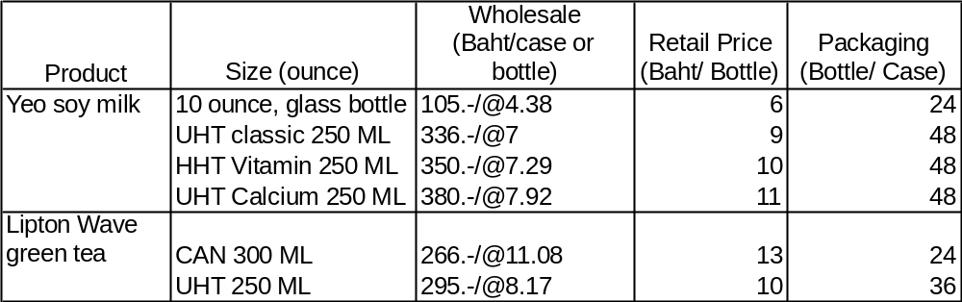

4) Foremost Friesland (Thailand) Pub Co Ltd

Head Office: 6th Flr., S.P. Bldg.,388 Paholyothin Rd. Samsen Nai, Phayathai, Bangkok 10400, THAILAND
Tel: 66 2 620-1900
Factory: 89/2 Moo 8, Soi Watsuansom, Poochasamingprai Road, South Sumrong, Samuthprakarn 10130, Tel. 0-2384-2760 to 1
Website: www.foremostforlife.com
Contact: Ms.Jutathip Wangsai/ R&D Manager (Tel. 0-2384-2760 ext.3131)

Company Profile

Foremost Friesland (Thailand) Public Company Limited manufactures and distributes dairy products within Thailand. The company's products include sweetened and unsweetened condensed milk, evaporated milk, drinking yogurt, UHT pasteurized milk and infant feeding products in sizes from 110 to 946 ml. These products are sold under brand names such as Ship, Alaska, Falcon, Foremost, Kitty, Yo-Most and Frisolac.

5) Dutch Mill Co., Ltd.

Head Office: 226 Kungthon Muangkaew Building, Sirindhorn Rd., Bangplud, BKK 10700
Tel: 0-2881-0000
Fax: 0-2423-2133
Website: www.dutchmill.co.th
Factory 1: 137/6 Moo 1 Buddhamonton 8th Rd., Kunkaew, Nakhonchaisri, Nakhonpathom 73120
Tel: 0-3423-2222 to 4
Fax: 0-3433-9027
Contact: Khun Varaporn Makpoon/ R & D Manager (M. phone 01 398-6118)
Khun Suvimon/ Marketing Director
Company Profile

Dutch Mill Co., Ltd. is one of Thailand's largest manufacturers and marketers of dairy products. The company's product range includes "Dutch Mill" UHT yogurt drink, "Dairy Plus" UHT fresh milk and "Duchies" ice lolly. With an annual intake of nearly twenty million liters of raw milk for farmer suppliers and group sales in excess of US $78 million. Dutch Mill in recent years has positioned itself as a growing force in the Thai export market for dairy products, with the majority of shipments destined for the Asian region.

Dutch Mill Co., Ltd. was established in 1984 under the name of Profood Co., Ltd. and was renamed Dutch Mill Co., Ltd. in 1991. The company has invested around US $55 million in its business. The company's head office is located in Bangkok and its factory is in Nakornpathom, 40 km from Bangkok.

Products
Dutch Mill Co. Ltd. Produces drinking yogurt in fruit flavors with a special line for kids, “light” enriched drinking yogurt, “Dairy Plus” UHT bottled milk, “DNA” boxed soymilk, and “Pop Eyes” ice pops ranging in size from 110-830 ml.

New Products

After launching the original DNA soymilk three years ago, the company launched a new product in November 2004: DNA high calcium with black sesame. The product is available in 3 sizes: 110 ml, 180 ml, and 230 ml. This new product targets health conscious consumers and the new generation working group.

6) Uni-President (Thailand) Ltd.

Address: 253, 18th Floor, Soi Asoke, Sukhumvit 21 Rd., North Klongtoey, Khet Wattana, Bangkok 10110

Company Profile

Uni-president (Thailand) Ltd., a subsidiary of a Taiwanese company, President Enterprises Corporation. It is a worldwide manufacturer and distributor of food and drink products. It was established on May 17, 1994 with a capital of 250 Million Baht, under the name of “Uni-president Enterprises Corp. Ltd.” This company has been set up with the objective of producing canned drinks under the brand name “Unif”, which has been researched and developed with the support of the Central R & D Institute of its parent company. Therefore, all products have been fitted to the Thai taste. In 1997, the company name changed to “Uni-president (Thailand) Ltd.”.

In accordance with technology adapted from the parent company, upon entering the Thai market Uni-President (Thailand) Ltd. Has focused on a new manufacturing line of innovative health food products under the “Green& Healthy” concept. The product will be launched for the first time in Thailand in addition to Unif’s five existing juice categories: vegetable with mixed fruit juice, fruit juice, fruit tea, coffee, and traditional drinks. The company caters a target group aged between 15-19 and working people who are now health conscious.

Products for Export: RTD coffee, tea, fruit juice, mixed fruit juice, vegetable & green tea

Export Markets: Indo-China, South-East Asia, Europe

7) Lactasoy Co., Ltd.

Head office: 3532 Sukhumvit Rd., Bangna, Bangkok 10260
Tel: 0-2396-0320 to 7
Fax: 02745-2855, 0239-5233
Website: www.lactasoy.com
Factory: 199 Moo10 Chacherngsao-Kabinburi rd., Srimahaphot, Prachinburi
Tel: 037-209301 to 10
Fax: 037-209311, 209322
Contact: Samart Chiraphathanakul/ President
Phanwana Mahasup/ Assitance Marketing Manager

Company Profile

LACTASOY Co., Ltd. was established by Mr. Viriya Chiraphadhankul who has been a successful producer of soft drinks in Thailand for over 50 years. Over the years, the company has expanded to include a bottling, canning and UHT (Ultra Heat Treatment) packaging operation at its Bangkok production facility, with a wide range of brands, some of them under franchise from North American firms such as Kickapoo, King Kist and Cosco.

The company’s major breakthrough came 22 years ago with the introduction of its own brand of "LACTASOY" soymilk. With it the company combined the best of soybean and regular milk to produce a nutritious and healthy product for the general consumer. In addition to this the company also has chocolate and natural flavors which contain 100% soymilk.

Lactasoy was the first to invest in UHT packaging with which it wishes to bring to the consumer a sterilized and nutritious product. This innovative idea was first questioned by many, but after the first production line was ready and the machinery started, it never stopped. Today Lactasoy is a recognized market giant with prominent media presence. It has a nationwide distribution network and bustling sales throughout Thailand and Indochina. The company capital now stands at 400 million Thai Baht.

The company motto:
- Only produce from Non Genetically Modified Organism Soybean.
- Only produce from the best variety of fresh and whole beans.
- Guaranteed with 20 years of soymilk making experience.

7) The Universal Food Public Co., Ltd.

Address: 947/157 Moo 12 Bangna-Trad Rd., Bangna, Bangkok 10260
Tel. 0-2398-8555, 0-2361-8954 to 57
Fax: 0-2744-0860 to 2
E-mail: ufc@ufc.co.th
Website: www.ufc.co.th

Company Profile

The Universal Food Company Limited or UFC was founded in 1969 with registered capital of 15 million Baht. Its primary operation was vegetable and fruit canning based on the vision that Thailand was a country of various agricultural products and an abundance of cheap labor. This business has assisted in the promotion of Thai agriculture emphasizing the grower's higher income generation by productivity and employment of locals.

UFC’s first footprint was a canning factory at Lampang, in the northern of Thailand, producing canned pineapple. Over time, testing and product development, UFC has diversified its product line into other suitable agricultural raw materials, such as lychee, longan and the other fruit and vegetables grown in the northern region. UFC distributes products throughout Thailand and the rest of the world.

UFC first appointed Berli Jucker Co. Ltd as sole dealer trading all UFC domestic products until 1992. However, due to an enormous domestic market expansion that year the company decided to establish its own Marketing & Sales Department with the intention of increasing efficiency and convenience. In 1996 UFC was then floated as a Public Company, at the same time expanding its business ventures in many areas.

To increase productivity, UFC took over Orchid Foods Co., Ltd. located in Nakhornpathom province and used them as another manufacturing base. Collaborating with Union Frost Co., Ltd. and Union Fresh Co., Ltd., UFC moved into the frozen product and fresh product industry respectively. Furthermore, the UFC has also manufactured other types of products such as fruit juice, tea and coffee in cans.

Products:

UFC produces juices in cans and boxes, canned fruit in syrup, canned coffee, canned vegetables, frozen vegetables and fruit jams ranging in size from 180 to 1000 ml.

UFC's Service Providing

UFC today, is not just a manufacturer but also a supplier of raw materials to many companies. In addition, UFC has formed the UFC product distribution team for customer convenience and fast responsiveness.

Export Market

UFC exports its products to 30 countries all over the world. Its major customers are: OP Corporation, Safeway, Green Giant, Libby, Sun Queen, Sainsbury's, Rykoff-Sexton, and Eldorando.

8) CP-Meiji Co., Ltd.

Head Office: CP Tower2 (between Lotus & Fortune), 30th Floor
Ratchadapisek Rd. Dindaeng Bangkok 10320
Tel: 0-2641-1124 to 5, 0-2664-5280
E-mail: info@cpmeiji.com
Factory: 2/9 Moo 4 Phaholyothin Road, Nongnak, Nongkae District, Saraburi 18230
Tel: (036) 336-036-7, 379-057-8
Fax: (036) 379-059
E-mail: fac@cpmeiji.com

Land Area: 155 Rai (250,000 Square Meters)

Capacity: 60,000 Tons/Day

Staff: 480 People

Products:
Pasteurized and UHT milks, yogurt and paigen.

Background:
Company Established: February 1, 1989
Supported Investment: Board Of Investment (BOI)

Board of Directors
President -- Mr.Chummchook Kantapichan
Vice President -- Mr.Yoshihiro Hashimoto

History:
CP-Meiji Co.,Ltd. is a joint venture between the Charoen Pokphan Group (CP) and Meiji Milk Products Co., Ltd. of Japan. With over seventy years of experience in the dairy industry with Meiji Milk and nearly 20 years of trading relations between the two companies CP-Meiji is aiming to be the leading milk products supplier in Thailand.

Raw material: Unprocessed Milk

Chilled Product:
The company produces pasteurized milk, sweetened milk, cocoa, pandan, chocolate, strawberry and coffee flavored milk, soymilk, non-fat milk and Maiji drinking yogurt and soft yogurt ranging in size from 200cc to 5 liters.

9) Tipco Foods (Thailand) Public Company Limited

Head Office: 118/1 TIPCO Tower, Rama 6 Rd., Samsen Nai Sub district, Phaya Thai District, Bangkok
Tel. 02-273-6200
Fax No. 02-271-4304
Website: www.tipco.net
Factory: 212 Moo 16, Tambon Aou Noi, Muang District, Prachuab Kirikan

Company Profile

Tipco Foods (Thailand) Public Company Limited operates its core business in producing and exporting canned pineapple, pineapple juice and mixed fruit. Its current paid-up capital is Bt 429.77 million. The founder Prasit Sapsakorn wanted to help out pineapple farmers, his main clients at his gas station, who were always in despair about the low price for pineapple. The Thai Pineapple Company Limited was established in 1976 in Muang district, Prachubkirikhan and is the biggest pineapple plantation in Thailand. TIPCO has grown and strengthened their business with their initial public offer of shares on September 25, 1989 in the name of the Thai Pineapple Public Company Limited.

The company production capacity has grown continuously from 100,000 tons per year at the beginning to a current 200,000 tons per year. The company has expanded its product line to pineapple concentrate in both frozen and aseptic packaging and has introduced other processed fruit such as papaya, guava, rambutan, mango, and aloe vera, of which it is the leading exporter. In 2003, the company launched a new product process, the individual quick frozen product.

Products:
Tipco markets 10 fruit and vegetable juice flavors, “Tipco Squeeze”- pasteurized orange juice, 25-40% fruit and vegetable juices and RTD green tea. Tipco also introduced a juice bar under the name “Squeeze” in December 2004.

10) Nestle Thailand Co., Ltd.

Head Office: 500 Ploenchit Rd., Lumpini, Patumwan, Bangkok 10330
Tel: 66-2-657-800
E-mail: Goodfood.nestle@th.nestle.com

Nestle Thailand was established in 1893. It currently has seven factories with over 3,000 staff. The company has marketed aggressively and its “good food good life” center has been established to obtain closer relationships with its customers.

Products: Bear brand sterilized milk, “Bear” and “Carnation” condensed milk, powdered milk, Milo, nesVita, Nestle ice cream, juice, baby food, and “Carnation” coconut-milk substitute. Nestle baby food products are listed as GMO products by Greenpeace as it alleges they contain genetically modified organisms (GMOs). In March, 2005, Nestlé (Thai) Co introduced a coconut milk-like cream which it hopes to substitute for a traditional basic ingredient in Thai cooking. The company is tapping the demand for coconut milk or "kati", shunned in recent years by health-conscious consumers due to its high cholesterol content. Apart from Thailand, Carnation Ka-Ti will be exported to Malaysia in the future.

The Carnation brand has a 54% share in the 500-million-Baht evaporated milk market, followed by Foremost (34%), Bird Wing (7%). With the launch of new product, the market share of Carnation is expected to rise to 57-58%. Consumption of evaporated milk peaked six years ago before declining, however the market started to grow again over the past three years. Last year, the market grew by around 9%.

11) Ampol Food Processing Limited

Head Office: 392/56-57 Soi Prechapanich, Maharaj Rd., Pranakorn, Bangkok 10200
Tel: 66-2-2622-3434
Fax: 66-2-226-1829
E-mail: apf@ampolfood.com
Website: http://www.ampolfood.com
Contact: Mr.Kiengsak Theppadungporn/ Managing Director
Mr.Suchart Vachirawittayakarn/ Factory Manager
Ms.Wanne Jaturachamroenchai/ R & D Manager
Products: UHT coconut cream, konjacku jelly, young rice milk

The company was founded by the Theppadungporn family in 1986. It specializes in producing and distributing frozen fruit and vegetables. Its well-known products are “Chao-Koh” coconut milk, coconut juice, coconut nectar, V-fit rice milk, Pro-fit Job’s tears drink, Fit-C juice. Its major export markets include Japan, UK, German, Holland, Denmark, and Spain with a total value over 1,000 million Baht.

End of Report.

