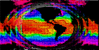



Report Prepared for NASA Earth Science Applications
By the Naval Research Laboratory

Applications of Satellite Ocean Products
For Naval Operations

“The Evolution of Navy Diver Visibility Products for Coastal Waters Using the NASA MODIS Satellites in Support of Operation IRAQI FREEDOM”

Robert Arnone Alan Weidemann
A. Rost Parsons Sherwin Ladner
Richard Gould Paul Martinolich

Naval Research Laboratory ,
Ocean Science Branch Code 7330
Oceanography Division
Stennis Space Center, MS 39529-5004
arnone@nrlssc.navy.mil

Table of Contents
Executive Summary 3
Introduction 5
1.0 Identifying the customer’s problem, existing capabilities, and product needs 8
1.1 The Problem during OIF 8
1.2 Operational Area and Special Requirements for the Persian Gulf Area- 9
1.3 Previous Operational Capabilities for Diver Visibility 12
2.0 Value added using satellite ocean color and evaluating its contributions to diver visibility 17
2.1 Baseline capabilities -- CZCS Satellite 17
2.2 SeaWiFS and APS 19
2.3 MODIS 25
3.0 Calibration and Validation Requirements 29
3.1 Issues in calibration and validation for coastal waters and OIF- 36
3.2 Product calibration and validation 50
3.3 Special validation for a customer 53
4.0 Making the Decision Support Tool for OIF- Expanding the science and setting up the product 55
5.0 Product Dissemination (Capturing the customer’s interest, responding to their needs, and implementing new specialized products -- The pro-active approach) 59
5.1 Chronology of rapid development and delivery of a 250 m resolution diver visibility product for OIF 60
5.2 Implementation 63
6.0 Post-evaluation-Benchmarking 69
7.0 Long term cost of developing MODIS Ocean Products in support of Operational Iraqi Freedom. 71
References 75

Executive Summary
This document describes the progression of Earth Observing Satellite ocean optical properties algorithm formation from research and development (R&D) to a Navy operational product. The document traces the “transition path” of remote sensing and optical oceanographic research, generation of science properties, exploratory development of potential Navy relevant products, to the distribution of specialized operational products which are used by Navy fleet operations. We describe how existing capabilities and infrastructure in place at both National Aeronautics and Space Administration (NASA) and Department of Defense (DOD) facilitated long-term and rapid product development and enabled near real-time distribution of the operational product to support a customer, in this case the Navy Warfighter. The process presented can be used as a guide and a model for any agency (such as NASA) that requires vertical integration of basic research efforts, the ingestion of large data with seamless data flow and processing, and the formation of decision support tools. These decision support tools are tailored to meet customer needs based on data availability/ distribution, algorithm development with calibration and validation, and then product dissemination in a usable fashion. This document describes how this process was accomplished for Diver Visibility in support of Operation IRAQI FREEDOM (OIF).
We describe the mechanism and support structure that is required to create ocean satellite products and the level of effort both in R&D, the system architecture development, and customer response and reach-back required to create a customer-tailored product line. Included in this is process is: 1) understanding the customer’s problem, requirements, and knowing what is currently available, 2) determining what contribution, decision support tool, and “value added” a satellite product can offer, 3) addressing the sensor calibration and validation required to meet the product’s needs, 4) movement of science based properties and satellite derived information to a product and decision support application, and 5) efficient dissemination of the product with customer participation, feedback, and product adjustment. In order to address the contribution that satellites can make to an application also requires the ability to handle the data and implement algorithms in an efficient, timely, and effective manner. This document addresses the issues associated with this process.
Our specific purpose is to describe the use of ocean parameters and their associated decision support tool development using Moderate Resolution Imaging Spectroradiometer (MODIS) satellite imagery. Specifically we illustrate the steps required in the above process that were undertaken to produce and distribute a underwater diver visibility and vulnerability product using near real-time access to the MODIS data stream. This effort was design to create a decision support tool for use by Explosive Ordnance Disposal (EOD) teams and Navy Special Warfare (NSW) operations in the Persian Gulf during OIF. As is demonstrated, the development of ocean operational products is not a simple process. While it can take place rapidly it requires inherent coordinated efforts of years of prior research, the infrastructure to allow creation and validation of the product and decision support tool, and coupled developer and customer (Navy Warfighter) interaction.
This document describes how a process was created at NRL-SSC Code 7333 Ocean Optics Section that includes retrieval of the data stream, image processing, evolution of the final products, and then distribution via the Internet to provide access to Naval operations in-theater within about 3-6 hours of the satellite overpass. Portions that will be highlighted are initial capabilities of the customer and of the satellite data flow, required calibration and validation of the sensor and the retrieved properties, product evolution, the coupling of the R&D community with feedback from the operational warfighter, and the development and distribution of the satellite products that were used to enhance the diving operations. We limit the details of the product evolution to the unclassified aspects and do not describe classified aspects that are related to specific customer requests. In the end, however, it will be shown how the MODIS satellite provided near real time diver visibility and vulnerability products at 250 m resolution in theater in support of OIF. The delivery of these products is a template for future transition of satellite products to a variety of customers.

Introduction
The utility of space borne satellite sensors for monitoring and understanding the ocean cycles is maturing. Our capability to detect ocean movements and understand coastal processes has been addressed by the R&D community for years, starting with the launch of the first ocean color satellite, the Coastal Zone Color Scanner (CZCS) in 1978. Follow-on ocean color satellite sensors include the multispectral Sea-Viewing Wide-Field-of-View Sensor (SeaWiFS), the MODIS, the Medium Resolution Imaging Spectrometer (MERIS), and the hyperspectral Hyperion sensor. These satellites provide the ability to detect subtle changes in the ocean color and have permitted retrieval of quantitative geophysical values of the ocean optical properties. We have matured in our ability to reliably extract ocean properties with these sensors. With higher temporal coverage, provided by new satellites, it is possible to monitor changes in the coastal environment. The need for high temporal coverage has been strongly requested by customers with coastal zone missions where the changing ocean properties require frequent or continuous updates.
For coastal applications there is a need for frequent updating of information. This is being addressed in planned next generations of ocean color sensors, which include satellites in geostationary orbit. These sensors will provide coastal monitoring on time scales under an hour. Therefore, future ocean color satellites will be capable of monitoring coastal processes such as river plume dispersion, tidal fluctuations, coastal jets and filaments, coastal advection, storm events, sediment resuspension, phytoplankton growth, and others. Coastal monitoring using these satellites is based on the optical signatures of ocean waters and the optical properties and techniques learned from past sensors. However, from a customer perspective the utility of these data, outside of research, is often not explored thoroughly nor is the customer’s problem addressed. Consequently, the application of the satellite information is not exploited. One use of satellite data that until recently has been largely overlooked is in the development of decision support tools. But issues of identification of customer needs, satellite calibration and validation, data flow, product development, and customer acceptance have not been addressed. A substantial commitment of time and resources from both the researcher and the end-user of the application are required to produce useful products from these data.
Our ability to derive and deliver routine customer based ocean products from satellite ocean color has resulted from four advancements.
In the last two decades there have been major breakthroughs in:
- Calibration and validation (including radiometric calibration, measurement protocols of optical properties of the water and remote sensing reflectance, data match-ups, and sensor monitoring),
- Management of data flow and standardization of formats for data transfer,
- Increased computational capabilities that allow for immediate testing and implementation of new algorithms and product implementation, and
- Development of new rapid methods for information dissemination.

The later has been the most important to the customer; if they cannot get the product or do not know it is available then they have little to benefit from the product development. Furthermore, in most cases, the advances in science have exceeded the ability of the research and applications communities to couple the research products with applied products. In other words, there is a “disconnect” between the science and the technology with the customer base. For example, from the research perspective, new algorithms to estimate the optical absorption and backscattering coefficients from space are extremely valuable tools. On the other hand, the end-user (the warfighter in this case for the Navy) has no direct use for this scientific information. From the customer’s perspective, they require a simple derived product that focuses on the operational parameter of interest. The customer has specific applied problems that sometimes are distantly related to the basic research. Therefore, to reach our customer base, we must demonstrate how resolving the fundamental spectral optical properties of the water impacts Navy operations.
This document presents an example of how an operational product was generated from R&D satellite properties to provide unique customer support and a decision support tool. Specifically, we show how the MODIS (Terra and Aqua) and SeaWiFS satellites were used to generate diver visibility and vulnerability products to support Navy divers during OIF.
By combining NASA satellite ocean color imagery, NRL-SSC research capabilities in ocean optics, and customer interaction, we successfully developed a new satellite product tailored to the needs of our customer.
Here we demonstrate the progressive steps that occurred in advancing from a R&D project to the implementation and dissemination of an operational product. The process is described in the following steps:
- Understanding the customer’s problem, his requirements, his knowledge base, and the fundamental research that can help with his problem,
- Determining what contribution, decision support tool, and “value added” a satellite product can offer including what has been previously used from other satellites, and what data flow steps need to occur,
- Addressing the sensor calibration and validation required to meet the product’s needs,
- Movement of science based properties and satellite derived information to a product and decision support application, and
- Efficient dissemination of the product with customer participation, feedback, and rapid changes to meet the customer’s needs.

An important component in addressing “the value added” that satellites can make to an application is assessing the efficiency and “speed” of product formation when a product change is required. This includes data handling, quality control (QC), algorithm updates, continuous calibration and validation, and “getting the information to the user.” This document addresses the issues associated with this process. We use the chronology of events associated with delivery of a diver visibility/vulnerability product in OIF to demonstrate how customer request, algorithm development, product generation and adjustments, and finally distribution can take place on short time scales.

1.0 Identifying the customer’s problem, existing capabilities, and product needs
In the progression of “R&D” to an application, the first step is always identifying the problem that is being addressed and the present operational solution. Assuming a problem is identified, a thorough understanding of what limitations and contributions can be made toward the problem from satellite derived information is required. The problem that is addressed in this document is diver visibility for Navy applications.

1.1 The Problem during OIF
Divers and camera systems are limited by the visibility of the water. Poor visibility restricts the capability of divers to detect underwater objects and restricts operations. Navy divers are required to conduct underwater identification of objects i.e. mines or navigational hazards located by acoustic systems. In addition, search and rescue operations and covert operations, where acoustics detection is not allowed or feasible, requires divers to locate objects on hulls of vessels, bottom obstructions, and visually clear ingress routes for follow-on operations. For their mission in OIF EOD divers were required to identify underwater objects which were detected by acoustic systems. Since their operations are time and risk sensitive, and because there are specific stand-off requirements that a ship must use as part of their Standard Operating Procedures, poor visibility results in higher risk to the ship and the diver (i.e. both need to get closer to a potential threat that is being examined). Additionally, divers were required to inspect ship hulls exiting the Tigris-Euphrates River as they entered the Persian Gulf. The hull inspection for potential threats to in-theater forces required divers know the visibility in order to optimize “where to do the inspection.” Consequently, the greater the visibility the more vulnerable a diver is to visual detection from above the water’s surface by an observer. In the above operations diver visibility and vulnerability (due to daylight operational requirements) are critical operational parameters that impacted operations in the Northern Persian Gulf. The task for remote sensing is to determine how to use satellite ocean color properties to obtain the key parameters in horizontal (identification) and vertical (vulnerability) visibility estimations. This includes determining how to get such information to the warfighter in a timely and operational manner.

1.2 Operational Area and Special Requirements for the Persian Gulf Area-
The majority of maritime operations for OIF were focused in the northern portion of the Arabian Gulf and the Khawr Abd Allah (KAA) waterway. Deriving tactical environmental products from the optical properties of the Arabian Gulf to support OIF was challenging due to the complex and varied oceanographic conditions. Extended aircraft carrier flight operations during OIF and Maritime Intercept Operations (MIO) did require NRL-SSC ocean environmental support over most of the Middle East region (Red Sea, Eastern Mediterranean Sea, Gulf of Oman, and Arabian Sea) but the Arabian Gulf support was viewed as the most crucial to operations.
The Arabian Gulf is very shallow with a mean depth of only 35 meters. Even with these shallow depths, the arid climate and unimpeded connection to the Arabian Sea through the Strait of Hormuz and Gulf of Oman establishes unique oceanographic conditions. Fresher surface waters flows northward into the Gulf through the Strait while oxygen rich saline water, formed due to high evaporation rates, flows southward out of the Gulf at depth. The surface circulation in the southern Gulf is generally characterized by a cyclonic gyre due to this inflow. Circulation in the Northern Gulf is primarily dominated by along-axis wind forcing that generates southeastward flowing coastal currents along both the Arabian and Persian coasts. Along the northeastern shore of the Gulf, these coastal currents induce upwelling favorable conditions that lead to enhanced chlorophyll plumes which can be observed in remotely sensed data (Johns et al., 2000) (Fig. 1).
Several other features contribute to the observed variability of ocean properties. The primary fresh water flux into the northern Gulf comes from the Tigris-Euphrates river system that discharges into the Northern Gulf. These discharges are laden with fine sediments as well as carbonate sands and generally are carried along the western coasts of the Gulf southwards (Basham and El-Sayed, 1998). The discharges can be clearly seen in the ocean color imagery (MODIS true color) and are observed in imagery loops to be oscillating with the tides (Fig. 2). Additionally, periods of strong northwesterly winds predominate in summer months, called shamals, can carry dust and terrigenous material far out over the Arabian Gulf both contributing to the sediment loading as well as limiting retrieval of ocean optical properties. In the winter months, northwesterly winds following frontal systems can also generate significant dust events in the northern Gulf. It is estimated that one-third of all bottom sediments in the Arabian Gulf are of aeolian origin (Sugden, 1963),
Tides in the Arabian Gulf are also complex as the forcing is derived from co-oscillation with the Gulf of Oman through the Strait of Hormuz. Two semi-diurnal amphidromes (one north and one south) and a single diurnal amphidrome are observed. As such, some locations with the Gulf are primarily diurnal while others are mixed or semi-diurnal. The semi-diurnal tidal amplitude has a local maximum in the northern Gulf creating significant tidal currents affecting both optical variability and diving conditions on short time and spatial scales.

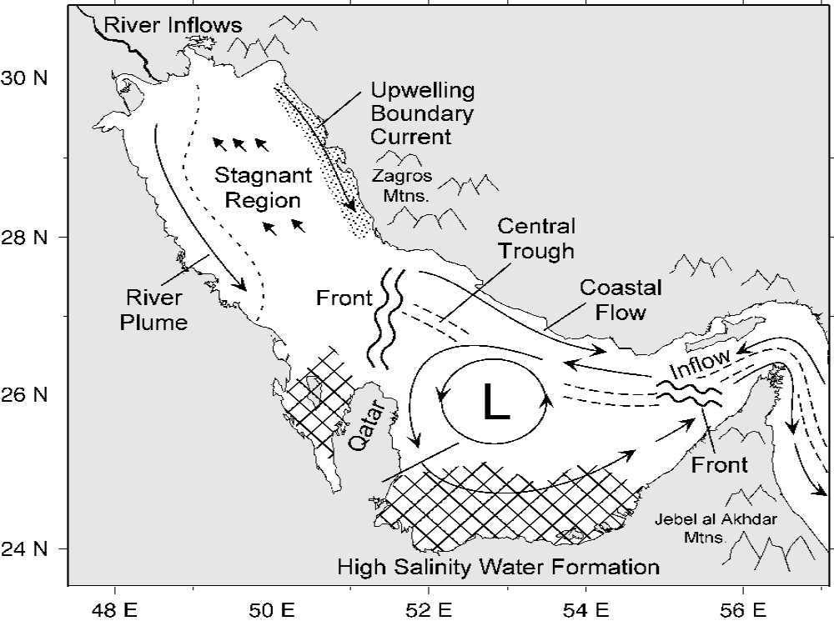
Figure 1. - General Oceanography of the Persian Gulf
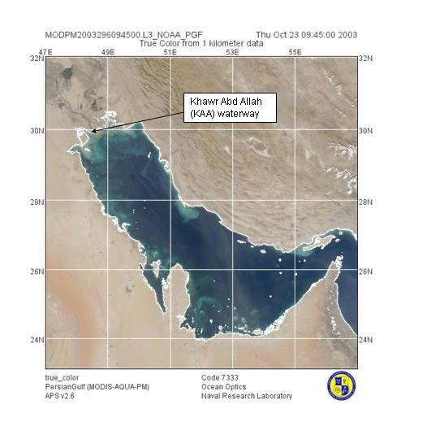
Figure 2. - Persian Gulf imaged by MODIS AQUA - True Color (Channel 7, 8, 10) – 1 km

1.3 Previous Operational Capabilities for Diver Visibility -
Diver visibility has long been an issue as a product for the operational Navy. It has been a “requirement” without an official product line associated with it. Part of this has been due to the unpopularity of previous visibility products that the Navy used, and the historically “blue water” Navy for which diver visibility was a secondary problem. As Mine Warfare, Special Forces operations, and shallow water Antisubmarine Warfare increased in importance in the coastal environment, the end-user’s interest in the diver visibility product increased sharply.

1.3.1 Theory of Diver Underwater Visibility.
Historically very detailed nomographs were developed in the 1950’s and 1960’s by S.Q. Duntley (1952, 1960) that used contrast transmittance theory to derive underwater visibility based on extrapolation of the atmospheric concepts to give a “hydrologic range.” Fundamentally, the contrast transmittance theory states that the diver visibility range for an object is reached when the contrast threshold of the human eye is reached and there is no “discernable difference” in radiance between the object and its surrounding medium. The inherent contrast (range at zero distance) and the contrast at range ‘r’ for the target (i.e. the apparent contrast) are described by:
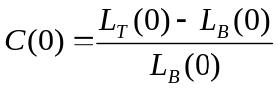 and 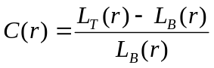 ,
where C(0) and C(r) are the inherent contrast and contrast at range ‘r’; and L_{T} and L_{B} are the radiances of the target and background respectively. Underwater, solar light is attenuated approximately exponentially with depth. The extinction rate of this light is described by the “diffuse attenuation K_{d.}” In early formulations for diver visibility it was assumed that the underwater light field had reached a condition in which the light field distribution no longer changed, except in intensity (i.e. reached the asymptotic condition and K_{d} was constant). It was also assumed that the target was “small enough” and/or “at sufficient distance” that the radiance from the target propagates as L(r) = L(0) e^{-cr} where ‘c’ is the total attenuation coefficient. The total attenuation coefficient ‘c’ represents the loss rate in transmission along a path due to the sum of absorption ‘a’ and scattering ‘b’.
Through radiative transfer theory (see Bowers 2003 for further details) it can be shown that the contrast at range r and at look angle θ can be described by:
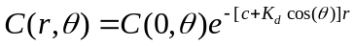
When the sight path distance (range, r) is such that the apparent contrast C(r) is equal to the eye’s threshold limit (i.e. the contrast threshold C_{Threshold}), then this distance represents the visibility range. By setting C(r) equal to C_{Threshold} and then solving for the range we arrive at:
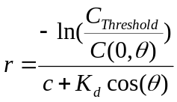
which, in the special case of horizontal viewing (K_{d} cos(θ) = 0), reduces to
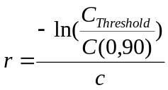.
The nomographs for diver visibility were developed on sound fundamental physics. However, these charts required target information and optical property measurements that were not available at the time (specifically ‘c’ and K_{d}). But they did give visibility as a function of light level, solar angle, target reflectivity, look angle, etc. all which are important to accurate visibilities estimates. The assumptions for these nomographs were: a) the presence of a vertically and horizontally homogenous ocean, b) use of a black target, c) divers are deep enough so that an asymptotic light field is present, and d) the contrast threshold for the human eye is a fixed value of about 0.02. In the final analysis, however, the customer rejected the nomographs as “impractical” and “valueless” since insufficient information regarding the inputs was available. In addition, the charts could not be used on-scene and the divers could not decipher the scientific quantities required. There was confusion on “where to get the inputs”, and even how to use the nomographs.
In an effort to keep the basic information provided in the nomograph, diver visibility prediction was reduced by simplifying the problem. Using the 0.02 for C_{Threshold}, the above equation can be reduced to a single horizontal visibility of 3.9/c (rounded off to the 4/c in common use). But as shown by numerous investigators the “background illumination”, eye adaptation level (ranging from <0.006 to > 0.03; depending on exposure time), water color, etc can cause this relationship to vary from 3.5/c to about 6.3/c. This range is problematic for diver visibility prediction particularly when values for “c” were not available on-scene with instrumentation available to the warfighter.

1.3.2 Secchi Depth - Solution
The utility of the nomographs required that specific optical properties of the waters are available. These measurements were difficult to obtain, especially in foreign areas. Without a viable alternative the Navy opted to use the Secchi Disk as a measure of visibility. The Secchi disk is an 18 cm white disk that is lowered into the water until it “just disappears” from the human eye. It is a measure of “water clarity.” The Navy developed a global climatology atlas of the seasonal “Secchi depth” to determine the optical properties of strategic regions for operational planning (Arnone, 1985). This atlas was developed from data gathered by the National Oceanographic Data Center and from open literature for water depths less than 500 meters, but still the spatial and temporal coverage was severely limited (Fig. 3). Note that little information is available for the Area of Interest (only a few “large areas”). However, even with limited measures of actual visibility available, the Secchi Disk visibility developed into the present water clarity and visibility product provided by Naval Oceanographic Office (NAVOCEANO) for the Special Tactical Oceanographic Information Charts (STOIC). When data is available for total attenuation, 4/c is used to give a “seasonal or regional diver visibility.” With the wide range in Secchi Disk values, and few at-sea measurements of “c”, the product is not utilized by normal fleet operations.
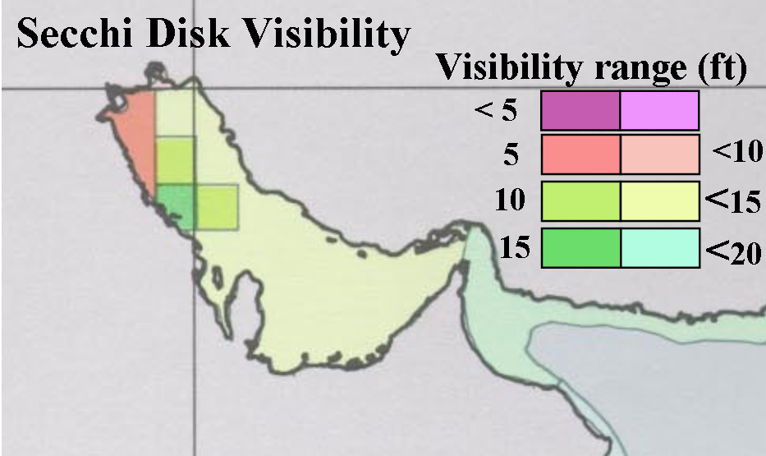
Figure 3. - Secchi Disk Visibility in Persian Gulf
-
It is in the context of the deficiencies in existing operational diver visibility products and the complexity of the operations in the Persian Gulf that motivated development of a diver visibility decision support tool for Navy operations. Several key points about the customer’s requirements can be made.
- First, to this point there is no on-scene capability. With the oceanographic complexity for the area and the time-critical nature of operations, this was a foremost requirement from the customer. Even the digitally available STOIC was insufficient for tactical use in the area.
- Second, only regional and seasonal “best statistical” information is available.
- Third, temporal and spatial information is lost even if it is available due to the method of dissemination. As requests arise for higher and higher spatial resolution for riverine and coastal operations none of the existing capabilities meet this need.
- And lastly, the climatologically based product did not meet the needs of the warfighter to rapidly assess areas of high and low diver visibility present during OIF.
The utilization of satellite ocean color to produce an operational product addressed these deficiencies.

2.0 Value added using satellite ocean color and evaluating its contributions to diver visibility
To evaluate the contribution and value-added that satellite ocean color can make to diver visibility and product generation requires knowledge of the evolution of ocean color satellite capabilities and what was, and is, done with the data provided. To act as a guide in product formation, previous work and use of satellites such as the CZCS and SeaWiFS for providing oceanographic information is examined. This previous work is the template for product development at NRL-SSC. Work from these sensors define the infrastructure and foundation required for data flow, sensor and property calibration and validation, algorithm development, product formation, and product dissemination used in the diver visibility product created using the MODIS 250 meter channels. When modifications in the process are required they can be quickly implemented to provide a more valued product.

2.1 Baseline capabilities -- CZCS Satellite
With the launch of the CZCS (1978-1986 operational lifespan) the Navy environmental optical research programs matured. This was the first multi-spectral ocean color sensor capable of quantitative ocean radiometry. This satellite pioneered space borne retrieval of ocean bio-optical properties and provided the first global understanding of the Earth’s bio-optical climate. The satellite was specifically designed for bio-optical environmental applications and had four visible channels (443 nm, 520 nm, 550 nm, 670 nm, all with 20 nm bandwidths). The two most important aspects of the satellite to Navy applications were the demonstration of increased spatial coverage, particularly in denied access areas, and the capability to retrieve optical information from space borne platforms. Optical maps were developed with this sensor which demonstrated the ability of a satellite to derive optical properties, such as the diffuse attenuation coefficient K_{d}(490), from space (Fig. 4). For CZCS this property was obtained for the bands of 443, 520, and 550 nm by using the 670 nm band for atmospheric correction. The property represented a measure of water clarity beyond the Secchi disk.
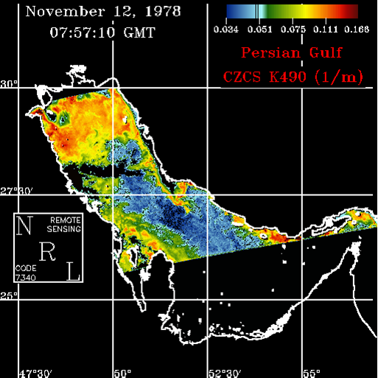
Figure 4. - CZCS K_{d}(490)
Because satellites penetrate the surface, and radiance from all points below the surface contribute to upwelled light, the value of K_{d}(490) represents an integrated value. But as presented above, the K_{d}(490) can not be directly applied to diver visibility in a straight-forward fashion. Since CZCS was designed for monitoring of changes in chlorophyll, it was not optimized for extraction of optical properties. Data was distributed to users as tapes weeks after collection. Limitations arose with continuous reprocessing of the data when changes in calibration or modifications in the algorithms occurred. The limited extent to which this data could be processed, or more appropriately reprocessed, difficulties in distributing data to the users, and problems with sensor calibration left this sensor as a “first” step toward a satellite used for ocean optical property retrieval. Attempts to improve the issues of sensor calibration, improved atmospheric correction, and inadequate validation programs were developed for the follow-on SeaWiFS program. Even so, the capability offered by satellite retrieval of bio-optical properties showed a potential contribution to the problem of diver visibility. The extensive coverage area and large data volume could vastly improve the “Secchi Disk climatology”. Thus the Navy identified optical data derived from ocean color satellites as a present and future solution to many Navy optical requirements.

2.2 SeaWiFS and APS
As a CZCS follow-on, the SeaWiFS sensor developed jointly by Orbital Sciences Corporation and NASA was launched August 01, 1997. This has been the research sensor for algorithm development to uncouple optical properties from remote sensing reflectances, the baseline for long-term calibration and validation efforts for oceanic studies, and the standard for development of data flow. It was past work with this sensor that resulted in the rapid product formation during OIF with the MODIS imagery.
The SeaWiFS project office is based at Goddard Space Flight Center (GSFC); its mission is to make the ocean color sensor “science ready” through an extensive calibration and validation effort. The Goddard Data Active Archive Center (DAAC) provides data to NASA-authorized users. Because this is a joint NASA/industry venture, researchers experience a 2-week data delay and commercial users must purchase the data from Orbital Sciences. For operational use, however, such a delay is unacceptable.
An advantage for the customer from SeaWiFS is that it can provide locally available high resolution data transmitted during the overpass and then global data from the Goddard data archive. SeaWiFS provides Local Area Coverage (LAC)/High Resolution Picture Transmission (HRPT) coverage at a swath width of 2801 km and Global Area Coverage (GAC) coverage at a swath width of 1502 km. SeaWiFS has a ground pixel resolution of 1.1 km for LAC and 4.5 km for GAC coverage. Another sensor attribute for the Navy is that SeaWiFS has overlapping orbits so that it covers any point on the globe at least one time per day. NRL-SCC is one of 128 authorized NASA research stations globally for receiving SeaWiFS high resolution LAC/HRPT data and one of five authorized by NASA for covering the Continental US in real-time. NRL-SSC captures every SeaWiFS pass covering the Gulf of Mexico and transmits the data to the SeaWiFS Goddard DAAC for archiving and dissemination. The importance of being a receiving site is that this allows NRL-SSC to develop and test algorithms for various applications.
The SeaWiFS sensor was specifically developed for ocean color applications. It has 8 channels, six visible channels for ocean color and two channels in the near-infrared for atmospheric correction (Table 1). The two infrared channels for atmospheric correction channels are a specific result of the problems associated with CZCS. Channels in the blue end of the spectrum are used to partition colored dissolved organic material (CDOM) and phytoplankton absorption. The baseline SeaWiFS bio-optical capability for the Navy includes all the standard algorithms approved by the SeaWiFS science team and developed by NASA in collaboration with university investigators and government agencies. NRL-SSC played an important role in providing software and algorithm capabilities specifically designed for coastal properties (see Section 3).
Table 1. - SeaWiFS Bands and primary algorithm contribution.
Waveband | Spatial Resolution | Normal Algorithm Use
402-422 nm | 1 kilometer | Dissolved Organic Matter and Detrital Absorption
433-453 nm | 1 kilometer | Chlorophyll concentration, Particulate Absorption
480-500 nm | 1 kilometer | Chlorophyll concentration
500-520 nm | 1 kilometer | Total Absorption, Separation into components
545-565 nm | 1 kilometer | Phytoplankton separation, Sediment concentration
660-680 nm | 1 kilometer | Chlorophyll concentration, Particulate Absorption, Phytoplankton Fluorescence, Bottom classification
745-785 nm | 1 kilometer | Aerosol type, Atmospheric Correction
845-885 nm | 1 kilometer | Aerosol type, Atmospheric Correction

As a research satellite and project, SeaWiFS resulted in the development of many required algorithms to uncouple remote sensing and optical properties of the water. Most of these algorithms are semi-analytical and therefore have physical basis that can be exploited in creating customer specific products. The properties that are relevant to the diver visibility product are the spectral absorption coefficient which is separated into the particulate and dissolved components, the spectral backscattering components, the diffuse attenuation coefficient, and atmospheric correction techniques. These algorithms are investigated through joint NASA/Navy efforts and are under constant validation, re-examination, and modification. Each derived property, calibrated radiances, and data manipulation undergoes calibration and validation processes outlined Section 3. These algorithms form the basis of those being developed for MODIS and consequently were used in the development of a diver visibility product for OIF.
With 1 km daily global coverage the data volume from SeaWiFS was much greater than previous imagery. In order to provide data in a timely manner, to meet research and application needs, to meet requirements of calibration and validation, and to handle the continuous and growing stream of satellite data, NRL-SSC developed an Automated Processing System (APS). Originally, the system was designed to produce sea surface temperature maps from data collected by the Advanced Very High Resolution Radiometer (AVHRR). The APS provides for near real time processing with the option of reprocessing historical data. The advantage of this system is that the processing method can be continuously modified which allows for easy implementation of new algorithms, test data sets for validation, and customized user specific products.
APS consists of a collection of UNIX programs and shell scripts designed to generate map-projected image databases of satellite derived products from a large flow of raw satellite input data in an automated fashion. The APS uses a simple monitoring technique. The main driver regularly polls a specified input directory for incoming data. For each data set found the driver executes what are known as areas scripts on the file in a working directory. Area scripts allow modification and customization of outputs for selected geographical regions. After each area script has been run on the file, it is moved to an output directory. This method uses the directory as the queuing system for data to be processed. The areas scripts do the actual construction of the desired results (i.e. the databases). The system executes on Red Hat Linux 7.1 and SGI IRIX 6.5 (Martinolich, 2001).
The processing steps are as follows. APS first applies sensor calibrations to convert from digital counts to calibrated radiances (Level 0 to Level 1a). Next, conversion of the level 1a through 1b and then to the level 2 occurs by applying a radiance calibration/correction and implementation of the atmospheric correction procedures. Following atmospheric correction (level 1b to level 2) the derived remote sensing reflectances are input into bio-optical algorithms to yield the final bio-optical properties (Fig. 5). The optical properties and the derived products are processed to four different temporal (daily, 8-day, 8-day latest valid pixel, monthly, and yearly) composites or averages (level 3 to level 4) to remove the effects of clouds and to show trends in seasonal features. The resulting imagery is stored in the Hierarchical Data Format (HDF) used by NASA in its satellite product archive. The APS also automatically generates quick-look “browse” images in JPEG format that are used to populate an SQL database for product dissemination and queries by potential customers. At each step quality control (QC) checks are routinely done and imagery examined for continuity and consistency.
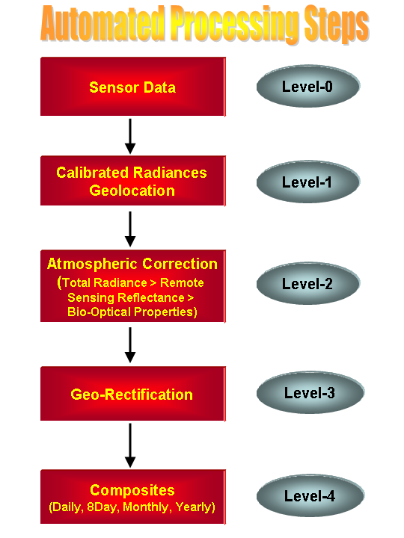
Figure 5 - Automated Processing System steps
Navy work under the SeaWiFS program included environmental R&D through transition of the APS and automated production of optical properties. SeaWiFS has been used as a “test bed” for developing ocean optical products. This effort established a transition mechanism for optical products for the Navy. The advancements included the daily production of 1 km optical properties in selected regions using APS, enhancements in data flow and format structure, improved stability of the sensor and calibration/validation protocols, and the development of optical property retrievals. Increased coverage and the use of APS to process data in a timely manner (a matter of hours instead of days and weeks) and then dissemination of a product to the user resulted in a merging of the R&D and a customer. The processing speed and the 1 km resolution demonstrated to the Navy the application potential for this sensor. Consequently, the Navy purchased three licenses from Orbital Sciences and established three regional S-band Terascan antennas to capture SeaWiFS imagery over strategic regions. These ground stations are located at Naval Meteorology and Oceanography (METOC) centers at Rota, Spain, Yokuska, Japan, and Manama, Bahrain.
With the multiple ground stations, the Navy has local satellite coverage in several strategic areas of the globe. NRL-SSC plays a critical role in the exploitation of this imagery. Imagery from these sites is transferred to the Naval Oceanographic Office and then to NRL-SSC for real-time processing (Fig. 6.) using APS. As shown in Figure 6, imagery from the regional center is transferred to NAVOCEANO to an ftp site where it can be processed by NAVOCEANO. NRL-SSC can access the data from the NAVOCEANO site and Level 0 data is moved over to NRL-SSC and ingested into the APS system. In order to meet regional needs, quick look images are posted on a password protected web site (see Section 5). The processed optical properties and resulting customer products (Level 3 and 4 data) are put in HDF format for achieving and distribution to the customer.
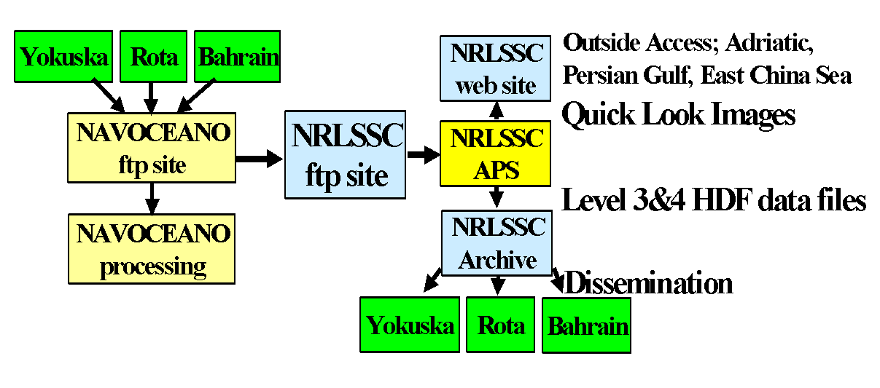
Figure 6 - Data Flow from Regional Center and NAVOCEANO to NRL-SSC

The SeaWiFS imagery provided evidence of the impact that remote sensing could have on situational awareness for Navy operations. The 1 kilometer biological and optical properties provided quantitative information on the changing environment. However as an operational product it did not meet the customer’s needs because details were required at higher spatial resolution.
Table 2. - MODIS – First 18 Channels

2.3 MODIS
Channel | Waveband  nm | Spatial  Resolution | Application
1 | 620-670 | 250 m | Land
2 | 841-876 | 250 m | Land- Atm Correction
3 | 459-479 | 500 m | Land – Blue
4 | 545-565 | 500 m | Land – Green
5 | 1230-1250 | 500 m | Land – NIR
6 | 1628-1652 | 500 m | Land – NIR
7 | 2105-2155 | 500 m | Land – NIR
8 | 405-420 | 1 km | Ocean CDOM
9 | 438-448 | 1 km | Ocean Chlorophyll
10 | 526-536 | 1 km | Ocean Particles
11 | 546-556 | 1 km | Ocean Particles
12 | 662-672 | 1 km | Ocean Particles
13 | 673-683 | 1 km | Ocean Fluorescence
14 | 743-753 | 1 km | NIR- Atm. Correction
15 | 862-877 | 1 km | NIR- Atm. Correction
16 | 890-920 | 1 km | NIR- Atm. Correction
17 | 931-941 | 1 km | NIR- Atm. Correction
18 | 915-965 | 1 km | NIR- Atm. Correction
The first MODIS instrument was launched December 18, 1999 aboard the Terra (Earth Observing System (EOS) AM-1) spacecraft. MODIS Terra is in a descending orbit and passes over the equator at 10:30 AM. It is in a sun synchronous polar orbit. The MODIS Terra has a total of 36 bands. Of these bands there are 18 that are used extensively in oceanographic research. Two bands (center band at 645 nm, and 858 nm) are imaged at a nominal resolution of 250 m at nadir, and 5 bands (469 nm, 555 nm, 1240nm, 1640 nm, and 2130 nm) at 500 meters. The remaining bands have a spatial resolution of 1 km (Table 2). It was the combining of channels with differing spatial resolutions that was an important step in the product formation for OIF.
MODIS Terra provides LAC at a swath width of 2330 km (cross track) by 10 km (along track at nadir). Similar to SeaWiFS, MODIS- Terra covers any point on the globe at least once every one to two days. In order to meet needs specific to Navy applications, the Navy has established a regional X-band Terascan antenna to capture MODIS imagery over the strategic Persian Gulf region. This ground station exists at the Bahrain METOC center. While MODIS imagery from this site was not used by NRL-SSC for the OIF customized product, the goal of the OIF effort is for future formation of the product at a METOC Center.
The second MODIS flight instrument was integrated on the Aqua (EOS PM-1) spacecraft. It was successfully launched on May 04, 2002. MODIS Aqua is similar to the MODIS Terra sensor except Aqua collects daytime data during an ascending orbit, which crosses the equator at 1:30 PM. Together with MODIS Terra and SeaWiFS, this trio of sensors provides a critical “three looks per day” at an operational region. The “three-looks” per day for strategic areas permits assessment of rapidly changing optical conditions and reassures the customer that time-critical information that impacts diver visibility missions is available (Fig. 7).
The NASA MODIS science team developed MODIS bio-optical algorithms and processing software. These algorithms were extended by the NRL-SSC into coastal areas through improvements to atmospheric correction and in-water optical algorithms. These algorithms are currently being tested and evaluated. The MODIS Terra is currently being integrated into operations at NAVOCEANO with a follow-on of MODIS-Aqua in scheduled in 2004. For the most part the algorithms and optical properties are extensions of those developed under the SeaWiFS program. However contributions in the form of coastal specific atmospheric corrections were added and will be discussed in the calibration and validation section. Also, because of the additional wavebands available in MODIS, new algorithms were developed for fluorescence, phycoerythrin and phycobiliproteins, chlorophyll a concentration, and CDOM absorption. The development of APS serves as a link between this algorithm research and Navy operations. As such any new algorithms (such as for bio-optical properties) that arise in research or improved or new calibration coefficients that must be applied can be implemented immediately. For MODIS processing, the inclusion of biweekly updates in the calibration coefficients are critical. The MODIS Calibration and Science Team (MCST) maintains a close biweekly calibration update of Look-Up Tables which is used to generate Level 1a from the Level 0 data.
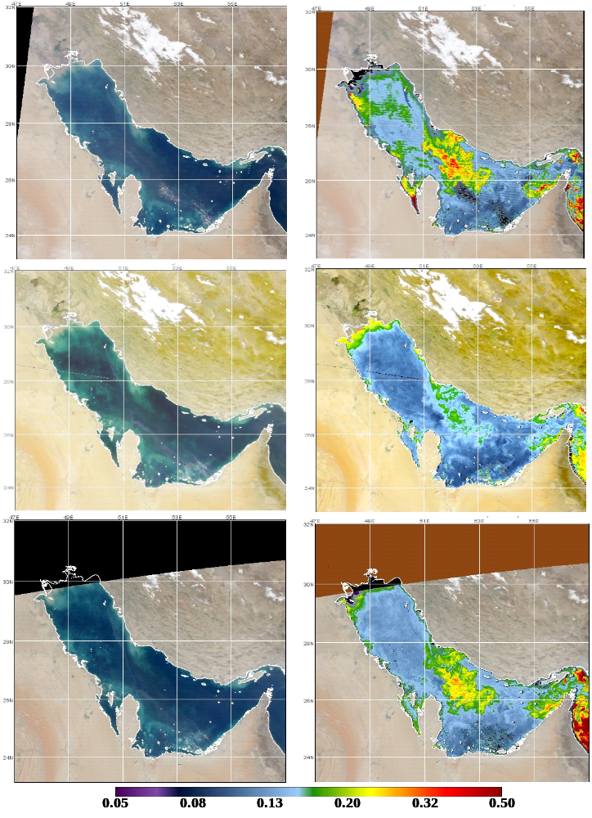
Figure 7. - MODIS AM, SeaWiFS, MODIS PM True Color and Diffuse Attenuation Coefficient K_{d} (532) on 7 Feb’03 showing 3 looks per day (K_{d} is m⁻¹).
Currently, NRL-SSC uses the level 1a data in APS and in the past relied on the receiving sites to apply the correct calibration in generation of Level 1a. As will be shown later, receive sites and MODIS data distribution centers do not always update this software in a timely fashion. As a test bed for MODIS software and algorithms NRL-SSC can quickly examine state-of-the-art updates, go through calibration and validation, and then transfer these from the research community into potential operational products.
To achieve the “three looks a day” on a timely basis for the Persian Gulf required several modifications to data flow (Figs. 5 and 6). MODIS data is transmitted from multiple sites to NRL-SSC. Persian Gulf and Adriatic imagery was initially acquired from the Goddard DAAC which resulted in a 2 day delay (unacceptable for real-time missions by the customer). To solve this problem an agreement between the NOAA /NASA and NRL-SSC was reached by streamlining data transfer using a “bent pipe”. The “bent pipe” for MODIS data is located in Building 32 at Goddard, where the global MODIS data stream is being sent to the DACC for processing on MODAPS.
As the global data set is being sent, subsets of these data (critical areas) is duplicated and stripped out to meet immediate needs. While all the global data set is sent to the DACC, the “bent pipe” provides a real time data flow that otherwise would take several days to obtain. A subscription to theses critical areas was used by the Navy, Air Force, and NOAA and provided to several users through the DREN (Defense Research Educational Network). These data were obtained at NRL-SSC through the DREN from the bent pipe within 2-3 hours after the imagery collects and was used to support the war effort for real time needs. A direct file transfer protocol (ftp) was developed that allowed NRL-SSC to receive all MODIS (MOD02) Level 1b data as soon as NOAA completed processing. This improved the data flow for rapid-response and delivery of Navy optical products from MODIS imagery. NRL-SSC retrieved MODIS granule from the Persian Gulf, Arabian Sea and the Red Sea. A granule represents an area of approximately 1 minute of satellite data which is approximately 500 square km. For each MODIS satellite there are three granules for each area at different spatial resolutions 1) 250m (channels 1-2), 2) 500m (channels 3-4) and 3) 1000m (channels 6-32). Each granule is approximately 1 gigabyte. NRL-SSC obtains approximately 5 -10 gigabytes per day of MODIS data. This large data volume limits the number of ocean products that can be produced since both Terra and Aqua data are obtained. The limitations of the DREN network impact the processing capabilities at the present time.
MODIS imagery is also collected for the Gulf of Mexico and U.S. East Coast via Goddard’s Direct Broadcast System, while imagery from the U.S. West Coast is pulled from Oregon State University. NRL-SSC receives and processes approximately five gigabytes of SeaWiFS and MODIS imagery on a daily basis for many different areas of the world. When a customer requests a product and imagery for an area, special scripts can be written to develop a “custom” tailored region with specific processing and product formation using APS. The results are assessed by the customer via web pages (secure and unrestricted/password protected).

3.0 Calibration and Validation Requirements
Before supplying the customer with either standard optical properties or a customized product, extensive calibration and validation efforts are necessary. Both SeaWiFS and MODIS satellites have calibration and validation efforts that continuously are evaluated and for which NRL-SSC processing and field efforts are an integral part. Calibration and validation is much more than just algorithm formation and testing, particularly for customized products such as those required by the Navy. Calibration and validation efforts are required at several levels that include:
- Pre and post launch sensor calibration,
- Long-term sensor stability and application of accurate calibration coefficients,
- Bio-optical property and water leaving radiance match-ups,
- Vicarious calibration at monitoring areas and local data collects for inter-sensor comparison, and
- Customer product validation, evaluation, and calibration.

Each type of effort occurs at various stages between sensor radiance collection/down-link and delivery of the final product. In order for NRL-SSC to produce dependable operational products Quality Control (QC) checks are conducted on sensor output, the atmospherically corrected radiances, the calculated normalized water leaving radiances, retrieved optical properties, and derived products. Consistency amongst various optical properties and oceanographic features is used to recognize subtle changes in algorithm performance. These procedures are nominally applied to the 1 km SeaWiFS, MODIS Terra, and MODIS Aqua sensors output. This provides a sensor to end-product/user calibration and validation (including on-scene feedback).
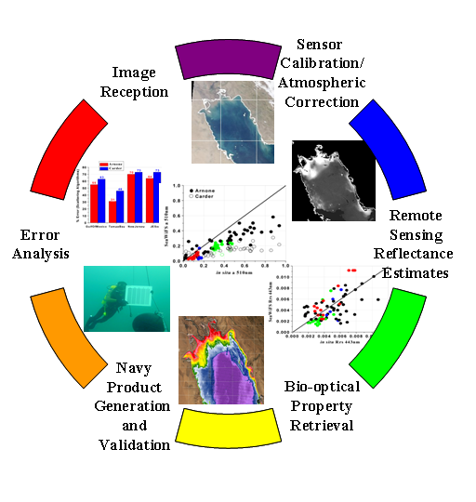
Figure 8. - Calibration/Validation process for data collection and product dissemination

Figure 8 is a generalized representation of the cross calibration and validation efforts that take place in developing and delivering a useful product. The first calibration and validation step is in the image reception with identification of a bad data stream. These can occur when improper decryption coefficients have been applied. During processing of the raw level 0 imagery to level 1, the sensor calibration and atmospheric corrections are applied. As will be demonstrated below, lack of careful monitoring and application of calibration coefficients can result in a poor quality product. Long-term temporal monitoring programs and in situ field programs provide calibration and validation points for the remote sensing reflectances derived from the satellite. Sensor calibration changes can also be evaluated in this fashion. For multiple sensors that pass over the same area in a close temporal period, the comparison (and perhaps calibration) of one sensor with the other is valuable. For OIF this type of calibration was important since the SeaWiFS satellite has been more extensively characterized than MODIS and is used as the “radiometrically correct standard” for areas without field-truth. The process of vicariously calibrating sensors (i.e. using ground-truth and other sensors to monitor performance) is important to make a seamless transition from one sensor and its algorithms to another sensor. The next step in Figure 8 is the validation of retrieved optical properties with those measured in situ. For coastal areas there are issues of spatial variability (addressed below) questioning how to best accomplish this, particularly for denied access areas. Lastly is the product validation. While being the most important phase, it is also the most difficult since data is seldom available and therefore the validation requires constant customer feedback for the customer to the developer. In each part of the process error analysis is conducted to determine where future efforts should be concentrated.
Figure 9 illustrates the specific process which is used to generate Navy ocean products (Arnone et al., 2003). This process is constructed and based on radiometric accuracy of the sensors and standardized procedures so that universal algorithms can be applied to develop a Navy product (this is discussed in more detail in the next section on “match-ups”). The process ensures a procedure for developing the most accurate Navy product for global applications in areas where no in situ observations are available. To accomplish this requires strict radiometric control which is maintained through the entire product generation process. The process is being applied to SeaWiFS and MODIS to successfully generate products. This process will be applied to follow-on sensors to insure consistency in Navy products and permit new algorithms to be defined. The process is very closely aligned with NASA- and NOAA product development. However, there are some differences. Differences arise in that the Navy’s requirement for a real time capability that can be developed within the calibration-validation procedures, whereas NASA-NOAA looking for long-term changes and capabilities.
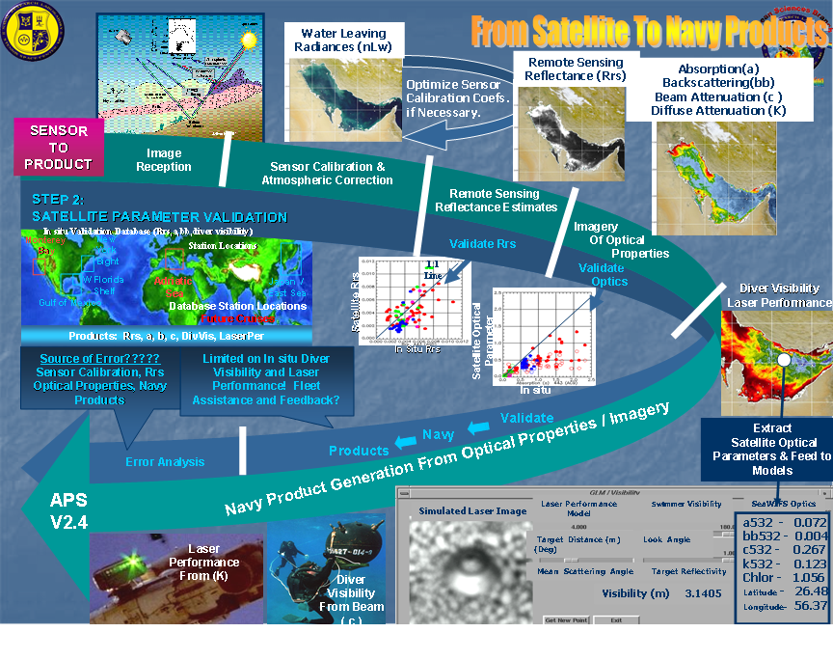
Figure 9. - Generation of Navy products, outlining the steps of the calibration and validation processes used to develop products. A series of algorithms and procedures are used to generate Navy products. Each step contributes to the product error and accuracy.

The steps in the Navy product development process are outlined as follows.
Step 1: Sensor Calibration-

The initial step involves the senor calibration which is typically the most difficult. This step includes sensor drift and spectral (channel) accuracy and involves the long term stability of the sensor. This includes the performance and characterization of the spectral channels based on time (or orbit number). The initial sensor calibration is from level 1, which will initially be determined through on-board internal radiometric control and sensor stability, such as a solar diffuser or periodic views of the moon. The stability and spectral drift are critical inputs to follow-on steps. But the results from the initial sensor calibration step can be modified via an optimization process to improve the product. For NRL-SSC the first step in the process is to use the sensor calibration provided by the SeaWiFS/MODIS project office at level 2. However, these calibrations will be adjusted by follow-on steps to insure product quality as will be shown. If discrepancies are still evident after proceeding through subsequent calibration-validation procedures, then sensor calibration is refined to optimize the final Navy product.
This procedure of vicarious calibration works well and minimizes the error of the final product. NASA and Navy have used this procedure based on the radiometric measurements from the in-water Marine Optical Buoy (MOBY) buoy to optimize the retrieved radiance for this open ocean, relatively stable site. For many spectral channels this adjustment to calibration is important for ocean open waters. However, for Navy applications, additional vicarious calibration is required to enable improved calibration of the channels critical to coastal algorithms. This requires that a coastal calibration site be established to augment the open ocean calibration.
Step2: Atmospheric Correction

Because the atmosphere can contribute to as much as 90% of the total signal measured in space, the atmospheric correction step is extremely important for ocean products. To remove the atmosphere “noise” from the total radiance measured, the radiometric contribution of the Rayleigh (molecular) and aerosol scattering of the atmosphere is modeled from spectral information. The atmospheric correction for water leaving radiance uses the near-IR spectral channels and then extrapolates this to other spectral regions. Errors in radiometric calibration and modeled loss assigned to the atmosphere result in major errors in the resulting ocean signal. Ocean products require that ocean reflectivity is known to within 2-5% for Navy products. Therefore high precision calibration is required between the channels to limit errors. However, there are problems in the near-IR atmospheric correction when applied in coastal waters.
The Navy has extended the atmospheric correction used in blue waters to coastal waters by applying an iterative solution between the atmospheric correction step and the next step in calculating ocean water reflectivity. This coupled ocean- atmospheric iterative model solution determines an optimum solution for separation of water and atmosphere radiance contributions to the total radiance at the sensor. Additionally by this methodology we account for the reflectivity of the sea surface (sky reflectance) and include influences from white foam on the surface.
Step 3: Water reflectivity -

The spectral water reflectivity is the amount light coming out of the water measured just below the sea surface relative to that entering the water and is termed the remote sensing reflectance. The satellite sensor measures the radiance (dependence on angular distribution). This radiance is converted to the normalized radiance (directly overheard) and is then related to the remote sensing reflectance (RRS) by normalizing with the incoming spectral solar radiance. The RRS are the values which can be measured at the sea surface and are the first stage of validation. However, RRS is not a Navy product. These spectral values are used by algorithms to derive the bio-optical properties of the near surface waters. Measurement of RRS is difficult and requires exact protocols. Changes of 10 – 15 % between instruments and protocols can occur.
Step 4: In-water optical properties -

Bio-optical properties are determined by using the spectral remote sensing reflectance (RRS(λ)) and a suite of bio-optical algorithms. For example, NASA uses a simple empirical algorithm applying the lowest ratio of 3 channels of the RRS to estimate the chlorophyll (called OC3). Other semi–analytical algorithms use the spectral RRS to estimate the in-water optical properties of spectral absorption, backscattering, colored dissolved organic absorption and beam attenuation coefficient. Currently there are many Navy algorithms that are available in research that are undergoing testing and validation. The Navy currently uses approximately 10 algorithms which use RRS to determine in-water optical properties. These bio-optical ocean properties are validated by in situ observations and are used to generate specific Navy ocean products.
Navy research has an advanced set of optical instruments and has established procedures for measuring these in-water optical properties. These measurements are used to determine the accuracy of the satellite products. The measurements are an area of active ocean research in ocean algorithm development.
Navy products are tightly linked to the fundamental optical properties of the waters. This is slightly different from NASA or NOAA who are interested in biological properties such as chlorophyll. It is usually easier to quantify the relationship of the RRS with optical properties than it is to link RRS with the biological properties. This is due to the inherent difficulties associated with biological processes such as “cell structure and physiology”.
Step 5: Navy Ocean Products –

The last step in the Navy product generation is to use the optical properties, such as absorption and scattering, to derive a Navy product such as diver visibility. Other examples include using optical properties to determine the depth that an underwater laser will penetrate. This last step requires a suite of algorithms based on specific Navy systems and how their performance is linked to ocean optics. This step is difficult to validate since these products deal with the 1) classification of systems and 2) non – quantitative metrics - diver eyesight etc.
As demonstrated above the calibration and validation of each step going from “sensor to product” is required. It is not just a simple match-up of the end product with observations. Each step in the development contributes errors to the final product. In addition there is no one algorithm but a number of algorithms that contribute to uncertainty and error and therefore impact product accuracy. Understanding the accuracy and limitations of each step from sensor calibration, atmospheric correction, in water optical algorithms, and the final product development is critical to the sensor calibration and validation. These include the errors associated with:
- Sensor calibration
- Atmospheric correction algorithms
- Remote sensing reflectance algorithms
- In water bio-optical algorithms
- Navy product algorithms

Initially, the vicarious procedure is used to minimize the error in satellite RRS based on the in situ observations by adjusting the sensor calibration. However the error in optical property (e.g, absorption, backscattering, etc.) retrieval is also minimized based on the in situ observations by adjusting the calibration (Step 1) for subsequent evaluations.

3.1 Issues in calibration and validation for coastal waters and OIF-
The standard for calibration and validation of bio-optical properties being derived from satellites over blue water has been set by NASA (5% accuracy for retrieval of water radiances, ± 30% for retrieval of chlorophyll). The importance of such calibration and validation has been recognized through the reprocessing of data and the emergence of a variety of algorithms and atmospheric correction schemes. It is the SeaWiFS and the follow-on MODIS development cycles that have set the infrastructure, architecture, in situ data measurement protocols, standardization and inter-comparison of measurement sensors (through SIMBIOS), and data accuracies that are required to retrieve accurate bio-optical properties. This process is the template and goal for the operational products, although some latitude may be available since the Navy’s (customer) requirements are often not as stringent as those for monitoring global climate change. NRL-SSC requirements for ocean color sensor suite accuracies, however, are aligned with those of NASA since both basic and applied algorithm development occur simultaneously to nurture and promote rapid product development and distribution. As will be demonstrated, however, the spatial and temporal resolution of the product required by the Navy during OIF surpassed that needed for monitoring environmental change.

3.1.1 Updating coefficients for imagery
Without accurate imagery that has geo-location and sensor calibration coefficients applied then results of algorithms and product generation can be futile. During the SeaWiFS program and continuing into the MODIS program NRL-SSC has and continues to interact with scientists at University of Miami and NASA’s GSFC to ensure that we receive the latest MODIS processing code updates. The University of Miami (RSMAS) is the software provider for Ocean algorithms (level 1 to 2) to NASA Goddard and the MODAPS processing. MODAPS is the software that is used by the Goddard DACC for global MODIS ocean products that has been approved by the Science team.
The need for the most recent calibration tables was evident in the MODIS products during OIF. The calibration tables are updated on bi-weekly basis by the MODIS Characterization Support Team (MCST). These calibration look up tables (LUT) are used in processing MODIS from level 0 (raw) to level 1a. These LUT are used to calibrate the 10 individual sensors which strip across the scene as the image is created. When these calibration updates are not implemented, then “striping” can occur on an image (Fig. 10) as miss-calibration of these sensors. Note that this occurs at level 0 to 1 processing which is where NRL-SSC normally receives MODIS data and uses APS for processing. (Level 1b MODIS data is the lowest data level that can be ordered from the DACC. When there are major changes in MODIS calibration then the entire reprocessing must occur to generate the level 1b data set. This has been a problematic issue of Terra during the first two years.) The striping is the easiest and most visual way to detect errors in the calibration coefficients. This striping is not evident in the true color image. It is following removal of the atmospheric correction (which constitutes ~80-90% of the total signal) for ocean applications that errors and striping are observed. Inaccuracy in the calibrations is immediately noted in the ocean products because ocean signal is low in comparison to the total. When this occurred NRL-SSC contacted the NOAA/ NASA bent pipe data provider to update the calibration tables. During the OIF, these calibration updates were not being updated quickly and poor MODIS products were initially generated. By interacting directly with the source of the coefficients NRL-SSC was able to improve the accuracy of the product. This was in part made easier by the flexibility of APS which allowed for the rapid and efficient upgrade. Once the appropriate coefficients are applied the striping is reduced or eliminated thus improving the product.

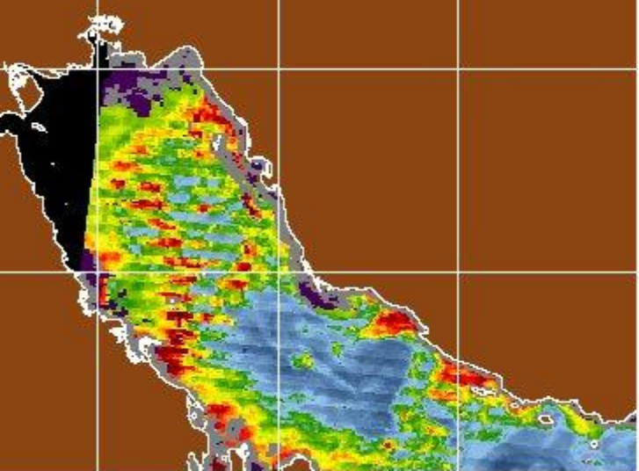
Figure 10. - MODIS image demonstrating “striping” when biweekly updates in calibration coefficients and corrections are not applied. Optical property shown is K_{d}(532).

Communication between NRL-SSC and the University of Miami has also helped to quickly test and implement new software changes. As a beta test site for the Miami Level 1 to Level 2 MODIS software, NRL-SSC has been able to examine calibration and algorithm updates and routinely carries out anomaly detection. This is used to monitor what changes in the product and radiances occur after modifications of calibration coefficients or changes in bio-optical algorithms are implemented. The Miami software for ocean processing has been improved by NRL-SSC for coastal waters using the near-IR atmospheric correction. Although not influencing the offshore waters, the coastal Navy products are improved with this upgrade to the Miami software. Presently these changes are not formally approved by the NASA MODIS science team and therefore have not been implemented into the DACC processing.

3.1.2 Long-term Radiometric Monitoring
SeaWiFS and MODIS are environmental monitoring satellites; consequently, their calibration and validation requirements concentrate on the “blue-water” condition. Because of the sensor drift in the CZCS sensor, NASA recognized the need for a long-term monitoring capability for which the radiometric accuracies measured by the satellite could be compared with those measured collected at the ocean surface. In addition to these long-term at-sea measurements, the sensors are required to have onboard sensor calibration practices. This includes having the sensor periodically view the moon as a source of stable light to track the long term stability of the sensors. Additionally, on-board sensors routinely view the solar spectrum using a solar diffuser to determine sensor drift and long-term stability of the spectral characteristics and dynamic range of the sensors. However, the long-term stability of the solar diffusers also must be monitored as they degrade in space as was determined by CZCS.
To help resolve these issues, the SeaWiFS/MODIS team deployed a Marine Optical Buoy (MOBY) off the coast of Lanai, Hawaii on February 21, 1994. This effort was funded jointly by NASA and NOAA and is headed by Dr. Dennis Clark, a member of both the SeaWiFS and MODIS science teams. The primary purpose of MOBY is to measure, with high accuracy and high precision, the visible and near-infrared radiation entering and emanating from the ocean. This ocean region is basically radiometrically stable and has small variations of reflected radiation that is critical to the biological and optical properties derived from ocean color. MOBY is located in an area that is intentionally spatially and temporally homogeneous so that issues of bio-optical variability in and around the MOBY site are greatly reduced.
Measurements at MOBY cover the complete set of parameters set forth by the SeaWiFS and MODIS science teams. This includes spectral upwelling radiance, spectral downwelling irradiance, all the inherent optical properties (absorption, attenuation, and backscattering), biological properties (such as chlorophyll), and above water leaving radiances and sky/solar radiance spectra. Consequently, MOBY serves as a calibration reference station for satellite instruments such as SeaWiFS and MODIS. The site ensures that the satellite instruments remain accurate and stable and that sensor calibration changes can be monitored and accounted for via modifications in calibration coefficients. MOBY also assists in supporting atmospheric correction programs. Hence, the long-term monitoring using the MOBY measurements combined with coincident SeaWiFS and MODIS imagery is used to vicariously calibrate most ocean color sensors.
However, while deployment in clear blue waters helps with long-term sensor calibration issues, performance and sensor calibrations issues in coastal and turbid waters are not addressed by MOBY. To help overcome this NRL-SSC uses point measurements in a variety of coastal environments, interaction with numerous investigators, and often must rely on vicarious calibration using in situ remote sensing reflectance estimates in coastal waters. This results in algorithm/calibration coefficient adjustments specific to coastal environments.

3.1.3 Match-ups of Inherent Optical Properties and Remote Sensing Reflectance
NRL-SSC plays a leading role using in situ measurements to help calibrate and validate a suite of ocean color satellites and their derived ocean water properties. NRL-SSC maintains an in situ validation database of over 800 stations collected in coastal and offshore waters (Ladner et al., 2002). Measurements of remote sensing reflectance and bio-optical properties are available at these stations. The field measurements have been used to develop algorithms, calibrate sensor performance, and validate satellite-derived properties for coastal waters. This database is made up of in situ measurements of spectral absorption (total, phytoplankton component, detritus, colored dissolved organic matter, and water), spectral particulate backscattering, spectral total attenuation, remote sensing reflectance, chlorophyll concentration, sun and sky contributions to incident light, particle size concentrations, and the spectral diffuse attenuation coefficient. The database includes bio-optical properties collected on more than 60 cruises in the Gulf of Mexico, Monterey Bay, CA, New York Bight, Chesapeake Bay, Fort Lauderdale, FL, Arabian Sea, Adriatic Sea, Japan/East Sea and Yellow Sea. This field program leverages off of programs supported by NASA, ONR, and NRL-SSC.
To provide the best bio-optical properties and calibration/validation, NRL-SSC requirements for a radiometric satellite are strongly linked with the stringent radiometric control of the NASA science team. The most critical field measurement is the spectral water leaving radiance (remote sensing reflectance). Redundant measurements of above surface and subsurface optical properties are required to validate satellite products and provide for accurate calibration and validation of spectral remote sensing reflectance. Remote sensing reflectances are collected in the field by using a handheld radiometer. The above water RSR at 512 channels are measured using Analytical Spectral Devices (ASD) and Remote Optical Systems Incorporated (Spectrix) radiometers (Fig. 11). A Microtops sensor, that measures solar light levels is used to evaluate atmospheric properties.
A complete set of in-water measurements of optical properties is also collected. A Satlantic Incorporated Hyperspectral Tethered Radiometric Buoy (HSTRB) is used to measure remote sensing reflectance just below the surface at 123 channels and provides a consistency check for surface reflectance losses. A Satlantic Inc., K-chain Buoy measures upwelled radiance, L_{u}, at 7 channels just below the surface and downwelling irradiance, E_{d}, at 3 channels just above the surface. Throughout the water column this instrument measures E_{d} at 5 depths at 532nm, and therefore provides a measure of the diffuse attenuation coefficient K_{d} for comparison with the satellite derived property. NRL-SSC uses a WetLabs’ AC9 (9 channels) and Hystar (100 channels) instrument to measure spectral total attenuation, c, and spectral total absorption, a. Spectral total scattering, b is derived from the difference (b = c-a). Backscattering properties are measured at 6 channels using a HOBI-LABS Hydroscat-6. In order to examine spatial variability in coastal waters, which is a fundamental issue in calibration and validation, NRL-SSC maintains an optical underway measurement system containing a WetLabs AC9, Seabird CTD, fluorometer, depth, and GPS. This provides measurements of optical properties near the surface over significant distances. With this data statistical variability in optical properties can be examined relative to the pixel size of the satellite.

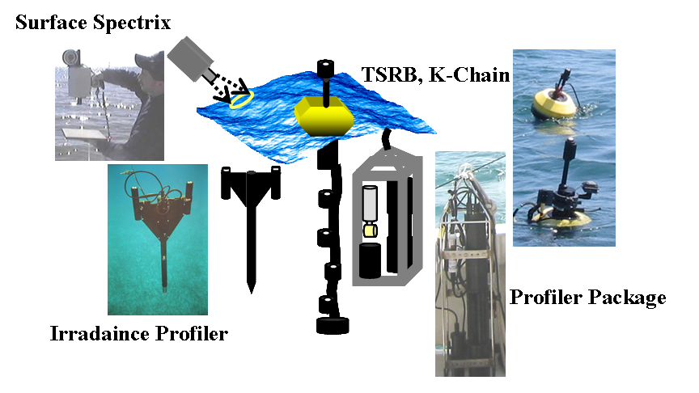
Figure 11. - Instrumentation used for field calibration and validation program.

The in situ field data (remote sensing reflectance and water optical properties) is used to validate bio-optical property retrievals, monitor performance of the sensor, and evaluate algorithms in coastal environments. Data points are selected in which in situ data is compared with satellite properties as “match-ups.” These match-ups compare the satellite derived optical properties with those from the field measurements. These match-ups are invaluable in determining stability of the satellite, algorithm performance, defining new optical properties that can be retrieved from the satellite signal, and finding data anomalies. The match-ups are used to calibrate and validate the remote sensing reflectance retrievals. This has been particularly important in the coastal waters where difficulties due to high backscattering and local variability have been factors. The data match-ups provide a means of evaluating the accuracy of derived properties and the reliability one assigns to the end-product.
Figure 12 shows match-ups of remote sensing reflectance from the SeaWiFS satellite and that measured in situ. The variance is a measure of satellite uncertainty, the ability to accurately “measure” remote sensing reflectance in situ, and atmospheric correction and spatial measurement difficulties present in coastal waters (see next section). While there is a high degree of spread in the data, the measured remote sensing reflectance from above the water surface agree favorably with those derived from SeaWiFS after NRL-SSC applied gain settings and calibration coefficients that had been determined vicariously for the coastal areas. 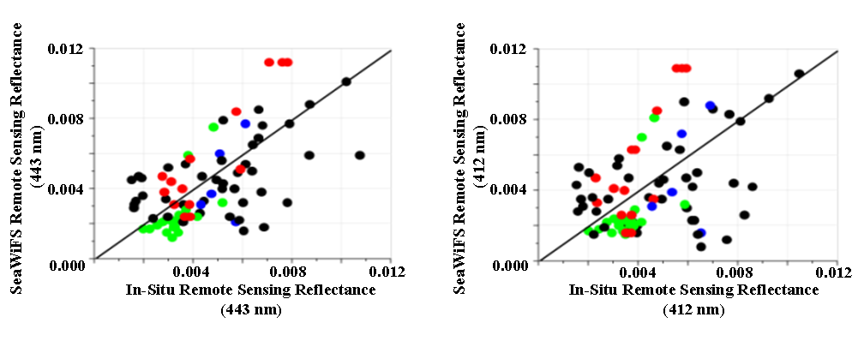
Figure 12. - Match-ups of Remote Sensing Reflectance from in situ measurements and that derived from SeaWiFS.

In the examination of the match-ups, we look for systematic divergences between the in situ and satellite remote sensing reflectances. If the in situ remote sensing reflectances from the handheld radiometer do not match those derived from the satellite, then a vicarious calibration is performed. This adjusts the satellite calibration to optimize a match between the field and satellite data. Slight adjustments to the sensor calibration coefficients are performed, imagery is reprocessed and the comparison is repeated until the in situ and satellite remote sensing reflectances converge. After convergence is obtained, the retrieval and calibration/validation of the derived properties is carried out.
Using optical in situ data collected in the field, validation of the satellite optical algorithms is performed. Figures 13-A and B show the match-ups between absorption and scattering at 510 and 555 nm. These are wavebands appropriate to the diver visibility algorithm. Note that while the remote sensing reflectance variability were randomly distributed around a near 1:1 line (Fig. 12), the discrepancies between the measured optical property values and those derived from the satellite are substantial. Previous validations of the optical properties have yielded errors of 10-40% for absorption and scattering. The smaller errors occur most often in clearer waters and higher errors occur in coastal waters (Table 3) due to errors in sensor calibration, atmospheric correction, and optical algorithms (Ladner et al., 2002). The difference between the in situ optical property and that derived from satellite remote sensing reflectances is adjusted only after other collaborative information such as optical property inter-relationships and forward modeling of remote sensing reflectances has been completed. The mismatch between the optical properties is a challenge for providing accurate products to the customer. Once an algorithm is found to require correction it is adjusted for global or regional application and then the imagery is reprocessed and a re-validation is performed.
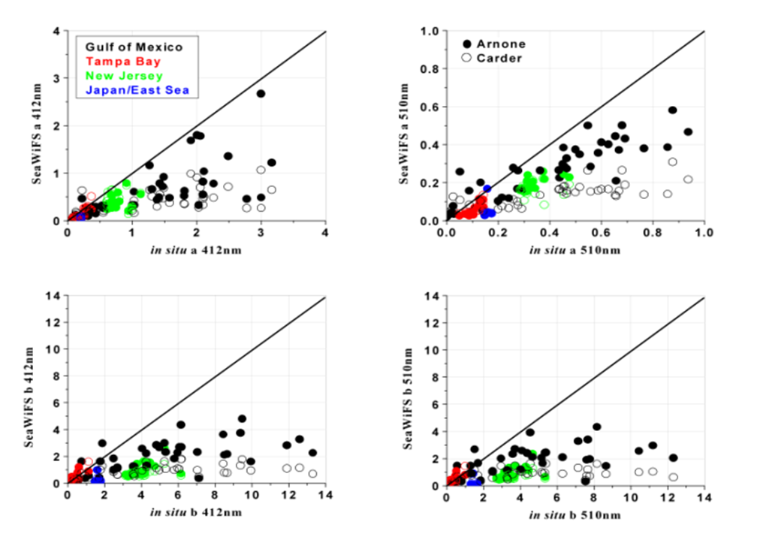
Figure 13. - (A&B) Comparison of SeaWiFS derived absorption at 412 and 510 nm and in situ measured properties (Top Panels); Comparison of SeaWiFS derived scattering (with assumed backscattering/scattering ratio) and in situ measured scattering at 412 and 510 nm

The retrieval of optical properties is often uncertain, particularly in coastal waters (Table 3). For the most part there are systematic underestimates of both absorption and total scattering (derived assuming b_{b}/b of 0.02). The errors in both the absorption and scattering are highest in the most variable environments (Gulf of Mexico and LEO). These results suggest that measurement of the optical properties in these environments is also non-trivial.

Table 3. - Error Analysis in retrieval of Absorption and Scattering (with assumed b_{b}/b of 0.02).
Wavelength | Absorption Error as percent  Arnone (Carder) |  |  |  | Scattering Error as Percent  Arnone (Carder)
Nanometers | GOM | TBAY | LEO | EAS | GOM | TBAY | LEO | EAS
412 | 47 (60) | 37 (21) | 48 (35) | 67 (69) | 58 (64) | 56 (63) | 71 (74) | 65 (74)
443 | 45 (58) | 37 (21) | 42 (42) | 64 (71) | 56 (63) | 31 (39) | 70 (74) | 65 (74)
490 | 38 (59) | 41 (36) | 42 (44) | 56 (75) | 54 (62) | 34 (56) | 71 (74) | 65 (74)
510 | 42 (65) | 42 (40) | 42 (47) | 57 (72) | 54 (62) | 31 (47) | 71 (74) | 65 (74)
555 | 40 (60) | 36 (32) | 63 (64) | 66 (74) | 55 (62) | 29 (46) | 73 (73) | 61 (73)
670 | - | - | - | - | 55 (64) | 33 (52) | 66 (72) | 64 (74)

The total attenuation coefficient ‘c’ is not a standard SeaWiFS or MODIS bio-optical property derived from remote sensing reflectance. The normal remote sensing algorithms derive total absorption and total backscattering. But diver visibility is based on total attenuation, the sum of absorption and total scattering, and only backscattering and absorption are available. The issue for diver visibility in calibration and validation is two fold. The first is deriving an optical property not normally retrieved from the satellite (which we will address here). The second is the calibration and validation of the diver visibility product (discussed in section 3.2).
Part of the error in ‘b’ (scattering) that is apparent in Figure 13 and Table 3 comes from the extreme difficulty in retrieving an optical property for which limited information is available and when assumptions are being made. This underlines the accurate calibration and validation work that must be maintained to derive a useful product since error bars are critical. For diver visibility, NRL-SSC’s normal algorithm assumes a shape for the volume scattering function (a quantitative measure of the angular dependence for light scattering) described by Petzold (1972) for San Diego Harbor. This common assumption yields a value of 0.02 for the ratio of backscattering to scattering. Using this assumption, the scattering coefficient can be directly obtained from the backscattering coefficient derived from the ocean color. However, it is useful to note that the range in the backscattering to scattering ratio extends from 0.006 to 0.03 for coastal waters (phytoplankton to sediment dominated). Research is being conducted to constrain this range and improve the retrieval of the scattering coefficient. Another source of uncertainty is in the “assumed” coefficients that are used to relate remote sensing reflectance to the ratio of backscattering and the sum of backscattering and absorption (i.e. b_{b}/(a+b_{b})). Since the remote sensing reflectances agree well in Figure 12 one can speculate that the coefficient used to define relationships between light distribution in the nadir direction and the scattering function may be non-linear and/or a function of total scattering. While such relationships have been suggested by Lee (2002) they have not been incorporated into retrievals of the scattering coefficient.
A match-up comparison of retrieved values for total attenuation at 670 nm and that measured by the Wetlab’s Inc attenuation meter is presented in Figure 14. It highlights the improvements that are being made for retrieval of beam attenuation. Note that measured values and satellite derived attenuation from the Arnone algorithm are close even at high attenuation (i.e. high scattering) near the mouth of the Mississippi River (Stations 9 and 10 in red). It also shows the significance in comparing various algorithms for backscattering (assuming a constant backscattering:scattering ratio) and provides a consistency check with total attenuation. This helps show where refinements are needed in an algorithm.
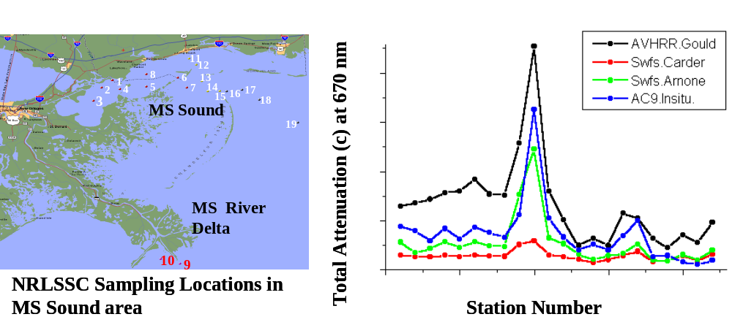
Figure 14. - Comparison of measured and SeaWiFS derived “total attenuation” c at 670 nm using algorithms of Carder, Arnone, and Gould.

3.1.4 Coastal issues of water leaving radiance
There are numerous problems that NRL-SSC had to overcome to calibrate and validate ocean color properties in coastal areas. The three most important to the diver visibility product are the atmospheric correction, the non-uniform atmospheric conditions common in coastal areas, and spatial uncertainty in measurements of bio-optical properties and the averaging over satellite “pixel” areas. For the OIF effort all three of these were issues in optical property validation, algorithm formation, and product validation.
As previously indicated 90% of the signal measured at the satellite originates from the atmosphere: with Rayleigh scattering accounting for ~60% and aerosol scattering ~30%. Therefore, in order to retrieve estimates of water color, and subsequently optical properties it is extremely critical to accurately calculate and then remove this portion of the signal. Standard NASA algorithms were developed for open oceanic conditions and as such do not address issues specific to coastal waters. Initial results from processing SeaWiFS and MODIS imagery using NASA’s standard software programs, calibration tables, and atmospheric correction algorithms have commonly resulted in negative radiances appearing in the coastal waters (Fig. 15). Obviously this can be problematic for coastal product generation and required identification of the source of the negative radiances and then development and implementation of a solution.
The problem was isolated to the treatment used in determining atmospheric correction by NASA. With the standard NASA algorithms, the water is assumed to be “black”, or totally absorbing at red and near-IR wavelengths. The requirement for a “black” wavelength is necessary since it is these near-infrared bands that are used to determine the atmospheric contribution. While valid in open-ocean conditions, this assumption is most often erroneous in turbid coastal areas where suspended sediments are in high concentration and reflect at these wavelengths. This erroneous assumption in coastal waters leads to an over-correction by the atmospheric correction algorithms resulting in negative water leaving radiances (i.e. radiance in the near infrared bands that was assumed to be zero and was added to the “atmospheric loss” term were in reality a property of the water).
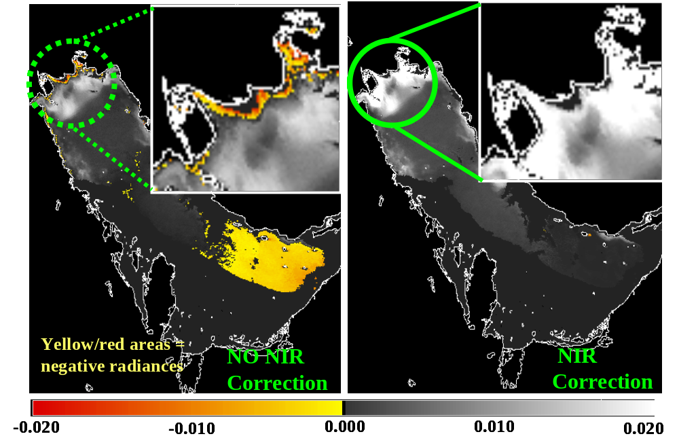
Figure 15. - Negative Radiances caused by Atmospheric Correction in coastal waters and then the application of the Near-Infrared iteration to improved water leaving radiance (Persian Gulf on 18 April 2003, SeaWiFS image). (Arnone et al., 1998).
To remedy this problem NRL-SSC developed a technique to improve the separation of the atmosphere radiance contribution from the turbid water radiance contribution for coastal waters. This is an iterative algorithm that uses a NIR radiance correction to determine the water reflectance in the 765 and 865 nm channels (assumed to be zero by the standard NASA algorithm). This correction is then applied to the entire spectrum increasing reflectances in the blue channels, mainly 412 and 443 nm. This algorithm resulted in significantly improved performance and retrieval of optical properties in the coastal areas (Figure 15). NASA SeaWiFS program has adopted the NRL-SSC improvements to the baseline atmospheric correction routines used by their standard processing. Its implementation permitted extension of ocean color algorithms into estuaries and bays critical to the customer.
Another issue for calibration and validation in the coastal waters is variability of the environment itself. Figure 16 shows how extremely variable a coastal environment can be using the MODIS 250 m product. As demonstrated there are several features in the derived optical property MODIS 250 m image that do not appear in the 1 km image. Other sensors have shown that this variability is pronounced to scales less than 10’s of meters. This pronounced variability cascades into calibration and validation since a measurement point may in truth be correct, but the variability and statistical techniques used to “validate” the product may cause uncertainty in the product. For most environmental monitoring applications the 1 km satellite resolution is sufficient for customer use. However, as demonstrated during OIF, this can also be a limitation that requires attention.
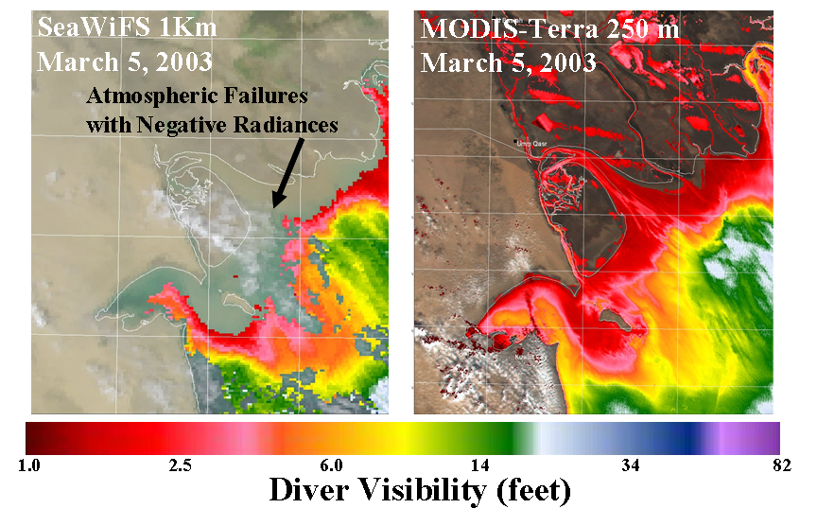
Figure 16. - Coastal Variability comparison between SeaWiFS (1 km) and MODIS (250 m) diver visibility product. Note the details present in the 250 m imagery that are not apparent in the 1 km data. (See Arnone et al., 2002).
The error caused by local variability is particularly problematic in the “match-ups” used for algorithm formation and calibration in the coastal waters. The field collection measurement is at a “point” which when compared to a satellite may or may not be correct depending on the spatial variability of the environment, the positional accuracies, and “temporal variability” (such as tidal fluctuations or local physical forcing). NRL-SSC addressed this with “along-track” measurements that are made to determine spatial variability in and around a measurement point.

3.2 Product calibration and validation
Diver visibility is a product which has undergone limited calibration and validation due to in part to the product itself. As described, visibility is not a property that can be derived directly from ocean color. However, as presented above there have been R&D efforts attempting to provide a “total attenuation” property at 532 nm (wavelength applicable to diver visibility and underwater laser propagation). For diver visibility, calibration efforts have centered around 1) determining the best algorithm to use , 2) providing a straightforward definition of visibility given all of the variables, and 3) how can we best validate a product. The later is a very important component and any discrepancy between the satellite derived product, the measured visibility, and a theoretically determined visibility limit is where the interaction with the customer is absolutely critical in the calibration and validation step. This step of the calibration and validation process can sometimes result in the entire procedure being re-evaluated and can point to new required algorithms or new research areas.
For diver visibility NRL-SSC relied on work conducted under an ONR sponsored Gauging Littoral Optics for the Warfighter (GLOW) project, and an ONR sponsored effort in validating a scientific visibility algorithm called the “Distance Visibility Algorithm” (DiVA). There were also two masters theses that where conducted in collaboration with NRL-SSC that provided diver visibility calibration and validation information (Thesis of LT Erica Museler, USN, Naval Postgraduate School; and Todd Bowers, University of Southern Mississippi). The GLOW project used Navy reserve divers to make measurements underwater of objects at specific ranges to determine how a Navy diver would interpret “diver visibility” and at what range various objects would disappear. This was invaluable since it was the background necessary to move the science into the fleet application. Measurements of the optical properties were collected concurrently with diver observations. The various efforts provided four distinct aspects related to the validation of the Navy’s diver visibility product. These were:
- GLOW- Used the reserve divers to come up with a “standard” definition for diver visibility that could be directly related to the fleet as a product, and collected data for comparison of the historical 4/c product and Secchi disk product with other models. Both diver visibility and diver vulnerability (being seen from above the surface) were addressed.
- Bower Thesis- Expanded the theoretical treatment originally part of the contrast transmittance theory used in formation of the nomographs (recall these nomographs were not used by the fleet). The approach was to develop a computer aided model of diver visibility that could take into account target size, solar angle, background illumination, eye adaptation, and optical properties of the water. The thesis also addressed the visibility of object of given size from above the surface.
- DiVA- Compared “new” exploratory models of diver and camera visibility which had potential for transition and application using remote sensing properties. The primary contribution of this project was forcing a comparison between all of the diver visibility models using coastal water data.
- Museler Thesis- This work is the most relevant project related to product validation. LT. Museler, as a Navy Postgraduate School thesis student, helped make measurements of in-water optical properties; collect diver visibility data; and applied SeaWiFS algorithms to compare “derived visibility from SeaWiFS” versus “Measured Visibility” in a turbid environment (Visibility less than 15 feet).

All of the efforts above concentrate on the 1 km SeaWiFS product and not the MODIS 250 m product which was the final product requested and produced for the Navy Warfighter in OIF. As such, there is a calibration and validation step that is missing (i.e. 250 m vs. 1 km optical property retrieval). Hence this was conducted during OIF using on-scene information and feedback to the developer.
In the above work, U.S. Navy Reserve divers measured the distance at which a 20” black, 20” gray, and 20” black/white sphere disappeared at depths of 10, 20, and 30 feet (Figure 17). Measurements of the corresponding optical properties (absorption, attenuation, backscattering, and diffuse attenuation) were collected as a function of depth. This was conducted at several locations (clean to turbid water) and at directions corresponding to “into the sun, 90˚ from the sun, and away from the sun (i.e. sun behind look direction of the diver).
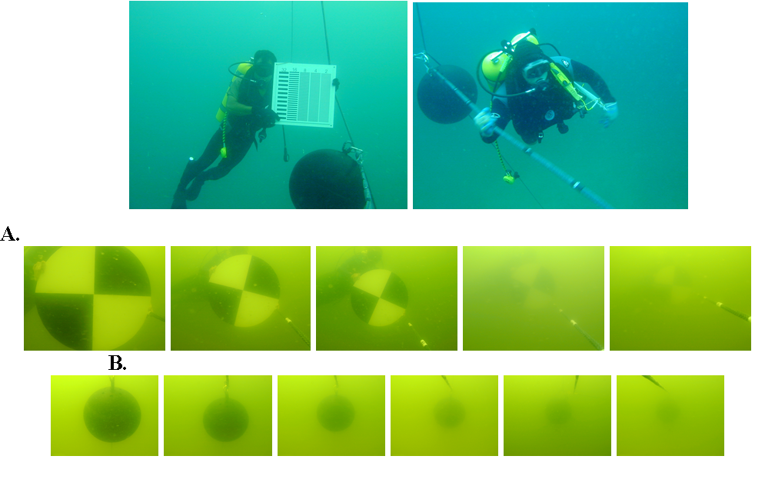
Figure 17. - - Diver Visibility Validation: Divers measured visibility of black, black and white, and gray targets at 10, 20, and 30 foot water depths. Figure panels A and B show 20” black and white disk and a 20” sphere disappearing with increasing distance.

The results of the field validation for diver visibility can be summarized as follows. The work with GLOW and DiVA showed that the 4/c was normally inappropriate for most turbid water applications and that a value of 4.8/c had a lower error for the waters tested. This value was also obtained by Davies-Colley (1988) and more recently by Zaneveld and Pegau (2003). The work in the Gulf of Mexico showed values varied from 3.9/c to 5.5/c but most values were within 20% of 4.8/c. Hence this value (4.8/c) has been adopted as the “newest” diver visibility algorithm and was implemented into the MODIS and SeaWiFS processing using APS. Work by Bowers demonstrated the importance of solar zenith angle and provided a method by which both diver visibility and vulnerability could be estimated. However, the inputs for the Bowers model required that the absorption and scattering be known. Hence the model, while being more accurate and precise, required the same information as previous models. But this model became a critical component for the OIF product because of the ability to calculate visibility and vulnerability as a function of target since, solar direction, and above and below surface capabilities.
The research work by LT. Museler demonstrated the capability to retrieve the required information for diver visibility from SeaWiFS, and then its application using APS. This was henceforth moved to the Naval Postgraduate School for demonstration of diver visibility (part of the ‘customer preparation’ below). This movement closer to the operational user is an important calibration and validation step since performance is best determined by those that use the product and their response. One other important point raised by the work of Museler was the mismatch between the predicted and measured diver visibility. Underestimation of “c” using SeaWiFS (the Carder algorithm) lead to overestimations of diver visibility. This calibration and validation component of the product has thus spawned a renewed interest in the derivation of the coefficients needed by the product and how to best determine these (i.e. what algorithm is best for beam attenuation from ocean color).

3.3 Special validation for a customer
The creation of a specific product (diver visibility and vulnerability) from SeaWiFS and then from MODIS for a specific customer required some special validation protocols. It required both a knowledge base from the customer about the satellite and then the developer understanding the customer’s intended product use. The first point was that the customer “preferred” a visibility product for a depth of 10 feet. This impacted how the product was derived and set the protocols for the calibration and validation above (i.e. how the measurements were collected and how models and algorithms were implemented). The customer also requested that a “black” target be the standard instead of a black and white target as a previous study had used. Other factors that the customer asked to be considered were the “size” of the target, and its shape. During calibration and validation the algorithm was based on specific size, color, and shape in order to allow the customer to determine if additional information was required. The 20” target was selected so that effects of a small target on visibility could be minimized. A round target provided a means of standardizing the product. In the calibration and validation process however, targets of different colors were also used so the customer would understand the uncertainties associated with the final products validation as far as color was concerned (Fig. 18).
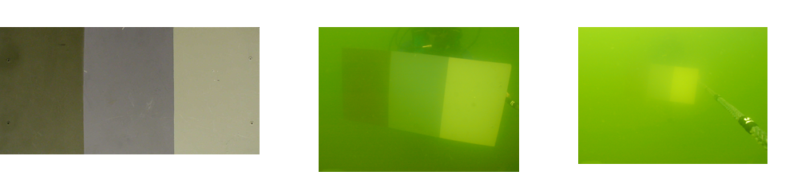
Figure 18. - Visibility of three color panel (olive gray, gray, and light gray) representing “typical underwater targets” that a Navy customer would deal with for comparison with the “black” target.
So that the customer understood the “situation” being described by the product, a “graphical illustration” representing the visibility and vulnerability accompanied the product (Fig. 19). This illustration was designed so that the customer was aware of the conditions represented by the product. This helped the customer easily translate the product into their application. As shown in Figure 19 there is a product description. This showed the customer that the product is for 1) visibility at 10 foot water depth, 2) the sun is directly overhead, 3) the target is black and is 20 inches in diameter, and 4) there are no clouds in the sky. In a similar fashion the illustration for the “vulnerability” product showed that: 1) the “observer” would be looking straight down, 2) the target was about the size of an underwater diver, 3) the water depth would be 10 feet, and 4) the sun was setting. A similar vulnerability was created for a “larger” object and also for daytime operations.
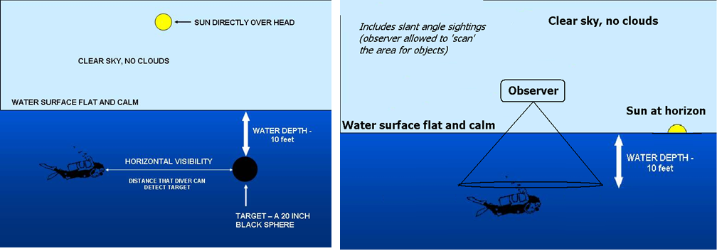
Figure 19. - Graphical Illustration of the conditions represented by the product (Visibility on the left and Vulnerability on the right).
A key point above is that the transition of the science to an operational product initially takes place in calibration and validation, but all operational products are continually refined and reassessed to determine if they meet the customer’s needs. In the case of the diver visibility product from the 250 m MODIS imagery for OIF a comparison of two products and their errors was required over a short time period. Under these circumstances calibration and validation was difficult if not impossible. Procedures for calibration and validation of two properties were compared and then one method was selected over the other. Until a more extensive calibration and validation can be conducted this was the “selected algorithm” for the operational product. For this product feedback from customer evaluation and on-scene information was the primary method for validation until the operational product can be more fully validated at a science level. For the diver visibility product, this feedback allowed a customized and more accurate representation to be developed. This was especially important during the time-critical product generation and dissemination associated with OIF.

4.0 Making the Decision Support Tool for OIF- Expanding the science and setting up the product
The initial effort during OIF was an extension of the routine work in the retrieval of bio-optical properties, algorithm development, and product generation (such as the 1 km diver visibility) conducted at NRL-SSC to meet customer needs (METOC Navy community). Part of this routine work includes interaction with academia, NASA, NOAA, and Navy investigators on remote sensing. In order to exploit the technical expertise in retrieval of bio-optical properties from remote sensing a password protected public web site has been available for researchers to examine work by NRL-SSC (www7333.nrlssc.navy.mil). The web page was designed for interaction at the scientific level but also to show potential customers what capabilities remote sensing may have to meeting their product needs (Fig. 20). These products may include applications that have not been envisioned by NRL-SSC or others.

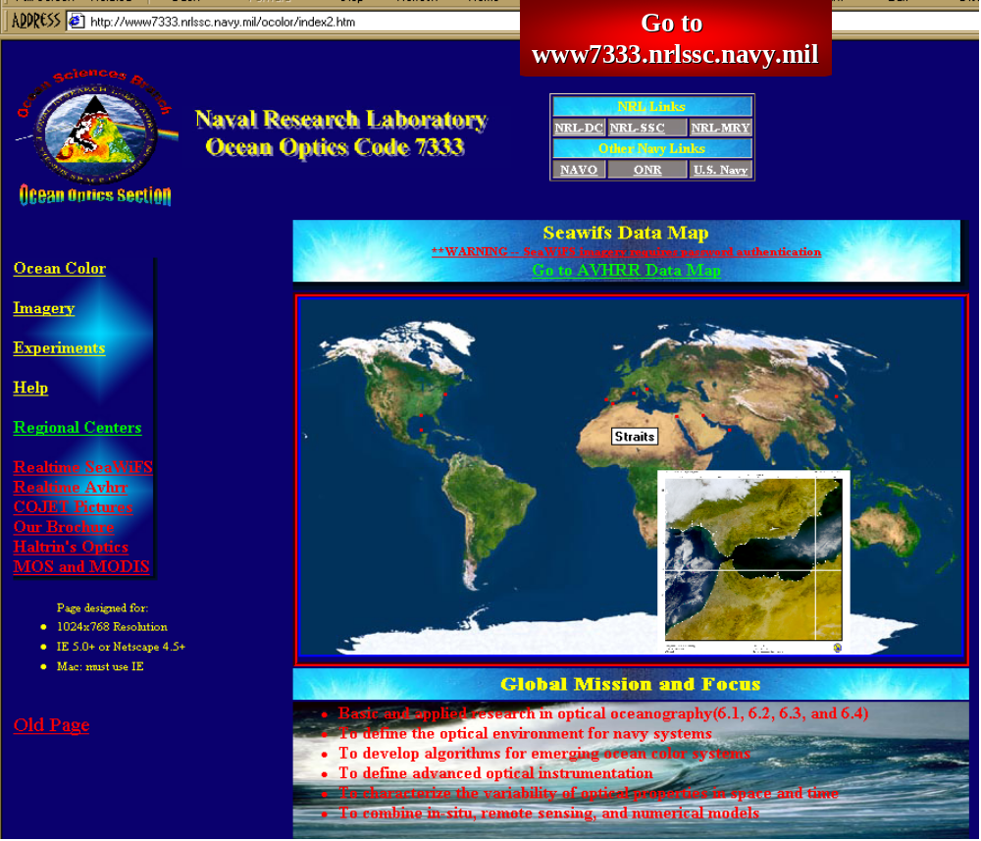
Figure 20. - NRL-SSC Home webpage developed for interaction with scientists and potential customers.

In preparing the customer (i.e. the Navy) for various products, such as diver visibility, NRL-SSC collected daily imagery over several key regions throughout the world that a user could select (i.e. Persian Gulf, Mediterranean, Sea of Japan, and coastal United States). The user could browse on imagery that had been collected for the region with the MODIS and SeaWiFS (if research oriented) 1 km bio-optical properties (absorption, diffuse attenuation coefficient, backscattering, and chlorophyll), a true color image, and the diver visibility product. It was hoped that once the operational Navy (via the METOC regional centers) knew that products such as diver visibility were available they would go to the web page for further information. The web page also contained information defining what was meant by diver visibility or the diffuse attenuation coefficient. The imagery contained the latest available images as well as weekly and monthly averages, and “best pixel” composites designed to give the customer and researcher a “best representation” of the properties and products by minimizing interpolation necessary due to cloud cover.
In the past a potential customer was required to “search” the image database and find a product that met their needs. While bio-optical properties and diver visibility were always available on the web page, there was little effort to make it as “real time” as possible, customized the product for a specific requirement, or go the customer directly. The unclassified web page was updated as part of the routine APS operation.
Early in OIF, a specific request was received from the Bahrain METOC Center to subdivide the Persian Gulf area into five operational sub-regions. These areas represented specific Navy operational areas. The sub-regions provided a template to develop customized and simplified products to meet specific needs. Images where routinely put on the web to get feedback from the customer as to their utility. The regions were (Fig. 21):
- Entire Persian Gulf,
- North Persian Gulf (i.e. Kuwait (KAA) area),
- Central Persian Gulf,
- Qatar region, and
- Strait of Hormuz

Similarly a change in the color tables for diver visibility followed interaction with the operational fleet and NAVOCEANO to standardize the visibility product that was sent to the fleet. This included more information in the 0 to 15 foot visibility range and less gradient information at visibilities greater than 15 feet. It was apparent, however, that the fleet needed more time-critical products that were tailored for their application and area of interest (see the chronology of diver visibility product below and Table 4).
Getting the information to Navy operations in a time critical fashion and in a customized manner required special attention with product dissemination a critical issue. The customer wanted the data faster, special products, and focus on their immediate needs. The specific products were diver visibility and vulnerability, and true color. The true color offered an overview of land operations and a visual representation of the environment in-theater.

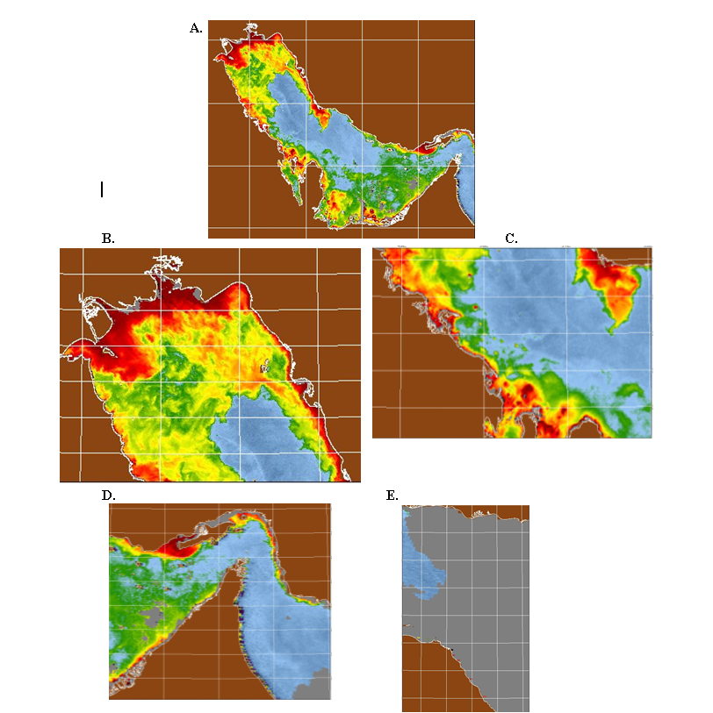
Figure 21. - Diver Visibility shown for areas of the Persian Gulf available via the web-site: A) Persian Gulf, B) Kuwait, C) Central Persian Gulf, D) Straits of Hormuz, E) Oman Gulf.

To get the customer the desired products in-theater and in a timely manner a secure web site was formed that was much reduced from the original research web page. An operational diver visibility product was produce for SeaWiFS, and MODIS Aqua and Terra sensors for each day. Initially the major images were the 1 km diver visibility product and a true color image produced daily for each of the five regions. Each image was geo-rectified into a standard projection. The images of diver visibility were quality controlled by a “man-in-the-loop” to ensure a “best image” was available. This reduced the interpretation required by the customer. The time delay in the imagery product was too great for the customer, therefore, NRL-SSC worked with NOAA and NASA to receive the Persian Gulf imagery as quickly as possible. Using the APS system the quality controlled imagery could be placed on a secure web site within about three to six hours of data reception. The flexibility of APS allowed tailored products requested by the customer to be created and distributed. These products were adapted from products initially available over the public website. In addition, the web page for OIF was “streamlined” so that the customer could quickly find his tailored product. The products changed from the 1 km diver visibility and true color imagery to the higher resolution 250 m MODIS diver visibility and vulnerability products (see below). The key was capturing the customer’s interest with a product that could potentially be useful by showing him the application directly. This was accomplished by a proactive approach of going to the customer and getting initial interest in the products.

5.0 Product Dissemination (Capturing the customer’s interest, responding to their needs, and implementing new specialized products -- The pro-active approach)
During the OIF effort NRL-SSC the first issue to be addressed was to provide new products and imagery to the Fleet as quickly as possible (less than 3 hours). This request came from in-theater METOC personnel since information was not forthcoming from NAVOCEANO and operations were changing daily. In order to meet the time-critical operational nature of the customer the products were produced each day and on weekends. This is more “operational” support than a R&D laboratory is accustomed to providing. The operational Navy could access the streamlined web-site over the SIPRNET at the METOC regional centers, or aboard major command vessels. The customer was informed that the product was available via e-mail messages and asked to comment on product utility, desired information, and presentation. When the 1 km diver visibility product was available to the customer, comments were actively solicited about the product and how it could be improved. The dissemination of the product changed from a “come and get it” approach to a “here it is for you, what else do you need.” This proactive interaction with the customer led to several additional requests involving what products were available. The chronology of the events and the development sequence of these new products are outlined in the following section and summarized in Table 4. The interaction with the customer resulted in the development of a 250 m MODIS diver visibility and a vulnerability product for the EOD and Special Forces communities. Note that in this case calibration and validation was abbreviated, but still was partially carried out using in-field observations and consistency checks among several sensors.

5.1 Chronology of rapid development and delivery of a 250 m resolution diver visibility product for OIF
After a week of using the 1 km products, response directly from the fleet was positive, but they particularly wanted information concentrating in the northern Persian Gulf (Kuwait area) at higher resolution if possible and with more “gradient” information available. It was indicated that while the 1 km products were helpful, the true color pictures of the 250 MODIS showed other features and more details. The customer wanted to wanted to know if products could be developed from this imagery. The high resolution products could improve planning and operations in the riverine and coastal areas. The product requests called for identification of areas were visibility was improved by 20% or more and at the resolution of the 250 m MODIS true color image. The customer (here the Explosive Ordinance Disposal teams) wanted to know where they could “see” farther and when they could be “seen” from a further distance.
There was no algorithm or product line for the 250 m MODIS imagery at that time. Since the SeaWiFS and MODIS 1 km standard products could not meet the immediate mission needs of the customer, a new product was required using the 250 m MODIS imagery. Specifically a diver visibility product was requested that concentrated on the KAA region to help with visibility in the highly variable confined areas close to the coast and in bays and estuaries. The customer wanted to extend the product up the estuary as far as possible. This was well beyond previous efforts with MODIS.
There were several difficulties using the 250 m MODIS imagery for the diver visibility product. Foremost is that the channels available do not normally lend themselves to such a product, since there are only two MODIS channels available at 250 m resolution and they are in the red (620-670 nm) and the near infrared (841-876 nm). The issues with these wavebands are 1) the normal channels used for atmospheric correction are no longer available, 2) any optical property will need to be converted to the proper wavelength for diver visibility (~532 nm), and 3) water absorption that is high in the red would cause most clear waters to appear “black” and therefore have reduced sensitivity in the open ocean. For the customer the last issue was not as important as the improved resolution. This is an example were the customer determined the level of scientific accuracy required.
The NRL-SSC Ocean Optics Section put together a joint effort to provide the customer with the products requested, and time was a critical factor. There were several steps involved in producing the 250 m diver visibility product using the MODIS channel 1 (620-670 nm) and channel 2 (841-876 nm). As stated above two principle factors needed to be overcome in using the 250 m MODIS imagery. The first was developing an algorithm from which optical properties related to diver visibility could be derived. And the second was producing atmospherically corrected imagery that was accurate enough to provide a useful product using that optical algorithm.
A solution was agreed upon using previous work of Gould and Arnone (1997). They developed an algorithm for deriving the total attenuation coefficient ‘c’ at 660 nm using AVHRR bands. Because the MODIS 250 m channels and the bands in AVHRR were similar it was determined that this algorithm would be used as an initial starting point. The AVHRR algorithm of Gould and Arnone relates the remote sensing reflectance at 660 nm to ‘c’ in the form:
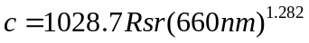
where 1028.7 is a scaling constant and Rsr(660 nm) is the remote sensing reflectance at 660 nm. The c(660 nm) was assumed to be approximately equal to the c(532 nm) used for diver visibility following the work of Barnard (1998), Zaneveld and Pegau (2003) and measurements made during GLOW. The diver visibility would then be obtained using the Davies-Colley and GLOW derived 4.8/c(532 nm) algorithm.

The next step was deriving a remote sensing reflectance at 660 nm which required implementation of an atmospheric correction using only the two 250 m MODIS channels The final atmospheric corrected radiances would be compared to SeaWiFS and MODIS 1 km data. It was determined that channel 2 would be used for a “coarse” correction for the atmosphere and radiance in this band offshore would be treated as the “dark pixel correction.” The method used was a simple subtraction. Channel 2 was scanned for the smallest positive reflectance in the scene (dark pixel subtraction), which was then subtracted from channel 1 giving a coarse atmospheric correction. This approximate atmospheric correction does not include the water reflectivity differences as a function of wavelength and all aerosol and Rayleigh components. The results also showed an offshore to onshore trend as expected but this could not be fully accounted for in the methodology.
The Gould and Arnone algorithm was then applied to the “atmospherically corrected” Channel 1 of MODIS and diver visibility calculated using the 4.8/c algorithm. This preliminary product was compared to the standard 1 km SeaWiFS diver visibility product in “transition” zones or in areas where only small changes in diver visibility were apparent in the imagery. Areas were selected based on criteria of low “local” spatial variance, but included high and low “c” values. In match-ups for the area it was found that a “linear scaling” factor (0.35) was required to provide consistent “c” values (and therefore diver visibility) between the 1 km SeaWiFS and the 250 MODIS. Therefore, the MODIS derived visibility was multiplied by 0.35 to give the final visibility for the 250 m MODIS imagery.
There are several reasons for the required scaling factor. One was the differences in the “definitions” used for remote sensing reflectance in algorithm formation. Another reason was undoubtedly due to the coarse atmospheric correction applied (lack of complete aerosol correction). The incomplete aerosol correction was also evident in comparison of the visibility product and the true color imagery. In addition, the initial Gould and Arnone algorithm produced a “total” reflectance and this required conversion to remote sensing reflectance. The assumption that the attenuation coefficient (c) at 660 nm was the same as that at 532 nm was also likely a source of error in waters high in estuarine discharge such as the KAA area. The above uncertainties together with previous confidence in the “c” SeaWiFS work lead to the opinion that it would be more accurate to use the SeaWiFS product with the scaling factor. Therefore, the scaling factor was derived using the random points selected across the imagery that met the transition criteria.

5.2 Implementation
To make the final product for fleet operational use, several other steps were followed. To automate the process for the 250 m MODIS as much as possible, a new program was written and shell scripts were developed to make these products quickly and efficiently. Software was modified to warp and project the image by working on a pixel-by-pixel basis to correct for the “bowtie effect.” This occurs when overlapping scenes are found and some differences occur in the imagery. This new method of projecting images also produced a more accurate geographic representation for the riverine and near-coastal operations. Adjustments in the product were also made for land and clouds. Land was detected using a Normalized Difference Vegetation Index (NDVI) threshold so that this would minimize the coastal effect on the ‘c’ calculations. Clouds were also identified using thresholds in channels 1 and 2. When the process was completed a 250 m MODIS diver visibility product was visually inspected for obvious uncertainties and then transferred to the secure web site. The procedure put only the “best available product” out to the customer. This was to make the “on-scene” interpretation by the customer as “straight-forward” as possible since a “science” team at the customer’s end was not available.
Within a week of the request for the higher resolution product, a diver visibility product using the 250 m MODIS data was available for inspection by the customer. The initial feedback was very positive and included requests for small graphical modifications (i.e. annotated text regarding critical features, geographic areas, true color overlays, etc). To meet these requests, scripts were generated and enhancements were made to an image browse routine that gave the user control of annotations / notes and color tables. Later another software change was made that permitted a 250 m MODIS true color image to be underlayed as background to derived optical and Navy support products. This enhanced the Navy’s use of the product by not only yielding an operational product but also giving them a snapshot of the land activity at the same time. The browse imagery was once again quality checked daily and the latest-best imagery was placed on the secure web site (SIPRNET, Fig. 22).
The interaction with the customer was quick and valuable in the product generation and response cycle. E-mail activity between NRL-SSC and the customer indicated that the diver visibility product was accurate and useful. From the developer side, requests for “confirmation” of the diver visibility product were made. The customer stated that “changes in visibility were consistent with observations and observed data was sent to NAVOCEANO for post calibration and validation of the image product.
Occurring concurrently another Navy customer saw the 250 m MODIS visibility product and asked if a “vulnerability product” be made. This vulnerability product was for Special Forces diver operations and swimmer delivery vehicle vulnerability. To meet this challenge NRL-SSC met with PSI to determine if the visibility model developed by Todd Bowers could be used. This model had been tested during GLOW for potential use in diver vulnerability scenarios. Since the model of Bowers was complex and only a “go, no-go” decision tool was requested, the model was run with customer specific object sizes, observation conditions, and various optical properties to provide a “look-up table (LUT). This matrix was then used with the retrieved optical properties to produce a vulnerability map (Fig. 23) that indicated where potential problems due to enemy observers could occur (no-go) versus areas where underwater operations could not be detected (go). The “go, no-go” customer tailored product required implementation of the LUT into APS and then annotation made by visual inspection. The customer could then select between the visibility and vulnerability products.
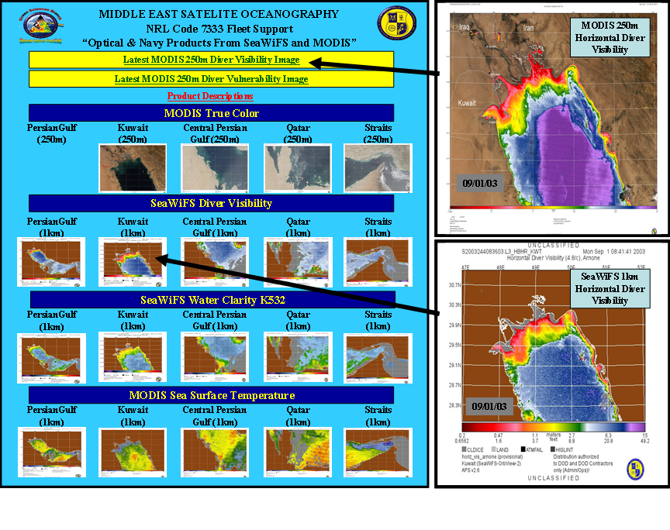

Figure 22. - Overview of the “secure” web site with diver visibility demonstrated.

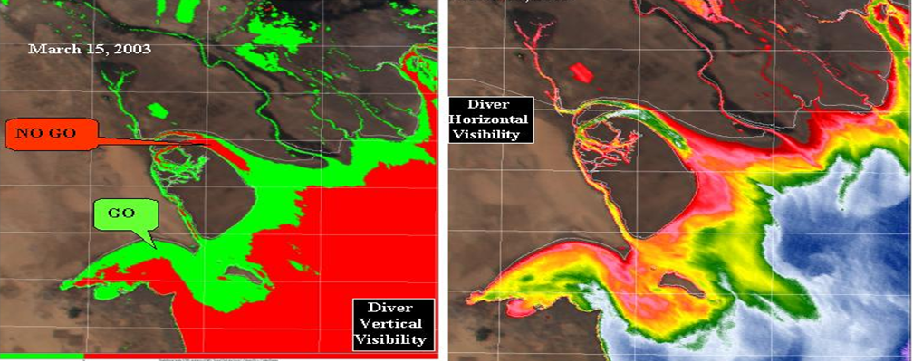

Figure 23 - Diver Vulnerability (left) and Visibility (right) showing the go/no go areas for operations and where “improved” visibility up river can be found.

Table 4 - . Chronological summary of fleet supported events as they evolved.
Date | Event
February 2003 | NRL 7000 directs latest and best research efforts in the Persian Gulf to be made available to the fleet. NRL-SSC Code 7333 initiates support by streamlining a website for ocean color imagery to support a potential war effort in Iraq. The goal of NRL was to use the web site to provide only the latest and best cloudless imagery available. Fleet users were not required to search a database to find best imagery to support their missions. This support required NRL-SSC personnel to manually QC each day’s imagery and make the scientific judgment on which was the best optical product for the fleet to use. A developmental version of NRL-SSC Code 7333’s APS was implemented in a classified space to produce MODIS (1Km & 250m) and SeaWiFS (1Km) optical and Navy products for the region of interest. This developmental version of APS was implemented due to the volume of imagery received and processed daily at NRL-SSC. This allowed us to produce and validate the Navy products in a timely manner and gave the flexibility of customizing products to meet fleet requirements.
28 February 2003 | Revised Ocean Color Website is put online and advertised to Fleet users in Persian Gulf Region. This was enhanced by the addition of 250-meter true color plus 1 kilometer derived horizontal visibility derived from SeaWiFS and MODIS.
1-3 March 2003 | Considerable / positive feedback from the fleet was received.
5 March 2003 | Feedback from EOD team through Commander Cruiser Destroyer Group 1 (CCDG1) on the aircraft carrier USS Abraham Lincoln indicating they would like a product that could indicate regions, which would show relative, increases of 20% visibility in KAA (overall poor visibility) for underwater searches. CCDG1 noted that the 1-kilometer resolution imagery products did not reach far enough into the KAA.
5-11 March 2003 | Developed an algorithm to produce a 250-meter resolution horizontal visibility product.
11 March 2003 | First Horizontal Diver Visibility product derived using MODIS 250m channels sent to fleet for comment.
12 March 2003 | Feedback from CCDG1 indicates spatial area of scene should be smaller covering the northern coastal area and the entire KAA. Revisions made. Feedback from mission support Center and NAVPACMETOCCEN San Diego indicates requirement for product for diver and diver delivery vehicle vertical vulnerability per SOCOM 525-6.
12-14 March 2003 | Optics team at NRL-SSC Code 7333 develops new vertical vulnerability algorithms derived from the MODIS 250 meter vertical diver visibility product and optical model of Bowers with some calibration and validation using human observed field measurements from the GLOW exercises conducted by Alan Weidemann. Unix scripts were developed to produce these products.
13 March 2003 | Feedback from EOD teams indicated that MODIS 250m horizontal visibility products were consistent with observations from dive teams.
14 March 2003 | New vertical vulnerability product using 250m MODIS released to fleet for SDV and Divers. Received positive feedback.
17 March 2003 | Vertical Vulnerability product put on SIPRNET web site.
18 March 2003 | Positive feedback from Naval Special Warfare Mission Support Center on vulnerability products briefed to SPECWARGRU 2.
20 March 2003 | Brief to Commander Naval Meteorology and Oceanography Command (CNMOC), RADM Donaldson, on new optical products to support war effort. Admiral commenced continuous support (7 day / week).
21 March 2003 | OIF commenced.
23 March 2003 | Period of bad weather caused a 5 delay on ocean color updates. Visibility products requested by UK to support downed Helicopter operations.
28 March 2003 | Hybrid visibility products with PC Tides overlaid on 250 m MODIS products to give tidal affects on visibility were released to fleet. Sporadic coverage due to weather and time laden tidal currents due to product delivery made this product less useful to fleet users.
4 April 2003 | Returned to Monday thru Friday updates.
12 May 2003 | Last update to SIPRNET website of special support.

The effort with the MODIS 250 m product also included a “combined” product for the warfighter. A PC-Tides model developed at NRL-SSC was used to provide tidal currents that could be overlayed on the operational products. This effort was to demonstrate to the customer any relationships between physical forcing of certain water masses and the optical properties (Fig. 24. PC-Tides Overlay). This was important due to the “time-critical” nature of many of the operations. It also was “value-added” to the MODIS 250 m product that was another customer requirement. By overlaying the information this reduced the analysis time needed for pre-operation planning.
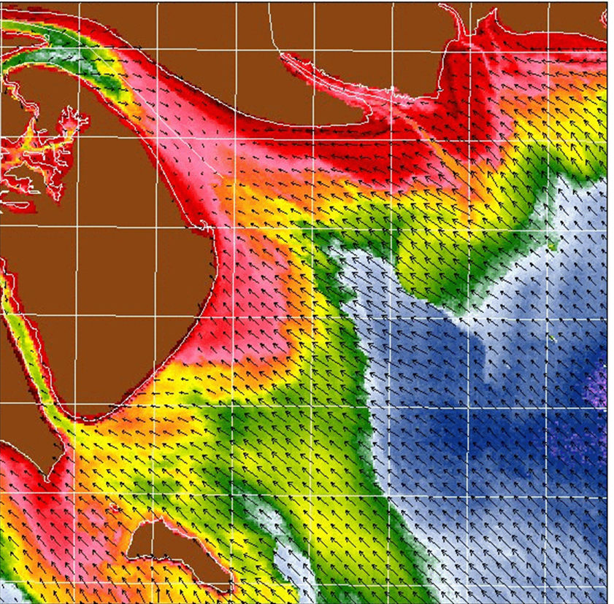
Figure 24 - Combined PC Tides and Optical properties (diver visibility) from the MODIS 250 m Product; note the information available at a considerable distance upriver.

6.0 Post-evaluation-Benchmarking
The diver visibility/vulnerability produced for the warfighter during OIF was disseminated on the SPIRNET until May 2003. The post-analysis of the effort demonstrates four important results. The first is that proactive interaction with the customer is critical in the development and transition of an operational product. This was especially important during OIF when a timely custom tailored product was required. The second is that customer “request” to product “delivery” time can be extremely short when a strong infrastructure and calibration/validation capability is already in place. Third, there is no silver bullet in many operational products; some products must be derived from a combination of information or sensors. And lastly, that the MODIS satellite system could be used in near-real-time to produce a product for the warfighter on-scene use.
Validation of the diver visibility product was very difficult and required feedback from the customer (the vulnerability product is even more difficult to validate). The customer’s use of the product and their “independent” analysis of the product helped create a more straightforward transition of the visibility and vulnerability products. Trust in the products reliability is established as the customer “validates” the product against his own experience. The MODIS 250 m horizontal diver visibility products produced from the AVHRR C660 algorithm looked extremely well and showed a lot of detail in the coastal and riverine waters. For the customer, the MODIS 250 m product was much better than the 1 km visibility product since his primary interest is in estuarine and coastal areas where variability is highest, and the details of the MODIS 250 m product allowed the customer to look for the spatial areas that are tactically significant. More importantly, it was much better than the Secchi Disk range normally provided as visibility.
The product to delivery time for the diver visibility using the 250 m MODIS sensor took only one week. This was accomplished by the utility of the APS and the pre-existing calibration and validation work at NRL-SSC, which had been developed over years of R&D. Because of this prior experience and development, NRL-SSC was poised to respond rapidly to the fleet request. The processing capabilities expedited changes in the product and the incorporation of beta-test versions of the new algorithm using the 250 m MODIS imagery. The output could then easily be compared with the standard 1 km SeaWiFS product for an evaluation.
The work with OIF also demonstrated the importance of multi-sensor work. The final product used information provided by SeaWiFS, MODIS, and the AVHRR satellites for its development and then “quick” calibration and validation. The “three looks a day” permitted monitoring of the product for quality and consistency. The processing speed and dissemination made the product available to the customer quickly. The customer wanted the product in minutes. Through use of automated processing the time was reduced from over eight hours to approximately 2-3 hours. In this time period, we are approaching the current computational limits for processing the satellite imagery (reception, atmospheric correction, application of optical algorithms, georectification). However, there is room for improvement so that the “human-in-the-loop” can be eliminated. Some of this will come about from further refinements in the data flow into secure areas. It was clear from the customer feedback that the products were far superior to what they had available. There are issues with “in-stride” adjustments based on on-scene information that must be addressed. Likewise the integration of “other valued information”, such as the tidal cycle and current fields, creates a product that is much more valued to the customer. It is the interaction with the customer that will define and prioritize the level of effort that each of these improvements should receive. The process of going from the baseline effort to formation of a new product should even be “smoother” and more efficient in the future. The OIF effort provides a template of the process needed to transition science to an immediate operational requirement and ocean color application.

7.0 Long term cost of developing MODIS Ocean Products in support of Operational Iraqi Freedom.
We evaluated what is required to develop and produce these decision making products used in the Operation Iraqi Freedom. We assessed our:
- Prior commitment which was made in research and development at NRL-SSC and other agencies,
- Prior Navy programs which were used to develop transition of research to operations and establish direct communication with the customer (warfighter)

The real cost of the swimmer delivery product is assessed as a combination of 1) man-years of efforts, 2) the experience of the personnel and 3) the establishment of competent team which is composed of research scientists, programmers, and operations specialists.

Prior and ongoing research
The Navy has a dedicated satellite ocean research program which is conducting basic and applied research. The Ocean Optics Section at NRL-SSC is a lead ocean optics laboratory for the Navy and has been developing new algorithms and conducting optical radiometric research. The mission of the section is to develop new understanding of how ocean optical properties can be used for improved Navy applications. This group specifically has been working with NASA research programs for the past 10 years and has exchanged research algorithms, calibration and validation methods and protocols. This research group is well respected within the national and international ocean color community for state of the art ocean color research. The section is experienced with NASA algorithms and software applications. NRL-SSC works closely with NASA in SeaWiFS and MODIS and Hyperion satellites. They are an approved NASA SeaWIFS Receive Site for the Gulf of Mexico.
This prior research provides the basis which enabled understanding of the science issues in satellite oceanography. This research also included in situ calibration and validation instrumentation, radiometric stability and long term vicarious calibration.
We attribute a team of four scientists per year for the past 5 years was required to develop this diver visibility product (20 man-years). Note that this research team in composed personnel experienced in satellite oceanography, optical oceanography and bio-optical oceanography.

Prior and ongoing programs in transition of Navy research to operations
Navy R&D programs include funding support (6.4 funding) where research programs can be transitioned to Navy operations. These programs are coordinated by the Commander, Naval Meteorological Oceanography Command (CNMOC) and the Oceanographer of the Navy for ocean research. Their job is to examine new Navy capabilities and requirements and match them to evolving research to meet those requirements – in this cases new satellites and ocean products. As part of this process, CNMOC and the Oceanographer of the Navy identified mature elements of NRL-SSC research in satellite oceanography that should be transitioned to the NAVOCEANO. NAVOCEANO is the environmental center where the operational Navy requests and obtains all ocean products. NAVOCEANO provides a continuous (24/7) suite of ocean products for locations around the globe to Navy users. NAVOCEANO is responsible for developing a structured roadmap of getting new products and ocean monitoring and measurements into their operational product line. NRL-SSC has assisted in this effort and has been supported to develop a pathway where ocean color satellites can be automatically processed into Navy products. This software is now utilized at NAVOCEANO and gets updated periodically as the new products are deemed “operational”.
Note that the process for developing new ocean products at NAVOCEANO undergoes a transition period to ensure quality control is being applied to the products, proper implementation of the products into Navy dissemination systems, as well as sufficient time for software and system training. NRL-SSC’s commitment to making operational software and products for Navy ocean color products is based on a long-term structured architecture of how product transitions are made and how they are integrated into operations at NAVOCEANO. This transition process is extremely important and includes:
- Identifying a roadmap of what and when products are coming on-line for NAVOCEANO to prepare for future products.
- Identifying a transition team from Research and operations
- Identifying a transition plan
- Locating where the product line will be produced at NAVOCEANO and with associated personnel, hardware, and software commitments.
- Determining the validation requirements of the products based on NAVOCEANO and Navy operational requirements
- Software and hardware configuration management
- Identification of a continued data sources (e.g. different satellites, etc.)

This is a team effort with NRL-SSC and NAVOCEANO teams. We have developed these methods for the last 5 years utilizing transition team of three persons. This team is composed of programmers, and operations specialists. The transition team works as the link between the research scientists and the operations at the NAVOCEANO. This team is essential if research is ever to go operational. Thus, this element represents a 15 man-year effort which allowed these new MODIS products to be available.

OIF MODIS Product Transition
These new products developed for OIF are scheduled to be transitioned to NAVOCEANO for operational use in the near future. As we developed these new products with direct input from with the warfighter, NAVOCEANO was very interested at the response that we received. They are enthusiastic to begin producing these new products for many other ocean regions and to develop additional Navy warfighter customers.
Note that the NAVOCEANO is not the actual customer that we identified in the OIF effort. NAVOCEANO is not the decision maker, but a supplier of environmental data to the warfighter. In Navy terms, the warfighter is assisted in making decisions by integrating information involved in operations and employment of force by use of a Tactical Decisions Aid (TDA). Typically, environmental data are integrated into TDA where criteria are evaluated to assist in a tactical decision. In the OIF effort, the warfighter used the MODIS visibility products to make decisions in managing his diving assets. This was the first time this capability was available and we expect that a TDA will be developed to include these diver visibility products.

References
Arnone, R.A, “Coastal Secchi Depth Atlas,” Naval Ocean Research and Development Activity, NORDA Report 83 (1985).

Arnone, R.A., Lee, ZhongPing, Martinolich, P., and Ladner, S.D. “Characterizing the optical properties of coastal waters by coupling 1 km and 250 m channels on MODIS – Terra,” Ocean Optics XVI, New Mexico (2002).

Arnone, R.A., R.W. Gould, A. Weidemann, S.D. Ladner, and P. Martinolich. “Satellite ocean color products for real-time Navy applications,” International Geoscience and Remote Sensing Symposium, France (2003).

Arnone R. A., P. Martinolich, R. W. Gould, Jr., R. Stumpf and S. Ladner “Coastal Optical Properties Using SeaWiFS,” SPIEE Ocean Optics XIV, ed: S. Ackleson and Cambell, Hawaii (1998).

Barnard A.H., W.S. Pegau, and J.R.V. Zaneveld, “Global relationships of the inherent optical properties of the ocean,” Journal of Geophysical Research, 103, C11, 24,955-24,968 (1998).

Basaham A. S., and M. A. El-Sayed, “Distribution and phase association of some major trace elements in the Arabian Gulf sediments,” Estuarine, Coastal and Shelf Science, 46, pp. 185-194 (1998).

Bowers T.E., “Directionally dependent threshold visual detection range of non-self-luminous objects submerged in optically stratified waters,” Master’s Thesis, University of Southern Mississippi, 66 pages (2003).

Carder, K.L., F.R. Chen, and J.P. Cannizzaro, “MODIS Ocean Science Team Algorithm Theoretical Basis Document,” ATBD 19, Version 6 (2002).

Carder, K.L., F.R. Chen, Z.P. Lee, and S.K. Hawes, “Semianalytic moderate-resolution imaging spectrometer algorithms for chlorophyll a and absorption with bio-optical domains based on nitrate-depletion temperatures,” Journal of Geophysical Research, 104, C3, 5403-5421 (1999).

Davies-Colley, R.J., “Measuring water clarity with a black disc,” Limnology and Oceanography, 33, 616-623 (1988).

Duntley, S.Q., “The visibility of submerged objects,” Massachusetts Institute of Technology, Visibility Laboratory, 74 pp. (1952).

Duntley, S.Q., “Improved nomographs for calculating visibility by swimmers,” Scripps Institute of Oceanography Visibility Laboratory, 32 pp. (1960).

Gould Jr. R.W., and R.A. Arnone, “Estimating the beam attenuation coefficient in coastal waters from AVHRR imagery,” Continental Shelf Research, 17, 11, 1375-1387 (1997).

Johns, W. E., G.A. Jacobs, J. C. Kindle, S. P. Murray, and M. Carron, Arabian Marginal Seas and Gulfs, Report of a Workshop held at Stennis Space Center, MS, 1999, University of Miami RSMAS Technical Report 2000-01, 60 pp. (2000).

Ladner, S.D., R.A. Arnone, R.W. Gould Jr., P.M. Martinolich, “Evaluation of SeaWiFS Optical Products in Coastal Regions,” Sea Technology, 29-35 (2002).

S. Ladner, R.Gould, Jr., R. Arnone, A. Weidemann, P. Martinolich, and B. Casey, Coupling In situ and Satellite Data to Validate Satellite Optical Properties. Oceanography Society Annual Meeting, LA (2003).

Lee, Z.P., K.L. Carder, and R.A. Arnone, “Deriving inherent optical properties from water color: a multiband quasi-analytical algorithm for optically deep waters,” Applied Optics, 41, 27, 5755-5772 (2002).

Martinolich, P.M., “Automated Processing System User’s Guide,” Version 2.4, PDF Format (2001).

Sugden, W., Some aspects of sedimentation in the Persian Gulf, Sedimentary Petrology, 33, pp. 355-364, (1963).

Zaneveld, J.R.V., and W.S. Pegau. “Robust underwater visibility parameter,” Accepted to Optics Express (2003).

