Automated DNA
Sequencing (ABI PRISM 3100)
Training Manual/Protocols

by

John P. Curran

TABLE OF CONTENTS

INTRODUCTION TO SEQUENCING 1

INTRODUCTION TO PCR 2

1. PCR 3
Part 1 – picking sequences: Accessing GenBank 3
Part 2 - converting single-stranded sequences to double-stranded sequences 5
Part 3 – primer design 8
PCR Rules 11
Part 4 – aliquoting & storing PCR reagents 11

Part 5 – mixing dNTPs 12
Part 6 – rehydrating primers 12

Part 7 – diluting primers 13

Part 8 – the master mix 13

Part 9 (optional) – programming the thermocycler for PCR 16

Part 10 – running the thermocycler PCR program 17

2. AGAROSE GEL ELECTROPHORESIS 19
Part I – casting the gel 19
Part 2 – sample preparation 20
Part 3 – electrophoresis 21
Part 4 – photographing the gel 22

3. POST-PCR PURIFICATION: QIAquick 23

4. QUANTITATIVE ANALYSIS: KDS1D software 24

5. BDT SEQUENCING REACTION 30
Part 1 – aliquoting & storing BDT reagents 30

Part 2 – diluting primers 30

Part 3 – calculating the volume of PCR product 31

Part 4 – the master mix 32

Part 5 (optional) – programming the thermocycler for BDT sequencing 34

Part 6 – running the thermocycler BDT program 35

6. POST-SEQUENCING PURIFICATION 37
Method 1: Centri-Sep 8 37
Method 2: DyeEx 38

7. SAMPLE PREPARATION FOR ABI PRISM 3100 SEQUENCE READING 40
Part 1 – spin drying 40
Part 2 – sample resuspension 41
Part 3 (optional) – programming the thermocycler for denature 42

Part 4 – running the thermocycler denature program 42

Part 5 – renaturation 42
Part 6 (optional) – changing the POP-6 polymer 43
Part 7 (optional) – changing the buffer 45
Part 8 – sample loading 45
Part 9 – programming the ABI PRISM 3100 47

8. DATA RECOVERY AND ANALYSIS 49
Part 1 – data recovery 49
Part 2 – sequence analysis 52

9. APPENDIX A: QUANTITATIVE ANALYSIS: SpectraMAX 250 55

REFERENCES 59

SUMMARY FLOW CHART 60

INTRODUCTION TO SEQUENCING

The aim of DNA sequencing is fairly self-explanatory. Knowledge of the exact sequence of nucleotides in a gene, for example, can ultimately act as a precise map of that gene. Armed with just such a map, a researcher could compare experimentally derived sequences to a “standard”, known, sequence for that gene. Discrepancies and/or deviations can point to potentially deleterious mutations which can, in turn, result in loss-of-function of the corresponding protein; a condition which could lead to a devastating disease such as cancer.

Automation has pervaded most aspects of modern life, and the world of molecular biology is certainly no exception. Nowhere is this more apparent than in the technique of DNA sequencing. First pioneered in the mid-1970’s, the ability to sequence DNA has recently culminated in the completion of the Human Genome Project. The rapid pace at which the Human Genome Project proceeded was due in large part to automating the DNA se-quencing process. Since the completion of the Human Genome Project is just the starting point in our understan-ding of human physiology, it is expected that automated sequencing will enhance this understanding by greatly accelerating the process of genetic discovery and pathology.

Sanger method: The most common method of manual DNA sequencing, the Sanger method requires that a DNA sample be split into 4 different reactions, with one enzymatic reaction occurring per tube. The reagents are a combination of naturally occurring nucleotides (the 4 building blocks of DNA) and chemically modified nucleotides in which an oxygen atom is missing from the ribose portion of the molecule. The former are collectively known as deoxynucleotide triphosphates (dNTPs) and include adenine (dATP), thymine (dTTP), cytosine (dCTP), and guanine (dGTP). The latter are collectively known as dideoxynucleotide triphosphates (ddNTPs). In addition, short, artificially synthesized DNA fragments of about 20-30 nucleotides (nt), known as primers, bind to regions flanking the area to be amplified. This binding site serves as a substrate for the enzyme DNA polymerase which synthesizes a complementary strand from a single-stranded template. During this synthesis, DNA polymerase begins to incorporate the dNTPs and ddNTPs into the complementary strand. The diagram below illustrates this method of DNA sequencing using ddATP (dideoxyadenine triphosphate) as an example:
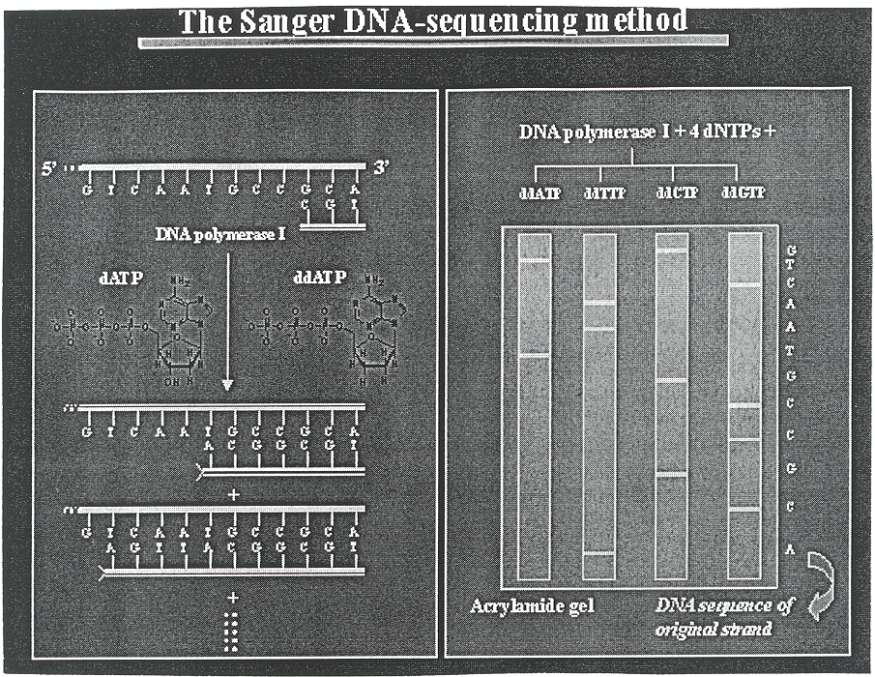
The ddNTPs are incorporated randomly during the synthesis of the complementary strand of DNA. Since ddNTPs cannot be covalently linked by DNA polymerase, strand synthesis stops at points where a ddNTP has in-serted. If a reaction tube contained ddATP plus normal dNTPs, for example, the end result would be partially double-stranded DNA chains of varying lengths in which all of the double-stranded regions end with an adenine (A). When the contents of that tube are loaded onto a lane of an acrylamide gel for electrophoretic separation, all of the fragments in that lane will end in “A”. Similarly, adding primers, template, polymerase, and dNTPs to tubes containing ddCTP, ddTTP, or ddGTP yields products that can each be resolved on different lanes of the same gel for comparison. One can then “read” the DNA sequence from the bottom of the gel up to the top. Advances in this method use ddNTPs that are “labeled” with covalently attached, light sensitive molecules such as rhodamine derivatives. These labels fluoresce at certain wavelengths that can be detected by a computer when illuminated with a laser beam. This is the basis of automated sequencing.

There are 8 general techniques (phases) that you will need to master in order to successfully sequence DNA using an automated sequencer. The sequence of events and techniques listed here are optimized for use with the Applied Biosystems, Inc. (ABI) 3100 genetic analyzer. They are, in order: 1.) polymerase chain reaction (PCR); 2.) agarose gel electrophoresis; 3.) post-PCR purification; 4.) quantitative analysis; 5.) BigDye Terminator (BDT) sequencing reaction; 6.) post-sequencing purification; 7.) sample preparation for ABI PRISM 3100 sequence reading; 8.) data recovery and analysis.

INTRODUCTION TO POLYMERASE CHAIN REACTION (PCR)
Overview. In 1993, Kary Mullis netted the Nobel Prize for his discovery of the polymerase chain reaction (PCR), a way to replicate DNA in vitro. The ability of PCR to amplify a little bit of DNA into a lot of DNA has re-volutionized molecular biology, evolution, field ecology, biotechnology, medicine, and forensics. When sequen-cing, as in other applications in molecular biology and genetics, DNA and DNA donors are often scarce com-modities. Since most DNA extracted from tumors come from biopsies that have been surgically excised from hu-man patients (living or otherwise), there can often be a paucity of such DNA. Therefore, PCR is used to appreci-ably amplify the quantity of the DNA to be sequenced. Furthermore, PCR enables researchers to zero in on a specific region of DNA of interest. The threshold for PCR’s amplifying power is ~ 40 kilobases (kb).

Before PCR was discovered, genes, and other DNA of interest to researchers and technicians, had to be excised by digestion with endonucleases (bacterial enzymes that cleave DNA strands wherever a specific sequence of bases is encountered in the genome), then cloned into vectors such as phages or bacteria. This technique is recombinant DNA and is still commonly used in biotechnology and research to reproduce larger fragments of genomic DNA. However, the capacity of most automated sequencers is limited to fragments of DNA short enough to easily lend themselves to the utility of PCR’s amplifying power.

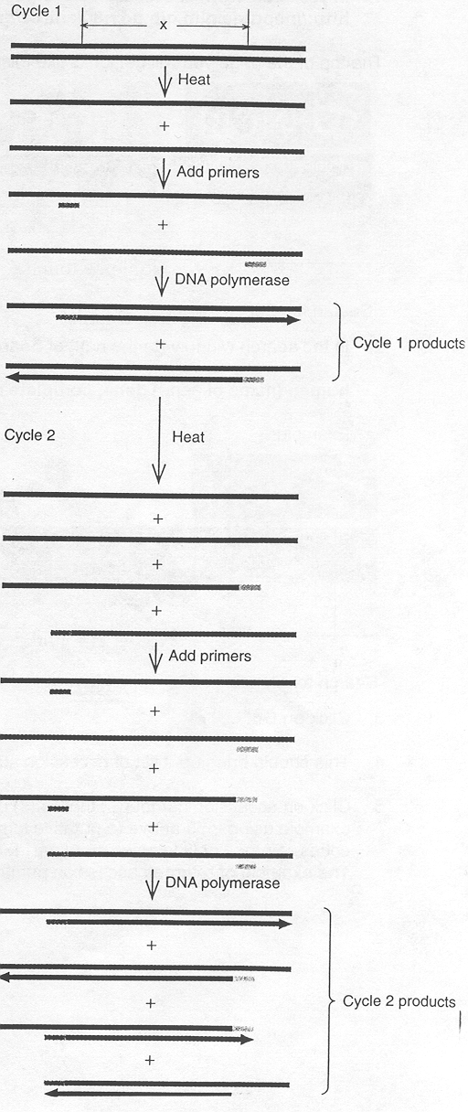
Theory. In a living cell, DNA is packaged into chromosomes. Before the chromosomal DNA can be
replicated, a battery of enzymes such as helicases, topoisomerases, gyrases, polymerases, primases, and
ligases, to name a few, unwind and separate the double helix before replicating the DNA. PCR unwinds and
separates the strands by applying high heat. The two strands of the double helix are normally held together by
hydrogen bonds between the base pairs C≡G (3 bonds) and A=T (2 bonds). These hydrogen bonds are easily
disrupted by heating the DNA to near the boiling point of water (~100°C) – a process known as denaturation.
The temperature is then lowered so that short, artificially synthesized oligonucleotides known as primers can
bind to complementary regions of the now single-stranded DNA chains by base pairing convention – a process
known as annealing. In the next step, the DNA polymerase enzyme (from which polymerase chain reaction gets
its name) binds to the short double-stranded region of DNA where the primers have annealed to the chromosomal DNA. Finally, raising the temperature to that of the enzyme’s optimal activity initiates the third step in the process – extension. During extension, DNA polymerase proceeds along the DNA strand in a 5’ → 3’ direction and incorporates nucleotides (which have been added to the PCR mix) into a nascent complementary strand. Theoretically, one ends up with 2 new stretches of DNA that span the region flanked by the two primers (a
forward and a reverse) that are identical in base composition and sequence to each other and to the parental genomic DNA from which they were derived. The regimen of denaturing, annealing, and extension is known as thermocycling. Programmable machines known as thermocyclers vary the temperatures appropriately
for each of the 3 stages of PCR. It is possible to exponentially replicate DNA in this way for an indefinite number of cycles until the limiting reagent (the primers) are consumed in the reaction. This means that one DNA double helix will yield 2 double helices after one cycle of replication, 4 after two cycles, 8 after three cycles, 16
after four cycles, 1024 after ten cycles, etc.
PHASE I - PCR

Part 1 – picking sequences. One of the drawbacks to PCR is that it can be applied only when the nucleotide sequence of at least one short DNA segment on each side of the region of interest is known. The PCR procedure involves using synthetic oligonucleotides complementary to these known sequences to prime enzymatic amplifi-cation of the intervening segment of DNA in the test tube. As mentioned in the introduction, the Human Genome Project has rendered many of these sequences known to the public via the National Center for Biotechnology In-formation (NCBI). NCBI is located in building 31 on campus (the same building where you obtain your parking permits and bus passes). Yet, you can conveniently retrieve many DNA/RNA/protein sequences from anywhere in the world from NCBI’s online catalog – GenBank.

Accessing GenBank:

- In your web browser’s location bar, type in: http://neptune.nlm.nih.gov:80/entrez/query.fcgi?CMD=search&DB=Nucleotide

The top of the page you will get looks like this:
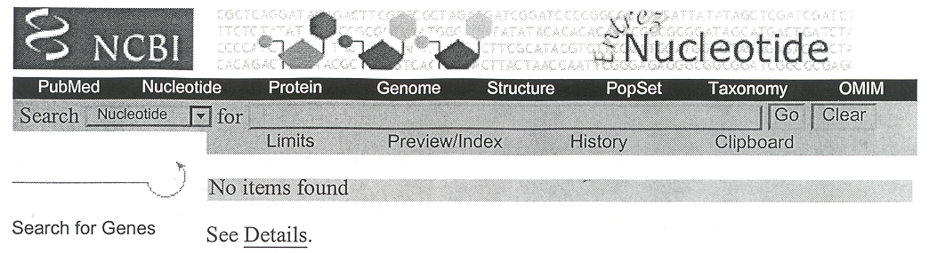
- In the search window (to the right of Search Nucleotide for), type in:

human (name of gene) gene, complete cds

Example:
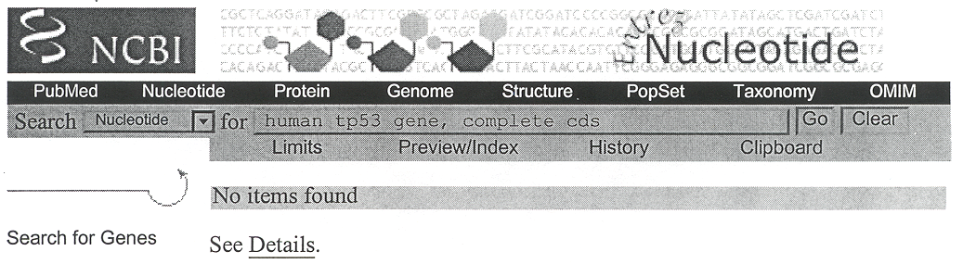
- Click on Go.

- This should bring up a list of accession numbers. Hopefully, it will be a short list as with the entry for tp53.

- Click on accession number(s) that list(s) complete cds (codes). There may be more than one. In the example using tp53 above (a putative tumor suppressor gene), entries 1 and 3 are both based on complete codes. Entry 2 only focuses on exon 11, so you can skip that one unless you are only interested in exon 11. The example of returned accession numbers appears at the top of the following page.
Part 1 – picking sequences (continued).
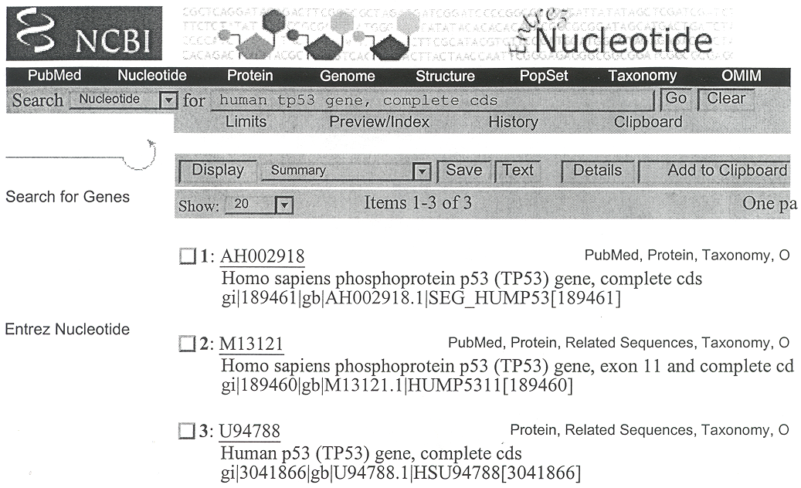
A cursory examination of entry 1, for accession number AH002918, does not list the actual nucleotide sequences. Rather, it provides links to bits and pieces of sequences. Examining entry 3, for accession number U94788, rev-eals the full 20,303 nt sequence for this gene. An excerpt from this 20.3 kb gene appears below.

1141 gatgatgggg atgttaggac catccgaact caaagttgaa cgcctaggca gaggagtgga
1201 gctttgggga accttgagcc ggcctaaagc gtacttcttt gcacatccac ccggtgctgg
1261 gcgtagggaa tccctgaaat aaaagatgca caaagcattg aggtctgaga cttttggatc

The number to the left of each line is the number of the base that begins that line. The first base in the gene is obviously 1. Each string is 10 nt long and there are 6 strings for a total of 60 nt per line. Since the entire gene sequence is over 5 pages long, you may just wish to use your browser’s edit functions to copy just the region of interest into a word processor file. For example, if you were interested in sequencing only the ~1800 bp region between exons 5 – 9, copy just that region. How do you know where the exon (parts of the mRNA that are actually translated rather than being spliced out) boundaries are? The file that you retrieve from GenBank should list them. Here is another excerpt from that same file below.

exon 13055..13238
/gene="TP53"
/number=5
exon 13320..13432
/gene="TP53"
/number=6
variation 13399
/gene="TP53"
/note="Polymorphism: A or G"
/replace="g"
exon 14000..14109
/gene="TP53"
/number=7
exon 14452..14588
/gene="TP53"
/number=8
exon 14681..14754
/gene="TP53"
/number=9

Part 1 – picking sequences (continued).

The region of interest (exons 5 – 9) ranges from base 13055 to 14754. This would take up about 2 pages – a far more manageable number. Next, you will need to convert the single-stranded code to double stranded-code. There is a simple program available online to enable you to do this easily.

Part 2 - converting single-stranded sequences to double-stranded sequences.

From your copied GenBank word processor file:

- Press <Ctrl> + A.

- Press <Ctrl> + C.

- In your web browser’s location bar, type in: http://genzi.virus.kyoto-u.ac.jp/tacg/tacg.form.html

- Click inside the box beneath the heading:
Sequence Entry (>30 bp)

- Press <Ctrl> + V.

- Under the heading: Restriction Enzyme Characteristics
Click in the circle to the left of the line: by Explicit Pick from List Click here to Pick
Don’t actually select any of the enzymes on the list, though!

- Under the heading: Analyses
- Click in the box to the left of the line:
Pseudo Gel Map with a low-end cutoff of 100 | bases.

- Click in the box to the left of the line:
Entire Linear Map WARNING!!~10x your input sequence in bytes, but REQUIRED for Translation below!

- Leave the rest of the settings alone.

- Click on the button: Submit Sequence to WWWtacg
The web page with the all of the appropriate boxes checked and the window filled in appears on the next 2 pages.
If you used the short 180 nt sequence in the middle of page 4, the result that is returned from WWWtacg should look like the following:

1 gatgatggggatgttaggaccatccgaactcaaagttgaacgcctaggcagaggagtgga 60
ctactacccctacaatcctggtaggcttgagtttcaacttgcggatccgtctcctcacct

61 gctttggggaaccttgagccggcctaaagcgtacttctttgcacatccacccggtgctgg 120
cgaaaccccttggaactcggccggatttcgcatgaagaaacgtgtaggtgggccacgacc

121 gcgtagggaatccctgaaataaaagatgcacaaagcattgaggtctgagacttttggatc 180
cgcatcccttagggactttattttctacgtgtttcgtaactccagactctgaaaacctag

- Copy your double-stranded sequence into a new word processor file. Discard the original.

- You will, of course, have to change the numbers at the left to coincide with the GenBank position numbers. The numbers at the right can be deleted.

Now you are free to map out the locations of primers and exons. You may highlight primer binding locations in color. By convention, exon sequences are expressed in CAPITAL letters. An example from such a file would look like:
--
14341 5’-tccagaaagg acaagggtgg ttgggagtag atggagcctg gttttttaaa tgggacaggt ←GenBank
3’-aggtctttcc tgttcccacc aaccctcatc tacctcggac caaaaaattt accctgtcca ←WWWtacg
----------------------------------------------------→
- 14401 aggacctgat ttccttactg cctcttgctt ctcttttcct atcctgagta gtggtaatct
tcctggacta aaggaatgac ggagaacgaa gagaaaagga taggactcat caccattaga

14461 actgggacgg aacagctttg aggtgcgtgt ttgtgcctgt cctgggagag accggcgcac
tgaccctgcc ttgtcgaaac tccacgcaca aacacggaca ggaccctctc tggccgcgtg

14521 agaggaagag aatctccgca agaaagggga gcctcaccac gagctgcccc cagggagcac
tctccttctc ttagaggcgt tctttcccct cggagtggtg ctcgacgggg gtccctcgtg

14581 taagcgaggt aagcaagcag gacaagaagc ggtggaggag accaagggtg cagttatgcc
attcgctcca ttcgttcgtc ctgttcttcg ccacctcctc tggttcccac gtcaatacgg

9 14641 tcagattcac ttttatcacc tttccttgcc tctttcctag cactgcccaa caacaccagc
agtctaagtg aaaatagtgg aaaggaacgg agaaaggatc gtgacgggtt gttgtggtcg

14701 tcctctcccc agccaaagaa gaaaccactg gatggagaat atttcaccct tcaggtacta
aggagagggg tcggtttctt ctttggtgac ctacctctta taaagtggga agtccatgat

14761 agtcttggga cctcttatca agtggaaagt ttccagtcta acactcaaaa tgccgttttc-3’
tcagaaccct ggagaatagt tcacctttca aaggtcagat tgtgagtttt acggcaaaag-5’
←--------------------------------------
The above illustration shows that 2 primers flank the region of interest (exons 8 & 9 in this example). One is on the top, coding strand (blue), i.e. the GenBank sequence. The other is on the bottom, anti-coding strand (green) returned from WWWtacg. The former is called the forward primer and the latter is called the reverse primer. Both are essential for PCR.

Since DNA extension can only proceed in a 5’ → 3’ direction, the forward primer is the 1st building block in the synthesis of one strand, while the reverse primer is the 1st building block in the synthesis of the complement-ary strand. Thus, once the sequence of the DNA region of interest has been obtained, the next logical step is to design forward and reverse primers that flank the region of interest.

Part 3 – primer design. There are some simple rules concerning primer design that take only a few minutes to learn, but a long time to master. Some general characteristics of ideal primers are as follows:

- The melting temperature (T_{m}) should ideally be 60°C. The most effective tem-perature range is 50 to 65°C. Generally, the suitable annealing temperature on the thermocycler will have to be adjusted to 5°C less than the primer’s actual T_{m}. If your primer’s T_{m} is 60°C, for example, then the annealing temperature programmed into the thermocycler should be 55°C.

- The ideal primer has 50% GC content. Primers are still acceptable if they have slightly more or less than this. However, the lower the GC content, the lower the T_{m}. This decreases overall efficiency because of the extra time required for each temperature cycle. More cycles would have to be added to compensate for this effect. As the temperature drops, the template DNA’s single strands begin to compete with the primers in binding to their complementary strands. This tends to lower the efficiency also. By contrast, primers with a high GC content have higher T_{m}. This, too, lowers the efficiency of the reaction because the primers may have a difficult time binding to its single strand DNA template if the T_{m} is too close to the denaturation temperature.

- An ideal primer that has a T_{m} of 60°C AND 50% GC content is about 24 nt long. As a matter of practicality, primers can range from 15-30 nt in length. However, keep in mind that the shorter the primer, the lower the T_{m}. Conversely, the longer the primer, the higher the T_{m}.

Part 3 – primer design (continued).

- Try to end primers with CG. This is the most uncommon dinucleotide in the human genome.

- There should be at least a 15 nt distance between the end of your primer and the beginning of the region of interest to be sequenced. This caveat only applies to the design of primers to be used in sequencing reactions. It is not necessary for successful PCR. Consider the following example in which the primer sequence is in blue and the region of interest begins at the 1st capital letter. The primer is 27 nt and the distance between the end of the primer and the beginning of the sequence of interest is 21 nt. Note the GC content is 48.1% & the T_{m} is 60.2°C – this is an ideal primer!

5’-tgggacaggt aggacctgat ttccttactg cctcttgctt ctcttttcct atcctgagta gtggtaatct-3’
3’-accctgtcca tcctggacta aaggaatgac ggagaacgaa gagaaaagga taggactcat caccattaga-5’

- Avoid designing primer pairs that are complementary to each other and themselves for more than 3 or 4 nt. On the one hand, this can cause a primer-dimer to form. On the other hand, you could get a hairpin structure. Also, your reverse primers should not have more than 3 or 4 nt that are complementary to your forward primers. All of these problems, of course, limit the efficiency of primers to bind to their intended templates. Take the following example:

5’-tgggacaggtaggacctgatttccttactgcctcttgcttctcttttcctatcctgagtagtggtaatct-3’
3’-accctgtccatcctggactaaaggaatgacggagaacgaagagaaaaggataggactcatcaccattaga-5’

The primer ggacctgatttccttactgcctcttg has 50% GC content, a T_{m} of 59.7°C, and is 27 nt long. Ostensibly, you would think that this would be an ideal primer, right? Upon further scrutiny, this primer can form a dimer with itself over an 8 nt region. Observe the base pairs in red.

5' GGACCTGATTTCCTTACTGCCTCTTG 3'
||| | | |||
3' GTTCTCCGTCATTCCTTTAGTCCAGG 5'

Also observe the internal hairpin structure that is also possible over a 3 nt region.

5' GGACCT

||| G
3' GTTCTCCGTCATTCCTTTA

How to calculate length, GC content, T_{m}, and primer-dimer or hairpin structures:

Integrated DNA Technologies (the company from which we order most of our primers) has an internet tool called OLIGO ANALYZER 2.5 that will calculate all of the above information.

- In your web browser’s location bar, type in: http://207.32.43.248

- Enter your sequence in the box beneath the heading SEQUENCE AND SETTINGS, as in the example below.
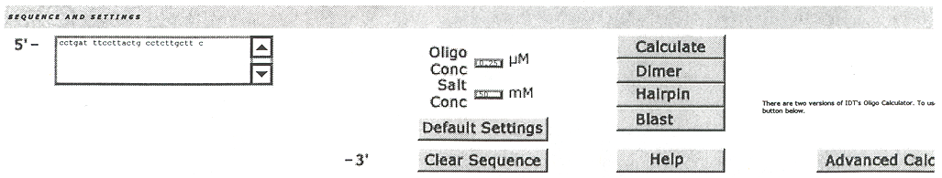

CAVEAT: When you design a reverse primer, you will have to invert the base order so that it reads 5’→3’ from left to right. For example, if your reverse primer is: 3’-tagttcacctttcaaaggtc-5’ you will have to type into the OLIGO ANALYZER 2.5 window: 5’-ctggaaactttccacttgat-3’.
Part 3 – primer design (continued).

- Click on the Calculate option.
- click on Dimer to assess the possibility of primer-dimer formation. Avoid possibilities that say (bad!).
- click on Hairpin to assess the possibility of hairpin formation. Avoid possibilities that say (bad!).

- If you do not have internet access, there is a quick, albeit far less accurate, way to derive the approximate T_{m}.
- Multiply the sum of G+C by 3.
- Multiply the sum of A+T by 2.
- Add the 2 sums.

Since A=T bonds are held together by 2 hydrogen bonds, they get a coefficient of 2. Since G≡C bonds are held together by 3 hydrogen bonds, they get a coefficient of 3.
Example: 5’-cctgatttccttactgcctcttgcttc-3’ There are 10 C’s, 3 G’s, 2 A’s & 12 T’s.

C + G = 10 + 3 = 13. 3 x 13 = 39
A + T = 2 + 12 = 14. 2 x 14 = 28
39 + 28 = 67°C

Note, however, that this is an overestimate of the actual value of 60.2°C, so it is best to use the software whenever possible. Also note that some of the older literature assigns a coefficient of 4 to the G+C sum. If using 4 instead of 3 in the above example, the estimated T_{m} would have been 80°C! This is even farther off the mark than 67°C!

BEGINNING WITH THIS PART, YOU WILL NEED TO DO ALL WORK IN THE PCR HOOD IN ROOM D702A!

First, a few simple precautions to be used for all work done with PCR reagents, and in the PCR hood in D702A:
PRECAUTION 1: BEFORE BEGINNING, PLACE ALL OF THE ITEMS YOU WILL NEED (i.e. 23” x 24” UNDERPADS, PRIMERS, UNOPENED BOXES OF PIPET TIPS, UNOPENED BAGS OF 1.7-ml TUBES, UNOPENED BOTTLES OF WATER) INTO THE SPECIALLY DESIGNATED PCR HOOD IN ROOM D702A.
PRECAUTION 2: PIPETTORS SPECIFICALLY DESIGNATED FOR PCR USE SHOULD ALREADY BE PRESENT IN THE HOOD. DO NOT USE ANY OTHER PIPETTORS. THERE IS ALSO A MICROFUGE IN THIS HOOD. USE ONLY THIS MICROFUGE DURING PREPARATORY STEPS.
PRECAUTION 3: STORE ALL REAGENTS TO BE USED FOR PCR (INCLUDING TEMPLATE DNA) ONLY IN THE PCR ROOM – D702A. THIS INCLUDES ANYTHING STORED IN FREEZERS, REFRIGERATORS, BOXES, DRAWERS, AND ON SHELVES. EXCEPTION: THE LOWER HALF OF THE JEN LAB FREEZER (NEXT TO THE ICE MACHINE WHEN YOU ENTER THE LAB) LABELLED “PCR REAGENTS ONLY”. TYPICALLY, LAB STOCKS ONLY GO IN THIS ONE.
PRECAUTION 4: STORE ALL UNDERPADS TO BE USED FOR THE PCR HOOD IN ROOM D702A.
PRECAUTION 5: NEW ITEMS ORIGINATING OUTSIDE OF ROOM D702A CAN BE INTRODUCED INTO THE PCR HOOD, BUT ONLY IF THEY ARE CERTIFIED TO BE FREE OF CONTAMINATION FROM DNAse, RNAse, DNA, RNA, AND PYROGENS (i.e. STERILE). ALL ITEMS MUST ALSO BE SEALED AND UNOPENED.
PRECAUTION 6: ALWAYS DON A NEW, CLEAN PAIR OF LATEX GLOVES BEFORE HANDLING ANYTHING THAT IS DESTINED FOR THE PCR HOOD, OR THAT IS ALREADY IN THE PCR HOOD. AND, DON A CLEAN LAB COAT BEFORE YOU START WORKING.
PRECAUTION 7: NEVER PLACE THE PRODUCTS OF A PRIOR PCR REACTION INTO THE PCR HOOD (OR EVEN BRING THEM INTO THE ROOM IF YOU CAN HELP IT)!
PRECAUTION 8: ALWAYS CHANGE PIPET TIPS AFTER USE.
PRECAUTION 9: WHEN PIPETTING, Loosen the caps on vialS, REMOVE TO PIPET, and restorE when done.
PRECAUTION 10: KEEP THE HOOD CLEAN BY PUTTING AWAY ITEMS YOU DO NOT NEED OR HAVE FINISHED USING.
PRECAUTION 11: ALL STEPS THAT CALL FOR THE USE OF ICE, REQUIRE WATER (i.e. WET) ICE. Do not accidently use dry (CO₂) ice as there is a 78° difference in temperature between water ice (freezing point 0°C) and dry ice (freezing point -78°C). Water ice keeps reagents COOL, while dry ice keeps reagents frozen.
PRECAUTION 12: EVERYONE SHOULD HAVE HIS/HER OWN “PCR BOX” CONTAINING EACH ONE OF THE ITEMS LISTED BELOW IN PART 3.

Part 4 – aliquoting & storing PCR reagents. - ALL ALIQUOTING MUST BE DONE IN THE PCR HOOD IN ROOM D702A! There are 9 “ingredients” that go into a typical 50 µl PCR. All reagents should be frozen at -20°C until ready to use. Furthermore, it is a good idea to partition some of the stock “ingredients” into aliquots. This prevents an entire stock from becoming simultaneously contaminated. Minimize the number of freeze-thaw cycles for each reagent.

The ingredients:
- PCR Gold Buffer – This consists of 150 mM Tris-HCl, pH 8.0 & 500 mM KCl. The ionic strength and pH of the buffer have been optimized carefully, and controlled for use with the AmpliTaq Gold DNA polymerase. Do not aliquot from a 1.5-ml vial; otherwise partition into ~ 500 µl aliquots.

- MgCl₂ – PCR is especially sensitive to magnesium ions (Mg²⁺), which can affect primer annealing, DNA de-naturing temperature, and the activity/fidelity of strand extension by Taq polymerase. The recommended con-centration per reaction is 1 – 4 mM. However, the optimal concentration within this range is dependent on the specific set of primers and template used. Do not aliquot from a 1.5-ml vial; otherwise partition into ~ 500 µl aliquots.

Part 4 – aliquoting & storing PCR reagents (continued).

- DMSO (dimethylsulfoxide) – This organic compound is probably the most commonly used PCR enhancing agent and is frequently included as part of a standard optimization of PCR amplifications. The goal of using enhancing agents is to increase the yield and specificity of PCR products. DMSO disrupts base pairing which speeds up the denaturation process, especially of GC rich regions. If you have ≤ 50% GC content, you could actually skip adding DMSO. Partition into ~ 500 µl aliquots.

- forward primer – This marks the upstream boundary of the DNA region to be amplified. See part 5.

- reverse primer – This marks the downstream boundary of the DNA region to be amplified. See part 5.

- dNTPs – These are the monomers that DNA polymerase incorporates into a nascent DNA strand, complementary to the parent (template) strand. Partition into ~ 250 µl aliquots.

- ultrapure deionized (d)H₂O – Water acts as a generic reaction solvent. Partition into ~ 1 ml aliquots.

- Taq DNA polymerase – This is the enzyme that makes PCR possible. It is extracted from the bacterium Thermus aquaticus, an extreme thermophile that dwells in geothermal vents and hot springs. Most com-mercially available DNA polymerases are derived from such bacteria because, unlike other DNA polymer-ases, thermophilic DNA polymerases can withstand the high temperatures required for PCR. DNA polymer-ases are named with the 1st letter of the genus and first 2 letters of the species from which they are derived. Thus, DNA polymerase from Thermus aquaticus is known as Taq polymerase (note the 1st letter is always capitalized and all letters are italicized). The particular variant of Taq that we use is chemically modified so that it will only be activated at elevated temperatures. Upon thermal activation, the modifier is permanently released, regenerating active enzyme. Do not aliquot.

Part 5 – mixing dNTPs. – THIS PART MUST BE DONE IN THE PCR HOOD IN ROOM D702A!
The dNTPs we receive from Amersham-Pharmacia Biotech come as a set of 4 1-ml tubes of each dNTP. Thus, the set contains a 1-ml tube of 100 mM dATP, a 1-ml tube of 100 mM dTTP, a 1-ml tube of 100 mM dGTP, and a 1-ml tube of 100 mM dCTP.

- Thaw the dNTP vials in the PCR hood, preferably on ice.

- Label 4 clean 1.7-ml microfuge tubes (NSN 6640-01-398-2427) “25 mM dNTP mix”.

- Pipet 255 µl of dATP into one of the tubes.

- Pipet 255 µl of dTTP into the same tube.

- Then pipet 255 µl of dGTP into the tube.

- Finally, pipet 255 µl of dCTP into the tube. This should give you 1020 µl of dNTP mix total. Collectively, the concentration of each individual dNTP is ¼ of the 100 mM total or 25 mM for each dNTP.

- Close the lid tight on the tube, vortex on the Vortex Genie 2 in the PCR hood for a few seconds, and spin briefly in the PMC-060 microfuge (also in the hood). CAUTION: Always use the centrifuge in a balanced configuration. For the PMC-060, balanced configurations occur with 2, 3, 4, and 6 tubes. If the microfuge doesn’t work when you shut the lid, check the on/off switch at the back of the unit to make sure it is on.

- With your pipet, apportion 250 µl aliquots into the microfuge tubes labeled “25 mM dNTP mix”. The extra 20 µl hedges against pipetting errors.

- Store frozen at -20°C until ready to use.

Part 6 – rehydrating primers. – THIS PART MUST BE DONE IN THE PCR HOOD IN ROOM D702A!
Prior to setting up a PCR, you will need to rehydrate the stock vials of primers to a concentration of 1000 ng/µl using ultrapure deionized water (dH₂O). The primers are usually shipped to us in the form of a lyophilized powder that has to be resuspended. The powder is stable for years when stored at -20°C. However, the primers are less stable in solution but can be kept for several months if stored at -20°C. All of the primers’ technical information, i.e. base sequence, T_{m}, molecular weight (MW), mass (mg), and moles, are printed on the labels. An example of such a label appears at the top of the next page.

Part 6 – rehydrating primers (continued).
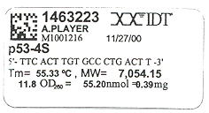
- The mass will have to be converted from milligrams (mg or 10⁻³ g) into nanograms (ng or 10⁻⁹ g).
Multiply the mass by 1,000,000 ng/1 mg.
Example: 0.39 mg x (1,000,000 ng/1 mg) = 390,000 ng.

- The dry primer will have to be rehydrated in ultrapure dH₂O (Invitrogen # 10977-015).
Add 1000 µl for every 1 mg.
Example: 0.39 mg x (1000 µl/1 mg) = 390 µl.

- Dividing the mass obtained in step 1 by the volume obtained above in step 2 should give 1000 ng/µl.
Example: 390,000 ng ÷ 390 µl = 1000 ng/µl.

Part 7 – diluting primers. – THIS PART MUST BE DONE IN THE PCR HOOD IN ROOM D702A!
Once resuspended, an aliquot from each 1000 ng/µl primer stock vial will have to be diluted down to a final working concentration of 350 ng/µl. Make enough for ~ 200 µl per aliquot.

- Label 2 1.7-ml microfuge tubes. Label one with “350 ng/µl” and the name of your forward primer. Label the other with “350 ng/µl” and the name of your reverse primer.

- Add 70 µl of the stock (i.e. 1000 ng/µl) forward primer solution to the “350 ng/µl forward primer” tube and add 70 µl of the stock (i.e. 1000 ng/µl) reverse primer solution to the “350 ng/µl reverse primer” tube. How was the value of 70 µl obtained? Using the generic dilution formula, C_{new}V_{new} = C_{stock}V_{stock}, where C is concentration and V is volume: (350 ng/µl) x 200 µl = (1000 ng/µl ) x V_{stock} → 70,000 ng = 1000 ng x V_{stock} → 70,000 ng/1000 ng = V_{stock}; V_{stock} = 70 µl.

- Add 130 µl of ultrapure dH₂O to each of the labeled 350 ng/µl tubes. How was the value of 130 µl obtained? V_{final} - V_{stock} = V_{water} → 200 µl – 70 µl = 130 µl water.

- Cap both tubes & lightly vortex the contents of each on the Vortex Genie 2 to mix.

- Briefly spin both tubes in the PMC-060 microfuge to pool the contents.

- Store in an aliquot box in one of the D702A freezers at -20°C.

Part 8 – the master mix. – THIS PART MUST BE DONE IN THE PCR HOOD IN ROOM D702A!

Before getting started, make sure you review and understand all 12 warnings on page 11!

- Lay down a clean, new 23”x24” blue underpad (NSN 6530-01-027-0179) in the PCR hood.

- Fill a clean beaker (from room D702A) with ice and set inside the PCR hood.

- Remove your box of aliquots from the freezer.

- Inside the PCR hood, open your aliquot box and remove 1 tube of each of your 8 different PCR reagents. Place the tubes in a tube holder until the contents have thawed.

- Return the box to the freezer from which it came if there are other tubes of reagents in it. If there is nothing left in the box, you can obviously skip this step.

- As the contents thaw, place into the beaker full of ice to keep chilled. Generally, handle the reagents the same way that you would handle meat. Refrigeration and minimal exposure to air prevent spoilage.

EXCEPTION: Don’t keep the DMSO on ice once thawed because DMSO freezes at a much higher temperature than water (18.5°C). Optional: You may place the tubes in the 37°C block heater (VWR Select Heatblock) just long enough to thaw. DMSO can take forever to thaw at room temperature.

- While thawing reagents, label a 1.7-ml microfuge tube “master mix”.

Part 8 – the master mix (continued).

- Place a strip of 0.2-ml PCR microtubes (NSN 6640-00-L01-7436) in between the holes of an empty pipet tip box. You can almost always find one in the hood.

- Lightly vortex the contents of all tubes on the Vortex Genie 2 to mix.

- Briefly spin all tubes in the PMC-060 microfuge to pool the contents. CAUTION: Always spin in a balanced configuration (see step 7, page 12).

- Once ready, add the reagents below to the “master mix” tube. NOTE: The example below is a mix that has been optimized for PCR of the conserved region (exons 5-9) of the human p53 tumor-suppressor gene. How-ever, you need to bear in mind that the volume of MgCl₂ typically ranges from 4 µl to 13 µl and DMSO can be eliminated altogether depending on your specific template-primer combination. When lowering the volume(s) of MgCl₂ and/or DMSO, compensate by adding an equivalent amount of ultrapure dH₂O. The final reaction volume should always be 50 µl regardless of the volume of MgCl₂ or DMSO used.

component vol./rxn manufacturer catalog # [reagent]/rxn
1. GeneAmp® 10X 1X (pH 8.0) =
PCR Gold Buffer – 5 µl Perkin-Elmer 4306892 15 mM Tris-HCl
50 mM KCl

2. 25 mM MgCl₂ – 13 µl (can vary) Perkin-Elmer N808-0249 6.5 mM (can be less)

3. DMSO – 3 µl (can vary) Sigma-Aldrich D2650-5X5ML 6% (can be less or 0%)

4. 350 ng/µl – 1 µl Integrated DNA 0.2 – 1.0 µM
forward primer Technologies

5. 350 ng/µl – 1 µl Integrated DNA 0.2 – 1.0 µM
reverse primer Technologies

6. 25 mM dNTP mix – 2.5 µl Amersham-Pharmacia 27-2035-02 1250 µM
Biotech

7. ultrapure dH₂O – 20.5 µl (can vary) Invitrogen 10977-023 (can be more)

8. 1000U Taq – 1 µl Perkin-Elmer N808-0249 5 U
polymerase

NOTE: You will of course have to multiply the volume of each reagent by the number of reactions you are doing + 1. Thus, for example, if you are doing 8 reactions, you will need to multiply each of the following reagent volumes by 9 (8 + 1 = 9), if you are doing 21 reactions, multiply the volumes by 22 (21 + 1 = 22), etc.

Part 8 – the master mix (continued).

Here is how the master mix would be made if you were doing 8 reactions (the number of microtubes per strip).

rxns total
vol./rxn + 1 vol.
1. GeneAmp® 10X PCR Gold Buffer: 5 µl x 9 = 45 µl

2. 25 mM MgCl₂: 13 µl x 9 = 117 µl

3. DMSO: 3 µl x 9 = 27 µl

4. 350 ng/µl forward primer: 1 µl x 9 = 9 µl

5. 350 ng/µl reverse primer: 1 µl x 9 = 9 µl

6. 25 mM dNTP mix: 2.5 µl x 9 = 22.5 µl

7. ultrapure dH₂O: 20.5 µl x 9 = 184.5 µl

8. 1000 U Taq polymerase: 1 µl x 9 = 9 µl
TOTAL: 47 µl x 9 = 423 µl

As you add each reagent (after the first), place the pipet tip into the mix, alternately withdrawing & expelling the contents into & out of the pipet tip to mix thoroughly.

- When finished making your master mix, close the lid securely, invert the tube rapidly a couple of times, and spin briefly on the PMC-060 microfuge. CAUTION: DO NOT VORTEX THE MASTER MIX AFTER YOU HAVE ADDED THE Taq. YOU MAY, HOWEVER, VORTEX THE MASTER MIX PRIOR TO ADDING THE Taq, BUT YOU MUST STILL MIX MANUALLY AFTER THE Taq IS ADDED.

- Set a pipet for 47 µl and quantitatively transfer 47 µl of master mix from your master mix tube into each of the 0.2-ml PCR microtubes that you have set up in step 11.

- If you have ≥ 6 reactions (plus 1 positive & 1 negative control reaction), number your tubes with a Sharpie pen – the kind with super permanent ink. If you have ≤ 6 reactions (plus 1 positive & 1 negative control reaction), you can use the numbers stamped on the tubes (1 - 8).

- Annotate in your lab notebook, which DNA samples are being added to each tube (one of your samples will contain ultrapure dH₂O as a negative control). A sample entry appears below.

tube # |  | 1 | 2 | 3 | 4 | 5 | 6 | 7 | 8
DNA |  | 136201 | Mayo | 1199N | 1199T | 133202 | 1217N | 1217T | dH₂O
[DNA], ng/µl |  | 10 | 70 | 670 | 234 | 10 | ? | 324.5 | 0
DNA mass, ng |  | 30 | 210 | 2010 | 702 | 30 | ? | 973.5 | 0
[DNA]/rxn, ng/µl |  | 0.6 | 4.2 | 40.2 | 14.04 | 0.6 | ? | 19.47 | 0
↑ ↑
positive negative
control control

- Add 3 µl of ultrapure dH₂O to one of your microtubes. As the above table shows there should always be one reaction tube that contains no DNA. Because of PCR’s great amplifying power, this negative control should show no DNA bands by gel electrophoresis. The presence of DNA in the tube containing only water indicates contamination. The negative control in the example above is tube 8.

- Add 3 µl of the template DNA to be amplified to all but one of the remaining tubes. In addition to the negative control (the tube containing only water), you should also dedicate one tube as a positive control. The positive control should contain DNA from a known source that has yields a consistently reproducible PCR product for others in the lab. The positive control in the above example is tube 2.

NOTE: Every time you do a PCR, you will never do less than 3 reactions – 1 positive control, 1 negative control, & at least 1 experimental template. Therefore, you will multiply all ingredients by at least 4 (3+1).

Part 8 – the master mix (continued).

- Snap the microtube lids securely onto the tubes. The best way is to start with the tube on the far left and
work your way to the far right (the lid strips come in the same baggies as the tube strips). Since the tubes
and lids come in strips of 8, cut off the excess (if applicable) with a pair of scissors.

- Once the lids are on, run a finger along the bottom of the tube strip to mix.

- Clean up the PCR hood. Don’t forget to put DNA back into the refrigerator and aliquots back into your
assigned aliquot box in the D702A freezer.

Part 9 (optional) – programming the thermocycler.

- Once you leave the PCR set-up room (D702A), briefly spin your microtubes in a PMC-860 “capsulefuge” – a miniature centrifuge that can accommodate up to 2 8-microtube strips.

- Place your tubes into a PTC-200 “DNA Engine” thermocycler.

There should already be a generic PCR temperature regimen programmed into the machine. But, if there’s not, or you want to run your own program, the remaining steps are for your edification, using the generic program as an example.

- If the LCD screen is blank, the unit is off. The “on/off” switch is located at the rear of the machine just above the extension cord.

- Give the machine about 2-3 minutes to warm up. Close the lid and tighten it by turning the blue thumbwheel clockwise.

The main menu should appear thusly.
PTC-200:
_RUN Enter
List Edit
Files Setup
You will then be prompted to give your file a name.

Repeat this process until you have spelled out the name you want to give your program. Then press the “proceed” key twice in succession to save your program name.

- You will get the following menu.

Control method:
_BLOCK Probe
Calculated

BLOCK is the default option. Press the “proceed” key.

- You will get the following menu.

Step 1: = _TEMP
Gradient
Ramp End

TEMP is the default option. Press “proceed” and enter 95°C. This is the denaturation temperature.

- Enter a time of 2:30. The display will then ask _YES NO OPTION?

Part 9 (optional) – programming the thermocycler (continued).

- YES is the default option. Press the “proceed” key.
You can use the “select” arrows to move back and forth between highlighted options.

- You will then get the following menu.

Step 2: = _TEMP Goto
Gradient
Ramp End

Once again TEMP is the default option. Enter 58°C and a time of 1:30. This is the primer-template annealing temperature.

- For the 3rd line of your program, enter 70°C and a time of 1:30. This is the primer extension (complementary strand synthesis) temperature.

- For the 4th line of your program, enter 95°C and a time of 0:30.

- Enter the information from steps 12 and 13 above for the 5th and 6th lines of your program, respectively.

- When you are ready to enter the 7th line of your program, use the right arrow (“select” keys) to choose the “Goto” option instead of “TEMP”.

Step 7: = Temp _GOTO
Gradient
Ramp End

- After the prompt “Goto step:”, enter 4.

- After the prompt Addtnl cycles:, enter 35. The 7th line of your program should now read: Goto 4, 35 times.

- For the 8th line of your program, enter 95°C and a time of 0:30.

- For the 9th line of your program, enter 58°C and a time of 1:30.

- For the 10th line of your program, enter 70°C and a time of 6:30.

- For the 11th line of your program, enter 4°C and either a time from 16:00:00-24:00:00, or 0 to indicate for ever. This last step keeps your PCR product refrigerated until you are ready to work with it (which might not be until the following work day). If you are able to work with your PCR product the same day, then it is only necessary to wait a minimum of 10 minutes after the temperature goes to 4°C before you remove your samples.

- If you input a time instead of the for ever option for the last step, then enter END as the 12th line of your program on the menu.

Step 12: = Temp Goto
Gradient
Ramp _END

- The machine will then present you with a list of directories and prompt you to save your program in one of them. <MAIN> is the default directory. Use your select arrows to choose a directory and press “proceed”. Your program is now saved.

Part 10 – running the thermocycler.

- Once you leave the PCR set-up room (D702A), briefly spin your microtubes in a PMC-860 “capsulefuge” – a miniature centrifuge that can accommodate up to two 8-microtube strips.

- Place your tubes into a PTC-200 “DNA Engine” thermocycler.

Part 10 – running the thermocycler (continued).

- If the LCD screen is blank, the unit is off. The “on/off” switch is located at the rear of the machine just above the extension cord.

- Give the machine about 2-3 minutes to warm up. Close the lid and tighten it by turning the blue thumbwheel clockwise. The main menu should appear thusly.

PTC-200:
_RUN Enter
List Edit
Files Setup

Choose “RUN” by pressing the “proceed” key. “RUN” is the default option.

- Use the “select” arrows to move the cursor to the left of the directory name in which your file is saved and press “proceed”.

- Use the “select” arrows to move the cursor to the left of your file name and press “proceed”.

- You will then be prompted, “Use heated lid? _YES No”. Select YES; this is the default option.

- That’s all there is to running the program! The temperature regimen of the generic program is as follows.
cycle | temp (°C) | time | purpose
 | 95 | 2:30 | denature
1 | 58 | 1:30 | anneal
 | 70 | 1:30 | extend
2 | 95 | 0:30 | denature
through | 58 | 1:30 | anneal
36 | 70 | 1:30 | extend
 | 95 | 0:30 | denature
37 | 58 | 1:30 | anneal
 | 70 | 6:30 | extend
38 | 4 | >10:00 | storage
The entire program, including 10 minutes of storage time, is 3:04:39.

- If you chose a time limit for the 4°C (storage) step, the program will shut off automatically upon reaching the time limit. To manually end the program, press the “Stop” key at the bottom. You will get a prompt asking if you want to end the program. Choose YES.

- Loosen the blue thumbwheel by turning it counter-clockwise and lifting the lid. Remove your samples.

- Some condensation will inevitably have collected on the inside surface of the lids. Briefly spin the tubes in the PMC-860 capsulefuge to pool your sample.

A few final words about thermocycling: the generic temperature regimen listed above may not apply to all PCR situations. Make sure the program you are using is applicable to the particular combination of primers, T_{m}, and template DNA needed for your specific application.
PHASE II - AGAROSE GEL ELECTROPHORESIS

Once you have completed your PCR, you will need to verify that it worked. The standard way to do this is to load a small aliquot of your PCR product into wells of a 1% agarose gel. An electrical field applied across the gel causes the DNA fragments to move from their origin (the sample well) through the gel matrix toward the positive electrode (anode). The gel matrix acts as a sieve through which smaller DNA molecules migrate faster than larger ones. The PCR product will be appear as a band that is made visible by staining the gel with a dye that binds to DNA.

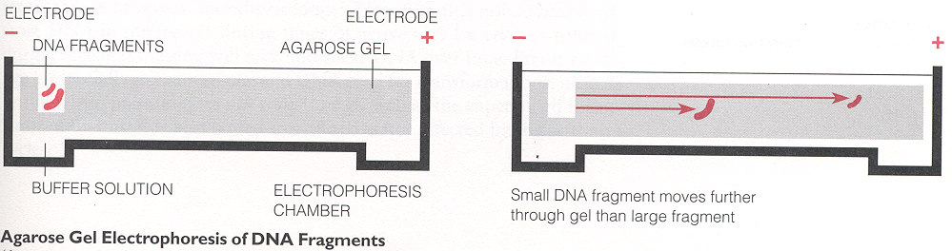

The migration of DNA (a negatively charged molecule owing to all those phosphate groups) through the gel to-wards an oppositely charged electrode can be explained by Coulomb’s Law where: distance = Vqt² - F_{f}t²r/mr. In this expression, V is the applied voltage, q is the charge of the DNA, t is the time elapsed, m is the mass of the DNA, r is the distance between the anode and the loading wells, and F_{f} is the frictional force generated by the DNA molecules as they snake their way through sub-microscopic pores in the gel. The greater the DNA size (mass or molecular weight), the greater the frictional resistance (F_{f}), the shorter the migration distance over a fixed period of time. Also, looking at the above equation, one can see that migration distance is also inversely proportional to the DNA’s mass. Thus, the larger the fragment, the shorter the migration distance over a fixed period of time. Conversely, the shorter the fragment, the greater the migration distance over the same time period. Since voltage is proportional to migration distance, increasing the voltage can also speed up migration.

Another way to look at distance is at², where a is acceleration and t is time. So that, at² = Vqt² - F_{f}t²r/mr = (Vqt² - F_{f}t²r/r) x m⁻¹. Dividing t² from both sides of the equation gives: a = (Vq - F_{f}r/r) x m⁻¹. Integrating both sides gives: ∫a = ∫(Vq - F_{f}r/r) x m⁻¹ → v = ∫(Vq - F_{f}r/r) x m⁻¹ = (Vq - F_{f}r/r) x ∫m⁻¹ = (Vq - F_{f}r/r) x ln m. v = d/t = (Vq - F_{f}r/r) x ln m. Multiplying both sides by t gives: distance = (Vqt - F_{f}tr/r) x ln m. Thus, distance is directly proportional to the natural logarithm of mass.

Part I – casting the gel.

- Thaw a vial of Gelstar® SYBR Green stain (stored at -20°C). (BioWhittaker # 50535)

- Place an Erlenmeyer flask on the PG5002-S analytical balance and tare it (the mass will read 0.00g).

- Sprinkle some SeaKem ME agarose (NSN 6810-01-144-8366) into a weigh boat (they can be found in a drawer to the right of and beneath the bench where the balances sit). NOTE: Agarose is a polysaccharide found in seaweed; it’s also very expensive. Do not pour out more than a little bit at a time.

- Pour 0.35 g of agarose into your flask for a mini-gel (10 wells wide), or 1 g for a regular gel (20 wells wide).

- Pipette 35 ml of 1X TBE (Tris-Boric acid-EDTA) into your flask for a mini-gel, or 100 ml for a regular gel, and swirl the contents around. A 25-ml serological pipette (found in room D702E) will actually hold 35 ml. The TBE stock concentration is 10X. So, if nobody has made any 1X TBE lately:
- Add 100 ml of 10X TBE (NSN 6810-00-L06-7854) to a 1L graduated cylinder and fill the remainder of the
cylinder (up to the 1000 ml mark) with DI water (The DI water can be identified by a large white nozzle at
the end of a slender black hose, holstered on the glassware racks over the sinks).
- Pour the mixture into an empty TBE or water bottle (but no other type of bottle to avoid contamination)
and label as 1X TBE.
- Cap the bottle and shake it vigorously for a few seconds to mix the contents.
Part I – casting the gel (continued).

- Microwave the flask for 1 minute for 35 ml or 1:30 for 100 ml. If there still appears to be undissolved agarose, microwave for an additional 15 seconds or until the remaining agarose dissolves. Make sure you wear heat-resistant gloves when handling the Erlenmeyer flask – it’s hot!

- Add 3.5 µl of Gelstar® SYBR Green stain to 35 ml molten agarose or 10 µl SYBR Green to 100 ml molten agarose. Swirl to mix.

- Pour the mix into a casting tray according to the illustration below.

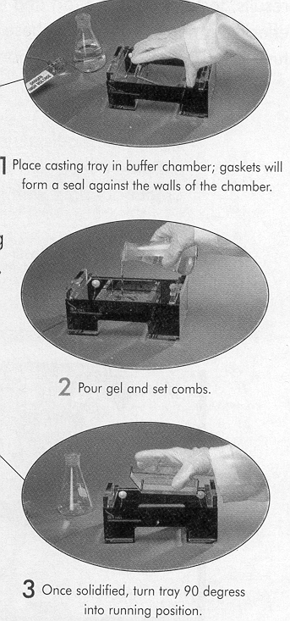

- Since the SYBR Green is light sensitive, you may wish to cover the gel box with aluminum foil. It should take about 10 minutes for the gel to congeal. While waiting for your gel to set, you can begin to prepare your samples for electrophoresis.

Part 2 – sample preparation.

- Label some clean, new 0.2-ml microtubes with the same numbering/labeling scheme as your samples.

- Transfer 1/10 (5 µl) from each of your samples to the new tubes.

- Add an equal volume of 2X gel loading buffer (GLB). The GLB contains glycerol (to weigh down the DNA), 2 tracking dyes (bromophenol blue & xylene cyanol), and buffers. The final [GLB] = 1X.
- To make 2X GLB from a 10X stock solution, add 4 parts dH₂O for every 1 part 10X GLB.

- Mix thoroughly by pipetting in and out. You should have 10 µl total volume (5 µl sample + 5 µl 2X GLB) for each representative sample of PCR product to be run on the gel.

- Spin the tubes briefly in a PMC-860 capsulefuge.

Part 3 – electrophoresis.

- Fill the gel box with 1X TBE to a level that barely covers the entire surface of the gel.

- Gently remove the comb, pulling it straight up and out of the set agarose. Do not rock or wiggle the comb.

- Sometimes comb removal pulls the agarose well edges above the buffer surface; these edges appear as “dimples” around the wells. Add buffer until any dimples disappear and the buffer surface is smooth.

- Load all 10 µl from each of the sample reaction tubes into a separate well in the gel. Use a fresh tip for each.

- You might want to chart out which lanes contain which samples in your lab notebook. Example:

gel lane assignments:
lane # | 1 | 2 | 3 | 4 | 5 | 6 | 7 | 8 | 9 | 10
DNA | 136201 | Mayo | 1199N | 1199T | 133202 | 1217N | 1217T | dH₂O | MW | empty

- In addition to your samples, you also need to run 5 µl of molecular weight size marker (Minnesota Molecular Hi-Lo™ DNA marker # 1010) in one of your lanes.

- Close the top of the gel box, and connect the electrical leads to a power supply. Make sure that both electrodes are connected to the same channel of power supply (EC 105). WARNING: ENSURE THAT THE RED CABLE (-) IS CONNECTED TO THE END FARTHEST AWAY FROM THE LOADING WELLS. Your DNA will electrophorese off the short end of the gel and be lost, otherwise.

- Turn on the power supply and set it to ~128 V. The ammeter should register ~ 50 mA. Current flow can be detected by the presence of gas bubbles at either end of the box (water is being electrolyzed to hydrogen and oxygen gas).

- Cover with aluminum foil and let run for about 45 minutes. Good separation has occurred when bromophenol blue bands have moved 4-7 cm from the wells. Stop electrophoresis before the bromophenol blue band runs off the end of the gel!

- Turn off the power supply and remove the foil and top of the box. Unplug the electrode cables from the power supply.

Part 4 – viewing the gel.
The SYBR Green that was added to the gel intercalates between base pairs of DNA and fluoresces when exposed to UV light.

- Remove the gel from the box and slide off of the casting tray onto the TFX-35M UV transilluminator.

- Close the plastic lid of the transilluminator before switching it on! Unshielded UV radiation can damage your eyes!

A discrete green band should be present in each sample lane except the negative control lane (water) and molecular weight marker (MW) lanes. If a band(s) is/are present in the negative control lane, or if there are multiple bands present in any lane (except the MW lane), it may be a sign of contamination.
Part 4 – viewing the gel (continued).

The MW lane should ideally give you 16 bands:

size (bp) mass (ng)
10,000 30
8,000 30
6,000 45
4,000 60
3,000 85
2,000 150
1,550 100
1,400 100
1,000 120
750 30
500 60
400 20
300 40
200 30
100 20
50 15
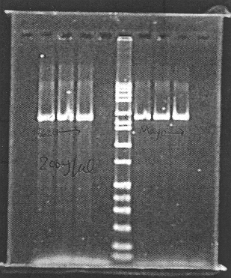
sample: empty 1 2 3 H₂O MW 4 5 6 empty

sample gel photo of PCR products
Part 5 – photographing the gel.

- With the transilluminator off, lift the plastic lid and center the Kodak DC120 camera over the gel.

- Turn the transilluminator on.

- Turn the camera on by pulling out the sliding contact (under the green dot with the number 01).

- On the adjacent computer, press <Alt>, f, q, d.

- In the dialog box, set the Gel Type to SYBR Green, the gel size, and exposure. You set the latter by choosing faint bands (2 sec), bright bands (0.5 sec), or normal bands (1 sec); the computer selects the time automatically.

- Click Take Picture and wait, and wait, and wait, and wait. Hopefully, you will obtain an image similar to the one at the top of the page. Look to match up your PCR product with the MW bands. If your PCR product is 1790 bp, for example, the bands in each sample lane should fall between the 2000 bp and 1550 marker bands.

- To print your photograph, press <Alt>, f, p. Just check image. You don’t need to print analysis or annotations (not yet anyway).

- Click OK.
PHASE III - POST-PCR PURIFICATION

Once you have confirmed the existence of a PCR product via gel electrophoresis, you will now need to purge everything that is not PCR product from the remaining (45 µl) PCR master mix. This includes polymerase, unincorporated dNTPs, DMSO, MgCl₂, buffer, excess genomic DNA, and primers. QIAGEN corporation makes spin-columns (QIAquick PCR Purification Kit, NSN 6550-01-414-9411) specially suited for that purpose.

The columns can theoretically recover 90-95% of the PCR product, can bind up to 10,000 ng (10 µg) of DNA, and are best suited for purification of PCR products ranging in size from 100 – 10,000 bp. The uniquely-designed silica-gel membrane in the columns can filter out 17-40 bp DNA fragments (the size range of PCR primers). In principle, DNA adsorbs to the silica-membrane in the presence of high salt while contaminants pass through the column. Impurities are efficiently washed away, and the pure DNA is eluted with Tris buffer.

Before 1st use, add 24 ml of 100% ethanol (NSN 6505-00-105-0000) to Buffer PE and mix.

- Add 5 volumes of Buffer PB (225 µl) to 1 volume of the PCR reaction (45 µl) and mix. The mixing will have to be done in a separate tube that is at least 270 µl (225 + 45) or 0.27 ml. The original PCR microtubes are only 200 µl or 0.20 ml.

- Place a QIAquick column in a provided 2-ml collection tube.

- Apply the sample to the QIAquick column and centrifuge in an Eppendorf 5415D tabletop microcentrifuge at a speed of ≥ 10,400 rpm (≥ 10,000 g) for 30-60 sec. CAUTION: Remember to snap the circular plastic muffler in place over the centrifuge rotor after loading your samples and before centrifuging them. If you forget, you’ll know because the noise will be ear-piercing. Don’t forget to balance the rotor. Balanced configurations for the Eppendorf 5415D occur with 2, 3, 4, 6, 8, 10, 12, 14, 16, 18, 20, 22, and 24 tubes.

- Discard flow-through. Place the QIAquick column back into the same tube.

- Add 750 µl Buffer PE to the QIAquick column and centrifuge again as in step 3.

- Discard flow-through completely. Residual ethanol will not be completely removed unless the flow-through is discarded before this additional centrifugation. Place the QIAquick column back into the same tube. Centrifuge the column for an additional minute at the same speed as in steps 3 & 5.

- Place the QIAquick column in a clean 1.7-ml microfuge tube.

- To elute PCR product, add 50 µl of Buffer EB (10 Mm Tris-Cl, pH 8.5) directly to the center of the spin-column membrane and centrifuge the column (≥ 10,400 rpm) for 1 minute. For increased DNA concentration, add 30 µl Buffer EB, let the column stand for 1 minute, then centrifuge the column.

- Remove the columns from the 1.7-ml microfuge tubes and discard. Close the lids on the microfuge tubes, and store the newly purified PCR product in those tubes at –20°C until you are ready to begin the BDT (BigDye Terminator) sequencing reaction.

- You will now need to do agarose gel electrophoresis again using 1/10 of your purified product (i.e. 3-5 µl) and an equal volume of 2X GLB. Refer to pages 19-22 for how to do this. When you have captured the gel image on your computer screen, you will need to perform an additional analysis step before you print your gel photo.
PHASE IV – QUANTITATIVE ANALYSIS: KDS1D SOFTWARE

- First, you will need to create a file for your MW standards. From the Edit menu, choose Standards. The Standards dialog box appears.

- Click New. The Edit Standards dialog box appears.

- Decide on a name for your file and type it in the text field.

- Standard Type: DNA.

- Next, enter the following information into your file.

Size (bp) Band Mass (%)
10000 3.209
8000 3.209
6000 4.813
4000 6.417
3000 9.091
2000 16.043
1550 10.695
1400 10.695
1000 12.834
750 3.209
500 6.417
400 2.139
300 4.278
200 3.209
100 2.139
50 1.603

- Click OK.

- Choose the Image Selection Tool (a rectangle) in the Toolbar (to the left of the gel image). The cursor changes to a crosshair.

- Click and drag around the region of the image to be analyzed. Be sure to select an area close to the edges of the bands in the outer lanes. Be careful when selecting the top and bottom of the region of interest. These areas are used to calculate the background level. Therefore, do not place the edge of the region of interest on or through the bands, wells, or any gel artifacts.

- Click the Find Lanes button in the Image Window.

- Choose the Pointer Tool in the Toolbar.

- Double-click on a lane line. The Lane Information dialog box appears.

- Choose Standard, Experimental or Inactive from the Lane Type pop-up menu. Choose Experimental for all of your PCR product lanes except the H₂O (negative control) lane. Choose Inactive for the H₂O lane. To advance to the next lane, click Next. To go back to the previous lane, click Previous.

- Choose Standard for the MW marker lane.

- Click Select to access the Standard dialog box.

- Double-click on the name you gave your MW standards file.

- Enter the total mass in your MW marker lane. The concentration of the Hi-Lo™ MW marker is 93.5 ng/µl. Thus, if you used 5 µl, enter a mass of 467.5 ng (93.5 x 5 = 467.5). The default mass units are µg, so make sure you change this to ng!

- Click OK.

- Click on the Find Bands button.
Quantitative analysis (continued).

- The computer will now mark all of your bands. However, a word of caution is necessary. The computer will mark a lot of extraneous bands, especially near the wells. You may also wish to delete bands in your MW standards lane. Usually, you will delete the 10,000 bp & 8,000 bp bands because they are difficult to resolve.

- To delete an extraneous band, click on it then press <Delete>.

21. What you see should look like the photograph at left below. The photograph at right is the same gel without
the computer generated band and lane markers superimposed.

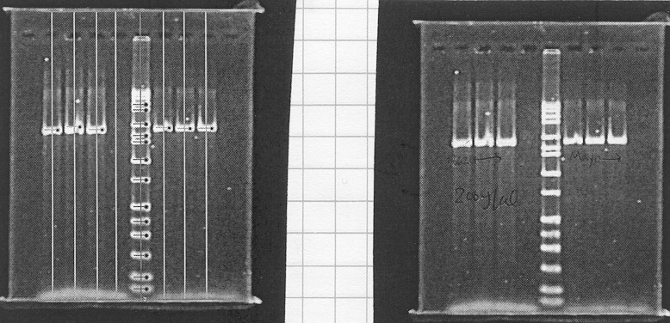

- Press <Ctrl> + 3.

- Press <Alt>, d.

- Select MW, Mass, & Net Intensity.

- Close the Analysis Window (click on the X in the upper right hand corner).

- Press <Ctrl> + p. The Print dialog box appears.

- Select the checkboxes for Print Image and Print Analysis.

- Click on Options. The Analysis Layout window appears.

- In the Analysis Layout window, under Lane Data, click in the circle next to Only info displayed in Analysis window. You can choose to display your data either along the horizontal axis or vertical axis.

- Click OK. Then, click Print.

- Save your file.

- The data printout should look like the following page.

Quantitative analysis (continued).

- Next you will want to plot the masses of your MW bands against the net intensity in an Excel spreadsheet and graph it using an XY scatter chart to see if the data is reasonably linear. It probably won’t be. Here’s what the graph of the previous page’s MW standard data looks like.

MW (bp) | Mass (ng) | Net Int.
8000 | 6 | 292551.88
6000 | 9 | 184248.25
4000 | 12 | 234875.68
3000 | 17 | 198858.22
2000 | 30 | 306403.19
1550 | 20 | 224661.28
1400 | 20 | 171748.39
1000 | 24 | 270283.58
750 | 6 | 196737.99
500 | 12 | 201646.91
400 | 4 | 113443.54
300 | 8 | 122589.46
200 | 6 | 78716.58
100 | 4 | 67091.42
50 | 3 | 62385.46

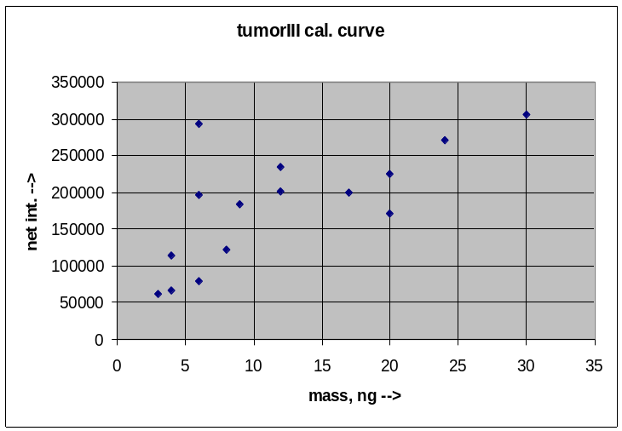
Quantitative analysis (continued).

By removing the anomalous data points, you get the following reliable data points (highlighted):

MW (bp) | Mass (ng) | Net Int.
8000 | 6 | 292551.88
6000 | 9 | 184248.25
4000 | 12 | 234875.68
3000 | 17 | 198858.22
2000 | 30 | 306403.19
1550 | 20 | 224661.28
1440 | 20 | 171748.39
1000 | 24 | 270283.58
750 | 6 | 196737.99
500 | 12 | 201646.91
400 | 4 | 113443.54
300 | 8 | 122589.46
200 | 6 | 78716.58
100 | 4 | 67091.42
50 | 3 | 62385.46
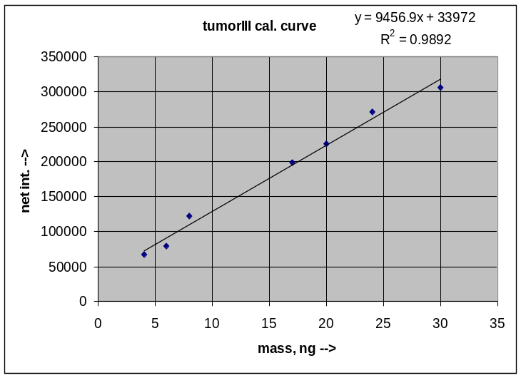
- Return to your saved gel image file and delete the MW bands corresponding to the anomalous data points on the Excel graph. Using the above example, these would be the bands at 8000, 6000, 4000, 1440, 750, 500, 400, and 50 bp.

- Now double-click on the MW standard lane, then click Select.

- Double-click on your standards file name, then click Edit.

- Click on the numbers to the left of the bands you wish to delete and press <Delete> for each one.

- Click OK.

- Repeat steps 26 – 31. You do not need to reprint your image. However, if you want a photograph without the lanes and bands marked, delete all of your lanes (click on the lane, then press <Delete>), then print. Using the above data as an example, the revamped computer analysis printout would appear as follows on the next page. You will need to refer to the masses for the next phase – the BigDye Terminator (BDT) sequencing reaction.

NOTE: Masses that are underlined are outside the range of the calibration curve.

PHASE V – BDT SEQUENCING REACTION

The theoretical basis of sequencing reactions is elucidated on page 1. For BigDye Terminator (BDT) reactions, the all ddNTPs, dNTPs, and other PCR reagents are conveniently pre-mixed into one reagent by the manufacturer. Unlike conventional Sanger sequencing, where you set up a different reaction for each ddNTP, the BigDye ddNTPs are covalently linked to 2 dye molecules – a donor and an acceptor. The donors contain a modified form of fluorescein, usually 6-carboxyfluorescein (6-FAM). The acceptors, various forms of dichloro-rhodamine, fluoresce at different wavelengths when illuminated by a laser. Fluorescent wavelength is, thus, equivalent to base. The fluorescent dye molecules for each ddNTP are as follows:

Terminal base Associated Acceptor Dye Molecule
dd-Adenine dichloro-R6G (dichloro-rhodamine 6G)
dd-Cytosine dichloro-ROX (dichloro-rhodamine X)
dd-Guanine dichloro-R110 (dichloro-rhodamine 110)
dd-Thymine dichloro-TAMRA (dichloro-tetramethylrhodamine)

Part 1 – aliquoting & storing sequencing reagents. - ALL ALIQUOTING MUST BE DONE IN THE PCR HOOD IN ROOM D702A! There are 4 “ingredients” that go into a typical 20 µl sequencing reaction. All reagents should be frozen at -20°C until ready to use. Furthermore, it is a good idea to partition some of the stock “ingre-dients” into aliquots. This prevents an entire stock from becoming simultaneously contaminated. Minimize the number of freeze-thaw cycles for each reagent.

Before getting started, make sure you review and understand all 12 warnings on page 11!

The ingredients:
- BDT mix – For an explanation of what it is and what it does, see above.
WARNING: A 40-ml vial of the BDT sequencing dye costs about the same as a new car or a down payment on a house. The retail price is $22,500.00!!!!! However, we get it for the bargain price of only $16,500.00!!! This stuff is more expensive than gold. If this is the 1st time you are doing BDT sequencing, make sure you are supervised by someone who is familiar with the process.
WARNING: BDT mix is light sensitive. When working with BDT mix out in the open, the PCR hood light should be turned off and, preferably, the room light as well.
WARNING: When thawing out the BDT mix, closely monitor the progress. As soon as it is almost completely thawed, stick it in a bucket full of ice to keep it cool while aliquoting.
Partition into ~ 200 µl aliquots.

- sequencing primer(s) – Unlike PCR, which requires the use of two primers (forward & reverse), sequencing only requires the use of 1 primer per reaction. Of course, the limit of reliability of the ABI PRISM 3100 Gene-tic Analyzer is about 500 bp. Therefore, if you need to sequence a region of DNA that is > 500 bp, you will need a primer at the boundary of each region. For example, if you are sequencing a 1500-2000 bp PCR pro-duct, you may need 3 or 4 different sequencing primers (refer to pages 8-10 for primer design info and refer to pages 12 & 13 for rehydrating primers). See next step.

- ultrapure deionized (d)H₂O – Water acts as a generic reaction solvent. Partition into ~ 1 ml aliquots.

- Hi-Di formamide – Although this is not a sequencing reagent per se, you will need this reagent to prepare your sample for sequence detection in the ABI PRISM 3100 Genetic Analyzer. Formamide is used to de-nature the DNA samples (sequencing products) before placing them in the 3100.
WARNING: Formamide is harmful if absorbed through the skin and may cause irritation to the eyes, skin, and respiratory tract. It may cause damage to the central nervous system, reproductive system, and is a possible birth defect hazard. Always wear gloves and a lab coat when handling.
Partition into ~ 250 µl aliquots.

Part 2 – diluting primers. – THIS PART MUST BE DONE IN THE PCR HOOD IN ROOM D702A!
Once resuspended, an aliquot from each 1000 ng/µl primer stock vial will have to be diluted down to a final working concentration of 1.6 pmol/µl or 1.6 µM. (FYI: pmol/µl is equivalent to µM). Make ~ 250 µl per aliquot.

- To figure the nmol/µl, divide the number of nanomoles on the primer label by the resuspension volume of the 1000 ng/µl primer stock vial. (Refer to page 13 for the calculations.)

Part 2 – diluting primers (continued).
Using the above primer label as an example, we have 55.20 nmol and 390 µl volume for: 55.2 nmol/390 µl = 0.14154 nmol/µl.

- To convert from nmol/µl to pmol/µl multiply by 1000 (10³ pmol/nmol). This will be the 1000 ng/µl stock expressed in pmol/µl. Using the above example, we have:
0.14154 nmol/µl x (10³ pmol/nmol) = 141.54 pmol/µl.

- To figure the volume of this stock to use in the dilution, we use the formula C_{new}V_{new} = C_{stock}V_{stock}. Rearranging the terms gives us V_{stock} = (C_{new}V_{new})/C_{stock}, where C_{new} = 1.6 pmol/µl, V_{new} = 250 µl, and C_{stock} is whatever you calculated in step 2 above. (C_{new}V_{new}) = 1.6 pmol/µl x 250 µl = 400 pmol.
Using our above example, where C_{stock} = 141.54 pmol/µl:
V_{stock} = 400 pmol / 141.54 pmol/µl = 2.826 µl.

- The volume of ultrapure dH₂O = 250 - V_{stock}. Using our above example: V_{water} = 250 – 2.826 = 247.174 µl.

- Once you have V_{stock} and V_{water} worked out, label a 1.7-ml microfuge tube. Label it with your primer name and “1.6 pmol/µl”.

- Add the calculated volume of ultrapure dH₂O to the tube first.

- Lightly vortex the stock primer vial on the Vortex Genie 2 to mix.

- Briefly spin the vial in the PMC-060 microfuge. CAUTION: As with all centrifuges, always spin in a balanced configuration. Never spin just 1 tube in any centrifuge. You can use the 1.7-ml tube you just filled with water as a counterbalance.

- Add the calculated volume of stock primer to the 1.7-ml microfuge tube. Immerse the pipet in the water and pipet in and out several times.

- Cap the tube & lightly vortex the contents on the Vortex Genie 2 to mix.

- Briefly spin the tube in the PMC-060 microfuge.

- Store in an aliquot box in one of the D702A freezers at -20°C.

Part 3 – calculating the volume of PCR product.

The table below shows the template quantities needed for the BDT reaction.
 | Template |  | Template Quantity
PCR product:
 | 100-200 bp |  | 1-3 ng
 | 200-500 bp |  | 3-10 ng
 | 500-1000 bp |  | 5-20 ng
 | 1000-2000 bp |  | 10-40 ng
 | > 2000 bp |  | 40-100 ng
Single-stranded |  |  | 50-100 ng
Double-stranded |  |  | 200-500 ng
Cosmid, BAC |  |  | 0.5-1.0 µg
Bacterial genomic DNA |  |  | 2-3 µg

- You will need to refer to the chart above to determine the mass of DNA you will need for your sequencing reaction. Example: Suppose you are sequencing a 1790 bp PCR product. According the chart above, you will need 10-40 ng. Better to aim for the higher amount to hedge against any losses which may occur in pipetting or post-BDT purification.

- You will need to refer to the computer analysis printout (revised) from step 39, page 28.

Part 3 – calculating the volume of PCR product (continued).

- Divide the DNA mass for each sample on the printout by the volume run on the gel for each sample in step 10, page 23 (generally 3-5 µl).

- Divide the required template quantity (from the chart on the previous page) by the above result.

Example: Suppose you are sequencing a 1790 bp PCR product – 1381T. You determined you should aim for ~40 ng of DNA in step 1 above. You ran 3 µl of sample on the gel in step 10 (page 23). Consulting the computer analysis printout on page 29, sample 1381T has a mass of 13.01 ng. The concentration is thus: 13.01 ng / 3 µl = 4.34 ng/µl. Dividing 40 ng by 4.34 ng/µl ≈ 9.22 µl.

- It is a good idea to round up to the nearest microliter to hedge against any losses which may occur as a result of pipetting errors or post-BDT purification. Thus, in the above example, you would use 10 µl of PCR product in your sequencing reaction.

- Multiply the obtained volume by the number of regions you will be sequencing within the PCR product DNA.

Example 1: If you are sequencing 3 regions, you will need at least 30 µl (3 x 10 = 30) in the example above. That means if you started with 30 µl post-PCR purification product and ran 3 µl of it on the gel for analysis, you would have 27 µl remaining. You will not have enough to sequence all 3 regions!

Example 2: Let’s suppose you are sequencing 3 regions and want to run duplicate samples (as a verification of reproducibility). This is 6 samples total (3 x 2). If you have 27 µl of purified PCR product, you can use no more than 4.5 µl per reaction. If your calculations show that you will need more than 4.5 µl to achieve 40 ng, either you will not be able to run duplicates of every sample or you will not be able to sequence all 3 regions.

As you can see from the above examples, it is essential that you calculate all of your required volumes ahead of time so you can plan accordingly and don’t run into unexpected surprises in the middle of an experiment!

Part 4 – the master mix. – DOING THIS PART IN THE PCR HOOD IN ROOM D702A IS OPTIONAL.

- Follow steps 1 – 6, 8 - 10 in part 8 on pages 13 & 14. NOTE: Perform step 12 only for the sequencing pri-mers. (Don’t confuse your sequencing primers with your PCR primers). The BDT mix contains Taq poly-merase and should not be vortexed or thawed in a heat block. Also, thaw the BDT mix in a closed (i.e. dark) container until you are ready to use it. If you are using more than one sequencing primer, you will need to make a separate master mix for each primer. Thus, you may need more than one 1.7-ml master mix tube.

- Once ready, add the reagents to 1.7-ml “master mix” tubes in the following order, in the following quantities:

component vol./rxn manufacturer catalog # [reagent]/rxn
1. ultrapure dH₂O – (10-DNA vol.) Invitrogen 10977-023

2. BDT mix – 8 µl Perkin-Elmer 4314416

3. 1.6 pmol/µl – 2 µl Integrated DNA 0.16 pmol/µl
sequencing primer Technologies

NOTE 1: You will of course have to multiply the volume of each reagent by the number of reactions you are doing + 1. For example, if you are doing 9 reactions, you will need to multiply each of the following reagent volumes by 10 (9 + 1 = 10), for 21 reactions, multiply by 22 (21 + 1 = 22), etc.

NOTE 2: For simplicity’s sake, calculate the volume required for your most dilute sample and use this volume for each template. Example: Your computer analysis shows samples with masses of: 31.97 ng, 14.24 ng, 20.38 ng, and 19.14 ng. You would calculate the volume required for the smallest of these quantities – 14.24 ng. If you ran 3 µl on the post-PCR purification gel, the concentration of this sample is 4.75 ng/µl and there are 8.43 µl in 40 ng. Your desired volume is thus 9 µl. If you need to run many samples and 9 µl per sample is too much, you may wish to make a separate master mix for this DNA or you may wish to exclude it from sequencing.

Part 4 – the master mix (continued).

Here is how the master mixes would be made if you were sequencing 3 regions within 5 different templates (3 master mixes with 5 + 1 = 6 reactions per mix). This recipe also assumes that 4 µl of PCR product DNA equals or exceeds 40 ng for all samples and that you are not making duplicates of each sample. Bear in mind that real life situations are rarely this simple!

Master mix 1:
rxns total
vol./rxn + 1 vol.
1. ultrapure dH₂O 6 µl x 6 = 36 µl (10-4 µl DNA = 6 µl/rxn)

2. BDT mix 8 µl x 6 = 48 µl

3. 1.6 pmol/µl primer 1 2 µl x 6 = 12 µl
TOTAL: 16 µl x 6 = 96 µl

Master mix 2:
rxns total
vol./rxn + 1 vol.
1. ultrapure dH₂O 6 µl x 6 = 36 µl (10-4 µl DNA = 6 µl/rxn)

2. BDT mix 8 µl x 6 = 48 µl

3. 1.6 pmol/µl primer 2 2 µl x 6 = 12 µl
TOTAL: 16 µl x 6 = 96 µl

Master mix 3:
rxns total
vol./rxn + 1 vol.
1. ultrapure dH₂O 6 µl x 6 = 36 µl (10-4 µl DNA = 6 µl/rxn)

2. BDT mix 8 µl x 6 = 48 µl

3. 1.6 pmol/µl primer 3 2 µl x 6 = 12 µl
TOTAL: 16 µl x 6 = 96 µl

As you add each reagent (after the first), including the DNA, place the pipet tip into the mix, alternately withdrawing & expelling the contents into & out of the pipet tip to mix thoroughly.

- When finished making your master mixes, close the tube lids securely, invert the tubes rapidly a couple of times, and spin briefly on the PMC-060 microfuge. CAUTION: DO NOT VORTEX THE MASTER MIX AFTER YOU HAVE ADDED THE BDT MIX; IT CONTAINS Taq. YOU MAY, HOWEVER, VORTEX THE MASTER MIX PRIOR TO ADDING THE BDT MIX, BUT YOU MUST STILL MIX MANUALLY AFTERWARDS.

- Set a pipet for a volume that is (20 – vol. of DNA). In the above example, this would be 16 µl (20 – 4 = 16). Quantitatively transfer into 0.2-ml PCR microtubes that you have previously set up.

- If you have ≥ 7 reactions (plus 1 positive control reaction), number your tubes with a Sharpie pen – the kind with super permanent ink. If you have ≤ 7 reactions (to include 1 positive control), you can use the numbers stamped on the tubes (1 - 8).

- Clean up the PCR hood. Don’t forget to put DNA back into the refrigerator and aliquots back into your assigned aliquot box in the D702A freezer.
CAUTION: IF YOU HAVE MADE UP THE MASTER MIXES IN THE PCR HOOD IN D702A, YOU WILL NEED TO DO THE REST OF THE STEPS OF THIS PROCEDURE AT YOUR LAB BENCH BECAUSE YOU WILL BE WORKING WITH A PCR PRODUCT FROM THIS POINT ON. IF YOU CARRIED OUT THE ABOVE STEPS AT YOUR LAB BENCH (THIS IS OK), DISREGARD THIS PRECAUTION.

Part 4 – the master mix (continued).

- (optional) If you wish to run a positive control, use the 200 ng/µl double-stranded DNA Control Template pGEM-3Zf(+) and its associated sequencing primer M13 (-21). This is a 1000 bp plasmid fragment that is included with the BDT kit. You will only need one, so you can mix this up right in a 0.2-ml PCR microtube. Since the [DNA] is constant, the recipe is always:

component vol./rxn manufacturer catalog # [reagent]/rxn
1. ultrapure dH₂O – 6 µl Invitrogen 10977-023

2. BDT mix – 8 µl Perkin-Elmer 4314416

3. M13 (-21) primer – 4 µl Perkin-Elmer

4. pGEM-3Zf(+) – 2 µl Perkin-Elmer 20 ng/µl
TOTAL: 20 µl

- Add the calculated volume of each PCR product sample to the appropriate tube. For the example we’ve been using so far, this would be 4 µl. The total volume of master mix (primer, BDT, dH₂O) + PCR DNA must equal 20 µl in all cases.

- Annotate in your lab notebook, which DNA samples are being added to each tube. A sample entry appears below.

tube # |  | 1 | 2 | 3 | 4 | 5 | 6 | 7 | 8 | 9 | 10
DNA |  | 1199 | 1199 | 1199 | 1217 | 1217 | 1217 | 1435 | 1435 | 1435 | pGEM-3Zf(+)
primer |  | 5-6r | 7f | 8-9f | 5-6r | 7f | 8-9f | 5-6r | 7f | 8-9f | M13
master mix |  | 1 | 2 | 3 | 1 | 2 | 3 | 1 | 2 | 3
↑
positive
control

- Snap the microtube lids securely onto the tubes.

- Once the lids are on, run a finger along the bottom of the tube strip to mix.

Part 5 (optional) – programming the thermocycler.

- Follow steps 1-8 on page 16.
The manufacturer’s recommended program may or may already be programmed into one of the thermocyclers.
If not, or you want to run your own program, the remaining steps are for your edification.

- You will get the following menu.

Step 1: = _TEMP
Gradient
Ramp End
TEMP is the default option. Press “proceed” and enter 98°C. This is the denaturation temperature.

- Enter a time of 5:00. The display will then ask _YES NO OPTION?

- YES is the default option. Press the “proceed” key.

- You will then get the following menu.
Step 2: = _TEMP Goto
Gradient
Ramp End

Use your select button to scroll the cursor over to “Ramp”, as below.
Step 2: = Temp Goto
Gradient
_RAMP End

Part 5 (optional) – programming the thermocycler (continued).

- Press “proceed”. You will get the prompt: Rate °C / s:

- Enter 1. You will get the prompt: Finish temp:

- Enter 96°C.

- The following menu will then be reiterated.
Step 3: = _TEMP Goto
Gradient
Ramp End

Press “proceed”; enter 96°C and a time of 0:10.

- For the 4th line of your program, scroll to the Ramp option and enter: Rate °C / s: 1 and Finish temp: 50°C.

- For the 5th line of your program, enter 50°C and a time of 0:05.

- For the 6th line of your program, scroll to the Ramp option and enter: Rate °C / s: 1 and Finish temp: 60°C.

- For the 7th line of your program, enter 60°C and a time of 4:00.

- When you are ready to enter the 8th line of your program, use the right arrow (“select” keys) to choose the “Goto” option instead of “TEMP”.

Step 8: = Temp _GOTO
Gradient
Ramp End

- After the prompt Goto step:, enter 2.

- After the prompt Addtnl cycles:, enter 25. The 8th line of your program should now read: Goto 2, 25 times”.

- For the 9th line of your program, scroll to the Ramp option and enter: Rate °C / s: 1 and Finish temp: 4°C.

- For the 10th line of your program, scroll to Temp, enter 4°C and a time between 16:00:00 and 24:00:00, or 0 to indicate for ever. This last step keeps your PCR product refrigerated until you are ready to work with it (which might not be until the following work day). If you are able to work with your PCR product the same day, then it is only necessary to wait a minimum of 10 minutes after the temperature goes to 4°C before you remove your samples.

- If you input a time instead of the for ever option for the last step, then enter END as the 11th line of your program on the menu.

Step 11: = Temp Goto
Gradient
Ramp _END

- The machine will then present you with a list of directories and prompt you to save your program in one of them. <MAIN> is the default directory. Use your select arrows to choose a directory and press “proceed”. Your program is now saved.

Part 6 – running the thermocycler.

- Follow steps 1-7 in part 10 on pages 17-18. Make sure you select your sequencing program, though, instead of your PCR program.

- The temperature regimen of the sequencing program follows on the next page.

Part 6 – running the thermocycler (continued).

cycle | temp (°C) | time | purpose
0 | 98 | 5:00 | denature
 | 1°C/sec. |  | ramp
1 | 96 | 0:10 | denature
 | 1°C/sec. |  | ramp
through | 50 | 0:05 | anneal
 | 1°C/sec. |  | ramp
25 | 60 | 4:00 | extend
 | 1°C/sec. |  | ramp
 | 4 | >10:00 | storage
The entire program, including 10 minutes of storage time, is 2:49:15.

- Follow steps 9-11 on page 18.
CAUTION: YOUR SAMPLES ARE NOW LIGHT SENSITIVE. AVOID PROLONGED EXPOSURE TO LIGHT. YOU MAY WISH TO STORE THEM IN A BOX OR IN A DRAWER UNTIL READY TO USE THEM.

- Some condensation will inevitably have collected on the inside surface of the lids. Briefly spin the tubes in the PMC-860 capsulefuge to pool your sample.

- Withdraw 1 µl of each sample and transfer to clean, new 0.2-ml microtubes. Add an equal amount of 2X GLB to each of the tubes. Mix and spin. Save until completion of post-sequencing purification.

MODIFICATIONS TO THE ABOVE STANDARD PROTOCOL

- If your PCR product < 300 bp, use 20 cycles instead of 25 cycles.
- If the T_{m} of the sequencing primer > 60°C, eliminate the annealing step altogether.
- If the T_{m} of the sequencing primer < 50°C, either:
- increase the annealing time from 5 seconds to 30 seconds or
- decrease the annealing temperature from 50°C to 48°C.
PHASE VI – POST-SEQUENCING PURIFICATION

As with PCR, so too must sequencing products be purified before proceeding to the next step. The objective is to filter small molecules (e.g. nucleotides, buffer salts, etc.) out of the sequencing product DNA. There are two com-mon methods which use spin-columns – Centri-Sep 8 (Princeton Separations # CS-912) and DyeEx (QIAGEN # 63104).

Method 1: Centri-Sep 8.

The Centri-Sep gel will provide excellent recovery of DNA fragments with sizes greater than 16 bp (dsDNA) or 25 nt (ssDNA). When designing sequencing primers, taking this fact into consideration would dictate leaving a ~16 bp “space” between the end of the sequencing primer fragment and the beginning of the region you want to se-quence. The columns also remove > 98% of salts, dNTP's and other unwanted low-molecular-weight impurities which would foul the capillaries or obscure analysis of the results of the ABI PRISM 3100 Genetic Analyzer.

IMPORTANT: Centri-Sep columns have a shelf life of ~ 2-3 months when stored at 4°C. Make sure to check the expiration date prior to using. Using expired columns will severely diminish recovery efficiency.

- The Centri-Sep 8 package contains 12 strips sealed with foil in a single block of 96 columns. The block must be separated into single strips before the sealing foil is removed.

- Separate the desired number of strips to be used by cutting the foil between the strips with scissors.

- Open the well outlets on each strip by cutting through the integral bottom seal constriction with scissors.

- Place a number of 0.2-ml PCR microtubes equal to the number of samples to be analyzed into the wells of a 96-well plate. Remove the top foil from the Centri-Sep columns and insert each strip of columns into the microtubes in the plate to collect the interstitial liquid.

- Weigh the plate assembly and load another 96-well plate with 0.2-ml PCR microtubes. Place the plate with the microtubes on top of an analytical balance and begin filling the tubes with water until the weight is roughly equal to that of the plate with the Centri-Sep columns.

- Place both plates in plate carriers at opposite ends of a GH-3.8A rotor in the Beckman Allegra 6KR centrifuge (outside the D702E tissue culture room).

- Close and lock the lid of the centrifuge by pressing down on the lid firmly and sliding the small lever beneath the lid’s center from left to right.

- Press and hold in the button beneath the digital red LED counter labeled “ACCU-SET” and turn the speed control dial (the ω symbol appears above it) clockwise until the digital LED display reads 3250 rpm. (This is the maximum speed allowable with the GH-3.8A rotor when spinning plate carriers.) Turning the dial clockwise increases speed while counter-clockwise decreases speed. A speed of 3250 rpm ≈ 1500 g.

- Set the timer dial (the symbol  appears above it) to 4 minutes.

- Since the volume of the interstitial fluid exceeds 0.2 ml, the interstitial fluid that collects in the microtubes after this centrifuging step will have to be discarded.

- Repeat steps 6-10.

- Place your Centri-Sep columns into the wells of a MicroAmp® Optical 96-well plate (Applied Biosystems # N801-0560), then label the columns with your sample names/numbers.
Method 1: Centri-Sep 8 (continued).

- Annotate the well assignments in your lab notebook. Use the following example as a template.

MicroAmp® plate well assignments:
 | 1 | 2 | 3 | 4 | 5 | 6 | 7 | 8 | 9 | 10 | 11 | 12
A | EKVX | EKVX | EKVX | Hi-Di | empty | -------- | -------- | -------- | -------- | -------- | -------- | ------>
 | 5-6r | 7f | 8-9f | formamide | |
B | H322M | H322M | H322M | | | |
 | 5-6r | 7f | 8-9f | | | |
C | HOP92 | HOP92 | HOP92 | | | |
 | 5-6r | 7f | 8-9f | | | |
D | H23 | H23 | H23 | | | |
 | 5-6r | 7f | 8-9f | | | |
E | H522 | H522 | H522 | | | |
 | 5-6r | 7f | 8-9f | | | |
F | H460 | H460 | H460 | | | |
 | 5-6r | 7f | 8-9f | | | |
G | H226 | H226 | H226 | | | |
 | 5-6r | 7f | 8-9f | | | |
H | HOP62 | HOP62 | HOP62 | | | |
 | 5-6r | 7f | 8-9f | V | V

Note that each grid contains the name of the sample and the sequencing primer used for that sample.

- Use a P20 pipette to load the full volume of each of your sequencing products onto the centers of the columns’ moist Sephadex matrix. Remember to avoid touching the matrix with the pipet tip and to work quickly, as the samples are light sensitive.

- Repeat steps 5-9 above.

Method 2: DyeEx

This method offers an advantage over the Centri-Sep method in that the columns can be stored at room temperature (15-25°C) for up to 1 year or can be stored indefinitely at 4°C. By comparison, the Centri-Sep columns have a limited shelf life of 2-3 months and must always be refrigerated.

The DyeEx columns (QIAGEN # 63104) use gel filtration material consisting of spheres with uniform pores. When sequencing reactions are applied onto DyeEx columns, dye terminators diffuse into the pores and are retained in the gel-filtration material, while the DNA fragments are excluded and recovered in the flow-through.

- Label clean 1.7-ml microfuge tubes with the names/numbers of your samples.

- Gently vortex the spin columns to resuspend the resin using a Vortex Genie 2.

- Loosen the caps of the columns ¼ turn.

- Snap off the bottom closures of the spin columns, and place the spin columns in the 2-ml collection tubes provided with the kit.

- Centrifuge at 3000 rpm (~ 800 g) in an Eppendorf 5415D for 3 minutes. Don’t forget the muffler or to balance the rotor (see page 23 – step 3).

- Carefully transfer the spin columns to the 1.7-ml microfuge tubes you labeled in step 1.

- Use a P20 pipette to load the full volume of each of your sequencing products onto the centers of the columns’ gel-bed. Remember to avoid touching the gel-bed with the pipet tip and to work quickly, as the samples are light sensitive. See photo at top of following page.

- Repeat step 5.
Method 2: DyeEx (continued)
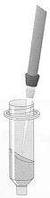
- Remove the spin columns from the microfuge tubes and discard. The eluate in the 1.7-ml tubes contains the purified sequencing product.

- Use a P20 pipette to transfer each of your sequencing products into the wells of a MicroAmp® Optical 96-well plate (Applied Biosystems # N801-0560).

- Annotate the well assignments in your lab notebook. Use the following example as a template.

MicroAmp® plate well assignments:
 | 1 | 2 | 3 | 4 | 5 | 6 | 7 | 8 | 9 | 10 | 11 | 12
A | EKVX | EKVX | EKVX | Hi-Di | empty | -------- | -------- | -------- | -------- | -------- | -------- | ------>
 | 5-6r | 7f | 8-9f | formamide | |
B | H322M | H322M | H322M | | | |
 | 5-6r | 7f | 8-9f | | | |
C | HOP92 | HOP92 | HOP92 | | | |
 | 5-6r | 7f | 8-9f | | | |
D | H23 | H23 | H23 | | | |
 | 5-6r | 7f | 8-9f | | | |
E | H522 | H522 | H522 | | | |
 | 5-6r | 7f | 8-9f | | | |
F | H460 | H460 | H460 | | | |
 | 5-6r | 7f | 8-9f | | | |
G | H226 | H226 | H226 | | | |
 | 5-6r | 7f | 8-9f | | | |
H | HOP62 | HOP62 | HOP62 | | | |
 | 5-6r | 7f | 8-9f | V | V

Note that each grid contains the name of the sample and the sequencing primer used for that sample.
PHASE VII –SAMPLE PREPARATION FOR ABI PRISM 3100 SEQUENCE READING

Before proceeding, you will need to put your name on the sign-up sheet.

Part 1 – spin drying

- Load your MicroAmp® Optical 96-well plate into a brown plate adapter.

- Load your plate assembly into one of the plate carriers in the Automatic Environmental SpeedVac® System (AES 2010) centrifuge chamber. If there is not already one in there, load an empty plate assembly into the opposite plate carrier of the centrifuge rotor for balance.

- Close the lid. You will have to slide the COVER RELEASE rod towards you to unlock the lid so it will close.

- You should notice 3 black switches and a green LED display on the top right hand side of the centrifuge:
0.25
 RC  AUTO 
OFF
 RUN  MANUAL 
1 2 3
Set switch # 3 above to the off (middle) position. No light should be lit.

- Turn the main power switch OFF, then ON. This is located on the bottom edge of the right-hand side of the centrifuge about halfway back. This resets the timer settings.

- Set switch # 2 above to RC. The green light to the right of RC will be lit.

- Set the LED display to OFF by pressing down accordingly on switch # 1 above. This ensures that the radiant cover light will not illuminate the centrifuge chamber and destroy your light sensitive samples!

- Now set switch # 2 above to RUN. The green light to the right of RUN will be lit (see above).

- Set the LED display to 0.25 (25 minutes) by pressing either up or down accordingly on switch # 1 above.

- About midway down the machine is another group of switches:

DRYING RATE VAPORNET
HIGH CRYOPUMPING
- 

  

LOW FULL VACUUM
4 5
Set switch # 4 above to the HIGH (65°C) position. The green light beneath HIGH will be lit (see above).

- Set switch # 5 above to the FULL VACUUM (10 torr) position. No light should be lit.

- Set switch # 3 to the AUTO position. The green light to the right of AUTO will now be lit (see below).

 RC  AUTO 
0.25
OFF
 RUN  MANUAL 

Your samples will be centrifuged and dried by a combination of heat and negative pressure (i.e. vacuum). This will evaporate the fluid content and concentrate/pool your DNA. The machine will shut off automatically in 25 minutes.
Part 2 – sample resuspension.

When spin drying is complete, you will need to rehydrate your samples. Hi-Di formamide is used to both rehydrate and denature the DNA samples before loading them on the ABI PRISM 3100 Genetic Analyzer.

- During the 25 minutes your samples are being concentrated in the AES 2010, thaw out an appropriate number of aliquots of Hi-Di formamide (Perkin-Elmer # 4311320).

- When the AES 2010 shuts off, remove the plate assembly.

- Add 15 µl of Hi-Di formamide to each sample well. If you have less than a multiple of 16 samples, you will need to add 15 µl to each empty well adjacent to your sample wells until you have filled a multiple of 16 wells. Consider the example on the following page in which there are only 3 samples. 15 µl of Hi-Di formamide must be added to the remaining 13 wells.

 | 1 | 2 | 3 | 4 | 5 | 6 | 7 | 8 | 9 | 10 | 11 | 12
A | EKVX | Hi-Di
 | 5-6r | formamide
B | H322M | |
 | 5-6r | |
C | HOP92 | |
 | 5-6r | |
D | Hi-Di | |
 | formamide | |
E | | | |
 | | | |
F | | | |
 | | | |
G | | | |
 | | | |
H | | | |
 | V | V

This must be done because the electrokinetic injectors on the ABI PRISM 3100 Genetic Analyzer are arranged in an array of 16. When the sample plate is loaded into the machine, the entire array is plunged into a cluster of 16 wells simultaneously. If any of the 16 wells are dry (or if there is less than 10 µl of Hi-Di formamide), air will be sucked into the instrument’s capillaries and possibly damage the equipment.

- Cover your plate with Biomek™ ‘Seal & Sample’ foil (Beckman # 538619), adhesive side contacting the top of the plate. Ensure that the fit is snug and that all wells are covered. You should see the outline of the well holes in the foil.

- Centrifuge at 1500 rpm (555 g) for 10 seconds in the Eppendorf 5804 centrifuge (to the right of the microwave oven where you heat the agarose for your gels). Don’t forget to add a balance plate to the opposite side of the rotor.

- You have now reached a stopping point. If you wish, you can wrap your plate in aluminum foil and store at -20°C (> 24 hours). If you are going to store your samples < 24 hours, you can leave them at room temperature. If you are proceeding, you do not need to wrap your sample plate in aluminum foil. If you are retrieving your sample from storage, unwrap.
Part 3 (optional) – programming the thermocycler.

- Place your plate into a PTC-200 “DNA Engine” thermocycler.

- Follow steps 3-8 in part 9 on page 16.

- You will get the following menu.

Step 1: = _TEMP
Gradient
Ramp End

TEMP is the default option. Press “proceed” and enter 95°C. This is the denaturation temperature.

- Enter a time of 5:00. The display will then ask _YES NO OPTION?

- YES is the default option. Press the “proceed” key.

- You will then get the following menu.

Step 2: = _TEMP Goto
Gradient
Ramp End

- Enter END as the next line of your program on the menu.

Step 2: = Temp Goto
Gradient
Ramp _END

- The machine will then present you with a list of directories and prompt you to save your program in one of them. <MAIN> is the default directory. Use your select arrows to choose a directory and press “proceed”. Your program is now saved.

Part 4 – running the thermocycler.

- Follow steps 3-7 in part 10 on pages 17-18.

- The temperature regimen of the generic program is as follows.

cycle | temp (°C) | time | purpose
1 | 95 | 5:00 | denature

The entire program length, including warm up time, is 06:30.

Part 5 – keep your products denatured.

- Place your tray in a bucket of ice for at least 5-7 minutes. Be careful when handling your sample plate; it will be hot! Lowering the temperature keeps the denatured DNA from reannealing.

- Centrifuge at 1500 rpm (555 g) for 10 seconds in the Eppendorf 5804 centrifuge (to the right of the microwave oven where you heat the agarose for your gels). Don’t forget to add a balance plate to the opposite side of the rotor.

- Peel off the ‘Seal & Sample’ foil.

- Place a gray rubber septa snuggly into the holes of your plate so that it sits level.
ABI PRISM 3100 Genetic Analyzer

The “3100” automated sequencer is really just a highly sophisticated (and expensive) gel electrophoresis box. If you were to open it up, you would find a spaghetti-like network of thin, wiry capillaries filled with a polymer. A sample containing DNA is loaded into the capillaries. Just as with gel electrophoresis, a negatively charged electric field propels the DNA fragments through the polymer, with the smaller fragments passing through the polymer-filled capillaries ahead of the larger fragments (see illustration page 19). As the DNA fragments pass through the capillaries, they are illuminated by an argon ion laser that transmits at ~ 488 nm. The 6-FAM molecules (donor), covalently attached to the ddNTPs, absorb the excitation energy. Energy is transferred to the acceptor molecules (dichlororhodamine derivatives unique to each ddNTP). The resultant fluorescence emission is then “read” by a detector. The sequencer’s software can then translate fluorescent wavelengths into nucleo-tides. The string of nucleotides and their relative fluorescent intensities are then plotted on an electropherogram which delineates the sequence of your sample(s).

ANODE (+)

ATGA ______________________________________________________________________
laser

ATGAT ↑

ATGATA ↑

ATGATAC ↑

ATGATACG ↑

ATGATACGG ↑

ATGATACGGT ↑

ATGATACGGTC ↑

ATGATACGGTCT ↑

DNA fragments direction
of migration

CATHODE (-)

Part 6 (optional) – changing the polymer.
The ABI PRISM 3100 uses 3100 POP-6 (Perkin-Elmer # 4316357) which is kept refrigerated at 4°C when not in use. Polymer should be changed roughly every 10-15 days depending on how frequently the sequencer is used. A typical sequencing run uses 50-80 µl of polymer.

- On the desktop of the computer screen adjacent to the 3100, there is a Microsoft Excel icon with the caption:
3100 Log.xls

- Double-click on this icon, then click on the tab towards the bottom left-hand side of the screen labeled 3100 Log to check to see when the polymer was last changed. An example of the spreadsheet/log appears on the following page. If it does appear that the polymer will need to be changed:

- Bring a bottle of POP-6 to room temperature.

- Access the 3100 Data Collection Software from the computer screen adjacent to the instrument. From the Tools menu, select Change Polymer Wizard. A dialog box will state the length of the capillary array (50 cm is the default). Since we use a 50 cm array, click OK and follow the on-screen prompts.

- Open up the cabinet doors and remove both syringes from the polymer block. Be careful not to loosen the hexagonal fitting that connects the syringe in the polymer block (see figure on next page).

- Clean the syringes thoroughly by rinsing the inside and outside of the syringe barrels and tips with warm water. Be sure there is no dried polymer left in the syringes.

Part 6 (optional) – changing the polymer (continued).

- Rinse the syringe barrel and tip with DI water.

- Blow dry with compressed air. There are lots of air nozzles throughout the lab on just about every bench top. They have a bright orange marking and are labeled AIR.

- Assemble the syringes and check that both O-rings are in place.

- Fill both syringes with POP-6.

- Push down on the polymer-reserve syringe (the large, 50 ml one) to move air bubbles through to the lower right of the block. Push slowly (or tap) to minimize the amount of polymer used (see figure below, left).
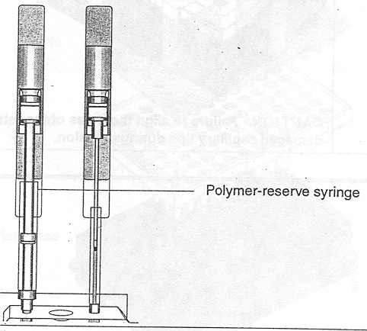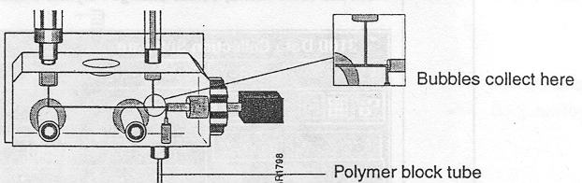
- Push down slowly on the array-fill syringe (the small, 0.25 ml one) to move bubbles down the channel. The bubbles will collect where the channels join (see figure above, right).

- Hold down the anode buffer pin valve and simultaneously push down on the array-fill syringe to build pressure in the channels (see figure at top of next page)

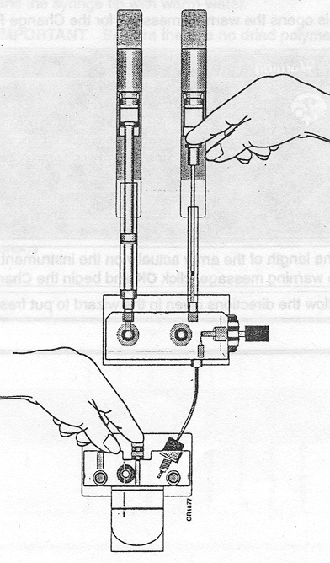
- Release the buffer pin valve (while still pressing down on the array-fill syringe) to expel bubbles into the polymer block tube.

- Repeat steps 12-13 as necessary. Excess polymer and air bubbles will drain into the glass cup (anode buffer reservoir).

- Close the cabinet doors.
Part 7 (optional) – changing the buffer.
The ABI PRISM 3100 uses 3100 10X Buffer w/ EDTA (Perkin-Elmer # 402824) which is kept refrigerated at 4°C when not in use. Buffer should be changed once daily. A typical sequencing run uses 30 ml of buffer.

- Check the 3100 log file (3100 Log.xls) to see if the buffer has been changed already today. If not:

- Add 5 ml of buffer to 45 ml of DI water in a 50-ml conical tube to make 50 ml of 3100 1X Buffer w/ EDTA.

- Press the tray button on the front of the instrument to bring the autosampler to the forward position and wait until the autosampler has stopped moving.

- Open the cabinet doors.

- Remove the anode buffer reservoir (glass cup) by firmly pulling down and twisting slowly (see figure at top of page for location of anode buffer reservoir).

- Discard the used buffer, clean and rinse the reservoir.

- Fill the reservoir to the line with the fresh 1X buffer made in step 2 above. NOTE: Replace buffer in the anode buffer reservoir if the fluid level rises above the red line. For example, if the reservoir fills with polymer during bubble clearing.

- Replenish the DI water and cathode buffer reservoirs. 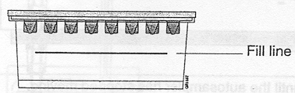

- Fill one of the reservoirs to the fill line with the fresh 1X buffer made in step 2 above, cover with a clean septa, and place it in position 1 (see figure at top of next page).

- Fill the remaining 3 reservoirs to the fill line with DI water. Cover with clean septas. Place in positions 2, 3 & 4 (see below).
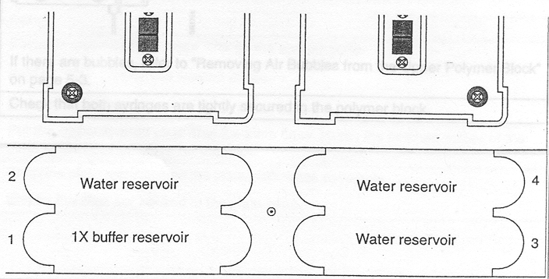
CAUTION: Be sure that the septa (gray rubber seals) fit snugly and flush on the tops of the reservoirs in order to prevent damaging the capillary tips.

Part 8 – sample loading.

- Centrifuge at 1500 rpm (555 g) for 10 seconds in the Eppendorf 5804 centrifuge.

- Assemble according to the exploded diagram below. All pieces must fit securely and level in the base. The plate retainer must snap into place and fit securely. Look down into the assembly to ensure the holes in the plate retainer line up perfectly with the holes in the septa.

Part 8 – sample loading (continued).
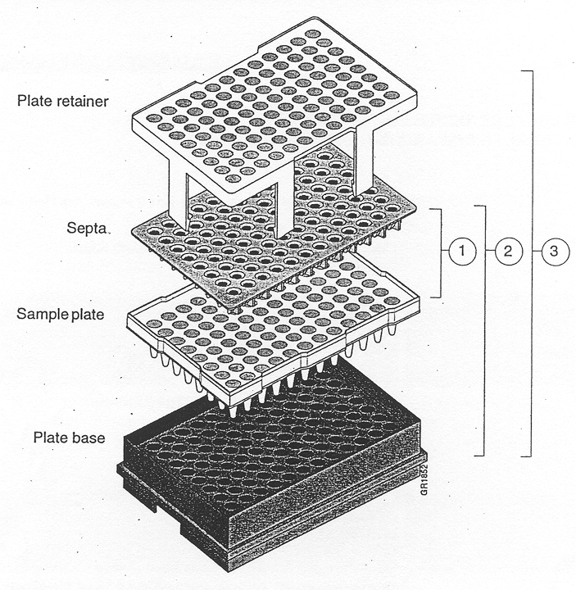
- Place the plate into the autosampler with the notched end of the plate base (the left side in the diagram above) facing away from you.

- When the plate is securely locked in place, close the cabinet doors. The autosampler will retract and the electrokinetic injectors will be plunged into the cathode buffer reservoir.

- Double-click on the 3100 Log.xls icon on the desktop and click on the tab InputForm in the lower, left side of the screen.

- Click on the button:

3100 Log

You will obtain the following mask:
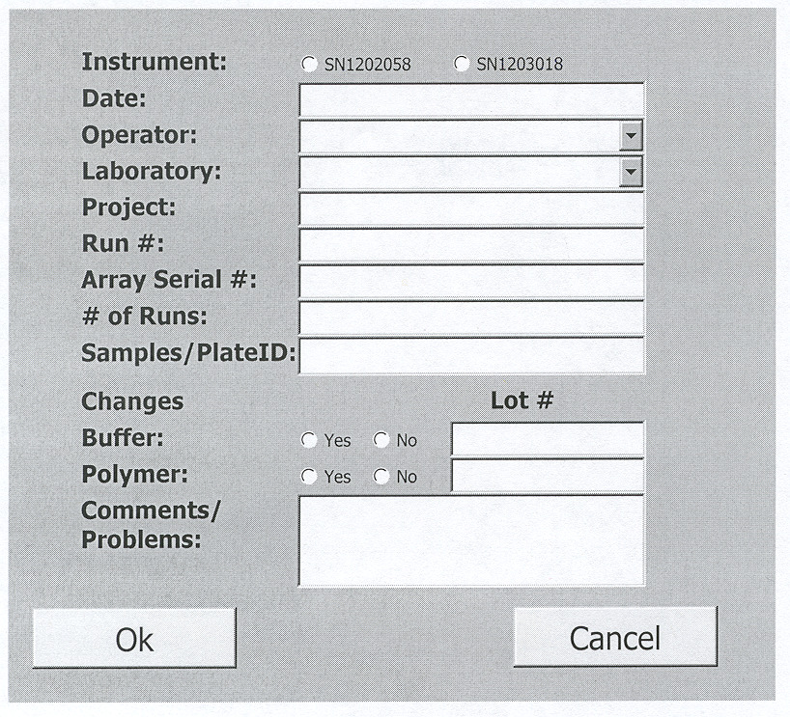

Part 8 – sample loading (continued).

- Fill in the following fields:

Instrument: This will already be chosen for you (SN1203018).

Date: Today’s date in MM/DD/YY format.

Operator: Click on the arrow then find and click on your name on the drop down menu. If you don’t find your name, ask Amelia Smith to add your name to the list.

Laboratory: Click on the arrow then find and click on your lab group on the drop down menu.

Project: Give your project a name, any name you want.

Run #: Your run #’s will begin after the last highest run number. The number of runs you will have is equal to the number of samples you have divided by 16. Round up to the nearest whole number. Your sequencing run numbers are all whole numbers between the highest number of the last sequencing run and the total obtained above. Example: Let’s say the previous sequencing run #’s were 451-452. You have 22 samples. 22/16 = 1.375. Rounding up to the nearest whole # gives you 2. Adding 2 to the highest previous run # gives you 454 (452 + 2 = 454). Your sequencing run #’s are between the last run # and 454. In other words: 453-454.

Array Serial #: This will already be filled in for you.

# of Runs: The # of samples you have divided by 16 and rounded up to the nearest whole # (see above).

Samples/PlateID: Use any name you want.

Buffer: Indicate if you have changed the buffer by checking Yes or No. If yes, fill in the lot #.

Polymer: Do the same thing as above.

Comments/Problems: Leave blank unless you think anything warrants attention.

- When the plate assembly is correctly positioned, the plate position indicator on the Plate View page on the computer screen changes from gray to yellow.

Part 9 – programming the ABI PRISM 3100.

- Click the Plate View tab on the 3100 Data Collection software window.

- Click the New button in the bottom-left corner of the page to open the Plate Editor dialog box.

- Give your file a name. NOTE: You can only use letters, numbers and the following symbols - _ ( ) { } # . + Do not use spaces.

- Under Application, select Sequencing.

- Select 96-Well from the Plate Type list box.

- (optional) Type comments about the plate in the Comments box.

- Click Finish. The Plate Editor spreadsheet opens.

- Enter information in the following format (the items in red are the only things that usually vary):

Well | Sample Name | Dye Set | Mobility File | Comment | BioLIMS Project | Run Module | Analysis Module
A1 | your sample | E | DT3100POP6{BD}v2.mob |  | your lab group | StdSeq50_POP6DefaultModule | BC-3100_SeqOffFtOff.saz

Type in the names of your sequencing samples for each corresponding well. NOTE: Your sample names are limited to 59 characters in length. Once the 1st row is filled out, highlight the “Dye Set”, “Mobility File”, “BioLIMS

Part 9 – programming the ABI PRISM 3100 (continued).
Project”, “Run Module”, and “Analysis Module” columns and press <Ctrl> + D. The run module can vary according to the length of the product you are sequencing.

500+ bp = StdSeq50_POP6DefaultModule
440 bp = 80min_50cm_POP6module
330 bp = 60min_50cm_POP6module
220 bp = 40min_50cm_POP6module
110 bp = 20min_50cm_POP6module

- Make sure the plate record is correct, then click OK. The new plate record is then added to the Pending Plate Records table.

- Click on your file in this table.

- Click on the appropriate plate position indicator. The grid pattern color changes from yellow to green. The plate record file moves from the Pending table to the Linked Plate Records table.

- Click the Run Instrument button () to begin running. Once the oven temperature reaches 50°C, the samples will be automatically loaded. It takes about 2.5 hours to sequence 16 samples. The machine will shut off automatically at the end of the last scheduled run.
PHASE VIII – DATA RECOVERY AND ANALYSIS

Part 1 – data recovery.

- On the desktop, double-click on the folder:
Shortcut to Extracted Runs

- Load a Jaz (2GB) disk into the Jaz drive (the gray box atop the CPU).

- From the Windows desktop, double-click on the My Computer icon again.

- Double-click on: Jaz 2GB F:\ as well as any directories you may have set up. I recommend setting up folders by date. You can do this by pressing <Alt>, F, F. Type in the name and press <Enter>.

- Click on the sequencing run folder at the top of your list. The files have the general format:
Run_1203018_YYYY-MM-DD_NNN, where 1203018 is the serial number of the ABI PRISM 3100, YYYY is the 4-digit year, MM is the month, DD is the date, and NNN is the run #.
For example: Run_1203018_2002-01-17_676 would pertain to run # 676 on January 17, 2002.

- Then press and hold the <Shift> key while clicking on the sequencing run folder at the bottom of your list. All of your folders should be highlighted blue.

- Click anywhere in the highlighted area and drag the folder(s) into your Jaz drive directory window. Close both windows.

- Press the disk release button on the Jaz drive (bottom-right).

- Carry the Jaz disk over to the workstation next to the 4500N color printer (across from the Beckman Allegra 6KR centrifuge).

- Insert the Jaz disk into the Jaz drive (under the desk, atop the CPU).

- From the Windows desktop, double-click on the My Computer icon.

- Double-click on: Jaz 2GB E:\ as well as the folder in which you have saved your sequencing file(s).

- Double-click on any one of your sequencing files. The Sequencing Analysis 3.7 window should open (below).
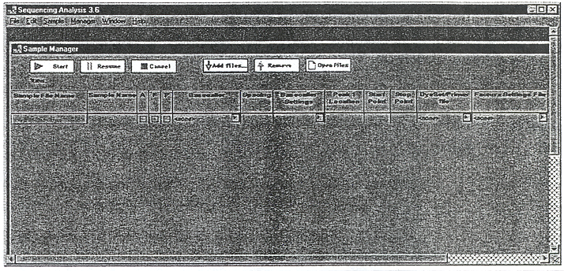

- To open your files, click on the ⬇ Add files… icon.

Part 1 – data recovery (continued).
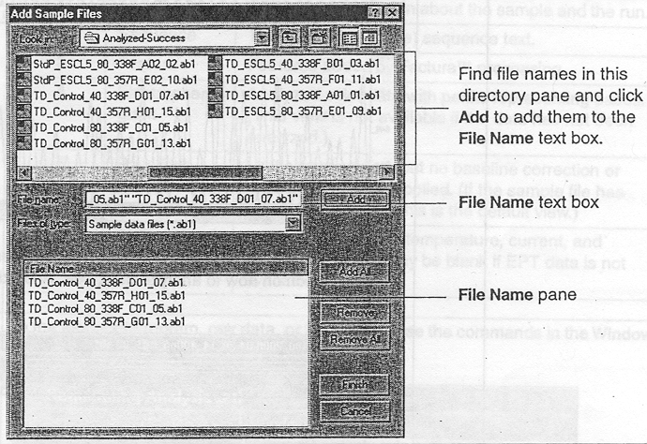

- Click on the Add All icon.
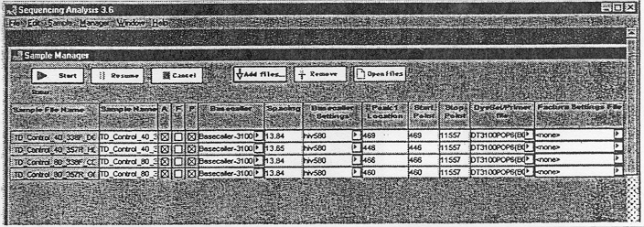

- Now click on any file in the Sample File Name column to open it.

- Once the file(s) are open, press <Ctrl> + J and set the page orientation to Landscape.

- Click OK.

- Press <Ctrl> + P to print. Click OK in the dialog box. The electropherogram option should be the only one with a check mark next to it by default.

- In the Print dialog box, set the printer Name: \\NCI\pq-d702_lj45.

- Click OK. Your electropherogram will be printed.

- In the bottom-left hand corner of the electropherogram, click on the CATG icon. This will give you the raw sequence file. Set up a word processor file and copy these raw sequences into them by pressing <Ctrl> + A, then <Ctrl> + C.

- Switch over to your newly created word processor file and press <Ctrl> + V. If there are a lot of N’s at the end of the file, simply delete them.

- When you are done with printing and copying, press <Ctrl> + W to close your sequencing analysis program and <Alt>, X to close your word processing file. Save the word processing file on the S:\ drive so you can access it from the computer at your own desk.

- When reviewing your signal strengths, consider any signals > 100 to be a good read and any > 300 to be very good. Any file in which all 4 bases’ signals > 300 are excellent (see next page). You also want to avoid files with lots of N’s (though some N’s are resolvable). Bear in mind the maximum readability is about 500-700 nt.

Two things to do at this point are to run a comparison with the single-stranded GenBank word processor
file (not the double-stranded primer map) and to translate the exons (expressed portions of the sequences not spliced out by spliceosomes in vivo).

If you are comparing a sequence from a reverse primer (which reads the non-coding strand “backwards”), you will have to cut and paste the portion you are sequencing into a new word processing file, or a different por-tion of the same file. Then you will have the painstaking task of typing in each line in reverse order. Example:

3’-gatgatgggg atgttaggac catccgaact caaagttgaa cgcctaggca gaggagtgga

gctttgggga accttgagcc ggcctaaagc gtacttcttt gcacatccac ccggtgctgg

gcgtagggaa tccctgaaat aaaagatgca caaagcattg aggtctgaga cttttggatc-5’

becomes:
5’-ctaggttttc agagtctgga gttacgaaac acgtagaaaa taaagtccct aagggatgcg

ggtcgtggcc cacctacacg tttcttcatg cgaaatccgg ccgagttcca aggggtttcg

aggtgaggag acggatccgc aagttgaaac tcaagcctac caggattgta ggggtagtag-3’

Part 2 – sequence analysis.
From your GenBank word processor file:

- Highlight the portion covered by the sequencing primer.

- Press <Ctrl> + C.

- In your web browser’s location bar, type in: http://pbil.univ-lyon1.fr/lfasta.html. This brings up the Local Alignment Tool (see next page).

- Double-click in the small box that says Seq1; enter GenBank.

- Click in the large box below; press <Ctrl> + V.

From your raw sequencing data word processor file:

- Highlight the applicable region corresponding to the region above (e.g. exons 5-6, exon 7, etc.).

- Press <Ctrl> + C.

- Switch to the Local Alignment Tool internet file.

- Double-click in the small box that says Seq2; enter the name of your sample.

- Click in the large box below; press <Ctrl> + V.

- Click SUBMIT.

- Click on the hyperlink LFasta on line 1. If you get an error message instead of the LFasta Output page, click the back button on your web browser and try removing either the first or the last letter from each of the 2 sequences. Then resubmit. This usually always does the trick. You should ultimately get a file that looks like the one on page 53.

Local Alignment Tool Example:

searching EKVX_7f library
Comparison of:
(A) GenBank >GenBank - 831 nt
(B) EKVX_7f >EKVX_7f - 815 nt
using matrix file DNA

97.2% identity in 811 nt overlap; init: 1787, opt: 3056

10 20 30 40 50 60
GenBan TGGCCTCATCTTGGGCCTGTGTTATCTCCTAGGTTGGCTCTGACTGTACCACCATCCACT
::::::::::::::::::::::::::::::::::::::::::::::::::::::::::::
EKVX_7 TGGCCTCATCTTGGGCCTGTGTTATCTCCTAGGTTGGCTCTGACTGTACCACCATCCACT
10 20 30 40 50 60

70 80 90 100 110 120
GenBan ACAACTACATGTGTAACAGTTCCTGCATGGGCGGCATGAACCGGAGGCCCATCCTCACCA
::::::::::::::::::::::::::::::::::::::::::::::::::::::::::::
EKVX_7 ACAACTACATGTGTAACAGTTCCTGCATGGGCGGCATGAACCGGAGGCCCATCCTCACCA
70 80 90 100 110 120

130 140 150 160 170 180
GenBan TCATCACACTGGAAGACTCCAGGTCAGGAGCCACTTGCCACCCTGCACACTGGCCTGCTG
::::::::::::::::::::::::::::::::::::::::::::::::::::::::::::
EKVX_7 TCATCACACTGGAAGACTCCAGGTCAGGAGCCACTTGCCACCCTGCACACTGGCCTGCTG
130 140 150 160 170 180

190 200 210 220 230 240
GenBan TGCCCCAGCCTCTGCTTGCCGCTGACCCCTGGGCCCACCTCTTACCGATTTCTTCCATAC
:::::::::::::::::::: :::::::::::: ::::::::::::::::::: ::::::
EKVX_7 TGCCCCAGCCTCTGCTTGCCTCTGACCCCTGGGTCCACCTCTTACCGATTTCTGCCATAC
190 200 210 220 230 240

FINAL WORDS: The excerpt above shows 2 discrepancies (highlighted in yellow). It is now up to you to find out if these are polymorphisms or mutations. You must also map out the exon boundaries so you know if the discrep-ancies occur in expressed (i.e. exon) regions or are spliced out as introns. You can usually look up the translation (i.e. protein) sequence at the same GenBank site where you obtained your nucleotide sequence (see pages 3-4). You can translate a raw sequence at the same WWWtacg website where you converted from single-stranded se-quence to double-stranded sequence (see page 5). Just cut and paste the exon sequence of interest, check all of the boxes required on page 5 as well as the &nbspTranslation box before submitting your sequence to the WWWtacg website. Then compare the translated protein sequence to the GenBank protein sequence to determine the extent of amino acid substitution, if any.
APPENDIX A: QUANTITATIVE ANALYSIS: SPECTRAMAX PLUS

This method describes an alternative to the method outlined under PHASE IV on page 24 of this manual. That method, which relies on a DNA mass/MW marker in conjunction with gel electrophoresis and densitometry-imaging software (KDS1D) is best suited for quantitating PCR products. The ideal range for extrapolation of mass defined from the Hi-Lo marker’s standard curve is about 1 to 150 ng. If you examine the chart on page 31 under part 3, you’ll see that this range is adequate for determining the mass of PCR products needed for the subse-quent sequencing reaction. However, according to the chart, there are some instances when a greater quantity of sequencing reaction template is needed. When sequencing plasmid DNA, for example, the ideal template amount ranges from 200 – 500 ng, beyond the effective range described under PHASE IV. For these instances, you will have to quantitate using UV spectrophotometry.

Since DNA absorbs electromagnetic energy most effectively at a wavelength of 260 nm (energy/photon = 7.64x10⁻¹⁹ J or 127x the kinetic energy of a molecule of air), within the ultraviolet (UV) part of the electromagnetic spectrum, we have a spectrophotometer – SPECTRAmax PLUS – that measures the optical density (i.e. the absorb-ance) of DNA samples at that wavelength. The SPECTRAmax PLUS is located near the tissue culture room above the Beckman Allegra 6KR.

Part 1 – dilution & loading of samples

For optimum results, the recommended sample volume for each well in the 96-well Costar UV microplate is 100 – 300 µl. Unless you have at least this much of each sample to spare (that’s 20 – 60 µg per sample of a 200 ng/µl solution!) – highly unlikely to ever happen in the real world – you will have to dilute your samples at least 25-fold to achieve this volume range. If you are quantifying plasmid DNA obtained from a mini-prep, for example, you will have about 30 – 50 µl of sample – comparable to the volume of a typical PCR.

- Draw a diagram of a 96-well plate in your notebook and annotate which samples are going into each well. A sample entry appears below.
 | 1 | 2 | 3 | 4 | 5 | 6 | 7 | 8 | 9 | 10 | 11 | 12
A | EKVX | pGEM
 |  | 8 ng/µl
B | H322M | pGEM
 |  | 8 ng/µl
C | HOP92 | λ
 |  | 4 ng/µl
D | H23 | λ
 |  | 4 ng/µl
E | H522 | BLANK
 |  | dH₂O
F | H460 | BLANK
 |  | dH₂O
G | H226 | BLANK
 |  | dH₂O
H | HOP62

- Quantitatively transfer 10% of your sample volume into its designated well in the 96-well Costar UV microplate (VWR # 66021-983).

- Add {([dilution factor] –1)/10 x [total sample volume]} of ultrapure dH₂O to each well.
Example 1: You have mini-prep products in 50 µl volumes. If you’re doing a 25-fold dilution, add [(25 - 1)/10] x 50 µl = (24/10) x 50 µl = 2.4 x 50 µl = 120 µl water to 5 µl (10%) of sample for a final volume of 125 µl. Of course, if you have less than 42 µl of sample, you will need to do a greater than 25-fold dilution.
Example 2: You have mini-prep products in 30 µl volumes. You will need to do at least a 35-fold dilution or higher: [(100 µl/30µl) x 10] + 1 = 35-fold. To keep the calculations simple, do a 50-fold dilution. You would, therefore add [(50 – 1)/10] x 30 µl = (49/10) x 30 µl = 4.9 x 30 µl = 147 µl water to 3 µl (10%) of sample for a 150 µl final volume.
Part 1 – dilution & loading of samples (continued)

- In addition to preparing dilutions of your samples, you should also prepare dilutions of at least 2 standards of known DNA concentration. This enables you to gauge your accuracy. For best results, designate at least 2 wells for each of your standards. This enables you to gauge your precision. Remember to use the same dilution factor for your standards that you use for your samples. I typically use the 200 ng/µl pGEM-3Zf(+) described on p. 34 (part 4, step 7) as one of my standards and a 100 ng/µl λ DNA (Molecular Probes # P-11496) as my second. Examples: 3 µl of a 200 ng/µl stock solution diluted 50-fold to 150 µl final volume gives a new con-centration of 4 ng/µl. For the 100 ng/µl stock solution, the new concentration would be 2 ng/µl. 5 µl of a 200 ng/µl stock diluted 25-fold to 125 µl final volume gives a new concentration of 8 ng/µl and 5 µl of a 100 ng/µl stock diluted 25-fold to 125 µl final volume gives a new concentration of 4 ng/µl.

- Finally, designate at least 3 wells for your blanks. Use the same volume of ultrapure dH₂O in your blank wells as in your sample dilutions. Thus, for example, add 125 µl of water if you added 125 µl of diluted sample/ standard to each of your wells, 150 µl of water if you added 150 µl of diluted sample/standard to each of your wells, etc. The SOFTmax Pro 3.1.1 software will automatically subtract the absorbance of the blanks from each of your DNA sample/standard dilutions.

Part 2 - simplified protocol for the SPECTRAmax PLUS

- If the instrument is not already on, turn on the power switch in back of the unit by the extension cord outlet.

- Double-click on the SOFTmax Pro 3.1.1 icon on the desktop to open the program.

- Close the default plate window that appears (Untitled) by clicking on the ☒ that appears in the upper right-hand corner of the window.

- Press <Ctrl> + O.

- Double click on the Nucleic Acids folder. This will open up a blank window.

- Change the Files of type to: Pro Protocol Files (*.ppr). This will bring up 5 options.

- Double-click on DNA Plate Blank Method.ppr. Two of the options that appear – Oligreen.ppr & PicoGreen.ppr – are used in conjunction with spectrofluorimetry and do not apply. The DNA Background Constant.ppr program is used when the UV microplate has low and uniform background across all wells such as the Costar UV microplates we use (OD = 0.050 ± 0.001 @ 260 nm) AND the volumes in each well vary. The DNA PreRead Method.ppr program is used principally with Polyfiltronics UV microplates that have high and variable background (OD > 0.075 ± 0.003) across all wells AND the volumes in each well vary. This does not generally apply to us. The DNA Plate Blank Method.ppr program we use is intended for UV microplates with low and uniform background across all wells (as with the DNA Background Constant.ppr program) AND a constant volume in each well.

- Double-click on the Setup icon about halfway down the page.
Part 2 - simplified protocol for the SPECTRAmax PLUS (continued)

- On the Instrument Settings window that pops-up (see below), find the Options box to the left and click on Wavelength.

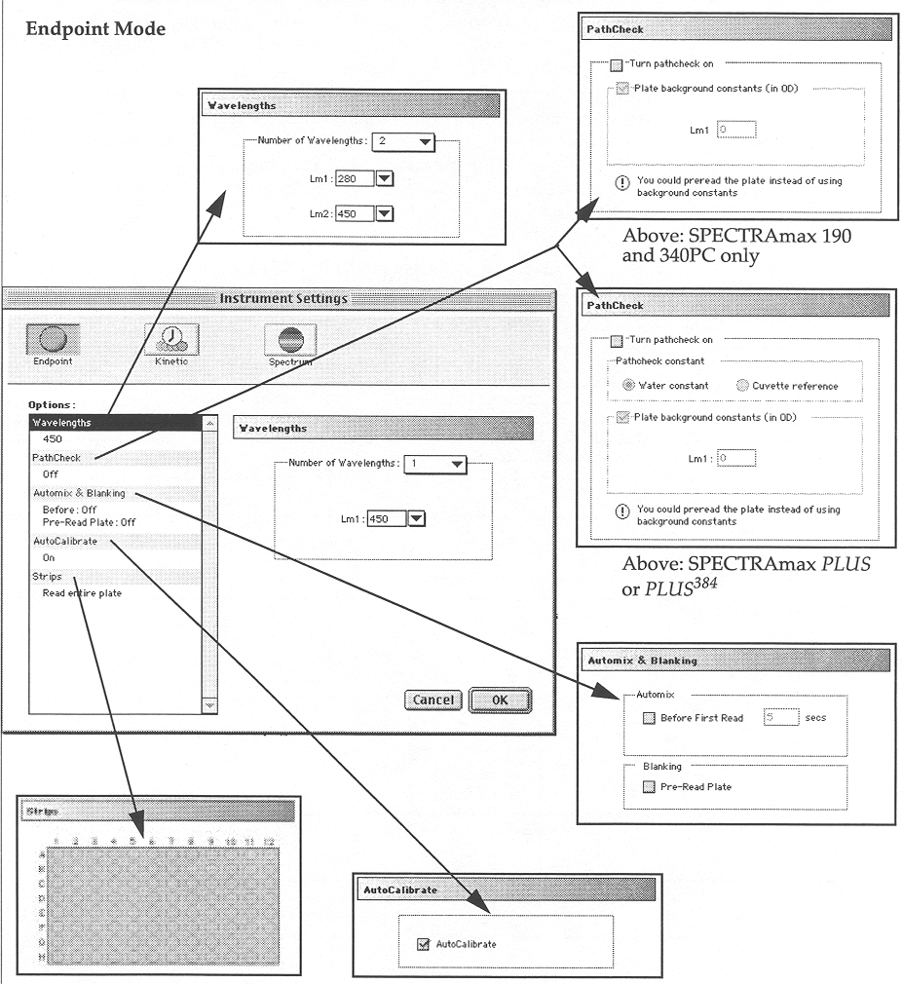
- Number of Wavelengths should be 1 and Lm1 should be 260.

- Now click on Automix & Blanking. In the Automix box: ☑ Before First Read secs
30

- Finally, click on Strips. If you arranged your samples into discrete columns, you could select only those columns that contains samples or you can choose Read entire plate.

- Click OK in the lower right corner. If it is not already open, the plate reader door should open and the plate carrier should extend outward.

- Load your plate with the “A1” well oriented in the designated position.

- Double-click on the Template icon about halfway down the page.

- When the window opens, the 4 grid squares in the upper left corner are usually pre-set to BLANK. Select these 4 squares and click on Clear to erase this.

- Click inside any grid square to highlight it.

- In the Group menu, choose Samples .

- Click on Edit…. This will open up the Group Settings window (below).
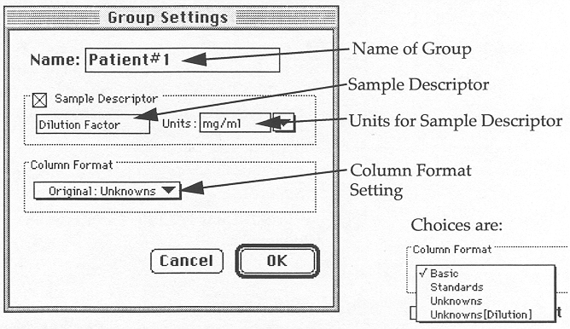
- Type in the name of your experiment (up to 32 characters long) to the right of Name:

- Check ☑ Sample Descriptor.

Part 2 - simplified protocol for the SPECTRAmax PLUS (continued)

- Type concentration in the box if it does not already appear.

- Choose Units: ug/ml (this is identical to ng/µl).

- Under Column Format, choose Basic .

- Click OK.

- Click on Series.

- Give your sample a name. Sample names can be 300+ characters long. Make sure Sample Descriptor is not checked. Click OK.

- Repeat steps 26-27 for all of your samples including the standards of known concentration.

- Now highlight all of your blank wells, and in the Group menu, choose Blank .
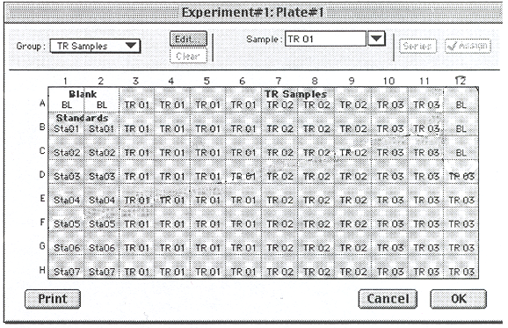Sample Plate Record Template

- Click OK in the bottom right corner (see above). The plate carrier will retract automatically. If you chose automix, the instrument will begin quaking and shaking for the time you specified (30 seconds is best). It will then take about another 12 seconds for the internal UV spectrophotometer to “read” the plate.

- (optional) Double-click on the column ExtCoef. You can choose 1of 3 options:
- Summary#1 uses a conversion factor of 38.1 ng/µl per 1 OD₂₆₀ (water).
- Summary#2 uses a conversion factor of 44.6 ng/µl per 1 OD₂₆₀ (TE).
- Summary#3 uses a conversion factor of 50.0 ng/µl per 1 OD₂₆₀ (saline TE).
I find that Summary#2 (44.6 ng/µl per 1 OD₂₆₀) gives the best results even when water is my diluent.

- Press <Ctrl> + P to print.

- Press <Ctrl> + Q to exit.

P.S. Don’t forget to multiply your results by the dilution factor to obtain the original (undiluted) concentration of your samples!

REFERENCES

1. Bloom MV, Freyer GA, Micklos DA. Laboratory DNA Science, pp. 31, 44, 285 – 286. Menlo Park, CA:
Benjamin/Cummings, 1996.

2. Eastman Kodak Company. Kodak Digital Science™ 1D Image Analysis Software: Windows User’s Manual,
pp. 85-86, 88-90, 92, 108-116, 133-135. Rochester, NY: 1995.

3. http://fticr.chem.cuhk.edu.hk/workshop/18/sld008.htm.

4. http://www.photonics.com/Spectra/Tech/Jul00/techBlue.html.

5. Owl Separation Systems. Electrophoresis Products Catalog, p. 3. Portsmouth, NH.

- PE Corporation. ABI PRISM 3100 Genetic Analyzer Quick Start Guide for Sequencing, pp. 2-6, 2-8 – 2-13,
3-6 – 3-7. Foster City, CA: 2000.

7. PE Corporation. ABI PRISM 3100 Genetic Analyzer Sequencing Chemistry Guide, pp. 3-4 – 3-7, 6-2. Foster
City, CA: 2000.

8. PE Corporation. ABI PRISM BigDye™ Terminator Cycle Sequencing Ready Reaction Kit Protocol, pp. 1-2.
Foster City, CA: 1998.

9. PE Corporation. AmpliTaq™ Gold product insert, pp. 3, 6, 8-9. Foster City, CA: 1996.

10. PE Corporation. GeneAmp® 10X PCR Gold Buffer product insert. Foster City, CA: 1998.

11. Princeton Separations. Centri-Sep 8 Strips product insert. Adelphia, NJ.

12. QIAGEN. DyeEx™ Handbook, pp. 8-9, 17. Valencia, CA: 2000.

13. QIAGEN. QIAquick® Spin Handbook, pp. 9, 11, 18. Valencia, CA: 2000.

14. Weaver, Robert F. Molecular Biology, pp. 77-78, 103-106. Boston, MA: WCB/McGraw-Hill, 1999.

ACKNOWLEDGEMENTS
I would like to thank the following people for their help and guidance:
Michael Gandolph, Dr. Kent Hunter, Jenny Kelly, Dr. Moon-Soo Koh, Luanne Lukes, Dr. Audrey Player, Dr. Joni Rutter, and Amelia Smith.
SUMMARY FLOW CHART OF EVENTS

1. PCR:
Part 1 – picking sequences: Accessing GenBank.
http://neptune.nlm.nih.gov:80/entrez/query.fcgi?CMD=search&DB=Nucleotide

Part 2 - converting single-stranded sequences to double-stranded sequences.
http://genzi.virus.kyoto-u.ac.jp/tacg/tacg.form.html

Part 3 – primer design.
http://207.32.43.248

Part 4 – aliquoting & storing PCR reagents - PCR HOOD IN D702A!

Part 5 – mixing dNTPs – PCR HOOD IN D702A!

Part 6 – rehydrating primers – PCR HOOD IN D702A!

Part 7 – diluting primers – PCR HOOD IN D702A!

Part 8 – the master mix – PCR HOOD IN D702A!

Part 9 (optional) – programming the thermocycler (DNA Engine) for PCR.

Part 10 – running the thermocycler PCR program = 3:04:39 running time on DNA Engine.

2. AGAROSE GEL ELECTROPHORESIS I:
Part I – casting the gel = 11:00 congeal time + microwave time.

Part 2 – sample preparation.

Part 3 – electrophoresis = 45:00 running time.

Part 4 – photographing the gel (DC120 camera).

3. POST-PCR PURIFICATION: QIAquick
00:03 to 00:04 centrifuge time on Eppendorf 5415D

4. AGAROSE GEL ELECTROPHORESIS II = 45:00 running time

5. QUANTITATIVE ANALYSIS: KDS1D software

6. BDT SEQUENCING REACTION:
Part 1 – aliquoting & storing BDT reagents - PCR HOOD IN D702A!

Part 2 – diluting primers – PCR HOOD IN D702A!

Part 3 – calculating the volume of PCR product.

Part 4 – the master mix.

Part 5 (optional) – programming the thermocycler (DNA Engine) for BDT sequencing.

Part 6 – running the thermocycler BDT program = 2:49:15 running time on DNA Engine.

7. POST-SEQUENCING PURIFICATION:
1. Centri-Sep 8 = 00:12 centrifuge time on Beckman Allegra 6KR.
2. DyeEx = 00:06 centrifuge time on Eppendorf 5415D.

8. AGAROSE GEL ELECTROPHORESIS III = 45:00 running time

9. SAMPLE PREPARATION FOR ABI PRISM 3100 SEQUENCE READING
Part 1 – spin drying = 25:00 running time on AES 2010.

Part 2 – sample resuspension.

Part 3 (optional) – programming the thermocycler (DNA Engine) for denature.

Part 4 – running the thermocycler denature program = 06:30 running time on DNA Engine.

Part 5 – 00:06 to 00:08 chill time + centrifuge time on Eppendorf 5804.

Part 6 (optional) – changing the POP-6 polymer – every 10-15 days.

Part 7 (optional) – changing the 3100 buffer – daily.

Part 8 – sample loading.

Part 9 – programming the ABI PRISM 3100: 3100 Data Collection software.

10. SEQUENCE DETECTION = 20:00 to 18:00:00 running time on ABI PRISM 3100

11. DATA RECOVERY AND ANALYSIS
Part 1 – data recovery.
Shortcut to Extracted Runs

ABI PRISM Sequencing Analysis 3.7. software.

Part 2 – sequence analysis.

http://pbil.univ-lyon1.fr/lfasta.html

