Techniques for Modeling Human Intestinal Cancer in Mice

October 22-26, 2000

Presented by

The Jackson Laboratory

Faculty: Catherine Booth, William F. Dove, Jeffrey I. Gordon, Richard B. Halberg, Julie Ann O'Shea, Thaddeus S. Stappenbeck, and Robert H. Whitehead

Edited by: W. F. Dove, R. B. Halberg, L. Clipson,
and I. L. Riegel

The McArdle Laboratory for Cancer Research
University of Wisconsin-Madison

Send any corrections or additions to dove@oncology.wisc.edu
- Cell Culture

Primary Culture Isolations

Catherine Booth
Paterson Institute

Requirements

Mouse colons (4 per isolation)
Forceps
Scalpel blade holder
Size 22-scalpel blade
10 ml syringe
21-gauge needle
Plastic petri dishes 100x20mm
T25 cm² tissue culture flasks (2 per isolation)
T75 cm² tissue culture flask (1 per isolation)
Scalpel blade remover
5 ml Movette pipettes
24-well tissue culture plates (usually 4 per isolation)

Sterile clear universals
5, 10, and 25 ml pipettes
Centrifuge
500 ml beaker

2.5% FCS in DMEM with 4500 mg/L glucose and pyridoxine HCl (Life technologies 41965-039) plus

5 ml sodium pyruvate Sigma S8636

0.25 U/ml insulin
100U/ml Penicillin
25 μg/ml Gentomycin Sigma G1397
30 μg/mlStreptomycin Sigma S0890

2% D-sorbitol: DMEM with 2.5% FCS (and the above antibiotics etc) plus 2% D-sorbitol (Sigma S1876), i.e., 10 g in 500 ml

1XHBSS: 900 ml DD water, 100 ml 10X HBSS (Sigma H4641), 1.8 ml sodium bicarbonate (Sigma S8761), antibiotics as above.

All reagents should be sterilized by filtration prior to use, and all work must be carried out in a tissue culture cabinet after enzymatic digestion.
Digestion Media: This consists of 30 ml DMEM (as previously described) with 2.5% FCS together with 75U/ml Collagenase type XI (Sigma C9407) and Dispase 1 neutral protease at 20 μg/ml (Roche 1284 908). A stock supply of Collagenase and Dispase is usually reconstituted in 1XHBSS and stored as frozen aliquots, which are then adjusted to the correct concentration/volume with DMEM.

Coating Of Plates: At least 3 hr prior to plating out your crypts, you should coat your plates with a 1:10 dilution of Vitrogen (Nutacon BV 0701) made up in DDH₂0. The Vitrogen is then removed, and the plates are allowed to air-dry in the tissue culture hood.

METHOD

Digestion:

1. Remove colons from mice and place them in 1XHBSS solution.

2. The colons are then flushed out with 1XHBSS by using your needle and syringe in a plastic petri dish, to remove their contents.

3. Place the colons on a clean lid of a petri dish and remove any attached mesenchymal tissue. Using your scalpel, slice the colons down the center and cut them into 2 mm² pieces (small enough so that they can easily be agitated with your pipette).

4. Transfer the contents to a T25 flask and top up with about 30 ml HBSS; agitate your solution with your 5 ml movette pipette; allow the pieces of tissue to sink to the bottom of the flasks and remove HBSS. (Your HBSS will now appear cloudy; as you repeat the process, the solution will become clearer as it gets cleaner).

5. Repeat the above process 4-5 times, until your HBSS remains relatively clear.

6. Remove the HBSS and empty the contents of your flask onto a petri dish lid. Remove any excess liquid and then begin to finely chop the tissue, using your scalpel. The chopping process may initially take you a few minutes; continue to chop until the tissue has a smooth, paste-like appearance. (The best way to chop is probably via a rapid chopping action; you can be fairly aggressive with the tissue so do not worry that you are damaging it; ultimately you want to chop the tissue as small as you can, as quickly as you can).

7. Transfer your material into a T25 flask and add your solution of digestion mix. Incubate in a water bath at 37°C for a period of about 1 hr 30 min. (We usually put the small flask into a beaker of water in the water bath.)

8. Transfer the contents of your flask into a T75 flask and shake fairly vigorously; by this stage you should start to see that the tissue has started to be digested and that small clumps of crypts have started to appear (Fig2a). You now need to keep a close eye on your tissue; return it to the waterbath, gently shake the flask, and check your isolation at 20-min intervals, until you can see that most of your crypts have become liberated and your solution contains large numbers of single crypts (Fig2b).

(Note: You cannot wait until you have a complete suspension of single crypts as not all crypts will become free at the same time; those that become free first are at risk of damage from the enzyme from over-digestion. You will have to decide at which point to stop your digestion; this is usually when about 70% of the crypts are present as singlets).

Sedimentation

9. After digestion, you need to sediment your isolation to remove any undigested material; wash it in several changes of sorbitol, thereby cleaning up your prep to remove contaminating factors. This is done as follows:

10. Inside the tissue culture hood, empty the contents of your flask into two 25-ml sterile universal tubes (set 1) and top up with 2% Sorbitol solution (so that you have a working volume of about 20 ml per tube). Allow any undigested material to sink to the bottom of the tubes (usually this takes about 60 sec) and then transfer the supernatant to clean tubes (set 2).

You can then allow the tubes containing the supernatant (set 2) to settle for a minute to remove any undigested material that you may have carried over to your new tubes. Once again, transfer the supernatant to a clean set of tubes (set 3) and top up with 2% sorbitol; these tubes are then ready for centrifuging.

11. Centrifuge your tubes (set 3) at 2-300 revs/min (or lowest speed possible on your centrifuge) for 4 min; while these are spinning, check the material left in your remaining tubes (sets 1and 2) for the presence of single crypts. If there is largely only undigested material, discard this material. If, however, there are quite a few single crypts present, pool the contents of the tubes into one, top up with sorbitol, and repeat the above-mentioned sedimentation step.

12. When you remove your tubes from the centrifuge, carefully discard the supernatant (which will be cloudy in appearance at this stage, but will become clear as you clean up your isolation), and resuspend your pellet by gently flicking the base of the universal and topping up with 2% sorbitol. Again at this stage you may see some large undigested pieces of material that you have failed to remove previously; allow these to sink to the bottom of the tube and transfer your supernatant into clean tubes, top up with sorbitol, and centrifuge once more.

13. You will need to repeat the centrifugation/sedimentation stage approximately 5 times in total, until you are left with your pellet surrounded by a clear supernatant.

The crypts are then ready to be resuspended and plated out. They are usually plated out at between 800 and 1000 per ml in a 24-well plate. To do this, you will need to serial dilute your crypt suspension and count the crypts present; e.g., resuspend your pellet in 5-10 ml medium, transfer 100 μl of this to a universal containing 900 μl medium, mix, and remove 100 μl to count the number of crypts present. The number of crypts you count can then be multiplied by 100 to give you the number of crypts per ml you have.

Incubate your crypts at 7.5% carbon dioxide and 37°C temperature. Allow the culture to attach for a period of 48 hr and then change your samples by adding 1 ml of fresh medium to each well. Isolations can routinely be cultured for a period of 15 days if the medium is supplemented with 0.5 ml fresh medium at 5-day intervals, or for 30 days when the isolations are grown on irradiated 3T3 feeder layers. The addition of EGF and transferrin can also encourage the growth of the primary cultures. Fig. 3 illustrates typical primary cultures.
Figure 2a: Clumps Of Crypts
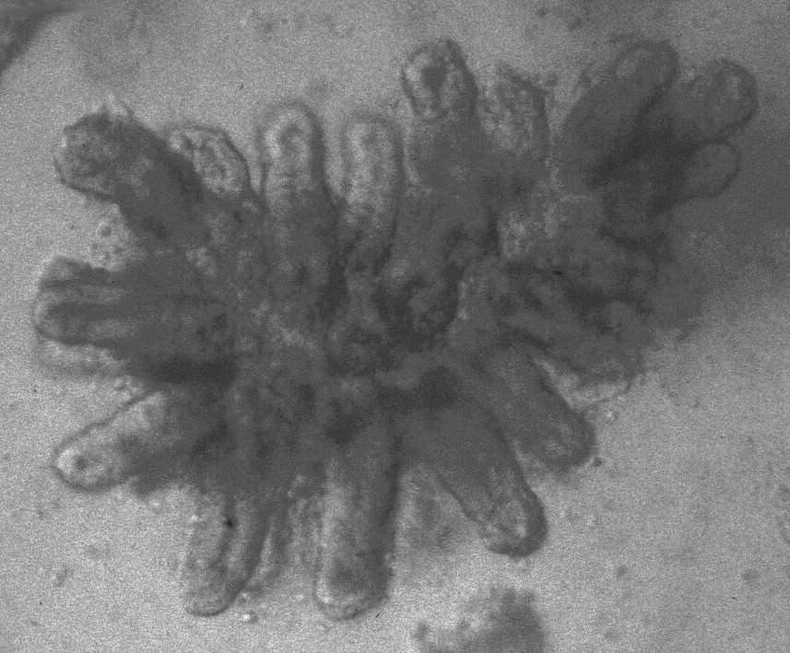
Figure 2b: Single Crypts
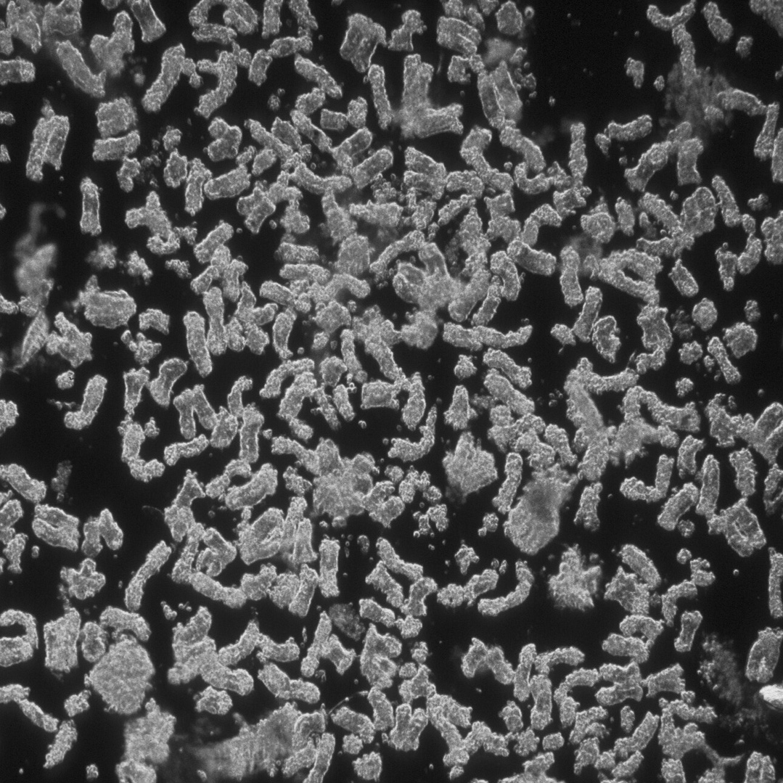
Figure 3: Cultures
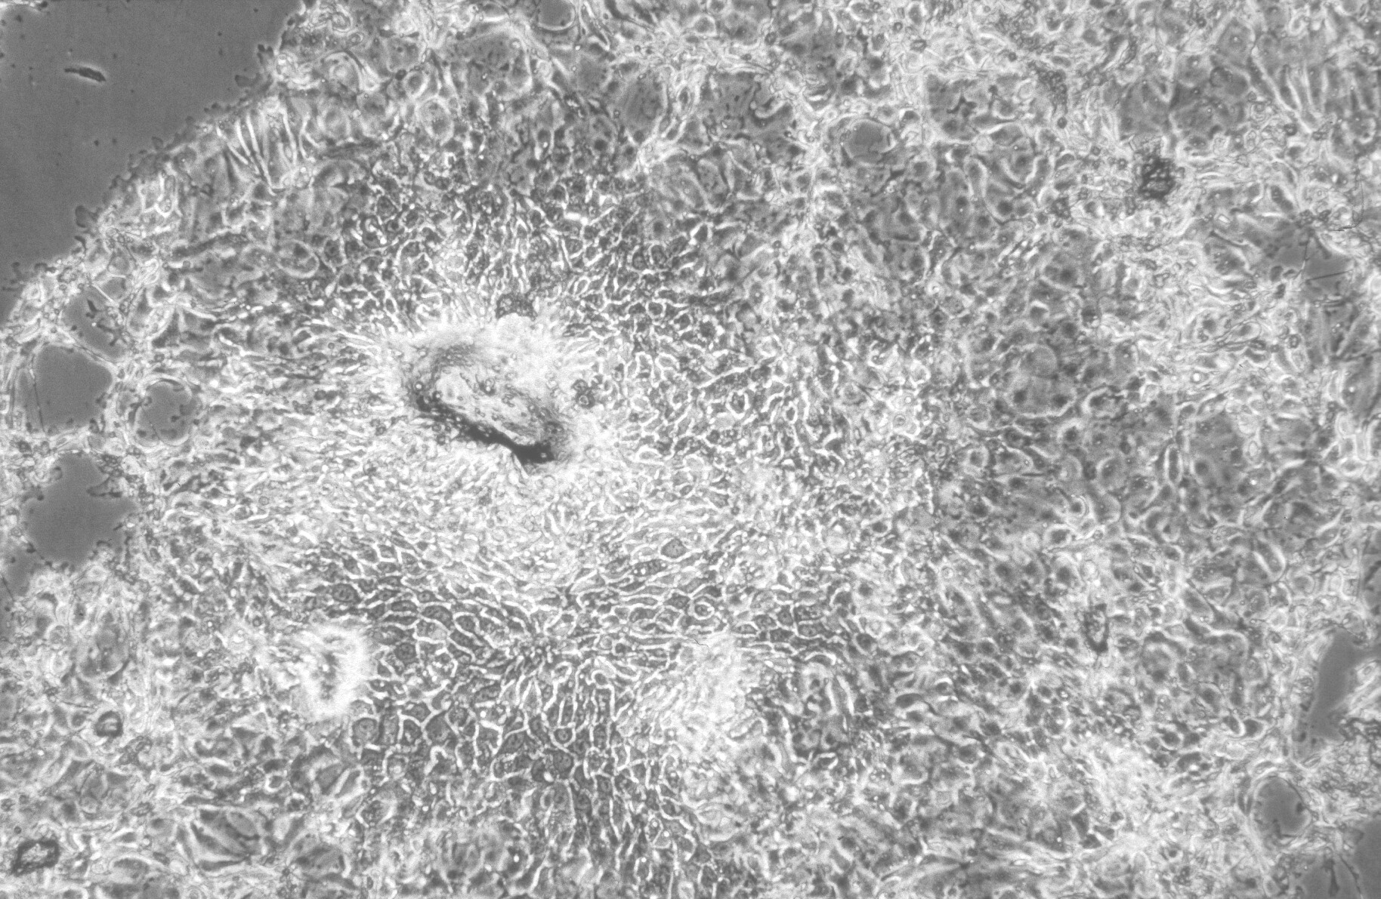

A CLONOGENIC ASSAY FOR IDENTIFYING GROWTH AND DIFFERENTIATION FACTORS FOR COLONIC CRYPT EPITHELIUM

R. H. Whitehead
Department of Gastroenterology
Vanderbilt University
Nashville, TN 37232

Introduction

Although the intestinal epithelium proliferates rapidly throughout life, very little is known about the factors that control this process. Because of the difficulty we have encountered in culturing colonic epithelial cells, most of our knowledge about growth control of the colon come from in vivo studies. The problem with these studies is that it is impossible to be certain that you are seeing a primary effect and not some secondary effect caused by the factor you have administered.

It is well demonstrated that each crypt of the colonic mucosa contains a small proportion of stem cells from which all of the cells of the mucosa arise. In the hemopoietic system it has been possible to develop assays for the stem cells and to identify the factors that induce both proliferation and differentiation into the known mature cell phenotypes of the blood and bone marrow.

A similar assay for colonic stem cells could provide a method for identifying similar factors for this tissue. I will demonstrate a method that I have devised for isolating crypts free from stroma and for disaggregating these crypts into single cells. I will then use these single cells in a clonogenic assay based on the hemopoietic stem cell assay. We can use this assay to identify growth factors for the proliferative cells of the colonic crypt.

Requirements
Scissors and forceps
Mouse colons (2 per student)
Phosphate-buffered saline
500-ml beakers
4% sodium hypoclorite
3 mM EDTA/ 0.05 mM DTT solution in PBS. (111.6 mg EDTA disodium salt plus 7.7mg DTT in 100 ml PBS – sterilized by filtration).
Screw-capped, 50-ml centrifuge tubes
15-ml centrifuge tubes
Centrifuge
0.3% Pancreatin (Sigma P1500) in PBS – this suspension is incubated in a 37ºC waterbath for 3 hr before being filtered. It will still contain a lot of insoluble material, so prefiltration or centrifugation will make filter sterilization easier.
Difco Bacto-agar - 1% in H₂O [sterilized by autoclave; liquid setting (15 lb pressure for 15 min)]
Sigma Type VII agar – 0.8% in H₂O [sterilized by autoclave; liquid setting (15 lb pressure for 15 min)]
X2 RPMI 1640
Fetal calf serum
6-well tissue culture plates
Sterile pipettes – 10 ml and 5 ml.
Sterile plugged Pasteur pipettes
Hemocytometer
20-ml syringes
18-gauge needles
21-gauge needles
Microscope
0.2-μ sterile filters
Trypan blue
METHOD

- Prepare 0.04% sodium hypoclorite (1 ml of 4% sodium hypoclorite in 100 ml PBS) and 3 mM EDTA + 0.05 mM DTT in PBS (114 mg tetrasodium EDTA plus 7.7 mg DTT in 100 ml CA⁺⁺-, Mg⁺⁺-free PBS). Sterilize EDTA/DTT solution by filtration.
- Mice are killed and the colons are removed.
- The colons are opened and washed in 3 changes of PBS (Ca⁺⁺, Mg⁺⁺ free).
- The washed colons are transferred to 25 ml of 0.04% sodium hypoclorite solution in sterile PBS in a sterile tube and incubated for 20 min at room temperature.
- The colons are rinsed once in sterile PBS and transferred to 25 ml of EDTA/DTT solution in a sterile, screw-capped, 50-ml centrifuge tube and incubated at room temperature for 90 min.
- The EDTA solution is removed and replaced with 15 ml of sterile PBS. The lid is closed tightly and the tube is shaken VIGOROUSLY for 15–30 sec.
- The supernatant is transferred to a 15-ml centrifuge tube; fresh sterile PBS is added to the tube containing the colon and shaken. The process is repeated 3 times.
- The tubes are centrifuged at 400 rpm for 5 min.
- The PBS is removed and the crypts are resuspended in PBS and examined microscopically.
- The crypt pellets are pooled and transferred to a tube containing 25 ml of 0.3% Pancreatin (300 mg Pancreatin in 100 ml PBS, dissolved and sterilized by filtration) and incubated for 90 min at room temperature.
• **During this period, the 1% agar and 0.8% agarose are melted and held in a 40ºC waterbath. The x2 medium plus 10% FCS is also placed in the 40ºC waterbath.
• When the 1% agar has cooled to 40ºC, the underlay can be prepared by mixing equal volumes of 1% agar and x2 medium plus FCS and pipetting 2 ml of the mixture into each well of a 6-well plate. The plate is then kept at room temperature to allow the agar to set, and then used below to plate the cell suspensions made in agarose/FCS.
- After 90 min the cell suspension is diluted with an equal volume of PBS and transferred to centrifuge tubes.
- The tubes are centrifuged at 1000 rpm for 5 min.
- The supernatant is removed carefully because a lot of mucus is often present and the whole pellet can be taken up into the pipette if care is not taken.
- The pellets are resuspended in the EDTA/DTT solution and centrifuged at 1000 rpm for 5 min.
- The cell pellets are resuspended in growth medium and pooled.
- The cell suspension is examined microscopically.
- If the cells are in a single-cell suspension, a cell count is done with a hemocytometer.
- Normally small clumps of cells are still present, so the cell suspension is passed gently 3 times through an 18-gauge needle, followed by 3 times through a 21-gauge needle.
- The cell suspension is examined again.
- If small clumps are still present, the cell suspension is filtered through a cotton wool plug in a Pasteur pipette. (n.b.: this can result in considerable cell loss). Recently we have used 40-μ nylon cell strainers from Falcon. These give good results as long as you pipette the cell suspension gently.
- The cells in the cell suspension are counted.
- Factors to be tested are added to labeled wells at 2x the final concentration to be tested, to allow for diffusion through the underlay.
- The cell suspension is diluted in a mixture of equal volumes of 0.8% agarose and x2 medium plus FCS to give a final cell concentration of 50,000 cells per ml.
- The cell mixture is aliquoted into the wells of the plate containing the underlay and factors. This pipetting should be done carefully to avoid bubbles.
- The plates are cooled at 4ºC for 5 min as the type VII agarose sets only at 26ºC and can remain liquid for long periods at room temperature.
- After 5 min at 4ºC, the plates are placed in a sealed container with a small container of H₂O and incubated at 37ºC for 3–4 weeks.
- The plates are examined, and colonies of 30 cells or more are scored. Clusters of >15 cells can also be counted.

Potential Problems

The major problem with this technique comes from the release of mucus from the goblet cells. This becomes a major problem only if the crypts and later the single cells are pipetted too vigorously and cells are ruptured. Gentle pipetting, gentle passage through the needles, and a wash with EDTA/DTT all help in obtaining a good single-cell suspension of high viability.

Summary

This is the first method to describe the clonal growth of proliferative cells of the colonic crypt. At the present time we cannot assume that this is a stem cell assay, but we know that we are assaying cells capable of autonomous growth, and that is a property associated with stem cells in other tissues. This method allows us to study growth responses and hence can be used to identify novel growth factors for the proliferative cells of the colon. It will also allow us to identify factors that induce the differentiation of these proliferative cells into the known differentiated cell phenotypes found in the colonic mucosa. For these studies, the colonies can be picked from the agarose using a fine-bore Pasteur pipette. The colonies can be fixed for ultrastructural studies or can be disaggregated and transferred to a slide using a cytocentrifuge for immunohistochemical studies of cell phenotype. Ultimately the stem-cell nature of the cells in the colony can be tested by disaggregating the colony and cloning the cells in the colony assay once more.

Note: This is an evolving technique. The method described here is not necessarily the optimal method. Further experimentation may make improvements in crypt disaggregation, culture methods and medium, and methods of assessing colony formation. Similarly, better methods for assessing colony phenotype are needed.
References

- Whitehead, R.H., Brown, A. and Bhathal, P. (1987) A method for the isolation and culture of human colonic crypts in collagen gels. In Vitro 23:436-442.
- Whitehead, R.H. and Van Eeden, P.E. (1991) A method for the prolonged culture of colonic epithelial cells. J. Tissue Culture Methods, 13: 103-106.
- Whitehead, R.H., VanEeden, P.E., Noble, M.D., Ataliotis, P. and Jat, P.S. (1993) The establishment of conditionally immortalized epithelial cell lines from both colon and small intestine of adult H-2Kb-tsA58 transgenic mice. PNAS, 90, 587-591.
- Whitehead, R.H. and Joseph, J.L. (1994) Derivation of conditionally immortalised cell lines containing the Min mutation from the normal colonic mucosa and other tissues of an F1 mouse (Immortomouse/Min) Epithelial Cell Biol,3, 119-125.
- Whitehead, R.H., Demmler, K., Rockman, S.P. and Watson, N.K. (1999) Clonogenic growth of epithelial cells from normal colonic mucosa from both mouse and human. Gastroenterology, 117, 858-865.
Single Crypts
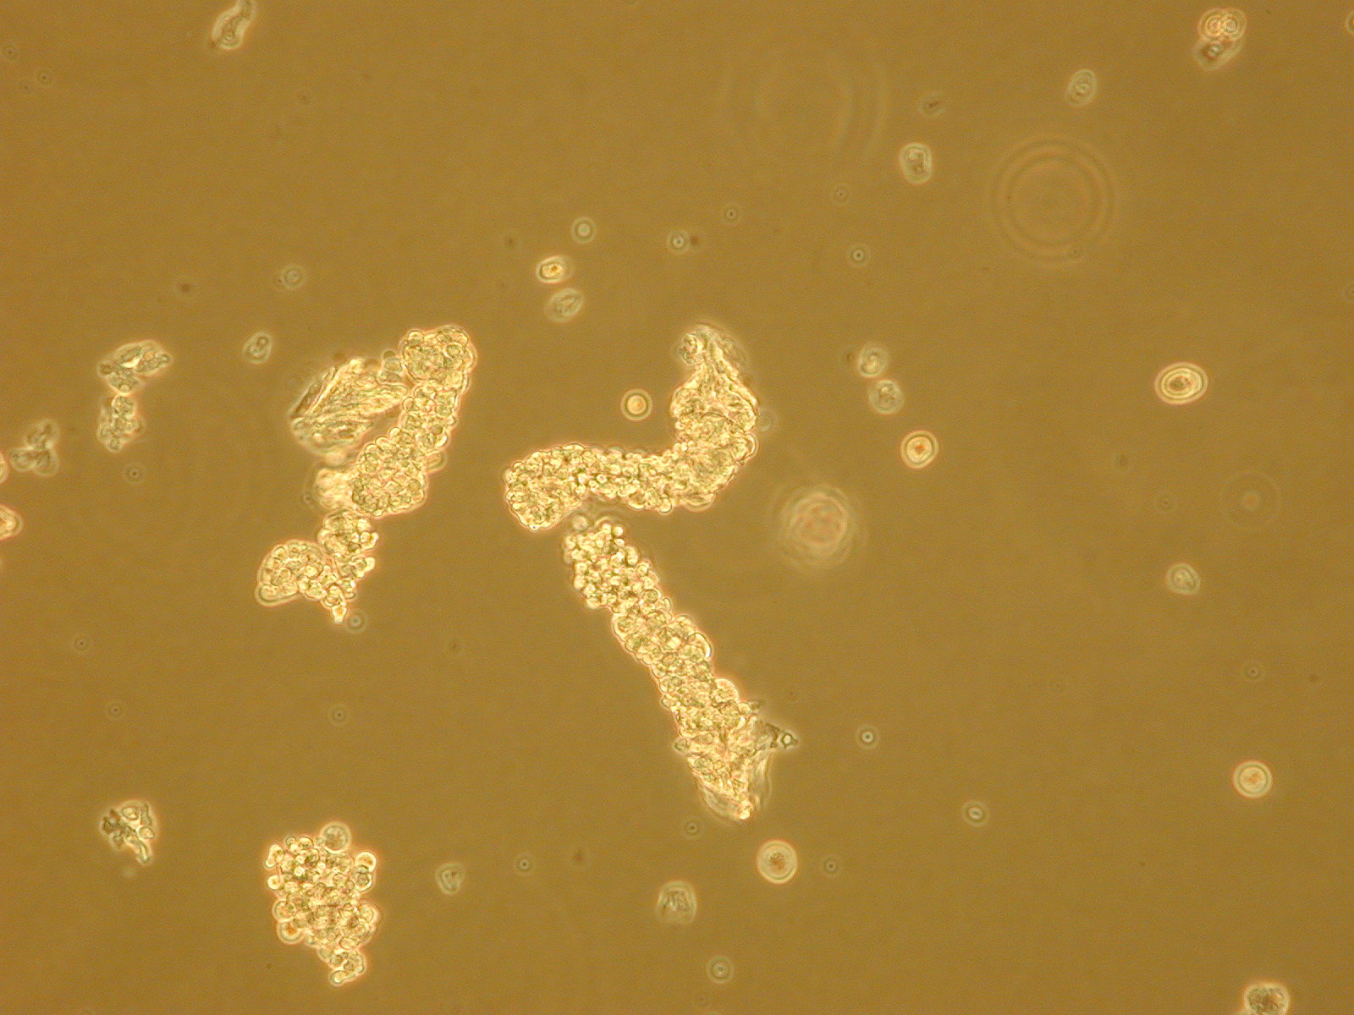

Single Cells
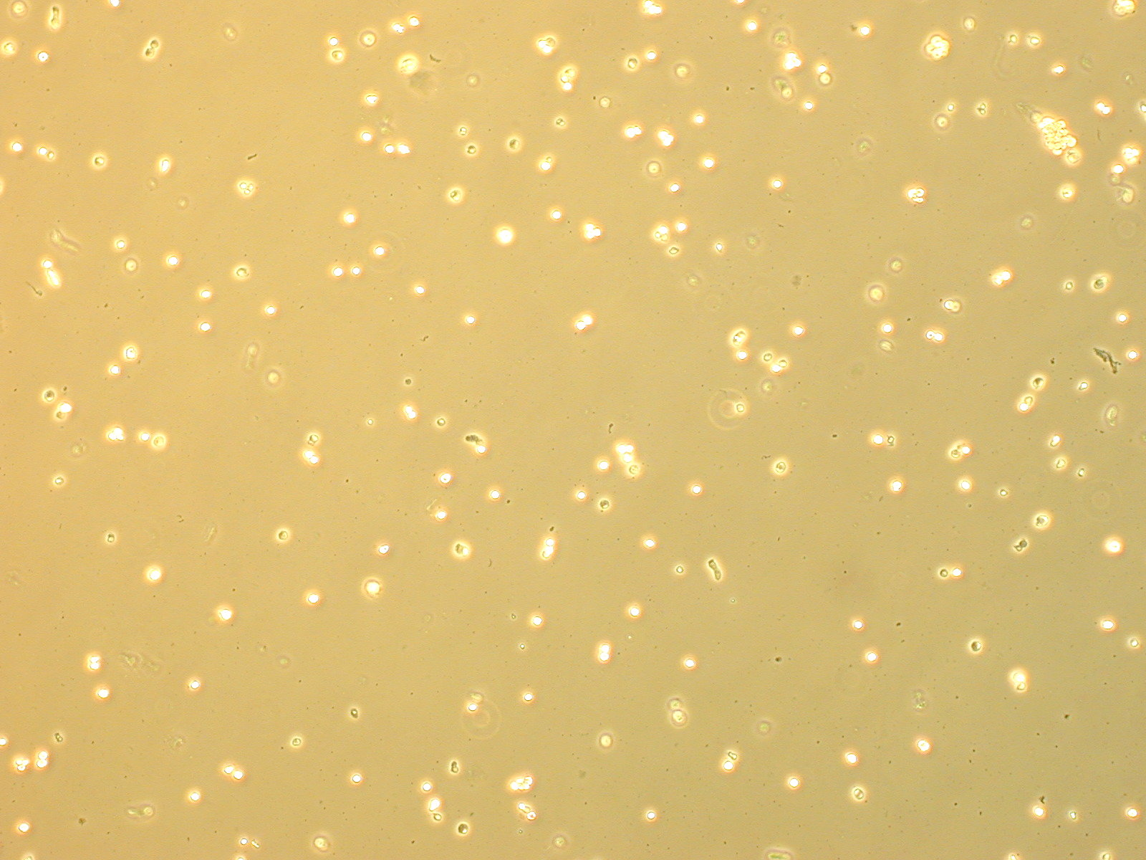
Colonies

