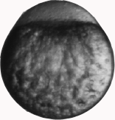
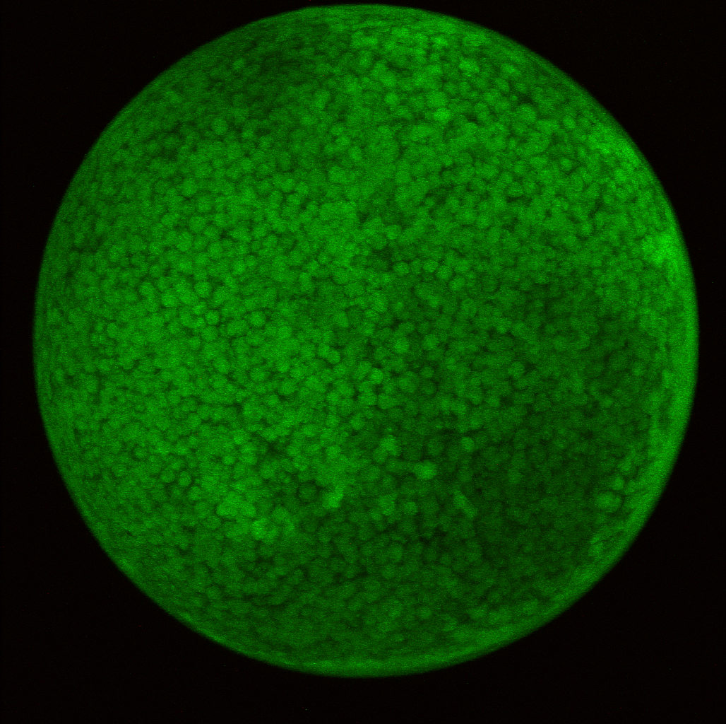
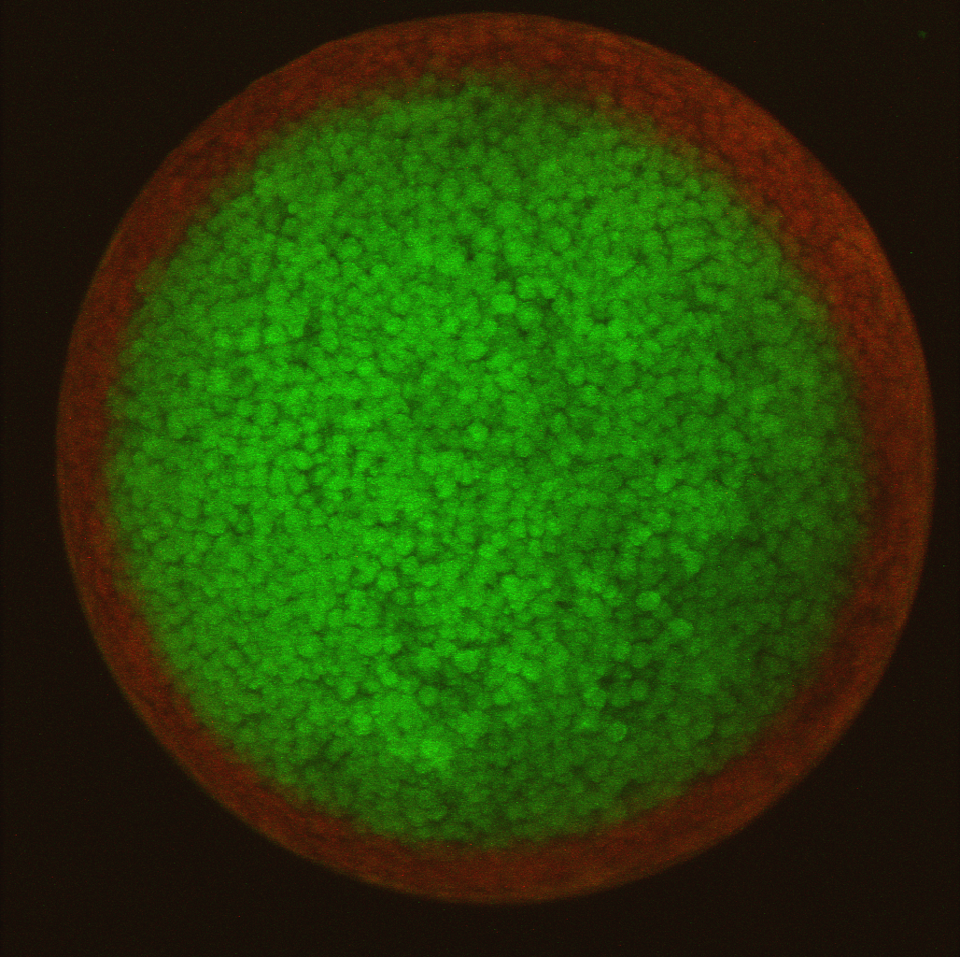
Inject
Incubate
Photoconversion
UV

Kaede, a protein that has a base state of green fluorescence, is injected into the embryonic yolk of embryonic cells. The injected embryos are incubated until a specific stage of development, at which time they are mounted on a confocal microscope and photoconverted using an ultraviolet scanning laser. Upon photoconversion, with a particular wavelength of light, Kaede undergoes cleavage, and its fluorescence shifts from green to red. In this way specific regions of the cells are labeled.

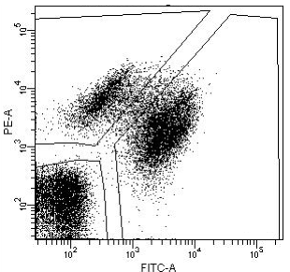
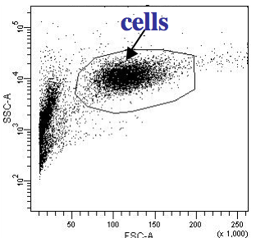
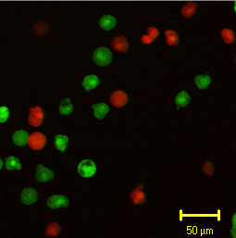
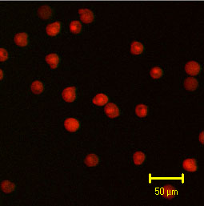
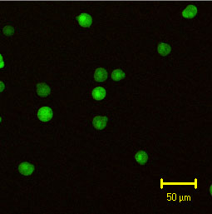
FACS

size

granularity

dissociate
FACS

Red

Green

After photoconversion, the embryonic cells are dissected from one another by enzymatic treatment to produce a suspension of red and green cells. The cell suspensions are then sorted based on their different fluorescent colors by FACS. This separates the cell mixture into populations of red and green cells.

