SECTION J

LIST OF ATTACHMENTS

ATTACHMENT A: DOE and Regulatory Requirements

ATTACHMENT B: Standard Terms for Components of OU-1

ATTACHMENT C: Deliverables

ATTACHMENT D: Task Background and Current Status

ATTACHMENT E: List of Government Property

ATTACHMENT F: Wage Determination

ATTACHMENT G: Funding Recapitulation

SECTION J

ATTACHMENT A

DOE and Regulatory Requirements

10 CFR 707, Workplace Substance Abuse Programs at DOE Sites
10 CFR 820, Procedural Rules for DOE Nuclear Activities
10 CFR 830, Nuclear Safety Management
10 CFR 830 Subpart A, Quality Assurance Requirements
10 CFR 830 Subpart B, Safety Basis Requirements
10 CFR 835, Occupational Radiation Protection
10 CFR 850, Chronic Beryllium Disease Prevention Program
10 CFR 860, Trespassing on Department of Energy Property
10 CFR 1008.17, Records Maintained on Individuals (Privacy Act)
10 CFR 1017, Identification and Protection of Unclassified Controlled Nuclear Information
10 CFR 1046, Physical Protection of Security Interests
20 CFR 617.66, Transition procedures for amendments in section 13002 through 13009 of Public Law 99-272 (Consolidated Omnibus Budget Reconciliation Act (COBRA) of 1986)
29 CFR Part 5, (Davis-Bacon Act) Labor Standards Provisions Applicable to Contracts Covering
Federally Financed and Assisted Construction (Also Labor Standards Provisions Applicable to Nonconstruction Contracts Subject to the Contract Work Hours and Safety Standards Act.)
29 CFR 30, Equal Employment Opportunity in Apprenticeship and Training
29 CFR 516, Records to be Kept by Employers
29 CFR 525, Employment of Workers with Disabilities Under Special Certificates
29 CFR 531, Wage Payments Under the Fair Labor Standards Act of 1938
29 CFR 541, Fair Labor Standards Act
29 CFR 548, Authorization of Established Basic Rates for Computing Overtime Pay
29 CFR Part 825, Family and Medical Leave Act of 1993
29 CFR 1602, Record-keeping and Reporting Requirements Under Title VII and the ADA
29 CFR 1608, Affirmative Action Appropriate Under Title VII of the Civil Rights Act of 1964, as amended
29 CFR 1611, Privacy Act Regulations
29 CFR 1620, The Equal Pay Act
29 CFR 1625, Age Discrimination in Employment Act
29 CFR 1627, Records To Be Made or Kept Relating to Age: Notices To Be Posted: Administrative Exemptions
29 CFR 1904, Recording and Reporting Occupational Injuries and Illnesses
29 CFR 1910, Occupational Safety and Health Standards for General Industry, Subparts A thru Q, S & Z[Excluded: Subpart R, Special Industries; Subpart T, Commercial Diving Operations]:
29 CFR 1926, Safety and Health Regulations for Construction
[Excluded: Subpart S, Underground Construction, Caissons, Cofferdams, and Compressed Air; Subpart T, Power Transmission and Distribution, Subpart Y, Diving]
29 CFR 2520, Rules and Regulations for Reporting and Disclosure under the Employees Retirement Income Security Act of 1974
29 CFR 4041A, Termination of Multi-employer Plans
36 CFR 1200 series, National Archives and Records Administration, Vital Records and Records Disaster Mitigation and Recovery
36 CFR 1236, Management of Vital Records
40 CFR 61, National Emission Standards for Hazardous Air Pollutants (NESHAPS)
40 CFR 136, Guidelines Establishing Test Procedures for the Analysis of Pollutants
40 CFR 141, National Primary Drinking Water Regulations. The following sections concerning analytical methods apply as required: 141.11-16, 141.21(f), 141.23(k), 141(q), 141.24(e), 141.25(a), 141.27, 141.28, 141.30(e), 141.30-Appendix C, 141.40(g), 141.40(h), 141.41(d), 141.42(c), 141.74(a), 141.80(h), 141.89
40 CFR 247, Comprehensive Procurement Guideline for Products Containing Recovered Materials
40 CFR 300, National Oil and Hazardous Substances Pollution Contingency Plan, (CERCLA Response and Enforcement)
40 CFR 302, Designation, Reportable Quantities, and Notification
40 CFR 355, Emergency Planning and Notification
41 CFR 60-1, Obligations of Contractors and Subcontractors
41 CFR 60-3, Uniform Guidelines on Employee Selection Procedures (1978)
41 CFR 60-20, Sex Discrimination Guidelines
41 CFR 60-250, Affirmative Action and Non-discrimination Obligations of Contractors and
Subcontractors Regarding Special Disabled Veterans and Veterans of the Vietnam Era
41 CFR 60-741, Affirmative Action and Non-Discrimination Obligations of Contractors and
Subcontractors Regarding Individuals with Disabilities
41 CFR 101-20.103, Physical Protection and Building Security
41 CFR 102-36, Disposition of Excess Personal Property
41 CFR 102-71, Disposition of Real Property
41 CFR 109-45.309-52, Classified Property
41 CFR 109-45.309-53, Nuclear-related or proliferation sensitive property
41 CFR 409-43.307-53, Automatic data processing equipment (ADPE)
48 CFR 22, Application of Labor Laws to Government Acquisition. Subpart 22.1, Basic Labor Policies (22.101-22.103-5) and 22.8 Equal Employment Opportunity (22.800-22.810) only
48 CFR Part 970.2201, Application of Labor Policies (Pre-employment investigations)
48 CFR Part 9904, Cost Accounting Standards
49 CFR 211, Rules of Practice
49 CFR 171, General Information, Regulations, and Definitions
49 CFR 172, Hazardous Materials Table, Special Provisions, Hazardous Materials Communications, Emergency Response Information, and Training Requirements
49 CFR 173, Shippers-General Requirements for Shipments and Packagings
49 CFR 174, Carriage by Rail
49 CFR 177, Carriage by Public Highway
49 CFR 178, Shipping Container Specifications
50 CFR Part 402, Interagency Cooperation – Endangered Species Act of 1973, as amended
8 U.S.C. 1324a., Immigration Reform and Control Act (IRCA) of 1986
20 U.S.C. 401 et seq., Labor-Management Reporting and Disclosure Act of 1959, as amended (LMRDA)
29 U.S.C. 158, National Labor Relations Act
29 U.S.C. 201 et seq., Federal Wage and Hour Law
33 U.S.C. Section 1251 et seq., the Federal Water Pollution Control Act, as amended by the Clean Water Act of 1977
33 U.S.C. Section 1318, Guidelines and standards for effluent, pretreatment standards, and discharge of treatment system effluent
33 U.S.C. Section 1344, the Federal Water Pollution Control Act, as amended by the Clean Water Act of 1977
38 U.S.C. 4214, Section 402, Vietnam Era Veterans Readjustment Act of 1974
42 U.S.C. Sections 300(f) et seq., Safe Drinking Water Act of 1974, as amended
42 U.S.C. 6901 et seq., Resource Conservation and Recovery Act of 1976 (RCRA) (PL 940580)
42 U.S.C 6901 et seq., Federal Facilities Compliance Act of 1992
42 U.S.C. 7384 et seq., Energy Employees Occupational Injury Compensation Program Act (EEOICPA) of 2000, as amended
42 U.S.C. Sections 7401 et seq., Clear Air Act, as amended
42 U.S.C. Section 9601, Comprehensive Environmental Response, Compensation, and Liability Act of 1980 (CERCLA)
42 U.S.C. Section (11001-11050) et seq., Emergency Planning and Community Right-to-Know Act of 1986 (EPCRA)
42 U.S.C. 12101, Americans with Disabilities Act of 1990
42 U.S.C. 13101-13109, Pollution Prevention Act of 1990
Executive Order 12580, Superfund Implementation at Federal Sites, signed 1-23-87
Executive Order 12656, Assignment of Emergency Preparedness Responsibilities, signed 11-18-88
Executive Order 12898, Federal Actions to Address Environmental Justice in Minority Populations and Low-Income Populations, signed 2-11-94
Executive Order 13101, Greening the Government Through Waste Prevention, Recycling, and Federal Acquisition
American Conference of Governmental Industrial Hygienist (ACGIH), "Threshold Limit Values (TLV) for Chemical Substances and Physical Agents and Biological Exposure Indices" [Used where TLVs are lower than OSHA's Permissible Exposure Levels (PEL). TLV's for exposures to laser emissions in the
ACGIH Indices are excluded from these requirements.]
American National Standards Institute (ANSI) N323A-1997, Radiation Protection Instrumentation Test and Calibration
American National Standards Institute (ANSI) Z136.1, Safe Use of Lasers [Only the exposure limits and technical requirements apply. Programmatic components of ANSI Z136.1 do not apply.]
American National Standards Institute (ANSI) Z49.1, Safety in Welding, Cutting and Allied Processes, Section 4.3 and E4.3 1994
American National Standards Institute (ANSI) Z88.2-1992, Respiratory Protection
CERCLA Section 120 Federal Facility Agreement (FFA) signed between DOE and EPA (EPA
Administrative Docket Number VW-90-C-075)
Emergency Response Planning Guidelines (ERPGs), American Industrial Hygiene Association (AIHA)
EPA 400-R-92-001, Manual of Protective Action Guides and Protective Actions for Nuclear Incidents, 1992
National Fire Protection (NFPA) Codes and Standards [Exceptions: NFPA standards not applicable to the site: 10R, 13D, 13R, 17, 17A, 32, 34, 35, 36, 40, 40E, 43B, 46, 50, 50A, 50B, 51A, 53, 57, 59, 59A, 61, 65, 73, 86C, 86D, 88A, 92B, 99, 99B, 120, 121, 122, 123, 130, 150, 231D, 231E, 231F, 260, 261, 302, 303, 306, 307, 312, 395, 402, 403, 407, 408, 409, 410, 412, 414, 415, 416, 417, 418, 423, 424, 481, 482, 485, 490, 496, 501A, 501C, 501D, 560, 650, 651, 654, 655, 803, 804, 851, 911, 912, 914, 1003, 1061, 1122, 1123, 1124, 1125, 1126, 1127, 1231, 1405, 1452, 8503, 8504]
National Fire Protection Association (NFPA) 70, National Electrical Code
National Fire Protection Association (NFPA) 70E, Electrical Safety Requirements for Employee Workplaces
Ohio Administrative Code (OAC) 3745-07, Water Supply Works and Wastewater Works Personnel Certification; parts -01 through –016
Ohio Administrative Code (OAC) 3745-15, General Provisions on Air Pollution Control
Ohio Administrative Code (OAC) 3745-17, Particulate Matter Standards
Ohio Administrative Code (OAC) 3745-27, Solid Waste and Infectious Waste Regulations
Ohio Administrative Code (OAC) 3745-33, Ohio NPDES Individual Permits
Ohio Administrative Code (OAC) 3745-35, Air Permits to Operate and Variances
Ohio Administrative Code (OAC) 3745-38, Ohio NPDES General Permits
Ohio Administrative Code (OAC) 3745-50 thru 66 excluding OAC 3745-56 and OAC 3745-57,
Hazardous Waste Management Systems
Ohio Administrative Code (OAC) 3745-54-13, Waste analysis requirements before storage
Ohio Administrative Code (OAC) 3745-81, Primary Drinking Water Rules
Ohio Administrative Code (OAC) 3745-81-23, Maximum Contamination Levels and Best Available Technologies for Inorganic Compounds
Ohio Administrative Code (OAC) 3745-89, Laboratory Approval
-03, Procedure for laboratory certification
-04, Renewal of laboratory certification
Ohio Administrative Code (OAC) 3745-100, Toxic Chemical Release Reporting
Ohio Administrative Code (OAC) 3745-400, Disposal Methods for Construction and Demolition Debris, parts 01-05
Ohio Administrative Code (OAC) 3750-20, Emergency Planning
Ohio Administrative Code (OAC) 3750-30, Hazardous Chemical Reporting
Ohio Administrative Code (OAC) 4101:2, Board of Building Standards
Ohio Administrative Code (OAC) 4101:4-3, Administrative and General Requirements
Ohio Administrative Code (OAC) 4101:8, Inspection: Ohio Pressure Piping Systems Rules (Code)
Ohio Administrative Code (OAC) 4123, Industrial Commission, Bureau of Worker’s Compensation
Ohio Administrative Code (OAC) 4101:11, Steam Engineers; Personnel Certification
Ohio Revised Code (ORC) 3704, Air Pollution Control
Ohio Revised Code (ORC) 3710, Asbestos Abatement
Ohio Revised Code (ORC) 3714, Construction and Demolition Debris
Ohio Revised Code (ORC) 3734, Solid and Hazardous Waste
Ohio Revised Code (ORC) 3750, Emergency Planning
3750.07 Owner or Operator to submit list of hazardous chemicals; request for material safety data sheet
3750.08 Emergency and hazardous chemical form to be submitted
Ohio Revised Code (ORC) 4109, Employment of Minors
Ohio Revised Code (ORC) 6109, Safe Drinking Water
Ohio Revised Code (ORC) 6111, Water Pollution Control
DOE-STD-1027-92, Chg. 1, Hazard Categorization and Accident Analysis Techniques for Compliance with DOE Order 5480.23, Nuclear Safety Analysis Reports (Applicable Portions Only)
DOE Personal Property Letter (PPL) 970-3, Revision 1, dated February 3, 1998
State of Ohio Technical Guidance for Sealing Unused Wells, by the State Coordinating Committee on Ground Water, 1996
Interim Utility Agreement by and between the United States Department of Energy and the Miamisburg
Mound Community Improvement Corporation, March 18, 1999
Memorandum of Agreement by and between the United States Department of Energy and the Miamisburg Mound Community Improvement Corporation, January 23, 1999
General Purpose Lease by and between the U. S. Department of Energy and the Miamisburg Mound Community Improvement Corporation, September 7, 1994, and all exhibits, attachments and amendments
Memorandum of Agreement between the U. S. Department of Energy and the Advisory Council on Historical Preservation regarding the Disposition of the Mound Plant, September 19, 2000
Memorandum of Understanding (MOU) between the U. S. Department of Energy and the U. S.
Department of Justice, Federal Bureau of Investigation’s Cincinnati Field Office and Dayton Resident Agency, September 9, 1988
Memorandum of Understanding (MOU) between the U.S. Department of Energy and the State of Ohio Emergency Management Agency, April 20, 1989
Mutual Firefighting and Emergency Response Agreement between the City of Miamisburg, Ohio and the U. S. Department of Energy, November 3, 1988
Mutual Use Permit Agreement between the City of Miamisburg, Ohio and the U. S. Department of Energy, January 10, 1983
Memorandum of Understanding (MOU) between the U. S. Department of Energy and the State of Ohio Miami Valley Emergency Management Authority, August 3, 1988
Memorandum of Understanding between the U. S. Department of Energy and the Kettering Medical Center, September 1993
Mound Fire Department/Miamisburg Fire Division Mutual Response Guideline for Fire, Emergency
October 4, 1995, Director's Final Findings and Orders for mixed waste (Federal Facilities Compliance Act of 1992) between Ohio EPA and DOE
July 15, 1993, Federal Facility Agreement under CERCLA Section 120, signed by DOE, U.S. EPA Region 5 and Ohio EPA
Ohio Hazardous Waste Facility Installation and Operation Permit No. 05-57-0677, issued and effective March 22, 2002, expires March 22, 2007
OU1 Authorization to Discharge from the groundwater treatment works (Authorization No. 1IN90010*AD), issued July 11, 1997, effective August 1, 1997- no expiration date
Permits to Operate An Emissions Unit Boiler No. 1 (B001) 08-57-09-1196 and Boiler No. 2 (B006) 08-57-09-1196, effective 7/31/00, expires 7/31/05
Permit to Operate An Emissions Unit -Building Crusher (F003), 08-57-09-1196, effective 12/10/01, expires 12/10/06

DOE M 200.1-1, Telecommunications Security Manual
Specific Contractor Requirements: All

DOE G 205.3-1, Password Guide
Specific Contractor Requirements: All

DOE O 221.1, Reporting Fraud, Waste, and Abuse to the Office of Inspector General
Specific Contractor Requirement Document paragraphs: All

DOE O 225.1A, Accident Investigations
Specific Contractor Requirement Document paragraphs: All

DOE O 231.1, Chg. 002, Environment, Safety, and Health Reporting
Specific Contractor Requirement Document paragraphs: 3; 6; 9; 10

DOE N 231.1 Environment, Safety, and Health Reporting Notice
Specific Contractor Requirement Document paragraphs: 1-4

DOE O 232.1A, Occurrence Reporting and Processing of Operations Information
Specific Contractor Requirement Document paragraphs: All

DOE O 413.1A, Management Control Program
Specific Contractor Requirement Document paragraphs: 1-12

DOE O 413.3, Program and Project Management for the Acquisition of Capital Assets
Specific Contractor Requirement Document paragraphs: All

DOE O 414.1A, Chg. 001, Quality Assurance
Specific Contractor Requirement Document paragraphs: All

DOE O 420.1A, Facility Safety
Specific Contractor Requirement Document paragraphs: 4.1; 4.2 (except 4.2.2 item 4 redundant fire protection systems); 4.4

DOE O 430.1A, Life Cycle Asset Management
Specific Contractor Requirement Document paragraphs: All (except 2.c. “predictive” maintenance)

DOE O 435.1, Chg. 001, Radioactive Waste Management
Specific Contractor Requirement Document paragraphs: All

DOE O 440.1A, Worker Protection Management for DOE Federal and Contractor Employees
Specific Contractor Requirement Document paragraphs: 6; 14a(2-4); 16a (1,2,4); 18-22

DOE P 450.4, Safety Management System Policy

DOE P 450.5, Line Environment, Safety and Health Oversight

DOE O 460.1A, Packaging and Transportation Safety
Specific Contractor Requirement Document paragraphs: 2 and 5 only
Note: The existing MCP procedures meet the intent of CRD 5

DOE O 460.2, Chg. 001, Departmental Materials Transportation and Packaging Management
Specific Contractor Requirement Document paragraphs: 1-8, 10
Note: Provide the information in CRD 10 only upon direction of the Contracting Officer.

DOE O 470.1, Chg. 001, Safeguards and Security Program (Cancels Chapter XI of DOE M 5632.1C-1)
(Extended until 08-15-02 by N 251.43)
Specific Contractor Requirement Document paragraphs: Attachment 1 Chapters I, II, and IV-X

DOE N 471.3 Reporting Incidents of Security Concern (Extended until 12-31-02 by N 251.44)
Specific Contractor Requirement Document paragraphs: All

DOE O 472.1B, Personnel Security Activities (Extended until 8-15-02 by N 251.43)
Specific Contractor Requirement Document paragraphs: All

DOE G 1324.5B, Implementation Guide for Records Management
Specific Contractor Requirement Document paragraphs: All

USDOE Ohio Field Office Records Management Program, A Management Guide, March 2001

DOE 5400.1, Chg. 1, General Environmental Protection Program
Specific Contractor Requirement Document paragraphs: All, except for Chapter II, paragraph 5 effluent reporting.

DOE 5400.5, Chg. 002, Radiation Protection of the Public and the Environment
Specific Contractor Requirements:
Chapter II, paragraph 5(c) Release of Materials and Equipment
Chapter IV, paragraph 4(d) Surface Contamination;
Chapter IV, Figure IV-1 Surface Contamination Guidelines

DOE 5631.2C, Personnel Security Program
Specific Contractor Requirements: Chapters I-VIII

DOE 5632.1C, Protection and Control of Safeguards and Security Interests
Specific Contractor Requirements: All

SECTION J

ATTACHMENT B

Standard Terms for Components of OU-1

Features currently visible in the OU-1 area include an overflow pond, located on the northern portion of OU-1, and the Site Sanitary Landfill, located on the southern portion of OU-1. Other features present within OU-1 include older waste disposal areas, now buried beneath portions of the overflow pond and the Site Sanitary Landfill. The following are uniform terms used in all text and diagrams pertaining to the remediation of OU-1:

OVERFLOW POND AREA

Overflow Pond – A part of the site storm water drainage system, where excess water can be temporarily stored. This pond was constructed in 1976 and 1977 by excavating up to 40 feet of soil from a hillside formerly located in the northeastern portion of the overflow pond area, and by constructing a dike around portions of the northwestern and western borders of the pond. This dike is now occupied by the access road. The Site Sanitary Landfill was constructed at the same time as the pond, as a site to dispose of wastes that had to be excavated from the footprint of the overflow pond.

Water reaches this pond via an inlet/outlet structure located on the north side of the pond, and via a concrete-lined ditch that empties into the southeastern corner of the pond. Water leaves the pond via the inlet/outlet structure, as well as by evaporation, and possibly by infiltration through the liner.

Previous sampling of the sediments within the overflow pond demonstrates that these sediments meet the Site Cleanup Objectives, and therefore need no additional remediation.

Overflow Pond Liner – An approximately 3 foot thick liner on the floor and sides of the Overflow Pond, composed of re-compacted soil, originally excavated from within the Overflow Pond footprint. No sampling of the liner has been performed, but since the soil that makes the liner was excavated from beyond the limits of past waste disposal in OU-1, and because the sediments atop the liner have been proven to be clean, the liner is presumed to be clean as well.

WASTE DISPOSAL AREA

Areas where wastes have been disposed of within OU-1 include the areas to the south of the Overflow Pond, as well as areas beneath the southern 1/3 of the Overflow Pond itself. There were three disposal units within the OU-1 area, two of which remain:

- The Site Sanitary Landfill
- The Waste Disposal Trenches (removed and wastes relocated to the Site Sanitary Landfill), and
- The Historic Waste Disposal Area

Each of these three waste disposal units is composed of several different components, described in more detail below.

Site Sanitary Landfill - the landfill created in 1976/1977 when the overflow pond was created. It contains five parts:
- Cover - a layer of presumed clean soil over the top of the cocooned waste, used to support the vegetative cover and as isolation material over the cap.
- Cap - a layer of soil material placed over the top of the cocooned wastes. This material was presumed to be clean soil when it was originally placed, but is presumed to be dirty for cost estimation purposes due to contact with the wastes, possible mixing of wastes into the cap during placement and compaction, and due to the difficulty of separating this thin layer from the wastes
- Cocooned wastes - actual wastes contained within the sanitary landfill, composed of wastes excavated from the disposal trenches, soil from between and beneath the trenches, the intermediate and final soil covers to these trenches and (according to construction plans) a very small amount of historic wastes removed from the southwestern corner of the overflow pond footprint. The cocooned wastes are presumed by the Project Team to be just sanitary wastes, based on the evidence summarized in the "White Paper", but regulators have not concurred. These wastes are also presumed by the Project Team to be less of an environmental issue than wastes in the historic waste disposal area, leading to the idea of possibly replacing the cocooned wastes into the historic waste disposal area excavation, to allow for more money for the removal of historic wastes
- Liner - compacted soil immediately below and surrounding the cocooned wastes. The liner overlies the berm on the sides and ends of the cocooned waste, and overlies native soil on the floor beneath the cocooned wastes. The liner is presumed to have been clean soil when originally placed and compacted, but the Project Team assumes it to be at least partially contaminated by contact with the wastes and possible migration of leachate. Leachate collection lines run through or under the liner and through the berm towards the Overflow Pond. Historical observations suggest that only a small amount of leachate was discharged from these lines during the first several years after the landfill was constructed, and none has been discharged since that time.
- Berm - Soil surrounding and supporting the cocooned waste. The berm (including material used to fill the excavated disposal tenches) overlies native soil in the eastern portion of the site sanitary landfill, and overlies the historic waste disposal area in the western portion of the site sanitary landfill. The elevation of the contact between the berm and the underlying historical waste is between 705 and 710 feet above sea level based on the construction plans for the landfill. Environmental sampling completed to date also supports this conclusion. The berm is presumed by the Project Team to be clean, based on environmental sampling. Regulators have not concurred, and will require sampling to clear the berm soils for future reuse anywhere on the Mound Site with the "no-dig” restriction removed.
Waste Disposal Trenches - The area where these trenches were located is to the east of the historic waste disposal area. Wastes were placed in the northern three of four excavated trenches within between about 1969 and 1976. Wastes within these trenches are presumed by the Project Team to be just sanitary wastes, based on the evidence summarized in the "White Paper", but regulators have not concurred. The waste, intermediate and final cover, septa between the waste disposal trenches and some soil beneath and surrounding the wastes were removed and placed in the site sanitary landfill as the vast majority of the cocooned wastes. No wastes are known to remain in the waste disposal trench area.

Historic Waste Disposal Area – This is the area that served as an open dump between 1948 and 1969. It is located beneath the western half of the Site Sanitary Landfill and the southwestern corner of the overflow pond. All wastes contained within this area are called "historic wastes". Several unique waste types are present within the historic waste disposal area:
- Dayton Unit – This unit is a volume of historic wastes within the historic waste disposal area where burned building debris was disposed of in 1954. The debris was from demolished structures located in west Dayton and Oakwood that was transported to the Mound facility and stockpiled. After this material caught fire and partially burned, it was disposed of by burial in the historic waste disposal area. This material was deposited in a trench located along the southern margin of the historic waste disposal area. The thorium drums (described below) were deposited on top of the Dayton Unit materials. The boundary between the thorium drum wastes and the Dayton Unit may not be visible in the field. Small amounts of the Dayton Unit may have been removed during the partial PRS-11 excavation, in 2005-2006.
- Thorium Drums (PRS-11) – This unit is a volume of historic wastes within the historic waste disposal area where approximately 2,500 crushed drums that had contained thorium compounds were disposed of in 1955. Most of these wastes were disposed of in a trench near the southern limit of the historic waste disposal area. Some of the wastes extend northward in a thin layer (the “smear zone”), presumably dragged to the north during site grading. A substantial portion of these wastes was removed during the partial PRS-11 excavation in 2005-2006.
- Polonium Sands – Several feet of sands possibly contaminated with Polonium-210 were disposed of above the thorium drum area and smear zone in 1950. Due to the short half-life of polonium, no radioactivity is expected to be present in these materials. They are not shown in any maps of the site provided, and are considered part of the generalized “historical wastes”.
- PRS-11 backfill – Following completion of the partial PRS-11 excavation and collection of confirmation samples from the floor and sidewalls, the excavation was backfilled with soil from a surplus soils stockpile area, located to the southeast of OU-1. The boundary between the backfill materials and the area where residual thorium-contaminated wastes are present is marked with a geotextile. The materials used as backfill may include some of the berm materials removed to reach the thorium-contaminated wastes, as well as additional soil from other portions of the Mound facility. These soils are presumed to be clean, based on field screening when they were originally excavated, but no confirmation samples of this backfill material have been collected or analyzed.
- VOC hot spot area – This is a volume of historic wastes within the historic waste disposal area where very high concentrations of both chlorinated solvents (tetrachloroethene and trichloroethene) and non-chlorinated solvents (benzene, toluene, ethylbenzene, chloroform) have been found during environmental sampling or during confirmation sampling. The solvents are present in both soils and wastes within the historic waste disposal area, and have also migrated downward into native soils, downward to the ground-water table. The limits of the hot spot area are not completely defined by field sampling, and other isolated hot spot areas may be present in areas between test boring locations, or beyond the areas where test borings have been completed. The limits shown in maps and cross sections on the DOE procurement web site are based on a total solvent concentration of more than 100 ppm of total VOCs.
- Geophysical Anomaly Areas – Based on surface geophysical techniques, there are three areas underlain by magnetic anomalies indicative of buried metallic objects within or adjacent to the historical waste disposal area, designated as B-1, B-2 and B-3. The exact boundaries of buried metal associated with these anomalies are not known, nor are the exact boundaries of the wastes.
  - B-1 - One of the three anomalies is located above the thorium drum area and appears to be caused by buried metal associated with either these drums, or the deeper Dayton Unit wastes
  - B-2 - The second anomaly is located at the southern margin of the historic landfill area, and is consistent with the presence of buried metallic objects beneath a portion of the east-west haul road. The depth to the bottom of the apparent wastes, and the nature of contaminants (if any) associated with this anomaly are not known.
  - B-3 – The third anomaly is located coincident with the VOC hot spot area.
- Other historic wastes - All waste materials contained within the historic waste disposal area that are not included in any of the previous categories are included in this category. The nature of contaminants included in this category is not known with certainty. At environmental sampling locations located within the "other historic wastes" materials, there is evidence for variable amounts of solvents ranging from non-detect values to less than the 100-ppm concentration used to define the hot spot. There is no positive evidence for radioactive contamination within these wastes. However, the actual composition of the wastes has not been adequately defined, the materials are likely to be heterogeneous, and the presence of solvent and/or radioactive contaminants in at least isolated pockets can be expected.
- PRS-409 and PRS-410 – Two additional Potential Release Sites (PRS) are located adjacent to the Site Sanitary Landfill and the underlying historical waste disposal area. PRS-409 is located near the northeastern corner of the Site Sanitary Landfill, in the vicinity of the north-south access road. Stoddard solvents had been detected in the excavation for a storm sewer line to the west of this area, and the contaminated soil was removed. Additional characterization and clearance samples were collected from test borings completed in this area, and no contamination above Site Cleanup Standards. PRS-410 is located along the east-west access road, near the southwestern corner of the Site Sanitary Landfill and the intersection with the north-south access road. Oil staining of surface soils was observed, and additional characterization of the shallow soils (to depths of 2’ to 4’) was conducted. No contamination was detected at concentrations above Site Cleanup standards. While both PRS-409 and PRS-410 are located within the boundaries of OU-1, no additional investigation, removal or confirmation sampling needs to take place within these areas to the depths reached by previous confirmation sampling. In addition, any data previously collected from these sites can be used in conjunction with results from confirmation samples collected during the OU-1 project to demonstrate that cleanup standards have been achieved.
SECTION J
ATTACHMENT C
DELIVERABLES
 | Report | Description | Driver / Requirement | Frequency / Timing | Contact | Approval
 | Operable Unit - 1 (OU-1)
1 | Work Plan | Describes implementation procedures for conducting the defined scope of work (QA/QC, WM, engineering, verification, schedule, ES&H, etc.) | Mound 2000 Work Plan, ARAR's Table | Within 30 Days of contract award. | DOE-PM | DCO
2 | Verification Sampling & Analysis Plan | Plan for verifying that objectives have been met. | Mound 2000 Work Plan | As required for demonstrating that the excavation objectives have been met. | DOE-PM | DCO
3 | Final Data Report | Documents analytical results once scope of work is complete. | Mound 2000 Work Plan | At completion of project prior to backfilling. | DOE-PM | DCO
 | Potential Release Site 441 (PRS 441)
4 | Work Plan | Describes implementation procedures for conducting the defined scope of work (QA/QC, WM, engineering, verification, schedule, ES&H, etc.) | Mound 2000 Work Plan, ARAR's Table and Action Memorandum Engineering Evaluation/Cost Analysis, Contingent Removal Action for Contaminated Soil | Prior to implementing the excavation activity. | DOE-PM | DCO
5 | Public Fact Sheet | Brief description/history of the PRS, contaminants of concern, risk criteria, background levels, cleanup objectives, dust controls, surface water controls, environmental surveillance measures, verification sampling, and schedule of key activities (public review period, excavation, shipping, On Scene Coordinator Report publication), estimated cost, where to find additional information etc. | Mound 2000 Work Plan and Action Memorandum Engineering Evaluation/Cost Analysis, Contingent Removal Action for Contaminated Soil | Complete prior to implementing verification, ( must provide to the public for 30 day review) | DOE-PM | DCO
6 | Verification Sampling & Analysis Plan | Plan for verifying that objectives have been met. | Mound 2000 Work Plan and Action Memorandum Engineering Evaluation/Cost Analysis, Contingent Removal Action for Contaminated Soil | As required for demonstrating that the removal action objectives have been met. | DOE-PM | DCO
7 | Final Data Report | Documents analytical results once scope of work is complete. | Mound 2000 Work Plan and Action Memorandum Engineering Evaluation/Cost Analysis, Contingent Removal Action for Contaminated Soil | After verification if required and prior to final backfill. | DOE-PM | DCO
8 | On Scene Coordinator Report | Documents action as complete and demonstrates that objectives were met. | Mound 2000 Work Plan and Action Memorandum Engineering Evaluation/Cost Analysis, Contingent Removal Action for Contaminated Soil | After site restoration is completed. | DOE-PM | DCO
9 | Contractor Performance Measurement Baseline | Includes technical scope, schedule, and budget: PBS, WBS definition, dictionary, cost estimates and basis, milestones, quantitative metrics. | Contract | Within 30 days of Award | DOE-DCO | DCO
10 | Proposed Project Control Description and Cost Performance Report (CPR) | Describe EV Variance Analysis Report (VAR) by WBS, Control Account level explaining the variance: including project status, ETC Analysis, milestones, metrics, corrective action plans and corrective action status. | Contract | Project Controls description with baseline, Report Monthly | DOE-DCO | DCO information
11 | Contractor Baseline Change Proposal | Baseline Change Control logs to show that changes are within the DOE O 413.3 control threshold. | Contract | As Needed | DOE-DCO | DCO information and/or approval
12 | Submission of Cost Invoices | Monthly Invoices | Contract | Monthly | DOE-DCO | DCO
13 | Risk Analysis Report and Management Plan | Project cost and schedule uncertainties, mitigation, and management plan. | Contract | Within 30 days of Award | DOE-DCOR | DCO
14 | Area Specific Soil Excavation Plans (ASSEP) for OU-1 | Consistent with the SOW. | Contract | Within 30 days of Award; updated as needed | DOE-DCOR | DCO
15 | Government Furnished Services, Items and equipment (GFSI&E) | Defines Government deliverables and timeframes under the contract. | Contract | Prior to award | DOE-DCO | DCO information
16 | Budget Submittal Documentation (includes IPABS) | Budget request input to IPABS | Contract | As required | DOE-DCOR | DCO information
17 | Site Access Control and Traffic Plan | Development and implementation of site access control and traffic. | SOW |  | DOE-DCOR | DCO
18 | List of Equipment that Require disposition offsite at Completion | List of contaminated equipment and uncontaminated equipment which shall require disposition at completion of the project. | Contract | Monthly | DOE-DCO | DCO
19 | Area Specific Data Reports for OU-1 | Documents final analytical results for the affected area. | Contract | At completion of project activity prior to backfilling. | DOE-DCOR | DCO
20 | Termination Inventories | Physical inventory for disposal purposes of all Gov't property. | Contract | Upon termination or completion of contract. | DOE-DCO | DCO
21 | Site Treatment Plan | Plan addressing treatment, generation or storage of mixed waste. | Contract | 60 days after award; updated as needed. | DOE-DCOR | DCO information OEPA approval
22 | Water Well Sealing Reports | After well abandonment an Ohio Department of Natural Resources (ODNR), Division of Water, Water Well Sealing Report must be completed and sent to ODNR. | Contract | As required | DOE-DCOR | DCO
23 | SARA Title III 312/313 | Hazardous chemical inventory/release data locations for state and local emergency response organizations. | Contract | As required | DOE-DCOR | DCO
24 | NESHAPS Evaluation Report | Report the anticipated and actual air emissions to EPA as required. | Contract | As required | DOE-DCOR | DCO information EPA approval
25 | Environmental Monitoring Plan and Reporting | Environmental monitoring data reporting. | Contract | 60 days after award; Report monthly. | DOE-DCOR | DCO
26 | Storm Water Control Plan and Wastewater Management Plan | NPDES compliance | Contract | Within 30 days of task order award. | DOE-DCOR | DCO
27 | Health and Safety Plan | Contractor developed H&S Plan consistent with the task order SOW. | Contract | 15 calendar days prior to work commencement. | DOE-DCOR | DCO
28 | First Responder Plan | Contractor developed First Responder Plan consistent with the task order SOW. | Contract | 15 calendar days prior to work commencement. | DOE-DCOR | DCO
29 | Quality Assurance Program Plan | Contractor developed QAP and associated procedures consistent with the task order SOW. | Contract | 15 calendar days prior to work commencement. | DOE-DCOR | DCO
30 | Radiation Protection Program Plan | Contractor developed Radiological Program and associated procedures consistent with the task order SOW. | Contract | 15 calendar days prior to work commencement. | DOE-DCOR | DCO
31 | Personal Contamination Report | Documents personal contamination event. | Contract | Three days after precipitating event. | DOE-DCOR | DCO information
32 | Non-Conformance Reports |  | Contract | Initial notification-two days after precipitating event. Final-two days after report finalization. | DOE-DCO | DCO information
33 | Declaration of Project Completion | Letter stating the SOW for OU-1 and PRS 441 projects have been completed. | Contract | At completion of scope of work. | DOE-DCO | DCO

SECTION J
ATTACHMENT D
Task Background and Current Status
OU-1 History and Description
- The OU-1 landfill area occupies approximately four acres of land in the southwestern portion of the original Mound Plant property. Figure 1 shows its location on site. An overflow pond in the northern half of the area now occupies the area, and a landfill occupies the southern half of the area. The OU-1 area includes three different waste disposal areas, used at different times between 1948 and 1977. These are shown in Figure 2. Documents are available at the EMCBC website: www.emcbc.doe.gov/Mound_OU1 that include maps and cross-sections of OU-1 showing the distribution of natural materials and wastes.
- The historic waste disposal area is a former borrow pit that was used to dispose of general trash, laboratory wastes and both liquid and solid hazardous wastes from 1948 to 1969. Several unique wastes were also disposed of within this area. During the mid-1950s, Dayton Unit salvage materials, consisting of partially burned building debris was buried in a trench at the southern margin of the waste disposal area, and approximately 2,500 empty, crushed drums (55 gallon) that had been used to store thorium wastes were buried above the Dayton Unit debris. Polonium-210-contaminated sand from research and production activities was disposed of in the mid-1960’s.
- Following a ban on open dumping in 1969, waste disposal practices changed. Liquid wastes were collected and disposed of off-property. Four waste disposal trenches were cut into a hillside to the east of the historic waste disposal area. Wastes were disposed of within these trenches and covered with soil. Between 1970 and 1976, the northern two trenches were completely filled, and a small amount of waste was disposed of in a third trench. The southernmost trench was never used for waste disposal.
- The overflow pond was constructed in the OU-1 area during 1977 and 1978. Excavation of the area now occupied by the pond required that the wastes within the northern three waste disposal trenches be relocated. The site sanitary landfill was constructed in 1977 and 1978 to contain the wastes from these three waste disposal trenches, and a very small amount of wastes from the portion of the historic waste disposal area occupied by the overflow pond. No wastes were removed from that portion of the historic waste disposal area now covered by the site sanitary landfill. No new site wastes were disposed of in OU-1 after 1976, and no waste disposal activity of any kind took place after completion of the site sanitary landfill.

- In 1989, the Mound site was placed on the United States Environmental Protection Agency’s (US EPA) National Priorities List (NPL). Pursuant to this NPL designation, a Federal Facilities Agreement (FFA) was executed between the DOE, and the US EPA in October 1990. The Ohio Environmental Protection Agency (OEPA) became a party to this agreement in 1993. Subsequent to the signing of this agreement, a Comprehensive Environmental Response Compensation and Liability Act (CERCLA) Record of Decision (ROD) was signed by the three agencies in June 1995. The 1995 ROD selected a groundwater pump-and-treat system to collect, treat and dispose of groundwater contaminated with VOCs, which represented the principal risk concern.
- The goal of the remedy was to control and reduce (to drinking water standards) the contaminant concentrations in the groundwater beneath OU-1 and prevent contaminant movement into the Buried Valley Aquifer (BVA), which serves as a drinking water source for area residents. The agencies determined the soils within the OU-1 area would not pose an unacceptable risk to a future outdoor industrial worker with soil cover and no dig institutional controls in place. Excavation and treatment of the residual subsurface contaminants within the OU-1 area was not considered practical given the diffuse nature of contamination and the lack of any identifiable “hot spots” of contamination at that time. The ROD required a CERCLA five-year review of the remedy as long as contaminants were above health-based levels.
- The groundwater pump-and-treat system was installed in 1996. Shortly thereafter, DOE installed a soil vapor extraction (SVE) system to treat residual VOCs in soils and accelerate remediation of the site. Based on the results of the first CERCLA five-year review completed in 2001, which found a continuing drop in the VOC concentrations within the OU-1 compliance boundary, the agencies concluded the OU-1 remedy was functioning as intended and designed, and was protective of human health and the environment.
- During the summer of 2005, a portion of the crushed thorium drums from within the historic waste disposal area, known as Potential Release Site (PRS)-11, was removed from the southwest corner of the OU-1 area. The area has subsequently been backfilled with berm soil.
- Although the 2001 CERCLA five-year review found the OU-1 remedy to be protective, the Miamisburg Mound Community Improvement Corporation (MMCIC) and the City of Miamisburg remained concerned over the potential public health and reuse impacts of the OU-1 landfill area. In response to these community concerns, Congress directed the DOE to take additional remedial actions at OU-1. The DOE received a Congressional appropriation of $30,000,000.00 to execute this work, which will be conducted as a CERCLA 104 removal under Section VII D of the FFA.
- Specific Congressional language concerning OU-1 is as follows (reference page 170, House of Representatives conference report 109-275, dated November 7, 2005, “Making Appropriations for Energy and Water Development for the Fiscal year Ending September 30, 2006, and for Other Purposes”):

- “The conferees provide an increase of $30,000,000 to complete remedies at Mound Operable Unit 1 (OU-1), and direct the Department to work with the Miamisburg Mound Community Improvement Corporation in developing a mutually acceptable remedy. The remedy shall meet the spirit and intent of the “Sales Contract by and between the U.S. DOE and the Miamisburg Community Improvement Corporation, January 23, 1998”, permit industrial reuse of OU-1, and be consistent with past site cleanup practices and cleanup levels and objectives. Agreement on the remedy shall be completed by March 1, 2006. DOE shall report to Congress the progress of the remedy development by December 1, 2005. If substantial progress has not been made in the development of the remedy by this time, DOE shall engage the services of a mediator, mutually acceptable to the parties, to facilitate the remedy selection for the OU-1 waste disposal area.”
PRS 441 History and Description:
- Potential Release Site (PRS) 441 is shown on Figure 4 and includes the soil staging area, rail siding (including a segment formerly part of PRS 75), and a segment of the site drainage ditch (formerly part of PRS 67). The siding has been used for loading and unloading packaged materials and packaged wastes for the polonium, thorium, and plutonium projects during the 1950s, 60s, and 70s.
- The staging and shipping of soil began in the 1990s as part of the Miami-Erie Canal remediation project. In the late 90s, the soil staging area was expanded to accommodate the increasing volume of low level contaminated soil. In 2002 and 2004, the staging area was again expanded to accommodate increased volumes of contaminated soil related to the accelerated site closure schedule.

- The elevated historic results in the shaded areas on Figure 1, previously identified as parts of PRSs 67 and 75, have been removed from PRSs 67 and 75 and are included as part of this RA for PRS 441. The proximity, identified contaminants of concern (COCs) and historic use of these areas supports the inclusion and investigation with PRS 441.

- Maximum historic sample results above COs are presented in the table below (units = pCi/g), along with other analytes, and constitute the COCs for PRS 441.

Analyte | Bkgd** | Maximum  Value | Cleanup Objective*
Actinium-227 | 0.11 | 1.14 | 4.6
Americium-241 | ND | 0.82 | 63
Cesium-137 | 0.42 | 0.41 | 3.8
Cobalt-60 | NC | 0.21 | 0.7
Lead-210 | 1.2 | 34.95 | 7.4
Radium-226 | 2.0 | 5.07 | 2.9
Thorium-228 | 1.5 | 14.89 | 2.6
Thorium-230 | 1.9 | 29.07 | 2.8
Thorium-232 | 1.4 | 223 | 2.1
Plutonium-238 | 0.13 | 1780 | 55
Bismuth-207 | ND | 18.72 | 1.2
Protactinium-231 | 0.11 | 82.47 | 4.0
Silver-108m | NC | 3.17 | 1.22
Bismuth-210m | ND | 106.7 | 8.3
* risk criteria **background soil concentration
NC= Not Calculated ND= Not Detected

The PRS 441 Unique Work Package, includes procedures, instructions, and applicable permits and notifications required to safely conduct the work. Erosion and run-on/runoff controls will be managed per the Storm water Pollution Prevention Plan.

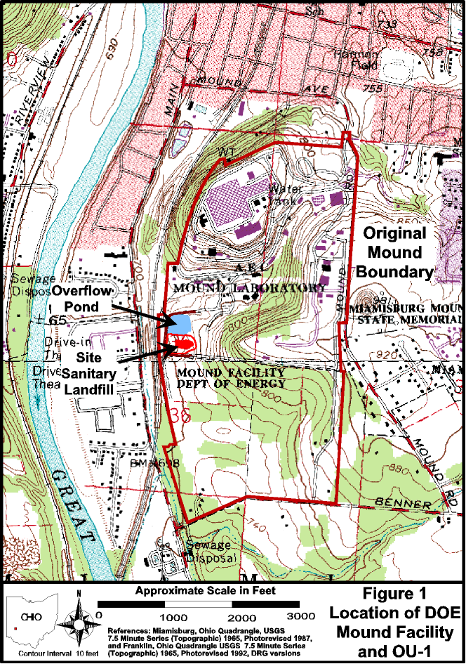
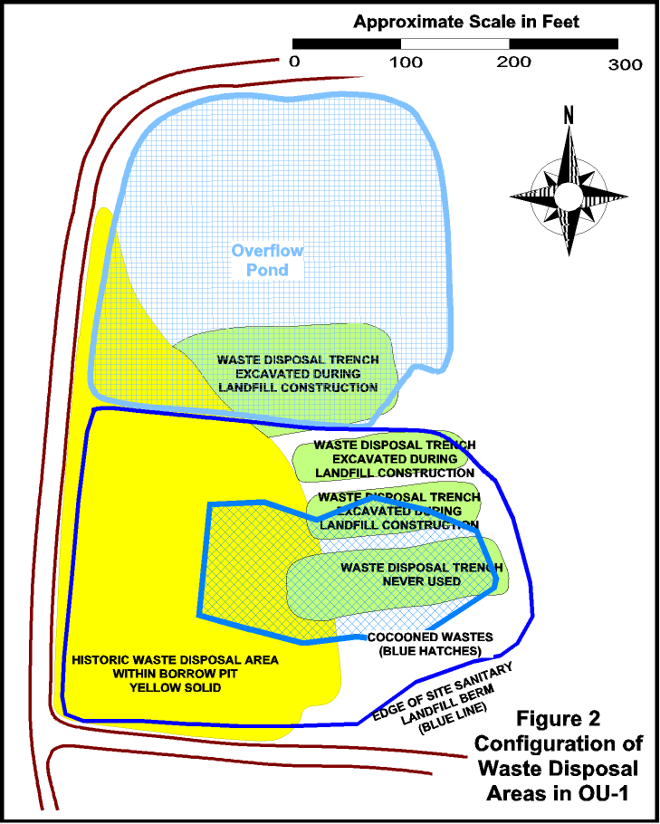
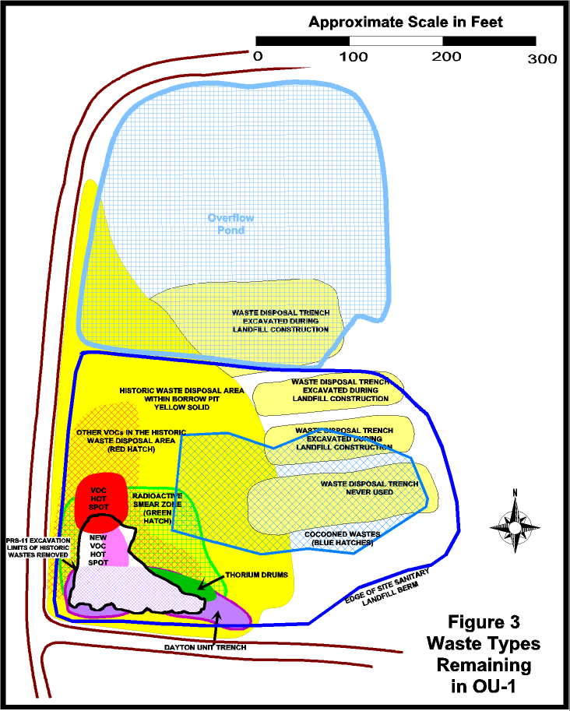

SECTION J

ATTACHMENT E
Structures, Equipment, and Resources
To Be Retained by the OU-1 Team from the MCP Team
for Use on The OU-1 and PRS-441 Projects

Description | Approx.  # of pieces
JD 992 w/shear, arm, and bucket | 1
Komatsu PC400LC Excavator and bucket | 1
Cat 966 Loader, bucket, forks | 1
JD 790 Excavator, bucket, graple, hoe ram | 1
Cat 973 track loader and bucket | 1
JD 744-H Loader, bucket, forks, & stinger | 1
JD 644G Loader, stinger, bucket, forks, ball plate, snow blade | 1
Volvo A25C Hauler 1,2,3,&4 | 4
Loader Box Handler Attachment | 1
Tandemolic Plate | 1
White Type A Boxes | 8
Skids of Old Rail Car Liners - Used as Tarps | Mult.
East & West Sheads (Sugar Shacks) | 2
Pit Catch Basin | 1
Light Plants | 2
Diesel Fuel Day Tank (portable) | 4 | (2 at rail & 2 at project)
Hotsi Pressure Washer | 1
International HD Service Truck | 1
Rail Shuttle wagon/engine | 1
Pallet Jack | 1
Pit Step Off Pad Structures | 3
Rail Car Work Platforms | 2
Flamable Cabinets | 4 | (2 at Rail and 2 at Project)
Monitoring Stations (dog house/bird cage/Tee-Pee) | Mult.
5 gallon Gas Cans (for Rail and Project Site) | Mult. | (Rail and Project)
Honda EU 3000 is Generators | 1
Fire Hoses, Fire Hose "Y", Fire Hose Nozels | Mult.
Garden Sprayer | 2
2" Davey Pump | 1
Rail Car Chock | Mult.
Garden Hoses | Mult.
Timbers (Outside Pit Area) | Mult.
TORBO Abrasive Blaster & Hoses | 2
LeROI Compressors | 1
3" Vangard Pump | 1
3" Pump Hoses (Intake/Suction, Discharge, Strainer) | Mult.
Electrical Extension Cords and GFCI for Outdoor | Mult.
Electrical Extension Cords Inside Pit Area | Mult.
Work Table | 1
5 gallon Igloo | 1
Cabinet | 1
Fence Posts | Mult.
Rail Car Liners | Mult. | (Approx. 50)
Polly Holding Tank | 3 | (1 at Spur, 2 at OU-1)
Cones | Mult.
Drum Scale | 1
Box Scale | 1
RR Car Scale | 1
Burnt Red Klein Tools Box | 1
Rail Car Ladders | 2
Roll-a-bout ladders | Mult.
Concrete blocks | 3 skids
Rail Car Top Tarps | 17
Absorbant WasteLock | 2 skids
Rebar Caps | Mult.
Black Beauty Slag | 1/2 skid
Equipment Shed (by Tr 12) | 1
Cryotech CF7 Liquid Deicer | 2 drums
Misc. Pit Hand Tools and Containers | Mult.
Power/Communications  (infrastructure as required by remaining structures) | Mult.
Stanchions for Power/Communications | Mult.
Trailer 1 (to be used at OU-1 Site) | 1
Trailer 4 | 1
Trailer 12 | 1
FIDLER instruments (radiological screening) | Mult.
Field alpha detectors (radiological screening) | Mult.
Air Samplers | Mult.
Trailer 11 | 1
Packard liquid scintillation counter | 2
Tennelec 5100 alpha beta counter | 1
Tennelec 4100 alpha beta counter | 1
G3000 sample changer | 1
Canberra semiplanar germanium detector w/electronics (and G3000) | 1
Lab based FIDLER detector systems | 3
20' SeaLands | 8
1 SeaLand at Rail containing HD Fluids
1 SeaLand at Rail containing HD Spare Parts, Work Bench, Manuals, Supplies
1 SeaLand at Rail containing Rail Supplies
2 SeaLands at Rail containing Equipment
1 SeaLand at Rail containing 8 skids of Hi-Dry Absorbant
1 SeaLand for Project Site containing Supplies (Tools, Cones, Electrical, etc.)
1 SeaLand for Project Site containing Equipment (Pumps, Generators, etc.)
1 SeaLand for Project Site containing HD Maintenance Equipment & Supplies
40' SeaLand at Rail East End (Rigging, HD Support, Sheltered Work Area) | 1
40' SeaLand at Rail Support Area (PPE and RadCon Equipment) | 1
Tractor Trailer (Rad and Safety PPE) | 1
Respirators (4 of each size, PAPERs, etc.) | Mult. | 40’ Sealand RSA
TVA 1000 FID PID | 1 | Tr 11
Confined Space Monitor | 3 | Tr 11
WBGT Temperature Monitor | 1 | Tr 11
Ludlum 2360 with Alpha-Beta Probes | 17 | Tr 12
G5 "Fidler" Sodium Iodide Probe | 6 | Tr 12
Low Volume Air Samplers | 15 | 40’ Sealand RSA
Ludlum 3030 Alpha Beta Sample Counters | 10 | Tr 12
High Volume Air Samplers | 6 | 40’ Sealand RSA
Personnel Lapel Air monitors | 20 | 40’ Sealand RSA
Air Monitoring Enclosures | 4 | 40’ Sealand RSA
1NIST Traceable Radiological Standards | 4 | Tr 11
Ludlum 500 Pulser | 1 | Tr 12
MP-2 Eberline Mini Pulser | 1 | Tr 12
Model # 1650 Tri-output Power Supply | 1 | Tr 12
Mini Buck Calibrator | 1 | Tr 12
F&J Digital Airflow Calibrator (Low Vols) | 1 | Tr 12
F&J Digital Airflow Calibrator (High Vols) | 1 | Tr 12
Radiological Standards | Mult. | Tr 11
J- Signs for Postings a Variety of Types | Set | 40’ Sealand RSA
Stanchion to hold postings signs | 16 | 40’ Sealand RSA
Rad Rope | 2500 ft | 40’ Sealand RSA
Radiological Field Sources | 8 | Tr 11
Tape | Mult. bxs.

SECTION J

ATTACHMENT F

WAGE DETERMINATION

SECTION J

ATTACHMENT G

FUNDING RECAPITULATION

Funding Action | CLIN 001 | CLIN 002 | CLIN 003 | CLIN 004 | CLIN 005 | CLIN 006 | Total
Basic Contract
Mod ##
Mod ##
Mod ##
Mod ##
Mod ##
Mod ##
Mod ##
Mod ##
Mod ##
Mod ##
Mod ##
Mod ##
Mod ##
Mod ##
Mod ##
Mod ##
Mod ##
Mod ##
Mod ##
Total CLIN
75% of CLIN
Total Task Order

