Logging into iSupplier Portal

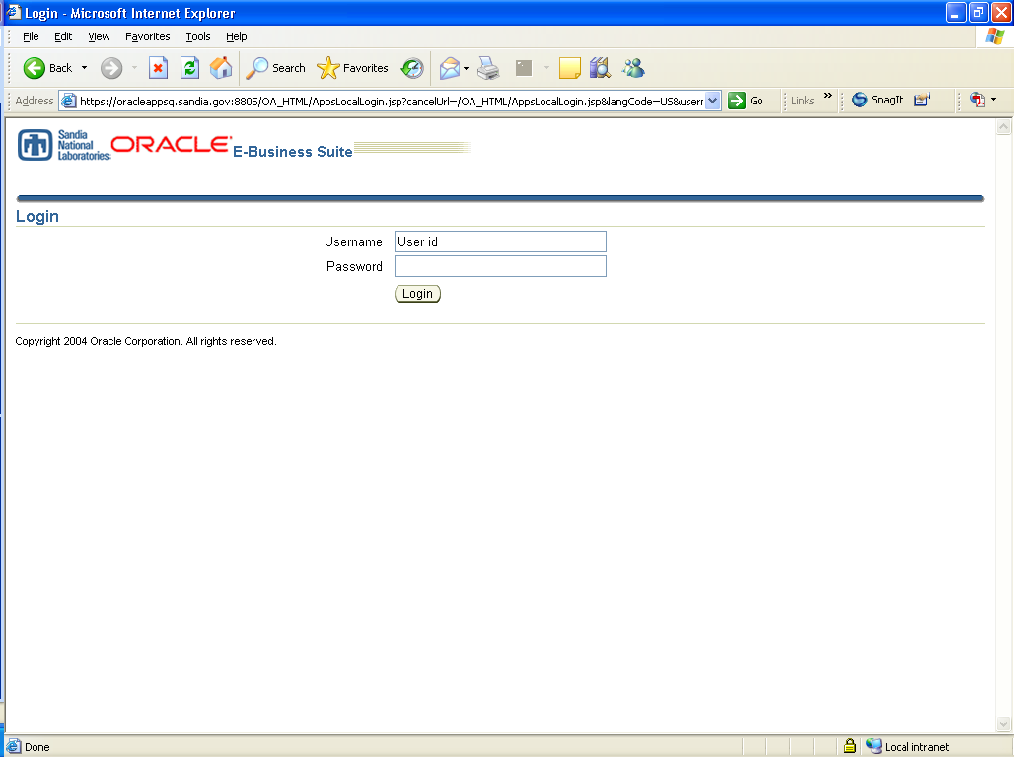

- To log into iSupplier Portal use the following link: https://oracleapps.sandia.gov:8807/OA_HTML/AppsLocalLogin.jsp

- Enter your user id and password emailed to you from the registration process (see Supplier Guide - Supplier Profile Management) and click Login.

- Contact the Procurement Help Desk (505-284-4743) if you have questions or issues about logging in.

Sandia is a multiprogram laboratory operated by Sandia Corporation, a Lockheed Martin Company, for the United States Department of Energy’s National Nuclear Security Administration under Contract DE-AC04-94AL85000.
Accessing Certified Payroll

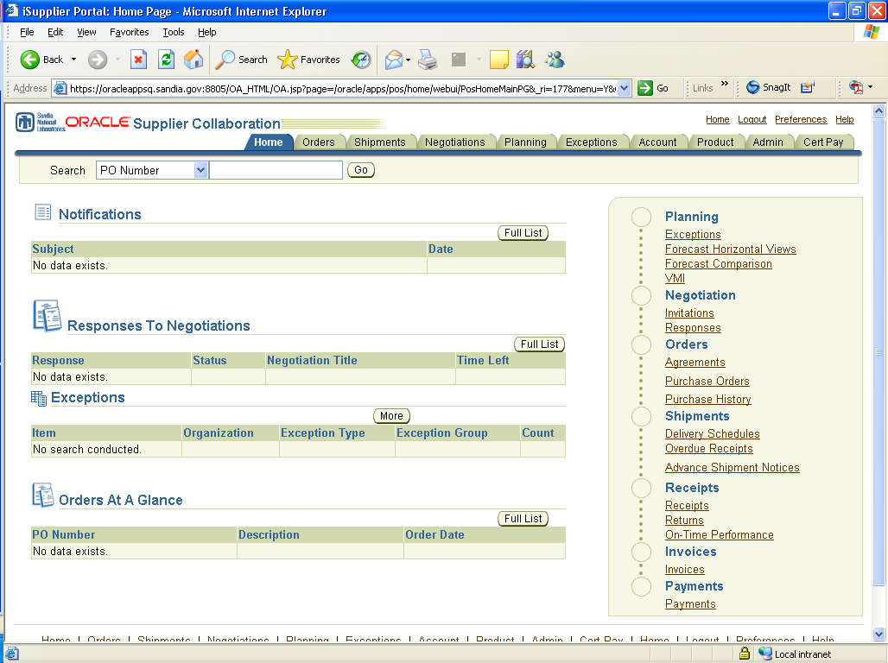

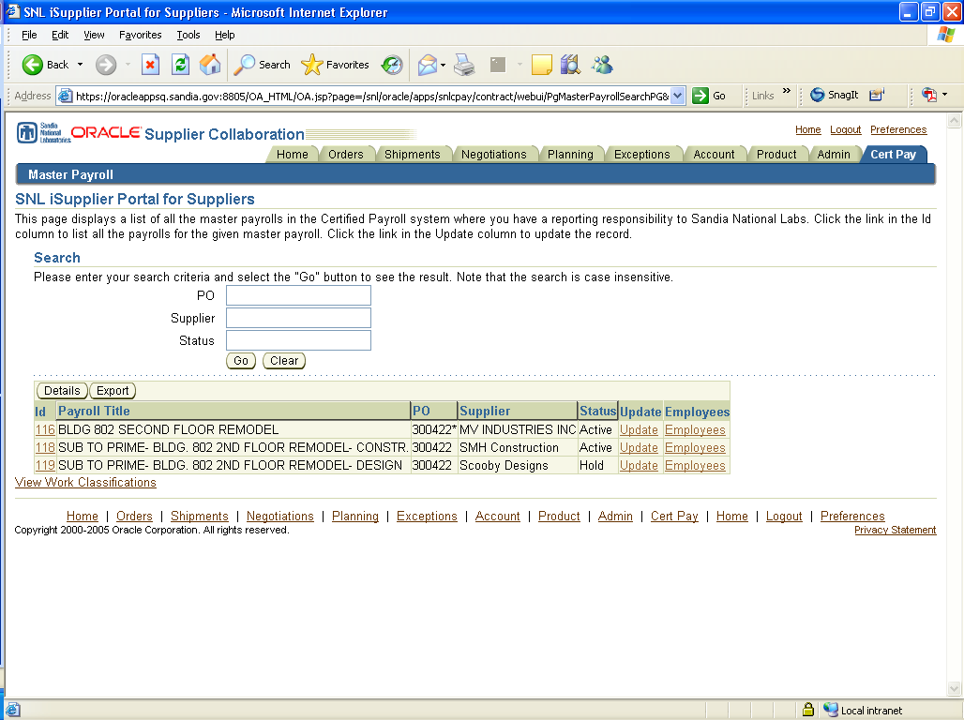

To access certified payroll:
- At the Home Page, click the CertPay tab on the upper right hand corner.
- Once you have accessed the Master Payroll screen it is important to verify that all of your contracts are listed and that all of your subs payrolls are listed as well. This will be important in order to correctly certify and review payroll (refer to Authorized Signatory Party form).
  - NOTE: If there is a contract or subcontractor missing, contact certpay@sandia.gov immediately, so we can setup a master payroll.
- Next, select a certified payroll for a specific contract.
  - Note: that an asterisk (*) next to a PO number represents a Prime payroll
Accessing Weekly Payrolls

To access weekly payrolls for a specific contract:
- Select a payroll for a contractor from the Master Payroll list.

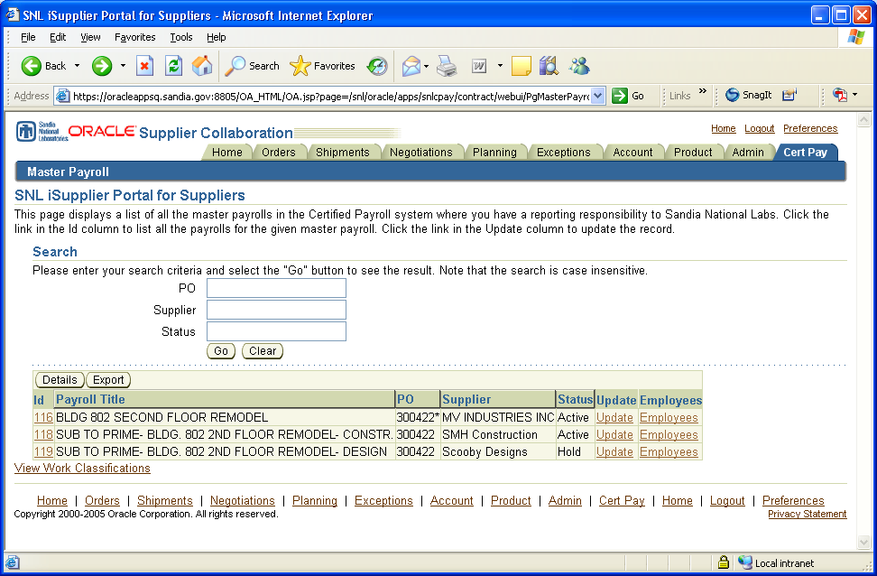

- Select a payroll week to enter timecards by clicking on the Id link.
  - Note: payrolls are listed in descending order with the most recent payroll week at the top.
- You also have the capability to export timecards and payrolls from this screen, by clicking the button (see Exporting).

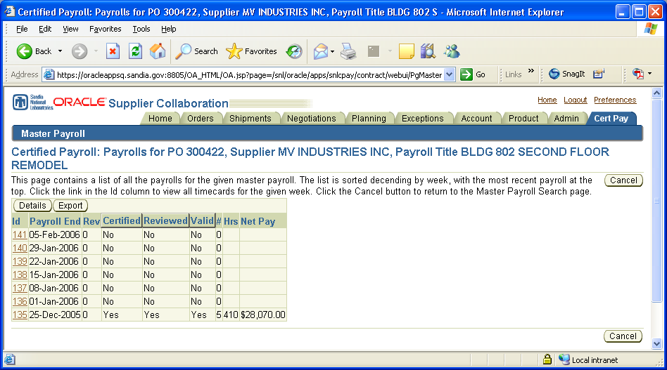
Entering Employees

- Once you have accessed the certified payroll for the first time, you will want to enter or import employee’s information into the system.
- Begin by clicking on the Employees links on the Master Payroll screen.

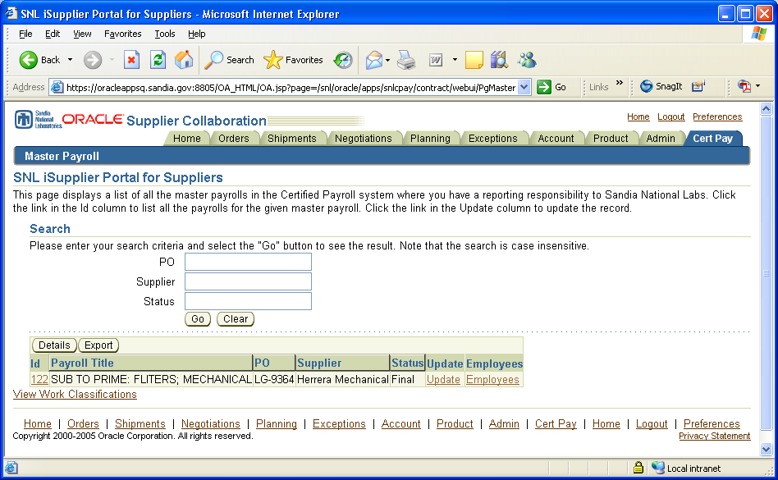

- Next, you will proceed to add employees into the system. You can add employees by clicking on the button or you can (see Importing)

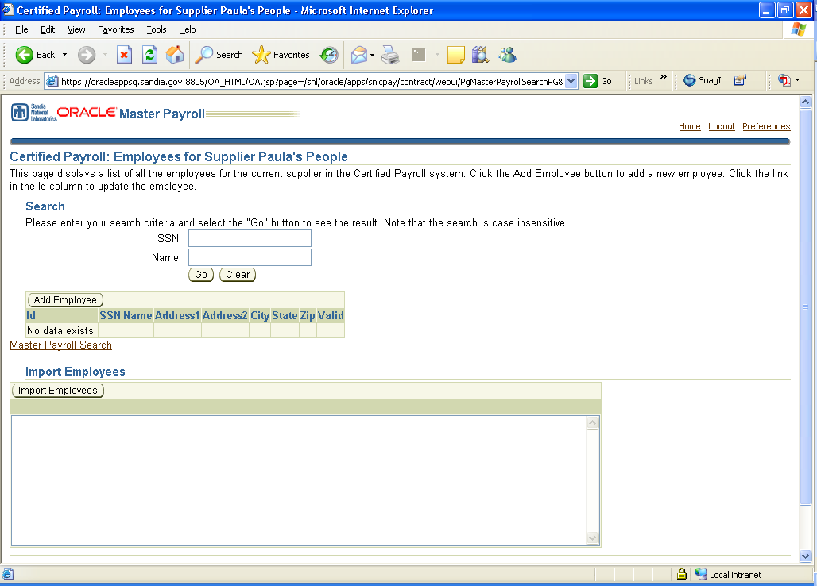

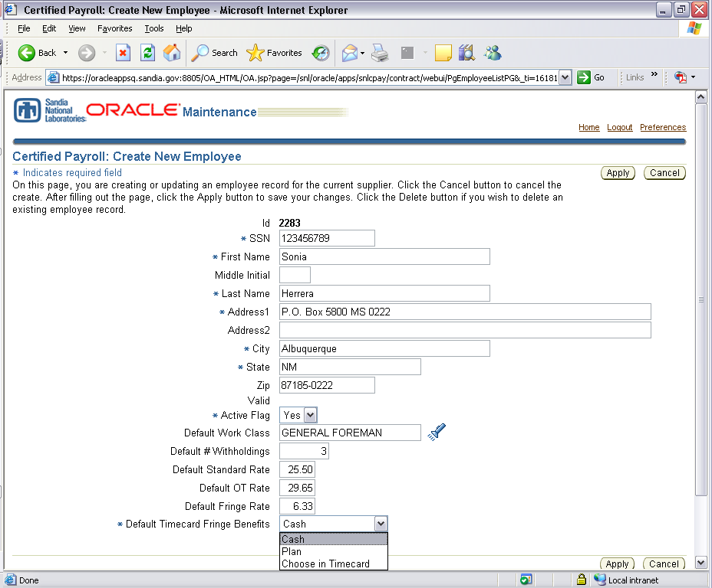
You can select how your Fringe Benefits will be calculated into the timecard (i.e. cash or plan).

- Once you have filled in all required fields click on the button to save employees data.
  - Note: SSN is 9 digits, no dashes!
- You also have the option to select default values that will be pulled into the timecard, such as Default Work Class, Default Standard/OT Rates, Default Fringe Rate, and how that fringe rate is going to be paid, either cash or plan.
  - Note: These fields are not required, but they may be useful to fill in, as it will cut down on data entry at the Timecard level.

Creating a New Timecard

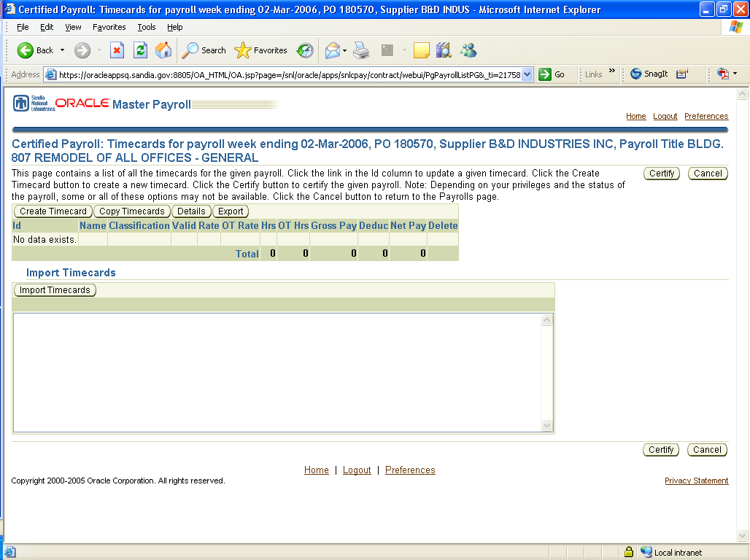

To create a new timecard:
- Click on the button or
- You can also choose to import a timecard (see Importing/Exporting)
- From this screen you also have the option to , view the , or the timecards (see Importing/Exporting)
Entering Timecard Information

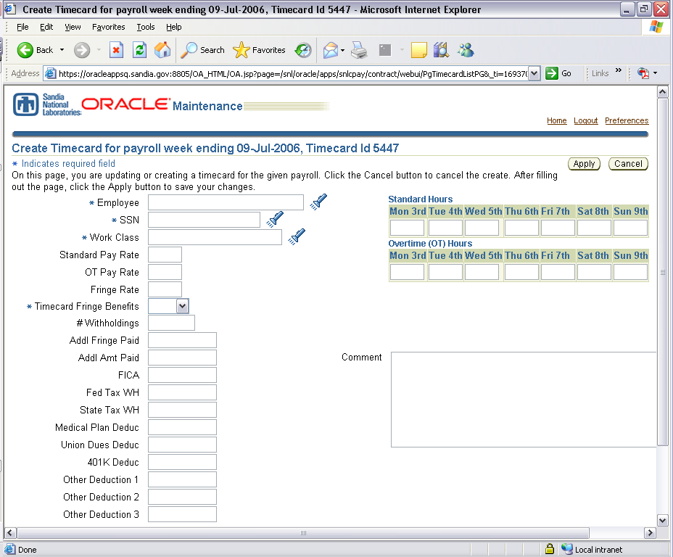

To enter information in timecard:
- Begin by selecting an employee
  - You can either enter the employees name or click on the flashlight to lookup an employee.
    - Note: Employee must already be entered into system before you can use them for timecards. (see Entering Employees)
  - Once you have clicked on the flashlight a new window will pop-up and you can search for an employee by name or social security number. Once you have found the correct employee hit the Quick Select icon.
    - Note: If you have entered default information in the Employees page, your defaults will automatically copy over into the Timecard page. You can always adjust the defaults in the Timecard page if necessary.
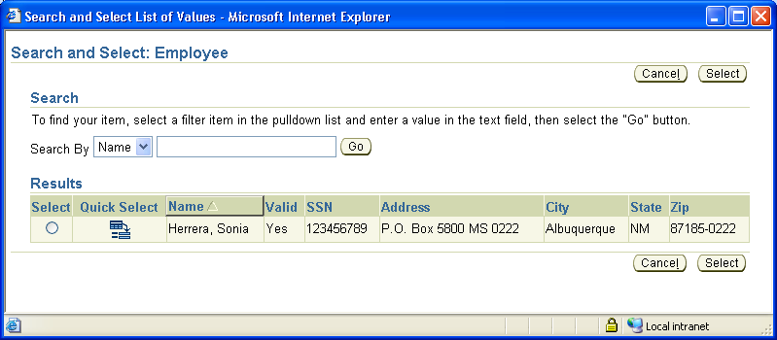

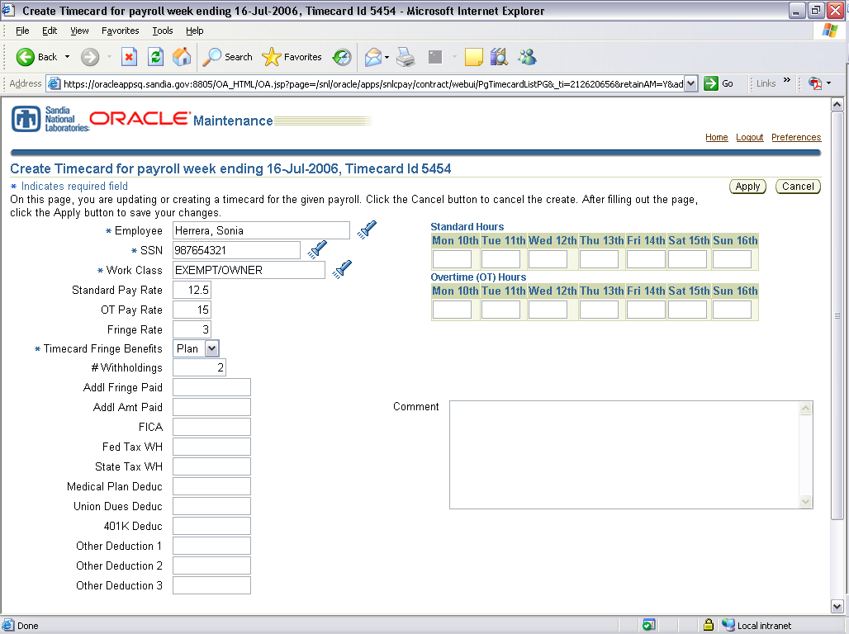
- If you did not set default values at the Employee level, you will want to enter Withholdings and select a job Work Classification.
  - Note: (*) indicates required field
  - To select a job classification, click the flashlight for listings. Click on the button for a complete listing. Then use the Quick Select to make choice.

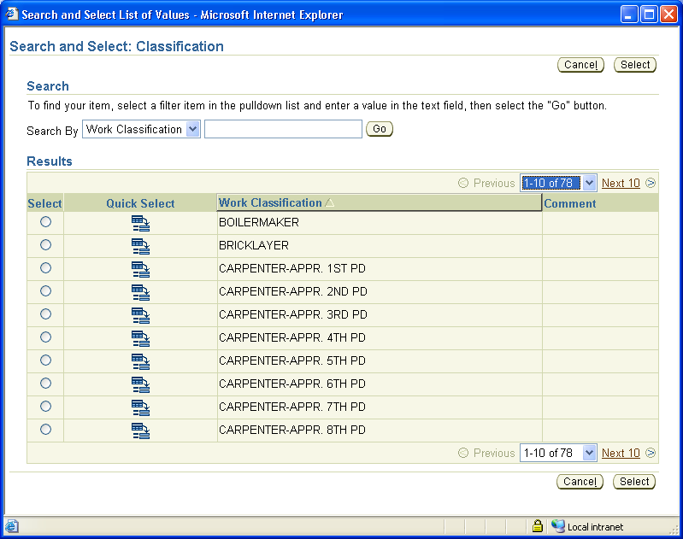

- Once, you have filled in the required fields, you can proceed to enter deductions; such as Additional Fringe Paid, Additional Amount Paid, FICA, Federal/State Tax Withholding, Medical Plan, Union Dues, 401k, or Other Deductions.

- The next step will be entering Standard hours, Overtime hours and the pay rates for each.
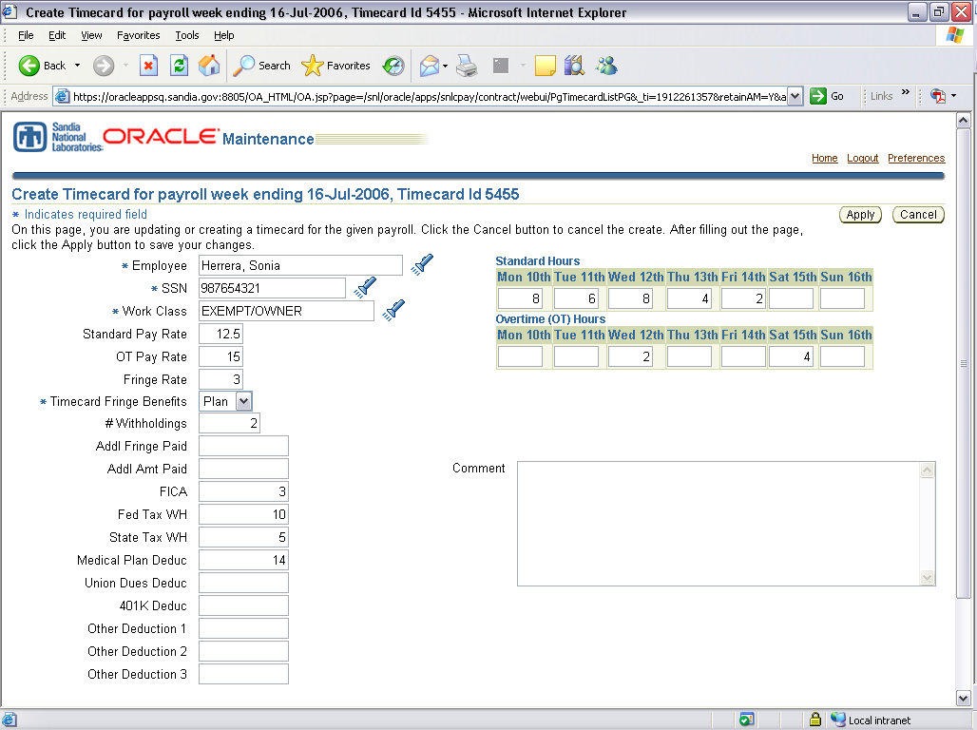

- Lastly, click to save timecard.

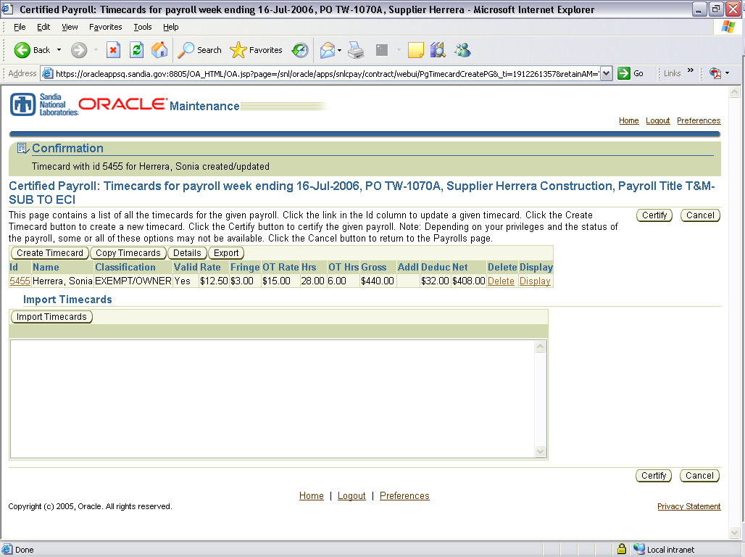

You can create more timecards for additional employees in the same payroll week ending by either selecting Copy Timecards, which will allow you to copy a payroll already entered and/or make edits to the information (see Copy Timecards). Or you can Create Timecards and repeat steps 1-5.
Certifying Payroll

- Once you have completed timecards for a payroll week, you are ready to certify the payroll, which automatically submits it to the Prime for review.
  - Note: In order to certify, you must either be identified as a Certifier or Reviewer. Timekeepers cannot certify payroll (refer to Getting Started- Roles/Responsibilities on Authorized Signatory Party form).
- To certify timecards for a payroll, click on the button on the upper or lower right hand corner.

- Next you will notice the wording from the Department of Labor form. You will also have to certify your Fringe Benefits.

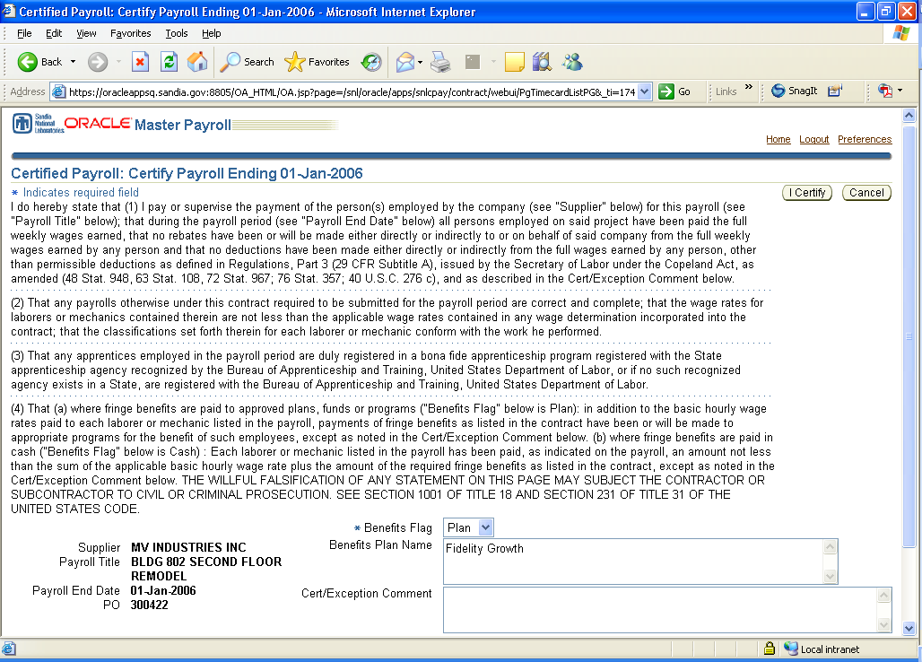

- Once you are ready to certify, click on the button to accept.

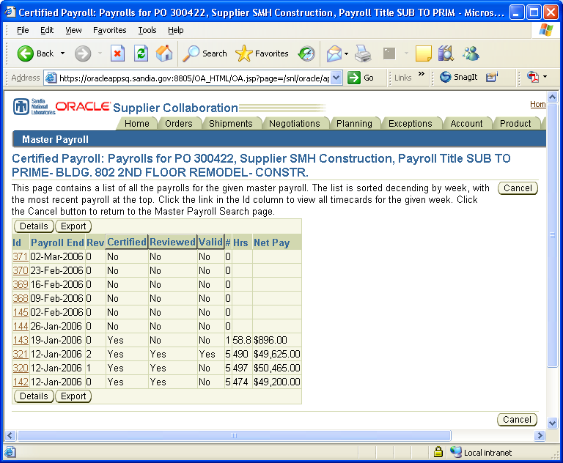

- You can see that your payroll has been certified by the certified flag.
- Certifying Zero Hours: If you do not have any hours to report for a given week, you have the ability to certify zero hrs.
  - Instead of clicking on button you can just proceed to click on the button, even though “No data exists.”
  - Next, you will just click on the button to accept the zero hours and you’re done!

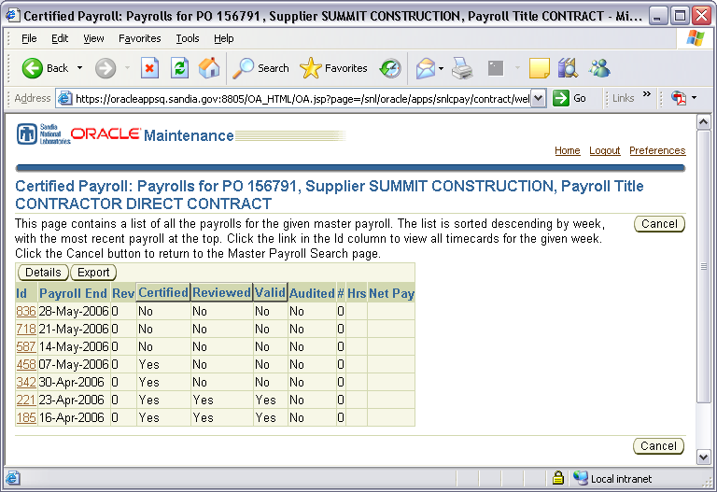

Reviewing Payroll

- Once you have completed timecards for a payroll and a sub has certified their payrolls, a prime can now review payrolls.
  - Note: In order to review, you must be identified as a Reviewer. Reviewer responsibility is given to Prime Contractors only.
- Begin, by selecting the payroll week that needs to be reviewed.

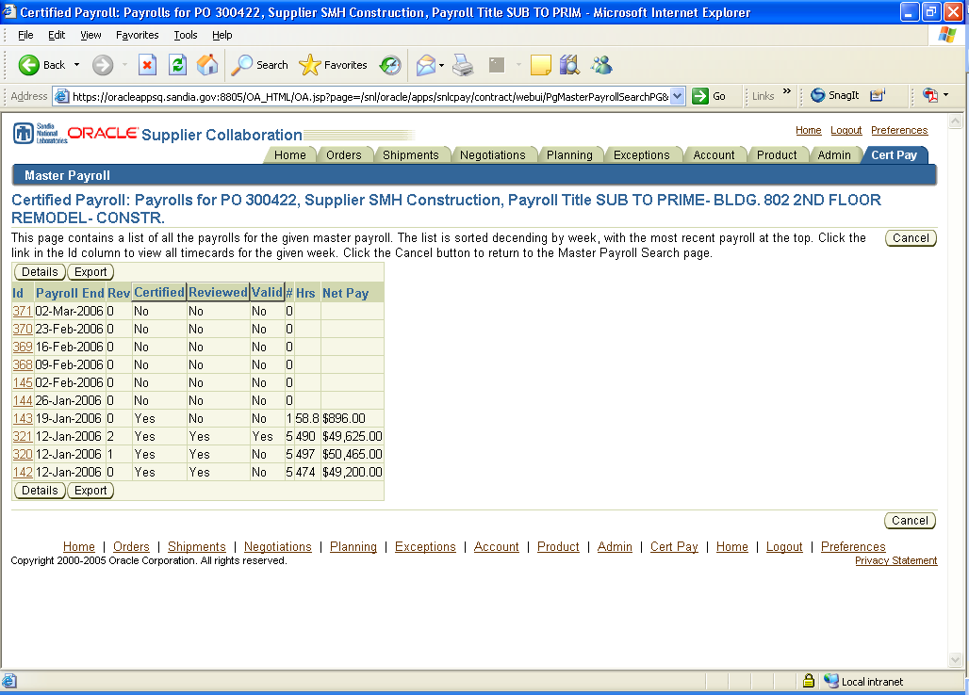

- As a Reviewer it is your responsibility to review and validate Davis-Bacon Wages and ensure your subs are paying accordingly on a weekly basis.
- Once you have confirmed the data entered, you can select the button.
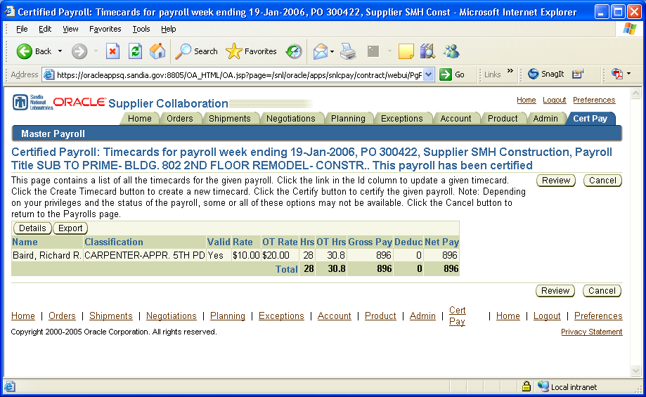

- Once you have reviewed the rates, click on the button. Next you will have the option to indicate whether the payroll rates are valid or not.
  - Note: if a payroll rates are not valid, please provide a comment why it is not valid and any actions needed to be taken by the subcontractor.
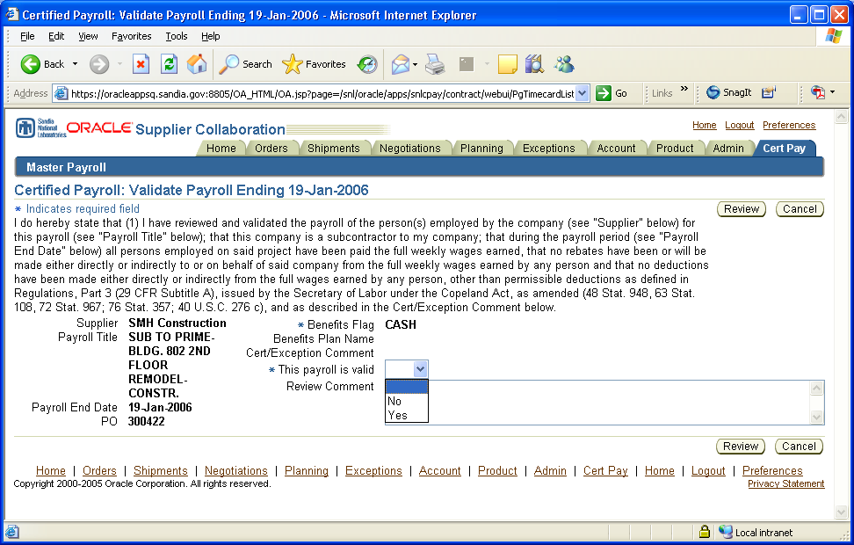

- To complete to the review process, click on the button once more to save changes.

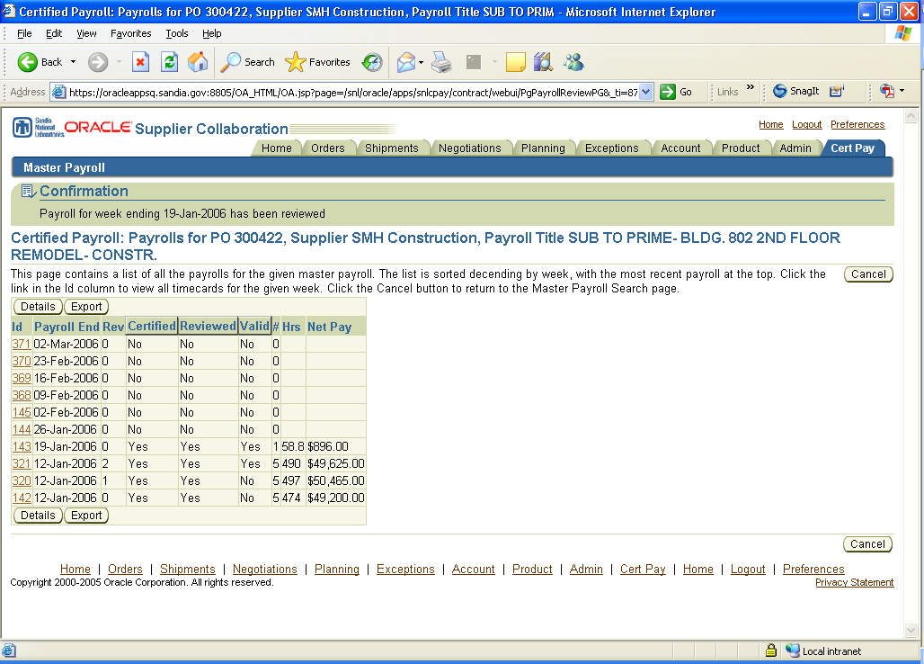

- Subs can now see their payroll has been reviewed or not. If payroll has been reviewed but is not valid, click on the button to view comment provided by Prime. Email notifications will be sent to subs for any invalid payroll(s).

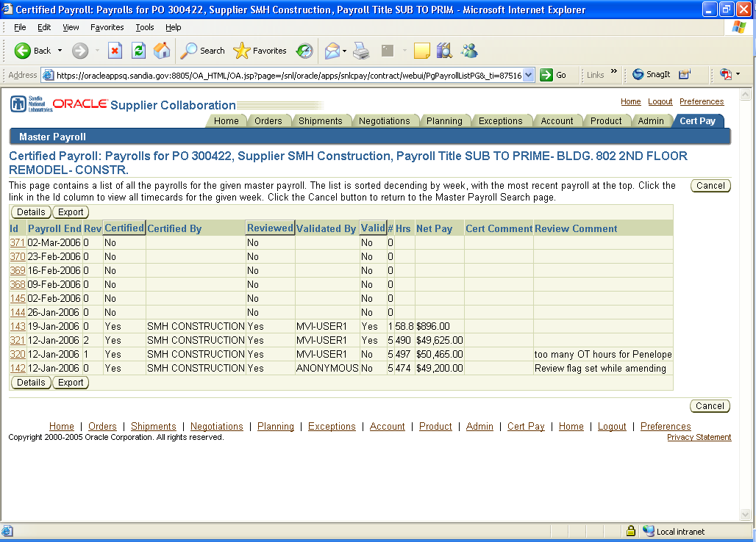

- If a payroll is not valid, you will need to amend the payroll (see Amending Payroll).
Finalizing Master Payroll

- Certified payroll for a specific contract can only be finalized when all timecards/payrolls have been certified and reviewed. This is done by both subs and prime contractors.
- The finalization process begins with the subcontractor’s payroll. A sub must verify that all timecards/payrolls have been certified, reviewed, and validated (see Certifying Timecards and Reviewing Timecards).

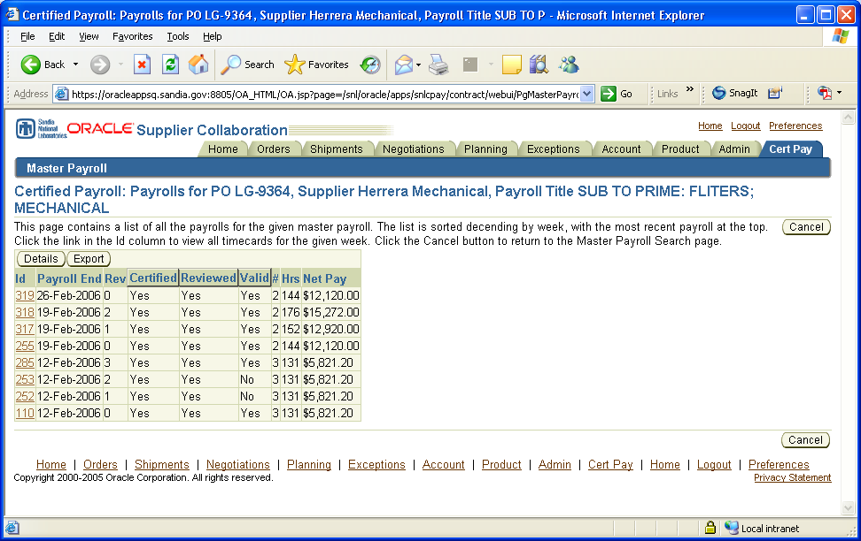
All timecards must be Certified, Reviewed and Valid.

If a timecard is not valid, then you will need amend it (see Amending Timecards).

- If all timecards/payrolls are valid, then click on the button to go back to the Master Payroll screen.
- From the Master Payroll screen click on the Update link to begin finalization process.

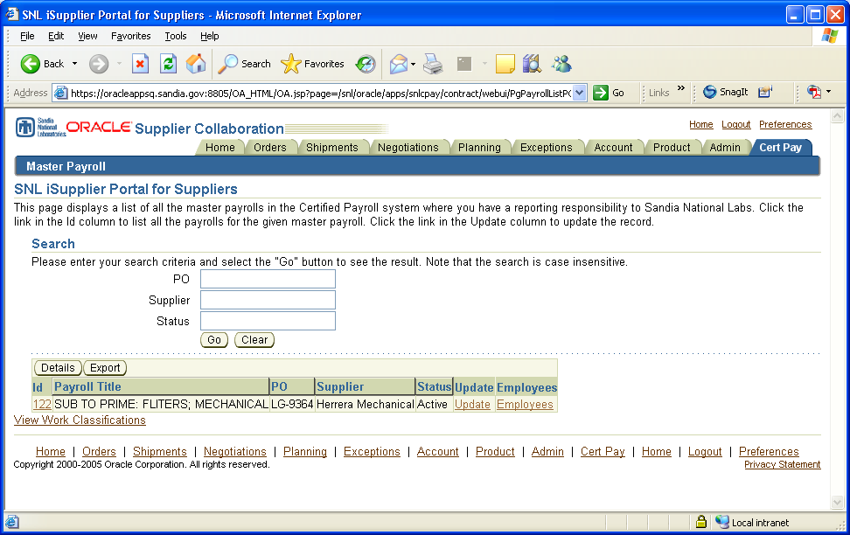

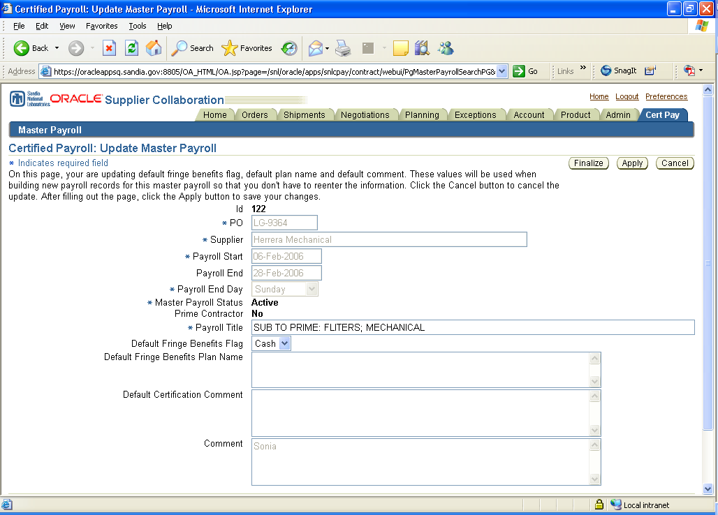

- To finalize a master payroll, click on the button.
  - Note: Once you have finalized you will no longer have edit capabilities for that payroll, just viewer capability.
  - Also, if a payroll is not ready to be finalized a validation error will appear that will indicate why a master payroll cannot be finalized (see example below).

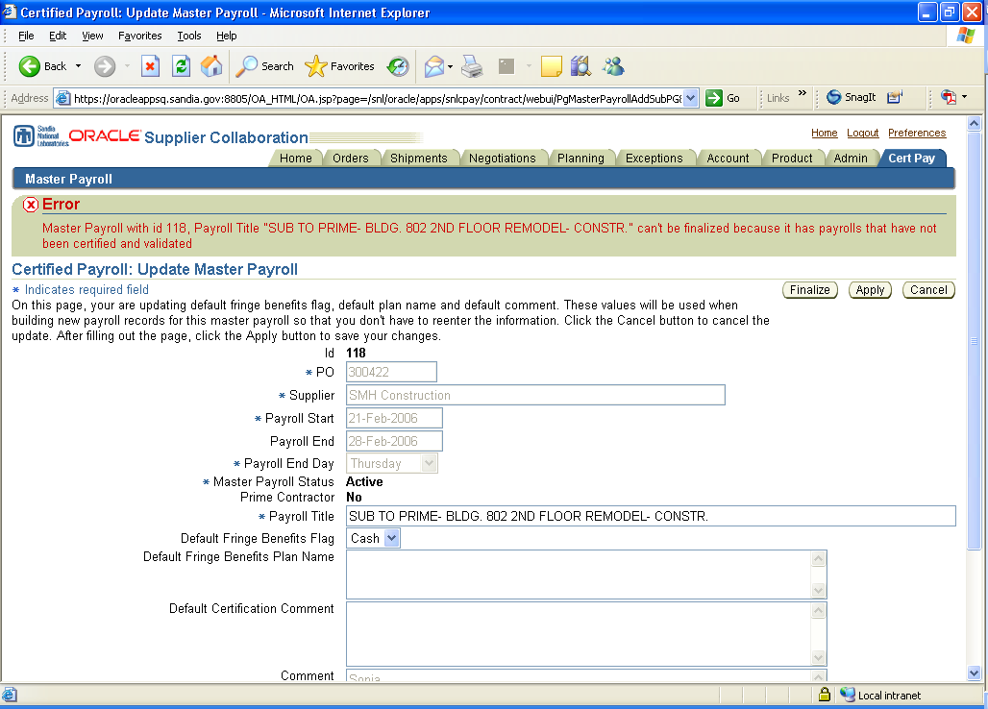

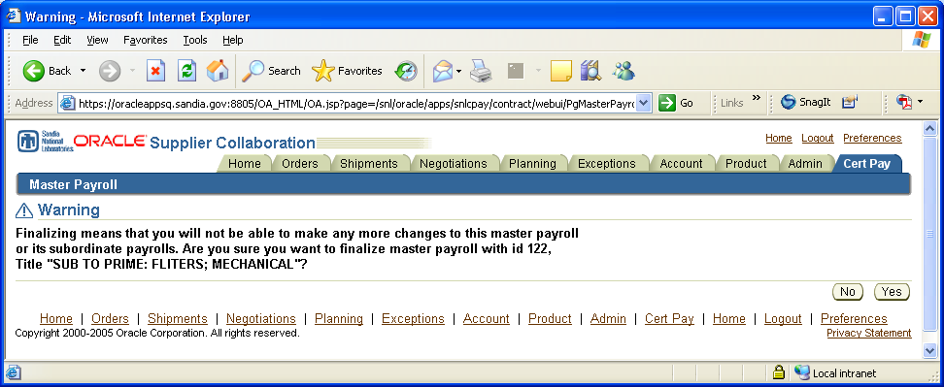

- If there are no errors, you will proceed to accept the finalizing process. To accept click on the button, this will place the master payroll in final status.
  - Note: If a master payroll has been finalized and needs to be reactivated, you will need to contact SNL. The account can only be reactivated by a Certified Payroll Superuser (see Administrative Changes).
- Once a sub(s) status is set to Final a prime can precede to final their master payroll (repeat steps 4-6).
Copying Timecards

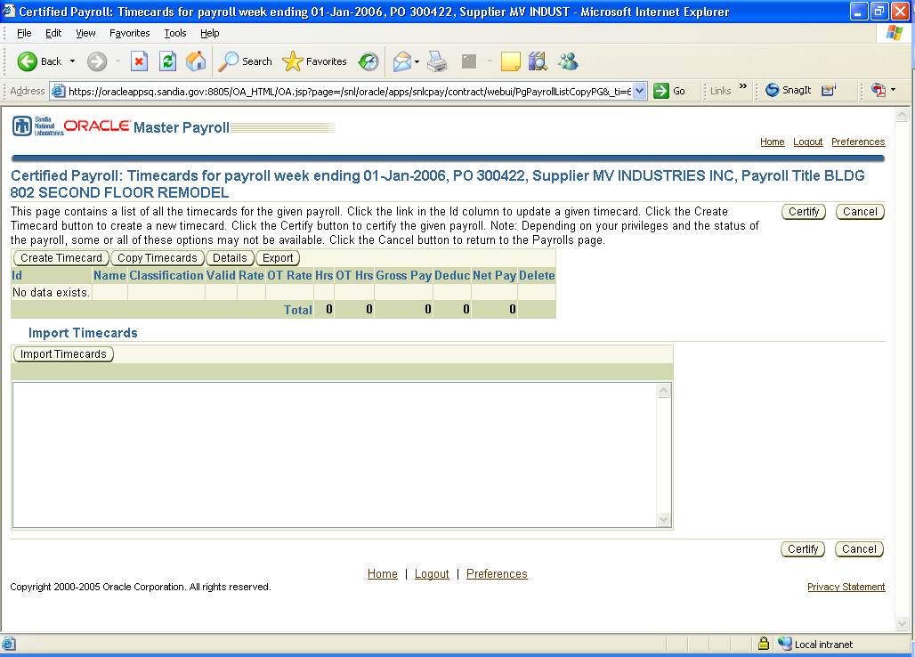

- To copy timecards begin by clicking on the button.
  - Note: there must be an existing payroll in order to do a copy.
- Next, you will select which payroll you would like to copy.

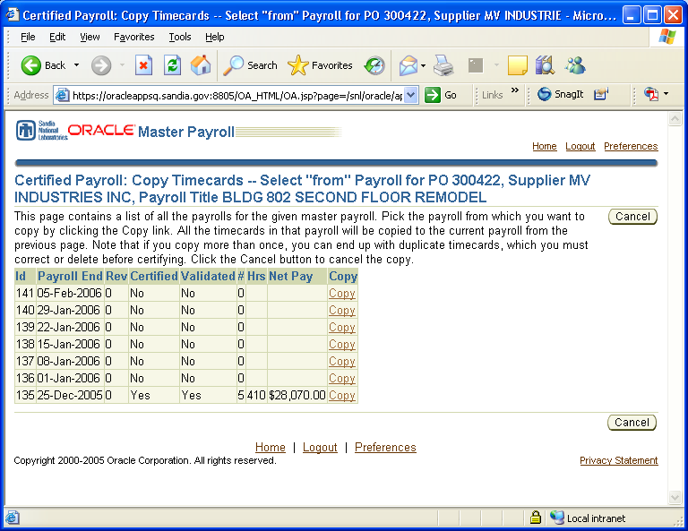

- Once you have clicked on the Copy link, you can make changes to the payroll.
  - Delete timecards; update hours worked, pay rate, job classifications, etc.

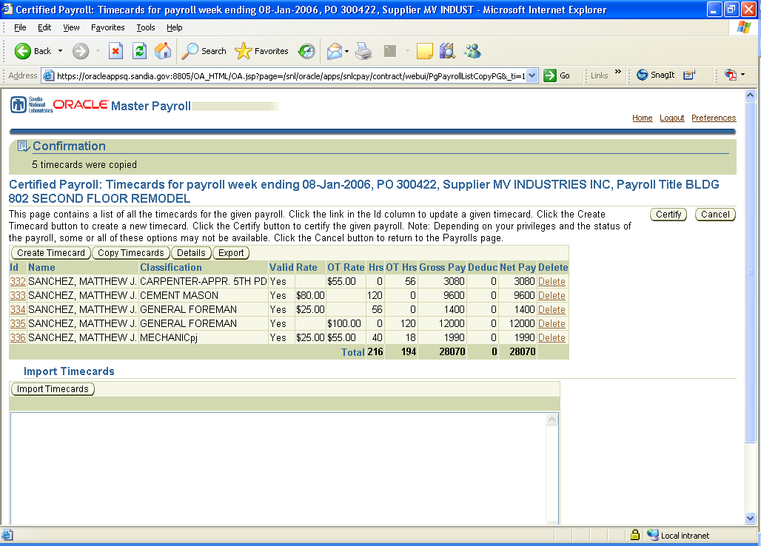

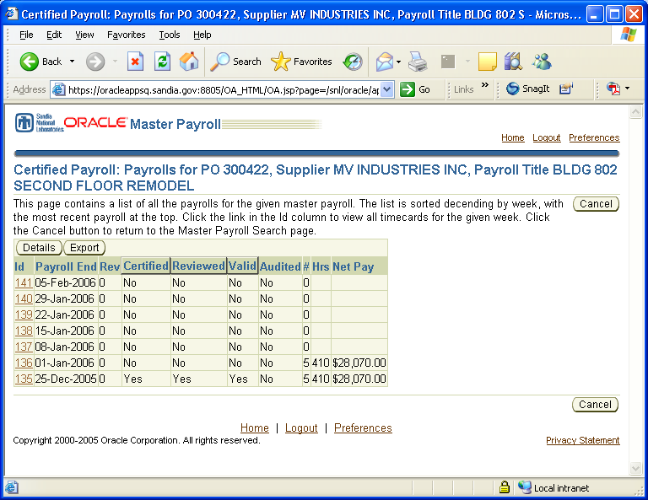
New timecards copied

Importing Timecards/Employees

- As an added feature you can import timecards and employees information. Whenever you see a button or a button you can import data.

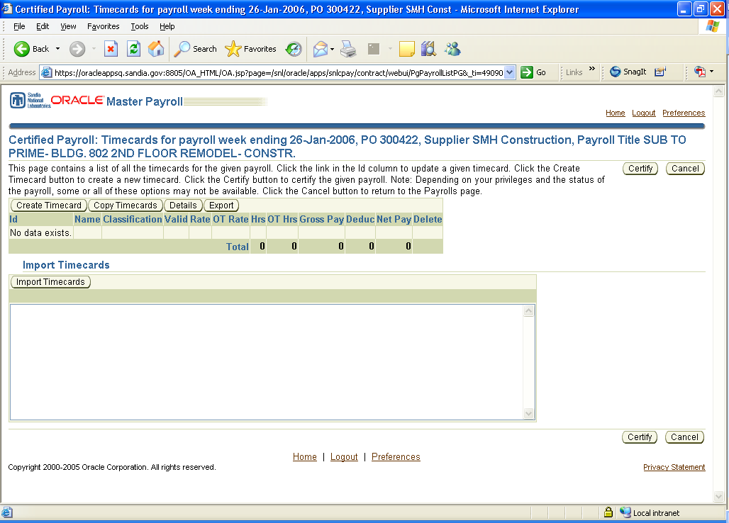

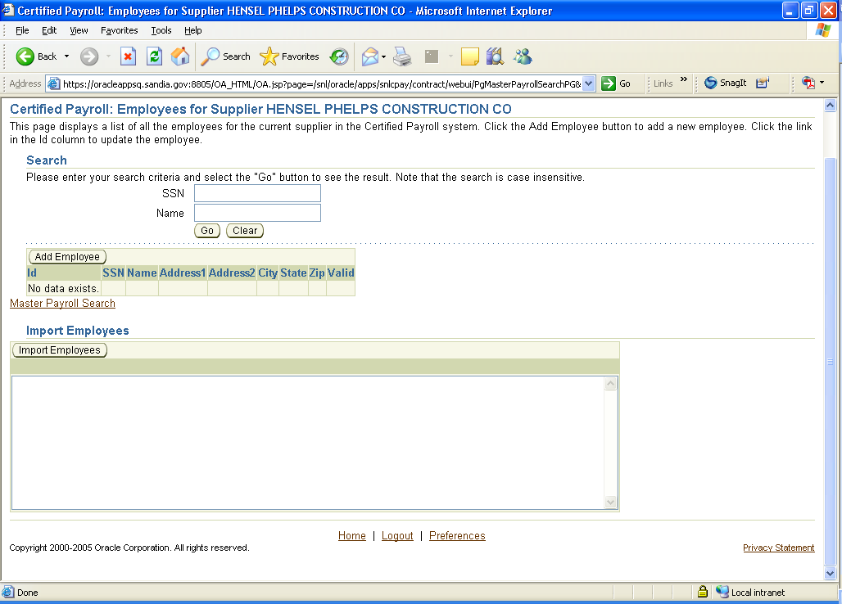

- If you company is interested in using the import capability, please refer to the following website for the Importing Job Aid for further instruction.
  - Note: All information imported must be in XML format.
- Again, contact us at certpay@sandia.gov if you are interested in using Import.
Exporting Timecards

- Another capability available is to export payroll and timecard data. You can export data at any point where a button exists.

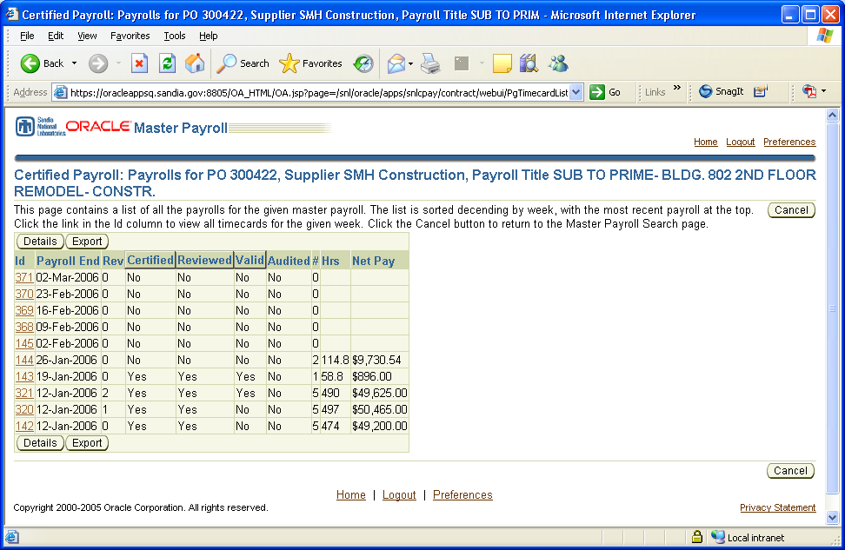
Export Payrolls

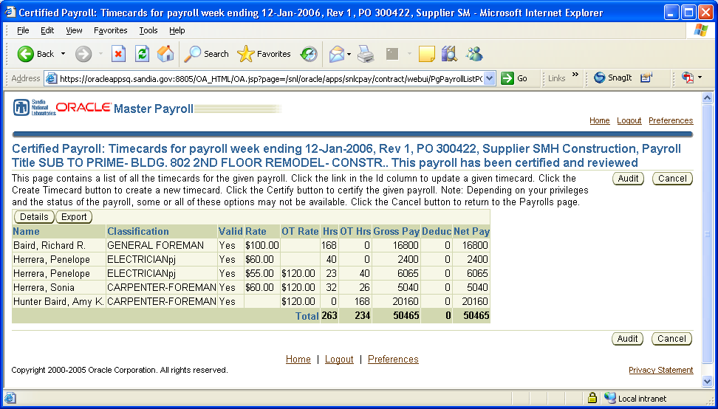
Export Timecards

- Once you have selected to export data, you can either open or save the file to your system.

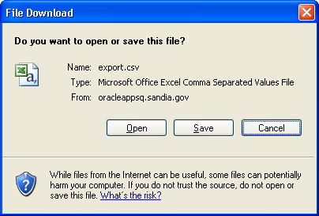

Amending Payroll

- You can amend a payroll at two different points of the system. You can amend any payroll that has been certified or you can also amend a payroll if it has been reviewed but is not valid.
  - Note: the original payroll will remain in the system and will be replaced with a completely new revision. If previous amendments have been made, only the latest revision can be amended.
- After a payroll has been certified, you can click on the Id link to amend the timecard.

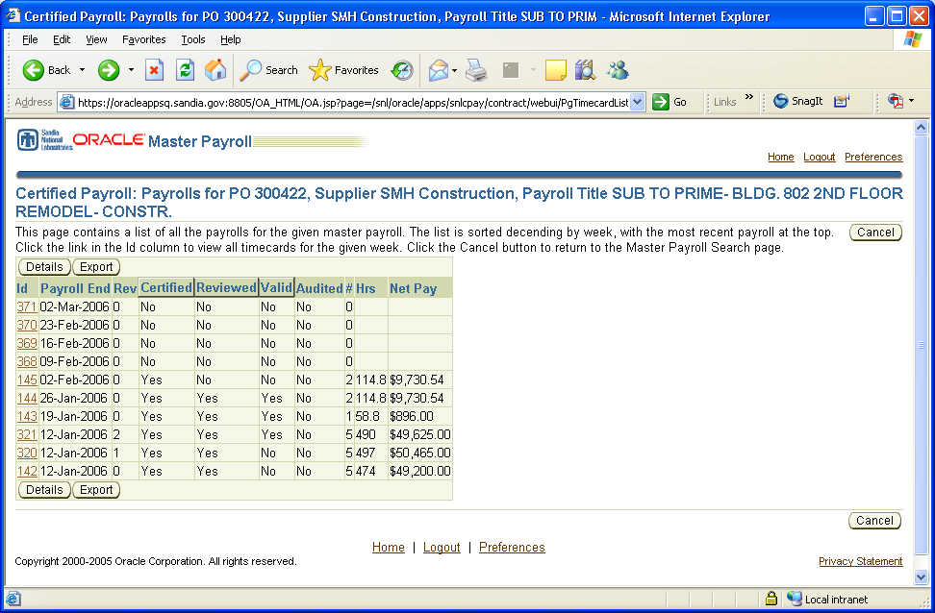

- Next, you can click on the button to create a revision of the payroll.

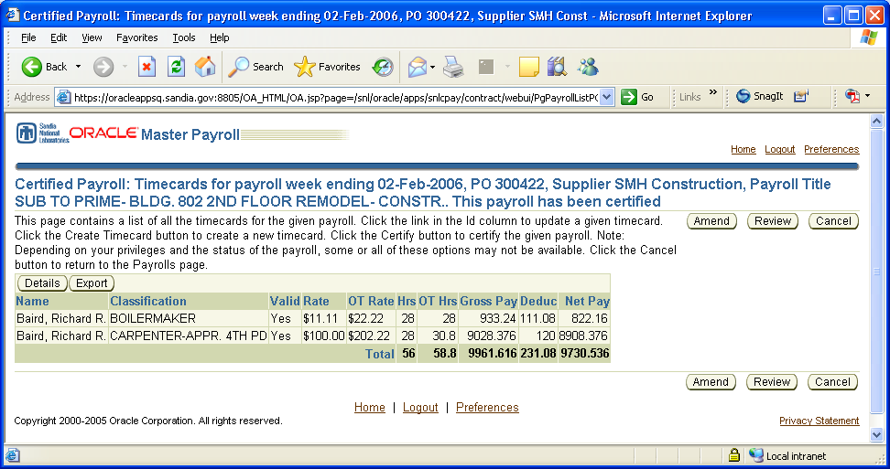

- You must confirm that you are creating an amendment and acknowledge that it will be recorded as a revision. Click to continue with amendment.

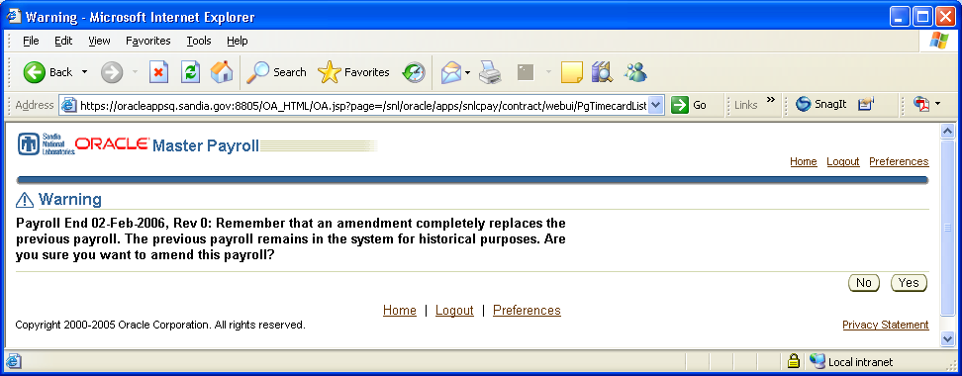

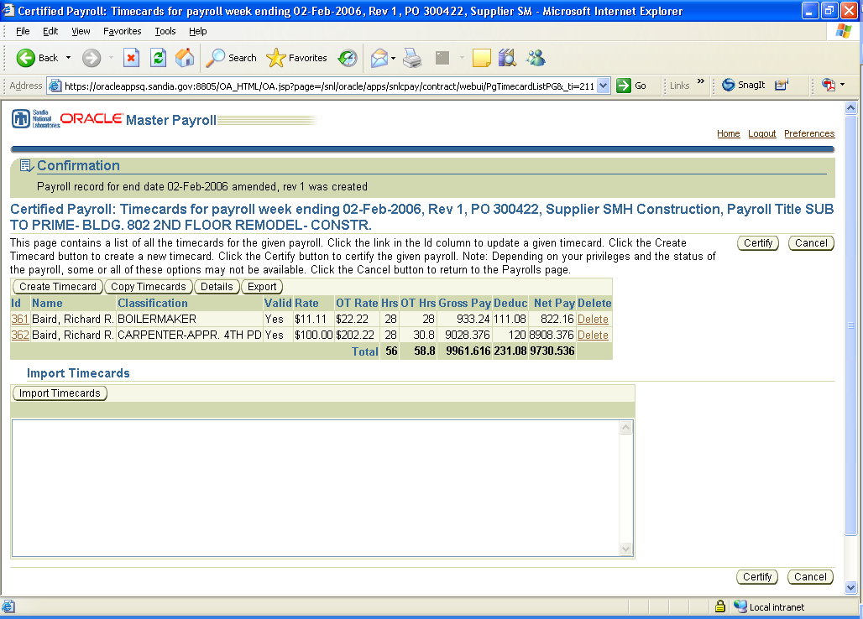

- Now you can edit the timecard and make changes. You will be required to re-certify the new payroll, in order for the changes to be saved (see Certifying Payrolls). Changes will be saved as a revision.
- If a payroll has been reviewed but is not valid, a sub can go back into that payroll and repeat steps 2-5.

Sorting Data

- You can sort data by clicking on the header row of each screen. You can sort by Payroll Title, PO, Supplier, and Status if you are viewing master payrolls. If you are viewing payrolls you can sort by Certified, Reviewed or Valid.
  - Note: if you click on the button, you can also sort by Start Date and End Date at the master payroll level.

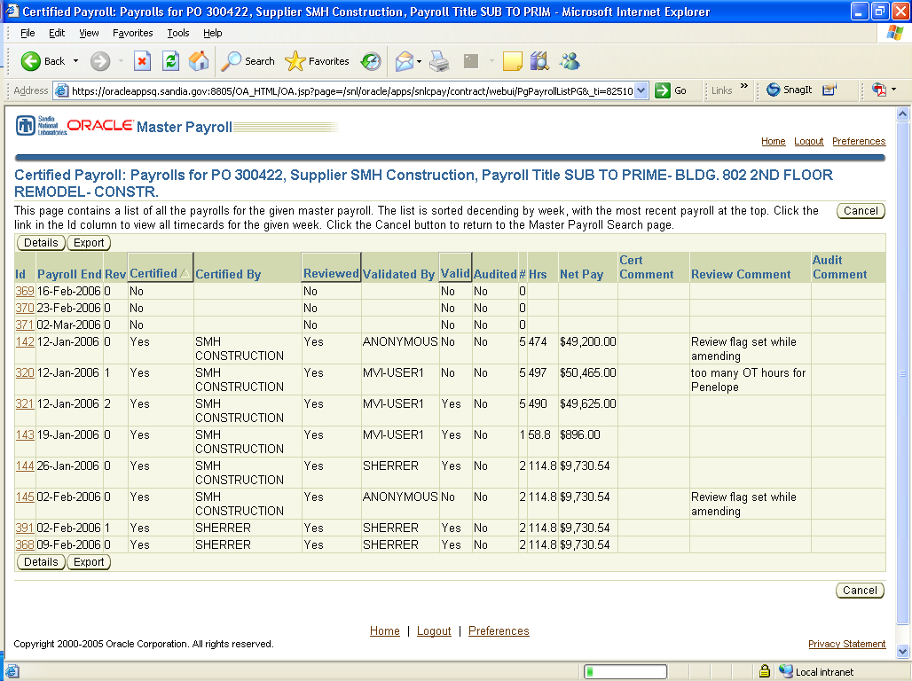

- To sort a column in descending order, click the header once.
- To sort a column in ascending order, click the header twice.

Administrative Changes

- Limited administrative changes can be made to a master payroll either by a subcontractor and/or prime contractor.
- To make administrative changes to your information click on the Update link on the master payroll screen.

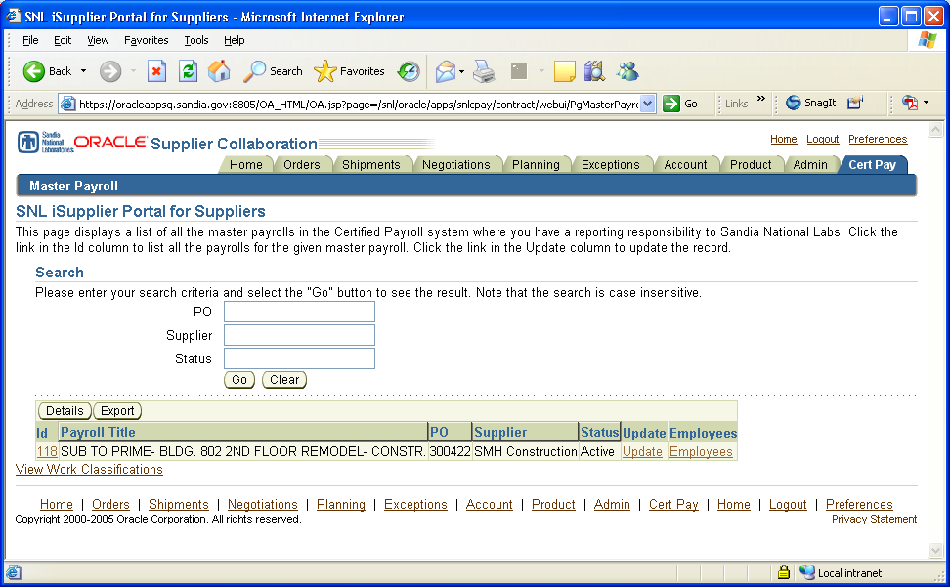

- Next, you have the option to change your Default Fringe Benefit Flag.
  - You have the ability to set it, to Cash or Plan.
    - If Plan is chosen, you will need to provide a Plan Name.
  - Note: The purpose of selecting defaults is to reduce the amount of data entry each week when certifying payrolls.

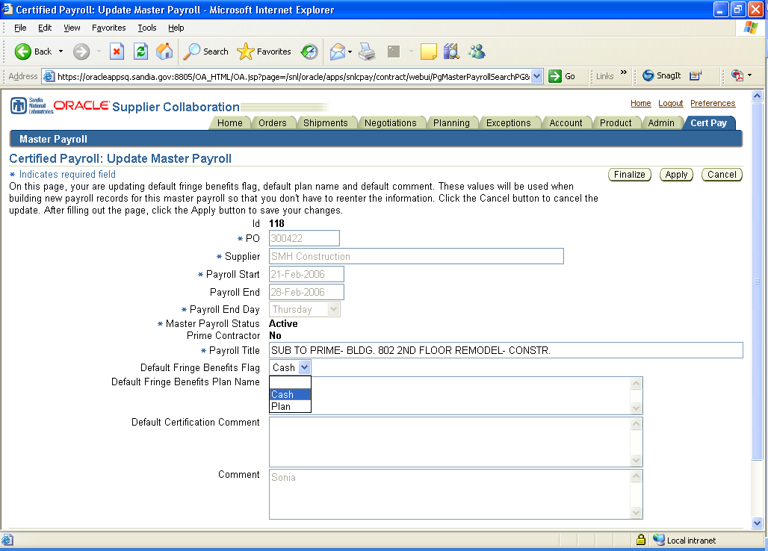

- Once you are done, click to save changes.
- If other changes need to be made to a master payroll, such as changes in:
- Payroll Start date,
- Payroll End date, or
- Payroll End Day.
You will need to contact SNL with these changes, at certpay@sandia.gov.
- Reactivating a master payroll can only be done by SNL and must be requested via email by the contractor with an explanation for reactivation. You can email certpay@sandia.gov.
- Lastly, please notify SNL if there are any changes in personnel. If a user leaves the company or no longer needs access to certified payroll, we can delete the user and add a new user, if desired.

Printing Options

- You can choose to print out a timecard by simply clicking on the Display link next to the specific timecard. This feature was added to allow users to print out timecard information in a “printer-friendly” view.
  - Note: You can also Export information to Excel and print out in Excel.



