THE UNIVERSITY OF CHICAGO ENGINEERING CENTER
5640 S. Ellis Avenue, Chicago, IL 60637
Phone: (773) 834-3773
Fax: (773) 702-8212
wang@oddjob.uchicago.edu

MEMO

To: Al Harper

From: Shu-i Wang

Cc: Tim Rennick, Steve Heimsath

Date: 4/6/01

Re: Vacuum Window Tests

We tested three materials as vacuum window candidates for HAWC. The materials were Ultra High Molecular Weight Polyethylene (UHMWPE), High Density Polyethylene (HDPE) and Polypropylene (PP) in copolymer form. The candidates were chosen by their transmission from 50-250 microns, mechanical properties, price and availability. Materials with high transmission at room temperature in the 50-250 microns wavelength range are almost non-existent. Even the three materials we tested are quite lossy. To maximize the window transmission, we tested the feasibility of using the candidate materials in thinner forms than we have used in the past.

Table 1 lists the published mechanical strength and stiffness of the three materials. As a comparison, chemical vapor deposition (CVD)-grown diamond is also included in the Table. We mechanically tested 0.5mm thick windows made of UHMWPE and PP, and a 0.83mm (thinnest available) thick HDPE window. The windows had a 3-inch diameter clear aperture. Figure 1 shows the window mount and the vacuum test fixture. The windows were vacuum cycled to test their deflections under vacuum and their effectiveness as a vacuum seal. The window sag (deflection) under vacuum was measured with a dial indicator as a function of radius and time. Figure 2 shows a photo of the window measurement setup. The window curvatures tend to approached an asymptotic value after several days of vacuum pumping. After a successful vacuum test, the windows were pressurized by water to test the burst strength.

Table 1. Mechanical Properties of Window Materials.
Material | Tensile Strength, S | Tensile Modulus, E | Poisson's Ratio, NU
UHMWPE, | 38 – 48 MPa | 0.2-1.2 GPa | 0.4
HDPEError: Reference source not found^{,2} | 22 – 31 MPa | 0.5-1.2 GPa | 0.4
PP-CopolymerError: Reference source not found^{,2} | 27 – 38 MPa | 0.9-1.5 GPa | 0.4
(CVD-Diamond),, | 200 MPa | 1000-1140 GPa | 0.07

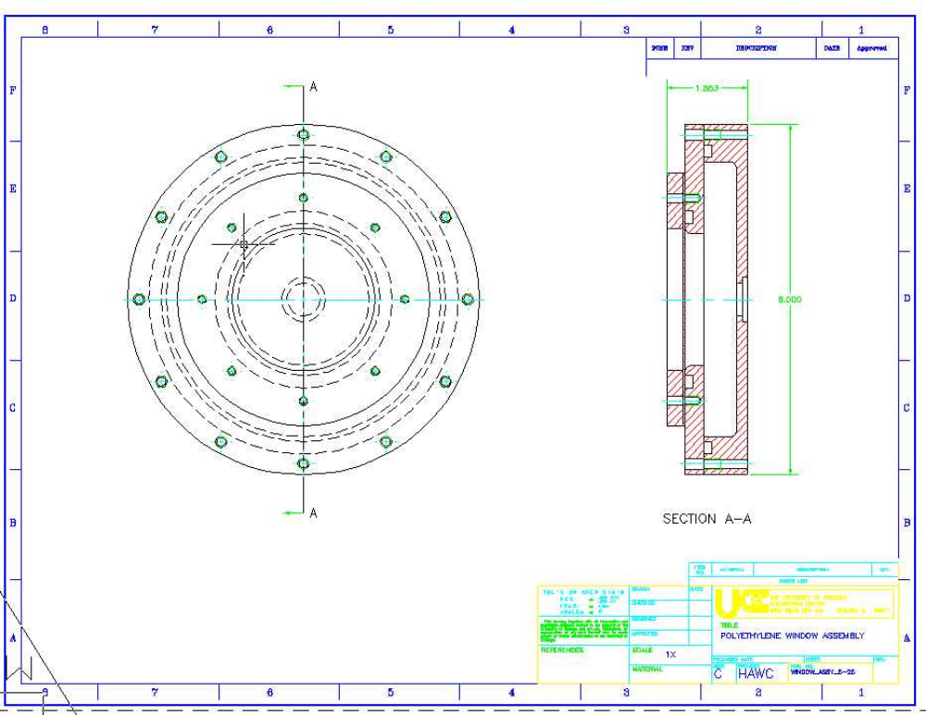
Figure 1. Window Test Mount Assembly.

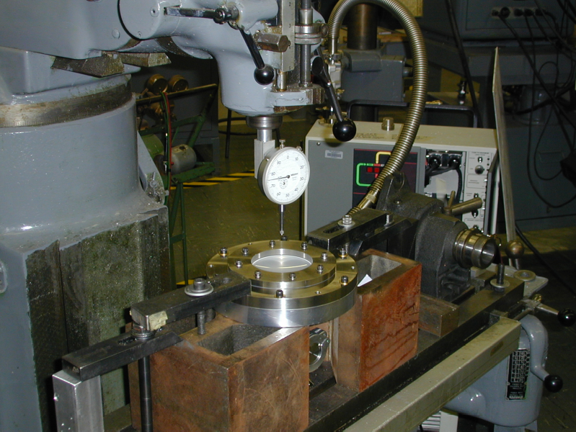
Figure 2. Setup for Measuring Window Sag Under Vacuum.
Ultra-High Molecular Weight (UHMWPE) is similar to HDPE and PP in deflection and strength. It has outstanding toughness, and has a better abrasions resistance than HDPE. A 0.02" (0.5mm) thick sheet of UHMWPE was procured from the McMaster-Carr Supply Company for our test. We were not able to find transmission data for UHMWPE in the literature, and the transmission data we found for HDPE and PP had significant variations,,,,,. We therefore sent samples of our window materials to the GSFC IR Spectroscopy Lab to have the transmissions measured. Figure 3 shows the measured transmission of a piece of the 0.5mm UHMWPE material.

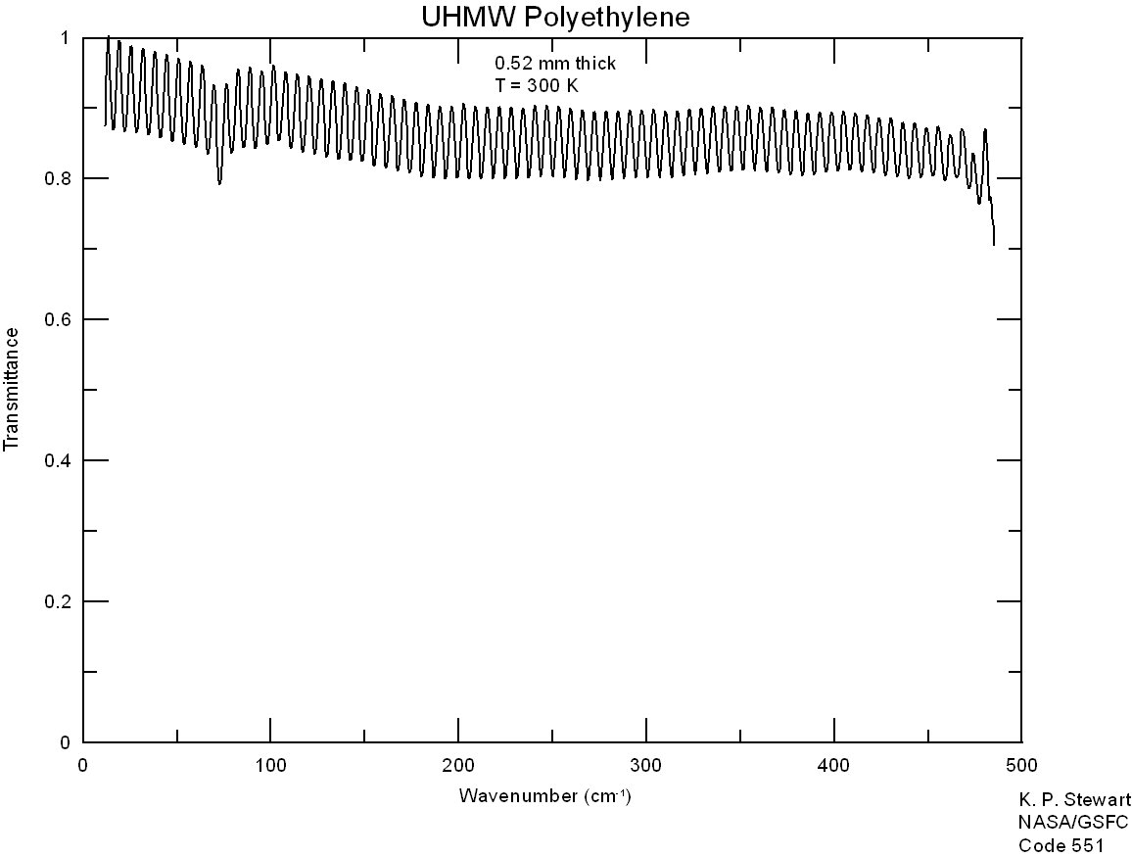
Figure 3. TransmissionError: Reference source not found of 0.5mm Thick UHMWPEError: Reference source not found.

To test the mechanical properties, we vacuum cycled a 3-inch clear aperture diameter UHMWPE window 6 times. The center and half radius window sag were measured for cycles 1, 3, and 6. The results are shown in Figure 4. The data were fitted with a fourth order polynomial (the theoretical form for the deflection). The fitted window surface was then added to the HAWC optics model in the Zemax Optical Design Program to calculate a best-fit spherical radius for the window and to evaluate the system image quality. The spherical radius varied from 100.9mm to 85.6mm from cycles 1-6. Figure 5 shows the change in best-fit spherical radius with vacuum cycles. The maximum center-edge deflection was 0.375" after 6 cycles. This amount of deflection was worrisome since the window had only been steadily pumped for 1.5 hours and we expected the deflection to increase at the same rate before settling toward an asymptotic value after about 20 hours on the pump. (This trend was observed in the other two materials tested.) Otherwise, UHMWPE looks promising mechanically. The window survived 3 atmospheres in our water test. (Our test fixture leaked at 3 atm., causing the pressure test to be halted, while the window showed no sign of failure.)
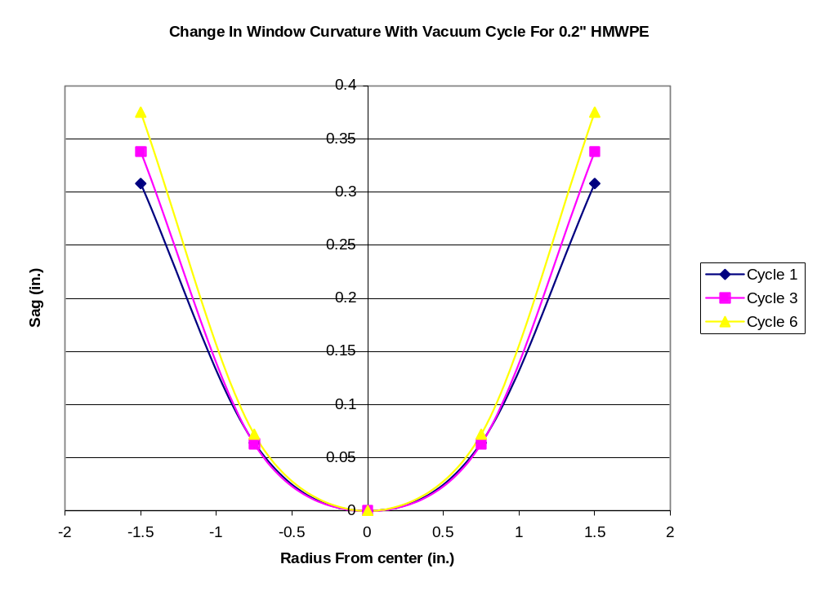
Figure 4. Vacuum Testing of UHMWPEError: Reference source not found Window Sag.

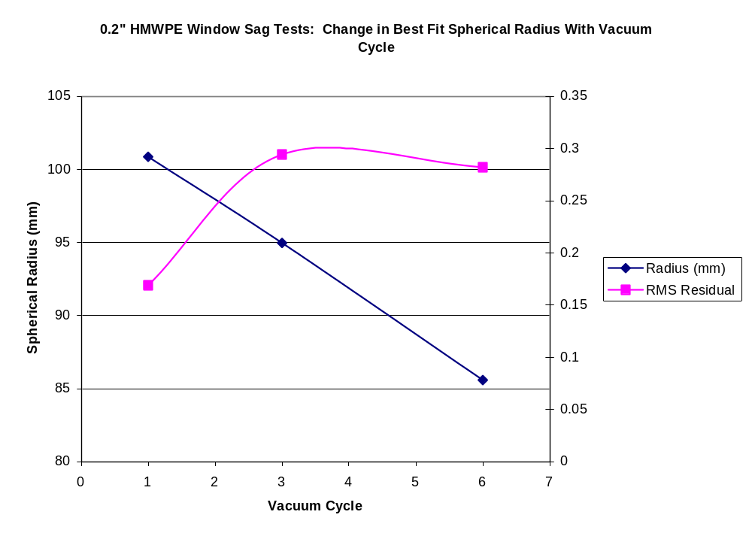
Figure 5. Change in Best-Fit Radius With Vacuum Cycles for 0.02" UHMWPEError: Reference source not found.
High Density Polyethylene (HDPE) is the most proven of all our tested window materials. Thicker HDPE windows had been used in several UC instruments. At the time of mechanical testing, we could not obtain HDPE thinner than 0.03" off-the-shelf. The window we tested was cut from a sheet of 0.033" HDPE from Abbott Plastics & Supply Co. This sheet of HDPE seems to be from Poly Hi Solidur, but I could not get the particular trade name. The measured transmission of this material is shown in Figure 6. We have since procured sheets of both 0.3" and 0.02" thickness HDPE from Cadillac Plastic. The Cadillac Plastic HDPE sheets were manufactured by Spartech Plastics. The transmissions of the Spartech Plastic materials are shown in Figures 7 & 8 for the 0.3" and 0.02" HDPE sheets, respectively. The 0.3" HDPE manufactured by Spartech Plastic has about a 0-1% higher transmission than the Abbott Plastics sample from 50-250 μm, and about a 5% higher transmission at 500cm⁻¹ (20 μm). The higher transmission is most likely due to differences in material purity. It would be interesting to see if the transmissions converge as the materials age. The Spartech Plastic 0.02" HDPE has about a 1-5% higher transmission than the 0.3" HDPE from 50-250 μm. This agrees with our theoretical calculations of HDPE absorption. Compared with the 0.02" UHMWPE sample, the Spartech Plastic 0.02" HDPE has about a 0-1% lower transmission from 50-250 μm, and about a 5% lower transmission at 20 μm. This difference in transmission is about the same as the variation observed between the two 0.3" HDPE sheets from the two manufacturers. We therefore expect very similar transmission between UHMWPE and HDPE.

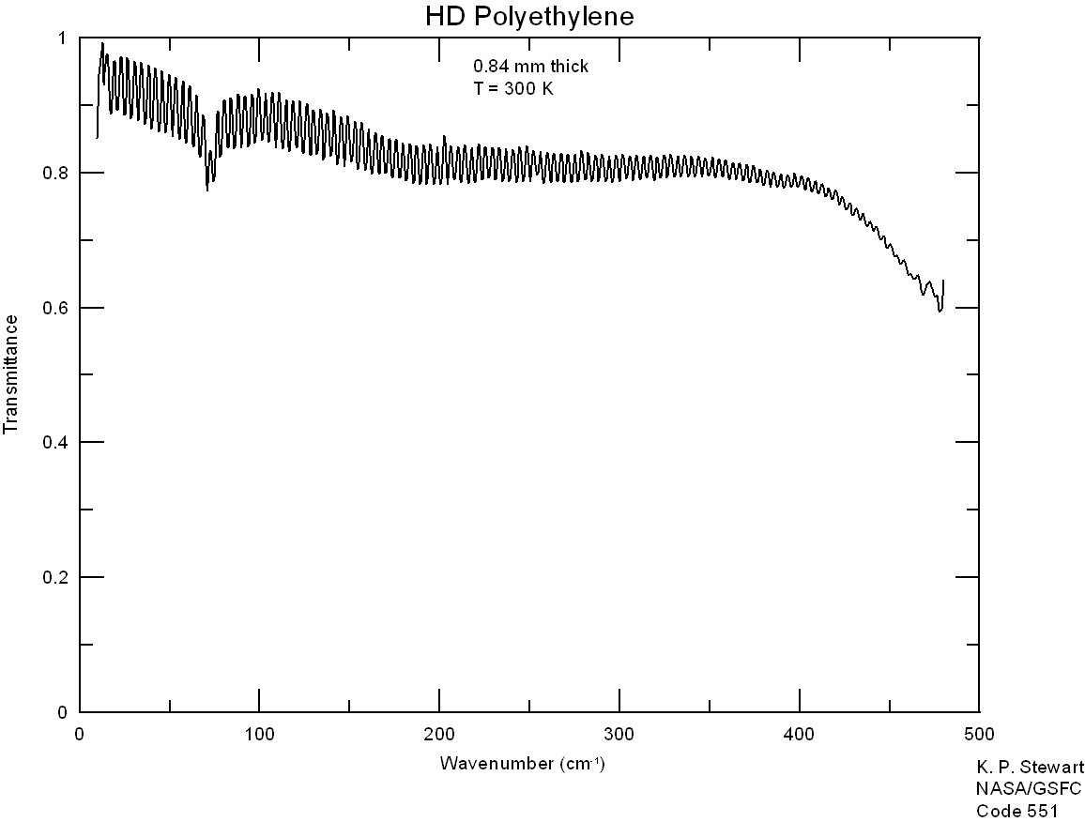
Figure 6. TransmissionError: Reference source not found of 0.033" Thick HDPE from Abbott Plastics & Supply Co.
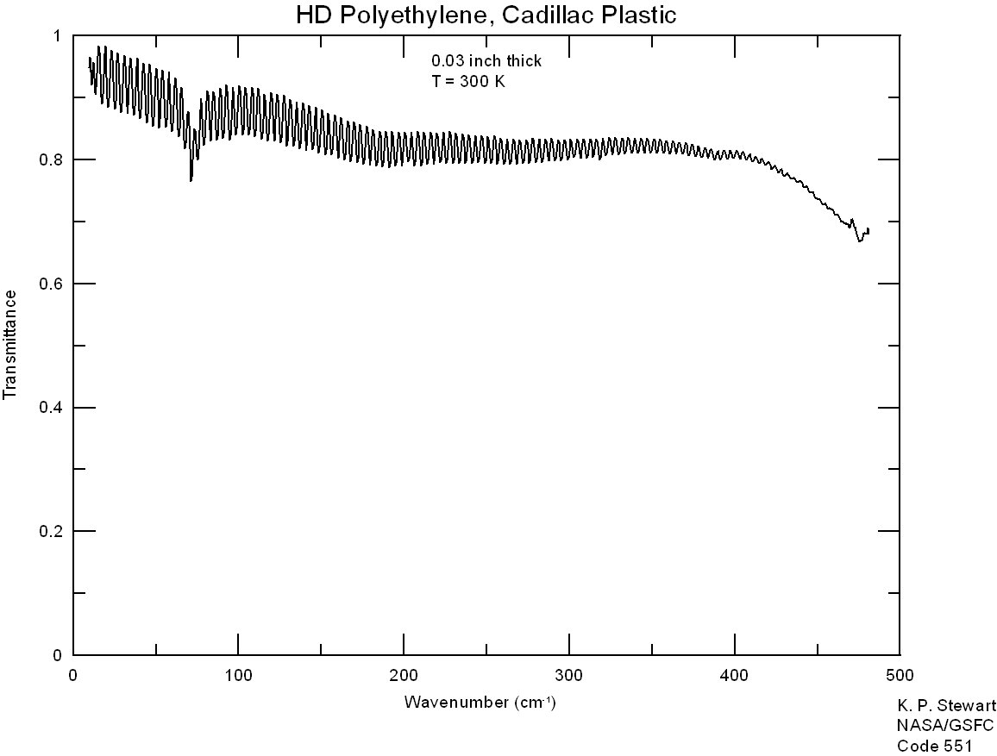
Figure 7. TransmissionError: Reference source not found of 0.033" Thick HDPE manufactured by Spartech Plastic.

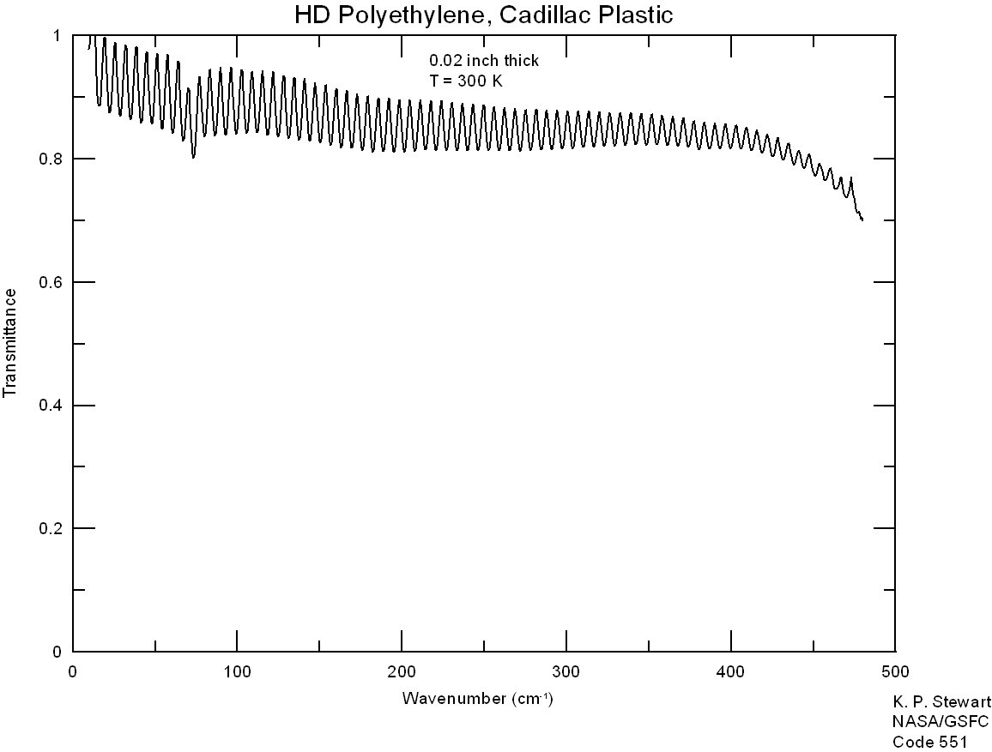
Figure 8. TransmissionError: Reference source not found of 0.5mm Thick HDPE manufactured by Spartech Plastic.
The 0.033" HDPE showed the best mechanical performance of the three materials we tested. After vacuum pumping for 2-3 days, the window settled into a fairly constant deflected shape. Figure 9 shows the change in window curvature with time. The change in best-fit spherical radius with time is plotted in Figure 10. Figure 10 shows that the RMS Residual is increasing with time. This increase in asphericity is predicted by the window's 4th order polynomial theoretical form. However, the measured window curvature is best modeled by a 5th order polynomial. The window shows insensitivity to mounting configurations and edge conditions. Short-term burst strength is very good at better than 7 atm.

The image degradation due to the aspheric windows were calculated for the last three sets of measurements, at T=49hr. 45min., T=121hr. 45min. and the 2nd pump down. The optics was optimized with the criteria of best performance with all 3 window profiles without refocusing the telescope. The image degradation was the worst in Band 1, with a worst-case increase in rms spot diameter of 65 microns in-field, and 91 microns in the 5-Airy fields. The largest variation in rms spot diameter between the three sets of measurements was about 15 microns. Even with the expected worst case degradation of the optics due to the aspheric window profile, the HAWC optics are still diffraction limited.

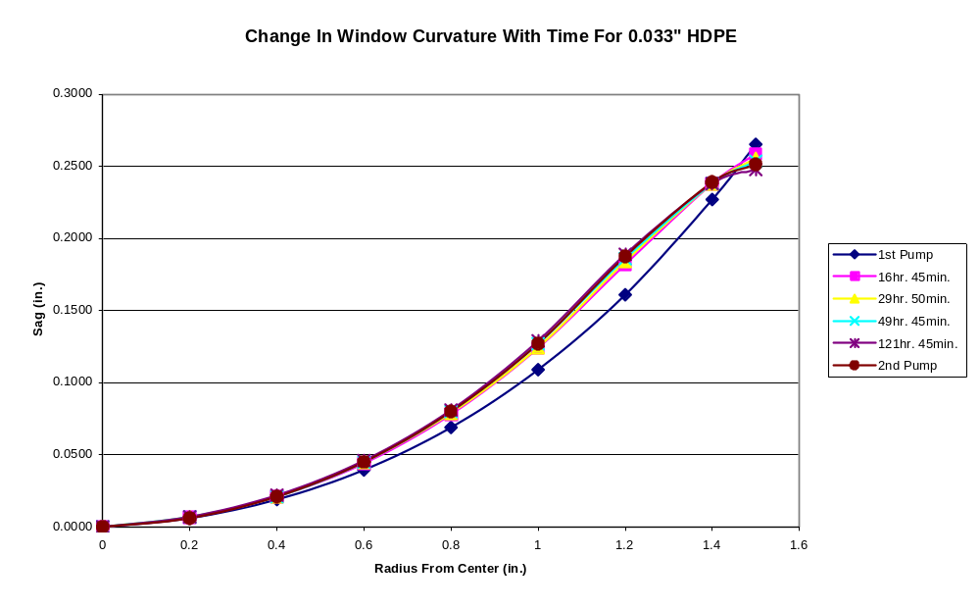
Figure 9. Vacuum Testing of 0.033" HDPEError: Reference source not found Window Sag.

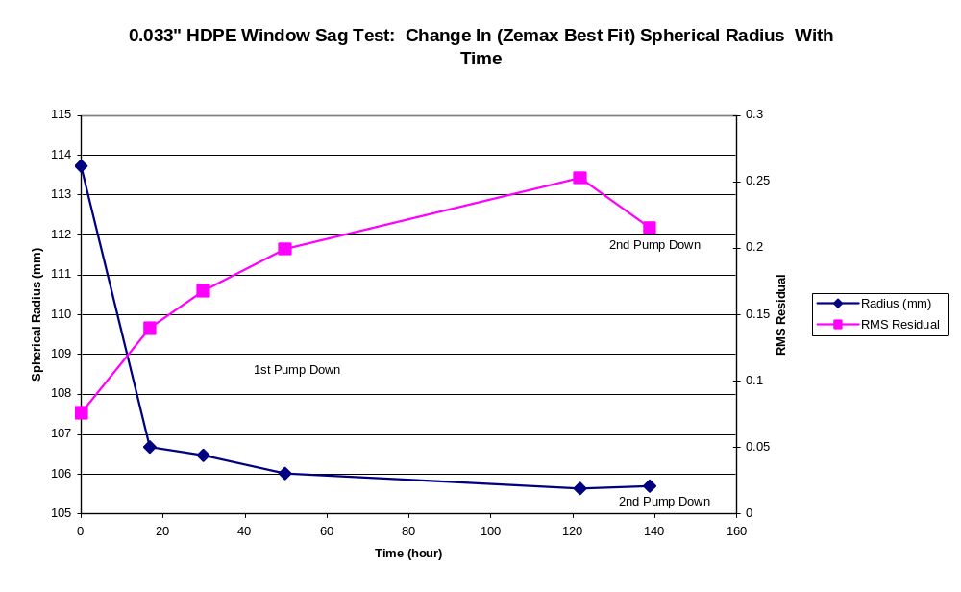
Figure 10. Change in Best-Fit Spherical Radius With Vacuum Cycles for 0.033" HDPEError: Reference source not found.

Polypropylene (PP) comes in homopolymer (brittle below 0 degree C) and copolymer formulations. We used a 0.02" piece of copolymer PP from GoodfellowsError: Reference source not found. The measured transmission for the 0.02" thick PP is shown in Figure 11.

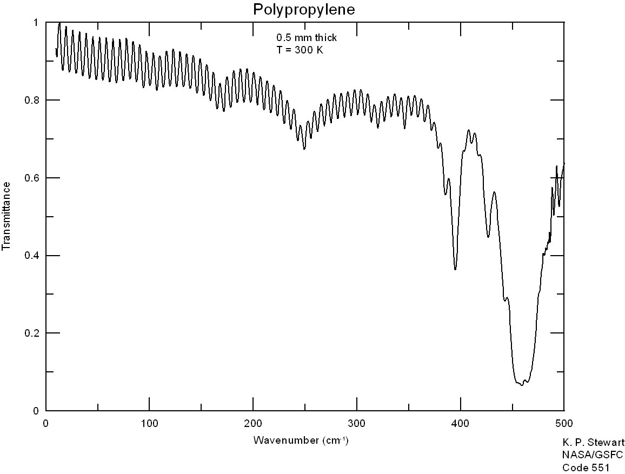
Figure 11. TransmissionError: Reference source not found of 0.5mm thick PP.

Figure 12 shows the change in window curvature with time. The best-fit spherical radius is plotted in Figure 13. Of the three windows tested, the 0.02" PP window was the most spherical in shape. However, the 0.02" PP showed poor mechanical performance due to edge sensitivity. After 2 days of vacuum pumping, micro-cracking developed around the edge and lead to a failed helium leak check. Since the average transmission of PP is lower than PE of comparable thickness in our wavelength region, there is no advantage in using PP as our window material.
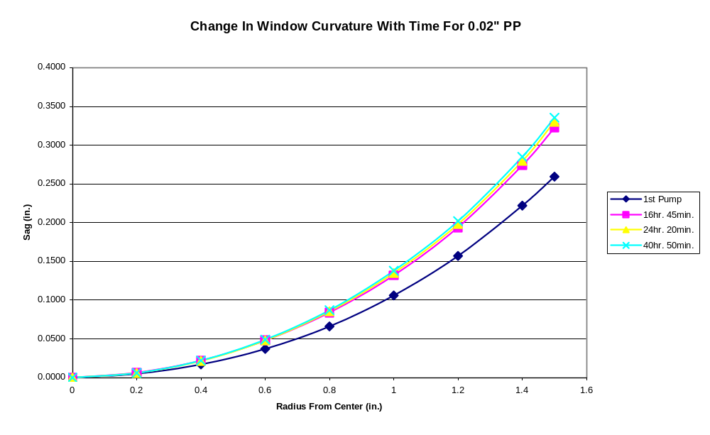
Figure 12. Vacuum Testing of 0.02" PP Window Sag.
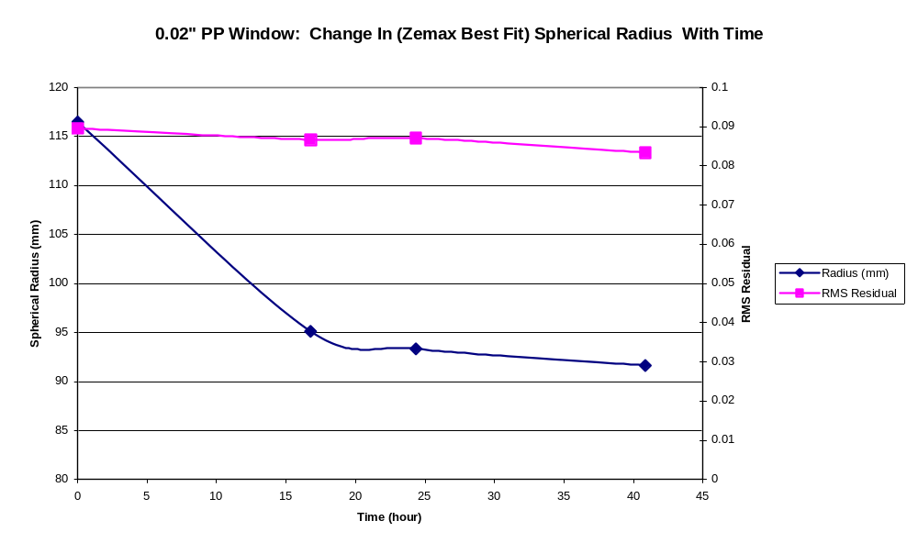
Figure 13. Change in Best-Fit Spherical Radius With Vacuum Cycles for 0.02" PP.
As an interesting investigation of alternative window materials, we looked into the possibility of using chemical vapor deposition (CVD)-grown diamond as the window material. CVD diamond can be made to 3-inch diameters of 1mm thickness. Diamond has no absorption lines in our wavelength region. High quality CVD diamond has optical properties similar to those of Type IIa single-crystal diamond. Its 1-phonon vibrations centered around 1000 cm⁻¹ are forbidden by the perfect tetrahedral symmetry of the carbon atoms. Therefore, the transmission of diamond is flat beyond the 2-phonon absorption region centered around 5 micronsError: Reference source not found. With a proper AR coating, the transmission of CVD diamond could be quite high and uniform in our wavelength region. A nonlinear finite element analysis was performed to determine the deflection under 1 atmosphere pressure of a 3.0-inch diameter 1-mm thick diamond window. The analysis used shell elements clamped around the edges. The maximum deflection/sag calculated for the diamond window was 0.0015", as shown in Figure 14. The maximum stress (at 14572 psi) was around the edges. This level of stress gives a safety factor better than 4, based upon the maximum quoted tensile strength of 420-630 MPaError: Reference source not found. With its very high stiffness and expected brittle behavior, the diamond window sag should not creep like the polymer windows, and its curvature would be very repeatable. However, the high cost of diamond windows, around $60,000 for a 3" window, discouraged us from pursuing this option.

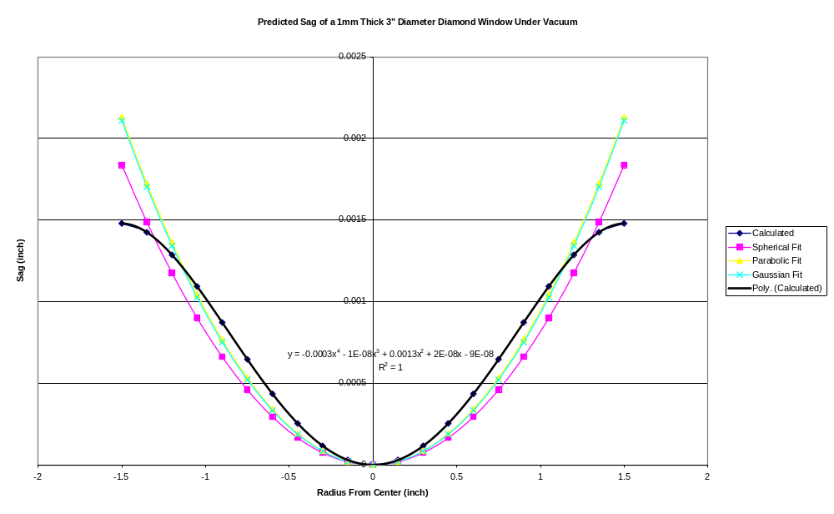

Figure 14. Calculated Sag Profile of a 3 inch Diameter Diamond Vacuum Window.

Of the materials tested, the 0.033" HDPE window showed the best mechanical performance. We plan on using the Spartech Plastic 0.03" HDPE as the window material for the flight dewar, since we have the material certification for this materialError: Reference source not found. Its measured transmission was actually higher than we had predicted using absorption values from Chantry et al.Error: Reference source not found. We will rerun the mechanical tests for this particular sheet of material as part of the FAA certification procedure. Although additional mechanical testing may be performed to test the window curvature variations between samples to obtain the statistical tolerance between windows, we expect the variations to be small. The long-term aging effects may also be tested by accelerating the window life tests at a slightly elevated temperature. This should be followed by a burst test to look for residual strength. The results of these tests will be checked against the tolerance analysis to make sure we don't exceed the window tolerance specifications.

Goodfellow Web Site: http://www.goodfellow.com/ (7/00).
Avallone, E. and Baumeister, T. Mark’s Standard Handbook for Mechanical Engineers, 10th Ed., McGraw-Hill, pp. 6-196 – 6-197 ('76).
Private Communication with Joseph Yehoda of Diamonex, Inc. (11/99).
Coherent Auburn Group Catalog, p. 206 (11/99).
"Materials for infrared windows and domes: properties and performance", D. C. Harris, SPIE Optical Engineering Press, Washington ('99).
McMaster-Carr Supply Company Web Site: http://www.mcmaster.com/ (7/00).
"Far infrared & millimeter-wave absorption spectra of some low-loss polymers," G. Chantry, J. Fleming & P. Smith, Chem Phys Letters, Vol. 10, No. 4, pp. 473-477 (8/71).
"Precise dielectric measurements of low-loss materials at millimeter and submillimeter wavelengths," M. Afsar and G. Chantry, IEEE Transactions on Microwave Theory and Techniques, MTT-25. pp. 509-511 (6/77).
"Optical constants of far infrared materials. 3: plastics", D. Smith & E. Loewenstein, Applied Optics, Vol. 14, No. 6, pp. 1335-1341 (6/75).
"Absorption spectra of polypropylene in the millimetre and submillimetre regions", G. Chantry, J. Fleming & G. Pardoe, Infrared Physics, Vol. 11, pp. 109-118 ('71).
"The far infrared optical constants of some common polymers", J. Birch, NPL Report DES 111 (6/91).
"The far infrared transmission of polyethylene at reduced temperatures", N. Stone, D. Williams, Applied Optics, Vol. 5, No. 2, pp. 353-354 (2/66).
Private Communications with Ken Stewart of the GSFC IR Spectroscopy Lab (3/01).
Focus Software, Inc. Web Site: http://www.focus-software.com (7/00).
Abbott Plastics, Rockford, IL. Phone: (800)850-8551. (6/00).
Poli Hi Solidur Web Site: http://www.polyhisolidur.com/Default.asp (7/00).
Cadillac Plastic Web Site: http://www.cadillacplastic.com (10/00).
Spartech Plastics, Conneaut, OH. Phone: (440)599-8175. Virgin grade high density polyethylene resin, reference batch number 05/01/00-35-60-10, FPI #3500035296 (10/00).

