10th International Fusarium Workshop

and

Fusarium Genomics Workshop 2008

Hotel Carlos V, Alghero, Sardinia (Italy)
August 30th - September 2nd, 2008

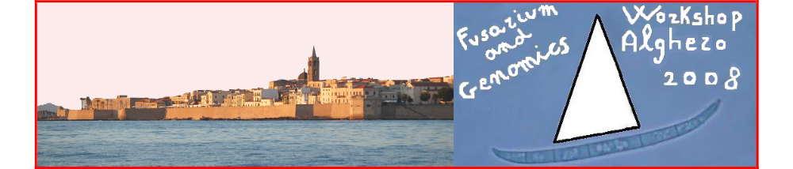

Dear colleague,

The X International Fusarium Workshop and the Fusarium Genomics Workshop will be held at the Hotel Carlos V in Alghero (Sardinia, Italy) from August 30th through September 2nd, 2008.

The International Fusarium Workshop is sponsored by the Fusarium Committee of the International Society for Plant Pathology and held every four years in conjunction with the International Congress of Plant Pathology. In 2008 we are also meeting with the annual Fusarium Genomics Workshop.

The Fusarium workshops 2008 are organized by the Department of Plant Protection, University of Sassari in collaboration with Istituto Nazionale Biostrutture e Biosistemi.
We do hope that the proverbial warm hospitality of Sardinia and the picturesque atmosphere of Alghero and its enchanting sea will attract many scientists from around the world including students, researchers, academics, and industrial representatives to present and discuss their latest results with their international peers. We will also be happy to send a personal invitation to any scientist upon request. Such invitations should help participants in making their travel and VISA arrangements and are not commitments on the part of the Organizing Committee to provide financial support.
With our very best wishes,
Quirico Migheli and Virgilio Balmas
On behalf of the Organizing Committee

Fusarium Committee, ISPP:
H. Corby Kistler, USDA-ARS Cereal Disease Laboratory, St. Paul, USA
Ulf Thrane, Technical University of Denmark, Kgs. Lyngby, Denmark
Scientific Committee:
Marie-Josèe Daboussi, Université Paris-Sud, Orsay, France
Harold Corby Kistler, USDA-ARS Cereal Disease Laboratory, St. Paul, USA
Antonio Logrieco, CNR - Istituto di Scienze delle Produzioni
Alimentari, Bari, Italy
Brett Summerell, Royal Botanic Gardens, Sydney, Australia
Ulf Thrane, Technical University of Denmark, Kgs. Lyngby, Denmark
Local organizers:
Virgilio Balmas, Quirico Migheli, University of Sassari, Sassari, Italy

With the kind support of:


University of Sassari
Faculty of Agriculture, University of Sassari
Department of Plant Protection, University of Sassari


Società Italiana di Patologia Vegetale


Società Italiana di Microbiologia

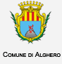
Comune di Alghero


Provincia di Sassari


Fondazione Banco di Sardegna


Fondazione per le Biotecnologie

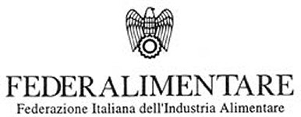
Federalimentare

Società Italiana di Microbiologia


Isagro SpA


Bayer CropSciences Italia

