
Verification & Validation Report for ArboNET/Plague Surveillance System

NASA GSFC / GIMMS in partnership with the Centers for Disease Control and Prevention

ArboNET/PSS
Bacterial Zoonoses Branch, National Center for Infectious Diseases (NCID)
Center for Disease Control and Prevention (CDC)
Global Inventory Modeling and Mapping Studies (GIMMS)
National Aeronautics and Space Administration/Goddard Space Flight Center (NASA/GSFC)
Science Systems and Applications, Inc. (SSAI)

September 2006
Acknowledgments
This work was supported by NASA Science Mission Directorate, Earth Science Division under the Applied Sciences Program, Public Health Program Element.

ArboNET/PSS Team
Compton J. Tucker–Team Leader
NASA/GIMMS/SSAI  Jorge E. Pinzon  Joseph Nigro | CDC  Kenneth L. Gage  Russell E. Enscore  Rebecca J. Eisen

© National Aeronautics and Space Administration
This document is not a formal publication of NASA, and all rights are reserved by the Administration. The document may, however, be freely reviewed, abstracted, reproduced and translated, in part or in whole, but not for sale nor for use in conjunction with commercial purposes. The views expressed in documents by named authors are solely the responsibility of those authors. The mention of specific companies or specific manufacturers' products does no imply that they are endorsed or recommended by the National Aeronautics and Space Administration in preference to others of a similar nature that are not mentioned.
Table of Contents
Table of Contents iii
Figures iii
Tables iv
Executive Summary v
1. Introduction 1
1.1. Epidemiology and Distribution of Plague 1
1.2. The Surveillance/Observational Data 4
1.3. Integrated System Solution: ESD Inputs against ArboNET/PSS Requirements 6
2. Methods and Data. 8
2.1. Systems Engineering Approach 8
2.2. ArboNET/PSS and ESD data and models 9
2.3. V&V measures 10
3. Results 11
3.2. NASA ESD Models 12
3.3. Communicating Risk 16
4. Conclusions 18
4.1. Findings 18
4.2. Recommendations 18
4.3. Next Steps 18
5. References 19

Figures
Figure 1. World distribution of plague. Plague remains endemic in natural foci around the world: large parts of Africa, Central and South Asia, South America and Southwest US, particularly in the Four Corners states. Source WHO. 1
Figure 2. Climate/Plague linkages. 5
Figure 3. Integrated system solution diagram for incorporation of Earth science research results to enhance the Plague Surveillance System component of CDC’s ArboNET. 8
Figure 4. DEM and water bodies of the Four Corners states where most of the plague cases have been reported. Source USGS EROS Data Center. 10
Figure 5. Wild and domestic plague risk derived from control environmental fake conditions: reported plague outbreaks, land cover, NDVI, precipitation and elevation. 13
Figure 6. Correspondence between domestic risk patterns and temporal plague outbreak patterns. Empirical mode decomposition shows a 5-year cycle correspondence (green and red.) Reported cases by year are normalized by 45. 15
Figure 7. NDVI and normalized anomaly assuming a t^2 distribution. This data is used to issue risk maps with one month of precedence. 15
Figure 8. Domestic risk associated to the environmental conditions given in Figure 7. Colors proportional to risk (0.5-blue → 1-red) as in Figure 5. 17

Tables
Table 1. Integrated Plague Surveillance System. 3
Table 2. ArboNET/PSS requirements. 6
Table 3. ArboNET/PSS requirements and ESD data and models match. 9
Table 4. Risk disaggregated by month. 14
Table 5. Interpretation of risk and uncertainty of environmental conditions associated to plague risk in terms of common words used to express degrees of danger. 17

Executive Summary

Members of the Global Inventory Modeling and Mapping Studies (GIMMS) group at NASA Goddard Space Flight Center and CDC National Center for Infectious Diseases, Division of Vector-borne Infectious Diseases in Fort Collins, have conducted a follow up validation and verification study of the integration of the NASA Earth Science Division (ESD) results and models into the CDC's ArboNET/Plague Surveillance System (PSS). This work was performed under NASA’s Verification and Validation (V&V) Program as a systematic review of the ESD suite that are more readily available for integration. This V&V covers all datasets recommended in the evaluation report of the entire ESD suite that may be integrated as system inputs for addressing ArboNET/PSS requirements and may improve its accuracy, quality, or efficiency. Many of these matches are products derived from the Moderate Resolution Imaging Spectroradiometer (MODIS) instrument flown on the Terra and Aqua satellites of the EOS and from the Advanced Very High resolution Radiometer (AVHRR) processed by the Global Inventory Modeling and Mapping Studies (GIMMS) group at NASA Goddard Space Flight Center.

This is a first attempt to respond to the need for a better understanding of climate/disease linkages with continuous spatial and temporal environmental data that would complement “traditional surveillance and response” systems with “prediction and prevention” strategies. The study is focused on the risk areas of the four corners states (New Mexico, Arizona, Utah and Colorado) identified in the ArboNET/PSS evaluation report, and on the resulting new NASA monthly environmental risk maps of plague for the region. The environmental risk maps of plague are the result of the NASA/GSFC/GIMMS disease-ecoclimatic monitoring system that integrates relevant ESD data, i.e. 16-day NDVI and 8-day temperature 1-km data from MODIS sensors, land cover information from Landsat TM data, elevation data from Shuttle Radar Topography Mission (SRTM), monthly precipitation data from Tropical Rainfall Measuring Mission (TRMM), and 15-day NDVI 8-km data processed by the GIMMS group from NOAA-Advanced Very High Resolution Radiometer (AVHRR).

Effective plague prevention and control programs require up-to-date information on the incidence and distribution of the disease. The best means of gathering this information is through a surveillance program that collects, analyses, and interprets clinical, epidemiological, and epizootiological data on plague. A surveillance system is a key element of decision support within the Centers for Disease Control and Prevention (CDC). Surveillance should identify cases and epizootics as quickly as possible so that steps can be taken to control disease spread. The ArboNET/PSS is defined by guidelines issued by the World Health Organization in collaboration with the CDC. The primary goal of the ArboNET/PSS is to promptly identify changes in incidence either in the form of an acute outbreak or in a change in long-term trends. At present, plague is one of only three infectious diseases subject to the International Health Regulations, which stipulate that all confirmed cases of human plague be investigated and reported through appropriate authorities to the World Health Organization. Whenever clinical symptoms or laboratory results suggest that a patient is infected with Yersinia pestis, the suspect case should be reported immediately. This will allow public health authorities to: (1) advise on treatment and management of human plague cases; (2) initiate efforts to identify the source of infection; (3) determine the extent of any epizootic activity; (4) assess the potential for additional human cases; (5) disseminate information on plague to health care personnel; and (6) implement emergency prevention and control measures. Thus, ArboNET/PSS uses in essence traditional “surveillance and response” strategies.
CDC defines the success of a surveillance system in terms of a number of factors including simplicity, flexibility, data quality, acceptability, sensitivity, predictive value positive, timeliness, representativeness, and stability. Clearly, sensitivity and predictive value are important to measure the usefulness of the system. The other factors are also critical since they can affect the performance of the ArboNET/PSS by data reporting cost, level of integration with other systems, legal assurance of privacy and confidentiality, staff training, or legal requirements for data collection. The ArboNET/PSS includes human, rodent, and vector surveillance since the appearance of early cases of plague in a population is the most commonly used tool to prevent further human infections. These “surveillance and response” approaches provide fairly high predictive certainty of plague occurrence but often leave public health authorities with little advance notice for mobilizing actions to prevent further spread of the disease. In contrast, ecological observations and climate forecasts can potentially be used in efforts to predict the appearance of a pathogen and thus open the opportunity to minimize its transmission. The ArboNET/PSS relies on meteorological data, such as precipitation and temperature, to feed the various modeling routines that are central to the surveillance system. Much of this data was collected from systems implemented long before NASA-ESD missions.
The results of this V&V study are part of the overall NASA/GIMMS ArboNET/PSS enhancement effort that follows a rigorous NASA systems engineering approach to ensure that the products selected for implementation meet ArboNET/PSS requirements. It builds heavily from the previous evaluation phase. The evaluation underpinned the assumption made by both NASA and CDC agencies when entering into this partnership – that NASA ESD systems have the potential to enhance and complement the plague “surveillance and response” system used by the CDC with “prediction and prevention” strategies. Specifically, this study undertook the following three tasks:

- Conduct an in-depth, critical review of the results of the NASA/GIMMS environmental risk maps of plague derived from the linkages between temporal and spatial variations of climate and the plague events in the four corners states;
- Examine the potential for establishing useful plague-oriented climate early-warning and surveillance systems, and for developing new benchmark metrics communicating and dealing with uncertainty in quantitative risk and policy analysis;
- Identify future metrics and data that could further clarify and quantify the effective use of the plague-oriented climate early-warning and surveillance system for societal responses to any such early warnings.

There are many substantial challenges associated with establishing a useful plague-oriented climate early-warning and surveillance system. For instance, the current strategies for controlling plague, or more generally infectious diseases, depend largely on surveillance for new outbreaks followed by a rapid response to control the epidemic. For these “surveillance and response” approaches, risk analysis does not need to deal with uncertainty and therefore it does not need to develop correspondent metrics. For “prediction and prevention” approaches a key limiting factor is the uncertainty associated to predictions. This divergence in metrics for assessing uncertainty is usually overlooked and limits the application of early warning systems. In this study, we have considered carefully how users (decision makers) in public health policy and response might use uncertainties in analyzing risk and have implemented quantitative and qualitative tools to communicate uncertainty. Recognition of the importance of uncertainties for risk analysis can also improve communication by more clearly distinguishing between uncertainty in whether, or how frequently, certain events or outcomes might occur and uncertainty in their consequences. This perspective shows that when faced with uncertainty in validating and verifying an early warning system, it is not sufficient to identify only the most likely outcome and compare its result, but to communicate it in a common standardized language.
The results of this V&V demonstrate that NASA ESD assets could make important contributions to ArboNET/PSS. The GIMMS group, using ESD results, has implemented a progressive “prediction and prevention” approach that could be used to issue an alert that environmental conditions are conducive to plague outbreak which in turn can trigger surveillance efforts for the area in question. This watch/warning approach is analogous to the multi-stage early warning system used by the U.S. National Weather Service. Although, it is likely to have much lower predictive value, a benefit of this multi-stage approach is that response plans can gradually ramp up as forecast certainty increases and as surveillance data confirm earlier projections. The active participation of the system’s end users helps ensure that forecast information is provided in a useful manner and that effective response measures are developed. The input of CDC’s stakeholders will ensure that data and products produced for the NASA science community meet the data delivery and continuity requirements of ArboNET/PSS, so that response plans can be developed with realistic expectations. Finally, a recent paper showed that the concerns about data continuity were mitigated in the long-term by focusing integration efforts on the GIMMS-AVHRR NDVI data set that is consistent with the ESD systems that have an operational follow-on (such as the National Polar-orbiting Operational Environmental Satellite System (NPOESS)) and planned system continuity (such as the Global Precipitation Measurement (GPM) mission).

Introduction
In this section, we described the characteristics of the ArboNET/Plague surveillance system and its relationship with ESD data and models.

Epidemiology and Distribution of Plague

Plague is one of three epidemic diseases still subject to the International Health Regulations and notifiable to the World Health Organization (WHO). The pathogen causing the disease Yersinia pestis circulates in animal reservoirs, particularly in rodents, in the natural foci of infection found on all continents except Australia. The natural foci of plague are situated in a broad belt in the tropical and sub–tropical latitudes and the warmer parts of the temperate latitudes around the globe between the parallels 55 degrees North and 40 degrees South (Error: Reference source not found). Plague remains endemic in natural foci around the world: large parts of Africa, Central and South Asia, South America, and the Soutwest US, particularly in the Four Corners states. However, within these limits many areas are free of natural foci of plague, such as desert areas with few or no rodents and large areas of continuous forest, particularly in the tropics and high glacier–covered mountain ranges. 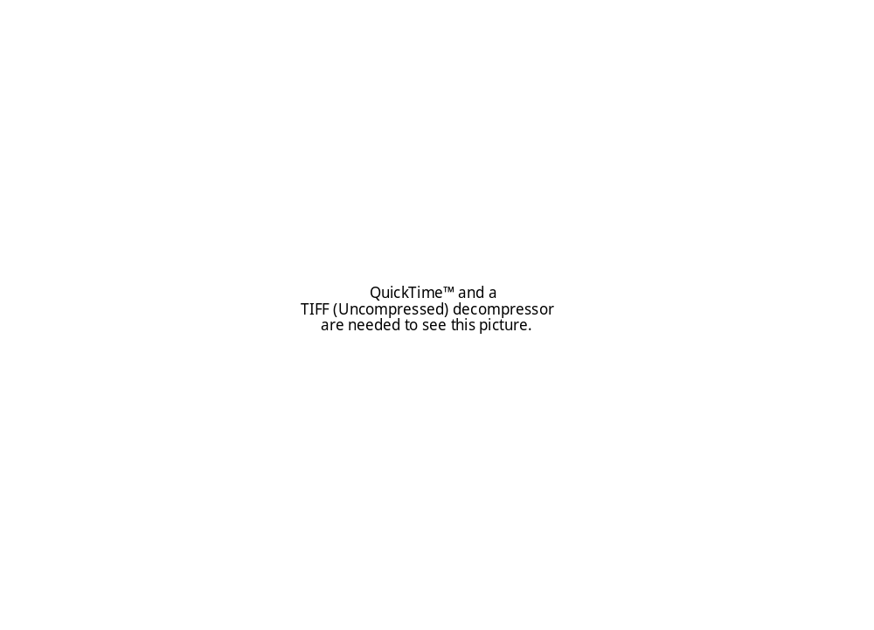
Figure 1. World distribution of plague. Plague remains endemic in natural foci around the world: large parts of Africa, Central and South Asia, South America and the Soutwest US, particularly in the Four Corners states. Source WHO.
Plague is transmitted between rodents and to other animals via wild rodent fleas, cannibalism or (possibly) contaminated soil. Wild plague exists in its natural foci independent of human populations and their activity. Domestic plague is intimately associated with rodents living with humans and can produce epidemics in both human and animal populations. Humans are extremely susceptible to plague and may be infected either directly or indirectly. Indirect transmission through the bite of a flea is the most common route of transmission between plague–infected rodents and humans. Human infection most frequently occurs when an epizootic develops among rats in centers of human population, following contact with infected wild rodents. Commensal rat fleas, including plague–infected fleas, leave the bodies of rats killed by plague seeking a blood meal from another host and may bite human beings. Humans who contract the disease may subsequently become infective to other people. However, plague is only occasionally transmitted between humans, either through the bites of human fleas (Pulex irritans) infected after biting patients in the septicemic stage, or through direct contact between a healthy person with an infected person. When primary bubonic plague develops into secondary pneumonic plague, airborne transmission of the infective agent may take place via the respiratory route, leading to primary pneumonic plague among close contacts. Infection through direct contact with objects contaminated with sputum from pneumonic plague patients can lead to the development of bubonic plague. Effective treatment methods enable almost all plague patients to be cured if diagnosed in time. The use of these measures has led to a sharp reduction in the number of cases of plague throughout the world. Today the distribution of plague coincides with the geographical distribution of its natural foci. It is unlikely that all the primary foci of plague have been discovered. Accordingly, close examination should be given to any rural area in which repeated cases of human plague occur. The prolonged absence of human cases in the vicinity of a natural focus does not in itself mean that plague has disappeared. If there is no evidence that plague has come from outside sources, the disease must be sought among local wild rodents. On every continent, primary natural foci of plague are connected with particular types of landscape in which climatic conditions are favorable for a high and stable number of rodent reservoirs and flea vectors of Y. pestis. Most natural foci of plague, including the mountains, are found where there is low annual precipitation, or where dry seasons inhibit the growth of thick woody vegetation and lead to the formation of deserts, semi–deserts and steppes (savannas, prairies, pampas and so on). Human cases of plague are relatively sparse in natural foci. Cases occur among people who come in contact with wild rodents in the course of their work, hunting, or camping. The risk of human infection increases significantly when plague penetrates populations of domestic rodents, particularly rats of the genus Rattus.

WHO recommends that health facilities use the following surveillance case definition for reporting suspected cases of plague - any person with painful swelling under the arms or in the groin area; or in an area known to have plague, any person with cough, chest pain and fever. For plague, a single suspected case is a suspected outbreak and the case-based information should be reported immediately to the district following the standard forms. Summary reports are due monthly, even in those periods where zero cases were confirmed. Error: Reference source not found summarizes the surveillance case definition for reporting suspected/confirmed cases of plague.

Table 1. Integrated Plague Surveillance System.
Background | - Zoonotic systemic bacterial infection caused by Yersinia pestis (plague bacillus) usually transmitted to humans by rodents and their fleas.  - Main disease forms: bubonic, pneumonic, and septicemic; large-scale epidemics may occur in urban or rural settings.  - Incubation period is 1 to 7 days.  - Case fatality rate (CFR) may exceed 50-60% in untreated bubonic plague and approaches 100% in untreated pneumonic or septicemic plague, but is usually <1% with appropriate treatment.  - Risk factor: rural residence. Exposure to infected populations of wild or domestic rodents and their fleas.
Surveillance Goal | - Detect outbreaks of plague promptly. Verify etiology of all suspected non-outbreak-related cases and the first 5 to 10 outbreak-related cases.
Recommended case definition | Suspected case:  Any person with sudden onset of fever, chills, headache, severe malaise, prostration and very painful swelling of lymph nodes, or cough with blood stained sputum, chest pain, and difficulty in breathing.  Confirmed case:  Suspected case confirmed by isolation of Yersinia pestis from blood or aspiration of buboes, or epidemiologic link to confirmed cases or outbreak.
Respond to alert threshold for  epidemic-prone diseases | If a single case is suspected:  - Report case-based information to the next level.  - Collect specimen for confirming the case.  - Investigate the case.  - Treat the patient with streptomycin, gentamicin or chloramphenicol, and administer chemoprophylaxis of close contacts with tetracycline for seven days from time of last exposure.
Respond to action  threshold for  epidemic-prone  diseases | If the suspected case is confirmed:  - Isolate patients and contacts of pneumonic plague with precaution against airborne spread (wear masks, for example) until at least after 48 hours of appropriate antibiotic therapy.  - Mobilize community to enable rapid case detection and treatment, and to recognize mass rodent die-off as a sign of possible impending epidemic.  - Identify high risk population groups through person, place, and time analysis.  - Reduce sporadic and outbreak-related cases via improved control or rodent populations (remove trash, food sources, and rat harborages) and protect against fleas with insect repellent on skin and clothing and environmental flea control (especially in homes and seaports and airports).
Analyze and  interpret data | Time: Graph monthly trends in cases and deaths. Construct epidemic curve for outbreak cases.  Place: Plot the location of case households.  Person: Immediate case-based reporting of cases and deaths for routine surveillance. Count weekly cases and deaths for outbreaks. Analyze age distribution and assess risk factors to improve control of sporadic disease and outbreaks.
Reference | Gage,1999

As in most of the current public health systems, this surveillance relies primarily on “surveillance and response” approaches to controlling infections of plague. In contrast, recent progress in climate forecasting and the availability of remote-sensing technologies can potentially be used in efforts to provide early warnings of conditions conducive to disease outbreak. In the next two sections, the elements of such a system are described ⎯ ESD data and models, and their integration into the current “surveillance and response” approach for plague.

The Surveillance/Observational Data

Since surveillance should identify cases and epizootics as quickly as possible so that steps can be taken to control disease spread, early warnings of a potential outbreak derived from observational climatic conditions could be used for early detection of outbreaks, and analysis of trends. As human cases of plague are relatively sparse in natural foci, an enviro-climatic early warning system should differentiate between wild and domestic plague risk. Implicit in an early warning system is the uncertainty associated to the prediction and the quantification of this risk. Continuous surveillance of climatic conditions, rodent and vector populations, and their proximity to human populations are important even during periods when no human cases are reported since many years may elapse between the occurrence of isolated cases or epidemics. In these cases, the ESD system integrated as part of a systematic collection of surveillance information over many years will provide information that can be used to:

- Predict areas where future human cases and rodent epizootics may occur;
- Identify the most common zoonotic sources of human infection;
- Identify particular environments and climatic conditions that are optimal for plague outbreaks;
- Assess the effectiveness of plague prevention and control measures;
- Identify local ecological factors or human activities that may result in increased plague exposure risks for humans; and
- Detect trends in the epidemiology and epizootology of plague in a given region.

A national update paper of modeling relationships between climate and frequency of human plague cases in the Southwestern U.S found that precipitation, temperature, humidity, land cover, vegetation, and altitude are important factors to be analyzed in an early warning system (Enscore et al., 2002.) Disease plague agents and their vectors each have particular environments that are optimal for growth, survival, transport, and dissemination (Figure 2.)
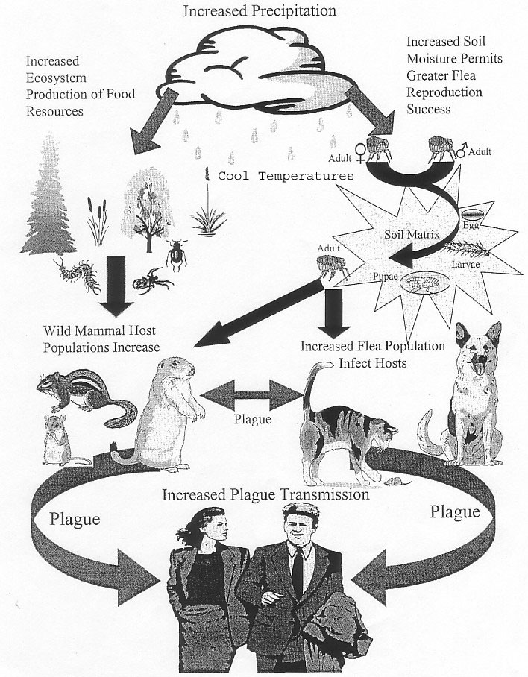
Figure 2. Climate/Plague linkages.

Integrated System Solution: ESD Inputs against ArboNET/PSS Requirements

It might seem a simple task to use ESD observations and models to create predictive disease models. Unfortunately, the mathematical relationships between climate and disease are neither so obvious nor so simple. In particular, with the current Trophic Cascade Hypothesis (TCH) developed to explain changing levels of human risk for zoonotic diseases associated with climate variability in the US Southwest, the role of ecological/environmental mechanisms by which human health is impacted by climate variability is not well understood. In fact, infectious disease patterns are affected by many factors other than climate, and the relationship between climatic variations and disease outbreaks is often mediated by ecological, biological, or societal changes. When the TCH modeling system is applied to forecast plague outbreak conditions, two different triggering mechanisms are observed. Depending on the region, a bimodal (May and July) or unimodal (August) peak dynamic is found. Rodents’ movements also play an important role in plague dynamics, complicating the system. Rodents can move down slopes, from higher elevations to lower elevations; plague does the same. A summary of these new requirements is given in Table 2.

ARBONET/PSS Property |  | Requirement | Drivers
Data Frequency (time step) | Monthly reporting | 10 day, with 15-day summaries | Need to establish trends within 1-month cycle (seasonal signature of incidences)
Data Frequency (time step) | Emergency | 2 day | Time requirements of emergency response planners
Spatial Resolution | Monthly reporting | Synoptic analysis: 8 km or better | Surveillance of enviro-climatic conditions with better resolution than stations
Spatial Resolution | Monthly reporting | Field-level analysis: 30 m or better | For high risk areas
Spatial Resolution | Emergency | 1 km or better | Breeding/resting/feeding habitats
General Properties | Cost | Moderate resolution product should be free | Budget constraints by region
General Properties | Format | Simple (web based) | Easy reporting
General Properties | Accessibility | Web accessible | Continue greater public benefit leveraging being demonstrated
General Properties | Data validation | Validated and science team in place | Quality assurance
General Properties | Data redundancy | Multiple sources | Data continuity, convergence of evidence
Parameters | Precipitation | 1 degree or better | Cumulative precipitation of stand-alone interest and assessment of vegetation
Parameters | Min and max temperature | 1 degree or better | Temperature changes affect vectors and vegetation
Parameters | Vegetation index numbers | 8 km or better | Needed for relative vegetation condition assessments
Parameters | Bare earth elevation | 5 km or better | Needed for rodent movement model
Parameters | Soil moisture | Unknown at this time | soil moisture of stand-alone interest in regard to flea survival
Table 2. ArboNET/PSS requirements.
The GIMMS group has implemented a progressive “prediction and prevention” approach that is being used to issue an alert that environmental conditions are conducive to a plague outbreak which in turn can trigger surveillance efforts for the area in question (Pinzon et al., 2005a,b.) A reverse engineering paradigm was used to identify the ESD data and models that match requirements and specifications of the ArboNET/PSS given in Table 2. Figure 3 shows the GIMMS’ Integrated System Solution (ISS) for integrating ESD results into ArboNET/PSS. Part of this system is the integration of the epidemiological surveillance data provided by CDC/NCID, such as proximity of infected rodents and fleas to human dwellings or workplaces and estimated number of people involved in activities that place them at high risk of plague infection. Reports of these investigations include: 1) a complete history of the patients' activities and travel during the incubation period of the infection; 2) results of field studies to determine which animal and flea species are likely sources of infection or pose a continuing threat to humans (surveillance techniques for rodents and fleas can be found in Gage, 1999); 3) proximity of infected rodents and fleas to human dwellings or workplaces; 4) estimated number of people involved in activities that place them at high risk of plague infection; and 5) information on possible exposure to Y. pestis infection from patient contacts (especially important for pneumonic plague cases).

In the United States, rapid sub–urbanization has resulted in increasing numbers of people living in or near active plague foci. During each successive decade from 1944 to 1993, the number of states reporting plague cases increased: from three in 1944–1953 to thirteen in 1984–1993. Surveillance of plague in rodent and rodent–consuming carnivore populations indicates that plague spread eastward in the 1990s to areas believed to have been disease–free since extensive animal surveillance began in the 1930s. Two hundred and forty seven human plague cases were reported in the United States during 1980–2000, the highest of any 20–year period since the epidemic years in the early part of the century. Thirty seven of these patients died -- a case fatality rate of 15. The number of cases by year during this 20–year period ranged from one indigenous case in 1990 to highs of 40 in 1983 and 31 in 1984.

The NASA/GSFC/GIMMS disease-ecoclimatic monitoring system was customized according to the PSS operations to be more in-line with their CDC modeling systems. The MODIS-AVHRR NDVI datasets integration (complemented by other remote sensing observation products) are highlighted as part of the system. Thus, the epidemiological data combined with products derived from Earth observing instruments, technology, and science information that consider not only vegetation dynamics, but also elevation, slope, aspect, and land cover diversity in their models will provide information on plague vector habitats. This will enable ArboNET to better characterize wild and domestic plague outbreak conditions and will enhance the plague surveillance system.

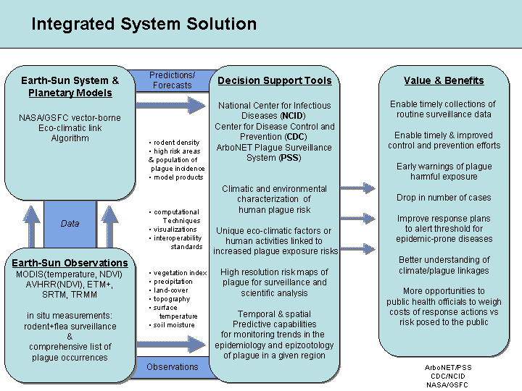

Figure 3. Integrated system solution diagram for incorporation of Earth science research results to enhance the Plague Surveillance System component of CDC’s ArboNET.

Methods and Data.

Systems Engineering Approach
This validation and verification (V&V) phase is part of the systems engineering approach followed by the GIMMS group for the ArboNET/PSS which entails three phases: evaluation, verification and validation (V&V), and benchmarking. In terms of this approach, the purpose of this report is to verify and validate that the NASA ESD data and models integrated into the ArboNET/PSS provide the early warning capabilities needed to enhance the system.
As expected, this process has not been strictly linear. It uses a Reverse Engineering Paradigm to calibrate NASA ESD measurements and models to ensure that all factors that affect the success of the system - sensitivity, predictive value positive, timeliness, acceptability, simplicity, flexibility, data quality, stability, continuity, and representativeness – are for improvement of socioeconomic benefits and adaptation or adoption by the CDC. This process inherently requires interdisciplinary collaboration and must progress in a coordinated fashion with an active participation of the ArboNET/PSS system’s end users.

ArboNET/PSS & ESSD data and models
Table 3 summarizes all ESD inputs used in the GIMMS’ Integrated System Solution (ISS) approach and the validation and verification steps followed in this report. The NDVI-AVHRR dataset, created by the GIMMS group, is of particular interest because it is the first AVHRR 8-km NDVI time series that covers the period from July 1981 to the present and it is compatible with the NDVI from more modern instruments, e.g. MODIS and SPOT Vegetation (Pinzon et al. 2005c, Fensholt et al. 2006.) Since most of the plague activity in the USA has occurred in the 1980s and 1990s, the NDVI-AVHRR data set is an essential part of the GIMMS’ ISS to study the environmental factors that often set the stage for optimal conditions for the spread of plague and are important in determining its transmission, intensity and duration.
Table 3. ArboNET/PSS requirements and ESD data and models match.
PSS Required Observation & Predictions | ESD data and models | Validation and Verification
High/Moderate Resolution Visible-IR Remote Sensing Information & Products | AVHRR &MODIS | - 15-day global coverage → AVHRR (global coverage)  - 8-km spatial resolution → MODIS 250 m to 1 km  → AVHRR 8 km
- Moderate Resolution Vegetation Indices | - MODIS NDVI  - AVHRR  NDVI/GIMMS | - Continuity from 1981 data (AVHRR)  - Temporal Domain: The NASA/GIMMS cross-validation work among the various AVHRR sensors and MODIS has given confidence in the long-term NDVI data quality and important as a transition to the next generation moderate resolution sensor. It favors efforts on the understanding of disease/climatic linkages and their application to early warning systems.  - Spatial Domain: MODIS characterization of current enviro-climatic conditions.
- Temperature (Min and Max) | - MODIS Land Surface Temperature | - Measured land surface temperature as opposed to current interpolated temperatures
- Topography | - SRTM | - SRTM30 for North America is available since 2003.
- Precipitation | - TRMM | - Precipitation reaching the ground measured by radar as opposed to current interpolated WMO stations.
- Land Surface type | - AVHRR Land Cover | - Useful to ArboNET/PSS identification of rodent habitat, Regions with high risk use Landsat for better interpretation of land cover mixing.

The GIMMS group also developed a t²-normalized anomaly product based on the AVHRR-NDVI data set to better characterize the disease/climatic linkages. The integration of this data set with the higher resolution and better quality NDVI data from MODIS is used to display current climatic/environmental conditions. The NDVI AVHRR/GIMMS and MODIS data sets are also important as a transition to the next generation moderate resolution sensors: the Visible Infrared Imaging Radiometer Suite (VIIRS) that will be part of the National Polar-orbiting Operational Environmental Satellite System (NPOESS) and the NPOESS Preparatory Project (NPP) missions.

V&V measures
This study reports V&V measures for the Four Corners region (figure 4.)
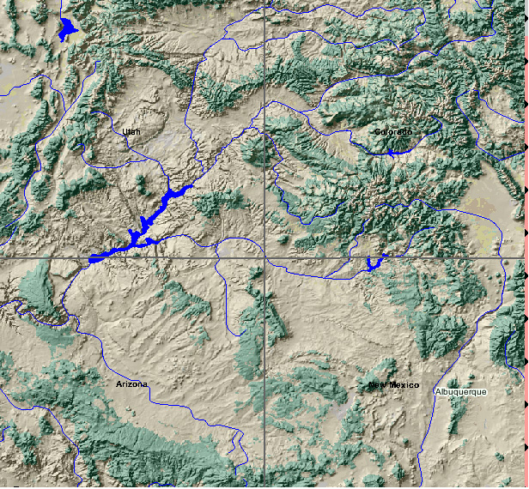
Figure 4. DEM and water bodies of the Four Corners states where most of the plague cases have been reported. Source USGS EROS Data Center.
The V&V measures are: 1) correlations between plague risk warnings derived from the ISS system and reported outbreak cases; 2) time series analysis of risk maps; 3) correspondence between risk and plague seasonality; 4) correlation between wild and domestic plague risk; 5) correspondence between risk maps and regions with reported plague; and 6) assessment of the uncertainty associated to the prediction of risk maps at current enviro-climatic conditions and characterization of predominant vegetation types. This includes the amount of local land surface covered by each vegetation type, roads, railways, airports, and seaports, land use patterns (agricultural, residential, industrial, other), types of dwellings present, and whether these dwellings and associated food storage areas or other man-made sites provide food and harborage for rodents.

Results
  - ESD Data Sets

NDVI AVHRR
As discussed earlier, the NASA/GIMMS NDVI archive is a vital data stream for ArboNET/PSS. The NASA/GIMMS cross-validation work among the various AVHRR sensors has given confidence in the long-term data quality and has allowed the group to focus more efforts on the disease/climate linkages. In a recent evaluation of the 8 km NASA/GIMMS NDVI data set, Rasmus et al. (Rasmus, 2006) showed that overall the accuracy of the data set is consistent to the SPOT-4 VGT, a more accurate and recent sensor, explaining most of the SPOT-4 VGT variance. They concluded that this data set can be considered the most accurate long time AVHRR data record, and should be used for analyses of long-term trends in regional or continental scale NDVI. Pinzon et al. (Pinzon, 2005a,b) used the t²-normalized anomaly product based on this AVHRR-NDVI data set to better characterize the disease/climatic linkages. In particular, their results showed high consistency with plague cases in the Four Corners region (Pinzon, 2005b.)

MODIS standard products (NDVI, temperature)
The MODIS Standard Products (NDVI and land surface temperature) were used to characterize current conditions of regions of high risk at 1km resolution based on the risk maps derived from NASA/GIMMS AVHRR-NDVI. The data is integrated, presented, and accessible in secure web environments and GIS tools. The NDVI vegetation index and the surface temperature products met ArboNET/PSS requirements (8km) and therefore were an upgrade to the data quality and continuity (radiometric and spatial) that were derived from the surface weather stations.

TRMM precipitation
Currently ArboNET/PSS’s precipitation information comes from WMO weather stations or from precipitation estimates. The weather station information is limited to point estimates, which are sparse in some regions.
TRMM calibrates its passive microwave sensor, the TRMM Microwave Imager (TMI) with simultaneous radar: the Precipitation Radar (PR). The radar can determine if precipitation is reaching the ground; in fact, it gives three-dimensional information about rain cloud structure. It is not feasible to achieve broad coverage with radar, but it can serve as a calibration source for the passive microwave sensor. This calibrated data can then be cross-calibrated with passive microwave sensors on other platforms to create a global precipitation measurement constellation. This constellation is the concept of the Global Precipitation Measurement (GPM) mission for which TRMM is a precursor. A research group at NASA/GSFC has developed a cross-calibration of the TRMM TMI data with other microwave sensors, namely the DMSP SSM/I sensors to create a level 3 TRMM product (3B42RT), the “TRMM Real-Time Multi-Satellite Precipitation Analysis”, with some completeness and consistency. This product is being delivered online at http://daac.gsfc.nasa.gov/CAMPAIGN_DOCS/hydrology/TRMM_analysis.html
The TRMM is used to complement current climatic conditions and improved risk prediction from the NASA/GIMMS AVHRR-NDVI.

Land Cover Characterization
The system uses the AVHRR 8km global land cover data set to characterize the land cover of natural foci around the world where plague remains endemic and to facilitate the extension worldwide of the prototype being developed for the Four Corners states of the U.S. Landsat is used to provide a high resolution data set for better interpretation of the land cover map at identified (predicted) high risk areas.

Bare Earth Elevation
The new global dataset is based primarily on SRTM30 data. The SRTM30 is a near-global digital elevation model (DEM) comprising a combination of data from the SRTM mission and the U.S. Geological Survey’s GTOPO30 data set. It can be considered to be either an SRTM data set enhanced with GTOPO30, or as an upgrade to GTOPO30. It is used to characterized movement of rodents (and thus plague wave.) It provides (static) environmental conditions useful for a better characterization of rodent niche (plague foci.)

NASA ESD Models
The NASA/GSFC/GIMMS disease-ecoclimatic monitoring system uses the land cover map, the SRTM30 data, precipitation profiles, and NDVI profiles to characterize the regions more susceptible to plague outbreaks. For security reasons, we use fake data in this report for this characterization due to the International Health Regulations that plague is still subject. Wild and domestic risk are derived from this characterization (Figure 5.) We repeat the same computations with actual data with similar results. Thus, the results of this V&V measure applied to the control fake data is a genuine representation of what the disease ecoclimatic monitoring system would predict when applied to actual data.
The risk is derived according to the similarity between the (fake) environmental conditions at any point and the temporal and spatial environmental characteristics of the regions with (fake) outbreaks reports. The V&V measures summarize temporal and spatial correspondence between plague outbreak and predicted plague risk regions. The domestic risk is derived from the predicted wild risk map by computing (fake) distance to populated areas. About 27% percent of continental USA has environmental conditions similar to outbreak areas. However, less than 35% percent of those regions have “optimal conditions” for plague, i.e. they have high risk. In the disease-ecoclimatic monitoring system, the conditions are also evaluated by month. Integrating the risk associated to each point by month we can estimate the risk of plague by month. Table 4 show this risk disaggregated by month.
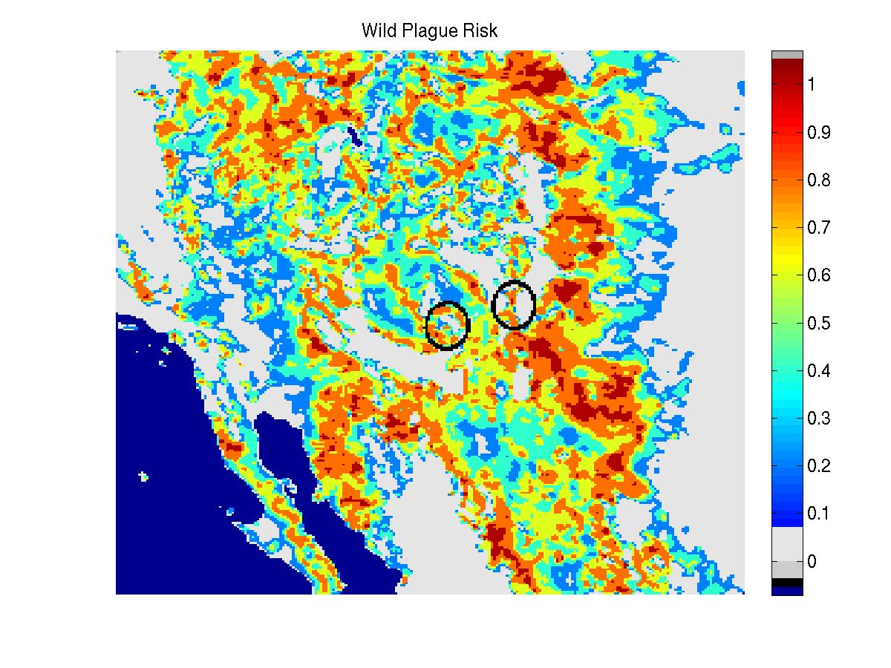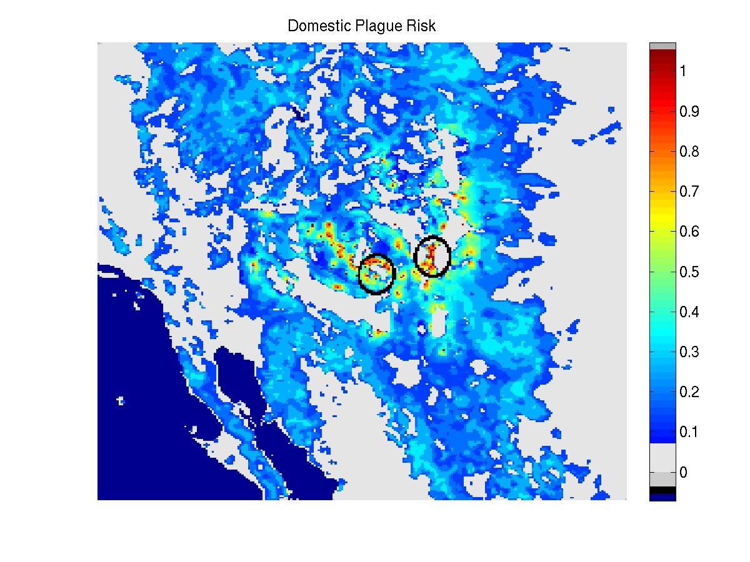
Figure 5. Wild and domestic plague risk derived from control environmental fake conditions: reported plague outbreaks, land cover, NDVI, precipitation and elevation.

Table 4. Risk disaggregated by month.
Month | Wild |  | Domestic
Month | Percent | Avg. risk | Percent | Avg. risk
January | 2 | 48 | 0 | 26
February | 3 | 48 | 1 | 24
March | 5 | 46 | 2 | 25
April | 19 | 52 | 6 | 26
May | 38 | 52 | 21 | 29
June | 39 | 53 | 21 | 30
July | 41 | 54 | 15 | 30
August | 43 | 55 | 20 | 30
September | 44 | 54 | 23 | 30
October | 38 | 54 | 22 | 31
November | 12 | 55 | 5 | 29
December | 4 | 52 | 0 | 22

Wild and domestic plague are related to each other by identifying the months of May through October as the period with higher percentage risk. However, summing up all individual risk to obtain average risks, wild and domestic risks have a notable difference. While domestic risk still identifies May-November, wild risk extends from April to December. The correlation between the percent area of domestic risk and the average domestic risk is 0.99. This relation allows the use of percent or average domestic risk indifferently. Figure 6 shows a comparison between the predicted average domestic risk lagged by one month and the average behavior of reported plague outbreaks. Their similarity in profiles and in the time series analysis show that environmental and climatic features can be successfully used as an early warning system of plague risk with one month of precedence. Here, empirical mode decomposition (Pinzon et al. 2005c) is applied to the domestic risk average to identify trends in the time series. A 5-year cycle in plague outbreaks and predicted domestic risk is apparent from the two EMD modes shown. This reaffirms the use of the NASA/GSFC/GIMMS disease-ecoclimatic monitoring system as an accurate early warning system for the ArboNET/PSS.

The NASA/GSFC/GIMMS disease-ecoclimatic monitoring system is also applied to generate monthly warnings. It uses NDVI from AVHRR data at 8km resolution and the derived normalized anomaly (Figure 7). The AVHRR data is used for continuity purposes since it covers 26 years (1981-present) and it is global. The risk maps are transformed as dynamic GIS layers and they are combined with other ESD data (MODIS NDVI-higher resolution, temperature-higher resolution, SRTM, and other ancillary data) for better interpretation of the risk and, therefore, better supporting tools for decision making.

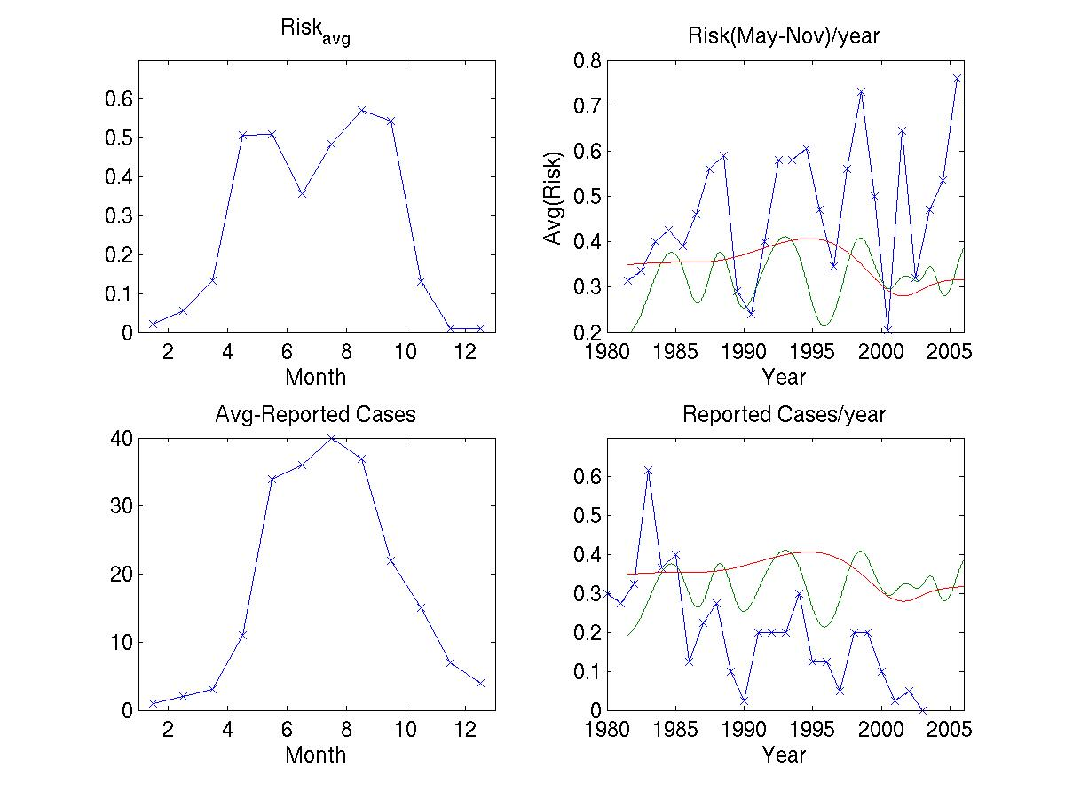
Figure 6. Correspondence between domestic risk patterns and temporal plague outbreak patterns. Empirical mode decomposition shows a 5-year cycle correspondence (green and red.) Reported cases by year are normalized by 45.
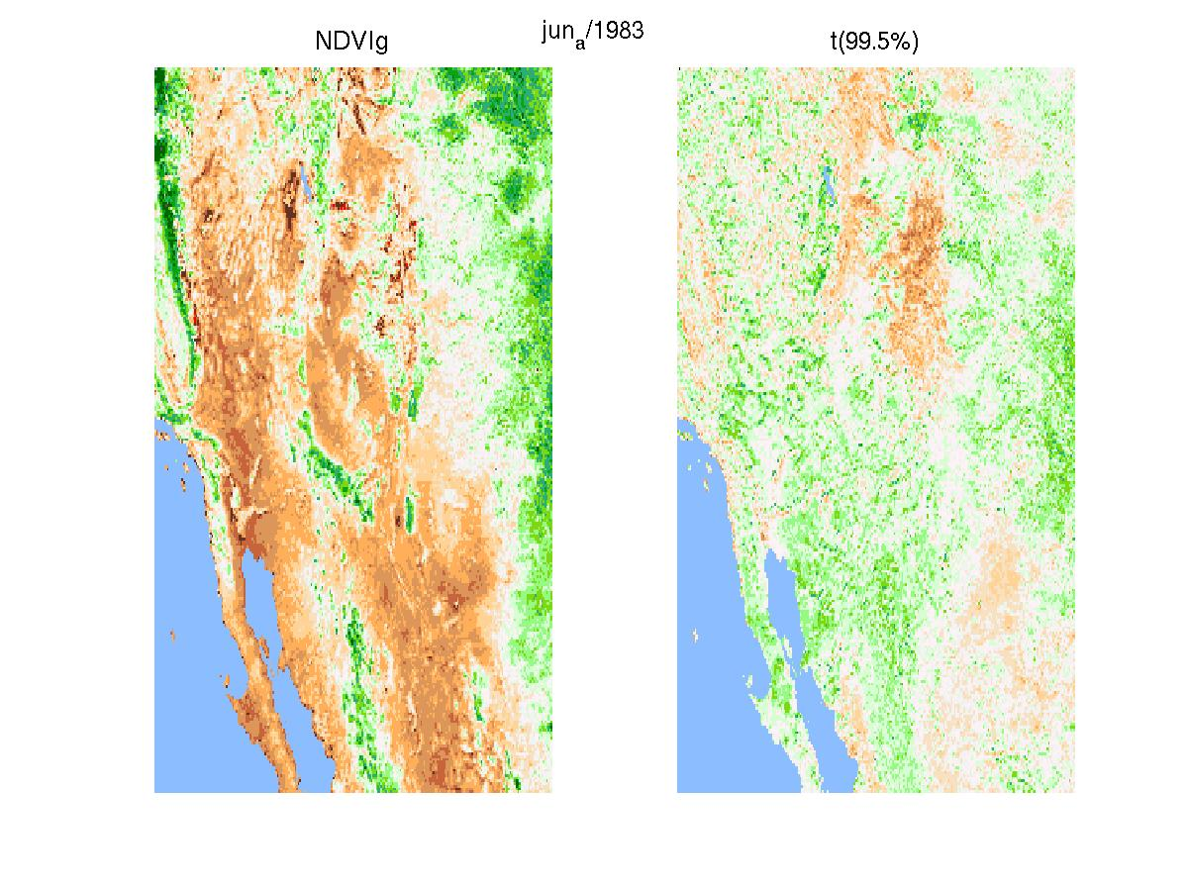
Figure 7. NDVI and normalized anomaly assuming a t^2 distribution. This data is used to issue risk maps with one month of precedence.

Communicating Risk
In general settings, danger and risk are near synonyms. However, these two words have two different meanings: “danger” is the qualitative description of an effect that can cause harm or injury, while “risk” is a quantitative measure of the probability of a situation involving exposure to danger. In general, it is possible to reduce risk when appropriate actions are taken. People tend to be particularly resistant to the idea that they are at risk from any particular hazard. They tend to feel infallible; they feel they are in less danger than the average with a lower than average likelihood of suffering the effects of the exposure to danger. This influences people’s response to risk. The message “this includes you” is more difficult to get across than “many will die.” Thus, perception is an important factor to be taken into account when communicating risks. Research by sociologists and anthropologists has shown that risk perception and its acceptance are rooted in cultural and social factors. It is not different in the case of communicating plague risk.

It is important to transmit the environmental information along other information relevant to risk management about the magnitude of the plague risk so that people may become aware of this connection. Information about personal vulnerability is important for the transition from awareness to the decision to act. However, the decision to act is not the same thing as acting.

There are many substantial challenges associated with establishing a useful plague-oriented climate early-warning and surveillance system. The communication of early plague risk based on environmental conditions is an important factor for establishing such a system. Another important factor is communication of uncertainty associated to the environmental risk. For instance, the current strategies for controlling plague, or more generally infectious diseases, depend largely on surveillance for new outbreaks followed by a rapid response to control the epidemic. For these “surveillance and response” approaches, risk analysis does not need to deal with uncertainty and therefore it does not need to develop correspondent metrics. For “prediction and prevention” approaches a key limiting factor is the uncertainty associated to predictions. This divergence in metrics for assessing uncertainty is usually overlooked and limits the application of early warning systems. In this study, we have considered carefully how users (decision makers) in public health policy and response might use uncertainties in analyzing risk and have implemented quantitative and qualitative tools to communicate uncertainty. Recognition of the importance of uncertainties for risk analysis can also improve communication by more clearly distinguishing between uncertainty in whether, or how frequently, certain events or outcomes might occur and uncertainty in their consequences. This perspective shows that when faced with uncertainty in validating and verifying an early warning system, it is not sufficient to identify only the most likely outcome and compare its result, but to communicate it in a common standardized language (Figure 8 and Table 5.)

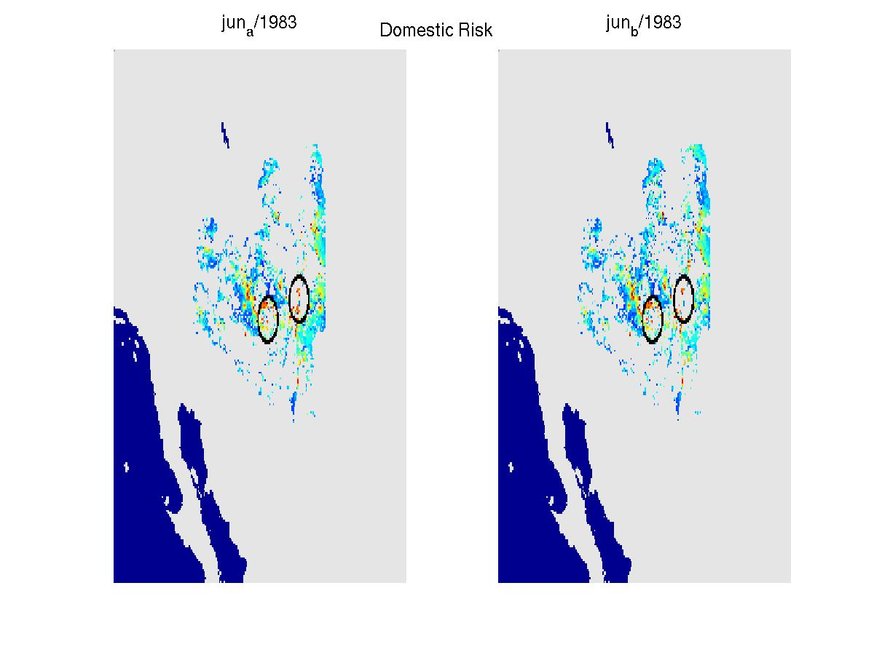
Figure 8. Domestic risk associated to the environmental conditions given in Figure 7. Colors proportional to risk (0.5-blue → 1-red) as in Figure 5.
Studies in risk communication during the past 20 years have recognized that their evolution has passed through seven chronological phases (Fischhoff, 1987, 1995.) The successive stages build on one another, but they do not replace one another:

- All we have to do is get the numbers right (Figures 4-8.)
- All we have to do is tell them the numbers.
- All we have to do is explain what we mean by the numbers (Table 5.)
- All we have to do is show them that they’ve accepted similar risks in the past.
- All we have to do is show them that it’s a good deal.
- All we have to do is make them our partners.
- All of the above.
Table 5. Interpretation of risk and uncertainty of environmental conditions associated to plague risk in terms of common words used to express degrees of danger.
Risk range | Quality description
>0.9 | Probable
0.85-0.9 | Good Chance
0.7-0.84 | Possible
0.5-0.7 | Unlikely
<0.5 | Improbable

This V&V shows that the early-warning system is in phase (iii). In the benchmark, it should obtain phases (iv) through (vii.)

Conclusions
A systematic validation and verification of the ESD suite of measurements against the ArboNET/PSS requirements showed that they add value as input requirements of the ArboNET/PSS. However, there are still many substantial challenges associated with establishing a useful plague-oriented climate early-warning and surveillance system. In particular, tools from risk communication research should be included in the following benchmark phase from the System Engineering approach followed in this project.

Findings
The results of this V&V demonstrate that NASA ESD assets make important contributions to ArboNET/PSS. The GIMMS group, using ESD results, has implemented a progressive “prediction and prevention” approach that is being used to issue an alert that environmental conditions are conducive to plague outbreak which in turn can trigger surveillance efforts for the area in question. This alert has been translated in terms of qualitative descriptions that are used in common language to facilitate the communication of plague risk. These alerts should be used and integrated along with other information into the set of tools available for the decision-making process of plague risk management, policy establishment, and hazard identification.

Recommendations
This V&V report reinforces the findings of the previous evaluation report which underpins the assumption that ESD systems have the potential to enhance and complement the plague “surveillance and response” system used by the CDC with “prediction and prevention” strategies. The overall ArboNET/PSS enhancement effort should continue to be managed through a systems engineering approach so that verified and validated ESD products result in improvements to the ArboNET/PSS system and so they can be effectively benchmarked. The active participation of CDC ArboNET stakeholders should continue so that data and products produced by the NASA science community meet the data delivery and continuity requirements of ArboNET/PSS. Still, a prudent strategy to reduce people’s overall vulnerability is to continue with strong public health measures such as epidemiological surveillance and prevention measures.

Next Steps
Having verified and validated ESD products and models against the ArboNET/PSS requirements -- making sure the quantitative risk numbers are correct and then translating them into a common language used for interpretation of risk -- the next part of the systems engineering process is benchmarking. In the benchmarking phase, special attention should be taken to the integration of these environmental alerts of plague risk along other information relevant to risk management so that people may become aware of the connection to personal vulnerability. This is important for the transition from awareness to the decision to act. However, it should be noted that the decision to act is not the same thing as acting.
Work will continue with the active participation of CDC researchers to benchmark the integration of NASA products into ArboNET/PSS.

References

Enscore, Rusell E, BJ Biggerstaff, TL Brown, RF Fulgham, PJ Reynolds, DM Engelthaler, CE Levy, RR Parmenter, JA Montenieri, JE Cheek, RK Grinnell, PL Ettestad, and KL Gage,. 2002. Modeling relationships between climate and the frequency of human plague cases in the Southwestern United States, 1960-1997, American Journal of Tropical Medicine and Hygiene, 66(2): 186-196.
Fensholt, Rasmus, TT Nielsen, and S Stisen, 2006. Evaluation of AVHRR PAL and GIMMS 10-day composite NDVI time series products using SPOT-4 vegetation data for the African continent. International Journal of Remote Sensing, 27(13): 2719-2733.

Fischhoff, B. 1987. Treating the public with risk communication: A public health perspective. Science, Technology & Human Values, 12 (3- 4), 13- 19.

Fischhoff B. 1995. Risk perception and communication unplugged: Twenty years of progress. Risk Analysis, 15(2):137-145.

Gage, Kenneth L, 1999. Plague Surveillance, Plague Manual: Epidemiology, Distribution, Surveillance and Control. WHO/CDS/CSR/EDC/99.2, Geneva, 1999,135-170.
Morgan, MG, and M Henrion (1990). Uncertainty: A guide to Dealing with Uncertainty in Quantitative Risk and Policy Analysis, Cambridge University Press, Cambridge, UK.
Pinzon, Jorge E., JM Wilson, and CJ Tucker, 2005a. Climate-based health monitoring systems for eco-climatic conditions associated with infectious diseases. Bulletin de la Societe de Pathologie Exotique, 98(3): 239-243.

Pinzon, Jorge E, CJ Tucker, KL Gage, RE Enscore, and RJ Eisen, 2005b. Integration of NASA data into ArboNET/Plague Surveillance System. U.S. Climate Change Science Program (CCSP) Workshop, “Climate Science in Support of Decision Making,” November 14-16, 2005, http://www.climatescience.gov/workshop2005/posters/P-AQ1.10_Pinzon.pdf

Pinzon, Jorge E, ME Brown, and CJ Tucker, 2005c. EMD Correction of Orbital Drift Artifacts in Satellite Data Stream, Chapter 8, Part II in Hilbert-Huang Transform and and its Applications Ed. N. E. Huang and S. S. Shen, World Scientific, Singapore.

Pinzon, Jorge E, CJ Tucker, KL Gage, RE Enscore, and RJ Eisen, 2006. Evaluation Report for ArboNET/Plague Surveillance System. NASA, January 2006.

Tucker, CJ, JE Pinzon, ME Brown, D Slayback, EW Pak, R Mahoney, E Vermote and N El Saleous. 2005. An Extended AVHRR 8-km NDVI Data Set Compatible with MODIS and SPOT Vegetation NDVI Data. International Journal of Remote Sensing, Vol. 26 (20), 4485-4498.

Pinzon, JE, CJ Tucker, KL Gage, RE Enscore, and RJ Eisen (2006). ArboNET/Plague surveillance system: Evaluation report, Jan/2006.
Pinzon JE, Wilson JM & Tucker CJ Climate-based health monitoring systems for eco-climatic conditions associated with infectious diseases/Systèmes de surveillance de santé des maladies infectieuses, basés sur les conditions climatiques. Bulletin de la Societe de Pathologie Exotique, T.98 (3), 2005.
Pinzon, JE, ME Brown, and CJ Tucker, 2005. EMD Correction of Orbital Drift Artifacts in Satellite Data Stream, Chapter 8, Part II in Hilbert-Huang Transform and and its Applications Ed. N. E. Huang and S. S. Shen, World Scientific, Singapore. Tucker, CJ, JE Pinzon, ME Brown, D Slayback, EW Pak, R Mahoney, E Vermote and N El Saleous. 2005. An Extended AVHRR 8-km NDVI Data Set Compatible with MODIS and SPOT Vegetation NDVI Data. International Journal of Remote Sensing, Vol. 26 (20), 4485-4498.
Morgan, MG, and M Henrion (1990). Uncertainty: A guide to Dealing with Uncertainty in Quantitative Risk and Policy Analysis, Cambridge University Press, Cambridge, UK.
Fensholt, Rasmus, TT Nielsen, and S Stisen, 2006. Evaluation of AVHRR PAL and GIMMS 10-day composite NDVI time series products using SPOT-4 vegetation data for the African continent. International Journal of Remote Sensing, 27(13): 2719-2733.
Morgan, MG, and M Henrion (1990). Uncertainty: A guide to Dealing with Uncertainty in Quantitative Risk and Policy Analysis, Cambridge University Press, Cambridge, UK.

