HVAC Air Systems

Exhaust Systems

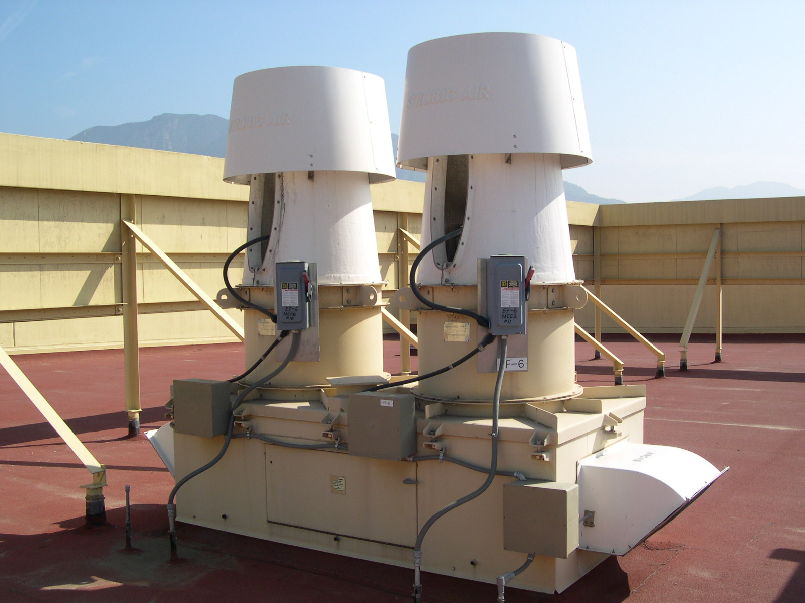

Summary
Process exhaust often operates 8,760 hours a year and is a significant consumer of energy in a cleanroom. As in most areas of efficient design, the first step is to minimize the total demand, in this case, minimize the exhaust volumes through variable flow control and exhaust optimization for the process equipment. Other areas to consider include design approaches to maintain proper stack exit velocity with optimal bypass/dilution airflow and targeting pressure drop bottlenecks in the exhaust ductwork system.
Conditioning makeup air for a cleanroom is expensive. Makeup air goes through several processes before it can be delivered to a cleanroom. Dependent on the space setpoints and the outside climate, the air has to be filtered, heated, cooled, pressurized by a fan, dehumidified and/or humidified. Optimizing the exhaust volumes also result in conditioning and fan energy savings.

Principles
- Optimize the volume of conditioned air exhausted by using a variable volume exhaust system.
- Optimize the dilution airflow rate required to maintain exit velocity by staging stacks or other means. Consider wind tunnel tests or computational fluid dynamics (CFD) analysis to set and verify minimum exit velocity safety.
- Manifold the exhaust streams together when appropriate to maximize turndown capability, reduce initial cost, and increase safety by providing internal dilution of intermittent fume releases.
- Minimize the exhaust system pressure drop.
- Maximize the efficiency of the fan, motor, and drive components.

Approach
The easiest way to achieve energy savings in exhaust systems is to reduce the volume of exhaust. An exhaust optimization program to properly set exhaust rates of all major process equipment will ensure that exhaust rates are safe and reasonable. Further savings can be realized through the use of variable volume exhaust systems whenever feasible. The most common VAV exhaust system is a variable airflow fume hood. Other opportunities for exhaust turndown exist. For example, gas cabinets often operate at higher than necessary airflows to ensure safety on the infrequent occasions the cabinet window or door is opened for service. A reduction in exhaust flow may also be possible for some pieces of equipment when they are not in use or in idle mode, or when the space is unoccupied.
The need to maintain a constant exit velocity from the stack presents a challenge in variable exhaust volume systems. The minimum exit velocity is an easily measured parameter often set based on general guidelines. When very small volumes are being exhausted, a higher velocity may be required. If condensate is possible in the exhaust, a lower velocity may be called for. Very large volumes of exhaust may be safely ejected at lower velocities. A wind tunnel test of the stack design or possibly a detailed CFD study of how the stack relates to the building offers both a verification of the system’s safe operation and a chance to investigate lower exit velocities that would result in equally safe operation, lower power use and lower noise.
When the process exhaust volume drops significantly from the design volume, unconditioned air must be added to the exhaust stream via a bypass, or alternatively the stack exit nozzle area must be reduced to maintain the exit velocity. Using bypass air reduces the amount of conditioned air that is lost to exhaust. It is the most common approach used in laboratory variable air volume (VAV) exhaust systems. However, fan energy is still required to accelerate the dilution air out the stack at a typical velocity of 2,000 - 3,000 fpm.
Reducing the stack exit nozzle area saves both conditioning energy and fan energy. Two approaches are available. The simplest is to utilize multiple stacks, possibly of different exit nozzle areas. As the exhaust volume drops, stacks can be shut off to reduce the total operating nozzle area. A limited amount of dilution air is likely to be needed due to the stepped nature of volume control via staged stack operation. A stack nozzle with an actuated variable area exit orifice offers the most efficient solution, potentially eliminating all need for dilution air; however, it is a more complex, specialty approach that requires locating a suitable manufacturer and properly addressing maintenance concerns.
The final key approach to reduce exhaust energy requirements is to reduce the pressure drop. There are several areas to consider when taking a system approach to minimizing pressure drop.
The type of exhaust and the hours of operation should be considered when sizing the ducts. Fume exhaust ducting that operates 24 hours a day should be sized larger than a particulate exhaust system that requires high velocity for material transport capability, or office space systems that operate 7 AM - 6 PM on business days only. Process exhaust systems vary a great deal and the use of rule of thumb or generic guidelines in sizing decisions can result in excessive operating costs, noise and limitations to future site flexibility. Flexibility is sacrificed since retrofitting of larger exhaust ductwork is often a prohibitively expensive task in an operating facility. Larger ductwork captures immediate operation savings and provides for far greater future expansion flexibility.
Where scrubbers are used, low pressure drop equipment should be selected. The system should be configured to operate the typically redundant scrubbers in a parallel flow arrangement rather than staged. The operation of two scrubbers at 50% of design flow results in a quarter of the pressure drop of operating a single scrubber at 100% flow. Often a redundant backup scrubber can be operated in parallel with the primary unit, resulting in cost savings along with the added benefit of having the backup immediately operating and ready to take over. Variable speed exhaust fan drives and the proper fan and ducting configuration are required to take advantage of all this more efficient configuration.
The required exhaust manifold pressure, which is the negative pressure required from the exhaust fan to operate the collection devices, should be carefully evaluated both in the design stage and during balancing. Often a single bottleneck can result in the pressure drop of the entire system being increased. The pressure drop of the full exhaust fan system is driven entirely by the single highest pressure drop component served. In one laboratory exhaust system, a bathroom exhaust that was placed on the laboratory exhaust system for convenience resulted in the entire 25,000 CFM exhaust fan system being balanced to a higher pressure, and higher fan power, point than required by the laboratory devices. Similarly, a single process tool with a very conservative manufacturer’s recommendation or a cleanroom bay with last minute equipment additions could result in bottlenecks that drive the exhaust fan pressure requirements. Careful design work and active designer participation in the balance process are economical approaches to optimizing the exhaust fan power requirement. A VFD driven exhaust fan is typically required to tune the exhaust fan to the minimum appropriate pressure and power level, although some constant state situations may be able to achieve the most efficient operation point by adjusting pulleys during the air balance.

Related Best Practices
Exhaust Optimization Right Sizing

References

Resources
- http://hightech.lbl.gov/
- Clean Spaces, Chapter 16, ASHRAE HVAC Applications handbook, 2003.
- Industrial Ventilation: A Manual of Recommended Practice, 24th Edition, American Conference of Governmental Industrial Hygienists, Inc., 2001.

