

Call for Action

The Costs of Collecting Medical Records

on Behalf of Consumers Must be Standardized

Summary

Peoplechart works on behalf of consumers to collect, organize, and securely distribute their medical records, so that the information is both secure and available when needed to health providers and other authorized individuals.

Consumers rely on us to perform a difficult task—obtaining records from individual medical providers. Even though patients have a right to request a copy of their medical information, and they have asked us to obtain it on their behalf, we are often handcuffed by exorbitant fees for copying and handling, and by lengthy processes that take months to complete.

Peoplechart participates actively in the nation-wide effort to adopt data standards and move towards greater systems interoperability. Yet, there must also be recognition that today, the majority of clinical information about the patient is still being captured and shared on paper.

A key role for PHR is to provide the tools and services for patients to store their health information with their physicians and other authorized users. Until the rate of adoption increases to a point where the primary medium for capturing and sharing patient information is electronic, the industry must be realistic and acknowledge the existing medium of paper and find ways to capture the information on behalf of patients before the information is lost or destroyed.

We believe we owe it to our customers to fight for standardize photocopying rates and processes, so that we can most efficiently and effectively serve our customers and protect their rights to access this important medical information.

Our Experience
In 2005, as part of Peoplechart-Sponsored National PHR Research Study, we have readily assembled data from three study sites, two in Hawaii and one in Cleveland:
- Waikiki Health Center (Honolulu)
- Transplant Institute of the Pacific (Honolulu)
- Golden Age Centers (senior centers) (Cleveland)

This call-for-public-action centers on the exorbitant charges imposed by some providers—simply for giving patients a copy of the medical records they have requested.

These charges are often imposed by either (1) medical record companies that provide outsourced services under contract with a health care provider; or (2) by medical record departments internal to the health care provider. Typically, we have found that outsourced companies charge higher fees. However, in both cases, the fees are approved by the individual health care provider and governed by the limitations specified by state laws.

There has been little enforcement over the existing legislatures on the amount that providers can charge patients for the medical record copies, and patients bear the consequence of not having access to records unless payment is made at the provider’s asking price.

A Lack of Standardized Fees and Processes Hurts Patients
Peoplechart has over five years of experience collecting records on behalf of consumers—our members. During this time, Peoplechart has discovered great disparity in states’ laws governing the maximum amount of fees that providers can charge for administering patient requests and for photocopying the records. The laws governing the limits on these fees are under the jurisdiction of the state’s civil codes, which are often influenced by special interest groups, provider organizations, and document management companies.

Moreover, the limits are very loosely defined and, as a result of the degree of non-specificity, proven to be totally ineffective and subject to intense arguments and negotiations. Such has been the experience of Peoplechart. A sampling of legislations will reveal that the only limitations placed on the amount charged to patients have been that which would cover a provider’s “reasonable costs.” Several states do specify a maximum fee amount for one-time and per-page costs. Overall, however, the most consistent message we have experienced is that, unless charges are monitored and set to be affordable for most patients, the exorbitant charges impose a strong disincentive on consumers desire to request a copy of their records.

Fortunately, 30% of providers in the study did not charge for a copy of the medical records at the patient’s request. However, for those providers who did charge patients for handling and photocopying the records, charges ranged from $7.22 per page to $0.40 per page. Even at the lowest page rate of 40 cents, this amount is much higher than the rates charged by copying services that perform the work on behalf of individual consumer customers (e.g., FedEx Kinko’s, Office Depot, OfficeMax).

We acknowledge that there is need to cover the costs of labor and supplies. Yet the need to respond to patient requests for a copy of the medical records should not be considered a profit center – which we believe the medical document industry has evolved to be upon review of the statistics accumulated to date from our three study sites.

(1) Because photocopying fees for medical records are not standardized, patients are being charged exorbitant, and often hidden, fees.
- From this study, the average fees charged to patients for administering and copying the medical record files, including the cost of postage and shipping, is 61 cents per page. The average size of records collected is about 75 pages per file. The average total cost to patient for each medical file is $46.
- This amount includes 31% of provider records that do not charge patients. When no-charge records are excluded from the pool, the average rises from 61 cents to 80 cents per page.
- In addition to the per-page charge, most states allow providers to charge upfront fees for administering the patient request (about $15-$20 per record) and set fees for postage and handling.
- For records with 5 pages or less, this upfront fee can be prohibitively expensive. When divided by the minimal number of pages, the costs can be as high as $7.22 per page.
- It has been argued that some providers might have mistaken requests made by Peoplechart on behalf of patients to be that of an insurance or legal firm (usually charged a higher rate). Yet, we did not experience any rate changes, even after explaining our role in the process and despite the fact that each request for a patient’s medical record was stamped with a very obvious “Patient’s Request.”

(2) Records are extremely challenging to obtain, even after multiple written and verbal requests.
- Even with our experience and knowledge, the average number of days it takes Peoplechart to receive a patient’s records is about 37 days. Imagine how much longer for consumers if they were to do this themselves.
- Nearly 30% of records took over 2 months to collect mostly due to rate disputes between Peoplechart acting on behalf of patients and the health care providers.
- Two-thirds of the requests require at least 2 verbal and written attempts, while one-quarter require 3 or more attempts to secure a copy from the health provider.

CALL FOR ACTION
- Patients have the right to obtain copies of their medical records. This should not be a revenue-generating service.
- Copies of medical records must be more affordable for patients. The current provider fees are often prohibitively high and unaffordable for many patients.
- Like the HIPAA regulations governing patient privacy and patient access to medical records, the provider fees that impact patient behavior should be governed by national standards and regulations, not subject to provider influence in each state.
- For medical records stored on-site, we recommend limiting fees close to the equivalent market rates charged by photocopying service companies.
- Record copies should be delivered in a timely manner, with a time limit enforced.
- Both these calls-for-actions could be addressed by a regulatory entity that is able to act quickly and in focused way to address the issues of high medical records charges and delays in record delivery (versus DHHS -- Office of Civil Rights).
- This entity should be funded with adequate resources to (1) enforce limits on cost and time of delivery; and (2) to help address patient complaints and grievances on all aspects related to their health information.
Peoplechart PHR Study Site Statistics 2006

Average Provider Charge $46.39 Per Chart
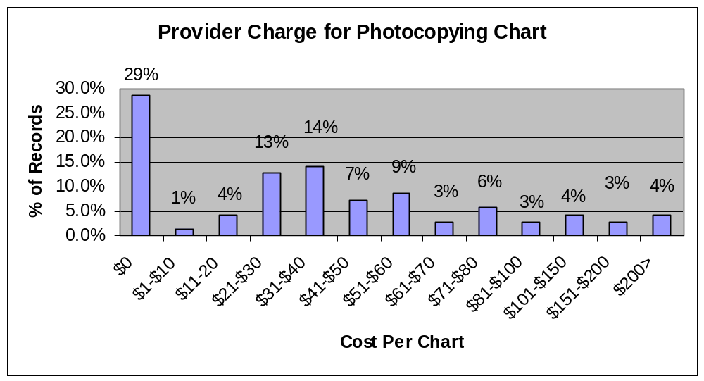

Average 75 Pages Per Record
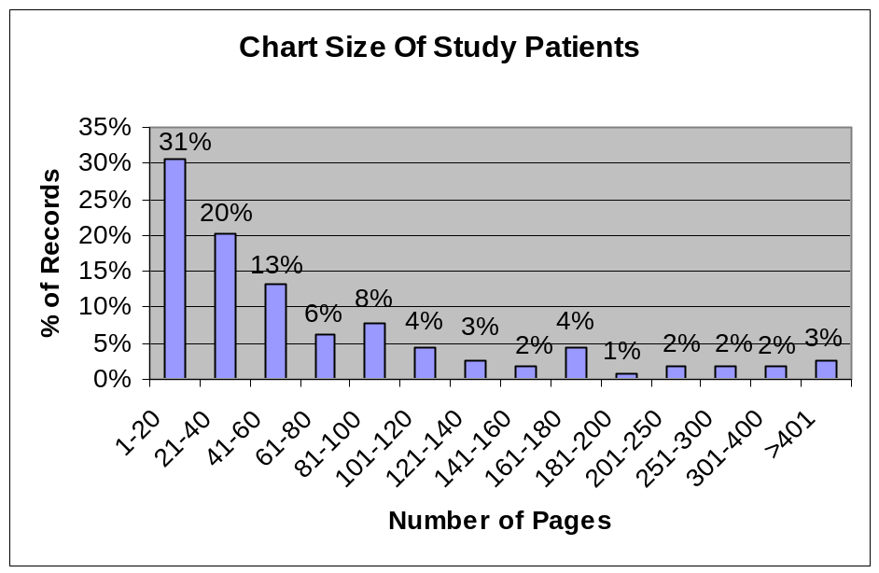

Initial Record Collection Averages 37 Days

(Does not include disputed fees)
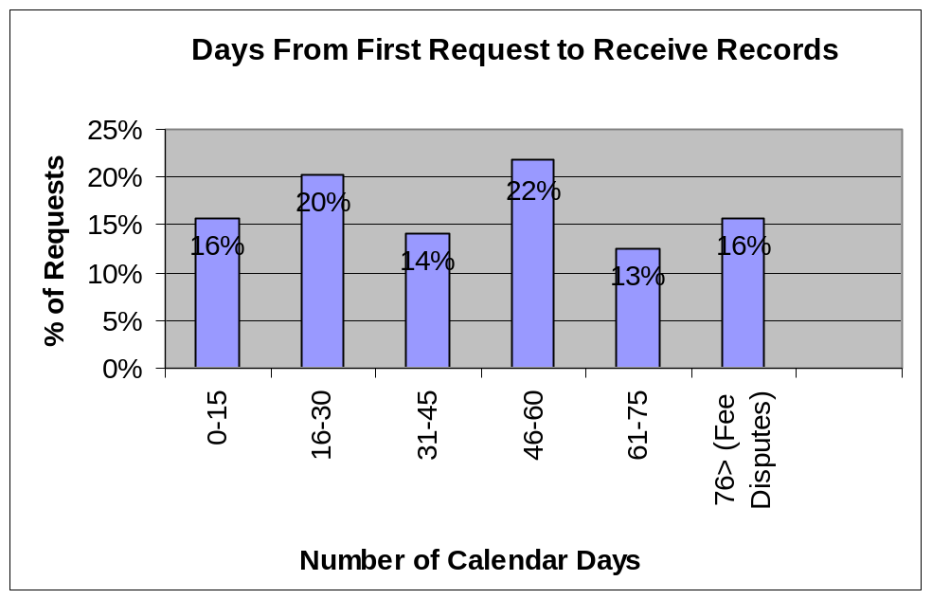

Average Provider Charge $0.61 Per Page

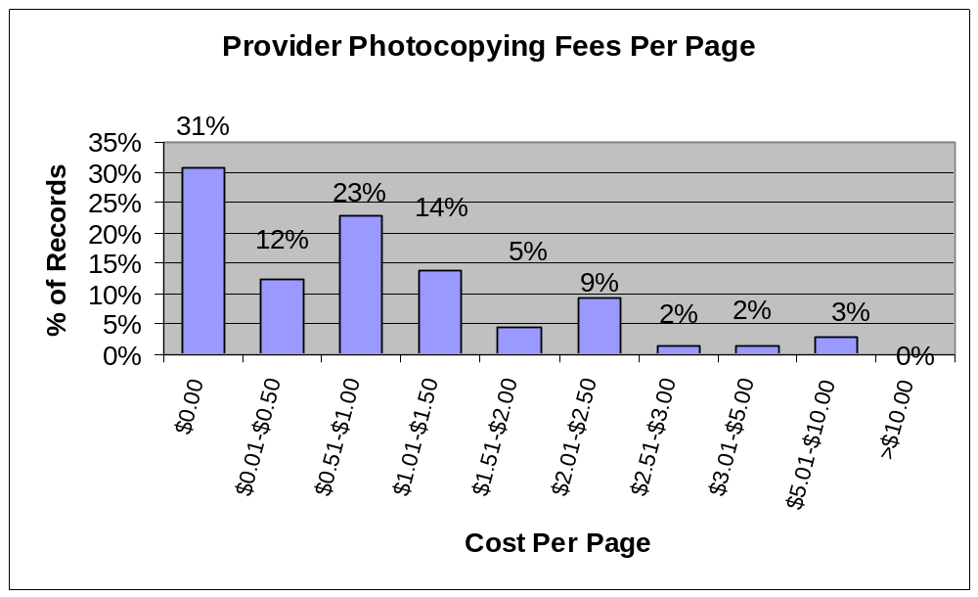
Two Thirds Of Patient Requests Require At Least 2 Attempts
While One Quarter Require 3 Or More Attempts To Secure A Copy



