DESCRIPTION OF THE NEW HIRE COMPONENT
The New Hire (W-4) component of the NDNH is a database of all newly-hired employees as reported from the SDNHs and directly from Federal agencies. This data consists of six data elements found on the Department of Treasury, Internal Revenue Service, W-4 form, “Employee’s Withholding Allowance Certificate”, in addition to other optional information states and Federal agencies may submit.

Legislation
Section 453A(a)(1) of the Social Security Act (the Act) requires states to develop an SDNH that meets Federal requirements by either October 1, 1997, or October 1, 1998, depending on whether a state had a new hire reporting law in effect on August 22, 1996. Section 453(i) of the Act requires the Department of Health and Human Services (HHS) to develop an NDNH by October 1, 1997.
Section 453(n) of the Act requires Federal agencies to report new hire and quarterly wage data as of October 1, 1997. In addition, the law requires maintenance at the national level of information on multistate employers who choose to report W-4 data to one state in which the employer has employees pursuant to Section 453A(b)(1)(B) of the Act. Refer to section 9.3, “Multistate Employer”, for more detailed information regarding W-4 reporting options for multistate employers.
Appendix A, “Federal Law”, contains portions of the Social Security Act that are specific to the NDNH.

Timeframes
There are timeframes associated with the reporting of W-4 data, the performance of matches, and reporting by the NDNH. Some of the timeframes are required by the Social Security Act and other timeframes are functions of the NDNH System processing. Chart 8-1, “W-4 Timeframes,” shows the activities associated with W-4 reporting and the corresponding timeframes.
CHART 8-1: W-4 TIMEFRAMES
Activity | Timeframe
Employers report W-4 data to the SDNH | Such report shall be made not later than 20 days after the date the employer hires the employee; or in the case of an employer transmitting reports magnetically or electronically, by 2 monthly transmissions (if necessary) not less than 12 days nor more than 16 days apart.
Enter W-4 data received from employers into SDNH | Within 5 business days of receiving reports from employers, the SDNH must enter the new hire reports into its database.
SDNHs transmit W-4 data to the NDNH | Within 3 business days after the new hire data is entered into the SDNH, new hire data must be furnished to the NDNH.
Federal agencies transmit W-4 data to the NDNH | Such report shall be made not later than 20 days after the date the employer hires the employee.
Enter W-4 data from Federal agencies and SDNHs into the NDNH | W-4 data must be entered into the NDNH within two business days of the system receiving the data.
Return summary and transmittal data, including error reporting, to the submitter | The NDNH sends transmittal, summary, and error data to the submitting Federal agency and SDNH within four business days of the system receiving the data.
Management information delineating and summarizing each Federal agency’s and SDNH’s submittal data | The NDNH produces reports on a periodic basis.
Compare NDNH and Federal Case Registry (FCR) data | NDNH data and FCR data must be cross-matched not less than every two business days.
Report matches from the NDNH and FCR comparison to the Child Support Enforcement IV-D Agency | The FCR must report NDNH and FCR matching information to the IV-D agency within two business days of the match.

State Directory of New Hires
The provisions of PRWORA require each state to establish an SDNH. States that did not have a new hire reporting law as of the date of the PRWORA (August 22, 1996) must establish an SDNH and be able to receive and transmit data to the NDNH as of October 1, 1997.
Those states that had a law for new hire reporting as of the enactment of PRWORA must report this data to the NDNH as of October 1, 1997. These states have until October 1, 1998 to comply with the remaining requirements of Section 453A of the Act.
States may determine where to house the SDNH (e.g. Child Support Enforcement IV-D agency), State Workforce Agency (SWA), revenue department, private vendor under contract with the state, or local child support enforcement agency. Section 453A of the Act does not specify that the state locate the SDNH in a specific agency. Each state decides where to house its SDNH based on the advantages and disadvantages of each location and selects the place that best meets its operational needs.
Though there are various options concerning where to house the SDNH, each state must have only one site for the collection of new hire data and only one transmission point of connection to the SSA’s transmission system and the NDNH.

W-4 DATA REQUIREMENTS
The SDNHs and Federal agencies collect new hire data and forward this information to the NDNH. Federal law mandates the collection and submission of data elements that are on the Department of Treasury, Internal Revenue Service, W-4 form, “Employee’s Withholding Allowance Certificate”. In addition to the collection and submission of mandated data, the NDNH System stores optional information that is not on a W-4, specifically the Employee Date of Birth, Employee Date of Hire, the State of Hire, and a second Employer Address. These optional data fields improve states’ fraud detection efforts, assist with the administration of programs, increase the effectiveness in identifying the location of persons in Child Support Enforcement IV-D cases, and assist in the prompt implementation of wage withholding for non-custodial parents who owe child support. Even though additional data is optional under federal law, a state may require information that is more extensive. However, any state requirement that employers report information beyond the six federally-mandated data elements must be made under the authority of state law. If a state chooses to require additional information, it may necessitate the filing of a separate report by employers. The Federal law gives employers the option of complying with the Federally-mandated requirements by submitting a W-4 form or, at the option of the employer, an equivalent form. Employers are given the choice to define an “equivalent form”.

Data Requirements
Federal agencies and SDNHs collect and transmit information regarding employees and employers to the NDNH. With the exception of the four optional data elements listed above, this information is found on the W-4 form that is completed by an employee at the time of hire. Refer to the Appendix E, “W-4 Form”, for a copy of the W-4 form. Refer to Section 10.0, “W-4 Transmission”, for record layouts and specifications.

Mandatory Data Elements
Federal law requires collection of the following six data elements from the W-4 form:
- Employee Name,
- Employee SSN,
- Employee Address,
- Employer Name,
- Employer Address, and
- Federal Employer Identification Number (FEIN).
States without new hire laws in existence on August 22, 1996 must comply with the mandatory data elements by October 1, 1997.
States with existing new hire laws prior to August 22, 1996 have until October 1, 1998 to fully comply with the mandatory data requirements. As of October 1, 1998, all W-4 records submitted must contain the mandatory data elements. Prior to October 1, 1998, the NDNH System will accommodate records that contain at the minimum:
- Employee Name,
- Employee SSN, and
- Either the Employee Address, or the Employer Address. (If the record is missing both addresses, but contains an FEIN, the system searches the Employer Identification File (EIF) to attempt to derive an Employer Address. If an employer address is not found on the EIF, then the record does not meet the minimum requirements and is rejected.)

Optional Data Elements
Federal law does not require the collection of the following four data elements; they are not on the W-4 form. However, states may choose to require employers to transmit these data elements to the SDNH, which will then transmit the data to the NDNH. The following are the optional data elements:
- Employer Optional Address (for wage withholding purposes),
- Employee Date of Birth,
- Employee Date of Hire, and
- Employee State of Hire.

Description of the Data Elements
Employee Name: This element is in box #1 of the W-4 form. This is the employee’s first name, middle name or initial, and last name.
Employee SSN: This element is in box #2 of the W-4 form. SSA assigns this 9-digit number to an individual.
Employee Address: This element is in the un-numbered box below box #1 of the W-4 form. This is the number, street name or rural route, city, state, and zip code where an individual resides. This may be a foreign address.
Employer Name: This element is in box #8 of the W-4 form. This is the name of the entity that hires the individual.
Employer Address: This element is in box #8 of the W-4 form. This is the number, street name or rural route, city, state, and zip code of the entity that hires the individual. This should be the address the employer reports to the IRS. This may be a foreign address.
FEIN: This element is in box #10 of the W-4. The IRS assigns this 9-digit number to an employer.
Employee Date of Birth: The W-4 does not contain this optional element. This is the century, year, month, and day the employee was born.
Employee Date of Hire: The W-4 does not contain this optional element. This is the date (Century, Year, Month and Day) the individual was hired.
The date of hire is the first day in which a person performs services for pay (that is the first day of work). This is also the date that the employer recognizes as the first day for income tax withholding.
For additional description of how to determine the Employee Date of Hire, consult OCSE’s “Frequently Asked Questions” at:
http://www.acf.hhs.gov/programs/cse/newhire/employer/faq/faq.htm
Employee State of Hire: The W-4 does not contain this optional element. This is the two-character state abbreviation where an individual’s wages are reported to the State Workforce Agency (SWA).
Employer Optional Address: This is an optional element and is the number, street name or: rural route, city, state, and zip code of an entity that hires an individual. This is the address where an employer receives child support wage withholding orders.

SDNH Collection Methods and Processes
Federal law requires each state to have an SDNH that receives reports from employers on either a W-4 form or, at the option of the employer, an equivalent form. The SDNH must be able to accept W-4 data electronically, magnetically or by first class mail. The SDNH can significantly increase the likelihood of employer compliance by offering employers several other methods for submitting W-4 data, in addition to the methods mandated by Federal law. The following are examples of methods for W-4 data collection.
ELECTRONICALLY AND MAGNETICALLY: Federal law permits employers to submit data by electronic and magnetic means. The following are some of the methods an SDNH may use to collect data electronically or magnetically:
- An SDNH establishes and disseminates an Internet E-Mail Address that allows an employer to submit data either by creating and sending an e-mail or by scanning and sending a W-4 or equivalent form.
- An SDNH creates an interactive World Wide Web site that prompts an employer to key in W-4 data and then submit the data. The site address is:
http://www.acf.hhs.gov/programs/cse/newhire/employer/contacts/nh_matrix.htm
- An employer sends an SDNH a Floppy Disk, Magnetic Tape, Cartridge Cassette Tape, Compact Disk, DVD, FTP, or EFT that contains the data.
Employers are not required by Federal law to transmit W-4 data electronically or magnetically in the same record layout format as required of SDNHs for transmission to the NDNH. However, a state may choose to make that layout a requirement for the employers that report electronically to their SDNH.
PAPER: Federal law requires that an SDNH accept data by first class mail. The SDNH can implement additional paper submission methods for an employer to submit information. The following are some of the other methods of collecting data on paper:
- An employer Mails a copy of the W-4 or equivalent form to the SDNH by private mail service (such as Federal Express).
- An employer sends a copy of the W-4 or equivalent form to the SDNH using a Facsimile Machine.
- An employer Hand Delivers a copy of the W-4 or equivalent form to the SDNH.
TELEPHONE: An SDNH can set up a process whereby an employer can use the telephone to submit data on newly-hired employees. This accommodates small employers who may not have an electronic means to forward the information. There are several ways to collect data by telephone:
- An Operator receives the call from an employer. The employer speaks directly to the operator and the operator records the data.
- A Voice Mail system receives the call and allows the employer to leave a verbal message containing the data.
- A Voice Response System receives the call and prompts the employer to verbally input the data at certain points in the program.
- A Touch-tone Data Input system receives the call and prompts the employer to key in the data using the telephone’s touch-tone keypad.
Once an employer submits W-4 data, the SDNH can process the information into the system using several different means. Some methods of collection, such as receipt of paper copies, require manual entry of data by keying or scanning. Other methods, such as magnetic submission, may only require that an SDNH establish a prescribed format for the records and then process the data directly into its system.

Multistate Employer
Multistate employers are employers that have employees in two or more states. Federal law gives multistate employers two options for reporting their new hire W-4 data:
- A multistate employer may choose to report data on each newly-hired employee to the state in which the employee works. This option allows the employer to submit data via any of the methods accepted by a state; or
- A multistate employer may choose to report data on all newly-hired employees to one of the states in which the employer has employees. If a multistate employer chooses this option, the employer must comply with two requirements of the Federal law:
- Multistate employers must transmit W-4 data electronically or magnetically, and
- Multistate employers must notify the Secretary of Health and Human Services in writing as to which state they are reporting all newly hired employees.
When submitting written notification to the Secretary about the designation of the single state for new hire reporting, an employer should include the following information:
- Federal Employer Identification Number (FEIN),
- Employer’s name, address, telephone number related to the FEIN,
- State selected for reporting purposes,
- Other states in which the company has employees, and
- Corporate point of contact.
If the company will be reporting new hires on behalf of subsidiaries who operate under different names and FEINs, the employer should also list the names, FEINs, states and zip codes where they have employees working.
An employer can notify the Secretary of HHS in one of three ways:
- Notify the Secretary in writing at the following address:
Department of Health and Human Services
Administration for Children and Families
Office of Child Support Enforcement
Multistate Employer Notification
P.O. Box 509
Randallstown, MD 21133
- Notify the Secretary in writing by facsimile:
Department of Health and Human Services
Administration for Children and Families
Office of Child Support Enforcement
Multistate Employer Notification
1-410-277-9325
- Notify the Secretary via online Internet registration by accessing the Multistate Employer Notification Form for New Hire Reporting on the OCSE FPLS Website. The internet address is:
http://www.acf.hhs.gov/programs/cse/newhire/employer/publication/publication.htm
A copy of the Multistate Employer Notification Form for New Hire Reporting (optional form) appears on the following pages as Figure 9-1. The multistate employer can complete this form on the Internet and send it electronically to the Secretary, or they may send it by U.S. mail or facsimile to the Secretary at the above address or facsimile number.
If a multistate employer has questions regarding the reporting of new hires to one state, they can contact the Multistate Employer Hotline at: 1-410-277-9470.
Federal law requires the Secretary of HHS to maintain within the NDNH a list of employers who have chosen to report new hires to one state and the state that each employer has so designated to receive their new hire W-4 data. OCSE maintains this list to assist in identifying employer compliance with W-4 new hire reporting requirements.

INTERNET USERS ONLY:
- Before you sign on to the Internet, we suggest that you fill out the sample form, which follows this section, as a reference.
- To register your company via the Internet, sign on to:
http://151.196.108.21/ocse/
- Follow the instructions at the Internet website.
- If you have any questions or if you experience trouble, please call 1-410-277-9470.
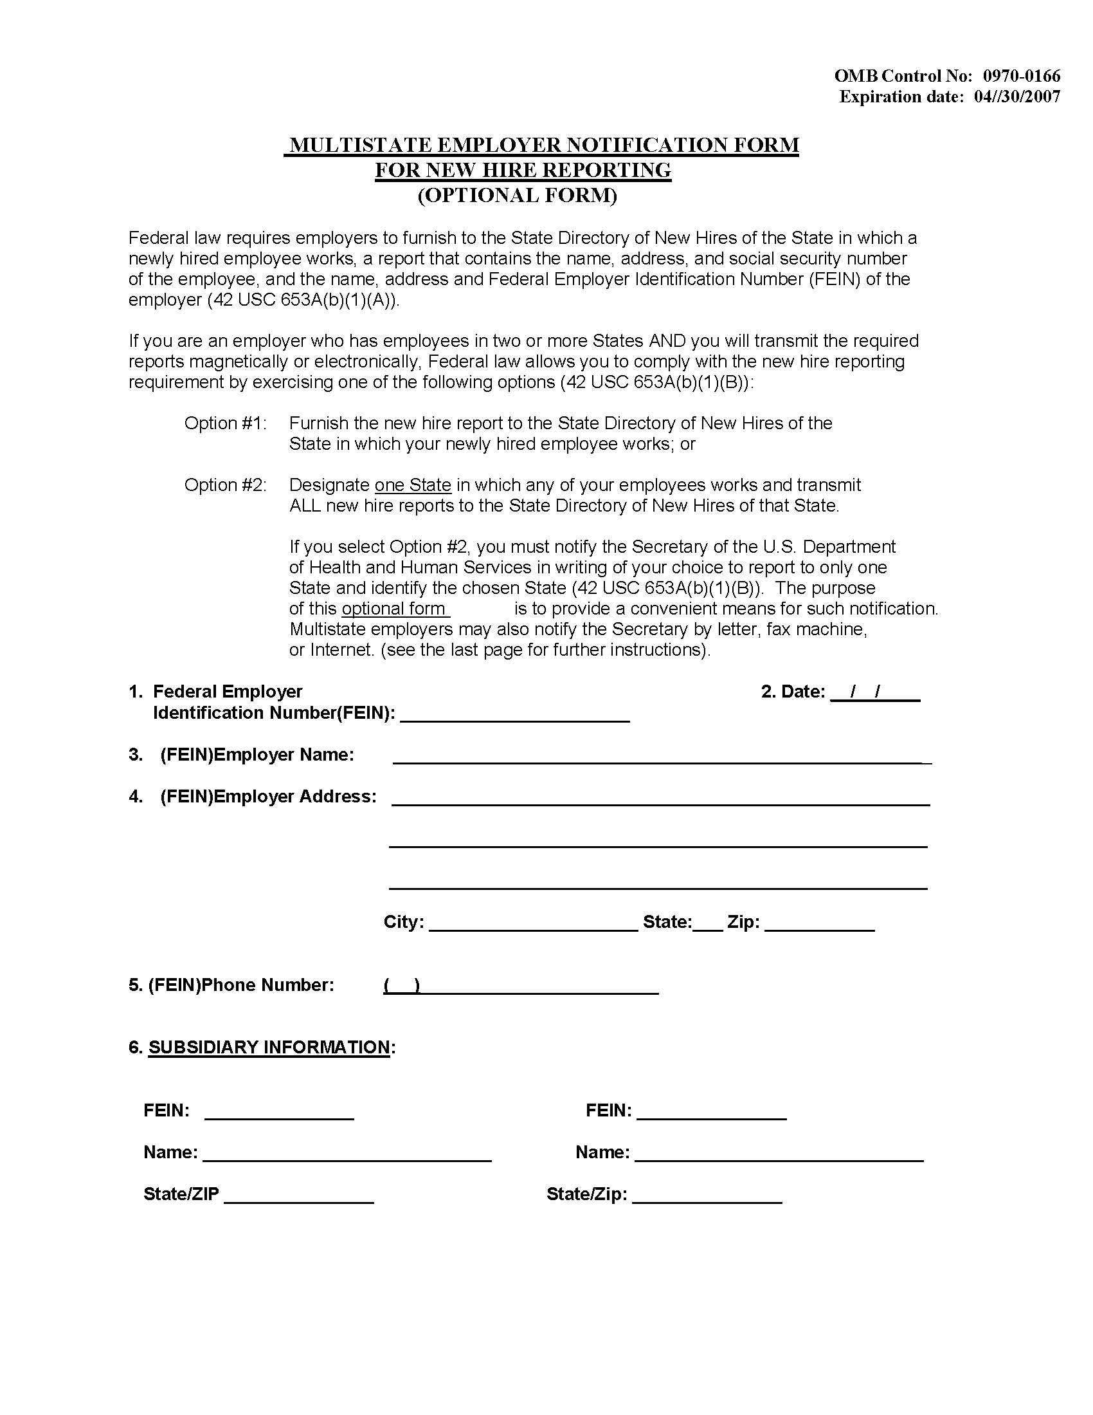
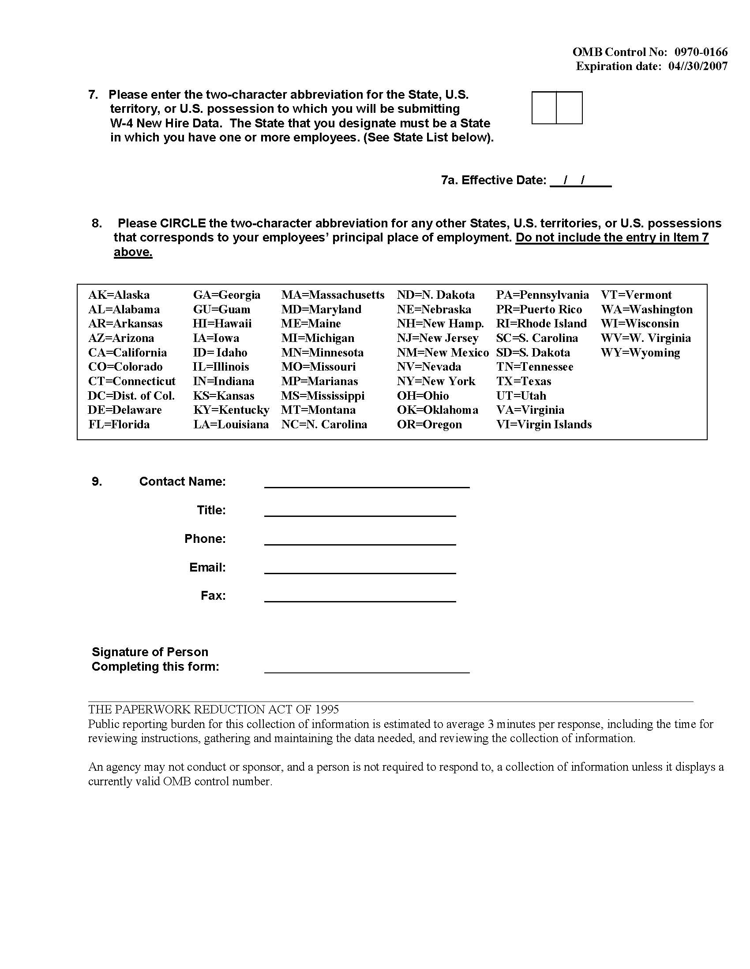
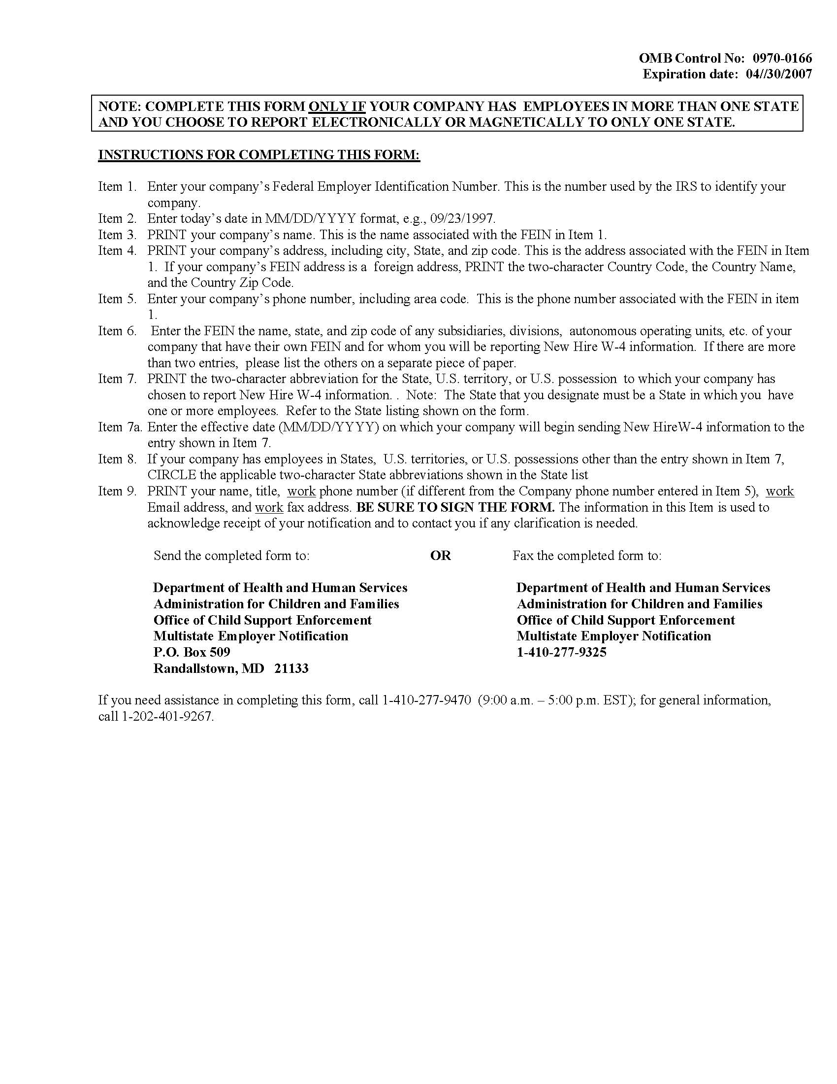

W-4 TRANSMISSION
Designated Federal agencies and the SDNHs transmit W-4 records via SSA’s closed-line CONNECT:Direct system. Each transmission must contain three types of records in the following order:
- W-4 Transmitter Header Record – This record precedes the W-4 data records and contains information about the submitter.
- W-4 Data Records – These records contain the actual W-4 data.
- W-4 Total Record – This record follows the W-4 data records and is a summary of the transmission.

Federal Agency Alternate Transmission Method
Some Federal agencies do not have access to CONNECT:Direct software. The agencies that do not have CONNECT:Direct access may send their data via an alternative transmission method. The transmission method is via Vital Information Systems Network (VISN) PC-to- PC.

TRANSMISSION INSTRUCTIONS FOR AGENCIES THAT DO NOT HAVE connect:Direct

Hardware and Software Requirements for VISN PC-to-PC Transmission
Hardware – PC minimum 486, 25 MHz running Windows (3.1 or higher) 14.4 Kbps Modem
Software – Communications Software (ProComm Plus recommended) PCCrypto Encryption Software by McAfee

VISN PC-to-PC Transmission
VISN utilizes Pro-Comm Plus to exchange data to and from a site to SSA. It is designed as an alternative method to File Transfer Management System for data exchange. The SSA site is maintained as a host, permitting agencies to dial-in to upload their files and to download SSA output files.

The Welcome Screen
The VISN welcome screen asks the caller to provide a first name, last name and password prior to accepting a logon.
First Name = 3 character Organization Code (Organization codes are listed below.)
Last Name = NHD (constant)
Password = Maximum of 8 characters (Each agency designates their own password.)
Example: For Bureau of the Census
First Name = BOC
Last Name = NHD
Password = (alphanumeric password, between 4 and 8 characters, chosen by each agency)
Following acceptance into the system, a menu is offered that allows the caller to select the action they wish to perform. Callers are permitted to choose the protocol they wish.
CHART 10-1: VISN PC-TO-PC TRANSMISSION – ORGANIZATION CODES
Organization | Code | Organization | Code
Administrative Office of the U.S. Courts | AOU | House of Representatives | HOR
AgFirst Farm Credit Bank | AGF | Office of Thrift Supervision | OTS
Bonneville Power Administration | BPA | Supreme Court of the United States | CUS
Bureau of the Census | BOC | Tennessee Valley Authority | TVA
Environmental Protection Agency | EPA | United States Senate | USS
Federal Reserve Board | FRB

To Upload a File
- Select ‘U’ from the menu.
- Select the protocol to be used.
- Identify the file. (See “Dataset Naming Convention Standards” below.)
- Provide a file description.
- Begin the file transfer.
The system will alert you to successful completion or ABEND.
Note: The maximum file size that the VISN system will handle is 5 MB. If you have a file larger than 5 MB, you should divide the file into multiple files and send them individually.

To Check Availability of Files to Download
- Initiate a ProComm session.
- Select ‘F’ from the menu to search for files to be downloaded.
- Enter XXX*.* to identify files that are available for your agency. Place your 3-character Organization Code in the ‘XXX’.
Example: For Bureau of the Census
BOC*.*
- Identify which files should be downloaded. Files to be downloaded are identified as follows:
XXXMMDD.EXE
XXX = 3 character Organization Code
MM = Month
DD = Day
Example: For Bureau of the Census
BOC0909.EXE

To Download Files
- After identifying your file(s) to download, select ‘D’ to download the appropriate file(s) with the extension “.EXE”.
Example: BOC0909.EXE
- Select the protocol to be used.
- Type the full name of the file to be downloaded.
Example: BOC0909.EXE
- Type the 3-character Organization Code followed by “*.EXE” to download all files for your agency.
Example: BOC*.EXE
- Decrypt and uncompress the file after the download is complete.
Note: The file will be downloaded to the default download directory of your communications software program. Check the setup menu to find this directory.

To Leave Mail for the System Operator
Select ‘L’ from the menu.

To Page the System Operator
Select ‘C’ from the menu

Dial-up Lines for PC Transmissions
(410) 966-0454
(410) 966-0459

System Operator’s Phone Number
(410) 966-0461 (24 hour operations)

Instructions for Using PCCrypto
Use PCCrypto to encrypt the data sent to the NDNH. Follow these steps for encryption:
- Create properly formatted file
- Name file using the following naming convention:
xxxMMDDs.NHD
xxx = Organization Code
MM = Month file was created
DD = Day file was created
s = The segment, a number from 0-9, which instructs the NDNH how to put together a file if the size of the file necessitates using more than one diskette (should be ‘0’ if sending only one diskette).
- Encrypt the file using PCCrypto:
- Open PCCrypto and compress the file by selecting the “compress” box before encrypting the file.
- Save the encrypted file as a self-extracting executable file with an “.EXE’ extension. The original file will still have an “.NHD” extension, but the encrypted file needs to be a self-extracting executable with an “.EXE” extension.

Downloading PCCrypto Files
PCCrypto will also be used to compress and encrypt return files. The file will be a self-extracting executable. The requesting site need only download the executable and provide the pre-determined password to uncompress and decrypt the return file(s).
- At the DOS prompt, change the directory to the location of the downloaded file and type the filename without the “.EXE”.
- Enter the password when prompted.
- The downloaded file will be decrypted and uncompressed into the final output file(s).
Note: The file with the “.EXE” extension will remain on your hard drive. Normal maintenance should be applied.

Recommended Dataset Naming Convention Standards
INCOMING – Files transmitted to VISN for processing
XXXMMDD#.NHD
XXX = 3 character Organization Code
MM = Month
DD = Day
# = Sequence number if sending more than one file per day from the same site
NHD = New Hire Data
OUTPUT FILES – Report files made available for download.
XXXMMDD.NHD
XXX = 3 character Organization Code
MM = Month
DD = Day
NHD = New Hire Data

W-4 Record Layouts
The Federal agencies and SDNHs must transmit the W-4 information according to the specified record layouts. The general rules that apply to all the record formats are shown below:
- All data must be in EBCDIC format.
- All alphabetic data must be upper case.
- All alphabetic and alphanumeric data must be left justified.
- All numeric data must be right justified and zero filled.
- All dates must be in the Year 2000-compliant format of CCYYMMDD.
- CC represents the century.
- YY represents the year.
- MM represents the month and must be a number greater than 00, but less than 13.
- DD represents the day of the month and must be a valid number for the designated month (e.g., 01-31 for months 01, 03, 05, 07, 08, 10 or 12; 01-30 for months 04, 06, 09, or 11; and 01-29 for the month 02).
- Name fields cannot include suffixes, such as “Jr.”, “Sr.”, or “III”.
- With the exception of the Employer Name, Employee First Name, Employee Last Name and city names, all data must consist of the characters A-Z and numbers 0-9. The hyphen is the only special character allowed and is only allowed in the Employer Name, Employee Name and City Name fields.
- All state and territory abbreviations in addresses must be valid U.S. Postal Service abbreviations. See Appendix C for a complete list.
- All foreign country codes in addresses must be the two-letter FIPS codes assigned to foreign countries. Refer to the Appendix D or to the U.S. Department of Commerce FIPS Code Manual, National Institute of Standards and Technology, FIPS PUB 10-4 (April 1995) to derive this code. In addition, FIPS codes may be found on the Internet at:
http://earth-info.nga.mil/gns/html/fips10-4.html
- If an address is less than 40 characters per line, do not concatenate into one line.

W-4 Transmitter Header Record
System processing requires the completion of all fields in the W-4 Header Record.
CHART 10-2: W-4 TRANSMITTER HEADER RECORD
OMB Control nO: 0970-0166 expiration date: 04/30/2007
Field Name | Location | Length | A/N | Comments
Record Identifier | 1-2 | 2 | A/N | Required  This must contain the characters ‘H4’.
Transmitter State Code | 3-4 | 2 | A/N | Required for states and territories  This must contain the two-digit numeric FIPS code of the state or territory that is transmitting data to the NDNH. Refer to the Appendix C of this Guide or to the Department of Commerce FIPS Code Manual, National Institute of Standards and Technology FIPS PUB 5-2 (April 1995) for a list of these codes. In addition, FIPS codes may be found on the Internet at http://www.itl.nist.gov/fipspubs/fip5-2.htm Federal agencies leave this field blank.
Transmitter Agency Code | 5-13 | 9 | A/N | Required for Federal agencies  This must contain the nine-character Federal Employer Identification Number (FEIN) or the letter ‘A’ followed by the FIPS code of the Federal agency. SDNHs leave this field blank.
Transmission Type | 14-15 | 2 | A/N | Required  This must contain the characters ‘W4’.
Department of Defense Code | 16 | 1 | A | Required for DoD only  This must contain one of the following characters:  A = Active duty employees  C = Civilian employees  R = Reserve employees  SDNHs and Federal agencies, other than the DoD, leave this field blank.
Version Control Number | 17-18 | 2 | A/N | Required  This must contain the numbers ‘01’. OCSE will notify the SDNHs and Federal agencies when this field changes.
Date Stamp | 19-26 | 8 | N | Required  This must contain the transmission date of the W-4 data to the NDNH. This must be in the Year 2000-compliant format of CCYYMMDD.
Batch Number | 27-32 | 6 | N | Required  This should be a sequential number generated by the transmitting Federal agency or SDNH. Do not repeat batch numbers.
Filler | 33-801 | 769 | A/N | Required  This will be used in future versions. For the current version, this should be all spaces.

W-4 Data Record
Although it is desirable to include all data elements in the W-4 Data Record, it is recognized that this may not be possible initially. The intent of the system is to provide information for locating persons in response to requests from Child Support Enforcement IV-D agencies and to that end, the minimum number of data elements required are those which together constitute a meaningful locate record. A W-4 Data Record must include an Employee First Name, Employee Last Name, Employee SSN and an address. The address may be the Employee Address or the Employer Address. The employer’s address may be represented by a valid FEIN, i.e., one that is held on the system’s EIF and therefore has an associated address already in the system.
System processing requires the completion of the Record Identifier field of the W-4 Data Record.
CHART 10-3: W-4 Data Record
OMB Control nO: 0970-0166 expiration date: 04/30/2007
Field Name | Location | Length | A/N | Comments
Record Identifier | 1-2 | 2 | A/N | Required  This must contain the characters ‘W4’.
Employee SSN | 3-11 | 9 | N | Required  This must contain a nine-digit SSN.  If this field is blank or contains any alphabetic characters, the system rejects the record.
Employee Name  First Name  Middle Name  Last Name | 12-27  28-43  44-73 | 16  16  30 | A  A  A | Required: At least one character in the First Name and one character in the Last Name  If either the first or last name is blank, the system rejects the record.  No special characters, except hyphens, are allowed.
Employee Street Address  Line (1)  Line (2)  Line (3) | 74-113  114-153  154-193 | 40  40  40 | A/N  A/N  A/N | Required: Line (1), if the FEIN and Employer Address are missing  If an address is less than 40 characters per line, do not concatenate into one line.  Use Line (3) for a military designation or Canadian Province Code.
Employee City | 194-218 | 25 | A | Required: If the FEIN and Employer Address are missing  This must have at least two characters. No special characters, except hyphens, are allowed.
Employee State | 219-220 | 2 | A | Required: If the FEIN and Employer Address are missing  This must be a valid two-letter U.S. Postal Service abbreviation of a state or territory. Refer to the Appendix C for state and territory abbreviations.
Employee Zip Code  Zip Code (1)  Zip Code (2) | 221-225  226-229 | 5  4 | A/N  A/N | Required: First five-digits, if the FEIN, Employer Address and Foreign Zip Code are missing  This must be a five-digit U.S. Postal Service Zip Code.  The Zip Code (2) must be either all spaces or all numeric.
Employee Foreign Address  Foreign Country Code  Foreign Country Name  Foreign Zip Code | 230-231  232-256  257-271 | 2  25  15 | A/N  A/N  A/N | Required: If the FEIN and Employer Address are missing and the employee’s address is a foreign country, the Foreign Country Code is required.  Refer to the Appendix D or to the U.S. Department of Commerce FIPS Code Manual, National Institute of Standards and Technology, FIPS PUB 10-4 (April 1995) to derive this code. In addition, FIPS codes may be found on the Internet at http://earth-info.nga.mil/gns/html/fips10-4.html.  The Foreign Country Name and Zip Code are optional.  The Foreign Country Name, if present, must be at least two characters.  Include military designation or Canadian Province Code.
Employee Date of Birth | 272-279 | 8 | A/N | This must be in the Year-2000 format of CCYYMMDD, if present.  This must be either all spaces or all numeric.
Employee Date of Hire | 280-287 | 8 | A/N | This must be in the Year-2000 format of CCYYMMDD, if present.  This must be either all spaces or all numeric.  The date of hire is the first day in which a person performs services for pay (that is, the first day of work). This is also the date the employer recognizes as the first day for income tax withholding.  For additional description of how to determine the Employee Date of Hire, consult OCSE’s “Frequently Asked Questions” at:  http://www.acf.hhs.gov/programs/cse/newhire/employer/faq/faq.htm
Employee State of Hire | 288-289 | 2 | A | This must be a valid two-letter U.S. Postal Service abbreviation of a state or territory, if present. Refer to the Appendix C for state and territory abbreviations.
Federal EIN | 290-298 | 9 | N | Required: If the Employee Address and the Employer Address are missing  This is the Federal Employer Identification Number (FEIN) the IRS assigns to an employer.
State EIN | 299-310 | 12 | A/N | This is a number a state may assign an employer.
Employer Name | 311-355 | 45 | A/N | This must be at least two characters, if present. No special characters except hyphens are allowed.
Employer Street Address  Line (1)  Line (2)  Line (3) | 356-395  396-435  436-475 | 40  40  40 | A/N  A/N  A/N | Required: If the Employee Address and the FEIN are missing  This must be at least 2 characters, if present.  If an address is less than 40 characters per line, do not concatenate into one line.  Use Line (3) for a military designation or Canadian Province Code.
Employer City | 476-500 | 25 | A | Required: If the Employee Address and the FEIN are missing  This must be at least two characters, if present.  No special characters, except hyphens, are allowed.
Employer State | 501-502 | 2 | A | Required: If the Employee Address and the FEIN are missing  This must be a valid two-letter U.S. Postal Service abbreviation of a state or territory, if present. Refer to the Appendix C for state and territory abbreviations.
Employer Zip Code  Zip Code (1)  Zip Code (2) | 503-507  508-511 | 5  4 | A/N  A/N | Required: If the Employee Address, FEIN, and Foreign Zip Code are missing  This is the five-digit U.S. Postal Service Zip Code associated with the employer’s address.  The Zip Code (2) must be either all spaces or all numeric.
Employer Foreign Address  Foreign Country Code  Foreign Country Name  Foreign Zip Code | 512-513  514-538  539-553 | 2  25  15 | A/N  A/N  A/N | Required: If the FEIN and Employee Address are missing and the employer’s address is a foreign country, the Foreign Country Code is required.  Refer to the Appendix D or to the U.S. Department of Commerce FIPS Code Manual, National Institute of Standards and Technology, FIPS PUB 10-4 (April 1995) to derive this code. In addition, FIPS codes may be found on the Internet at http://earth-info.nga.mil/gns/html/fips10-4.html. The Foreign Country Name and Zip Code are optional.  The Foreign Country Name, if present, must be at least two characters.  Include military designation or Canadian Province Code.
Employer Optional Street Address  Line (1)  Line (2)  Line (3) | 554-593  594-633  634-673 | 40  40  40 | A/N  A/N  A/N | This is the employer’s street address where a child support wage withholding order should be sent.  If an address is less than 40 characters per line, do not concatenate into one line.  Use Line (3) for a military designation or Canadian Province Code.
Employer Optional City | 674-698 | 25 | A | No special characters, except hyphens, are allowed.
Employer Optional State | 699-700 | 2 | A | This must be a valid two-letter U.S. Postal Service abbreviation of a state or territory, if present. Refer to the Appendix C for state and territory abbreviations.
Employer Optional Zip Code  Zip Code (1)  Zip Code (2) | 701-705  706-709 | 5  4 | A/N  A/N | This must be either all spaces or all numeric.
Employer Optional Foreign Address  Foreign Country Code  Foreign Country Name  Foreign Zip Code | 710-711  712-736  737-751 | 2  25  15 | A/N  A/N  A/N | Foreign Country Code: Refer to the Appendix D or to the U.S. Department of Commerce FIPS Code Manual, National Institute of Standards and Technology, FIPS PUB 10-4 (April 1995) to derive this code. In addition, FIPS codes may be found on the Internet at  http://earth-info.nga.mil/gns/html/fips10-4.html.  The Foreign Country Name must be at least two characters, if present.  Include military designation or Canadian Province Code.
Filler | 752-801 | 50 | A/N | This will be used in future versions. For the current version, this should be all spaces.

W-4 Total Record
System processing requires the completion of all fields in the W-4 Total Record.
CHART 10-4: W-4 TOTAL RECORD
OMB Control nO: 0970-0166 expiration date: 04/30/2007
Field Name | Location | Length | A/N | Comments
Record Identifier | 1-2 | 2 | A/N | Required  This must contain the characters ‘T4’.
Data Record Count | 3-13 | 11 | N | Required  This must be the number of records in the transmission, including the header and trailer records.
Filler | 14-801 | 788 | A/N | Required  This will be used in future versions. For the current version, this should be all spaces.

Pre-Transmission Editing
Prior to submitting W-4 data to the NDNH, Federal agencies and SDNHs should perform edits on the data to ensure compliance with the requirements as outlined in the record layouts. This ensures that the data meets the requirements for acceptance to the NDNH and that the NDNH has accurate and complete information. All submitters must meet the mandatory data requirements.

Frequency of Transmission
Federal law requires the SDNHs to enter W-4 data on their system within five business days of receipt of the data from employers. The SDNHs must then transmit the data to the NDNH within three business days from entering it into their system.
Federal agencies transmit W-4 data directly to the NDNH. Such report shall be made not later than 20 days after the date the agency hires the employee; or in the case of an agency transmitting reports magnetically or electronically, by 2 monthly transmissions (if necessary) not less than 12 days nor more than 16 days part.

Transmission Errors
When transmitting W-4 data, there are errors that can occur at the transmission level. Depending upon the type of error, the system: 1) rejects the entire transmission, 2) rejects part of the transmission, or 3) accepts the transmission, but returns a warning code to the submitting agency. If a Federal agency or SDNH receives notice of rejection due to transmission error (#1 and #2 above), they must correct the information and resubmit the data. The following table lists the error codes at the transmission level. Refer to the Section 11.0 “W-4 Data Validation and Verification”, for a list and explanation of W-4 record errors.
CHART 10-5: W-4 Transmission Error and Warning Codes Table
Code | Error Message and Description
TRANSMISSION ERROR CODES – Full Transmission Rejected
5000 | The Transmitter Header record is required.  The Transmission Header Record must be present at the beginning of each transmission file.
5001 | The Transmitter Header Record does not contain the Transmitter State Code or Transmitter Agency Code.
5002 | The Transmitter Header Record does not contain the Version Control Number or has an invalid Version Control Number. Version Control Number must equal ‘01’.
5003 | The Transmitter Header Record contains a non-numeric Batch Number. The Transmission Header Record must contain a numeric Batch Number.
5004 | The Transmitter Header Record contains a Batch Number that is a duplicate of a previously received Batch Number. The Transmission Header Record must not contain a Batch Number that is a duplicate of a Batch Number received in a previous transmission from the state or Federal Agency within the same calendar year.
TRANSMISSION ERROR CODES – Part of the Transmission Rejected
5005 | The Transmitter Header Record is not the first record. All records are rejected until a Transmitter Header Record is found.
TRANSMISSION WARNING CODES – Transmission Accepted, Warnings Issued
5006 | The Transmission Type in the Transmitter Header Record must equal ‘W4’.
5007 | The Transmitter Header Record does not contain the Date Stamp or the Date Stamp is an invalid date.
5008 | The Total Record is missing.
5009 | The Data Record Count is non-numeric.
5010 | The Data Record Count does not equal the count of the records received.

Resubmittal Process
The resubmittal process is identical to the standard submittal process. Federal agencies and SDNHs resubmit all corrected records and transmissions in the standard formats and via C:D or via the alternative transmission method for designated agencies. When resubmitting a corrected transmission, the submitter should submit the corrected full transmission. When resubmitting corrected records, only the corrected records. Submitters that are unable to correct the records or identify the transmission problems can contact technical support for assistance. Refer to Section 3.0, “Technical Support”, for a list of the available technical support options.

W-4 DATA VALIDATION AND VERIFICATION
Accurate data is essential to ensure the integrity of the NDNH database. W-4 data transmitted by a Federal agency or state undergoes various validation and verification processes. Submitters receive information regarding validation and verification within four business days. Refer to Section 13.0, “W-4 Output to Submitters”, for more detail regarding return data.

Validation Process
NDNH edits incoming data at the various levels from file transmission to the individual record.

TRANSMISSION LEVEL EDITING
When a file is received by the NDNH, the Node ID in the dataset name for states and Federal agencies is verified to determine if the submission is from a valid user. If the Node ID is not valid, the file will be suspended and the submitter will be contacted.
After the Node ID has been validated, the Submitter ID in the Header Record is evaluated against a Master Table to determine the authenticity of the submission. If the Submitter ID is not registered in the Master Table, the batch will be suspended and the submitter will be contacted.

Batch EDITING
All files that pass the transmission level editing are evaluated to ensure that the required records and data values in the header and file are present. If the required elements or records are missing, the transmission will be rejected. The edits will allow part of or the entire transmission to be processed if minor errors occur. Chart 11-1, “W-4 Batch Editing”, describes the types of edits performed and the output at the submission level.

CHART 11-1: W-4 Batch Editing
Edit | Processing
Check for a Transmission Header Records in the file. If the Transmitter Header Record is missing, the file is rejected. | The transmission is rejected and an error code is returned to the submitter.
The Transmitter Header Record does not contain a valid Transmitter State or Federal Agency Code. | The transmission is rejected and an error code is returned to the submitter.
The Transmitter Header Record does not contain the Version Number or has an invalid Version Number. | The transmission is rejected and an error code is returned to the submitter.
The Transmitter Header Record contains a non-numeric Batch Number. | The transmission is rejected and an error code is returned to the submitter.
The Transmitter Header Record contains a Batch Number that is a duplicate of a Batch Number that was previously received from the submitter within the Calendar Year. | The transmission is rejected and an error code is returned to the submitter.
The Transmitter Header Record is not the first record in the file. | All records prior to the Header Record are rejected and all records after the Header Record are processed. A warning code is returned to the submitter.
The Transmission Type in the Transmitter Header Record is not equal to ‘W-4’. | All records are processed and a warning code is returned to the submitter.
The Date Stamp is missing or invalid in the Transmitter Header Record. | All records are processed and a warning code is returned to the submitter.
The Total Record is missing. | All records are processed and a warning code is returned to the submitter.
The Data Record Count is non-numeric. | All records are processed and a warning code is returned to the submitter.
The Data Record Count does not equal the count of the records received. | All records are processed and a warning code is returned to the submitter.
If a W-4 submitter receives notice of rejection, the submitter should correct the information and resubmit the data via CONNECT: Direct or the designated alternative transmission method. If the submitter receives a warning notification, they should investigate the warning. If records were not processed because of the warning, the submitter should correct the issue and resubmit the data.

rECORD LEVEL EDITING
The NDNH edits each record to ensure that all of the required data elements are present, that key values are valid, and that data conforms to the system standards before it is accepted.

SSN/Name Verification
The NDNH System performs edits on the SSN and Name entries and sends SSN/Name combinations that appear to be valid to SSA for verification. Section 5.0, “Social Security Number Verification”, outlines the SSN verification processes and errors. Chart 11-2, “W-4 SSN/Name Verification”, describes the types of SSN edits performed on each W-4 record.
CHART 11-2: W-4 SSN/Name Verification
Edit | Processing
The SSN is spaces. | The record is rejected with an error code and is returned to the submitter.
The SSN is non-numeric. | The record is rejected with an error code and is returned to the submitter.
The SSN is not greater than zeros. | The record is rejected with an error code and is returned to the submitter.
The first 5 digits of the SSN have not been issued by SSA. | The record is rejected with an error code and is returned to the submitter.
The Employee Name is missing. | The record is rejected with an error code and is returned to the submitter.
The SSN and name do not match with SSA’s records, or the SSN is not found at SSA. | The record is rejected with an error code and is returned to the submitter. This is returned after all attempts to verify the SSN and name fail.
Verification of SSN and name failed, the First Name and Last Name were transposed, and the SSN and transposed name combination was verified. | The record is passed to the next level of verification. The record is assigned a warning code and is returned to the submitter.
Any records that do not pass the SSN or SSN/Name verification process are dropped from the system. All records passing the SSN or SSN/Name verification process will continue through the record edits.

Minimal Data Validation
Each W-4 data is validated to ensure that it contains an:
- Employee Address,
- Employer Address, or
- FEIN.
If the record does not an Employee Address, Employer Address or FEIN; it is rejected with an error code and returned to the submitter.

General Validation
General Validation edits are performed on all records passing the SSN/Name and Minimal Data Validation. These edits will determine the validity of the data provided or identify missing data that would be beneficial to NDNH users. General validation will only create warning codes for the W-4 record. These warning codes will not keep records from being posted to the NDNH.
The employee data is checked for a first and last name. If the first or last name is missing a warning code is returned to the submitter.
The date of birth and date of hire are checked to ensure that they are numeric and contain valid dates. If the dates contain an invalid day, month, or year; a warning code is returned to the submitter.
The employee and employer address data are analyzed to determine the validity of the data provided. Chart 11-3, “W-4 General Validation”, describes how the analysis is performed:
CHART 11-3: W-4 General Validation
Edit | Processing
The Employee or Employer Zip Code is missing or non-numeric. | A warning code is returned to the submitter.
The Employee or Employer Zip Code does not match the City. | A warning code is returned to the submitter.
The FEIN is non-numeric. | A warning code is returned to the submitter.
The FEIN is blank or zeros. | A warning code is returned to the submitter.
The Employee or Employer State is missing. | A warning code is returned to the submitter.
The Employee or Employer State is invalid (not a valid 2 character USPS abbreviation). | A warning code is returned to the submitter.
The Employee or Employer Name is blank. | A warning code is returned to the submitter.
The Employee or Employer Address Line 1, 2 and 3 are all blanks. | A warning code is returned to the submitter.
The Employee or Employer City is blank. | A warning code is returned to the submitter.
The Employee or Employer Foreign City is blank and the Employer Zip Code is blank. | A warning code is returned to the submitter.

Error Codes and Explanations
The following Chart 11-4, “W-4 Error and Warning Codes”, outlines the W-4 record error and warning codes:

CHART 11-4: W-4 Error and Warning Codes
Code | Error Description
ERROR CODES – RECORD REJECTED AND NOT ADDED TO NDNH
0001 | SSN and name do not match.
0002 | SSN is invalid or out of range.
0011 | SSN is non-numeric.
0015 | SSN is missing or is not greater than zeroes.
0016 | Employee Name is missing.
0017 | Employee Address and Employer Address are missing (and Employer Address cannot be derived from the FEIN).
WARNING CODES – RECORD ACCEPTED AND ADDED TO NDNH
0004 | W-4 SSN verified by transposing First Name and Last name.
0005 | W-4 SSN has been corrected.
0020 | Employee Zip Code is missing or non-numeric; format must be a five-digit U.S. Postal Service Zip Code.
0021 | Employee Zip Code does not match City.
0022 | Employee State abbreviation is missing.
0023 | Employee State abbreviation is invalid; format should be two letter state or territory abbreviation.
0024 | Employee First Name is missing.
0025 | Employee Last Name is missing.
0027 | Employee Street Address Lines are missing.
0028 | Employee City is missing.
0029 | Employee Date of Birth is an invalid date; format should be CCYYMMDD.
0030 | Employee Date of Hire is an invalid date; format should be CCYYMMDD.
0031 | Employee State of Hire is invalid; format should be two-letter state or territory abbreviation.
0032 | Employee Address is incomplete.
0040 | Employer Zip Code is missing or non-numeric.
0041 | Employer Zip Code does not match City.
0042 | FEIN is non-numeric.
0043 | FEIN is missing or is zero.
0044 | Employer State abbreviation is missing.
0045 | Employer State abbreviation is invalid; format should be two-letter state or territory abbreviation.
0046 | Employer Name is missing.
0047 | Employer Street Address Lines are missing.
0048 | Employer City is missing.
0049 | Employer Foreign Address is incomplete.

W-4 NDNH UPDATE
The NDNH System stores verified records in the NDNH W-4 File. The W-4 records in the NDNH W-4 File are the records the system uses for proactive matching with the FCR and for locate searches in response to a locate request.

Duplicates
If a Federal agency or SDNH submits a duplicate record or records within a transmission, the NDNH System processes the first of such records and ignores the duplicate W-4 record(s). Two W-4 records are considered duplicates of each other only if the contents of each field matches the contents of the corresponding field on the other record. If an SDNH or Federal agency submits a duplicate record in a subsequent transmission, the NDNH stores the duplicate W-4 record, as the system does not compare new W-4 records to previously- submitted records.

W-4 OUTPUT TO SUBMITTERS
The NDNH System returns information regarding W-4 data to the submitter. The NDNH
System returns the following:
- The number of records received in a transmission, including the Transmitter Header Record and the Total Record;
- The number of rejected records;
- The number of records in a transmission with errors or warnings regardless of the return error suppression matrix choices;
- The number of records accepted and written to the NDNH file;
- Transmission error codes;
- Each W-4 record that has errors or warnings along with up to five error or warning codes; and
- Each W-4 record that has a corrected SSN along with the correct SSN.
In addition to receiving return data about W-4 records, SDNHs receive an MI summary report on a regularly scheduled basis. Refer to Section 14.0, “W-4 Management Information”, for details and information on MI reports.

Output Record Layouts
The NDNH returns W-4 record transmission and error information via SSA’s closed-line C:D system to:
- all states, and
- Federal agencies that submit data by C:D.
Federal agencies that submit data via VISN PC-to-PC method obtain their W-4 transmission and error information via VISN.
A trailer or total record is not returned to the submitting state or Federal agency in response to W-4 transmissions. Each transmission contains two types of records in the following order:
- W-4 Transmission Control Record – This record precedes the returning W-4 records and contains information about the submitter’s transmission.
- W-4 Data Records – These records contain the actual W-4 data, associated errors or warnings and the corrected SSN (when applicable).
The NDNH transmits the returning W-4 information according to specified record layouts. There are some general rules that apply to the record formats. The following are the general rules:
- All data are in EBCDIC format.
- All alphabetic data are upper case.
- All alphabetic and alphanumeric data are left justified.
- All numeric data are right justified and zero filled.
- All dates are in the Year 2000-compliant formatting of CCYYMMDD.
- CC represents the century.
- YY represents the year.
- MM represents the month and must be a number greater than 00, but less than 13.
- DD represents the day of the month and must be a valid number for the designated month (that is, 01-31 for month 01, 03, 05, 07, 08, 10, and 12; 01-30 for month 04, 06, 09, and 11; and 01-29 for month 02).
- There are no special characters with the exception of Employer Name, Employee First Name, Employee Last Name and City, which may have the special character hyphen only.
- All state and territory abbreviations in addresses are valid U.S. Postal Service abbreviations. See Appendix C for listing.
- All foreign country code abbreviations in addresses are the 2-digit FIPS code assigned to a foreign country. Refer to Appendix D, “Foreign Country FIPS Codes”, in this Guide, or to the U.S. Department of Commerce FIPS Code Manual, National Institute of Standards and Technology, FIPS PUB 10-4 (April 1995), to derive this code. In addition, FIPS codes may be found on the Internet at http://earth-info.nga.mil/gns/html/fips10-4.html.

CHART 13-1: W-4 Transmission Control Record
OMB Control nO: 0970-0166 expiration date: 04/30/2007
Field Name | Location | Length | Alpha/Numeric
Record Identifier | 1-2 | 2 | A/N
Transmitter State Code | 3-4 | 2 | A/N
Transmitter Agency Code | 5-13 | 9 | A/N
Transmission Type | 14-15 | 2 | A/N
Department of Defense Code | 16 | 1 | A
Version Control Number | 17-18 | 2 | A/N
Date Stamp | 19-26 | 8 | N
Batch Number | 27-32 | 6 | N
Records Received | 33-43 | 11 | N
Records Rejected | 44-54 | 11 | N
Error Records Returned | 55-65 | 11 | N
Records Posted to NDNH | 66-76 | 11 | N
Filler | 77-87 | 11 | A/N
Error Code 1 | 88-91 | 4 | A/N
Error Code 2 | 92-95 | 4 | A/N
Error Code 3 | 96-99 | 4 | A/N
Error Code 4 | 100-103 | 4 | A/N
Error Code 5 | 104-107 | 4 | A/N
Filler | 108-831 | 724 | A/N
Data in the W-4 Transmission Control Record is a duplicate of the information submitted by the Federal agency or SDNH, with the exception of the following:
Record Identifier: This is the character and number ‘R4’ identifying the record as the header record containing returning W-4 data.
Records Received: This is the total number of records received in the transmission, including the header and trailer records.
Records Rejected: This is the total number of records rejected in the transmission.
Error Records Returned: This is the total number of W-4 records with errors or warnings returned in the transmission.
Records Posted to NDNH: This is the total number of W-4 records in the transmission that were accepted and posted to the NDNH W-4 File.
Error Code 1: *This is an error at the transmission level.
Error Code 2: *This is an error at the transmission level.
Error Code 3: *This is an error at the transmission level.
Error Code 4: *This is an error at the transmission level.
Error Code 5: *This is an error at the transmission level.
Filler: This field is all spaces.
*Refer to the “W-4 Transmission Error and Warning Codes Table” in section 10.5, “Transmission Errors”, for the transmission level error and warning codes and their explanation.

CHART 13-2: W-4 DATA RECORD (RETURNED TO SUBMITTER)
OMB Control nO: 0970-0166 expiration date: 04/30/2007
Field Name | Location | Length | Alpha/Numeric
Record Identifier | 1-2 | 2 | A/N
Employee SSN | 3-11 | 9 | N
Employee Name  First Name  Middle Name  Last Name | 12-27  28-43  44-73 | 16  16  30 | A  A  A
Employee Street Address  Line (1)  Line (2)  Line (3) | 74-113  114-153  154-193 | 40  40  40 | A/N  A/N  A/N
Employee City | 194-218 | 25 | A
Employee State | 219-220 | 2 | A
Employee Zip Code  Zip Code (1)  Zip Code (2) | 221-225  226-229 | 5  4 | A/N  A/N
Employee Foreign Address  Foreign Country Code  Foreign Country Name  Foreign Zip Code | 230-231  232-256  257-271 | 2  25  15 | A/N  A/N  A/N
Employee Date of Birth | 272-279 | 8 | A/N
Employee Date of Hire | 280-287 | 8 | A/N
Employee State of Hire | 288-289 | 2 | A
Federal EIN | 290-298 | 9 | N
State EIN | 299-310 | 12 | A/N
Employer Name | 311-355 | 45 | A/N
Employer Street Address  Line (1)  Line (2)  Line (3) | 356-395  396-435  436-475 | 40  40  40 | A/N  A/N  A/N
Employer City | 476-500 | 25 | A
Employer State | 501-502 | 2 | A
Employer Zip Code  Zip Code (1)  Zip Code (2) | 503-507  508-511 | 5  4 | A/N  A/N
Employer Foreign Address  Foreign Country Code  Foreign Country Name  Foreign Zip Code | 512-513  514-538  539-553 | 2  25  15 | A/N  A/N  A/N
Employer Optional Street Address  Line (1)  Line (2)  Line (3) | 554-593  594-633  634-673 | 40  40  40 | A/N  A/N  A/N
Employer Optional City | 674-698 | 25 | A
Employer Optional State | 699-700 | 2 | A
Employer Optional Zip Code  Zip Code (1)  Zip Code (2) | 701-705  706-709 | 5  4 | A/N  A/N
Employer Optional Foreign Address  Foreign Country Code  Foreign Country Name  Foreign Zip Code | 710-711  712-736  737-751 | 2  25  15 | A/N  A/N  A/N
Filler | 752-801 | 50 | A/N
Error Code 1 | 802-805 | 4 | A/N
Error Code 2 | 806-809 | 4 | A/N
Error Code 3 | 810-813 | 4 | A/N
Error Code 4 | 814-817 | 4 | A/N
Error Code 5 | 818-821 | 4 | A/N
SSN Correction Indicator | 822 | 1 | A/N
Corrected SSN | 823-831 | 9 | A/N
All returning W-4 data records are duplicates of the information submitted by the SDNH or Federal agency, with the exception of the following:
Record Identifier: Contains the characters ‘WO’ identifying the record as containing returning W-4 employee and employer data.
Error Code 1: *This is an error on the W-4 record.
Error Code 2: *This is an error on the W-4 record.
Error Code 3: *This is an error on the W-4 record.
Error Code 4: *This is an error on the W-4 record.
Error Code 5: *This is an error on the W-4 record.
SSN Correction Indicator: If an SSN has been corrected, this is ‘C’. If the record does not contain a corrected SSN, this field is blank.
Corrected SSN: If an SSN has been corrected, this is the corrected SSN.
* Refer to Chart 11-4, “W-4 Error and Warning Codes”.

Output Mode
The NDNH returns W-4 data via SSA’s closed-line CONNECT:Direct system, or via the alternate transmission method, if used by a Federal agency. Each Federal agency or SDNH receives return data on a daily basis, as scheduled by SSA. The NDNH does not return any data by hard copy.

Output Control Matrix
During the processing of W-4 records, the system may detect errors or identify abnormal conditions that can cause the return of a record to the submitter with error or warning messages. The NDNH Output Control Matrix determines which W-4 records with errors, warnings, or information codes are returned to each submitter. This form cannot be used to suppress transmission or submission-level errors. Submission of the form is optional; the default is to return all records with error, warning or information codes.
Federal agencies may not use the Output Control Matrix to suppress the output of response records that have SSN verification codes.
Each state or Federal agency can set some of the report parameters of the Output Control Matrix based on their requirements and needs for returned information by completing the form. This gives the submitter the ability to restrict some of the returned data that they receive from the NDNH System.
If a state or Federal agency chooses to set the parameters, they must complete the W-4 Output Control Matrix Registration Form and the Output Suppression Options and send it to OCSE. A state or a Federal agency can change the parameters by notifying OCSE at the address that appears on the form.
For a complete description of W-4 errors and warnings refer to section 11.2, “Error Codes and Explanations”.
A copy of the W-4 Output Control Matrix Registration Form is shown on the following page as Figure 13-1.

W-4 OUTPUT CONTROL MATRIX REGISTRATION FORM
To suppress processed W-4 records and associated error, warning, or information codes, send this registration to:
Department of Health and Human Services
ACF / OCSE / FPLS 2nd Floor
370 L’Enfant Promenade, S.W.
Washington, D.C. 20447
Date:
Submitting Agency:
Requester: Phone number:
Address:
City: State:
Zip Code:
OUTPUT SUPPRESSION OPTIONS
Error Codes | Condition Description | An ‘X’ suppresses output
RECORDS REJECTED AND RETURNED WITH ERROR CODES
0001 | SSN and name do not match.
0002 | SSN is invalid or out of range.
0011 | SSN is non-numeric.
0015 | SSN is missing or is not greater than zeroes.
0016 | Employee Name is missing.
0017 | Employee Address and Employer Address are missing.
RECORDS ACCEPTED AND RETURNED WITH WARNING CODES
0005 | W-4 SSN has been corrected.
0024  0025 | Employee First Name is missing.  Employee Last Name is missing.
0020, 0021, 0022, 0023,  0027, 0028, 0032 | Employee Address contains errors.
0029  0030  0031 | Employee Date of Birth is an invalid date.  Employee Date of Hire is an invalid date.  Employee State of Hire is invalid.
0046 | Employer Name is missing.
0040, 0041,  0044, 0045,  0047, 0048, 0049 | Employer Address contains errors.
0042  0043 | FEIN is non-numeric.  FEIN is missing or zero.

W-4 MANAGEMENT INFORMATION

General Information
The NDNH produces one Management Information (MI) report to assist the SDNHs and Federal agencies in performing statistical analysis, tracking data, and analyzing trends.

MI Report and Explanation
Figure 14-1, “Summary For State/Agency of W-4 Data Processed”, is a sample of the available MI report. This sample report contains contrived data to clarify the data that is present in an actual report.

Report 1 – Summary for State/Agency of W-4 Data Submitted
The NDNH produces this report for each Federal agency and state submitter. For each batch in a given report period (e.g., week, month, quarter, or year), the report displays:
- The Header date,
- The Process date,
- The batch number;
- The number of records in each batch;
- The number and percent of those records that were:
- Posted to the W-4 NDNH file;
- Rejected with an unverified SSN;
- Rejected, including the records that are rejected because of unverified SSNs; and
- Duplicate within a batch.
The report displays the totals of all the above counts for the report period. In addition, the report lists the totals of the same information for a pre-set prior period, and sums these numbers to create cumulative totals.
REPORT 1
PAGE: 1 DEPARTMENT OF HEALTH AND HUMAN SERVICES DATE REPORT PRODUCED: 11/12/2003
REPORT: NN008-S ADMINISTRATION FOR CHILDREN AND FAMILIES PERIOD COVERED– FROM: 11/01/2003
OFFICE OF CHILD SUPPORT ENFORCEMENT TO: 11/03/2003
NATIONAL DIRECTORY OF NEW HIRES CUMULATIVE SINCE: 09/30/1997
SUMMARY FOR STATE/AGENCY OF W-4 DATA PROCESSED
AGENCY/STATE:
28-MISSISSIPPI
RECORDS POSTED RECORDS REJECTED TOTAL RECORDS REJECTED
HEAD DATE BATCH TOTAL RECORDS TO W-4 NDNH FILE WITH UNVERIFIED SSNs INCLUDING UNVER SSNs DUPLICATE RECORDS
PROC DATE NUMBER SUBMITTED NUMBER PERCENT NUMBER PERCENT NUMBER PERCENT NUMBER PERCENT
------------- ------ ------------- ---------- -------- ------------ ------- ---------------- -------- ---------- --------
20031031
20031030 01520 1,946 1,855 95.3 % 91 4.6 % 91 4.6 % 0 .0 %
TOT THIS PER. 1,946 1,855 95.3 % 91 4.6 % 91 4.6 % 0 .0 %
TOT PRIOR PER. 5,103,043 4,710,340 92.3 % 388,646 7.6 % 390,044 7.6 % 2,659 .0 %
cuMULATIVE TOT 5,103,043 4,710,340 92.3 % 388,646 7.6 % 390,044 7.6 % 2,659 .0 %
New page for each change of AGENCY/STATE.
Report totals on last page.
AGENCY/STATE:
RECORDS POSTED RECORDS REJECTED TOTAL RECORDS REJECTED
HEAD DATE BATCH TOTAL RECORDS TO W-4 NDNH FILE WITH UNVERIFIED SSNs INCLUDING UNVER SSNs DUPLICATE RECORDS
PROC DATE NUMBER SUBMITTED NUMBER PERCENT NUMBER PERCENT NUMBER PERCENT NUMBER PERCENT
------------- ------ ------------- ---------- -------- ------------ ------- ---------------- -------- ---------- --------
FINAL THIS PER. 199,502 184,475 92.4 % 14,970 7.5 % 15,001 7.5 % 26 .0 %
FINAL PRIOR PER. 366,271,687 329,396,864 89.9 & 35,866,463 9.7 % 36,109,770 9.8 % 765,053 .2 %
cuMULATIVE FINL 366,471,189 329,581,433 89.9 & 35,881,433 9.7 % 36,124,771 9.8 % 765,079 .2 %

NDNH Report 1 Field Descriptions
Page Number: This is the page number(s) within the total report (which includes all Federal agencies and states) on which a Federal agency’s or state’s report data is located. The page number on an individual Federal agency or state report may not begin with the number one.
Report Number: This number is NN008. The first ‘N’ identifies the report as an NDNH report. The second ‘N’ indicates that the report contains summary data of submitted W-4 data. The numbers distinguish this report from other W-4 reports.
State/Agency: This field contains the name of the Federal agency or state that submitted the W-4 data.
Date Report Produced: This is the date of the report run.
Period Covered: These are the inclusive dates for the W-4 data presented in this report. This “window” is the day, week, month, or quarter of submission being reported.
Cumulative Since: This is 10/1/97, the start date of the NDNH.
Header Date: This is the date in the Date Stamp field for a specific W-4 batch.
Process Date: This is the date a specific W-4 batch was processed.
Batch Number: This is the unique Batch Number submitted with each W-4 submission.
Total Records Submitted: This is the total number of W-4 data records submitted. Header and Total records are not counted. This is expressed for each specific batch in the report period, and as:
- a total for the report period,
- a total for the prior report period, and
- cumulative from the “Cumulative Since” date.
Records Posted to W-4 NDNH File: This is the total number and percent of W-4 records that met validation and SSA verification criteria and were added to the NDNH W-4 File. This is expressed for each specific batch in the report period, and as:
- a total for the report period,
- a total for the prior report period, and
- cumulative from the “Cumulative Since” date.
Records Rejected With Unverified SSNs: This is the total number and percent of W-4 records that have unverified SSNs and are rejected by the NDNH. This is expressed for each specific batch in the report period, and as:
- a total for the report period, and
- a total for the prior report period, and
- cumulative from the “Cumulative Since” date.
Total Records Rejected Including Unverified SSNs: This is the total number and percent of W-4 records that did not meet the minimum information requirements or contain an unverified SSN. These records were not added to the NDNH and were rejected and individually returned to the submitter at the time of transmission. This information is expressed for each specific batch in the report period, and as:
- a total for the report period,
- a total for the prior report period, and
- cumulative from the “Cumulative Since” date.
Duplicate Records: This is the number and percent of duplicate W-4 data records received within each batch. Duplicate records are not added to the W-4 NDNH file, but were rejected and individually returned to the submitter at the time of transmission. This information is expressed for each specific batch in the report period, and as:
- a total for the report period,
- a total for the prior report period, and
- cumulative from the “Cumulative Since” date.
Percents: The percents are derived by dividing each “number” by the “Total Number of Records Submitted” for that row.
Total for This Period: This line is the sum of all records:
- posted to the W-4 NDNH File,
- rejected with unverified SSNs, and
- total rejected records, including unverified SSNs,
- for the report period specified “Period Covered” in the report heading.
Total for Prior Period: This line is the sum of all records:
- posted to the W-4 NDNH File,
- rejected with unverified SSNs, and
- total rejected records, including unverified SSNs,
- for the period from the “Cumulative Since” date to the day prior to the “Period Covered” in the report heading.
Cumulative Total: This line is the sum of all records:
- posted to the W-4 NDNH File,
- rejected with unverified SSNs, and
- total rejected records including unverified SSNs,
- for the entire period from the “Cumulative Since” date up to and including the “Period Covered” in the report heading.

W-4 SUMMARY, CONCLUSION AND RECOMMENDATIONS
Federal agencies and the SDNHs submit information on newly hired employees to the New Hire (W-4) portion of the NDNH. This Guide provides an overview of the requirements and specifications to assist the submitters in forwarding the data to the NDNH. Technical support and help are available to each submitter. We recommend that the Federal agencies and SDNHs use the support that is available to ensure the successful transmission of the required information. Refer to the Section 3.0, “Technical Support”, for information on obtaining assistance with new hire reporting.
There will be changes made to the NDNH as new needs and requirements are identified, and as user recommendations are received. Future releases of the NDNH will include updates to this manual.

For the purpose of this document, the term ‘W-4’ reporting is used to describe the six Federally-mandated data elements required by the new hire reporting provisions pursuant to Section 453A (b)(1)(A) of the Social Security Act. Section 453A (c) of the Act states that “Each [new hire] report shall be made on a W-4 form or, at the option of the employer, an equivalent form, and may be transmitted by 1st class mail, magnetically, or electronically.”

