4.1 Airline Operations:
Passenger medical emergencies and medical kits
Cabin air quality issues
Passenger comfort (economy class syndrome)
Inflight nutrition and hydration issues (preparation, storage, serving of meals) including food poisoning
Personal protective equipment and procedures
Disruptive passengers
Crash survival and crash worthiness
Emergency evacuation

Commercial air operations in the United States carry over 700 million passengers per year and, worldwide, over 1.2 billion. These commercial operations tie our world together so that, for the first time in human history, no city is more than twenty-four hours away from any other city. Carrying passengers safely and efficiently is a complex operation, requiring close cooperation between the Federal Aviation Administration, which certifies, regulates, and controls the air transportation system, and the other components of the aerospace industry: the aircraft manufacturers, commercial air carriers, and air taxi operators, airports, reservation-making organizations, and other travel agencies. The scope of this section will concentrate on the medical aspects of airline operations.

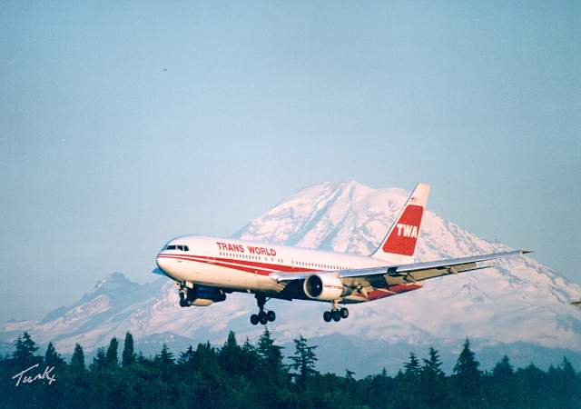
Commercial air carriers with twenty or more passengers per aircraft are governed under Part 121 of the Federal Aviation Regulations and charter and air taxi operations are governed under Part 135. Certification and safety standards are identical, although the medical requirements for the pilot in command of a scheduled airline carrier require that a first class medical certificate must be held. All other pilots must hold a second class medical certificate. Any other crew member must be medically fit to operate their equipment and all safety equipment within the aircraft. In effect, this means that flight attendants must be physically capable of seeing, hearing, and performing ably in an emergency to operate cabin doors, release slides, and other safety equipment. Flight attendants are not required to hold a medical certificate and a recent survey indicated that one third of them would be unfit to hold a third class pilot medical certificate.

The environment of the passenger carrying aircraft is relatively benign. The cabin altitude is limited to 10,000 feet in pressurized aircraft by federal regulation, although, in practice, air carriers function with cabins between 6,000 to 8,000 feet. In most aircraft, the cabin air pressurization is derived from bleed air taken from the jet engine compressor. In some aircraft, a small separate compressor engine is used. In unpressurized aircraft, flight between 10,000 and 12,000 feet is limited to no more than thirty minutes at a time and oxygen is required above 12,000 feet. Cabin temperature is generally regulated through an air conditioning system controlled by the pilots, which simultaneously regulates air pressure. The relative humidity in commercial aircraft is low, ranging between 5 and 20%. Acceleration forces tend to be at a minimum with a standard bank turn of 30° being the maximum permitted, which imposes the maximum of 1.3 Gz load on the occupants. Ascents and descents are usually at no greater than 6° nose up/down pitch angles.

Passenger briefings are required and a flight attendant must be present if there are forty or more seats and one flight attendant for every fifty seats in an aircraft. Smoking is prohibited for all scheduled flights within the United States. Parts 121 and 135 also prohibit passengers from carrying weapons or interfering with crew members. Any such actions are subject to detention and potential arrest by Federal authorities. Disruptive passengers, such as those who threaten others, become loud and abusive, smoke or disable smoke detectors are also subject to arrest.

Prior to flight, passenger information briefings must be provided by a crew member, usually the flight attendant. Passenger information briefing must include instructions on safety procedures, including the use of safety belts and emergency oxygen systems, flotation devices, and emergency exit procedures. This will include the location and the operation of emergency exits and how to identify emergency exit lighting. Smoke hoods must be provided for the cabin crew, although they are not required for passengers.
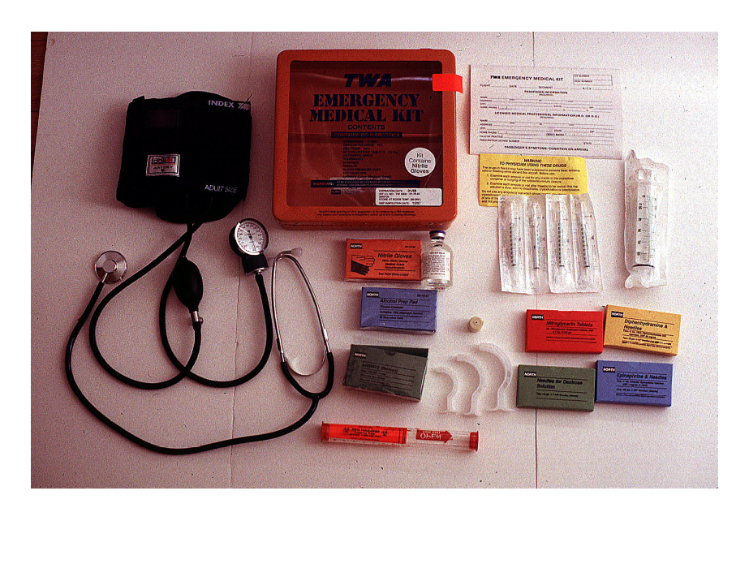
Basic Medical Kit

In 1996-97, the FAA conducted a survey of the five largest U.S. air carriers and reviewed 1132 in-flight medical emergencies. The use of bronchodialator inhalers, antihistamines and non-narcotic analgesics led to the recommendation of their inclusion in a larger and more robust emergency medical kit. Upgraded Emergency medical equipment is required on commercial airliners with twenty seats or more, as of 2004. This includes an automatic external defibrillator (AED), a primary medical kit, and an advanced medical kit. Cabin crew must be certified in cardiopulmonary resuscitation, use of the AED, and contents of the primary medical kit. The primary medical kit will consist of minor medical items, such as a stethoscope, blood pressure cuff, Band-Aids, bandages, and analgesics such as aspirin or acetaminophen.

The advanced medical kid is a “crash kit”, such as the Banyan 600 or equivalent, containing advanced cardiac life support medications, airways, laryngoscope, and such drugs as the airline elects to utilize. The carriers are not required to provide any specific pharmacy items and may elect to exclude controlled drugs. The medical kits and AED are typically kept in a locked overhead compartment, which is accessible by a key held by all of the flight crew members. The advanced medical kit is accessible only by a licensed medical provider, that is, M.D., D.O., D.D.S. or a nurse practitioner. The pilot in command may elect to permit other knowledgeable medical persons to open and use the advanced medical kit at their discretion.

Many commercial airlines utilize an air to ground communication system that connects the aircraft to an emergency medical consultant on the ground, using commercial contractors like Med-Air or MedSTAT. These services provide telecommunication with a medical consultant on a real time basis. In the event of an in-flight medical emergency, however, the pilot in command of the aircraft bears the ultimate responsibility for any decisions, regardless of medical advice provided from an onboard physician or consultant on the ground.

Cabin air quality and comfort issues remain a subjective condition. Comfort may mean different things to different people. One individual may like a warm humid environment, while another prefers it cooler. The aviation industry is faced with a dilemma: when the temperature of an aircraft cabin is set at a level to make a sitting and inactive passenger comfortable, it may be too warm for the physically active flight attendants. Cabin pressurization is typically set between 6,000 and 8,000 feet or 565 mm/hg. The oxygen percentage remains 21% and, in the normal person, oxygen saturation will remain at or above 90%. However, there is a subset of the population that will desaturate at between 5,000 and 8,000 feet and demonstrate hypoxic symptoms. This has not been demonstrated to be a health hazard nor has repeated exposure to lower cabin pressures on an occupational basis been demonstrated to be a hazard to the flight crew.
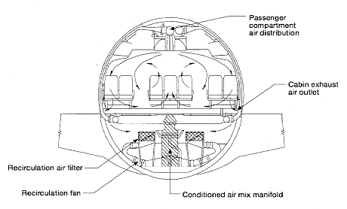
Aircraft Environmental Control Systems

The cabin is ventilated and fresh air continually plumbed into the cabin. Some of the air is recirculated in modern aircraft, as it is in most modern buildings. The purpose of this circulating air conserves energy in the form of heat, as well as less air “robbed” from the compressor section of the jet engine. The fuel savings can be very significant, up to near 40% in modern aircraft such as the Boeing 777 and the Airbus 320. A typical ratio of fresh air to recirculated air can be up to 50/50. Compare this to a typical modern commercial building where there is 20% fresh air and 80% recirculated air. Recirculated air is air that was removed from the aircraft cabin. Some is dumped overboard while the remainder is pumped through high efficiency particulate air filters (HEPA), which remove over 99% of all contaminants, including bacteriologic agents. The oxygen percentage in a 50/50 cabin of a modern commercial airliner that is at maximum load capacity will not drop below 20.5%.

There are potential contaminants in the aircraft cabin. These include carbon monoxide. However, typical carbon monoxide levels in jet aircraft are extremely low and typically under ten parts/million. The major source of carbon monoxide is cigarette smoke and with a total ban on smoking in American aircraft and recommended worldwide by the International Civil Aviation Organization, carbon monoxide contamination should be a problem of the past. Carbon dioxide also exists in the aircraft cabin. There are two primary sources for carbon dioxide. The major source is human respiration. The second source is carbonated beverages and dry ice. The maximum allowed concentration of carbon dioxide is 1,500 parts/million, although this does not actually represent a health hazard. Carbon dioxide is also used as a surrogate marker for body odors, which cannot be easily measured. Measuring carbon dioxide is difficult and care must be taken not to place the sensors too close to the occupants, as exhaled human breath is typically 2% (20,000 parts/million) carbon dioxide. Ozone, a substance found at high altitude, may be pumped into the aircraft ventilation system. This can be easily removed by placing a catalytic converter in the line.

Other chemicals, such as volatile organic compounds and multiple sources from food, lubricants, off gassing of clothing have been observed. In aircraft where smoking is permitted, cigarette fumes are the primary source of volatile organic compounds. Insecticides are used in some aircraft for disinsection when the cabins are sprayed on arrival at an international port of entry. The primary chemical used is a synthetic pyrethrin. The World Health Organization continues to support the use of disinsection to prevent importation of disease vectors.

The aircraft cabin has also been reviewed as a potential source of disease spread. Biological contaminants do circulate within the aircraft cabin. It is clear that the low humidity in an aircraft cabin reduces the transmission ability of many biologic agents. The major concern has been tuberculosis and between 1992 and 1994, Centers for Disease Control and Prevention conducted seven investigations, reviewing potential spread of tuberculosis in aircraft. There were 2,600 potentially exposed passengers and crew on a total of 191 flights, with nine different aircraft. A total of one flight attendant and six passengers converted skin tests on two of these flights. There were no active cases of tuberculosis. An additional investigation of a pilot with active tuberculosis was reviewed by a corporate medical director as the flight deck air supply was separate and the aircraft in question, a DC-9 had non-recirculating air. The pilot in question, over a six month period before he was identified, had flown with forty-four other pilots. Of the forty-four, thirty-five did not have previously positive tuberculin skin tests and none of them converted. Of the nine with preexisting positive skin tests, all had unchanged chest x-rays. Clearly, the transmissibility of tuberculosis in the aircraft cabin is a possibility, but an event on a low order. Active cases of tuberculosis should be treated for a minimum of three weeks with multi-drug therapy and have non-viable organisms in their sputum before being permitted to travel or be about in public areas.

Another disease was influenza. In a 1977 case, 72% of an aircraft passenger cabin became ill after an index case boarded the aircraft. This was an unusual event, as the aircraft was delayed on the ground for three hours with a non-functioning ventilation system, allowing an unusual pattern of spread that would not normally be seen.

Food and beverages are supplied to passengers and crew in flight. Food preparation is important here as in any public restaurant. In a unique event, in 1992 a plane departed South America bound for the United States had been supplied with seafood contaminated with cholera bacteria. The resulting outbreak was the largest in America in the 20th century with 75 cases and one death.

Food service affects the aircraft operation. The aircraft may not be moved on the ground, takeoff or landing when any food or beverage is located in a passenger seat and passenger food trays must be stowed with an aircraft moving on the ground or in the approach or landing portion of the flight. Alcoholic beverages may be served, but the certificate holder is the only permitted source of alcohol. Passengers may not bring their own alcoholic beverage onboard nor is an intoxicated passenger permitted to board an aircraft. Food must conform to basic sanitation and food handling rules. Specific equipment for food and beverages is required. For example, a coffee maker on a commercial aircraft may cost thousands of dollars, as it must have a latch to secure the coffee container, which itself must be unbreakable and unpressurized. Many a general aviation pilot has taken a thermos of coffee along on a flight, only to open it and have the now pressurized hot coffee spray all over the cockpit.
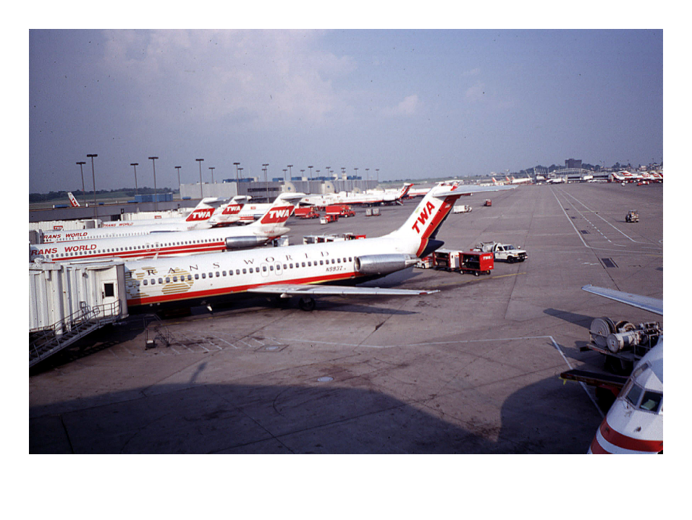
In flight passenger medical emergencies are rare, but do occur. A 1999-2000 survey by the Air Transport Association estimated that one passenger in every 300,000 experienced a significant medical problem in flight and that one in every 3.5 million would have a life-threatening emergency. This compares to approximately 1 in 150,000 in the United States general population on a daily basis. The difference primarily speaks to the nature of the population flying as passengers. Terminally ill and extremely debilitated persons are more likely to be found in hospitals than on board aircraft. The American with Disabilities Act and the Air Carrier Access Act have increased greatly the number of disabled and debilitated individuals who fly. In flight medical events are most commonly cardiovascular, neurologic and pulmonary in nature. Most pulmonary conditions are asthma or chronic obstructive pulmonary disease. Many of these are attributable to non-compliance with prescribed medications. Passengers may request supplemental oxygen in flight. However, the oxygen must be prescribed by a licensed physician and must be provided by the air carrier. Passengers may not bring their own oxygen system on board the aircraft. Air carriers are not obliged to provide oxygen in flight and those that do will limit the maximum flow rate typically to eight liters/minute. Additional costs are assessed to the traveler requesting oxygen.

A simple measure of whether an individual can fly with supplemental oxygen is to have the passenger walk one hundred yards at a normal pace or climb one flight of stairs. If they do not become short of breath, they have adequate pulmonary reserves. Travelers should be reminded to maintain hydration, drinking constantly throughout the flight. Cardiac disease is the second most common cause of in-flight medical conditions. Travelers should carry their medications with them and consult with their physician prior to traveling. New York Heart Association class 3 and 4 should strongly consider the necessity of traveling with a medical attendant or utilizing an air ambulance. If a pacemaker is installed, the airline should be notified in advance.

Neurologic conditions include seizure disorder. Most seizures in flight are due to patient noncompliance and due to difficulties with controlled substances. Anti-seizure medications are not necessarily carried, even in the advanced medical kits. Psychiatric disorders are generally safe to fly. However, individuals who are unstable and constitute a threat to themselves or others should not fly. Individuals with ear, nose or throat conditions or recent surgery may be subject to problems with cabin pressure changes and, again, advised to consult their physician prior to flying.

Pregnant travelers should consult with their physician. Turbulence in flight is not uncommon. In addition, it is inadvisable to travel by air after the thirty-sixth week of pregnancy. An airplane is not a delivery suite. Those women with a history of complications or premature delivery should not fly at all. Pregnant patients are at significantly increased risk for deep venous thrombosis, regardless of whether traveling by air or not.

Deep venous thrombosis is an intrinsic risk for many individuals. Those with abnormal clotting factors, pregnancy, smoking, obesity, hormone replacement, and recent lower leg trauma or surgery, as well as those with cancer and coronary artery disease, are at significantly increased risk. Prolonged immobilization can promote the formation of deep venous thrombosis, not only in an airplane, but in any other similar situation. While some researchers have implied that high altitude and low humidity of an aircraft cabin promote the formation of deep venous thrombosis, this has not been verified scientifically or epidemiologically. Deep venous thrombosis and pulmonary embolism have been demonstrated to occur in the general population and account for 6 to 14% of all deaths, depending on autopsy series. In order to minimize the risk of deep venous thrombosis, the Aerospace Medical Association recommends exercising the legs by flexing and extending the ankles at regular intervals, getting up and walking about the cabin periodically on longer flights, avoiding sleeping in a cramped position or the use of sleeping aids, and maintaining adequate amounts of hydration with water and fruit juices. They recommend avoiding dehydrating drinks such as alcohol or caffeinated beverages. Other devices, such as compression stockings and anti-coagulant medication have been recommended, but have not been demonstrated scientifically to be effective. While deep venous thrombosis has been termed “economy class syndrome”, the rate of DVT among all travelers is the same, regardless of first class, economy class or crew and the intrinsic risk factors of the individual passenger are the best predictor of risk. Accordingly, this has been termed “traveler’s thrombosis.”

Decompression sickness or the bends is a great risk for individuals who have been scuba diving. Divers who have been on a single dive of less than thirty-three feet sea water and not requiring a decompression stop should wait a minimum of twelve hours prior to flying. All other divers should wait at least 24 hours prior to flying.

Absolute contraindications to flight by passenger for medical reasons include active communicable disease; recent surgery, with retained gas within the brain or eye or surgery without being cleared by the treating surgeon; recent heart attack, and any other unstable medical or psychiatric condition.

Passengers should carry their medication with them in its original container, with a prescription label. If they have a significant medical problem, an abbreviated copy of the medical records should be carried on their person. Airlines should be alerted 48 hours in advance of any special requirements, with provisions for extra time if pre-boarding is requested. Special seating arrangements may be requested for passengers with mobility problems. For example, passengers who require a wheelchair may be boarded first and will be transferred to the aisle chair, a special narrow wheelchair designed to be moved down an aircraft aisle. The armrest on aisle seats can be lifted, allowing a mobility impaired passenger to be transferred from an aisle chair into a regular passenger seat. Typically, mobility impaired passengers are seated in the front of bulkhead row to provide more room for attendants to assist the passenger in transfer. Paraplegic passengers will typically prefer the aisle row seat, as it is easiest for them to affect their own transfer. Quadriplegic patients and passengers will prefer the window seat, as the cabin wall provides more support for them in flight.

Commercial airlines are required to accommodate all disabled passengers, but a disability in and of itself does not give a passenger more rights than any other. For example, passengers who are severely obese may be directed to buy a second seat if their physical presence actually occupies two seats. A passenger requiring oxygen may be denied travel on an airline that does not provide oxygen. Stretcher patients currently may only travel on one United States carrier (Northwest), as no other commercial carriers currently permit this service.

A passenger who experiences an in-flight medical problem may cause the aircraft to declare an emergency. The pilot in command will declare an emergency and air traffic control will provide them priority routing for immediate landing at the nearest suitable facility. Medical resources at the airport will be alerted. All controlled airports in the United States are required to have a fire/rescue capability of responding to any point on the airport rounds within three minutes. Additional in-flight resources can consist of the pilot descending the aircraft physically, as well as lowering the cabin altitude as quickly as possible. Flight attendants can provide Cardiopulmonary resuscitation (CPR) and first aid. Medical personnel on board the aircraft (there is a statistical 78% chance that a physician will be onboard a flight and a 98% chance that some other medically qualified person will be on board the flight) can provide in-flight medical attention and ground-based emergency resources can be consulted. Oxygen can be provided by emergency oxygen tanks on board the aircraft. The drop down masks used for cabin depressurization incidents may not be used for an emergency medical condition. In any event, they contain between 8 and 15 minutes of low pressure oxygen supply.

Airlines take reasonable precautions to avoid in-flight medical emergencies. The majority of such emergencies are unforeseeable or the potential was known only to the passenger prior to embarkation. Because of the potential of emergency evacuation of an aircraft, disabled passengers are not permitted to be seated in the emergency evacuation rows and there are no primary provisions for evacuating those who are movement disabled. This is a risk that these individuals must accept in order to fly.

References

Aerospace Medical Association, “Medical Guidelines for Airline Passengers”, Alexandria, VA 2002.

Bagshaw, M., Travelers Thrombosis, A Review of Deep Vein Thrombosis Associated with Travel, Air Transport Medicine Committee, Aerospace Medical Association, Alexandria, VA 2002.

Bendz, B., Rostrup, M. et al., Association Between Acute Hyperbaric Hypoxia and Activation of Coagulation in Human Beings, The Lancet 2000; 356: 1657-8.

DeJohn, C.A., Véronneau, S.J.H., Wolbrink, A.M., and Larcher, J.G. DOT/FAA/AM-00/13: The evaluation of in-flight medical care aboard selected U.S. air carriers: 1996 to 1997. Civil Aeromedical Institute, Federal Aviation Administration, Oklahoma City, OK. April 2000.

House of Lords: Science and Technology – Fifth Report on Air Travel and Health, November 2000.

Kenyon, T.A., Valway, S.E., Ihnle, W.W. Transmission of Multi Drug-Resistant Micobacterium Tuberculosis During a Long Airplane Flight. Review of Internal Medicine 1996; 334: 933-938.

Kraaijenhagen, R.A., Haberkamp, D. et al., Travel and Risk of Venous Thrombosis. The Lancet 2000; 356: 1492-3.

Mohler, S.R. Chapter 24 Civil Aviation Medicine in Fundamentals of Aerospace Medicine 2nd edition, R.L. De Hart, editor. Williams & Wilkins, Baltimore 1996; 747-766.

Pheby, D.F.H., Cobling, B.W., Pulmonary Embolism at Autopsy in the Normal Population: Implications for Air Travel Fatalities, Aviation Space & Environmental Medicine 2002; 73 (12): 1208-14.

Scurr, J.H., Machin, S.J. et al. Frequency and Prevention of Symptomless Deep Vein Thrombosis and Long Haul Flights: A Randomized Trial. The Lancet 2001; 357: 1485-89.

Thibeault, C. Airline Cabin Air Quality. Occupational Medicine State of the Art Reviews 17(2): 279-292 2002.

Wicks, R.L., Irvine, L.A. Microbiological Composition in Airline or Cabin Air. Aviation Space Environmental Medicine 1995; 66: 2200-2204.

