LandView® 6Tutorial

December 2003
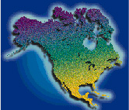

U.S. Census Bureau

U.S. Environmental Protection Agency

U.S. Geological Survey

National Oceanic and Atmospheric Administration

Introduction
The LandView ® 6 Tutorial provides instructions for accessing the LandView 6 databases, for using the MARPLOT ® mapping application and for performing basic navigational tasks. Users are asked to explore the examples in this tutorial using relationship customized to their Home County—a geography well known to them. The illustrative examples in the tutorial reference Prince William County, Virginia. New users of LandView/MARPLOT should follow the tutorial stepwise as a number of procedures build upon previous development. Experienced users should browse the tutorial to become familiar with features associated with LandView 6.
Additional LandView/MARPLOT usage information is available from the LandView Help and the MARPLOT Help files and from content specific Help within many modules. Help files are occasionally updated. The Help button on the LandView Home page links to either Help files packaged with LandView 6 or to possibly more recent Help files available on the Internet.

What is LandView 6?
LandView 6 contains both database management software and mapping software that displays:
- Census 2000 demographic data from the U.S. Census Bureau. In the previous release, LandView 5, Census 2000 data was limited to data then available (post-Census processing) from Summary File 1 (SF1). LandView 6 includes data from both Summary File 1 and Summary File 3.
- EPA regulated site locations and data, updated from LandView 5.
- The U.S. Geological Survey's Geographic Names Information System (GNIS), updated from LandView 5. The GNIS contains geographic names for all known places, features, and areas in the United States that are identified by a proper name.
- MARPLOT mapsets based on Census 2000 TIGER/Line®
This information is presented in a geographic context that includes:
- Jurisdictional entities (states, counties, cities & towns, and congressional districts) and other statistical entities of the U.S. Census Bureau
- Detailed topological networks of major and minor roads, rivers, and railroads
- Census 2000 block points, block groups and census tracts
- Selected feature names from 1:24,000 scale U.S. Geological Survey (USGS) topographic maps.
Demographic and geographic information are integrated and accessible through software that provides:
- Desktop mapping capabilities for displaying, searching, and identifying map objects
- Thematic mapping capabilities—choosing map display attributes based on database information
- Calculations of Census 2000 population and demographic profiles within a user-defined radius
- Printed maps and reports

Background Information
LandView 6 has its roots in the CAMEO (for Computer Aided Management of Emergency Operations) program of emergency planning and response software. CAMEO was developed by the Environmental Protection Agency (USEPA) and the National Oceanic and Atmospheric Administration (NOAA) to facilitate the implementation of the Emergency Planning and Community Right-to-Know Act (EPCRA, sometimes referred to as SARA Title III—for Title III of the Superfund Amendment and Reorganization Act of 1986). This is a far-reaching law requiring communities to develop emergency response plans to address chemical hazards and to make information on chemical hazards in the community available to the public.

Mapping Systems, Spatial Information, and Layers
The LandView 6 product contains two software programs—the LandView 6 data viewer and the MARPLOT map viewer. These two programs work together to create a simple mapping system that will associate data records in LandView with their corresponding map objects displayed in MARPLOT.
For example, LandView 6 contains a database of USEPA Regulated Sites, and MARPLOT contains a mapped location for each site. Locating one or more EPA facilities in MARPLOT allows their data records to be viewed in LandView. Conversely, identifying one or more such facility records in LandView allows the facilities to be displayed in MARPLOT in the context of other map features.
MARPLOT allows the user to access all or some of the stored spatial information. Layers can be shown or hidden to tailor the displayed objects to a user's needs. For example, if only the EPA layer is shown, a user will only see EPA objects displayed. However, without other layers in view, there is no context to see which roads or rivers or cities are nearby. By showing these relevant layers, a user can create a map that displays the EPA layer relative to roads, rivers and cities. One analogy frequently used to describe the layer concept is that layers can be thought of as a series of transparent sheets that are overlaid one on top of the other, so that each layer is visible either above or below the others. The power of the MARPLOT software lies in the user's ability to customize the map view to display only layers of interest and then to use LandView 6 to get information about the map objects.
For more detailed information regarding the LandView 6 databases, please go to the LandView Databases section of LandView Help. There you will find descriptions of the Census, EPA, and USGS databases.

Notes for Users of the CAMEO Program
The CAMEO suite of programs includes CAMEOfm—its current release, ALOHA and a freestanding version of MARPLOT. As LandView has a ‘sharing’ relationship with its included MARPLOT application, the CAMEO applications have a sharing relationship with the freestanding MARPLOT. For CAMEO to interact with LandView, it must use the same version of MARPLOT as is used by LandView. The following explains how to create the linkages between programs. Once such linkages are established, they remain unless other programmatic changes create new pathways.
1. No version of MARPLOT should be running when LandView starts nor should the CAMEO or ALOHA applications. The MARPLOT application does not start until it receives a command from LandView—either from the Go to Map button on the LandView Home Page or from a LandView command to show selected records in MARPLOT. From LandView, start MARPLOT.
2. Once MARPLOT starts, applications such as CAMEO and ALOHA that interface with MARPLOT become aware of its location. Start either CAMEO or ALOHA. Each has a Sharing menu that directs the application to MARPLOT. If MARPLOT is running, the application will find it, despite having had a previous pathway to an alternate MARPLOT location.
3. Once a pathway to MARPLOT is established, you should check the reverse pathway from MARPLOT’s Sharing menu back to the application. It is good practice not to have two versions of MARPLOT on the computer. If you are to be a consistent user of LandView, the free-standing version of MARPLOT should be deleted.

Organization of the Tutorial
- Lesson 1—Getting Started in LandView and MARPLOT Page 5
- Lesson 2—Exploring the LandView 6 Census Datasets Page 18
- Lesson 3—Exploring the LandView EPA and GNIS Databases Page 29
- Lesson 4—Interacting LandView and MARPLOT Page 37
- Lesson 5—Population Searches and Other MARPLOT Searches Page 48

Lesson 1

Getting Started in LandView and MARPLOT
Objectives for Lesson 1 are:
- Become familiar with the LandView 6 programmatic interface
- Become familiar with LandView’s mapping component—MARPLOT

Starting LandView 6
Since you are reading this Tutorial, you most probably have successfully installed LandView and have opened the program from the LandView icon on your Desktop. LandView opens to display the screen shown in Figure 1. We will refer to this screen as Home.
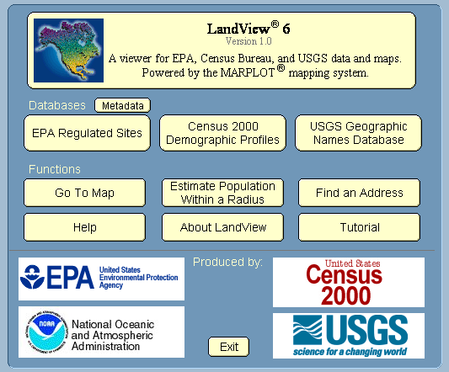
Figure 1. The LandView Opening Screen—the Home Screen

Getting Comfortable with LandView 6
At this time, only the LandView database management program is running; MARPLOT, its mapping software, is not. The MARPLOT application does not start until a Go to Map command is invoked either from the Home screen or from within one of LandView’s data modules.
Buttons identify access to the three datasets in LandView 6—the Census Bureau’s 2000 Demographic Profiles, the USEPA’s database of Regulated Sites and the USGS Geographic Names Database maintained by the U. S. Geological Survey. Each agency’s contribution to LandView is explored separately in later lessons. A button provides Metadata—data about data—for the included databases.
An estimate of population around a point, as we will see in Lesson 5, can be initiated either from within LandView, at the Estimate Population within a Radius button, or from within MARPLOT. In either case, the Census 2000 Population Estimator references the current position of the Focus Point as displayed in MARPLOT.
The mapped location of most addresses can be determined knowing only the street address and its ZIP Code. (Some streets displayed in MARPLOT lack address information. For these, a user can select the nearest intersecting street to define a mapped location.) The Find an Address button updates previous MARPLOT functionality that required also knowing the identity of the County containing an address.
The Help button, visible on the Home page and similarly accessible through MenuBar Help, opens the dialogue shown in Figure 2. Here, buttons provide linkages either to the PDF file installed on the hard drive as part of the installation of the LandView application or to its most current version maintained on the Web.
Throughout LandView and in MARPLOT other Help buttons provide specific information within the context of their location.
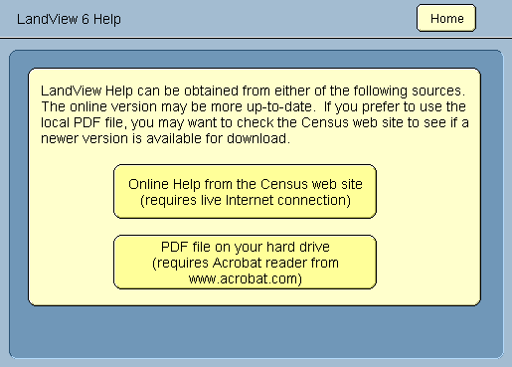
Figure 2. Help Is Available to LandView Users
The Table of Contents for the LandView Help is displayed in Figure 3. The user is particularly referred to the section entitled The FileMaker Interface for information relating to the FileMaker Pro runtime program supporting the LandView application.
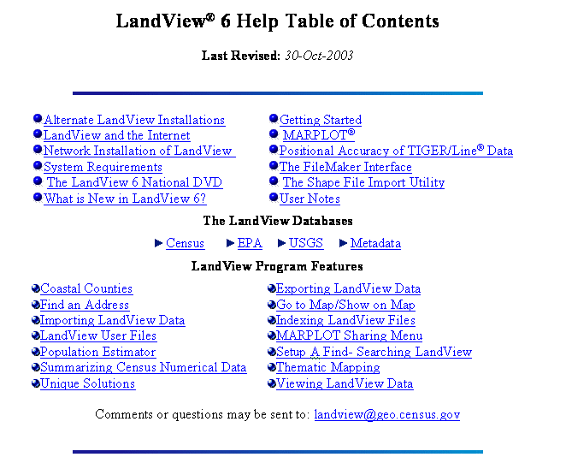
Figure 3. LandView 6 Help Table of Contents
Referring back to Figure 1, the four logos at the bottom of the screen identify the federal agencies providing data and/or technical support to the LandView program. The logos act as buttons to access each agency’s home page on the Internet. Other buttons within LandView provide Internet access to specific programs within the agencies.
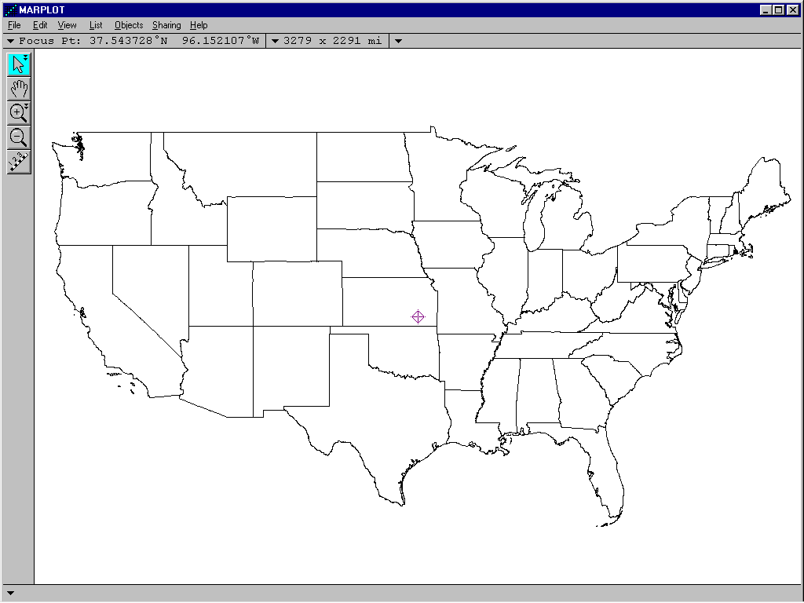
Figure 4. The MARPLOT Opening Screen from the LandView 6 National DVD

Getting Comfortable with MARPLOT
The Go to Map button starts the MARPLOT application or allows returning to MARPLOT from LandView once MARPLOT has been started. In MARPLOT, use the Sharing menu to return to LandView. Invoking Go to Map displays the MARPLOT opening screen, above.
A small, flashing, cross-shaped icon, called the Focus Point, is at screen center. The Focus Point marks the location of the most recent point of interest on the map. Each time you click on the map with the Arrow Tool, , the Focus Point moves to the location of your click. The location of the Focus Point also changes in response to other operations.
The latitude/longitude coordinates of the Focus Point are shown in the upper left corner of the map window. The dimensions of the map window are shown in the upper middle part of the map window.
The opening screen displays only a single map layer—a States layer and only those states included in the conterminous United States—the 48 contiguous states on the North American continent.
Note four inverted triangles in the Header Bar and at the base of the map screen. These display drop-down menus that replicate MenuBar commands. As you become a more comfortable MARPLOT user, you may prefer these to other navigational pathways.

The MARPLOT Navigation Tools
We have already discussed the Arrow Tool, , but it has an additional function. It is used to Select. Selection is the process where one or more MARPLOT map objects are selected from available objects so that MARPLOT can employ a procedure. When selected, each object is highlighted by a series of red, square points. When a single object is in select mode, the identity of the object—its name, its containing layer and its containing map—is displayed at the bottom of the screen.
Notice the two triangles on the icon. These indicate an additional function—multiple selection within a defined area. Clicking and dragging with will place multiple map objects in select mode. A dialogue box will ask you to identify the layer or layers that you wish to include in your selection.
The Hand Tool, , is used for making minor adjustments of your map display.
The Zoom-In tool, , and the Zoom-Out, , tool will be discussed together. Clicking on the map screen with either of these tools changes the scale of the map by a factor of two, and the click point becomes the center of the new display.
The Zoom-In tool, , also has a secondary function. Clicking and dragging with the tool opens a new map window that zooms to the dragged area. It is a principal method for zooming-in to a new map area.
The Tape Measure tool, , as its name implies, measures distances. When used, the distance between two map points and the bearing in compass degrees between the first and second point display at the bottom of the screen.

Some notes on the File Menu
Save as a Picture . . . The MARPLOT map screen can be saved as an image file. There are two options: 1—saving as a bitmap, sometimes referred to as a raster image, saves the map screen pixel by pixel as displayed. 2—saving as a Windows Metafile saves each displayed map object as a vector image. MARPLOT map objects are vector images—a format that allows enlargement or reduction of the image without distortion.
Print . . . allows sizing of the printed map. To best replicate the display screen, Print Setup . . . should first be set to Landscape.
Import . . . and Export . . . are powerful MARPLOT functions. The user is referred to the MARPLOT Help files for further information.
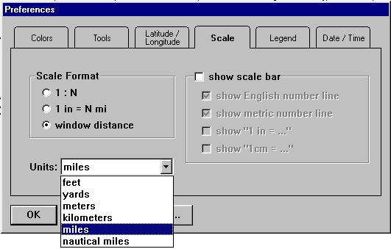
Figure 5. The Preference Dialogue
Preferences . . . provides a number of options for customizing the MARPLOT display. The option displayed in Figure 5 is the option to change map scale format.
The MARPLOT default for Scale is Window Distance—the distance in selected map units from west to east in the map display window. A scale shown as 1:N interprets as one inch on the map relates to an equivalent ground distance of N inches, e.g., 1:24,000. A scale of 1 in = N miles is notation typical of a road atlas, e.g., 1″ = 5 miles. The Scale Format currently checked in Preferences is the default scale format—Window Distance.
Most of the other options in Preferences . . . relate to enhancement of printed maps for display purposes.

List/Layer List . . .
The MenuBar command, List/Layer List . . . , opens the dialogue box displayed in Figure 6. This is an important MARPLOT work area, and we will provide detailed notes.
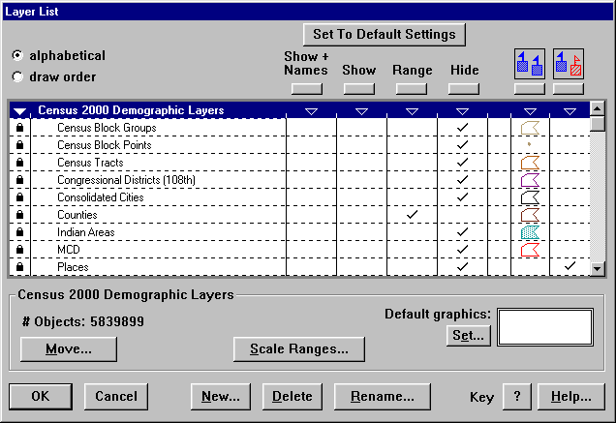
Figure 6. The Layer List Dialogue
Notice that there are two layer display options—alphabetical, the default setting, and draw order. Draw order needs only to be invoked if you suspect that there are map objects hidden from view. If you were to have a Boats layer and a Lakes layer, and Boats drew before Lakes, the boats would be at the bottom of the lake and would not be displayed. In Draw Order, the Move . . . button allows you to make the necessary corrections.
Figure 6 opens to display MARPLOT’s default layer settings. As you make changes in MARPLOT, some displayed layers will be hidden and others will be placed in display mode. Set to Default Settings returns the user to the original layer display.
The Layer List, itself, can be seen to be of two types—Group headers and individual Layers. The Group header is identified by a triangle icon which changes direction to indicate either an open or closed group. Clicking on the triangle acts to display or hide the layers contained within a group. Layers are identified by the padlock symbol. Unlocking a padlock places that layer into an active mode where objects on the layer can be added to, deleted or modified. Note: Layers stored on read-only media (CDROM or DVDROM) cannot be unlocked. If LandView/MARPLOT is available to the users from a LAN server, data may be similarly locked.
Figure 7 provides a new view of the Layer List Dialogue with all Groups but the Census TIGER/Line 2000 group closed. TIGER/Line files are topological files—the network of features visible on the ground. TIGER/Line files have no LandView data component.
Note the reference to Federal Lands. The USGS contribution to LandView/MARPLOT consists of two map sets and one data set. The Geographic Names Information System (GNIS) from USGS is present as a LandView 6 dataset, and its records are linked to map features displayed in MARPLOT. Federal Lands are included only as map files with no corresponding data records in LandView.
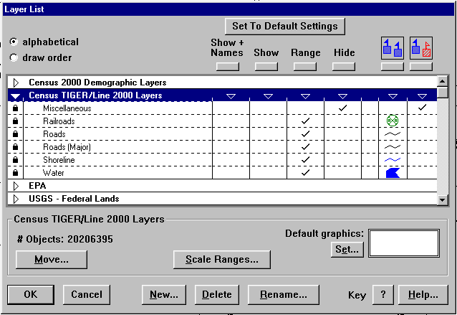
Figure 7. Only the TIGER/Line Layers are Displayed
Notice in both Figure 6 and Figure 7 that when a Group header is in select mode, a screen message identifies the group and the number of map objects contained on all layers within the group. Similarly, if a single layer is in select mode, the message area identifies the selected layer by name and both the number of map objects contained on the layer and the number of MARPLOT maps contributing map objects to the layer.
The six buttons, , heading six columns of display options are global buttons. Invoking one of the buttons acts on all layers below it to place them in the specified display mode. Notice that each Group header has inverted triangles, , similarly positioned over the columns. These triangles act as buttons to bring all layers within a group into the selected display option.
Three of the headings—Show with Names, Show and Hide are rather self-explanatory. The others need some discussion.
Range is a user option that allows selected layers to Show or Hide automatically. If you were viewing an entire state, you would not want the Roads layer to show, as the roads would be indistinguishable from each other. Similarly, if you were locating a street address on the Roads layer, you might not want the Places layer to show, as it would obscure details of the neighborhood. Users can adjust Range with the Scale Ranges . . . button. The Scale Ranges . . . dialogue is shown in Figure 8.
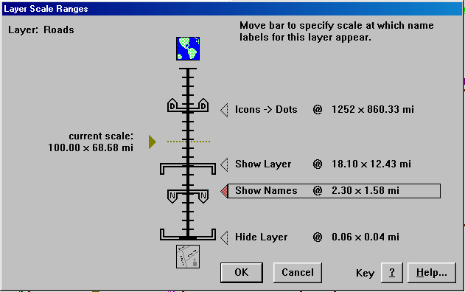
Figure 8. The Scale Ranges Dialogue
Figure 8 displays the current setting for Roads. When Range is selected as the display option, Roads will be displayed from a window width of 0.06 miles (MARPLOT’s maximum Zoom-in) to 18 mile. Identifying names will be displayed for the selected layer at all window width settings between 1.58 and 2.3 miles. If the user wanted road names to display only at window setting below one mile, the Show Names bar could be dragged to that setting.
Blue-Red and Blue-Blue, shown in Figure 7, provide additional display options. Blue-Red can be thought of as the Designer mode—if the designer of the original map data wanted to make one object on a layer Blue and another Red to emphasis a point, the designer could do so. Blue-Blue is known as the Graphic Override mode. Using Graphic Override, all objects on a layer can be set to display options chosen by the user. The Set . . . [Default Graphics] button provides the pathways.
Other options available from the Layer List include the ability to create new layers or groups, delete existing layers or groups and rename layers or groups. An OK is necessary to confirm changes and return to the map display. Cancel will cancel all changes made while in the dialogue box. Layers can be moved into and out of Groups with the Move button.

List/Map List . . .
Before we try some exercises, let us look at List/Map List . . . This is another important MARPLOT work area, and it is shown in Figure 9.
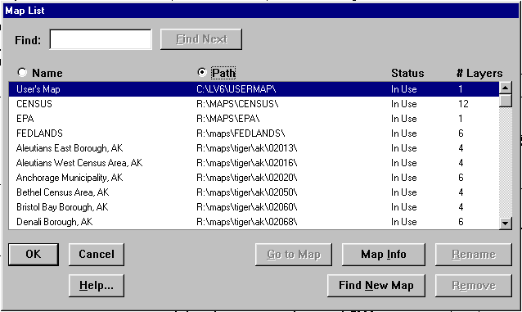
Figure 9. The Map List Dialogue
What you see in the Map List dialogue depends upon how you have LandView installed on your computer and what, if any, customization you have done. If you are accessing LandView/MARPLOT data directly from a LandView DVD, the DVD must be in an available drive to see the maps it contains. Alternate methods for installing LandView are discussed in LandView Help. Map files installed according to those instructions are automatically available to MARPLOT. MARPLOT’s default map—User’s Map is nested in the LandView application and is always available to MARPLOT. Users can create maps of their own choosing to define certain projects, and such map directories would normally be nested in the c:\lv6 directory.
When the map list is long, the Find: dialogue is very helpful. Enter the first few characters of a map name, most generally a county map, and the list will scroll to that name. Agency maps included with LandView are Census, EPA, FEDLANDS and USGSGNIS.
Highlight the Census map in Map List . . . , and click on the Map Info button to view detailed information about the Census map. This is shown in Figure 10.
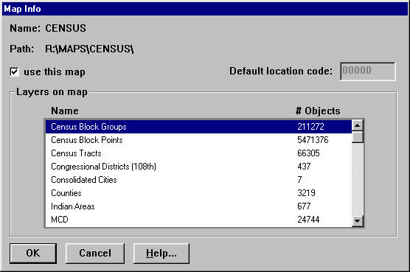
Figure 10. The Map Info Dialogue within the Map List Dialogue
Map Info lists the layers included on the selected map and the number of map objects on each layer. For the LandView 6 National DVD, MARPLOT displays 3,219 Counties and 5,471,376 Census Block Points!
The Go to Map button returns the user to a screen displaying the mapped area for the selected map. The OK button returns the user to the same screen that was displayed on entering the dialogue.

Some Definitions
Other than special objects used for display or reference, Map Objects are of three types—Points, (Poly)lines and Polygons.
Points are map objects represented by a single value of latitude and longitude, a point, that may represent physical objects of greater magnitude, e.g., a city represented by its centroid.
(Poly)lines are map objects best represented by a line, e.g., a road or a river. The term, Polyline, references the fact that the line is really a series of points (Vertex or Vertices) connected by line segments.
Polygons represent an area, such as the boundaries of a city. Again, the polygon is a series of points connected by line segments.
A Layer is a collection of similar map objects that can be viewed alone or in relation to map objects contained on other layers—a layer of EPA regulated facilities can be viewed in relation to the road network.
A Map is the smallest rectangle, defined by latitude and longitude that will contain all of the map objects assigned to the Map. The map of Virginia touches the east and west boundaries of the display screen while a map of Illinois would touch the north and south boundaries of the display screen.
A Map can contain many Layers—as the Census map, viewed in Figure 10, shows.
The same Layer can be contained on many Maps. All County maps contain a Roads layer, as roads are continuous between Counties.

Exercises
First, use File/Preferences . . . /Legend to bring the map Legend to the screen. If the Legend covers up some map objects, it can be dragged to a new location. The Legend will help to identify new layers as they appear. As you become a more familiar MARPLOT user, you may reserve this step for only your printed maps.
From your Entry Screen, zoom-in on your Home County using each of the following three methods:
For the first method, use the tool to click inside of your Home State. Note that on each successive click, the map scale increases by a factor of two. On a final click, the boundaries of Counties within the State will appear. This is the ranging feature of MARPLOT, previously discussed, While this tool is fine for making short hops, it is inappropriate to this task. Use to approximate the original screen. Note that the click point becomes the center of a new screen. Again, you are zooming out on each click by a factor of two.
For our second method, again use the tool, this time to Drag a rectangle around that portion of your Home State that contains your Home County. Most likely, you can now identify your Home County by its shape. So, again, use the tool, this time to drag to a display screen that just includes your County. Again, the ranging property of MARPLOT kicks in, and we have new levels of detail. The Map Legend identifies these new levels of detail.
Finally, we will use List/Map List . . . as a navigation tool. Enter the name of your Home County in the Find: dialogue box, and use the Find Next button to scroll to your Home County. With your Home County highlighted, use the Go to Map button to return to the map display window.
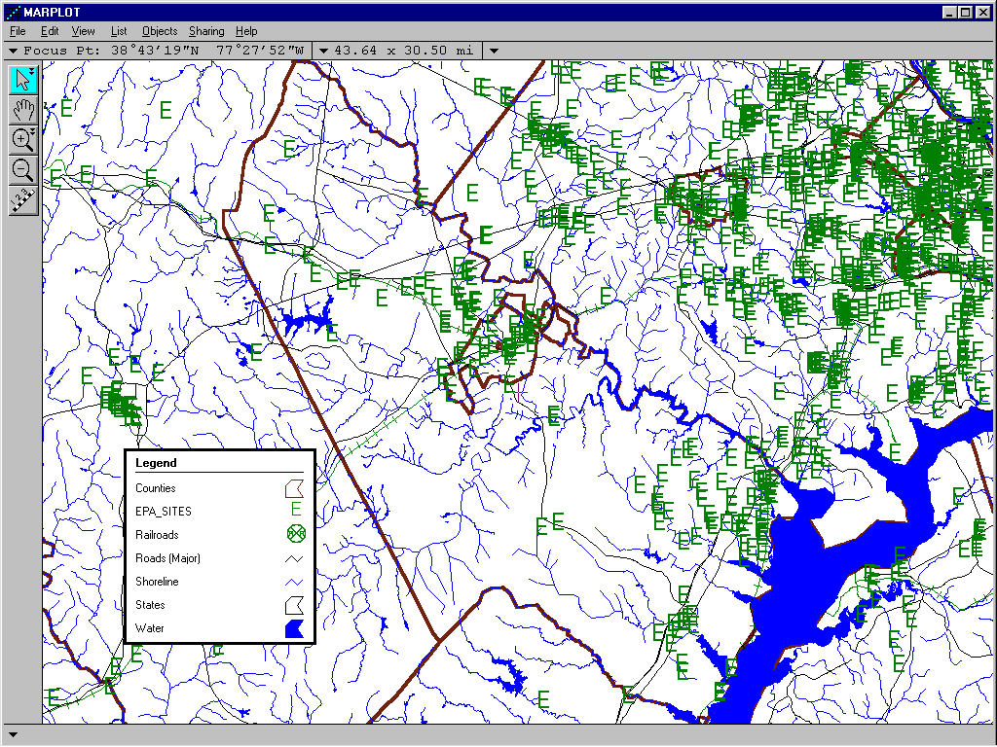
Figure 11. Prince William County VA as Displayed Using Go to Map From List/Map List . . .
Figure 11 demonstrates the final procedure, above. In Figure 11, we see the boundary for Prince William County defined in the Graphic Override mode as a heavy brown line. Major Roads and Rivers are shown. A number of ‘E’ icons are identified as EPA Sites. The Map Legend provides a key.
As can be seen, as we zoom-in to a map display, we are seeing increased levels of detail. The details shown are governed by the Default settings in List/Layer List . . . However, these may not be the particular details that concern you at a particular moment. Take some time to explore your Home County using List/Layer List . . . and Show and Hide layers. For example, show only Counties, Places and Roads (Major) layers. Reset some Range values. Take a look at a layer displayed as Blue-Blue—the Graphic Override mode versus Blue-Red—Designer mode.
If the system seems to be taking too long to draw the map, you can press the [Escape] key, which causes MARPLOT to stop drawing. A message, “DRAW INCOMPLETE”, will be displayed at the bottom of the map window to remind you that drawing was stopped while the map was incomplete. You can still click on the map and use the navigational tools to zoom in or out. The map will be completely redrawn if you change scale. The View/Redraw command will redraw the map at its current scale.

Customizing Your MARPLOT
In LandView 6, the default MARPLOT Entry View is similar to that shown in Figure 4—a 48 States view. However, your work in MARPLOT will most likely be more localized—perhaps only a single County. Let us replace the current Entry View with one more closely associated with your work. We will set the Entry View to Prince William County VA. You should set yours to your Home State or to your Home County.
An Entry View must be selected from available Views. Our first step will be to save the selected view and give it a name. We will demonstrate using Prince William County shown in Figure 11. Use View/Save Current View . . . to open the dialogue box shown in Figure 12. You need to provide a name for your view, and we will call it County View. The Set button prompts you for an appropriate map association.
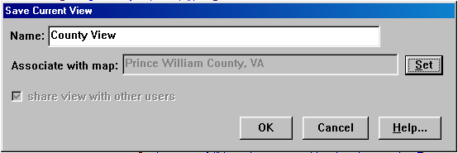
Figure 12. Creating a View for your Home County
With a saved view, we can now go to View/Entry View . . . to set the Entry View. The dialogue box is shown in Figure 13. First, select your choice for an Entry View from among the available choices, and click the Set Entry View and OK buttons.
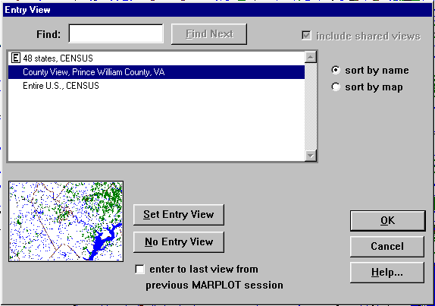
Figure 13. The Entry View Dialogue
You may now continue with Lesson 2 or close LandView and resume the Tutorial later. As mentioned earlier, the LandView 6 product consists of two separate computer programs, so you need to separately close the MARPLOT map viewer and the LandView 6 data viewer. Each program can be closed either from the File menu or by using the close symbol, X, in the upper-right hand corner of the screen.
If you wish to continue with Lesson 2, you are currently in MARPLOT, so click on Sharing/LandView/Go to LandView to return to the LandView screen.

Lesson 2

Exploring the LandView Census Datasets
Objectives for Lesson 2 are:
- Examine the LandView Census datasets as prototypes for all LandView datasets.
- Explore LandView functionality specific to the Census database.
- Explore the hierarchal and inter-relational aspects of Census data.
- View derived LandView Census data, a Found Set, in the MARPLOT mapping application.
To start this exercise, you will need to be in LandView 6. If you closed LandView at the end of Lesson 1, restart LandView.
You can access a wide range of information using LandView 6 including Census 2000 population and demographic data, EPA information on its media programs such as air regulated facilities, hazardous waste facilities and Superfund sites and USGS information on geographic landmarks from the Geographic Names Information System (GNIS). Much of LandView’s functionality is common to all three of these datasets. Lesson 2 will examine Census as an example of common functionality, reserving module-specific functionality to later lessons. There is functionality unique to Census, and this will be identified.

Census 2000 Data
From LandView Home, click on the Census 2000 Demographic Profiles button. LandView opens to display the screen shown in Figure 14, below. The opening screen shows the State of Alabama—first alphabetically of the State datasets. Note that while the screen displays data at the state level, file tabs to the left will access data at lesser political and statistical areas within the State. Buttons across the top of the screen access a range of LandView functionality.
To the upper-right of the screen are radio buttons, one of which identifies the current page as Demographic (DP-1). The Header on the page reads as, “LandView 6 – Census 2000 Profile of General Demographic Characteristics DP-1 (100%)”. You might take a moment now to explore the other choices—Social (DP-2), Economic (DP-3) and Housing (DP-4). Note the changes in the Header as you scroll through the data pages.
Table DP-1 is tabulated from a limited number of questions that were asked of every person and housing unit in the United States during the Census 2000 enumeration. Tables DP-2 through DP-4 are based on additional questions that were asked of a sample (generally 1-in-6) of persons and housing units during the Census 2000 enumeration. The datasets at each level of Census geography, except at the Census Block level, are presented in DP-1 through DP-4 data format. This makes for easy comparison of data between Found Sets and various levels of Census geography, including the National Summary which will be discussed shortly.
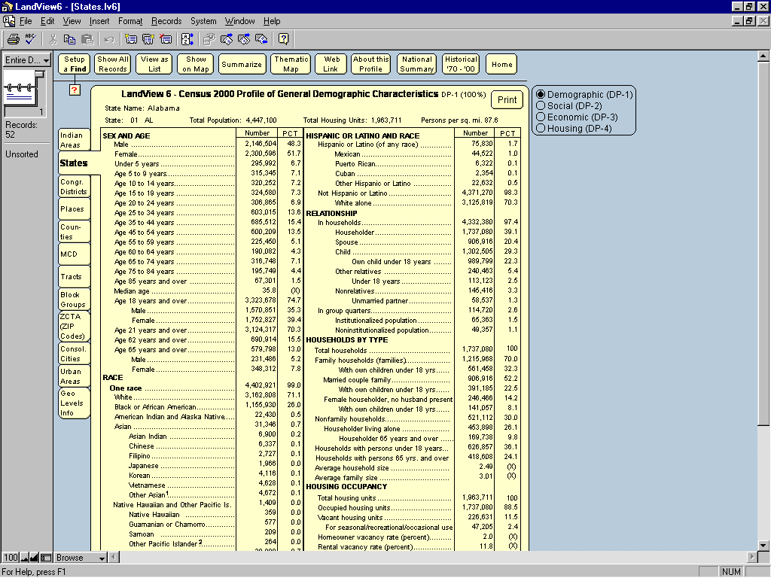
Figure 14. Census Demographic Profile for the State of Alabama
At first glance, the depth of data is obvious, and a vertical scroll bar is required to fully explore each table. The radio buttons allow easy movement among DP tables.
The political/statistical areas that nest hierarchically within one another are: state, counties, minor civil divisions (MCDs), census tracts, census block groups and census blocks. Census Blocks are shown only as a subgroup of the Census Block Group that contains them. Because there are more than 5.4 million census tabulation blocks in LandView, only a limited set of data could be provided. The primary source for accessing block data is the Population Estimator.
Places and the 108th Congressional Districts nest only within a state, as they can cross county boundaries. Indian Lands, ZIP Code Tabulation Areas (ZCTAs) and a new data classification in LandView—Urban Areas can and do cross state boundaries. In such cases, data reported at the state level represents only that part of the population that each state contributes to the geographic entity. This hierarchy of data is shown graphically by accessing the Geo Level Info tab and also is displayed as Figure 15.
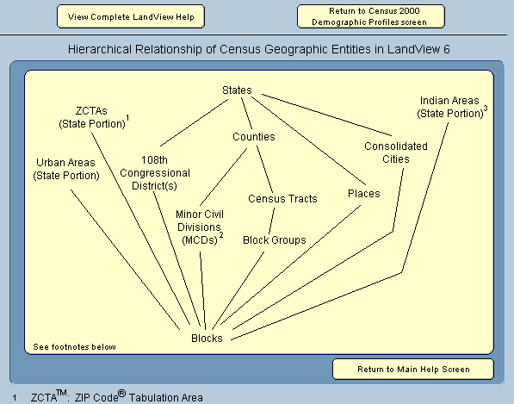
Figure 15. Hierarchical Relationships of Census Geographic Entities
The eleven buttons across the top of the data screen perform customized FileMaker scripts to accomplish specific tasks. Let us briefly describe each button and then return to accomplish some navigational tasks.
The Setup a Find button allows a user to define criteria for searching the database and to limit browsing and other actions to a subset of records based on the ‘Setup a Find’ parameters. Once criteria are established, the Find button in the Status Area initiates the search. The search results are known as the Found Set
Show All Records clears the Found Set and allows the user to see all records in the data set.
View as List presents each record on a separate line so a user can view multiple records for a geographic area at a time. However, unlike the Form View, not all fields are visible on one screen.
The Show on Map button opens to a MARPLOT map to display selected LandView data.
Summarize, when invoked, will display totals for numerical fields in a Found Set.
Thematic Map allows display of the Found Set in MARPLOT based on a theme—the range of data within a single user selected data field.
Web Link moves directly to Census Bureau Internet sites that amplify displayed information. This button requires the user’s work station to have an Internet capability.
About This Profile provides a link to an Adobe Acrobat PDF document that provides definitions of terms used in the demographic tables and other relevant census information.
National Summary is an Adobe Acrobat PDF document presenting a ‘national summary’ of LandView datasets in DP-1 through DP-4 data format. The national summary has composite data for the 50 United States and the District of Columbia. As previously footnoted, it does not include data for the Commonwealth of Puerto Rico—included as a State equivalent in LandView.
Historical ’70-’00 compares selected data fields to similar data reported for the 1970 through 2000 Decennial Census for States and for Counties.
Home returns to the LandView Entry Screen.

Using the Census 2000 Data
Let us put some of the above to work . . .
First, let us do a simple Find to view your Home State. Using ‘Setup a Find’ brings up an empty data form that shows only field headings with no associated data. This is shown as Figure 16.
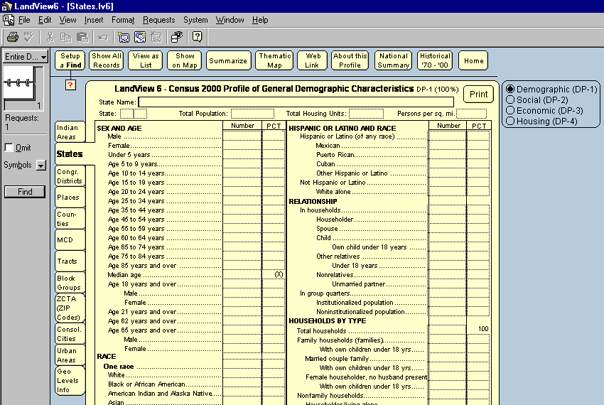
Figure 16. A ‘State’ Data Entry Form for ‘Setup a Find’
Enter the first few letters of your Home State name in the State Name field and click the Find button. You now see Census data displayed for your Home State. Data for Census entities nested within your State can be accessed from appropriate tabs.
Let us proceed to a more complex example of ‘Setup a Find’.
A concern of a number of federal agencies is Environmental Justice—a concept that people living in disadvantaged communities may not have the necessary political and social resources to resist unsolicited intrusions into their neighborhood. While definitions of Environmental Justice vary, two elements are common—minority status and poverty. Either can be a criterion, but both together identify the more disadvantaged communities. Assume that you want to identify such areas within your Home State. We will use Census Block Groups as identifying neighborhoods. We will define Minority Status as “Table DP-1—Race, One Race, White” being less than 50% of the population. We will define Poverty as “Table DP-3—Poverty Status in 1999, Families” being greater than 20%. Let us proceed to identify such areas within your Home State.
Since our definition of a neighborhood is the Census Block Group, the ‘Setup a Find’ must start at the Block Group tab. Note that when looking at a State dataset, each State is represented by both a name and a Code. This Code is known as a FIPS Code, for Federal Information Processing Standard. In your search at the Census Block Group level, you cannot use your State Name; you must use its FIPS Code. So, you will need to remember it.
Open the Block Group tab, and ‘Setup a Find’. In the State field at the top of table DP-1 enter your State’s FIPS Code. In the table, find the “One Race—White” data field and move over to the Percent column. Enter “less than 50%”, but this must be entered so that the computer will understand; your actual entry is “<50.00”. (Note that the Symbols button to your left will open a palette of choices that you will find useful.) Now, open table DP-3 using the radio buttons at the upper-right. Locate “Poverty Status in 1999—Families”. In the Percent column, enter “greater than 20%” as “>20.00”. Now, click the Find button and LandView will commence its search.
It is from here that we can demonstrate several very powerful features of LandView. Your search has yielded a group of records, perhaps 10, perhaps 500. Individually these records mean little. You can scroll through the records and note a range of values relating to your search conditions, but such information is hard to quantify.
First, let us summarize these records. The Summarize function is unique to the Census database, as neither the EPA nor the GNIS databases contain similarly related numerical fields. With the Status Area to your left displaying the number of records in your Found Set, click on the Summarize button. LandView recalculates the data. Numerical values in individual data fields are added together, and new percentage totals are calculated. Certain fields, mainly Median values, are not recalculated, and a value of “(X)” is displayed adjacent to these fields to so indicate.
With the records summarized, you can now do a comparison. How does the demographic profile of the communities sheltering this population compare to your City, your County, your State, or to the National Summary? For example, the percentages of males and females in the Found Set may differ markedly from a reference population. A Print button allows saving the Found Set as a hardcopy. Similarly, profiles for other Census geographies can be printed for comparison. A Close button on the summarized data set returns the user to the original Found Set.
You can now explore a third step in explicating the data—displaying the Found Set on a map in MARPLOT. The Show on Map button opens the dialogue box shown in Figure 17.
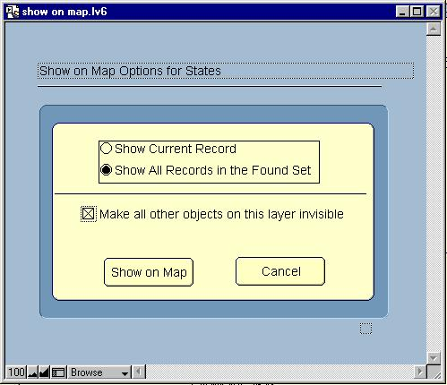
Figure 17. The Show on Map Dialogue
In the dialogue are several display options. In this case, we would like to ‘Show All Records’ and we would like to ‘make invisible’ those objects not in our Found Set. On the other hand, if we had chosen to make all objects visible, MARPLOT would display the Found Set in Select mode and those objects not in the Found Set would be displayed unselected. On Show on MAP, we move from the LandView application to MARPLOT. If MARPLOT is not running, the application opens. The map displays the Found Set. Some customizing of MARPLOT’s layers is generally necessary to display the data in an appropriate geographic context. Figure 18 displays a Found Set for the State of Virginia with the State boundary in display mode to provide appropriate context.
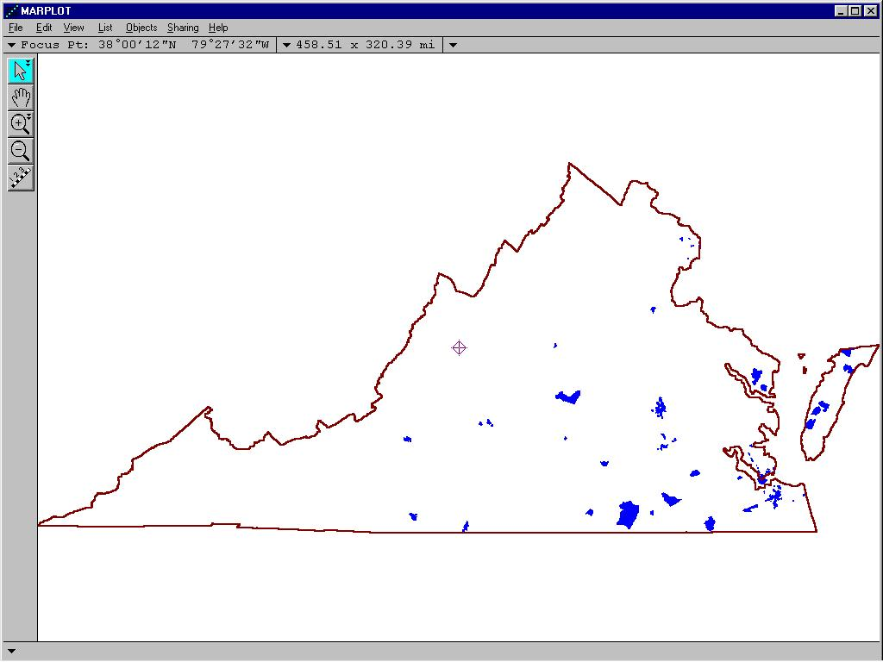
Figure 18. Census Block Groups in Virginia that Meet an Environmental Justice Concern
There is, yet, another search technique that finds particular use in extracting Census data, and that is Records/Sort . . . Records/Sort requires users to use the LandView MenuBar.
Census data contains tables of numerical values that can be sorted either in ascending or descending order to capture those values that may be unusually low or unusually high. Let us give one example of how Sort Order in the database can aid in extracting information.
Say, you wish to identify those clusters of population (we will use Census Block Groups as our search unit) in your Home County that contains the largest percentage of people that are 65 years of age and older. By now, you should easily be able to navigate to your Home County in your Home State. If you click on the Census Block Group tab, you will have selected only those Census Block Groups within your Home County. But, these are in an unsorted order! Using MenuBar Records/Sort . . . opens a dialogue box. The Sort Dialogue is as shown in Figure 19. In the left-hand column of the dialogue box is a listing of searchable fields. Scroll to “pc_Age_65_years_and_over”. Click to select, and Move the selected field name to the right-hand column. (Use the first of three similar entries for this term—the second and third entries, as can be seen from the database, refer to male and female subsets.) Remember, though, that the default for sort order is ascending. To see the highest percentages at the top of the list, you need to sort in descending order. Now, use the Sort button to place the list in Sort order and return to the viewing screen. Notice that the Status Area at the left of your screen now alerts you to the fact that the Found Set is in sort order!
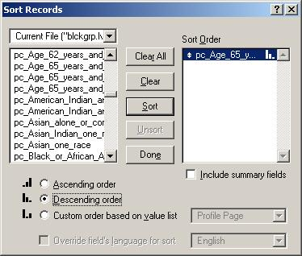
Figure 19. Block Group Sort Dialogue for % Age 65 and Over
Let us examine the remaining buttons in the Census database that have not, as yet, been discussed . . .
Note that we have arrived at a Found Set by two different pathways—using ‘Setup a Find’ and by tabbing to a lesser geography nested in a selected State. There are occasions, where it is useful to view the contents of an entire dataset. The Show All Records button will revert to the total of records for that geography and the Found Set notation will disappear from the Status Area.
As previously footnoted, View as List is an alternate search procedure to ‘Setup a Find’. When in Form View, invoking View as List opens a table of all data records. You can scroll to an appropriate entry and select. The View as List button has changed to now read, View as Form. Clicking returns to Form View with that record displayed.
Thematic Map is a subject worthy of a more extended treatment, and it will be discussed in a subsequent lesson.
A Web Link button is available within each of LandView’s data modules. In Census, it opens to display the URLs shown in Figure 20.
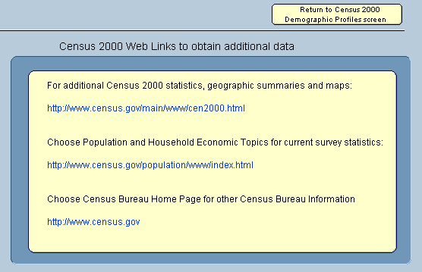
Figure 20. Census Sites Accessed from LandView
The first displayed URL navigates to the screen shown in Figure 21. If you have never browsed the American Fact Finder, available from this page, you will find it well worth your time.
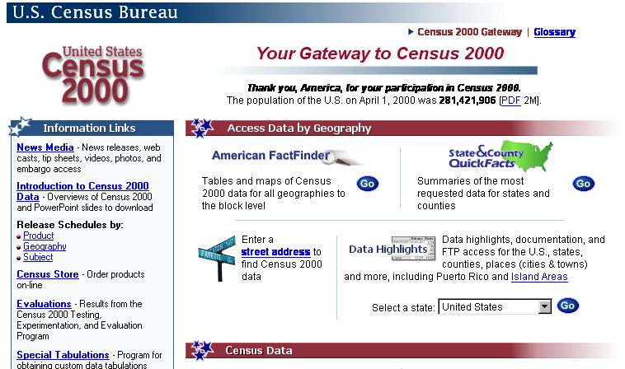
Figure 21. An Internet Link through Census Web Links
The second URL opens to the page displayed in Figure 22. Scan the alphabetical listing for additional information on a variety of subjects.
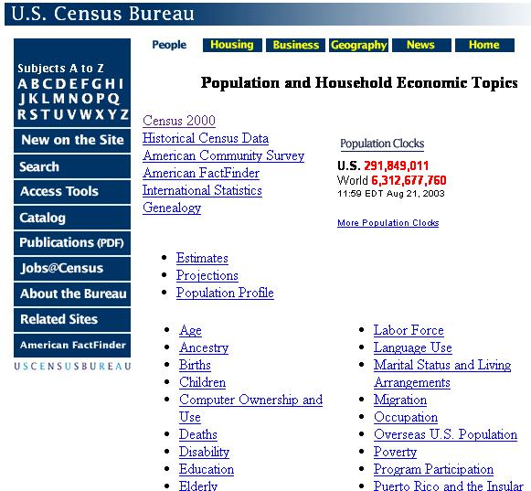
Figure 22. Another Internet Link through Census Web Links
Finally, there is another button of interest to those perusing Census data—Historical ’70 – ’00. Figure 23 displays an historical comparison for the State of Virginia while Figure 24 displays an information screen available from within the window.
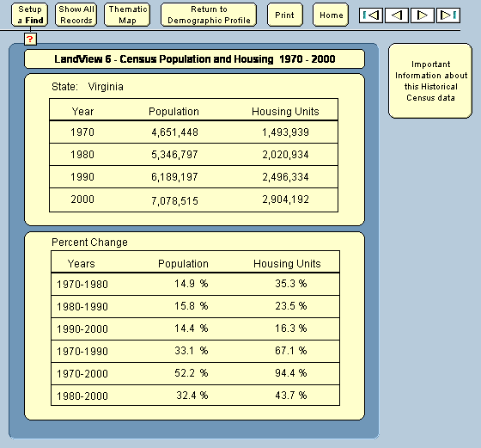
Figure 23. An Historical Data Comparison for the State of Virginia
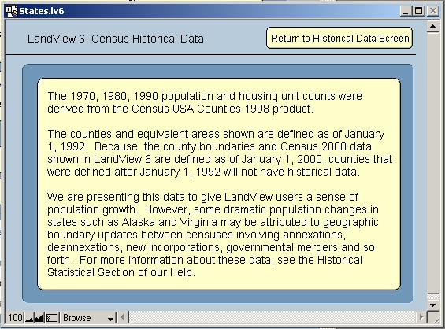
Figure 24. Placing Historical Data into Context

Lesson 3

Exploring the LandView EPA and GNIS Databases
Objective for Lesson 3 are:
- Become familiar with the content of both the U.S. EPA database and USGS’s GNIS database in LandView.
- Explore new LandView/MARPLOT functionality as demonstrated through examples in the datasets.
- Further explore ‘Setup a Find’, LandView’s data search methodology.
Each of LandView’s databases contains unique datasets, and each has tools and functionality crafted to best explore their uniqueness. We will look next at the dataset available at the EPA Regulated Sites button at LandView Home.

U. S. Environmental Protection Agency Data
Click on the EPA Regulated Sites button. Figure 25 shows a typical EPA-regulated facility in Manassas Park, Virginia. Across the top of the screen, there are fewer buttons than in Census. Those shown perform functions similar to those already met in the Census datasets.EPA-regulated facilities are identified by their name and location, by an EPA ID, by their SIC Code, and locational information expressed as a latitude/longitude.
Facilities can be regulated by the U.S. Environmental Protection Agency under a single media program or under several programs. As you can see in Figure 25, there is a listing of the media programs under which a facility may be regulated. Checked boxes identify the programs for which the facility is actually under regulation. The Metadata button at LandView Home provides background information on U. S. EPA’s media programs.
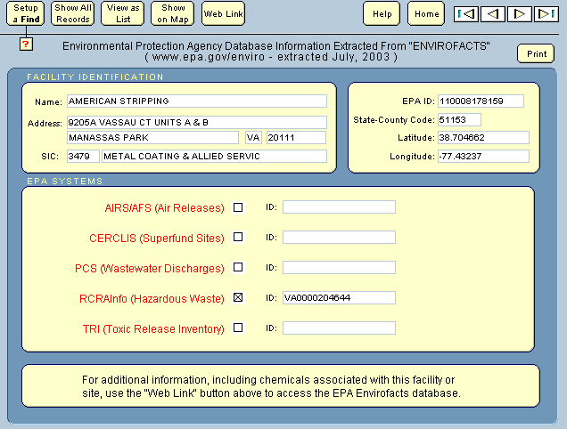
Figure 25. An EPA Regulated Facility in the LandView EPA Database
First, we will describe methodologies for locating facilities of interest to a user. Later, we will see that there is a wealth of information available about individual facilities.

Locating Facilities Within a Census Geography
Let us ‘Setup a Find’ to identify all regulated facilities in your Home County. In the Census and in the USGS GNIS databases, counties are identified by name. In the EPA database, this is not so. Notice that in the upper-right corner of the form there is a listing for State-County Code:. This identifies a five digit FIPS Code for State and County—the first two digits identify the State and the remaining three identify a County within the State.
To learn the FIPS Code for your County: In the Census Counties dataset, do a ‘Setup a Find’ for your state and county, by name. When found, its FIPS Code will be displayed in the header. On returning to the EPA dataset, use this value in a ‘Setup a Find’. All EPA regulated facilities in your Home County will be included in the Found Set. Of course, you could have used other geographies—you could have entered the name of your Home City or a ZIP Code in appropriate fields.
With this Found Set, you have two options, you can show the Found Set in MARPLOT to see the distribution of facilities, or you can scroll through the list to find individual facilities of interest. However, as you gain familiarity with EPA regulations, you may find that some regulating programs are of greater concern to you than others. Let us repeat our search, but, this time, let us ask for only those facilities regulated under TRI—the Toxic Release Inventory program. We do this by entering a check in the checkbox adjacent to the program name in ‘Setup a Find’.

Locating Facilities Through EPA Media Programs
The demonstration County used in our illustrative example is Prince William County, Virginia; its State-County FIPS Code is 51153. Figure 26 displays the ‘Setup a Find’. Figure 27 shows the Found set. Only six EPA regulated facilities of this type are found within the County.
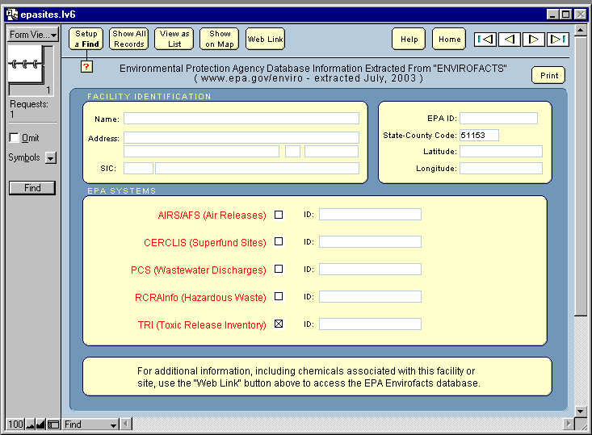
Figure 26. ‘Setup a Find’ for TRI Facilities in Prince William County
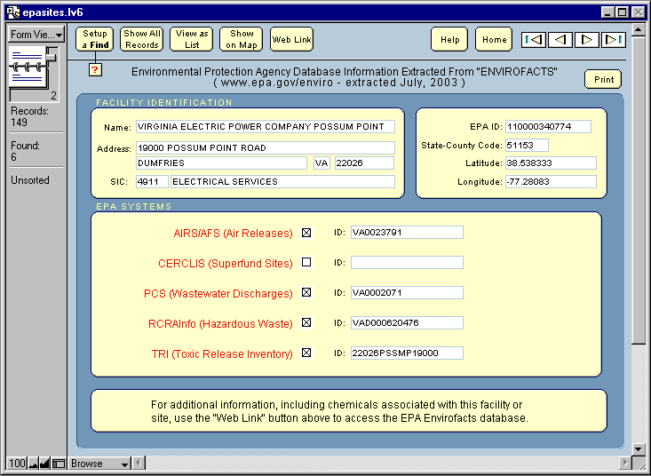
Figure 27. The Found Set for Facilities Regulated under TRI
In Lesson 2, we used the Show on Map dialogue option ‘Make all other objects on this layer invisible’. Here, as shown in Figure 28, we will ignore this option. The resulting map image is displayed in Figure 29.
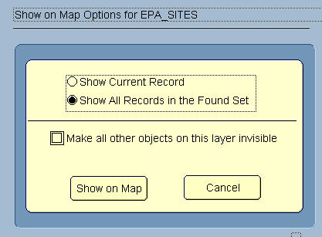
Figure 28. Show All Records—Found Set Shows in Select Mode
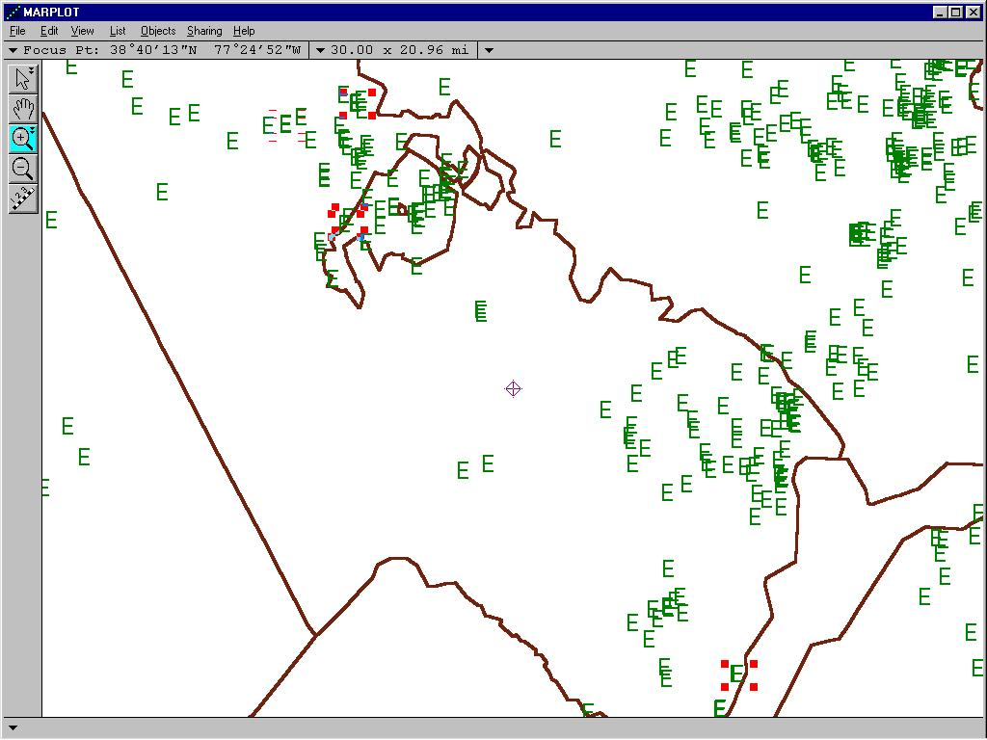
Figure 29. The Found Set Displayed in MARPLOT
The six facilities in the Found Set are in Select mode. Other EPA facilities not meeting the test for TRI are shown as unselected. The ability to show the Found Set in Select mode allows for further processing in MARPLOT. A LandView Help file, under the heading of Unique Solutions, Thematic Mapping of Multiple Variables, further discusses this subject.

Facility Information in EPA’s EnviroFacts Warehouse
Let us turn now to the task of obtaining more information about a single facility. In your home area, you will recognize one or more facilities that, because of size, reputation or the materials processed, stand out from the rest. Either select this facility from your current Found Set, or do a new ‘Setup a Find’ for the facility by name. As our example, we will use a facility in our Found Set, Virginia Electric Power. For this exercise, you will need to connect to the Internet. With the facility displayed in Form view, access the Web Link button. We are taken to the EPA Internet site, EnviroFacts Warehouse, opened to the record for our selected facility. This is shown in Figure 30.
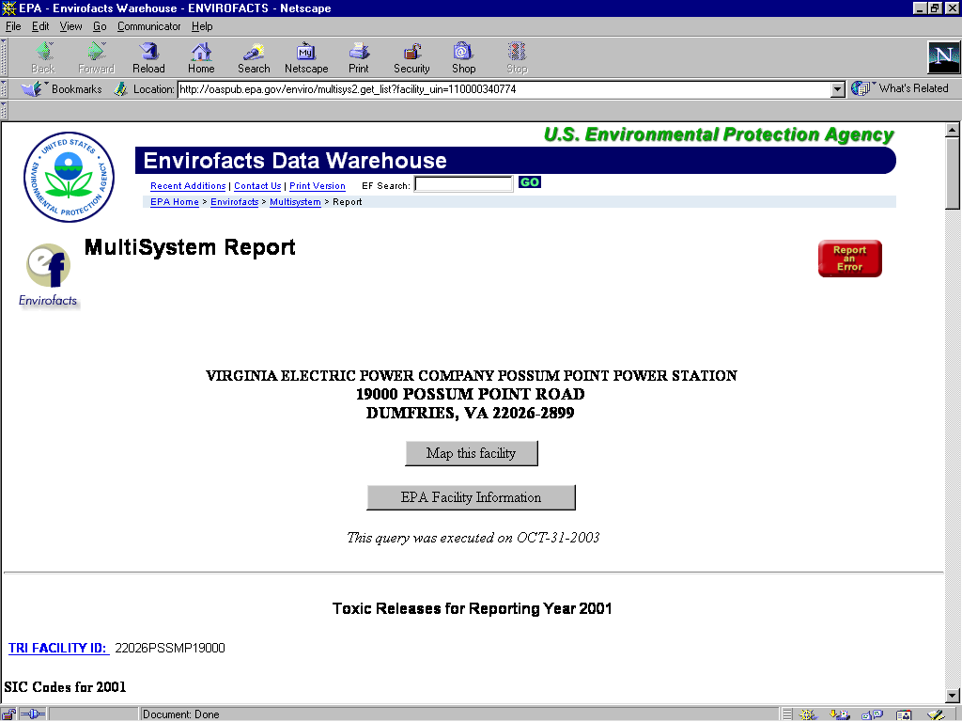
Figure 30. Header for an EPA Record in the EnviroFacts Warehouse.
There can be a wealth of information here. On Scrolling down, we first encounter data taken from its TRI report. As can be seen from the information captured in Figure 31, the information can become quite detailed, and hypertext links connect to additional information. Continued scrolling identifies other media programs under which this facility is required to report to USEPA.
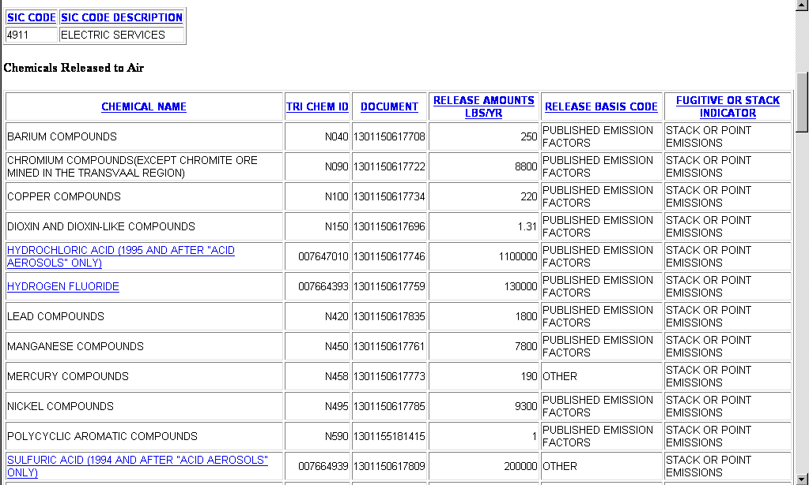
Figure 31. Part of a Toxic Release Inventory Report from EnviroFacts Warehouse

United States Geological Survey (USGS) Data
On opening the GNIS database, the Geographic Names Inventory System, you again see that each LandView dataset has its own look and feel. Header buttons replicate those shown in the EPA database. Like Census, GNIS is a relational dataset, and additional information is available through other buttons contained in the display. Principally, observe that there is shown the name of a geographic feature and the feature is described by type.
You can search for features within several geographic areas—the complete dataset, the containing state or the containing county. You can search for features either by name or by type (selected from a drop-down menu). The opening screen is displayed in Figure 32.
The Geographic Names Information System (GNIS), developed by the USGS in cooperation with the U.S. Board on Geographic Names (BGN), contains information about almost 2 million physical and cultural geographic features in the United States. The federally recognized name of each feature described in the database is identified, and references are made to a feature's location by state, county, and geographic coordinates. The GNIS is our Nation's official repository of domestic geographic names information.
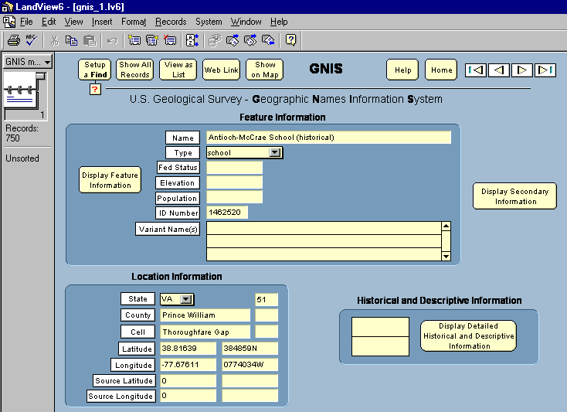
Figure 32. A Typical Record from the GNIS in LandView 6
Using the USGS GNIS Database
We will look at one example of using the GNIS. We wish to determine the number of schools included in the database for your Home County and to find out how many of these schools can be classed as elementary. We will do this Find in two separate steps.
First, use the ‘Setup a Find’ button to enter our Type criteria—Schools. Enter the appropriate location information. Click the Find button. Our Found Set includes all schools in the County— grammar schools, high schools and beauty colleges.
To find schools that are classed as ‘elementary’, we have two choices. We can institute a new Find, or we can use the MenuBar command, Records/Modify Last Find. Using the latter, we return to our original ‘Setup a Find’ statement, and we only need to add “elementary” as part of the Name field, Figure 33. This will find all schools that include “elementary” as part of the school name. However, it would not find elementary schools that were identified as “St. Peter’s Parochial School” or “PS 116”.
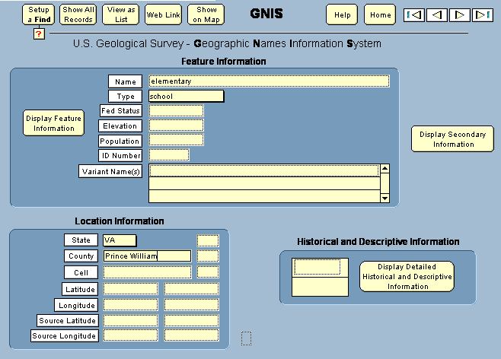
Figure 33. Searching GNIS for the Category—Schools Containing “elementary” in Name
For Prince William County VA, our first search had a Found Set of 80 for all schools and a Found Set of 24 for ‘elementary’ schools.
From here we proceed to Lesson 4. In Lesson 4, we take a new look at MARPLOT mapping and its interaction with LandView.

Lesson 4

Interacting LandView and MARPLOT
Objectives for Lesson 4 are:
- Use the Address Finder in LandView and the TIGER/Line map files in MARPLOT to locate a street address
- Determine the State and County FIPS Codes, the Census 2000 Tract number and the Block Group identifier for the location
- Use the MARPLOT Search function to locate a street address or a road intersection
- Examine data crossing multiple jurisdictions
- Examine extracted data as a Thematic map
In LandView, the Address Finder function allows users to quickly map to a specified street identified by an address and a ZIP Code. In earlier versions of LandView/MARPLOT, the name of the host County was a required search element when doing an address search. Zip Code Tabulation Areas—ZCTAs are a recent statistical entity developed by the U.S. Census Bureau for tabulating summary statistics from Census 2000.

Find your own Home Address
From the LandView Home page, click on the Address Finder button. The LandView 6 Address Finder window opens. Our demonstration search will be for “7959 Ashton Avenue, Bull Run VA 20109”. Enter the first few letters of your Street Name and its 5-digit ZIP Code. Click on the Find Street button. The Address Finder dialogue box is shown as Figure 34.
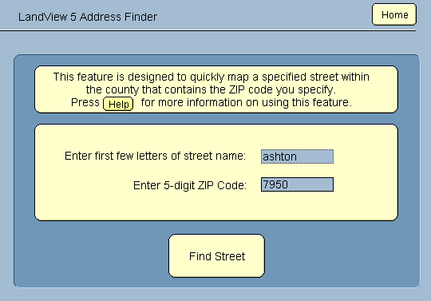
Figure 34. The Address Finder Dialogue in LandView.
The Find Street button opens MARPLOT, if not already open, and, behind the scenes, MARPLOT initiates a Search. (More on MARPLOT ’s Search function later.). The resulting Search Collection is shown in Figure 35.
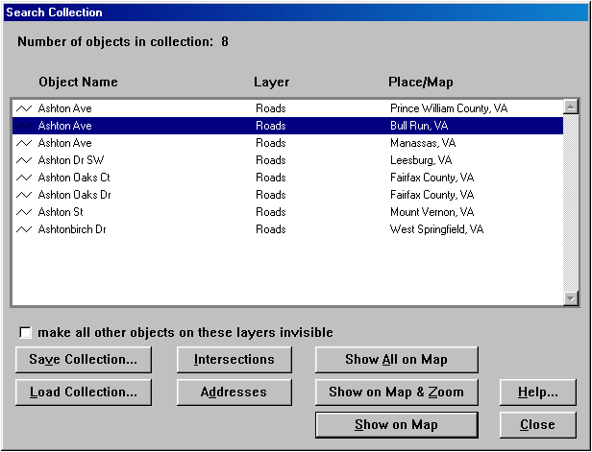
Figure 35. We have located Ashton Avenue in Bull Run VA
The Search Collection displays a list of all streets meeting our search criteria. Within ZIP Code 20109, Ashton Avenue passes through two communities and a section of unincorporated Prince William County. We need to highlight that section passing through Bull Run. To locate our street address of 7950, click on the Addresses button, and a new dialogue box opens. See Figure 36.
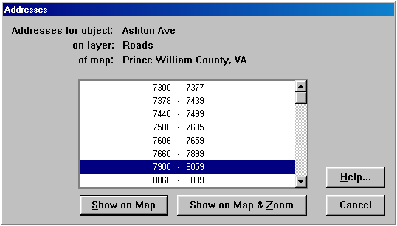
Figure 36. Address Ranges on Ashton Avenue in Bull Run VA
MARPLOT identifies address ranges along each block face. A block face, generally, is the polyline segment contained between two intersections. However, if the roadway should be curving along the block face, two or three segments may define the block face. Once you have identified the block face segment containing your address, return to the map screen with the button option, Show on Map & Zoom. This returns you to the map display screen with all of Ashton Avenue in Select mode and with the Focus Point on that segment of Ashton Avenue containing our address range. This is shown in Figure 37.
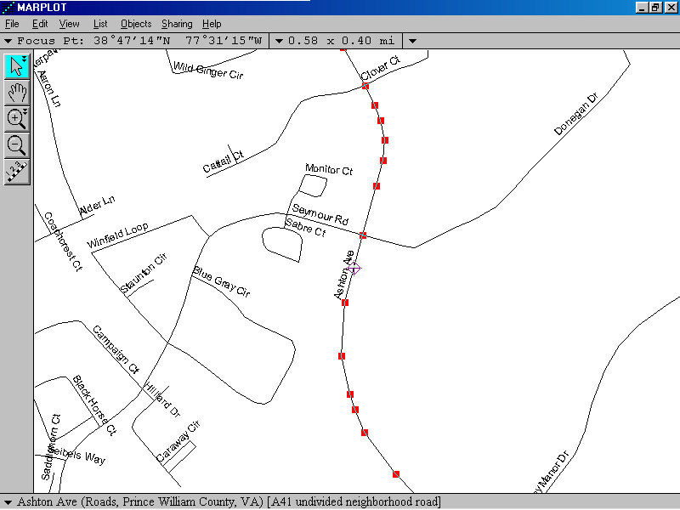
Figure 37. This segment contains 7950 Ashton Avenue, Bull Run VA 20109
If this was known geography, your home street, you would know exactly where to show your house, but as this is unknown geography, it is necessary to ask MARPLOT for more precise instructions. Is 7950 on the east side of the street or the west side? Do house number increase north to south or from south to north? To answer these questions, use Objects/Segment Setting . . . to obtain this information. A new dialogue box opens. See Figure 38.
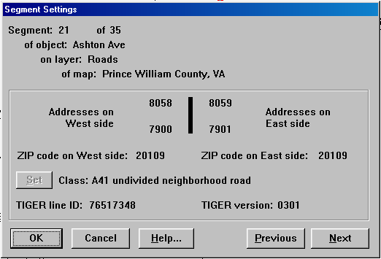
Figure 38. Address Matching using Objects/Segment Setting . . .
Remember the advisory, above, about curving, block faces? We need to examine each segment adjacent to our selected segment. We can do this by either returning to the map and examining selected adjacent segments, or we can use the Previous and Next buttons in our dialogue to move to adjacent records. Doing so, we will find that four segments contain the same address range information—7900 to 8059. To properly locate the address we need to consider all four segments as a unit. Our target address will lie on the west side of the roadway (even numbers). Presuming that the house addresses are evenly spaced along the four segments, we will spot (by clicking appropriately adjacent to the roadway) the address approximately one-third of the distance from south to north.
After displaying your address on the map, let us call on another bit of MARPLOT functionality—the Marked Point. Use View/Marked Point/Mark Focus Point to identify the address location. The Marked Point will remain until removed or until a new Marked Point is chosen, even after MARPLOT is shutdown and restarted. Our located address is shown in Figure 39. Your address should now be at the Marked Point on your copy of MARPLOT.
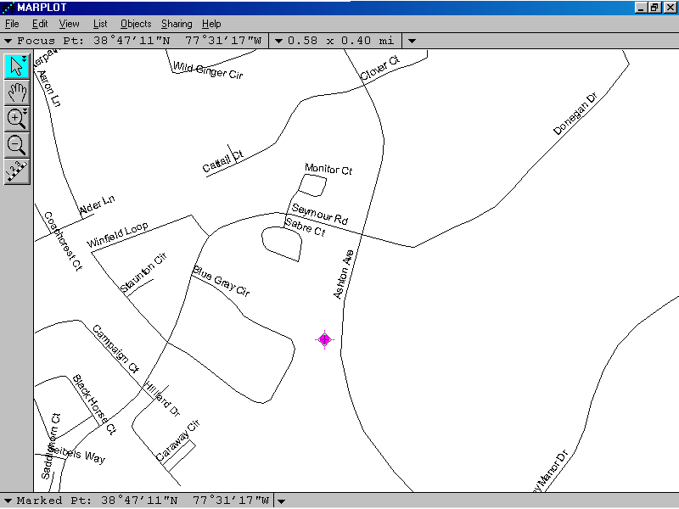
Figure 39.The Marked Point locates an address on Ashton Road

Determining the Census 2000 Tract and Block Group
There are reasons to know additional information about the physical location of a map point. For example, Census Tract and Block Group numbers can be required information in applying for a Federal Assistance grant in various federal programs. We could, perhaps, go to our List/Layer List . . . and selectively Show individual layers until we had accumulated the data, but there is an easier way. Use Sharing/LandView/Identify Census Areas at Current Map Pointer to return to LandView. An information screen, shown in Figure 40, provides the data.
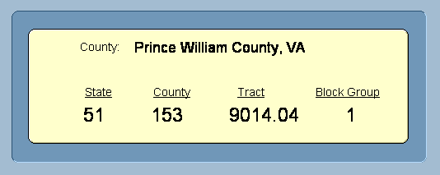
Figure 40. Locational information for our Marked Point
We previously provided a method for determining the FIPS Code used to identify a State and a County in LandView and MARPLOT. In addition to identifying the Census Tract and Block Group associated with a map point, the utility also identifies the containing FIPS Codes.

MARPLOT MAP Search Techniques
While the above address search was initiated in LandView, MARPLOT ’s Search functionality could have been used instead. One proviso—for an address or an intersection search in MARPLOT, it is important to identify the County containing the address. For example, many of the three thousand and some counties in the country contain some variation of a Washington Street, and, without identifying the search county, we could be deluged with false positives.
This time, let us search for the intersection of two roads. We will be searching for the intersection of Ashton Avenue and Donegan Drive in Bull Run, Virginia Your search should be for two main intersecting streets in your Home Town. But first let us state a principle that will apply to each and every search conducted in MARPLOT:
In every MARPLOT search, we are looking for one or more objects on one or more layers of one or more maps.
To start the Search, use List/Search . . . to open the Search dialogue. Figure 41 shows the dialogue with our information entered.
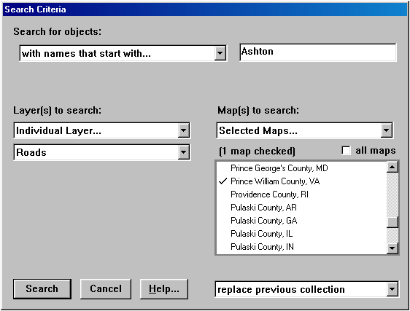
Figure 41. MARPLOT Search for a Road
The Search dialogue reflects our principle—object, layer and map. In searching for an object there is a dropdown menu that allows multiple methods for describing the object. We can specify individual or multiple layers or all layers. If we are confident that our layer name is contained on only one map, we can default to Maps in View. However, for street names, we need to be careful to specify the containing County—therefore, we have entered Prince William County. The Search button initiates the Search.
The results of the Search are displayed in the Search Collection—the same information screen in which we previously viewed the results of an address search from the LandView Address Finder. This is displayed in Figure 42.
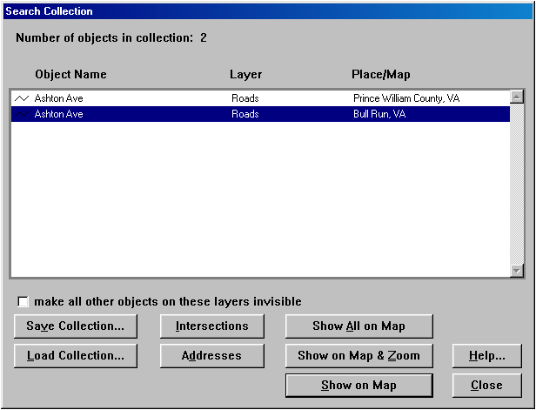
Figure 42. MARPLOT Search for Ashton Avenue
This time, our interest is in those roads intersecting with Ashton Avenue, so we use the Intersections button. This brings up the screen shown in Figure 43.
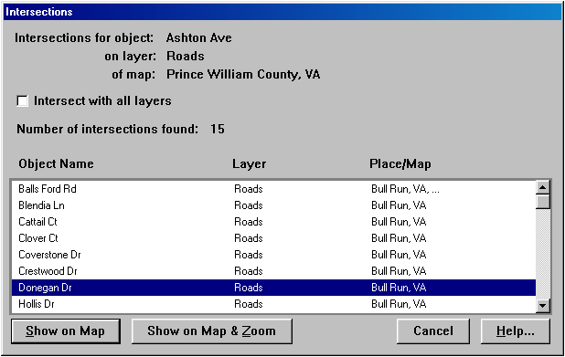
Figure 43. Donegan Drive intersects with Ashton Avenue
Using Show on Map & Zoom, we return to the screen with the view shown in Figure 44.
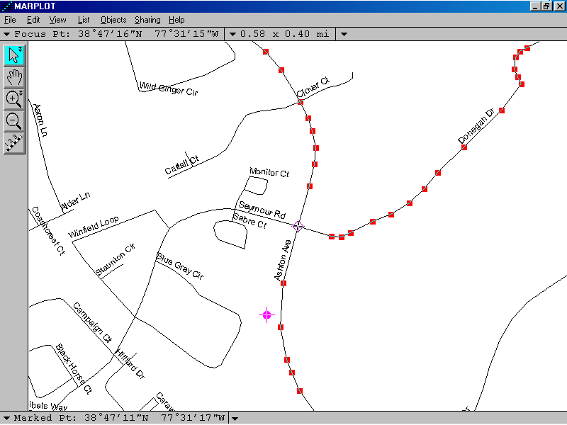
Figure 44. Donegan Road Intersects with Ashton Avenue
Notice that we now have two roads in Select mode, and our map centers on the intersection of the two roads. Since we have not changed our Marked Point, it is still displaying the results of our previous Search.

Thematic Mapping
In LandView, Thematic Mapping is only available from within the Census database, as only Census includes numerical data fields with a range of numerical values. In concept, thematic mapping examines a unique numerical data field within a Found Set of related records and apportions the range of values among the members of the set. In LandView, thematic mapping can be applied to only a single variable.
In Lesson 2, we used Sort order to find instances of older population—those 65 years of age and older. Let us return to that theme. This time, we ask the question: What areas of your Home County contain older population greater than 10% of the total population? We will want to view this data thematically in MARPLOT. We will use Census Block Groups as our search geography.
In this exercise, we will be demonstrating an additional objective for Lesson 4—examining data across multiple jurisdictions. We are asking you to search for a set of population data not only in your Home County, but a cross a three-county area that includes your Home County
Since the data screen for Census Block Groups does not identify counties by name, but only by their FIPS Code, we need to know the FIPS Code for your Home State and for each of the Counties in your search. In LandView, access the Form View for your Home State and display its counties in List View. You can scroll through this list to find the Counties that you will use for your search. In the column adjacent to each County Name is its FIPS Code designation.
Before starting the exercise, we need to explain a characteristic of the FileMaker interface that drives the LandView application. Many of you are familiar with a standard search statement which is stated typically as, “Find this and this or that and that.” In most search statements the ‘and’ terms and the ‘or’ terms can be grouped together, sometime with groups of terms enclosed in parentheses for precise definition of the search. FileMaker does not operate in this fashion. Each individual Request in a ‘Setup a Find’ can only contain ‘and’ terms. Each ‘or’ term requires a New Request. Let us illustrate . . .
Return to the County Form View and access the Census Block Group tab. Now, ‘Setup a Find’. For the demonstration example, we will be using three files sets included in the LandView Demo program—Prince William County, Virginia (FIPS Code 51153) and two independent cities included within the County borders—Manassas (FIPS Code 51683) and Manassas Park (FIPS Code 51685).
Our first request will be for the data contained in Prince William County, FIPS Code 51153. Notice that, in the Status Area, that this is identified as Request No. 1. We have identified the State FIPS Code and the County FIPS Code. Adjacent to the data identifier, ‘age 65 years and older’, there are two columns—the first gives population as a number and the second gives it as a percent of the total population. Most data searches requires use of what is termed Boolean logic, and LandView makes this easy by presenting a pallette of logical choices. This, too, is illustrated in Figure 45. In the Percent column, we have identified our search as ‘Greater than 10 %’ or ‘>10’.
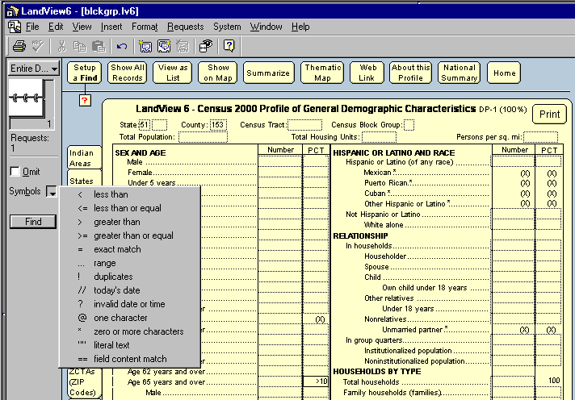
Figure 45. Request No. 1 for Multi-County Search for Population Data
We are now ready for a second request. Notice in Figure 45 that, whenever a ‘Setup a Find’ is initiated, a new term showing in the Census MenuBar—Requests. We have two choices—either Requests/Add New Request or Requests/ Duplicate Request. In this case, MenuBar Requests/ Duplicate Request requires less work. The original request reappears as Request 2, and it is necessary only to change our County FIPS Code from “153” to “683”.
Figure 46 shows that in our search for our multi-county search, 19 Census Block Groups met our search conditions. We are now prepared to display our data as a Thematic Map.
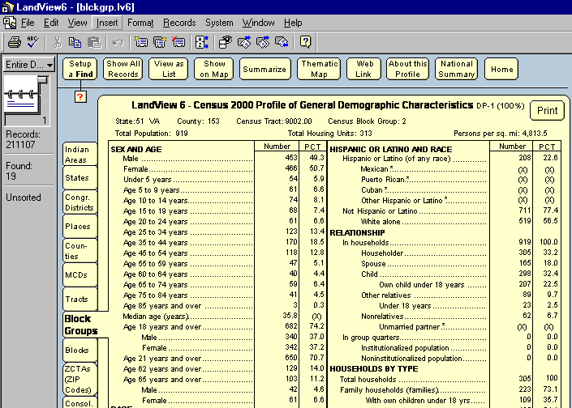
Figure 46. The Found Set for Prince William County to be Map Thematically
With the Found Set of records displayed, first click in the data field of interest—Percentage population 65 year of age and older—and click the Thematic Map button. The dialogue box in Figure 47 appears.
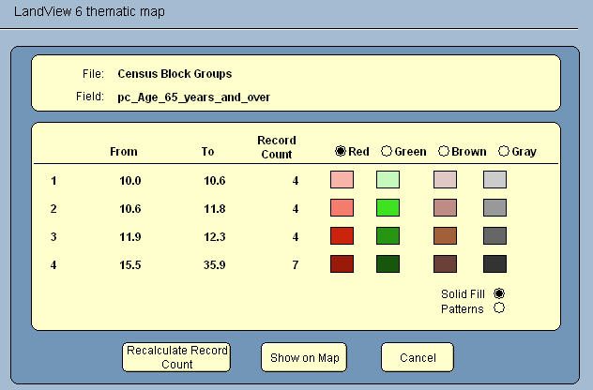
Figure 47. Thematic Map Dialogue Showing the Default Distribution
Our 19 records are divided evenly into four parts, quartiles, with the overflow going into the last quartile. The Show on Map button brings us to MARPLOT with our 19 selected Census Block Groups displayed. The Legend provides a key to the Graphics. This is shown in Figure 48.
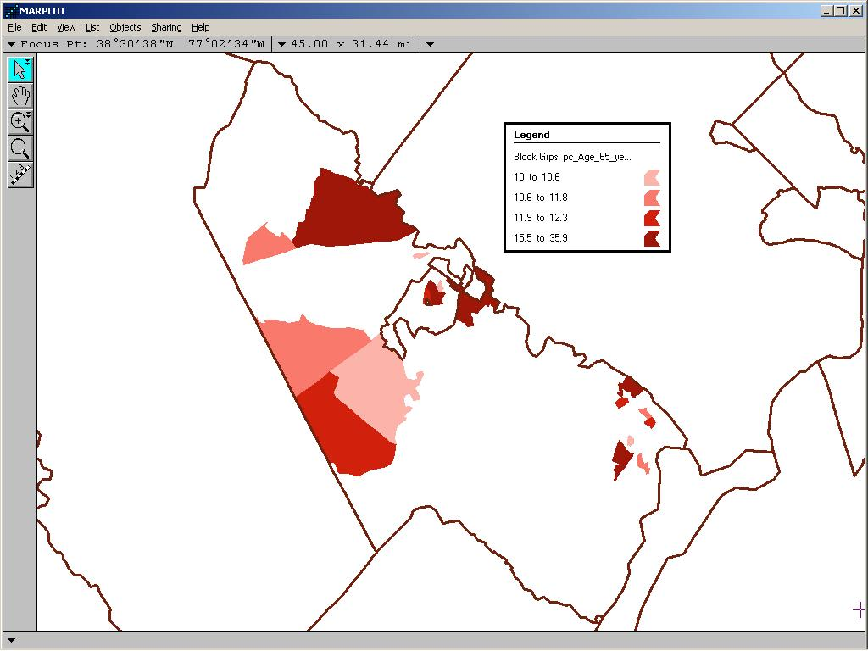
Figure 48. Areas of Prince William County with High Percentages of Elderly
LandView evenly divides the Found Set into four groups. This establishes the range of values for each quartile. As can be seen in Figure 47, it is not easy to relate to these values. You may be more comfortable with creating value ranges to which your audience may more easily relate. The range information in Figure 47 can be edited. Figure 49, below, displays a more meaningful set of range data. LandView needs to be told to Recalculate Record Count before the new distribution occurs. It is important to remember that ranges must be continuous; otherwise data will be lost if there are breaks in the data ranges.
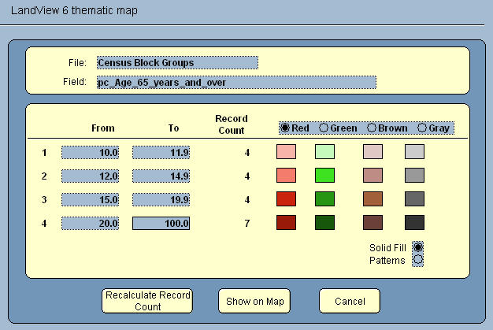
Figure 49. Thematic Display with Revised Data Ranges
When you are finished reviewing the revised map, return to LandView 6 and select the Cancel button in the Thematic Map dialogue box. This will clear the thematic map and return you to the Census Block Group data form. We are now ready for Lesson 5—more on Searching.

Lesson 5

Population Searches and Other MARPLOT Searches
Objectives for Lesson 5 are:
- Determine populations at a radius about a map point
- Understand ‘most accurate’ population count vs ‘more demographic information’
- Use MARPLOT’s Search to search for other mapped objects
- Explore additional MARPLOT mapping functionality
- Find populations within an irregular polygon
In determining the population within a mapped area, we generally are looking either for the population at a radius about a map point or for the population contained in an irregular area such as a town boundary. For defined geographic areas, such as a town, Census has already done the necessary work, and it is merely necessary to look up the data in LandView. In Lesson 5, we will examine population searches and other searches based on the relative position of map objects. Let us first look at population at a radius about a mapped point.

The Population Estimator
In Lesson 1, we identified the Estimate Population within a Radius button on the LandView Home page. Clicking on the button opens the Population Estimator dialogue. Most normally, the MARPLOT application is, or should be, running when using the Population Estimator, and the Latitude and Longitude fields in the dialogue default to the location of the Focus Point in MARPLOT. You will probably most often open the Estimator directly from MARPLOT, as the first step in making a population estimate is to appropriately set the location of the Focus Point. To access the Estimator from MARPLOT, use the MARPLOT MenuBar Sharing/LandView /LandView Census 2000 Population Estimator.
In LandView 6, the Population Estimator function has been considerably enhanced over that seen in LandView 5. In LandView 5, population count was based solely on the data available from a capture of Census Blocks. In Lesson 2, it was mentioned that because of the very large number of Census Blocks in the Census datasets, over 5 million, it was necessary to limit the number of data fields in the dataset. The first level of Census geography for which a significant demographic profile is available is the Census Block Group dataset.
For the most accurate count of population at a radius around a point, LandView 6 uses a dataset of centroids of Census Blocks. For a richer view of the demographics of a neighborhood, LandView 6 uses a dataset of centroids of Census Block Groups. The population count shown in relation to a Census Block Group search can differ markedly from that arrived at through a search by Census Blocks.
A Census Block, while it is small compared it to other units of census geography, does represent a defined area on the ground. A capture circle can and will truncate some Census Blocks leaving parts of their population outside the circle, but the error introduced when capturing a large number of block point centroids is relatively small. On the other hand, each Census Block Group represents a number of Census Blocks. Its centroid represents a larger area, and a Block Group is more apt to be truncated by a capture circle leaving whole Census Blocks outside the circle. This represents a population overcount. Compensating for this is the under count resulting from the Census Block Groups intruding into the capture circle while their centroids lie outside the circle.
For Census Blocks, demographic data is limited to those fields displayed in the dialogue. For Census Block Groups, while the population count will be somewhat less exact, there is the richness of demographic data associated with LandView’s tables DP-1 through DP-4. Let us go through an exercise to illustrate this.
Select a popular merchant in your home community, and, using your search techniques, locate the nearest road intersection to the merchant in MARPLOT. We will use the intersection of Jefferson Davis Highway and Dumfries Road in (Dumfries Town) Prince William County, Virginia. Typically, merchants are interested in the makeup of the populations that reside within three miles of their location. Use View/Mark Point to mark the location of the intersection
To better demonstrate the Population Estimator (and to introduce you to additional mapping techniques), we need to do some preparation. Use View/Marked Point/Center on Marked Point to place our merchant at the center of the display screen. Use View/Set Scale to set our window distance to 10 miles.
We will now place a Reference Circle on the map that will mimic the capture process. To do this, we need to create a new layer to contain our new map object. In List/Layer List . . . , use the New . . . button to create a new Layer—Reference, as shown in Figure 51. This layer is created Unlocked, and you return to the MARPLOT display screen with the OK button. When a layer is Unlocked, map drawing tools are shown as being available to the user.
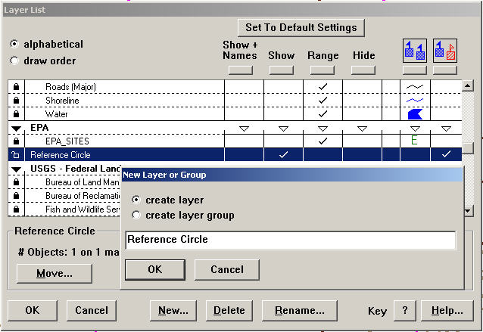
Figure 51. Creating a New Layer in MARPLOT
Selecting the Circle tool, , place your cursor on the Marked Point and drag your circle out to a radius of three miles. On releasing the mouse, the dialogue box in Figure 52 appears.
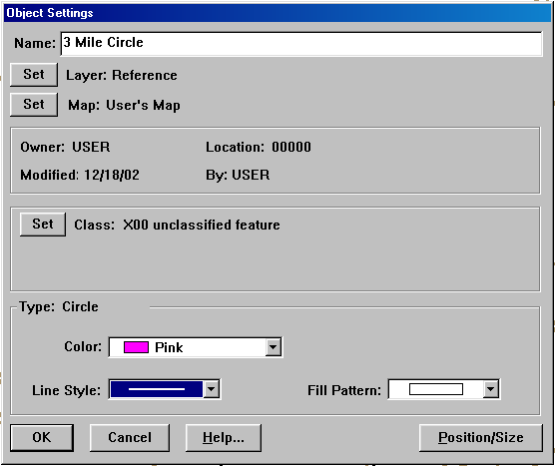
Figure 52. Dialogue Box for a New Map Object
Provide a name for your new map object—3 Mile Circle is a good one. Notice that the new object is on the Reference Layer and on the User’s Map. For better contrast, color your circle pink and change its line style to double weight. Returning to the map screen, your view should look something like that shown in Figure 53.
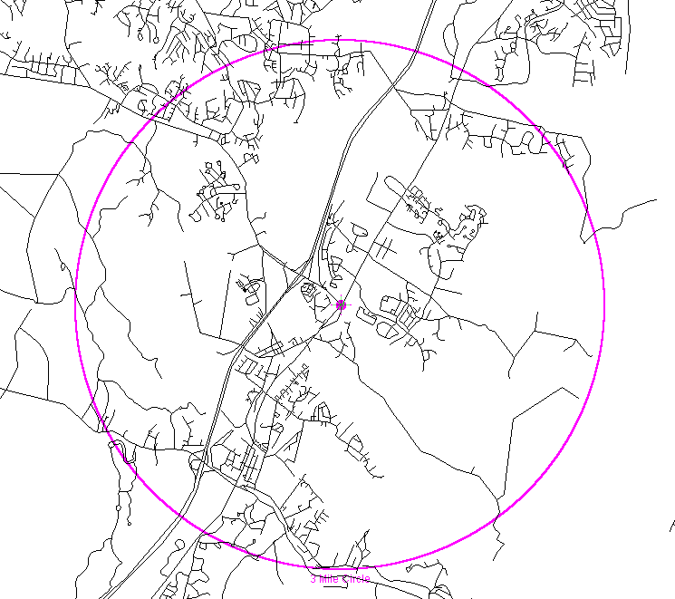
Figure 53 Road Layers provide a Visual Reference for Population Estimator Search
To better visualize the Population Estimator process, let us reconfigure the screen. Return to List/Layer List . . . This time Hide your open roads layers, leaving your Reference Circle displayed. Place the Census Block Points in Show mode. Returning to the screen, your Reference Circle will enclose those Block points that are the search objective of the Population Estimator. Our view is shown as Figure 54.
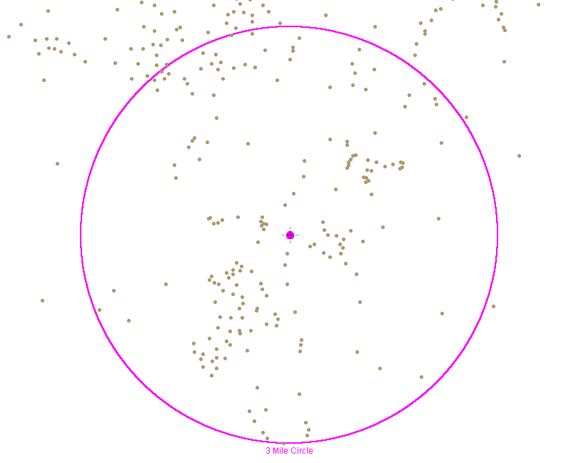
Figure 54. Census Block Points Layer Demonstrates the Capture Process
Each mapped point represents a Census Block containing either population or housing units. We need to use LandView/MARPLOT functionality to capture this data as a population estimate.
With your Focus Point at the Marked Point (View/Merked Point/Center on Marked Point), use Sharing/LandView/LandView Census 2000 Population Estimator to go to the Estimator dialogue box within LandView. This is shown in Figure 55.
We have yet to enter the defined search radius of three miles. There are a number of button whose functions are readily deduced. Primarily, we are faced with two search methodologies—search by Census Block points and search by Census Block Group points. Choosing first, the more accurate estimate of population, use the Calculate Population using Block Points button. LandView completes a calculation and the empty data fields shown in Figure 55 are replaced with those shown in Figure 56.
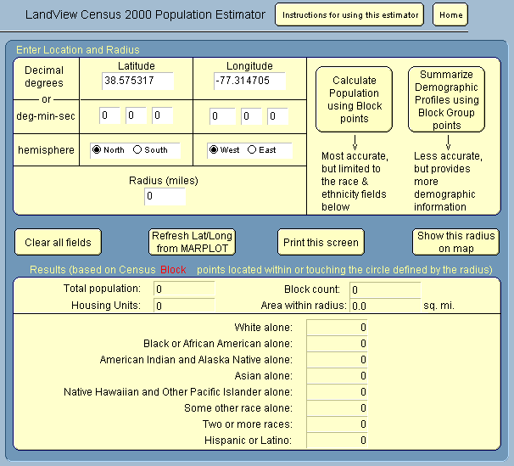
Figure 55. The Population Estimator Requires a Search Radius
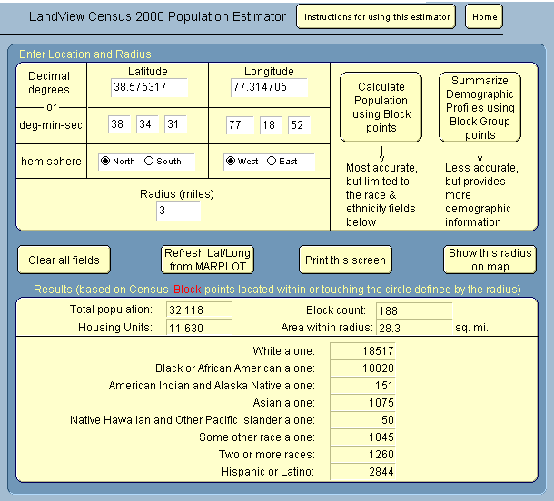
Figure 56. Block Point Statistics at a Radius of Three Miles of a Retail Merchant

Obtaining Demographic Information
An alternate button in the Population Estimator allows Summarize Demographic Profiles using Block Group points. An annotation tells users that the population count using centroids of Census Block Groups is less accurate than using centroids of Census Blocks. However, the data extract yields a complete set of DP-1 through DP-4 tables. The DP-1 table displays in Figure 57.
Figure 57.The DP-1 Table Showing Demographic Data at a 3 Mile Radius
Another button visible in Figure 56 allows Show this radius on map. The resulting image is shown in Figure 58. The displayed circle is a map object and can be used in other MARPLOT searches. It has the same functionality as the Reference Circle previously drawn.
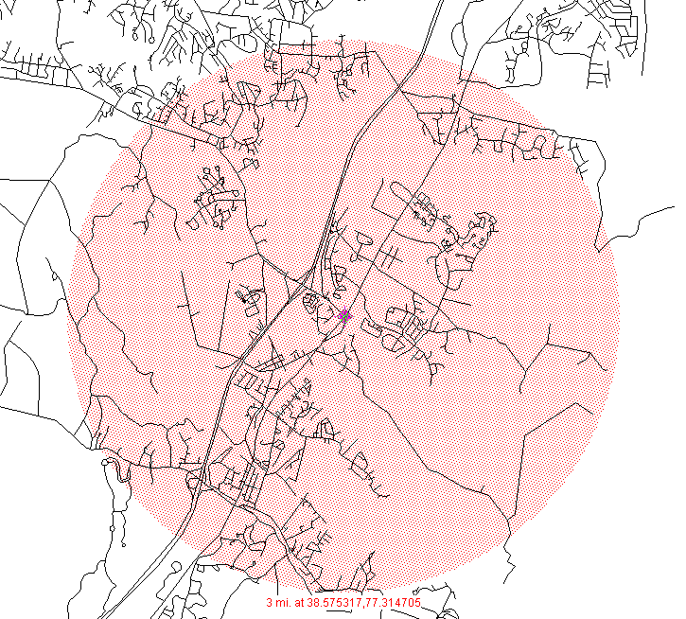
Figure 58. The Population Estimator Search Area Displayed

MARPLOT Searches at a Radius about a Point
MARPLOT Search is a powerful tool. We have used it once to search for objects by name. We will now use it to search for map objects at a radius around a point. For simplicity, since we still have a Marked Point, we will continue to use that as our point of interest. Let us say that we wish to identify all USEPA regulated facilities within three miles of the merchant in our previous example. MenuBar List/Search . . . opens the Search dialogue. The drop down menu in Figure 59 provides choices for characterizing our search objects. Note that ellipsis indicates that the option will open a to new dialogue box requesting additional information.
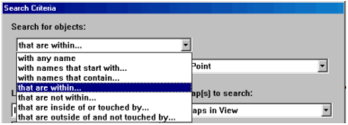
Figure 59. Drop Down Menu Available When Searching for Objects
On selecting that are within . . . as search methodology, a new dialogue box opens asking for additional information. The information provided is shown in Figure 60.
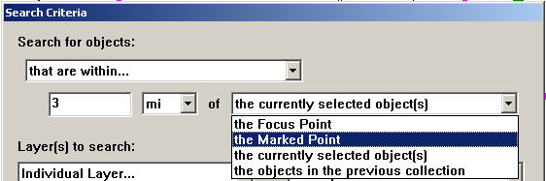
Figure 60. Further Defining the Object Search Criteria
As you can see, we can specify any radius, and we can specify a number of ways of defining the center points of the search. Our completely defined search is shown as Figure 61. The Search Collection resulting from the Search is shown as Figure 62.
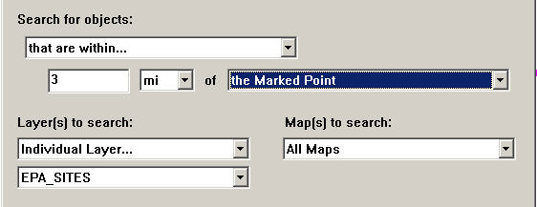
Figure 61. A MARPLOT Search Completely Defined
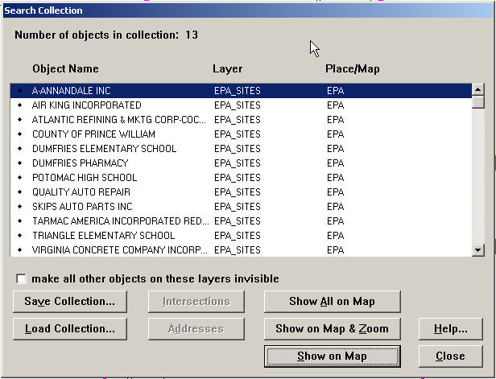
Figure 62. The Search Collection for Figure 60.

MARPLOT Searches Within an Irregular Polygon
In Figures 59 and 60, above, notice that among the drop down menu choices available are ones that can be stated as, “Objects that are inside of or touched by the currently selected object(s)”. The currently selected objects can be of any type—point, polyline or polygon. A polygon search is typical. Polygons abound in LandView—places, counties, census block groups, etc. There is also the ability for users to create polygons of their own choosing. For this, see MARPLOT Help and MARPLOT Technical Documentation.
For our Search polygon , use your ZIP Code. For our illustrative example, we will use ZIP Code 22191. Returning to our previous theme of EPA regulated facilities, we will search for all EPA facilities within the ZIP Code. First, in List/Search . . . , locate the ZIP Code polygon. Our Search definition is, “Objects with Names that start with 22191, on Layer Zip Code Tabulation Areas, on All Maps”.Since Zip Code Tabulation Areas is on the Census map, we do not need to specifically identify it. The Search Collection contains only the one object, ZCTA 22191, shown in Figure 63—with the identified ZIP Code polygon in Select mode.
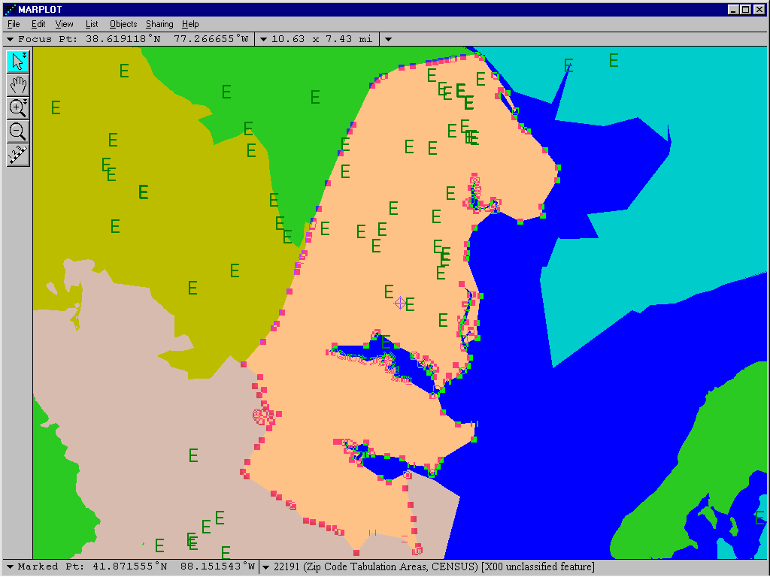
Figure 63. ZIP Code Tabulation Area 22191 in Select Mode
Continuing, we do another MARPLOT Search. This time our search definition is, “Objects that are inside of or touched by the currently selected object(s), on Layer EPA_Sites, on All Maps”. The resulting Search Collection is shown in Figure 64.
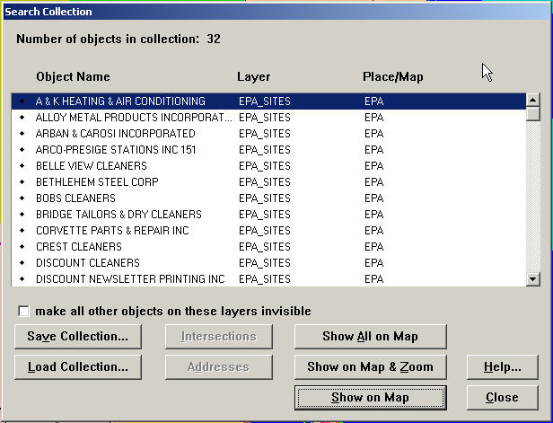
Figure 64. EPA Regulated Facilities in ZIP Code Tabulation Area 22191

Population Searches Within an Irregular Polygon
Populations within an irregular polygon is a recurring theme in LandView/MARPLOT. Most all of the polygons already present in MARPLOT have population data associated with them. However, for user defined polygons, the methodology is similar to the above. With such polygon in Select mode, our Search statement would be, “Objects that are inside of or touched by the currently selected object(s), on Layer Census Block Points, on All Maps”. On completion of the search and in the Search Collection dialogue, use Show All on Map. On return to the map screen, all Block Points within the polygon show in Select mode. Now, use MenuBar Sharing/LandView/Get Info to see the records displayed in LandView. The Summarize button will give you population totals. As previously footnoted, MARPLOT contains a map layer, Congressional Districts (106th), representing the boundaries of congressional districts at the time of the 2000 Decennial Census. This map layer contains no corresponding LandView data. If you were interested in the population count represented by the district boundaries, you would place the polygon representing the boundaries in Select mode and proceed as above.

Where Do You Go From Here
While this Tutorial has dealt extensively with various topics in LandView and MARPLOT, it has only begun to explore the functionality inherent in the programs. Users are encouraged to refer questions to the Help files in both LandView and MARPLOT. For some users, the MARPLOT Technical Documentation will be an additional useful resource. In addition, both LandView and MARPLOT contain additional Help buttons placed appropriately within certain modules and dialogue boxes
Users are encouraged to visit the LandView Help page and provide comments and other feedback that can be incorporated into future versions of this tutorial or the Help files. You can access the LandView Help page by clicking on the Help button on the LandView 6 Home page.

Source: U. S. Census Bureau, Geography Division Revised: November, 2003

A LandView 6 Demo version is available for download from the LandView Internet site. The LandView 6 Demo uses Prince William County as its point of reference, in part, because CAMEO, an emergency planning and response software compatible with LandView/MARPLOT also uses Prince William County in its illustrative examples. For further information about CAMEO software, go to http://www.epa.gov/ceppo/cameo/.
LandView 6 datasets at all levels of Census geography except the Census Block level are published in the same format as the National Profile—a four table set, Tables DP-1 through DP-4. These datasets are further described in Lesson 2.
An alternate navigational technique is to move between the two applications using the icons on the Windows Taskbar. If the Taskbar is not visible, the keystrokes [Control]-[Escape] will bring it into view.
Multiple selection or deselection can be accomplished by holding down the [Shift] key while using the tool.
The triangles are actually buttons that allow the user to specify the selection area as either a circle or a rectangle.
Map and Layer can also be defined as data elements of the MARPLOT application program. To MARPLOT, a Map is any directory accessible to the MARPLOT application that contains a name.map file. Objects on a Layer are defined by one or more sets of similarly named files contained in one or more MARPLOT map directories. Generically, the file set would include filename.lyr, filename.obj and filename.sum.
A View establishes the boundaries, identified by latitude and longitude, for an area on the ground. What displays in the View depends upon what layers are currently in Show mode. If no layers are in Show, the View is empty.
LandView 6 provides data and map sets for an additional political/geographical entity—the Commonwealth of Puerto Rico, included in LandView as a state equivalent. Puerto Rico is not included as part of the National Profile, to be discussed shortly in relation to the National Summary button which accesses this dataset. The first reason for this is be consistent with the Census Bureau's published U.S. Demographic Profile. A second reason is that the slightly different data content in the DP-2 table for Puerto Rico prevents it from being combined with the 50 states and District of Columbia.
Not all States contain Minor Civil Divisions. Minor civil divisions (MCDs) are the primary governmental or administrative divisions of a county in many states (parish in Louisiana). MCDs represent many different kinds of legal entities with a wide variety of governmental and/or administrative functions. The U.S. Census Bureau recognizes MCDs in 28 states. LandView, however, only provides data for 20 states and Puerto Rico. The states are: Connecticut, Illinois, Indiana, Iowa, Kansas, Maine, Massachusetts, Michigan, Minnesota, Nebraska, New Hampshire, New Jersey, New York, North Dakota, Ohio, Pennsylvania, Rhode Island, South Dakota, Vermont, and Wisconsin.
There are 8.2 million census tabulation blocks for the geographic areas shown in LandView. 2.7 million blocks are excluded because they contain zero population and zero housing units.
LandView 6 presents population data for congressional districts as apportioned in the 108th Congress and links to a MARPLOT map layer, Congressional Districts (108th), displaying the mapped locations of these districts. For comparison purposes, there is included in MARPLOT a map layer, Congressional Districts (106th), representing congressional boundaries at the time of the 2000 Decennial Census. This layer is not linked to LandView. Users wishing to obtain comparison population data for the 106th Congress can use MARPLOT capture techniques to find associated data in LandView 6.
Status Area, at the left of the screen, is part of the FileMaker Interface. Users are referred to the LandView Help files for further information on the FileMaker Interface.
Two other methods would have allowed you to move to your Home State. The Flip Chart Icon in the upper left of the screen would allow you to ‘flip’ to your State. However, this could require considerable flipping if your Home State were Wisconsin. Another method would be to View as a List and scroll to your listed State. The View as a Form button would allow you to return to Form View with your Home State displayed.
It is not necessary to go to your Home State before accessing the Block Groups tab. Each LandView ‘Find’ reverts to the entire dataset. A Find must included entries in each of the data fields necessary to identifying Census geography appropriate to the data subset. In this instance a State identification is needed to identify all Block Groups within the State.
Each LandView search starts from the complete dataset, and there are more than 200,000 Census Block Groups records to be searched. Some LandView Searches are prolonged. Indexed fields are searched much more quickly. However, indexing all fields that might interest individual researchers would add immeasurably to data content of LandView. For purposes of the Tutorial, ‘One Race—White’ and ‘Poverty Status in 1999—Families’ have been specially indexed to speed this search. For more on indexing, see LandView Help, Indexing LandView Files.
Most LandView functionality is button driven. However, certain MenuBar features add utility to the program. Users are encouraged to develop a familiarity with MenuBar content.
Do not confuse the field heading, “Age_65_years_and_over”, an actual numerical count, with “pc_Age_65_years_and_over”, the percentage of the population that is equal to or exceeds age 65.
The Sort dialogue includes a number of options. Most are self-explanatory. Data can be sorted across multiple fields. If you have several entries in the right hand column, you can ‘Click and Drag’ a lower entry in the list to the top of the list. The uppermost field is the key sort field.
SIC—Standard Industrial Classification—identifies the type of activity undertaken by the facility. Facilities engaged in manufacturing have SIC Codes that range from 2000 to 3999.
For most regulated faculties, the latitude/longitude values are taken directly from reports submitted by the facility, and inaccuracies occur. However, it is these values that are plotted in MARPLOT and linked to records in LandView. Users are cautioned to use mapped values only as general references.
That is, all schools in the GNIS. USGS is making efforts to update the GNIS, but you will find that some information is out of date. As an example, check the list of schools in your Found Set for what it contains and what it does not contain against what you know of your present day County.
This new entity was developed to overcome the difficulties in precisely defining the land area covered by each ZIP Code®. Defining the extent of an area is necessary in order to accurately tabulate census data for that area. ZCTAs represent the majority USPS five-digit ZIP Code found in a given area. For those areas where it is difficult to determine the prevailing five-digit ZIP Code, the higher-level three-digit ZIP Code is used for the ZCTA Code.
Not every street in the Census Bureau TIGER/Line files has associated address data. In the rare instance that your street address is such, you can locate your home by its street and nearest intersection—this methodology is discussed later in the tutorial. For now, pick any main street in Town. These are most usually addressed.
In some cases, and this is one, the ZCTA touches an adjacent County. The name search, then, includes both the Home County and the neighboring County. Our search is in Prince William County, but data for Fairfax County is included.
Not all roads in TIGER/Line have associated addresses. For those few, it is possible to identify a near intersecting road from the Intersections button. An example is given later in this lesson.
In Lesson 2, our example Found Set included two variables, Race as exemplifying Minority Status and Families in Poverty. There are procedures for thematically mapping such data. An example is given under Unique Solutions in LandView Help.
Virginia is one of a very few states where certain cities exercise governmental functions normally reserved to counties. As such, cities are listed in the Census datasets under the headings of both Places and Counties. For the convenience of users of the Demo program, we will use these three entities in the example.
Population searches can be conducted inside of user defined polygons, and this subject is touched upon at the conclusion of this Lesson.
The Reference Circle can be removed from MARPLOT whenever it has served its purpose. To remove, first Unlock the Reference Circle layer in List/Layer List . . . , return to the MARPLOT display screen, and with the Reference Circle in Select mode, use Edit/Clear to remove. As an alternate, the Reference Circle layer, itself, can be removed. Unlock the layer and highlight it. Use the Delete button.
The LandView algorithm for determining which block internal points fall within the radius takes the curvature of the earth into account. The MARPLOT mapping engine does not. Consequently for larger radii, users might note differences in the block point counts between MARPLOT and the Population Estimator.
One-third of the 8.2 million Census Blocks do not contain either population or housing units. These are excluded from LandView 6. Doing this conserves file space and improves mapping performance.
Since the EPA_Sites Layer resides on only one map—the EPA Map, we can use the general expression, All Maps, to define our map search.
ZIP Code boundaries are not subject to easy definition and can change. To differentiate, Census defines its ZIP Code boundary files as Zip Code Tabulation Areas (ZCTAs).
A plume model of a chemical release as plotted from the MARPLOT-compatible ALOHA program could be an example of a user-created polygon. Population estimates within the contaminated zone prove useful to emergency responders.

