Couples HIV Counseling and Testing

Module One: Background and Discordance
____________________________________________________________________

Module Perspective:
This module establishes the climate for this training course. The trainer(s) will welcome participants to the training; allow participants to introduce themselves; review the goal of Couples HIV Counseling and Testing (CHCT); and review the goal and objectives of this training. The trainer will review the agenda and participants will agree on ground rules for the training. Participants will then participate in an icebreaker exercise that will help them to become acquainted and reinforce the importance of effective communication in a couple relationship.

Participants will learn important concepts that will be the foundation for learning how to effectively work with couples in an HIV counseling and testing setting.

Participants will complete a pre-knowledge assessment form and then take a morning break.

When participants return from break, trainers will discuss the importance of couple counseling, including the rationale for couples HIV counseling and testing, and will allow participants the opportunity to brainstorm about the advantages of couples HIV counseling and testing. This module will conclude by reviewing data on HIV knowledge among couples and by briefly addressing HIV sero-discordance.

Objectives for Module One:

- Review the course agenda, including goals and the content of the entire course.
- Structure introductions to allow the participants to become acquainted with one another and the trainers.
- Introduce the objectives of Couples HIV Counseling and Testing (CHCT).
- Discuss each of the possible outcomes of couples testing, including the concept of HIV sero-discordance.

Advance Preparation

- Prepare Overheads 1-1 through 1-16

1-1: Couples HIV Counseling and Testing: Facilitating a Shared Vision
1-2: Goal of the Training Course
1-3: Objectives for the Training Course
1-4: Multiple Models of HIV Counseling and Testing Services
1-5: Advantages of Couples HIV Counseling and Testing
1-6a: Importance of Couples HIV Counseling and Testing
1-6b: Importance of Couples HIV Counseling and Testing (Continued)
1-6c: Importance of Couples HIV Counseling and Testing (Continued)
1-7: Sero-Discordance
1-8: Proportion of Discordant and Concordant Couples
1-9: HIV Knowledge among CHCT Clients
1-10: Myths about Discordance
1-11: Facts about Discordance
1-12: Discordant Couple
1-13: 100 HIV-Negative Partners in Discordant Couples
1-14: 22 Newly Infected Partners
1-15: HIV-Negative Partners with CHCT
1-16: Importance of CHCT

- Make Copies of the Handout

Couples HIV Counseling and Testing: Pre-Course Knowledge Assessment (H1-1)

- Write the Following on Separate Newsprint Pages

Participant Self-Introductions (page 4)
Expectations (page 5)
Ground Rules (blank—see page 10)
Parking Lot (blank—see page 11)
Advantages of CHCT (blank—see page 16)

- Make Sure You Understand the Participant Coding Sheet (see pages 30–35)

Day One

Module 1: Topics/Activities Schedule

Start time: 8:30 am

Activity Time

Host Welcome 10 minutes

Introduction of Trainers/Participants 35 minutes

Goals, Objectives, Agenda, and Ground Rules 15 minutes

Icebreaker 25 minutes

Pre-Course Knowledge Assessment 15 minutes

Morning Tea/Coffee Break 20 minutes

Couple HIV Counseling and Testing: Advantages 15 minutes

Importance of CHCT and Discussing Discordance 40 minutes
with Couples

End time 11:25 am

Welcome

Begin the session by:
- Asking participants to write their names on the tents
- Introducing yourself briefly, including your educational background, your experience in counseling, and your knowledge of and history with the geographic area
- Asking the representative of your host organization to formally welcome the participants and trainers

Welcome! This morning we will start a training course that will go through the next 4½ days. Before we get started, please write your name on the table tent in front of you. We will begin by getting to know each other a little better. We will also go over the sequence of topics and times for the next few days. We will also talk a little about why you are here.

But first, our host, (name) would like to welcome you to this couples HIV counseling and testing training.
Welcome by the Host

Ask your host to welcome participants and briefly talk about the importance of learning how to implement and deliver HIV counseling and testing services specifically tailored to couples. If your host is not available, consider making this presentation yourself. Suggest that your host offer a word of encouragement and support for the participants and the trainer. You can suggest that the host include basic information about HIV/AIDS in their district or country, such as:

- Brief overview of the HIV/AIDS epidemic in the country
- Local data on discordance and transmission risk (if available)
- Government commitment to supporting and expanding counseling and testing activities, including CHCT services

Introduce yourself. If you have a co-trainer, introduce that person by name. Provide information on your background and experience and have the co-trainer do the same.
Introductions of the Participants

As you facilitate the participants’ self-introductions, have your co-trainer listen to and write down each person’s name, sex, and years of counseling experience. If you do not have a co-trainer, you will need to record this information yourself. The information will be helpful when you begin filling in the Participant Coding Sheet for role plays that begin on the second day of training. After this session, but before Module 2 begins, decide where each participant should be ranked on the Participant Coding Sheet. Instructions and the Coding Sheets can be found on pages 31–35.

The Participant Coding Sheet is a tool designed for 15–18 participants. It is useful for ensuring that people with varied skill levels have equal opportunities to play specific parts, including that of the counselor, during the role plays. Skilled counselors should role play difficult sessions (e.g., giving discordant results), while less-skilled counselors should role play less difficult situations. Use of the Participant Coding Sheet will also help to ensure, to the extent possible, that men will role play male partners and women will role play female partners. The Coding Sheet also helps to ensure that participants get the opportunity to role play with different individuals in the different role-play activities.

Newsprint: Introductions of

Introductions of Participants
- Name
- Agency or organization
- Years of counseling experience
- Approximate number of couples
you have counseled
- What you hope to learn from the
training (your expectations)

Participants

Use the newsprint sheet to remind people what information to include. As the participants introduce themselves, prompt for any part of the introduction that is omitted.

Write on the newsprint sheet the participants’ goals and expectations and post the sheet in a visible place in the room.

Participants’ Expectations

It is a pleasure to be here with a group of such talented and experienced counselors. I look forward to our time together learning about couple HIV counseling and testing.

Please introduce yourself to the group and include your:
- Name
- Agency or organization
- Years of counseling experience
- Approximate number of couples you have counseled
- What you hope to learn from the training (your expectations)

Go over housekeeping details, such as location of the toilets, phones, and emergency exits; security issues; parking; and any other details that might need to be discussed.
Housekeeping
Goals, Objectives, and Ground Rules

Display Overhead 1-1.
Introduction to Couple HIV Counseling and Testing

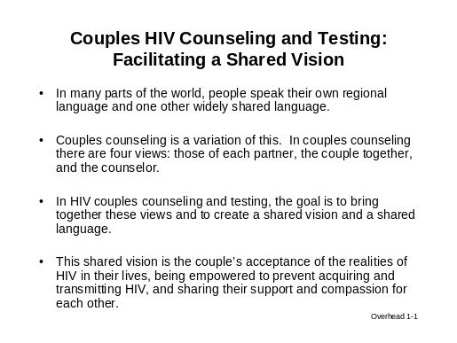

Tell the participants that the information on this overhead is in their manuals. Also, tell them there is room for them to take notes in their manuals if they wish.

We will start our training session today by going over the goals of the course and what we will do in the first module. This overhead explains the overall goal of couple counseling—that is, to help couples come to a shared vision of HIV in their lives.

In many parts of the world, people often speak their own regional language and one other widely shared language. Couples counseling is a variation of this. Couples counseling has four views: those of each partner, the couple together, and the counselor.

In HIV couples counseling and testing, the goal is to combine these views and create a shared vision and language. The shared vision is the couple accepting the realities of HIV in their lives, being empowered to prevent acquiring and transmitting HIV, and sharing their support and compassion for each other.

As we know, couples and families are very important to our society; they are the backbone of our communities. Therefore, when one or both partners in a couple become infected with HIV or have AIDS, their family and the community and society are also affected. It is essential that both partners know their status so they can plan their future and ensure the health of their children, family, and community.

Display Overhead 1-2.
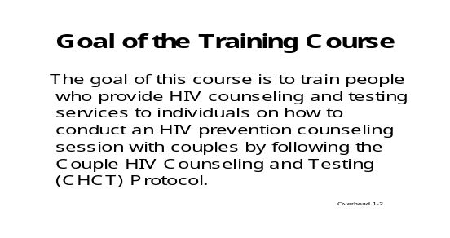
Goal and Objectives for the Training Course
Display Overhead 1-3.
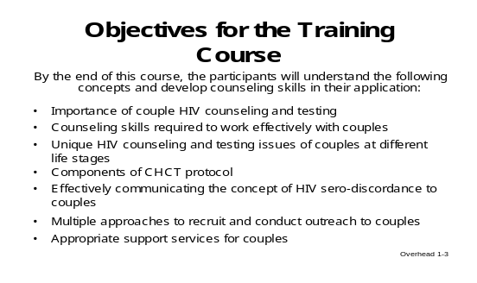

Tell the participants they can find the goal and objectives for the course in the Introduction of the Participant Manual.

Over the next few days, we will cover many aspects of counseling couples. Our goal is that you understand all the aspects of couples HIV counseling and testing. We will cover the importance of couples counseling, the skills you will need to counsel couples, and the unique characteristics of counseling couples in different life stages.

We will cover the communication skills you will need to help couples understand sero-discordance. We will examine the components of couples HIV counseling and testing (CHCT). We will also discuss approaches to recruit appropriate support services for couples and conduct outreach to them.

To help you better see how we will cover all the course topics; let’s quickly review the agenda for the week. You can also find the course agenda in the Introduction of your Participant’s Manual.

Briefly go through the 4½-day agenda items.

We will spend the next 4½ days on these topics. Besides sharing a lot of information, we will help you practice new skills through many role plays and small group exercises. We have

also allotted time to discuss major issues that may arise as a result of learning and practicing the couples HIV counseling and testing intervention. We will talk in both small groups and all together.

Throughout this course, we will refer to this intervention as the CHCT intervention.

Refer to the participants’ list of expectations that they provided during the introductions. Note where the goal or objectives match the group’s expectations, and gently indicate items that might not be covered in depth.

Now let’s look at your list of expectations. You can see where this course will meet many of your expectations.

Acknowledge any expectations that are outside the scope of the training course. There may be time to discuss these issues at the end of the course. You can encourage participants to write these questions in the “Parking Lot” when you discuss it.

This morning we will concentrate on the importance of couples HIV counseling and testing. We will also discuss the fact that some couples may have a partner that is HIV negative and a partner who is HIV positive—meaning they are HIV sero-discordant, or what is commonly referred to as a “discordant couple.”

This morning’s session will introduce you to the training and to some of the topics we will be discussing. Later this morning and this afternoon we will begin to look at specific couple counseling skills. We will practice what we have discussed so far in a role play.
Agenda for Module One

Please note that we will have lunch and breaks at (indicate times). I would request that all of you help us keep time. We have a great deal to cover, and we don’t want to get behind. Today will be a mixture of lecture, discussion, and role play.

To help everyone meet their goals and objectives, we will go over some ground rules that will help the training run smoothly and keep discussions open and comfortable. These ground rules will be posted throughout the entire course and should be kept in mind at all times. Do any of you have any suggestions for rules or guidelines for us to follow?
Ground Rules

Write the participants’ suggestions on the newsprint titled “Ground Rules.”

Ground Rules

Post the ground rules in an obvious place. Make sure the suggestions in the script below appear on the completed list. If participants do not bring them up, suggest them yourself.

An important ground rule for the trainer is to stay organized with course materials, time, and structure. You should model this in every way, letting participants observe your structured and focused approach to training.

You might comment about any of the ground rules that need to be clarified. For examples, see the accompanying script.

Examples of script for different ground rules:

Actively participate: This training should be viewed as an opportunity to learn and practice new skills. Active participation will allow you to get the most out of the training.

Manage time and stay on task: Because there is so much material to cover, it is extremely important to stay on task and on time. I will do my best to keep track of time, but everyone is responsible for arriving on time at the start of class and after breaks. I encourage discussion and questions, but recognize that sometimes I will have to cut discussion short to move on with the material.

Listen to and respect all opinions: Participants may have different ideas and disagree on certain issues. By respecting all ideas and opinions, we can learn about subjects from different points of view. Thinking about issues from all sides will help counselors understand their clients and the issues better.

Honor confidentiality: It is extremely important to make sure that everyone feels comfortable sharing experiences. Personal stories that people share during training should stay in this room. Please do not make assumptions about a person’s character based on gender, age, sexual orientation, religion, education, economic situation, or race.

Have fun: This training is an opportunity to learn new skills, share ideas, and meet new people in a comfortable setting.

Place the newsprint titled “Parking Lot” on the wall.
Parking Lot

Parking Lot

Provide participants with sticky notes that can be placed on newsprint. At the end of the day or anytime before the end of the training course, you should address the issues that are in the Parking Lot. If you do not have sticky notes, tell the participants to write directly on the newsprint.

Throughout our training course, this newsprint sheet will stay on the wall. You can write issues you would like to see addressed on sticky notes and place them on the Parking Lot newsprint page (or write directly on the newsprint) if we cannot cover them at the moment you think of them.

These can be issues that are not directly related to what we are discussing at the moment. Or they might be relevant, but we’ve run out of time and need to remember to address them later. We will address items on the Parking Lot either at the end of the day or before the course ends.

Ice Breaker

Explain and Conduct the Activity
The dynamics of couple relationships may be raised many times during this training and may come up when processing this ice breaker. Trainers should inform participants that they will address the skills needed to manage couple dynamics in the counseling session later in the module.

Ask participants to get into groups of three.

We are now going to conduct a brief ice breaker.

You will all break into groups of three.

In your groups, I want you to choose one person who will observe the exercise, leaving the two remaining people to perform the exercise.

The two in each group who will conduct the exercise should think of your dream house. Quietly visualize what this house is like, and do not worry about the cost. This is the house where you live in your dreams. Just think—do not discuss your thoughts.

Allow a moment for each group to select their observer and then give the remaining pair a moment to think about their dream house.

Now, I want each pair to pick up the pen together and draw your dream house on the paper at the same time. I want the pairs to draw their house while both are holding one pen.

Pairs may not talk while they are drawing their house.

You will have 5 minutes to complete your drawing. When you have completed your drawing, please put the pen down to indicate that you have finished. Observers—remember that you are to watch the process and take mental notes of what you see without interfering or making any statements.

Are there any questions?

Answer or clarify as needed.

Ask participants to begin.

Call time when 5 minutes have passed or when participants have completed their task.

In the discussion, listen for:
Discuss the Ice Breaker
- One partner giving in to the other, either voluntarily or not
- Specific challenges the partners encountered
- The importance of communication to enable two people to function as one

First, I have a question for the observers: What did you observe as your couple drew their house?

Now for those of you in pairs—our couples for today’s exercise:
- How did the process of drawing the house go?
- What were some of the challenges that this exercise presented?
- Was there a dominant person or a person who submitted to the other in order to complete the task?

During the exercise, each of you represented a perspective of a member of a couple that can be seen in a counseling and testing setting. The observers represent the counselor. The two people drawing a house represent the individuals in the couple, and the pen represents the couple as a unit.

Many factors can influence the couple dynamics. During this training, we will learn about couple counseling skills that will be useful in managing the dynamics during the counseling session.

As we cover the course materials we will address some of the challenges that couples may be facing, and we will identify issues that are beyond the counselors’ ability to control.

As we review couples counseling skills and the CHCT intervention, you will begin to learn the following four important concepts.

The following four concepts should be written on newsprint and placed on the wall for the rest of the training.
- Counselors should focus on solutions—not problems.
- Counselors must assist in diffusing blame and tension.
- Counselors should focus on the present and the future.
- Remember, the past is in the past and cannot be changed.

Pre-Course Knowledge Assessment

Distribute Handout 1-1: Pre-Course Knowledge Assessment
Administer the Assessment

Give each participant an index card to use for responding to question #11 in the Pre-Course Knowledge Assessment.

Instruct participants to write their response to question #11 (How would you explain to a disbelieving couple how it is possible for them to have different HIV test results?) on the index card. You will need to collect all index cards and save them for use in the discordance exercise in Module Six.

Before we take our morning break, I’m going to ask you to take a few minutes to complete a knowledge assessment form. This is not a test. This assessment will help us to determine if the training is effective. Please answer as best you can. If you do not know the answer, feel free to write, “I don’t know.”

You do not need to put your name on this form. However, please put an identifying code that you can remember on the form—for example, MJ241. We will ask you to put the same code on the Post-Course Knowledge Assessment form.

I’m also giving you each an index card to use to answer question #11. You need a little more space than you have on the form for that question.

You have 15 minutes to complete the assessment. Then we will take a 20-minute morning break.

At the end of 15 minutes, collect the Pre-Course Knowledge Assessments and index cards.

Tell participants that you will take a 20-minute morning break. Ask them to be prompt in returning to the room. You may find it helpful to state the time they should return.
Morning Tea/Coffee Break

Couples HIV Counseling and Testing: Advantages

Welcome participants back from the break.

Multiple Models of HIV Counseling and Testing and Advantages of CHCT

Display Overhead 1-4

Models of HIV Counseling and Testing (HCT) Services

- Client-initiated testing and counseling (CITC)
  - At stand-alone or mobile voluntary counseling and testing centers (VCT)
  - In the workplace
  - Services for individuals
  - Services for youth
  - Services for vulnerable populations
  - HCT for families
  - Couples HIV counseling and testing (CHCT)

- Provider-initiated testing and counseling (PITC)
  - For all persons seeking in-patient and out-patient services in a health facility
  - HIV diagnosis for tuberculosis (TB) clinic patients
  - Prevention of Mother-to-Child Transmission (PMTCT) for antenatal clinic, post-natal ward, and labor and delivery ward clients (including couples)
  - HCT for persons attending sexually transmitted infection (STI) clinics
  - For individuals, couples, or families in the home-based setting

Overhead 1-4

Overhead 1-4

Tell the participants that they can find this list and other information in their manuals.

This session will focus on the advantages of couple HIV counseling and testing. But before we talk about this, let’s first briefly review the many models for counseling and testing. As you can see from this list, these models address youth, women who are pregnant or could potentially be pregnant, families, individuals who may be at risk, and patients who will be tested when they undergo testing for other health problems.

These different models may have different purposes and objectives, messages, emphases, target populations, and protocols. The models require different skills and training.

The models can be offered in a variety of formats: different models in different settings; multiple models in a single setting; integrated services delivered in a single setting; stand-alone services; outreach and mobile services; and clinic-based services.

The services may be delivered by a counselor, health care worker, or multidisciplinary team.

Countries need a strategic mix of models to reach the greatest number of people and to assure that those who are HIV-positive get appropriate care and treatment.

We are going to focus on CHCT in this training. Couples counseling and testing can be delivered in different sites and within different models of existing counseling and testing services, such as VCT centers and during PMTCT sessions. Couples counseling and testing is different because two people in a relationship come for services together. They are counseled together and receive their test results together.

Let’s begin by discussing the advantages of couples counseling and testing in relation to counseling and testing of partners individually.

Begin the discussion of advantages of CHCT by briefly brainstorming.
Advantages of CHCT

Follow the brainstorming by comparing the advantages listed on Overhead 1-5 with those the participants came up with. Keep this section brief.

Newsprint Sheet (blank)

Advantages of Couples
HIV Counseling and Testing

Couples HIV counseling and testing has many advantages, particularly in relation to client-initiated counseling and testing (CITC), which is sometimes known as voluntary counseling and testing (VCT).

What do you think these advantages are?

Display Overhead 1-5.

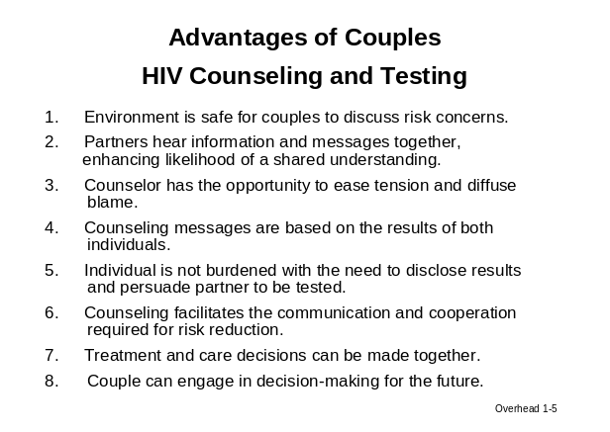

When the participants have finished brainstorming, go through the information on Overhead 1-5. Be sure to acknowledge the suggestions that participants came up with in the brainstorming exercise.

This overhead lists a number of advantages of CHCT. Let’s see how the ones we came up with compare with the ones on the overhead.

- Environment in CHCT is safe for couples to discuss their risk concerns.

As a counselor, you will need to use your counseling skills to create a secure environment for the couple.

- Partners hear information and messages together, enhancing the likelihood of a shared or common understanding.

- Counselor has the opportunity to ease tension and diffuse blame.

- Counseling messages are based on the results of both individuals.

- The individual is not burdened with the need to disclose results to his or her partner and persuade the partner to be tested.

This is a perfect example of the difference between CHCT and VCT. A client who is tested as an individual must tell his or her partner of the results. Studies have found that fewer than one out of four women who received VCT or PMTCT services disclosed their HIV-positive test results to their partner. This means that many, if not most, male partners were not aware that their female partners were infected with HIV. (Reference: Maman 2001).

In couple counseling, the partners receive the test results together. This facilitates disclosure because the partners learn their HIV statuses together, making disclosure immediate. The counselor is present to provide assistance. Essentially, disclosure in CHCT is 100%.

- Counseling facilitates the communication and cooperation required for risk reduction.

In CHCT, the couple may talk about issues that they might not have discussed in detail before. The counselor’s role is to help couples address the issues and concerns required for risk reduction.

- Treatment and care decisions can be made together.

Infected members of couples may be more likely to follow up on needed medical care and take medication when their partners know their HIV status.

- Couple can engage in decision-making for the future.

Importance of CHCT and Discussing Discordance with Couples

Inform participants that you will review the importance of couple HIV counseling and testing.

Display Overhead 1-6a.
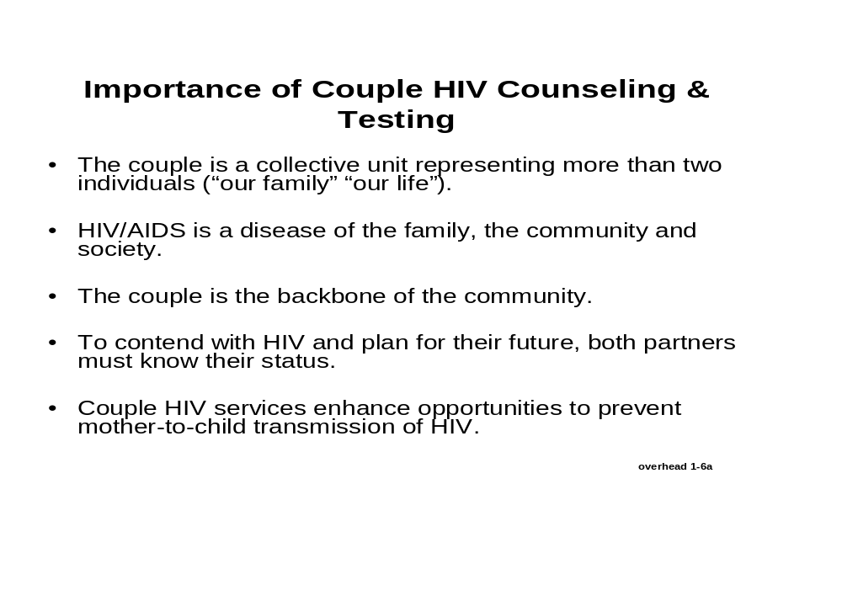
Importance of CHCT

Display Overhead 1-6b.

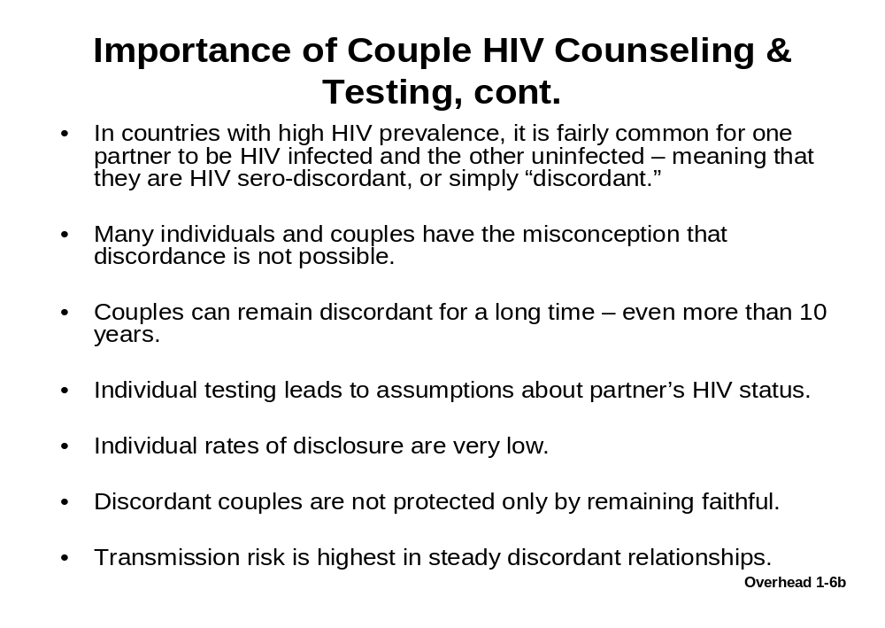

Display Overhead 1-6c.

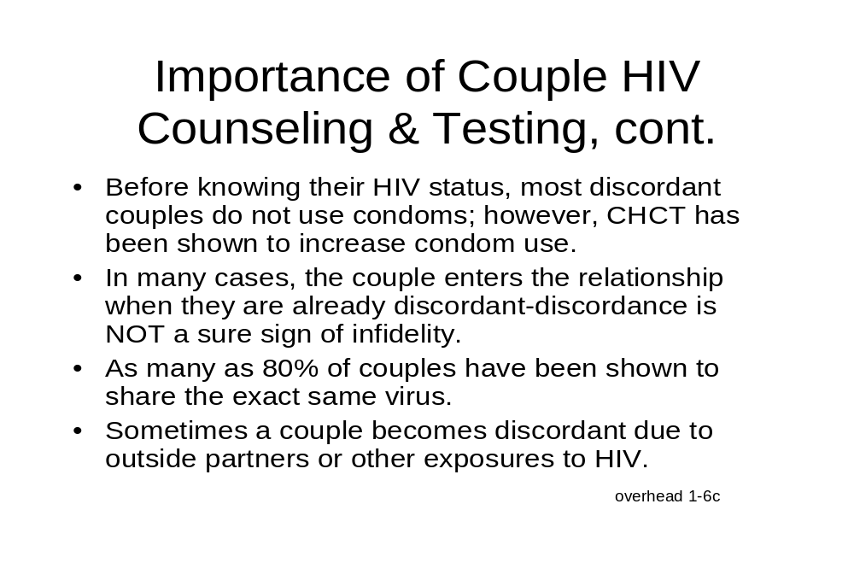

Display Overhead 1-7.
Possible HIV Test Results for Couples Receiving CHCT

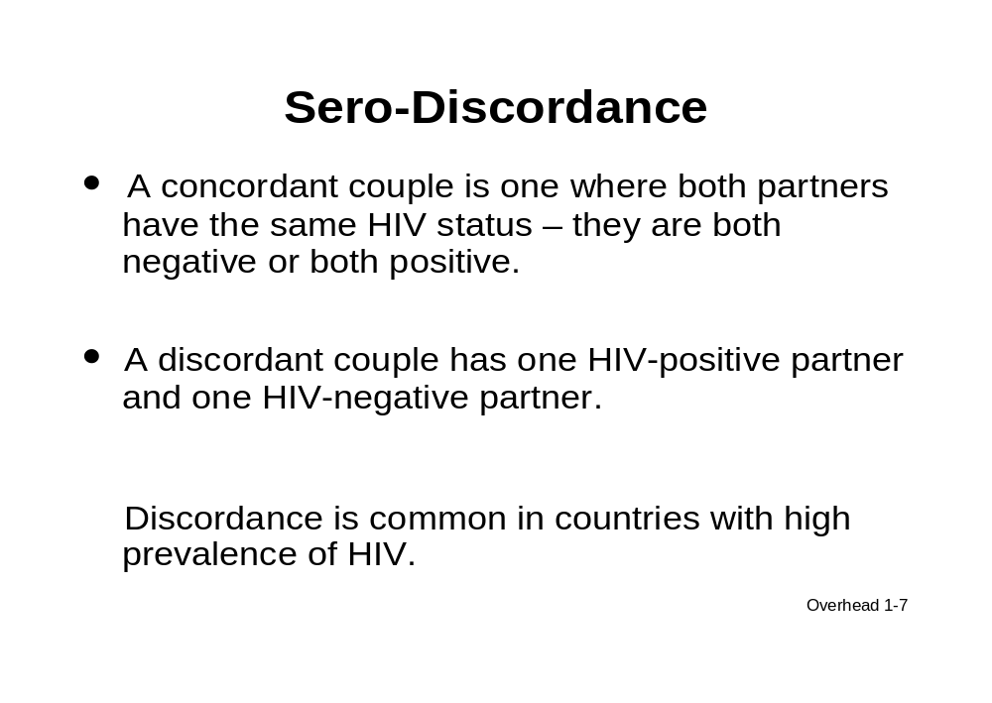

Now let’s talk about the types of HIV test results that are possible during a couple counseling session.

Most couples are concordant negative, meaning they are both HIV-negative. For other couples, one or both partners may be infected with HIV. In concordant positive couples, both partners are HIV-positive. In discordant couples, one partner is HIV-positive and the other is HIV-negative.

The percentages of couples who are concordant negative, concordant positive, and discordant will vary by the prevalence of HIV in the country and where services are provided (for example, in urban or rural settings, PMTCT settings, VCT services, and TB clinics, among others). Communities with high HIV prevalence rates also have higher rates of concordant positive and discordant couples. In one study in an African country with a high HIV prevalence, it was found that about three in four couples were concordant negative, less than one in four couples were concordant positive, and about one in ten couples were discordant. (Reference: Roth 2001)

Display Overhead 1-8.

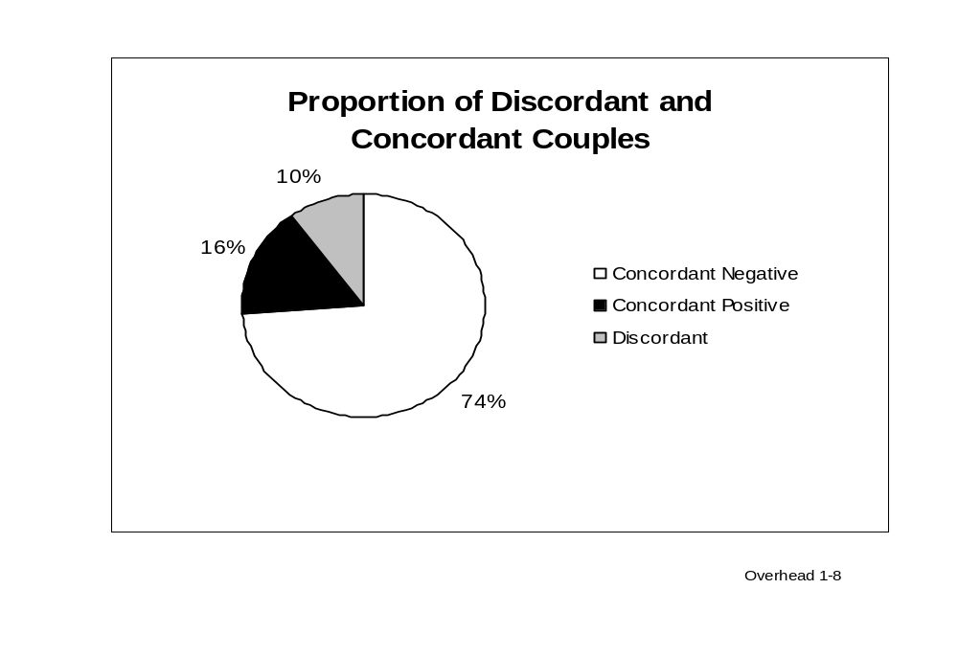
(Source: Roth 2001)

Most couples tested for HIV will be concordant negative. CHCT will help concordant negative couples maintain their HIV-negative status by recognizing that being faithful to their partner is the only certain way to keep their future free of HIV.

Display Overhead 1-9.

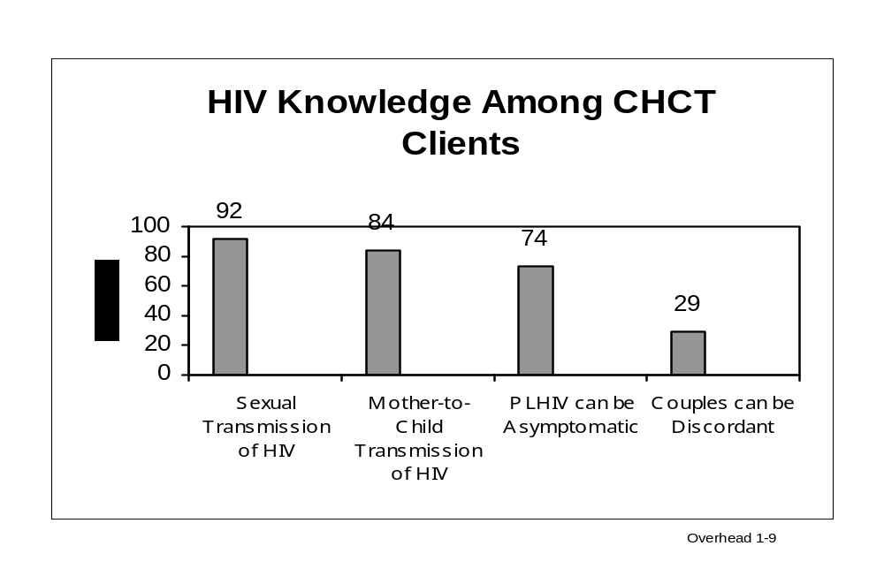

As you can see from this chart, most people, 92%, understand that HIV is sexually transmitted. Fewer people, but still a majority, are aware that HIV infection can be transmitted from a woman to her infant and that someone with HIV may have no symptoms. Even fewer people, only three out of ten, are aware that one person in a couple can be HIV-infected while the other is not.

In CHCT it will be very important for you to emphasize and explain things that are not widely understood, such as couple discordance. The HIV-negative partner in a discordant couple is at very high risk for getting HIV if the couple does not take steps to protect the HIV-negative partner. We will talk more about discordance in Module Six when we review that section of the CHCT intervention.

The information found in this overhead should guide counselors about the most important topics to focus on during the CHCT session. In most cases, providing information about sexual transmission is unnecessary because most people clearly know and understand that HIV is sexually transmitted. However, VCT and CHCT clients may not be aware that it is possible for partners in a couple to have different test results (couple discordance). (Data source: McKenna 1997)

Display Overhead 1-10.
Myths about Discordance

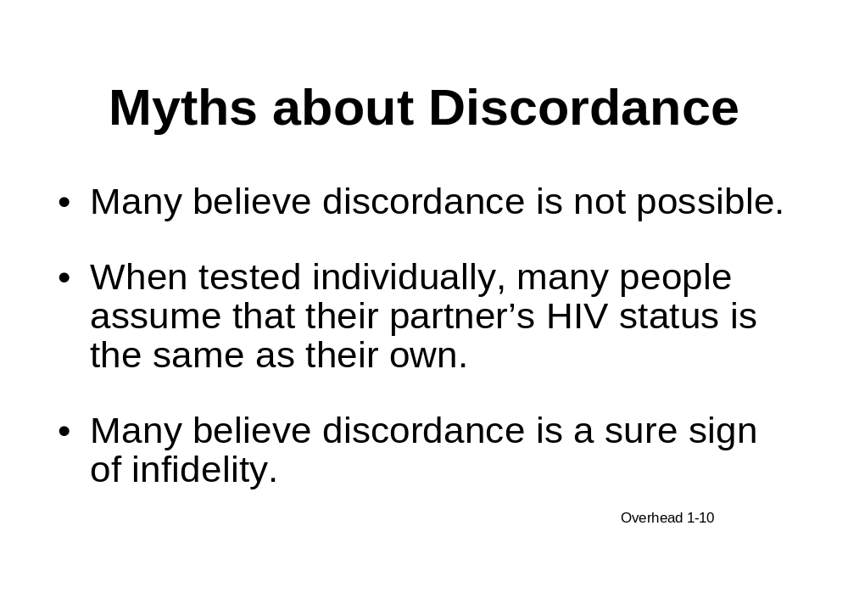

Many people do not understand the facts about discordance, and there are many myths about discordance that need to be corrected. For instance, many people believe that discordance is not possible— that is to say, if one partner is HIV-positive, the other must be positive also or if one partner is HIV-negative, the other must be HIV-negative also. Consequently, when only one partner in the couple gets tested, many people automatically assume the other partner’s status is the same. This is not necessarily true.

Another myth is that discordance is a sure sign of infidelity. Many people assume that if one partner is HIV-positive and the other is HIV-negative, that the positive partner must have been unfaithful.

It is important for couples to understand that the HIV-positive partner may have entered the relationship already infected or may have acquired HIV non-sexually. The most important thing to focus on is to protect the HIV-negative partner from getting infected.

Facts about Discordance
Display Overhead 1-11.

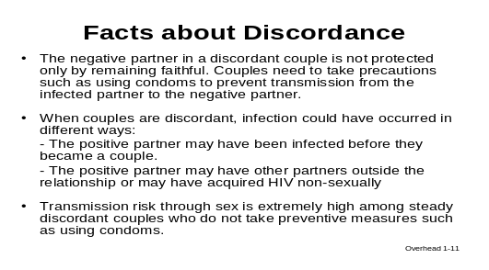

It is important that you as counselors make sure that discordant couples understand the facts about discordance.

Remember, the transmission risk is extremely high among steady discordant couples who do not take preventive measures.
(References: Ryder 2000, Roth 2001)

Allow a few moments for people to read Overhead 1-11, and then ask if there are any questions.

It is difficult to explain discordance clearly. Therefore, over the course of this training, we will help you understand discordance, teach you how to explain discordance to your clients, and help you learn skills in counseling discordant couples about preventing transmission to the HIV-negative partner.

As we covered earlier, transmission risk is extremely high in steady discordant relationships. Studies have shown that if couples are counseled together, many will change their sexual behavior and the HIV-negative partner will be able to maintain their status. (References: Allen 2003, Allen 1992, Heyward 1993, Kamenga 1991, Ryder 2000, Roth 2001)
Transmission Risk in Discordant Relationships
CHCT helps reduce transmission among discordant couples by helping couples adopt risk-reduction behaviors, increase condom use, and reduce mother-to-child transmission.

Counseling couples will not always change their behavior, and no behavioral intervention is effective with 100% of the people who undergo the intervention. Human beings must choose to change their behavior, and some will not. However, studies have shown that most discordant couples do change their behavior after couples counseling and testing. As counselors, it is critical that we take the opportunity to counsel discordant couples and help protect someone from getting HIV-infected.

The following overheads, based on one study, will give you an idea of the impact you can have with partners in a discordant relationship by counseling them to change risk behaviors.
(Reference: Allen 1992)

Display Overhead 1-12
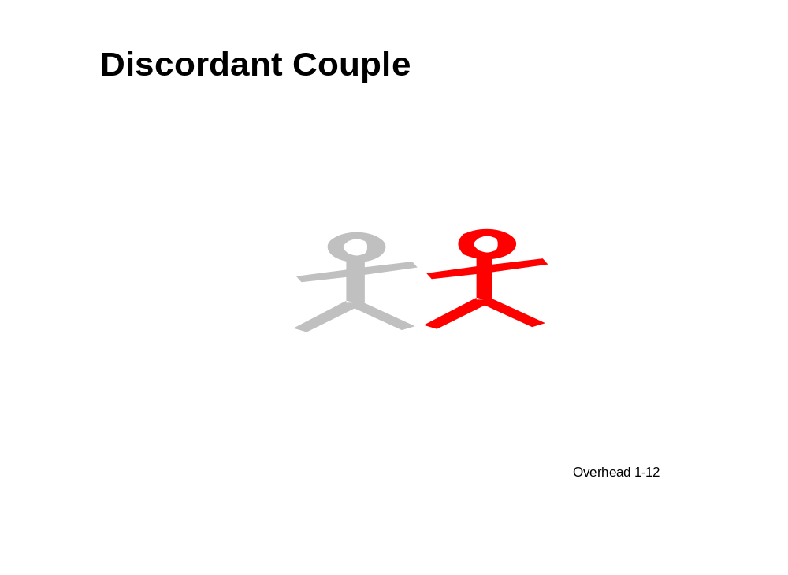

In a discordant couple, the HIV-negative partner is at high risk for acquiring HIV from the HIV-positive partner through sex. Imagine that the solid black figure is the HIV-infected partner.

Display Overhead 1-13.
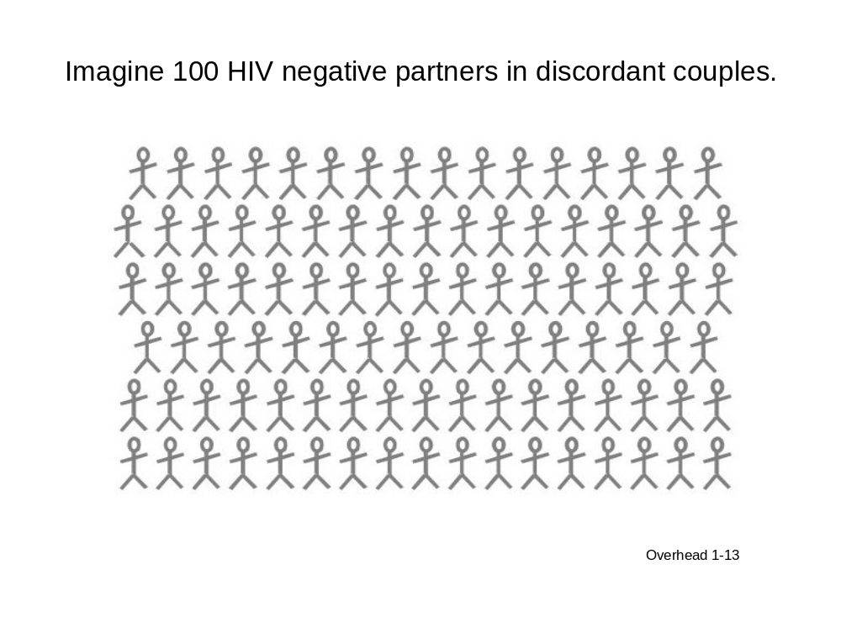

Imagine that these figures are 100 HIV-negative partners in discordant couples.

Display Overhead 1-14.

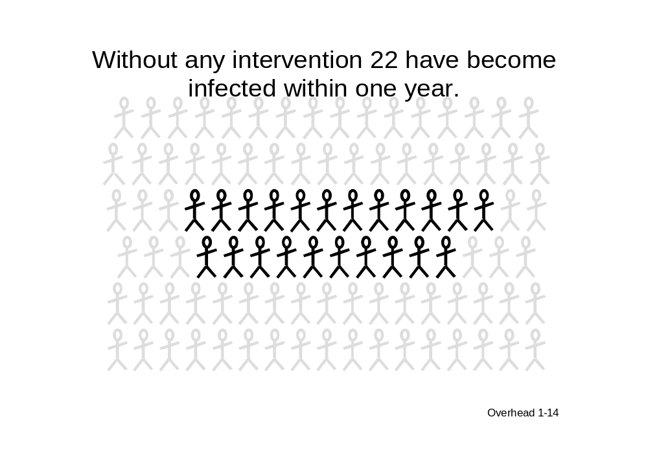

If they are sexually active with one another regularly, within 1 year, an average of 22 of these 100 HIV-negative partners will become infected unless they change their risk behaviors. This rate of transmission is higher than the rates of tuberculosis or malaria transmission. In subsequent years without intervention, we can expect more and more negative partners to become HIV-infected.

Display Overhead 1-15.

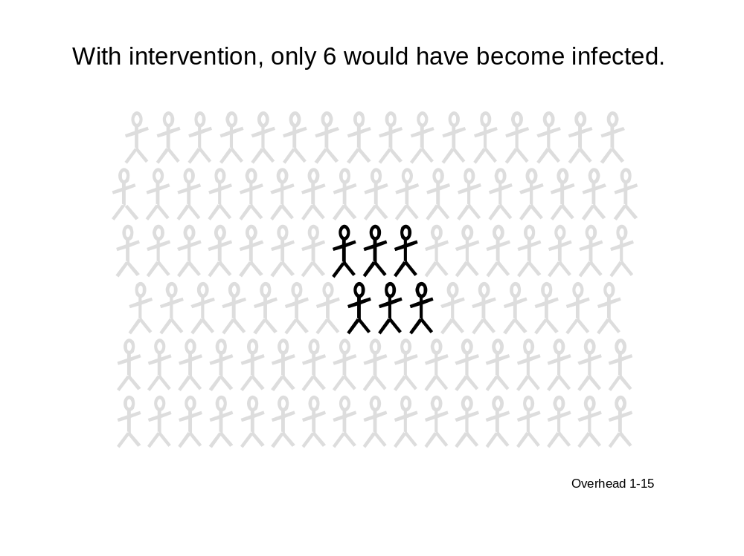

However, in one study of couples counseling, the majority of discordant couples changed their behavior and only 6 of 100 became infected within 1 year, suggesting that 16 infections were prevented.

This demonstrates the importance of couples counseling and its impact on HIV transmission.

Are there any questions?

Acknowledge and answer questions.

Wrap Up: Importance of CHCT

Display Overhead 1-16.

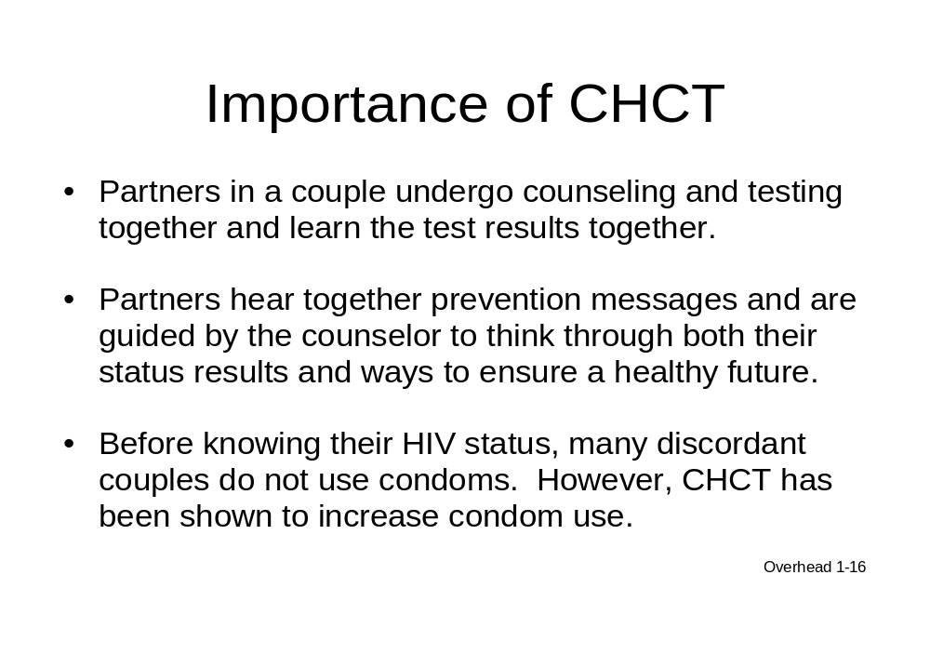

One of the most important aspects of couples counseling is that both partners learn their HIV status together.

Shared knowledge will help prevent the problems that occur when an HIV-infected partner learns his or her result but does not tell the partner or has difficulty asking the partner to be tested.

Shared knowledge can result in mutual support and the adoption of prevention measures such as condom use. For example, before knowing their HIV status, many discordant couples do not use condoms. CHCT has been shown to increase condom use.

CHCT may be as beneficial for concordant positive and concordant negative couples. Concordant negative couples can take steps to protect their relationship from HIV, such as by being faithful to each other. Concordant positive partners can be supportive of each other and make decisions together regarding their HIV care and treatment and their future.
(References: Allen 2003, Allen 1992, Heyward 1993, Kamenga 1991)

References

Allen S, Tice J, Van de Perre P, Serufilira A, Hudes E, Nsengumuremyi F, et al. Effect of serotesting with counseling on condom use and seroconversion among HIV discordant couples in Africa. BMJ 1992; 304(6842):1605-1609.

Allen S, Meinzen-Derr J, Kautzman M, Zulu I, Trask S, Fideli U, et al. Sexual behavior of HIV discordant couples after HIV counseling and testing. AIDS 2003; 17(5):733-740.

Antelman G, Smith Fawzi MC, Kaaya S, Mbwambo J, Msamanga GI, Hunter DJ, et al. Predictors of HIV-1 serostatus disclosure: a prospective study among HIV-infected pregnant women in Dar es Salaam, Tanzania. AIDS 2001; 15(14):1865-1874.

Balmer D, Grinstead OA, Kihuho F, Gregorisch SE, Sweat M, Kamenga C, et al.. Characteristics of individuals and couples seeking HIV-1 prevention services in Nairobi, Kenya: the Voluntary HIV-1 Counseling and Testing Efficacy Study. AIDS Behavior 2000; 4(1):15-23.

Bunnell R, Nassozi J, Marum E, Mubangizi J, Malamba S, Dillon B, et al. Living with discordance: knowledge, challenges, and prevention strategies of HIV-discordant couples in Uganda. AIDS Care 2005; 17(8):999-1012(14).

Forsyth AD, Coates TJ, Grinstead OA, Sangiwa G, Balmer D, Kamenga MC, et al. HIV infection and pregnancy status among adults attending voluntary counseling and testing in 2 developing countries. Am J Pub Health 2002; 92(11):1795-1800.

Gray RH, Wawer MJ, Sewankambo NK, Serwadda D, Li C, Moulton LH, et al. Relative risks and population attributable fraction of incident HIV associated with sexually transmitted diseases and treatable sexually transmitted diseases in Rakai District, Uganda. AIDS 1999; 15(13):2113-2123.

Heyward WL, Batter VL, Malulu M, Mbuyi N, Mbu L, St Louis ME, et al. Impact of HIV counseling and testing among child-bearing women in Kinshasa, Zaire. AIDS 1993; 7(12):1633-1637.

Kamenga M, Ryder RW, Jingu M, Mbuyi N, Mbu L, Behets F, et al. Evidence of marked sexual behavior change associated with low HIV-1 seroconversion in 149 married couples with discordant HIV-1 serostatus: experience at an HIV counseling center in Zaire. AIDS 1991; 5(1):61-67.

Keogh P, Allen S, Almedal C, Temahagili B. The social impact of HIV infection on women in Kigali, Rwanda: a prospective study. Soc Sci Med 1994; 38(8):1047-1053.

Lindan C, Allen S, Carael M, Nsengumuremyi F, Van de Perre P, Serufilira A, et al. Knowledge, attitudes, and perceived risk of AIDS among urban Rwandan women: relationship to HIV infection and behavior change. AIDS 1991; 5(8):993-1002.

Lurie MN, Williams BG, Zuma K, Mkaya-Mwamburi DM, Garnett GP, Sweat MD, et al. Who infects whom? HIV-1 concordance and discordance among migrant and non-migrant couples in South Africa. AIDS 2003; 17(15):2245-2252.

Maman S, Mbwambo J, Hogan NM, Kilonzo GP, Sweat M. Women's barriers to HIV-1 testing and disclosure: challenges for HIV-1 voluntary counseling and testing. AIDS Care 2001; 13(5):595-603.
Maman S, Mbwambo JK, Hogan NM, Weiss E, Kilonzo GP, Sweat MD. High rates and positive outcomes of HIV-serostatus disclosure to sexual partners: reasons for cautious optimism from a voluntary counseling and testing clinic in Dar es Salaam, Tanzania. AIDS Behav 2003; 7(4):373-382.
McKenna SL, Muyinda GK, Roth D, Mwali M, Ng’andu N, Myrick A, et al. Rapid HIV testing and counseling for voluntary testing centers in Africa. AIDS 1997; 11(Suppl 1):S103-S110.

Pilcher CD, Price MA, Hoffman IF, Galvin S, Martinson FEA, Kazembi PN, et al. Frequent detection of acute primary HIV infection in men in Malawi. AIDS 2004; 18(3):517-524

Ramon R, La Ruche G, Sylla-Koko F, Boka-Yao A, Bonard D, Coulibaly IM, et al. HIV counseling and testing: Behavior and practices of women of childbearing age in Abidjan, Cote d’Ivoire. J Acquir Immune Defic Syndr Hum Retrovirol 1998; 17(5):470-476.

Roth DL, Stewart KE, Clay OJ, van der Straten A, Karita E, Allen S. Sexual practices of HIV discordant and concordant couples in Rwanda: effects of a testing and counseling program for men. Int J STD AIDS 2001;12(3):181-188.

Ryder RW, Kamenga C, Jingu M, Mbuyi N, Mbu L, Behets F. Pregnancy and HIV-1 incidence in 178 married couples with discordant HIV-1 serostatus: additional experience at an HIV-1 counseling center in the Democratic Republic of the Congo. Trop Med Int Health 2000; 5(7):482-487.

Siriwasin, W, Shaffer, N, Roongpisuthipong, A, et al. HIV prevalence, risk, and partner serodiscordance among pregnant women in Bangkok. JAMA 1998; 280:49-54.

Trask SA, Derdeyn CA, Fideli U, Chen Y, Meleth S, Kasolo F, et al. Molecular epidemiology of Human Immunodeficiency Virus type 1 transmission in a heterosexual cohort of discordant couples in Zambia. J Virol 2002; 76(1):397-405.

van der Straten A, Gomez CA, Saul J, Quan J, Padian N. Sexual risk behaviors among heterosexual HIV serodiscordant couples in the era of post-exposure prevention and viral suppressive therapy. AIDS 2000; 14(4):F47-F54.

Sample Participant Coding Sheet for 15 Participants
The Participant Coding Sheet is a tool designed to help you divide the participants into appropriate groups for the role plays. Groups are assigned so that every participant has the opportunity to role play the counselor once and has the opportunity to work with as many other participants as possible. The Participant Coding Sheet should be filled out the first day of the training according to the amount of counseling experience each participant has (see instructions). The goal is to allow the least-experienced participants to act the part of the counselor during the least difficult role plays. As the role plays become more challenging, the more-experienced participants will assume the role of counselor.

Instructions
- List the most experienced counselors in the slots #1–#3 (the males in the “M” column and the females in the “F” column); moderately experienced counselors in the slots #3–#5; and the least experienced counselors in slots #6–#8.
- Depending on the number of participants, there may be at least one “extra” man or woman. Parentheses indicate roles that may need to be filled by participants of the opposite sex depending on the male/female ratio in the class.
- If the gender ratio is eight to seven, fill the “extra” person’s name in the appropriate male or female column.
- If the gender split is less even, such as nine women and six men, fill out the columns as evenly as possible according to counseling experience. In these situations, a woman may need to play the role of the male partner and vice versa, so ask participants to act their characters as realistically as possible.
- Avoid having participants play a character of the opposite sex more than once.

SAMPLE—Six male and nine female participants

Master List

#  Participants with more experience counseling  Less experience counseling | Male Participants’ Names | # | Female Participants’ Names
1-M | Ronald | 1-F | Carolyn
2-M | George | 2-F | Esther
3-M | Peter | 3-F | Blessing
4-M | Max | 4-F | Ruth
5-M | Henry | 5-F | Mary
6-M | Lewis | 6-F | Sarah
7(M) | Katie | 7(F) | Eve
8(M) |  | 8(F) | Grace

Transfer the participants’ names from the master list to the corresponding slots in the charts that follow to form counselor/husband/wife groups for the role plays.

SAMPLE—Groupings for the Initial Session Role Play (Module Three) and the Providing Concordant Negative Results Role Play (Module Four)

Group |  | Counselor |  | Husband |  | Wife
1 | 7(M) | Katie | 5M | Henry | 5F | Mary
2 | 6M | Lewis | 4M | Max | 4F | Ruth
3 | 8F | Grace | 3M | Peter | 3F | Blessing
4 | 7F | Eve | 2M | George | 2F | Esther
5 | 6F | Sarah | 1M | Ronald | 1F | Carolyn

SAMPLE—Groupings for Providing Concordant Positive Results Role Play (Module Five)

Group |  | Counselor |  | Husband |  | Wife
1 | 5F | Mary | 3M | Peter | 1F | Carolyn
2 | 4F | Ruth | 1M | Ronald | 2F | Esther
3 | 3F | Blessing | 2M | George | 6F | Sarah
4 | 5M | Henry | 6M | Lewis | 7F | Eve
5 | 4M | Max | 7(M) | Katie | 8F | Grace

SAMPLE—Groupings for Providing Discordant Results Role Play (Module Six)
If a woman has been in the role of a man in a previous role play, switch adjacent partner roles so she will not have to play a man twice. In the example below, Katie and Blessing should swap roles because Katie has already acted as the man. Counselor roles should not be switched.

Group |  | Counselor |  | Husband |  | Wife
1 | 3M | Peter | 4M | Max | 8F | Grace
2 | 2M | George | 5M | Henry | 4F | Ruth
3 | 1M | Ronald | 6M | Lewis | 5F | Mary
4 | 2F | Esther | 7(M) | Katie (Switch) | 3F | Blessing (Switch)
5 | 1F | Carolyn | 6F | Sarah | 7F | Eve

Participant Coding Sheet for 15 Participants

Master List*

# | Male Participants’ Names | # | Female Participants’ Names
1M  Participants with more experience counseling  Less experience counseling |  | 1F
2M |  | 2F
3M |  | 3F
4M |  | 4F
5M |  | 5F
6(M) |  | 6(F)
7(M) |  | 7(F)
8(M) |  | 8(F)

*Parentheses indicate that these roles may need to be filled by participants of the opposite gender depending on the male/female ratio in the class.

Groupings for the Initial Session Role Play (Module Three) and Providing Concordant Negative Results Role Play (Module Four)

Group |  | Counselor |  | Husband |  | Wife
1 | 7M |  | 5M |  | 5F
2 | 6M |  | 4M |  | 4F
3 | 8(F/M) |  | 3M |  | 3F
4 | 7F |  | 2M |  | 2F
5 | 6F |  | 1M |  | 1F

Groupings for Providing Concordant Positive Results Role Plays (Module Five)

Group |  | Counselor |  | Husband |  | Wife
1 | 5F |  | 3M |  | 1F
2 | 4F |  | 1M |  | 2F
3 | 3F |  | 2M |  | 6F
4 | 5M |  | 6M |  | 7F
5 | 4M |  | 7M |  | 8(F/M)

Groupings for Providing Discordant Results Role Play (Module Six)**

Group |  | Counselor |  | Husband |  | Wife
1 | 3M |  | 4M |  | 8(F/M)
2 | 2M |  | 5M |  | 4F
3 | 1M |  | 6M |  | 5F
4 | 2F |  | 7M |  | 3F
5 | 1F |  | 6F |  | 7F

**If a woman has been in the role of a man in a previous role play, switch adjacent partner roles so she will not have to play a man twice. Do not switch with the counselor role.

Participant Coding Sheet for 18 Participants
Master List*

#  More experience counseling  Less experience counseling | Male Participants’ Names | # | Female Participants’ Names
1M |  | 1F
2M |  | 2F
3M |  | 3F
4M |  | 4F
5M |  | 5F
6M |  | 6F
7(M) |  | 7(F)
8(M) |  | 8(F)
9(M) |  | 9(F)

*Parentheses indicate that these roles may need to be filled by participants of the opposite gender depending on the male/female ratio in the class.

Groupings for the Initial Session Role Play (Module Three) and Providing Concordant Negative Results Role Play (Module Four)

Group |  | Counselor |  | Husband |  | Wife
1 | 9(M) |  | 6M |  | 6F
2 | 8M |  | 5M |  | 5F
3 | 7M |  | 4M |  | 4F
4 | 9(F) |  | 3M |  | 3F
5 | 8F |  | 2M |  | 2F
6 | 7F |  | 1M |  | 1F

Groupings for Providing Concordant Positive Results Role Play (Module Five)

Group |  | Counselor |  | Husband |  | Wife
1 | 6F |  | 3M |  | 1F
2 | 5F |  | 2M |  | 3F
3 | 4F |  | 1M |  | 2F
4 | 4M |  | 8M |  | 7F
5 | 5M |  | 9(M) |  | 8F
6 | 6M |  | 7M |  | 9(F)

Groupings for Providing Discordant Results Role Play (Module Six) **

Group |  | Counselor |  | Husband |  | Wife
1 | 3M |  | 4M |  | 5F
2 | 2M |  | 5M |  | 6F
3 | 1M |  | 6M |  | 8F
4 | 3M |  | 7M |  | 7F
5 | 2F |  | 8M |  | 9(F)
6 | 1F |  | 9(M) |  | 4F

Handouts

Module One: Background and Discordance

Couples HIV Counseling and Testing
Pre-Course Knowledge Assessment

Questions | Strongly  Agree |  | Agree |  | Strongly  Disagree
- A husband and wife can have different test results—one positive, one negative. | 1 | 2 | 3 | 4 | 5
- Most people understand that HIV is a sexually transmitted disease. | 1 | 2 | 3 | 4 | 5
- In the case of a concordant positive or a discordant result, it is important to identify when and by whom one or both of the partners became infected by HIV. | 1 | 2 | 3 | 4 | 5
- When working with couples it is effective to separate them to conduct individual risk assessments. | 1 | 2 | 3 | 4 | 5
- It is much more common in a couple for both partners to be negative than for the couple to have different test results, one positive and one negative. | 1 | 2 | 3 | 4 | 5
- Window period explains why couples have different HIV test results. | 1 | 2 | 3 | 4 | 5
- After couple counseling, couples frequently reduce their risk behavior. | 1 | 2 | 3 | 4 | 5
- Women who are infected with HIV during pregnancy or while breastfeeding are more likely to transmit HIV to their infant. | 1 | 2 | 3 | 4 | 5
- A person taking ARVs cannot transmit the HIV virus to others. | 1 | 2 | 3 | 4 | 5
- Divorce or abandonment occurs frequently after married couples receive different test results. | 1 | 2 | 3 | 4 | 5
- How would you explain to a disbelieving couple how it is possible for them to have
different HIV test results, one is positive and one is negative (write response below):
Handout 1-1

Overheads

Module One: Background and Discordance

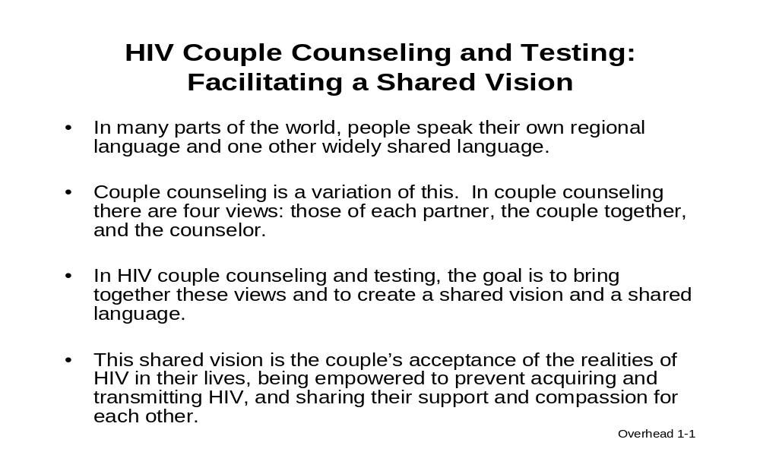

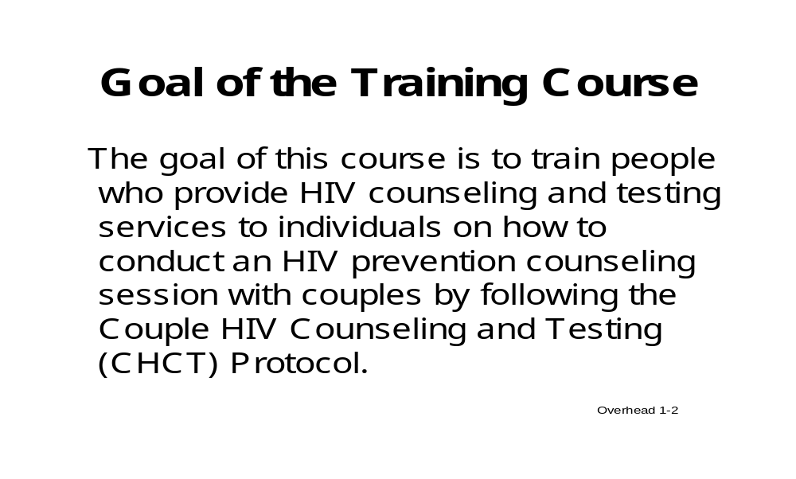
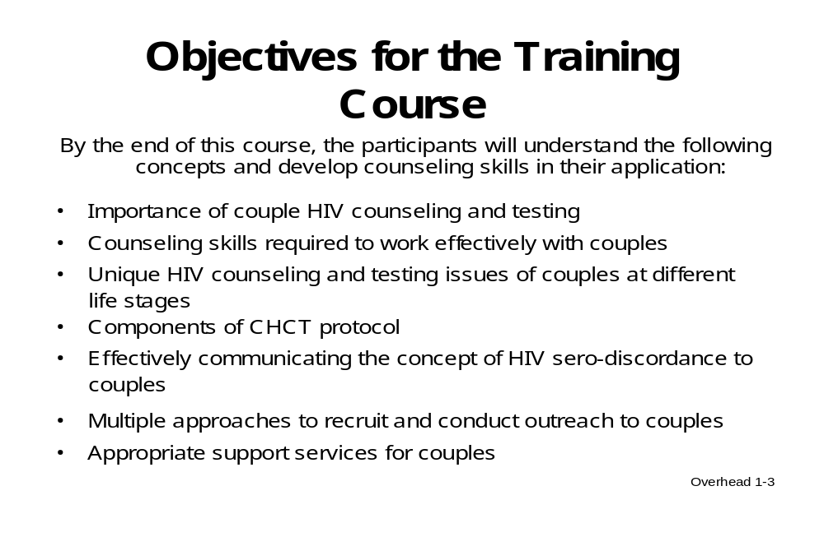

Models of HIV Counseling and Testing (HCT) Services

- Client-initiated testing and counseling (CITC)
  - At stand-alone or mobile voluntary counseling and testing centers (VCT)
  - In the workplace
  - Services for individuals
  - Services for youth
  - Services for vulnerable populations
  - HCT for families
  - Couples HIV counseling and testing (CHCT)

- Provider-initiated testing and counseling (PITC)
  - For all persons seeking in-patient and out-patient services in a health facility
  - HIV diagnosis for tuberculosis (TB) clinic patients
  - Prevention of Mother-to-Child Transmission (PMTCT) for antenatal clinic, post-natal ward, and labor and delivery ward clients (including couples)
  - HCT for persons attending sexually transmitted infection (STI) clinics
  - For individuals, couples, or families in the home-based setting

Overhead 1-4



