Hopewell Archeology:

The Newsletter of Hopewell Archeology in the Ohio River Valley

Volume 6, Number 2, March 2005

1. Newark Earthwork Cosmology: This Island Earth

By William F. Romain, Ph.D.

Most descriptions of the Newark earthworks (e.g.,Squier and Davis 1848;Thomas 1894) consider the complex to include: the Octagon and Observatory Circle, Wright Square, Great Circle, Large Oval, numerous smaller circle earthworks along the parallel walkways, and perhaps an outlier earthwork, such as the Salisbury Square. In addition to these earthworks, I propose that another feature should be included in our thinking of what comprises the Newark earthworks complex – namely, Geller Hill.
Geller Hill is a prominent feature located about 7,000 feet southwest of the Newark Great Circle (figure 1). The hill is the central feature of Geller Park, in Heath, Ohio. The hill is roughly 35 feet in elevation, 1,150 feet in length, and 700 feet wide at its base. In Hopewell times (note 1), Geller Hill would have been the highest feature on the flat Newark plain where the geometric earthworks were built. Several lines of evidence suggest that Geller Hill was included in the design and layout of the Newark earthworks.
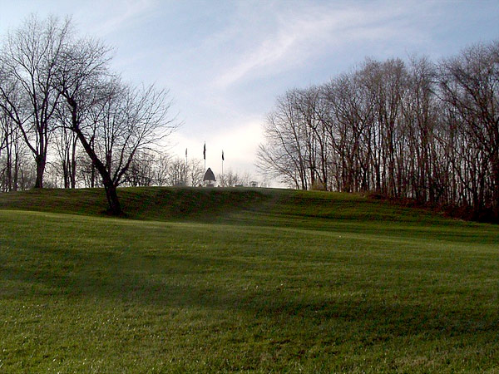
Figure 1. View of Geller Hill, Heath, Ohio. Photo by the author.
First, the geometric relationship between Geller Hill, the Newark Octagon, and the Newark Great Circle describes a fairly accurate isosceles triangle. An isosceles triangle has two equal sides and consequently, two equal angles. In the case of the Geller Hill-Octagon-Great Circle triangle, the two sides that are of near equal length are the sides that extend from the apex of Geller Hill to the centers of the Octagon and Great Circle, respectively. In (figure 2), the triangle just described is labeled A-B-D, with point A at the apex of Geller Hill.
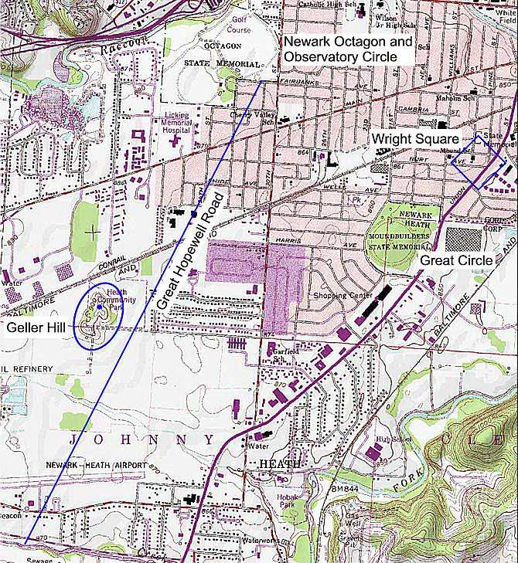
Figure 2. Section of USGS 7.5 minute series map (Newark Quardrangle) showing the triangular relationship between the Newark Octagon, Great Circle, and Geller Hill.
In 1982, Hively and Horn (1982:S8) identified a unit of length, used by the Hopewell. This unit of length is equal to the diameter of the Newark Observatory Circle – hence, they refer to the unit as 1 OCD. One OCD is equal to 1,054 feet. Hively and Horn found this unit of length expressed not only in the diameter of the Observatory Circle, but also in the linear dimensions of the Newark Octagon.
With reference to the Geller Hill isosceles triangle, as mentioned, sides A-B and A-D are nearly equal to each other. Of special interest is that the lengths of these two sides are both, near-multiples of 7 OCDs. The length of 7 OCDs is equal to 7378 feet. As measured by reference to a digitized USGS 7.5-minute series topographic map for the area, the distance from point A at the apex of Geller Hill to point B at the center of the Octagon is 7,392 feet. This differs from the ideal 7 OCD length by 14 feet, or 0.2 percent. Similarly, the map-measured distance from point A on Geller Hill to point D at center of the Great Circle is 7,498 feet. This differs from the ideal 7 OCD length by 119.6 feet, or 1.6 percent. Thus the measured Geller Hill-Octagon-Great Circle triangle varies from the geometric ideal by an average of less than 1 percent. The magnitude of this linear deviation from the ideal falls well within the range of similar analyses for other Hopewell earthworks – e.g., Fort Ancient (Romain 2004a).
The statistical likelihood that the centers of two geometrically shaped Hopewell earthworks would be situated about the same distance from Geller Hill strictly due to chance is slim. The likelihood that both distances would also be near multiples of the OCD strongly suggests that the linear relationship between Geller Hill and the two geometric earthworks was intentional.
Hively and Horn (1982:table II) showed that the major axis of the Newark Octagon earthwork is closely aligned to the moon’s maximum north rising point. The same alignment appears represented in the Geller Hill-Octagon-Great Circle triangle. In (figure 2, above), point C is the bisection point of line B-D. If a line is drawn from point A on Geller Hill through bisection point C, that line is found to extend along an azimuth of 53°.3. Given a date of A.D. 100 and apparent horizon elevation of 0°.5 (corrected to 1°.34), the lower limb moonrise as observed from the top of Geller Hill would have been at azimuth 52°.2. The lunar alignment of the bisected triangle therefore, is to within 1°.1. Like the Newark Octagon, the symmetry axis of the Geller Hill triangle is closely aligned to the moon’s maximum north rise point. From Geller Hill, the moon would have been observed to rise at a point on the horizon about equi-distant between the Octagon and Great Circle and balanced between the two.
The most significant archaeological feature of Geller Hill is the existence of possible burial mounds located at the top of the hill (figure 3). Notably, the Salisbury map of 1862 shows several of these possible mounds. Further, the Salisburys make the following observations:
…about one and one half miles distant from the octagon, is
seen a little to the right, standing boldly out in the plain, an
irregular isolated hill about 75 ft. in height covering a surface
of perhaps ten acres. On this lonely hill in the midst of the
plain, are some 8 or 10 small mounds, generally situated on
the highest points. Whatever people selected this locality as
the last resting place of their dead, deserve some credit for
such a proof of their good taste (Salisbury and Salisbury 1862:28).
Review of the literature suggests that the features identified by the Salisburys have not been excavated. Further investigation is needed to determine if the features noted by the Salisburys are man-made. In general appearance, however, the features look like Hopewell burial mounds.
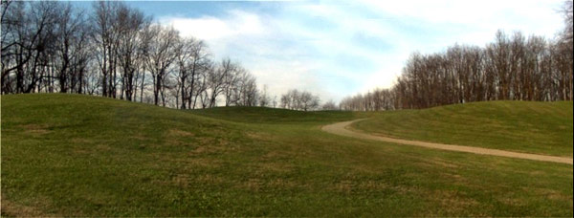
Figure 3. Panoramic composite showing several of the burial mounds located at the top of Geller Hill. Photos by the author.
Parallel walls once extended between several of the Newark earthworks. Long parallel walls extended, for example, between the Octagon and Wright Square. Another set of parallel walls extended from the Octagon, in a southwest direction, at least as far as Ramp Creek. By reference toReeves (1936) it is possible to reconstruct the trajectory of the parallel walls from the Octagon to Ramp Creek. From this analysis it is found that the Octagon-Ramp Creek parallel walls passed within 400 - 500 feet of the base of Geller Hill. It may be that Geller Hill was a destination option when transiting the walled pathway. If that is the case, then the special status of Geller Hill is indicated.
In summary, geometric relationships, measurement data, astronomical data, and archaeological evidence all strengthen the hypothesis that Geller Hill was included in the design, layout, and possibly, ritual functioning of the Newark earthworks complex. The question is, what made Geller Hill important to the Hopewell? To help answer this, it is necessary to view Geller Hill and the Newark complex as an integrated whole.
Bradley T. Lepper (2004:80) has argued that the Newark complex was not merely a set of arcane symbols; but rather, functioned as a “gigantic machine or factory in which energies from the three levels of the Eastern Woodland Indian’s cosmos …were drawn together and circulated through conduits of ritual to accomplish some sacred purpose.” Lepper (2004:80) compares the Newark complex to ‘giant superconducting supercollider.’ Although thought provoking, the analogy Lepper draws is not one I would use. Native Americans do not think of created things in terms of machines, or factories – terms that bring to mind images of cold steel structures and dehumanized work places. While many Western people may think of non-human and non-animal things as inanimate, Native Americans, on the other hand, often consider such things to possess a life essence, spirit, or soul. Among the seemingly non-living things that Indians sometimes think of as having a life essence are smoking pipes, effigy masks, weapons, and natural phenomena to include certain rocks, sun, moon, rivers, and mountains (see e.g., Hallowell 1975 [1960]). Given this, it might be appropriate to think of the Newark complex in more organic terms as might be the case if we consider the complex as a functioning microcosm of the Eastern Woodland Indian cosmos. By functional microcosm, I mean a smaller, dynamic manifestation, or expression. A functional microcosm of the Eastern Woodland Indian cosmos replicates on a reduced scale, mythic time and space at the beginning. This alternative interpretation is presented below.
In shamanic thought generally (e.g., Eliade1964; Furst1976) and among Native American peoples in particular (e.g.,Lankford 1987; Hudson 1976), the cosmos is often thought of as having three basic levels – i.e., Upperworld, earth, and Lowerworld (figure 4). These three levels are vertically connected by an axis mundi. In Native American cosmology, the Upperworld is the realm of the sky, sun, and stars, as well as powerful celestial birds known as Thunderbirds. By contrast, the Lowerworld is a watery world, located opposite to the Upperworld. It is the realm of fishes, frogs, snakes, and related creatures. Chief of the Lowerworld creatures is either the Great Horned Serpent or Underwater Panther. The Upperworld and Lowerworld are antithetical to each other.
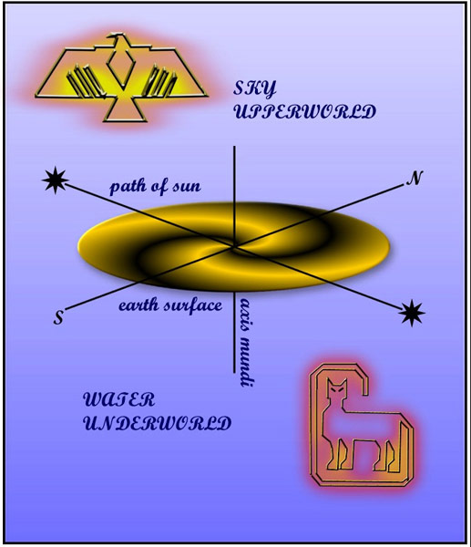
Figure 4. Idealized representation of the Eastern Woodlands cosmos.

Balanced between the Upperworld and Lowerworld, is the earth. In many cosmologies, the earth is described as a flat, circular island floating in a surrounding primordial sea. Associated with the belief that the earth is a circular island floating in a surrounding sea are many examples of the Earth-diver myth – wherein a mythical creature, such as the otter, is said to have dived to the bottom of the primordial sea to bring back a piece of mud, which magically expanded, thereby creating the earth.
Physical evidence indicates that the Great Circle was built in a prairie setting(Lepper 2004:78). While the area extent of this prairie is unknown, it is possible that a large part of the area occupied by the Newark earthwork complex was likewise, covered by prairie. Human activities may have further reduced any forest cover in the vicinity of the earthworks. In this sort of setting, Geller Hill would likely have been visible from the Octagon and Great Circle earthworks, located less than two miles away. Certainly, the Octagon and Great Circle would have been visible from Geller Hill.
The Newark earthworks are located at the confluence of three watercourses. Less obvious is the extent to which watercourses surround the Newark plain – to include Geller Hill. The watercourses that surround the Newark plain include Raccoon Creek, South Fork Licking River, and Ramp Creek. As (figure 5), shows, out of a 360-degree circle perimeter around the entire complex, these watercourses enclose about 320 degrees of that circle. By calculation therefore, water surrounds approximately 90% of the Newark complex. Notably, the use of water barriers to separate Hopewell earthworks from the surrounding topography is known elsewhere – e.g., at Fort Ancient (Connolly 1996; Romain 2004a).
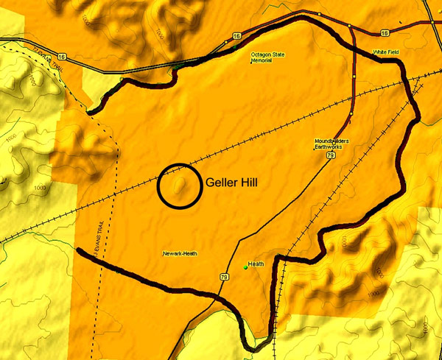
Figure 5. Relief map showing the Newark plain and location of Geller Hill. Highlighting traces the course of Raccoon Creek, Ramp Creek, and the South Fork Licking River.
If we apply the archetypal cosmological model discussed earlier to the topographic observations just noted for Newark, we find some intriguing correspondences. In this thought exercise, the Newark complex is equivalent to the island earth, surrounded by the primordial sea. The primordial sea is represented by the surrounding waterways of Ramp Creek, Raccoon Creek, and the South Fork Licking River. Located in the symbolic center of this island earth, Geller Hill serves as an axis mundi, connecting the three cosmic realms.
In this view, consistent with Native American understandings of the cosmos, the Newark complex was balanced between cosmic realms. As such, the Newark complex was a cosmic center; and it was in this center that the mound builders performed the most sacred of their rituals – i.e., rituals intended to maintain cosmic balance, ensure plant and animal abundance, maintain health, and facilitate in death, the transition of the soul from the land of the living to the land of the dead. In this view, the Newark complex was a functional microcosm of the Hopewell universe. Indeed, it may be that many of the other Hopewell enclosures that are surrounded by water – particularly the hilltop enclosures – were constructed with this cosmological idea in mind. Alternative explanations for what we find in the archaeological record are always possible. What is clear, however, is that, if we are to understand phenomena as complex as the Newark earthworks, we need to expand our thinking beyond the two-dimensional map limits depicted more than a hundred years ago. We need to consider relationships between the earthworks and surrounding environment to include earth, sky, and water (Romain 2000, 2004b). Importantly too, we need to frame our interpretations based not in Euro-centric views of the world; but rather, in Native American terms.
As to Geller Hill, purchase and conservation of the section held in private ownership and currently under plow would be desirable. Additionally, I think it would be useful to initiate further investigation. Magnetic survey, soil resistivity, and ground penetrating radar studies, as well as emergency salvage work of the section currently under plow - if purchase of that section is not an option - might help answer questions not only about the nature of the possible burial mounds discussed earlier; but also, broader questions relating to the geometric earthworks.
We know, for example, from reports dating to the early 1800s, that some Middle Woodland period people were buried in the now obliterated, Cherry Valley Mound group, located within the Oval earthwork. According toSalisbury and Salisbury (1862), no fewer than eleven mounds existed in this group. Squier and Davis (1848:72) document the discovery of fourteen individuals found in one of the Cherry Valley mounds. Newspaper reports document one or two additional individuals recovered from the area. What seems missing, however, are the significant numbers of burials we might expect, given that Newark is the largest geometric complex of its kind in the world. For a site this size, we might expect to find at least scores, or even hundreds of burials, as reported for other major Hopewell centers such as Mound City, Liberty, Seip, and Tremper. Having said this, I would not be surprised if, one day, we find the Newark shamans, chiefs, and Ancient Ones, buried near their earthworks – perhaps high on Geller Hill – ever watchful over their people, ever connected to their ancestral lands – this island earth.
Acknowledgments:
This article is dedicated to my Native American friends in southern Ohio, who welcomed me into their circle, gave me an Indian name, and tried to teach me something about Indian ways. Thanks especially, to Jean, Charla, and Doug.
Many thanks to Pat Mason and Bob Geller for background information on Geller Hill. Special thanks to my mother, Frances Spania Rothenberg for her thoughts and encouragement; and to my wife, Evie, for her patience and support.
References Cited:
Connolly, Robert P.
1996. Middle Woodland Hilltop Enclosures: The Built Environment, Construction and Function. Ph.D. dissertation. University of Illinois at Urbana-Champaign, Urbana, Illinois.

Eliade, Mircea.
1964. Shamanism: Archaic Techniques of Ecstasy. New York: Pantheon Books.

Furst, Peter.
1976. Shamanistic Survivals in Mesoamerican Religion. Actas del XLI Congreso Internacional de Americanistas 3:149-157.

Hallowell, A. Irving.
1975 (1960). Ojibwa Ontology, Behavior, and World View. In Teachings from the American Earth, edited by D. Tedlock and B. Tedlock. New York: W.W. Norton.

Hively, Ray, and Robert Horn.
1982. Geometry and Astronomy in Prehistoric Ohio. Archaeoastronomy (Supplement to Vol. 13, Journal for the History of Astronomy) 4:S1-S20.

Hudson, Charles.
1976. The Southeastern Indians. Knoxville: University of Tennessee Press.

Lankford, George E., ed.
1987. Native American Legends. Southeastern Legends: Tales from the Natchez, Caddo, Biloxi, Chicasaw, and Other Nations. Little Rock: August House.

Lepper, Bradley T. 2004.
The Newark Earthworks: Monumental Geometry and Astronomy at a Hopewellian Pilgrimage Center. In Hero, Hawk, and Open Hand: Ancient Indian Art of the Woodlands, edited by R. F. Townsend and R. V. Sharp. New Haven: The Art Institute of Chicago and Yale University Press.

National Park Service.
2001. Long Range Interpretive Plan for the Hopewell Culture National Historic Park. Washington, D.C.: U.S. Government Printing Office.

Reeves, Dache M.
1936. A Newly Discovered Extension of the Newark Works. Ohio State Archaeological and Historical Quarterly 45:187-193.

Romain, William F.
2000. Mysteries of the Hopewell : Astronomers, Geometers, and Magicians of the Eastern Woodlands. Akron, Ohio: University of Akron Press.

2004a. Journey to the Center of the World: Astronomy, Geometry, and Cosmology of the Fort Ancient Enclosure. In The Fort Ancient Earthwork: Prehistoric Lifeways of the Hopewell in Southwestern Ohio, edited by R. P. Connolly and B. T. Lepper. Columbus: The Ohio Historical Society.

2004b. Hopewell Geometric Enclosures: Gatherings of the Fourfold. Ph.D. dissertation. University of Leicester.

Salisbury, James, and Charles Salisbury.
1862. Accurate Surveys and Descriptions of the Ancient Earthworks at Newark, Ohio. Transcribed from the original by B. T. Lepper and B. T. Simmons: Manuscript on file, American Antiquarian Society, Worcester, Massachusetts.

Squier, Ephraim G., and Edwin H. Davis.
1848. Ancient Monuments of the Mississippi Valley. Smithsonian Contributions to Knowledge Vol. 1. Washington, D.C.: Smithsonian Institution.

Thomas, Cyrus.
1894. Report on the Mound Explorations of the Bureau of Ethnology for the Years 1890-1891. In Twelfth Annual Report of the Bureau of American Ethnology. Washington, D.C.: Smithsonian Institution.

