Johnson & Johnson Pharmaceutical Research & Development, L.L.C.
BACKGROUND INFORMATION
FOR

Oncologic Drugs Advisory Committee Meeting
May 4, 2004
Gaithersburg, MD

Safety of Erythropoietin Receptor Agonists (ERAs) in Patients With Cancer
available for public disclosure without redaction

Issue/Report Date: 30 MARCH 2004
Department: Drug Development
Document No.: EDMS- USRA-9005967:2.0

This Advisory Committee Meeting background package is prepared for the Oncologic Drugs Advisory Committee (ODAC) meeting, to be held on May 4, 2004. This document provides a summary of the relevant findings of the Company’s ongoing evaluation of PROCRIT® safety, including evaluation of questions that have arisen from recently published studies of other Erythropoietin Receptor Agonist (ERA) product formulations. Evaluation of the available data from clinical studies and post-marketing experience continues to support the safety and effectiveness of PROCRIT, when used as directed for the approved indications.
TABLE OF CONTENTS
LIST OF ABBREVIATIONS AND DEFINITIONS OF TERMS 5
1. EXECUTIVE SUMMARY 7
2. INTRODUCTION 12
2.1. Erythropoietin Receptor Agonists, Overview and History 12
2.2. Clinical Benefits and Safety in Approved Indications 13
2.3. Safety in Investigational Use 14
3. SAFETY OF CURRENT LABELED INDICATION - TREATMENT OF ANEMIA IN CANCER PATIENTS ON CHEMOTHERAPY 16
3.1. Adverse Events, Including Thrombotic Vascular Events 17
3.2. Patient Outcomes 19
3.2.1. Survival 19
3.2.2. Tumor Response/Disease Progression 22
3.2.3. Post-Marketing Surveillance 22
3.2.4. Conclusion 23
4. INVESTIGATIONAL CLINICAL STUDIES – TREATMENT BEYOND CORRECTION OF ANEMIA 23
4.1. Study EPO-INT-76 25
4.1.1. Study Design 25
4.1.2. Patient Demographics 26
4.1.3. Patient Treatment 27
4.1.4. Early Discontinuation of Study Drug Treatment 29
4.1.5. Data Sets Analyzed 30
4.1.6. Survival – Final Analysis of 12-Month Survival Rate 30
4.1.7. Survival – Deaths Within 4 Months After Randomization 32
4.1.7.1. Patient Demographics in Patients Who Died Within 4 Months 32
4.1.7.2. Causes of Death 33
4.1.8. Tumor Response 35
4.1.8.1. Optimal Tumor Response to First-Line Chemotherapy 35
4.1.8.2. Tumor Response at the End of First-Line Chemotherapy 36
4.1.8.3. Tumor Response at Individual Subject Study End 37
4.1.9. Time to Disease Progression 38
4.1.10. Conclusion 40
4.2. Study of Henke M, et al. 40
4.2.1. Study Design 41
4.2.2. Reported Study Results 41
4.3. Ongoing Study in Follow-Up Phase: Study AGO/NOGGO 42
4.3.1. Study Design 42
4.3.2. Preliminary Analysis 43
4.4. Ongoing Study in Follow-Up Phase: EPO-GBR-7 44
4.4.1. Study Design 45
4.4.2. Preliminary Analysis 45
4.4.3. Demographic and Baseline Characteristics 46
4.4.4. Tumor Response 47
4.4.5. Disease Progression 48
4.4.5.1. Local Tumor Evidence 48
4.4.6. Survival 50
4.5. Study N93-004 52
4.5.1. Tumor Response to Chemotherapy / Disease Progression 53
4.5.2. Overall Survival 56
4.6. Other Relevant Information from Clinical Trials 58
4.6.1. Overall Incidence of TVEs in Prior Epoetin Alfa Studies 58
4.6.2. Recently Discontinued Studies With Imbalances in Thrombotic Vascular Events and/or Survival 59
4.7. Conclusion 62
5. BENEFIT AND RISK ASSESSMENT OF ERAs IN PATIENTS WITH CANCER 63
6. CONCLUSION 67
7. REFERENCES 68
APPENDIX 70
Attachment 1: Package Insert 71
Attachment 2: Lancet Letter to the Editor on EPO-INT-76 104
Attachment 3: Henke Lancet Article 106
Attachment 4: Overview and Design of PROCRIT and EPREX Clinical Studies in Oncology 113
Attachment 5: Preclinical Data on Epoetins and Tumor Proliferation 122

LIST OF ABBREVIATIONS AND DEFINITIONS OF TERMS

Abbreviations
CAC Cvitkovic et Associés Consultants
CI confidence interval
CR complete remission
CRF case report form
DSMB Data Safety Monitoring Board
DVT deep vein thrombsis
ECOG Eastern Cooperative Oncology Group
EpoR erythropoietin receptor
ERA erythropoietin receptor agonist
FIGO International Federation of Gynecology and Obstetrics
HNC head and neck cancer
HUVECs human umbilical vein endothelial cells
IDMC Independent Data Monitoring Committee
LRPFS locoregional progression-free survival
MI myocardial infarction
PE pulmonary embolism
pNi peri lymph node metastases
PR partial remission
RT radiotherapy
RT-PCR reverse transcriptase polymerase chain reaction
SCLC small cell lung cancer
TIA transient ischemic attack
TVE thrombotic vascular event
Definitions of Terms
Beyond the correction of anemia initiation of ERA treatment in cancer patients who had a hemoglobin concentration of 13 g/dL or higher, or continued treatment of patients after anemia was corrected
epoetin alfa recombinant human erythropoietin (r-HuEPO)
LIST OF ABBREVIATIONS AND DEFINITIONS OF TERMS (CONTINUED)
Definitions of Terms (Continued)
EPREX® Ex-U.S. trade name of epoetin alfa manufactured by Cilag AG, Division of Johnson and Johnson (Schaffhausen, Switzerland), and distributed in Europe and other countries. The active substance epoetin alfa for EPREX is supplied by Ortho Biologics, L.L.C. (Manati, Puerto Rico).
PROCRIT® U.S. trade name of epoetin alfa manufactured by Amgen, Inc. (Thousand Oaks, CA) and distributed by Ortho Biotech Products, L.P. (Bridgewater, NJ).
the Sponsor Johnson & Johnson Pharmaceutical Research & Development, L.L.C. (Sponsor) and affiliates

EXECUTIVE SUMMARY
Erythropoietin Receptor Agonists (ERAs) are medications that are very similar to human erythropoietin, both in structure and in biological activities. The first ERA produced for human use, epoetin alfa, was introduced in the US in 1989, and has an amino acid sequence identical to that of natural human urinary erythropoietin. Two different epoetin alfa formulations are marketed by the Sponsor including EPREX (ex-US) and PROCRIT (US). These products have provided important benefits to over 3 million patients with anemia due to renal disease or due to cancer chemotherapy. In addition to these indications, extensive ongoing research has led to the identification of additional approved indications for epoetin alfa, including use for anemia related to antiviral therapy (azidothymidine, AZT) for HIV infection, or to reduce the need for transfusions for perisurgical blood loss. The Sponsor is committed to supporting scientifically appropriate development activities investigating potential additional benefits that ERAs may offer patients in existing and future indications.
Other ERAs, introduced more recently, include epoetin beta (NeoRecormon®, ex-US) and darbepoetin alfa (Aranesp®, ex-US and available in the US since 2001). These more recent ERAs share a close homology with epoetin alfa and endogenous human erythropoietin. The products in this class of medications act on the same cellular target (the erythropoietin receptor) on erythroid precursor cells, to produce their benefits by increasing red blood cell (RBC) production. They also share similar side effect profiles, including thrombotic vascular events (TVEs) and hypertension. These recognized side effects are described in product labels for all medications in the ERA class.
Erythropoietin receptors are expressed on other cell lines besides erythroid precursor cells. These include vascular endothelial cells and some tumor cell lines. Whether these receptors have any functional activity when exposed to clinically relevant concentrations of ERAs is doubtful, however the theoretical possibility that ERAs could act as growth factors for tumor cells is reflected in the labeling of products in this class.
ERAs have been extensively investigated in clinical trials and are widely used to provide important benefits in terms of treatment of anemia. The symptoms of anemia include tiredness, shortness of breath, weakness and fatigue (weariness from labor or exertion). In addition to correcting anemia, ERAs have proven benefits in reducing the needs for RBC transfusions, in their approved indications.
Recent investigational studies of ERAs have focused on additional potential benefits for patients with cancer, including benefits on tumor response to radiotherapy and improved survival. This research was prompted by observations that cancer patients with anemia may have decreased survival. Additionally, a trend towards improved survival was noted in two prospective studies with different ERAs. Those studies were not designed to test this hypothesis, but were powered for other end-points. Subsequently studies have been performed to specifically evaluate potential effects on survival. The design of these studies included treatment with ERAs beyond the correction of anemia, with the intent of maximizing any benefit on survival.
Published findings from two studies evaluating survival, however, have indicated that there may be increased risks associated with treatment of non-anemic cancer patients. Treatment beyond the correction of anemia is defined for the purposes of the Sponsor’s evaluation as: initiation of ERA treatment in cancer patients who are not anemic, or continued ERA treatment after correction of anemia.
One of these studies, EPO-INT-76, conducted by the Sponsor, investigated the effects of prolonged treatment of EPREX (epoetin alfa ex-US product) and maintenance of non-anemic target hemoglobin levels in patients starting on chemotherapy for metastatic breast cancer. The other study, conducted by Henke and colleagues, investigated the effects of treatment with NeoRecormon® (epoetin beta) to high target hemoglobin levels during radiation therapy for head and neck cancer.
Both studies reported adverse survival outcomes associated with ERA treatment. These findings were unexpected and not representative of the Sponsor’s prior safety experience in clinical trials. These findings occurred in the setting of new uses of ERAs in studies conducted outside of the US, and did not utilize US-marketed formulations of ERAs. However, the findings of these studies are relevant to all ERAs including PROCRIT, given the close homology of ERAs in structure and mechanism of action.
The Sponsor has evaluated the findings of both of these studies as extensively as possible, has communicated with the FDA regarding the questions raised by these studies, and has taken appropriate actions based on the information available to ensure the ongoing safe and effective use of epoetin alfa products in clinical studies and actual practice. This included examination of our ongoing oncology clinical research programs. Study protocols were modified, where necessary, to reduce entry and target hemoglobin levels to more closely reflect treatment to correct anemia. Most of the sponsor’s studies of epoetin alfa in oncology have demonstrated no evidence of safety concerns, and are continuing. A small number of studies, with investigational uses beyond the correction of anemia, were discontinued due to potential safety signals relating to adverse experiences and/or survival imbalances. The data from these studies are preliminary, and, as patient enrollment was terminated at an early stage, limited conclusions can be drawn from these studies except for the potential hazards posed by treating patients beyond the correction of anemia.
To address the important question about the appropriate investigational use of ERAs, and to assess the safety of these products when used for approved indications, the Sponsor has undertaken an extensive evaluation of data from prior clinical studies and data from current studies, including EPO-INT-76. In addition, the Sponsor’s review of the available data on the study by Henke et al., published in the literature was considered in this evaluation. The data for this evaluation are derived from controlled studies to ensure inclusion of the most reliable information, as follows:
- 12 completed, randomized, double-blind, placebo-controlled studies that included over 3,000 patients (10 which focused on treatment of anemia, and 2 that evaluated treatment beyond the correction of anemia); and
- 2 randomized, double-blind, placebo-controlled studies, and 11 randomized, open-label, controlled studies, for which only limited mortality data are available.
The analyses discussed in this document focus on the 12 completed, randomized, double-blind, placebo-controlled studies, as these were most rigorous data available to address these issues. These data were evaluated with respect to the following key variables; survival, tumor response/tumor progression and TVEs. A summary of the evaluations from each section follows.
Clinical studies involving use of epoetin alfa for the treatment of anemia in patients with cancer who are receiving chemotherapy (the current approved oncology indication) have shown no signal of an adverse impact on survival. Data are more limited regarding tumor response and disease progression, but available data from clinical studies where these parameters can be evaluated have not revealed any indications of an adverse effect of epoetin alfa.
Labels for all ERA products describe the association of TVEs with use of these products. Experience in clinical trials of epoetin alfa in treatment of anemia in cancer patients receiving chemotherapy, and information obtained from post-marketing surveillance, is consistent with this product labeling.
The results of the EPO-INT-76 and Henke et al. studies raised concerns regarding shortened survival, possibly mediated by enhanced disease progression. However, other clinical data have provided little support for an adverse effect on tumor growth or disease progression. Similarly, preclinical data regarding tumor proliferative effects of ERAs are viewed as inconclusive. Alternative explanations for the survival observations of the EPO-INT-76 and Henke studies must also be considered. In this regard, while ERAs generally have a limited spectrum of adverse effects, TVEs are described in the labels for all ERAs, and are potentially more likely to occur when ERA use is extended beyond the treatment of anemia.
The evaluation of the Sponsor’s clinical program did not demonstrate that the survival questions generated from EPO-INT-76 and the study by Henke et al., are relevant to other studies or clinical settings where ERAs are used to correct anemia. This evaluation is supported by the Sponsor’s ongoing post-marketing surveillance program, which continuously monitors the safety of products in the approved indications through evaluation and assessment of spontaneous reports. The post-marketing data confirm the recognized association of epoetin alfa use with TVE occurrence, but do not suggest any new survival or tumor proliferation signal in the marketed indications of epoetin alfa. Although post-marketing surveillance is an imprecise and insensitive tool for detecting subtle safety signals, and is no substitute for data from randomized studies, this provided supportive evidence for the more robust clinical trial data presented in this document.
In addition, the Sponsor’s review of data from EPO-INT-76, did not support that the survival signal was related to effects of ERA on tumor response or tumor progression. An excess of TVEs, including fatal TVEs, was observed on the EPREX arm. These TVEs account for some of the differences in survival noted, and a blinded chart review of other deaths in this study support that death due to TVE may be misdiagnosed as tumor progression and could account for more of the observed effect on mortality in this study. Patients with cancer have an increased risk for TVEs, and ERAs are also associated with an increased risk for these events (as described in the labels for ERAs). Patients should be appropriately managed to reduce such risk when clinically indicated. Response to ERA therapy should be closely monitored and dose adjustments made as appropriate to maximize patient benefit and minimize risk.
In summary, in some investigational studies, ERA treatment of patients beyond the correction of anemia has resulted in decreased survival or increased side effects. These specific investigational designs should be avoided in future development programs. The available data also support the conclusion that, when used for approved indications and within established guidelines for baseline and target hemoglobin concentrations, the benefits of ERA therapy continue to be supported by a well-defined and acceptable risk profile.
This document provides a detailed discussion of the safety of ERAs in patients with cancer. For this purpose, the document is divided into the following key sections:
- an introduction and overview of ERAs including the clinical benefits, safety and a discussion of the current safety question raised by the survival findings from a small number of investigations studying benefits of ERAs beyond the correction of anemia;
- analyses supporting the safety of the current labeled indication- treatment of anemia in cancer patients on chemotherapy;
- a detailed review of the key data from the investigational studies exploring benefits beyond correction of anemia, including data on survival, tumor progression/ tumor response and TVEs;
- an assessment of Benefit-Risk of ERAs in patients with cancer; and
- the Sponsor's conclusion about the safe and effective use of ERAs in patients with cancer.

INTRODUCTION

Erythropoietin Receptor Agonists, Overview and History
Erythropoietin is a glycoprotein hormone produced primarily by the kidney in response to hypoxia and is the key regulator of RBC production. It is involved in all phases of erythroid development, and has its principal effect at the level of erythroid precursors. Erythropoietin exerts its biological effect by binding to its cell surface receptor, which results in concomitant tyrosine phosphorylation of the receptor and other intracellular proteins. After erythropoietin binds to its receptor (the erythropoietin receptor, EpoR), it activates signal transduction pathways that interfere with apoptosis and stimulate erythroid cell proliferation. These pathways are operative in nonhematopoietic as well as hematopoietic cells.
Anemia is a common feature of kidney disease, when the production of erythropoietin by the kidneys is reduced and levels of endogenously-produced erythropoietin are no longer sufficient to maintain normal levels of erythroid cell production. The development and commercialization of a recombinant version of erythropoietin (epoetin alfa), manufactured using recombinant DNA technology to introduce the human erythropoietin gene into cultured mammalian cells, was completed in the late 1980’s and provided an important new alternative for the treatment of anemia in patients with kidney disease. Subsequently, it has been shown that recombinant erythropoietins have value for treating anemia associated with cancer chemotherapy and with certain other human illnesses as well. Additional recombinant erythropoietins have been developed.
Erythropoietin receptors are known to be expressed on cells other than erythroid precursor cells, including vascular endothelial cells and certain tumor cells. Although the functional role of these receptors on other cells lines is uncertain, there is a theoretical potential for erythropoietin to act as a growth factor on cell lines other than erythroid cells. This potential applies to exogenously administered erythropoietins produced by recombinant techniques as well as to natural erythropoietin.
The first ERA marketed in the US, epoetin alfa, was developed by Amgen, and has been marketed as EPOGEN by Amgen for anemia of kidney disease since 1989. Under terms of a license agreement with Amgen, epoetin alfa has also been marketed in the US by Ortho Biotech (an affiliate of the Sponsor) under the trade name PROCRIT, since April 1993 for use in treatment of anemia in patients with cancer receiving chemotherapy. PROCRIT/EPOGEN® solution for injection (recombinant human erythropoietin, r-HuEPO, epoetin alfa) is a glycoprotein manufactured by recombinant DNA technology, has an amino acid sequence identical to human urinary erythropoietin, is indistinguishable from naturally-occurring human erythropoietin on the basis of biological erythropoietic effects, and has a molecular weight of 30,400 daltons.
More recently, Amgen has introduced another ERA in the US, Aranesp (darbepoetin alfa), marketed since 2001 for treatment of anemia in patients with kidney disease and since 2002 for treatment of anemia in patients with cancer receiving chemotherapy. This product is closely homologous with epoetin alfa and differs by 5 amino acids.
ERAs available outside of the US include Aranesp, marketed by Amgen; EPREX, another formulation of epoetin alfa marketed by the Sponsor under license from Amgen; and NeoRecormon®, an epoetin beta product marketed by Hoffmann – La Roche.
Products in the ERA class of medication share close structural homology with naturally occurring human erythropoietin, and differ from each other by minor amino acid substitutions. Epoetin alfa marketed in the U.S (PROCRIT and EPOGEN) differs from the epoetin alfa marketed ex-U.S (EPREX) in the preservative that is used.
PRODUCTS IN ERA CLASS
 | Molecule | Homology of Amino Acid sequence to human erythropoietin | Year Introduced in US for anemia in cancer patients on chemotherapy*
PROCRIT | Epoetin alfa | 100% | 1993
EPREX | Epoetin alfa | 100% | NA
NeoRecormon® | Epoetin beta | 100% | NA
Aranesp | Darbepoetin alfa | 97% | 2002
* EPOGEN (epoetin alfa) is the same formulation as PROCRIT and is marketed by Amgen in the US for the dialysis indication.

Clinical Benefits and Safety in Approved Indications
Over 3 million patients have benefited from EPREX or PROCRIT therapy in over a decade of clinical experience in multiple indications. With respect to patients with cancer, EPREX or PROCRIT treatment of anemic cancer patients receiving cancer chemotherapy has been shown to significantly ameliorate anemia and to reduce transfusion requirements. This has provided for the effective treatment of the symptoms of anemia in these patients, including tiredness, shortness of breath, weakness and fatigue (weariness from labor or exertion). In addition to correcting anemia, ERAs have proven benefits in reducing the needs for RBC transfusions, while reducing potential risks that may accompany transfusions of allogeneic RBC products, and also reducing utilization of the limited supplies of blood products. These benefits are supported by a well-defined safety profile in currently approved indications.
Over the years since the initial US marketing approval of epoetin alfa, numerous additional clinical studies have been performed by the Sponsor, both to further evaluate the approved uses for PROCRIT and to explore potential new therapeutic uses. PROCRIT is thus also approved for the treatment of anemia in zidovudine (azidothymidine, AZT)-treated patients who are infected with human immunodeficiency virus (HIV), and to reduce allogeneic blood transfusion requirements in the perisurgical setting.
In addition to providing demonstrated benefits in their approved indications, by stimulating the erythropoietin receptor, products in the ERA class also share well characterized and similar side effect profiles. Some of the side effects common to this class include hypertension and thrombotic complications. These ERA class side effects are reflected in the prescribing information for all products. Other possible side effects are also common to products in this class.
Although these side effects have the potential to result in serious outcomes, they need to be considered in the context of the important benefits this class of medications provides to patients with serious and terminal illnesses, and as the only therapeutic alternatives to blood transfusions.

Safety in Investigational Use
ERAs have been extensively investigated in clinical trials, and safety data from trials investigating ERAs in the treatment of anemia in patients with cancer receiving chemotherapy supports the safety and benefits of these products when used for this indication.
More recently, published findings from two studies evaluating potential new investigational uses for ERAs in patients with cancer have indicated that there may be increased risks associated with treatment of non-anemic patients. These investigational uses were designed to demonstrate benefits from ERA therapy beyond the reduction in the requirements for transfusion or treatment of symptoms of anemia. The intent of these studies is described in this briefing document as treatment beyond the correction of anemia; this is specifically defined as initiation of ERA treatment in cancer patients who are not anemic, or continued ERA treatment after correction of anemia, considering a hemoglobin level of 13 g/dL as a clearly non-anemic value.
One of these studies, EPO-INT-76¹, investigated the effects of prolonged treatment of EPREX (epoetin alfa, formulation marketed ex-US) and maintenance of non-anemic target hemoglobin levels in patients starting on chemotherapy for metastatic breast cancer. The other study, conducted by Henke and colleagues², investigated the effects of treatment with NeoRecormon (epoetin beta, formulation marketed ex-US) to high target hemoglobin levels during radiation therapy for head and neck cancer.
These studies, sponsored by different manufacturers, both independently reported inferior survival associated with this new investigational use. These findings were unexpected and did not reflect the Sponsor’s prior safety experience with established marketed uses. Although these findings occurred in the setting of new uses of ERAs, they raised questions as to whether the outcomes observed in those settings were specific to those investigational settings, and stimulated the need to examine and confirm the ongoing positive benefit-risk profile of these products when used to correct anemia associated with chemotherapy in patients with cancer.
The Sponsor has thus undertaken an extensive evaluation of all currently available data, including data from these investigational studies; has communicated with the FDA regarding the issues raised by these studies; and has taken the following actions deemed appropriate based on the information available:
- The Sponsor has undertaken an extensive evaluation of data from prior clinical studies together with data from current studies, including EPO-INT-76 and other investigational studies, to assess and re-affirm the favorable benefit-risk profile of EPREX and PROCRIT when used as directed in approved indications.
- The Sponsor took steps to modify or suspend clinical research studies involving administration of ERAs beyond the correction of anemia in patients with cancer.
- The Sponsor has communicated its concerns regarding such research designs to clinical scientists globally as well as to regulatory authorities, and has ensured that all of its ongoing clinical research studies incorporate appropriate patient safeguards, including avoidance of treatment beyond the correction of anemia, and data monitoring by independent Data Safety Monitoring Boards (DSMB)s.
- While the use of the Sponsor’s epoetin alfa products in clinical practice (outside of research studies) in patients with cancer appears to be well-delimited to the approved indication, i.e, the treatment of anemia, the Sponsor continues to work in cooperation with global regulatory authorities to ensure that prescribing information provides all information relevant for making clinical decisions regarding beneficial and safe use.
- The Sponsor also continues to work with global regulatory authorities and clinical research consultants to identify any additional research that may be needed or desirable to further define the optimal use of the Sponsor’s ERAs and other products.
These data are presented in detail in this document, and form the basis for the Sponsor’s assessment that ERAs continue to have a favorable benefit-risk profile when used for approved indications. Data from randomized controlled studies form the primary database that was used for the analyses presented in this document (detailed study designs are found in Attachment 4). These studies were chosen as they represent robust, reliable data and have information on the variables of interest (survival, tumor response/tumor progression and TVE).

SAFETY OF CURRENT LABELED INDICATION - TREATMENT OF ANEMIA IN CANCER PATIENTS ON CHEMOTHERAPY
Based on the questions arising from the recently-published investigational studies of ERAs, the Sponsor has undertaken an examination of data available from clinical trials and from post-marketing experience. The Sponsor’s clinical trials database is extensive, and there is a large post-marketing experience with epoetin alfa products. The analyses summarized here focus on all relevant information that has been generated in randomized, controlled trials, particularly trials that were double-blind. Analyses that are most useful to the evaluation of the current questions are provided.

Adverse Events, Including Thrombotic Vascular Events
As noted above, ERAs have a long history of use in the treatment of anemia in patients receiving cancer chemotherapy. Several thousand patients have been enrolled in PROCRIT controlled clinical studies, and millions of patients have received PROCRIT for this indication. The adverse events that have been observed in association with this use are described in product labeling.
Among the adverse events that have been described in association with ERA use for anemia in cancer patients receiving chemotherapy, thrombotic events (also described as thrombotic vascular events, or TVEs) are events that may occur relatively frequently in cancer patients and can be serious. Examples of serious TVEs may include such events as deep venous thrombosis with pulmonary embolism, cardiac ischemia or infarction, or thrombotic stroke. Other more common but less serious events such as superficial venous thrombosis may also be considered as TVEs, depending on the definition used to characterize these events. The list of general TVEs is the Sponsor’s broadest approach for identifying TVEs, and includes all superficial TVEs, all catheter related TVEs and events that could, but not necessarily would, be caused by an underlying thrombovascular event, and where no information was available to prove the contrary. General TVEs are also subclassified as clinically relevant, a definition that is still broader than the generally accepted clinically important TVEs (e.g., DVT, PE, stroke/TIA, and MI).
The Sponsor has performed an analysis of TVEs in 10 double-blind, randomized, placebo-controlled trials of PROCRIT epoetin alfa or EPREX epoetin alfa that focused on treatment of anemic cancer patients receiving chemotherapy. All studies were part of regulatory submissions or filings made by the Sponsor in support of the oncology indication for treatment of anemia. Many of the studies enrolled patients with a mix of tumor types, limiting the possibilities to evaluate any tumor type-specific effects but expected to still have sensitivity to an adverse event (e.g., TVE) – related effect. Some studies utilized PROCRIT (epoetin alfa), while others utilized EPREX (a different formulation of epoetin alfa). A list of the studies is provided in Table 1, below.
Table 1: Study Characteristics for Double-Blind, Placebo-Controlled Oncology
Studies in Anemic Patients
Study | Tumor | Entry | Target (initial) | Dose | Duration
Study | Type | Hb (g/dL) | Hb (g/dL) | of Therapy
Non-Chemo | Mixed | ≤10.5 | Hct 38%-40% | 100 IU/kg TIW | 8 wks
Noncisplatin | Mixed | ≤10.5 | Hct 38%-40% | 150 IU/kg TIW | 12 wks
Cisplatin | Mixed | ≤10.5 | Hct 38%-40% | 150 IU/kg TIW | 12 wks
J89-040 | CLL | Hct <32% | Hct 38%-40% | 150 IU/kg TIW | 12 wks
P-174 | CLL | Hct <32% | Hct 38%-40% | 150 IU/kg TIW | 12 wks
INT-1 | Ovarian | <11* | 12.5-14 | 150/300 IU/kg TIW | 1 mo past CTX
INT-2 | MM | <11 | 12-14 | 150-300 IU/kg TIW | 12 wks
INT-3 | Mixed | <12 | 12-14F, 14-16M | 150-300 IU/kg TIW | 12 wks
INT-10 | Mixed | ≤10.5 | 12-15 | 150-300 IU/kg TIW | 24 wks/6 cycles
PR98-27-008 | Mixed | ≤11.5/10.5** | 13-15 | 40,000 IU QW | 16 wks
* Patients were also eligible if they had experienced a Hb decline of ≥ 1.5 g/dL (from a baseline of
< 14 g/dl), or if they had experienced a Hb decline of ≥ 2 g/dL (from a baseline of ≥ 14 g/dL).
** ≤11.5 g/dL for men; ≤10.5 g/dL for women

Figure 1 illustrates the odds ratios for TVEs in these 10 studies.
Figure 1: Incidence of Clinically Relevant Thrombotic Vascular Events Odds Ratios
and 95% Confidence Intervals
(10 Double-Blind, Placebo-Controlled, Completed Oncology Studies: Safety Population).
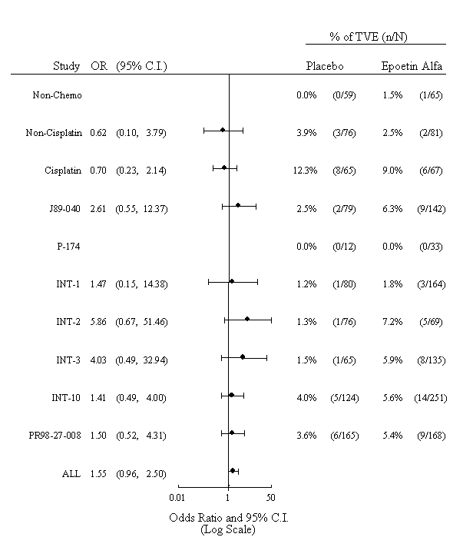
For the pooled analysis, the odds ratio was based on Mantel-Haenszel estimate stratified by study.

In brief, the odds ratios for TVEs were variable in these 10 studies. The combined analysis of all 10 studies yielded an odds ratio of 1.55 with a 95% CI (0.96, 2.50) suggesting higher incidence of TVEs with epoetin alfa treatment.

Patient Outcomes

Survival
The Sponsor also has reanalyzed survival data from its prior clinical studies of PROCRIT and EPREX in anemic patients receiving cancer chemotherapy. The analyses (including a combined analysis) presented in this section of this background document are also based on the same 10 completed, randomized, double-blind, and placebo-controlled studies identified in Table 1, above. It should be noted that these studies are generally of relatively shorter double-blind duration than the investigational studies that are presented in Section 4, Investigational Clinical Studies – Treatment Beyond Correction of Anemia, of this background document. As noted previously, many of the studies enrolled patients with a mix of tumor types, limiting the possibilities to evaluate any tumor type-specific effects but expected to still have sensitivity to adverse event (e.g., TVE) – related effects. Some studies utilized PROCRIT (epoetin alfa), while others utilized EPREX (epoetin alfa).
The results of these analyses are presented in Figure 2.

Figure 2: Subject Survival: Hazard Ratios and 95% Confidence Intervals
(Up to 30 Days After End of Double-Blind Phase)
(10 Double-Blind, Placebo-Controlled, Completed Oncology Studies)
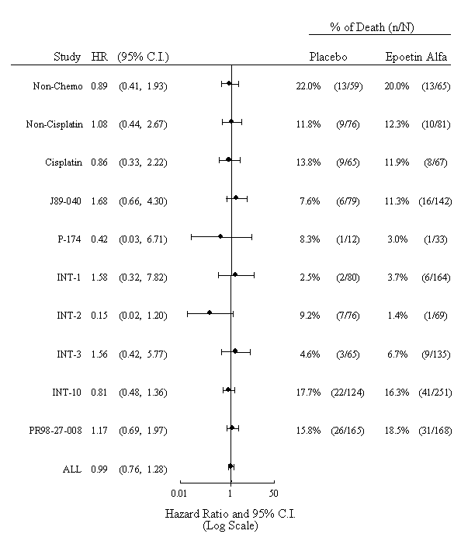
For the pooled analysis, the hazard ratio and its 95% CI were obtained using Cox’s Regression stratified by study.

Combined analyses of survival from the double-blind phase plus 30 day follow-up for these 10 double-blind, placebo-controlled oncology studies were similar for the epoetin alfa and placebo groups.
Finally, an abstract recently presented at the annual meeting of the American Society of Hematology described an independent meta-analysis, evaluating survival across a number of studies evaluating epoetins in the treatment of anemia in patients with cancer. There was no evidence of an impairment of survival among patients receiving epoetins in these studies.³

Tumor Response/Disease Progression
Tumor response to chemotherapy, disease progression, or both were evaluated in five of the completed, double-blind studies listed in Table 1, above, at the end of a double-blind phase that ranged from 12 to 24 weeks. Tumor response data were available for studies EPO-INT-1, EPO-INT-2, EPO-INT-3, EPO-INT-10, and PR98-27-008. Tumor response was assessed after the last cycle of chemotherapy, and the assessment of response did not require a complete radiographic assessment. The method for assessing tumor response was at the investigator's discretion. Of note, a number of caveats commonly applied to the interpretation of these studies: 1) tumor response was not a primary or secondary objective of the study; 2) predesignated times and method or instrument to evaluate tumor response were not specified; 3) baseline data on the extent of disease was missing in many patients in some studies; 4) time to tumor progression or progression-free survival was not a primary or secondary objective of many studies and the methods to evaluate these outcomes varied from study to study; and 5) by design, many studies were of relatively short duration and later-occurring outcomes such as tumor progression and death were not built into the study design. However, when data were available, overall or clinically objective tumor response rates (complete remission plus partial remission) were similar for subjects treated with epoetin alfa and those who received placebo. Thus, results from all five of these completed studies for which tumor response data are available suggest that treatment with epoetin alfa had no adverse effect on response to chemotherapy.
Disease progression is another important clinical observation that may be used to determine a subject’s response to chemotherapy and any possible role of ERAs on tumor progression. In Studies EPO-INT-1 (ovarian cancer), EPO-INT-2 (multiple myeloma), and EPO-INT-3 (mixed tumor types), disease progression was similar for subjects in the epoetin alfa and placebo groups at the end of the double-blind phase of the study. In Study EPO-INT-10 (mixed tumor types), disease progression was reported in 24% of the subjects who received epoetin alfa compared with 33% of subjects who received placebo. These data suggest that disease progression was unlikely to be affected by treatment with epoetin alfa.

Post-Marketing Surveillance
Cumulative patient exposure for PROCRIT and EPREX for all marketed indications is 3.1 million years since their introductions. This represents a large patient experience, which is continuously monitored. Although post-marketing surveillance is an imprecise tool for detecting subtle safety signals, the Sponsor’s ongoing post-marketing surveillance program has not identified any indications of an adverse effect of PROCRIT or EPREX on tumor response, disease progression, or survival. Interpretation of these data is constrained by the known limitations of these reporting systems. TVEs have been reported in association with PROCRIT and EPREX use. The frequency and nature of these reports is consistent with the Sponsor’s prior experience and is adequately reflected in product labeling.

Conclusion
Clinical studies involving use of epoetin alfa for the treatment of anemia in patients with cancer who are receiving chemotherapy (the current approved oncology indication) have shown no signal of an adverse impact on survival. Data are more limited regarding tumor response and disease progression, but available data from clinical studies where these parameters can be evaluated have not revealed any indications of an adverse effect of epoetin alfa.
Labeling for all ERA products describes the association of TVEs with use of these products. Experience in clinical trials of epoetin alfa in treatment of anemia in cancer patients receiving chemotherapy, and information obtained from post-marketing surveillance, is consistent with this product labeling.

INVESTIGATIONAL CLINICAL STUDIES – TREATMENT BEYOND CORRECTION OF ANEMIA
As noted above, the established, approved use of ERAs in patients with cancer is to treat anemia in patients receiving chemotherapy. That is, ERAs are used in the supportive care of patients and are not currently administered with an expectation of affecting the outcome of anticancer treatment. However, some preclinical and clinical study findings have suggested the possibility that ERAs might have a beneficial impact on treatment outcomes in cancer patients (e.g., a favorable effect on tumor response and/or patient survival). For example, laboratory and clinical studies have suggested that tumor hypoxia may reduce the anticancer effectiveness of radiation therapy and of many chemotherapy drugs; in theory, use of ERAs to increase hemoglobin levels might enhance tumor oxygenation and thus might enhance the effectiveness of these treatment modalities.^{4,5} Also, clinical studies have frequently suggested that anemic cancer patients do not do as well as non-anemic patients, raising the question of whether correcting anemia would have a beneficial impact on patient prognosis.⁶ Finally, limited survival data from two earlier studies
(EPO-INT-10 and the study of Vansteenkiste et al.^{7,8}) of ERAs in anemic cancer patients also suggested the possibility of modestly improved treatment outcomes for patients receiving ERAs. While these findings and arguments suggested a possibility of benefit, there was no substantive evidence and further research was needed.
Several investigational studies have subsequently been designed to examine whether ERA treatment of patients with cancer could lead to better treatment outcomes. Given the extensive prior use of these agents, the perceived high degree of safety of treatment, and the desire to adequately test the hypothesis that higher hemoglobin levels would be associated with better patient outcomes, the designs of these investigational studies have commonly provided for the treatment of patients to higher hemoglobin levels than described in current prescribing information. Thus, these studies have involved treatment of cancer patients who were not anemic, or the use of target hemoglobin levels that were significantly higher than those recommended for the established use of these agents for treatment of anemia (i.e., treatment beyond the correction of anemia, as previously noted). In this regard, these investigational studies differed from prior clinical studies that had raised the possibility of better treatment outcomes with ERA treatment; in the prior studies, ERA administration was generally in accordance with current prescribing information for use of these products in anemic patients with cancer receiving chemotherapy.
Partial results from two studies evaluating the effects of ERAs on treatment outcomes in patients with cancer have recently been published. In the EPO-INT-76 study, patients beginning chemotherapy for metastatic breast cancer were randomized to receive concomitant EPREX (the epoetin alfa formulation marketed outside the US) or placebo for one year. In the study performed by Henke et al.,² patients beginning radiation therapy for head and neck cancer were randomized to receive concomitant NeoRecormon® (epoetin beta) or placebo prior to and for the duration of their radiation therapy. In brief, patient survival in these two studies appeared to be worse, not better, with ERA treatment compared to placebo. The results of these investigational studies are summarized below. This section also summarizes available data from three other studies that have examined the impact of ERAs on treatment outcomes in cancer patients, and provides information from other clinical trials relevant to the questions raised by the results of the EPO-INT-76 and Henke et al. studies.

Study EPO-INT-76 ⁹

Study Design
EPO-INT-76 was a company-sponsored randomized, double-blind, placebo-controlled multicenter trial conducted in women with breast cancer who were receiving first-line chemotherapy for disseminated disease, and was designed to evaluate the impact on survival and quality of life of using epoetin alfa to maintain hemoglobin at non-anemic levels for 12 months. The primary efficacy variable was 12-month survival. A total of 939 patients were enrolled, and were randomly assigned to receive either epoetin alfa (EPREX), 40,000 IU s.c. weekly or placebo in a 1:1 ratio. Study drug was initiated when the hemoglobin concentration was 13 g/dL or lower and was to be continued thereafter on a weekly basis, until the end of the 12-month double-blind phase of the study; this treatment was intended to continue regardless of any changes in patients’ anticancer treatments.
Subsequent to the double-blind phase of the study, there was an optional open-label phase, in which all subjects could receive epoetin alfa. In both phases, study drug was administered with the goal of maintaining hemoglobin concentrations in the range of 12 to 14 g/dL. The dose of study drug could be escalated up to a maximum of 60,000 IU per injection if, after receiving 4 weekly doses, the hemoglobin concentration was less than 10.5 g/dL and had increased by less than 1 g/dL or the reticulocyte count had increased by less than 40,000 cells/μL. Treatment was to be interrupted if the rate of rise in hemoglobin level exceeded 2 g/dL per month or if hemoglobin exceeded 14 g/dL. Randomization was stratified according to 3 categories: disease restricted to the skeleton, extraskeletal measurable disease, and extraskeletal nonmeasurable disease. The choice of chemotherapy and hormonal therapy was left to the discretion of the investigators, except that dose-intense chemotherapy for bone marrow or stem cell transplantation was not allowed. There were no detailed requirements for tumor assessment at entry nor during the follow-up period.
Subjects included in the study had a confirmed diagnosis of metastatic breast carcinoma, including histology of the primary tumor. Subjects were female, at least 18 years of age, were starting first-line chemotherapy, had an Eastern Cooperative Oncology Group (ECOG) performance status score of 0, 1, or 2, and were to have an estimated life expectancy of at least 6 months. Subjects were excluded if they had brain metastases or leptomeningeal disease at the time of randomization, if they were receiving dose intensification chemotherapy for bone marrow or stem cell transplantation, if they had an active second primary malignancy, if there were causes of anemia known to be unresponsive to epoetin alfa, or if they had had a prior TVE within 6 months (unlike prior studies of epoetin alfa, which largely excluded patients with any prior TVE).

Patient Demographics
Demographic and baseline characteristics for the intent-to-treat population are summarized by treatment group and overall in Table 2a; baseline tumor-related characteristics are presented in Table 2b.
Table 2a: Demographics and Baseline Characteristics
(Study EPO-INT-76: Intent-to-Treat Subjects: Metastatic Breast Cancer)
 | Placebo | Epoetin Alfa
Characteristic | (N=470) | (N=469)
Age (years)
N | 470 | 469
Mean (SD) | 55.1 (10.49) | 55.8 (11.13)
Median | 55 | 56
Range | 30-84 | 24-83
Age categories (years), no. (%)
<=35 | 10 (2%) | 14 (3%)
36-45 | 65 (14%) | 66 (14%)
46-55 | 149 (32%) | 133 (28%)
56-65 | 156 (33%) | 145 (31%)
66-75 | 75 (16%) | 86 (18%)
>=76 | 15 (3%) | 25 (5%)
Weight (kg)
N | 470 | 469
Mean (SD) | 70.6 (12.88) | 70.6 (14.10)
Median | 69 | 69
Range | 40-120 | 40-138
Body mass index categories (kg/m²), no. (%)
< 18.5 | 9 (2%) | 11 (2%)
18.5-24.9 | 169 (36%) | 176 ( 38%
24.9-29.9 | 168 (36%) | 160 (34%)
>=30.0 | 123 (26%) | 121 (26%)
Missing | 1 (<1%) | 1 (<1%)
Reference: EPO-INT-76 CSR⁹

Table 2b: Baseline Tumor-Related Characteristics
(Study EPO-INT-76: Intent-to-Treat Population: Metastatic Breast Cancer)
Characteristic | Placebo  (N=470) |  | Epoetin Alfa  (N=469)
Estrogen receptor result, no.(%)
Negative | 131 | ( 28) | 126 | ( 27)
Positive | 232 | ( 49) | 226 | ( 48)
Not determined | 107 | ( 23) | 117 | ( 25)
ECOG performance status, no.(%)ª
0 | 222 | ( 47) | 198 | ( 42)
1 | 199 | ( 42) | 216 | ( 46)
2 | 49 | ( 10) | 55 | ( 12)
ª ECOG performance scores: 0 = able to carry out all normal activity without restriction; 1 = restricted in physically strenuous activity but ambulatory and able to do light work; 2 = ambulatory and capable of all self-care but unable to carry out any work; 3 = capable of only limited self-care, confined to bed or chair more than 50% of waking hours; 4 = completely disabled; cannot carry out any self care; totally confined to bed or chair.
Reference: EPO-INT-76 CSR⁹

Patient Treatment
Summary statistics regarding exposure to study drug are provided in Table 3 for the intent-to-treat population.
Subjects did not have to be anemic to qualify for study entry; any baseline hemoglobin concentration was acceptable. Following randomization, however, study drug administration was to not to begin until the hemoglobin level was 13.0 g/dL or less. The median time from randomization to study drug start was the same in both treatment groups (4 days).
Table 3: Time From Randomization to Study Drug Start, Time on
Study and Study Drug, and Number of Doses
(Study EPO-INT-76: Intent-to-Treat Subjects: Metastatic Breast Cancer)
 | Placebo | Epoetin Alfa
Exposure Parameters | (N=470) | (N=469)
Time from randomization to study drug start (days)
N | 456 | 448
Mean | 12.2 | 13.0
Median | 4 | 4
Interquartile Range | 0-14.0 | 0-12.5
Range | 0-265 | 0-286
Time on study drug (weeks)
N | 456 | 448
Mean (SD) | 36.9 (16.34) | 30.4 (17.25)
Median | 44.1 | 32.1
Range | 0.1-59.7 | 0.1-65.4
Number doses per subject
N | 456 | 448
Mean (SD) | 35.2 (15.91) | 21.4 (13.50)
Median | 40 | 19
Range | 1-57 | 1-58
Time on study (weeks)
N | 470 | 469
Mean (SD) | 43.8 (15.18) | 41.6 (16.78)
Median | 52.0 | 52.0
Range | 0-68 | 0-66
Reference: EPO-INT-76 CSR⁹

During the study, study drug was administered to maintain the subject’s hemoglobin concentration in the range of 12 to 14 g/dL, and doses were to be withheld when the hemoglobin level was increased above 14 g/dL. Subjects in the epoetin alfa group were on study drug for a shorter length of time and received fewer doses of study drug per subject compared with those assigned to the placebo group (Table 3). In both groups, the majority of subjects in both treatment groups remained in the double-blind study for the specified 12-month duration (median, 52 weeks).
The mean doses of study drug over time in the epoetin alfa and placebo group are shown for the intent-to-treat population in Figure 3.
Figure 3: Mean Weekly Dose Over Time for Patients Receiving Study Drug
(Study PRI/EPO-INT-76: Intent-to-Treat Subjects: Metastatic Breast Cancer)

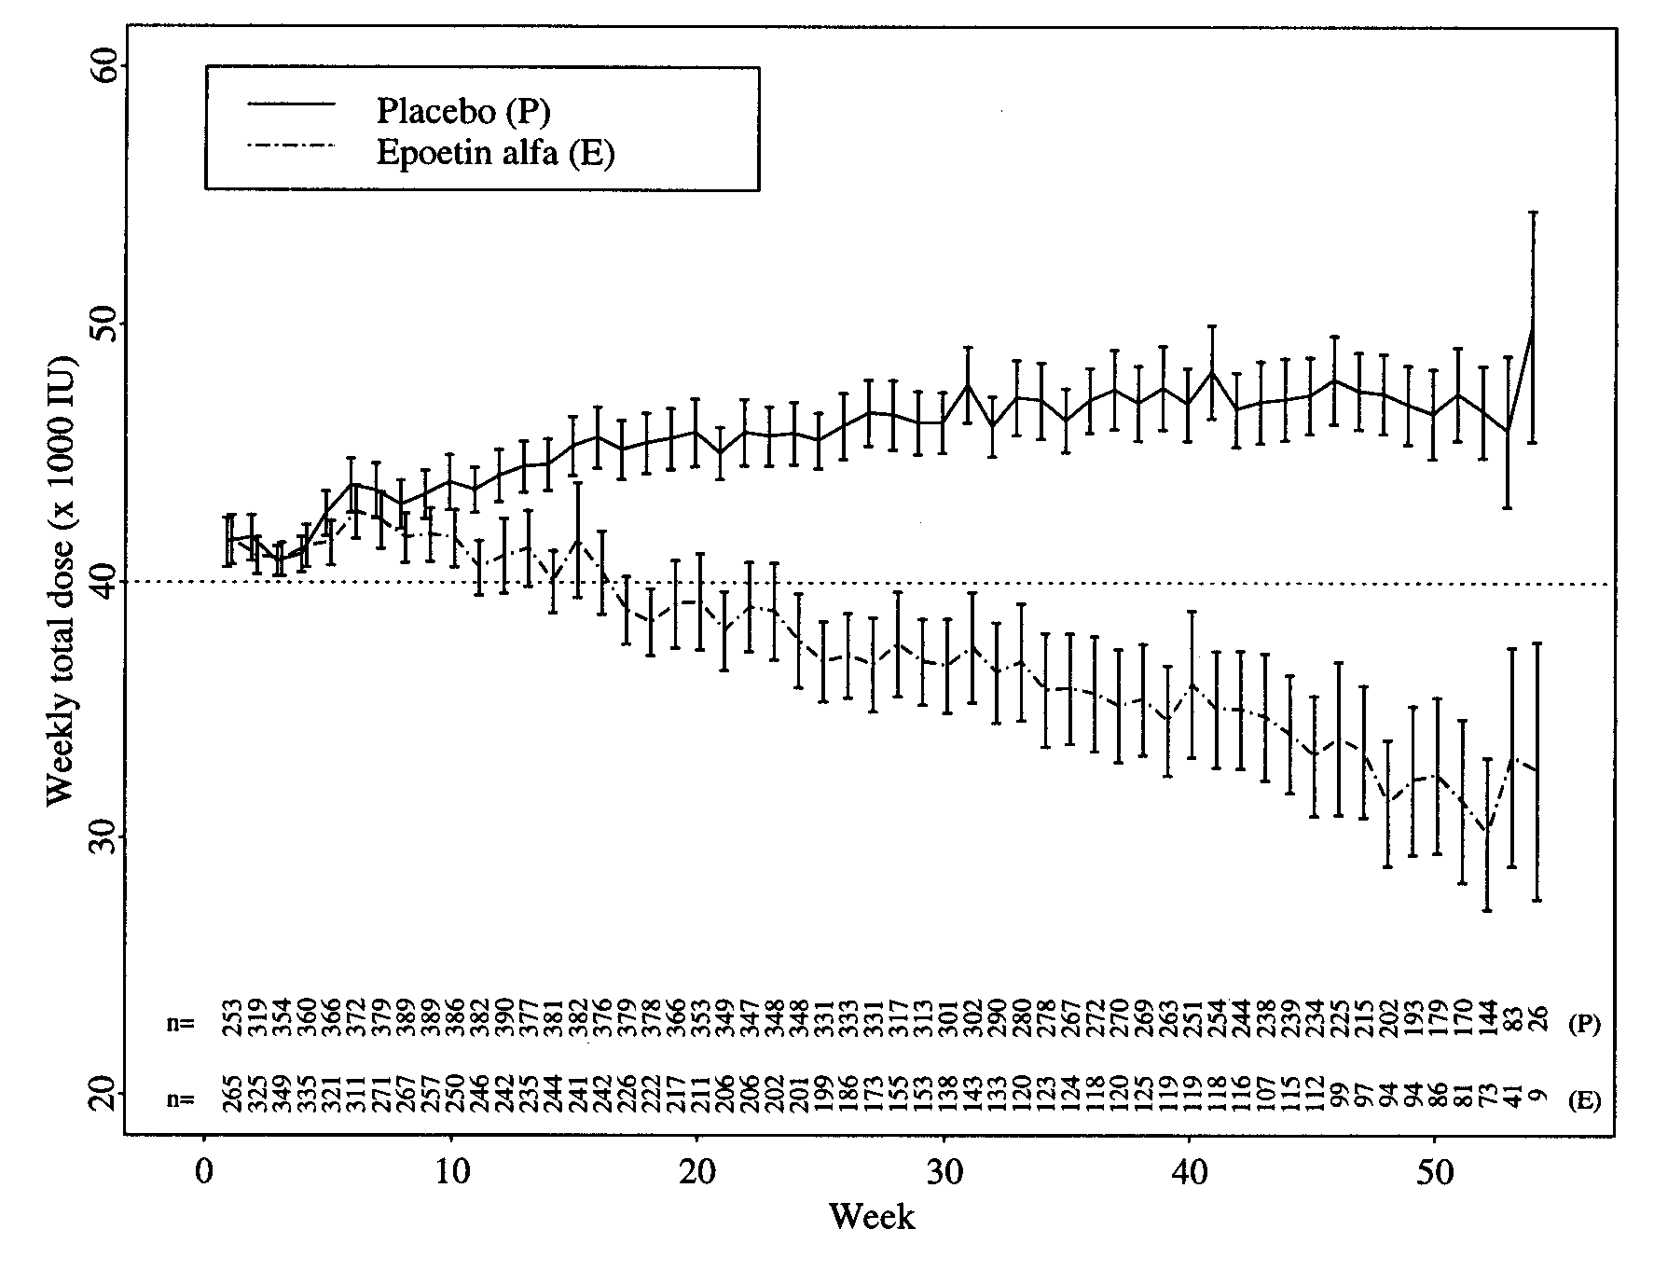
Note: Zero weekly doses were excluded from the summary.
Reference: EPO-INT-76⁹
Patients in the placebo arm tended to receive higher doses of study drug over time, consistent with a lack of pharmacologic effect resulting in dose escalations. Patients in the active treatment arm tended to receive lower doses over time consistent with dose adjustments based on hemoglobin increases or due to adverse events.

Early Discontinuation of Study Drug Treatment
In April 2002, the Independent Data Monitoring Committee (IDMC) reviewed available data on the 939 enrolled subjects. The IDMC recommended discontinuation of the study because of an unexpected increase in mortality among subjects in the epoetin alfa-treated group compared with the placebo group. Although study drug treatment was terminated, study participants were to be followed according to the protocol. At the time of discontinuation of study drug treatment, all study patients had already been enrolled, 88% of study patients had already completed the study period or had withdrawn from treatment, and the last patients to be enrolled had completed 10 months of the planned 12-month treatment period.

Data Sets Analyzed
In general, data and conclusions concerning the analysis of the primary efficacy end point for the efficacy population (defined as patients who received at least one dose of study drug; this included 904 of the 939 patients enrolled) were consistent with those for the intent-to-treat population. Therefore, results for the intent-to-treat population are discussed in the text of this document.
After study drug treatment was discontinued (follow-up continued and is ongoing), and the pre-planned primary analysis was completed, the Sponsor engaged an outside consulting firm (Cvitkovic et Associés Consultants [CAC], Paris, France), staffed by medical oncologists, to review the subjects’ medical charts at all sites. This review was conducted in an attempt to collect further information to better understand the efficacy and safety results. The oncologists who performed the review were blinded to the identity of the study drug previously administered to each subject. Additional information obtained from this medical chart review is utilized in some analyses, and is so identified when used.

Survival – Final Analysis of 12-Month Survival Rate
The intent-to-treat population, which included all subjects randomized, consisted of 939 subjects with a mean age of 55.5 years. In general, demographic and baseline characteristics were similar between epoetin alfa- and placebo-treated subjects. For the intent-to-treat population, survival rates at 12 months after randomization, based on Kaplan-Meier estimates, are presented in Table 4. The 12-month survival rate based on Kaplan-Meier estimates was lower in the epoetin alfa group (70%) compared with the placebo group (76%). The analysis based on Cox’s proportional hazards model stratified by metastatic category showed that the difference between the treatment groups was statistically significant (p=0.012). The Kaplan-Meier curves for time to death within 12 months after randomization for the intent-to-treat population are presented in Figure 4.
Table 4 also summarizes the 12-month survival results for the efficacy population. For this population, the 12-month survival rate, based on Kaplan-Meier estimates, was also significantly lower in the epoetin alfa group compared with the placebo group (p=0.019). Similar results were seen using the survival data as of the date of treatment discontinuation (hazard ratio=1.33, p=0.024). In this analysis, subjects were censored at the date the study treatment was discontinued or at 12 months, whichever occurred first.
Table 4: Primary Efficacy Variable: 12-Month Survival Rate
(Study PRI/EPO-INT-76: Intent-to-Treat and Efficacy Subjects: Metastatic Breast Cancer)
 | Placebo | Epoetin Alfa | Hazard Ratio [95% CI]  p valueª
Intent-to-Treat | (N=470) | (N=469)
Died^{b} | 24% | 30% | 1.37 [ 1.07, 1.74]
Survived^{b} | 76% | 70% | 0.012
Efficacy^{c} | (N=456) | (N=448)
Died^{b} | 23% | 29% | 1.35 [ 1.05, 1.74]
Survived^{b} | 77% | 71% | 0.019
Key: CI=confidence interval
ª Based on Cox’s model stratified by metastatic category.
^{b} reported percentages are based on Kaplan-Meier estimates.
^{c} Efficacy population comprised only of subjects who received study drug.

Reference: EPO-INT-76 CSR⁹

Figure 4: Time to Death Within 12 Months After Randomization
(Study PRI/EPO-INT-76/EPO-CA-489: Intent-to-Treat Subjects: Metastatic Breast Cancer)
Note: Survival curves for 365 days (+ 2-week window) post-randomization.
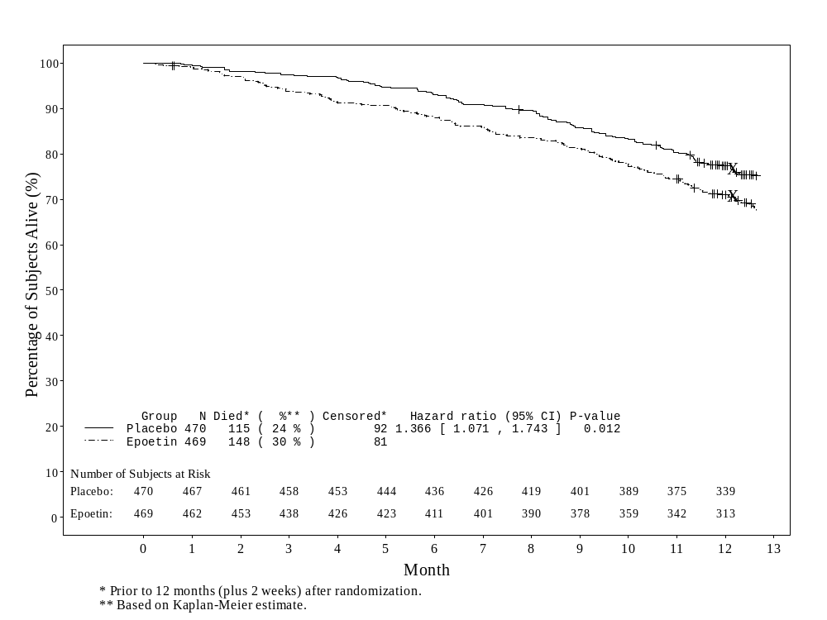
Reference: EPO-INT-76 CSR⁹

Survival – Deaths Within 4 Months After Randomization
The Kaplan-Meier survival curves separated early in the study, with nearly the maximum difference in mortality already evident after the first 4 months of the double-blind study. As the excess deaths occurred largely in the first 4 months, the subset of subjects who died within the first 4 months of randomization was examined further. This was a post-hoc analysis, to better understand the data. For the intent-to-treat population, a total of 57 subjects died within the first 4 months after randomization in the double-blind phase. Of these 57 subjects, 16 were in the placebo group and 41 were in the epoetin alfa group.

Patient Demographics in Patients Who Died Within 4 Months
No apparent reasons for the observed imbalance in deaths at 4 months were evident from examination of the selected characteristics of patients who died at 4 months, compared to the total population. Table 5 is illustrative of the findings of these comparisons.
Table 5: Selected Baseline Characteristics of
Subjects Who Died Within 4 Months After Randomization Versus Total Population
(Study EPO-INT-76: Intent-to-Treat Subjects: Metastatic Breast Cancer)
 |  |  |  | Placebo |  |  | Epoetin Alfa
 |  |  |  | Early Deaths | Total |  | Early Deaths | Total
 | Characteristic |  |  | (N=16) | (N=470) |  | (N=41) | (N=469)
 | Median Age (years) |  |  | 56.5 | 55 |  | 58 | 56
 | >65 years of age (%) |  |  | 31% | 19% |  | 41% | 24%
 |  | Estrogen Receptor Positive (%) | 50% |  | 49% | 37% |  | 48%
 |  | Hemoglobin ≤ 10.5 g/dL, (%) | 6% |  | 11% | 29% |  | 14%
 |  | ≥3 Indicator lesions at entry (%) | 0 |  | 21% | 37% |  | 23%
 |  | Reference: EPO-INT-76 CSR⁹

There were no notable differences in the prestudy (adjuvant) or on-study chemotherapy received by patients who died in the first 4 months after randomization, compared to the total study population.

Causes of Death
The causes for all deaths that occurred within 4 months of randomization, and for all deaths that occurred during the 12-month double-blind phase of Study EPO-INT-76, are summarized in Table 6, for the intent-to-treat population.
As shown in Table 6, a total of 263 (28%) subjects in the intent-to-treat population died during the 12-month double-blind phase, including 24% of placebo-treated subjects and 32% of epoetin alfa-treated subjects. During the first 4 months after randomization, 16 placebo-treated subjects died, compared with 41 subjects in the epoetin alfa group. The most common cause of death at 4 months and at 12 months post-randomization was reported as disease progression. During the first 4 months after randomization, deaths attributed by the investigator to disease progression accounted for 13/16 and 28/41 of the deaths in the placebo and epoetin alfa treatment populations, respectively. This pattern was still seen at the 12-month time point, where a large majority of deaths (91% and 85%) in each of the two treatment groups was attributed to disease progression.
Table 6: Cause of Deaths Among Subjects Who Died Within 4 Months and Within 12 Months of Randomization as Attributed by the Investigator
(Study PRI/EPO-INT-76: Intent-to-Treat Subjects: Metastatic Breast Cancer)
 | Placebo | Epoetin Alfa | Difference
 | (N=470) | (N=469) | EPO-PBO
No. (%) died within 4 months | 16 (3) | 41 (9) | 25
Cause of death within 4 months as attributed by investigator
Chemotherapy toxicity | 1 | 3 | 2
Disease progression | 13 | 28 | 15
Missing | 0 | 1ª | 1
Other^{b} | 1 | 4 | 3
Thrombotic vascular event | 1 | 5 | 4
No. (%) died during 12 months | 115 (24) | 148 (32) | 33
Cause of death during 12 months as attributed by investigator
Chemotherapy toxicity | 1 | 8 | 7
Disease progression | 105 | 126 | 21
Missing^{c} | 0 | 2 | 2
Other^{d} | 6 | 6 | 0
Thrombotic vascular event | 3 | 6 | 3
ª Cause of death was unknown. Subject 3003 died suddenly on Study Day 36.
^{b} Other causes include:
- fatty embolism, ischemic colon perforation, pulmonary edema, unknown
^{c} Cause of death not listed for 2 subjects in the epoetin alfa treatment group.
^{d} Other causes of death included
-aspiration of barium – cardiac arrest, cardiomyopathy and disease progression
-cardiomyopathy, circulatory tract insufficiency
-euthanasia, fatty embolism
-heart insufficiency, ischemic colon perforation
-died with traffic accident, pulmonary edema
-renal insufficiency
-respiratory/circulatory insufficiency, serious adverse event: aspiration of barium
-traffic accident, unknown.

Reference: EPO-INT-76 CSR⁹

It should be noted that the cause of death given for subjects in Study EPO-INT-76 was based on the assessment of the investigator, and it was not necessary for the study investigator to provide corroborating information when he/she checked off “disease progression” as the cause of death. It is perhaps not surprising that, in this population of subjects with metastatic cancer, most deaths were attributed to “disease progression”. To help determine whether the observed difference in mortality reflected a true difference in tumor treatment response / disease progression, a blinded chart review was undertaken, in which all available information in individual patient charts regarding indicators of disease progression was evaluated, including tumor response, time to disease progression, and progression-free survival. All chart information on the patients who died in the first 4 months was also examined to look for any records regarding associated TVEs.
Based on the information generated in this blinded chart review, among the patients who died in the first 4 months following randomization, 2/16 deaths in the placebo group and 11/41 deaths in the epoetin alfa group were related to TVEs, compared with 1/16 and 5/41 deaths that had been attributed to TVEs according to the original report of the study investigator on the case report form (CRF). Thus, TVEs accounted for some of the increased mortality in the epoetin alfa group in the 4 months following randomization, and this analysis, together with the potential for underdiagnosis of fatal TVEs, suggests that these events may well have accounted for a substantial portion of the observed increased mortality in the epoetin alfa group.

Tumor Response
Study EPO-INT-76 was designed as a survival study with limited data collection, and there were no detailed requirements for tumor assessment at entry or during study treatment or follow-up. Further, despite post-hoc efforts to retrospectively collect additional information via chart reviews, 26% of placebo-treated subjects and 29% of epoetin alfa-treated subjects had inadequate tumor assessments before chemotherapy. This substantial level of missing data clearly constrains the interpretation of analyses of response rates and time to progression in this study. However, analyses of tumor response were performed with findings as described below.

Optimal Tumor Response to First-Line Chemotherapy
Optimal tumor response rate to first-line chemotherapy was defined as the best overall response noted at any time during first-line chemotherapy. Individual investigators made the determination on the basis of tumor measurements obtained during first-line chemotherapy, and the method of determination was at the investigator's discretion. No detailed requirements were defined for tumor assessment at study entry or during the follow-up period. As noted above, baseline tumor assessment data were missing in a substantial proportion of patients in each treatment group.
For the intent-to-treat population, the optimal tumor response to chemotherapy was not statistically different between the treatment groups (p=0.93). The proportion of patients who had a complete or partial response to first-line chemotherapy was similar in the placebo and the epoetin alfa treatment groups (Table 7). The number of patients who developed new lesions, as a manifestation of progressive disease, was also similar in both groups, indicating that epoetin alfa was not associated with a higher incidence of new metastatic lesions.
Table 7: Optimal Tumor Response to First-Line Chemotherapy
(Study PRI/EPO-INT-76: Intent-to-Treat Subjects: Metastatic Breast Cancer)
 | Placebo | Epoetin Alfa
 | (N=470) | (N=469)
Tumor response, n (%)
Complete response | 45 (10) | 55 (12)
Partial response | 170 (36) | 154 (33)
Overall response (CR + PR) | 215 (46) | 209 (45)
No response (stable disease) | 156 (33) | 149 (32)
Progressive disease | 84 (18) | 87 (19)
New lesions | 56 (12) | 43 (9)
Unknown | 15 (3) | 24 (5)
p valueª | 0.9303
ª The p-value was based on a stratified Cochran-Mantel-Haenszel test. Response to chemotherapy categories:
Complete response: complete absence of detectable tumor.
Partial response: reduction in estimated tumor mass by ≥50%; <25% increase in the size of any measurable malignant lesion; <25% increase in the estimated size of any evaluable but non-measurable malignant lesion; no new lesions.
No response (stable disease): reduction of tumor mass by <50%; <25% increase in the size of any measurable malignant lesion; <25% increase in the estimated size of any evaluable but non-measurable malignant lesion; no new lesions.
Progressive disease: increase in estimated tumor mass by ≥25% or appearance of new lesion.
Reference: EPO-INT-76 CSR⁹

Tumor Response at the End of First-Line Chemotherapy
For the intent-to-treat population, the tumor response at the end of first-line chemotherapy was 35% for subjects in the epoetin alfa treatment group and 36% for subjects in the placebo group (Table 8).
Table 8: Tumor Response at the End of First-Line Chemotherapy
(Study PRI/EPO-INT-76: Intent-to-Treat Subjects: Metastatic Breast Cancer)
 | Placebo | Epoetin Alfa
 | (N=470) | (N=469)
Tumor response, n (%)
Complete response | 41 (9) | 49 (10)
Partial response | 127 (27) | 115 (25)
Overall response (CR + PR) | 168 (36) | 164 (35)
No response (stable disease) | 124 (26) | 96 (20)
Progressive disease | 123 (26) | 125 (27)
New lesions | 101 (21) | 86 (18)
Unknownª | 55 (12) | 84 (18)
ª All information on response to chemotherapy was missing.
Response to Chemotherapy Categories:
Complete response: complete absence of detectable tumor.
Partial response: reduction in estimated tumor mass by ≥50%; <25% increase in the size of any measurable malignant lesion; <25% increase in the estimated size of any evaluable but non-measurable malignant lesion; no new lesions.
No response (stable disease): reduction of tumor mass by <50%; <25% increase in the size of any measurable malignant lesion; <25% increase in the estimated size of any evaluable but non-measurable malignant lesion; no new lesions.
Progressive disease: increase in estimated tumor mass by ≥25% or appearance of new lesion.

Reference: EPO-INT-76 CSR⁹

Tumor Response at Individual Subject Study End
For the intent-to-treat population, tumor response at the last assessment for each individual subject during the 12-month double-blind phase was similar for the two treatment groups (Table 9). Slightly more subjects who received placebo showed progressive disease than those who received epoetin alfa, with a corresponding finding for the occurrence of new lesions. These data do not indicate any effect of epoetin alfa on tumor response rate.
Table 9: Tumor Response to First-Line Chemotherapy at Final Assessment
(Study PRI/EPO-INT-76: Intent-to-Treat Subjects: Metastatic Breast Cancer)
 |  |  | Placebo | Epoetin Alfa
 |  |  | (N=470) | (N=469)
 |  | Tumor response, n (%)
 |  | Complete response | 34 (7) | 44 (9)
 |  | Partial response | 66 (14) | 45 (10)
 |  | Overall response (CR + PR) | 100 (21) | 89 (19)
 |  | No response (stable disease) | 88 (19) | 102 (22)
 |  | Progressive disease | 216 (46) | 195 (42)
 |  | New lesions | 177 (38) | 140 (30)
 |  | Unknownª | 66 (14) | 83 (18)
ª All information on response to chemotherapy was missing.
Response to Chemotherapy Categories:
Complete response: complete absence of detectable tumor.
Partial response: reduction in estimated tumor mass by ≥50%; <25% increase in the size of any measurable malignant lesion; <25% increase in the estimated size of any evaluable but non-measurable malignant lesion; no new lesions.
No response (stable disease): reduction of tumor mass by <50%; <25% increase in the size of any measurable malignant lesion; <25% increase in the estimated size of any evaluable but non-measurable malignant lesion; no new lesions.
Progressive disease: increase in estimated tumor mass by ≥25% or appearance of new lesion.

Reference: EPO-INT-76 CSR⁹

If epoetin alfa were interfering with response to chemotherapy or potentiating tumor growth, a lower objective response rate might have been observed in patients treated with epoetin alfa, and the number of patients in the epoetin alfa group with new lesions or disease progression might have been higher. These findings are not suggestive of an effect of epoetin alfa on tumor response to treatment, and may support consideration of other mechanisms, such thrombotic vascular events (some of which may be occult) and/or other adverse events, to explain the observed survival differences. This also may suggest that disease progression was not the true reason for the difference in deaths in the two treatment groups, despite the attributions assigned in the case records.

Time to Disease Progression
It is again important to note that Study EPO-INT-76 was designed as a survival study with limited data collection, and there were no detailed requirements for tumor assessment at entry or during study treatment or follow-up. Further, despite efforts to retrospectively collect additional information via chart reviews, 26% of placebo-treated subjects and 29% of epoetin alfa-treated subjects had inadequate tumor assessments before chemotherapy. This substantial level of missing data clearly constrains the interpretation of analyses of response rates and time to progression in this study.
For purposes of analysis, the date of disease progression was determined to be the first time the investigator noted disease progression when recording evaluation of optimal tumor response to first-line chemotherapy, tumor response at the end of first-line chemotherapy, and tumor response at completion or withdrawal from the study. If a subject did not have disease progression reported on study, time to disease progression was determined by using the following rules:
- if subject died within 12 months after randomization and death was attributed to disease progression, she was considered as having disease progression with the time to disease progression equivalent to the time to death;
- if subject died within 12 months after randomization of causes other than disease progression, time to disease progression was censored at the date of death;
- if death occurred beyond 12 months after randomization, time to disease progression was censored at the date of completion or withdrawal.
Forty subjects (24 in the epoetin alfa group, 16 in the placebo group) were not evaluable for this endpoint, because of early withdrawal from the study before any tumor assessments were conducted.
For the intent-to-treat population, time to disease progression was similar between the 2 treatment groups (p=0.71) (Figure 5). On the basis of Kaplan-Meier estimates, 43.4% of subjects who received epoetin alfa and 41.1% of those who received placebo had evidence of disease progression by Month 12.
Figure 5: Time to Disease Progression
(Study PRI/EPO-INT-76: Intent-to-Treat Subjects: Metastatic Breast Cancer)
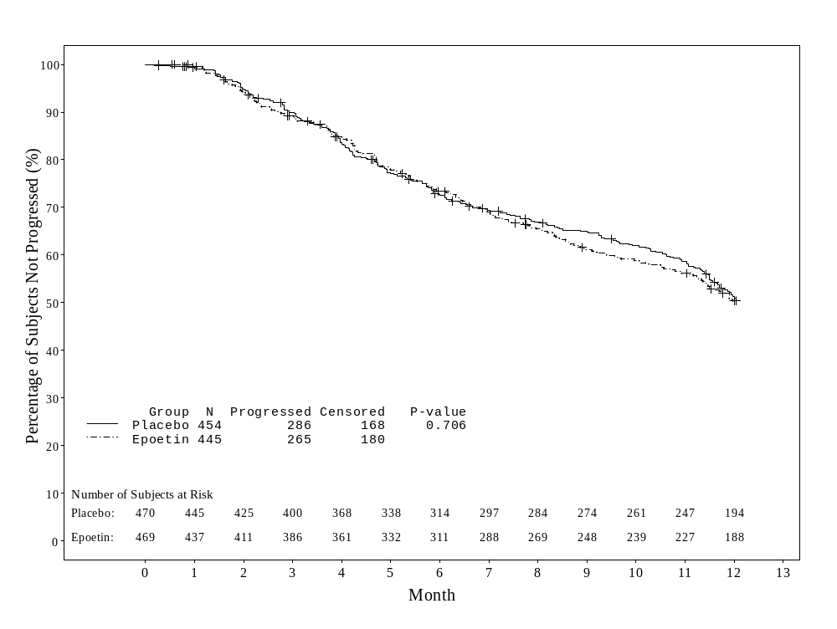
Reference: EPO-INT-76 CSR⁹

Conclusion
Study EPO-INT-76 evaluated whether epoetin alfa treatment, administered weekly for one year to maintain hemoglobin levels at 12-14 g/dL in patients starting first-line chemotherapy for metastatic breast cancer, could favorably affect the survival of these patients. Treatment differed from the common uses of ERAs for chemotherapy-associated anemia in that target hemoglobins were relatively high and treatment continued for a year regardless of chemotherapy. The reasons for the observed outcome of EPO-INT-76 are not clear. An effect on tumor treatment response / disease progression cannot be excluded, but it also appears likely that increased adverse effects (TVEs), associated with this use of ERA treatment of patients beyond the correction of anemia, may have played a role.

Study of Henke M, et al. ²
It is important to acknowledge that the Sponsor did not have access to the primary data to evaluate the results of this study. This discussion of the results is based on data available in the public domain.

Study Design
Henke et al. conducted a multicenter, randomized, double-blind, placebo-controlled clinical trial in patients with head and neck cancer, designed to investigate the effects of epoetin beta (NeoRecormon®) on locoregional progression-free survival (LRPFS) and overall survival, compared with placebo. The starting dose of epoetin beta was 300 IU/kg t.i.w. for 7 to 9 weeks, beginning 10-14 days before the start of radiation therapy (double the starting dose recommended in product labeling). Study subjects had advanced stage (III/IV) head and neck cancer (HNC) and were to receive postoperative radiation therapy, or radiation therapy alone if their disease was inoperable. The entry level for hemoglobin was <12.0 g/dL for women and <13.0 g/dL for men. The target hemoglobin was ≥14.0 g/dL for women and ≥15.0 g/dL for men . The study was designed to determine if ERA-induced higher hemoglobin levels can increase the radiosensitivity of head and neck cancer, and thus improve the outcome of treatment.
The primary end point of the study was LRPFS. Time to locoregional tumor progression and survival were also assessed. A total of 351 subjects were enrolled between March 1997 and April 2001 and were randomly assigned to either the epoetin beta group or the placebo group. Randomization was to three strata, based on complete resection; incompletely resected disease; or not operable (candidates for primary definitive radiotherapy).

Reported Study Results
Subjects treated with epoetin beta had a robust increase in hemoglobin concentration that was maintained during treatment, with a reported median hemoglobin at baseline of 11.7 g/dL, rising to reported mean hemoglobin values of 14.8 and 15.4 g/dL after 4 weeks and 9 weeks, respectively. In the intent-to-treat population, the median LRPFS was 406 days for subjects in the epoetin beta treatment group and 745 days for those who received placebo. The stage-adjusted and stratum-adjusted relative risk for LRPFS was 1.62 (95% CI, 1.22 to 2.14, p=0.0008). Survival in the intent-to-treat population also favored the placebo group (p=0.02, RR=1.39 [95% CI, 1.05 to 1.84], respectively). Separation of the LRPFS and survival curves began at about 6 months and continued for the duration of follow-up.
A total of 89 (52%) subjects in the placebo arm and 109 (61%) subjects in the epoetin beta arm died. One-third (34%) or 119 subjects in the 2 treatment groups had deaths attributed to cancer. Data on the number of cancer-related deaths by treatment arm are not available in the publication. Interestingly, the majority of the 20 excess deaths in the epoetin beta treatment arm could be accounted for by imbalances in reported deaths from cardiac disorders (5 placebo versus 10 epoetin beta deaths) and “general disorders” (1 placebo versus 9 epoetin beta). There was no difference in the rate of distant metastatic disease in the 2 arms of the study (23% in the placebo group versus 25% in the epoetin beta group,).
Vascular disorders were reported in 5% of placebo patients and 11% of epoetin beta patients, and included hypertension, hemorrhage, venous thrombosis and pulmonary embolism, and cerebrovascular disorders.
These unanticipated results suggested that therapy with epoetin beta in advanced stage HNC treated with radiotherapy might have exerted an adverse effect on LRPFS and survival; and the publication raised concerns that ERAs might be radioprotective or might stimulate tumor cell proliferation, resulting in disease progression and decreased survival.

Ongoing Study in Follow-Up Phase: Study AGO/NOGGO¹⁰
The study conducted by a German cooperative group AGO/NOGGO, referred to as Study AGO/NOGGO, is an investigator-sponsored study. It is important to note that the Sponsor did not have access to the primary data, and results are presented with the author's permission based on a presentation at ASCO in September 2003 together with a draft manuscript. This study was initiated in 1999 among patients with cervical cancer receiving sequential adjuvant chemoradiotherapy (ifosfamide and carboplatin followed by radiotherapy) and has a primary endpoint of recurrence-free survival after 5 years. The data presented here are preliminary, as median follow-up for study participants is currently approximately two years.

Study Design
The study is a multicenter, randomized, open-label study conducted primarily to compare relapse-free survival of patients with high-risk cervical cancer receiving adjuvant sequential chemotherapy and radiotherapy with or without epoetin alfa. Secondary endpoints were change in hemoglobin levels, transfusion requirements, reduction in anemia, changes in ECOG performance status, toxicity, and overall survival. Eligible patients had International Federation of Gynecology and Obstetrics (FIGO) staging scores of IB, IIA, or IIB, and had undergone radical hysterectomy. Patients in stages IB or IIA were also required to have one of the following poor prognostic factors: invasion of the tumor into lymph and/or blood vessels, adenocarcinoma, age less than 35 years, grading G3, tumor greater than 4 cm in diameter, and pN1 (pelvic lymph node metastases). Patients were centrally randomized using three prognostic factors as stratification criteria: lymph node involvement, staging according to FIGO classification system, and quality of tumor resection. At baseline (after surgery but before chemotherapy or radiotherapy) patients in the epoetin alfa group began treatment with 10,000 IU of epoetin alfa subcutaneously 3 times a week. Administration of epoetin alfa continued until 2 weeks after the end of radiotherapy to a target hemoglobin of 13.0 g/dL. If hemoglobin at chemotherapy initiation was <10.5 g/dL, epoetin alfa dose was increased to 10,000 IU 6 times weekly. If hemoglobin rose to >13.0 g/dL, epoetin alfa dose was reduced to 10,000 IU 2 times weekly; epoetin alfa was discontinued if hemoglobin reached >14.0 g/dL.
Patients in the control group received oral iron (Fe++ 200 mg/day) and blood transfusions for treatment of hemoglobin <9.0 g/dL. Patients in the epoetin alfa group whose hemoglobin declined to this level also received blood transfusions.

Preliminary Analysis
Before the initiation of chemotherapy, 53% of patients who received epoetin alfa and 43% of patients in the control group had hemoglobin levels >12 g/dL. The respective mean values were 12 g/dL and 11.8 g/dL. Before radiotherapy, mean hemoglobin levels were 12.5 g/dL for the epoetin alfa group and 10.8 g/dL for the control group. Mean hemoglobin at the end of radiotherapy was 12.9 g/dL for the epoetin alfa group and 12.1 g/dL for the control group. Two weeks after radiotherapy mean hemoglobin levels increased to 13.1 g/dL for the epoetin alfa group and 12.4 g/dL for the control group.
As designed, the study initially had three arms; a chemoradiotherapy (control) arm, a chemoradiotherapy plus epoetin alfa arm, and a radiation therapy alone arm. The third arm accrued very few patients and was closed. Of the 264 patients enrolled, 257 were in the control or epoetin alfa arms. Evaluable patients who had baseline demographics and characteristics for the primary intent-to-treat analysis included 122 epoetin alfa and 125 control patients. The relapse-free survival for the control group and the epoetin alfa group over time is shown in Figure 6. Table 10 summarizes relapse-free survival at a median observation time of 105 weeks (mean 102.6 weeks). The difference between the groups trended towards significance (p = 0.074).
Table 10: Recurrence of Malignancy at Median of 105 weeks*
(Study AGO/NOGGO: Cervical Cancer)
 | Epoetin alfa group  (n=113) | Control group (n=116) | Total  ( n=234)
No recurrence | 94 (83%) | 87 (75%) | 185 (79%)
Recurrence | 19 (17%) | 29 (25%) | 49 (21%)
*p = .074
Note: 5 patients were randomized to the radiotherapy group, which are not included in this table.
Reference: Reference #10.

Figure 6: Relapse-Free Survival for the Control Group vs the Epoetin Alfa Group
(Study AGO/NOGGO: Cervical Cancer)
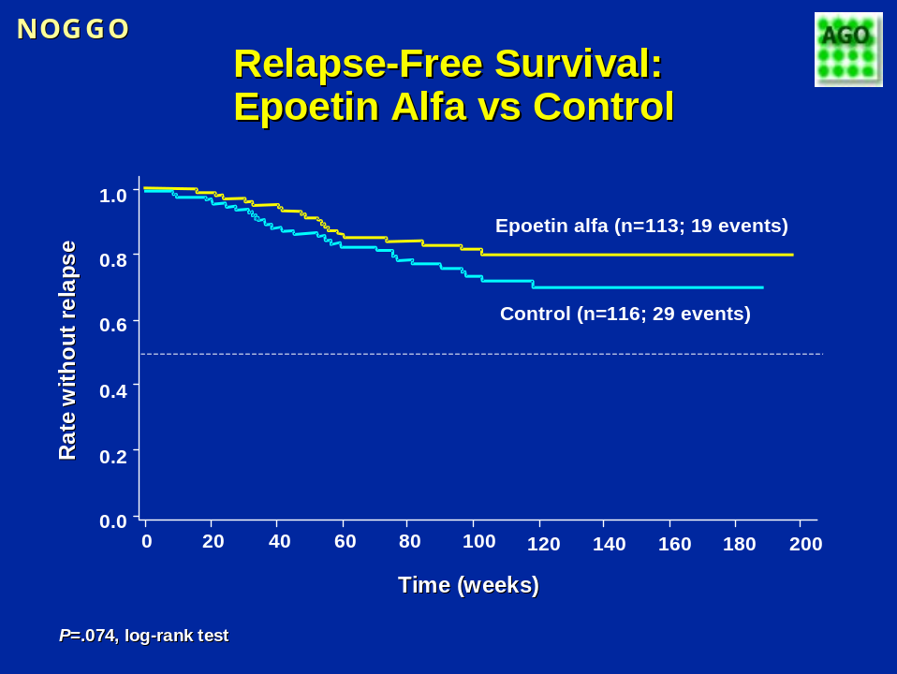

Reference: Reference #10.

Ongoing Study in Follow-Up Phase: EPO-GBR-7¹¹
Study EPO-GBR-7 was a company-sponsored study conducted in the United Kingdom with a planned sample size of 800 subjects receiving radiotherapy for head and neck cancer. The first subject was randomized in August 1999. Due to slow accrual, enrollment was stopped after 301 subjects had been recruited, with the last subject randomized in April 2002. Based on the study protocol, the study treatment phase has been completed and the 5-year follow-up phase is ongoing. Subjects who completed the study were to be followed monthly for 3 months after the end of radiotherapy and annually thereafter either until death or for 5 years post-radiotherapy, whichever is sooner.

Study Design
This was a randomized, open-label, Phase 3, multicenter study. The primary objective of the study was to evaluate the effect of treatment with epoetin alfa on the length of local disease-free survival, local tumor control, and quality of life in subjects receiving radical radiotherapy with curative intent for head and neck cancer. Subjects were randomly assigned to receive either standard radiotherapy plus epoetin alfa (4,000 or 10,000 IU s.c. 3 times per week based on whether entry hemoglobin concentration was >12.5 g/dL or ≤12.5 g/dL) or standard radiotherapy alone. The duration of treatment was through the end of radiotherapy. Subjects were to have a baseline hemoglobin concentration of less than or equal to 15 g/dL. Hemoglobin concentrations during the study were intended to be maintained at approximately 12.5 g/dL-15 g/dL.

Preliminary Analysis
Of the 301 subjects enrolled, no data were available for one subject. All summaries and analyses presented in this document were based on the 300 subjects (149 in the observation group [standard radiotherapy only] and 151 in the epoetin alfa group) who were randomized and had data (referred to as “All Subjects Randomized” in this document for simplicity).
Fifty-seven (38%) subjects in each treatment group were withdrawn from the study (Table 11). The majority of the withdrawals were due to tumor recurrence (46 [31%] in the observation group and 43 [28%] in the epoetin alfa group).
At the time of the current analysis, a total of 148 (49%) subjects (74 [50%] in the observation group and 74 [49%] in the epoetin alfa group) were alive and still being followed in the study.
Table 11: Study Completion/Withdrawal Information
(Study EPO-GBR-7: All Subjects Randomized: Head and Neck Cancer)
 | Observation | Epoetin Alfa
 | (N=149) | (N=151)
 | n (%) | n (%)
Died before end of RT | 0 | 0
Died between end of RT and end of Year 5ª | 17 (11) | 20 (13)
Withdrawal and reasons^{b} | 57 (38) | 57 (38)
Tumor recurrence | 46 (31) | 43 (28)
Adverse event | 1 (1) | 0
Personal choice | 5 (3) | 3 (2)
Lost to follow-up | 1 (1) | 2 (1)
Other | 5 (3) | 11 (7)
Alive and being followed in study | 74 (50) | 74 (49)
Status unknown | 1 (1) | 0
Key: RT=radiotherapy
ª According to the protocol, subjects were considered to have completed the study if they either completed the 5-year follow-up or died between the end of radiotherapy and Year 5.
^{b} Each subject could have up to 2 reasons. Per protocol, subjects could withdraw from the 5-year study due to any of these reasons. However, vital status of withdrawn subjects is still being followed to obtain complete, long-term survival data.

Reference: EPO-GBR-7 preliminary report.¹¹

Demographic and Baseline Characteristics
Demographic and baseline characteristics are summarized in Table 12. The overall population of this study had a median age of 58.5 years and a 77:23 male-to-female ratio. At baseline, 38% of study subjects had Stage IV tumors, 25% had Stage III, 33% had Stage II, and the remaining 4% had Stage I. The median hemoglobin concentration at baseline for the overall population was 13.6 g/dL.
Compared with subjects in the observation group, more subjects in the epoetin alpha group had stage IV disease (39% vs. 36%).
Other demographic and baseline characteristics (age, sex, and hemoglobin concentration) were generally balanced between the 2 groups.
Among subjects who were randomized into the active treatment group, 25% had starting dose of 10,000 IU 3 times weekly, and 75% had a starting dose of 4,000 IU 3 times weekly, which were determined according to the subjects' baseline hemoglobin concentrations.
Table 12: Demographic and Baseline Characteristics
(Study EPO-GBR-7: All Subjects Randomized: Head and Neck Cancer)
 | Observation | Epoetin Alfa
 | (N=149) | (N=151)
Age (Years)
N | 149 | 151
Mean (SD) | 60.2 (10.6) | 59.8 (10.8)
Median | 58.0 | 60.0
Range | 35 - 84 | 37 - 88
Sex, n (%)
N | 149 | 151
Male | 118 (79) | 114 (75)
Female | 31 (21) | 37 (25)
Tumor Stage, n (%)
N | 147 | 150
I | 5 (3) | 8 (5)
II | 52 (35) | 45 (30)
III | 37 (25) | 38 (25)
IV | 53 (36) | 59 (39)
Hemoglobin (g/dL)
N | 146 | 148
Mean (SD) | 13.5 (1.3) | 13.4 (1.2)
Median | 13.65 | 13.40
Range | 8.9 - 16.7 | 9.3 - 15.5
Hemoglobin Category, n (%)
N | 146 | 148
<12.5 g/dL | 30 (21) | 35 (24)
≥12.5 g/dL | 116 (79) | 113 (76)
Epoetin Alfa Assigned Doseª, n (%)
N |  | 150
10,000 IU t.i.w. |  | 37 (25)
4,000 IU t.i.w. |  | 113 (75)
ªNot applicable for observation group.
Reference: EPO-GBR-7 preliminary report¹¹

Tumor Response
At the time of this analysis, data on local tumor response at Week 12 were available for approximately three-quarters of the patients in each treatment group. On the basis of these preliminary data, 99% of the subjects in both treatment groups had either a complete response or partial response to radiotherapy at the primary tumor sites (Table 13).
Table 13: Local Tumor Response at Week 12 after Radiotherapy
(Study EPO-GBR-7: All Subjects Randomized: Head and Neck Cancer)
 | Observation  (N=149) | Epoetin Alfa  (N=151)
Primary Tumor, n (%)
N | 111 | 114
Complete response | 106 (95) | 108 (95)
Partial response | 4 (4) | 5 (4)
CR and PR | 110 (99) | 113 (99)
No response (stable disease) | 0 | 1 (1)
Progressive Disease | 1 (1) | 0
Nodes, n (%)
N | 104 | 102
Complete Response | 97 (93) | 94 (92)
Partial Response | 3 (3) | 4 (4)
No Response | 1 (1) | 0
Study Day of Assessment
N | 113 | 115
Mean (SD) | 149.03 (17.36) | 150.09 (16.66)
Median | 149 | 147
Range | 109 - 220 | 120 - 203
Note: Response to chemotherapy categories was based on the investigator's assessment.

Reference: EPO-GBR-7 preliminary report¹¹

Response rates were also high in lymph nodes. The median study day when these assessments were performed was similar for the observation group (Day 149) and the epoetin alfa group (Day 147). Based on these preliminary data, there was no apparent effect of epoetin alfa treatment on local tumor responses assessed 12 weeks after completion of radiotherapy.

Disease Progression

Local Tumor Evidence
Local tumor evidence was assessed at Weeks 1, 4, and 8 after radiotherapy, and Years 1, 2, 3, and 5 during the follow-up period. Since study data collection is ongoing, not all subjects have reached all the assessment time points, relatively few patients have more than 1 year of follow-up data, and no subject has had the Year 5 assessment at the time of this analysis. Based on the data available at this time, epoetin alfa treatment appeared to have no effect on the outcomes of these assessments (Table 14).
Table 14: Local Tumor Evidence After Radiotherapy
Study EPO-GBR-7: All Subjects Randomized: Head and Neck Cancer)
 | Observation  (N= 149) | Epoetin Alfa  (N=151)
Week 1 Post RT, n (%) | N=142 | N=142
Yes | 14 (10) | 12 (8)
No | 86 (61) | 98 (69)
Missing | 42 (30) | 32 (23)
Week 4 Post RT, n (%) | N=140 | N=138
Yes | 14 (10) | 12 (9)
No | 111 (79) | 103 (75)
Missing | 15 (11) | 23 (17)
Week 8 Post RT, n (%) | N=135 | N=129
Yes | 11 (8) | 6 (5)
No | 101 (75) | 106 (82)
Missing | 23 (17) | 17 (13)
Year 1, n (%) | N=93 | N=92
Yes | 4 (4) | 6 (7)
No | 81 (87) | 85 (92)
Missing | 8 (9) | 1 (1)
Year 2, n (%) | N=53 | N=56
Yes | 0 | 1 (2)
No | 45 (85) | 52 (93)
Missing | 8 (15) | 3 (5)
Year 3, n (%) | N=21 | N=18
Yes | 0 | 0
No | 17 (81) | 13 (72)
Missing | 4 (19) | 5 (28)
Reference: EPO-GBR-7 preliminary report.¹¹

Survival
The protocol did not require survival status follow up after subjects had withdrawn from the study. In order to have a more complete and up-to-date mortality assessment, data collection was initiated to update the survival status of all enrolled subjects, including those who had withdrawn, as of 01 November 2003 or later wherever possible. At the time of this analysis, the status of 29 subjects (14 in the observation group, 15 in the epoetin alfa group) who had withdrawn remained unknown. Among all subjects who were not known to have died, the median duration of last follow up was 869 days in the observation group and 896 days in the epoetin alfa group (Table 15).
Table 15: Day of Last Follow-Up
(Study EPO-GBR-7: All Subjects Randomized: Head and Neck Cancer)
 | Observation | Epoetin Alfa
 | (N=149) | (N=151)
Day of last follow-upª
N | 99 | 98
Mean (SD) | 834 (366) | 858 (358)
Median | 869 | 896
Range | 1 – 1482 | 10 - 1519
.ª Follow-up cut-off was 01 November 2003 or later. This summary excluded subjects who were known to have died.
Reference: EPO-GBR-7 preliminary report ¹¹

As noted above, at the time of this preliminary analysis, no subject had completed the scheduled 5-year follow-up. Fifty (34%) of the subjects in the observation group and 52 (34%) of the subjects in the epoetin alfa group were known to have died during the follow-up period between the end of radiotherapy and the end of Year 5 (Table 16); these subjects were considered to have completed the study according to the protocol.
Disease progression was the most frequently reported cause of death (41 [28%] in the observation group and 36 [24%] in the epoetin alfa group). The next most frequently reported cause of death as reported on the CRFs was “Other”. Detailed information for such reported causes is provided in Table 17 for the 8 (5%) subjects in the observation group and 13 (9%) subjects in the epoetin alfa group.
Table 16: Subject Deaths
(Study EPO-GBR-7: All Subjects Randomized: Head and Neck Cancer)
 | Observation | Epoetin Alfa
 | (N=149) | (N=151)
 | n (%) | n (%)
Number and percent of deaths | 50 (34) | 52 (34)
Cause of deathª
Disease progression | 41 (28) | 36 (24)
Other | 8 (5) | 13 (9)
Missing | 1 (1) | 3 (2)
ª Percent based on the total number of subjects in the group.
Reference: EPO-GBR-7 preliminary report¹¹

Table 17: Listing of “Other” as Cause of Death
(Study EPO-GBR-7: Head and Neck Cancer)
Group/Subject Number | Cause of Death (Verbatims on the CRFs)
Observation
41 | Carcinoma of Tongue Carcinomatosis
153 | Aspiration Pneumonia and Cardiac Arrest
174 | Alcohol Abuse
224 | Ischaemic Heart Disease
231 | Pneumonia + Ischaemic Heart Disease
303 | Lung Cancer (Second Primary)
315 | Liver Disease (Alcoholic)
320 | 2nd Primary Lung
Epoetin Alfa
13 | Abdominal Sepsis
102 | Ca Oesophagus
119 | Heart Attack
125 | Strangulated Hernia
136 | Small Bowel Obstruction Ischaemic Colitis
183 | Unknown
211 | Carcinomatosa and Lymphargitis of Chest
265 | Adenocarcinoma of Gastro-Oesophageal Junction
266 | Chest Infection / Grade IV Glioma
302 | Pneumonia + Septic Shock
411 | Aspiration Pneumonia
413 | 2nd Primary (Nasopharynx)
445 | Presumed Cardiac Event
Reference: EPO-GBR-7 preliminary report.¹¹

As of this analysis, the Kaplan-Meier estimate of the 1-year survival rate was 84.1% for the observation group and 79.6% for the epoetin alfa group, yielding a difference of -4.6% (epoetin alfa vs. observation) with 95% confidence interval of (-13.6%, 4.4%). Kaplan-Meier estimates of the survival curves are shown in Figure 7. The difference between the treatment groups was not statistically significant (p=0.73, log rank test).
Figure 7: Subject Survival
(Study EPO-GBR-7: All Subjects Randomized: Head and Neck Cancer)
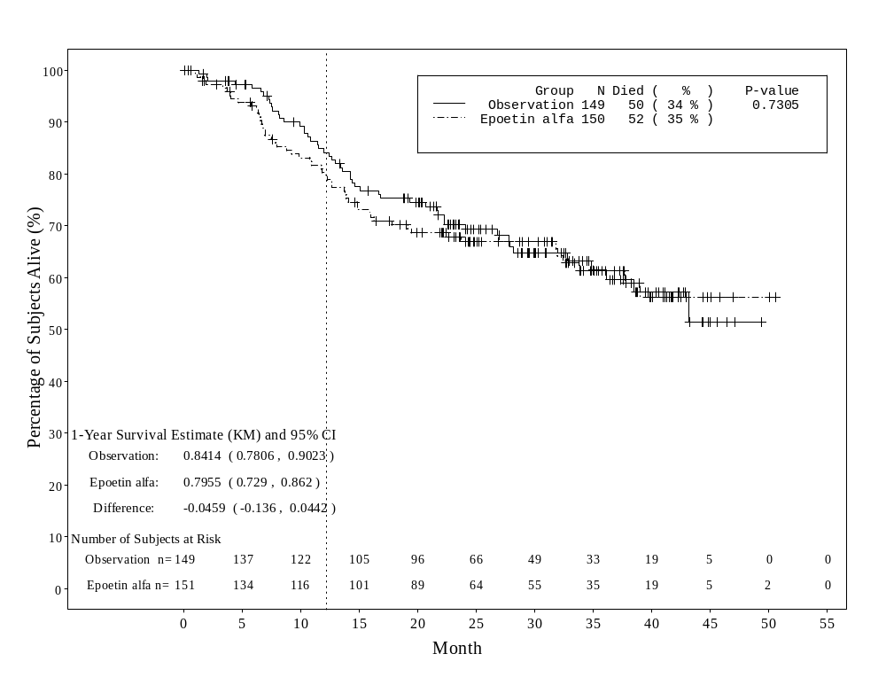
Reference: EPO-GBR-7 preliminary report.¹¹
Presently, the results observed in the placebo and epoetin alfa groups in study EPO-GBR-7 appear to be generally similar, although there is a 4.6% difference in 1-year survival favoring the placebo group. It is noted that there are similarities in the designs of EPO-GBR-7 and the Henke et al. study, although the doses of epoetin alfa studied in EPO-GBR-7 were lower than the doses of epoetin beta studied by Henke et al.

Study N93-004¹²
This double-blind, placebo-controlled study was designed to enroll subjects with newly-diagnosed limited or extensive stage small cell lung cancer (SCLC) who were to be treated with etoposide and cisplatin. It was requested as a post-marketing Phase 4 study by the FDA to evaluate the possible stimulatory effects of epoetin alfa on solid tumor growth. The primary objective of the study was to demonstrate that epoetin alfa does not adversely affect tumor responsiveness to chemotherapy. The minimum detectable difference to demonstrate non-inferiority was set to 15% in the protocol. The planned number of patients to be enrolled was 400. Initiated in 1993, this was the first study performed by the Sponsor in which response to chemotherapy and survival were established as primary and secondary endpoints, respectively, and is the largest study prospectively designed to measure tumor response as a primary endpoint.
Subjects were randomly assigned to receive 150 IU/kg epoetin alfa (PROCRIT) s.c. t.i.w. or placebo until approximately 3 weeks after the final cycle of etoposide and cisplatin chemotherapy. Subjects were to have a hemoglobin concentration of ≤14.5 g/dL at study entry. Hemoglobin concentrations were to be maintained within the range of 14 to 16 g/dL during the study (it should be noted, however, that the actual hemoglobin levels in participants over the course of the study were substantially below these levels, i.e., in the marginally anemic range; see below). If a subject’s hemoglobin was >16 g/dL, the dose was withheld until the hemoglobin level was <14 g/dL, and the dose was to be restarted at 75 IU/kg t.i.w. All enrolled subjects received the same chemotherapy and had the same evaluations at the end of the third cycle of chemotherapy.
Two hundred twenty-four subjects with a mean age of 64 years were enrolled in the study; 109 were randomly assigned to receive epoetin alfa and 115 to receive placebo. Demographic and baseline characteristics were similar among epoetin alfa- and placebo-treated subjects with the exception that thrombocytosis was more prevalent among subjects treated with epoetin alfa than those treated with placebo. A somewhat higher proportion (66%) of subjects assigned to treatment with epoetin alfa had extensive stage SCLC at diagnosis than those assigned to placebo (59%). The intent-to-treat population in this study included all subjects and was the same as the safety population. As noted previously, this study was stopped early due to slow enrollment, resulting from changes in standard chemotherapy treatment approaches for SCLC such that the regimen specified in the protocol fell into disuse after 224 of a planned 400 subjects were enrolled.

Tumor Response to Chemotherapy / Disease Progression
The optimal method for assessing tumor response in each patient was determined by the investigator. Evaluations of tumor to assess response to chemotherapy were performed at baseline, after the third cycle of chemotherapy, and at the study completion or the termination visit. Assessments included the extent of measurable and evaluable malignant lesions and the overall response to chemotherapy, and were performed after the third cycle of chemotherapy and at study completion. The same imaging or measurement method and indicator lesions were to be used for each assessment. Response was also compared between subjects with limited- and extensive-stage disease.
For the intent-to-treat population, the tumor response rates were similar for subjects in the epoetin alfa and placebo treatment groups after 3 cycles of chemotherapy (Tables 18 and 19). The observed difference in tumor response rates for the intent-to-treat population was 6%, favoring epoetin alfa (Table 20). The 95% CI of the difference (-6%, 18%) did not contain -15% which was the protocol-specified criterion for non-inferiority. Thus, the primary objective that epoetin alfa did not reduce tumor responsiveness to chemotherapy by more than the minimum detectable difference was achieved.
Table 18: Response to Chemotherapy After 3 Cycles
(Study N93-004: Intent-to-Treat Population; Small Cell Lung Cancer)
Response to Chemotherapy | Placebo  N=115 | Epoetin Alfa  N=109
Intent-to-treat population n (%)
Complete response | 16 (14) | 18 (17)
Partial response | 61 (53) | 61 (56)
Overall response (CR + PR) | 77 (67) | 79 (72)
No response (stable disease) | 10 (9) | 3 (3)
Progressive disease | 9 (8) | 8 (7)
Missing/Unknown | 19 (17) | 19 (17)
Response to chemotherapy categories:
Complete response: complete absence of detectable tumor.
Partial response: reduction in estimated tumor mass by ≥50%; <25% increase in the size of any measurable malignant lesion; <25% increase in the estimated size of any evaluable but non-measurable malignant lesion; no new lesions.
No response (stable disease): reduction of tumor mass by <50%; <25% increase in the size of any measurable malignant lesion; <25% increase in the estimated size of any evaluable but non-measurable malignant lesion; no new lesions.
Progressive disease: increase in estimated tumor mass by ≥25% or appearance of new lesion.

Reference: N93-004 CSR¹²

Table 19: Tumor Response Rate After 3 Cycles of Chemotherapy
(Study N93-004: Intent-to-Treat Population; Small Cell Lung Cancer)
 | Placebo | Epoetin Alfa | Difference (Epoetin Alfa Minus Placebo)
Intent-to-Treat population
N | 115 | 109
No. with complete or partial response | 77 | 79
Tumor Response Rate, (95% CI), % | 67 (58, 76) | 72 (64, 81) | 6 (-6, 18)
Complete response: complete absence of detectable tumor.
Partial response: reduction in estimated tumor mass by ≥50%; no new lesions.
Reference: N93-004 CSR¹²

The overall response rate after the 3 cycles of chemotherapy also tended to favor the epoetin alfa treatment group among a subset of subjects with extensive-stage SCLC (Table 20). Among the subjects with extensive-stage disease, those who received epoetin alfa had a higher tumor response rate (74%), indicating that these subjects did not have a poorer outcome compared with subjects who received placebo. The clinically objective overall response rate among the subset of subjects with limited-stage SCLC was similar after the final cycle of chemotherapy (Table 21).
Table 20: Tumor Response After 3 Cycles of Chemotherapy as a Function of SCLC Stage at Diagnosis
(Study N93-004: Intent-to-Treat Population: Small Cell Lung Cancer)
 | Placebo | Epoetin Alfa | Difference (Epoetin Alfa Minus Placebo)
Extensive-stage SCLC
N | 68 | 72
No. with a CR or PR | 41 | 53
Tumor Response Rate, (95% CI), % | 60 | 74 | 13 (-2, 29)
Limited-stage SCLC
N | 47 | 37
No. with a CR or PR | 36 | 26
Tumor Response Rate, (95% CI), % | 77 | 70 | -6 (-25, 13)
Key: SCLC=small cell lung cancer
Complete response: complete absence of detectable tumor.
Partial response: reduction in estimated tumor mass by ≥50%; no new lesions.
Reference: N93-004 CSR¹²

Tumor response after the final cycle of chemotherapy was a secondary endpoint of the study. After the final cycle, the proportion of subjects in the intent-to-treat population who had had a CR or PR was comparable between the two treatment groups (Tables 21 and 22).
Table 21: Response to Chemotherapy After Final Chemotherapy Cycle
(Study N93-004: Intent-to-Treat Population: Small Cell Lung Cancer)
Response to Chemotherapy | Placebo  (N=115) | Epoetin Alfa  (N=109)
Frequency distribution, n (%)
Complete response | 21 (18) | 20 (18)
Partial response | 43 (37) | 45 (41)
Overall response (CR + PR) | 64 (56) | 65 (60)
No response (stable disease) | 6 (5) | 2 (2)
Progressive disease | 14 (12) | 16 (15)
Missing/Unknown | 31 (27) | 26 (24)
Response to chemotherapy categories:
Complete response: complete absence of detectable tumor.
Partial response: reduction in estimated tumor mass by ≥50%; no new lesions.
No response (stable disease) : reduction of tumor mass by <50%; <25% increase in the size of any measurable malignant lesion; <25% increase in the estimated size of any evaluable but non-measurable malignant lesion; no new lesions.
Progressive disease: increase in estimated tumor mass by ≥25% or appearance of new lesion.
Reference: N93-004 CSR¹²

Table 22: Overall Response to Chemotherapy After Final Chemotherapy Cycle as a Function of SCLC Stage at Diagnosis
(Study N93-004: Intent-to-Treat Population: Small Cell Lung Cancer)
 | Overall Response (CR and PR) |  | Difference (Epoetin
 | Placebo | Epoetin Alfa | Alfa Minus Placebo)
Total population
N | 115 | 109
No. (%) subjects | 64 (56) | 65 (60) | 4
95% CI, % | 47, 65 | 50, 69 | -9, 17
Extensive-stage SCLC
N | 68 | 72
No. (%) subjects | 35 (51) | 38 (53) | 1
95% CI, % | 40, 63 | 41, 64 | -15, 18
Limited-stage SCLC
N | 47 | 37
No. (%) subjects | 29 (62) | 27 (73) | 11
95% CI, % | 48, 76 | 59, 87 | -9, 31
Key: CI=confidence interval; CR=Complete response (absence of detectable tumor); PR=partial response (reduction in estimated tumor mass by ≥50%; no new lesions); SCLC=small cell lung cancer.

Reference: N93-004 CSR¹²

Overall Survival
Two hundred twenty-four subjects were enrolled in this study. Two hundred one died at some time during the double-blind period or in the 3-year follow-up period.
The median duration of survival, based on Kaplan-Meier estimates was 10.5 months for subjects treated with epoetin alfa and 10.4 months for those who received placebo. The overall mortality rate for subjects in the epoetin alfa treatment group was 100 of 109 (92%) and the overall mortality rate for subjects in the placebo group was 101 of 115 (88%).
As shown in Figure 8, the Kaplan-Meier plots of survival were almost identical for the epoetin alfa and placebo treatment groups through Month 12 but showed some divergence after this time point. In considering the longer term parts of the survival curve, it should be noted that a slightly higher proportion of subjects assigned to placebo treatment had limited stage SCLC diagnosis (41% for epoetin alfa versus 34% for placebo group).
Figure 8: Summary of Survival Over Time
(Study N93-004: Intent-to-Treat Population: Small Cell Lung Cancer)
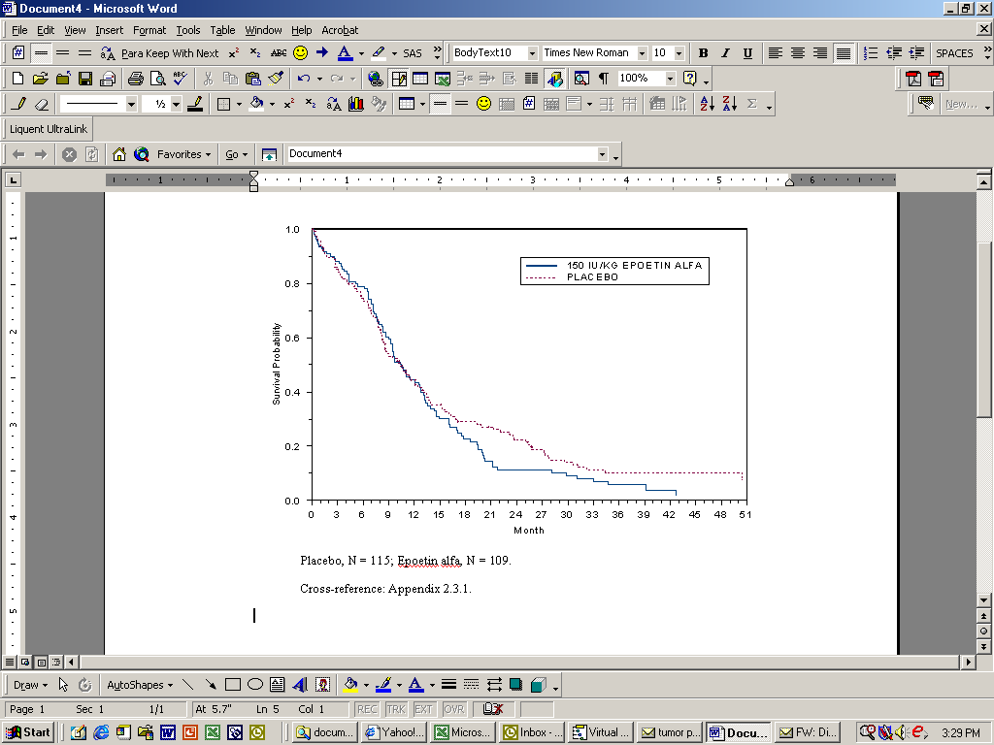
Placebo, N = 115; Epoetin alfa, N = 109.
Reference: N93-004 CSR¹²

The results of the study indicated that the response rate in epoetin alfa-treated subjects was not inferior to that in the control group. Median survival time and overall survival were similar in the two treatment groups.
In summary, this study was conducted in predominantly non-anemic cancer patients and was designed to assess tumor response with survival as a secondary endpoint. In both arms of Study N93-004, tumor response and survival through Month 12 appeared similar. Beyond Month 12, there was divergence in the survival curves favoring the placebo group, though the data are sparse and complete follow-up information is not available.
The results of Study N93-004 do not suggest any substantive effect of epoetin alfa on tumor treatment response or disease progression in SCLC and the 95% confidence intervals exclude an impairment of response rate of 6% or higher.

Other Relevant Information from Clinical Trials

Overall Incidence of TVEs in Prior Epoetin Alfa Studies
The Sponsor has also examined data from double-blind, randomized controlled trials that may aid in the evaluation of the possible role of TVEs in recent ERA study outcomes.
As noted previously in this document, TVEs have been observed in association with use of all ERAs, and TVEs may account at least in part for survival imbalances reported in investigational studies of ERAs.
The list of general TVEs is the Sponsor’s broadest approach for identifying TVEs, and includes all superficial TVEs, all catheter related TVEs and events that could, but not necessarily would, be caused by an underlying thrombovascular event, and where no information was available to prove the contrary. General TVEs are also subclassified as clinically relevant, a definition that is more focused but still is broader than the generally accepted clinically important TVEs (e.g., DVT, PE, stroke/TIA, and MI).
The incidences of general TVEs based on the 12 completed double-blind, placebo-controlled, oncology studies (Studies EPO-INT-76, N93-004 and the 10 clinical studies that focused on correction of anemia in cancer patients) were 4% to 24% in placebo-treated patients and 3% to 22% for epoetin alfa-treated patients. Fifty percent of the general TVEs were assessed as being clinically relevant. The incidences of clinically relevant TVEs ranged from 0% to 12.3% for placebo-treated patients and 0% to 11% in epoetin alfa-treated patients. See Figure 9 for the odds ratios of the clinically relevant TVEs.
Figure 9: Incidence of Clinically Relevant Thrombotic Vascular Events Odds Ratios and 95% Confidence Intervals (All 12 Double-Blind, Placebo-Controlled, Completed Oncology Studies: Safety Population)
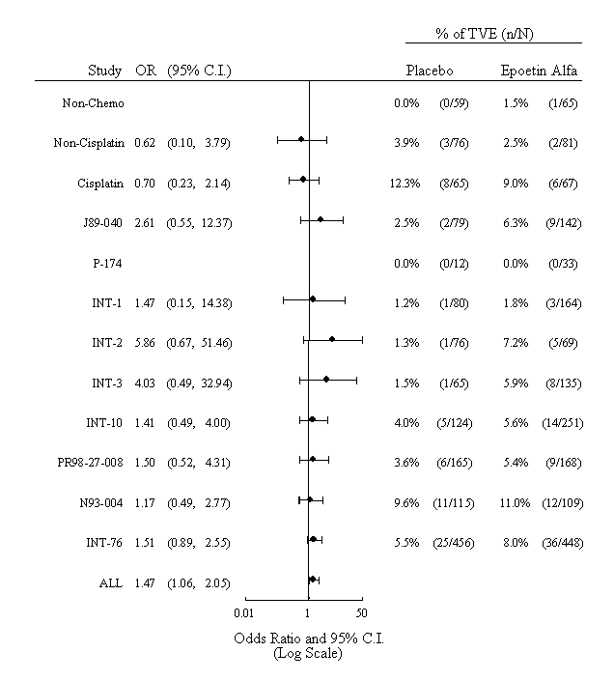
Key: TVE=thrombotic vascular event; OR=odds ratio; C.I.=confidence interval
Note: Odds ratios were calculated using the Cochran-Mantel-Haenszel method stratified by study for all pooled analyses.

Recently Discontinued Studies With Imbalances in Thrombotic Vascular Events and/or Survival
Data are presented for 5 discontinued studies in which imbalances in the occurrence of TVEs and/or survival were noted: PR00-03-006, PR01-04-005/GOG-0191, EPO-CAN-15, PR99-03-046/RTOG 99-03, and EPO-CAN-20. Data collection and analyses are ongoing for these recently discontinued studies, and the information provided here is preliminary. It should be noted that the recent study discontinuations started with an observation of an imbalance in TVEs in one study, PR00-03-006 (see below). This observation, plus the information emerging from EPO-INT-76 and Henke studies, led the Company to request evaluations of clinical safety findings across its full program of ongoing oncology epoetin alfa studies. While most of the Company’s epoetin alfa oncology studies are continuing, four additional studies were stopped for TVE and/or survival imbalances that were identified in this review.
Study PR00-03-006
This was a double-blind, placebo-controlled, multicenter study in patients with gastric or rectal cancer receiving a fluoropyrimidine concurrent with radiation. Planned recruitment was 184 patients. Patients were randomized 1:1 to receive epoetin alfa 40,000 IU s.c. once weekly or placebo. Patients had hemoglobin levels of ≥10 to <15 g/dL at entry, and were treated with PROCRIT epoetin alfa at 40,000 IU/week, with dose adjustments depending on response. If hemoglobin was ≤13 g/dL after 4 weeks, the epoetin alfa dose was increased to 60,000 IU/week; if hemoglobin exceeded 15 g/dL, treatment was interrupted and restarted at a lower dose when hemoglobin was ≤14 g/dL.
Data were available for 59 patients at the time the study was analyzed. Eight patients experienced at least one TVE, 6% (2/31) of placebo patients and 21% (6/28) of epoetin alfa patients. Seven of 8 TVEs were deep vein thromboses and were assessed by the investigator as serious. The eighth TVE was chest pain and was assessed as not serious. TVEs occurred in 11% (6/53) of patients with rectal cancer and 33% (2/6) of patients with gastric cancer.
Twenty percent (7/35) of patients with a baseline hemoglobin> 13 g/dL experienced at least one TVE, compared with 4% (1/24) of patients with a baseline hemoglobin ≤ 13 g/dL. Patients commonly had a hemoglobin level >13 g/dL within the 28 days before the TVE; but such levels were also common in patients who did not have TVEs. No patient had a hemoglobin increase of more than 2 g/dL in the 4-week period before their TVE.
Study PR01-04-005/GOG-0191
This was an open-label, randomized, multicenter, investigator-sponsored study in patients with cervical cancer receiving concurrent radiation and cisplatin. The study was intended to determine whether epoetin alfa treatment to maintain higher hemoglobin levels could prolong progression-free survival. Planned recruitment was 460 patients. Patients were randomized 1:1 to receive epoetin alfa 40,000 IU s.c. once weekly or standard of care. Patients had <14 g/dL at entry. Epoetin alfa dose was increased to 60,000 IU/week if hemoglobin could not be maintained >12 g/dL. Dosing was interrupted if hemoglobin exceeded 14 g/dL for 2 weeks or more, then restarted at the same dose when hemoglobin fell to <13 g/dL.
Data were available for 79 patients at the time the study was analyzed. Fifteen patients experienced at least one TVE, 5 (9%) of the 55 Cis+Rt patients and 10 (17%) of the 58 Cis+Rt+Epo patients. TVEs were classified as venous in 10 patients, arterial in 3 patients and unclassifiable in 2 patients. There was no apparent association between level of hemoglobin at baseline or on treatment and the occurrence of a TVE.
Four Cis+Rt+Epo patients had a hemoglobin increase of more than 2 g/dL in the 4-week period prior to the TVE. These hemoglobin increases could be explained by pRBC transfusions for 3 of the 4 patients.
Study EPO-CAN-15
This was a double-blind, randomized, placebo-controlled, multicenter study in which patients with limited disease SCLC received combined modality chemoradiation therapy. The study was intended to determine whether epoetin alfa treatment to maintain higher hemoglobin levels could prolong progression-free survival. Planned recruitment was 620 patients. Patients were randomized 1:1 to epoetin alfa 40,000 IU s.c. once weekly or placebo. Initially, the protocol was designed to maintain hemoglobin levels in the range of 14-16 g/dL. An amendment in October 2002 reduced this targeted hemoglobin range to 13-14 g/dL.
Data were available for 106 patients at the time the study was analyzed. Overall, there were 22 TVEs reported: 19 TVEs were reported in the epoetin alfa arm and 3 TVEs were reported in the placebo group. Of the TVEs in the epoetin alfa group, 2 of the events occurred prior to study drug treatment and 1 event was determined to not be significant from a clinical perspective. As such, subsequent analyses only consider the 16 clinically relevant TVEs in this group. In the placebo group, 1 of the events occurred prior to study drug treatment, and as such, the analyses for this group only consider 2 clinically significant TVEs.
Interestingly, the majority of TVEs in the epoetin alfa arm (14 of 16) occurred in patients randomized to the higher target range hemoglobin protocol (the pre-amendment protocol). An imbalance in mortality was also observed in this study, with several deaths associated with TVEs. Among the 16 patients experiencing TVEs in the epoetin alfa arm, there were 4 deaths.
Study PR99-03-046/RTOG 99-03
This was an open-label, investigator-sponsored cooperative group study in which patients with head and neck cancer were randomly assigned 1:1 to PROCRIT 40,000 IU s.c. once weekly plus radiotherapy or radiotherapy alone. Planned enrollment was 372 patients. The study was intended to determine whether treatment with epoetin alfa to maintain relatively high hemoglobin levels (up to 14 g/dL in women, up to 16 g/dL in men) would enhance the effectiveness of radiation therapy. When the study safety data (for the initial 148 patients enrolled) were analyzed, non-significant imbalances were noted in both locoregional disease control and survival, with the observed imbalances favoring the placebo group. These findings, together with the findings of the Henke et al. which had just been published, prompted closure of the study.
Study EPO-CAN-20
This was a double-blind, randomized, placebo-controlled, multicenter study in which patients with non-small cell lung cancer were treated with EPREX epoetin alfa, with the goal of evaluating quality of life effects. Planned enrollment was 300 patients. An analysis of safety findings among the 66 patients randomized to date (62 with data available) revealed poor survival in both the epoetin alfa and control groups. There had been 25 deaths in the epoetin alfa group, and 20 deaths in the control group, and it was noted that median survival was shorter in the epoetin alfa group (2 months versus 4 months). The study has been closed, and further analyses are in progress.

Conclusion
The results of the EPO-INT-76 and Henke et al. studies raised concerns regarding the possibility of adverse outcomes in cancer patients, including the possibility of shortened survival or enhanced disease progression. Other pre-clinical and clinical study data have provided little support for an adverse effect on tumor growth or lesion progression. Alternative explanations for the survival observations of the EPO-INT-76 and Henke studies must also be considered. In this regard, while ERAs generally have a limited spectrum of adverse effects, TVEs are described in labeling for all ERAs, and are potentially more likely to occur when ERA use is extended beyond the treatment of anemia. Considering the results of the EPO-INT-76 and Henke studies, together with other recently suspended studies, ERAs may be associated with reduced survival when they are used beyond the correction of anemia in cancer patients, and an increased risk of TVE may contribute substantially to the survival effect. However, other data provide strong support for the safety of PROCRIT when used in the labelled indication, treatment of anemia in cancer patients on chemotherapy.

BENEFIT AND RISK ASSESSMENT OF ERAs IN PATIENTS WITH CANCER
ERAs provide significant benefits to anemic patients with cancer receiving chemotherapy. Millions of patients have been treated with these products, to ameliorate the symptoms of anemia and to reduce transfusion requirements. This class of medications provides the only alternative to blood transfusions, which carry their own inherent risks, and are a limited resource.
Beyond the proven benefits in reduction of transfusion requirements, two studies, EPO-INT-10⁷ and a study by Vansteenkiste et al.⁸, demonstrated a non-significant trend to improved survival associated with ERA treatment of patients with cancer. Of note, these studies were not designed to detect a positive impact on survival and patients were treated to correct anemia with the primary end-points being Quality Of Life and reduction of transfusion requirements.
Recent trials testing potential survival benefits with ERA investigational uses beyond the correction of anemia have reported inferior survival and excesses of TVEs associated with these uses.
These reported outcomes have resulted in an evaluation of the Benefit-Risk assessment of ERAs in patients with cancer. The intent of this assessment is to better understand the appropriate investigational uses of these products, and to confirm the ongoing positive Benefit-Risk profile of marketed products when used for their approved indication.
The known presence of erythropoietin receptors on cell lines other than erythroid precursor cells, including tumor cells, directed one component of the assessment to the evaluation of whether ERAs might have tumor proliferative effects. In order to assess this, all available clinical data were reviewed, using tumor progression/tumor response as a surrogate for this effect.
In addition, the observed excess of TVEs with this new investigational use, and imbalance in fatal TVEs observed in EPO-INT-76, directed another focus of the evaluation to determine what contribution, if any, these may have had to the observed survival differences in these studies.
In order to ensure the safety and well-being of patients, the Sponsor’s initial Risk Mitigation Plan included:
- A review of our supported, ongoing and planned, oncology studies to ensure safety of participants.
- Arrangements to ensure independent safety monitoring in clinical studies.
The data from the Sponsor’s analyses of the survival risk, and risks of tumor progression and TVE’s are summarized below with a benefit-risk assessment.
Survival
Among the many drugs used in the palliative treatment of cancer patients, epoetin alfa is one of the most extensively studied. Analyses of survival in the Sponsor’s randomized controlled trials of epoetin alfa in anemic patients on cancer chemotherapy have not revealed evidence of significant imbalances. This is supported further by the two completed studies, EPO-INT-10⁷ (included in the combined analysis) and a study by Vansteenkiste et al.⁸ using darbepoetin alfa, suggesting a modest positive impact on mortality although they were not powered to detect this. These findings are also supported by the outcomes of the still continuing AGO/NOGGO study¹⁰ in cervical cancer supported by the Sponsor. These data, although from a large number of studies, do not exclude the possibility of any adverse effect on survival conferred by epoetin alfa.
The Sponsor’s data suggest that the survival signal from a small number of studies are associated with investigational uses of ERAs in patients with cancer, in studies with protocol-defined treatment beyond the correction of anemia. These findings are not seen in studies of the use of epoetin alfa for the correction of chemotherapy-induced anemia as labeled, where there is a large volume of data supporting the safety and efficacy of ERAs.
Tumor Progression/Tumor Response
The Sponsor’s analysis of the available data supports the conclusion that therapy with ERAs did not affect the response to antineoplastic therapy or lead to tumor progression via increased tumor cell proliferation, angiogenesis, or anti-apoptosis.
Most importantly, data from 7 randomized studies in patients with cancer, including 5 studies involving correction of anemia and 2 studies of ERA beyond the correction of anemia, do not support that epoetin alfa lowers tumor response rates or increases tumor progression. In the one study (N93-004) specifically designed to address this issue, and in which response to antineoplastic therapy was the primary end point, epoetin alfa did not impair the response to chemotherapy. Indeed, a substantial adverse effect could be statistically excluded.
Additional evidence for this conclusion comes from EPO-INT-76. This study, as described previously, showed a decreased 12-month overall survival in subjects with metastatic breast cancer who were treated with new investigational use of epoetin alfa to maintain hemoglobin concentrations in the range of 12 to 14 g/dL for 1 year. While most of the deaths in this study were clinically attributed to disease progression, a blinded analysis of tumor response and disease progression did not support the hypothesis that these deaths were due to effects of epoetin alfa on tumor progression or tumor response. Although baseline and regular, on-study tumor measurements were not performed for all patients, substantial information regarding both response rates and disease progression was available for many, and are the basis for the following key findings:
- while there were limitations in the data, tumor response to chemotherapy appeared to be similar in the 2 treatment groups, suggesting that epoetin alfa did not interfere with the efficacy of chemotherapy;
- time to disease progression was also similar in both groups, suggesting that effects on tumor response and disease progression did not account for much of the observed differences in survival associated with epoetin alfa use in the study; and
- analyses of causes of death in the study, including a blinded chart review, suggested that undiagnosed TVEs may have accounted for more of the difference between deaths on epoetin alfa and deaths on placebo than was originally appreciated.
The questions raised by the study of Henke et al. cannot be addressed further by the Sponsor at this time, as we have not had access to the data.
A review of the body of preclinical literature does not suggest an adverse impact of ERA therapy on tumors or cancer cells. Although there are reported studies suggesting proliferative or other potentially adverse effects of ERAs on tumor cells, these effects were observed at concentrations substantially exceeding those achieved with epoetin alfa therapy in the in-vivo clinical setting. One should also note that the preclinical in-vitro models do not accurately replicate the complex physiological milieu of the human tumors with respect to complex interactions between hypoxia and receptor-cytokine response regulation. This review of the relevant preclinical data is summarized in Attachment 5.
Although there is strong evidence preclinically and clinically to the contrary, the possibility that epoetin alfa can act as a growth factor for any tumor type, particularly myeloid malignancies, cannot be totally excluded. This potential effect is acknowledged and adequately described in the current labeling. The current benefit/risk of ERA use within labeled indications is unchanged.
Thrombotic Vascular Events
The association of TVEs with ERAs is described in the approved labeling for products in this class of medications. In other populations (e.g., renal), the frequency of TVEs associated with ERA therapy increases with rising hemoglobin levels.
Our analysis of TVEs from combined data of 12 studies (3,104 patients) suggests ERA treatment of anemic cancer patients is associated with some elevation in TVE frequency, consistent with that described in current product labeling.
As noted above, in Study EPO-INT-76, in which patients were treated beyond the correction of anemia, recognized and documented TVEs accounted for a significant share of the excess mortality observed in the epoetin alfa arm. More importantly, a blinded case review of mortality data from this trial supports that undiagnosed fatal TVE may have accounted for some of the deaths in patients who were reported to have died from disease progression. Finally, no objective evidence of impaired tumor response or accelerated tumor progression could be found in this study to account for the survival imbalance. Given the frequent uncertainty regarding proximate causes of death in cancer patients, it is important to consider the possibility that unrecognized fatal TVEs may have accounted, to a substantial degree, for the excess of deaths on the epoetin alfa arm.
As part of our risk mitigation strategy the Sponsor reviewed the ongoing trials of ERAs in cancer patients, and discontinued 3 studies for reportedly high TVE rates in the epoetin alfa group. These studies involved the use of epoetin alfa beyond the correction of anemia, in patients receiving chemotherapy and radiation therapy.
In summary, the Benefit-Risk assessment for ERAs, used to correct anemia in patients with cancer remains favorable when used for the approved indication. The risk profile of ERAs in clinical trials also remains favorable when these drugs are used to correct anemia. The association of TVEs with this class of medications is recognized and is included in labeling and reference safety information for clinical trials.

CONCLUSION
In some investigational studies, ERA treatment of patients beyond the correction of anemia has resulted in decreased survival or increased side effects. These specific investigational designs should be avoided in future development programs.
The available data support the conclusion that, when used for approved indications and within established guidelines for baseline and target hemoglobin concentrations, the benefits of ERA therapy continue to be supported by a well-defined and acceptable risk profile.
.

REFERENCES

- Leyland-Jones B. Breast cancer trial with erythropoietin terminated unexpectedly. Lancet 2003; 4:459-460.
- Henke M, Laszig R, Rube C, Schafer U, et al. Erythropoietin to treat head and neck cancer patients with anemia undergoing radiotherapy: Randomized, double-blind, placebo-controlled trial. Lancet 2003;362:1255-1260.
- Bohlius J. et al. Does Erythropoietin Improve Overall Survival in the Treatment of Patients with Malignant Diseases? Results of a Comprehensive Meta-Analysis. Session Type: Oral Session, 2003; Blood 102(11), abstract 709.
- Glaser C, Millesi W, Wanschitz F, et al. r-HuErythropoietin treatment increases efficacy of neoadjuvant radiochemotherapy and improves cancer free survival of patients with oral squamous cell carcinoma: a 17-month follow-up. J Clin Oncol 1999;18:399a.
- Strauss HG, Haensgen G, Becker A, et al. Prognostic impact of changes in the tumor tissue pO₂ during early radiotherapy in cervical cancers: Improved local control in primarily hypoxic tumors with “reoxygenation” and the impact of hemoglobin. Int J Radiat Oncol Biol Phys 1999; 45(Suppl):364.
- Thomas GM. Raising hemoglobin: An opportunity for increasing survival? Oncology 2002;63 (Suppl. 2):19-28.
- Littlewood TJ, Bajetta E, Nortier JW, et al. Effects of epoetin alfa on hematologic parameters and quality of life in cancer patients receiving nonplatinum chemotherapy: results of a randomized, double-blind, placebo-controlled trial. J Clin Oncol 2001;19:2865-2874.
- Vansteenkiste J, Pirker R, Massuti B, et al. Double blind placebo controlled randomized phase III trial of darbepoetin alfa in lung cancer patients receiving chemotherapy. J Natl Cancer Inst 2002;94:1211-1220.
- Vercammen E, Xiu L, Hendler J. A double-blind, randomized, placebo-controlled study to evaluate the impact of maintaining hemoglobin using EPREX® (Epoetin Alfa; RWJPRI-22512) in metastatic breast carcinoma patients receiving chemotherapy (Protocol PRI/EPO-INT-76/EPO-CA-489). Document ID No. EDMS-USRA-8230809:2.0 (16 April 2003).
- Blohmer J. et al. Impact of Epoetin Alfa on Disease-free Survival in High-risk Cervical Cancer Patients Receiving Sequential Adjuvant Chemotherapy. Abstract presented at ECCO Sept 2003
- Open-label randomized comparative group evaluation of the effect of epoetin alfa on local disease-free survival and quality of life in head and neck cancer patients receiving radical radiotherapy (Protocol EPO-GBR-7)(data on file).
- Vercammen E, Sullivan D, Matone P. The Effect of r-HuEPO in Patients with Small Cell Lung Cancer (SCLC): A Randomized, Double-Blind, Placebo-Controlled Trial. (Protocol N93-004; Phase 4). Document ID No. EDMS-USRA-8057829:4.0 (26 September 2002).
.

APPENDIX
Attachment 1: Package Insert
PROCRIT®
(Epoetin alfa)
FOR INJECTION

DESCRIPTION
Erythropoietin is a glycoprotein which stimulates red blood cell production. It is produced in the kidney and stimulates the division and differentiation of committed erythroid progenitors in the bone marrow. PROCRIT® (Epoetin alfa), a 165 amino acid glycoprotein manufactured by recombinant DNA technology, has the same biological effects as endogenous erythropoietin.¹ It has a molecular weight of 30,400 daltons and is produced by mammalian cells into which the human erythropoietin gene has been introduced. The product contains the identical amino acid sequence of isolated natural erythropoietin.

PROCRIT® is formulated as a sterile, colorless liquid in an isotonic sodium chloride/sodium citrate buffered solution or a sodium chloride/sodium phosphate buffered solution for intravenous (IV) or subcutaneous (SC) administration.

Single-dose, Preservative-free Vial: Each 1 mL of solution contains 2000, 3000, 4000 or 10,000 Units of Epoetin alfa, 2.5 mg Albumin (Human), 5.8 mg sodium citrate, 5.8 mg sodium chloride, and 0.06 mg citric acid in Water for Injection, USP (pH 6.9 ± 0.3). This formulation contains no preservative.

Single-dose, Preservative-free Vial: 1 mL (40,000 Units/mL). Each 1 mL of solution contains 40,000 Units of Epoetin alfa, 2.5 mg Albumin (Human), 1.2 mg sodium phosphate monobasic monohydrate, 1.8 mg sodium phosphate dibasic anhydrate, 0.7 mg sodium citrate, 5.8 mg sodium chloride, and 6.8 mcg citric acid in Water for Injection, USP (pH 6.9 ± 0.3). This formulation contains no preservative.

Multidose, Preserved Vial: 2 mL (20,000 Units, 10,000 Units/mL). Each 1 mL of solution contains 10,000 Units of Epoetin alfa, 2.5 mg Albumin (Human), 1.3 mg sodium citrate, 8.2 mg sodium chloride, 0.11 mg citric acid, and 1% benzyl alcohol as preservative in Water for Injection, USP (pH 6.1 ± 0.3).

Multidose, Preserved Vial: 1 mL (20,000 Units/mL). Each 1 mL of solution contains 20,000 Units of Epoetin alfa, 2.5 mg Albumin (Human), 1.3 mg sodium citrate, 8.2 mg sodium chloride, 0.11 mg citric acid, and 1% benzyl alcohol as preservative in Water for Injection, USP (pH 6.1 ± 0.3).

CLINICAL PHARMACOLOGY
Chronic Renal Failure Patients
Endogenous production of erythropoietin is normally regulated by the level of tissue oxygenation. Hypoxia and anemia generally increase the production of erythropoietin, which in turn stimulates erythropoiesis.² In normal subjects, plasma erythropoietin levels range from 0.01 to 0.03 Units/mL and increase up to 100- to 1000-fold during hypoxia or anemia.² In contrast, in patients with chronic renal failure (CRF), production of erythropoietin is impaired, and this erythropoietin deficiency is the primary cause of their anemia.^{3,4}
Chronic renal failure is the clinical situation in which there is a progressive and usually irreversible decline in kidney function. Such patients may manifest the sequelae of renal dysfunction, including anemia, but do not necessarily require regular dialysis. Patients with end-stage renal disease (ESRD) are those patients with CRF who require regular dialysis or kidney transplantation for survival.

PROCRIT® has been shown to stimulate erythropoiesis in anemic patients with CRF, including both patients on dialysis and those who do not require regular dialysis. ⁴⁻¹³ The first evidence of a response to the three times weekly (TIW) administration of PROCRIT® is an increase in the reticulocyte count within 10 days, followed by increases in the red cell count, hemoglobin, and hematocrit, usually within 2 to 6 weeks.^{4,5} Because of the length of time required for erythropoiesis – several days for erythroid progenitors to mature and be released into the circulation – a clinically significant increase in hematocrit is usually not observed in less than 2 weeks and may require up to 6 weeks in some patients. Once the hematocrit reaches the suggested target range (30% to 36%), that level can be sustained by PROCRIT® therapy in the absence of iron deficiency and concurrent illnesses.

The rate of hematocrit increase varies between patients and is dependent upon the dose of PROCRIT®, within a therapeutic range of approximately 50 to 300 Units/kg TIW.⁴ A greater biologic response is not observed at doses exceeding 300 Units/kg TIW.⁶ Other factors affecting the rate and extent of response include availability of iron stores, the baseline hematocrit, and the presence of concurrent medical problems.

Zidovudine-treated HIV-infected Patients
Responsiveness to PROCRIT® in HIV-infected patients is dependent upon the endogenous serum erythropoietin level prior to treatment. Patients with endogenous serum erythropoietin levels ≤ 500 mUnits/mL, and who are receiving a dose of zidovudine ≤ 4200 mg/week, may respond to PROCRIT® therapy. Patients with endogenous serum erythropoietin levels > 500 mUnits/mL do not appear to respond to PROCRIT® therapy. In a series of four clinical trials involving 255 patients, 60% to 80% of HIV-infected patients treated with zidovudine had endogenous serum erythropoietin levels ≤ 500 mUnits/mL.

Response to PROCRIT® in zidovudine-treated HIV-infected patients is manifested by reduced transfusion requirements and increased hematocrit.

Cancer Patients on Chemotherapy
Anemia in cancer patients may be related to the disease itself or the effect of concomitantly administered chemotherapeutic agents. PROCRIT® has been shown to increase hematocrit and decrease transfusion requirements after the first month of therapy (months 2 and 3), in anemic cancer patients undergoing chemotherapy.

A series of clinical trials enrolled 131 anemic cancer patients who were receiving cyclic cisplatin- or non cisplatin-containing chemotherapy. Endogenous baseline serum erythropoietin levels varied among patients in these trials with approximately 75% (n = 83/110) having endogenous serum erythropoietin levels ≤ 132 mUnits/mL, and approximately 4% (n = 4/110) of patients having endogenous serum erythropoietin levels > 500 mUnits/mL. In general, patients with lower baseline serum erythropoietin levels responded more vigorously to PROCRIT® than patients with higher baseline erythropoietin levels. Although no specific serum erythropoietin level can be stipulated above which patients would be unlikely to respond to PROCRIT® therapy, treatment of patients with grossly elevated serum erythropoietin levels (eg, > 200 mUnits/mL) is not recommended.

Pharmacokinetics
Intravenously administered PROCRIT® is eliminated at a rate consistent with first order kinetics with a circulating half-life ranging from approximately 4 to 13 hours in adult and pediatric patients with CRF.¹⁴⁻¹⁶ Within the therapeutic dose range, detectable levels of plasma erythropoietin are maintained for at least 24 hours. After SC administration of PROCRIT® to patients with CRF, peak serum levels are achieved within 5 to 24 hours after administration and decline slowly thereafter. There is no apparent difference in half-life between adult patients not on dialysis whose serum creatinine levels were greater than 3, and adult patients maintained on dialysis.

In normal volunteers, the half-life of IV administered PROCRIT® is approximately 20% shorter than the half-life in CRF patients. The pharmacokinetics of PROCRIT® have not been studied in HIV-infected patients.

The pharmacokinetic profile of PROCRIT® in children and adolescents appears to be similar to that of adults. Limited data are available in neonates.¹⁷

It has been demonstrated in normal volunteers that the 10,000 Units/mL citrate-buffered Epoetin alfa formulation and the 40,000 Units/mL phosphate-buffered Epoetin alfa formulation are bioequivalent after SC administration of single 750 Units/kg doses. The C_{max} and t_{1/2} after administration of the phosphate buffered Epoetin alfa formulation were 1.8 ± 0.7 Units/mL and 19.0 ± 5.9 hours (mean ± SD), respectively. The corresponding mean ± SD values for the citrate-buffered Epoetin alfa formulation were 2 ± 0.9 Units/mL and 16.3 ± 3.0 hours. There was no notable accumulation in serum after two weekly 750 Units/kg SC doses of Epoetin alfa.

INDICATIONS AND USAGE
Treatment of Anemia of Chronic Renal Failure Patients
PROCRIT® is indicated for the treatment of anemia associated with CRF, including patients on dialysis (ESRD) and patients not on dialysis. PROCRIT® is indicated to elevate or maintain the red blood cell level (as manifested by the hematocrit or hemoglobin determinations) and to decrease the need for transfusions in these patients.

Non-dialysis patients with symptomatic anemia considered for therapy should have a hematocrit less than 30%.

PROCRIT® is not intended for patients who require immediate correction of severe anemia. PROCRIT® may obviate the need for maintenance transfusions but is not a substitute for emergency transfusion.
Prior to initiation of therapy, the patient’s iron stores should be evaluated. Transferrin saturation should be at least 20% and ferritin at least 100 ng/mL. Blood pressure should be adequately controlled prior to initiation of PROCRIT® therapy, and must be closely monitored and controlled during therapy.

PROCRIT® should be administered under the guidance of a qualified physician (see DOSAGE AND ADMINISTRATION).

Treatment of Anemia in Zidovudine-treated HIV-infected Patients
PROCRIT® is indicated for the treatment of anemia related to therapy with zidovudine in HIV-infected patients. PROCRIT® is indicated to elevate or maintain the red blood cell level (as manifested by the hematocrit or hemoglobin determinations) and to decrease the need for transfusions in these patients. PROCRIT® is not indicated for the treatment of anemia in HIV-infected patients due to other factors such as iron or folate deficiencies, hemolysis, or gastrointestinal bleeding, which should be managed appropriately.

PROCRIT®, at a dose of 100 Units/kg TIW, is effective in decreasing the transfusion requirement and increasing the red blood cell level of anemic, HIV-infected patients treated with zidovudine, when the endogenous serum erythropoietin level is ≤ 500 mUnits/mL and when patients are receiving a dose of zidovudine ≤ 4200 mg/week.

Treatment of Anemia in Cancer Patients on Chemotherapy
PROCRIT® is indicated for the treatment of anemia in patients with non-myeloid malignancies where anemia is due to the effect of concomitantly administered chemotherapy. PROCRIT® is indicated to decrease the need for transfusions in patients who will be receiving concomitant chemotherapy for a minimum of 2 months. PROCRIT® is not indicated for the treatment of anemia in cancer patients due to other factors such as iron or folate deficiencies, hemolysis, or gastrointestinal bleeding, which should be managed appropriately.

Reduction of Allogeneic Blood Transfusion in Surgery Patients
PROCRIT® is indicated for the treatment of anemic patients (hemoglobin > 10 to ≤ 13 g/dL) scheduled to undergo elective, noncardiac, nonvascular surgery to reduce the need for allogeneic blood transfusions.¹⁸⁻²⁰ PROCRIT® is indicated for patients at high risk for perioperative transfusions with significant, anticipated blood loss. PROCRIT® is not indicated for anemic patients who are willing to donate autologous blood. The safety of the perioperative use of PROCRIT® has been studied only in patients who are receiving anticoagulant prophylaxis.
CLINICAL EXPERIENCE: RESPONSE TO PROCRIT®
Chronic Renal Failure Patients
Response to PROCRIT® was consistent across all studies. In the presence of adequate iron stores (see IRON EVALUATION), the time to reach the target hematocrit is a function of the baseline hematocrit and the rate of hematocrit rise.

The rate of increase in hematocrit is dependent upon the dose of PROCRIT® administered and individual patient variation. In clinical trials at starting doses of 50 to 150 Units/kg TIW, adult patients responded with an average rate of hematocrit rise of:

Starting Dose | Hematocrit Increase
(TIW IV) | Points/Day | Points/2 Weeks
50 Units/kg | 0.11 | 1.5
100 Units/kg | 0.18 | 2.5
150 Units/kg | 0.25 | 3.5

Over this dose range, approximately 95% of all patients responded with a clinically significant increase in hematocrit, and by the end of approximately 2 months of therapy virtually all patients were transfusion-independent. Changes in the quality of life of adult patients treated with PROCRIT® were assessed as part of a phase 3 clinical trial.^{5,8} Once the target hematocrit (32% to 38%) was achieved, statistically significant improvements were demonstrated for most quality of life parameters measured, including energy and activity level, functional ability, sleep and eating behavior, health status, satisfaction with health, sex life, well-being, psychological effect, life satisfaction, and happiness. Patients also reported improvement in their disease symptoms. They showed a statistically significant increase in exercise capacity (VO₂ max), energy, and strength with a significant reduction in aching, dizziness, anxiety, shortness of breath, muscle weakness, and leg cramps.^{8,21}

Adult Patients on Dialysis: Thirteen clinical studies were conducted, involving IV administration to a total of 1010 anemic patients on dialysis for 986 patient-years of PROCRIT® therapy. In the three largest of these clinical trials, the median maintenance dose necessary to maintain the hematocrit between 30% to 36% was approximately 75 Units/kg TIW. In the US multicenter phase 3 study, approximately 65% of the patients required doses of 100 Units/kg TIW, or less, to maintain their hematocrit at approximately 35%. Almost 10% of patients required a dose of 25 Units/kg, or less, and approximately 10% required a dose of more than 200 Units/kg TIW to maintain their hematocrit at this level.

A multicenter unit dose study was also conducted in 119 patients receiving peritoneal dialysis who self-administered PROCRIT® subcutaneously for approximately 109 patient-years of experience. Patients responded to PROCRIT® administered SC in a manner similar to patients receiving IV administration.²²

Pediatric Patients on Dialysis: One hundred twenty-eight children from 2 months to 19 years of age with CRF requiring dialysis were enrolled in 4 clinical studies of PROCRIT®. The largest study was a placebo-controlled, randomized trial in 113 children with anemia (hematocrit ≤ 27%) undergoing peritoneal dialysis or hemodialysis. The initial dose of PROCRIT® was 50 Units/kg IV or SC TIW. The dose of study drug was titrated to achieve either a hematocrit of 30% to 36% or an absolute increase in hematocrit of 6 percentage points over baseline.

At the end of the initial 12 weeks, a statistically significant rise in mean hematocrit (9.4% vs 0.9%) was observed only in the PROCRIT® arm. The proportion of children achieving a hematocrit of 30%, or an increase in hematocrit of 6 percentage points over baseline, at any time during the first 12 weeks was higher in the PROCRIT® arm (96% vs 58%). Within 12 weeks of initiating PROCRIT® therapy, 92.3% of the pediatric patients were transfusion-independent as compared to 65.4% who received placebo. Among patients who received 36 weeks of PROCRIT®, hemodialysis patients required a higher median maintenance dose (167 Units/kg/week [n = 28] vs 76 Units/kg/week [n = 36]) and took longer to achieve a hematocrit of 30% to 36% (median time to response 69 days vs 32 days) than patients undergoing peritoneal dialysis.

Patients With CRF Not Requiring Dialysis
Four clinical trials were conducted in patients with CRF not on dialysis involving 181 patients treated with PROCRIT® for approximately 67 patient-years of experience. These patients responded to PROCRIT® therapy in a manner similar to that observed in patients on dialysis. Patients with CRF not on dialysis demonstrated a dose-dependent and sustained increase in hematocrit when PROCRIT® was administered by either an IV or SC route, with similar rates of rise of hematocrit when PROCRIT® was administered by either route. Moreover, PROCRIT® doses of 75 to 150 Units/kg per week have been shown to maintain hematocrits of 36% to 38% for up to 6 months. Correcting the anemia of progressive renal failure will allow patients to remain active even though their renal function continues to decrease.²³⁻²⁴

Zidovudine-treated HIV-infected Patients
PROCRIT® has been studied in four placebo-controlled trials enrolling 297 anemic (hematocrit < 30%) HIV-infected (AIDS) patients receiving concomitant therapy with zidovudine (all patients were treated with Epoetin alfa manufactured by Amgen Inc. [Amgen]). In the subgroup of patients (89/125 PROCRIT® and 88/130 placebo) with prestudy endogenous serum erythropoietin levels ≤ 500 mUnits/mL, PROCRIT® reduced the mean cumulative number of units of blood transfused per patient by approximately 40% as compared to the placebo group.²⁵ Among those patients who required transfusions at baseline, 43% of patients treated with PROCRIT® versus 18% of placebo-treated patients were transfusion-independent during the second and third months of therapy. PROCRIT® therapy also resulted in significant increases in hematocrit in comparison to placebo. When examining the results according to the weekly dose of zidovudine received during month 3 of therapy, there was a statistically significant (p < 0.003) reduction in transfusion requirements in patients treated with PROCRIT® (n = 51) compared to placebo treated patients (n = 54) whose mean weekly zidovudine dose was ≤ 4200 mg/week.²⁵

Approximately 17% of the patients with endogenous serum erythropoietin levels ≤ 500 mUnits/mL receiving PROCRIT® in doses from 100 to 200 Units/kg TIW achieved a hematocrit of 38% without administration of transfusions or significant reduction in zidovudine dose. In the subgroup of patients whose prestudy endogenous serum erythropoietin levels were > 500 mUnits/mL, PROCRIT® therapy did not reduce transfusion requirements or increase hematocrit, compared to the corresponding responses in placebo-treated patients.

In a 6 month open-label PROCRIT® study, patients responded with decreased transfusion requirements and sustained increases in hematocrit and hemoglobin with doses of PROCRIT® up to 300 Units/kg TIW.²⁵⁻²⁷

Responsiveness to PROCRIT® therapy may be blunted by intercurrent infectious/inflammatory episodes and by an increase in zidovudine dosage. Consequently, the dose of PROCRIT® must be titrated based on these factors to maintain the desired erythropoietic response.

Cancer Patients on Chemotherapy
PROCRIT® has been studied in a series of placebo-controlled, double-blind trials in a total of 131 anemic cancer patients. Within this group, 72 patients were treated with concomitant non cisplatin-containing chemotherapy regimens and 59 patients were treated with concomitant cisplatin-containing chemotherapy regimens. Patients were randomized to PROCRIT® 150 Units/kg or placebo subcutaneously TIW for 12 weeks.

PROCRIT® therapy was associated with a significantly (p < 0.008) greater hematocrit response than in the corresponding placebo-treated patients (see table).²⁵

Hematocrit (%): Mean Change From Baseline To Final Value *
Study | PROCRIT® | Placebo
Chemotherapy | 7.6 | 1.3
Cisplatin | 6.9 | 0.6
Significantly higher in PROCRIT® patients than in placebo patients
(p < 0.008)

In the two types of chemotherapy studies (utilizing a PROCRIT® dose of 150 Units/kg TIW), the mean number of units of blood transfused per patient after the first month of therapy was significantly (p < 0.02) lower in patients treated with PROCRIT® (0.71 units in months 2, 3) than in corresponding placebo-treated patients (1.84 units in months 2, 3). Moreover, the proportion of patients transfused during months 2 and 3 of therapy combined was significantly (p < 0.03) lower in the patients treated with PROCRIT® than in the corresponding placebo-treated patients (22% vs 43%).²⁵
Comparable intensity of chemotherapy in the PROCRIT® and placebo groups in the chemotherapy trials was suggested by a similar area under the neutrophil time curve in patients treated with PROCRIT® and placebo-treated patients as well as by a similar proportion of patients in groups treated with PROCRIT® and placebo-treated groups whose absolute neutrophil counts fell below 1000 cells/µL. Available evidence suggests that patients with lymphoid and solid cancers respond equivalently to PROCRIT® therapy, and that patients with or without tumor infiltration of the bone marrow respond equivalently to PROCRIT® therapy.

Surgery Patients
PROCRIT® has been studied in a placebo-controlled, double-blind trial enrolling 316 patients scheduled for major, elective orthopedic hip or knee surgery who were expected to require ≥ 2 units of blood and who were not able or willing to participate in an autologous blood donation program. Based on previous studies which demonstrated that pretreatment hemoglobin is a predictor of risk of receiving transfusion,^{20,28} patients were stratified into one of three groups based on their pretreatment hemoglobin [≤ 10 (n = 2), > 10 to ≤ 13 (n = 96), and > 13 to ≤ 15 g/dL (n = 218)] and then randomly assigned to receive 300 Units/kg PROCRIT®, 100 Units/kg PROCRIT® or placebo by SC injection for 10 days before surgery, on the day of surgery, and for 4 days after surgery.¹⁸ All patients received oral iron and a low-dose post-operative warfarin regimen.¹⁸

Treatment with PROCRIT® 300 Units/kg significantly (p = 0.024) reduced the risk of allogeneic transfusion in patients with a pretreatment hemoglobin of > 10 to ≤ 13 g/dL; 5/31 (16%) of PROCRIT® 300 Units/kg, 6/26 (23%) of PROCRIT® 100 Units/kg, and 13/29 (45%) of placebo-treated patients were transfused.¹⁸ There was no significant difference in the number of patients transfused between PROCRIT® (9% 300 Units/kg, 6% 100 Units/kg) and placebo (13%) in the > 13 to ≤ 15 g/dL hemoglobin stratum. There were too few patients in the ≤ 10 g/dL group to determine if PROCRIT® is useful in this hemoglobin strata. In the > 10 to ≤ 13 g/dL pretreatment stratum, the mean number of units transfused per PROCRIT®-treated patient (0.45 units blood for 300 Units/kg, 0.42 units blood for 100 Units/kg) was less than the mean transfused per placebo-treated patient (1.14 units) (overall p = 0.028). In addition, mean hemoglobin, hematocrit, and reticulocyte counts increased significantly during the presurgery period in patients treated with PROCRIT®.¹⁸

PROCRIT® was also studied in an open-label, parallel-group trial enrolling 145 subjects with a pretreatment hemoglobin level of ≥ 10 to ≤ 13 g/dL who were scheduled for major orthopedic hip or knee surgery and who were not participating in
an autologous program.¹⁹ Subjects were randomly assigned to receive one of two SC dosing regimens of PROCRIT® (600 Units/kg once weekly for 3 weeks prior to surgery and on the day of surgery or 300 Units/kg once daily for 10 days prior to surgery, on the day of surgery and for 4 days after surgery). All subjects received oral iron and appropriate pharmacologic anticoagulation therapy.

From pretreatment to presurgery, the mean increase in hemoglobin in 600 Units/kg weekly group (1.44 g/dL) was greater than observed in the 300 Units/kg daily group.¹⁹ The mean increase in absolute reticulocyte count was smaller in the weekly group (0.11 x 10⁶/mm³) compared to the daily group (0.17 x 10⁶/mm³). Mean hemoglobin levels were similar for the two treatment groups throughout the postsurgical period.

The erythropoietic response observed in both treatment groups resulted in similar transfusion rates [11/69 (16%) in the 600 Units/kg weekly group and 14/71 (20%) in the 300 Units/kg daily group].¹⁹ The mean number of units transfused per subject was approximately 0.3 units in both treatment groups.

CONTRAINDICATIONS
PROCRIT® is contraindicated in patients with:
1. Uncontrolled hypertension.
2. Known hypersensitivity to mammalian cell-derived products.
3. Known hypersensitivity to Albumin (Human).

WARNINGS
Pediatric Use
The multidose preserved formulation contains benzyl alcohol. Benzyl alcohol has been reported to be associated with an increased incidence of neurological and other complications in premature infants which are sometimes fatal.

Thrombotic Events and Increased Mortality
A randomized, prospective trial of 1265 hemodialysis patients with clinically evident cardiac disease (ischemic heart disease or congestive heart failure) was conducted in which patients were assigned to PROCRIT® treatment targeted to a maintenance hematocrit of either 42 ± 3% or 30 ± 3%.⁴² Increased mortality was observed in 634 patients randomized to a target hematocrit of 42% [221 deaths (35% mortality)] compared to 631 patients targeted to remain at a hematocrit of 30% [185 deaths (29% mortality)]. The reason for increased mortality observed in these studies is unknown, however, the incidence of non-fatal myocardial infarctions (3.1% vs 2.3%), vascular access thromboses (39% vs 29%), and all other thrombotic events (22% vs 18%) were also higher in the group randomized to achieve a hematocrit of 42%.

Increased mortality was also observed in a randomized placebo-controlled study of PROCRIT® in adult patients who did not have CRF who were undergoing coronary artery bypass surgery (7 deaths in 126 patients randomized to PROCRIT® versus no deaths among 56 patients receiving placebo). Four of these deaths occurred during the period of study drug administration and all four deaths were associated with thrombotic events. While the extent of the population affected is unknown, in patients at risk for thrombosis, the anticipated benefits of PROCRIT® treatment should be weighed against the potential for increased risks associated with therapy.
Pure Red Cell Aplasia
Pure red cell aplasia (PRCA), in association with neutralizing antibodies to native erythropoietin, has been observed in patients treated with recombinant erythropoietins. PRCA has been reported in a limited number of patients exposed to PROCRIT®. This has been reported predominantly in patients with CRF. Any patient with loss of response to PROCRIT® should be evaluated for the etiology of loss of effect (see PRECAUTIONS: LACK OR LOSS OF RESPONSE). PROCRIT® should be discontinued in any patient with evidence of PRCA and the patient evaluated for the presence of binding and neutralizing antibodies to PROCRIT®, native erythropoietin, and any other recombinant erythropoietin administered to the patient. Amgen/Ortho Biotech Products, L.P. should be contacted to assist in this evaluation. In patients with PRCA secondary to neutralizing antibodies to erythropoietin, PROCRIT® should not be administered and such patients should not be switched to another product as anti-erythropoietin antibodies cross-react with other erythropoietins (see ADVERSE REACTIONS).

Chronic Renal Failure Patients
Hypertension: Patients with uncontrolled hypertension should not be treated with PROCRIT®; blood pressure should be controlled adequately before initiation of therapy. Up to 80% of patients with CRF have a history of hypertension.²⁹ Although there does not appear to be any direct pressor effects of PROCRIT®, blood pressure may rise during PROCRIT® therapy. During the early phase of treatment when the hematocrit is increasing, approximately 25% of patients on dialysis may require initiation of, or increases in, antihypertensive therapy. Hypertensive encephalopathy and seizures have been observed in patients with CRF treated with PROCRIT®.

Special care should be taken to closely monitor and aggressively control blood pressure in patients treated with PROCRIT®. Patients should be advised as to the importance of compliance with antihypertensive therapy and dietary restrictions. If blood pressure is difficult to control by initiation of appropriate measures, the hematocrit may be reduced by decreasing or withholding the dose of PROCRIT®. A clinically significant decrease in hematocrit may not be observed for several weeks.

It is recommended that the dose of PROCRIT® be decreased if the hematocrit increase exceeds 4 points in any 2-week period, because of the possible association of excessive rate of rise of hematocrit with an exacerbation of hypertension. In CRF patients on hemodialysis with clinically evident ischemic heart disease or congestive heart failure, the hematocrit should be managed carefully, not to exceed 36% (see THROMBOTIC EVENTS).

Seizures: Seizures have occurred in patients with CRF participating in PROCRIT® clinical trials.

In adult patients on dialysis, there was a higher incidence of seizures during the first 90 days of therapy (occurring in approximately 2.5% of patients) as compared with later timepoints.
Given the potential for an increased risk of seizures during the first 90 days of therapy, blood pressure and the presence of premonitory neurologic symptoms should be monitored closely. Patients should be cautioned to avoid potentially hazardous activities such as driving or operating heavy machinery during this period.

While the relationship between seizures and the rate of rise of hematocrit is uncertain, it is recommended that the dose of PROCRIT® be decreased if the hematocrit increase exceeds 4 points in any 2-week period.

Thrombotic Events: During hemodialysis, patients treated with PROCRIT® may require increased anticoagulation with heparin to prevent clotting of the artificial kidney (see ADVERSE REACTIONS for more information about thrombotic events).

Other thrombotic events (eg, myocardial infarction, cerebrovascular accident, transient ischemic attack) have occurred in clinical trials at an annualized rate of less than 0.04 events per patient year of PROCRIT® therapy. These trials were conducted in adult patients with CRF (whether on dialysis or not) in whom the target hematocrit was 32% to 40%. However, the risk of thrombotic events, including vascular access thrombosis, was significantly increased in adult patients with ischemic heart disease or congestive heart failure receiving PROCRIT® therapy with the goal of reaching a normal hematocrit (42%) as compared to a target hematocrit of 30%. Patients with pre-existing cardiovascular disease should be monitored closely.

Zidovudine treated HIV-infected Patients
In contrast to CRF patients, PROCRIT® therapy has not been linked to exacerbation of hypertension, seizures, and thrombotic events in HIV-infected patients.

PRECAUTIONS
The parenteral administration of any biologic product should be attended by appropriate precautions in case allergic or other untoward reactions occur (see CONTRAINDICATIONS). In clinical trials, while transient rashes were occasionally observed concurrently with PROCRIT® therapy, no serious allergic or anaphylactic reactions were reported (see ADVERSE REACTIONS for more information regarding allergic reactions).

The safety and efficacy of PROCRIT® therapy have not been established in patients with a known history of a seizure disorder or underlying hematologic disease (eg, sickle cell anemia, myelodysplastic syndromes, or hypercoagulable disorders).

In some female patients, menses have resumed following PROCRIT® therapy; the possibility of pregnancy should be discussed and the need for contraception evaluated.

Hematology
Exacerbation of porphyria has been observed rarely in patients with CRF treated with PROCRIT®. However, PROCRIT® has not caused increased urinary excretion of porphyrin metabolites in normal volunteers, even in the presence of a rapid erythropoietic response. Nevertheless, PROCRIT® should be used with caution in patients with known porphyria.

In preclinical studies in dogs and rats, but not in monkeys, PROCRIT® therapy was associated with subclinical bone marrow fibrosis. Bone marrow fibrosis is a known complication of CRF in humans and may be related to secondary hyperparathyroidism or unknown factors. The incidence of bone marrow fibrosis was not increased in a study of adult patients on dialysis who were treated with PROCRIT® for 12 to 19 months, compared to the incidence of bone marrow fibrosis in a matched group of patients who had not been treated with PROCRIT®.

Hematocrit in CRF patients should be measured twice a week; zidovudine-treated HIV-infected and cancer patients should have hematocrit measured once a week until hematocrit has been stabilized, and measured periodically thereafter.
Lack or Loss of Response
If the patient fails to respond or to maintain a response to doses within the recommended dosing range, the following etiologies should be considered and evaluated:
1. Iron deficiency: Virtually all patients will eventually require supplemental iron therapy (see IRON EVALUATION).
2. Underlying infectious, inflammatory, or malignant processes.
3. Occult blood loss.
4. Underlying hematologic diseases (ie, thalassemia, refractory anemia, or other myelodysplastic disorders).
5. Vitamin deficiencies: Folic acid or vitamin B12.
6. Hemolysis.
7. Aluminum intoxication.
8. Osteitis fibrosa cystica.
9. Pure Red Cell Aplasia (PRCA): In the absence of another etiology, the patient should be evaluated for evidence of PRCA and sera should be tested for the presence of antibodies to recombinant erythropoietins.

Iron Evaluation
During PROCRIT® therapy, absolute or functional iron deficiency may develop. Functional iron deficiency, with normal ferritin levels but low transferrin saturation, is presumably due to the inability to mobilize iron stores rapidly enough to support increased erythropoiesis. Transferrin saturation should be at least 20% and ferritin should be at least 100 ng/mL.

Prior to and during PROCRIT® therapy, the patient’s iron status, including transferrin saturation (serum iron divided by iron binding capacity) and serum ferritin, should be evaluated. Virtually all patients will eventually require supplemental iron to increase or maintain transferrin saturation to levels which will adequately support erythropoiesis stimulated by PROCRIT®. All surgery patients being treated with PROCRIT® should receive adequate iron supplementation throughout the course of therapy in order to support erythropoiesis and avoid depletion of iron stores.

Drug Interactions
No evidence of interaction of PROCRIT® with other drugs was observed in the course of clinical trials.

Carcinogenesis, Mutagenesis, and Impairment of Fertility
Carcinogenic potential of PROCRIT® has not been evaluated. PROCRIT® does not induce bacterial gene mutation (Ames Test), chromosomal aberrations in mammalian cells, micronuclei in mice, or gene mutation at the HGPRT locus. In female rats treated IV with PROCRIT®, there was a trend for slightly increased fetal wastage at doses of 100 and 500 Units/kg.

Pregnancy Category C
PROCRIT® has been shown to have adverse effects in rats when given in doses 5 times the human dose. There are no adequate and well-controlled studies in pregnant women. PROCRIT® should be used during pregnancy only if potential benefit justifies the potential risk to the fetus.

In studies in female rats, there were decreases in body weight gain, delays in appearance of abdominal hair, delayed eyelid opening, delayed ossification, and decreases in the number of caudal vertebrae in the F1 fetuses of the 500 Units/kg group. In female rats treated IV, there was a trend for slightly increased fetal wastage at doses of 100 and 500 Units/kg. PROCRIT® has not shown any adverse effect at doses as high as 500 Units/kg in pregnant rabbits (from day 6 to 18 of gestation).

Nursing Mothers
Postnatal observations of the live offspring (F1 generation) of female rats treated with PROCRIT® during gestation and lactation revealed no effect of PROCRIT® at doses of up to 500 Units/kg. There were, however, decreases in body weight gain, delays in appearance of abdominal hair, eyelid opening, and decreases in the number of caudal vertebrae in the F1 fetuses of the 500 Units/kg group. There were no PROCRIT®-related effects on the F2 generation fetuses.

It is not known whether PROCRIT® is excreted in human milk. Because many drugs are excreted in human milk, caution should be exercised when PROCRIT® is administered to a nursing woman.

Pediatric Use
See WARNINGS: PEDIATRIC USE.

Pediatric Patients on Dialysis: PROCRIT® is indicated in infants (1 month to 2 years), children (2 years to 12 years), and adolescents (12 years to 16 years) for the treatment of anemia associated with CRF requiring dialysis. Safety and effectiveness in pediatric patients less than 1 month old have not been established (see CLINICAL EXPERIENCE: CHRONIC RENAL FAILURE, PEDIATRIC PATIENTS ON DIALYSIS). The safety data from these studies show that there is no increased risk to pediatric CRF patients on dialysis when compared to the safety profile of PROCRIT® in adult CRF patients (see ADVERSE REACTIONS and WARNINGS). Published literature³⁰⁻³³ provides supportive evidence of the safety and effectiveness of PROCRIT® in pediatric CRF patients on dialysis.

Pediatric Patients Not Requiring Dialysis: Published literature^{33,34} has reported the use of PROCRIT® in 133 pediatric patients with anemia associated with CRF not requiring dialysis, ages 3 months to 20 years, treated with 50 to 250 Units/kg SC or IV, QW to TIW. Dose-dependent increases in hemoglobin and hematocrit were observed with reductions in transfusion requirements.

Pediatric HIV-infected Patients: Published literature^{35,36} has reported the use of PROCRIT® in 20 zidovudine-treated anemic HIV-infected pediatric patients ages 8 months to 17 years, treated with 50 to 400 Units/kg SC or IV, 2 to 3 times per week. Increases in hemoglobin levels and in reticulocyte counts, and decreases in or elimination of blood transfusions were observed.

Pediatric Cancer Patients on Chemotherapy: Published literature^{37,38} has reported the use of PROCRIT® in approximately 64 anemic pediatric cancer patients ages 6 months to 18 years, treated with 25 to 300 Units/kg SC or IV, 3 to 7 times per week. Increases in hemoglobin and decreases in transfusion requirements were noted.

Chronic Renal Failure Patients
Patients with CRF Not Requiring Dialysis
Blood pressure and hematocrit should be monitored no less frequently than for patients maintained on dialysis. Renal function and fluid and electrolyte balance should be closely monitored, as an improved sense of well-being may obscure the need to initiate dialysis in some patients.

Hematology
Sufficient time should be allowed to determine a patient’s responsiveness to a dosage of PROCRIT® before adjusting the dose. Because of the time required for erythropoiesis and the red cell half-life, an interval of 2 to 6 weeks may occur between the time of a dose adjustment (initiation, increase, decrease, or discontinuation) and a significant change in hematocrit.

In order to avoid reaching the suggested target hematocrit too rapidly, or exceeding the suggested target range (hematocrit of 30% to 36%), the guidelines for dose and frequency of dose adjustments (see DOSAGE AND ADMINISTRATION) should be followed.

For patients who respond to PROCRIT® with a rapid increase in hematocrit (eg, more than 4 points in any 2-week period), the dose of PROCRIT® should be reduced because of the possible association of excessive rate of rise of hematocrit with an exacerbation of hypertension.

The elevated bleeding time characteristic of CRF decreases toward normal after correction of anemia in adult patients treated with PROCRIT®. Reduction of bleeding time also occurs after correction of anemia by transfusion.

Laboratory Monitoring
The hematocrit should be determined twice a week until it has stabilized in the suggested target range and the maintenance dose has been established. After any dose adjustment, the hematocrit should also be determined twice weekly for at least 2 to 6 weeks until it has been determined that the hematocrit has stabilized in response to the dose change. The hematocrit should then be monitored at regular intervals.

A complete blood count with differential and platelet count should be performed regularly. During clinical trials, modest increases were seen in platelets and white blood cell counts. While these changes were statistically significant, they were not clinically significant and the values remained within normal ranges.

In patients with CRF, serum chemistry values (including blood urea nitrogen [BUN], uric acid, creatinine, phosphorus, and potassium) should be monitored regularly. During clinical trials in adult patients on dialysis, modest increases were seen in BUN, creatinine, phosphorus, and potassium. In some adult patients with CRF not on dialysis treated with PROCRIT®, modest increases in serum uric acid and phosphorus were observed. While changes were statistically significant, the values remained within the ranges normally seen in patients with CRF.

Diet
As the hematocrit increases and patients experience an improved sense of well-being and quality of life, the importance of compliance with dietary and dialysis prescriptions should be reinforced. In particular, hyperkalemia is not uncommon in patients with CRF. In US studies in patients on dialysis, hyperkalemia has occurred at an annualized rate of approximately 0.11 episodes per patient-year of PROCRIT® therapy, often in association with poor compliance to medication, diet, and/or dialysis.

Dialysis Management
Therapy with PROCRIT® results in an increase in hematocrit and a decrease in plasma volume which could affect dialysis efficiency. In studies to date, the resulting increase in hematocrit did not appear to adversely affect dialyzer function^{9,10} or the efficiency of high flux hemodialysis.¹¹ During hemodialysis, patients treated with PROCRIT® may require increased anticoagulation with heparin to prevent clotting of the artificial kidney.

Patients who are marginally dialyzed may require adjustments in their dialysis prescription. As with all patients on dialysis, the serum chemistry values (including BUN, creatinine, phosphorus, and potassium) in patients treated with PROCRIT® should be monitored regularly to assure the adequacy of the dialysis prescription.

Information for Patients
In those situations in which the physician determines that a home dialysis patient can safely and effectively self-administer PROCRIT®, the patient should be instructed as to the proper dosage and administration. Home dialysis patients should be referred to the full “Information For Home Dialysis Patients” insert; it is not a disclosure of all possible effects. Patients should be informed of the signs and symptoms of allergic drug reaction and advised of appropriate actions. If home use is prescribed for a home dialysis patient, the patient should be thoroughly instructed in the importance of proper disposal and cautioned against the reuse of needles, syringes, or drug product. A puncture-resistant container for the disposal of used syringes and needles should be available to the patient. The full container should be disposed of according to the directions provided by the physician.

Renal Function
In adult patients with CRF not on dialysis, renal function and fluid and electrolyte balance should be closely monitored, as an improved sense of well-being may obscure the need to initiate dialysis in some patients. In patients with CRF not on dialysis, placebo-controlled studies of progression of renal dysfunction over periods of greater than 1 year have not been completed. In shorter term trials in adult patients with CRF not on dialysis, changes in creatinine and creatinine clearance were not significantly different in patients treated with PROCRIT® compared with placebo-treated patients. Analysis of the slope of 1/serum creatinine versus time plots in these patients indicates no significant change in the slope after the initiation of PROCRIT® therapy.

Zidovudine-treated HIV-infected Patients

Hypertension
Exacerbation of hypertension has not been observed in zidovudine-treated HIV-infected patients treated with PROCRIT®. However, PROCRIT® should be withheld in these patients if pre-existing hypertension is uncontrolled, and should not be started until blood pressure is controlled. In double-blind studies, a single seizure has been experienced by a patient treated with PROCRIT® .²⁵

Cancer Patients on Chemotherapy

Hypertension
Hypertension, associated with a significant increase in hematocrit, has been noted rarely in patients treated with PROCRIT®. Nevertheless, blood pressure in patients treated with PROCRIT® should be monitored carefully, particularly in patients with an underlying history of hypertension or cardiovascular disease.
Seizures
In double-blind, placebo-controlled trials, 3.2% (n = 2/63) of patients treated with PROCRIT® and 2.9% (n = 2/68) of placebo-treated patients had seizures. Seizures in 1.6% (n = 1/63) of patients treated with PROCRIT® occurred in the context of a significant increase in blood pressure and hematocrit from baseline values. However, both patients treated with PROCRIT® also had underlying CNS pathology which may have been related to seizure activity.

Thrombotic Events

In double-blind, placebo-controlled trials, 3.2% (n = 2/63) of patients treated with PROCRIT® and 11.8% (n = 8/68) of placebo-treated patients had thrombotic events (eg, pulmonary embolism, cerebrovascular accident).

Growth Factor Potential

PROCRIT® is a growth factor that primarily stimulates red cell production. However, the possibility that PROCRIT® can act as a growth factor for any tumor type, particularly myeloid malignancies, cannot be excluded.

Surgery Patients

Thrombotic/Vascular Events

In perioperative clinical trials with orthopedic patients, the overall incidence of thrombotic/vascular events was similar in Epoetin alfa and placebo-treated patients who had a pretreatment hemoglobin of > 10 to ≤ 13 g/dL. In patients with a hemoglobin of > 13 g/dL treated with 300 Units/kg of Epoetin alfa, the possibility that PROCRIT® treatment may be associated with an increased risk of postoperative thrombotic/vascular events cannot be excluded. ^{18-20,28}

In one study in which Epoetin alfa was administered in the perioperative period to patients undergoing coronary artery bypass graft surgery, there were 7 deaths in the group treated with Epoetin alfa (n = 126) and no deaths in the placebo-treated group (n = 56). Among the 7 deaths in the patients treated with Epoetin alfa, 4 were at the time of therapy (between study day 2 and 8). The 4 deaths at the time of therapy (3%) were associated with thrombotic/vascular events. A causative role of Epoetin alfa cannot be excluded (see WARNINGS).

Hypertension

Blood pressure may rise in the perioperative period in patients being treated with PROCRIT®. Therefore, blood pressure should be monitored carefully.
ADVERSE REACTIONS

Immunogenicity
As with all therapeutic proteins, there is the potential for immunogenicity. The observed incidence of antibody positivity in an assay may be influenced by several factors including assay methodology, sample handling, timing of sample collection, concomitant medications, and underlying disease. For these reasons, comparison of the incidence of antibodies to PROCRIT® with the incidence of antibodies to other products may be misleading.

A few cases of PRCA associated with antibodies with neutralizing activity have been reported in patients receiving PROCRIT® (see WARNINGS: PURE RED CELL APLASIA). These cases were observed in patients treated by either SC or IV routes of administration and occurred predominantly in CRF patients.

Chronic Renal Failure Patients
PROCRIT® is generally well-tolerated. The adverse events reported are frequent sequelae of CRF and are not necessarily attributable to PROCRIT® therapy. In double-blind, placebo-controlled studies involving over 300 patients with CRF, the events reported in greater than 5% of patients treated with PROCRIT® during the blinded phase were:
 | Percent Of Patients Reporting Event
Event | Patients Treated With  PROCRIT®  (n = 200) |  | Placebo-treated  Patients  (n = 135)
Hypertension | 24% |  | 19%
Headache | 16% |  | 12%
Arthralgias | 11% |  | 6%
Nausea | 11% |  | 9%
Edema | 9% |  | 10%
Fatigue | 9% |  | 14%
Diarrhea | 9% |  | 6%
Vomiting | 8% |  | 5%
Chest Pain | 7% |  | 9%
Skin Reaction (Administration Site) | 7% |  | 12%
Asthenia | 7% |  | 12%
Dizziness | 7% |  | 13%
Clotted Access | 7% |  | 2%
Significant adverse events of concern in patients with CRF treated in double-blind, placebo-controlled trials occurred in the following percent of patients during the blinded phase of the studies:

Seizure |  | 1.1% |  | 1.1%
CVA/TIA |  | 0.4% |  | 0.6%
MI |  | 0.4% |  | 1.1%
Death |  | 0 |  | 1.7%

In the US PROCRIT® studies in adult patients on dialysis (over 567 patients), the incidence (number of events per patient-year) of the most frequently reported adverse events were: hypertension (0.75), headache (0.40), tachycardia (0.31), nausea/vomiting (0.26), clotted vascular access (0.25), shortness of breath (0.14), hyperkalemia (0.11), and diarrhea (0.11). Other reported events occurred at a rate of less than 0.10 events per patient per year.

Events reported to have occurred within several hours of administration of PROCRIT® were rare, mild, and transient, and included injection site stinging in dialysis patients and flu-like symptoms such as arthralgias and myalgias.

In all studies analyzed to date, PROCRIT® administration was generally well-tolerated, irrespective of the route of administration.

Pediatric CRF Patients: In pediatric patients with CRF on dialysis, the pattern of most adverse events was similar to that found in adults. Additional adverse events reported during the double-blind phase in > 10% of pediatric patients in either treatment group were: abdominal pain, dialysis access complications including access infections and peritonitis in those receiving peritoneal dialysis, fever, upper respiratory infection, cough, pharyngitis, and constipation. The rates are similar between the treatment groups for each event.

Hypertension: Increases in blood pressure have been reported in clinical trials, often during the first 90 days of therapy. On occasion, hypertensive encephalopathy and seizures have been observed in patients with CRF treated with PROCRIT®. When data from all patients in the US phase 3 multicenter trial were analyzed, there was an apparent trend of more reports of hypertensive adverse events in patients on dialysis with a faster rate of rise of hematocrit (greater than 4 hematocrit points in any 2-week period). However, in a double-blind, placebo-controlled trial, hypertensive adverse events were not reported at an increased rate in the group treated with PROCRIT® (150 Units/kg TIW) relative to the placebo group.

Seizures: There have been 47 seizures in 1010 patients on dialysis treated with PROCRIT® in clinical trials, with an exposure of 986 patient-years for a rate of approximately 0.048 events per patient-year. However, there appeared to be a higher rate of seizures during the first 90 days of therapy (occurring in approximately 2.5% of patients) when compared to subsequent 90-day periods. The baseline incidence of seizures in the untreated dialysis population is difficult to determine; it appears to be in the range of 5% to 10% per patient-year.³⁹⁻⁴¹

Thrombotic Events: In clinical trials where the maintenance hematocrit was 35 ± 3% on PROCRIT®, clotting of the vascular access (A-V shunt) has occurred at an annualized rate of about 0.25 events per patient-year, and other thrombotic events (eg, myocardial infarction, cerebral vascular accident, transient ischemic attack, and pulmonary embolism) occurred at a rate of 0.04 events per patient-year. In a separate study of 1111 untreated dialysis patients, clotting of the vascular access occurred at a rate of 0.50 events per patient-year. However, in CRF patients on hemodialysis who also had clinically evident ischemic heart disease or congestive heart failure, the risk of A-V shunt thrombosis was higher (39% vs 29%, p < 0.001), and myocardial infarction, vascular ischemic events, and venous thrombosis were increased, in patients targeted to a hematocrit of 42 ± 3% compared to those maintained at 30 ± 3% (see WARNINGS).

In patients treated with commercial PROCRIT®, there have been rare reports of serious or unusual thrombo-embolic events including migratory thrombophlebitis, microvascular thrombosis, pulmonary embolus, and thrombosis of the retinal artery, and temporal and renal veins. A causal relationship has not been established.

Allergic Reactions: There have been no reports of serious allergic reactions or anaphylaxis associated with PROCRIT® administration during clinical trials. Skin rashes and urticaria have been observed rarely and when reported have generally been mild and transient in nature.

There have been rare reports of potentially serious allergic reactions including urticaria with associated respiratory symptoms or circumoral edema, or urticaria alone. Most reactions occurred in situations where a causal relationship could not be established. Symptoms recurred with rechallenge in a few instances, suggesting that allergic reactivity may occasionally be associated with PROCRIT® therapy.

If an anaphylactoid reaction occurs, PROCRIT® should be immediately discontinued and appropriate therapy initiated.

Zidovudine-treated HIV-infected Patients

Adverse events reported in clinical trials with PROCRIT® in zidovudine-treated HIV-infected patients were consistent with the progression of HIV infection. In double-blind, placebo-controlled studies of 3 months duration involving approximately 300 zidovudine-treated HIV-infected patients, adverse events with an incidence of ≥ 10% in either patients treated with PROCRIT® or placebo-treated patients were:
 | Percent of Patients Reporting Event
Event | Patients Treated With PROCRIT®  (n = 144) | Placebo-treated Patients  (n = 153)
Pyrexia | 38% | 29%
Fatigue | 25% | 31%
Headache | 19% | 14%
Cough | 18% | 14%
Diarrhea | 16% | 18%
Rash | 16% | 8%
Congestion,  Respiratory | 15% | 10%
Nausea | 15% | 12%
Shortness of Breath | 14% | 13%
Asthenia | 11% | 14%
Skin Reaction  Medication Site | 10% | 7%
Dizziness | 9% | 10%

There were no statistically significant differences between treatment groups in the incidence of the above events.

In the 297 patients studied, PROCRIT® was not associated with significant increases in opportunistic infections or mortality.²⁵ In 71 patients from this group treated with PROCRIT® at 150 Units/kg TIW, serum p24 antigen levels did not appear to increase.²⁷ Preliminary data showed no enhancement of HIV replication in infected cell lines in vitro.²⁵

Peripheral white blood cell and platelet counts are unchanged following PROCRIT® therapy.

Allergic Reactions: Two zidovudine-treated HIV-infected patients had urticarial reactions within 48 hours of their first exposure to study medication. One patient was treated with PROCRIT® and one was treated with placebo (PROCRIT® vehicle alone). Both patients had positive immediate skin tests against their study medication with a negative saline control. The basis for this apparent pre-existing hypersensitivity to components of the PROCRIT® formulation is unknown, but may be related to HIV-induced immunosuppression or prior exposure to blood products.

Seizures: In double-blind and open-label trials of PROCRIT® in zidovudine-treated HIV-infected patients, 10 patients have experienced seizures.²⁵ In general, these seizures appear to be related to underlying pathology such as meningitis or cerebral neoplasms, not PROCRIT® therapy.

Cancer Patients on Chemotherapy

Adverse experiences reported in clinical trials with PROCRIT® in cancer patients were consistent with the underlying disease state. In double-blind, placebo-controlled studies of up to 3 months duration involving 131 cancer patients, adverse events with an incidence > 10% in either patients treated with PROCRIT® or placebo-treated patients were as indicated below:

 | Percent of Patients Reporting Event
Event | Patients Treated With PROCRIT®  (n = 63) | Placebo-treated  Patients  (n = 68)
Pyrexia | 29% | 19%
Diarrhea | 21% ª | 7%
Nausea | 17% ^{b} | 32%
Vomiting | 17% | 15%
Edema | 17% ^{c} | 1%
Asthenia | 13% | 16%
Fatigue | 13% | 15%
Shortness of Breath | 13% | 9%
Paresthesia | 11% | 6%
Upper Respiratory  Infection | 11% | 4%
Dizziness | 5% | 12%
Trunk Pain | 3% ^{d} | 16%
ª p = 0.041 ^{b} p = 0.069 ^{c} p = 0.0016 ^{d}p = 0.017

Although some statistically significant differences between patients treated with PROCRIT® and placebo-treated patients were noted, the overall safety profile of PROCRIT® appeared to be consistent with the disease process of advanced cancer. During double-blind and subsequent open-label therapy in which patients (n = 72 for total exposure to PROCRIT®) were treated for up to 32 weeks with doses as high as 927 Units/kg, the adverse experience profile of PROCRIT® was consistent with the progression of advanced cancer.

Based on comparable survival data and on the percentage of patients treated with PROCRIT® and placebo-treated patients who discontinued therapy due to death, disease progression, or adverse experiences (22% and 13%, respectively; p = 0.25), the clinical outcome in patients treated with PROCRIT® and placebo-treated patients appeared to be similar. Available data from animal tumor models and measurement of proliferation of solid tumor cells from clinical biopsy specimens in response to PROCRIT® suggest that PROCRIT® does not potentiate tumor growth. Nevertheless, as a growth factor, the possibility that PROCRIT® may potentiate growth of some tumors, particularly myeloid tumors, cannot be excluded. A randomized controlled phase 4 study is currently ongoing to further evaluate this issue.

The mean peripheral white blood cell count was unchanged following PROCRIT® therapy compared to the corresponding value in the placebo-treated group.

Surgery Patients
Adverse events with an incidence of ≥ 10% are shown in the following table:

 | Percent of Patients Reporting Event
Event | Patients  Treated  With PROCRIT®  300 U/kg  (n = 112) ª | Patients Treated  With PROCRIT®  100 U/kg  (n = 101) ª | Placebo-treated Patients  (n = 103) ª | Patients Treated  With  PROCRIT®  600 U/kg  (n = 73) ^{b} | Patients Treated  With  PROCRIT®  300 U/kg  (n = 72)^{b}
Pyrexia | 51% | 50% | 60% | 47% | 42%
Nausea | 48% | 43% | 45% | 45% | 58%
Constipation | 43% | 42% | 43% | 51% | 53%
Skin Reaction,  Medication Site | 25% | 19% | 22% | 26% | 29%
Vomiting | 22% | 12% | 14% | 21% | 29%
Skin Pain | 18% | 18% | 17% | 5% | 4%
Pruritus | 16% | 16% | 14% | 14% | 22%
Insomnia | 13% | 16% | 13% | 21% | 18%
Headache | 13% | 11% | 9% | 10% | 19%
Dizziness | 12% | 9% | 12% | 11% | 21%
Urinary Tract  Infection | 12% | 3% | 11% | 11% | 8%
Hypertension | 10% | 11% | 10% | 5% | 10%
Diarrhea | 10% | 7% | 12% | 10% | 6%
Deep Venous  Thrombosis | 10% | 3% | 5% | 0%^{c} | 0%^{c}
Dyspepsia | 9% | 11% | 6% | 7% | 8%
Anxiety | 7% | 2% | 11% | 11% | 4%
Edema | 6% | 11% | 8%21a | 11% | 7%
ª Study including patients undergoing orthopedic surgery treated with PROCRIT® or placebo for 15 days
^{b} Study including patients undergoing orthopedic surgery treated with PROCRIT® 600 Units/kg weekly x 4 or 300 Units/kg daily x 15
^{c} Determined by clinical symptoms

Thrombotic/Vascular Events: In three double-blind, placebo-controlled orthopedic surgery studies, the rate of deep venous thrombosis (DVT) was similar among Epoetin alfa and placebo-treated patients in the recommended population of patients with a pretreatment hemoglobin of > 10 to ≤ 13 g/dL.^{18,20,28} However, in 2 of 3 orthopedic surgery studies the overall rate (all pretreatment hemoglobin groups combined) of DVTs detected by postoperative ultrasonography and/or surveillance venography was higher in the group treated with Epoetin alfa than in the placebo-treated group (11% vs 6%). This finding was attributable to the difference in DVT rates observed in the subgroup of patients with pretreatment hemoglobin > 13 g/dL. However, the incidence of DVTs was within the range of that reported in the literature for orthopedic surgery patients.

In the orthopedic surgery study of patients with pretreatment hemoglobin of > 10 to ≤ 13 g/dL which compared two dosing regimens (600 Units/kg weekly x 4 and 300 Units/kg daily x 15), 4 subjects in the 600 Units/kg weekly PROCRIT® group (5%) and no subjects in the 300 Units/kg daily group had a thrombotic vascular event during the study period. ¹⁹

In a study examining the use of Epoetin alfa in 182 patients scheduled for coronary artery bypass graft surgery, 23% of patients treated with Epoetin alfa and 29% treated with placebo experienced thrombotic/vascular events. There were 4 deaths among the Epoetin alfa-treated patients that were associated with a thrombotic/vascular event. A causative role of Epoetin alfa cannot be excluded (see WARNINGS).

OVERDOSAGE

The maximum amount of PROCRIT® that can be safely administered in single or multiple doses has not been determined. Doses of up to 1500 Units/kg TIW for 3 to 4 weeks have been administered to adults without any direct toxic effects of PROCRIT® itself.⁶ Therapy with PROCRIT® can result in polycythemia if the hematocrit is not carefully monitored and the dose appropriately adjusted. If the suggested target range is exceeded, PROCRIT® may be temporarily withheld until the hematocrit returns to the suggested target range; PROCRIT® therapy may then be resumed using a lower dose (see DOSAGE AND ADMINISTRATION). If polycythemia is of concern, phlebotomy may be indicated to decrease the hematocrit.

DOSAGE AND ADMINISTRATION

Chronic Renal Failure Patients
The recommended range for the starting dose of PROCRIT® is 50 to 100 Units/kg TIW for adult patients. The recommended starting dose for pediatric CRF patients on dialysis is 50 Units/kg TIW. The dose of PROCRIT® should be reduced as the hematocrit approaches 36% or increases by more than 4 points in any 2-week period. The dosage of PROCRIT® must be individualized to maintain the hematocrit within the suggested target range. At the physician’s discretion, the suggested target hematocrit range may be expanded to achieve maximal patient benefit.

PROCRIT® may be given either as an IV or SC injection. In patients on hemodialysis, PROCRIT® usually has been administered as an IV bolus TIW. While the administration of PROCRIT® is independent of the dialysis procedure, PROCRIT® may be administered into the venous line at the end of the dialysis procedure to obviate the need for additional venous access. In adult patients with CRF not on dialysis, PROCRIT® may be given either as an IV or SC injection.

Patients who have been judged competent by their physicians to self-administer PROCRIT® without medical or other supervision may give themselves either an IV or SC injection. The table below provides general therapeutic guidelines for patients with CRF:

Starting Dose:
Adults | 50 to 100 Units/kg TIW; IV or SC
Pediatric Patients | 50 Units/kg TIW; IV or SC
Reduce Dose When: | 1. Hct. approaches 36% or,  2. Hct. increases > 4 points in any 2-week period
Increase Dose If: | Hct. does not increase by 5 to 6 point after 8 weeks of therapy, and hct. is below suggested target range
Maintenance Dose: | Individually titrate
Suggested Target  Hct. Range: | 30% to 36%

During therapy, hematological parameters should be monitored regularly (see LABORATORY MONITORING).

Pretherapy Iron Evaluation: Prior to and during PROCRIT® therapy, the patient’s iron stores, including transferrin saturation (serum iron divided by iron binding capacity) and serum ferritin, should be evaluated. Transferrin saturation should be at least 20%, and ferritin should be at least 100 ng/mL. Virtually all patients will eventually require supplemental iron to increase or maintain transferrin saturation to levels that will adequately support erythropoiesis stimulated by PROCRIT®.

Dose Adjustment: Following PROCRIT® therapy, a period of time is required for erythroid progenitors to mature and be released into circulation resulting in an eventual increase in hematocrit. Additionally, red blood cell survival time affects hematocrit and may vary due to uremia. As a result, the time required to elicit a clinically significant change in hematocrit (increase or decrease) following any dose adjustment may be 2 to 6 weeks.

Dose adjustment should not be made more frequently than once a month, unless clinically indicated. After any dose adjustment, the hematocrit should be determined twice weekly for at least 2 to 6 weeks (see LABORATORY MONITORING).

• If the hematocrit is increasing and approaching 36%, the dose should be reduced to maintain the suggested target hematocrit range. If the reduced dose does not stop the rise in hematocrit, and it exceeds 36%, doses should be temporarily withheld until the hematocrit begins to decrease, at which point therapy should be reinitiated at a lower dose.

• At any time, if the hematocrit increases by more than 4 points in a 2-week period, the dose should be immediately decreased. After the dose reduction, the hematocrit should be monitored twice weekly for 2 to 6 weeks, and further dose adjustments should be made as outlined in MAINTENANCE DOSE.

• If a hematocrit increase of 5 to 6 points is not achieved after an 8-week period and iron stores are adequate (see LACK OR LOSS OF RESPONSE), the dose of PROCRIT® may be incrementally increased. Further increases may be made at 4 to 6 week intervals until the desired response is attained.

Maintenance Dose: The maintenance dose must be individualized for each patient on dialysis. In the US phase 3 multicenter trial in patients on hemodialysis, the median maintenance dose was 75 Units/kg TIW, with a range from 12.5 to 525 Units/kg TIW. Almost 10% of the patients required a dose of 25 Units/kg, or less, and approximately 10% of the patients required more than 200 Units/kg TIW to maintain their hematocrit in the suggested target range. In pediatric hemodialysis and peritoneal dialysis patients, the median maintenance dose was 167 Units/kg/week (49 to 447 Units/kg per week) and 76 Units/kg per week (24 to 323 Units/kg/week) administered in divided doses (TIW or BIW), respectively to achieve the target range of 30% to 36%.

If the hematocrit remains below, or falls below, the suggested target range, iron stores should be re-evaluated. If the transferrin saturation is less than 20%, supplemental iron should be administered. If the transferrin saturation is greater than 20%, the dose of PROCRIT® may be increased. Such dose increases should not be made more frequently than once a month, unless clinically indicated, as the response time of the hematocrit to a dose increase can be 2 to 6 weeks. Hematocrit should be measured twice weekly for 2 to 6 weeks following dose increases. In adult patients with CRF not on dialysis, the maintenance dose must also be individualized. PROCRIT® doses of 75 to 150 Units/kg/week have been shown to maintain hematocrits of 36% to 38% for up to 6 months.

Lack or Loss of Response: Over 95% of patients with CRF responded with clinically significant increases in hematocrit, and virtually all patients were transfusion-independent within approximately 2 months of initiation of PROCRIT® therapy.

If a patient fails to respond or maintain a response, other etiologies should be considered and evaluated as clinically indicated (See PRECAUTIONS: LACK OR LOSS OF RESPONSE).

Zidovudine-treated HIV-infected Patients

Prior to beginning PROCRIT®, it is recommended that the endogenous serum erythropoietin level be determined (prior to transfusion). Available evidence suggests that patients receiving zidovudine with endogenous serum erythropoietin levels > 500 mUnits/mL are unlikely to respond to therapy with PROCRIT®.

Starting Dose: For adult patients with serum erythropoietin levels ≤ 500 mUnits/mL who are receiving a dose of zidovudine ≤ 4200 mg/week, the recommended starting dose of PROCRIT® is 100 Units/kg as an IV or SC injection TIW for 8 weeks. For pediatric patients, see PRECAUTIONS: PEDIATRIC USE.

Increase Dose: During the dose adjustment phase of therapy, the hematocrit should be monitored weekly. If the response is not satisfactory in terms of reducing transfusion requirements or increasing hematocrit after 8 weeks of therapy, the dose of PROCRIT® can be increased by 50 to 100 Units/kg TIW. Response should be evaluated every 4 to 8 weeks thereafter and the dose adjusted accordingly by 50 to 100 Units/kg increments TIW. If patients have not responded satisfactorily to a PROCRIT® dose of 300 Units/kg TIW, it is unlikely that they will respond to higher doses of PROCRIT®.

Maintenance Dose: After attainment of the desired response (ie, reduced transfusion requirements or increased hematocrit), the dose of PROCRIT® should be titrated to maintain the response based on factors such as variations in zidovudine dose and the presence of intercurrent infectious or inflammatory episodes. If the hematocrit exceeds 40%, the dose should be discontinued until the hematocrit drops to 36%. The dose should be reduced by 25% when treatment is resumed and then titrated to maintain the desired hematocrit.

Cancer Patients on Chemotherapy

Baseline endogenous serum erythropoietin levels varied among patients in these trials with approximately 75% (n = 83/110) having endogenous serum erythropoietin levels < 132 mUnits/mL, and approximately 4% (n = 4/110) of patients having endogenous serum erythropoietin levels > 500 mUnits/mL. In general, patients with lower baseline serum erythropoietin levels responded more vigorously to PROCRIT® than patients with higher erythropoietin levels. Although no specific serum erythropoietin level can be stipulated above which patients would be unlikely to respond to PROCRIT® therapy, treatment of patients with grossly elevated serum erythropoietin levels (eg, > 200 mUnits/mL) is not recommended. The hematocrit should be monitored on a weekly basis in patients receiving PROCRIT® therapy until hematocrit becomes stable.

Starting Dose: The recommended starting dose of PROCRIT® for adults is 150 Units/kg SC TIW. For pediatric patients, see PRECAUTIONS: PEDIATRIC USE.

Dose Adjustment: If the response is not satisfactory in terms of reducing transfusion requirements or increasing hematocrit after 8 weeks of therapy, the dose of PROCRIT® can be increased up to 300 Units/kg TIW. If patients have not responded satisfactorily to a PROCRIT® dose of 300 Units/kg TIW, it is unlikely that they will respond to higher doses of PROCRIT®. If the hematocrit exceeds 40%, the dose of PROCRIT® should be withheld until the hematocrit falls to 36%. The dose of PROCRIT® should be reduced by 25% when treatment is resumed and titrated to maintain the desired hematocrit. If the initial dose of PROCRIT® includes a very rapid hematocrit response (eg, an increase of more than 4 percentage points in any 2-week period), the dose of PROCRIT® should be reduced.

Surgery Patients

Prior to initiating treatment with PROCRIT® a hemoglobin should be obtained to establish that it is > 10 to ≤ 13 g/dL.¹⁸ The recommended dose of PROCRIT® is 300 Units/kg/day subcutaneously for 10 days before surgery, on the day of surgery, and for 4 days after surgery.

An alternate dose schedule is 600 Units/kg PROCRIT® subcutaneously in once weekly doses (21, 14 and 7 days before surgery) plus a fourth dose on day of surgery.¹⁹

All patients should receive adequate iron supplementation. Iron supplementation should be initiated no later than the beginning of treatment with PROCRIT® and should continue throughout the course of therapy.

PREPARATION AND ADMINISTRATION OF PROCRIT®

1. Do not shake. It is not necessary to shake PROCRIT®. Prolonged vigorous shaking may denature any glycoprotein, rendering it biologically inactive.

2. Parenteral drug products should be inspected visually for particulate matter and discoloration prior to administration. Do not use any vials exhibiting particulate matter or discoloration.

3. Using aseptic techniques, attach a sterile needle to a sterile syringe. Remove the flip top from the vial containing PROCRIT®, and wipe the septum with a disinfectant. Insert the needle into the vial, and withdraw into the syringe an appropriate volume of solution.

4. Single-dose: 1 mL vial contains no preservative. Use one dose per vial; do not re-enter vial. Discard unused portions.

Multidose: 1 mL and 2 mL vials contain preservative. Store at 2° to 8°C after initial entry and between doses. Discard 21 days after initial entry.

5. Do not dilute or administer in conjunction with other drug solutions. However, at the time of SC administration, preservative-free PROCRIT® from single-use vials may be admixed in a syringe with bacteriostatic 0.9% sodium chloride injection, USP, with benzyl alcohol 0.9% (bacteriostatic saline) at a 1:1 ratio using aseptic technique. The benzyl alcohol in the bacteriostatic saline acts as a local anesthetic which may ameliorate SC injection site discomfort. Admixing is not necessary when using the multidose vials of PROCRIT® containing benzyl alcohol.

HOW SUPPLIED
PROCRIT®, containing Epoetin alfa, is available in vials containing color coded labels and caps.

1 mL Single-Dose, Preservative-free Solution
Each dosage form is supplied in the following packages:

Cartons containing six (6) single-dose vials:
2000 Units/mL (NDC 59676-302-01) (Purple)
3000 Units/mL (NDC 59676-303-01) (Magenta)
4000 Units/mL (NDC 59676-304-01) (Green)
10,000 Units/mL (NDC 59676-310-01) (Red)

Cartons containing four (4) single-dose vials:
40,000 Units/mL (NDC 59676-340-01) (Orange)

Trays containing twenty-five (25) single-dose vials:
2000 Units/mL (NDC 59676-302-02) (Purple)
3000 Units/mL (NDC 59676-303-02) (Magenta)
4000 Units/mL (NDC 59676-304-02) (Green)
10,000 Units/mL (NDC 59676-310-02) (Red)

2 mL Multidose, Preserved Solution
Cartons containing six (6) multidose vials:
10,000 Units/mL (NDC 59676-312-01) (Blue)

1 mL Multidose, Preserved Solution
Cartons containing six (6) multidose vials:
20,000 Units/mL (NDC 59676-320-01) (Lime)

STORAGE
Store at 2° to 8° C (36° to 46° F). Do not freeze or shake.

REFERENCES:

1. Egrie JC, Strickland TW, Lane J, et al. Characterization and Biological Effects of Recombinant Human Erythropoietin. Immunobiol. 1986;72:213-224.

2. Graber SE, Krantz SB. Erythropoietin and the Control of Red Cell Production. Ann Rev Med. 1978;29:51-66.

3. Eschbach JW, Adamson JW. Anemia of End-Stage Renal Disease (ESRD). Kidney Intl. 1985;28:1-5.

4. Eschbach JW, Egrie JC, Downing MR, et al. Correction of the Anemia of End-Stage Renal Disease with Recombinant Human Erythropoietin. NEJM. 1987;316:73-78.

5. Eschbach JW, Abdulhadi MH, Browne JK, et al. Recombinant Human Erythropoietin in Anemic Patients with End-Stage Renal Disease. Ann Intern Med. 1989;111:992-1000.

6. Eschbach JW, Egrie JC, Downing MR, et al. The Use of Recombinant Human Erythropoietin (r-HuEPO): Effect in End-Stage Renal Disease (ESRD). In: Friedman, Beyer, DeSanto, Giordano, eds. Prevention Of Chronic Uremia.. Philadelphia, PA: Field and Wood Inc; , 1989;148-155.

7. Egrie JC, Eschbach JW, McGuire T, Adamson JW. Pharmacokinetics of Recombinant Human Erythropoietin (r-HuEPO) Administered to Hemodialysis (HD) Patients. Kidney Intl. 1988;33:262.

8. Evans RW, Rader B, Manninen DL, et al. The Quality of Life of Hemodialysis Recipients Treated with Recombinant Human Erythropoietin. JAMA. 1990;263:825-830.

9. Paganini E, Garcia J, Ellis P, et al. Clinical Sequelae of Correction of Anemia with Recombinant Human Erythropoietin (r-HuEPO); Urea Kinetics, Dialyzer Function and Reuse. Am J Kid Dis. 1988;11:16.

10. Delano BG, Lundin AP, Golansky R, et al. Dialyzer Urea and Creatinine Clearances Not Significantly Changed in r-HuEPO Treated Maintenance Hemodialysis (MD) Patients. Kidney Intl. 1988;33:219.

11. Stivelman J, Van Wyck D, and Ogden D. Use of Recombinant Erythropoietin (r-HuEPO) with High Flux Dialysis (HFD) Does Not Worsen Azotemia or Shorten Access Survival. Kidney Intl. 1988;33:239.

12. Lim VS, DeGowin RL, Zavala D, et al. Recombinant Human Erythropoietin Treatment in Pre-Dialysis Patients: A Double-Blind Placebo Controlled Trial. Ann Int Med. 1989;110:108-114.

13. Stone WJ, Graber SE, Krantz SB, et al. Treatment of the Anemia of Pre-Dialysis Patients with Recombinant Human Erythropoietin: A Randomized, Placebo-Controlled Trial. Am J Med Sci. 1988;296:171-179.

14. Braun A, Ding R, Seidel C, Fies T, Kurtz A, Scharer K. Pharmacokinetics of recombinant human erythropoietin applied subcutaneously to children with chronic renal failure. Pediatr Nephrol 1993;7:61-64.

15. Geva P, Sherwood JB. Pharmacokinetics of recombinant human erythropoietin (rHuEPO) in pediatric patients on chronic cycling peritoneal dialysis (CCPD). Blood. 1991;78 (Suppl 1):91a.

16. Jabs K, Grant JR, Harmon W, et al. Pharmacokinetics of Epoetin alfa (rHuEPO) in pediatric hemodialysis (HD) patients. J Am Soc Nephrol. 1991;2:380.

17. Kling PJ, Widness JA, Guillery EN, Veng-Pedersen P, Peters C, DeAlarcon PA. Pharmacokinetics and pharmacodynamics of erythropoietin during therapy in an infant with renal failure. J Pediatr. 1992;121:822-825.

18. de Andrade JR and Jove M. Baseline Hemoglobin as a Predictor of Risk of Transfusion and Response to Epoetin alfa in Orthopedic Surgery Patients. Am. J. of Orthoped. 1996;25 (8): 533-542.

19. Goldberg MA and McCutchen JW. A Safety and Efficacy Comparison Study of Two Dosing Regimens of Epoetin alfa in Patients Undergoing Major Orthopedic Surgery. Am. J. of Orthoped. 1996;25 (8): 544-552.

20. Faris PM and Ritter MA. The Effects of Recombinant Human Erythropoietin on Perioperative Transfusion Requirements in Patients Having a Major Orthopedic Operation. J. Bone and Joint Surgery. 1996;78-A:62-72.

21. Lundin AP, Akerman MJH, Chesler RM, et al. Exercise in Hemodialysis Patients after Treatment with Recombinant Human Erythropoietin. Nephron. 1991;58:315-319.

22. Amgen Inc., data on file.

23. Eschbach JW, Kelly MR, Haley NR, et al. Treatment of the Anemia of Progressive Renal Failure with Recombinant Human Erythropoietin. NEJM. 1989;321:158-163.

24. The US Recombinant Human Erythropoietin Predialysis Study Group. Double-Blind, Placebo-Controlled Study of the Therapeutic Use of Recombinant Human Erythropoietin for Anemia Associated with Chronic Renal Failure in Predialysis Patients. Am J Kid Dis. 1991;1850-59.

25. Ortho Biologics, Inc., data on file.

26. Danna RP, Rudnick SA, Abels RI. Erythropoietin Therapy for the Anemia Associated with AIDS and AIDS Therapy and Cancer.In: MB Garnick, ed. Erythropoietin in Clinical Applications — An International Perspective. New York, NY:.Marcel Dekker; 1990:301-324.

27. Fischl M, Galpin JE, Levine JD, et al. Recombinant Human Erythropoietin for Patients with AIDS Treated with Zidovudine. NEJM. 1990;322:1488-1493.

28. Laupacis A. Effectiveness of Perioperative Recombinant Human Erythropoietin in Elective Hip Replacement. Lancet. 1993;341:1228-1232.

29. Kerr DN. Chronic Renal Failure. In: Beeson PB, McDermott W, Wyngaarden JB, eds, Cecil Textbook of Medicine. Philadelphia, PA: W.B. Saunders; 1979;1351-1367.

30. Campos A, Garin EH. Therapy of renal anemia in children and adolescents with recombinant human erythropoietin (rHuEPO). Clin Pediatr (Phila). 1992;31:94-99.

31. Montini G, Zacchello G, Baraldi E, et al. Benefits and risks of anemia correction with recombinant human erythropoietin in children maintained by hemodialysis. J Pediatr. 1990;117:556-560.

32. Offner G, Hoyer PF, Latta K, Winkler L, Brodehl J, Scigalla P. One year’s experience with recombinant erythropoietin in children undergoing continuous ambulatory or cycling peritoneal dialysis. Pediatr Nephrol. 1990;4:498-500.

33. Muller-Wiefel DE, Scigalla P. Specific problems of renal anemia in childhood. Contrib Nephrol. 1988;66:71-84.

34. Scharer K, Klare B, Dressel P, Gretz N. Treatment of renal anemia by subcutaneous erythropoietin in children with preterminal chronic renal failure. Acta Paediatr. 1993;82:953-958.

35. Mueller BU, Jacobsen RN, Jarosinski P, et al. Erythropoietin for zidovudine-associated anemia in children with HIV infection. Pediatr AIDS and HIV Infect: Fetus to Adolesc. 1994;5:169-173.

36. Zuccotti GV, Plebani A, Biasucci G, et al. Granulocyte-colony stimulating factor and erythropoietin therapy in children with human immunodeficiency virus infection. J Int Med Res. 1996;24:115-121.

37. Beck MN, Beck D. Recombinant erythropoietin in acute chemotherapy-induced anemia of children with cancer. Med Pediatr Oncol. 1995;25:17-21.

38. Bennetts G, Bertolone S, Bray G, Dinndorf P, Feusner J, Cairo M. Erythropoietin reduces volumes of red cell transfusions required in some subsets of children with acute lymphocytic leukemia. Blood. 1995;86:853a.

39. Raskin NH, Fishman RA. Neurologic Disorders in Renal Failure (First of Two Parts). NEJM. 1976;294:143-148.

40. Raskin NH and Fishman RA. Neurologic Disorders in Renal Failure (Second of Two Parts). NEJM. 1976;294:204-210.

41. Messing RO, Simon RP. Seizures as a Manifestation of Systemic Disease. Neurologic Clinics. 1986;4:563-584.

42. Besarab A, Bolton WK, Browne JK, et al. The effects of normal as compared with low hematocrit values in patients with cardiac disease who are receiving hemodialysis and epoetin. NEJM. 1998;339:584-90.

Manufactured by:
Amgen Inc.
One Amgen Center Drive
Thousand Oaks, California 91320-1799

Distributed by:
Ortho Biotech Products, L.P.
Raritan, New Jersey 08869-0670

Revised September 2003
© OBPLP 2000 638-10-979-2
Printed in U. S. A.

Attachment 2: Lancet Letter to the Editor on EPO-INT-76
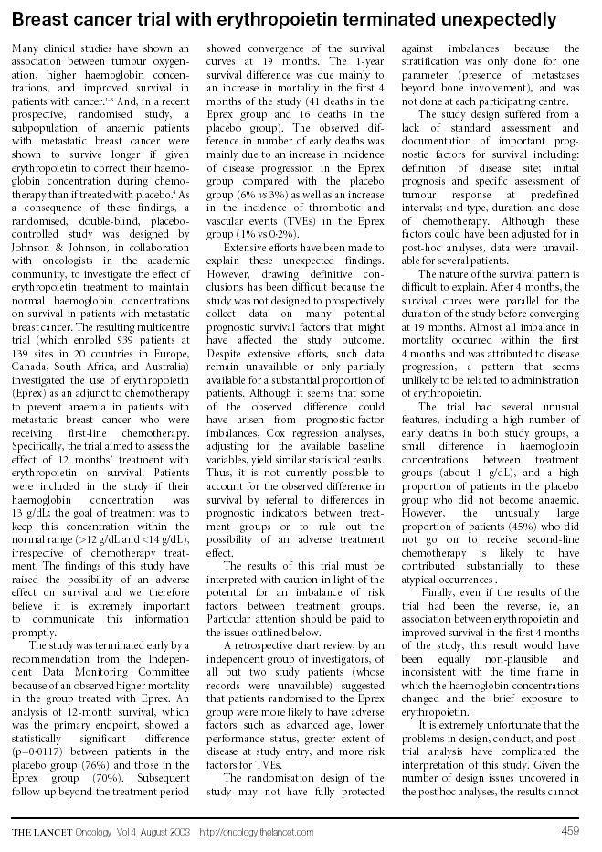

Attachment 2: Lancet Letter to the Editor on EPO-INT-76 (Continued)
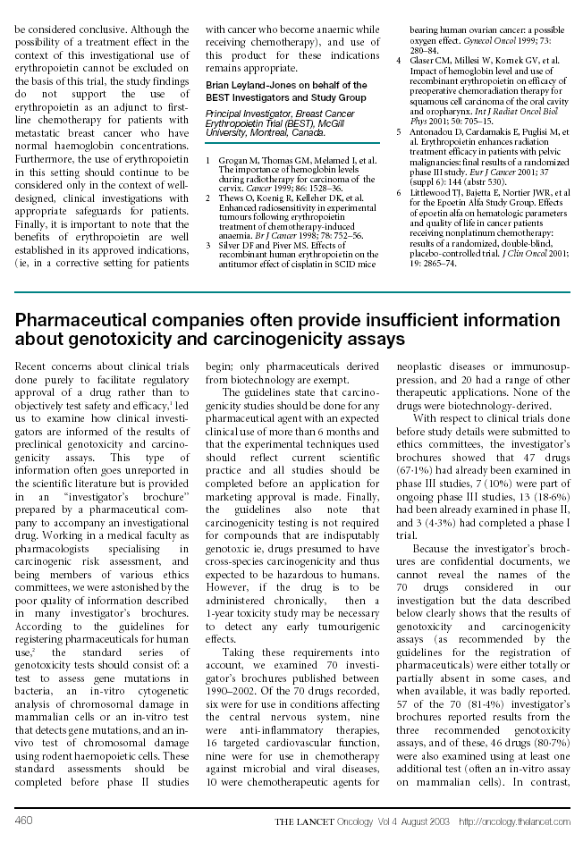

Attachment 3: Henke Lancet Article
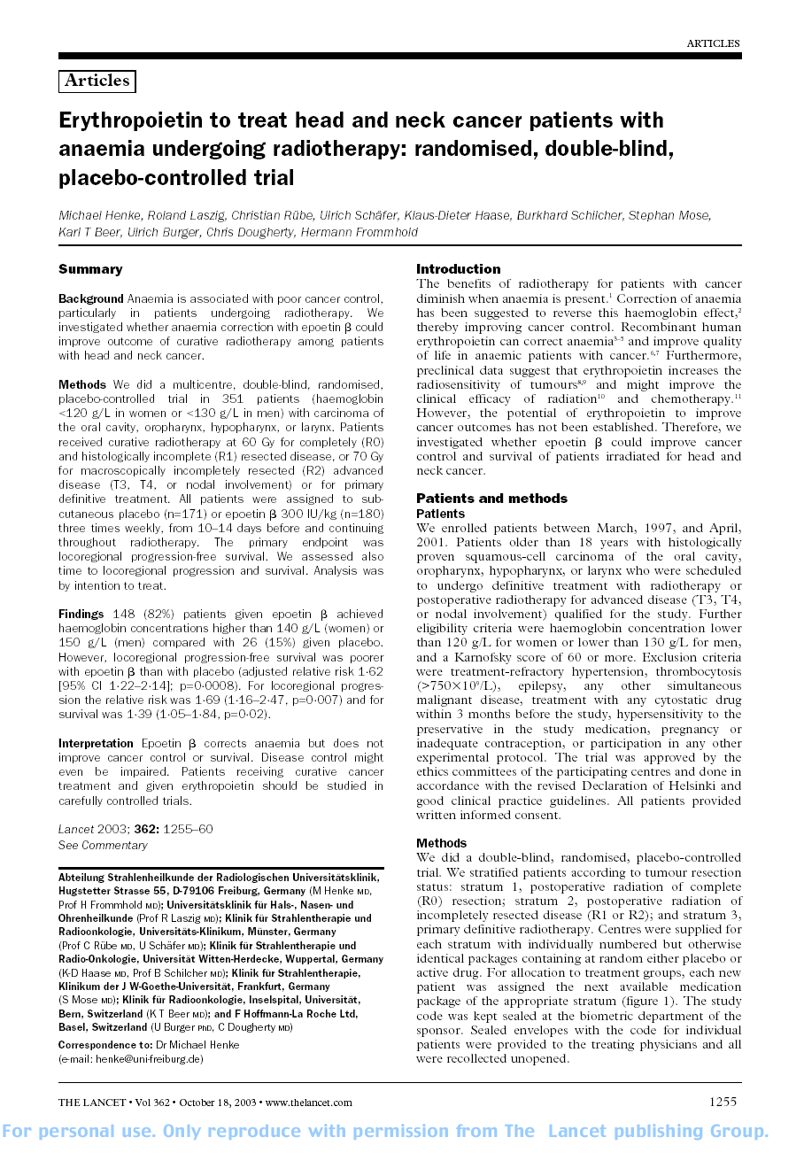

Attachment 3: Henke Lancet Article (Continued)
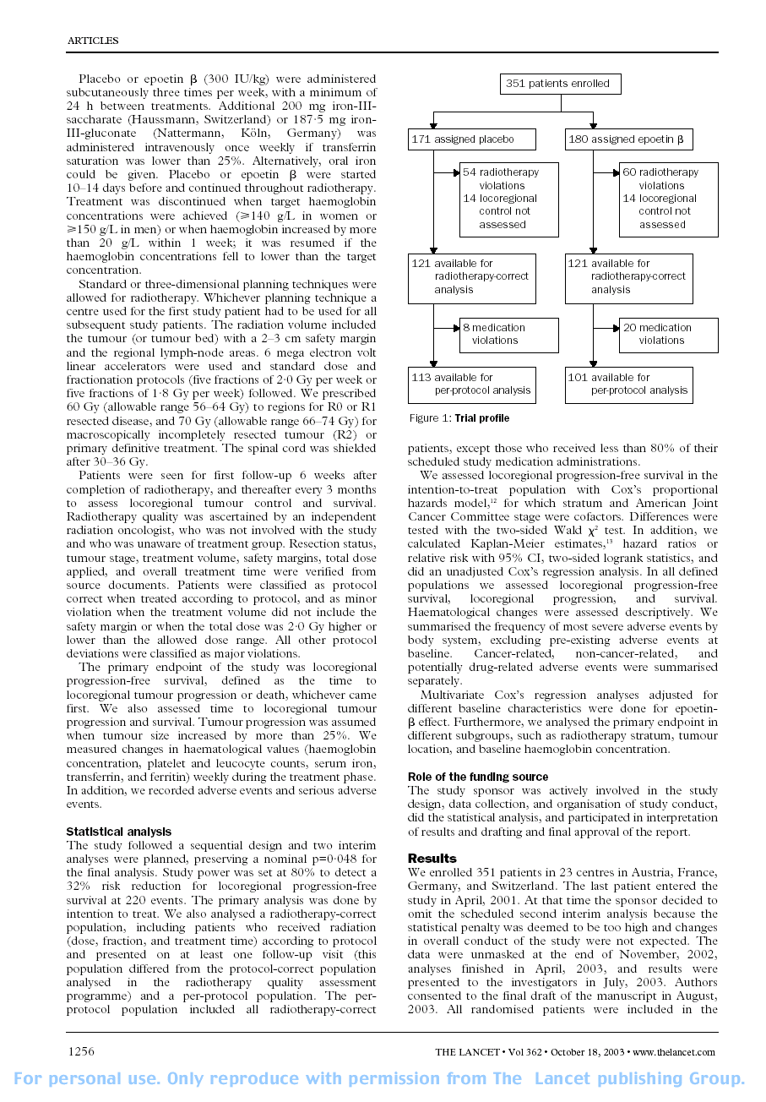

Attachment 3: Henke Lancet Article (Continued)

Attachment 3: Henke Lancet Article (Continued)
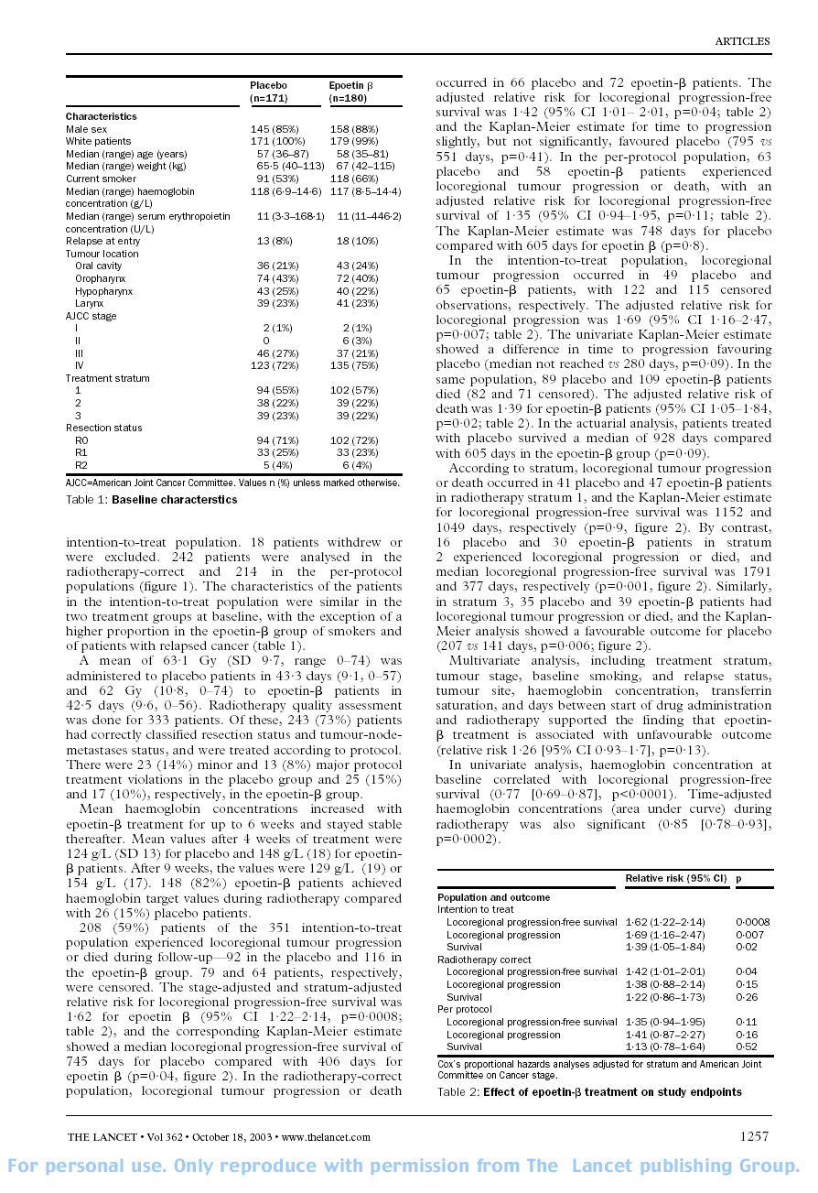

Attachment 3: Henke Lancet Article (Continued)
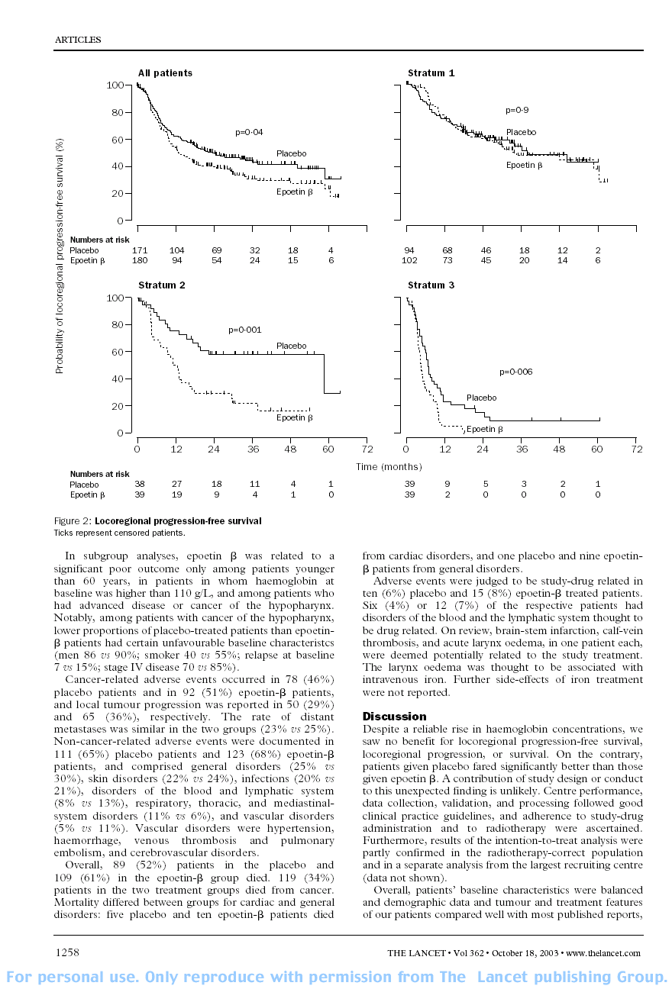
Attachment 3: Henke Lancet Article (Continued)
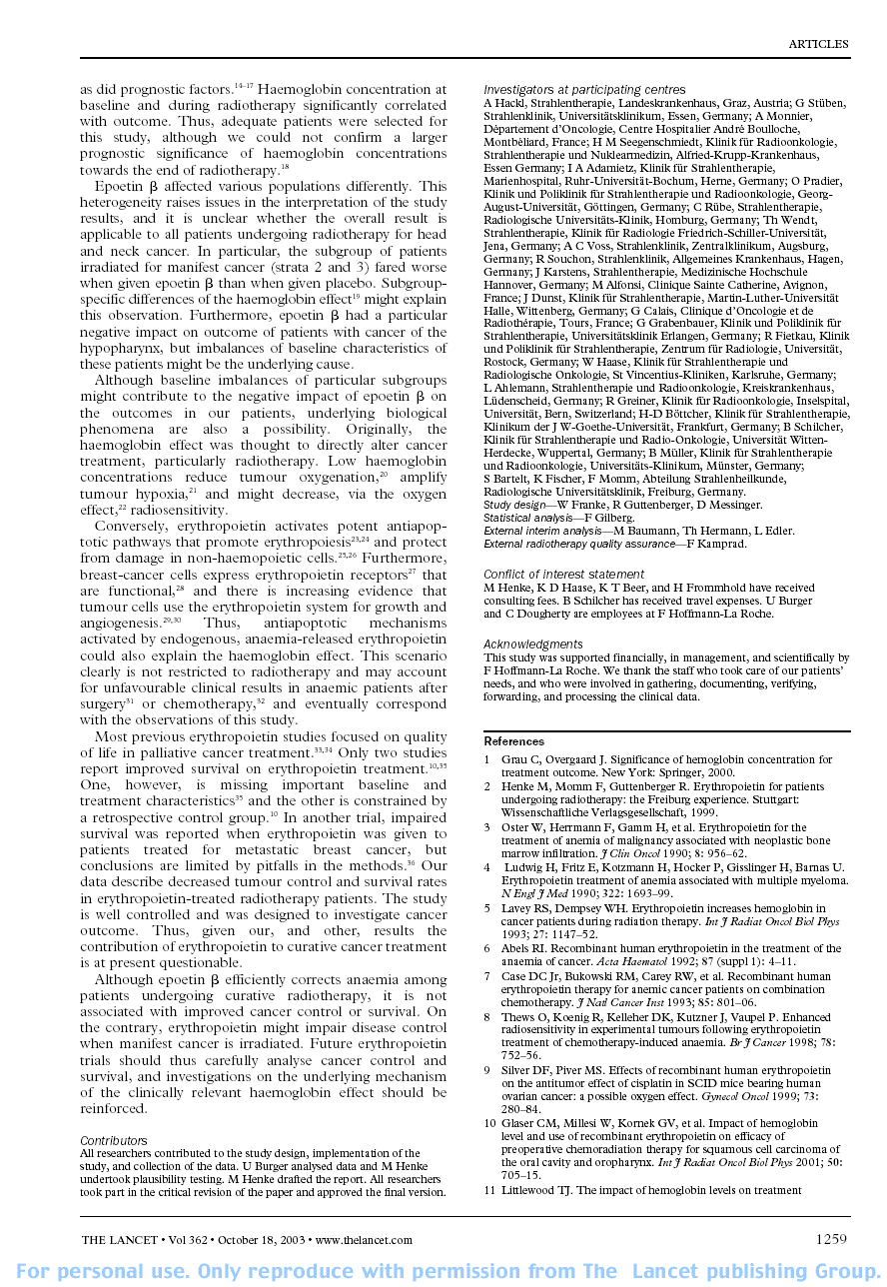
Attachment 3: Henke Lancet Article (Continued)
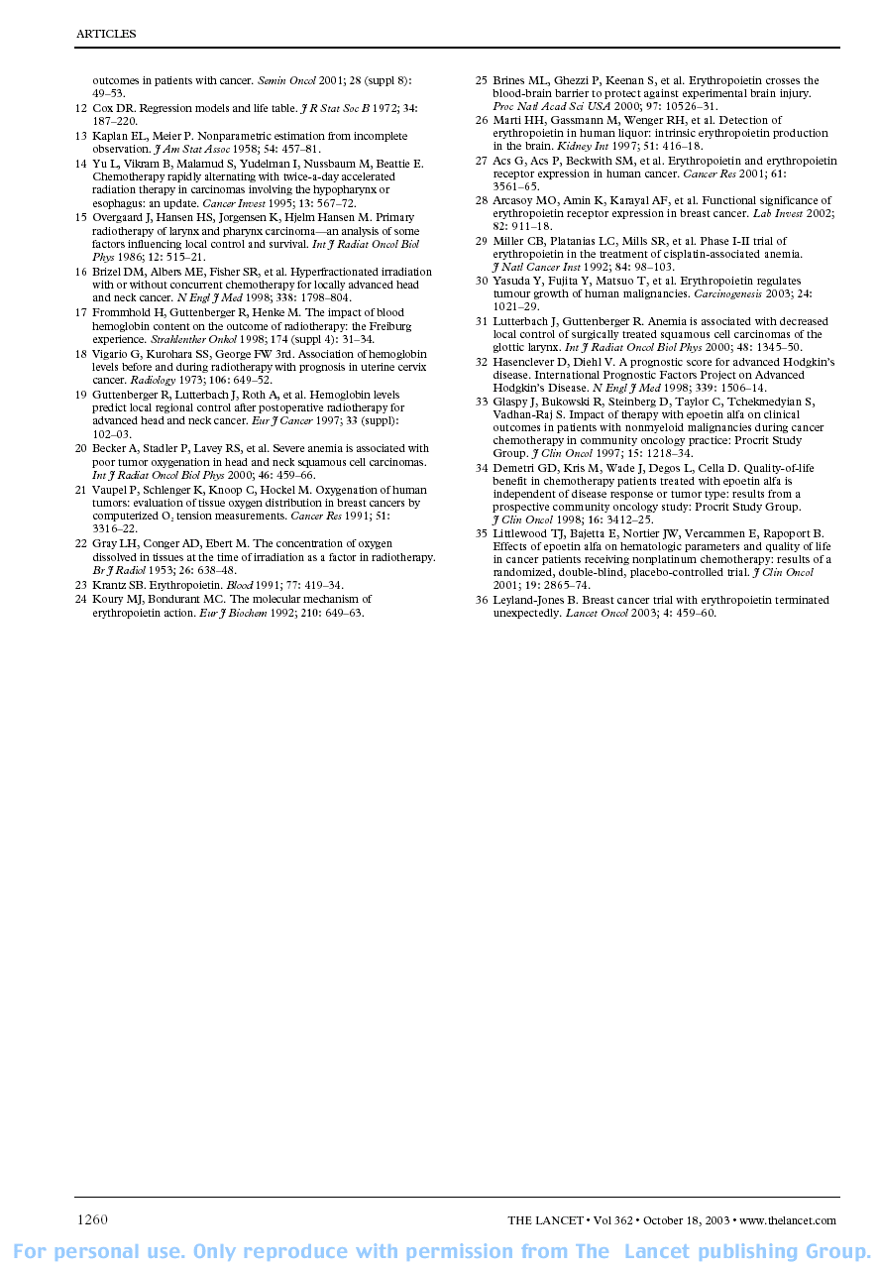

Attachment 4: Overview and Design of PROCRIT and EPREX Clinical Studies in Oncology
 |  |  |  |  |  | No. of Subjectsª
Protocol |  |  |  |  |  | DB Phase |  |  |  |  |  |  | OL Phase
(Country) |  | Study Type |  | Dose Regimen |  | EPO |  | PBO |  |  | Total |  | EPO
Completed studies
Non-Chemotherapy^{b} (H87-032, 87-014, 87-015)  (U.S.) | Type: Parallel-group, multicenter studies in subjects with chronic anemia secondary to advanced mixed cancers who are not receiving chemotherapy. DB phase followed by OL extension. |  | 100 IU/kg PROCRIT or PBO s.c., t.i.w. for up to 8 weeks or until a hematocrit of 38%-40% was achieved. |  | 65 |  | 59 |  |  | 124 |  | 93
 | Primary End point: Transfusion requirements, Hct, correction of anemia unrelated to transfusion, response to therapy unrelated to transfusion  Entry/Target Hb: ≤10.5 g/dL^{c}/Hct of 38%-40% |  | Change: If, after 4 weeks the Hct had decreased by 15% or more from baseline, or if the subject’s Hct reached 38%-40%, the subject was allowed to move to the OL phase of the study during which time all subjects received epoetin alfa at a dose titrated to maintain the Hct between 38%-40%.
Noncisplatin chemotherapy^{b}  (I88-037, 87-016, 87-017)  (U.S.) | Type: Multicenter studies in subjects with mixed cancers receiving aggressive noncisplatin-containing chemotherapy. DB phase followed by OL phase. |  | 150 IU/kg PROCRIT or PBO, s.c., t.i.w. for 12 weeks in DB phase, epoetin alfa dose titrated to maintain Hct between 38%-40% in OL phase |  | 81 |  | 76 |  |  | 157 |  | 117
 | Primary End point: Increase in Hct; decreased transfusion rate |  | Change: If Hct reached 38%-40%, the dose was titrated to maintain Hct within this target range.
 | Entry/Target Hb: ≤10.5 g/dL/ Hct of 38%-40%
Cisplatin chemotherapy^{b}  (I88-036, 87-018, 87-019)  (U.S.) | Type: Multicenter studies in subjects with mixed cancers receiving aggressive cisplatin-containing chemotherapy. DB phase followed by OL phase. |  | 150 IU/kg PROCRIT or PBO, s.c., t.i.w. for 12 weeks in DB phase, epoetin alfa dose titrated to maintain Hct between 38%-40% in OL phase |  | 67 |  | 65 |  |  | 132 |  | 78
 |  | Primary End point: Increase in Hct; decreased transfusion rate |  | Change: If Hct reached 38%-40%, the dose was titrated to maintain Hct within this target range.
 |  | Entry/Target Hb: ≤10.5 g/dL/ Hct of 38%-40%
ª Actual number of subjects enrolled.
^{b} Prior to study completion, a decision was made to pool data within each study type(according to type of cancer treatment). Thus, data in each category were pooled and reported as a single entity as follows: no chemotherapy treatment (Protocols H87-032, 87-014, 87-015), treatment with noncisplatin chemotherapy (Protocols I88-037, 87-016, 87-017), and treatment with cisplatin chemotherapy (Protocols I88-036, 87-018, 87-019).
^{c} Under Protocol 87-014.
Key: DB=double-blind; EPO=epoetin alfa; Hct=hematocrit; No.=number; OL=open-label; PBO=placebo; s.c.=subcutaneous; t.i.w.=3 times weekly; U.S.=United States of America (continued)

Attachment 4: Overview and Design of PROCRIT and EPREX in Clinical Studies in Oncology (Continued)
 |  |  |  |  |  |  |  |  | No. of Subjectsª
Protocol |  |  |  |  |  |  |  |  | DB Phase |  |  |  |  |  |  |  | OL Phase
(Country) |  |  |  | Study Type | Dose Regimen |  |  |  | EPO |  |  | PBO |  |  | Total |  | EPO
Completed Studies (continued)
J89-040  (Canada and U.S.) |  |  |  | Type: PBO-controlled, multicenter study in CLL subjects. DB phase followed by OL extension. | 150 IU/kg PROCRIT, EPREX or PBO, s.c., t.i.w. for 12 weeks in DBphase; epoetin alfa dose titrated to maintain Hct between 38%-40% in OL phase |  |  |  | 142 |  |  | 79 |  |  | 221
 |  |  |  | Primary End point: Change in Hct from baseline to endpoint | Change: NA for DB phase
 |  |  |  | Entry/Target Hb: NA^{b}/Hct 38%-40% in OL phase (after 12 weeks DB treatment or reached Hct 38%-40% in DB phase)
CC2574-P-174  (Europe) |  |  |  | Type: PBO-controlled, multicenter study in CLL subjects. DB phase followed by OL extension. | 150 IU/kg EPREX or PBO, s.c., t.i.w. for 12 weeks in DB phase; epoetin alfa dose titrated to maintain Hct between 38%-40% in OL phase |  |  |  | 33 |  |  | 12 |  |  | 45
 |  |  |  | Primary End point: Change in Hct from baseline to endpoint | Change: NA for DB phase
 |  |  |  | Entry/Target Hb: NA^{b}/Hct 38%-40% in OL phase and, if reached Hb >11.5 g/dL at end of OL phase, Hct 35%-45% in maintenance phase
CC 2574-P-416/EPO-INT-1 (Europe and Israel) |  |  |  | Type: DB, PBO-controlled, multicenter study in subjects with ovarian cancer receiving cyclic platinum-based chemotherapy. | 150 IU/kg, 300 IU/kg EPREX or PBO, s.c., t.i.w. for 1 month past chemotherapy. |  |  |  | 165^{c} |  |  | 81 |  |  | 246 |  | NA
 |  |  |  | Primary End point: Transfusion requirements  Entry/Target Hb: 1) <11.0 g/dL;  2) declined ≥1.5 g/dL since the beginning of chemotherapy when the baseline Hb level prior to chemo was <14 g/dL; or  3) declined ≥2 g/dL since the beginning of chemotherapy when baseline Hb prior to chemotherapy was ≥14 g/dL./12.5-14 g/dL and rate of rise <2 g/dL per month | Change: For subjects randomized to 150 IU/kg group, if reticulocyte count after 4 weeks of study drug had increased ≥40,000/μL above baseline, study drug was continued at that dose until 1 month after completion of the last cycle of chemo in the present course. If the reticulocyte count after 4 weeks of administration had increased <40,000/μL above baseline, the dose of study drug was increased to 300 IU/kg t.i.w. until 1 month after completion of the last cycle of chemotherapy in the present course. If Hb increased ≥1 g/dL above baseline after 4 weeks of therapy, the dose of study drug was maintained at 150 IU/kg t.i.w. regardless of reticulocyte count. If Hb for any subject in any group exceeded 14 g/dL, therapy was withheld until Hb decreased below 12.5 g/dL, and then restarted in a dose 25% lower that the dose previously administered. If Hb level rose by ≥2 g/dL/month, therapy was reduced by approximately 25% to maintain the rate of increase of Hb to <2 g/dL/month.
ª Actual number of subjects enrolled.
^{b} Defined as having a prestudy hematocrit <32%.
^{c} 80 subjects in 300 IU/kg group and 85 subjects in 150 IU/kg group.
Key: DB=double-blind; CLL=chronic lymphocytic leukemia; EPO=epoetin alfa; Hb=hemoglobin; Hct=hematocrit; NA=not applicable; No.=number; OL=open-label; PBO=placebo; s.c.=subcutaneous; t.i.w.=3 times weekly; U.S.=United States of America (continued)
Attachment 4: Overview and Design of PROCRIT and EPREX Clinical Studies in Oncology (Continued)
 |  |  |  |  |  |  |  | No. of Subjectsª
Protocol |  |  |  |  |  |  |  | DB Phase |  |  |  |  |  |  |  | OL Phase
(Country) |  | Study Type |  |  |  | Dose Regimen |  | EPO |  | PBO |  |  | Total |  |  | EPO
Completed studies (continued)
CC 2574-P-467/  EPO-INT-2  (Europe and Israel) | Type: PBO-controlled, multicenter study in subjects with multiple myeloma. DB phase followed by OL extension. |  |  |  |  |  | 150-300 IU/kg EPREX, ERYPO or PBO, s.c., t.i.w. for 12 weeks in double-blind phase; 150 IU/kg epoetin alfa, s.c., t.i.w. for 12 weeks in OL phase | 69 |  |  | 76 |  |  | 145 |  | 87
 | Primary End point: Transfusion requirements  Entry/Target Hb: <11.0 g/dL/12-14 g/dL and rate of rise <2 g/dL per month |  |  |  |  |  | Change: If after 4 wks of therapy Hb increased by <1 g/dL above baseline, the initial dose (150 IU/kg) was doubled to 300 IU/kg. If Hb exceeded 14 g/dL at any time during the study, therapy was withheld until Hb decreased below 12 g/dL then was restarted at a dose 25% below that which was previously administered.
CC 2574-P-034/  EPO-INT-3  (Europe) | Type: DB, PBO-controlled, randomized, multicenter study in subjects with mixed cancers receiving chemotherapy. |  |  |  |  |  | 150-300 IU/kg EPREX ERYPO or PBO, s.c., t.i.w. for 12 weeks in DB phase; 150-300 IU/kg epoetin alfa, s.c., t.i.w. for 12 weeks in OL phase | 136 |  |  | 65 |  |  | 201 |  | 153
 | Primary End point: Transfusion requirements  Entry/Target Hb: <12 g/dL or Hb decline ≥1.5 g/dL during current chemotherapy cycle/12-14 g/dL and rate of rise <2 g/dL per month |  |  |  |  |  | Change: If after 4 wks of therapy Hb increased by <1 g/dL above baseline, the initial dose (150 IU/kg t.i.w.) was doubled to 300 IU/kg t.i.w. If Hb exceeded 14 g/dL for women or 16 g/dL for men at any time during the study, therapy was withheld until Hb decreased below 12 g/dL for women or 14 g/dL for men, then was restarted at a dose 25% below that which was previously administered.
ª Actual number of subjects enrolled.
Key: DB=double-blind; EPO=epoetin alfa; Hb=hemoglobin; Hct=hematocrit; No.=number; OL=open-label; PBO=placebo; s.c.=subcutaneous; t.i.w.=3 times weekly; U.S.=United States of America (continued)

Attachment 4: Overview and Design of PROCRIT and EPREX Clinical Studies in Oncology (Continued)
 |  |  |  |  |  | No. of Subjectsª
Protocol |  |  |  |  |  | DB Phase |  |  |  |  |  |  |  |  | OL Phase
(Country) | Study Type |  | Dose Regimen |  |  | EPO |  |  | PBO |  |  | Total |  |  | EPO
Completed Studies (continued)
EPO-C111-457/  EPO-INT-10  (Europe and South Africa) |  | Type: DB, multicenter study in subjects with non-myeloid malignancies receiving non-platinum chemotherapy. |  |  | 150-300 IU/kg EPREX ERYPO or PBO, s.c., t.i.w. for up to 6 cycles or 24 weeks |  |  | 251 |  |  | 124 |  |  | 375 |  |  | NA
 |  | Primary End point: Transfusion requirements  Entry/Target Hb: ≤10.5 g/dL or Hb decline ≥1.5 g/dL during current chemotherapy cycle/12-15 g/dL and rate of rise <2 g/dL per month |  |  | Change: If after 4 wks of therapy reticulocyte count increased <40,000/μL above baseline and Hb increased by <1 g/dL above baseline, the initial dose (150 IU/kg) was doubled to 300 IU/kg. If Hb exceeded 15 g/dL at any time during the study, therapy was withheld until Hb decreased below 12 g/dL then was restarted at a dose 25% below that which was previously administered. If Hb rose ≥2 g/dL per month or cycle the dose was reduced by 25%.
N93-004  (U.S.) |  | Type: DB, multicenter study in subjects with small cell lung cancer./14-16 g/dL |  |  | 150 IU/kg s.c., t.i.w. PROCRIT or PBO until 3 weeks after completing their initial course of treatment |  |  | 109 |  |  | 115 |  |  | 224 |  |  | NA
 |  | Primary End point: Tumor response  Entry/Target Hb: ≤14.5 g/dL |  |  | If Hb exceeded 16 g/dL, study drug was held until the Hb fell below 14 g/dL and then was restarted at a dose of 75 IU/kg, s.c. t.i.w.
EPO-INT-76^{b}  (Europe, Canada, South Africa, and Australia.)  (B. Leyland-Jones, M.D.)^{c} |  | Type: DB, PBO-controlled, randomized, multicenter study in women receiving first-line chemotherapy for metastatic breast carcinoma. |  |  | 40,000 IU s.c., q.w. EPREX or PBO for 12 months |  |  | 448 |  |  | 456 |  |  | 904 |  |  | NA
 |  | Primary End point: 12-month survival rate  Entry/Target Hb: No upper or lower limit on Hb for inclusion/12-14 g/dL and rate of rise <2 g/dL per month |  |  | Change: If, at any time after receiving 4 weekly doses, Hb was <10.5 g/dL, and in the previous 4 wks Hb had increased by <1 g/dL or reticulocyte count had increased by <40,000 cells/μL, study drug was to be increased to 60,000 IU q.w. The maximum dose of study drug was not to exceed 60,000 IU q.w. If, at any time, Hb increased to >14 g/dL, study drug was to be withheld until Hb decreased to 12 g/dL or lower; study drug was then to be resumed at 75% of the last dose administered.
ª Actual number of subjects enrolled.
^{b} Study drug was discontinued in April 2002. The study is ongoing for following up per protocol.
^{c} Coordinating investigator.
Key: DB=double-blind; EPO=epoetin alfa; Hb=hemoglobin; NA=not applicable; No.=number; OL=open-label; PBO=placebo; q.w.=once weekly; s.c.=subcutaneous; t.i.w.=3 times weekly; U.S.=United States of America
Attachment 4: Overview and Design of PROCRIT and EPREX Clinical Studies in Oncology (Continued)
 |  |  |  |  |  | No. of Subjectsª
Protocol |  |  |  |  |  | DB Phase |  |  |  |  |  |  |  |  | OL Phase
(Country) | Study Type |  | Dose Regimen |  |  | EPO |  |  | PBO |  |  | Total |  |  | EPO
PR98-27-008  (U.S. and Canada) |  | Type: DB, PBO-controlled, randomized, multicenter study in anemic subjects with advanced mixed cancers receiving myelosuppressive, cytotoxic chemotherapy. |  | 40,000 IU s.c., q.w. PROCRIT or PBO for 16 weeks |  |  | 174 |  |  | 170 |  |  | 344 |  |  | NA
 |  | Primary End point: Transfusion requirements^{b}  Entry/Target Hb: ≤11.5 g/dL for men and ≤10.5 g/dL for women/13-15 g/dL |  | Change: The dose was to be increased to 60,000 IU q.w. if Hb had not increased by >1 g/dL after 4 weeks of therapy or if the subject had received a transfusion during the first 4 weeks of therapy. The dose was to be withheld if Hb was >15 g/dL and re-initiated with a 25% dose reduction if Hb became <13 g/dL.
Discontinued studies
PR00-03-006  (U.S.)  (S. Vadhan Raj, M.D.)^{c} |  | Type: DB, randomized, PBO-controlled, multicenter study in subjects with gastric or rectal cancer receiving fluoropyrimidine (5-FU or Xeloda®)-based therapy concurrent with radiation; randomization 1:1 epoetin alfa vs. PBO. |  |  | 40,000 IU s.c., q.w. PROCRIT or PBO |  |  | 29 |  |  | 31 |  |  | 60 |  |  | NA
 |  | Primary End point: Transfusion requirements  Entry/Target Hb: ≥10 g/dL to <15 g/dL/>14-<15 g/dL |  |  | Change: If Hb decreased by ≥1 g/dL or was ≤13 g/dL after 4 weeks of treatment, the dose of study drug was to be increased to 60,000 IU q.w., starting from Week 4 of chemoradiation. The dose of study drug was to be withheld if Hb increased to ≥15 g/dL and was to be resumed once the Hb decreased to ≤14.0 g/dL at a dose of 20,000 IU q.w. less than the current dose.
ª For completed studies=actual number of subjects enrolled; for discontinued studies=actual number of subjects enrolled when study was discontinued.
^{b} Primary endpoint per agreement with the U.S. Food and Drug Administration (FDA). The protocol specified primary endpoint was quality of life.
^{c} Coordinating investigator.
Key: DB=double-blind; EPO=epoetin alfa; Hb=hemoglobin; NA=not applicable; No.=number; OL=open-label; PBO=placebo; q.w.=once weekly; s.c.=subcutaneous; U.S.=United States of America (continued)

Attachment 4: Overview and Design of PROCRIT and EPREX Clinical Studies in Oncology (Continued)
 |  |  |  |  | No. of Subjectsª
Protocol |  |  |  |  | DB Phase |  |  |  |  |  | OL Phase
(Country) | Study Type |  | Dose Regimen |  | EPO |  | PBO |  | Total |  | EPO
Discontinued studies (continued)
PR01-04-005  (Denmark, Norway, Sweden, U.S.)  (G. Thomas, M.D.)^{b} |  | Type: OL, randomized, multicenter, investigator-sponsored study in subjects with cervical cancer receiving concurrent radiation and cisplatin, randomization 1:1 epoetin alfa vs. SOC. |  | 40,000 IU s.c., q.w. PROCRIT or SOC |  | NA |  | NA |  | NA |  | 58  (55 SOC)
 |  | Primary End point: Progression-free survival  Entry/Target Hb: <14 g/dL/13-14 g/dL |  | Change: If at any time the Hb rose to >14 g/dL on 2 consecutive wks, epoetin alfa was to be withheld until Hb dropped to 13 g/dL or below; then was to be reinitiated at the same dose. If Hb >12 g/dL could not be reached before commencing therapy or fell abruptly to ≤12 g/dL during therapy and remained ≤12 g/dL for a period of 1 week despite epoetin alfa, a transfusion was to be given as soon as possible to raise the Hb >12 g/dL and the dosage of epoetin alfa was to be escalated to 60,000 IU q.w.
ª Actual number of subjects enrolled when study was discontinued.
^{b} Coordinating investigator.
Key: EPO=epoetin alfa; Hb=hemoglobin; NA=not applicable; No.=number; OL=open-label; PBO=placebo; q.w.=once weekly; s.c.=subcutaneous; SOC=standard of care; U.S.=United States of America (continued)

Attachment 4: Overview of PROCRIT and EPREX Oncology Clinical Studies (Continued)
 |  |  |  |  |  | No. of Subjectsª
Protocol |  |  |  |  |  | DB Phase |  |  |  |  |  |  |  | OL Phase
(Country) |  | Study Type | Dose Regimen |  |  | EPO |  |  |  |  | PBO | Total |  | EPO
Discontinued studies (continued)
EPO-CAN-15  (Canada UK, Spain, Belgium, Italy)  (G. Goss, M.D.)^{b} | Type: DB, randomized, PBO-controlled, multicenter study in subjects with limited disease small-cell lung cancer receiving combined modality chemoradiation therapy, randomized 1:1 epoetin alfa vs. PBO. |  |  | 40,000 IU s.c., q.w. EPREX or PBO |  |  | 53 |  | 53 |  |  |  | 106 |  | NA
 | Primary End point: Progression-free survival  Entry/Target Hb: All Hb entered; study drug deferred until Hb≤14 g/dL (final protocol) or Hb≤13 g/dL (Amendment 1)/14-16 g/dL (12-14 g/dL post amendment) |  |  |  | Change: Final protocol (Nov 2000): If, at any time after receiving epoetin alfa 40,000 IU q.w. for a minimum of 3 consecutive weeks, Hb was ≤14 g/dL and there had not been a demonstrated increase in Hb ≥1.5 g/dL in those 3 weeks, the dose of study drug was to be increased to 60,000 IU q.w. If at any time during study drug administration Hb was >16 g/dL, study drug was to be withheld until Hb decreased to ≤14 g/dL. At that time, study drug administration was to be resumed at a defined lower dose (i.e., down to 30,000 IU if the subject was receiving 40,000 IU, or down to 40,000 IU if the subject was receiving 60,000 IU). If, after 3 wks following a dose decrease, Hb was not >14 g/dL, the dose was to be increased to the previous dose.  Amendment 1: (Oct 2002): If, at any time after receiving epoetin alfa 40,000 IU q.w. for a minimum of 3 consecutive weeks, Hb was ≤13 g/dL and there had not been a demonstrated increase in Hb ≥1.5 g/dL in those 3 weeks, the dose of study drug was to be increased to 60,000 IU q.w. If at any time during study drug administration Hb was >14 g/dL, study drug was to be withheld until Hb decreased to ≤13 g/dL. At that time, study drug administration was to be resumed at a defined lower dose (i.e., down to 30,000 IU if the subject was receiving 40,000 IU, or down to 40,000 IU if the subject was receiving 60,000 IU). If, after 3 weeks following a dose decrease, Hb was not >13 g/dL, the dose was to be increased to the previous dose.
ª Actual number of subjects enrolled when study was discontinued.
^{b} Principal investigator.
Key: DB=double-blind; EPO=epoetin alfa; Hb=hemoglobin; NA=not applicable; No.=number; OL=open-label; PBO=placebo; q.w.=once weekly; s.c.=subcutaneous; SOC=standard of care; UK=United Kingdom. (continued)

Attachment 4: Overview and Design of PROCRIT and EPREX Clinical Studies in Oncology (Continued)
 |  |  |  |  | No. of Subjectsª
Protocol |  |  |  |  | DB Phase |  |  |  |  |  | OL Phase
(Country) |  | Study Type | Dose Regimen |  | EPO |  | PBO |  | Total |  | EPO
PR99-03-046/RTOG 9903  (U.S.)  (Radiation Therapy Oncology Group)^{b} | Type: OL, epoetin alfa vs. control; randomly assigned 1:1 conducted by the RTOG to evaluate the effect of epoetin alfa on local-regional control in anemic cancer subjects treated with radiotherapy for carcinoma of the head and neck |  |  | 40,000 IU s.c., q.w. PROCRIT plus radiotherapy or radiotherapy alone. |  | NA |  | NA |  | NA |  | 117^{c}  (61^{d} in the control group)
 | Primary End point: Improvement in local regional control rate  Entry/Target Hb: ≥9 to ≤13.5 g/dL for men; ≥9 to ≤12.5 g/dL for women/>13.5-<16 g/dL for men and >12-<14 g/dL for women |  |  | Change: Subjects in the epoetin alfa group were to receive a starting dose of 40,000 IU s.c., q.w. weekly basis for 8 to 9 weeks or until completion of radiotherapy. Treatment with epoetin alfa was to begin 7 to 10 days prior to the start of radiotherapy. It was anticipated that subjects would have just received their second dose of epoetin alfa upon starting radiation therapy. If at any time the Hb concentration rose ≥16 g/dL for men or ≥14 g/dL for women, EPO was to be withheld until the concentration dropped to ≤13.5 g/dL for men or ≤12 g/dL for women; epoetin alfa treatment was then to be reinitiated at 30,000 IU q.w. If the Hb concentration failed to increase by ≥1 g/dL above baseline after the fourth epoetin alfa injection, the dose of epoetin alfa was to be increased to 60,000 IU q.w. Subjects randomized to Arm 1 were to receive radiotherapy only.
ª Actual number of subjects enrolled when study was discontinued.
^{b} A cooperative research group.
^{c} A total of 148 subjects were enrolled into the study. Of these, 1 subject was ineligible and 30 subjects had no reported follow-up data at the time of this report.
^{d} Treated with radiation alone or chemoradiation.
Key: EPO=epoetin alfa; Hb=hemoglobin; NA=not applicable; No.=number; OL=open-label; PBO=placebo; q.w.=once weekly; s.c.=subcutaneous; SOC=standard of care; U.S.=United States of America. (continued)

Attachment 4: Overview of PROCRIT and EPREX Oncology Clinical Studies (Continued)
 |  |  |  |  | No. of Subjectsª
Protocol |  |  |  |  | DB Phase |  |  |  |  |  | OL Phase
(Country) |  | Study Type | Dose Regimen |  | EPO |  | PBO |  | Total |  | EPO
EPO-CAN-20  (Canada)  (J. Wright, M.D.)^{b}  (Ontario Clinical Oncology Group)^{X} | Type: DB, PBO-controlled; randomly assigned 1:1 epoetin alfa vs. PBO to evaluate the effect of treatment with epoetin alfa on anemia-related QoL and anemia in subjects with advance non-small cell lung cancer. |  |  | 40,000 IU s.c. q.w. EPREX or PBO |  | 29 |  | 29 |  | 58^{c} |  | NA
 | Primary End point: QoL (change from baseline in FACT-An score)  Entry/Target Hb: ≤12 g/dL/12-14 g/dL |  |  | Change: Subjects were to receive EPO or placebo s.c. at a starting dose of 40,000 IU q.w. If, after 4 weeks of therapy, the Hb concentration had not increased by ≥1 g/dL the dose was to be increased to 60,000 IU for at least the next 4-week interval. If the Hb concentration increased by 2 g/dL over any 4-week interval, the dose was to be reduced by approximately 25%. If at any time, the Hb concentration exceeded 14 g/dL, the dose was to be withheld until the Hb concentration decreased below 12 g/dL. The dose was then to be resumed at approximately 75% of the previous dose.
Ongoing Study
GBR-7^{d}  (UK) | Type: OL, multicenter study in subjects with head and neck cancer for which radical radiotherapy with curative intent was imminent. Subjects randomly assigned (1:1) to receive either standard radiotherapy plus epoetin alfa or standard radiotherapy alone. |  |  | 4,000 IU s.c. t.i.w. or 10,000 IU s.c., t.i.w. EPREX |  | NA |  | NA |  | NA |  | 152  (148 in observation group)
 | Primary End point: Local tumor response at Week 12 after completion of radiotherapy  Entry/Target Hb: ≤15 g/dL/12.5-15 g/dL |  |  | Change: If at any time a subject’s hemoglobin exceeded 15 g/dL, the epoetin alfa dose was to be halted until the hemoglobin fell to below 14.5 g/dL, and then restarted at 50% of the previous dosage so as to maintain the hemoglobin level around 14.5 g/dL. Subjects whose hemoglobin did not reach 12.5 g/dL after 4 weeks were to have their dose doubled.
ª Actual number of subjects enrolled when study was discontinued.
^{b} Principal Investigator.
^{c} At the time the study was discontinued, 70 subjects were enrolled. The Data Safety Monitoring Board interim analysis only included baseline and safety analyses data available for 66 of these subjects. Of the 66, baseline data were only available for 58 subjects at the time of this report.
^{d} The study was discontinued in April 2002 due to slow enrollment. Per protocol, the study treatment phase has been completed and the 5-year follow-up phase is still ongoing.
Key: DB=double blind; EPO=epoetin alfa; NA=not applicable; No.=number; OL=open label; PBO=placebo; q.w.=once weekly; s.c.=subcutaneously; UK=United Kingdom; vs.=versus.

Attachment 5: Preclinical Data on Epoetins and Tumor Proliferation

The Sponsor has re-evaluated available non-clinical data related to the role of erythropoietins and EpoR in tumor proliferation, based on the information in the published literature and the Sponsor's research.
Expression of Erythropoietin Receptors on Cells
Erythropoietin is the key regulator for red blood cell production. It exerts its action by binding to its cognate receptor on cells of erythroid origin. Recent studies have shown that Erythropoietin and EpoR expression have been detected in a variety of hematopoietic and nonhematopoietic cells, including neurons, intestinal cells, liver, pancreas, prostate, colon and endothelium and malignant cell lines such as human breast cancer cells. The biological significance of the EpoR on these cell types is unknown.
Acs et al., (Cancer 95:969-981, 2002)¹ have reported the immunohistochemical expression of erythropoietin and EpoR in breast carcinoma, and suggested that EpoR may play a role in breast carcinogenesis. However, no correlation between EpoR immunostaining and tumor size was evident in the study. Similarly, no correlation between erythropoietin immunostaining and tumor size, tumor grade, presence of necrosis, lymphovascular invasion, lymph node status, hormone receptor status, or HER2/neu overexpression was seen. The methodology used in this study could not identify the cellular localization of the expressed protein and was unable to differentiate between EpoR on the cell surface and EpoR in the cytosol (EpoR sequestered in the cytosol is never activated as it cannot bind to extacellular erythropoietin). Data indicated that the erythropoietin/EpoR pathway in breast carcinoma is not apparently associated with other biological features that are known to correlate with more aggressive tumor growth.
Erythropoietin Receptor Agonists and Proliferation of Tumor Cells
Several investigators have reported that erythropoietin does not stimulate tumor cell proliferation²⁻⁵. These results are in agreement with the results of the Sponsor’s own studies in which 6 tumor cells lines (SK-BR-3, HT-29, MCF-7, PC-3, SK-OV-3 and MDA-MB-453) were treated with erythropoietin to assess erythropoetin-dependent proliferation. No effect was seen at any concentration including the highest concentration of 5 U/mL. This is in sharp contrast to that seen with the hematopoietic cell line UT-7 where maximal proliferative response was observed at 0.120 U/mL.
Westenfelder and Baranowski⁶ have also reported that Erythropoietin stimulates cell proliferation of human renal carcinoma cells. However, the conclusion that erythropoietin stimulated tumor cell proliferation was based on a minimal proliferative response (125% of control) at supra-pharmacological concentrations of r-HuEPO, >10 Units/mL (>5 fold that seen in clinical application).
A more recent study by Westphal et al.³, (2002) investigated erythropoietin and G-CSF receptor expression in human tumor cells. Receptor expression was confirmed by reverse transcriptase-polymerase chain reaction (RT-PCR), western blot and immunocytochemistry. Receptor expression was observed in several tumor cell lines of non-hematopoietic origin. On the other hand, no erythropoietin receptor expression by RT-PCR analysis was observed in the acute myelogenic leukemia cell line (KG-1a), the urinary bladder carcinoma (RT112), Burkitts lymphoma (Raji) and both primary and immortalized keratinocytes. To test for the functionality of the erythropoietin receptor on EpoR-bearing cell lines, two different parameters were measured; namely, cellular proliferation and tyrosine phosphorylation. Both analyses revealed that erythropoietin had no effect on the growth of EpoR-bearing tumor cell lines. The authors concluded that EpoR is not essential for cellular growth of these tumor cells in cell culture.
Erythropoietin and Anti-Apoptosis
Another active area of investigation is whether erythropoietin confers an anti-apoptotic effect on tumor cells and thereby interferes with the effectiveness of chemotherapeutic agents. Studies have shown that erythropoietin increases the expression of the anti-apoptotic genes, bcl_{xl} and bcl2 in hematopoietic and neuronal cells. In the recent study by Bahtra et al.,⁷ upregulation of bcl_{xl} and bcl2 was demonstrated at high erythropoietin concentration, >30 Units/mL. Expression of these genes was also observed in the absence of erythropoietin. The erythropoietin concentration necessary to affect gene expression is 1000-fold higher than erythropoietin levels in the normal physiological range and 10 to 100 fold higher than that seen after administration of high doses of erythropoietin in the clinical setting.
Erythropoietin and Angiogenesis
The role of ERAs and angiogenesis is an area that warrants further attention given that the Epo-R is expressed on endothelial cells⁸. In vitro studies have demonstrated that human umbilical vein endothelial cells (HUVECs) exhibit a modest proliferative response when cultured in the presence of ERAs. Additionally, ERAs exerted pro-angiogenic effects including increased expression of endothelin-1 (ET-1) and matrix metalloproteinase-2 at EPO concentrations of 50 U/mL and 2 U/mL, respectively⁹. ERAs also demonstrated angiogenic potential in a rat aortic ring assay; however, the minimal dose necessary to induce angiogenesis was 50 Units/mL, a supra-pharmacologic dose.
Summary of Findings from Preclinical Data
Although erythropoietin receptors are expressed on a number of malignant cell lines, none of the pre-clinical data are convincing that erythropoietin stimulates tumor cell proliferation, local progression, or the metastatic potential of cancer. No clear association has been established between ERAs or erythropoietin and increased EpoR expression on cancer cells. The hypothesis that ERAs stimulate tumor cell proliferation through an anti-apoptotic effect or the stimulation of angiogenesis and endothelial cell proliferation requires further studies.
References
- Acs G., Zhang, P.J., Rebbeck, T.R., Acs, P. and Verma, A. (2002) Immunohistochemical Expression of Erythropoietinitn and Erythropoietin receptor in breast Carcinoma. Cancer 95:969-981.
- Rosti, V., Pedrazzoli, P., Ponchio, L., Zibera, C., Novella, A., Lucotti, C., Gioachino, R., and Cazzola, M., Effect of Recombinant Human Erythropoietin on Hematopoietic and Non-hematopoietic Malignant Cell Growth In Vitro. (1993) Haematologica 78:208-12.
- Westphal, G., Niederberger, E., Blum, C., Wollman, Y., Knoch, T., Rebel, W., Debus, J., and Frierich, E., Erythropoietin and G-CSF Receptors in Human Tumor Cells: Expression and aspects Regarding Functionality (2002) Tumori 88:150-159.
- Berdel, W.E., Oberberg, D., Reufi, B., Thiel, E. (1991) Studies on the Role of Recombinant Human Erythropoietin in the Growth Regulation of Human Nonhematopoietic Tumor Cells In Vitro. Annals of Hematology. 63:5-8.
- Berdel, W.E., Koenigsmann, M. Papadimitriou, C.A., Zimmer, B., Oelmann, E., Oberberg, D., Reufi, B., Thiel, E. (1994) Studies on the Effects of Erythropoietin in Combination with Interleukin-3, Granulocyte-macrophage Colony Stimulating Factor or Granulocyte Colony-Stimulating Factor on the Growth of Human Nonhematopoieitc Tumor Cells In Vitro. Cytokines in Hemopoiesis, Oncology, and Immunology III 361-9.
- Westenfelder C, Baranowski RL. Erythropoietin stimulates proliferation of human renal carcinoma cells. Kidney Int 2000;58:647-657.
- Bahtra S, Perelman N, Luck LR, et al. Pediatric tumor cells express erythropoietin and a functional erythropoietin receptor that promotes angiogenesis and tumor cell survival. Lab Invest 2003;83:1477-1487.
- Anagnostou, A., Lee, E.S., Kessimian, N., Levinson, R., and Steiner, M. (1990) Eryhthropoietin has a mitogenic and positive chemotactic effect on endothelial cells. Proc. Natl. Acad. Sci USA 87:5978-5982.
- Ribatti D, Presta M, Vacca A, et al. Human erythropoietin induces a pro-angiogenic phenotype in cultured endothelial cells and stimulates neovascularization in vivo. Blood 1999;93:2627-2636.

