Magnetic Sensor Applications Workgroup

II. Driver Applications
Presentations were given that outlined many applications that are based on magnetic field sensors. In the course of the workshop, several specific “driver applications” were identified. These applications were defined as those that would have a large impact in areas such as homeland security, health care, and industrial applications. Once these applications were identified, it was then possible to start evaluating the specific criteria that they need to comply with. This will then allow us to match up various sensors with the specific applications.
These criteria included:
- Sensitivity – For the various applications, this parameter varies significantly. The units are typically reported in tesla, T, or oersted, Oe (1 Oe = 10⁻⁴ T). In SI units, these should be converted to ampere/meter using the relation 1 A/m=1000/4π Oe. Intrinsic to this parameter is the dynamic range that is required in order to achieve acceptable performance. This may imply the necessity of using shielded rooms or dynamic feedback. The main problem here is that ultra-high sensitivity devices will tend to saturate under ambient conditions.
- Frequency range – Again, there are a wide range of frequency ranges that are needed for the various applications. Fortunately, however, most applications need a relatively small bandwidth. This leads to a natural separation of applications into low and high frequency. In general, active feedback can be used in the low frequency range (as is done for SQUID magnetometers), while band pass filters can be used for high frequency applications (e.g. magneto-resistive sensors for hard disk drives).
- Operation temperature – Nearly all of the applications involved measurement of magnetic fields in a room temperature environment. However, the sensors themselves may require cooling. In this case, it is necessary for the cooling apparatus (typically a dewer) to be non-magnetic and allow the sensor to be close enough to the source of the magnetic field.
- Sensor size – This specification refers to the volume that the package or individual sensor can be allowed to encompass. While there is a wide range of package sizes, it must also be noted that cooling apparatus can significantly increase the required volume.
- State-of-the-art sensors – There has been significant development in most of these application areas. One of the main goals of this work is to identify areas where new, innovative technologies can have a significant impact. This may be either by supplanting the existing technology or enhancing the current methods, sensors, and associated materials.
- Arrays vs. single element and scanning techniques – Many applications require arrays of sensors for field mapping or parallel detection methods. The actual spatial dimensions that the field needs to be mapped over also help define what sensor will be optimal. For example, very large arrays of sensors can be fabricated on wafers, thereby allowing for small-scale magnetic field mapping. However, for mapping magnetic fields in a battlefield or border situation may require arrays of individual sensors that are with telemetry.
- Nano-scale vs. macro-scale – This parameter is similar to that of (4), however, it refers to the relevant dimensions of the actual sensor, independent of the packaging.
- Cost – In general, low cost is important when transferring technology. However, some applications may be important enough that cost is no object. Examples might be in specific homeland security and health care applications.
- Power consumption – This is most important in situations where either individual sensors are distributed with limited local sources of power, or where there is a very high density of magnetic sensors in a small area.
- Environment – In contrast to (3), this item includes other aspects such as corrosion and high temperature environments. These must be considered when comparing various technologies.

III. Magnetic Sensor Applications Worksheet

Driver applications
- Battlefield/unattended ground sensors – This is an application with possibly the most stringent requirements. These include operation with high field sensitivity in relatively high ambient fields, low frequency, low power consumption, and low cost. In addition, the environment that these sensors operate in is highly variable (see Fig. X.1). All possible types of terrain, weather conditions, and deployment methods must be accommodated. In general, distributed arrays of sensors with telemetry to a central station would have the most impact. Finally, the reliability of these devices is critical because lives and homeland security are at stake. Therefore, this is a high-risk, high-payoff application.
Fig. X.1 Field ranges for battlefield magnetic anomaly detection. Courtesy of A. Edelstein, Army Research Laboratory.

- Magneto-cardiography – It is well known that bio-magnetic signals from both the heart (MCG) and the brain (MEG) can be detected with ultra-high sensitivity magnetometers. Related applications include early detection fetal MCG. Again, these signals require very low frequency operation. Fig. X.2 illustrates this, and also compares various sensor response curves with the background magnetic noise. At present, these signals are typically measured using superconducting quantum interference devices (SQUIDs). These devices require cryogens, and are therefore limited in how close to the subject they can get and how many can be deployed effectively in an array. This is not such a critical concern, however, due to the fact that the magnetic fields vary relatively slowly over the regions to be measured. In general, the cost of these systems is not as critical as identifying the specific impact and mode of operation. However, it can be seen that relatively modest improvements room temperature sensors such as fluxgates or induction coils could allow for these techniques to be applied to MCG. In addition, if magneto-resistive (MR) sensors are integrated with flux guides, they may also have an impact. The goal would be to develop a real-time system with at least 1 cm source localization capability. The advantages of these devices would be low cost screening systems for routine checkups, arrhythmia diagnosis, and advance myocardial electrical diagnosis. This is a relatively high payoff, medium risk application.
Fig. X.2 – Medical applications for sensors. From “Biomagnetism,” by Malvivuo.
- Bead Array counters (BARC) – These devices are direct competition with the fluorescence tag technique that us used in many health care assay applications. The sensors needed for these must be packed into a very high density array, and single bead detection is desirable. An example of this technology is shown in Fig. X.2. The field sensitivity is modest, and medium frequency operation (~1 kHz) is acceptable. Existing devices are currently limited by the micro-fluidics and the chemistry of tagging, however, as these issues are worked out, the opportunity for magnetic sensors to make a high impact is there. This is a high payoff, relatively low risk application.
Fig. X.Y – Magnetic bead array counter (BARC) as implemented by NVE and NRL. The left panel shows the concept of tagging both sensors and beads which target specific proteins. When either the A or B target is present, the field from the bead will be sensed magnetically at the corresponding site. The right panel shows a picture of the actual device. An individual sensor is shown in the zoom, and illustrates the serpentine design of the spin valve GMR sensors. Images courtesy of NVE and NRL.

Other identified applications
- Sensors for measuring currents on high tension wires – Reliability of the power grid are dependent on adequate distributed diagnostics. Magneto-optic sensors for this application would allow reduced costs significantly reduced size (3% of current technologies). These are installable without breaking the circuit (as opposed to technologies currently in use) and can be safely queried by fiber optic means. There are no conductors and the fiber cables can be permanently installed to the ground. Such pervasive sensors are an enabling technology of an autonomously reconfureable power grid. The challenges of this are the harsh environment, with a linear response to 100 kV over a temperature range from subzero to 160 C . The sensor material (typically ferromagnetic garnets) and readout system must be able to deal with this. Improvements in sensitivity at low currents enable opportunities in “smart” buildings, optical power metering, and shipboard sensors. Coordination with voltage sensors can yield a complete power sensor. Moderate field sensors are inherently required. The timeline for development will depend on when mil-spec qualified prototypes could be available. This typically takes 1 – 2 years. Temperature independent and high sensitivity materials can be developed another 1 – 2 years down the line. Qualification by power companies will depend on their own agendas, but will be accelerated by military applications.
- Bead tracking in-vivo - This application has been identified by researchers at NIH as being a very promising avenue of studying blood flow in capillaries and organs. This can be used, for example, in conjunction with other imaging techniques to understand the impact of stroke on cardiac function and the electrical circuits in the heart. Pneumo-magnetometry – Magnetometry is a unique method of evaluating ron overload in organs such as the liver and lungs. It is non-invasive and real-time, showing the integrated signal from the area under evaluation.
Fig. X.3 – Non-destructive testing of VLSI chips. Left panel: Magnetic field above entire 20x20 cm RAM chip, showing the fields from the current supply lines. Right panel: Current vector calculated by inverting the fields. Images courtesy of NIST, samples courtesy of Intel Corp.

- Non-destructive evaluation (NDE) for micro-electronics – NDE using magnetic field mapping to obtain source current distribution can be conducted at two scales – either at the macro-scale, to evaluate the current vectors in a circuit, or at the nanoscale, to evaluate the current distribution in individual traces on a die. In an example of the first case, Fig. X.3 shows the magnetic field map above a RAM chip. The perpendicular component of the field is measured. This allows for de-convolution of the currents in the two in-plane directions, as shown in the right hand panel. In this application, arrays of relatively large (10’s of micro-meters) scale sensors can be used. This is because the sensors are typically scanned at distances at least the same distance from the source, i.e. from the back-side of a flip-chip package, circuit board, or other electronics package. In the second case, where the current distribution in individual traces is of interest, nano-scale sensors that come in direct contact are needed. These sensors can be highly shielded, and good results have been obtained using off-the-shelf components designed for hard disk drive readers.
- Magnetic media scanning and characterization – This application includes testing for advanced magnetic data storage media in hard disk drives as well as forensic analysis of conventional media from cassettes and other ubiquitous magnetic data storage media. In the first case, both of-the-shelf and custom read/write assemblies have been used to study the efficacy of nano-scale, fine-grained and patterned media. In general, this application requires scanning of a single, nano-scale sensor. In the second case, arrays of sensors that can map out wide swaths of data from audio and video storage media are needed. This is demonstrated in the image from a cassette tape, shown in Fig. X.Y. The image is approximately 4 mm long and 4 mm wide, representing 0.1 seconds of sound. The ridge along the left side is a ½ width (mono) erase head stop event, and the washboard on the top right is a test pattern written with a dual ¼ width (stereo) head. The magnetic texture of the tape and the details of the write stop even are significant in a forensic evaluation, and this image represents details that are orders of magnitude better than can be obtained by traditional magnetic powder/fluid techniques. The main obstacle is the need to screen many hours of tape in real time with high resolution.
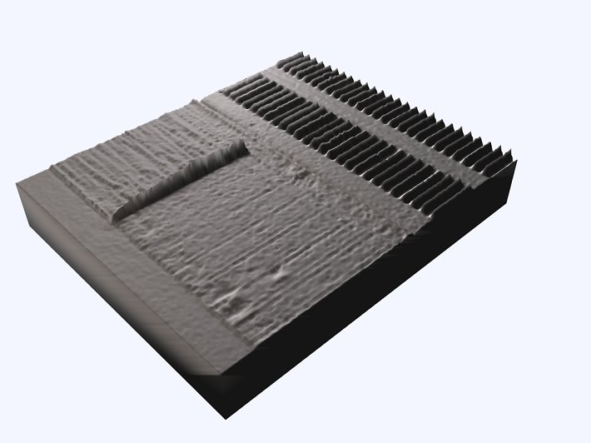
Fig. X.Y – Rendering of magnetic field above a cassette tap. Courtesy of NIST and the FBI Audio Forensics Laboratory.
IV. Development of applications: vision for the future

Many uses for advanced sensors were put forward at the meeting. However, the point was made that only a few specific applications may drive a given technology to its ultimate potential. Given that consideration, the three main driver applications were identified. These applications fit in the general areas of homeland security and health care, and are therefore good matches with NIST Strategic Focus Areas (SFA’s). Other identified applications also fit well with the Information Technology SFA, and are compatible with existing funded programs at NIST.
The general approach to this work will therefore be to focus on these areas of research. We will do this by identifying specific sensor technologies and materials systems that will enable the driver technologies.

