⁻Meson Test Beam Facility
Shielding Analysis - MT6 User Areas

13 August, 2002
Erik Ramberg

Introduction and Method

This document summarizes calculations on radiation dose in the MT6 area of the Meson Test Beam Facility (MTBF) using the established Malensek/Tokarek methodology.

The MTBF is a dedicated test beam consisting of the MTest beamline and associated user areas in the Meson Detector. The new facility will run in 2002, for the first time, with 120 GeV Main Injector protons delivered onto the MTest target, and will allow for the transport of a fraction of these protons to the user areas. The beamline can also deliver secondary particles at a lower momentum. These secondaries are produced and transported at a significantly lower flux, so the dominant safety considerations are for running with the primary proton beam.

The standard for evaluating radiation safety of enclosures was established in a note by Malensek and Tokarek entitled “Experimental Halls Methodology” and dated 6/12/91. It assumes a beam incident on a 90 cm long, 15 cm radius block of steel. To determine the radiation dose from this source, they give the formula:

Dose(mr/pulse) = I * (1x10⁻³) * (1x10⁻²) * (E/1000.)^{0.8} * (0.5/d)² * 10^{(-t/T)}

where I is the incident hadron intensity, E is the incident hadron energy, d is the distance from the center of the beamline to the point of interest, t is the thickness of any intervening material other than air, and T is the tenth value of the intervening material. The factors (1x10⁻³) and (1x10⁻²) are the mrem/star and star density, respectively. The tenth value for concrete is 2.6 feet and the tenth value for steel is 1.0 feet.

The above formula is used for dosages at locations transverse to the beam. To estimate radiation dosage rates directly downstream of a beam stop, I have simulated the stop in a standalone GEANT program and determined dosage rates in a 100 kg rectangle of water directly behind the stop for an incident proton beam at normal incidence.

For this analysis we then calculate the maximum allowed proton intensity I, at the MT6 user areas, for steady state running conditions such that this will satisfy the acceptable counting room dose rate of 0.25 mrem/hr for all continuously occupied areas in MT6. Any areas exceeding this rate will be labeled as minimum occupancy. The single pulse accident rate is then calculated for this maximum intensity to ensure that it is below the acceptable value of 5 mrem/pulse.

Description of MT6 Areas

The MT6 area is sketched in Figure 1. It consists of two beamline enclosures where experimenters can place their equipment; the upstream one is labeled MT6A and the downstream, larger one is labeled MT6B. There is a herculite tent enclosure in each area. We have surrounded these beamline enclosures with 3 foot thick 7.5 foot high B-type concrete blocks to reduce radiation exposures in the continuously occupied control rooms. There is a small control room called the ‘alcove’ to the east of MT6A and a larger counting and control room inside a portakamp to the west of MT6B. There is a gas distribution support area to the west of MT6B that receives gas from lines originating from an ouside gas shed. There is a power supply room labeled MS4 directly to the west of MT6A, with one unshielded controlled access door leading into MT6A and one door leading outside to the gas shed area. There is a 9 foot steel movable beam stop between the MT6A and MT6B enclosures. There is a fixed 9 foot steel and 1.5 foot concrete fixed beam stop at the end of MT6B.

Delivery of Beam to MT6

The Main Control Room (MCR) will deliver 120 GeV Main Injector protons to the MTest target located in the M01 enclosure. The Mtest beamline elements after this target can then be tuned for either this primary 120 GeV beam (‘proton tune’) or for secondaries lower than 80 GeV (‘pion tune’). Since for the proton tune we cannot shield the user areas for the flux of protons coming from the Main Injector (minimally 1E11 protons/pulse), then by necessity we have installed a pinhole collimator in M03. With quadrupole magnets off, then the flux is reduced by a factor of approximately 1x10⁻⁵. Because the flux of secondaries surviving to the user areas for a momentum of 80 GeV or less is low enough, then the pinhole collimator is taken out of the beam for the pion tune. It is assumed for this note that the Mtest beamline will deliver a 1 second flattop resonantly extracted Main Injector beam every 3 seconds.

Results of Steady State Dose Rate Calculations

Using the formula above for dose calculation, we have sampled various places along the MT6 areas and determined what steady state dosages might be expected for a 1 MHz proton beam, given the assumption of a 1/3 duty factor for delivered beam. The 16 locations are shown in Figure 2. The dose rates are given in Table 1. This table also includes results from the Geant calculation for dose downstream of the beam plug. (A sample Geant event is shown in Figure 3.) From these calculations, it is evident that to not exceed .25 mrem/hr, we will require the MS4 room and the gas utility area to be a radiation area with minimal occupancy. The dose rates in these areas range from .29 mrem/hr to 4.0 mrem/hr. The highest rate outside of these areas is in the east alcove control room, where the dose rate is .26 mrem/hr. This means that we will require the beam delivered to the MT6 area to be limited to .96 MHz, for a 1/3 duty cycle, or 1.9 MHz for a 1/6 duty cycle, and so forth.

Table 1. Steady state dose rates for various regions in MT6 for 1 MHz 120 GeV proton beam at 1/3 duty cycle.

Results of Single Pulse Accident Dose Calculation

To calculate the single pulse accident dose, we use the maximum allowed beam rate in the SY120 project to be 2 x 10¹² . The transmission of protons through the Mtest target and collimator down to the MT6 user areas is calculated to be 1x10⁻⁵ in the proton mode. This means that if all the SY120 beam is delivered in one pulse to MT6, we receive
2 x 10⁷ protons. This is 20 times the intensity of the dose rates shown in Table 1, for
one second, compared to 1200 seconds in that table. That means the single pulse accident dose for each of the areas in MT6 is 1/60 of the hourly dose shown in the Table. The maximum single pulse accident dose is thus 0.07 mrem, in region M. This is well below the acceptable value of 5 mrem.

Conclusion

The MT6 area in the Meson Detector Building will operate as a test beam using the SY120 Main Injector beam. The layout of the area, including added shielding, is shown in Figure 1. We have calculated the dose rates at various areas around the MT6 area and have determined that the maximum allowed beam rate in MT6 is .96 MHz for a 1/3 duty cycle beam, or correspondingly higher rate for a lower duty cycle beam. (The dose rates are shown in Table 1 and Figure 2.) This allows both the main control room and the east alcove control room to be continuously occupied. The MS4 service area and the gas utility area will have to be labeled as minimum occupancy. The single pulse accident dose for a SY120 beam of 2 x 10¹² p/sec is well below acceptable limits.

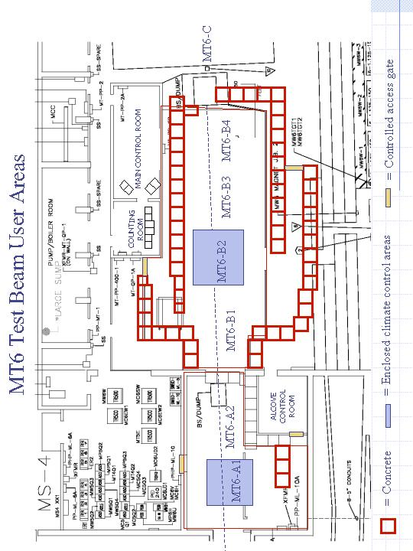
Figure 1. Layout and description of the MT6 test beam user areas.

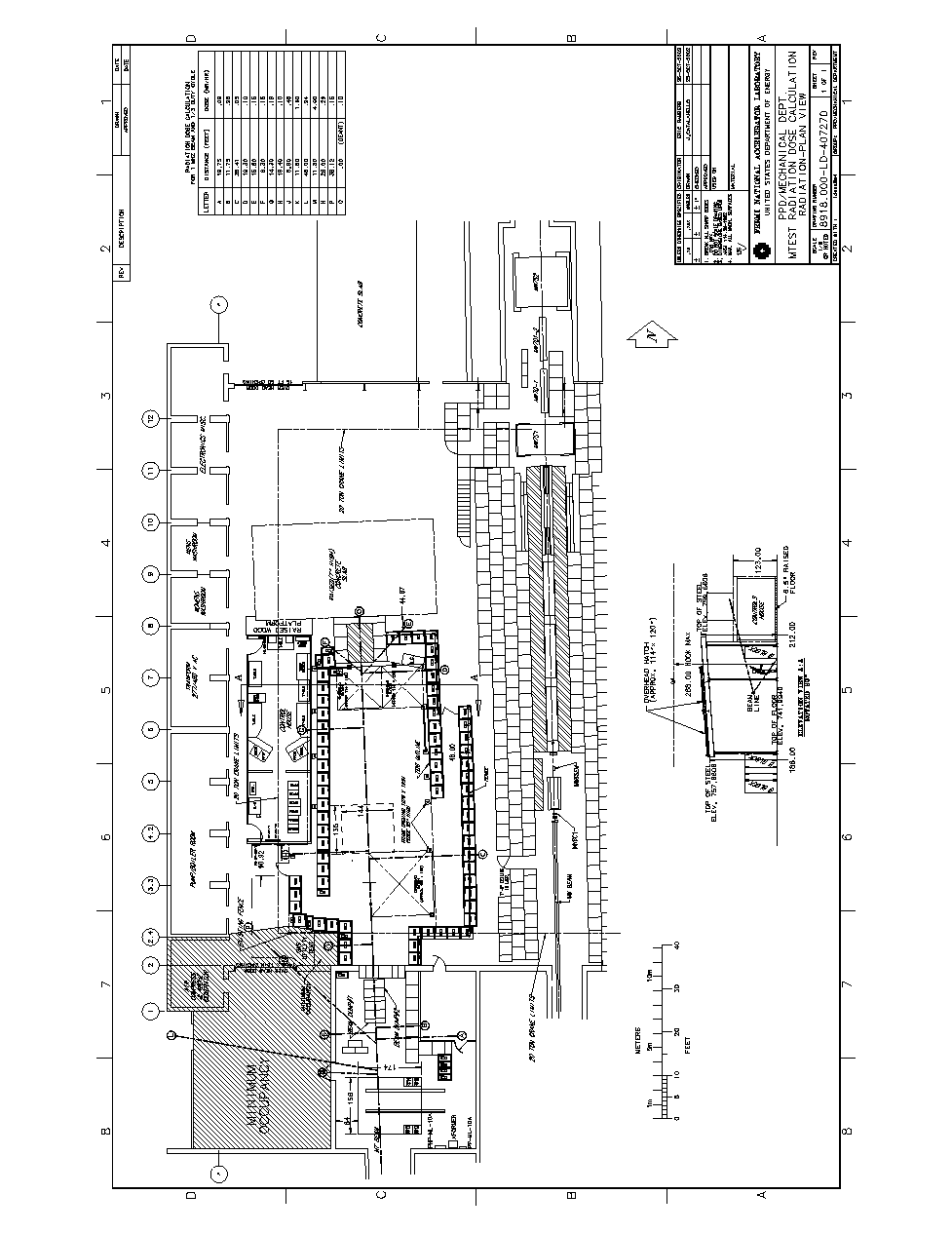

Figure 2. Areas in MT6 for which dose rates are calculated. Values are given in Table 1.
(This figure can be found on the test beam web site – http://www-ppd.fnal.gov/mtbf-w)

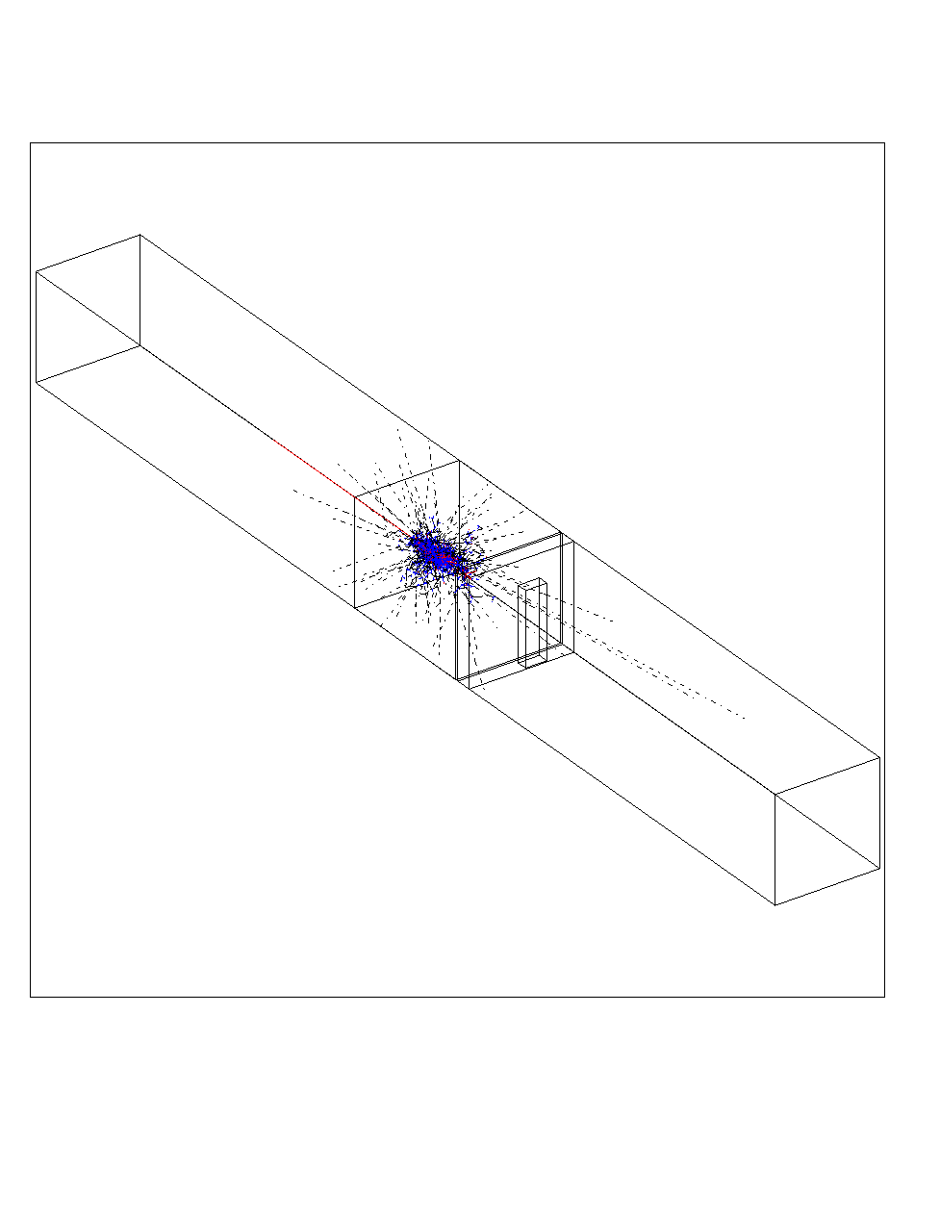

Figure 3. An example of a GEANT event used to calculate dose rates behind a beam stop.

