 National Pork Board

P.O. Box 9114 Des Moines, Iowa 50306 USA Phone: 515-223-2600 Fax: 515-223-2646

Division of Dockets Management (HFA-305)
Food and Drug Administration
5630 Fishers Lane, Room 1061
Rockville, MD 20852

August 8, 2004

RE: Federal Measures to Mitigate BSE Risk: Considerations for Further Action. Advanced Notice of Proposed Rulemaking, FDA Docket Number 2004N-0264, Federal Register Volume 69, Number 134, Wednesday, July 14, 2004, Pages 42288-42300.

The National Pork Board is pleased to have this opportunity to comment on the Advanced Notice of Proposed Rulemaking – Federal Measures to Mitigate BSE Risk. The National Pork Board is funded through the Pork Checkoff and represents over 70,000 pork producers in the United States. During 2003 nearly 25 billion pounds of pork were processed from approximately 129 million hogs. Annual farm sales typically exceed $11 billion, while the retail value of pork sold to consumers reaches $38 billion per year. The pork industry in the United States generates over $72 billion in total domestic economic activity. Additionally, the pork industry supports over 800,000 jobs and adds over $27 billion of value to basic production inputs such as corn and soybeans. Pork producers in the United States produce over 10% of the world’s hogs, and the United States is the second leading exporter of pork in the world.

The pork industry views food safety as a farm to fork continuum. The Checkoff’s pork safety objectives include:
- To assure the safety of U.S. Pork through coordinated science-based efforts throughout the pork chain.
- To ensure that producer interests are represented in food safety discussions.
- To improve product image domestically and internationally through communication of food safety practices.

FDA, in the Advanced Notice of Proposed Rulemaking (ANPR), is seeking public comment on additional measures under consideration to protect the public from health risks associated with BSE and to prevent the spread of the disease in U.S. cattle.

While this ANPRM is directed toward preventing the spread of disease in U.S. cattle, while protecting public health, the actions under consideration could have significant negative impact on the nation’s pork producers with no scientific basis that such broad actions will further enhance public health protection.

Prior to addressing the specific questions raised in the ANPRM, we will provide a brief review of the scientific body of knowledge regarding BSE and swine. Research conducted in Great Britain demonstrated that swine are resistant to BSE following oral exposure with large doses of infective material. In addition, no case of naturally acquired Transmissible Spongiform Encephalopathy (TSE) has ever been demonstrated in swine. The research is further strengthened by the fact that even at the height of the epidemic in cattle in the U.K. swine were not infected in spite of being exposed to the same feedstuff risk ingredients as the cattle. In addition, the Harvard Risk Assessment also indicated that there was no demonstrated transmission risk from pork. In summary, there is no evidence that pigs, or consumption of pork, contributes to the public health or animal health risk of BSE.

FDA has requested comments specifically on a series of questions regarding changes to the feed ban enacted in 1997 that were recommended in the report of the International Review Team (IRT).

It is important to note that the IRT report (p. 5) stated:
Unless aggressive surveillance proves the BSE risk in the USA to be minimal according to OIE standards, the (IRT) recommends that the SRM be excluded from the human and animal feed chains … In the mean time, until the level of BSE risk has been established the IRT concedes that the exclusion of CNS, skull, and vertebral column from cattle from cattle 30 months of age and older, and the small intestine and tonsils from cattle of all ages, from human food, including dietary supplements, and cosmetics is a reasonable temporary compromise. Many of the actions being presented in this ANPRM go well beyond the suggestion of what is reasonable by the IRT.

The National Pork Board would like to specifically comment on the questions posed under the heading All Mammalian and Avian Protein.

In response to Question 12: There is no scientifically justifiable reason to support banning porcine MBM in ruminant feed. As outlined in the Harvard Risk Assessment (Section 2, page 30) the hypothetical risk of feeding porcine MBM to ruminants would be through the potential for prions in the gut lumen to be recycled back to ruminants. Below is the discussion excerpted from the Harvard Risk Assessment that concludes that any such risk is minimal.

The following discussion outlines several factors suggesting that the potential is limited for BSE
to be recycled through the guts of pigs.

First, most pigs are not exposed to cattle-derived MBM because there are many other economical sources of protein. For example, in the U.S., soybean meal is usually the most economical source of high quality protein available for porcine diets. It is comparable to animal proteins in terms of the quality of its amino acid components and can be used as the only protein source in most swine diets.

Other sources of proteins fed to pigs include porcine MBM, peanut meal, fish meal, cottonseed meal, canola meal, sunflower meal, and raw soy beans. The amount of protein added to feed varies based on the specific needs of the animal as it grows. MBM, blood meal, and plasma can comprise between 2.5 and 5 percent of feed for pigs between weaning and 60 days of age and during the animal’s growing and finishing stages. Because it is not uniformly used, it is likely that approximately 80% of the pigs grown in the United States never receive MBM.

Second, even among pigs that do receive cattle-derived MBM, it is likely that little if any feed would remain in the GI system at the time of processing because pigs are usually sent to slaughter after restricting feed intake for 14 to 16 hours.

Third, due to the high water content of the GI tract, contents are unlikely to be rendered. Finally, if the gut contents are rendered, any BSE-contaminated material that does make its way back to cattle will have gone through rendering twice, thus providing an additional opportunity for infectivity to be destroyed by this treatment.

In response to Question 13: Since the hypothetical risk of porcine transmission of prions was due to the potential for them to be in the lumen of the gut and recycled back to ruminants in MBM if SRMs are excluded from ALL feeds, this hypothetical risk no longer exists.

In response to Question 14: Byproducts, such as offal, bone and other materials, represent over 20% of the weight of a market hog. The loss of market for this significant amount of material, as would occur if all mammalian proteins are prohibited from ruminant feed, would likely decrease the value of the hog causing economic hardship to the producer. In addition, by removing this source of protein from animal feeds, other protein sources such as soybean meal will see an increased demand, resulting in higher feed costs for pork producers. These negative consequences would occur without any scientific basis for the action.

The National Pork Board appreciates the opportunity to provide comment on the proposed changes in the FDA feed ban and continues to support decision-making based on sound science. While the proposed feed ban is intended to protect cattle from exposure to prions, there is the no sound scientific basis for the potential affects on pork producers.

Submitted by:
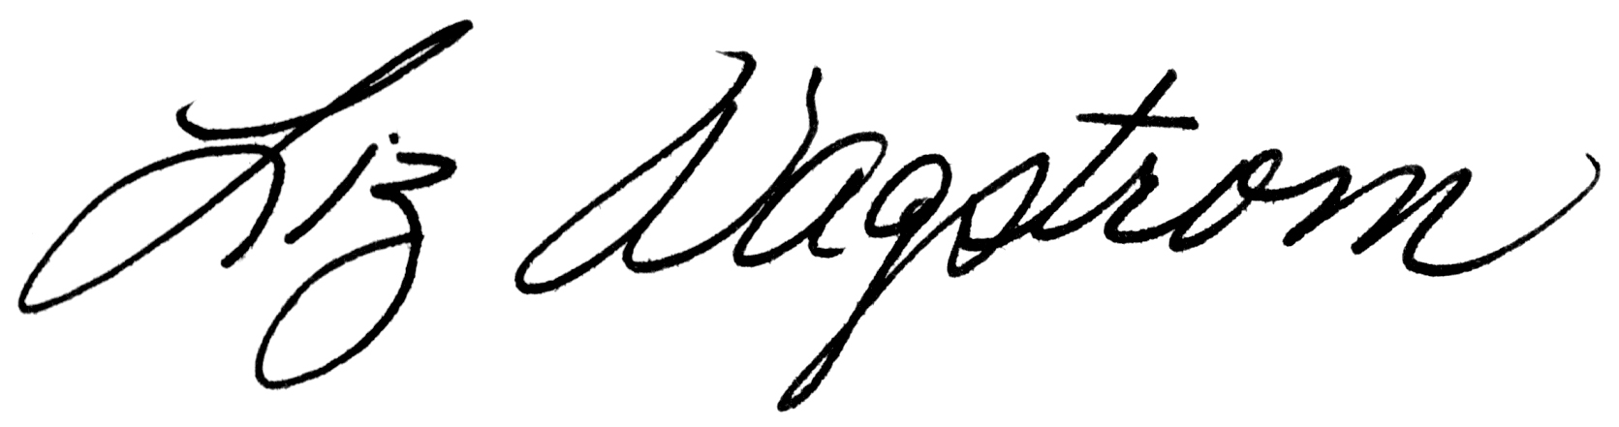
Liz Wagstrom, DVM, MS, DACVPM
Assistant Vice President, Veterinary Science

Reference Cited:

Wells GA, Hawkins SAC, Austin AR, et al. 2003. Studies of the transmissibility of the agent of bovine spongiform encephalopathy to pigs. Journal of General Virology, 84, pp. 1021-1031.
MAFF. 2000. MAFF BSE Information, htpp://www.maff.gov.uk/animalh/bse/index.html.
http://www.aphis.usda.gov/lpa/issues/bse/bse-riskassmt.html
Report on Measures Relating to BSE in the United States. htpp://www.aphis.usda.gov/lpa/issues/bse/BSE_tr_ban_ltr%20_enc_2.pdf

