Nandina
Habitat: Found sunny to shady areas in rich soil. It does not thrive in sandy soil.

Synonyms: heavenly bamboo

General Description: An evergreen or semi-evergreen woody shrub often used in landscaping.

Distinctive Characteristics: Its distinctive compound leaves which have lance shaped leaflets are held on multiple nonbranching stems. During the spring, large panicles of white flowers occur eventually developing into bright red berries.

Growth Habit: Shrub

Distribution: Found in the southeast from Florida to Virginia and west to Texas.

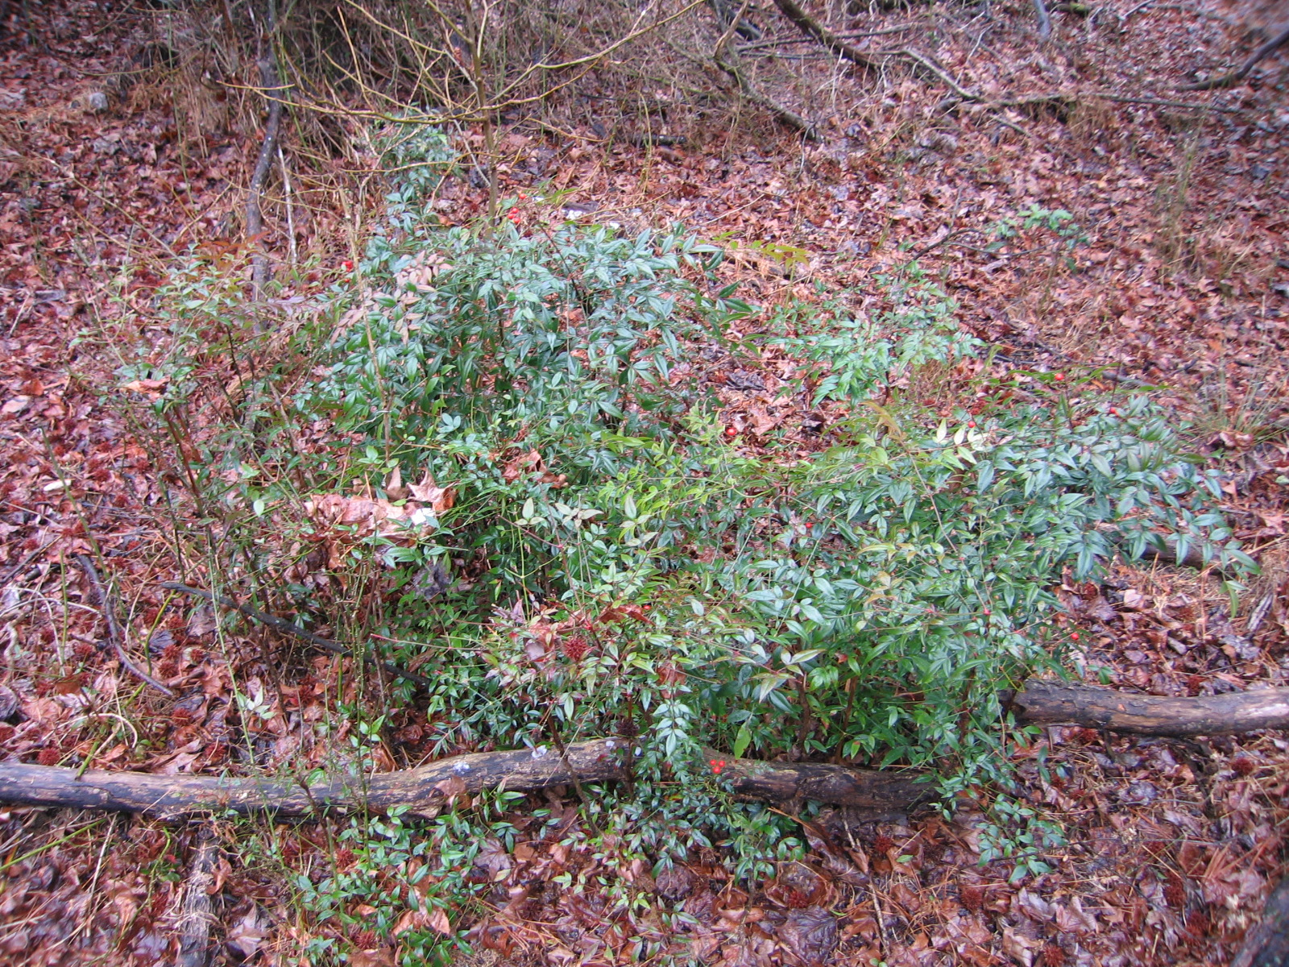
Nandina domestica
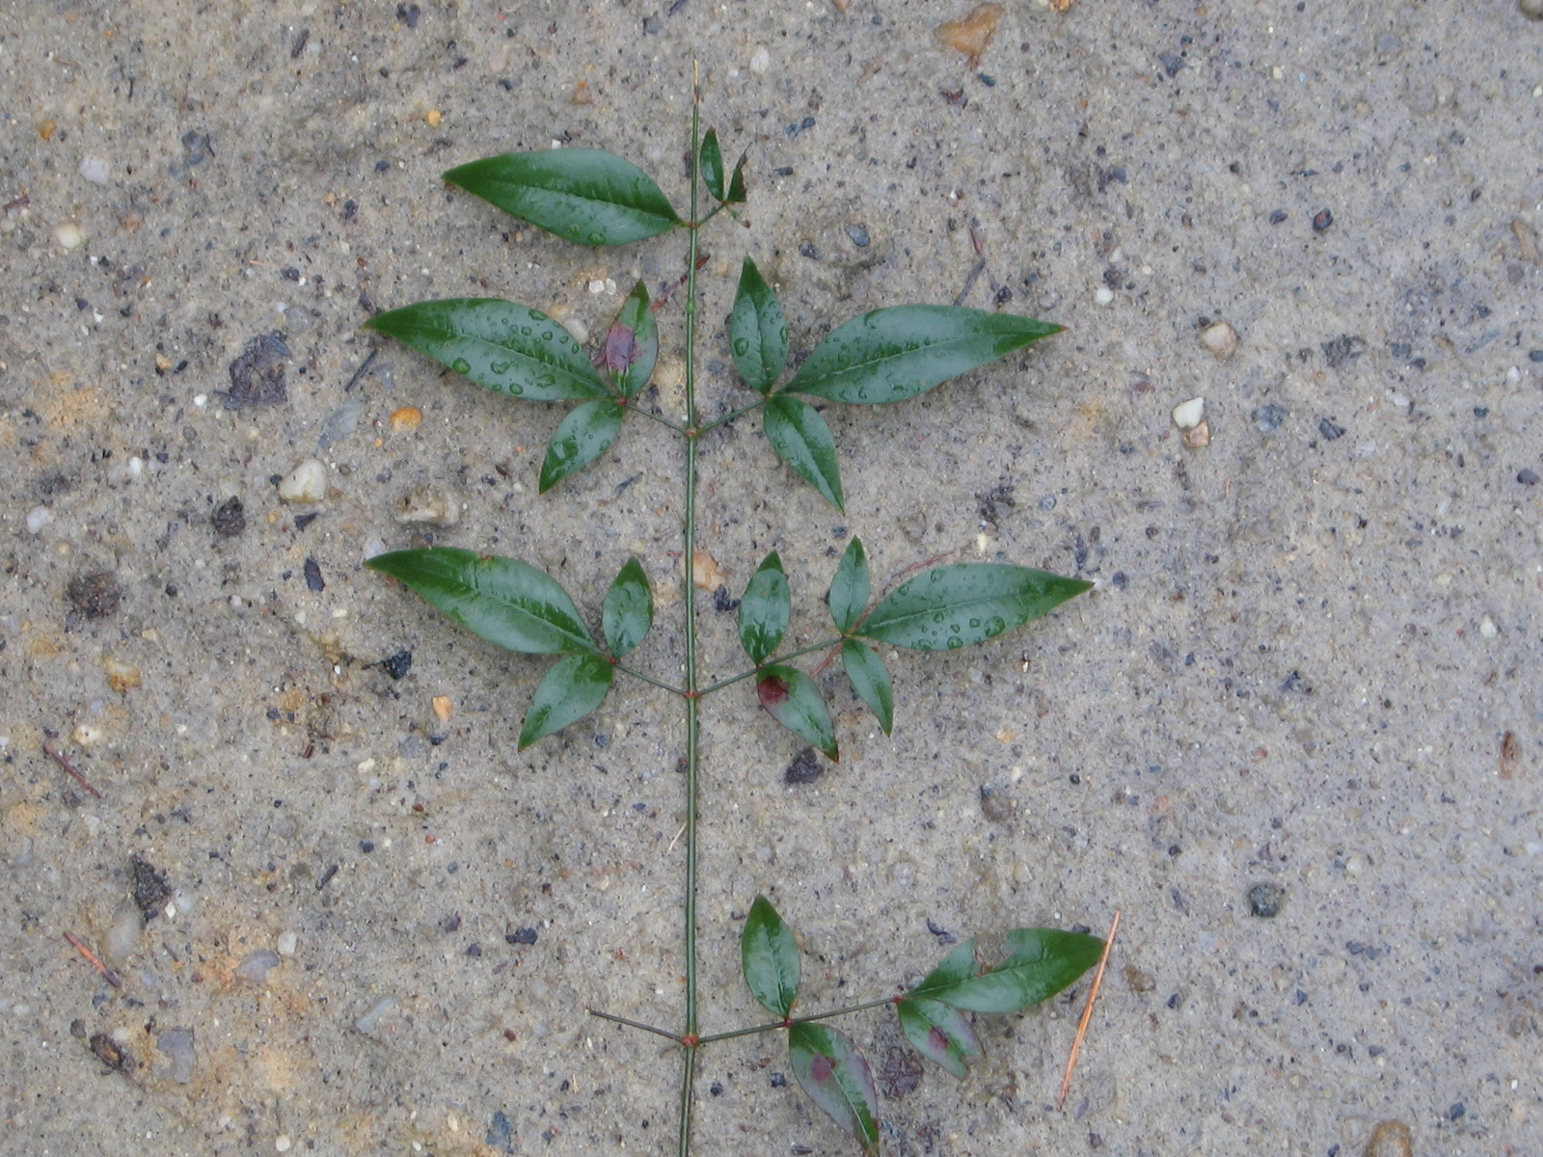

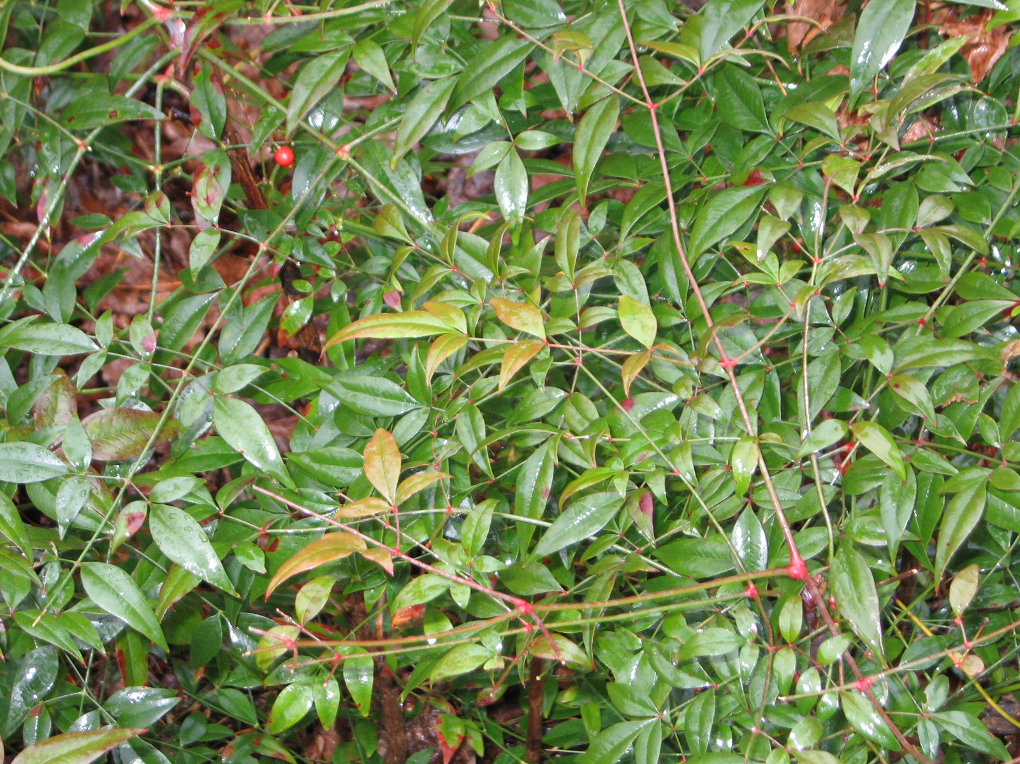
Family: Berberidaceae (Barberry Family)

