NIR breast cancer study(Case I)

Patient medical history: A 31-year-old pre-menopausal female felt a palpable lump in the upper quadrant of her left breast. Her baseline mammogram was performed on 11-08-05, HUP’s outside review of her films identified the palpable area along with a tiny cluster of calcifications.

A left breast core biopsy was performed on 11/11/2005, HUP’s review of outside pathology slides states “invasive poorly differentiated ductal carcinoma with associated intraductal carcinoma…”

NIR Device I
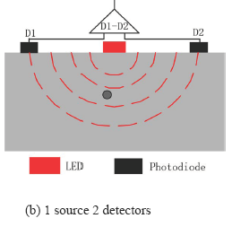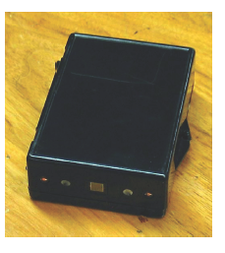
Fig. 1 1-Source 2- detector
This null plane will shift if there is a small object such as tumor exists, the blood volume and oxygen consumption of tumor will higher than normal tissue results in an inhomogeneous area. Therefore, the output signal of detector is the function of the of tumor’s location if the amplitude cancellation system scans around the tumor.
Fig. 2 The one wavelength scanner

Experimental Procedure and results

Scanner: Holding the scanner by hand, scanning from one side to the other side on both breasts. Red light on means touching the edge of the tumor, green light on later means leaving the edge of tumor in the other side.

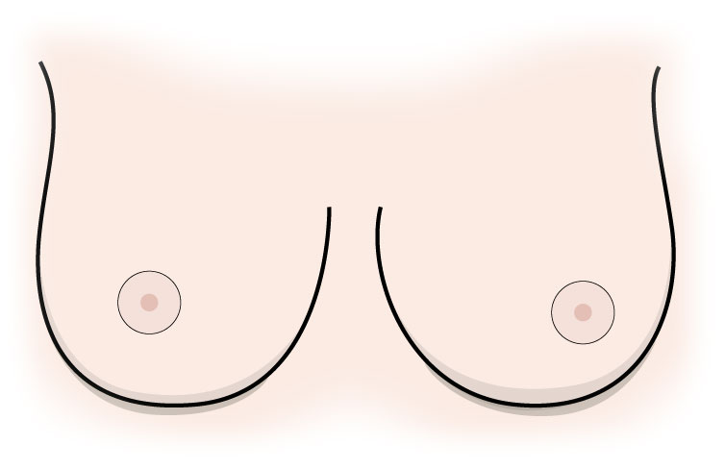
HEAD

TOE

assumptive lesion
Fig. 3 Scanner showing

Conclusion: Right breast has no NIR signal; Left breast has NIR signal at 1:00 as shown on Fig.3.

NIR device 2(Puck):

Basic method: Divided the breast into four quadrants:
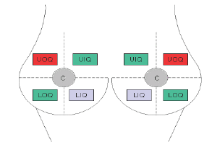
e.g.:
UOQ = upper/outer quadrant

muscle
UOQ
UOQ
UIQ
UIQ
LOQ
LOQ
LIIQ
LIIQ

Fig. 4 Illustration of breast quadrant

Put the puck on UOQ, UIQ, LOQ, LIQ(Fig.4), both breasts too.

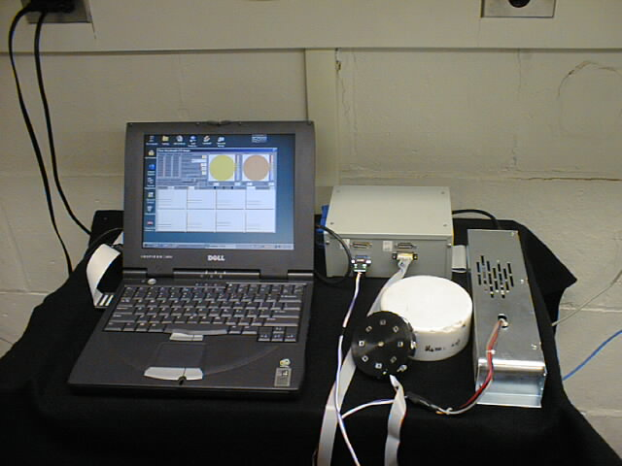
Power
Supply
Control Box
Probe with
LEDs and detectors
Laptop with
ADA board
Model

Fig. 5 LED imaging

Results:
The puck size is 3cm radius big. The breast size is 4cm radius maximum from the edge of nipple in supine position. So, put the probe on the nipple to cover the whole breast.

On the Left breast Upper outer Quadrant

1
2
%
JZ1
R
L
(a)
(b)

Fig. 6 Data plot of Left breast(a) and Illustration of probe location(b)

Left breast up inner quadrant, D2 has 3uM blood volume and -53% oxygenation.

Results fit to the published chart:
B. Chance, Shoko Nioka, Jun Zhang, et al. Breast cancer detection based on incremental biochemical and physiological properties of breast cancer: A six-year, two-site study, Acad Radiol. 2005 Aug; 12(8): 925-933.

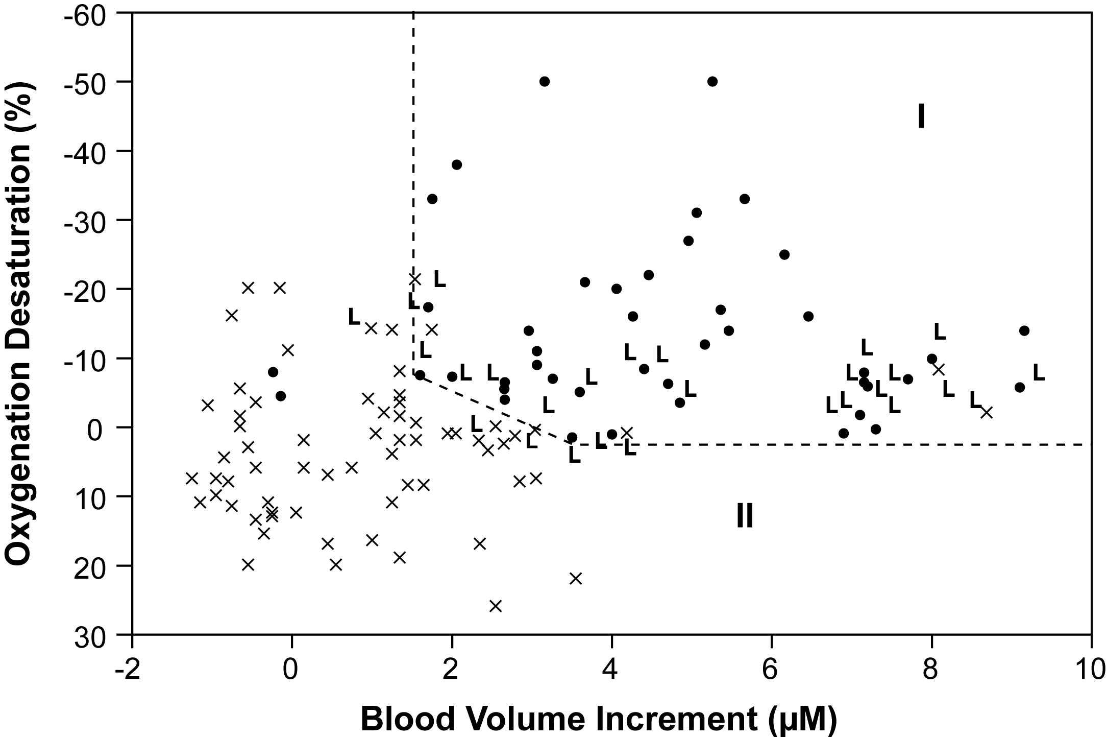
L
I
II

L-left breast; R-right breast; L-leipzig

A two-dimensional nomogram display of currently available NIR breast cancer data. The abscissa is relative increments of blood concentration in units of micromolar concentration change with respect to the average cancer-free value. The ordinate represents incremental change with respect to the average cancer-free value in percent change of hemoglobin saturation. The reference values (zero for saturations and blood volumes) are based on the contralateral cancer-free breast as represented by a congruence. The wavelengths are at 760 and 850 nm, and the incremental concentrations are appropriately processed for the weighted sum and difference quantities for blood concentration and saturation change, respectively, with 70% and 50 μM the reference points (0) for the two metrics. The data cover studies from 1997 to 2003. Verified cancers are indicated with a black dot and cancer-free breasts plotted with an X. Data from Leipzig are marked L, data from Philadelphia are not marked. The nomogram is divided into two parts, one containing the verified cancers (I) and the other containing the cancer-free breasts (II).

Red dot is from Fig. 6 which is suspicious lesion. It is on the left breast(L) 2:00, in zone I.

