CHAPTER 5 - Benefits Analysis Approach and Results

Synopsis

This chapter describes our initial analysis of the benefits associated with attaining the proposed National Ambient Air Quality Standard (NAAQS) for lead and the alternative standards outlined in Chapter 1. Benefits estimates will be revised and improved during development of the RIA for the final Pb NAAQS. The estimates outlined in this initial benefits analysis indicate that achieving a lower National Ambient Air Quality Standard (NAAQS) for lead from its current level of 1.5 μg/m³ maximum quarterly mean to one of the proposed alternative second maximum monthly mean values could result in significant reductions in adverse health effects due to reduced exposure from lead and fine particles (PM_{2.5}). We estimate a potential increase in intelligence quotient (IQ) points across the population (between 110,000 and 700,000) with the proposed alternative NAAQS under various assumptions, including baseline blood lead levels at 2002 levels.

This draft Regulatory Impact Analysis (RIA) seeks to estimate benefits for the year 2020; however this draft represents initial estimates using a 2002 baseline blood lead level, resulting in a possible overestimate of benefits in the year 2020. Prior to completion of the final draft, assumptions will be revisited and, to the extent technically feasible, EPA will update the baseline to reflect expected effects on blood lead levels from other lead rules and potentially from an anticipated decline in population blood lead levels.

This draft Regulatory Impact Analysis (RIA) provides illustrative estimates of the incremental costs and monetized human health benefits of attaining a revised primary lead (Pb) National Ambient Air Quality Standard (NAAQS) within the current monitoring network. Many of the highest-emitting Pb sources do not have nearby Pb-TSP monitors, and it is important to note that there may be many more potential nonattainment areas than have been analyzed in this RIA. Because of time and data constraints, in this draft RIA, estimates of costs and benefits employed different techniques for estimating future air quality. This results in benefits estimates that represent full attainment, and cost estimates that do not represent full attainment. These differences will be addressed in the final RIA, and further improvements to estimation techniques will be explored.

It should be noted again that overall data limitations are very significant for this analysis. One critical area of uncertainty is the limited TSP-Pb monitoring network (discussed in chapter 2). Because monitors are present in only 86 counties nationwide, the universe of monitors exceeding the various target NAAQS levels is very small; only 36 counties above 0.05 ug/m3, and only 24 counties exceeding the lowest proposed NAAQS level of 0.10 ug/m3. Because we know that many of the highest-emitting Pb sources in the 2002 NEI do not have nearby Pb-TSP monitors (see section 2.1.7), it is likely that there may be many more potential nonattainment areas than have been analyzed in this RIA. We should also emphasize that these benefit estimates are based on controlling Pb emissions using hypothetical control strategies, assuming no technological advances in emission control technology. As noted in the discussion of uncertainties below, the benefit and cost methods employed different air quality modeling techniques, which resulted in inconsistencies between the two values; that is, for certain standard alternatives the benefits and costs were estimated assuming different air quality changes.

As shown in Table 5-1 below, when applying a 3 percent discount rate, these IQ point benefits translate into monetary benefits for the least stringent standard alternative (0.5 μg/m³) ranging between $1 and $1.4 billion (all values in 2006$). If blood levels continue to the observed decline, benefits could be lower. For the most stringent standard alternative (0.05 μg/m³), monetary benefits range from $6.1 to $8.7 billion. Additional co-control benefits of reduced PM emissions are expected to range between $0.2 and $1.3 billion for the least stringent standard alternative, up to a range of $1.1 to $8.9 billion for the most stringent standard alternative. Therefore, the combined monetized health benefits from reductions in both lead and PM exposures as a result of lowering the current NAAQS range from $1.1 to $2.7 billion for the least stringent standard alternative, up to a range of $7.2 to $18 billion for the most stringent standard alternative.

When applying a 7 percent discount rate, the monetary benefits for changes in IQ the least stringent standard alternative (0.5 μg/m³) range between $0.1 and $0.2 billion. For the most stringent standard alternative (0.05 μg/m³), monetary benefits of IQ gains range from $0.8 to $1.5 billion. Additional co-control benefits of reduced PM emissions are expected to range between $0.1 and $1.1 billion for the least stringent standard alternative, up to a range of $1.0 to $8.0 billion for the most stringent standard alternative. Therefore, the combined monetized health benefits from reductions in both lead and PM exposures as a result of lowering the current NAAQS range from $0.3 to $1.4 billion for the least stringent standard alternative, up to a range of $1.8 and $9.5 billion for the most stringent standard alternative.

Table 5-1. Monetary Benefits of Alternate Lead NAAQS (in Millions of 2006$) in 2020
Standard Alternative¹ | Estimated Net Present Value of IQ Points Gained²³ |  | Monetized Benefits of Co-Controlled PM_{2.5} Emissions⁴ |  | Total Benefits⁵
Standard Alternative¹ | 3% Discount Rate | 7% Discount Rate | 3% Discount Rate | 7% Discount Rate | 3% Discount Rate | 7% Discount Rate
0.5 μg/m³ | $970 - $1,400 | $120 - $240 | $150 - $1,300 | $140 - $1,100 | $1,100 - $2,700 | $260 - $1,400
0.3 μg/m³ | $1,700 - $2,500 | $220 - $430 | $410 - $3,500 | $380 - $3,100 | $2,200 - $6,000 | $600 - $3,500
0.2 μg/m³ | $2,500 - $3,500 | $310 - $610 | $560 - $4,700 | $520 - $4,300 | $3,000 - $8,200 | $830 - $4,900
0.1 μg/m³ | $3,900 - $5,500 | $480 - $950 | $690 - $5,800 | $640 - $5200 | $4,600 - $11,000 | $1,100 - $6,200
0.05 μg/m³ | $6,100 - $8,700 | $760 - $1,500 | $1,100 - $8,900 | $970 - $8,000 | $7,100 - $18,000 | $1,700 - $9,500
¹ All standard alternatives are for a second maximum monthly mean concentration.
² Results reflect the use a 2002 derived non-air background blood lead applied to analysis year of 2020. To the extent that state and federal interventions such as the Renovation and Repair Rule (EPA, 2008c) reduce future non-air blood lead levels, the estimate of IQ change above may be overstated.
³ The lower end of the range of presented values was calculated using the Schwartz (1994b) valuation estimate; the upper end was calculated using the Salkever (1995) valuation estimate.
⁴ The range of presented values represent 14 different estimates from the PM epidemiological literature and an expert judgment study.
⁵ Numbers are rounded to two significant figures. Therefore, the sums in these columns may not total.

Figures 5-1 and 5-2 below display the health benefits from both lead and PM_{2.5} exposure reductions for each of the four alternative standards using a 3 percent and 7 percent discount rate, respectively. Figures 5-3 and 5-4 below display some examples of the total health benefits from both lead and PM_{2.5} exposure reductions using different input assumptions for each of the four alternative standards using a 3 percent and 7 percent discount rate, respectively.
Figure 5-1. Lead and PM _{2.5} Benefits by Standard Alternative
(3% Discount Rate)
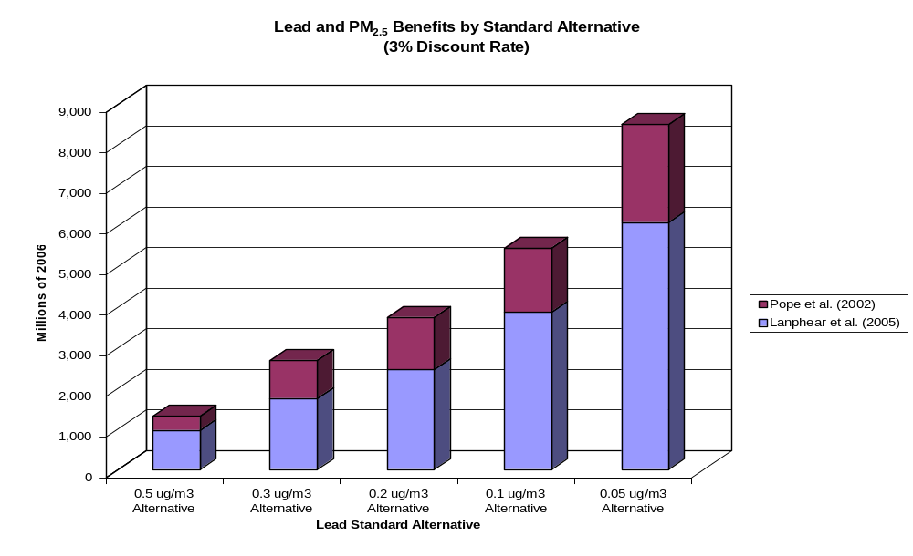

Figure 5-2. Lead and PM 2.5 Benefits by Standard Alternative
(7% Discount Rate)

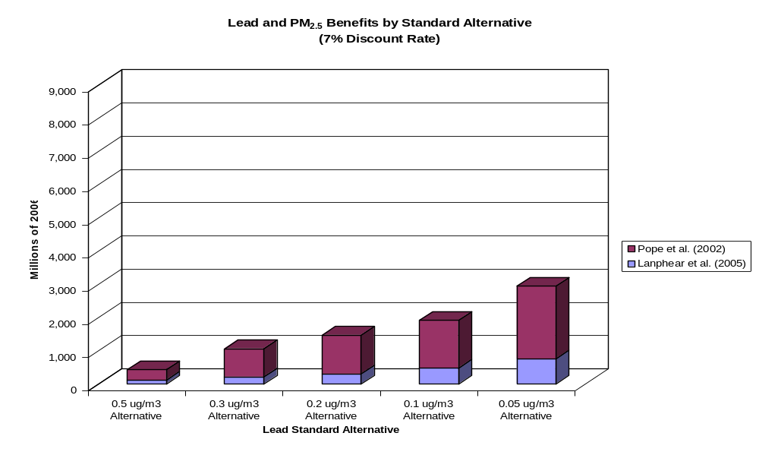

Figure 5-3. Example Combined Lead and Total PM_{2.5} Monetized Benefits Estimates by Standard Alternative (3% Discount Rate)

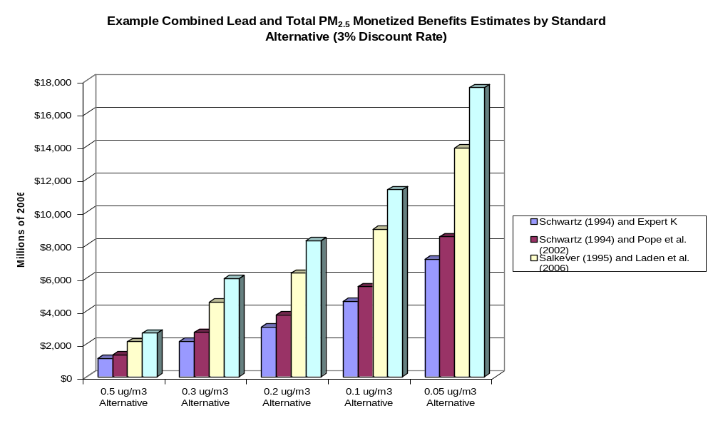

Figure 5-4. Example Combined Lead and Total PM_{2.5} Monetized Benefits Estimates by Standard Alternative (7% Discount Rate)
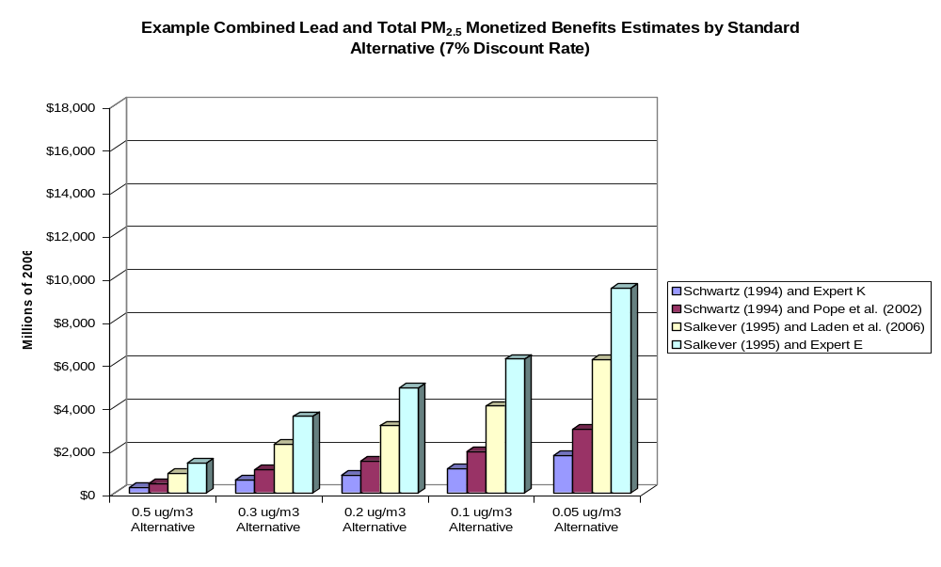

Introduction

This chapter documents our analysis of health benefits expected to result from achieving alternative levels of the lead NAAQS, relative to base case ambient air lead levels. We first describe our approach for estimating and monetizing the health benefits associated with reductions of lead in air. Next, we provide a summary of our results, including an analysis of the sensitivity of the benefits model. We then review our approach to and results from estimating benefits from co-control of direct PM_{2.5} emissions associated with implementing measures necessary to achieve alternative levels of the proposed lead NAAQS. Finally, we discuss the key results of the benefits analysis and indicate areas of uncertainty in our approach.

Benefits Approach

This section presents our approach for estimating avoided adverse health effects in humans resulting from achieving alternative levels of the lead NAAQS, relative to a base case ambient air lead level. We first review the epidemiological evidence concerning potential health effects of lead exposure and present the health endpoints we selected for our primary benefits estimate. We then describe our screening-level spreadsheet benefits model, including the data used and key assumptions. Finally, we describe our approach for assigning an economic value to the health benefits.

Benefits Scenario

We calculated the economic benefits from annual avoided health effects expected to result from achieving alternative levels of the lead NAAQS (the “control scenarios”) in the year 2020. We measured benefits in the control scenarios relative to the incidence of health effects consistent with ambient lead levels in air expected under the current standard (1.5 μg/m³ maximum quarterly mean; the “base case”) in 2020. Note that this “base case” reflects emissions reductions and ambient air quality improvements that we anticipate will result from implementation of other air quality rules, including compliance with all relevant Maximum Achievable Control Technology (MACT) rules and the recently revised NAAQS for PM_{2.5}. We compared benefits across four alternative second maximum monthly mean NAAQS levels of 0.5, 0.3, 0.2, 0.1, and 0.05 μg/m³.

Selection of Health Endpoints

Epidemiological researchers have associated lead exposure with adverse health effects in numerous studies, as described in the Air Quality Criteria for Lead (USEPA, 2006a; hereafter, Lead Criteria Document). Young children are particularly sensitive to lead exposures; neurobehavioral effects of lead exposure in infants and young children (less than 7 years of age) have been observed consistently across multiple studies that control for an array of confounding factors (USEPA, 2006a).

The Criteria Document provides a comprehensive review of the current evidence of health and environmental effects of Pb. With regard to health effects, the Criteria document summarizes the evidence as follows (CD, Section 8.4.1):
“…Pb has been shown to exert a broad array of deleterious effects on multiple organ systems via widely diverse mechanisms of action. Truly remarkable progress has been made during the past several decades with regard to (a) more fully delineating over time the wide variety of pathophysiologic effects associated with Pb exposure of human population groups and laboratory animals and (b) the characterization of applicable exposure durations and dose-response relationships for the induction of the multifaceted Pb effects. This progress has been well documented by the previous Pb NAAQS criteria reviews carried out by EPA in the late 1970s and during the 1980s, as well as being well reflected by previous chapters of this document.
The 1977 Lead AQCD (U.S. Environmental Protection Agency, 1977) that provided key scientific bases for the setting in 1978 of the current Pb NAAQS included discussion of both: (a) historical literature accumulated during several preceding decades that established Pb encephalopathy and other signs and symptoms of persisting severe central and/or peripheral nervous system damage, as well as renal and hepatic damage, and anemia as typifying the classic syndrome of acute and/or chronic high-level Pb poisoning among human pediatric and /or adult population groups, and (b) evaluation of then newly-emerging evidence for more subtle and difficult-to-detect “subclinical” Pb effects on IQ, other neurological endpoints, and moderate blood hemoglobin deficits or other erythropoietic indicators of heme synthesis impairment, which collectively were judged to constitute an array of adverse Pb health effects associated with Pb exposures indexed by blood Pb concentrations ranging down to ~30 µg/dL. The next Pb NAAQS criteria review during the 1980's, as contained in the 1986 Lead AQCD/Addendum and its 1990 Supplement (U.S. Environmental Protection Agency, 1986a, b, 1990) documented further rapid advances in Pb health effects research that provided (a) increasingly stronger evidence that substantiated still lower fetal and/or postnatal Pb-exposure levels (indexed by blood-Pb levels extending to as low as 10 to 15 µg/dL or, possibly, below) as being associated with slowed physical and neurobehavioral development, lower IQ, impaired learning, and/or other indicators of adverse neurological impacts and (b) other pathophysiological effects of Pb on cardiovascular function, immune system components, calcium and vitamin D metabolism, and other selected health endpoints.

Newly available scientific information published since the 1986 Lead AQCD/Addendum and the 1990 Supplement, as assessed in previous chapters of this document, further expands our understanding of a wide array of Pb-induced health effects, underlying mechanisms, and factors that enhance or lessen susceptibility to Pb effects. Very importantly, the newly available toxicologic and epidemiologic information, as integrated below, includes assessment of new evidence substantiating risks of deleterious effects on certain health endpoints being induced by distinctly lower than previously demonstrated Pb exposures indexed by blood-Pb levels extending well below 10 µg/dL in children and/or adults.
The ensuing subsections [of the CD] provide concise summarization and integrative synthesis of the most salient health-related findings and conclusions derived from the current criteria assessment. This includes discussion of new toxicologic and/or epidemiologic evidence concerning Pbinduced (a) effects on neurobehavioral development and other indicators of nervous system effects; (b) cardiovascular effects; (c) heme synthesis effects; (d) renal effects; (e) immune system functions; (f) effects on calcium and vitamin D metabolism; (g) inter-relationships to bone and teeth formation and demineralization; (h) effects on reproduction and other neuroendocrine effects; and (i) genotoxicity and carcinogenic effects.”

The differing evidence and associated strength of the evidence for these different effects is described in detail in the Criteria Document. The evidence with regard to adverse effects on plants and animals is also described in the Criteria Document.

Although a number of adverse health effects have been found to be associated with lead exposure, this benefits analysis only includes a subset, due to limitations in understanding and quantifying the dose-response relationship for some of these health endpoints and the fact that for some of these endpoints the science is less certain. We analyzed only those endpoints with sufficient evidence to support a quantified dose-response relationship. This determination was made using the information presented in the Lead Criteria Document, which contains an extensive literature review for several health endpoints related to lead exposure. However, this document only included studies published or accepted for publication through December 2005. Therefore, we performed supplemental searches in the online search engine PubMed to identify studies published between January 2006 and the present (see Appendix A for more information). Finally, we reviewed previous EPA lead benefits analyses to identify dose-response relationships that have been used previously (USEPA, 1997, 2006b & 2007a).

Our analysis focuses primarily on children’s health effects due to our use of child-specific data to convert air quality data to a blood lead level, which is the most common biomarker of exposure used in dose-response functions.

This human health benefits analysis does not attempt to estimate the changes in lead-related health effects among adults. Several key data limitations prevented EPA from quantifying these important endpoints:
- The available peer reviewed air:blood ratios to estimate adult blood lead changes are dated. Previous EPA analysis of the costs and benefits of the Clean Air Act (USEPA, 1997) utilized air:blood ratios for adults from based on Snee et al. (1981), a meta-analysis of several studies, including Johnson et al..(1976), Fugas et al.(1973), and Nordman (1975). While these studies do provide insight into the responsiveness of adult blood lead levels to changes in lead concentrations in air, the age of these studies suggests that these ratios may not be appropriate for application in 2020. The more-recent peer-reviewed estimates of air:blood ratios have been derived for children.Applying these ratios to adults would be inappropriate given the important differences between the two populations in their ambient exposure to Pb.

- There is a lack of current, peer reviewed non-air-related blood lead background estimates for adults. Quantification of adult endpoints would require a non-air-related blood background for adults. CASAC recommends a range of values for children in their review of the Lead Risk Assessment. However, due to differences between adults and children in the routes of exposure to lead, it is possible that background levels would differ between these two receptor groups. Therefore, applying the child-specific non-air-related background blood lead levels to adults could mis-estimate the true adult background levels.

- The adult health impact functions relating changes in blood lead to health outcomes are dated. Certain adult health impact functions, such as those quantifying the relationship between blood lead and diastolic blood pressure (Nawrot, 2002) are current. However, the functions relating changes in blood pressure to changes in premature mortality, chronic heart disease and stroke were each drawn from studies published in the 1970’s; advances in the treatment of high blood pressure suggest that these functions may over-predict of changes in these health effects in the current population. One newer study, Schober et al. (2006), quantifies the relationship between blood lead and cardiovascular mortality. However, according to the Lead Criteria Document, “…until the Schober et al. findings are replicated and more fully understood, the Schober et al. (2006) estimates for Pb-induced cardiovascular mortality should probably not be used for quantitative risk assessment” USEPA, 2006a, page 8-89.

Taken together, these data limitations make a credible quantified assessment of adult endpoints very challenging and subject to considerable uncertainty. The Agency is working to addressing these data limitations so that it may be possible to provide a quantitative estimate of the adult endpoints for the next Pb NAAQS review in approximately 5 years. In the final RIA EPA will include a more detailed discussion of the types of information and data that would improve its ability to provide quantitative health benefit estimates for adults.
Table 5-2 below presents the health effects related to exposure to lead in the air that are quantified in this benefits analysis. In addition, the table includes a list of other endpoints that potentially are linked to lead exposure, but which do not have dose-response functions available for quantifying benefits.

As shown in Table 5-2, our primary estimate is based on the effect of IQ loss on lifetime earnings. There are several recent epidemiological analyses that have found potential adverse health impacts of blood lead levels on cognitive function (most often measured as changes in IQ) in young children under 7 years of age, as described in the Lead Criteria Document. However, as also noted in that document, there has been conflicting evidence as to whether there exists a discrete period of neurological vulnerability to lead exposure during childhood.

For instance, the first three years of life represent the maximal period of lead ingestion as well as a period of time when important development of the central nervous system is occurring, which suggests that biologically, this could be a vulnerable period (USEPA, 2006a). In addition, there are two major meta-analyses that focused on the association between school age IQ and blood lead concentrations at two years of age or average blood lead concentrations up to three years of age (Pocock et al, 1994; Schwartz, 1994a). However, several recent prospective epidemiological studies have found concurrent blood lead level (i.e., blood lead measured at the same time as school age IQ) or lifetime average blood lead level (i.e., a mean of blood lead level from infancy to measurement of school age IQ) to be more strongly associated with school age IQ and other measures of neurodevelopment (Canfield et al., 2003; Dietrich et al, 1993; Tong et al. 1996, Wasserman et al., 2000). In addition, a large, international meta-analysis by Lanphear et al. (2005) included four measures of blood lead level: concurrent, peak, lifetime average, and early childhood. The authors found that the concurrent and lifetime blood lead levels were the strongest predictors of IQ deficits associated with lead exposure.

A study by Chen et al. (2005) specifically evaluated whether a window of enhanced susceptibility to lead exists. This study examined whether cross-sectional associations observed in school age children represent residual effects from two years of age or “new” effects emerging among these children (USEPA, 2006a). Chen et al. found that the blood lead metric with the strongest association with IQ was concurrent, and this relationship grew stronger with age. The authors did not find any association between peak blood lead level and IQ measured at seven years of age. In addition, a stronger relationship was found between IQ at seven years of age and blood lead level at seven years of age compared with blood lead at two years of age. The Lead Criteria Document concluded that “[t]hese results support the idea that lead exposure continues to be toxic to children as they reach school age, and do not lend support to the interpretation that all damage is done by the time the child reaches two to three years of age” (USEPA, 2006a, page 6-63). Based on this evidence, it is reasonable to assume that all children under seven years of age in the study area for this analysis will experience some cognitive benefit (i.e., IQ loss avoided) from reduced ambient air lead in 2020. Therefore, we have designed our benefits analysis to measure benefits to all children under seven in our study area.

Table 5-2. Human Health Effects of Lead
Quantified Health Effects | Unquantified Health Effectsª
-Intelligence Quotient (IQ) loss effect on lifetime earnings | -Other neurobehavioral and physiological effects  -Delinquent and anti-social behavior  -IQ loss effects on compensatory education  -Hypertension  -Non-fatal coronary heart disease  -Non-fatal strokes  -Premature mortality  -Other cardiovascular diseases  -Neurobehavioral function  -Renal effects  -Reproductive effects  -Fetal effects from maternal exposure (including diminished IQ)
ª The categorization of unquantified toxic health effects is not exhaustive. Health endpoints in this column include both a) those for which there is not consensus; and b) those for which associations, to various degrees, has been determined but empirical data are not available to allow calculation of benefits.

Benefits Estimation Model

Overview

For this benefits analysis, we created a spreadsheet model to provide a screening-level assessment of health benefits occurring as a result of implementing alternative NAAQS levels. The model uses various simplifying assumptions and is intended only to provide an approximate, preliminary estimate of the potential health benefits. EPA plans to refine the model as it progresses towards a final NAAQS level for lead.

The model was constructed in Microsoft Excel™ and provides an integrated tool to complete five benefits estimation steps: 1) estimate lead in air concentrations for the “base case” and “control scenarios”; 2) estimate population exposures to air lead concentrations for each scenario; 3) estimate blood lead levels in the population for each scenario; 4) estimate avoided cases of health effects due to changes in blood lead levels; and 5) apply an economic unit value to each avoided case to calculate total monetized benefits. These steps and the data inputs required are shown in Figure 5-5 and are discussed in further detail below.

Estimating Lead in Air Concentrations

We used estimates of the second maximum monthly mean lead total suspended particles (TSP) for each monitor included in our study to characterize ambient air lead concentrations for the “base case” in 2020 (USEPA, 2007b). These estimates were calculated by adjusting second maximum monthly mean lead TSP monitoring values for the years 2003 to 2005 to account for emissions reductions due to compliance with MACT requirements and the NAAQS for PM_{2.5} occurring by 2020 (see Chapter 4 for additional information). We assumed that under the “control scenario,” every monitor would meet the alternative NAAQS in 2020 and therefore, assigned the proposed alternative NAAQS level as the second maximum monthly mean to all monitors.

The benefits model used estimates of maximum quarterly mean lead concentrations in order to calculate avoided cases of health endpoints. This decision was based on a number of studies outlined in EPA’s 2007 Staff Paper (USEPA, 2007c; Section 5.5.2), which indicate that changes in blood lead levels resulting from changes in air lead concentrations occur within a relatively short timeframe (i.e., within a few weeks to months). This finding is also supported by a simulation of changes in urban residential dust lead levels following a change in ambient air lead using the hybrid mechanistic empirical model developed for the Lead Risk Assessment. That analysis showed that changes in indoor dust lead levels (the primary source of children’s exposure) tracked closely with changes in ambient lead air concentrations. The hybrid model developed for the general urban case study suggested that 90% of steady-state impacts will be recognized within the three months and take up to one year for a full change to be realized.

Figure 5-5

OVERVIEW OF LEAD BENEFITS MODEL
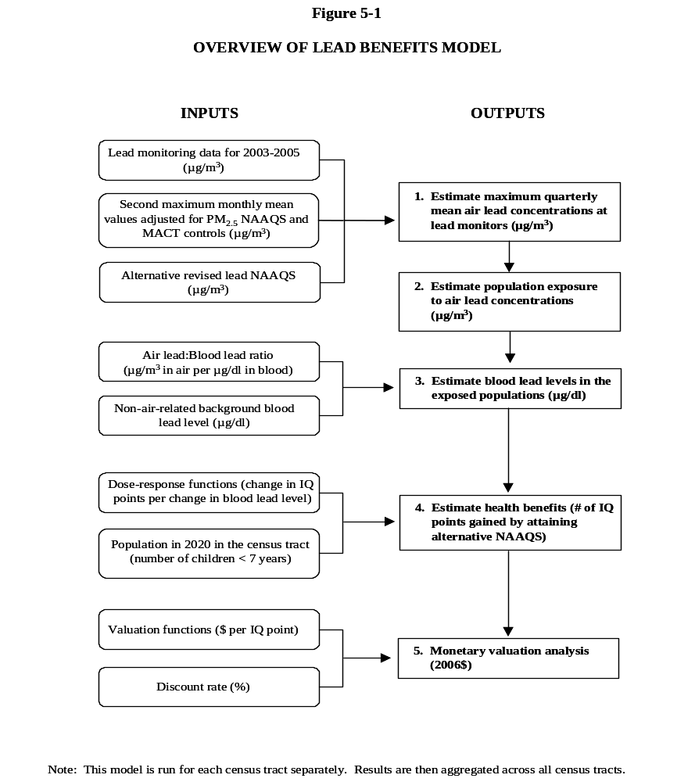

Therefore, for the “base case” estimates of lead air concentrations used in the model, we estimated the expected maximum quarterly mean air lead concentration in 2020 at each monitor based on the second maximum monthly mean values for the “base case.” This was achieved by calculating monitor-specific ratios of the second maximum monthly mean to the maximum quarterly mean for the period 2003-2005 and then dividing the second maximum monthly mean for the “base case” by this ratio.

For the “control scenario” we estimated the maximum quarterly mean lead in air concentration that would be expected in 2020, based on the second maximum monthly mean NAAQS concentration. As in the “base case,” we used monitor-specific ratios of the second maximum monthly means to maximum quarterly means for 2003-2005 and then divided the selected NAAQS by this ratio.

Estimating Population Exposure

The first input to any benefits assessment is the estimated changes in ambient air quality expected to result from simulated attainment of a NAAQS. EPA typically relies upon air quality modeling to generate these data. For this analysis, time and technical limitations prevented us from performing formal air quality modeling. Instead, EPA employed two alternate approaches to approximate the air quality change resulting from attainment of alternate lead NAAQS. Each approach relies upon the lead monitoring network as the basis for subsequent air quality estimates. The first approach, which we employed to generate our primary benefits estimate, uses an interpolation method utilized in previous RIA’s to estimate changes in lead concentrations in projected non-attainment areas. The second approach, which we utilized as a sensitivity analysis, applies a radius of a fixed size around each non-attaining lead monitor and estimates a fixed concentration of lead within that radius. We describe the process for using each approach below.

Interpolation Method

This approach applies an interpolation method to generate an air quality surface from available lead monitoring data to better represent the spatial heterogeneity of lead concentrations in a projected non-attainment area. It utilizes both the lead monitoring network as well as the lead-speciating TSP monitoring network; we added the lead-speciating monitors to increase the number of data points available for the interpolation. We interpolated lead concentrations to the census tract, rather than census block group, to increase the computational efficiency of the model.

To create an air quality surface of ambient lead values we applied the Voronoi Neighborhood Averaging (VNA) method. The VNA is an inverse-distance-weighting technique that interpolates point monitor data to a user-defined grid cell for the purpose of creating an air quality surface. The VNA approach is well suited for this type of analysis because the inverse distance weighting approach can approximate the gradient of ambient lead surrounding each monitor. VNA is a well-established technique that EPA has used in combination with modeled air quality changes to estimate the air quality change associated with full attainment of PM_{2.5} and Ozone NAAQS (USEPA, 2006c & 2008a).

Figure 5-6 below summarizes how we applied the VNA method in this analysis.

The VNA approach is expected to provide a better representation of the gradient of ambient lead around each monitor as compared to the radius approach. For this reason, we utilized this approach to generate our primary benefits estimate. However, this validity of this method is to some extent contingent upon the availability of a sufficient number of monitors to support an interpolation. In certain locations, such as Hillsborough County, FL, there are a sufficient number of lead and TSP monitors to generate an interpolation with a pronounced gradient around each monitor (see Figure 5-7). The lead and TSP monitoring network in other non-attainment areas can in some cases be sparse, and the resulting interpolation does not appear to generate a meaningful gradient, such as in Delaware County, IN (see Figure 5-8). To the extent that there was a denser lead monitoring network in such locations, the interpolation approach would produce a gradient that better represents actual ambient lead concentrations. While both the VNA and radius approaches exhibit limitations, we hold more confidence in the results of the interpolation approach and so rely upon it as our primary method of simulating air quality changes. As a means of acknowledging the limitations to the interpolation method we also provide sensitivity estimates using the radius method.

Figure 5-6

STEPS IN THE VNA INTERPOLATION METHOD

Step 3. Roll-back Pb and Pb-speciating TSP monitor values to just attain each standard alternative
0.5 μg/m³
0.5 μg/m³
0.3 μg/m³
0.2 μg/m³
0.1 μg/m³
0.05 μg/m³
Step 2. Apply VNA to create baseline air quality grid
Convert baseline 2nd max monthly mean to max quarterly value
Adjust baseline monitor values to reflect PM RIA and MACT controls*
Step 1. Identify all Pb and Pb-speciating TSP monitors
Step 4. Apply VNA to create control air quality grid
Interpolate Pb values to census tracts within 10km radius of each monitor
Interpolate Pb values to census tracts within 10km radius of each monitor
*This step required us to adjust the Pb-speciating TSP monitors to reflect the presence of PM RIA and MACT emission controls. The emissions controls team performed this adjustment for the Pb monitors. To make a conforming adjustment to the Pb-speciating TSP monitors, we used VNA to interpolate the PM RIA and MACT-related air quality improvement from the Pb monitors to the Pb-speciating TSP monitors.
Convert control 2nd max monthly mean to max quarterly value
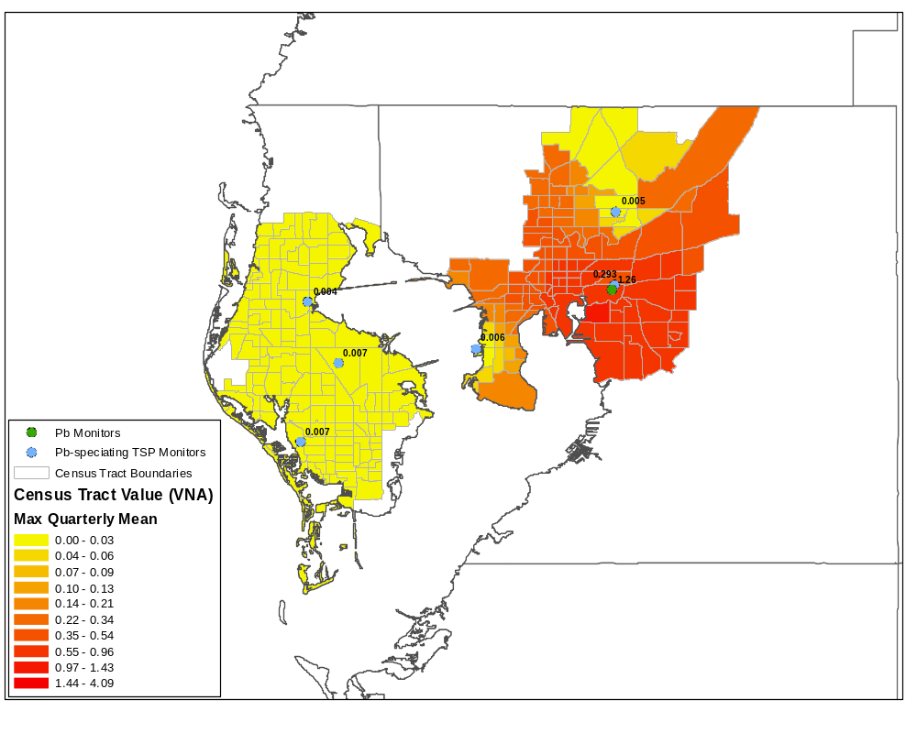
Figure 5-7. Air Lead Concentration Gradient in Hillsborough County, Florida

Figure 5-8. Air Lead Concentration Gradient in Delaware County, Indiana
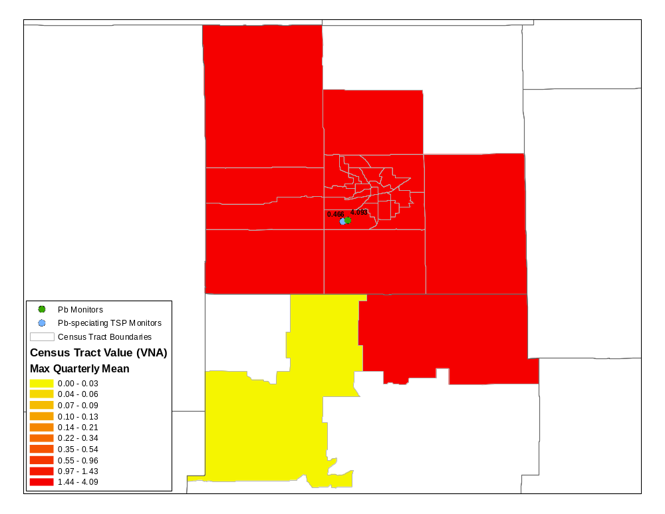
Radius Method

In this approach we focused on the 36 monitors in counties that potentially could be designated as non-attainment areas under at least one of these alternative lead NAAQS levels. These monitor concentration values likely only apply to the population of people living within the vicinity of these monitors, especially if the monitor is oriented near a source of lead contamination (e.g., a primary or secondary lead smelter). As a default, we defined the affected population as those individuals living within a 10-kilometer radius around the monitor. The 10-kilometer radius is consistent with source-specific modeling in the EPA Lead Risk Assessment case studies for primary and secondary sources (USEPA, 2007a). In the absence of detailed air quality modeling for the lead sources in the vicinity of each monitor, we assumed in this screening-level analysis that the lead concentrations in air measured at each monitor are uniform throughout the specified radius. To develop a conservative upper-bound estimate of lead benefits, we assumed the entire population of the county was exposed to the concentration measured at the monitor (the geographic extent of a county generally exceeds 10 km). Also, for the 19 source-oriented monitors in our dataset we performed sensitivity analysis using alternate, smaller radii of one, two, and five kilometers, since lead air concentrations can in some cases display significant gradients with distance from a source-oriented monitor. For example, second maximum monthly mean values measured at monitors in close proximity to the Herculaneum, MO lead smelter drop off 40 percent within roughly 1 km of the source and decrease by an additional 95 percent within 2 km.

We used ArcGIS to establish the radii around each monitor. Our spatial dataset contained US Census population data at the block group level for the year 2000. We calculated the total population within each radius in 2000 by adding the population of each Census block group that resided completely within the radius and the relative fraction of the population of block groups only partially falling within the radius, assuming that the population was uniformly distributed throughout the block group. For instance, if 50 percent of the block group was located inside the radius, we added 50 percent of its population to the total population of that radius.

We next took the estimate of the total population for each radius in 2000 and distributed it into gender- and age-specific groups (in five-year increments, consistent with the age ranges reported by the Census) according to the county-level Census data for the county in which the monitor resides. In a few instances where a radius extended into a neighboring county, we assumed the age and gender-specific proportions would be the same as the county in which the monitor resides.

Population Projections

For both the interpolation and radius methods, we extrapolated the 2000 age- and gender-specific population data to 2020, using Woods and Poole county-level projection data (Woods and Poole, 2001). We calculated a growth rate for each gender and age group combination by taking the ratio of the 2020 estimate from Woods and Poole to the corresponding 2000 county-level estimates from the Census. We applied the calculated growth rates to each gender and age group to estimate the total population in 2020 residing within each census tract or radius. This approach to population projection is consistent with previous EPA RIA’s that estimate future-year human health benefits (USEPA 2006c, 2007c, 2008a). However EPA does not assume that the number of Pb emitting sources will grow correspondingly with the population growth as discussed in the Chapter 4.

In order to determine the number of children aged six and under, we added the population of children in the 0-4 age group for both genders and then added two-fifths of the population in the 5-9 age group, assuming the population was uniformly distributed across all five ages in that group.

Estimating Blood Lead Levels

The concentration-response functions we employ in this benefits analysis require estimates of blood lead levels in the exposed population to calculate avoided incidence of adverse health effects. We chose to develop a first approximation of the blood lead levels associated with reductions in air lead concentrations for each of the alternative NAAQS by using the air lead to blood lead ratio (“air:blood ratio”) approach applied by EPA in deriving the current NAAQS in 1978 (43 FR 46246). These ratios predict geometric blood lead levels due to direct lead exposure via inhalation as well as indirect exposures via ingestion of dust and soils contaminated by lead deposition, based on comparisons of historical data on lead in ambient air and measured or modeled geometric mean blood lead levels in an exposed population. Table 5-3 lists the ratios considered for the current NAAQS analysis; for its primary estimate, EPA chose a ratio of 1:5 μg/m³ to μg/dl. That is, for every one microgram per cubic meter reduction in air lead, EPA assumed that geometric mean blood lead levels would be reduced by five micrograms per deciliter. We selected this value based on advice from the Clean Air Scientific Advisory Committee (CASAC) and analysis conducted as part of EPA’s Lead Risk Assessment (USEPA, 2007a & 2007d).

CASAC in its March 2007 review of EPA's Lead Risk Assessment recommended that EPA apply these ratios as part of a population level lead risk analysis to inform alternative proposals for a new lead NAAQS (USEPA, 2007d; see Appendix D). In its previous NAAQS analysis, EPA used a ratio of 1:2 μg/m³ to μg/dl; however, CASAC suggested that ratios higher than 1:2 may be appropriate based on more recent literature. CASAC cites the use of a ratio of 1:5 by the World Health Organization (WHO) in 2000 to better account for lead deposition from air to dust and soil, and they cite a ratio of 1:9-1:10 based on the data in Schwartz and Pitcher (1989) on blood lead changes resulting from the phase-out of lead in gasoline. This ratio is not considered further in this analysis due to the differences between that analysis and this RIA in the exposure environment considered.

As part of its Lead Risk Assessment, EPA calculated air:blood ratios based on the extensive modeling conducted for its case studies and compared these ratios to values reported in the literature (USEPA, 2007a). For the benefits analysis, we focused on the ratios in Table 5-7 of the Lead Risk Assessment that compare the incremental reduction in air concentrations required to meet lower alternative NAAQS levels to the corresponding incremental change in blood lead. The ratios for the general urban and primary lead smelter case studies range from 1:2 to 1:6 for scenarios ranging from the current NAAQS to an alternative NAAQS of 0.05 μg/m³ maximum monthly mean. EPA found these values to be similar to ratios available in the literature, specifically to ratios reported in a 1984 meta-analysis by Brunekreef (1:3 to 1:6) and to values calculated from a more recent 2003 study by Hilts (1:7). More recently, a study of changes in children’s blood Pb levels associated with reduced Pb emissions and associated air concentrations near a Pb smelter in Canada (for children through age six in age) reports a ratio of 1:6 and additional analysis of the data by EPA for the initial time period of the study resulted in a ratio of 1:7 (CD, pp. 3-23 to 3-24; Hilts, 2003). Ambient air and blood Pb levels associated with the Hilts (2003) study range from 1.1 to 0.03 µg/m3, and associated population mean blood Pb levels range from 11.5 to 4.7 µg/dL, which are lower than levels associated with the older studies cited in the 1986 Criteria Document (USEPA, 1986).

We selected as our default estimate a 1:5 air:blood ratio, which represented the ratio for the change in the urban case study from current (mean) conditions to an alternative NAAQS of 0.2 μg/m³ maximum monthly mean. According to the Notice of Proposed Rulemaking, “There are a number of sources of uncertainty associated with these model-derived ratios. The hybrid indoor dust Pb model, which is used in estimating indoor dust Pb levels for the urban case studies, uses a HUD dataset reflecting housing constructed before 1980 in establishing the relationship between dust loading and concentration, which is a key component in the hybrid dust model (see Section Attachment G-1 of the Risk Assessment, Volume II). Given this application of the HUD dataset, there is the potential that the non-linear relationship between indoor dust Pb loading and concentration (which is reflected in the structure of the hybrid dust model) could be driven more by the presence of indoor Pb paint than contributions from outdoor ambient air Pb. We also note that only recent air pathways were adjusted in modeling the impact of ambient air Pb reductions on blood Pb levels in the urban case studies, which could have implications for the air-to-blood ratios.” (US EPA, 2008b).

For sensitivity analysis, we selected a lower bound of the 1:2 ratio from the previous NAAQS and an upper bound of 1:7 as upper bound of the Hilts study-based estimates.

According to the Notice of Proposed Rulemaking, “…in EPA’s view, the current evidence in conjunction with the results and observations drawn from the exposure assessment, including related uncertainties, supports consideration of a range of air-to-blood ratios for children ranging from 1:3 to 1:7, reflecting multiple air-related pathways beyond simply inhalation and the lower air and blood Pb levels pertinent to this review” (US EPA, 2008b)

We divided the maximum quarterly mean lead in air concentrations for each scenario by the air:blood ratio to estimate the blood lead level in the population due solely to exposure to ambient air. We then added an estimate of non-air-related background blood lead level (e.g., from ingestion of indoor dust or outdoor soil contaminated by lead paint) to calculate the total geometric mean blood lead level expected in the population. For our estimate of non-air-related background, we selected the midpoint from a range of values reported by CASAC as being most appropriate for children under 7 years of age (USEPA, 2007d). We apply this estimate of current-year non-air background blood lead for an analysis year of 2020. State and federal interventions such as the Renovation and Repair Rule (EPA, 2008c) may reduce future non-air blood lead to a level below this estimate. Recognizing that future levels of non-air background among exposed populations may be lower than the estimates applied in this analysis, EPA is committed to exploring the technical feasibility of projecting background blood lead levels for the final RIA.

The air:blood ratio provided us with an estimate of the geometric mean blood lead level across the population of exposed children, which we then used to estimate the magnitude of health effects benefits. We assumed that the blood lead level changes in 2020 estimated in this way are a reasonable representation of lifetime average blood lead level for children under seven years of age in our study and were used with the selected dose-response functions without further adjustment.

Table 5-3. Air Lead to Blood Lead Ratios
Ratio | Source | Description
1:2 | USEPA, 1978 | Air:blood ratio applied in EPA’s previous NAAQS RIA. More recent evidence suggests blood lead more sensitive to air concentrations than previously thought, particularly at lower exposure levels; thus, a higher ratio may be appropriate for changes from current conditions.
1:2 to 1:6 | USEPA, 2007a | Ratios in Table 5-7 of EPA’s current Lead Risk Assessment (USEPA, 2007a) estimated from modeling of exposures in urban areas and areas near lead smelters. These ratios compare the incremental reduction in air concentrations required to meet lower alternative NAAQS levels to the corresponding incremental change in blood lead. This ratio is likely to provide the best estimate of blood lead associated with recent changes in air lead concentrations. These ratios for the general urban and primary lead smelter case studies range from 1:2 to 1:6 for scenarios ranging from the current NAAQS to an alternative NAAQS of 0.05 μg/m³ maximum monthly mean, respectively.
1:5 | USEPA, 2007a  WHO, 2005 | Ratio applied by WHO to establish current lead Air Quality Guideline for Europe. Also reported in Table 5-7 of EPA’s Lead Risk Assessment (USEPA, 2007a; see above) for the ratio for the change in the urban case study from current (mean) conditions to an alternative NAAQS of 0.2 μg/m³ maximum monthly mean. Selected as default air:blood ratio because it represents reasonable central estimate of the change from current conditions to a proposed alternative NAAQS level.
1:3 to 1:6 | Brunekreef, 1984 | Ratios reported in a meta-analysis of surveys of smelters and urban areas. Based on older studies that typically reflect ratios for children with blood lead levels > 10 μg/dl.
1:6 to 1:7 | Hilts, 2003 | Ratio calculated from more recent study of air concentrations and blood lead levels for children living near a British Columbia smelter during a period of decreasing lead emissions. Blood lead levels in this study (4 – 10 μg/dl) are lower than in the Brunekreef studies, but still higher than those modeled in EPA’s 2007 Lead Risk Assessment.

Estimating Avoided Health Effects

The following section presents the approach we used to quantify the health benefits of lead due to reductions in the blood lead levels in the population resulting from lowering the NAAQS.
This analysis estimates the adverse health impact of blood lead levels on changes in IQ in young children below seven years of age. Cognitive effects are thought to strongly relate to a child’s future productivity and earning potential (USEPA, 2006b).

According to the CDC, “[t]he data demonstrating that no ‘safe’ threshold for blood lead levels (BLLs) in young children has been identified” (CDC, 2005; page ix). Therefore, we did not incorporate a threshold in our analysis. Many epidemiological studies examining the link between blood lead level and children’s IQ have found an inverse relationship (i.e., increases in blood lead levels are associated with decreases in children’s IQ), with more potent effects occurring at lower blood lead levels (e.g., Lanphear et al., 2005; Canfield et al., 2003). The Workgroup of the Advisory Committee on Childhood Lead Poisoning Prevention to the Centers for Disease Control and Prevention (CDC) concluded that overall, the weight of available evidence supports an inverse association between blood lead levels and cognitive function in children in the low range of blood lead levels (i.e., below 10 μg/dl) (CDC, 2005). The CDC workgroup document also indicates that, “[a] steeper slope in the dose-response curve was observed at lower rather than higher [blood lead levels] BLLs” (page iv of the Appendix). In addition, EPA’s Integrated Risk Information System (IRIS) concluded the following: “by comparison to most other environmental toxicants, the degree of uncertainty about the health effects of lead is quite low. It appears that some of these effects, particularly changes in the levels of certain blood enzymes and in aspects of children’s neurobehavioral development, may occur at blood lead levels so low as to be essentially without a threshold” (USEPA, 2004).

In order to quantify the expected changes in IQ points in the population of children due to the implementation of alternative NAAQS, we utilized available dose-response functions in the literature. For our primary estimate, we selected a dose-response relationship from a pooled analysis of seven prospective studies in North America and Europe examining the effect of lead on full-scale IQ in children (Lanphear et al., 2005)., Blood lead levels were measured in each study five times over early childhood (at 6, 12 (or 15), 36, 48, and 60 months). Full-scale IQ was measured when the children were between 4 and 10 years of age. Four measures of blood lead were examined by the authors: concurrent blood lead (defined as the blood lead measured closest to the IQ test), maximum blood lead (defined as the peak blood lead measured at any time before the IQ test), average lifetime blood lead (defined as the mean blood lead from six months to concurrent blood lead tests), and early childhood blood lead (defined as the mean blood lead from 6 to 24 months). The authors found that the concurrent and lifetime blood lead levels were the strongest predictors of IQ deficits associated with lead exposure.

We used an estimate from this study based on a log-linear relationship between lifetime blood lead level and IQ score. The log-linear relationship was found to be the best fit for the data and the lifetime blood lead levels exhibited a strong relationship with IQ. In addition, we found this measure to be the most consistent with the benefits scenario (see the section in this chapter entitled “Selection of Health Endpoints for further information). Lanphear reports an IQ decrement of 6.2 points for an increase in lifetime blood lead level from 6.1 to 47.0 μg/dl for the selected model. However, the lowest measured lifetime blood lead level represented in the Lanphear pooled analysis was 1.47 μg/dl. To estimate IQ effects at blood lead levels below this “cutpoint,” we used a linearized slope, obtained by taking the tangent to the log-linear function at the point of departure (USEPA, 2007a).

To estimate IQ benefits from blood lead reductions, we first calculated the expected IQ point loss per child under each of the two scenarios (the “base case” and the “control scenarios”) for each monitor (Equation 1). We then subtracted the “base case” IQ loss from the “control scenario” IQ loss and multiplied by the population of children six years of age and younger living within the radius of influence of each monitor to estimate the total number of IQ points that would be gained by reducing the NAAQS (Equation 2).

Equation 1

For blood lead levels ≥ cutpoint:

IQ loss = β₁ × ln(PbB/cutpoint) + β₂ × cutpoint

For blood lead levels < cutpoint:

IQ loss = β₂ × PbB

Where:
Cutpoint = 1.47 μg/dl (i.e., the lowest observed lifetime blood lead level);
β₁ = -3.04 (log-linear regression coefficient from Lanphear (2005), Table 4);
β₂ = -2.1 (linear slope); and
PbB = blood lead level (μg/dl).

Equation 2
Δ IQ = (IQ loss _{Control} – IQ loss _{Base}) × P

Where:
Δ IQ = total number of IQ points gained under the “control scenario” in comparison with the “base case” in 2020;
IQ loss _{Control} = IQ point loss under the “control scenario” per child;
IQ loss _{Base} = IQ point loss under the “base case” per child; and
P = the population of children aged 0 – 6 within the monitor’s radius of influence.

We also assessed the sensitivity of the IQ benefits to the epidemiological study selected, using alternative estimates from a meta-analysis of seven studies (Schwartz, 1993) and a study of 172 children in Rochester, New York (Canfield et al, 2003). The Schwartz study calculated an overall estimate by linearizing coefficients from included studies that used natural logarithms of lead as the exposure index. Regression coefficients for studies with untransformed blood lead levels were used directly. The Schwartz analysis found a decrease of 0.25 IQ points per 1 μg/dl increase in blood lead level. Using a linear model between lifetime blood lead level and IQ score, Canfield et al. (2003) found a decrement of 0.46 IQ points per 1 μg/dl increase in blood lead level. We used the following equation (Equation 3) for these two linear dose-response functions:

Equation 3
Δ IQ = [β × (PbB₁ – PbB₂)] × P
Where:
Δ IQ = total number of IQ points gained under the “control scenario” in comparison with the “base case” in 2020;
β = linear regression coefficient (-0.25 for Schwartz and -0.46 for Canfield);
PbB₁ = blood lead level under the “control scenario” (μg/dl);
PbB₂ = blood lead level under the “base case” (μg/dl); and
P = the population of children aged 0 – 6 within the monitor’s radius of influence.

Table 5-4 below summarizes a range of studies quantifying the relationship between changes in blood lead and IQ that was included in the Lead NAAQS NPRM (EPA, 2008b). The Docket contains a memo that including estimates of IQ gains using two alternate concentration-response functions. These functions include:

- Lanphear et al. 2005 Log-Linear with low-exposure linearization (LLL), based on concurrent blood lead metric
- The median value of the slopes of the “set of studies with shallower slopes”

Table 5-4. Summary of Quantitative Relationships of IQ and Blood Pb Referenced in NPRM
Study/Analysis | Study Cohort | Analysis  Dataset | N | Range BLL  (µg/dL)  [5th-95th percentile] | Geometric Mean BLL (µg/dL) | Form of Model from which Average Slope Derived | Average Linear Slope^{A}  (points per µg/dL)
Set of studies from which steeper slopes are drawn
Tellez-Rojo <5 subgroup | Mexico City, age 24 mo | Children - BLL<5 µg/dL | 193 | 0.8 – 4.9 | 2.9 | Linear | -1.71
based on Lanphear et al 2005^{B},  Log-linear with low-exposure linearization (LLL)^{B} | Dataset from which the log-linear function is derived is the pooled International dataset of 1333 children, age 6-10 yr, having median blood Pb of 9.7 µg/dL and 5th -95th percentile of 2.5-33.2 µg/dL. Slope presented here is the slope at a blood Pb level of 2 µg/dL. ^{C} |  |  |  |  | LLL^{C} | -2.29 at  2 µg/dL^{C}
Lanphear et al 2005^{B}, <7.5 peak subgroup | Pooled International, age 6-10 yr | Children - peak BLL <7.5 µg/dL | 103 | [1.3-6.0] | 3.24 | Linear | -2.94
Set of studies with shallower slopes (Criteria Document, Table 6-1)^{D}
Canfield et al 2003^{B}, <10 peak subgroup | Rochester, age 5 yr | Children- peak BLL <10 µg/dL | 71 | Unspecified | 3.32 | Linear | -1.79
Bellinger and Needleman 2003^{B} | Boston ^{A,E} | Children - peak BLL <10 µg/dL | 48 | 1 - 9.3 ^{E} | 3.8E | Linear | -1.56
Tellez-Rojo et al 2006 | Mexico City, age 24 mo | Full dataset | 294 | 0.8 - <10 | 4.28 | Linear | -1.04
Tellez-Rojo et al 2006 full – loglinear | Mexico City, age 24 mo | Full dataset | 294 | 0.8 - <10 | 4.28 | Log-linear | -0.94
Lanphear et al 2005^{B}, <10 peak^{F} subgroup | Pooled International, age 6-10 yr | Children - peak BLL <10 µg/dL | 244 | [1.4-8.0] | 4.30 | Linear | -0.80
Al-Saleh et al 2001 full – loglinear | Saudi Arabia, age 6-12 yr | Full dataset | 533 | 2.3– 27.36 ^{G} | 7.44 | Log-linear | -0.76
Kordas et al 2006, <12 subgroup | Torreon, Mexico, age 7 yr | Children - BLL<12 µg/dL | 377 | 2.3 - <12 | 7.9 | Linear | -0.40
Lanphear et al 2005^{B} full – loglinear | Pooled International, age 6-10 yr | Full dataset | 1333 | [2.5-33.2] | 9.7 (median) | Log-linear | -0.41
Median value |  |  |  |  |  |  | -0.9^{D}
^{A} Average slope for change in IQ from 10th percentile to 10 µg/dL Slope estimates here are for relationship between IQ and concurrent blood Pb levels (BLL), except for Bellinger & Needleman which used 24 month BLLs with 10 year old IQ.
^{B} The Lanphear et al 2005 pooled International study includes blood Pb data from the Rochester and Boston cohorts, although for different ages (6 and 5 years, respectively) than the ages analyzed in Canfield et al 2003 and Bellinger and Needleman 2003.
^{C}The LLL function (described in section II.C.2.b) was developed from Lanphear et al 2005 loglinear model with a linearization of the slope at BLL below 1 µg/dL. The slope shown is that at 2 µg/dL. In estimating IQ loss with this function in the risk assessment (section II.C) and in the evidence-based considerations in section II.E.3, the nonlinear form of the model was used, with varying slope for all BLL above 1 µg/dL.
^{D} These studies and quantitative relationships are discussed in the Criteria Document (CD, sections 6.2, 6.2.1.3 and 8.6.2).
^{E} The BLL for Bellinger and Needleman (2003) are for age 24 months.
^{F} As referenced above and in section II.C.2.b, the form of this function derived for lifetime average blood Pb was used in the economic analysis for the RRP rule. The slope for that function was -0.88 IQ points per µg/dL lifetime averaged blood Pb.
^{G}69% of children in Al-Saleh et al (2001) study had BLL<10 µg/dL

Benefit Valuation

Value of Avoided IQ decrements
The valuation approach we apply for assessing monetary losses associated with IQ decrements is based on an approach applied in previous EPA analyses (USEPA, 1997, 2005 & 2006b). The approach expresses the loss to an affected individual resulting from IQ decrements in terms of foregone future earnings for that individual.

To estimate the expected monetary value of these effects, we first estimated the median present value of future earnings at time of birth for a person born in the U.S., based on earnings and labor force participation rate data from the 2006 Current Population Survey (CPS). When calculating the lifetime earnings estimate, we assumed an individual born today would begin working at age 16 and retire at age 67. We assumed a real growth rate for wages of one percent per year, as assumed in EPA’s Section 812 retrospective analysis (US EPA, 1997); adjusted for survival probabilities based on current US vital statistics from the CDC’s National Center for Health Statistics; and adjusted for labor force participation by age. We then discounted the expected lifetime stream of wages using a three percent annual rate. As in EPA’s Economic Analysis for the Renovation, Repair, and Painting Program Proposed Rule (EPA, 2008c), we assumed children will be affected by lead at age three, the midpoint of the range during which children are thought to be most susceptible to lead. Therefore, we discounted lifetime earnings back to age three. We estimated present value median lifetime earnings to be $606,930 in 2006 dollars.

In the previous EPA analyses cited above, the Agency has applied an average estimate of the effect of IQ on earnings of 2.379 percent per IQ point from an analysis by Salkever (1995). An analysis by Schwartz (1994b) estimated that a 1-point increase in IQ would increase earnings by 1.76 percent. The percentage increases in both studies reflect both direct impact of IQ on hourly wages and indirect effects on annual earnings as the result of additional schooling and increased labor force participation. A recent review of literature from the labor economics and environmental health fields by CDC economist Scott Grosse suggests that both of these studies may have overestimated the association of IQ with earnings (2007). Specifically, he found the Salkever estimate of direct impacts of IQ on wages to be higher than estimates reported in the labor economics literature. Grosse also found that the Schwartz study overestimates the cognitive impact of lead exposure on earnings, but he argues that the Schwartz estimate may still be appropriate for estimating the total effect of lead on earnings, because it includes the effects of lead on education and earnings that result from both cognitive and non-cognitive changes. Thus, it may be a more comprehensive estimate than one based on cognitive changes alone.

In recognition of the fact that the economics literature continues to evolve, and because EPA has traditionally relied upon the Salkever (1995) estimate to value changes in IQ, for this analysis we provide a range of valuation estimates based on both the Salkever (1995) and the Schwartz (1994b) functions. Below we describe how we estimate the cost per IQ decrement using each function.

The 1.76 percent estimate from Schwartz represents a gross impact on earnings; it does not account for the costs of additional schooling. EPA’s Clean Air Mercury Rule (CAMR) RIA (USEPA, 2005) reported an estimate of $16,425 per additional year of schooling in 1992 dollars, based on U.S. Department of Education data reflecting both direct annual expenditures per student and annual average opportunity cost (i.e., lost income from being in school). Consistent with the CAMR analysis, we assume that these costs are incurred when an individual born today turns 19, based on an average 12.9 years of education among people aged 25 and over in the U.S. We discount the educational costs back to a present value at age 3, to be consistent with the present value of lifetime earnings. We then adjust this value to 2006 dollars, resulting in an estimated $14,700 per additional year of schooling. Schwartz reports an increase of 0.131 years of schooling per IQ point (1994b); thus the change in average education costs per IQ point is $14,700 × 0.131 = $1,930.

Using the Schwartz function, we calculated the present value of the median net earnings loss associated with one IQ point as the present value of median lost earnings per IQ point lost ($606,930 × 0.0176 = $10,682) minus the change in average education costs per IQ point ($1,930). These calculations yield a value of $8,760 of net earnings lost per a one-point decrease in IQ using a 3% discount rate and a value of $1,094 at a 7% discount rate.

To estimate the cost per IQ point using Salkever (1995), we followed the same set of steps as above, substituting the Salkever estimate of the change in lifetime earnings. These calculations yield a value of $12,512 of net earnings lost per a one point decrease in IQ using a 3% discount rate and a value of $2,156 at a 7% discount rate.

Results

This section presents the health effects results and the associated monetary benefits. We first present the expected IQ point gains in 2020, comparing each of the “control scenarios” to the “base case.” We then provide the expected monetized value of those gains in IQ in 2020. We also describe an analysis we performed to assess the sensitivity of the model to the various inputs used and assumptions made. Finally, we explain the methodology we applied for estimating monetized health benefits from co-control of PM_{2.5} and the results of that analysis.

Changes in IQ

Table 5-5 below presents the total number of IQ points expected to be gained in the US in the year 2020 by achieving each of the alternate NAAQS level options, when compared to the “base case” (i.e., the lead NAAQS remains at its current level). Our results indicate that the number of IQ points gained in 2020 ranges from 110,000 if a 0.5 second maximum monthly mean NAAQS is achieved up to 700,000 for a 0.05 second maximum monthly mean NAAQS. These IQ point gains are valued at between $1.0 and $8.7 billion at a 3% discount rate and between $0.2 and $1.5 billion at a 7% discount rate (2006$).

Table 5-5. Number of IQ Points Gained and Monetary Benefits (in Millions of 2006$) in 2020

Standard Alternative | IQ Points Gained | Estimated Net Present Value of IQ Points Gained*
Standard Alternative | IQ Points Gained | 3% Discount Rate | 7% Discount Rate
0.5 Second Maximum Monthly Mean | 110,000 | $960--$1,400 | $120--$240
0.3 Second Maximum Monthly Mean | 200,000 | $1,700--$2,500 | $220--$430
0.2 Second Maximum Monthly Mean | 280,000 | $2,500--$3,500 | $310--$610
0.1 Second Maximum Monthly Mean | 440,000 | $3,900--$5,500 | $480--$950
0.05 Second Maximum Monthly Mean | 700,000 | $6,100--$8,700 | $760--$1,500
*Lower end of range calculated using Schwartz (1994b) estimate; upper end calculated using Salkever (1995) estimate.
** Results reflect the use a 2002 derived non-air background blood lead applied to analysis year of 2020. To the extent that state and federal interventions such as the Renovation and Repair Rule (EPA, 2008c) reduce future non-air blood lead levels, the estimate of IQ change above may be overstated.

We also assessed the geographic distribution of these benefits. We found that the benefits were concentrated in a small number of counties. Table 5-6 below is an example of the distribution of total benefits due to IQ points gained for the 0.2 μg/m³ second maximum monthly mean NAAQS alternative. For this standard, approximately 60 percent of the total benefits are due to changes in lead air concentrations in three counties: Hillsborough, Florida; Delaware, Indiana; and Berks, PA. Please see Appendix B for tables providing the percentage of total health benefits by county for all of the four alternative NAAQS levels.

Table 5-6. Percentage of Benefits by County (0.2 μg/m³ Second Maximum Monthly Mean NAAQS)
County | State | Population of Children in Affected Area | Affected Population (%) | Percentage of Benefits  (%)
Hillsborough | FL | 46,923 | 18 | 31
Delaware | IN | 9,236 | 3 | 19
Berks | PA | 23,977 | 9 | 10
Collin | TX | 16,593 | 6 | 7
Adams | CO | 25,746 | 10 | 6
Denver | CO | 40,395 | 15 | 5
Pike | AL | 2,342 | 1 | 4
Denton | TX | 6,301 | 2 | 4
Cuyahoga | OH | 35,680 | 13 | 3
Jefferson | CO | 8,689 | 3 | 2
Jefferson | MO | 7,358 | 3 | 1
Note: There were several other counties that constituted less than 1 percent of benefits that are not included in this table.

IQ Sensitivity Analysis

We performed a sensitivity analysis on the benefits model in order to assess the total range of potential benefits and to determine the sensitivity of the primary model results to various data inputs and assumptions. We used the model to calculate the total monetary benefits due to gains in children’s IQ for the 0.2 second maximum monthly mean NAAQS option using our default model input assumptions. We then changed each default input one at a time and recalculated the total benefits to assess the percent change from the default. Table 5-7 below presents the results of this sensitivity analysis. The table indicates for each input parameter the value used as the default (in bold) and the values for the sensitivity analyses. It then provides the total monetary benefits for each input and the percent change from the default value.

Our sensitivity analysis results indicate that the benefits model is most sensitive to the method used for assigning air lead exposure concentrations to the population of exposed children. Our primary estimate relied on an interpolation method, where several monitor concentrations were used in determining the exposure concentration. When the radius method was employed as part of the sensitivity analysis, the results varied. We assumed that monitor concentration applied to the population residing within a 10 km radius as a best estimate of the exposed population, which as we noted above, produces a conservative upper-bound estimate of exposure. When compared with the interpolation method, this increased results by 31 percent. The size of the radius assumed when using the radius method also had a large impact on the results. When the radius size was reduced to 5, 2, and 1 km for monitors associated with a lead source, the benefits are significantly reduced (i.e., total monetary benefits are reduced by 66, 94, and 98 percent, respectively). In addition, if the monitor concentration is assumed to apply to the population of the entire county in which that monitor resides, the benefits increase significantly (323 percent).

The discount rate also had a significant impact on results, because the benefits of lead on earnings occur over a lifetime, and the net present value of those earnings is highly sensitive to the discount rate applied. When the discount rate was changed from the default (3 percent) to a rate of 7 percent, the benefits fell by 88 percent.

Table 5-7. Sensitivity Analysis for the Primary Estimate of Health Benefits (for the 0.2 μg/m³ Second Maximum Monthly Mean Results*

 | Model Input | Total Benefits (in Millions of 2006$) | Percent Change from Default
Exposure Estimation Method | Interpolation | $2,500 | N/A
Exposure Estimation Method | County Radius | $11,000 | 340%
Exposure Estimation Method | 10 km Radius | $3,400 | 36%
Exposure Estimation Method | 5 km Radius | $890 | -64%
Exposure Estimation Method | 2 km Radius | $150 | -94%
Exposure Estimation Method | 1 km Radius | $65 | -97%
Discount Rate | 3 Percent | $2,500 | N/A
Discount Rate | 7 Percent | $310 | -88%
Epidemiological Study for IQ | Lanphear et al. (2005) | $2,500 | N/A
Epidemiological Study for IQ | Canfield et al. (2003) | $1,200 | -52%
Epidemiological Study for IQ | Schwartz (1993) | $650 | -74%
Air:Blood Ratios (μg/m³ in air:μg/dl in blood) | 1:5 | $2,500 | N/A
Air:Blood Ratios (μg/m³ in air:μg/dl in blood) | 1:7 | $2,800 | 12%
Air:Blood Ratios (μg/m³ in air:μg/dl in blood) | 1:2 | $1,500 | -40%
Non-Air-Related Background Geometric Mean Blood Lead Level (μg/dl) | 1.2 | $2,500 | N/A
 | 1.0 | $2,700 | 8%
 | 1.4 | $2,300 | -8%

The results were also found to be sensitive to the epidemiological study selected for calculating IQ point gains in 2020, with results decreasing by between 54 and 74 percent when dose-response functions derived from the Canfield et al. (2003) and Schwartz (1993) studies are used, as compared to the default function from Lanphear et al. (2005).

Inputs that had a moderate impact on the benefits results include the air:blood ratio selected to convert lead air concentrations into blood lead levels in the population and the non-air-related geometric mean blood lead level used.

PM Co-Control Benefits – Methodology and Results

As outlined in Chapter 4, most of the point source measures implemented to achieve the NAAQS standards are focused on controlling emissions of lead in particulate form. As a result, virtually all of these measures also have a significant impact on emissions of directly emitted particulate matter. Table 5-8 lists the PM-related health effects that are included in our monetized benefits estimate incorporating PM co-benefits.

In Chapter 4 we identified control technologies to reduce emissions of lead that also reduce PM_{2.5}. However, in some areas, more emission reductions are needed than can be achieved through identified control options (i.e., unidentified controls). The identified and unidentified controls are shown in Table 5-9 below. These emission reduction estimates are incremental to a baseline that reflects emission reductions from MACT controls and the PM_{2.5} NAAQS RIA.

Table 5-8. Health Effects of PM_{2.5}.

Effect | Quantified Health Effects | Unquantified Health Effects^{e}
Health^{a,b} | -Premature mortality based on both cohort study estimates and on expert elicitation^{c,d}  -Bronchitis: chronic and acute  -Hospital admissions: respiratory and cardiovascular  -Emergency room visits for asthma  -Nonfatal heart attacks (myocardial infarction)  -Lower and upper respiratory illness  -Minor restricted-activity days  -Work loss days  -Asthma exacerbations (asthmatic population)  -Respiratory symptoms (asthmatic population)  -Infant mortality | -Subchronic bronchitis cases  -Low birth weight  -Pulmonary function  -Chronic respiratory diseases other than chronic bronchitis  -Non-asthma respiratory emergency room visits
ª Because the PM co-benefits are estimated on a $-per-ton basis, we do not report quantitative estimates for individual PM health effects.
^{b} In addition to primary economic endpoints, there are a number of biological responses that have been associated with PM health effects, including morphological changes and altered host defense mechanisms. The public health impact of these biological responses may be partly represented by our quantified endpoints.
^{c} Cohort estimates are designed to examine the effects of long-term exposures to ambient pollution, but relative risk estimates may also incorporate some effects due to shorter-term exposures (see Kunzli et al., 20 01).
^{d} While some of the effects of short-term exposure are likely to be captured by the cohort estimates, there may be additional premature mortality from short-term PM exposure not captured in the estimates included in the primary analysis.
^{e} The categorization of unquantified toxic health effects is not exhaustive. Health endpoints in this column include both a) those for which there is not consensus on causality; and b) those for which causality has been determined but empirical data are not available to allow calculation of benefits.

Table 5-9. Summary of Estimated Co-Controlled PM_{2.5} Emissions Reductions (in Tons)
Alternate NAAQS (Second Maximum Monthly Mean) | Identified Controls | Unidentified Controls | All Controls
0.5 μg/m³ | 2,252 | 2 | 2,254
0.3 μg/m³ | 6,073 | 46 | 6,120
0.2 μg/m³ | 8,134 | 248 | 8,382
0.1 μg/m³ | 9,065 | 1,237 | 10,302
0.05 μg/m³ | 9,648 | 6,044 | 15,692

To estimate the value of these PM_{2.5} emissions reductions, EPA utilized PM_{2.5} benefit-per-ton estimates. These PM_{2.5} benefit-per-ton estimates provide the total monetized human health benefits (the sum of premature mortality and premature morbidity) of reducing one ton of PM_{2.5} from a specified source. EPA has used a similar technique in previous RIAs, including the recent ozone NAAQS RIA (USEPA, 2008a). The fourteen estimates presented below derive from the application of three alternative methods:

- One estimate is based on the concentration-response (C-R) function developed from a study of the American Cancer Society (ACS) cohort reported in Pope et al. (2002), which has previously been reported as the primary estimate in recent RIAs (USEPA, 2006c).

- One estimate is based on Laden et al.’s (2006) reporting of the extended Six Cities cohort study; this study is a more recent PM epidemiological study that was used as an alternative in the PM NAAQS RIA.

- The other twelve estimates are based on the results of EPA's expert elicitation study on the PM-mortality relationship, as first reported in Industrial Economics (2006) and interpreted for benefits analysis in EPA's final RIA for the PM NAAQS, published in September 2006 (USEPA, 2006c). For that study, twelve experts (labeled A through L) provided independent estimates of the PM-mortality C-R function. EPA practice has been to develop independent estimates of PM-mortality estimates corresponding to the C-R function provided by each of the twelve experts.

Readers interested in reviewing the complete methodology for creating the benefit per-ton estimates used in this analysis can consult the Technical Support Document (TSD) accompanying the recent final ozone NAAQS RIA (USEPA 2008a).
As described in the documentation for the benefit per-ton estimates cited above, national per-ton estimates are developed for selected pollutant/source category combinations. The per ton values calculated therefore apply only to tons reduced from those specific pollutant/source combinations (e.g., SO₂ emitted from electric generating units; NO_{x} emitted from mobile sources). Emissions controls modeled in this RIA are all applied to point sources; a few are at electric generating units (EGUs), but most are at industrial facilities involved in handling lead as a manufacturing product, byproduct, or input. From among the list of pollutant/source combinations outlined in the TSD referenced above, the combination most appropriate for valuation of PM_{2.5} emissions reductions from the sources controlled for lead emissions is the combination for PM_{2.5} from EGU and non-EGU point sources. Estimates of this per-ton value for a 3 percent discount rate vary from a low of $67,000 per ton to a high of $560,000 per ton (based on a change in emissions of 25 percent or less from a 2015 PM emissions base, in 2006$). Our estimate of PM_{2.5} co-control benefits is therefore based on the total PM_{2.5} emissions controlled multiplied by this per-ton value. The results of this calculation are provided in Table 5-10 below. Figures 5-9 and 5-10 provide a graphical representation of the 14 estimates of PM co-control benefits for PM_{2.5}, using both a 3 percent and 7 percent discount rate.

Table 5-10. Monetized Benefits of Co-Controlled PM_{2.5} Emissions (in Millions of 2006$)

Alternative | Pope et al. (2002) | Laden et al. (2006) | Expert A | Expert B | Expert C | Expert D | Expert E | Expert F | Expert G | Expert H | Expert I | Expert J | Expert K | Expert L
3 Percent Discount Rate
0.5 μg/m³ | 350 | 740 | 1,000 | 790 | 780 | 560 | 1,300 | 720 | 470 | 590 | 780 | 630 | 150 | 580
0.3 μg/m³ | 940 | 2,000 | 2,800 | 2,200 | 2,100 | 1,500 | 3,500 | 1,900 | 1,300 | 1,600 | 2,100 | 1,700 | 410 | 1,600
0.2 μg/m³ | 1,300 | 2,800 | 3,800 | 3,000 | 2,900 | 2,100 | 4,700 | 2,700 | 1,700 | 2,200 | 2,900 | 2,400 | 560 | 2,100
0.1 μg/m³ | 1,600 | 3,400 | 4,700 | 3,600 | 3,600 | 2,500 | 5,800 | 3,300 | 2,100 | 2,700 | 3,500 | 2,900 | 690 | 2,600
0.05 μg/m³ | 2,400 | 5,200 | 7,200 | 5,500 | 5,500 | 3,900 | 8,900 | 5,000 | 3,300 | 4,100 | 5,400 | 4,400 | 1,100 | 4,000
7 Percent Discount Rate
0.5 μg/m³ | 320 | 670 | 930 | 720 | 710 | 500 | 1,100 | 650 | 430 | 540 | 700 | 570 | 140 | 520
0.3 μg/m³ | 850 | 1,800 | 2,500 | 1,900 | 1,900 | 1,400 | 3,100 | 1,800 | 1,200 | 1,500 | 1,900 | 1,600 | 380 | 1,400
0.2 μg/m³ | 1,200 | 2,500 | 3,500 | 2,700 | 2,600 | 1,900 | 4,300 | 2,400 | 1,600 | 2,000 | 2,600 | 2,100 | 520 | 1,900
0.1 μg/m³ | 1,400 | 3,100 | 4,200 | 3,300 | 3,200 | 2,300 | 5,200 | 3,000 | 1,900 | 2,400 | 3,200 | 2,600 | 640 | 2,400
0.05 μg/m³ | 2,200 | 4,700 | 6,500 | 5,000 | 4,900 | 3,500 | 8,000 | 4,500 | 3,000 | 3,700 | 4,900 | 4,000 | 1,000 | 3,600
Note: All estimates have been rounded to two significant figures. All estimates are incremental to the 2006 PM NAAQS RIA. These estimates do not include confidence intervals because they were derived through a scaling technique described in the text.

Figure 5-9. Distribution of Total PM_{2.5} Monetized Co-Benefits by Lead Standard Alternative (3% Discount Rate)

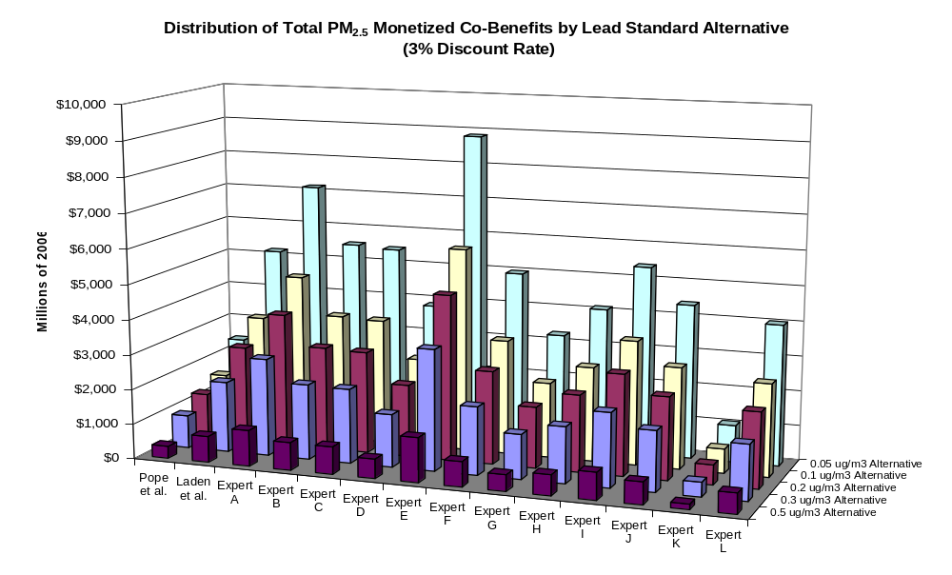

Figure 5-10. Distribution of Total PM_{2.5} Monetized Co-Benefits by Lead Standard Alternative (7% Discount Rate)

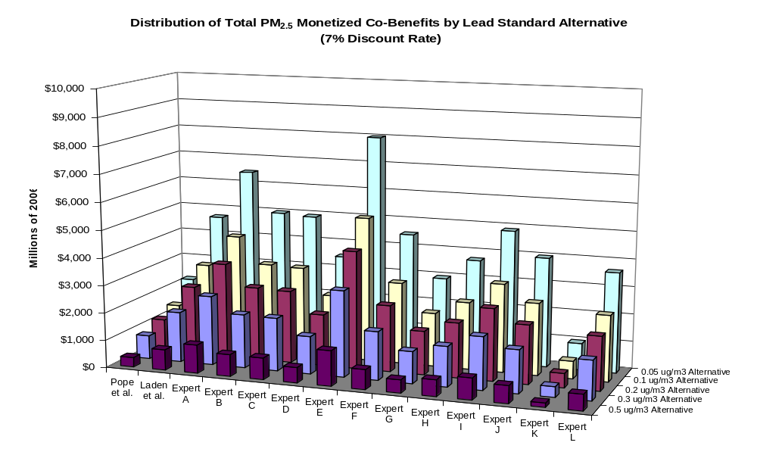

Discussion

The results of this benefits analysis demonstrate that lowering the current (1.5 μg/m³ maximum quarterly mean) lead NAAQS to one of the proposed alternative NAAQS would be expected to have a significant impact on the IQ of young children. Lowering the standard could cause an increase in total IQ points by between 110,000 and 700,000 points in 2020, which would be valued at between 1.0 and 8.7 billion 2006$. In addition, controls installed to achieve the lead NAAQS standards will also reduce emissions of fine particulates. As a result, this analysis includes a screening level calculation that indicates each of the alternatives considered could have a significant benefit in terms of improved particulate air quality, reduced health effects, and increased economic welfare of currently exposed individuals.

This benefits analysis is intended to be an initial screening investigation to provide a first estimate of the potential magnitude of the benefits of reducing the lead NAAQS. Therefore, the results of this analysis are associated with a number of uncertainties. The benefits of IQ point gains in children were very sensitive to the method employed for estimating exposures to the population. When comparing the default method, which involved concentrations that were interpolated from multiple monitors, to the method assuming a uniform concentration within a 10 km radius around an individual monitor, the results increase by 31 percent. Increasing the radius to include the entire county in which the monitor resides results in roughly 3-fold increase in benefits. Decreasing the radius size also has a large impact on benefits, decreasing the value by as much as 98 percent when a radius of 1 km is used. The results were also fairly sensitive to the discount rate selected. When a 7 percent discount rate was used in place of the default rate of 3 percent, results decreased by 88 percent. This is in part because the benefits of lead on earnings occur over a lifetime, and the net present value of those earnings is highly sensitive to the discount rate applied. The dose-response function selected for quantifying the number of IQ points gained as a result of achieving the alternative NAAQS levels affected the results. Utilizing alternate epidemiological studies decreased the primary estimate by as much as 74 percent. However, we believe the Lanphear et al. (2005) study was the best choice for our primary estimate. This study was a meta-analysis that synthesized a range of existing information and is based on more recent data than the studies included in the Schwartz (1993) study. In addition, the log-linear model was the most robust estimate from this study, in that it was the best fit for the data.

Additional uncertainties related to the benefits estimates include the following:

- For our primary estimate of the benefits due to gains in children’s IQ, we used a log-linear estimate from a recently published pooled analysis of seven studies (Lanphear et al., 2005). Using alternate estimates from other epidemiological studies examining the link between blood lead level and children’s IQ has significant impact on benefits results. We found the benefits to decrease by as much as 74 percent when an alternate estimate from a paper by Schwartz (1993) is used. This is due in part to the underlying shape of the dose-response relationship assumed by each of the functions. In the Lanphear study, a log-linear relationship was found to be the best fit for the data (i.e., the natural log-transformed blood lead level is used to predict changes in IQ score). This model implies that the magnitude of changes in IQ increases with lower blood lead levels. However, in the Schwartz (1993) and Canfield et al. (2003) studies, a single linear model is assumed (i.e., untransformed blood lead levels are used to predict changes in IQ score). The single linear model implies that the magnitude of change in IQ is constant over the entire range of blood lead levels. Therefore, at lower blood lead levels, the log-linear model predicts larger changes in IQ than the linear model. Note that CASAC, in their review of EPA’s Lead Risk Assessment indicated that “studies show that the decrements in intellectual (cognitive) functions in children are proportionately greater at PbB concentrations <10 μg/dl” (USEPA, 2007d, page 3). However, if the true dose-response relationship is linear, than our primary estimate of benefits is an overestimation.

- Some uncertainty is involved in the estimates of maximum quarterly mean lead air concentrations used for the benefits model. We used ratios of second maximum monthly mean values to maximum quarterly mean values from lead monitoring data from 2003-2005 to convert the second maximum monthly mean values in 2020 into a maximum quarterly mean for the “base case” as well as to convert the alternative second maximum monthly mean NAAQS into a maximum quarterly mean for the “control scenarios.” If the true ratio between the second maximum monthly means to the maximum quarterly mean is different in 2020 than in 2003-2005 because the pattern and distribution of daily values differs, then our results could be either over- or underestimated.

- The interpolation method of estimating exposure concentrations that we used for our primary estimate is associated with some uncertainty. The validity of this method is to some extent contingent upon the availability of a sufficient number of monitors to support an interpolation. In certain locations, such as Hillsborough County, FL, there are a sufficient number of lead and TSP monitors to generate an interpolation with a pronounced gradient around each monitor. The lead and TSP monitoring network in other non-attainment areas can in some cases be sparse, and the resulting interpolation does not appear to generate a meaningful gradient, such as in Delaware County, IN.

- The application of the monitor rollback technique to estimate full attainment air quality changes introduces some uncertainty to the analysis. This technique simulates the air quality change associated with an emissions control strategy that is capable of just attaining each standard alternative at each monitor. This approach to estimating air quality changes is different from the reduced-form air quality model employed to develop the emissions control strategy. When utilizing this reduced-form model to identify control strategies for each standard alternative, in certain cases emission controls achieved reductions in ambient lead below the standard alternative under analysis. In other cases, the modeled control strategies were insufficient to model full attainment with all monitors. The monitor rollback approach used to estimate full attainment benefits does not reflect this variability in attainment status, because it adjusts the violating monitor value down to, but not below, the standard alternative. Thus, where the control strategy attains air quality improvements below the standard at violating monitors, the monitor rollback approach will not reflect the additional benefits associated with this air quality improvement. Conversely, where the control strategy does not fully attain the standard alternative at a given monitor, the rollback technique would overstate benefits because it adjusts the monitor value all the way down to the standard, below a level actually achieved by the control strategy.

- The estimation of the population to which the benefits apply when using the radius method of exposure estimation is uncertain. We made a number of assumptions in the process of estimating the population living within the 10 km radius around each monitor which generated a conservative upper-bound exposure estimate. First, we assumed that the population within each census block group is uniformly distributed, and therefore, that the fraction of the block group geographically that overlapped with the radius corresponded to the fraction of the population living within the radius. In addition, we used 2000 Census data to calculate the population living within each radius and distributed it into five-year age groups by gender using the 2000 Census data for the county in which the monitor resides. We assumed that block groups falling inside the radius that reside in neighboring counties had the same age and gender distributions as the county in which the monitor resides. If these assumptions are inaccurate, the benefits results could potentially be under- or overestimated.

- We assumed that the IQ point effects of a change in concurrent blood lead (i.e., the effects of a change in 2020) apply to all children in our study population that were under seven years of age in 2020. If there is a critical window of exposure for IQ effects (e.g., between the ages of one and two), then we could potentially be overestimating benefits in 2020 because we would have overestimated the population affected by reduced lead exposure in that year. However, if partial or full achievement of the alternative NAAQS levels might occur earlier than 2020, the children in our 0-6 age cohort who are past any critical window in 2020 would have realized the partial or full benefits of reduced lead exposures in those earlier years. Thus, the issue of a potential critical developmental window reflects uncertainty in both the timing and size of benefits.

- The use of air:blood ratios represents a first approximation to the impact of changes in ambient air concentrations of lead on concurrent blood lead levels, applied in the absence of modeling data on lead transport and deposition and the on direct and indirect human exposures. While the values we apply match fairly well with available literature, there are relatively few studies that report such values or provide sufficient data to calculate such ratios. Further, the lead concentrations in those studies tend to be higher than those modeled here (USEPA, 2007a); thus uncertainty remains as to whether the same ratios would be expected at lower levels, or whether air exposures are more or less efficient at changing concurrent blood lead levels at these lower concentrations.

- If the air:blood ratio we apply for children or a similar value is also valid for estimating adult exposures, then our primary benefits understate the true health benefits accruing to the lead-exposed populations because they exclude impacts on morbidity and mortality impacts on adults as well as impacts on prenatal mortality. Additional research is needed to improve our understanding of the impacts of adult air exposure on adult blood lead levels.

- The earnings-based value-per-IQ-point lost that we apply in this analysis most likely represents a lower bound on the true value of a lost IQ point, because it is essentially a cost-of-illness measure, not a measure of an individual’s willingness-to-pay (WTP) to avoid the loss of an IQ point. Welfare economics emphasizes WTP measures as the more complete estimate of economic value.

- The earnings-based estimate of the value-per-IQ-point lost is based on current data on labor-force participation rates, survival probabilities, and assumptions about educational costs and real wage growth in the future. To the extent these factors diverge from these values in the future, our lifetime earnings estimate may be under- or overestimated.

- Co-control benefits estimated here reflect the application of a national dollar benefit per ton estimate of the benefits of reducing directly emitted fine particulates from point sources. Because they are based on national-level analysis, the benefit-per-ton estimates used here do not reflect local meteorology, exposure, baseline health incidence rates, or other local factors that might lead to an over-estimate or under-estimate of the actual benefits of controlling directly emitted fine particulates.

REFERENCES

Bellinger, D.C., Stiles, K.M., Needleman, H.L. (1992). Low-Level Lead Exposure, Intelligence, and Academic Achievement: A Long-Term Follow-Up Study. Pediatrics 90: 855-861.

Brunekreef, B. (1984). The Relationship between Air Lead and Blood Lead in Children: A Critical Review. Science of the Total Environment 38: 79-123.

Canfield, R.L, Henderson, C.R., Cory-Slechta, D.A., et al. (2003). Intellectual Impairment in Children with Blood Lead Concentrations below 10 μg per Deciliter. The New England Journal of Medicine 348(16): 1517-26.

Centers for Disease Control and Prevention (CDC). (1991). Strategic Plan for Elimination of Childhood Lead Poisoning. U.S. Department of Health and Human Services, Public Health Service, Centers for Disease Control and Prevention. Atlanta, GA: February.

Centers for Disease Control and Prevention (CDC). (2005). Preventing Lead Poisoning in Young Children. U.S. Department of Health and Human Services, Public Health Service, Centers for Disease Control and Prevention. Atlanta, GA: August.

Chen, A., Dietrich, K.N, Ware, J., et al. (2005). IQ and Blood Lead from 2 to 7 Years of Age: Are the Effects in Older Children the Residual of High Blood Lead Concentrations in 2-year-olds? Environmental Health Perspectives 113: 597-601.

Dietrich, K.N., Ris, M.D., Succop, P.A, et al. (1993a). The Developmental Consequences of Low to Moderate Prenatal and Postnatal Lead Exposure: Intellectual Attainment in the Cincinnati Lead Study Cohort Following School Entry. Neurotoxicology and Teratology 15: 37-44.

Dietrich, K.N., Berger, O.G., Succop, P.A. (1993b). Lead Exposure and the Motor Development Status of Urban Six-year-old Children in the Cincinnati Prospective Study. Pediatrics 91: 301-307.

Ernhart, C.B., Morrow-Tlucak, M., Wolf, A.W., et al. (1989). Low Level Lead Exposure in the Prenatal and Early Preschool Periods: Intelligence Prior to School Entry. Neurotoxicology and Teratology 11: 161-170.

Grosse, S. (2007). How Much Does IQ Raise Earnings? Implications for Regulatory Impact Analyses. Association of Environmental and Resource Economists (AERE) Newsletter 27 (2): 17-21.

Hilts, S.R. (2003). Effect of Smelter Emissions Reductions on Children’s Blood Pb Levels. Science of the Total Environment 303: 51-58.

Industrial Economics, Inc. (2006). Expanded Expert Judgment Assessment of the Concentration-Response Relationship between PM_{2.5} Exposure and Mortality. Prepared for: Office of Air Quality Planning and Standards, U.S. Environmental Protection Agency, Research Triangle Park, NC.

Kunzli, N., Medina, S., et al. (2001). Assessment of Deaths Attributable to Air Pollution: Should We Use Risk Estimates Based on Time Series or Cohort Studies? American Journal of Epidemiology 153(11): 1050-1055.
Laden, F., Schwartz, J., Speizer, F.E., et al. (2006). Reduction in Fine Particulate Air Pollution and Mortality. American Journal of Respiratory and Critical Care Medicine 173: 667-672.

Lanphear, B.P., Hornung, R., Khoury, J., et al. (2005). Low-Level Environmental Lead Exposure and Children’s Intellectual Function: An International Pooled Analysis. Environmental Health Perspectives 113(7): 894-899.

Needleman, H.L., et al. (1990). The Long-Term Effects of Exposure to Low Doses of Lead in Children. New England Journal of Medicine 322(2): 83-88.

Pocock, S.J., Smith, M., Baghurst, P. (1994). Environmental Lead and Children’s Intelligence: A Systematic Review of the Epidemiological Evidence. British Medical Journal 309: 1189-1197.

Pope, C.A., III, Burnett, R.T., Thun, M.J., et al. (2002). Lung Cancer, Cardiopulmonary Mortality, and Long-Term Exposure to Fine Particulate Air Pollution. Journal of the American Medical Association 287: 1132-1141.

Salkever, D.S. (1995). Updated Estimates of Earnings Benefits from Reduced Exposure of Children to Environmental Lead. Environmental Research 70:1-6.

Schnaas, L., Rothenberg, S.J., Perroni, E., et al. (2000). Temporal Pattern in the Effect of Post-Natal Blood Lead Level in Intellectual Development of Young Children. Neurotoxicology and Teratology 22: 805-810.

Schober, S. E.; Mirel, L. B.; Graubard, B. I.; Brody, D. J.; Flegal, K. M. (2006) Blood lead levels and death from all causes, cardiovascular disease, and cancer: results from the NHANES III Mortality Study. Environ. Health Perspect: doi:10.1289/ehp.9123

Schwartz, J. (1993). Beyond LOEL’s, p Values, and Vote Counting: Methods for Looking at the Shapes and Strengths of Associations. NeuroToxicology 14(23): 237-248.

Schwartz, J. (1994a). Low-level Lead Exposure and Children’s IQ: A Meta-Analysis and Search for a Threshold. Environmental Research 65: 42-55.

Schwartz, J. (1994b). Societal Benefits of Reducing Lead Exposure. Environmental Research 66: 105-124.

Schwartz, J., Pitcher, H. (1989). The Relationship between Gasoline Lead and Blood Lead in the United States. Journal of Official Statistics 5:421-431.

Tong, S., Baghurst, P., McMichael, A., et al. (1996). Lifetime Exposure to Environmental Lead and Children’s Intelligence at 11-13 years: the Port Pirie Cohort Study. British Medical Journal 312: 1569-1575.

U.S. Environmental Protection Agency. (1978) National Primary and Secondary Ambient Air Quality Standards for Lead. Federal Register 43(194): 46246-46263. Oct 5, 1978. Available at: http://www.epa.gov/ttn/naaqs/standards/pb/s_pb_pr_fr.html

U.S. Environmental Protection Agency. (1997). The Benefits and Costs of the Clean Air Act, 1970 to 1990. October.

U.S. Environmental Protection Agency. (2004). Integrated Risk Information System (IRIS) Profile for Lead and Compounds (inorganic). Office of Research and Development, Washington, DC. Last updated July 2004.

U.S. Environmental Protection Agency. (2005). Regulatory Impact Analysis of the Clean Air Mercury Rule. Office of Air Quality Planning and Standards, Research Triangle Park, NC. EPA-452/R-05-003.

U.S. Environmental Protection Agency. (2006a). Air Quality Criteria for Lead. Office of Research and Development, Research Triangle Park, NC. EPA/600/R-05/144aF.

U.S. Environmental Protection Agency. (2006b). Economic Analysis for the Renovation, Repair, and Painting Program Proposed Rule. Office of Pollution Prevention and Toxics. Washington, DC.

U.S. Environmental Protection Agency. (2006c). Final Regulatory Impact Analysis: PM_{2.5} NAAQS. Office of Air and Radiation, Research Triangle Park, NC.

U.S. Environmental Protection Agency. (2007a). Lead: Human Exposure and Health Risk Assessments for Selected Case Studies. Volume I: Human Exposure and Health Risk Assessments – Full-scale. Office of Air Quality Planning and Standards, Research Triangle Park, NC. EPA-452/R-07-014a.

U.S. Environmental Protection Agency. (2007b). 2003-2005 Total Suspended Particle NAAQS Review Database. Sent via email to James Neumann of Industrial Economics, Inc. on December 20, 2007.

U.S. Environmental Protection Agency. (2007c). Review of the National Ambient Air Quality Standards for Lead: Policy Assessment of Scientific and Technical Information – OAQPS Staff Paper. Office of Air Quality Planning and Standards, Research Triangle Park, NC. EPA-452/R-07-013.

U.S. Environmental Protection Agency. (2007d). Letter from Rogene Henderson, Chair of the Clean Air Scientific Advisory Committee (CASAC) to Stephen L. Johnson, EPA Administrator re: CASAC’s Review of the 1st Draft Lead Staff Paper and Draft Lead Exposure and Risk Assessments. March 27. EPA-CASAC-07-003.

U.S. Environmental Protection Agency. (2008a). Final Ozone NAAQS Regulatory Impact Analysis. Office of Air and Radiation. Research Triangle Park, NC, March.

U.S. Environmental Protection Agency (2008b) Proposed National Ambient Air Quality Standards for Lead. Office of Air and Radiation. EPA-HQ-OAR-2006-0735.

U.S. Environmental Protection Agency (2008c) Economic Analysis for the TSCA Lead Renovation, Repair, and Painting Program Final Rule for Target Housing and Child-Occupied Facilities. Economic and Policy Analysis Branch Economics, Exposure and Technology Division Office of Pollution Prevention and Toxics, 2008

Wasserman, G.A., Liu, X., Lolacono, N.J., et al. (1997). Lead Exposure and Intelligence in 7-Year-Old Children: the Yugoslavia Prospective Study. Environmental Health Perspectives 105: 956-962.

Wasserman, G.A., Liu, X., Popovac, D., et al. (2000). The Yugoslavia Prospective Lead Industry Study: Contributions of Prenatal and Postnatal Lead Exposure to Early Intelligence. Neurotoxicology and Teratology 22: 811-818.

Woods and Poole Economics, Inc. (2001). Population by Single Year of Age CD. CD-ROM. Woods & Poole Economics, Inc. Washington, D.C.

World Health Organization. (2000). Air Quality Guidelines for Europe, Second Edition. Regional Office for Europe, Copenhagen.

The costs presented in this chapter represent the direct pollution control expenditures associated with NAAQS compliance. As such, they do not reflect the general equilibrium impacts of the proposed rule.
There are currently 189 monitors representing 86 counties, but only 36 counties have monitors which exceed 0.05 ug/m³.
Note that these figures present the lead benefits results that incorporate valuation estimates from Schwartz (1994b) and PM co-control benefits using the Pope et al. (2002) epidemiological study and therefore do not represent the full range of uncertainty in the expected benefits.
Development of this base case is described further in Chapter 4.
Readers interested in reviewing the technical details of the VNA approach may consult the technical appendices to the BenMAP User manual, found at: http://www.epa.gov/air/benmap/models/BenMAPTechnicalAppendicesDraftMay2005.pdf
This was assessed using second maximum monthly mean monitoring data between 2003-2005 for eight monitors located near the Herculaneum Lead Smelter (operated by the Doe Run Company) (USEPA, 2007b).
In two instances, the radius drawn around one monitor overlapped with the radius drawn around another monitor. The first case affected monitors located in Adams and Denver counties in Colorado and the second affected monitors located in Madison and St. Claire counties in Illinois. We assigned the highest measured concentration at the two monitors to the population residing in the overlapping area.
The five-year age groups were 0-4, 5-9, 10-14, … up to 85 and above.
This study considered changes in ambient air Pb levels and associated blood Pb levels over a five-year period which included closure of an older Pb smelter and subsequent opening of a newer facility in 1997 and a temporary (3 month) shutdown of all smelting activity in the summer of 2001. The author observed that the air-to-blood ratio for children in the area over the full period was approximately 1:6. The author noted limitations in the dataset associated with exposures in the second time period, after the temporary shutdown of the facility in 2001, including sampling of a different age group at that time and a shorter time period (3 months) at these lower ambient air Pb levels prior to collection of blood Pb levels. Consequently, EPA calculated an alternate air-to blood Pb ratio based on consideration for ambient air Pb and blood Pb reductions in the first time period (after opening of the new facility in 1997).
We estimated total blood lead level to be consistent with the epidemiological studies underlying the dose-response functions we used for estimating changes in IQ due to changes in lead exposure, which are based on total blood lead level.
CASAC provided a range of non-air-related background geometric mean concentrations of 1.0 – 1.4 μg/dl in their comments on EPA’s Lead Risk Assessment (USEPA, 2007a). We selected the midpoint of this range, 1.2 μg/dl, for this analysis.
This study considered changes in ambient air Pb levels and associated blood Pb levels over a five-year period which included closure of an older Pb smelter and subsequent opening of a newer facility in 1997 and a temporary (3 month) shutdown of all smelting activity in the summer of 2001. The author observed that the air-to-blood ratio for children in the area over the full period was approximately 1:6. The author noted limitations in the dataset associated with exposures in the second time period, after the temporary shutdown of the facility in 2001, including sampling of a different age group at that time and a shorter time period (3 months) at these lower ambient air Pb levels prior to collection of blood Pb levels. Consequently, EPA calculated an alternate air-to blood Pb ratio based on consideration for ambient air Pb and blood Pb reductions in the first time period (after opening of the new facility in 1997).
Full-scale IQ is a composite score of verbal and performance tests. Children were administered a version of the Wechsler Intelligence Scales for Children under uniform conditions within each study (Lanphear et al., 2005).
The seven cohort studies included in this analysis include sites in Boston, Massachusetts (Bellinger et al., 1992); Cincinnati and Cleveland, Ohio (Dietrich et al., 1993 and Ernhart et al., 1989); Mexico City, Mexico (Schnaas et al., 2000); Rochester, New York (Canfield et al., 2003); and Yugoslavia (Wasserman et al., 1997).
The natural log of the blood lead levels were used for this analysis.
See http://www.bls.gov/cps/home.htm - data.
See http://www.cdc.gov/nchs/data/nvsr/nvsr54/nvsr54_14.pdf.
The 812 Retrospective analysis also included an estimate based on older work by Needleman et al. (1990).
Note that for the sensitivity analysis, we relied on the results that incorporated the valuation estimate for IQ from Schwartz (1994b).
Because the PM co-benefits are estimated on a $-per-ton basis, we do not report quantitative estimates for individual PM health effects.
The Technical Support Document, entitled: Calculating Benefit Per-Ton Estimates, can be found in EPA Docket EPA-HQ-OAR-2007-0225-0284.

