Dynamics of Ripples on the Sandy Inner Shelf off Martha’s Vineyard:
Surveys, Field Measurements, and Models

Christopher R. Sherwood
U.S. Geological Survey, Woods Hole Science Center
384 Woods Hole Road
Woods Hole, MA 02543-1598
Phone: (508) 457-2269 Fax: (508) 457-2310 Email: csherwood@usgs.gov

Richard P. Signell
U.S. Geological Survey, Woods Hole Science Center
384 Woods Hole Road
Woods Hole, MA 02543-1598
Phone: (508) 457-2229 Fax: (508) 457-2310 Email: rsignell@usgs.gov

Document Number: N0001407IP20087

LONG-TERM GOALS

The long-term goal of our research is to improve fundamental understanding and numerical representation of coastal sediment-transport processes. We participated in EuroSTRATAFORM project, where our goal has been to improve quantitative models describing the relationships among meteorological and oceanographic forcing, freshwater influx, particle resuspension, and transport and accumulation of sediment in the coastal ocean. We helped obtain data for the Optics Acoustics and Stress In Situ (OASIS) project with many of the same goals and additional focus on the interaction between bed and suspended sediments and the influence of fine sediments on optical properties in the water column. We are funded through the U. S. Geological Survey (USGS) Coastal and Marine Geology Program to help a National Oceanographic Partnership Program (NOPP)-funded partnership develop a community sediment-transport model (CSTM). Quantitative understanding of sedimentary processes is important to the Navy because they define environmental conditions in coastal regions, including current speeds, turbulence, water-column turbidity, and bottom acoustic properties. They are also of great interest to geologists and coastal resource managers.

OBJECTIVES

Our objectives are to support the Office of Naval Research (ONR) Ripples Directed-Research Initiative (DRI) studies at MVCO with data collection and modeling. We have three tasks, all related to the ongoing NOPP CSTM funded by ONR and to the OASIS project, and closely aligned with long-term USGS science objectives. They are as follows.
• Mapping: Conduct a high-resolution bathymetric survey and make a gridded bathymetric chart for use as initial conditions in wave and circulation models for the Ripples DRI study area.
• Tripod measurements: Measure ripple morphology and evolution, along with wave-orbital motions, currents, bottom stress, suspended-sediment concentrations, and sediment fluxes during the Ripples DRI experiment.
• Modeling: Implement a regional wave, circulation, and sediment-transport model for the Ripples DRI and OASIS study areas using code developed in the NOPP CSTM.

APPROACH

Task 1. Mapping – We have conducted a high-resolution bathymetric survey of the Ripples DRI experiment site south of Martha’s Vineyard using USGS survey instrumentation from a vessel of opportunity leased by WHOI.

Task 2. Tripod Measurements – We have deployed a pair of autonomous tripods to measure ripple morphology, waves, currents, bottom stress, suspended-sediment concentrations, and temperature at a site on the inner shelf. The exact location of the site was chosen after discussions with researchers from both ONR-funded experiments, the Ripples DRI and the OASIS project (Traykovski, Hay, Herbers, Boss, Hill, and Milligan). We hope to map ripple morphology on both sides of the boundary and measure changes in bottom stress, near-bottom turbulence, apparent roughness, and suspended sediment as the observed boundary-layer properties change with alternating tidal flow, advecting to our sensors properties acquired over either coarse sand or fine sand. We also hope to measure bedform transport associated with the migration of the fine-sand boundary, and compare it with bedload transport rates inferred from ripple geometry and calculated from wave and current measurements.

Task 3. Modeling – We are developing of a regional circulation and wave model, using the Regional Ocean Modeling System (ROMS) with the wave model SWAN, as developed under the NOPP-funded CSTM. The model will incorporate a coarse outer domain similar to the CBLAST model developed by Wilkin (2006) and a finer inner domain centered on the MVCO region. The objectives of the modeling studies are to critically evaluate the performance of a regional wave, circulation, and sediment-transport model with measurements made at several inner shelf locations occupied as part of the Ripples DRI, OASIS, and ongoing MVCO data collection, and to provide a regional sediment-transport context for to help interpret the point measurements.

WORK COMPLETED

Mapping –The USGS conducted nearshore geophysical mapping off the south coast of Martha’s Vineyard, in the vicinity of the Martha’s Vineyard Coastal Observatory (MVCO) in August 2007. Jane F. Denny was the chief scientist for the five-member survey team. The survey was conducted from the M/V Megan Miller August 9-14, 2007. The study area covers 35 km² from about 0.2 km to 5-km offshore, and ranges in depth from ~ 5 to 20 meters. The following high-resolution systems were used to map the surficial sediment distribution, depth and sub-surface geology: dual-frequency 100/500 KHz sidescan-sonar system, 234-KHz interferometric sonar, and 500 Hz -12 KHz chirp sub-bottom profiler.

All geophysical data were collected concurrently at a variable line spacing ranging from 40 to 70 m; ensuring overlap of the swath systems. The sidescan-sonar and sub-bottom systems were towed off the stern, with a digital cable-out display used to record sonar layback. The sub-bottom system was surface towed and configured with a differential global positioning system (DGPS) to acquire tow-fish position, yielding 1 – 2 meter horizontal accuracy. Real-time kinematic (RTK) positioning was acquired for the interferometric and sidescan-sonar systems, yielding better than 10-cm horizontal accuracy.
A motion-reference unit mounted directly above the interferometric sonar head recorded vessel motion (pitch, heave, roll, and yaw); attitude information was used to rectify bathymetric soundings. Additionally, a sound velocity profiler was used throughout the survey to measure the speed of sound in the water column. Vertical resolution of the bathymetric data is approximately 1% of water depth.

Sidescan-sonar and swath bathymetric data were acquired at a 50-m range (100-m swath). Ping rates for both systems exceeded 10 pings/second, providing cm-scale resolution for the sidescan-sonar in both along- and across-track directions and dense swath soundings for the interferometric sonar. Sub-bottom data were acquired at a 0.25-s fire rate and a 0.5 – 8.5 kHz sweep (swept frequency) and recorded in JSF format. All data were processed in the field resulting in a composite sidescan-sonar mosaic, preliminary bathymetric grid referenced to relative water level heights at the MVCO, and SEG-Y files and JPG images of all seismic data. Minimal post-cruise processing will be required.

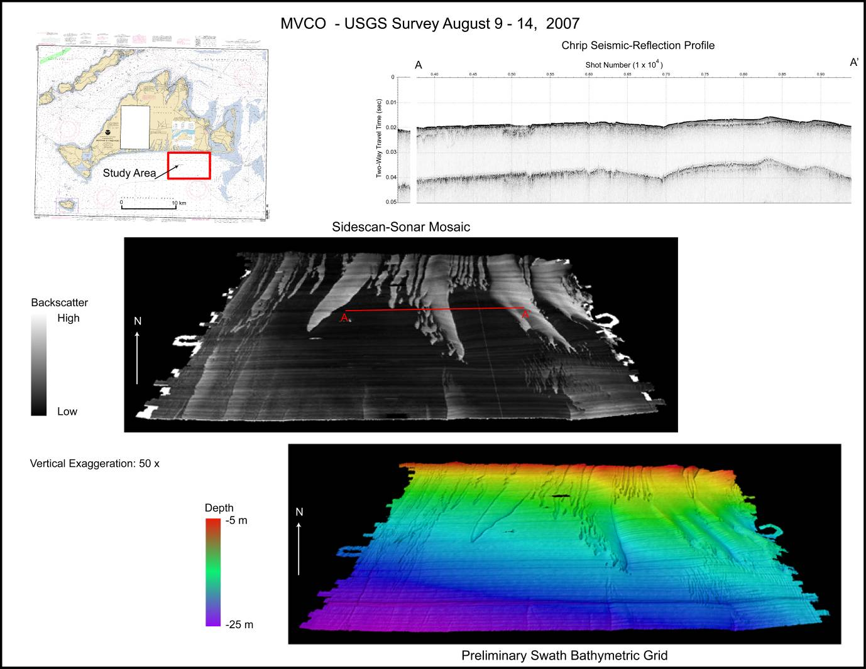
a)
b)
c)
d)

Figure 1. Results of the bathymetric and geophysical survey conducted August 9-14, 2007. a) Location of the survey at the Ripples DRI study area near MVCO, south of Martha’s Vineyard; b) high-resolution sub-bottom profile along west-east track (A to A’ in panel c) showing buried channels and accumulation of fine sand; c) backscatter from side-scan sonar draped on bathymetry; and e) shaded, illuminated bathymetric map from survey.
Tripods – Two instrumented tripods were deployed near the MVCO 12-m node from the R/V Connecticut on August 27, 2007. The tripods were deployed at two sites approximately 40 m apart, both on the boundary between fine sand and coarse sand. Prior to deployment, the sites were surveyed by divers and short hand-cores were taken for grain-size analysis. The southernmost tripod is designed to measure flow parameters, and supports several pressure sensors, three acoustic-Doppler velocimeters mounted ~0.4 mab, a downward-looking pulse-coherent acoustic Doppler profiler, an upward-looking acoustic Doppler profiler with wave-measurement capabilities, a three-frequency acoustic backscatterance sensor, two conductivity-temperature sensors, and several optical backscatterance sensors and transmissometers. The second tripod is designed to measure suspended particle size and to obtain sonar images of ripples and bottom topography. That tripod has a LISST laser in-situ particle size device, a dual-axis pencil-beam sonar for bathymetric mapping, a fan-beam imaging sonar, a camera for imaging the bottom, and an upward-looking acoustic Doppler profiler. These tripods are autonomous, and we hope to recover them in late October 2007.
Fine sand,
hummocks and small ripples
Coarse sand, large ripples
Particle tripod
Flow tripod
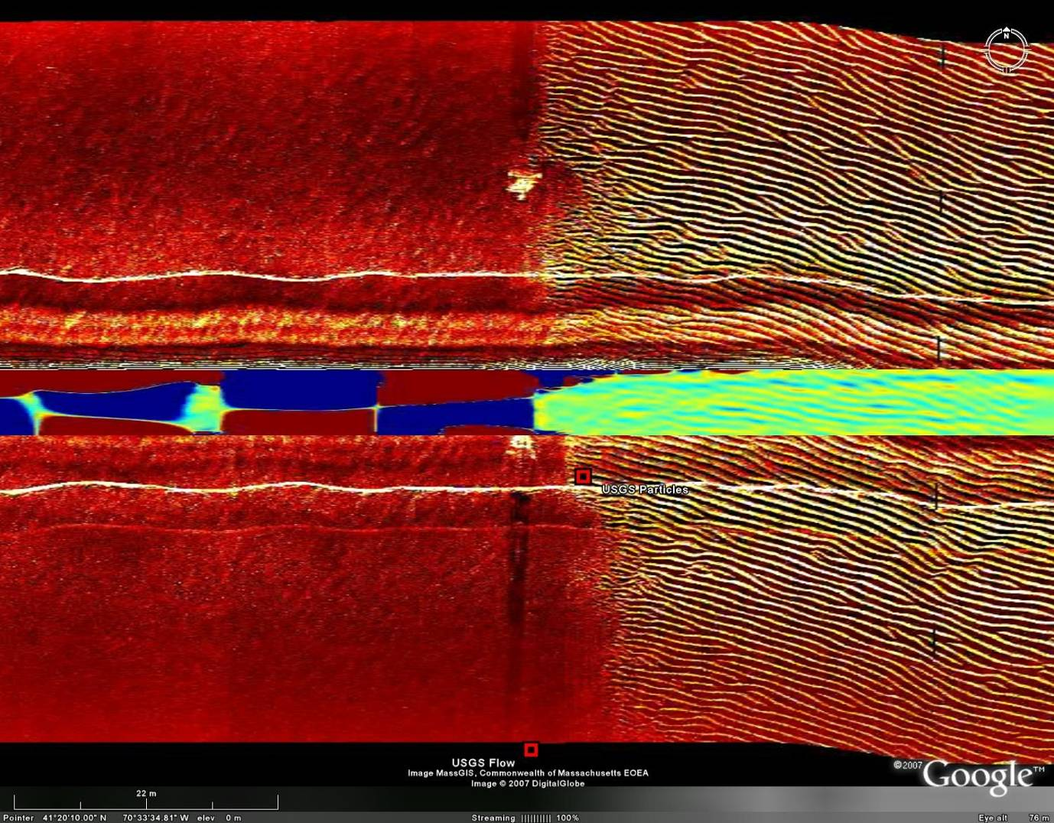
Figure 2. Side-scan sonar returns (brown and white) and multibeam bathymetry (green and blue) from autonomous underwater vehicle along west-east track between USGS tripods at 12-m sites, Sept. 13, 2007. Courtesy P. Traykovski, WHOI.

Modeling – We have updated regional bathymetry in the MVCO region for our regional circulation, wave, and sediment-transport modeling efforts. A new 1 arc-second digital bathymetric grid was constructed for the region 41.0-42.4°N, 71.2-69.7°W using a variety of sources (Figure 3). All digital sounding data was obtained from NGDC using the GEODAS web interface and quality controlled. Remaining data gaps were filled by digitizing smooth sheets from older non-digital surveys. The sounding data were adjusted from mean low water or mean lower-low water datums to mean sea level using the NOAA Vdatum model for the Gulf of Maine and merged with 1 arc-second land topography. The soundings were gridded using a technique similar to the one used to generate the 3 arc-second NOAA Coastal Relief Model. We used the “blockmedian” and “surface” routines from the Generic Mapping Tools (GMT) with slightly different tension parameters judged to represent this data better and with grid anisotropy to account for gridding in geographic coordinates. The resulting topographic dataset is available in several common formats at http://stellwagen.er.usgs.gov/models/grids/.
The following files are available.
32-bit GeoTIFF format vs_1sec_20070725.tif 117 MB
GMT NetCDF format vs_1sec_20070725.grd 109 MB
ArcGIS 9.2 NetCDF format vs_1sec_20070725.nc 109 MB
Google Earth KMZ (image)) vs_1sec_20070725.kmz 1.3 MB

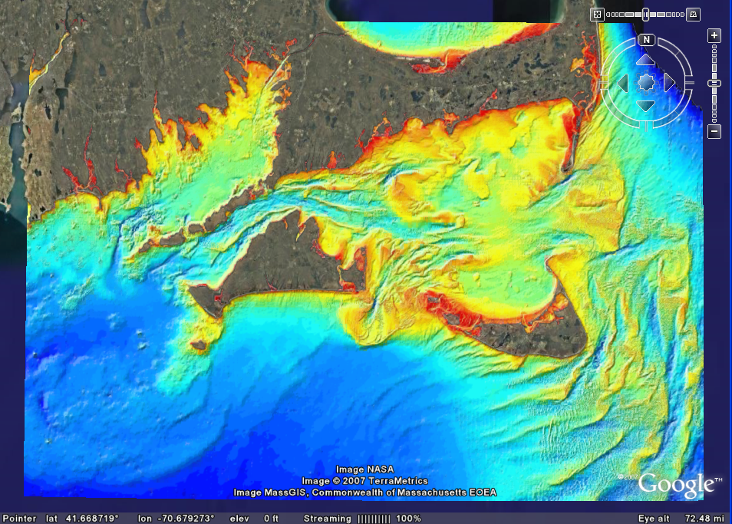

Figure 3. Illuminated, shaded relief map of regional bathymetric grid.

RESULTS

The valuable results obtained in FY2007 are high-resolution bathymetric datasets. Because bathymetry is one of the most important factors in determining the evolution of incident waves and their influence on the sea bed, these results are critical to any subsequent models for wave and ripple evolution, and provide a fundamental description of field conditions for the Ripples DRI project. Comparison of this survey with previous surveys indicates that the fields of fine and coarse sand have not moved substantially since the first detailed surveys were performed despite well-documented sediment-transport events. Instead, the patches have undergone slight modifications and subtle shifts at the boundaries. The importance of this result is that it means grain-size variations can produce relatively stable, self-perpetuating bottom features that can retain important characteristics (elevation, ripple morphology, hydrodynamic roughness) for many years, even in energetic inner shelf environments.

IMPACT/APPLICATIONS

The bathymetric and geophysical data collected this summer will be used in wave and circulation models. The near-bottom measurements and ripple characteristics being recorded by the bottom tripods will be used to validate models for waves, currents, sediment transport, and bottom morphology.

RELATED PROJECTS

These studies are part of the Ripples DRI and closely related to the OASIS studies and the NOPP Community Sediment Transport Project.

REFERENCES

Wilkin, J. L. (2006) The summertime head budget and circulation of Southeast New England Shelf waters, Journal of Physical Oceanography, 36(11): 1997-2011.

