Control Number ED-OIG/A05-D0008

Mr. Tom Horne, Superintendent of Public Instruction
Arizona Department of Education

1535 West Jefferson Street

Phoenix, AZ 85007

Dear Mr. Horne:

This Final Audit Report presents the results of our audit of 20 Arizona charter schools’ uses of U.S. Department of Education (ED) funds for the period October 1, 2000, through September 30, 2001. The objective of our audit was to determine if Arizona charter schools expended ED funds according to applicable law and regulations.

Charter schools in Arizona generally expended Title I, Part A (Title I) of the Elementary and Secondary Education Act of 1965 (ESEA), and Part B of the Individuals with Disabilities Education Act (IDEA) funds in accordance with applicable law and regulations. However, contrary to the law and regulations, we found that the Arizona Department of Education (ADE) provided Title I and IDEA funds directly to private, for-profit entities. We recommend that the Assistant Secretary for Elementary and Secondary Education and the Assistant Secretary for Special Education and Rehabilitative Services instruct ADE to

- refund $1,129,006 to ED for Title I and IDEA funds provided to private, for-profit charter holders authorized by the Arizona State Board for Charter Schools during the period October 1, 2000, through September 30, 2001;
- determine the total amount of Title I and IDEA funds that it provided to private, for-profit charter holders authorized by the Arizona State Board of Education and the individual school districts during the period October 1, 2000, through September 30, 2001, and refund that amount to ED;
- determine the total amount of Title I and IDEA funds that it provided to private, for-profit charter holders during the period October 1, 2001, through June 30, 2003, and refund that amount to ED;
- stop providing Title I and IDEA funds directly to private, for-profit entities; and
- implement procedures to give control of federal funds only to an institution that qualifies as a public entity and ensure students attending private, for-profit charter schools are provided the services to which they are entitled. (Finding No. 1)

Additionally, two of the charter schools that we audited did not expend Title I funds entirely in accordance with applicable law and regulations.

- One charter school used Title I funds to supplant funds intended to provide regular classroom instructional services. Because the school used Title I funds to supplant rather than supplement other funds, Title I eligible students may not have received the extra services they needed to gain the skills necessary to meet the State’s performance standards. We recommend that the Assistant Secretary for Elementary and Secondary Education instruct ADE to refund $89,833 to ED and instruct ADE to require the school to implement controls that provide reasonable assurance that Title I funds are used to supplement, not supplant, funds intended to provide regular classroom instruction. (Finding No. 2)

- Another charter school failed to provide adequate accounting records showing that it spent all of its Title I funds, inaccurately reported to ADE the amount of Title I funds it spent, and drew Title I funds in excess of its immediate needs. The charter school maintained an inadequate financial management system and inaccurately reported on its use of Title I funds because school officials failed to familiarize themselves with the regulations. We recommend that the Assistant Secretary for Elementary and Secondary Education instruct ADE to refund $46,104 to ED or provide support on how the charter school expended Title I funds during our audit period. We also recommend that ADE require the school to develop and implement controls that will provide reasonable assurance that the school accurately accounts for and reports on its use of Title I funds, minimizes Title I cash on hand, and limits requests for Title I funds to its immediate needs. (Finding No. 3)

In response to a draft of this audit report, ADE provided written comments agreeing with Finding No. 2 and Finding No. 3. ADE disagreed with Finding No. 1 and provided a detailed written response explaining why it disagreed. ADE commented that, consistent with Arizona law, ADE treats charter schools as public schools whether the charter schools are operated by a non-profit, public, or for-profit entity. ADE does not believe that federal law precludes for-profit charter schools from receiving federal funds. We evaluated ADE’s written comments for Finding No. 1 and have not changed our position. Private, for-profit entities that hold charters for public schools are not public entities under the administrative supervision or control of a government other than the federal government. Subsequently, such entities are not allowed to exert control over Title I and IDEA funds. ADE’s comments are summarized in the body of the report and included in their entirety as an attachment to this report.

AUDIT RESULTS

Finding No. 1 ADE Provided Federal Funds to Private Entities

ADE provided Title I and IDEA funds to private entities that operated charter schools in Arizona. Though ADE considers each charter holder a local educational agency (LEA), the private company holding the charter is not a public entity. Only public entities can receive Title I and IDEA funds.

The term "public" is defined in 34 C.F.R. § 77.1(c) as an agency, organization, or institution under the administrative supervision or control of a government other than the Federal Government. According to ESEA, as amended by the Improving America’s Schools Act of 1994, Title X, Part C, Section 10306(1)(B), the term charter school means “a public school that is created by a developer as a public school, or is adapted by a developer from an existing public school, and is operated under public supervision and direction.” According to ESEA, as amended by the Improving America’s Schools Act of 1994, Title XIV, Part A, Section 14101, Paragraph 18, and the IDEA Amendments of 1997, Part A, Section 602(15)(A), a LEA is a public board of education or other public authority legally constituted within a state for either administrative control or direction of, or to perform a service function for, public elementary or secondary schools in a city, county, township, school district, or other political subdivision of a state. Therefore, Title I and IDEA funds are required to stay in the control of a public entity.

For the purpose of providing Title I and IDEA funds to charter schools, Arizona law does not differentiate between charter holders. Charter holders in Arizona can be private or public entities. Private entities that hold a charter from an authorizing entity can open, control, and operate public charter schools funded with Title I and IDEA funds just like public entities. When one of these entities holds a charter and subsequently opens additional charter schools under the original charter, ADE considers that entity, whether private or public, a LEA. ADE gives control over Title I and IDEA funds to each LEA and expects each LEA to expend those funds according to appropriate laws and regulations.

During our audit period, the Arizona State Board for Charter Schools, Arizona’s largest chartering entity, recognized over 29 private, for-profit entities that operated at least 75 charter schools. ADE awarded $752,490 in Title I funds to these private, for-profit entities. In addition, ADE awarded $376,516 in IDEA funds to 13 of these private, for-profit entities. Giving control of federal funds to a non-public entity is contrary to the law and could detrimentally affect the quantity and quality of Title I and IDEA services provided to disadvantaged students attending a private, for-profit charter school.

Recommendations

We recommend that the Assistant Secretary for Elementary and Secondary Education and the Assistant Secretary for Special Education and Rehabilitative Services instruct ADE to

  - refund $1,129,006 to ED for Title I and IDEA funds provided to private, for-profit charter holders authorized by the Arizona State Board for Charter Schools during the period October 1, 2000, through September 2001;

  - determine the total amount of Title I and IDEA funds that it provided to private, for-profit charter holders authorized by the Arizona State Board of Education and the individual school districts during the period October 1, 2000, through September 30, 2001, and refund that amount to ED;

  - determine the total amount of Title I and IDEA funds that it provided to private, for-profit charter holders during the period October 1, 2001, through June 30, 2003, and refund that amount to ED;

  - stop providing Title I and IDEA funds directly to private, for-profit charter holders; and

  - implement procedures to give control of federal funds only to an institution that qualifies as a public entity and ensure students attending private, for-profit charter schools are provided the services to which they are entitled.

Auditee Comments

ADE did not concur with our finding that private, for-profit entities are not “public” entities for the purposes of receiving Title I and IDEA funds. ADE commented that it believes that its practice of distributing Title I and IDEA funds to Arizona’s for-profit charter schools complies with federal law. ADE stated that Arizona’s charter school law does not differentiate between charter schools operated by non-profit or for-profit entities. Under Arizona Revised Statutes, all charter schools are subject to the same financial and electronic data submission requirements. These requirements include an annual programmatic and financial external audit and financial reports to the Superintendent regarding funding by program. The financial and electronic data information that charter schools are required to submit is to demonstrate their compliance with state fiscal requirements and program regulations. In addition to monitoring each charter school’s use of state funds, ADE’s program staff monitor how charter schools expend federal funds. If ADE’s program staff are made aware of non-compliance issues, they work with LEA staff to develop corrective action plans and continue to monitor the LEA to ensure that the plan is in compliance with both fiscal and program regulations.

ADE also commented that the Arizona State Board of Education has the authority to exercise general supervision over and regulate the conduct of charter schools as public schools, regardless of whether each school is operated by a non-profit or for-profit organization. Arizona’s charter schools are monitored by one of its three types of sponsoring entities, which are all public entities and given their authority by Arizona state statute. The sponsoring entity of an Arizona charter school, which is authorized by state law and each school’s chartering contract, has oversight and administrative responsibility for each of the schools that it sponsors. These sponsoring entities monitor each school to ensure it complies with federal and state law and the terms of its charter. If a charter school does not comply with applicable federal and state laws, the sponsoring entity can request that the Arizona State Board of Education withhold up to ten percent of the monthly apportionments of state aid due to the school. The sponsoring entity also has the authority to revoke the school’s charter if the school “breaches one or more provisions of its charter.”

Additionally, ADE commented that the Title I and IDEA programs permit them to distribute funds to public charter schools operated by for-profit entities. For-profit charter schools have the same legal obligations to improve student achievement under Title I and to educate children with disabilities under IDEA. For-profit and non-profit charter schools meet the definition of public schools by Arizona law and operate under “public supervision and direction” as defined in the Title I and IDEA law.

Finally, ADE stated that there is no federal statute or regulation that prohibits for-profit charter schools from receiving Title I or IDEA funds.

OIG Response

ADE did not provide convincing evidence that private, for-profit entities holding charters in Arizona are allowed to receive Title I and IDEA funds. Based on ADE’s comments, we did not change the finding or recommendations in this report.

ADE provided information supporting that it does not differentiate between for-profit and non-profit schools and that both types of schools are held to the same state standards. However, ADE did not provide evidence showing that the for-profit entities that run the charter schools and are allowed to function as LEAs qualify as “public” entities. Additionally, ADE did not provide evidence showing that any of its three types of sponsoring entities (Arizona State Board for Charter Schools, Arizona State Board of Education, or a school district governing board) provide “administrative control or direction” of the private, for-profit entities that hold the charter for the schools. The controls that ADE points to are directed at the individual charter school holders that operate one school. ADE’s charter school law does not provide direction on the fiscal administration requirements pertaining to for-profit entities operating multiple charter schools.

ADE commented that, under Arizona Revised Statutes, all charter schools are subject to the same financial and electronic data submission requirements, including annual programmatic and financial external audits, and are required to submit financial reports to the Superintendent regarding funding by program. However, the results of our audit demonstrate that private, for-profit and non-profit charter schools are not subject to the same financial requirements. Non-profit charter schools expending over $300,000 in federal funds are required to submit to an Office of Management and Budget (OMB) Circular A-133 compliance audit designed to specifically look at the entity’s use of federal funds under generally accepted government auditing standards. These audit standards were implemented to obtain consistency and uniformity of audits for state and local governments and non-profit entities. Private, for-profit charter schools expending over $300,000 in federal funds are not subject to OMB Circular A-133 audit requirements, even though private, for-profit entities operating multiple charter schools have a greater chance of receiving over $300,000 in federal funds than those operating a single, non-profit charter school. Because ADE allows for-profit entities to operate charter school(s) that receive Title I and IDEA funds, it has allowed for-profit entities that operate multiple (or large) charter schools to circumvent the mandatory federal reporting requirement imposed on its non-profit counterparts. Pursuant to 20 U.S.C. 7221i, Section 5210 (1)(I), a charter school is a public school that agrees to comply with the same federal and state audit requirements as do other elementary and secondary schools in the state, unless such requirements are specifically waived for the purpose of this program.

ADE commented that it treats charter schools as LEAs and oversees all charter schools in the same manner, regardless of whether the school is operated by a non-profit, public, or for-profit entity. However, our audit disclosed that ADE did not maintain sufficient oversight of at least one private, for-profit entity that functioned as a LEA and operated multiple charter schools. One of the 20 entities that we audited was a for-profit entity that held the charter for 12 separate charter schools. During our audit period, 8 of the for-profit entity’s 12 charter schools had poverty percentages of 35 percent or more. Contrary to the Improving America’s Schools Act of 1994, Title I, Part A, Section 1113, the private, for-profit entity expended Title I funds at only 3 of its 8 charter schools, and it did not expend any Title I funds on the charter school that generated the most Title I funds.

The private, for-profit entity functioning as the LEA should have identified eligible school attendance areas (in this case, each of its charter schools), ranked each area, and then determined the allocation for each area. In determining allocations, the LEA must allocate funds received under Section 1113 to eligible school attendance areas or eligible schools in rank order on the basis of the total number of children from low-income families in each area or school. The for-profit entity determined the percentage of poverty for each school but did not expend Title I funding at the school that generated the most Title I funds. If ADE treated the private entity functioning as a LEA the same as it treated all its other LEAs, it might have identified the LEA’s non-compliance with federal Title I requirements.

Finding No. 2 One Charter School Used Title I Funds to Supplant Other Funds Intended to Provide Classroom Instructional Services

Contrary to the law, one charter school used Title I funds to supplant, instead of supplement, funds intended to provide regular classroom instructional services. The school used $89,833 of Title I funds to pay for salaries and fringe benefits for regular classroom teachers. The school would have employed these teachers even if the school did not receive Title I funds. Because the school did not have a school-wide Title I program, teachers paid with Title I funds should have provided supplemental instruction only to Title I eligible students.

ESEA, as amended by the Improving America's Schools Act of 1994, Section 1120A (b)(1)(A), states that "… a State or LEA shall use funds received under this part only to supplement the amount of funds that would, in the absence of such federal funds, be made available from non-federal sources for the education of pupils participating in programs assisted under this part, and not to supplant such funds."

When we asked what type of Title I program the school operated, the director of the school thought the school operated a school-wide program. However, the school only provided us with documents that showed it was allowed to operate a targeted assistance Title I program. When we brought this matter to their attention, ADE Title I program officials informed us that ADE has a monitoring/oversight system in place for ESEA programs. ADE’s Title I program office relies extensively on the work of independent auditors performing Office of Management and Budget Circular A-133 and limited scope audits. In addition, the monitoring/oversight system includes a self-assessment document that is completed on a rotating basis at least once every four to five years by every LEA within the State, including charter schools. After receipt of the self-assessment document, ADE conducts follow-up, on-site visits of each LEA. Had ADE scheduled and conducted a site visit, its review might have disclosed that the school was inappropriately operating as a school-wide Title I program and using Title I funds to pay regular classroom teachers’ salaries.

Recommendations

We recommend that the Assistant Secretary for Elementary and Secondary Education instruct ADE to

  - refund $89,833 to ED; and

  - instruct the school to implement controls to provide reasonable assurance that Title I funds are used to supplement, not supplant, funds intended to provide regular classroom instruction.

Auditee Response

ADE concurred with our finding and commented that a LEA’s compliance with federal fiscal requirements is monitored by external auditors and ADE’s program personnel who conduct regular monitoring of charter schools. When an issue of supplanting is found, the LEA is required to reimburse the federal project with state funds. ADE will take the appropriate action based on the findings in this report and, if appropriate, recoup the Title I funds from the respective charter school.

Finding No. 3 One Charter School Had an Inadequate Financial Management System, Inaccurately Reported on Its Use of Title I Funds, and Maintained Title I Funds in Excess of Its Immediate Needs

One charter school’s financial management system was inadequate. The school’s system did not provide for tracking expenditures by federal funding source. In addition, the school inaccurately reported the amount of Title I funds spent for the 2000-2001 school year (July 1, 2000, through June 30, 2002) to ADE. For the 2000 – 2001 school year, the school requested and received its entire Title I allocation of $49,175 at the beginning of the year. School officials informed us the school spent $3,071 during the year, but reported to ADE that it spent $45,000 and carried over the remaining $4,175 to the subsequent school year. When we asked for its accounting records, the school was unable to provide records showing how it spent the $49,175. On March 19, 2003, school officials provided accounting records showing the school only spent $3,071 in Title I funds during the 2000-2001 school year, meaning it maintained excessive cash on hand of $46,104 for most of the school year.

According to 34 C.F.R. § 80.20(a) and (b), fiscal control and accounting procedures of a state as well as its subgrantees must be sufficient to permit the tracing of funds to a level of expenditures adequate to establish that such funds have not been used in violation of the restrictions and prohibitions of applicable statutes. Grantees and subgrantees must maintain records that adequately identify the source and application of funds provided for financially assisted activities. These records must contain information pertaining to grant or subgrant awards and authorizations, obligations, unobligated balances, assets, liabilities, outlays or expenditures, and income. According to 34 C.F.R. § 80.21(b), when advances are made by letter-of-credit or electronic transfer of funds methods, the grantee or subgrantee must make drawdowns as close as possible to the time of making disbursements. The Treasury Regulations at 31 C.F.R. § 205.7(c)(4) provide that recipients shall request funds not more than three business days prior to the day on which it makes a disbursement.

The school maintained an inadequate financial management system and inaccurately reported on its use of Title I funds because school officials failed to familiarize themselves with the regulations. In addition, ADE officials informed us that the top 100 LEAs in Arizona received approximately 90 percent of all the State’s Title I funds. Therefore, these LEAs received the most oversight. Small LEAs received less oversight. According to ADE officials, during the 2000-2001 school year, all Arizona schools were required to submit a minimum of two cash management reports during the year. These reports were to show the amount of funds received and spent and the remaining cash balance. Beginning with the 2001-2002 school year, schools were required to submit monthly cash management reports. The monthly reports provide ADE’s Title I program officials with information that will allow them to evaluate how the funds were used. The monthly reports should provide reasonable assurance that charter schools accurately report on their uses of Title I funds.

School officials also failed to familiarize themselves with cash management requirements and establish a system to ensure it drew down Title I funds only for immediate needs. In addition, ADE allowed the school to draw its entire allocation at the beginning of the year. An ADE official said a school typically receives its Title I allocation in a series of monthly payments that reflects the timing of anticipated expenditures because Title I expenditures usually are mostly salaries. The official said the school should not have received its entire Title I allocation at the start of the year unless it could provide support showing the expenditures would be incurred at the start of the year. We reviewed the school’s 2000-2001 Title I budget and found it was comprised of $45,000 in salary and benefit costs and $4,175 in supply costs.

Because its financial management system was inadequate, the school could not show how it spent $46,104 in Title I funds. Because the school submitted a completion report to ADE that inaccurately reported the total amount of Title I funds spent for the 2000-2001 school year, ADE did not have an opportunity to prevent the school from drawing down additional Title I funds until it showed it had spent its cash on hand. The excess cash on hand could have resulted in the United States Government incurring additional interest costs.

Recommendations

We recommend that the Assistant Secretary for Elementary and Secondary Education instruct ADE to

  - instruct the school to provide support to show how it spent $46,104 in Title I funds received for the 2000-2001 school year. If the school cannot show how it spent the funds, require ADE to refund $46,104 to ED;

  - instruct the school to develop and implement controls that provide reasonable assurance that it properly accounts for and accurately reports on its use of Title I funds; and

  - instruct the school to develop and implement controls to minimize Title I cash on hand and limit requests for Title I funds to its immediate needs.

Auditee Response

ADE concurred with the finding and commented that it believed that it was possible for a LEA receiving less than $50,000 to receive its entire allocation at the beginning of the school year. ADE reported that it has implemented new controls to ensure that a LEA cannot maintain an excess cash balance of Title I funds. ADE requires all charter schools to submit quarterly cash management reports and an annual project report via an electronic grants management system. This system will automatically place a hold on payments to the LEA if it has “excess cash” on hand. ADE also offers assistance to charter schools to ensure that they are accurately reporting the use of Title I funds. If a charter school is submitting fraudulent reports, ADE will take the appropriate measures to report the charter school to the Office of the Attorney General and the sponsoring agency.

BACKGROUND

Charter schools are public schools that cannot charge tuition and are required to serve all students, including those with special needs. Charter schools may apply for and receive Title I funds to provide academic support and learning opportunities to help low-achieving children in high-poverty schools master challenging curriculum and meet state standards in core academic subjects. Charter schools also may apply for and receive special education funding through the Grants to States program that provides states with formula grants to meet special education and related services to children with disabilities aged 3 through 21.

ADE has designated three types of authorizing entities that may issue charters to individual schools. As of October 2001, the authorizing bodies in Arizona had chartered 419 schools. These charter schools served 69,884 students. During our audit period, Arizona charter schools received $4,786,423 in Title I funds and $1,482,284 in IDEA funds.

OBJECTIVE, SCOPE, AND METHODOLOGY

The objective of our audit was to determine if, for the period October 1, 2000, through September 30, 2001, a sample of Arizona charter schools expended ED funds according to applicable law [ESEA, as amended, Title X, Part C (20 U.S.C. 8061 – 8067), and Title I, (20 U.S.C., Sections 6301 – 6514); and IDEA, Section 611-619 (20 U.S.C. 1411 – 1419)] and related regulations [34 C.F.R. Parts 80, 200, and 300]. Though our audit covered PCSP, Title I, and IDEA funds, this report only conveys the results of charter schools’ uses of Title I and IDEA funds.

To accomplish our objective, we

- interviewed ADE and Arizona State Board for Charter Schools personnel;
- interviewed Arizona Auditor General officials;
- reviewed ADE’s policies and procedures for administering grants;
- reviewed Arizona State law pertaining to charter schools;
- randomly and judgmentally selected 20 charter schools from a population of 221 charter schools that received either Public Charter Schools Program, Title I, or IDEA funds for our audit period. We separated the charter schools into two different categories, urban and rural, by chartering entity. (Chartering entity officials provided the designation of whether the school was in an urban or rural area.) We randomly chose 13 schools based on the chartering entity that issued their charters – 4 schools chartered by the Arizona State Board for Charter Schools, 4 schools chartered by the Arizona State Board of Education, and 5 schools chartered by individual school districts. We judgmentally selected seven additional schools based on the total amount of federal funds expended and based on discussions with ADE and charter entity officials. Seven of the 20 charter schools that we selected received and expended Title I funds, and 2 received and expended IDEA funds; and
- Audited all 20 schools’ uses of federal funds.

During our audit of each school, we visited the school, spoke with charter school representatives, and reviewed the school’s accounting records pertinent to its use of ED funds. When sufficient accounting records and related documentation were available, we judgmentally selected expenditures and compared original source documents (such as purchase orders, requisitions, invoices, receipts, and canceled checks) with the school’s accounting records. We judgmentally selected the expenditures based on several factors. These factors included purchase type (services or salaries), the total expenditure amount, unclear or vague purchase descriptions, or descriptions that indicated the expenditure was unallowable.

We also relied, in part, on ADE’s computer-processed school data. We compared ADE’s Title I and IDEA award and expenditure data with the accounting records provided to us by various charter schools. Based on these comparisons, we concluded ADE’s data were sufficiently reliable to be used in meeting the audit’s objective. Additionally, we reviewed individual charter schools’ accounting records. We compared those records with a sample of supporting documentation such as invoices and canceled checks. Based on our tests at the individual charter schools, we concluded that, in general, the data the schools provided were sufficiently reliable to be used in meeting the audit’s objective.

We performed our work between December 2002 and June 2003. We visited 19 of the 20 schools in our sample from December 2 through 12, 2002 (we did not visit one of the schools because it was not necessary to achieve our audit’s objective). We discussed the results of our audit with ADE officials on March 31, 2003.

Our audit was performed in accordance with generally accepted government auditing standards appropriate to the scope of audit described above.

STATEMENT ON MANAGEMENT CONTROLS

As part of our audit, we did not assess the adequacy of ADE’s management controls over its administration of Title I and IDEA programs and funds because this step was not necessary to achieve our audit objective. Instead, we relied on testing of charter schools’ compliance with applicable Title I and IDEA law and regulations. Our testing disclosed a material weakness in ADE's management controls. Specifically, ADE relinquished control of Title I and IDEA funds to private, for-profit entities because Arizona State law does not differentiate between public, non-profit and private, for-profit entities. This weakness is discussed in the AUDIT RESULTS section of this report.

ADMINISTRATIVE MATTERS

Statements that managerial practices need improvements, as well as other conclusions and recommendations in this report, represent the opinions of the Office of Inspector General. Determinations of corrective action to be taken will be made by the appropriate ED officials.

If you have additional comments or information that you believe may have a bearing on the resolution of this audit, you should send them directly to the following ED officials, who will consider them before taking final Departmental action on this audit.

Ronald Tomalis, Acting Assistant Secretary
Office of Elementary and Secondary Education
U.S. Department of Education
400 Maryland Avenue, SW, Room 3W315
Washington, DC 20202

Robert H. Pasternack, Ph.D., Assistant Secretary
Office of Special Education and Rehabilitative Services
U.S. Department of Education
330 C Street, SW, Room 3006
Washington, DC 20202

It is ED’s policy to expedite the resolution of audits by initiating timely action on the findings and recommendations contained therein. Therefore, receipt of your comments within 30 days would be greatly appreciated.

In accordance with the Freedom of Information Act (5 U.S.C. §552), reports issued by the Office of Inspector General are available to members of the press and general public to the extent information contained therein is not subject to exemptions in the Act.

Sincerely,

/s/

Richard J. Dowd

Regional Inspector General
for Audit

Attachment

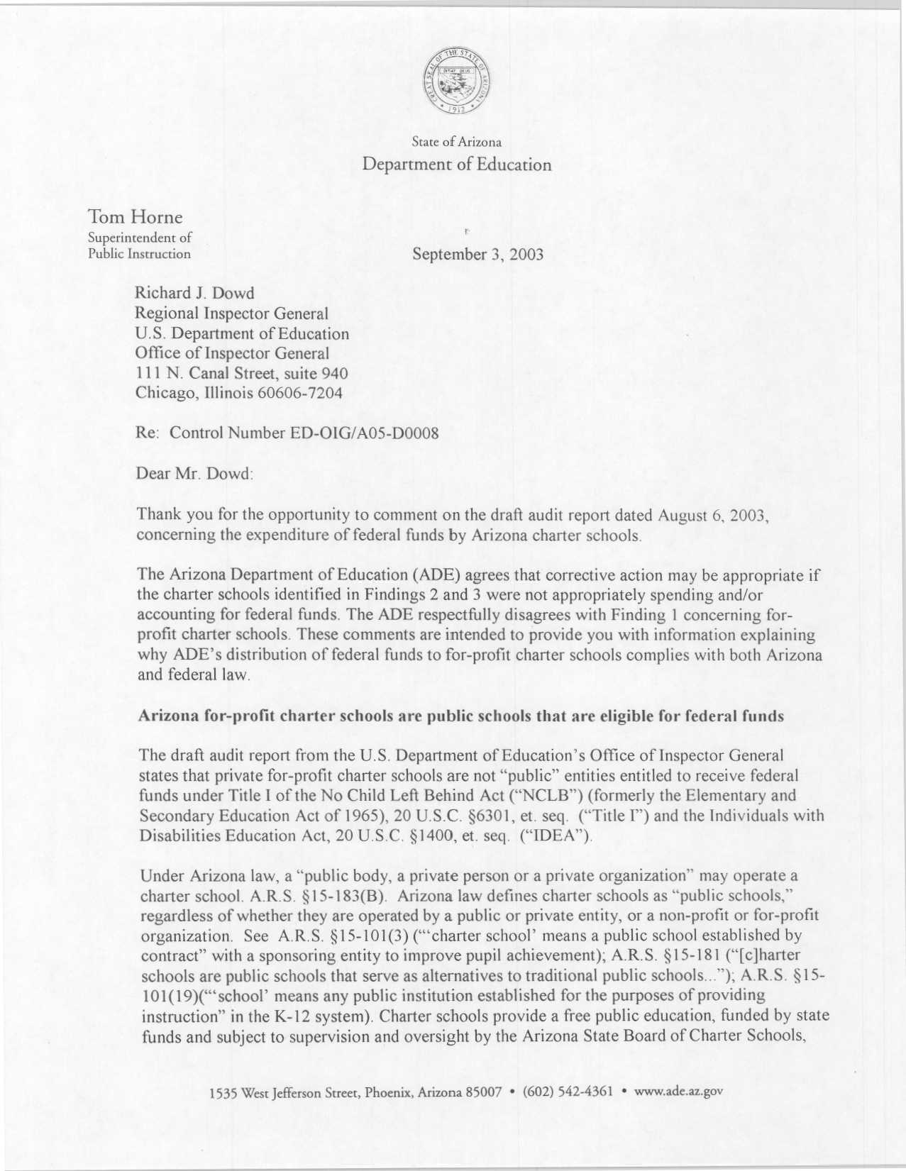
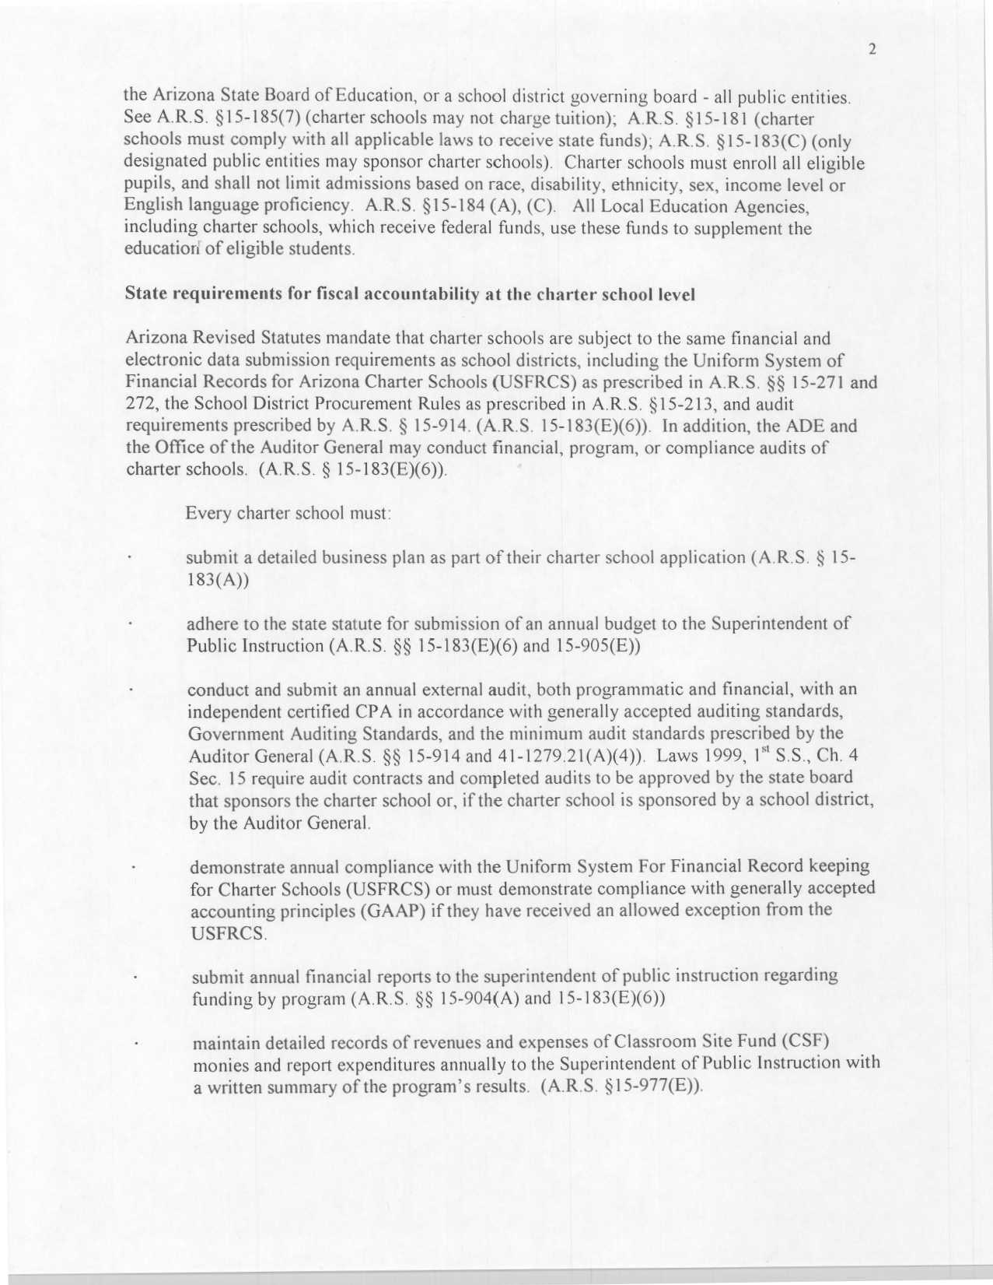
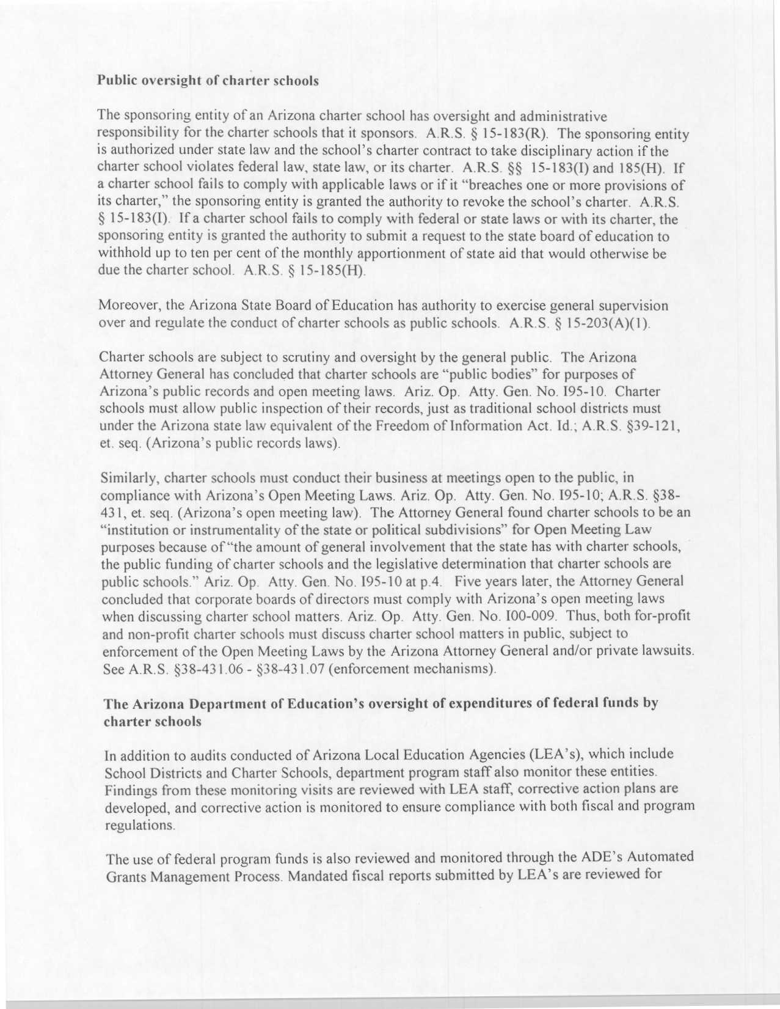
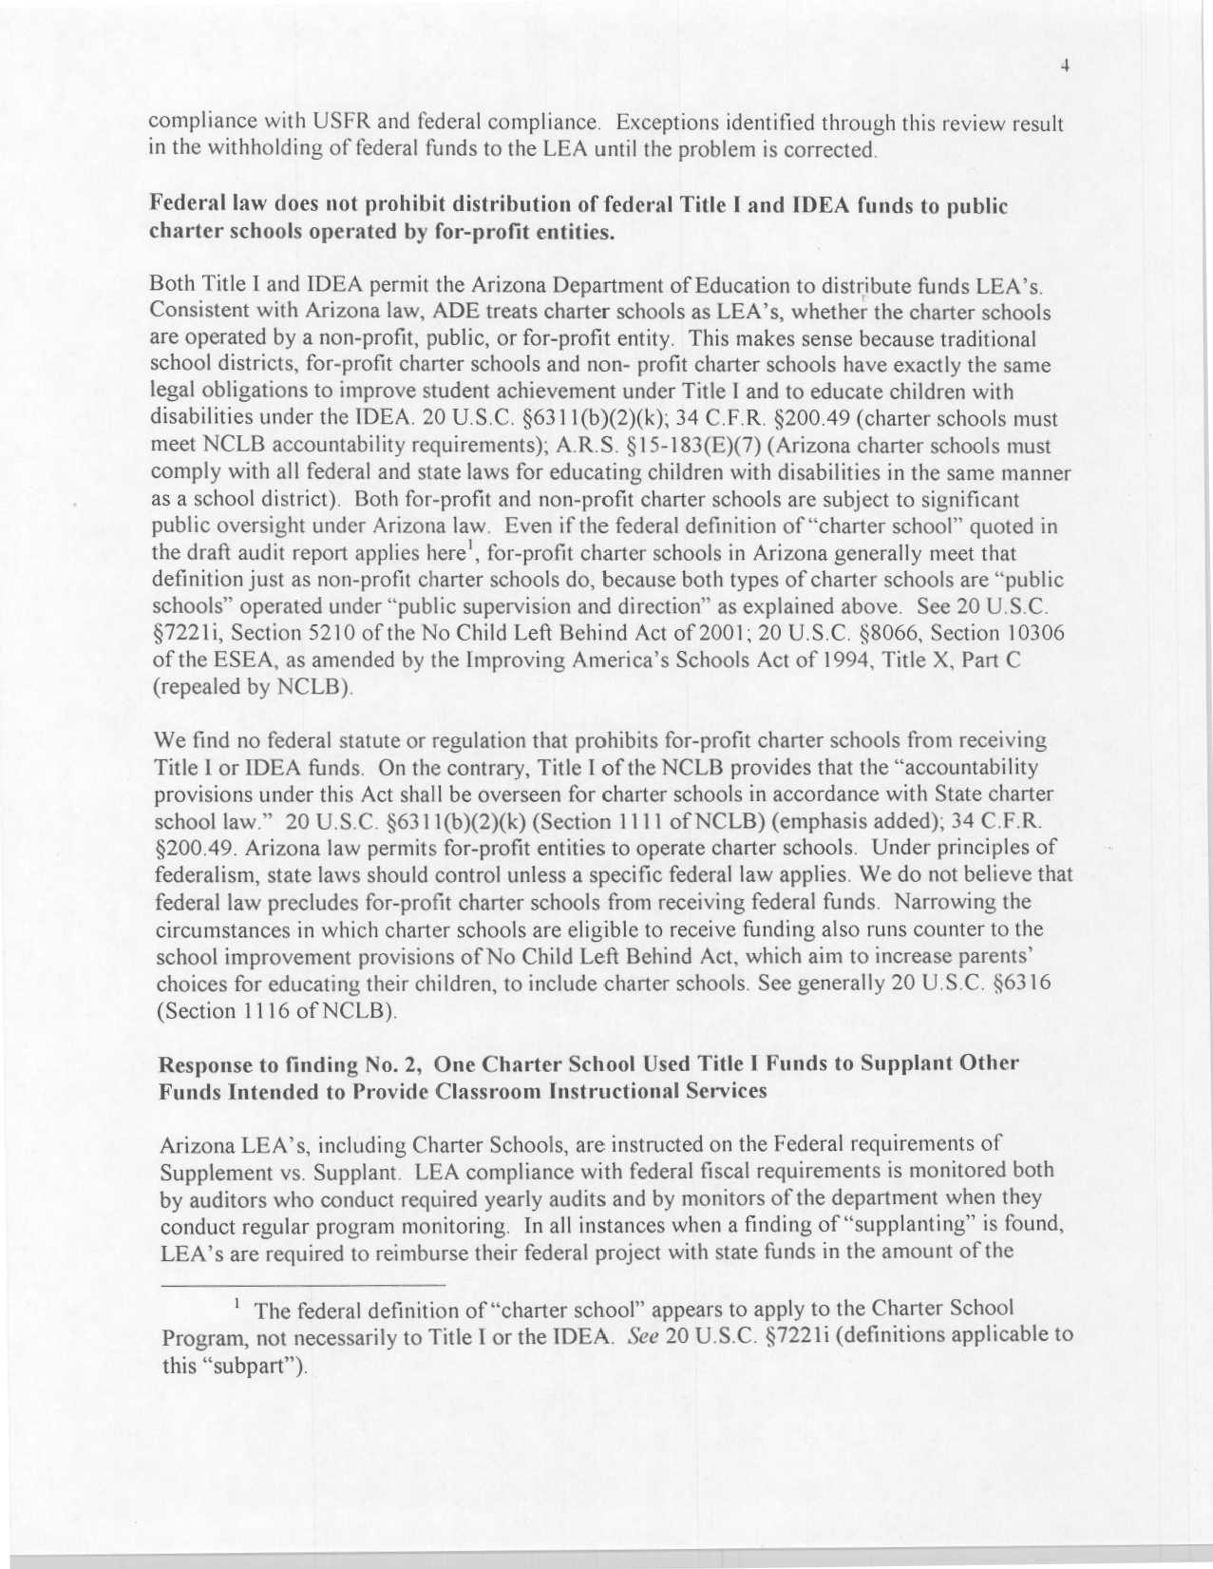
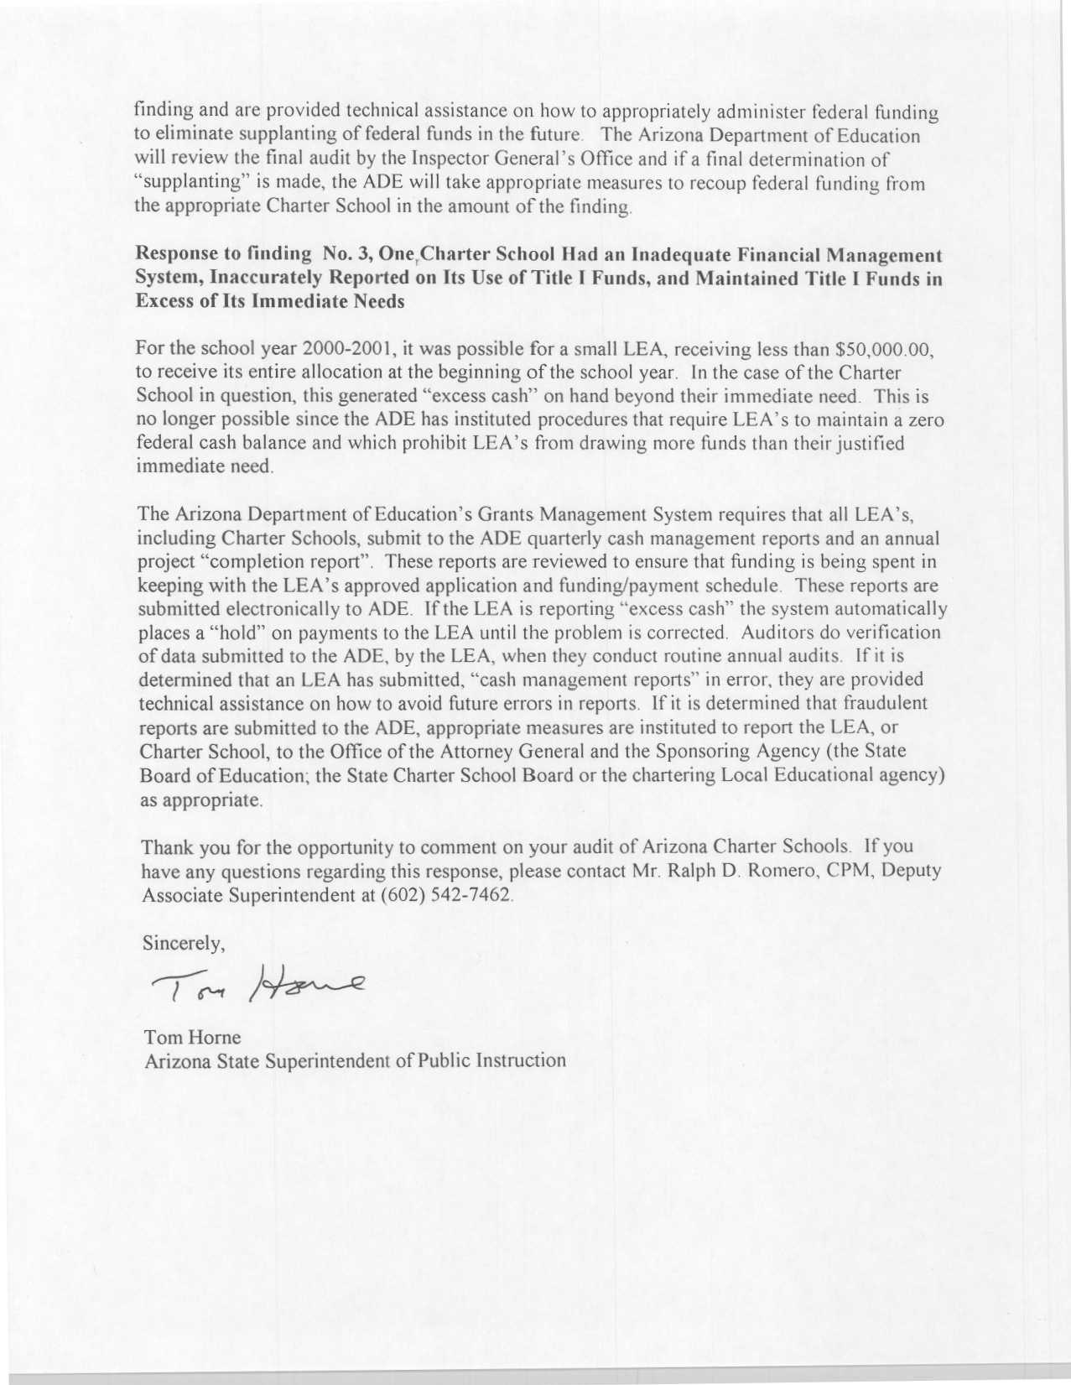

Our audit included Public Charter Schools Program, Title I, and IDEA funds. This report only covers Title I and IDEA funds. In Arizona, Public Charter Schools Program funds flow directly from ED to individual charter schools.
As amended by the Improving America’s Schools Act of 1994 and, subsequently, by the No Child Left Behind Act of 2001.
Authorized by Arizona Revised Statutes, Chapter 1, Title 15, Article 8, Section 15-183(B).
After we identified this issue, a charter school official notified ADE officials about the inaccurate reporting. On February 18, 2003, ADE approved the school’s amended 2002 Title I budget. The amended budget included the $46,104 in carryover from our audit period.
ADE generally considers each charter school a LEA. ADE considers a LEA small if it received less than $50,000 in Title I funds for the school year.
These three types of entities are the Arizona State Board of Education, the Arizona State Board for Charter Schools, and individual school districts.
In Arizona, charters can be issued to public and private entities.

