United States Youth Conservation Corps

The Program
The Youth Conservation Corps (YCC) is a well-balanced work-learn-earn program that develops an understanding and appreciation in participating youth of the Nation's environment and heritage. It is administered by the U.S. Department of Agriculture-Forest Service, and by the U.S. Department of the Interior-Fish and Wildlife Service and National Park Service. YCC offers gainful summer employment to youth, for approximately eight weeks, in a healthful outdoor atmosphere.

Enrollees will be paid the District of Columbia minimum wage for a 40 hour work week. Most projects will enroll an equal number of males and females.

Projects include building trails, maintaining fences, cleaning up campgrounds, improving wildlife habitat and thinning timber stands. Participants will do hard physical work and may be exposed to insects, poison oak and ivy, adverse weather, and difficult working conditions.

Eligibility Requirements
Young men and women, 15 through 18 years of age, who are permanent residents of the United States, its Territories, or possessions, are eligible for employment without regard to social, economic, racial, or ethnic backgrounds. Handicapped youth who can effectively participate in most YCC activities are eligible. Youth must have no history of serious criminal or other antisocial behavior that might endanger their safety or that of others; have or be able to obtain a work permit as required under the laws of their State; have a Social Security number or have made application for one; be willing and able to work hard and participate in most work projects. Employment is without regard to Civil Service or classification laws, rules, or regulations.

How You Can Enroll
To apply, youth meeting these qualifications should complete this YCC application form and return it by
April 15, 2008 to: National Capital Parks-East
1900 Anacostia Drive SE
Washington D.C. 20020
ATTN: YCC Project Manager
202-690-5185
Applicants will be selected on a random basis and will be notified of selection.
Demographic information such as age, race, and family income is not used in the selection process.

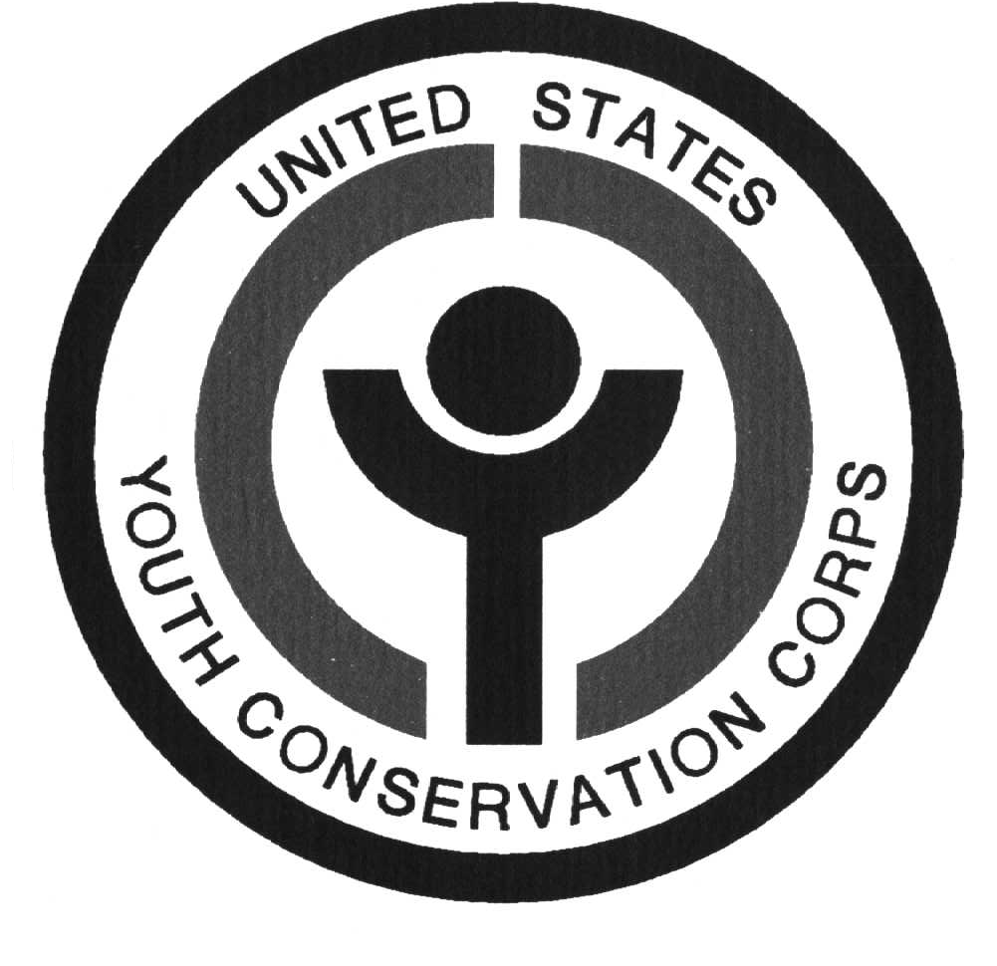
Public reporting burden for this collection of information is estimated to average 3 minutes per response, including the time for reviewing instructions searching existing data sources, gathering and maintaining the data needed, and completing and reviewing the collection of information. Send comments regarding this burden estimate or any other aspect of this collection of information, including suggestions for reducing this burden, to Department of Agriculture, Clearance Officer, OIRM, Room 404-W, Washington, D.C. 20250; and to the Office of Management and Budget, Paperwork Reduction Project (OMB #0596-0084), Washington. D.C. 20503.

YCC complies with Section 504 of the Rehabilitation Act of 1973 (29 US. Code 794). Under this Act and implementing Regulations, handicapped persons "who, with reasonable accommodation, can perform the essential functions'' of the YCC are eligible (7 CFR Part 15b and 43 CFR Part 17)

OMB No. 0596-0084 (Expires 10/31/05)

Youth Conservation Corps (YCC) Application

Print or Type all answers. All questions and statements must be answered to enable Selection Office to determine applicant's eligibility and availability. Incomplete applications may have to be rejected. Authority is PL 93-408. During the term of employment, you must be at least 15 years of age and not have reached age 19.

Name (Last First Middle Initial)

________________________________________________________________________________________________________________

Mailing Address (Street or P.O Box)

_______________________________________________________________________________________________________________

City

_______________________________________________________________________________________________________________

State Zip Code

_______________________________________________________________________________________________________________

__Female ___Male Social Security Number Date of Birth____/_____/_____
Month Day Year

School address Grade

Area Code Telephone Number Area Code Telephone Number

_______ -_______-_______ ________-_________-________ (Relationship)
Home In Case of Emergency

Applicant's Statement

YCC is an Equal I am familiar with the YCC program and interested in working in the outdoors to develop and
Opportunity Employer maintain the natural resources of the United States. If selected, I will obtain a work permit.
I have or am applying for a social security number. I am a permanent resident of the United States or its
Territories or possessions. I do not have a history of serious criminal or other antisocial behavior that might
jeopardize my safety or that of others. I certify that all information I have given above is true and correct to the
best of my knowledge. Incorrect statements constitute grounds for immediate dismissal. You have my
permission to give this application to any YCC official for whose camp I am selected.

________________________________________________________________________________________________________________
(Signature of Applicant) (County)

I am familiar with the YCC program and the applicant has my permission to participate.

________________________________________________________________________________________________________________
(Signature of Parent or Guardian) (Date)

