Tech Note 015: ArcGIS User Level
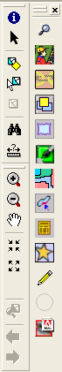
April 3, 2007

Problem: Users cannot find the desired menu options in ArcMap, or the expected ArcMap tools are not present on the Toolkit Toolbar. Commonly, this problem occurs after Toolkit is reinstalled.

Versions: All

Background
The ArcGIS User Level can be set to Basic or Advanced in Toolkit Preferences. When set to Basic, Toolkit uses the template called ‘Basic.Normal.mxt.’ The template for advanced users is called ‘Advanced.Normal.mxt’ (see Figures 1-2 on page 3).

Resolution
If the tools that the user expects to see are absent from the toolbars (pictured at right), change the ArcGIS User Level in Toolkit Preferences from Basic to Advanced, or Advanced to Basic, as appropriate. In some cases, you will need to reset the user level from Advanced to Basic, then save, then reset to Advanced, then save.

Comparing Basic and Advanced Templates
The right-click menus for Basic and Advanced Users are compared below.

Basic | Advanced
Right-click menu for consplan, practice, resource inventory, and build your own layers

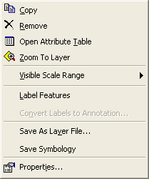 | 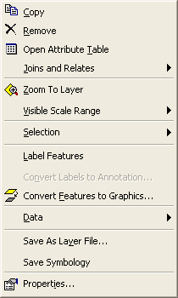
Right-click menu for an ortho/raster layer (the same for both basic and advanced users)

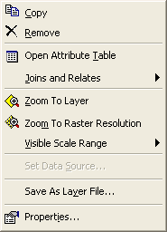
The selection menu is the same for both basic and advanced users.

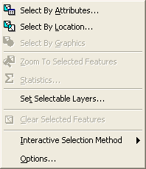

The screen shots on the next page show the different tools available on the Toolkit Toolbar when the user level is set to Basic and Advanced. Note that when the ArcGIS level is set to Advanced, the selection tools are menu options only. If users prefer to have the select tools on the toolbar, reset the ArcGIS User Level to Basic.
Support Tip: If the ArcGIS level is currently set to Advanced in Toolkit Preferences, the Selection menu will be present between the Insert and Tools menus in the top menu bar.

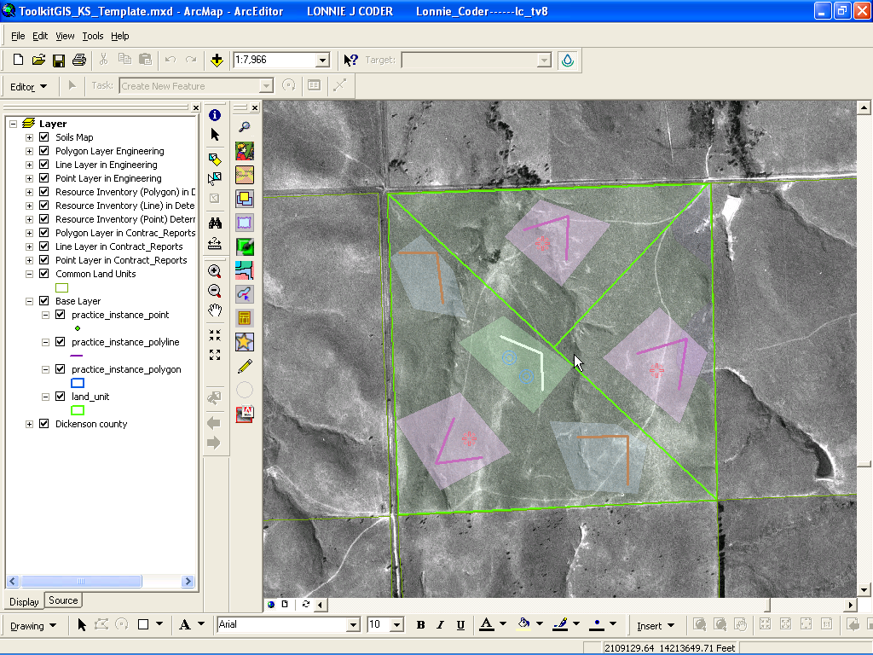
Figure 1. Basic.Normal.mxt

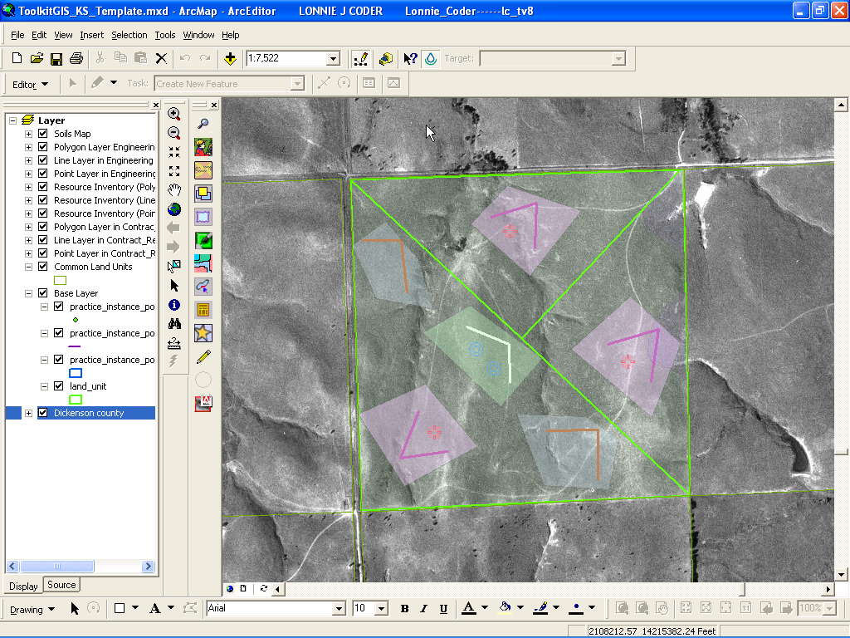

Figure 2. Advanced.Normal.mxt

