Target System for a Long Baseline Neutrino Beam

N. Simos, H. Kirk, J. Gallardo, S. Kahn, BNL
N. Mokhov, FNAL

OVERVIEW

The need for multi-MW class primary proton beams generating powerful, intense secondary neutrino beams for use in future neutrino experiments has prompted a host of feasibility studies of target concepts that will be capable in supporting such initiative. This is due to the fact that the survivability of a target that meets the physics demands at such power level holds the key to the success of any such experiment. To ensure that such target is even feasible at these power levels, a dedicated effort is necessary to explore physical limitations of materials considered in the target scheme. It is well understood that solid materials experience limitations that primarily stem from the following: 1) thermal management of the large target-heating generated by the interacting/showering proton beam; 2) radiation damage that alters material properties leading to possible degradation of target performance; and 3) generation of intense pressure (shock) waves that can lead to target destruction. While liquid targets are not bound by these limitations, they face a host of technical challenges such as implementation into a workable scheme (liquid jet) or effects on the target infrastructure (contained liquid) where cavitation-induced loads can limit the lifetime of the target scheme.

Since experience data at these power levels (approximately an order of magnitude higher than that of operating accelerators) are not available to-date, the viability of any target system concept (either based on solid or liquid targets) supporting a multi-MW proton source (2-4 MW) needs to be validated with a comprehensive R&D. Such effort must focus on materials and/or target concepts holding promise of both functionality and longevity under high-power conditions. Uncertainties that can only be resolved through experimental efforts are, for solid target options, primarily linked to the radiation damage resistance of the target material expressed by its ability to withstand the induced thermal shock in its irradiated state while maintaining the key physical properties (thermal diffusivity, thermal expansion, etc.) that enable the entire target scheme to function in place for practical time durations of weeks to months without replacement. On the other hand, proof-of-principle experiments of liquid target schemes that may be applicable to a neutrino initiative are vital in ensuring that the all elements of the concept work. Of paramount importance in these experiments should be (a) the validation of delivery of such target (when in jet form) into the extremely tight configurations required, including delivery at higher frequencies that are dictated by the higher power, and (b) the interaction and integration with the pion collector (solenoid or magnetic horn) that provides the magnetic field.

Discussed in the following sections are: (a) target concepts that have been implemented in the operating neutrino beam experiments and their potential or limitations in operating at the multi-MW level, (b) the technical challenges of proton drivers associated with the multi-MW class and their direct impact on the production target, (c) the ongoing R&D efforts to assess the viability of solid targets at the multi-MW power levels and their integration with collector devices such as horns, and (d) the ongoing R&D on liquid target schemes that might be of interest to a long baseline neutrino experiment.
1.0 Current state of the art in solid targets for a conventional neutrino beam

Conventional neutrino beam targets (those in the kW range) have relied on a variety of solid materials for pion generation. While aluminum and beryllium targets have been used in the K2K and MiniBooNE experiments respectively, the material that has been selected to support the CNGS, the NuMI and the T2K target concepts is graphite. Shown in Figure 1.1-1.3 are graphite-based target schemes implemented in some of the conventional neutrino beam experiments.

While graphite (in all different grades used in these targets) appears to satisfy the requirements at the current levels of power demand, the effects of the higher levels of irradiation on the key properties of the target material that control its functionality (i.e., thermal conductivity, fatigue, shock absorption, etc.) is either unknown or not very favorable for graphite (at least the graphite grades that have been in use). Shown in Figure 1.4 is the dramatic change in thermal conductivity of graphite with irradiation (even at low levels of damage expressed in terms of displacements per atom or dpa). The levels of dpa shown are expected to be achieved very quickly in a multi-MW operation. Since the data shown are from neutron exposure, it is apparently important that dedicated R&D efforts focusing on proton irradiation and damage assessment are needed. As it will be discussed in the following section, such studies have been initiated at BNL attempting to assess proton irradiation damage on graphite as well as other promising material candidates such as carbon composites. Figure 1.5 depicts another aspect of the BNL effort. Specifically the response of targets to an intense proton pulse (in terms of strain) is shown indicating that carbon composites are better able to absorb shock than graphite and therefore be in position to operate at higher accelerator power.

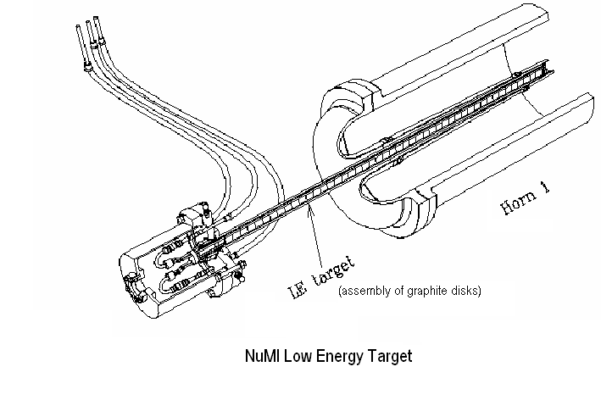
Figure 1.1: NuMI target system (low energy)

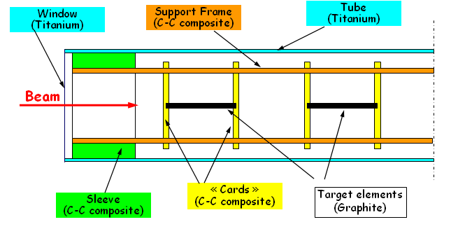
Figure 1.2: CNGS graphite target

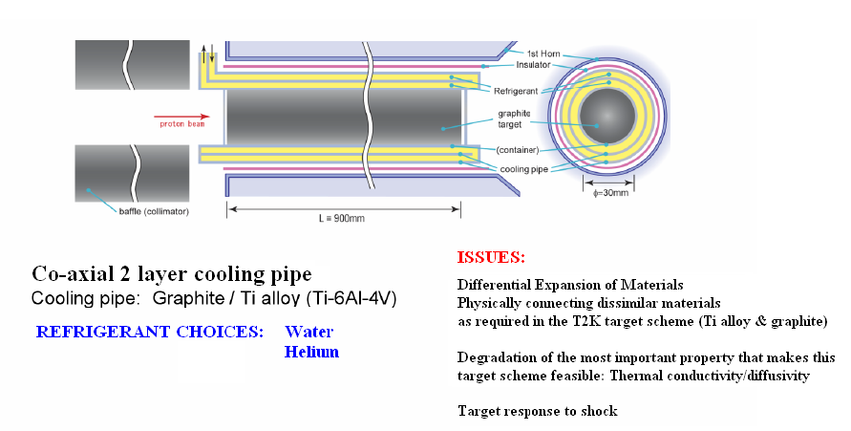

Figure 1.3: Graphite-based target scheme implemented in the T2K experiment

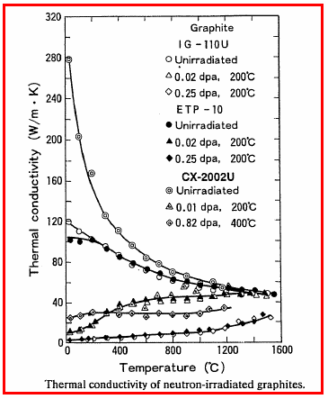
Figure 1.4: Effects of irradiation on thermal conductivity of graphite

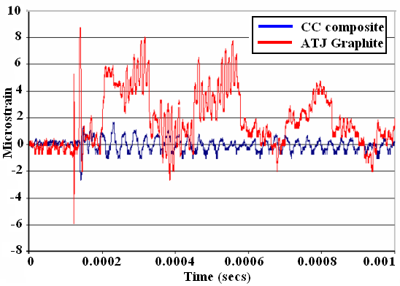
Figure 1.5: Comparison (experimental) of shock response between graphite and carbon-carbon composite. Data generated during the BNL E951 target validation experiment

2.0 The Challenges of a multi-MW Power Accelerator

Proton Driver Issues

The challenge of delivering 2+ MW of power on a target is governed by a number of controlling parameters. One parameter set relates to the production target and specifically the choice of material as well as its integrated design that allows it to operate as a functional unit. The second set is linked with the proton pulse structure delivered to the target and the parameter choices have a direct impact on the survivability of the target. Whether liquid or solid the target feasibility issues stem from the inherent material limits that in turn are a function of the deposited energy density. The energy density is a result of the pulse intensity, the proton energy, and pulse spatial structure as well as material density. Balancing of these interconnected parameters along with the repetition rate of beam delivery on target can lead to an optimal operational space within which the power delivered and safely absorbed by the target can be optimized. While studies exploring the optimal space for a functional multi-MW proton driver have been initiated exploring the possibilities in a rather generic sense, focused efforts based on the parameters of a neutrino beam are needed.

Energy Choice

The choice of energy to deliver 2 MW will have effects on muon production and collection as well as target survivability.

Figure 2.1 depicts muon collection from a recent BNL neutrino factory study.

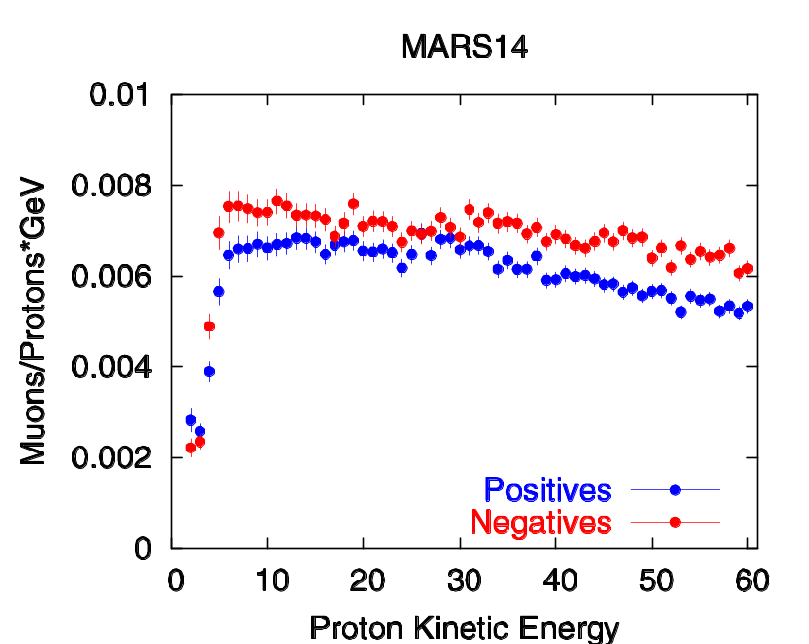

Figure 2.1: Efficiency of muon collection versus proton driver energy

While energy density distribution in a given solid target will vary within the target depending on the energy of the incoming protons, an important parameter in transferring deposited heat from the target, the maximum energy density, as several studies have shown, increases with increasing energy. Figure 2.2 shows the dependence of energy density on a copper target as a function of proton energy. Since the overall effect of higher power (i.e. 2 MW) is a combination of energy and repetition rate to achieve the desired power level, the optimal combination needs further study.

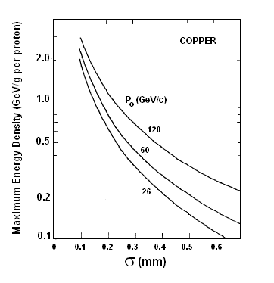
Figure 2.2: Energy density on target versus proton driver energy

The way proton energy will affect solid and liquid targets two is distinctively different. On one hand, solid targets are vulnerable to thermo-mechanical shock induced by high energy densities that can lead to failure even with a single pulse on target, fatigue due to the cyclic nature of the problem that will lead to premature failure of the target. Most importantly, solid targets are susceptible to irradiation damage manifesting itself in altering the key properties of the material, both physical and mechanical that is responsible for shock absorbance and heat diffusion towards the heat sink. The onset of irradiation damage is always expected to compromise the longevity and functionality of a solid target. In addition to the issues brought upon by the proton beam, solid targets, even under the best of circumstances, must enable the removal of the significant heat load through a feasible and “smart” design. This is particularly challenging because of the constraints brought onto the target by physics requirements that limit the size of the target to avoid re-absorption of secondary particles and thus limiting the available target surface area for heat transfer to the heat sink.

While experimental efforts are currently being pursued to evaluate the limits and feasibility of both liquid and solid targets, it is has been assessed, based on our understanding of the governing processes and extrapolated simulations, that solid targets are appear to be capable of reaching powers of 2 MW at best and only under the condition of low Z, high performance materials such as carbon composites. Liquid targets, on the other hand, appear to have a much greater chance in supporting a > 2 MW proton driver provided the technical challenges of its implementation into a workable scheme are solved.

3.0 Target R&D Studies

Dedicated experimental studies have been under way at BNL to address the issues (a) of irradiation damage on targets, (a) the effects of pulse intensities and the shock absorption capabilities of different material choices, and (c) of the feasibility of liquid targets in jet form and their interaction with proton pulses and strong magnetic fields.

The BNL solid target R&D program has been organized and pursued in response to the problems recognized and faced by any solid target material choice. As a result a material matrix of wide range of atomic-Z numbers has been adopted for study. One should also keep in mind that different types of secondary beams have different optimal production characteristics.

In the experimental effort thus far, solid targets have been investigated with a focus on the survivability of the targets. Materials, which are resistant to fracturing and break-up due to the generation of intense pressure waves, are being sought. This experimental effort entails the irradiation of candidate materials in order to evaluate their properties after prolonged exposure to radiation. However, the pace and scope of the current BNL target R&D needs to be intensified and expanded in order for it to provide answers for a neutrino experiment at the higher power levels sought in a timely manner and have the most effect.

BNL Solid Target R&D Overview

Beam-on-Targets (E951)

The beam on target experiment conducted under the BNL E951 aimed at evaluating whether carbon composites are better suited to absorb shock as compared with graphite counterparts. Figure 1.5 shows that indeed carbon-carbon composites, because of the low thermal expansion coefficient they exhibit, can absorb shock and therefore can intercept higher intensity pulses which in turn indicate higher power proton beams. A second aim of the E951 solid target study was to validate special simulation processes based on which assessments of target-proton interaction will be made. This step is considered vital given that understanding of how solid targets survive the high intensity pulses can only be done through extrapolation of the available data at much lower power levels through benchmarked simulation models.
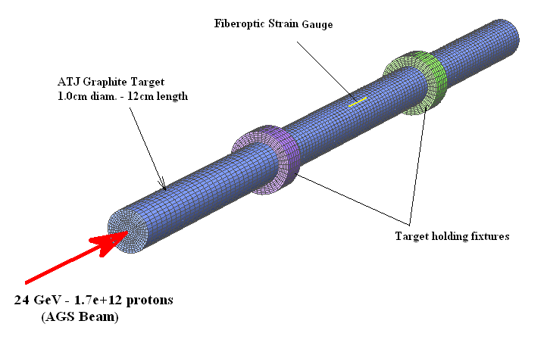
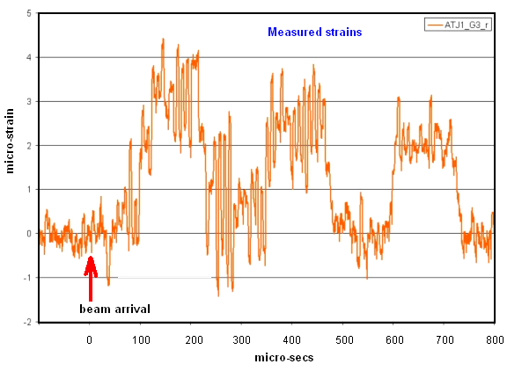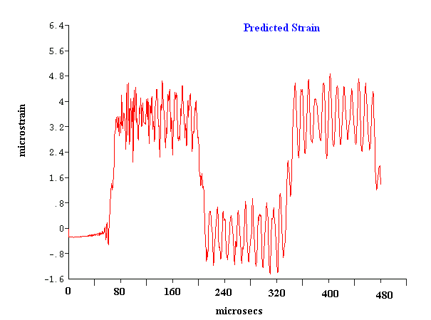

Target Irradiation Damage

The aim of the study is to experimentally confirm that new alloys and composites, attractive for their mechanical and physical properties in the un-irradiated state and under consideration as baseline target options, retain these properties after being exposed to high power, high intensity proton beam. This task has two sub-tasks:

- Irradiation of target materials - Achieve radiation damage levels that are representative of the anticipated operational levels for both the super neutrino beam and the neutrino factory proton targets. The study is exploring radiation damage (via intense proton exposures in BNL Isotope facility) in the following materials:

  - 3D and 2D carbon-carbon composites
  - Different grades of graphites
  - Super alloys (super Invar and gum metal)
  - Titanium alloys
  - Beryllium
  - Albemet
  - Vascomax
  - Copper and Glidcop
  - Tungsten
  - Tantalum
  - Nickel-plated aluminum (NuMI horn material)
  - Graphite-Titanium bonded targets

- Post-irradiation materials study - The work focuses on the resilience on the changes caused by radiation damage in the thermal diffusivity, thermal expansion, resistivity and density reduction. All of the mentioned functions/properties hold the key to a feasible target and horn system. Since recent experimental evidence suggests that some materials may undergo a special annealing that corrects irradiation damage, explore how common this behavior is to the materials considered.

The study has thus far led to some very interesting observations on the behavior of these material candidates, especially in the way thermal annealing plays a role in irradiation damage control. Also observed are the effects of irradiation, combined with the cooling environment such as water, on some materials and especially the baseline horn material. The effects of high proton dose that approaches the dose that might be expected in a 2 MW scheme on carbon composite (2D type) is also intriguing and needs further assessment.

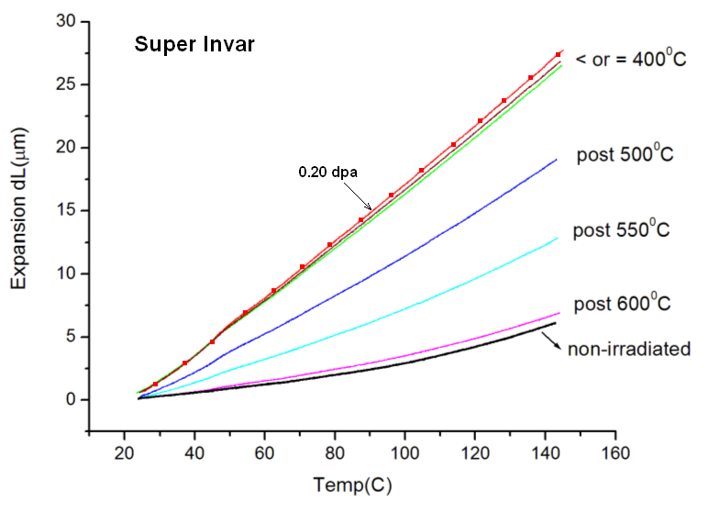
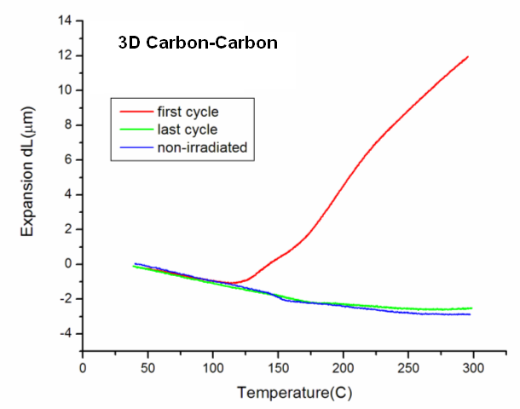
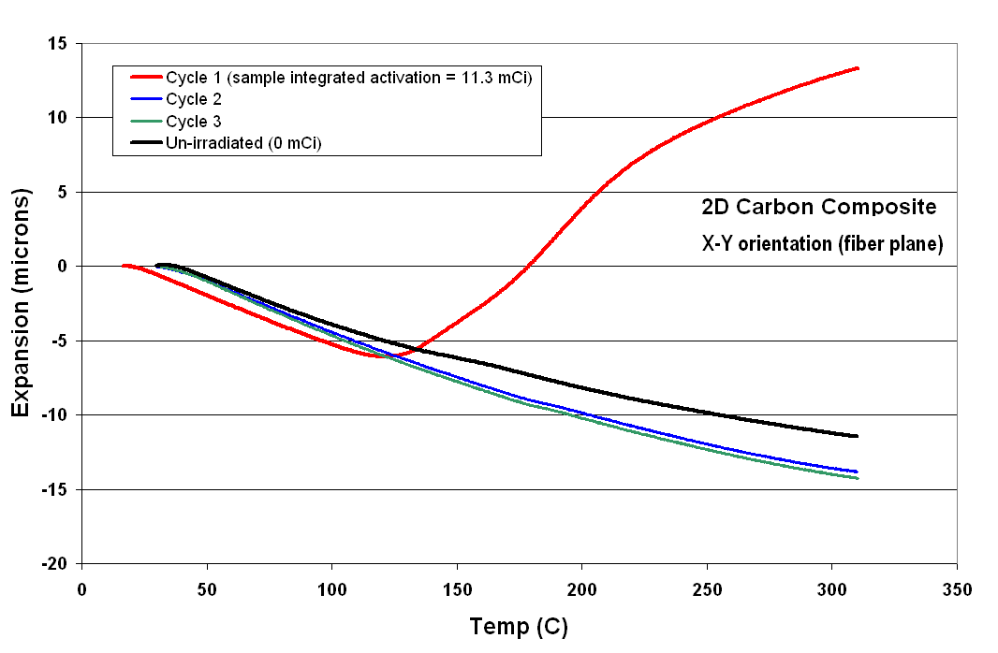
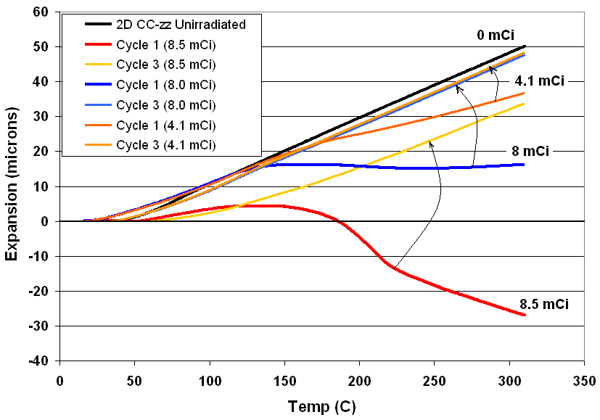
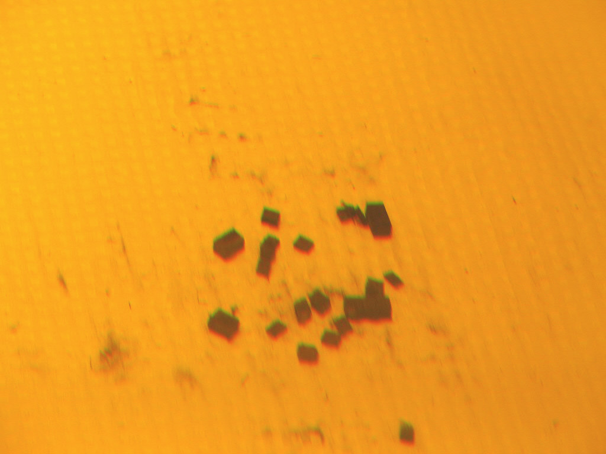

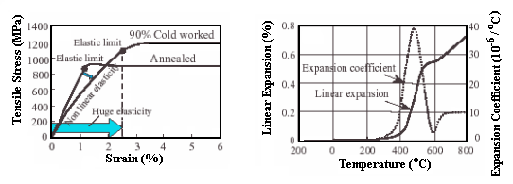
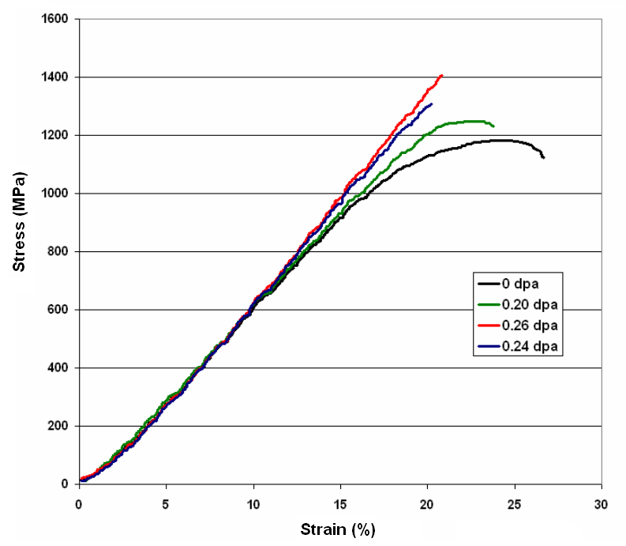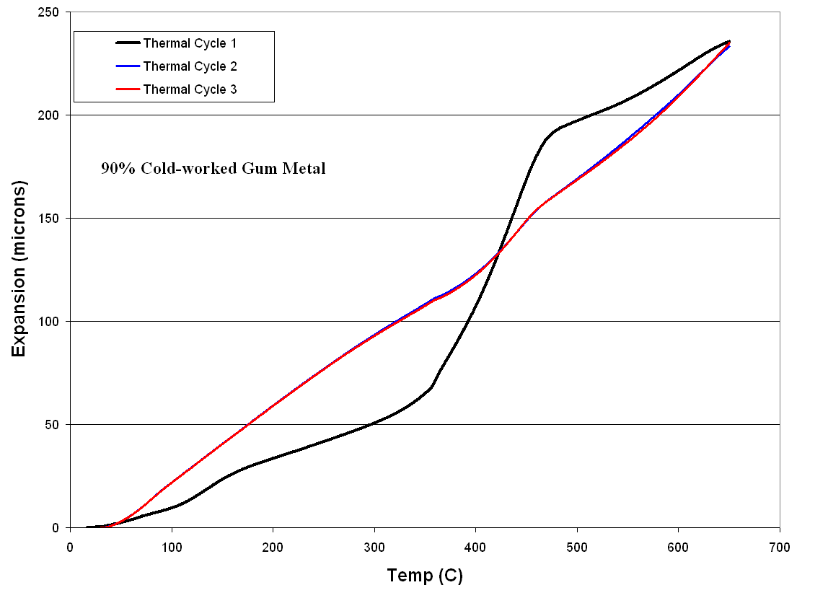

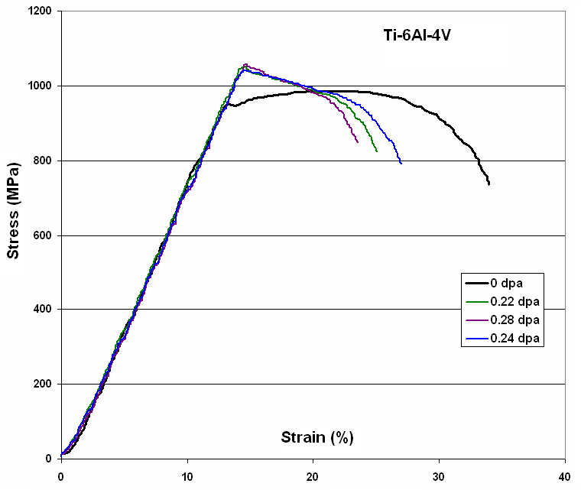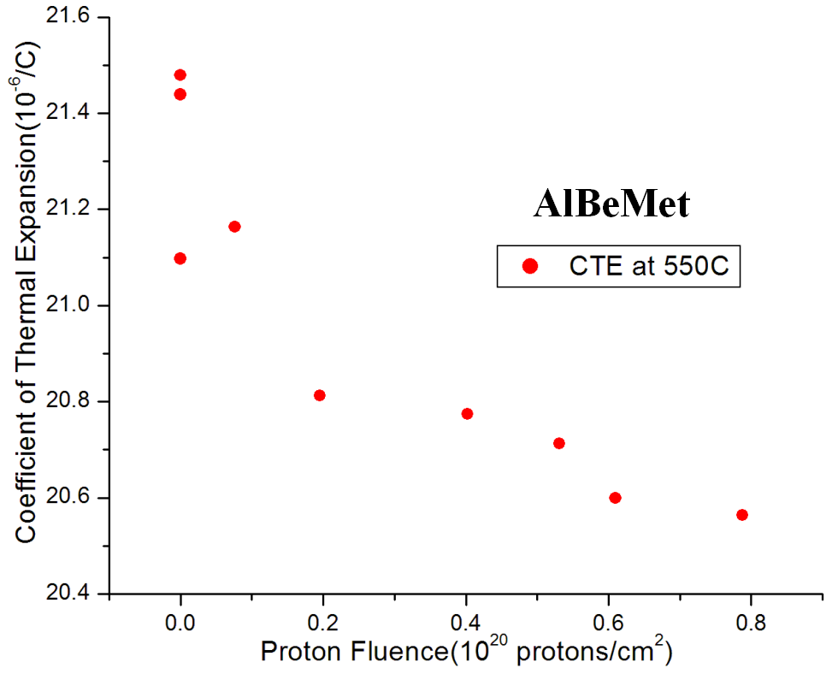

High-Power Horn-Focused Neutrino Beams:

The feasibility, as well as the functionality, of an integrated target/horn system supporting the physics requirements of a multi-megawatt Super Neutrino Beam pose significant challenges that require a substantial new R&D effort. While the experience of running similar neutrino beam experiments at power levels an order of magnitude lower than those proposed can be of value in conceptualizing a target and horn system with the potential of operating at much higher power levels, this experience cannot be simply extrapolated to the design of a feasible and functional system at the megawatt power levels. This circumstance stems primarily from material limitations related to both target and horn, especially their ability to retain the key physical and mechanical properties for which they were chosen in the first place. The severe radiation damage conditions induced by the high-power proton beam, along with the cyclic thermal shock encountered with each current pulse, provide severe challenges to the operational goal of pulsing for the longest possible time before replacement of the target or horn components is needed. Attractive candidate materials from the physics performance perspective are certainly available but most of them lack crucial information on radiation-induced degradation of their key materials properties. Some of these candidates (i.e., graphite or carbon-carbon) have been exposed to high levels irradiation, but the radiation exposure data comes from reactor experience and is based on neutron rather than proton irradiation. This experience also derives from steady-state conditions in the absence of shock and rapid thermal cycling. Variations in the material response to different types of radiation are not yet measured experimentally.

Horn/Target Integrated System Performance Issues:

Performance limitations and/or failures of the integrated target/horn system of either past or running neutrino beam experiments (i.e., K2K horn, MiniBoone horn, NuMi target, etc.), operating at much lower power than what will be required for the super neutrino beam application, provide clear indications that technical issues remain and that that these will increase in severity as the required beam power rises.

The inability to reliably extrapolate the performance of low-beam-power experiments and operating experience into the design of the proposed multi-megawatt neutrino beam requires that the following R&D issues must be addressed to resolve the integrated target/horn system technical design and materials suitability questions:

1) Target Issues/Optimization:
  - identification, design and proto-typing of an optimized target/horn configuration for parent pion capture in the desired wide-band neutrino beam, including robust and radiation-hard materials choices able to provide optimized pion collection for a multi-megawatt target/horn system;
  - analysis of the optimal target configuration and materials for their physics application compatibility (including atomic numbers and densities) and the relationship of these to the inventory of radiation-hard materials or composites identified in the first task;
  - analysis of the behavior of the target configuration and the expected cyclic beam-induced mechanical/thermal shock at the anticipated radiation-damage levels, and prediction of the longevity in service of the derived optimal target/horn system.
2) Horn Issues/Optimization

While the horn structure does not intercept the proton beam directly, it is still exposed to high levels of radiation from secondary particles and thus its ability to maintain the intended focusing function as radiation damage progresses is of primary importance. The ability of the horn material to maintain its resistivity as low as possible in the presence of progressive radiation damage is key to the selection and optimization of its design. This criterion is coupled with the requirement that serious degradation of the structural integrity of the horn (as it experiences radiation damage, thermal cycling due to electric current and proton beam heating, mechanical vibration and potentially corrosive cooling fluids) is strongly mitigated or avoided altogether.

In recent neutrino experiments, the failures of focusing horns that occurred earlier than anticipated, relative to their expected lives, point toward horn materials inability to resist radiation damage and to chemical corrosion degradation. Recent BNL radiation damage studies of horn materials showed that the material (even with a protective coating for fatigue resistance) experiences integrity degradation with modest levels of irradiation in a corrosive environment. At anticipated radiation damage levels that are an order of magnitude higher than current experience in the super neutrino beam era, the technical issue of getting the longest operational lifetime from the horn structure is of paramount concern.

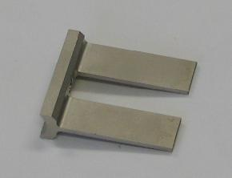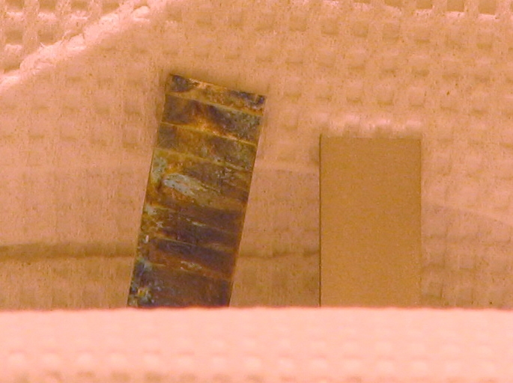

Figure 3.1: Effects of modest levels of proton irradiation (~0.25 dpa) on nickel-plated aluminum of the NuMI Horn. Experiment was performed
at the BNL BLIP facility with 200 MeV protons.

In order to achieve the horn performance required by the super neutrino beam and to extend its operational life as much as possible, alternative materials options need to be considered in place of aluminum, the traditional horn body material. Significant technical progress in materials development has benefited other technical applications and now needs to be applied to horn and target optimization. Alloys such as AlBeMet, that exhibit favorable properties for horn use still lack radiation damage characterization. Such non-traditional alloys could provide a way to meet the technical challenges of a super neutrino beam horn with its associated multi-magawatt operating levels. The recent BNL materials irradiation study (while still at modest irradiation levels) produced results that favor the use of AlBeMet. However, further studies at higher irradiation levels are needed to establish the viability of this materials option.

3) Integral Target/Horn Challenges/Optimization ➔ Planned feasibility experiments

While the two primary elements of particle generation and focusing (i.e., target and horn) may be optimized to achieve their intended functions separately, they still need to be compatible in an integrated configuration. This is especially challenging because these two components need to be coupled in some respects of the operation (i.e., sharing cooling path) and be decoupled in others (i.e., remain electrically insulated). For both aspects (coupling or de-coupling) the beam power plays a pivotal role. The energy deposited in the target, as well as in the horn conductor, is directly proportional to the beam power as is the demand for a heat transfer path out of the integrated system. While the configuration geometry is similar to that of the low power neutrino experiments, the demand for heat removal capacity is about an order of magnitude higher under the same boundary conditions. Added to that is the expected degradation due to radiation damage of the material properties that control the flow of heat such as thermal conductivity or diffusivity; this is also expected to occur at much higher rates due to the higher beam power.

To achieve the performance required of the integrated system, the configuration as well as the materials that are involved, must ensure that both the heat transfer and the electrical insulation between the target and horn are maintained in satisfactory condition even under long-term irradiation. Experience from low power neutrino experiments is not directly transferable to the design of the proposed high power system and therefore dedicated R&D effort is necessary to address the following issues
  - ability of helium gas flowing in the small annular space between the target and the horn inner conductor to remove heat deposited on the target. Helium gas is being considered to replace water cooling for several reasons: (a) the geometrical configuration to reach the optimal neutrino spectrum calls for an embedded target in the horn inner conductor that, in turn, has a very small diameter (~ 19mm). This geometry precludes the use of concentric annular spaces that allow coolant to flow past the surface of the target and never be in contact with the current flowing in the horn inner conductor. Helium gas represents the solution to the interface problem as long as it is capable of removing the target deposited heat at the rate required; (b) experience with water and its corrosive nature in recent experiments has not been positive. Protecting the horn surface from corrosion as well as the target surface from erosion will ensure a longer operational life. To assess the feasibility of helium cooling under such tight configuration, a dedicated heat transfer experiment needs to be performed while simulating the exact configuration of the proposed target/horn integration and materials as well as with the actual thermal loads anticipated.
  - An assessment of the radiation hardness of special insulating materials that perform the role of horn/target coupling to endure the radiation damage expected over the maximum operating life of the integrated system.
  - An assessment of the life expectancy of the integrated system subjected to the combined loading conditions. By utilizing radiation-induced material property changes, obtained by parallel efforts, simulations based on state-of-the-art software and modeling of the entire system are necessary to identify the weak points that may limit the life of the system. Since failure in one component, no matter how peripheral, would mean failure of the system as a whole, assessing the integrity under these high beam powers is vital. The NuMi experiment experience, in which a peripheral system failure caused significant beam downtime, is a reminder of the seriousness of the issue.

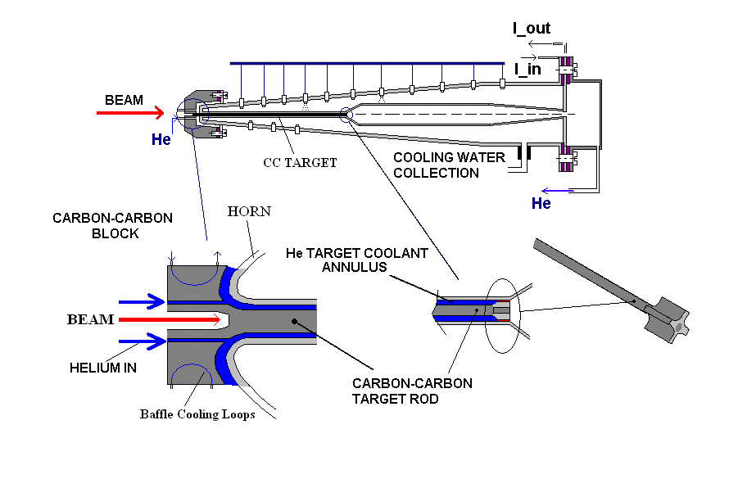
Figure 3.2: Conceptual design of target/horn system for the BNL neutrino superbeam

Helium INTO annular target/horn space
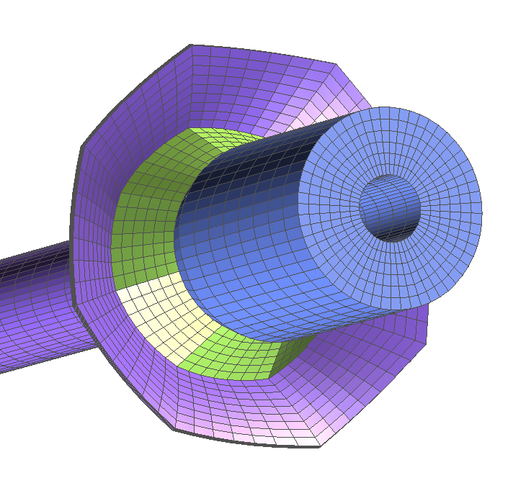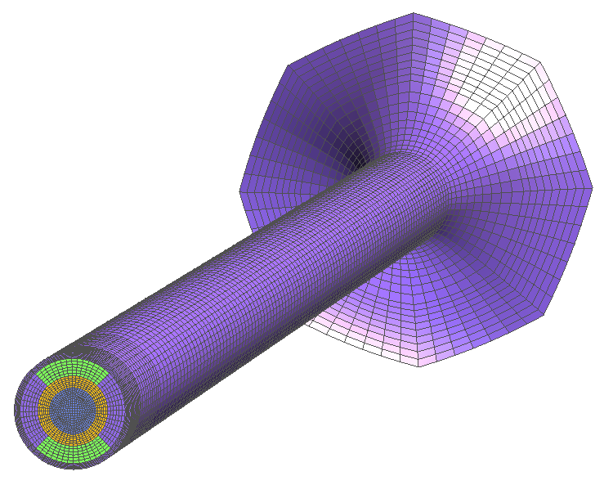
Target/Horn Integration concept of FRONT END
Target/Horn/Insulator
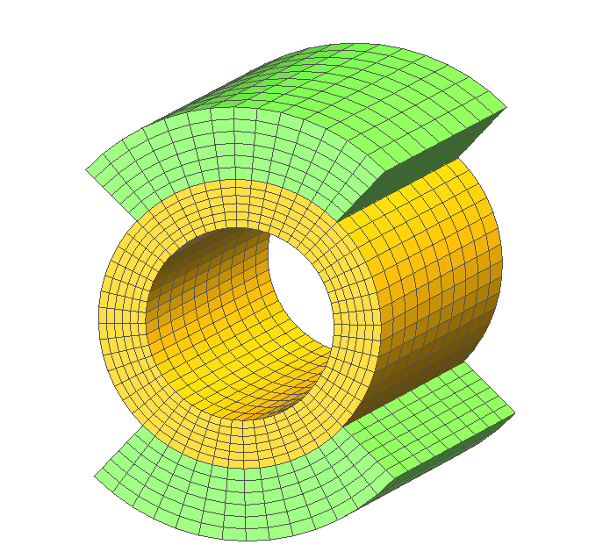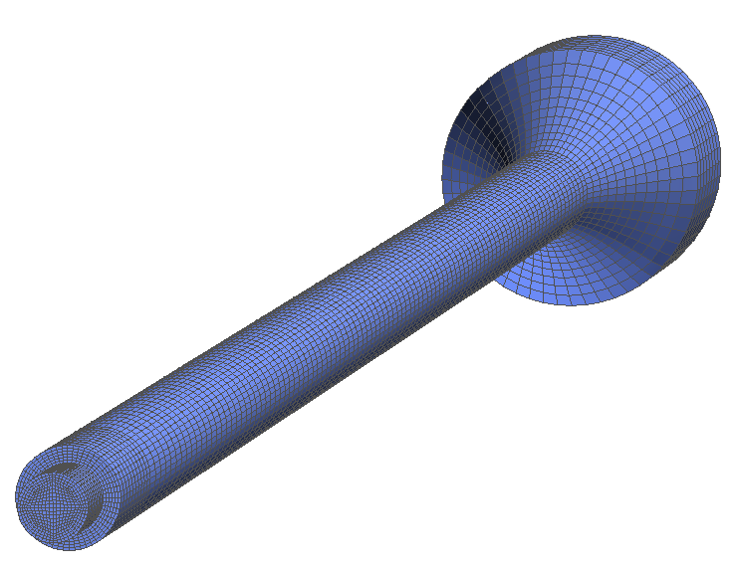
Insulator detail coupling neutrino target with horn
Target model including baffle (front) part and end details

Figure 3.3: BNL neutrino target/horn integration baseline model

Target/Horn Integration R&D:

Collaborations with CERN and T2K to validate the concept of He cooling under severe conditions.

To address the above issues, the following R&D tasks are proposed to be performed over a 2-year period:

Conceptualize, simulate, design and test the critical section of the integrated target/horn system (i.e. target, horn inner conductor, insulator, and forced helium integration) for helium cooling verification and feasibility of the target/horn conductor coupling: To maximize the life of the two key components (target and horn) the option of using helium gas flowing in the annulus between the target and the inner conductor to remove the target thermal load will be explored. The thermal loads induced by the high power beam are about an order of magnitude higher than what target/horn systems have experienced in experiments to date. In addition, the low heat capacity of the inert gas proposed places further challenges in meeting the requirements. However, a proof-of-principle experiment showing that helium can be used in the proposed target/horn configuration, will eliminate far more serious issues associated with water cooling. The task will consist of three (3) subtasks, namely:
- Helium cooling feasibility experiment: In a configuration simulating the horn inner conductor interfacing with the target (made of carbon-carbon composite or graphite) the ability of forced helium in removing heat deposited on the target inductively (similar to beam thermal load) will be tested and the maximum heat removal capacity of this scheme will be assessed.
- Integrated target heating, helium flow and horn current pulsing experiment: Key to the long term survival of the system is the ability of the various components to withstand fatigue and induced vibrations from all three sources. Experimental testing of the proposed target/horn configuration will reveal potential weak spots thus allowing for the system modifications.
- Testing of alternative material options: Explore other than the baseline materials for use as target, horn and insulators. Experimental verification of the erosion resistance of materials such as different grades of carbon composites and graphite to forced flow is of interest. In addition, assessment of electrical resistivity and corrosion resistance of materials other than aluminum as will provide potential alternatives for a horn with maximized life. Further, an experimental study, including irradiation, of different insulating materials that allow coupling between the horn and the target will provide much needed information on this key component of the system.

Simulation studies of the super neutrino beam integrated target/horn system

- Simulate particle interaction with various target systems using transport codes and couple the hadronic analyses with thermo-mechanical simulations of the entire system.
- Use both aspects of simulation (hadronic and thermomechanical) as well as irradiation data from a concurrent R&D to optimize the overall performance and design.
- Focus on the simulation of the unique characteristics of the CC composite such as weaving of reinforcing fibers, anisotropic bulk structure and customization of fiber configuration to maximize important properties such as thermal diffusivity, erosion resistance and thermal expansion.
- Identify the MW power capacity and life expectancy of the proposed target/horn scheme based on these comprehensive simulations. This is a very important task given that limitations in the target/horn system directly translate to limitations of the actual experiment. Understanding the limits of any proposed scheme (for this neutrino or any other experiment) in terms of useful life and power capacity is vital. Given that no proton driver to-date are capable of producing the powers proposed, the only path to assessing the system is based on simulations that analyze the exact system that has been benchmarked to powers that are achievable as of today.
4. Funding Support Necessary for Target System R&D

5. Comments on very advanced work on liquid targets

The problems presented by solid targets being exposed to intense proton beams has also led to a consideration of the merits of utilizing liquid targets. The Muon Collaboration, a national consortium that has been pursuing R&D for muon colliders and muon storage rings for a number of years, has developed a scenario for the production of intense low energy muon beams based on immersing a high-Z liquid material (either Hg or perhaps a Pb-Bi eutectic) within a high-magnetic-field solenoid for the purpose of producing and capturing the soft pions generated when the proton beam interacts with the target. This effort includes a leadership role in the approved CERN experiment (nTOF11) to demonstrate the technical feasibility of a mercury jet target under conditions suitable for a Neutrino Factory.

Liquid target either in the form of jets or contained volumes, do not suffer from thermal shock, fatigue or irradiation damage. While these serious limitations are avoided altogether, liquid targets face challenges of a different kind. Specifically, interaction of the proton beams with a high Z liquid jet target will lead to an explosive style destruction that, while of no consequence to the secondary particle production, could have serious consequences in the target infrastructure. The ability to replenish a liquid jet to meet the repetition requirement of the high power proton driver and the difficulties of adopting a feasible jet scheme to tight geometrical constraints pose additional challenges. In the case of a contained liquid, the generation of high cavitational pressures can induce damage on the target infrastructure.

Liquid Targets R&D:

This effort attempts to experimentally confirm the concept of using high-Z liquid target materials in an intense proton beam. Prior R&D work in this area has been proceeding for several years under the Muon Collider/Storage Ring R&D program and could be important to the neutrino physics program of a future muon storage ring facility. Emphasis is placed on the ability to replenish the target after successive beam pulses while confirming that the dispersal of the liquid jet is manageable. An approved target experiment, nTOF11 at CERN, designed to answer key questions concerning the performance of liquid-metal targets in a high-field magnetic field environment while being exposed to an intense proton beam pulse is the vehicle to address these important questions. The technical issues to be resolved include: trajectory and integrity of the liquid-metal jet in the magnetic field; explore the feasibility of 50 Hz operations; and the impact of μs proton bunch spacing on secondary particle production.

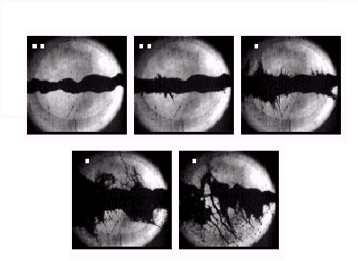

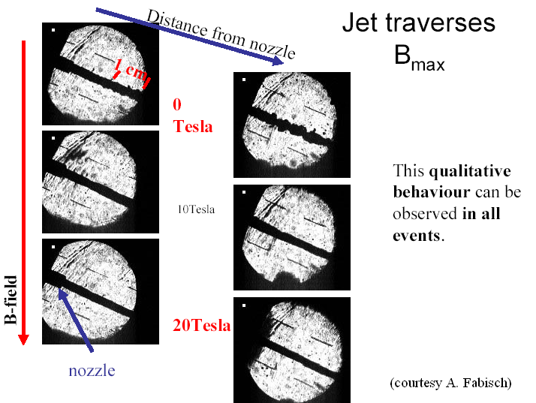

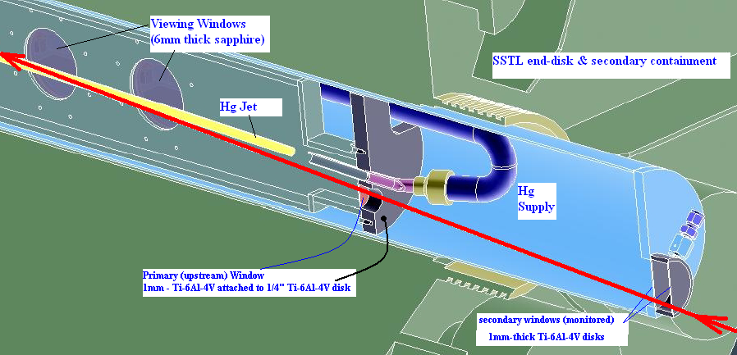
Summary

The envisioned R&D target studies have wide appeal given that the target feasibility issues are common to all initiatives associated with multi-MW power accelerator drivers. All neutrino beams and neutrino factory initiatives fall into that category.

For the solid targets, the limitations arise from the fact that materials available to-date, including alloys and composites, may not be able to endure the kinds of demand these beam initiatives require. Advancements in material science hold part of the answer in solving material limitations, i.e., target resilience to beam induced shock. Comprehensive and systematic material irradiation studies are necessary in assessing whether new materials, alloys and composites can withstand the levels of radiation damage expected with long exposure to a multi-MW beam. This R&D is focused on covering a broad range of material Z and therefore increasing its relevance to a wide field of current and future initiatives for neutrino physics and beyond.

For the liquid target options where the target destruction is not the primary issue, issues associated with (a) the current lack of understanding of the behavior of conductive liquids in strong magnetic fields and (b) the thermodynamic processes that take place during beam-target interaction need both experimental and simulation-based verification. Through this R&D, both aspects are being proposed. Benchmarking of simulations that include magneto-hydro-dynamic and thermodynamic relations on the experimental efforts will provide the basis to assess how feasible a multi-MW liquid target is and what are its limitations.

The underlying statement regarding the value of high power target R&D is that all initiatives involving multi-MW proton beams have to address these target issues. Therefore, results of this R&D will serve any future neutrino beam and neutrino factory initiatives.

Further, with the ever-increasing demand for high power neutrino beams the pool of workable and realistic target/horn schemes reduces dramatically. This is due to the limitations of the materials, alloys and composites, available to-date, to endure the kinds of demands these beam initiatives require. This issue is common to all of present or future neutrino initiatives. Advancements in material science hold the key to solving individual component limitations, i.e., target resilience to beam shock or horn resilience to corrosion and electrical degradation. Solving the individual component issue does not, however, solve the issue as a whole because it is the integration of the system based on compatibility between components (target/horn/insulators/coolant) and functionality that is important. This R&D will address both the individual component integrity and the feasibility/functionality of the integrated system. By utilizing on-going and future planned studies of irradiation effects on materials as well as state-of-the-art simulations, areas where the proposing team has extensive expertise, limitations of the proposed neutrino beam initiatives stemming from the engineering side of the target/horn system as well as possible path toward these high powers will be identified. Results of this R&D will serve any future neutrino beam initiative.

