Taking Good Weather Observations
John F Saltenberger
Predictive Services
Northwest Geographic Area Coordination Center
Portland, OR

Preface:

The purpose of taking weather observations during a wildfire or prescribed fire project is to record environmental conditions prevalent at the site. Depending on the size of the project and the complexity of the terrain, several separate weather observation sites may be necessary to adequately convey weather conditions representative of the entire burn site.

Accurate weather observations are important in wildland fire management for several reasons:

1^{st:} Meteorologists build their spot weather forecasts based on the observations reported from the fireline. The forecaster uses the observation to build a mental model of weather pattern in the vicinity of burn site. The more accurate and representative the weather observations are, the more effectively a meteorologist can forecast weather conditions at the site. This results in better fire behavior forecasts. If fireline weather observations are incomplete or unrepresentative, the forecaster will have a much more difficult time accounting for localized effects.

2^{nd:} Meteorologists seek to verify the accuracy of their forecasts by comparing weather conditions observed at the site versus what was forecast. When differences are noted, the meteorologist can potentially learn from the errors and correct for the next forecast. The belt weather kit observation constitutes the best record of weather conditions near the fireline.

3^{rd:} Belt weather kits observations become part of the official fire documentation record. If there is an investigation or litigation following some accident on the fire, belt weather kit observations comprise a key component for re-constructing environmental conditions surrounding the accident. These can prove critical during litigation.

1. Siting

Key Point:

Regardless of whether the fire is a prescribed fire project or a wildfire, the weather observer should strive to pick observation sites that most accurately reflect environmental conditions around the fire’s location.

Tips:

Consider whether to take a weather observation on a ridgetop, midslope or drainage bottom location. Is the fire site exposed or sheltered? What is the aspect and slope? What kind of surface texture? The choice of observation sites should reflect the type of terrain the fire front is most actively burning in. Selecting an unrepresentative site will result in weather observations that don’t truly reflect the environmental conditions of that incident, division or burn site.

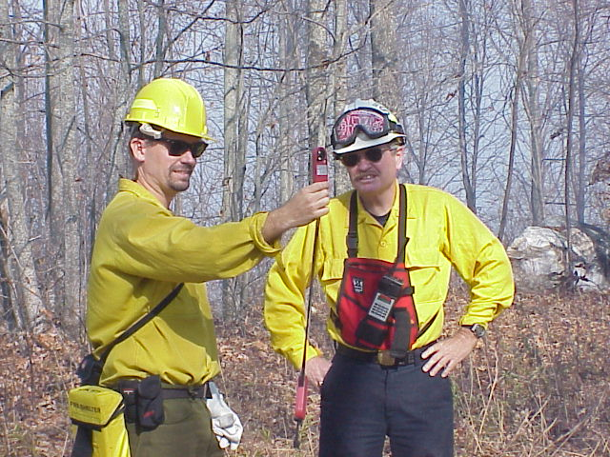 | Representative fuels  Once safe representative sites have been selected, the weather observer should try to take the observations in the same fuel type the fire is most active in. If the fire is spreading in timber litter, try to take the observations in similar unburned timber. The same is true for brush or grass fuel types.

Minimizing fire influences  The weather observer should avoid taking observations in the black since burned areas tend to be unrepresentatively warm and dry. Attempt to find a safe site upwind of the burned area if at all possible. If the observer has no choice but to take an observation in the black, make sure to note it in the remarks section of the log.  The weather observer should also take care to minimize localized weather effects generated by the fire itself. Take weather observations away from gusty indraft breezes and radiant heat in the vicinity of the flaming front. These are very localized conditions that don’t reflect the area’s general conditions. Generally, well ventilated areas in the shade are desirable spots for belt weather kits to be most effective. | 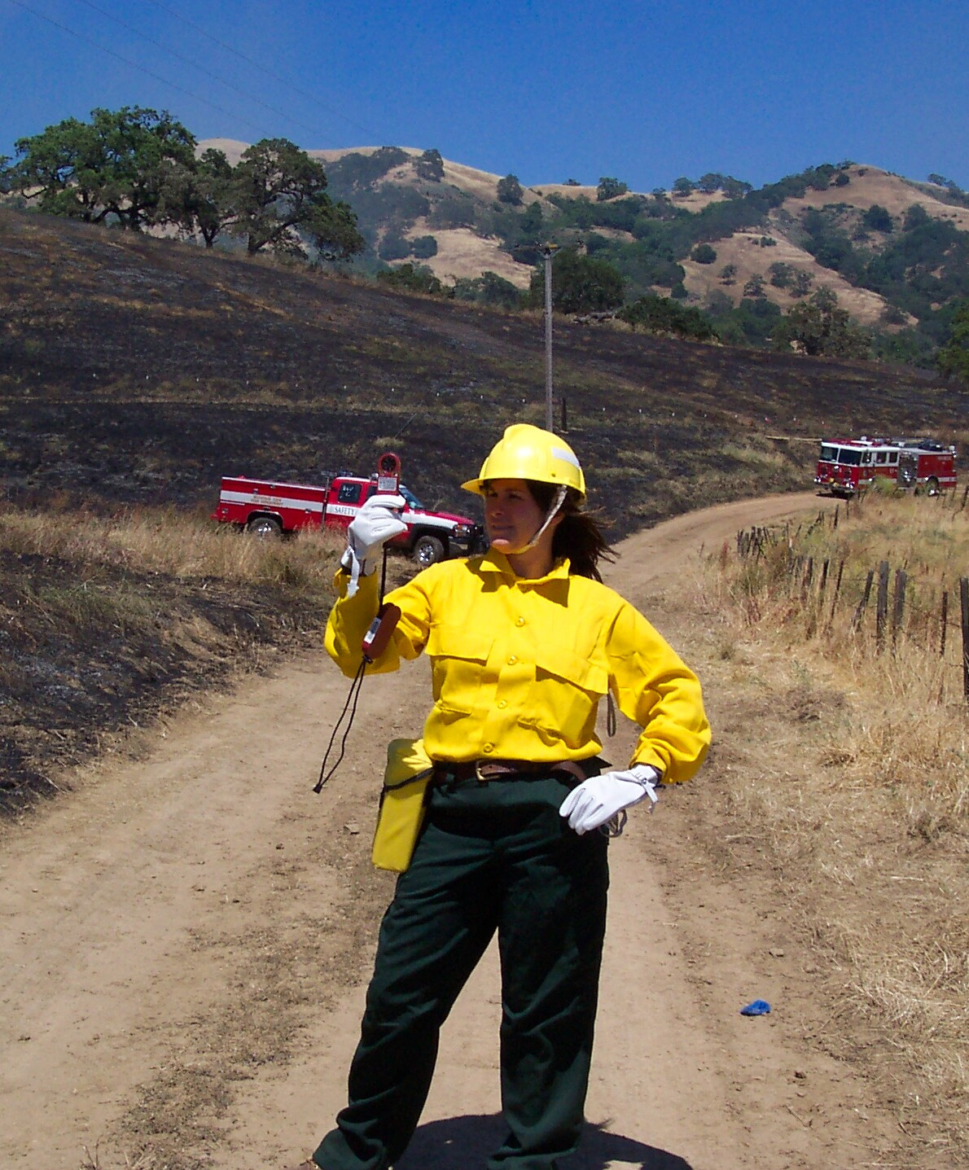

2. Observation process

Key Point:

To be effective, belt weather kits must be properly maintained and operated. Inspect kits for defects prior to each fire assignment. Old, dirty or broken parts should be replaced. Electronic sensors must be calibrated routinely during fire assignments. Proper procedure must be followed to extract the most accurate information from a weather observation.

Tips:

Here are some considerations to keep in mind:

- Check sling psychrometers for separated mercury columns. These can sometimes be corrected by exposing the thermometer to very cool temperatures such as an ice bath.

- Replace dirty wicks on wet bulb thermometers with a clean wick.

- Test the ball in Dwyer wind meters for free movement. Static electrical charge buildup, moisture, or dirt can lodge the ball in the tube.

- Electronic temperature and humidity sensors should regularly be calibrated against weather instruments of reliable accuracy. Check that the batteries are fresh.

- Well maintained sling psychrometers are still the most accurate, durable and reliable indicators of temperature and moisture. They function as well in extreme conditions as in moderate conditions.

Regardless of whether the kit is a traditional sling psychrometer or electronic sensor, get into the habit of letting it acclimatize for several minutes in a shaded, breezy area before beginning an observation. This allows the sensors to gradually adjust to environmental temperature and humidity. Avoid exposing the kit to body heat, sweat, ash, dirt, and direct sunlight. The observer should be careful to store the kit in locations away from temperature extremes such as vehicle dashboards or in line gear pockets.

Avoid direct sunlight during temperature and humidity observation  The wet bulb/dry bulb observation must be taken in shade. Even if the site is grassy (i.e. no shadows from an overstory) the instrument must be protected from direct sunlight. If necessary, the weather observer can use his or her own body shadow to avoid exposing the kit to sunlight. | 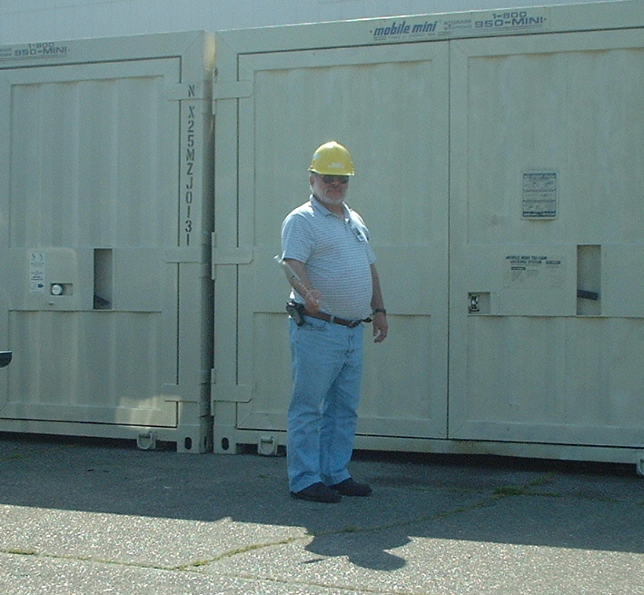

When using a traditional sling psychrometer, be sure the wick is thoroughly wetted before beginning to swing. Distilled water is preferred. Bottled water is the next best alternative. New wicks may tend to repel water droplets from the wet bulb so the observer may need to gently rub the wick against the side of the water bottle to eliminate air pockets. A soaked wick is the goal.

Continue swinging the sling psychrometer until the wet bulb temperature is reached. This may take several minutes. Continue to check the wet bulb temperature every thirty seconds until it reaches its lowest value. In very dry conditions it may be necessary to re-wet and continue swinging until the lowest value is attained. When the wet bulb temperature ceases descending, the correct value has been reached. Read and record the dry bulb immediately after the lowest wet bulb reading is obtained.

When wet bulb and dry bulb temperature have been determined, compute the dew point and relative humidity using the paper tables included with the kit. Select the appropriate table for the altitude range corresponding to the observation site. Plastic slide rules for computing dew point and humidity should only be used if a printed table is not available. Use of the printed tables will provide greater accuracy.

A time saving strategy is to conduct the wind observation while the temperature sensor is acclimatizing to ambient conditions. Wind observations need not be taken in shade but they should still reflect the ambient conditions affecting the fire.

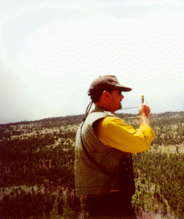 | Points to remember about eye level  wind observations.  - The observer should take care to face directly into the wind and closely observe the wind speed indicator fluctuations. Exposure to sunlight is not a concern during the wind observation.  - An eye level wind speed measurement requires at least one full minute of sampling and preferably more.  - When using a Dwyer tube, mentally average the wind speed and note the peak gust during the sampling period.  - Electronic sensors make wind averaging easy. They are more accurate and are preferred for eye level wind speed observations.  - Remember: The wind direction is defined as the direction the wind is coming from.

3. Observation logging and remarks

Key Point:

Careful record keeping is as important to the weather observation process as every other step. It’s a good idea for the observer to double check recorded values for obvious errors before logging and submitting.

Tips:

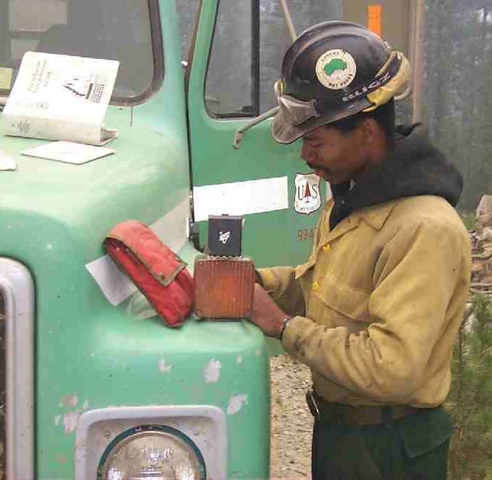 | Effective logging  Carefully note the date, time and location of each weather observation. Include aspect, elevation, exposure and fuel type whenever possible. If the observer is changing locations, this becomes even more important.  Don’t confuse the wet bulb, dry bulb and dewpoint temperatures. Double check to insure the proper values are noted in their respective columns of the observation form. Use clear penmanship. This is a frequent source of error.

Compare the latest weather observation against those taken during previous hours. Stay alert for any obvious discrepancies. Weather conditions naturally fluctuate during the course of a day but large changes may indicate either a significant weather event or an instrument malfunction. To reduce potential errors, its a good idea to cross check weather observations with nearby observers.

Best use of the remarks column  The remarks column can be used to log significant features such as:  - Alto-cumulus clouds, cumulus buildups or thunderstorms.  - Lightning  - Smoke column developing a pyro-cumulus cap cloud.  - Lenticular clouds  - Sudden wind shifts  - Changing cloud cover  - Dust clouds radiating away from downdraft impacts.  - Inversions  - Dust devils  - Showers or virga  - Upper level winds significantly different than surface winds  - Other significant features since last observation | 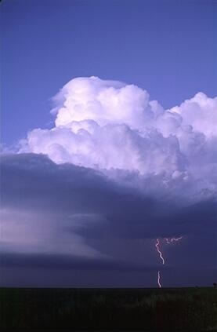

Lastly, it’s a good idea to remark whether the observations were made with an electronic weather sensor or traditional sling psychrometer.

4. Transmission of observations

Key Point:

The most accurate weather observation is of little use unless it is properly received by those who need its information. The weather observer should make sure that the chain of communication is functioning rapidly and efficiently at both ends.

Tips:

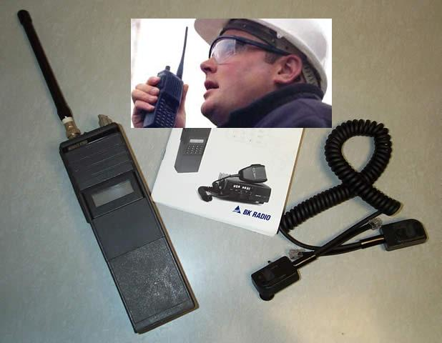 | Work out a plan to transmit weather observations to the Incident Communications Unit or local fire dispatch office on a regular schedule as necessary. Double check that each observation has been received clearly by asking to have it repeated back. This technique is effective at reducing errors.  Remember that weather observations may need to be recorded and transmitted more than once per hour. Fast breaking weather changes can endanger firefighter safety so be ready to act rapidly when the situation requires.

It’s a good idea make sure the observation is being properly relayed to the Incident Meteorologist, weather office, or other affected users. This is particularly true during critical burning conditions or significant weather changes. Don’t assume that weather observations are automatically being received by the proper users. The weather observer may need to take the initiative to verify that the information is being passed up the line.

