The Walker Run

Community Wildfire Protection Plan

An Action Plan for Wildfire Mitigation in

The Walker Run Community

Reardon, Florida

january 7, 2005
Prepared by K.J. Cotton
111 Walker Run Circle
Reardon, Florida 33300

The following report is a collaborative effort among various entities, including federal, state, and local government. The representatives listed below comprise the core decision-making team responsible for this report and mutually agree on the plan’s contents:

Maggi Brown
Walker Run Homeowner’s Association

Liam Wise
Florida Division of Forestry

Latisha Jones-Elliott
Florida Division of Emergency Management

Forrest Ortega
U.S. Forest Service

Samuel Lim
Bureau of Land Management
Plan Contents

- Objectives 1

- Community Collaboration 1

- Community Background and Existing Situation 3

- Community Base Map 4

- Community Wildfire Risk Assessment 5

- Community Hazards Map 8

- Prioritized Mitigation Recommendations 9

- Action Plan 12

I. Objectives
The mission of the following report is to set clear priorities for the implementation of wildfire mitigation in the Walker Run community. The plan includes prioritized recommendations for the appropriate types and methods of fuel reduction and structure ignitability reduction that will protect this community and its essential infrastructure. It also includes a plan for wildfire suppression. Specifically, the plan includes community-centered actions that will:

- Educate citizens on wildfire, its risks, and ways to protect lives and properties,
- Support fire rescue and suppression entities,
- Focus on collaborative decision-making and citizen participation,
- Develop and implement effective mitigation strategies, and
- Develop and implement effective community covenants and codes.

II. Community Collaboration
A task force convened in January of 2005 to assess risks and develop the Community Wildfire Protection Plan. The group, titled the Walker Run Community Fire Council, is comprised of representatives from local government, local fire authorities, and the state agency responsible for forest management. It also includes representatives from forest management groups, city council members, the homeowner association, water district, utilities cooperative, an environmental organization, and a timber and pulp company representing the forest products interests. Below are the groups included in the task force:

Murphy County Government
Fire Rescue
Planning Division
Cooperative Extension
Emergency Management
Upper Murphy Drainage District
Board of County Commissioners

Department of Community Development
Commission for Children and Families
Department of Forestry
Emergency Management
Graphical Information Systems Department
Walker Run Homeowner’s Association
Florida Division of Forestry
Florida Division of Emergency Management
U.S. Forest Service
Bureau of Land Management
Walker Valley Rural Fire Protection District #9
Walker Valley Forestry Action Committee
Walker Valley Watershed Council

In addition to the above, the Walker Run Community Fire Council consulted with a number of interested parties to acquire additional input as the plan was developed:

Murphy County-Walker Valley Cooperative Utilities
Walker Valley Recreation District
Partnership for Healthy Forests
Reardon Timber and Pulp, Inc.
Walker Valley Chamber of Commerce
Interactive Training Media, Inc.

Meetings were held to encourage input from all interested parties. In summary, these meetings included public meetings and invitations to organizations and stakeholders in the county. From these meetings, the following committees were formed to develop specific area-related objectives and actions to support the plan:

Executive Committee Provided oversight to activities related to the Walker Run Community Wildfire Protection Plan, ensured representation on and coordination among the committees, developed and refined goals for fire protection, and developed a long-term framework for sustaining efforts of the protection plan.
Risk Assessment Assessed wildfire hazard risks and prioritized mitigation actions.
Fuels Reduction Identified strategies for coordinating fuels treatment projects.
Emergency Management Forged relationships among local government and fire districts and developed/refined an evacuation plan.
Education and Outreach Developed strategies for increasing citizen awareness and action and created a partnership with an educational media group to conduct educational homeowner, community leader, and teacher workshops.

III. Community Background and Existing Situation

Background
Walker Run is a small neighborhood in northern Murphy county. It is located within the incorporated limits of the city of Reardon. With a population of 52, Walker Run has 18 households and 174.73 acres of land. Approximately 100 acres are planted in pines. A 500+ acre lake lies to the west, and several large tracts of industrial timberlands that total more than 1,000 acres are to the north, south, and east.

Development
The property is divided into 51 half-acre to 2 1/2 –acre lots, 15 acres of roads and easements, and 100 acres of conservation lands planted in pines. Houses have been built on 18 of the property’s lots. Eight of the lakefront lots lie completely in wetlands and will not be sold until water from the city of Reardon becomes available and a joint wastewater system is built. Until that time, these lots will be maintained as open space. Four additional lots are being reserved for a wastewater disposal site. The property is about 50% developed. Undeveloped lots are scattered among the housed and allowed to grow naturally.

Hazard Rating
A wildland fire risk assessment was conducted in Walker Run in 2002 by the Florida Division of Forestry. Walker Run received a score of 118, placing it in the “very high” hazard range.

Fire History
Florida Division of Forestry records indicate that wildland fires are not uncommon to Walker Run and the surrounding property. The 20-year fire history for Walker Run shows that, from January 1, 1983 to October 26, 2003, there have been 9 wildfires in different locations on or adjacent to the property. The individual fires burned 63.8 acres collectively, or 36% of the property and surrounding areas.

The largest and longest lasting of those wildfires was a 40-acre muck fire on the southern border of the Walker Run property. The cause of the fire is not determined. A trash fire that escaped early in 2002 from property to the south of Walker Run may have rekindled in May, or a lightning storm passing through the area may have been the cause. No ignition source was ever discovered, however. When spotted by aircraft, the fire was in a wet location, inaccessible to firefighters. The Division of Forestry monitored the fire for several months, believing it would burn itself out. The small fire smoldered beneath the ground for months, emitting minimal smoke. In mid-May, weather conditions turned extremely dry, and the muck beneath the soil increased its burning intensity, spreading to the surface vegetation. Smoke and flying embers worried Walker Run residents. Firefighters were extremely concerned about the safety of the homes in Walker Run due to the accumulation of hazardous vegetations next to the structures and to the flammable debris on the roofs and in the gutters. Firefighting operations lasted from May 12 to May 25 and were costly to the city of Reardon. Equipment, supplies, and additional personnel totaled $12,250. Fifty firefighters working for 2,872 hours were required to suppress the fire, totaling $43,065 in man hour costs. Several state and local agencies were involved in the muck fire suppression: City of Reardon Fire Department, Murphy County Volunteer Fire Department, Florida Division of Forestry, Murphy County Emergency Services, Office of Emergency Management, North Carolina Forestry Service, and the Florida Fish and Wildlife Commission.

IV. Community Base Map
The following map identifies the wildland/urban interface zone and boundary, inhabited area(s) at risk to wildfire, areas containing critical human infrastructure at risk, and land ownership.

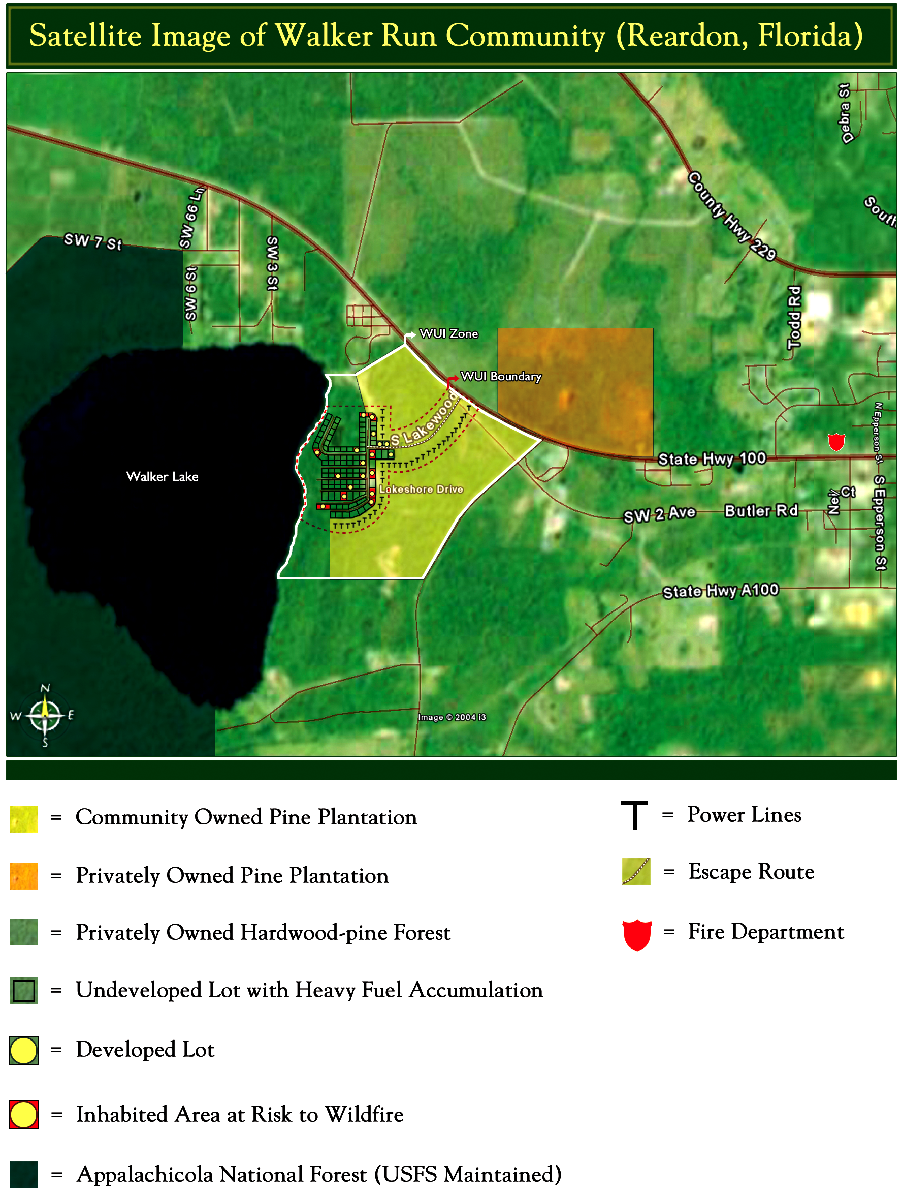

V. Community Wildfire Risk Assessment
Executive Summary
As already introduced, a wildland fire risk assessment conducted in 2002 by the Florida Division of Forestry returned a score of 118, placing Walker Run in the “very high” hazard range. The risk assessment instrument used to evaluate wildfire hazards to the Walker Run community was the Florida Wildfire Hazard Risk Assessment Checklist developed by the Florida Division of Forestry. The instrument takes into consideration accessibility, vegetation (based on fuel models), topography, roofing assembly, building construction, availability of fire protection resources, placement of gas and electric utilities, and additional rating factors. The following factors contributed to the wildfire hazard score for Walker Run:
- One entrance/exit
- Narrow roads without drivable shoulders, with dead ends and very small cul-de-sacs
- Long, narrow, and poorly labeled driveways
- Limited street signs and homes not clearly marked
- Thick, highly flammable vegetation on three sides of the development
- Minimal defensible space around structures
- Homes with wooden siding and roofs with heavy accumulations of vegetative debris
- No pressurized or non-pressurized water systems available
- Above ground utilities and poorly maintained corridors
- Large, adjacent areas of forest or wildlands
- Undeveloped lots comprising half the total lots
- High occurrence of wildfires in the general location

The equivalent National Fire Protection Association’s hazard rating (using the NFPA 1144 Wildfire Hazard and Risk Assessment Scoresheet) scores Walker Run at 91, in the “high risk” range.

Risk Assessment
Walker Run Community
Subdivision Type | Boundary and intermix interface
Fire History of Community and/or Adjacent Lands
Relative Frequency and Location | 9 fires in a 10-year period on or adjacent to the property.
Common Causes | Undetermined. Conjecture on the muck fire is either a lightning strike or a rekindled, escaped debris fire.
Factors Influencing Fire Probability | Heavy accumulation of hazardous vegetation adjacent to the structures, flammable debris on the roofs and in the gutters, large adjacent areas of forest or wildland with accumulated wildland fuels and no prescribed burning program for fuel management, extensive canal/ditch system impeding cross-country access to wildfires in and around subdivision, developed lots adjacent to undeveloped lots containing large accumulations of wildland fuels, significant history of fires due to lightning, arson, and debris burning, and a large muck fire in recent history.
Areas of Future Concern | Walker Run community is the primary area of concern, but adjacent lands will continue to pose a threat unless a fuels management program is implemented.

 | Access |  | Hazard Rating
 | - Ingress and Egress | One road in/out | 7
 | - Road Width | Road width is ≥ 20 ft. and < 24 ft. | 2
 | - Road Accessibility | Hard surface road without drivable shoulders | 2
 | - Secondary Road Terminus | Majority of dead-end roads > 300 ft. long | 3
 | - Cul-de-sac Turnarounds | Outside radius < 50 ft. | 2
 | - Street Signs | Present w/non-combustible materials | 1
 | Vegetation |  | Hazard Rating
 | - Vegetation Types | High fire hazard (palmetto/gallberry over 6 ft. with dense pine overstory, sand pine scrub with dense pine overstory, and dense melaleuca) | 20
 | - Defensible Space | Less than 30 ft. | 25
 | Building Construction |  | Hazard Rating
 | - Roof Material | > 75% of homes have Class A asphalt or fiberglass shingles, slate or clay tiles, cement, concrete or metal roofing, or terra-cotta tiles | 0
 | - Soffits/Siding | < 50% of homes have non-combustible or fire resistant siding or soffits | 10
 | Fire Protection |  | Hazard Rating
 | - Helicopter Dip Spots | Under 2 minute turnaround (< 1 mi.) | 0
 | - Structural Fire Protection | Two miles from nearest fire station | 0
 | - Water Supply | No pressurized hydrants present | 10
 | - Other Water Sources | Draft or pressure sources available within 1-5 miles via all-weather roads | 3
 | - Utilities | Overhead electric, but right-of-way is overgrown/not maintained | 5
 | - Septic Tank | Present and clearly marked | 10
 | Additional Rating Factors |  | Hazard Rating
 | - Large adjacent areas of forest or wildland with accumulated wildland fuels and no prescribed burning program for fuel management |  | 10
 | - Extensive canal or ditch system impedes cross country access to wildfires in and around the subdivision |  | 2
 | - Less than two-thirds of the lots have been developed, and the undeveloped lots have large accumulations of wildland fuels, making it difficult to stop the spread of the fire through the subdivision |  | 7
 | - History of wildfire occurrence is higher than surrounding areas due to lightning, arson, debris burning, etc. |  | 8
 | TOTAL HAZARD RATING = Very High Hazard |  | 118

VI. Community Hazards Map
The Community Hazards Map below resembles the Community Base Map with the exception that areas are marked to indicate wildfire hazard (low, moderate, high), potential “fire starts," values at risk (e.g., homes, infrastructure), and the locations of firefighting resources, evacuation routes, and safety zones.

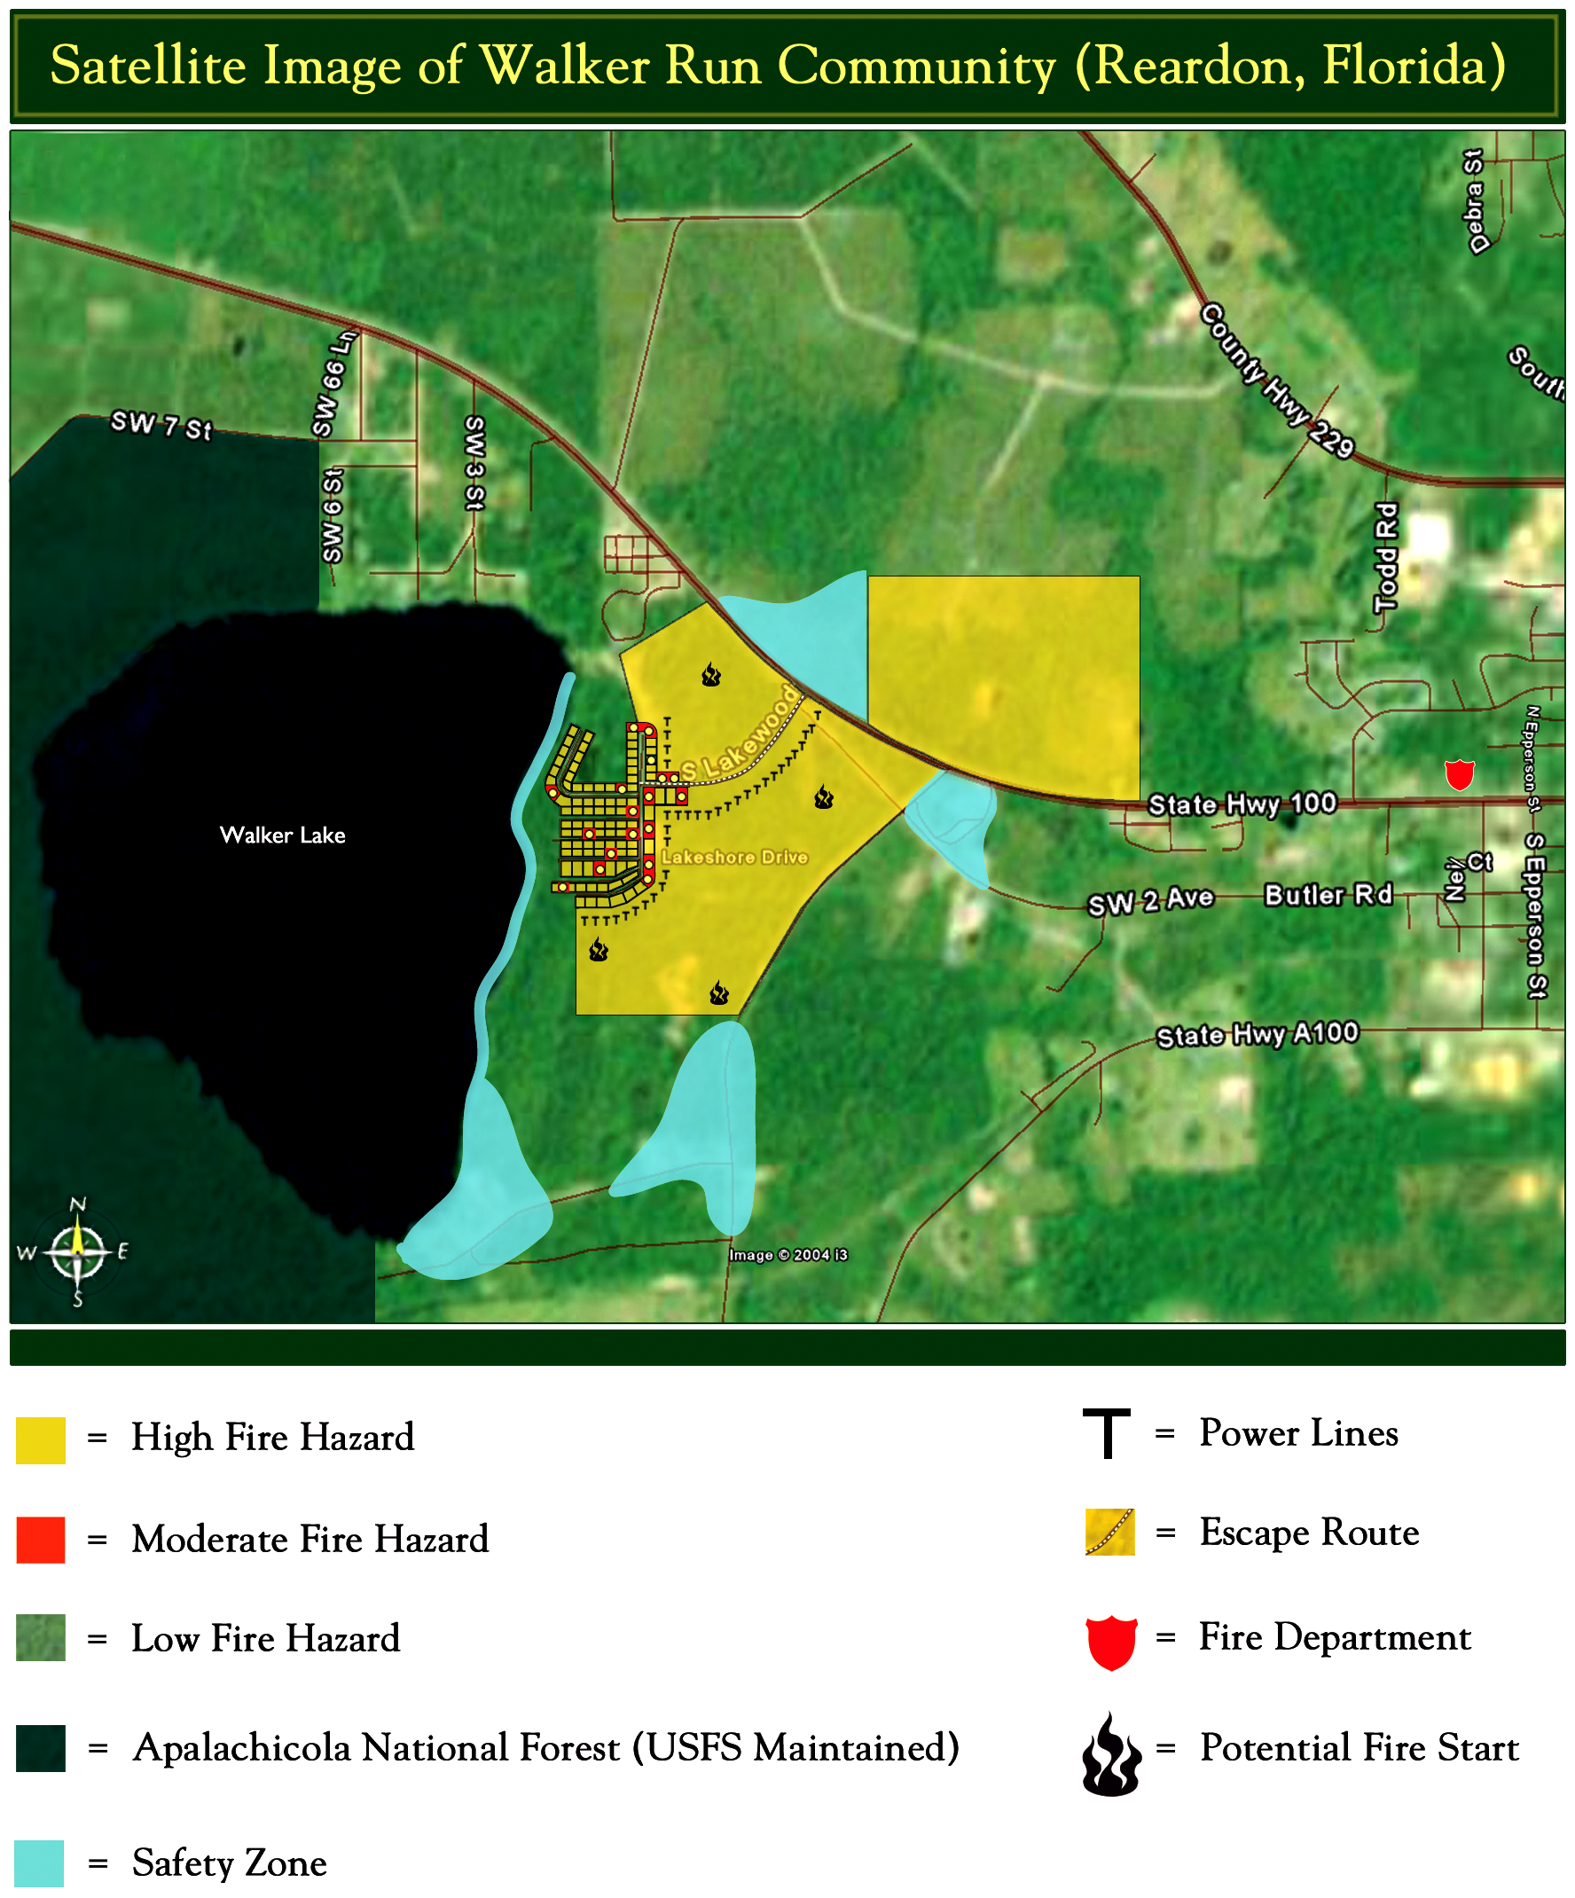

VII. Prioritized Mitigation Recommendations
Executive Summary
The following recommendations were developed by the Walker Run Community Fire Council as a result of surveying and assessing fuels and structures and by conducting public meetings and interviews with county and city officials. A priority order was determined based on which mitigation projects would best reduce the hazard of wildfire in the assessment area.

Proposed Hazard and Structural Ignitability Reduction Priorities
Primary Protection for Community and Its Essential Infrastructure*
Treatment Area | Treatment Types | Treatment Method(s)
- All Structures | Create minimum of 30-feet of defensible space** | Trim shrubs and vines to 30 feet from structures, trim overhanging limbs, replace flammable plants near homes with less flammable varieties, remove vegetation around chimneys.
- Applicable Structures | Reduce structural ignitability** | Clean flammable vegetative material from roofs and gutters, store firewood appropriately, install skirting around raised structures, store water hoses for ready access, replace pine needles and mulch around plantings with less flammable landscaping materials.
- Community Clean-up Day | Cutting, mowing, pruning** | Cut, prune, and mow vegetation in shared community spaces.
- Codes and Covenants | Amend neighborhood covenants** | Amend covenants and restrictions for Walker Run to provide better protection: improve driveway access and widen gates, improve the visibility of house numbers, store firewood appropriately, create defensible space and clear brush, require Class A roofing materials, provide for maintenance of community lots, and restrict debris burning.
- Lakeshore Pine Stand | Reduce hazardous fuels | Conduct prescribed burn of Lakeshore pine stand.
- Interior Perimeter | Reduce hazardous fuels | Mow common property along interior perimeter.
- 85-acre Interior Pine Plantation | Reduce hazardous fuels | Mow between rows.
- Existing Fire Lines | Reduce hazardous fuels | Clean and re-harrow existing lines.
- Water Lines | Install pressurized hydrant system | Extend City of Reardon’s water lines westward to Walker Run and install pressurized hydrant system.
- Water Lines | Install dry hydrant system | If water line project not feasible, install (as temporary measure) a dry hydrant system from pond in Pond Park to West Lakeshore Drive.
- Walker Run Road | Enlarge entrance | Widen entrance by combining two one-way entrance/exit roads into one.
- Southern Cul-de-sac, Lakeshore Drive | Enlarge turn-around | Enlarge south cul-de-sacs to a 50-foot diameter.
- Northern Cul-de-sac, Lakeshore Drive | Create emergency exit | Create secondary, emergency exit by building an unimproved road from north cul-de-sac on Lakeshore Drive to Old Butler Road.
- Utilities Corridor | Reduce hazardous fuels | Mow corridor and thin vegetation.
*Eligible under the HFRA for minimum (50%) WUI funding
**Actions to be taken by homeowners and community stakeholders

Proposed Education and Outreach Priorities
- Conduct “How to Have a Firewise Home” Workshop for Homeowners
Working with Interactive Training Media, Inc. (ITM), an education and training partner, conduct a workshop for homeowners that teaches the principles of making homes and properties safe from wildfire. Topics for discussion include defensible space, landscaping, building construction, etc. Workshop will be scheduled for evenings or weekends when most homeowners are available and advertised through conventional media outlets and homeowner association newsletters and emails.
Homeowners take home a free copy of the How to Have a Firewise Home CD-ROM containing practical video seminars on living in the wildland/urban interface, why homes burn, how to protect your home from wildland fire, and a 3-D home activity in which homeowners turn a home that is a wildfire hazard into a home that is “Firewise.”
- Conduct “Living on the Edge” Workshop for Community Leaders
Working with Interactive Training Media, Inc. (ITM), an education and training partner, conduct a workshop for community leaders that teaches the principles of making communities safe from wildfire. Discussion includes the perspectives of builders/developers, real estate agents, insurance agents, landscape designers, urban planners, homeowners, and more.
Participants leave with a free copy of the Living on the Edge CD-ROM, containing practical video seminars on the wildland/urban interface and interactive exercises on how to assess your community’s risk in a wildfire event and how to design and develop a community based on “Firewise” principles.
- Spring Clean-up Event
Conduct clean-up event every spring involving the Division of Forestry, Murphy County Emergency Management, Reardon Fire and Rescue, and residents. Set up information table with educational materials and refreshments. Initiate the event with a morning briefing by DOF mitigation specialist and the neighborhood association president detailing plans for the day and safety precautions. Activities to include the following:
- Clean flammable vegetative material from roofs and gutters
- Trim shrubs and vines to 30 feet away from structures
- Trim overhanging limbs
- Mow interior, shared community property
- Clean fire lines
Celebrate the work with a community cookout, with Emergency Management discussing and commending the work accomplished as well as the Walker Run Community Wildfire Protection Plan.
- Neighborhood Association Newsletter
Distribute the following with the already established quarterly, neighborhood newsletter:
- Firewise Status Reports
- Firewise Tips (including fire-resistant plant lists and defensible space ideas)
- Informational Packets
Develop and distribute informational packets to Walker Run residents. Included in the packets are the following (sources in parentheses):
- Florida Firewise Landscaping Guide (Florida Division of Forestry)
- Good Fire-Bad Fire Brochure (Florida Division of Forestry)
- Wildfire Danger Assessment Guide (Florida Division of Forestry)
- Wildfire Retrofit Guides (Institute of Business and Home Safety)
- Wildfire Flash Cards (Federal Alliance for Safe Homes)
- Firewise Landscaping and Construction Checklists (Firewise Communities, USA)
- Wildfire Protection Display
Create and exhibit a display for the general public for the Murphy County Fair. The fair runs each spring for one week. Display can be independent or combined with the annual Florida Division of Forestry display.
- Press
Invite the Murphy County Telegraph to community “Firewise” functions for news coverage and regularly submit press releases documenting wildfire risk improvements in Walker Run.

VIII. Action Plan

Roles and Responsibilities
The following roles and responsibilities have been developed to implement the action plan:

Role | Responsibility
Hazardous Fuels and Structural Ignitability Reduction
Walker Run Community Fire Council | Comprised of residents, DOF official, USFS official, Reardon Fire and Rescue official, a representative from the city of Reardon, and the Emergency Management Officer for Murphy county. Meet quarterly to review progress towards mitigation goals, appoint and delegate special activities, work with federal, state, and local officials to assess progress and develop future goals and action plans. Work with neighborhood association and residents to implement projects and provide in-kind services.
Firewise Delegates (2) | Attend annual Firewise retreats conducted by the Division of Forestry and report findings back to the Fire Council.
Resident Liaison | Obtain Wildfire Hazard Mitigation Agreements from property owners allowing the Division of Forestry to implement mitigation procedures, including prescribed burns and mowing as conditions permitted. Coordinate and advertise Fire Council meetings to community residents. Report Fire Council initiatives back to the community. Gather resident support of Fire Council initiatives.
City Liaison | Represent the Walker Run Community Fire Council at city council meetings. Support/encourage commissioner to procure funding allocated for extension of water lines and installation of pressurized hydrants in Walker Run.
DOF Liaison | Support and coordinate initiatives of the Fire Council with appropriate DOF personnel.
Funding Specialist | Identify funding sources and write grants and action plans to obtain funding for projects.
Publicity Specialist | Publicize community events and actions that result from Walker Run Community Fire Council projects.
Codes and Covenants Committee | Amend the Declaration of Covenants for the Walker Run community to permit the removal of trees and undergrowth by owners as well as to institute codes and covenants specified by the Walker Run Community Fire Council.
Spring Clean-up Day
Event Coordinator | Coordinate day’s events and schedule, catering for cookout, guest attendance, and moderate activities the day of the day of the event.
Event Treasurer | Collect funds from residents to cover food, equipment rentals, and supplies.
Publicity Coordinator | Advertise event through neighborhood newsletter, letters to officials, and public service announcements (PSAs) for local media outlets. Publicize post-event through local paper and radio PSAs.
Work Supervisor | Develop volunteer labor force of community residents, develop labor/advisory force from Division of Forestry, Reardon Fire and Rescue, and Emergency Management. Procure needed equipment and supplies. In cooperation with local city and county officials, develop safety protocol. Supervise work and monitor activities for safety the day of the event.

Funding Needs
The following funding is needed to implement the action plan:
Project | Estimated Cost | Potential Funding Source(s)
- Create a minimum of 30 feet of defensible space around structures | $2,000 | Residents will supply labor. Funding needed for tree removal-FDOF Hazardous Fuels Reduction Grant
- Reduce structural ignitability by cleaning flammable vegetation from roofs and gutters, appropriately storing firewood, installing skirting around raised structures, storing water hoses for ready access, replacing pine needles and mulch around plantings with less flammable material. |  | Residents will supply labor and fund required work on their own properties.
- Amend codes and covenants to provide better driveway access, increased visibility of house numbers, properly stored firewood, minimum defensible space brush clearance, required Class A roofing materials and skirting around raised structures, planned maintenance of community lots, and restricted debris burning. | No Cost | Attorney who resides in neighborhood will rewrite and certify free of charge.
- Prescribed burn Lakeshore pine stand (55 acres) | $2,500 | Walker Run Neighborhood Association
- Mow interior perimeter (7 acres) | $4,900 | Hazardous Fuels Reduction Grant through FDOF
- Mow between rows of interior pine plantation (85 acres) | $59,500 | Hazardous Fuels Reduction Grant through FDOF
- Clean and re-harrow of fire lines |  | FDOF
- Install pressurized hydrant system | $210,000 | City of Reardon for partial funding
- Install dry hydrant system (if #5 above not feasible) |  | City of Reardon
- Enlarge southern cul-de-sacs on Lakeshore Drive to a 50-foot diameter |  | Partial funding possible through City of Reardon
- Widen entrance |  | Partial funding possible through City of Reardon
- Create secondary, emergency exit
- Mow and thin utilities corridor | $4,500 | Partial funding possible through city of Reardon
- Conduct “How to Have a Firewise Home” workshop for homeowners | $10,000
- Conduct “Living on the Edge” workshop for community leaders | $10,000

Timetable
The following timetable has been developed for the highest priority projects:
Project (in order of priority) | Estimated Duration | Start | Finish
- Create a minimum of 30 feet of defensible space around structures | 6 weeks | 2/5/05 | 4/16/05
- Reduce structural ignitability by cleaning flammable vegetation from roofs and gutters, appropriately storing firewood appropriately, installing skirting around raised structures, storing water hoses for ready access, and replacing pine needles and mulch around plantings with less flammable material. | 2 weeks | 4/2/05 | 4/16/05
- Amend codes and covenants to provide better driveway access, increased visibility of house numbers, properly stored firewood, minimum defensible space brush clearance, required Class A roofing materials and skirting around raised structures, planned maintenance of community lots, and restricted debris burning. | 4 weeks | 2/28/05 | 3/28/05
- Conduct prescribed burn of Lakeshore pine stand (burning permit required and burn date dependent on weather) | 3-5 days | 1/31/05 | 2/28/05
- Mow interior perimeter (7 acres) | 1 day | 3/31/05 | 3/31/05

Assessment Strategy
To accurately assess progress and effectiveness for the action plan, the Walker Run Community Fire Council will implement the following:
- Annual wildfire risk assessment will be conducted to re-assess wildfire hazards and prioritize needed actions.
- Mitigation efforts that are recurring (such as mowing, burning, clearing of defensible space) will be incorporated into an annual renewal of the original action plan.
- Mitigation efforts that could not be funded in the requested year will be incorporated into the annual renewal of the original action plan.
- Continuing educational and outreach programs will be conducted and assessed for effectiveness. Workshops will be evaluated based on attendance and post surveys that are distributed by mail 1month and 6 months following workshop date.
- The Walker Run Community Fire Council will publish an annual report detailing mitigation projects initiated and completed, progress for ongoing actions, funds received, funds spent, and in-kind services utilized. The report will include a “state of the community” section that critically evaluates mitigation progress and identifies areas for improvement. Recommendations will be incorporated into the annual renewal of the action plan.
- An annual survey will be distributed to residents soliciting information on individual mitigation efforts on their own property (e.g., defensible space). Responses will be tallied and reviewed at the nearest Fire Council meeting. Needed actions will be discussed and delegated.

