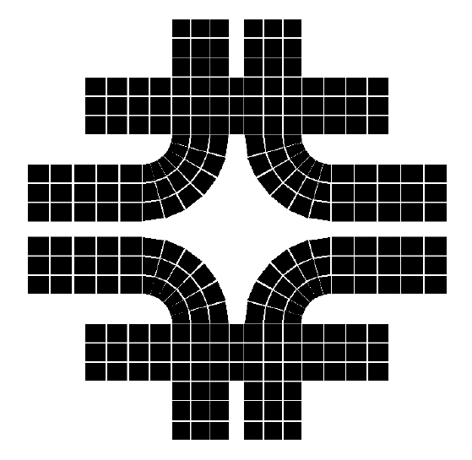
MSG-EAR-01-295
PPD/MD/Engineering Analysis Group
Fermilab
July 12, 2001

Dipole/Toroid Field Interaction

Bob Wands

Summary

A dipole magnet is placed in the bore of a series of toroid magnets. The clearance between the outer boundary of the dipole iron and the inner boundary of the toroid iron is ~ 1 cm. There are concerns that the field of each magnet may be unacceptably distorted by the presence of the other magnet.

A 2-d ANSYS finite element model of the two-magnet assembly was created. The BH used was the same that was applied to the most recent Minos toroid studies, and is based on measurements of Minos toroid steel. The BH data is shown in Table I. The BH curve is plotted in Figs. 1 and 2.

The total NI/coil for the dipole and toroids magnets were 36000 A-t, and 28800 A-t, respectively.

The field in the dipole across the air gap (line A-B of Fig. 3) is shown in Fig. 5. No asymmetry of field can be observed on the plot. Fig. 6 shows the field vectors in the dipole iron. Without the toroid, this field would be symmetric top-to-bottom in the figure. But the toroid coil forces much of the dipole flux downward, producing the field asymmetry in the dipole iron.

The toroid field was plotted along the two radii indicated by lines A-B and C-D of Fig. 4. Line C-D lies in the plane of the toroid coils; line A-B is midway between the two planes. Figs 7 and 8 show the field with and without the dipole. Because the hole in the center of the toroid iron is not square, there is about 4% more steel available for flux at theta = 0, which accounts for the consistently lower field along that line when the dipole is not present.

With the dipole in place, the primary effect is a suppression of the field at theta = 90, and an augmentation of the field at theta = 0.
Table I. BH Curve for Minos Toroid Analysis

H (A-T/m) | B (Tesla)
0.399179 | 0.106296
24.19925 | 0.151608
39.90442 | 0.202609
48.37524 | 0.257182
57.58945 | 0.30322
62.86961 | 0.351813
68.89665 | 0.402339
74.65029 | 0.459434
83.44129 | 0.504142
88.50487 | 0.555545
95.59025 | 0.601927
110.5865 | 0.650416
124.4171 | 0.706708
137.0773 | 0.750248
150.1383 | 0.802527
167.3008 | 0.85276
183.6754 | 0.902306
211.0142 | 0.953658
238.6406 | 1.005324
263.6361 | 1.051782
299.0317 | 1.101619
334.14 | 1.152131
379.1933 | 1.201794
443.0544 | 1.251806
513.8499 | 1.301553
612.0904 | 1.351628
744.7709 | 1.40154
948.7924 | 1.451394
1292.537 | 1.501308
1885.41 | 1.551123
2880.497 | 1.601317
4310.95 | 1.651106
6168.308 | 1.701096
8435.199 | 1.751365
11062.14 | 1.801329
14145.06 | 1.851199
17729.06 | 1.901095
21916.56 | 1.951278
26949.63 | 2.001226
33486.56 | 2.05101
43749.89 | 2.101159
62908.96 | 2.151141
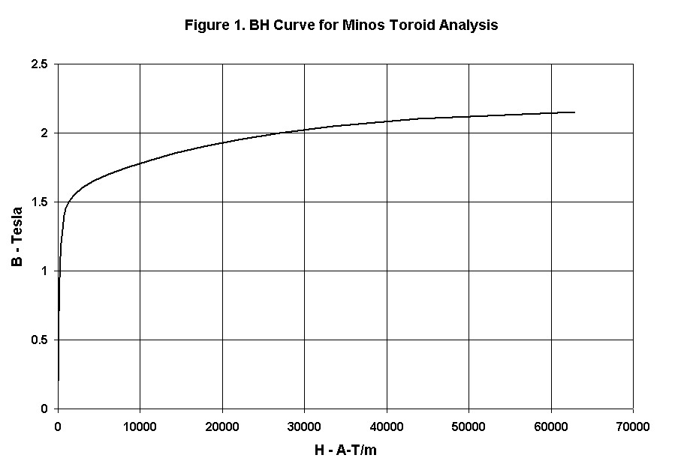

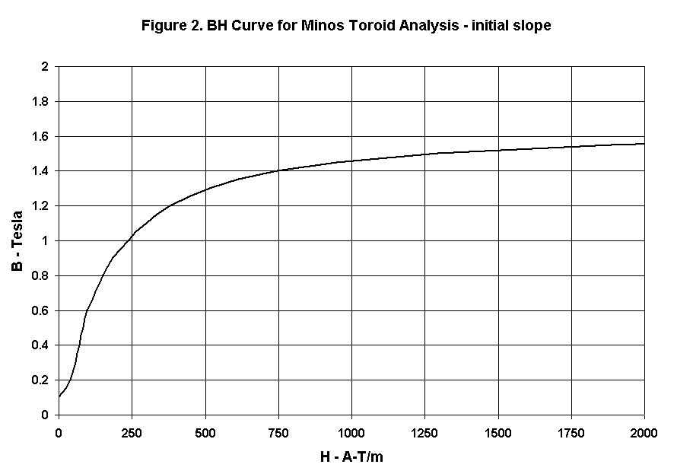

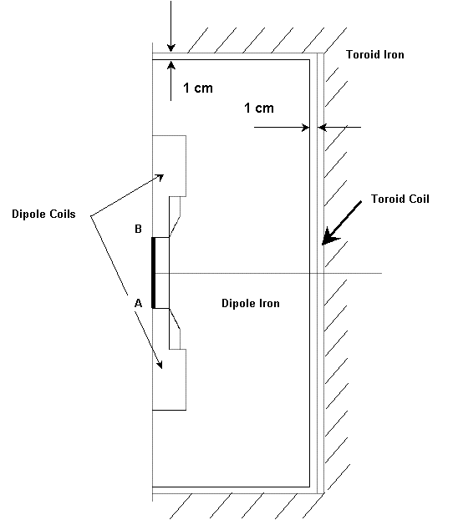
Figure 3. Dipole Cross section, and line A-B for Dipole Field Chart
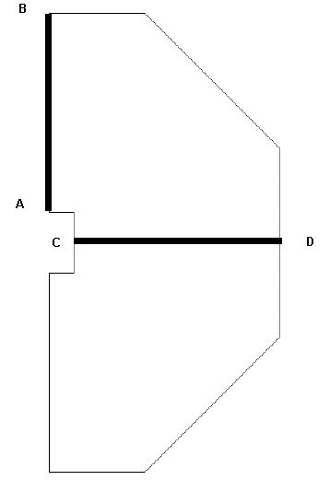
Figure 4. Lines for Toroid Field Chart
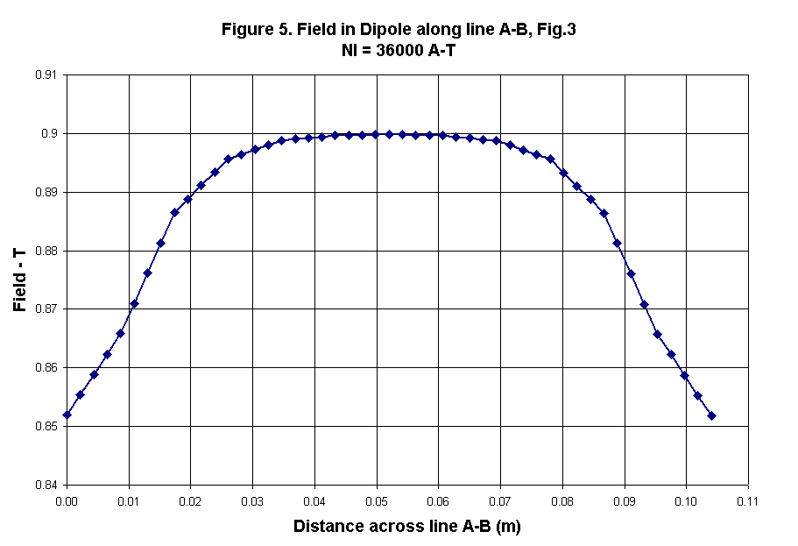

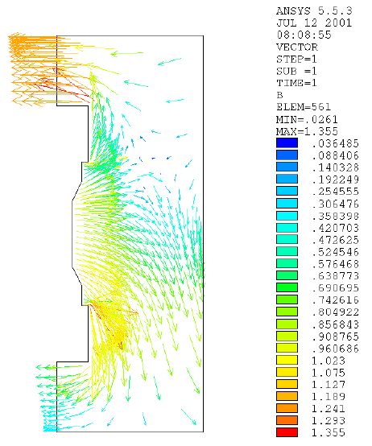
Figure 6. Field Vectors in Dipole Iron Showing Distortion Due to Toroid
Toroid Coil
