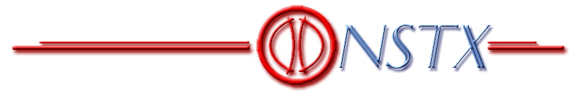

PRELIMINARY
INFORMATION
PACKAGE

NSTX TF FLAG JOINT

DESIGN REVIEW

E. Baker, A. Brooks, J. Chrzanowski,
P. Heitzenroeder, M. Kalish, R. Marsala, C. Neumeyer,
R. Parsells, B. Paul, H. Schneider, M. Williams, I. Zatz

7/31/3


Table of Contents

INTRODUCTION 3
PERFORMANCE REQUIREMENTS 7
OPERATIONAL HISTORY 8
FAILURE OF ORIGINAL TF ASSEMBLY 9
KEY DESIGN DRIVERS 13
SUMMARY OF FORCES 15
LOAD PATHS 16
DESCRIPTION OF NEW DESIGN 17
COMPARISON OF OLD AND NEW DESIGNS 21
ANALYSIS 22
TESTING 23
SUMMARY OF DESIGN MARGINS 27
SUMMARY OF PERFORMANCE 28
INSTRUMENTATION 29

INTRODUCTION

The TF Inner Leg Assembly failed on 2/14/03 at the Inner Leg-to-Flag joint due to structural weaknesses.

On 4/10/3 a new design was presented for review. Although analysis, testing, and detailing was incomplete at that time, sufficient confidence was gained so as to allow release of the inner leg conductors for machining.

Following the April review the analysis, component testing, and design detailing has been completed. In addition, the chits generated during the April review have been resolved as reported on under separate cover.

The purpose of the 8/7/3 review is to examine the final design and identify any shortcomings which may need correction prior to proceeding with manufacturing, assembly, commissioning, and operation.

An additional review in September will assess cost and schedule issues related to the TF recovery effort. It is highly desirable that the August review establish that the technical basis is sound and not in question in September.

As stated at the beginning of the recovery effort, the Project seeks a more robust design which will not suffer from the shortcomings of the original design. Toward this end, the re-design activity must:

- factor in lessons learned from failure

- ensure that all engineering aspects analyzed at appropriate level of detail

- perform testing as necessary for engineering input and design verification

- reduce dependence on precision manufacturing/assembly

- facilitate ease of maintenance

Figures 1, 2, and 3 depict the main elements of the joint and serve to identify the nomenclature. The scope of this review is limited to the following elements:

- Inner Leg / Flag Interface

- Flag

- Flag Fasteners (threaded inserts, studs, washers, nuts, etc.)

- Flag Structural Supports (Boxes, Shear Shoes)

- Hub Assembly/Torque Collar

- Instrumentation Features Built-in to Above

Other aspects may be discussed but are out of scope.

Figure 1 – TF Coil System

Figure 2 – Elements Related to TF Inner Leg –to- Flag Joint

Figure 3 – Flag Fasteners and Structural Support

As shown in Figure 4, recovery activities have consisted of three main thrusts:

- Design (drawing) development

- Finite Element Analysis

- Testing

Figure 4 – Joint Recovery Activities

The testing is subdivided into “component” tests and “prototype” tests. The component tests are designed to provide information necessary for the engineering design. The prototype tests are designed to confirm the design. Ideally, all testing would be complete prior to design review. However, due to schedule constraints and resource limitations, prototype testing will not take place until after the review.

Component testing consists of:

- Pull-out tests on threaded inserts (one time and 50,000 cycle at 100ºC)

- Pull-out tests on bolts threaded directly in copper (one time and 50,000 cycle)

- Friction coefficient and electrical resistance tests for silver plated copper

- Shear tests on simulated torque collar attachment

Prototype testing consists of:

- Mechanical mock-up tested for 50,000 cycles

- Electrical mock-up tested at full current and I²T

Since prototype testing will follow after the design review, and since chit resolution will also follow, another checkpoint is identified in the plan which will ensure that all design issues have been closed out. Most likely this will consist of a review by the PPPL Activity Certification Committee.

PERFORMANCE REQUIREMENTS

The base GRD requirement is for B_{t}=3kG at R₀=0.854m with 4.5 sec flat top, corresponding to 35580 Amp with the 36 turn coil. There is also a “high field” GRD requirement for 6kG at R₀=0.854m with 0.6 sec flat top, corresponding to 71160 Amp with the 36 turn coil. Waveforms are shown in Figure 5.

Figure 5 – Current Waveforms
(Shot 108712 was an actual 6kG Test Shot)

Allowing for the possibility of a power supply fault at the end of flat top from full current, the I²T requirements imposed by the waveforms are of order 6.0 x 10⁹ A²-sec. However the coil design anticipates a maximum of 6.5 x 10⁹ A²-sec, corresponding to an 80ºC rise in the main conductor.

The 6kG pulse is the design driver, not only because the forces are 4x higher than at 3kG, but also because of the short duration of the 6kG pulse, where minimal time is available for heat diffusion. This is the most severe condition in terms of peak local temperature rise at the joint. Figure 6 shows the result of a finite element analysis which shows how the temperature distribution tends to peak at the corner of the joint, where the current bunches up. Simulations have shown that this current bunching effect is due primarily to resistive effects, and that inductive effects are not significant.

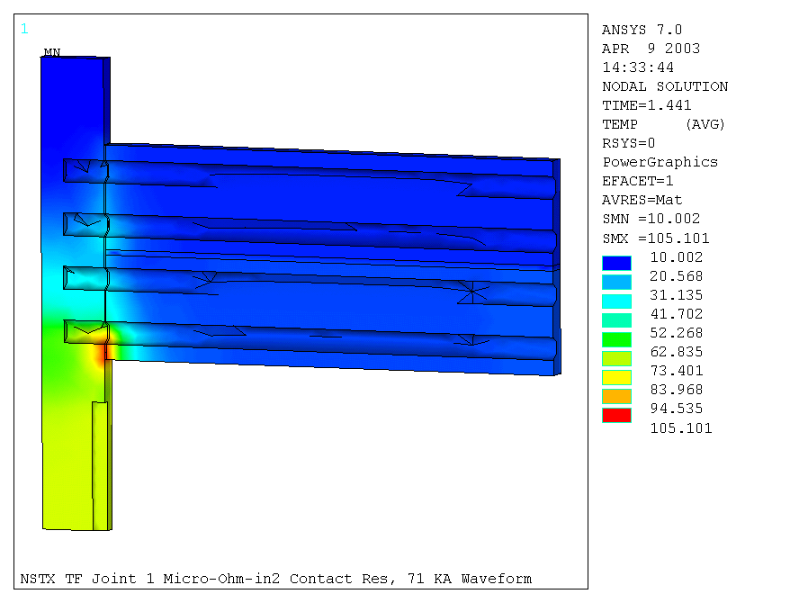
Figure 6 – Temperature Distribution

The TF system is driven by a 1kV power supply, so the voltage is of order 30V/turn. However, the TF conductor faces structure which can be biased to 1kV during Coaxial Helicity Injection (CHI) operations, so the groundwall insulation needs to anticipate 2kV. Thus the hipot requirement is 2E+1=5kV.

OPERATIONAL HISTORY

Approximately 7200 shots were executed with the original TF Inner Leg Assembly prior to failure. A spectrum is shown if Figure 7. The test shots, performed at 50% and 100% of the operating envelope in effect, are evident, along with the plasma shots which comprise the vast majority.

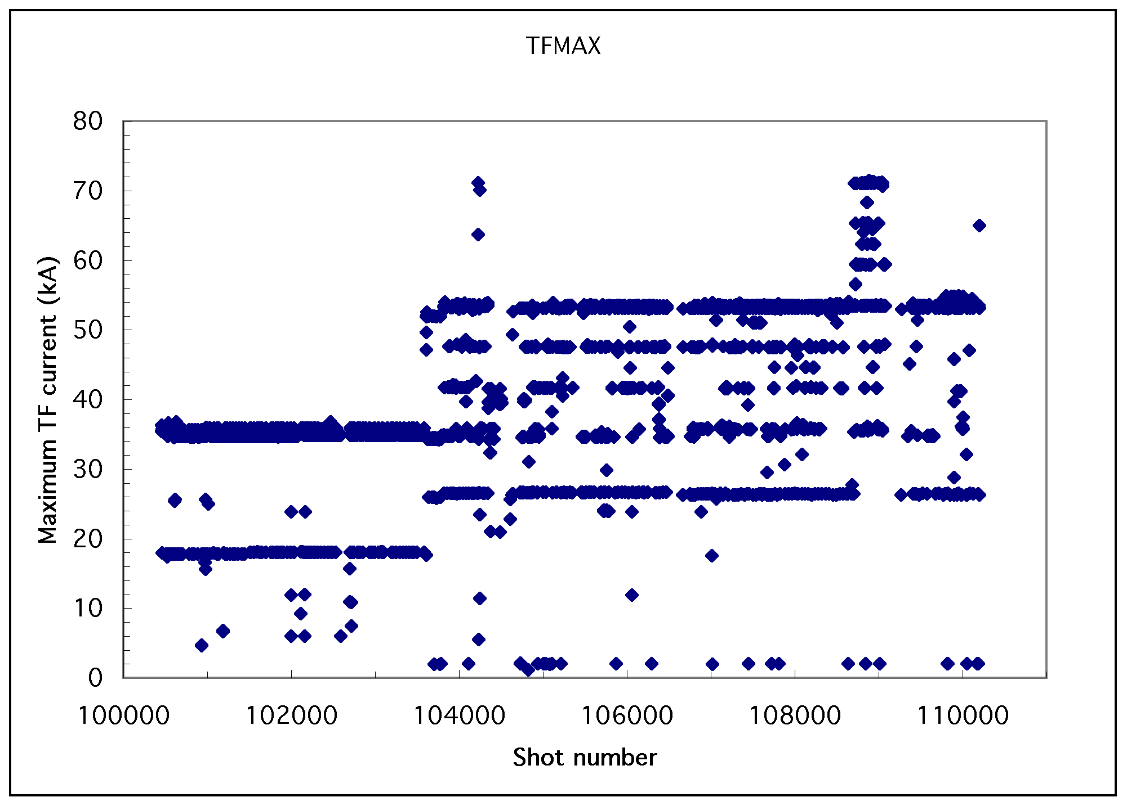
Figure 7 – TF Operational History

It is noted that the early shots were mainly at 3kG, and that most of the machine operations have been conducted at 4.5kG. The number of 6kG shots was quite limited. In this context it is noted that the forces present during the 3kG and 4.5kG shots are 25% and 50%, respectively, of those at 6kG.

FAILURE OF ORIGINAL TF ASSEMBLY

On February 14, 2003, following our morning test shots, the first plasma attempt of the day resulted in a loud bang (heard on thecontrol room audio monitors) accompanied by a plume of smoke (visible on the control room video monitors). Waveforms of the prior 100% test shot and the failed shot are shown superimposed in Figure 8.

Figure 8 – TF Operational History

The target flat top level was 53.4kA which produces Bt=4.5kG. The fault occurred just prior to flat top as the current passed 50kA.Several protective devices tripped:

- TF power supply fault detector section overcurrent

- TF Analog Coil Protection (ACP) overcurrent

- TF Rochester Instrument System (RIS) overcurrent

- TF ground fault current relay

Initial inspection revealed that one of the TF “flags” had been displaced radially by about 1 inch as shown in Figure 9. Subsequent inspection revealed the extent of the damage as shown in Figure 10.
Figure 9 – Radially Displaced Flag

Figure 10 – Peak Damage Area

Analysis of the electrical signals led to the following postulated fault scenario:

- An open circuit fault (the flag joint opening up) led to turn-to-turn (inner and outer legs) and turn-to-ground faults (to the hub and umbrella assemblies

- This fault condition led to a spike of fault current from the power supply which shunted the coil inner/outer leg assembly.

- Once the power supply tripped, the current spike decayed.

- This was followed by an L/R decay which can be modeled by an arc with V=125V and R=500µΩ.

- The energy dissipated in the arc was of order 1.4MJ.

A combination of factors are thought to have led to the failure as follows.

Design Factors

- hub stiffness not adequate to react moment

- communication of load from flag to hub uncertain with G10 shims

- bolt thread and shoulder engagement too small

- bolts necked down too far at threads, not enough on shaft

- dual shear/preload function of bolts

- torque collar connection to hub too stiff for vertical and radial displacement

- lack of feature to facilitate joint resistance measurement without disassembly

Quality Factors

- frequent manual reworking of contact surfaces

- non-planar flag surfaces

- shoulder bolt concentricity

Operational Factors

- monitoring of joint integrity too infrequent, too imprecise (1µΩ resolution)

All of the above factors have been addressed in the new design.

KEY DESIGN DRIVERS

Electrical contact resistance vs. pressure behavior is a key design driver. The contact pressure requirement drives the structural design, and the contact resistance determines heating and limits flat top time. The project has made precision measurements of contact resistivity vs. pressure for silver plated copper joints as shown in figure 11.

Figure11 – Contact Resistance Data

As shown in Figure 12 the contact resistance and temperature allowable will essentially dictate the realizable system performance in terms of flat top time.

Figure 12 –Effect of Contact Resistance on Temperature

In actuality, since contact pressure and resistance vary across the joint, the situation is more complex. However, this result suggests the general trend.

The following design guidelines have been established:

- Structural systems shall maintain 1ksi minimum contact pressure across joint

- Silver plated joint with R ≤ 2μΩ-in² @ P ≥ 1ksi

- Peak local temperatures to be limited to 120ºC

Future measurements (prototype joints and actual installation) will provide more data and ultimately establish the operating envelope.

SUMMARY OF FORCES

The in-plane EM forces on the flags and links (contribution out to half-way through flex link) at 6kG (71.2kA/turn) are given in the following table.

Summary of In-Plane Forces and Moments at 6kG

 | F_{vertical}  (lbs) | dR from effective point of application to flag inboard edge  (in) | Moment  (in-lbs)
Outer Layer, Inner Tier Flag | 7380 | 4.3 | 31719
Outer Layer Inner Tier Link | 1855 | 13.8 | 25652
Total Per Inner Tier Flag/Link | 9235 | 6.2 | 57371
Inner Layer, Outer Tier Flag | 1845 | 4.3 | 7930
Inner Layer, Outer Tier Link | 464 | 13.8 | 6413
Total Per Outer Tier Flag/Link | 2309 | 6.2 | 14343
Total from All Turns | 249325

Clearly the forces on the inner tier (associated with the 24 turn outer layer) are much higher than the outer tier.

The out-of-plane EM forces on the flags and links (contribution out to half-way through flex link) at 6kG (71.2kA/turn), with OH and all PF coils at maximum current, are given in the following table. Note that a significant fraction of these forces are due to the OH which is bi-directional.

Summary of Out-of-Plane Forces and Moments at 6kG
 | F_{lateral}  (lbs) | dR from effective point of application to flag inboard edge  (in) | Moment  (in-lbs)
Outer Layer, Inner Tier Flag | 3174 | 8.9 | 28286
Outer Layer Inner Tier Link | 1523 | 17.9 | 27323
Total Per Inner Tier Flag/Link | 4698 | 11.8 | 55609
Inner Layer, Outer Tier Flag | 1979 | 9.1 | 18061
Inner Layer, Outer Tier Link | 1060 | 18.2 | 19113
Total Per Outer Tier Flag/Link | 3039 | 12.2 | 37174
Total from All Turns | 149198 | 11.9 | 1.78e6  (148392 ft-lbs)
The out-of-plane EM forces on the inner leg bundle at 6kG (71.2kA/turn), with OH and all PF coils at maximum current result in a net torsional moment of 40870 ft-lbs. Note that a significant fraction of this force is due to the OH which is bi-directional.

It is noted that thermal displacements potentially result in additional forces and stresses. The significant effects are as follows:

- Temperature of inner leg conductor rises from 12ºC to 29ºC SOFT, 66ºC EOFT, 95ºC EOP (worst case)
- Vertical length of inner leg bundle from bottom to top increases by approximately 0.35”due to inner leg temperature rise during a pulse
- Vertical length of inner leg from torque collar to top of bundle increases due to inner leg temperature rise, whereas flag and hub remain relatively cool
- Radius of inner leg bundle increases bundle increases by approximately 0.006” during a pulse
- Flag heats modestly during a pulse (ΔT ~ 5ºC) but can ratchet by as much as ΔT ≤25ºC with rated I²T pulsing at 300 second rep rate, corresponding to an increase in length of approximately 0.005”.

LOAD PATHS

A simplified diagram of the in-plane force application and the elements available to react the load is given in Figure 13.

Figure 13 – Load Paths

The four primary load paths are 1) the bolted joint friction, 2) the shear shoe, 3) the torque collar, and 4) the hub/spline/VV. At the bolted joint, contact pressure results in friction which takes part of the shear load. In addition, shear keys or the bolts themselves can be used to take part of the load. At the torque collar, a maximum torsional load of 22480 lbf will add to any additional vertical load from the hub.

At the joint, the radial pressure exerted by the fasteners results in a frictional response to vertical loads on the flag, depending on the coefficient of friction. In addition, the shear shoe, which is bolted on to the ends of the inner leg conductor, provides a vertical stop.

The torque collar is attached to the inner leg bundle via a wet lay-up of room temperature cure epoxy. This collar serves to transmit the torque generated on the inner leg bundle to the hub assembly. The collar is connected to the hub at anchor points which are designed to transmit torque, but not vertical or radial load.

The hub assembly takes the vertical moment generated on the flags. In addition, it communicates the torsional load from the collar and the lateral load on the flags out to the vacuum vessel by way of the spline. The spline is designed to transmit torque, but not vertical or radial load.

DESCRIPTION OF NEW DESIGN

The ideal design would have the following attributes:

- Perfect communication of flag load through insulation/potting to hub

- Infinitely stiff hub

- Full vertical load shear capability at the inner leg/flat interface

- All inner leg torsion shunted away from flag via torque collar

- Contact pressure everywhere along the joint ≥ minimum allowable over the full temperature range

These design goals guide in the selection of the various design features and dimensions.

Several views of the new design are given in Figures 14-16. The following are some highlights of the design features:

- Solid flags (no split) are insulated with two half-lapped layers of Kapton, then glass tape wrapped and potted (Hysol RE2039 & HD3561) in 304SS boxes. Communication of in-plane and out-of-plane forces from flag to hub is very efficient.

- Boxes are bolted to the hub disks using 5/8” diameter hardware, forming a very stiff “I-beam” type hub structure.

- Mold release agent is used so that potting is not bonded to the box, thereby allowing for thermal displacement of the flag.

- Potting is accomplished “in place” with boxes flags already installed and tightened so as to ensure best possible contact surface fit. However, potted flag-boxes can be removed as necessary when sliding TF Inner Leg Assembly into OH Coil Tension Tube

- Flags are attached to inner legs using 3/8” dia. Inconel studs(Alloy 718, 5% Cold Worked, Aged,UTS 210ksi, Yield 185ksi) in threaded inserts and preloaded to 5000lbf each. Washer plate is used under tee at end of flag. Belleville washer and nut then complete the attachment. The total force of 20000lbf provides for high contact pressure leading to excellent electrical conductivity and frictional load bearing capability.

- Flag fasteners are necked down over their length to enhance elasticity. In this regard the Belleville washers are a redundant feature to ensure that fasteners remain tight after load cycling.

- Shear shoe located on outer edge of flags is bolted to ends of inner leg conductor using A286 SS bolts, one oriented directly for the vertical load and the other angled for the moment reaction. The shoe provide a load path for the vertical EM force and also provides a means of registering the vertical position of the flags during assembly.

- Torque collar consists of three segments attached with two 1/2” diameter bolts w/Belleville washers at each joint, attached to Scotchply groundwall using 0.180” thick wet lay-up glass epoxy (Hysol E-120HP) wrap. Collar is sized to provide modest compression to enhance shear capability of wet lay-up while still accommodating radial thermal expansion of bundle.

- Collar transmits torque to hub structure at three anchor points which are designed to slide in vertical and radial directions to accommodate anticipated displacements (0.020” and 0.006”, respectively). Low friction coatings (e.g. Magnaplate HMF) are under evaluation to minimize wear and friction.

- Redundant voltage probes are located on each side of the flag in grooves half way up. These spring loaded probes provide a very effective means for monitoring joint resistance during maintenance periods (200A injected) and voltage drop during actual machine operations.

Figure 14 – Cross Section of New Design (Top of Machine)

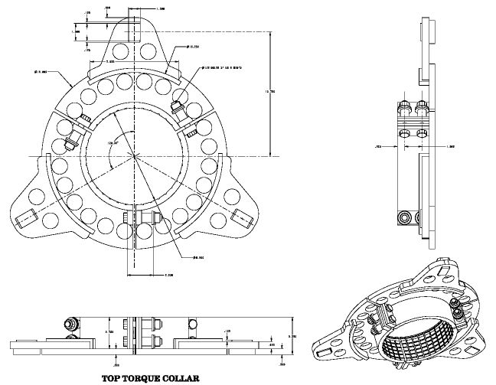

Figure 15 – Torque Collar

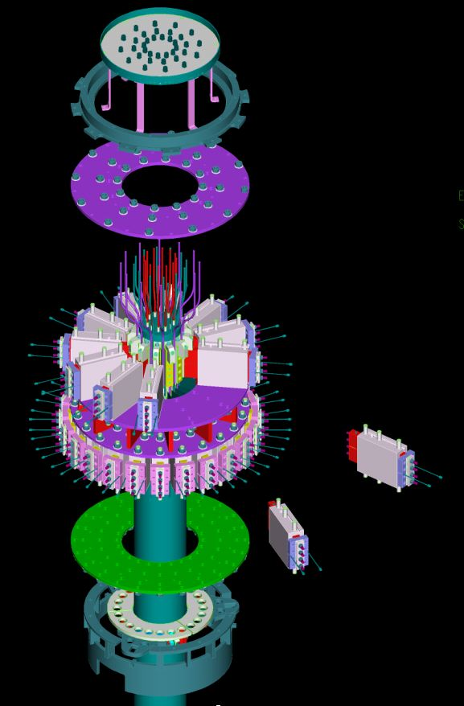

Figure 16 – Isometric View of New Design

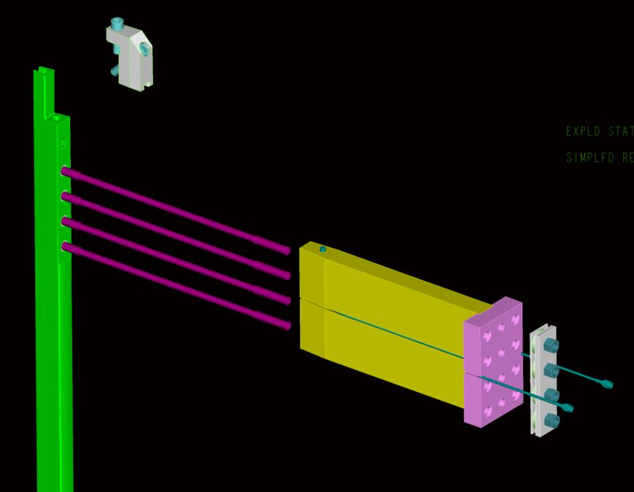

Figure 17 – Isometric View of Inner Conductor,
Flag, Shoe, and Accessories

COMPARISON OF OLD AND NEW DESIGNS

Features of the old and new designs are compared in the following table.

 | Old Design | New Design
Hub Stiffness | Not adequate; lacking stiff linkages between disks because flags could slide w.r.t. disks | Very stiff. Boxes form webs with disks like I-beams.
Bolts/Studs | Shoulder engagement was too small (4 bolts x 0.1 depth = .4 @ 1/2" dia, Area = 0.18 in^2) | Shear Shoe using two 3/8” dia bolts
 | Bolt 5/16” thread was necked down too far to 0.232" | Studs necked down to root dia of 3/8" bolt = 0.314"
 | 0.438” shank diameter was too large, bolt was not compliant for thermal cycling | Neck down to root dia of 3/8" bolt = 0.314"
 | No back-up to bolt compliance to accomodate creep | Belleville washer, initially flattened
 | Torsion in long bolts during tightening, inaccurate tensioning | Studs with nuts used in place of long bolts, stud tensioner
 | Dual purpose bolts, combined tension and shear functions, tolerance issues, torque(tension) uncertainty | Loose fitting clearance holes for studs, separate shear shoes
 | Four 5/16" bolts @ 2500#, marginal friction to carry shear (4*2500=10000lbf applied vs. 9230lbs, requires mu ~1.0) | Four 3/8" studs @ 5000#, doubling of preload (4*5000=20000lbf)
 | Thin washers under bolt heads at tee-ends | 1/4" thick washer plate over Belleville washers at tee-ends
Inserts | Keensert type, thread engagement = 0.113" | Taplok type, thread engagement > 0.5"
Shimming | Manually selected and inserted G10 shim stock | Hysol/glass tape potting in boxes, mold released to permit thermal growth
Out-of-Plane Load Path | Wedged G10 blocks with pusher bolts | Flags potted in boxes, boxes bolted to hub disks
Torque Collar | Two piece collar bolted directly to hub. Wet lay-up 0.25” thick Hysol RE2039 & HD3561. Holes in collar for epoxy outflow to enhance adhesion. | Three piece collar with sliding contact with hub for torsion-only connection. Wet lay-up 0.180” thick Hysol E-120HP (improved adhesive strength). Serrations in collar to enhance adhesion.
Joint Resistance Measurement | 10A Biddle measurement via connection to two half flags on disassembled joint | 200A precision measurement using voltage taps in situ

ANALYSIS

The primary means of analyzing joint behavior and guiding the design is a Finite Element Analysis (FEA) using the NASTRAN package which includes suitable features for non-linear behavior such as the friction interfaces. In-plane and out-of-plane forces and SOFT, EOFT, and EOP temperatures were calculated separately using ANSYS and input to the NASTRAN analysis.

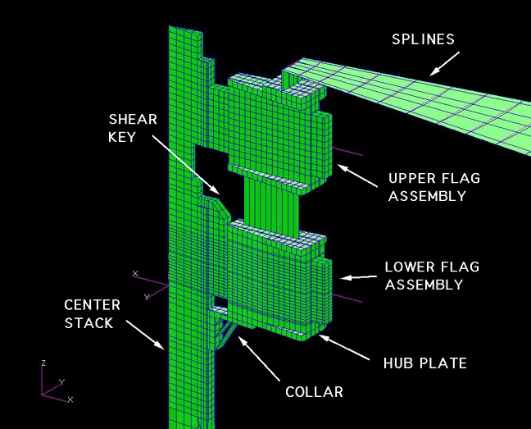
Figure 17 – NASTRAN Finite Element Model

The model consists of a 1/24th segment of the joint and represents all significant features including both tiers of flags, out-of-plane load path through the spline, as well as an axisymmetric equivalent model of the torque collar with torsion-only connection to the hub. The model neglects load transfer through the flex links to the outer legs (conservative for the joint).

A large number of cases were run to test the model in stages as features were added. Simplified spreadsheet calculations were performed when possible as a parallel check. The model was used as a design tool and influenced the final selection of features and dimensions.

Cases were run with friction coefficient equal to 0.2 and 0.4, and with temperatures corresponding to SOFT, EOFT, and EOP.

Key outputs from the model include the following:

- contact pressure distribution over joint
- tension in flag studs and shear shoe bolts
- shear stress in wet lay-up
- displacements

Additional analysis was performed on the box bolts, collar bolts, flag fasteners, etc.

TESTING

Test results are summarized in the following table.

Type | Load | Cycles | Temp | Samples | Avg | 3σ | Avg-3σ | Yield/  Failure | Comment
Insert Pull-out in Copper | To Failure | 1 | RT | 7 | 12714 | 2898 | 9817 | 0.84
 | 5000-  6000lbf | > 50000 | 100C | 4 | No Failures
 | To Failure | 1 | RT | 4 | 13003 | 2156 | 10847 |  | After Cycling
Bolt Pull-out in Copper | To Failure | 1 | RT | 8 | 12658 | 2641 | 10016 | 0.82
 | 5000-  6000lbf | > 50000 | RT | 5 | No Failures
 | To Failure | 1 | RT | 5 | 12828 | 2734 | 10094 |  | After Cycling
Wet Lay-Up Shear | To Failure | 1 | RT | 9 | 2617 | 746 | 1871 |  | Normalized to Zero Compression, w/o peaking
 | 0 to 1800psi, up to1000psi compression | > 50000 | RT | 6 | No Failures |  |  |  | Various load and compression combinations
Friction | Up to 7560lbf | 1 | RT | 5 | 0.41 | 0.04 | 0.36 |  | Coefficient of Friction

In regard to the wet lay-up shear tests, a rectangular sample configuration was used. Stress analysis was performed using ANSYS to determine the peak-to-average stress level for the test sample configuration, as shown in figures 18 and 19.

Figure 18 – Shear Test Sample Configuration

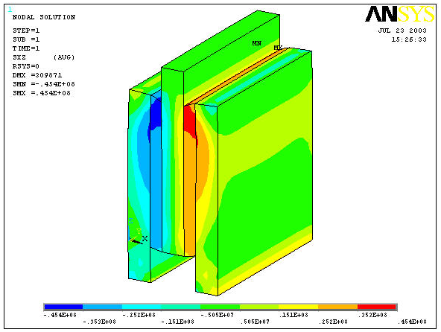
Figure 19 – Distribution of Shear Stress (xz):max= 45.4MPa (6.6ksi)

This analysis indicates a peak-to-average stress ratio of 1.65 for the test samples. An additional factor to be considered in interpretation of the shear data is the level of normal compression, which was varied from test to test. To account for compression, the following model was used…

$$s_{\text{failure}}=s_{0}+k_{N}s_{N}$$
where:

σ_{failure} = shear stress to failure
σ₀=shear stress to failure with zero compression
k _{N} =coefficient applied to normal stress
σ_{N}=normal stress

In interpreting the raw test data, values of σ₀ and k _{N} were first determined using a least squares curve fit. Then, based on this k _{N}, a σ₀ value was determined for each data point, and a average and standard deviation was taken of these values. Using these results a peak stress failure model is….

$${\hat{s}}_{\text{failure}}=k_{\text{PA}}\left[{\bar{s}}_{0}−3s+k_{N}s_{N}\right]$$
where:

${\hat{s}}_{\text{failure}}$ = peak shear stress to failure
${\bar{s}}_{0}$ = average shear stress to failure with zero compression = 2617psi
σ = standard deviation of ${\bar{s}}_{0}$= 746psi
k _{N} =coefficient applied to normal stress = 1.27
σ_{N} =normal stress
k _{PA} =peak/average ratio for test sample configuration = 1.65

These results are shown in figure 20.

Figure 20– Interpretation of Shear Test Data

It is important to note that the wet lay-up does not experience elevated temperature coincident with high shear loads. This justifies testing at room temperature.

To demonstrate this, an analysis was performed which simulated radial thermal diffusion from the inner leg copper, through the CTD turn insulation, Scotchply ground insulation, Hysol wet lay-up, and stainless steel torque collar. As shown in figure 21, the temperature rise of the Hysol is minimal during the pulse.

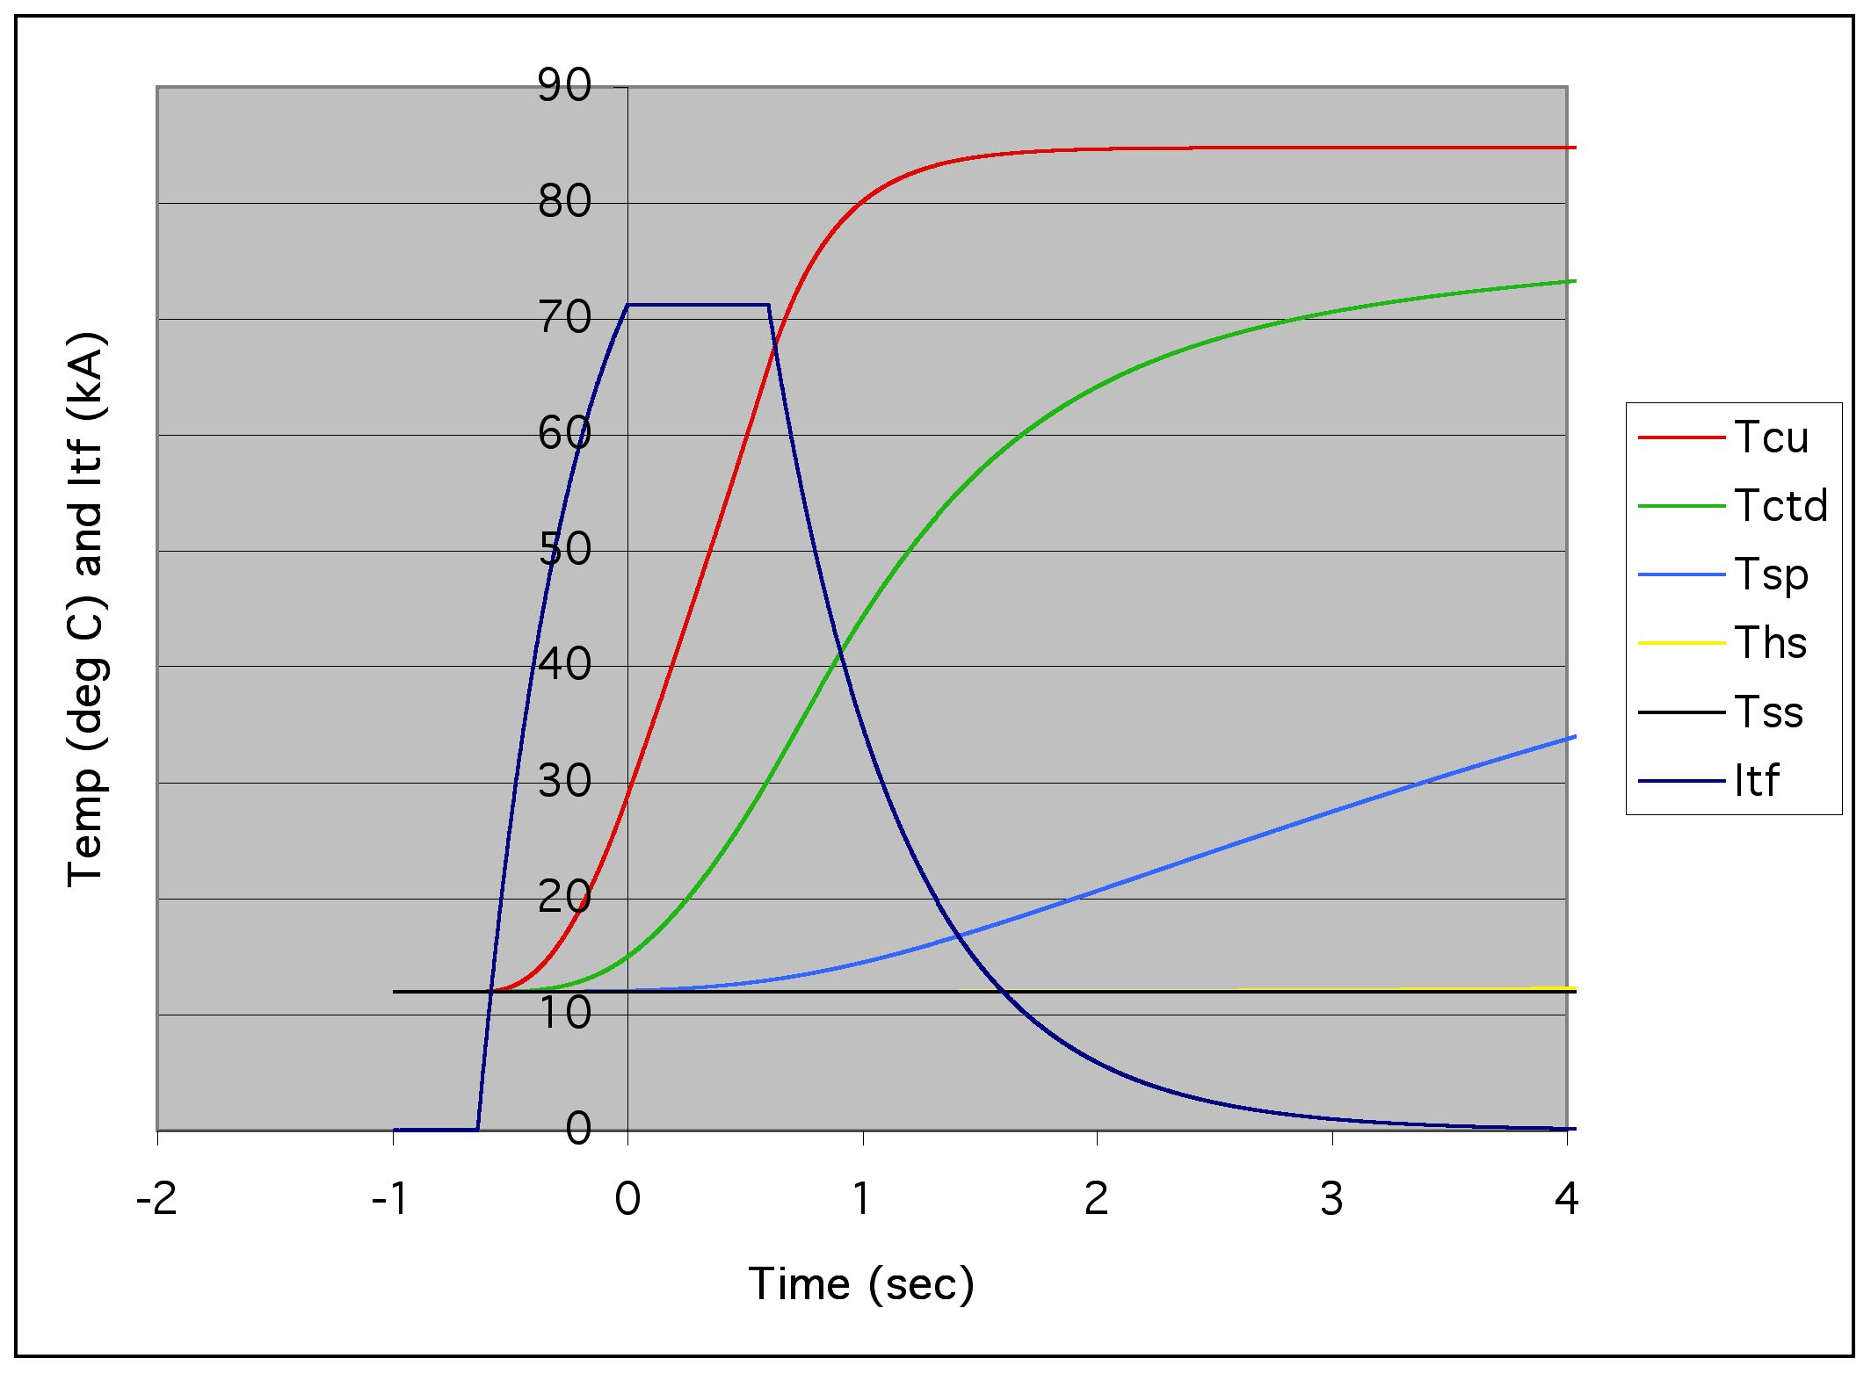
Figure 21 - Temperatures vs. Time
Copper (Cu), Turn Insu. (CTD), Ground Insul. (SP), Wet Lay-up (HS) and Collar (SS)

SUMMARY OF DESIGN MARGINS

Design margins are summarized in the following table. In those cases where the margins are derived from test data…

- the average –3σ results were used
- for the wet lay-up, 1000psi compression is assumed
- for the yield loads, test data for yield/failure was used

In the case of loads derived from the FEA, the worst of the four “nominal” cases (friction coefficient =0.2, 0.4 and temperature at SOFT, EOFT) was used.

Component | Material | Max Load (lbf) | Max Stress (psi) | Yield Stress (psi) | Safety Factor on Yield | Failure Stress (psi) | Safety Factor on Failure
Flag Studs | Inconel 718 | 6181 | 79771 | 185000 | 2.3 | 210000 | 2.6
Insert pullout | Copper | 6181 | 14579 | 19412 | 1.3 | 23152 | 1.6
Shear Shoe Bolt | A286 | 5279 | 68125 | 102000 | 1.5 | 146000 | 2.1
Shear Shoe Bolt pullout | Copper | 5279 | 11971 | 18701 | 1.6 | 22713 | 1.9
Wet Lay-up Peak Shear (Bond Plane) | Hysol | 123848 | 1532 |  |  | 5197 | 3.4
Wet Lay-up Peak Shear (Combined) | Hysol | n.a. | 3000 |  |  | 5197 | 1.7
Collar Bolts | A286 | 9084 | 64018 | 102000 | 1.6 | 146000 | 2.3
Box Bolts | 304SS | 5068 | 19800 | 31200 | 1.6 | 73200 | 4.4
Box Bolt Pullout | 304SS | 5068 | 7303 | 15600 | 2.1 | 36600 | 5.0
Box Friction | 304/304 | 4700 |  |  |  |  | 2.5

In addition to the above, it is noted that the flag threaded inserts , the shear shoe bolts, and the wet lay-up samples have been exposed to 50,000 cycles at or above their design loads, without failure.

Finally, mechanical and electrical prototype tests will provide further design verification prior to commencing machine operation.

SUMMARY OF PERFORMANCE

FEA runs using ANSYS, with contact pressure distribution from NASTRAN runs, were made for the SOFT and EOFT conditions. The results indicate that the variation in contact pressure does not result in significant deviations from earlier runs which assume constant pressure distribution and joint resistivity of 1 micro-ohm-in². This is due in part to the fact that the pressure is maintained at high levels across the joint, plus the fact that the current takes the path of least resistance, so that the phenomenon is somewhat self-correcting. See following figures.

SOFT Pressure (psi) |  | SOFT Resistivity (μΩ-in²) |  |  | EOFT Pressure (psi) |  | EOFT Resistivity (μΩ-in²)
14727 | 11877 | 0.336 | 0.366 |  | 15662 | 12639 | 0.328 | 0.357
10092 | 7835 | 0.390 | 0.431 |  | 10152 | 7808 | 0.389 | 0.431
9022 | 6719 | 0.408 | 0.458 |  | 8707 | 6344 | 0.413 | 0.468
7752 | 5380 | 0.433 | 0.499 |  | 7137 | 4736 | 0.447 | 0.525
6903 | 4513 | 0.453 | 0.535 |  | 6083 | 3732 | 0.476 | 0.576
6683 | 4272 | 0.459 | 0.547 |  | 5774 | 3453 | 0.486 | 0.594
6793 | 4408 | 0.456 | 0.540 |  | 5869 | 3617 | 0.483 | 0.583
6478 | 4068 | 0.464 | 0.557 |  | 5534 | 3297 | 0.494 | 0.605
5696 | 3215 | 0.488 | 0.611 |  | 4689 | 2393 | 0.527 | 0.686
5054 | 2552 | 0.512 | 0.669 |  | 3928 | 1631 | 0.565 | 0.797
4858 | 2329 | 0.520 | 0.693 |  | 3624 | 1313 | 0.583 | 1.228
5033 | 2519 | 0.512 | 0.672 |  | 3803 | 1512 | 0.572 | 0.821
4840 | 2295 | 0.520 | 0.697 |  | 3836 | 1528 | 0.570 | 0.818
4207 | 1587 | 0.550 | 0.806 |  | 3681 | 1286 | 0.579 | 1.285
3840 | 1202 | 0.570 | 1.458 |  | 4011 | 1554 | 0.560 | 0.812
3985 | 1312 | 0.562 | 1.230 |  | 4995 | 2505 | 0.514 | 0.674
4316 | 1633 | 0.544 | 0.797 |  | 6219 | 3719 | 0.472 | 0.577
4060 | 1503 | 0.558 | 0.823 |  | 6923 | 4417 | 0.452 | 0.539
3005 | 917 | 0.627 | 2.049 |  | 6364 | 3904 | 0.467 | 0.566
2087 | 306 | 0.724 | 3.318 |  | 6681 | 3013 | 0.459 | 0.627

Figure 22 –FEA Element Pressures and Resistivities

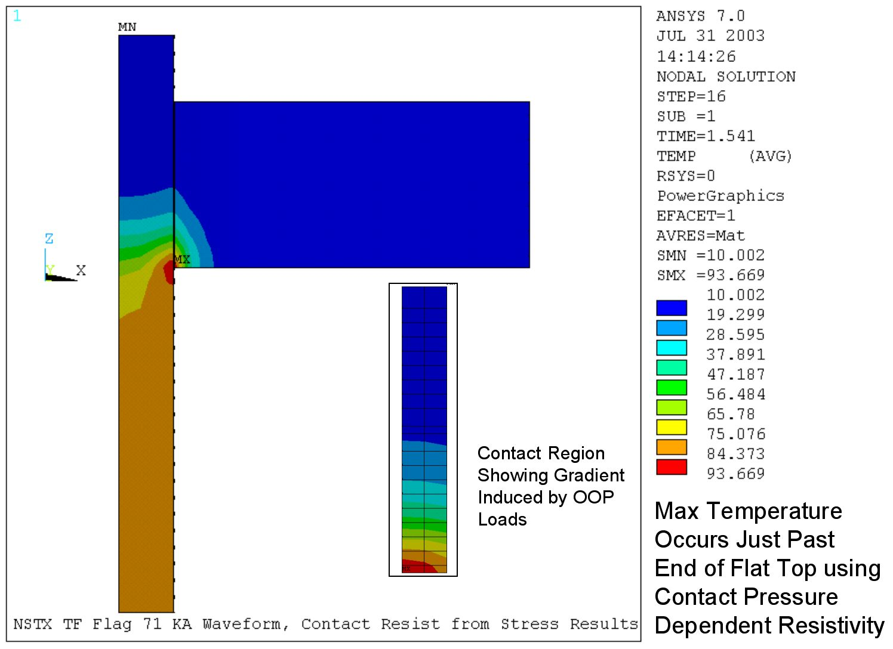
Figure 23 –Temperature Simulation

It is noted that the above simulation is for a 0.7 second flat top (vs. 0.6 second requirement), but does not attempt to model the effect of the bolt holes. From prior runs using constant pressure and resistivity, this effect is noted to add approximately 10ºC to the peak temperature. In any case it is clear that the new design meets the criteria of 0.6 second flat top at 6kG with peak temperature below 120 ºC.

INSTRUMENTATION

Joint voltage drop measurements are considered to be the top priority. They provide the best “end result” indication as to whether all of the various elements of the system are working properly. Voltage drop measurements during maintenance with a low current (200A) injected continuously will provide an excellent and precise means of assessing the condition of the joints, albeit without large EM loads applied. Voltage drop measurements made during actual pulsing will provide a real-time indication that the structural support systems are working properly, maintaining adequate contact pressure on the joints. Although non-trivial due to 5kV voltage isolation requirement, low signal level, and high noise environment, prior experience on MAST and C-MOD indicate that these measurements can be made successfully. NSTX envisions the trending of the real-time voltage drop signals, at least from the daily test shots (where noise from RF, NBI, and plasma is absent), as a means of monitoring joint integrity between maintenance intervals.

As shown in figure 24, voltage probes will be used to measure joint resistance. These are type IDI100526 spring loaded probes which are manufactured in large quantities for the semiconductor test industry. (ref. www.idinet.com) Although only one is shown in the figure, two will be implemented per flag, one on each side of the joint.

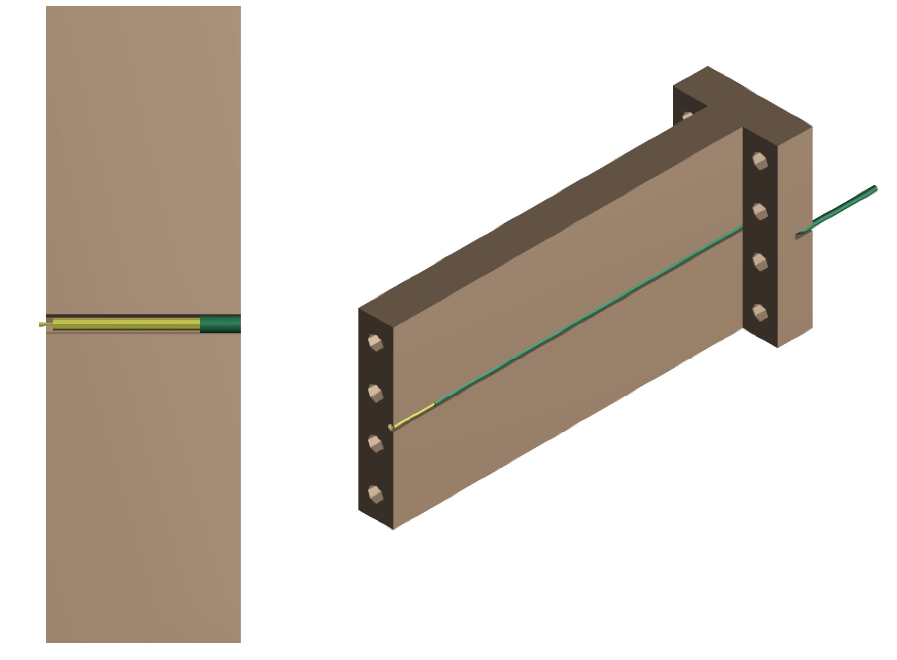
Figure 24 –Voltage Probe Configuration

Sensitivity to locally high contact resistance was examined using ANSYS (ref. NSTX-CALC-13-21, “TF Joint Voltage vs. Contact Resistivity”). Results are given in figures 25 and 26, which show the difference in probe measurement as a function of nominal contact resistivity for between a joint with constant contact resistivity and one where the corner region of the joint is at 1.1x and 2x nominal resistivity, for various lengths extending beyond the corner (0 length corresponding to no abnormal region at all).

Figure 25 – Sensitivity for 1.1x High Resistivity

Figure 26 – Sensitivity for 2x High Resistivity

Tests are underway to quantify the resolution the joint resistance measurement system which is being designed to measure joint voltage drop while 200A is injected through the TF coil system during maintenance. This measurement is challenging, due to the low voltage and various effects such as thermoelectric potentials in the wiring, bulk resistance changes in copper resistivity vs. temperature, etc.. We expect to experience nominal joint contact resistivity on the order of 2 micro-ohm-in² or less, in which case the typical joint voltage drop at 200A should be of order 100 microvolt. Based on preliminary results, however, it is expected that the system will be able to resolve down to 5 microvolt or better. On this basis, from the above two figures, 110% resistivity regions in the corner of the joint will be marginally detectable, but 200% abnormalities will be easily detected.

A fiber optic measurement system, which can in principle measure temperature, strain, and displacement in real time, is under evaluation. If implemented, a few (e.g. 4) channels would be procured but temperature, strain, and displacement transducers (e.g. 4 of each, 12 total) would be installed, positioned and plugged into the channels as required. If the fiber optic system is not procured and implemented, then some type of measurement scheme will be adopted for the spline axial and angular displacement. It would probably consist of two linear potentiometers with voltage source and buffered output.

