

Pest Management – Invasive Plant Control
Shrub Honeysuckles – VT Class B Noxious Weeds
Conservation Practice Job Sheet VT-595

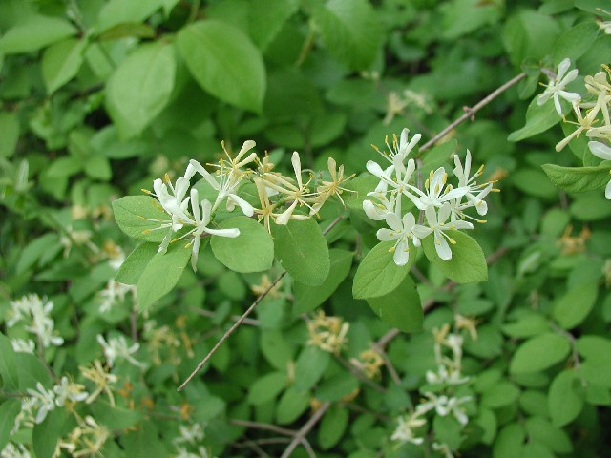 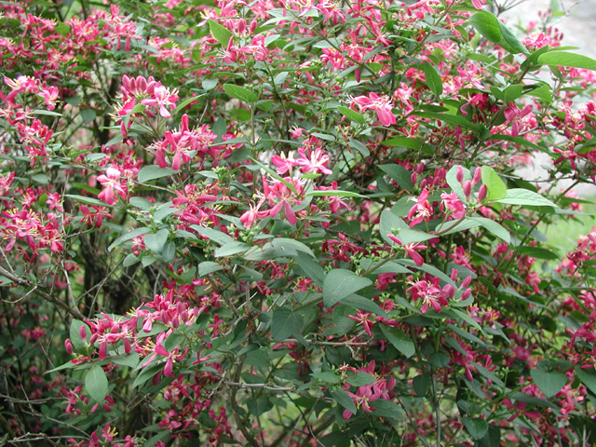 Morrow's honeysuckle (Lonicera morrowii) Tatarian honeysuckle (Lonicera tatarica)

Shrub Honeysuckles
The exotic shrub honeysuckles are increasingly common throughout much of the eastern and Midwestern United States and south-central Canada where they have contributed to reduced species richness and cover of native herb communities and to reduced tree regeneration in early to mid-successional forests. Although disturbance of some kind usually precedes invasion, the exotic shrub honeysuckles are adapted to a wide variety of habitats. Reproduction is almost entirely by seed. Seed production and short-term seed viability are consistently high, and seeds are readily dispersed by birds and, perhaps, small mammals.

Exotic shrub honeysuckles are upright, multi-stemmed, oppositely branched, deciduous shrubs. The exotic honeysuckles have hollow center branches when mature (native honeysuckles do not). The opposite leaves are entire (un-toothed margins) and paired. Axillary flowers (where leaf is attached to stem) are showy with white, pink, and sometimes aging to yellow corollas. The fruits of honeysuckles are usually red but can be yellow, orange or clear and fleshy. The fruits are never blue, black or white. In flower, exotic shrub honeysuckles can be distinguished from all native shrub honeysuckles except swamp fly-honeysuckle (L. oblongifolia) by their hirsute (hairy) styles.

The exotic shrub honeysuckles also generally leaf-out earlier and retain their leaves longer than the native shrub honeysuckles. This trait, shared by many invasive shrubs, gives them a competitive advantage over native plants but also allows landowners to easily locate the invasive shrubs and determine their extent on a property.

Similar Natives
Most notable in Vermont are the rare and uncommon fly honeysuckles Lonicera oblongifolia (S2) and Lonicera villosa (S3) and Lonicera canadensis which all have solid white piths.

Control
The potential for large-scale restoration of unmanaged natural areas infested with honeysuckle is probably low. Restoration potential for managed natural areas infested with honeysuckle is probably moderate. If attacked during the early stages of colonization, the potential for successful management is high.

Manual, mechanical, environmental/cultural, and chemical methods are all useful to varying degrees in controlling honeysuckles. Removing or killing plants will provide increased light at the site which may lead to a surge of seedlings in the following year. Prepare to monitor and control these outbreaks.

Biological Control
There are no known biological controls of honeysuckle.

Mechanical Control
Mechanical controls include grubbing or pulling seedlings and mature shrubs, and repeated clipping of shrubs. Effective mechanical management requires a commitment to cut or pull plants at least twice a year for a period of three to five years. Cuttings should be done in the growing season (spring and fall). Grubbing or pulling by hand (using a Weed Wrench or a similar tool) is appropriate for small populations or where herbicides cannot be used.

Any portions of the root system not removed can re-sprout. Because disturbed, open soil can support rapid re-invasion, managers must monitor their efforts at least once per year and repeat control measures as needed. Limit soil disturbance whenever possible. Winter clipping should be avoided as it encourages vigorous re-sprouting.

Prescribed Burning
Repeated annual prescribed burns during the growing season will top-kill shrubs and inhibit new shoot production. Because exotic shrub honeysuckles readily re-sprout, it may be necessary to re-burn every year or every other year for several years to achieve good control. Be aware that few plant communities in Vermont are fire-adapted so consider the effects on non-target vegetation.

Chemical Control
Most managers report that treatment with herbicides is necessary for large shrub honeysuckle populations. Formulations of glyphosate (brand names Roundup, and for use near waterbodies, Rodeo¹) and formulations of triclopyr (brand names Garlon¹, Pathfinder¹, and others), have been used as foliar sprays or cut stump sprays and paints with varying degrees of success.

Glyphosate is a nonselective herbicide which kills both grasses and broad-leaved plants while triclopyr is a selective herbicide that kills broad-leaved plants but does little or no harm to grasses.

Cut Stump Treatments: For ‘cut stump’ treatments, horizontally cut the stem near the ground. Do not cut the stem at ground level. Leaving some stem will allow another cut and application if there is sprouting. Apply a 25% solution of glyphosate or triclopyr³ and water to the stump being sure to cover the outer, top 20% of the cut stem^{2, 4}. Herbicide must be applied immediately following the cutting. Add dye or food coloring to the mixture to track treated stumps. This treatment is best applied late in the growing season when the plant is transporting nutrients to its root system (August-October).

Foliar Treatment: For foliar treatments a 2% solutions of glyphosate or triclopyr and water can be used². Both glyphosate and triclopyr should be applied to the foliage late in the growing season. Do not cut down treated plants for at least a full growing season.

Basal Bark Method: This method is effective throughout the year as long as snow cover does not prevent spraying to the ground level. Apply a mixture of 25% triclopyr³ and 75% horticultural oil to the basal parts of the shrub to a height of 12-15 inches from the ground^{2, 4}. Be sure to treat entire circumference of the stem in a band at least 12 inches wide. Thorough wetting is necessary for good control; spray until run-off is noticeable at the ground line. Do not apply to bark that’s wet from heavy dews and rain.

¹ – Class A Restricted Use Herbicides
² – From TNC ESA – Bush Honeysuckles
³ – Greater than 2% Triclopyr herbicide is Class A - restricted use in Vermont.
⁴ – Tennessee Exotic Plant Management Manual

Important Note
Mention of specific pesticide products in this document does not constitute an endorsement. These products are mentioned specifically in control literature used to create this document.

Disposal
Small, pulled shrubs should be hung in trees to prevent re-rooting. Larger, pulled shrubs may be piled or piled and burned, roots up, to prevent re-establishment. Cut stems may be piled or piled and burned. If chipping, do not remove material from the site as honeysuckle will spread by seeds.

Information and Recommendations compiled from:
- The Nature Conservancy - Element Stewardship Abstract (and references therein)
- Tennessee Exotic Plant Management Manual
- Invasive Plant Atlas of New England (IPANE)
- Virginia Natural Heritage Program – Invasive Plant Fact Sheets
- Vermont Invasive Exotic Plant Fact Sheets
- CT NRCS Invasive Species ID Sheets

