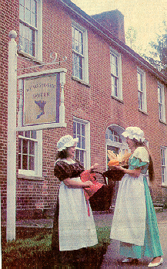

Welcome Brownie Girl Scout, Brownie Girl Scout Leaders, Parents, and Friends to Fort Necessity National Battlefield. We are happy you chose to visit our park as you earn your “Listening to the Past” Try-It.

With this book you will be able to complete four activities and earn your Try-It. So come and have fun and enjoy the park!

Dear Brownie Girl Scout Leader;

We are happy to help your girls earn their “Listening to the Past” Try-It. What a great way to learn about our history.

Using this booklet the girls should be able to complete the Try-It. With the program offered by the park rangers the girls will finish Activity #5 Acting Out and Activity #6 Games of the Past. While at the park the girls can also complete Activity #2 If These Buildings Could Talk.

After visiting Fort Necessity the girls may read the two stories in the booklet to complete Activity #4 Tell Stories of the Past. The booklet also gives suggestions for Activity #1 and Activity #3. It should be easy and fun to complete the “Listening to the Past” Try-It.

Try-Its can be purchased from the Girl Scout Council Office.

You should allow about 2 hours to complete the program. If you would like you may picnic in the park’s picnic area or in the grassy area near the parking lot.

We are glad you chose to visit us with your Brownie Girls Scouts and that we can help them learn and grow. We would like to know how you like the program. Please give us your feedback.

Sincerely,
The Education Department
Fort Necessity National Battlefield
724-329-8124
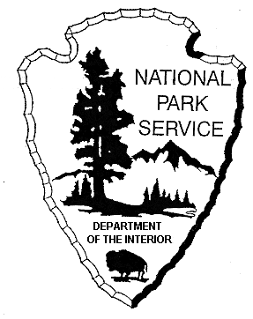
Activity #1 Community Stories

If you choose to do this activity after visiting Fort Necessity you may want to find someone who remembers the big celebration at Fort Necessity in 1954 or even someone who remembers the celebration in 1932! Ask her or him what they remember and what their favorite part was. You may also look for someone who remembered what Route 40 looked like when they were young and how people travel on it. When the National Road was paved it was given the name Route 40.

Try it and have fun!

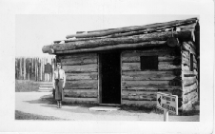
Park Ranger Ruth Martin at
Fort Necessity about 1950

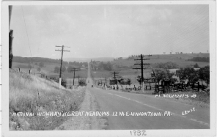

Route 40 near Fort Necessity, 1932

Activity #2 If These Buildings could Talk

All right! By coming here you are on your way to completing your Try-It.

Here are some things we suggest you do. Do as many as you want to.
- Read about the British soldier, French soldier, and American Indian in the visitor center
- Read about finding the fort logs 1953
- See the 10 minute slide show
- Walk to the fort and read the signs along the way

Write down some interesting fact you learned.

_________________________________________________________________________________________________________________________________________________________________________________________________________________________________________________________________________________________________________________________________________________________________________________________________________________________________________________________________________________________________________________________________

Activity #3 Visit the Oldest Cemetery

This is another great activity you can do right after visiting Fort Necessity. Just past Fort Necessity is the MOUNT WASHINGTON PRESBYTERIAN CHURCH. It has a very old cemetery.

Some of the people who worked at the Mount Washington Tavern are buried here. Try to find the graves of:
- Rebecca Sampey
- James Sampey

To complete your Try-It:

- Find the oldest dates on the gravestones. Write them down. How old were the people when they died?

- Write down some of the most unusual names. What is the most common name?

- Take photographs, make rubbings or draw pictures of the most unusual gravestones. (Please note: The church has asked that Girl Scouts get permission before making a rubbing)

Use the space below to draw either Rebecca or James Sampey’s Gravestone

Activity #4 Tell Stories of the Past

You can read these stories after you leave Fort Necessity to help you complete your Try-It, or you can find other stories about the past.

Both these stories are true! Look up the words in bold in the terms section.

Queen Alliquippa

Women who lived in the British Colonies of America could not do many things women can do today. They were not allowed to vote or to be elected to an office. So all the leaders were men.

But, this was not true for all of America. Queen Alliquippa was the leader of a large group of Indians who lived near what is today Pittsburgh. She was the main leader of her village and was very powerful. As a leader she also talked to other Indian leaders, both men and women.

Queen Alliquippa was a member of the Seneca tribe, one of the Iroquois Indian nations. She and all of her people probably lived in longhouses. These were long bark houses where several families would live. Although she was old she still helped with the chores. The women and girls tended the crops and took care of the children. The men and the older boys hunted and were the warriors. Queen Alliquippa’s village was right near the Ohio River.
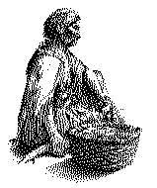
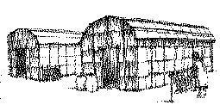
The 1740s and 1750s were upsetting times for the Indians living near the Ohio River. Many had only recently moved to the area. Most of them had lived further east and had been pushed off their land by Pennsylvania settlers. They liked their village, but now both the French Colonists and the British Colonists wanted to control the Ohio River. It looked like the two countries were about to fight over it! Queen Alliquippa and all the Indians were worried. They tried to see whether the French or the English would treat them the fairest. Which side would give them the best deal when trading? Which side would let them stay on their land?

Queen Alliquippa felt sure that the British would treat her village better than the French. She strongly supported the British. Then in the spring of 1754 the French captured the land near her village and she was forced to leave.

She traveled south with her entire village. In June of 1754 she met with George Washington. She and all her village camped in the meadow where Fort Necessity stood. George Washington had a special favor to ask, would her warriors help him in the fight against the French? The Indians had a meeting to talk about George Washington’s favor. Although Queen Alliquippa supported the British, she and the other leaders thought George Washington’s army was too small and that this would not be the best choice for her people. She moved with her village east, away from the French to safety.

Do you think she made the right choice? Did George Washington and his army do well at the Battle of Fort Necessity?

Later that same year Queen Alliquippa died. She was probably about 75 years old. She had been a very good leader of her village. She had also been a good example for all the Indian girls.

Terms:
British Colonies of America: These are the 13 colonies that were under the King of England. About 20 years after this battle these 13 colonies would fight against Britain for their freedom.

Iroquois Indian nation: There were many Indian tribes in America. The Iroquois were one of the most powerful in Pennsylvania and New York. They were made up of 6 different nations: the Seneca, the Mohawk, the Onondaga, the Oneida, the Cayuga and the Tuscarora.

Ohio River: This river starts right in Pittsburgh! Two rivers come together to form the Ohio River. Rivers were very important for transportation.

French Colonists: The French colonists lived in Canada and had trading posts throughout what is now the mid-western part of the United States.

Rebecca Sampey

Rebecca and James Sampey became the owners of the Mount Washington Tavern in 1840. They had operated taverns before and knew what to do. Both Rebecca and James would have been very busy. The Mount Washington Tavern stood on a very busy road, the National Road.

Thomas Searight lived on the National Road and wrote a book about it. He wrote that the National Road was more like a busy city street than the country road it really was. He also wrote that 24 horse drawn coaches were counted at one time on the road, and you could always see at least one large covered wagon drawn by six horses. His book also said the herds of horses, mules, cattle, hogs and sheep were so large that they could not be counted. That was a busy road!

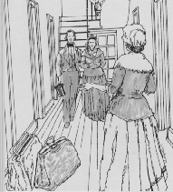
All those people and all those animals needed places to eat, drink and rest. The tavern provided these things for travelers. Rebecca Sampey would have been in charge of the cooking the food and setting up the rooms where travelers slept. James would have taken care of the stables and the bar room. Everyday Rebecca would make sure the food was cooked, the dishes were washed and the travelers at the tavern served their meals. She would also make sure that the bed sheets were washed each week; and each day fresh water, soap and towels was taken to the traveler who were sleeping overnight. Rebecca also had another big job; she had eight kids she had to take care of! Luckily Rebecca had lots of people to help her do all the work, including her older children.
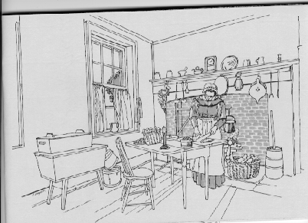
In 1844, only four years after getting the Mount Washington Tavern, James Sampey died. Rebecca hired a manager to help her run the tavern. That next year the tavern made $4,000. That was a lot of money back then.
In 1846 two of Rebecca’s daughters and their husbands probably did a lot of Rebecca’s work at the tavern. Her daughters were Eliza, 24 years old and Louisa, 20 years old. Rebecca lived on a nearby farm with her small children. One of her daughters, Ellen, was only 2 years old!

The Mount Washington Tavern continued to make money until the railroads made it across the Pennsylvania mountains. Passenger and goods started to take the trains because they were faster and cheaper than going on the National Road. Almost no one used the National Road. The Mount Washington Tavern didn’t have any traveler to help and closed. It was sold in 1856.

Rebecca lived on her farm until 1862. She died 13 years later when she was 74 years old. She was buried in the Mount Washington Presbyterian Church Cemetery where you can still see her grave today. She had had a very busy life.

Terms:
Taverns: A place where people and animals could eat, drink and rest while traveling.
National Road: This is the first road built by the United States government. It was a very good road, so many people traveled on it.
Drawn: A wagon or coach being pulled by an animal. Usually horses or oxen were used.
Goods: Things that were to be sold. They were usually carried in wagons on the National Road.

Activity #5 Acting Out

Surprise! The park has something just for Brownie scouts. The chance to dress up and act like a girl living at the Mount Washington Tavern!

You can pretend you are one of the five Sampey girls (there were also three boys). The girls’ names were Eliza, Louisa, Margaret, Mary Ann, and Ellen.

After visiting the Mount Washington Tavern you may like to try “acting out” butter making, one of the Sampey girls chores, at home or at one of your scout meeting. The Sampey girls would have used a butter churn, but, here is how to make butter at home.

Making Butter
Supplies:
- Heavy cream. It MUST be heavy cream, also called whipping cream.
- Several watertight containers, preferably small glass baby food jars
Put the heavy cream in the jars. Shake vigorously for about 5 minutes. Stop when it starts to become solid. Pour off the water. Taste your butter!
Try it!
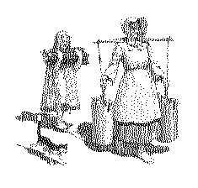

Activity #6 Games of the Past

While visiting the Mount Washington Tavern you will learn some games from the past and have an opportunity to teach them to other girls in you troop.

If you would like to learn some more games here are two that would have been played by children at the Mount Washington Tavern.

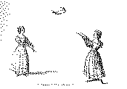

Hop, Step and Jump
Make a mark on the ground for the “starting point.” About 30 feet away make another mark, called the “spring.” Line up behind the starting point. Taking turns running to the spring. At the spring make first a hop on one leg, then a long step, and finally a long jump with both feet together. The girl who goes the furthest wins!

Word Charades
Divide into groups of 4 or 5. Each group thinks of a word or chooses one from a bunch that has been put in a hat. The groups then take several minutes to make up a skit or charade they can use to act out the word WITHOUT TALKING, POINTING OR WRITING. Then each group presents their skit to the other groups, who try to guess the word. See how well you can act and how well you can guess. Try it!

