Capillary Repair Log
M. Gilchriese

Prehistory
See http://www-physics.lbl.gov/~gilg/CoolingFittings/Repair/Capillary%20patch%20tests.pdf
And http://www-physics.lbl.gov/~gilg/CoolingFittings/Repair/caprepair.txt

March 15, 2007
Resurrect pressure drop setup

Sample Flow delta P Comments
S1 40 0.774 First try, no warm up
120A(120 cm) 40 0.889 This is suspect, since no warm up
120B 40 0.906
120A 40 0.907
120B 40 0.910
S1 40 0.791
S1 40 0.797 later time
S1 40 0.804 yet later

Clearly a bit uncertain. Say A and B are identical and take average of 0.906, 0.907 and 0.10 = 0.908. Ratio of 0.908/0.791=1.15. Ratio of 0.908/0.797=1.14

March 19, 2007
Let stabilize for about 1.5 hours

S1 40 0.786
S1 40 0.785

Rodney soldered the two 120 cm samples, A and B. Ratio A is value/0.7855. Ratio B is value/0.787
Ratio A Ratio B
120A 40 0.893 1.14
120B 40 0.902 1.15
S1 40 0.791 1.01
S1 again(wait) 40 0.787 1.00 1.00
120A 40 0.898 1.14 1.14
120B 40 0.905 1.15 1.15
120B again 40 0.900 1.15 1.14

Within limits of measurement, roughly 1%, looks same as before cutting and splicing. And A and B the same.

Samples with fittings F1-F4.
- Leak check/pressurized(50 times to 20 bar a)/leak check before splicing.
- Leak check/pressurized/leak check after splicing.
- LN2 dunk ten times then leak check.

Results not great. E-mail message from Tom
Date: Mon, 19 Mar 2007 17:45:29 -0700
From: Thomas Weber <TFWeber@lbl.gov>
To: Gil Gilchriese <MGGilchriese@lbl.gov>
Subject: test summary

Hi Gil, Capillaries tested. F1--F4 two ok two failed

F1 fine all through. final vac check after 10 dunks in LN2 1.11 E-9

F2 failed after second pressure test on vac check. You and I gave this one to Rodney.

F3 (short one) very well /final vac after LN2 x 10 1.03 E- 9

F4 passed first round only. After soldering some pump down problems with HLD test ~ 1.0 E-6 Leaks at
Cu splice on fitting end. Had been 1.10 E -9 first round.

I put last three capillaries in Rodneys office. Do we section or try a few more ? Tom

March 20, 2007
Trying with more solder. Calculation of max volume(desired) of solder

OD of capillary 39 mils or 0.0991cm or 0.050 radius
ID of sleeve 41 mils or 0.1041 cm or 0.052 radius

Volume is then length x pi x [0.052**2-0.050**2] = length x 6.4x10⁻⁴ cm³
The length is nominally 0.3” or 0.762 cm. So the volume is roughly 4.9 x 10⁻⁴ cm³
Call it 5 x 10⁻⁴ cm³

The solder is nominally 63 % tin and 37% lead. Density of tin is 7.31 gm/cc. Density of lead is 11.34 gm/cc. Density of solder is then 0.63*7.31+0.37*11.34=8.80 gm/cc.

So the mass of solder is nominally about only 4 mg! Rodney’s estimate of 20 mg for 1/3 wrap is wrong. Measured full wrap to be 7.8 mg, which makes much more sense.

So trying one sample with sleeve as is with full wrap of solder on F1. This passes all tests.

Increased ID of sleeve by 1 mil. Soldering this on F?. This one leaks after LN2 cycling!

Flycut of F?. Lots of solder inside. This is not good.
Agree to try two prong approach. Modify Cu sleeve for Mario to try gluing and to try no-clean flux solder.

F2 also with increased ID. Works fine after LN2. But way too much solder inside.

March 21, 2007
Two samples done with no-clean flux. First without crimping Cu sleeve. Passes all tests
Picture below

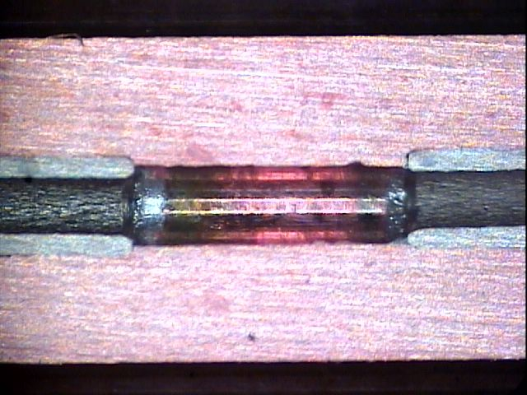

Second sample slight crimping of sleeve(but not during the soldering). Also passes all tests. Picture below
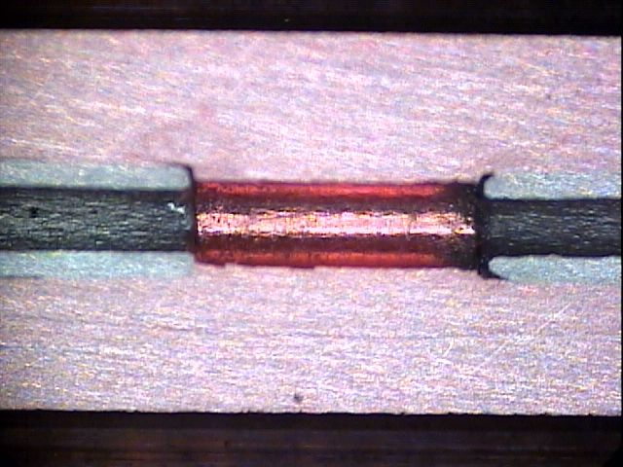

E-mail from Rodney on this
Date: Wed, 21 Mar 2007 15:26:28 -0700
From: Rod Post <RLPost@lbl.gov>
To: Murdock Gilchriese <gilg@lbl.gov>
Subject: more tests
Parts/Attachments:
1 Shown 5 lines Text (charset: ISO-8859-1)
2 OK 69 KB Image
3 OK 67 KB Image
----------------------------------------

So the flux core passed twice now with little to no solder intrusion or flux getting inside. The first was last nights using
the flux core with no crimp (ncflux1) The second was using flux core with a crimp (ncflux2a). We did however use less heat on
the second and the flow down the Z was spotty. Rod

e-mail from Weber today on 2nd sample tested today

Date: Wed, 21 Mar 2007 16:45:11 -0700
From: Thomas Weber <TFWeber@lbl.gov>
To: Gil Gilchriese <MGGilchriese@lbl.gov>, RLPost@lbl.gov
Subject: wed test

Newest capillary test
F1 rebuilt again. new numbers for next ones to help keep track?
this one no clean flux with crimp. Initial vac 1.07 E-9
Pressure cycle 300 # 50 cycles intermediate 1.51E-9
LN2 chilled connector 10 cycles Final vac test 1.32 E-9 then drifts up to 3 E-9 when He applied. Work with a bit to
get lower background then 1.73 E-9 then 1.26 E-9 then 1.20 E-9 No Helium detected good one. Section O.K

Mario glued up two samples with Cu +9396 + external sleeve with 9394. Need pictures.

He glued up two(?) sleeves with just 9396 that we can section tomorrow to see if epoxy flows into capillary. Here is his e-mail

Date: Wed, 21 Mar 2007 14:49:09 -0800
From: mdcepeda <MDCepeda@lbl.gov>
To: Murdock Gilchriese <MGGilchriese@lbl.gov>
Subject: update 3/21/07

Hi Gil,
Did the 9396 bond so we can check tomorrow, and also did solder with Rod with crimp
sleeve and this one worked , Tom did LN , pressure, leak check , we cut it in half , nothing went through. Heat is very
important just the right amount and when it beads take it out fast.
and dont go back and reheat to fix . tomorrow try a few more crimped and different heats to see if solder goes through
crimping. (Suggestion)
we will fill you more in the morning.
Mario

March 22, 2007
Pictures of gluing. First picture is of sleeves glued with 9396 yesterday.

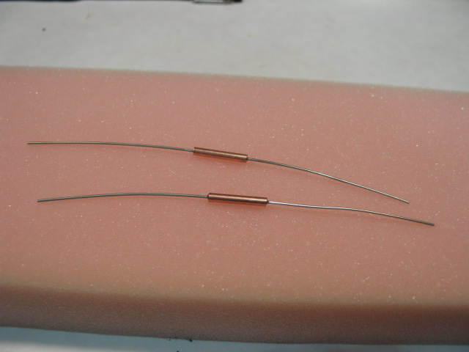
Next picture is of capillaries already glued into sleeves in turn glued into larger Al sleeve with 9394. Note teflon cap to keep glue in during cure.
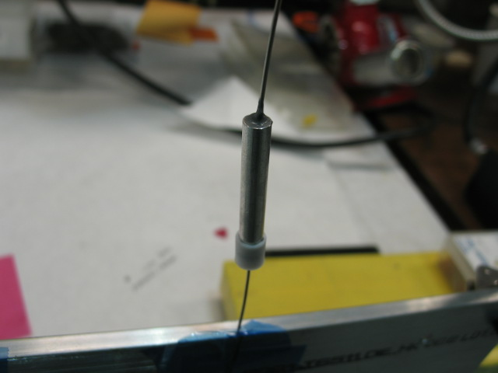

Decided to continue tests with crimped sleeves using no-clean flux solder. Start relabel samples from C2(C for crimp) since C1 was done and OK yesterday.

C1(no crimp), C2(“short” crimp), C3(“long” crimp), C4(long) all pass leak/P/leak/LN2/leak. C5 one side leaked initially. Added solder. Leaked. Reflowed carefully. OK through pressure cycle but apparently leaks after LN2. This one looks weird visually. Decided to flycut. The hole size is too large! Which is why more solder needed.

Message from Weber.

Date: Thu, 22 Mar 2007 17:47:03 -0700
From: Thomas Weber <TFWeber@lbl.gov>
To: Rod Post <RLPost@lbl.gov>, Gil Gilchriese <MGGilchriese@lbl.gov>
Subject: Thurs tests

Start with C2 50 crimped no clean flux
<1.00 E-9 initial
1.16 E-9 after press cycle
1.92 E-9 after Ln2 dunk
Higher background no Helium detected

C3 100 crimped no clean flux
1.49 E-9 initial
1.48 E-9 after pressure cycle
1.19E-9 after LN2 dunk

C4 100 crimped no clean flux
1.20 E-9 initial
1.410 E-9 after pressure cycle
1.61 E-9 after LN2 dunk

C5 100 crimp no clean flux
big leak re flow with added solder
1.87 E-9 initial
1.09 E-9 after pressure cycle
4.0 E-9 rising slowly real He leak
copper /capillary interface
check again tomorrow.

March 23, 2007
Making more sleeves. Making crimp tool. Tom testing glued samples.

Glued sleeve done yesterday cut. No glued leakage into crimp region. Looks good. So need to glue and immediately crimp.

Both glue samples pass all leak tests.

I tried samples C6 and C7. C6 got too hot also added solder one side because thought it had not flowed. Flame too close. Passes all tests but solder encroaches into void. Practiced soldering and then did C7, which passes all tests. Looks great!

Packing up.

Here are C1-C7 flycut pictures for record.
