FPD Detector Production
Gilvan A. Alves
Lafex/CBPF
This document intends to give an overview of the necessary steps for the production of the FPD fiber tracker detector. An overview of the detector design and components can be found at the FPD Technical Design Report.
The FPD fiber tracker uses square double-clad plastic scintillating fibers to detect the passage of a charged particle. Outside of the detector active area, matching square clear fibers transport the collected photons up to the photon detector, in our case a 16 channel Multi Anode Photomultiplier (MAPMT) developed by Hamamatsu (H6568-MOD). From there on the electronic signal is amplified, shaped and sent to the D0 trigger electronics.
Before any detector assembly, the square scintillating and clear fibers need to be cut to size and polished at one end, where the splicing of the two will take place. Polishing square fibers is only possible using the ice-polishing method, available at Fermilab Lab 7 facility, Eileen Hahn is the person responsible for the job requisitions on this facility, which includes also the vacuum deposition system used latter on.
The scintillating fibers are cut to 10cm length in order to allow for the handling in the polishing and splicing machines. The clear fibers are cut to 45cm, which should leave a 3cm margin for assembly in the cartridge.
Bicron has been committed to deliver the fibers within the tolerances of 2% and fiber width no greater than 0.8mm. We need to verify that this condition is met in every batch we receive. Usually the variations of width within a batch are well bellow the 2% quoted, but it is good to verify that too.
Before splicing production starts, it is a good idea to verify the transmission efficiency of the process. The method for that is as follows:
- Chose the appropriate glass cassette for the fiber width. There are two assembled cassettes at Lab 5, one with 0.78mm width and other with 0.82mm width. There is also a supply of glass pieces in case a new cassette needs to be made. The fiber should not be too tight or too loose inside the glass piece or the splicing will fail.
- Using a sample of about 8 scintillating fibers cut at about 50cm and polished at one end, fill and glue 2 channels of a MAPMT mask, polishing any excess at the mask end. Insert the individual fibers in the source collimator and measure the charge spectrum using either a multichannel analyzer or an ADC module. Save the contents in a histogram.
- Mark the fibers at both ends and have them cut at the middle and ice polished (the ends that were cut) at Lab 7.
- Splice individually each fiber to its counterpart, changing the heat time settings within ± 3 seconds, and redo the charge spectrum with the source collimator. Compare the histograms and mean charge distributions to get the transmission through the splice.

Once the fibers become available after polishing, and the transmission verified, splicing could commence using the best transmission settings from the earlier test. It should be noted that the splicing point is very weak to bending stress, so transportation of the fibers should be avoided. If possible the fibers should be readily assembled in the frames to avoid any damage.
In order to avoid any problems with dirt deposits, the splicing machine should be cleaned after about 100 splices or so with soft cotton swabs and alcohol (glass pieces) and dry clean air jet.
While the splicing is taking place, fiber assembly in the frames can be done using a regular microscope (100X) with light spot. The task can be eased using the fiber holding devices developed for this purpose.
Before loading the fibers in the frames, the primed planes need to be isolated with kapton tape to avoid the epoxy from running into the unloaded plane, which would fill in the gaps for the fibers.
The fibers need to be grouped in four, verifying the alignment of the splicing points, labeled according to channel number and fixed in place using a small drop of fast curing glue (plasti-zap or similar). The detector active area (17.39mmx17.39mm) can be marked in the frame using a precise cut mask and thin graphite in a granite table. This allows the border to be seen in the microscope for correct placement of the splicing point in the frame.
After the fiber loading in one plane, this can be filled with low viscosity epoxy, which fills the gaps and strengthen the splice joint making less risky any further handling of the frame. In order to assure a flush upper surface after the epoxy filling, the plane has to be covered with a piece of mylar (or other anti-adhesive material) and gently pressed with a flat piece of glass and a weight of around 200 grams. The epoxy takes about 8 hours to cure at room temperature and any handling should be avoided at this time.
After the epoxy curing, the same procedure should be repeated for the primed plane completing a whole view (XX’, UU’ or VV’). For the X’ plane the procedure differs in the last stage, because the trigger scintillator and light guide should be inserted in place during the epoxying of this plane in order to avoid any residual epoxy to cause problems in the insertion of this scintillator.
The trigger scintillator is a ½” thick solid piece of BC-408 plastic scintillator cut at the dimensions of the detector active area (17.39mmx17.39mm). In order to avoid the light from the scintillator to cause false signals in the fibers, this scintillator must have all its sides aluminized, with exception of the top, where the light guide is connected, and the bottom which is to be polished later in the assembly process.
After the assembly of the frames, the individual channels, which were labeled in that process, have to be inserted in the MAPMT cookies in the following order:

1
2
3
4
13
14
15
16
…
Insertion
guide

The 16 channels from XX’, UU’ and VV’ are inserted in their individual cookies. For the U and V views, the channels 17-20 are mixed into a single cookie with the following map:

U U’ V V’
17
18
19
20

The X view has its fibers running straight into the MAPMT, but for the U and V views the fibers have to be bent to reach the MAPMT. In order to avoid excessive stress on the fibers, they have to be bent prior to the epoxying on the cookie. In this way the fibers will keep the bending shape after the curing of the epoxy. At this stage the 200 μm fibers for the LED calibration, one for each channel, have to be inserted and fixed in place with epoxy. These fibers have to be bundled into a 1 mm fiber connector, which serves as the interface to the 1 mm fibers coming from the LED Mixing Block (LMB).
The next stage in the assembly is the polishing of the cookies, followed by polishing and aluminizing of the sides of the U and V views. The bottom of these views will be polished latter on together with the X view after the whole detector is assembled. This is to ensure the flatness of the whole detector bottom.
At this point the whole detector can be assembled using the mounting screws, and the whole bottom can be polished and aluminized.
The whole detector can now be mounted in the Detector Cartridge/Light Tight Box, following specific procedures for that.

Light Tigh Box:

The light tight box for the production detector is divided in 2 parts: The detector cartridge and the photomultiplier box. Figure 1 shows a drawing of these elements. The detector cartridge holds the detector frames and fibers in place, providing a mechanism to fix the detector at the bottom of the Pot, by the way of 2 hollow rods, which will slide into the threaded guiding rods, fixed at the alignment balls at bottom of the Pot. The photomultiplier box houses the trigger and multi anode photomultipliers and the cabling to the MAPMT amplifier/shaper. In order to allow for small deviations on the position of the fiber mask holders, the MAPMT will be encased in silicon rubber, which will allow only for lateral movements, since it is necessary to preserve the contact between the MAPMT window and the masks. At the same time this scheme also prevents excessive pressure on the photomultipliers window.

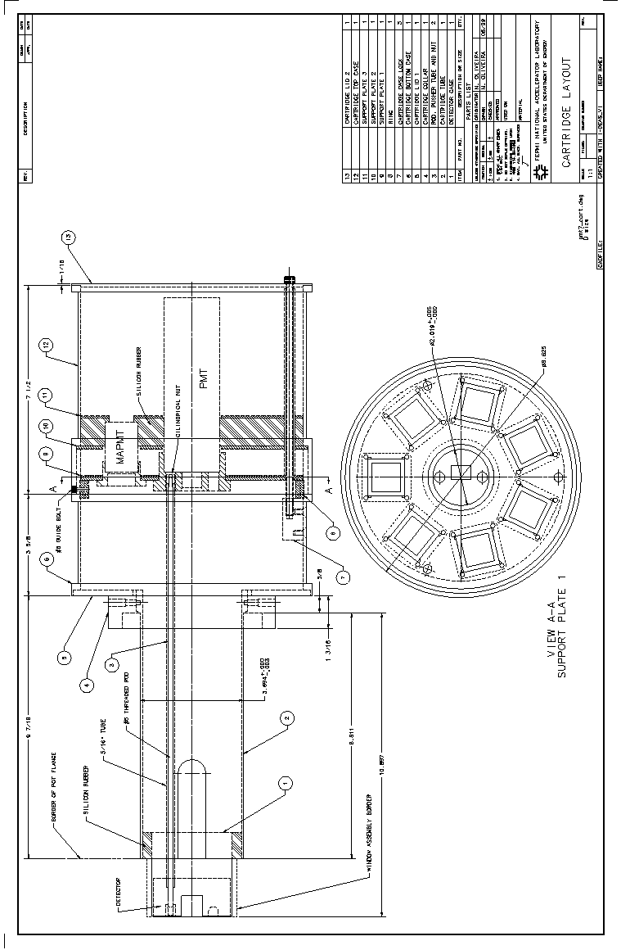

Fig.1 – Detector Cartridge for the FPD

Cable Routing:

The routing of each amplified signal from the MAPMT to the trigger boards, situated on the west platform, will proceed through long (~50m) 16-way flat coaxial cables, which will need to be joined for the farthest dipole detectors. An interface for these cables to the CFT analog board is under development. Unlike the VLPC case however this interface can be very simple since there is no special temperature needs involved. Cable trays will need to be added in the tunnel for these and the trigger scintillator signal cables. The latter ones will have to be routed to the Moving Counting House, where the Luminosity Monitor boards are located.

