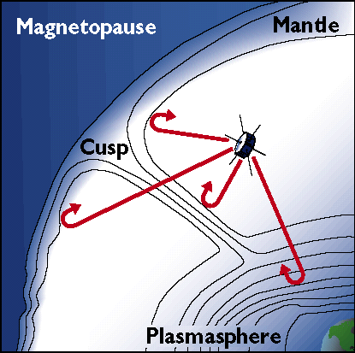

Low Frequency Electromagnetic Compatibility Testing
of the
IMAGE Satellite
using the
Radio Plasma Imager (RPI) 3-Axis Receivers

Document Number. TR.9000001-02

Submitted to:
Southwest Research Institute
6220 Culebra Road
San Antonio, Texas 78228

Subcontract No. 83822

Prepared by:
University of Massachusetts Lowell
Center for Atmospheric Research
600 Suffolk Street
Lowell, Massachusetts 01854

28 June 1999
TABLES OF CONTENTS

1.0 SCOPE…………..…………………………………………………………………………….……1

2.0 REFERENCE DOCUMENTS.…………………………………………………………….………1
2.1 SwRI Documents.…………………………………………………………………………1
.
3.0 TEST CONFIGURATION………………………………………………………………....………..1

4.0 TEST MEASUREMENT RESULTS…………….……………………………………….…..….….3
4.1 Spacecraft Susceptibility/Compatibility.……………………………………………....….3
4.2 RPI/Science Instrument Susceptibility…………………………………...….………...…12

FIGURES

3.1 EMC Test Configuration……………………..………..……………………..…………...…………2
3.2 IMAGE being sealed up in the Battel EMC Chamber…………………………………………..….4
4.1 Payload vs. Observatory baseline, top is low band, bottom is high (7.1.3.1)………………………5
4.2 Charging Battery with 5A from Umbilical Power (7.1.3.6)………………………………..………6
4.3 Deckplate Heaters on, highest current, top low band, bottom high (7.1.3.2)……………………….7
4.4 AST on and PWM at 63% (7.1.3.3)………………………………………………………...………8
4.5 Torque Rod Positive Current; Z-axis noise, 160-200 kHz (7.1.3.4)……………………………..…9
4.6 Torque Rod Negative Current (7.1.3.4)………………………………………………………...…10
4.7 S-Band Transponder On (5 Watts), Torque Rod still On (7.1.3.5)……………………………..…11
4.8 Same as Fig 4.7, but with Torque Rod off (7.1.3.6)……………………………………………….12
4.9 MENA on in most active mode, low-voltage on HV Supplies……………………………………13
4.10 EUV in most active mode…………………………………………………………………………14
4.11 FUV in most active mode………………………………………………………………………….15
4.12 LENA active………………………………………………………………………………………16
4.13 HENA active (Low voltage on HV supplies)………………………………………………….….17

- SCOPE

This Electromagnetic Compatibility (EMC) test report defines the test results from the EMC testing conducted at LMMS 12 – 13 June 1999. The object of the test was to characterize the electromagnetic environment created by the IMAGE observatory and to demonstrate that the RPI instrument and the IMAGE Observatory subsystems can operate adequately within this environment. Specific goals of the testing were:
- Establish an EMI noise floor for the RPI instrument in multiple observatory operating modes,
- Demonstrate compatibility among the Science Instruments and the Observatory subsystems,
- If necessary, to identify and characterize EMI emitters that interfere with RPI, and
- Characterize the conducted emissions of the observatory.

The EMC testing was conducted in accordance with the approved Electromagnetic Compatibility Test Procedure for the IMAGE Observatory, 8089-OBEMCTP-01, Rev. 0, Chg. 0.

- REFERENCE DOCUMENTS

2.1 SwRI Documents

8089-OBEMCTP-01 Electromagnetic Compatibility Test Procedure for the IMAGE Observatory

- TEST CONFIGURATION

To support the Payload level testing in March at Southwest Research Institute, Battel Engineering fabricated a temporary screen room enclosure designed to be a good enough shield against radiated EM waves and local electrostatic fields to enable RPI to see its receiver noise floor. Testing at SwRI confirmed that this was possible, so the chamber was transported to Lockheed Martin Missiles & Space systems (LMMS) for testing with the S/C systems added to the payload systems.

The configuration as used during the testing is shown in Figure 3.1. Notable features of this configuration are that one solar array panel input is replaced by the Solar Array Simulator (SAS), at which point the umbilical power cable (W202) can be removed, leaving only the SAS and one RS-422 cable connected through the walls of the EMC chamber. The SAS provided power during the second day of testing, 13 Jun 99, however we had occasion to run only on internal batteries on 12 Jun to investigate sources of conducted emissions entering the chamber, and to find a short in the DC power line filter. To also eliminate the RS-422 cable connection, we used the Mass Memory Module to store about 25min worth of telemetry while the cable was disconnected, allowing the S/C
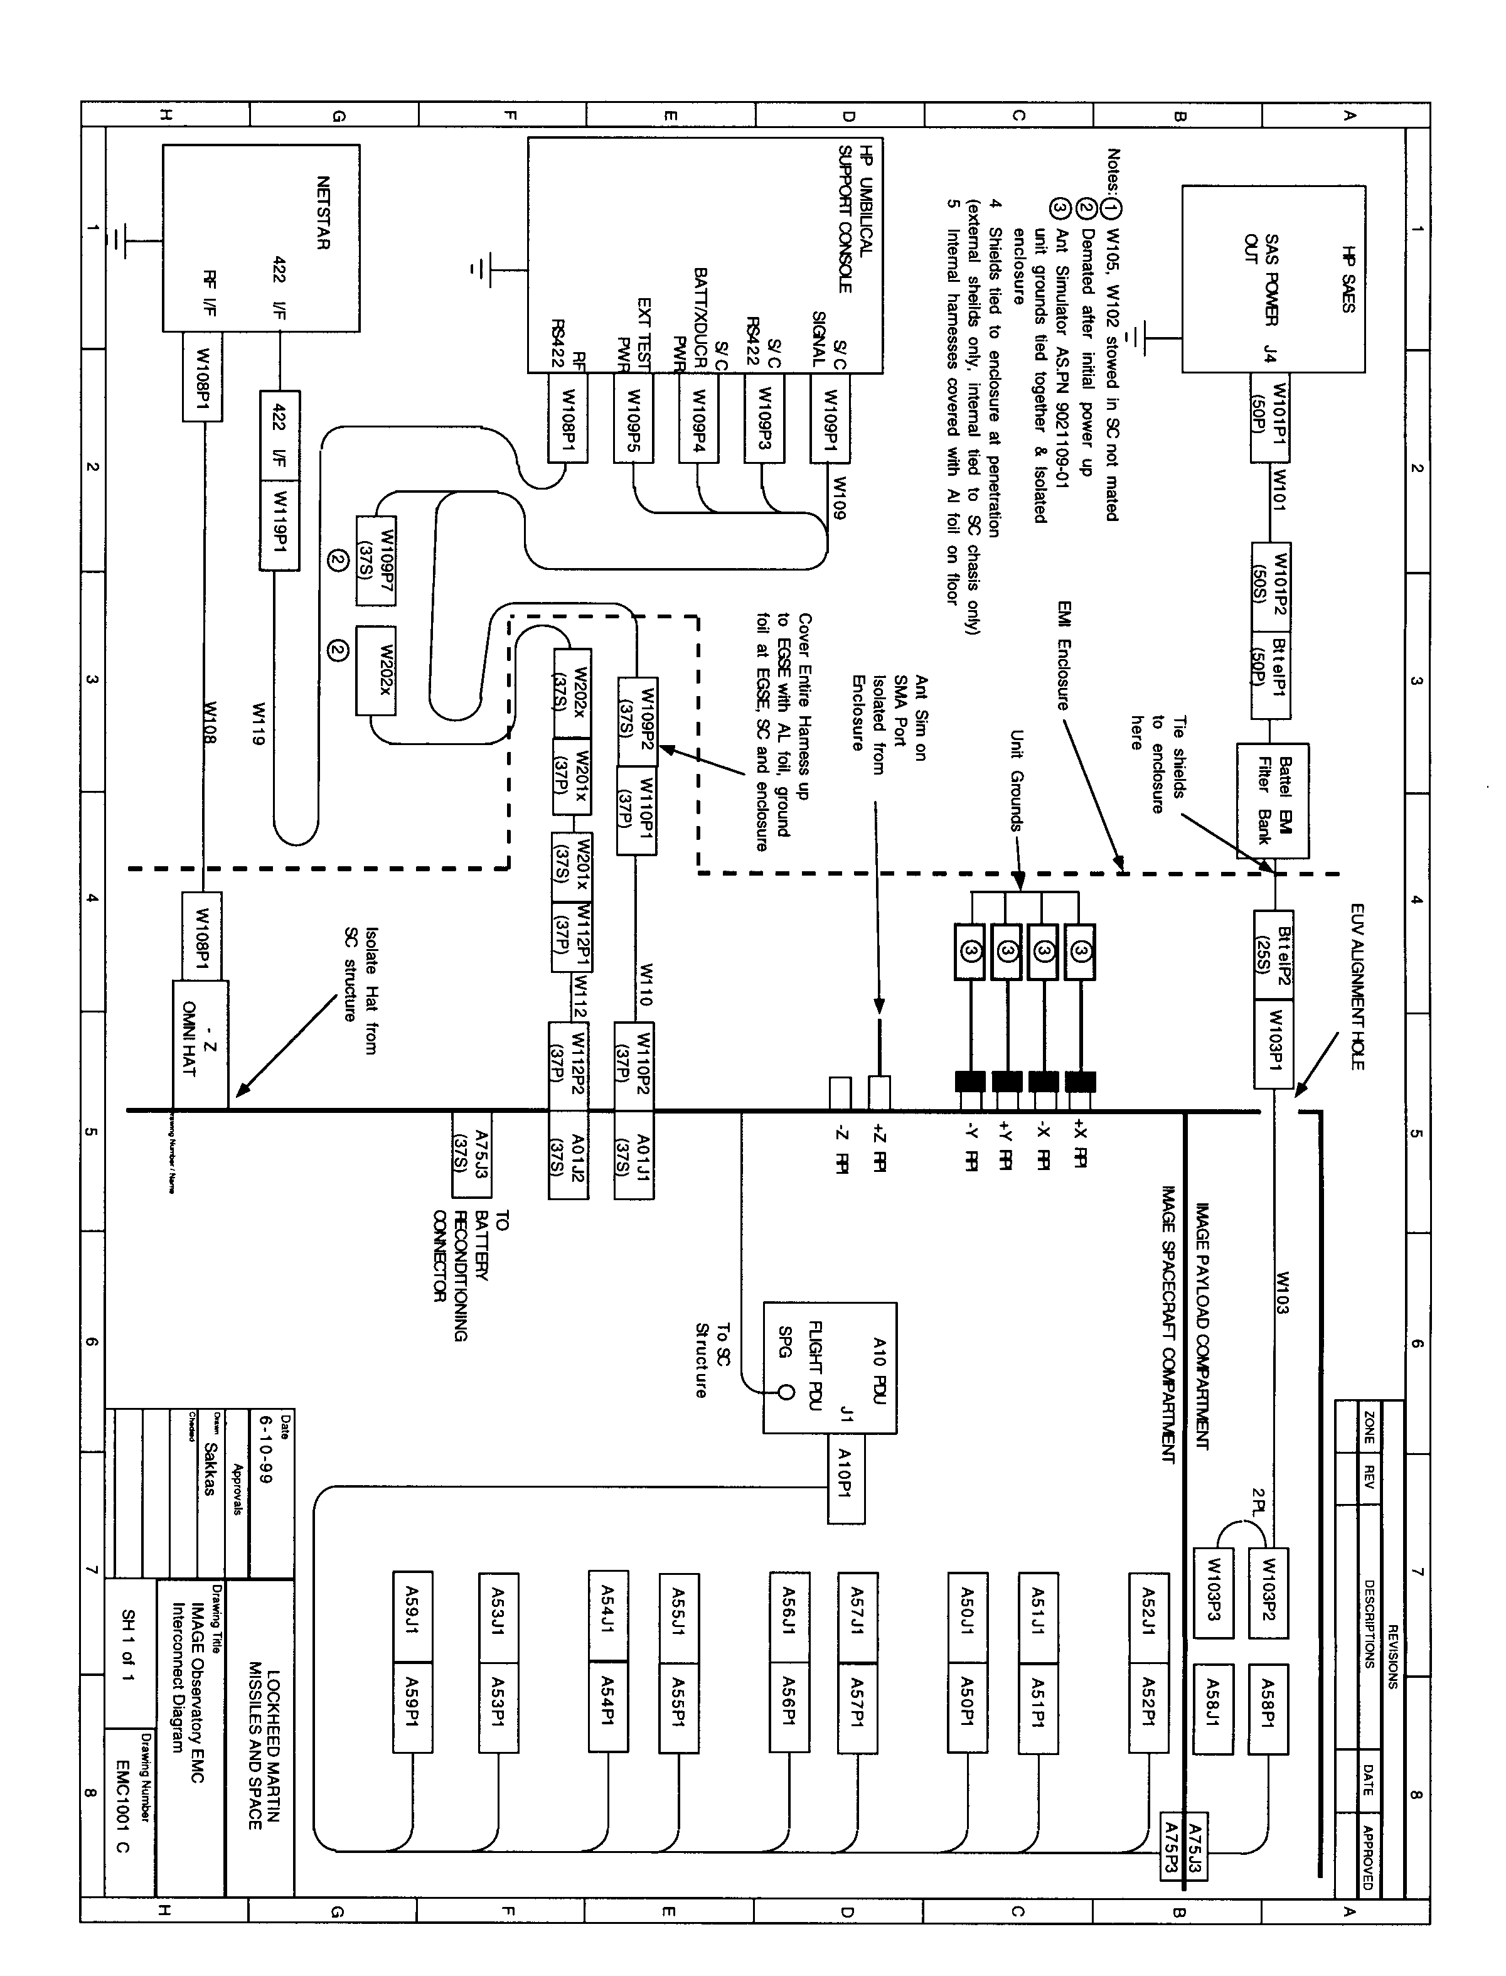
Figure 3.1 - EMC Test Configuration
to operate totally autonomously (i.e. no external cables connected). During this run there was still an unacceptable amount of external interference, which we concluded must be "internal" interference generated by the S/C, since nothing was connected to the outside world. However, after "sniffing" around with the active whip antenna as a probe and the HP spectrum analyzer as a receiver, we identified the air conditioning (A/C) hose (shown in Figure 3.2) and specifically the spiral support wire inside the hose, as the conduit which conducted low frequency RF into the chamber. This hose, used to cool the S/C battery, was determined to not be required, and the S/C was operated without the A/C hose for the remainder of the EMC testing.

Figure 3.2 shows the physical configuration, with the IMAGE satellite inside the EMC chamber before the end wall was reinstalled and before the A/C hose was removed. This picture also shows the single point for cable entry in the near left corner. Also note the RPI antenna simulator boxes installed in the far corners just before the "antenna" wire was installed, connecting them to the deployer tip masses. Another two boxes, shown on the floor, were later installed in the near end corners so that four antenna wires could be connected. The -Z antenna was not connected, and we placed a 1m wire into the +Z preamplifier input. It was shown that taping this loose wire to the +Z "stovepipe" support structure caused it to pick up about 20dB more noise, so it is important to keep the antenna element well away from the structural walls (another lesson learned for future testing, e.g. Observatory thermovac testing).

4.0 TEST MEASUREMENT RESULTS

  - Spacecraft Susceptibility/Compatibility

Payload level testing in March at Southwest Research Institute verified the interoperability of the RPI with the CIDP (Common Instrument Data Processor) and the four other instruments that were available at the time. The aim of the Observatory level series of tests was to establish the interoperability of the additional systems, primarily, comprising the S/C power, telemetry, attitude control, computers and data storage. Since we had already made measurements at Southwest Research Institute using the same Battel EMC chamber, we had a good baseline noise floor to compare with our results at Lockheed. Using the EMC Test Procedure, paragraph 7.1.3.1, we made a background measurement of the inside of the EMC chamber with a minimum of new systems operating, specifically the S/C PDU and SCU, which had to be on in order to power up the RPI and CIDP.

- Figure 4.1, is an overlay of the March and June background noise data. It shows only a slight increase in the noise floor between 10 and 60kHz. The peaks in this interference were correlated to noise monitored outside the chamber (especially the line at 20kHz on the X receiver) with an HP spectrum analyzer. Also, the fact that the amplitude of this noise is significantly greater on the X axis shows that it was carried in by cables passing through the EMC chamber wall near the -X antenna element. This same noise was two orders of magnitude larger on 12 June

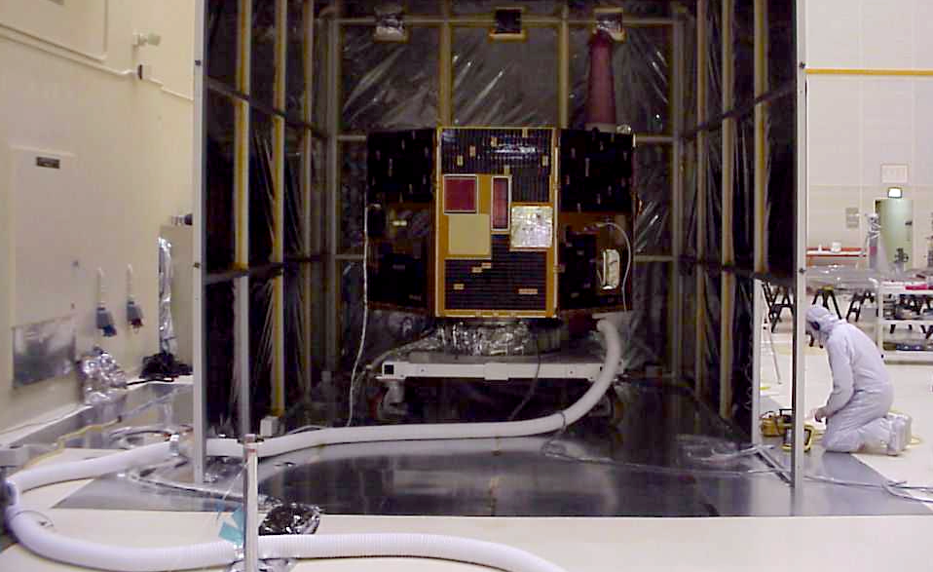

Figure 3.2 - IMAGE being sealed up in the Battel EMC Chamber. Note the cable entry point with all cables wrapped in foil and grounded. The cable run over to the umbilical consoles crossed the floor fully enclosed in what we called cannelloni (which is stuffed pasta), while we meant it to be calzone (which is a wrapped pizza with the goop on the inside). It could also be cannolli, which is a stuffed desert pastry, all the same idea.

before removing the A/C hose. The satellite was power by HP power supplies through the umbilical connector A01J2, see Figure 3.1, until early morning on June 13 when we switched over to input power from the Solar Array Simulator (SAS), filtered by a line filter built by Battel Engineering.

Although we had originally planned to command the S/C via the RF link, this link had not been thoroughly debugged, so the RS-422 communications cable going to the SCU (connector A01J1) remained connected during all measurements shown in Section 2. Short tests were made with these connectors disconnected (i.e. running on internal battery power) and no difference was noticeable.

The only detectable interference sources from S/C systems were:
- A small 63kHz line and its 2nd harmonic at 126kHz, when battery charge power was maximum. There were noticeable spikes only when the PWM duty cycle was greater than about 70%.
- The torque rod with positive current polarity showed a broad interference band between 160 and 200kHz.
- A small line came up at 75kHz whenever the S-band transponder was active.
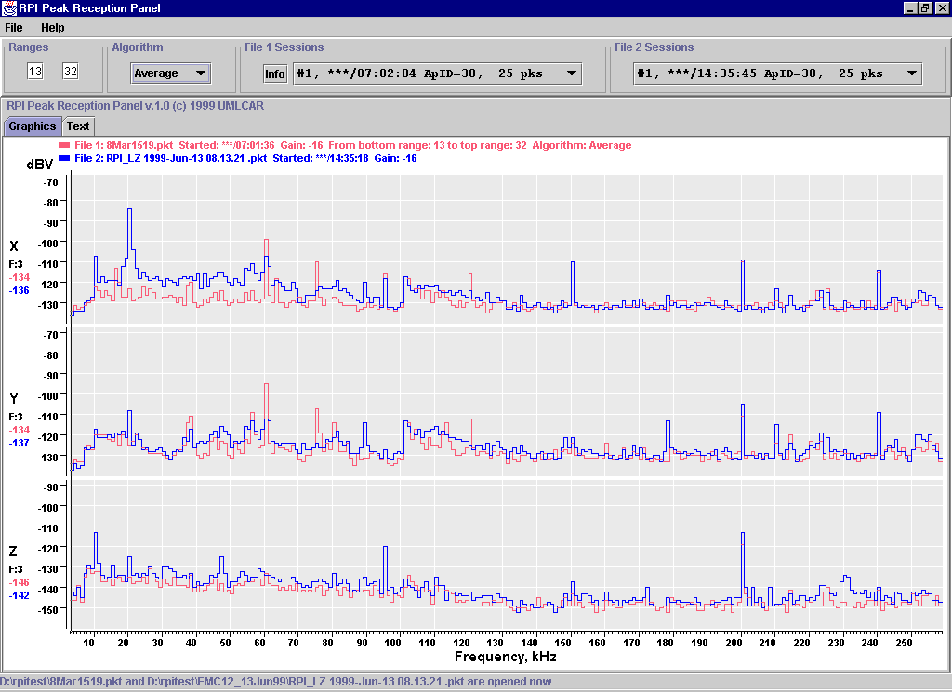
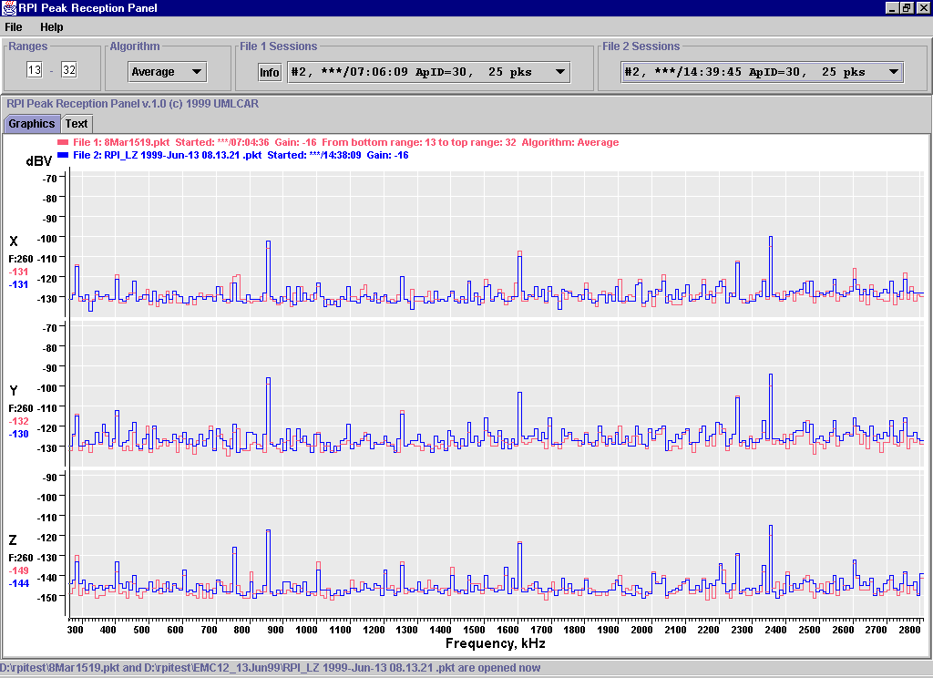
Fig 4.1 - Payload vs. Observatory baseline, top is low band, bottom is high (7.1.3.1)
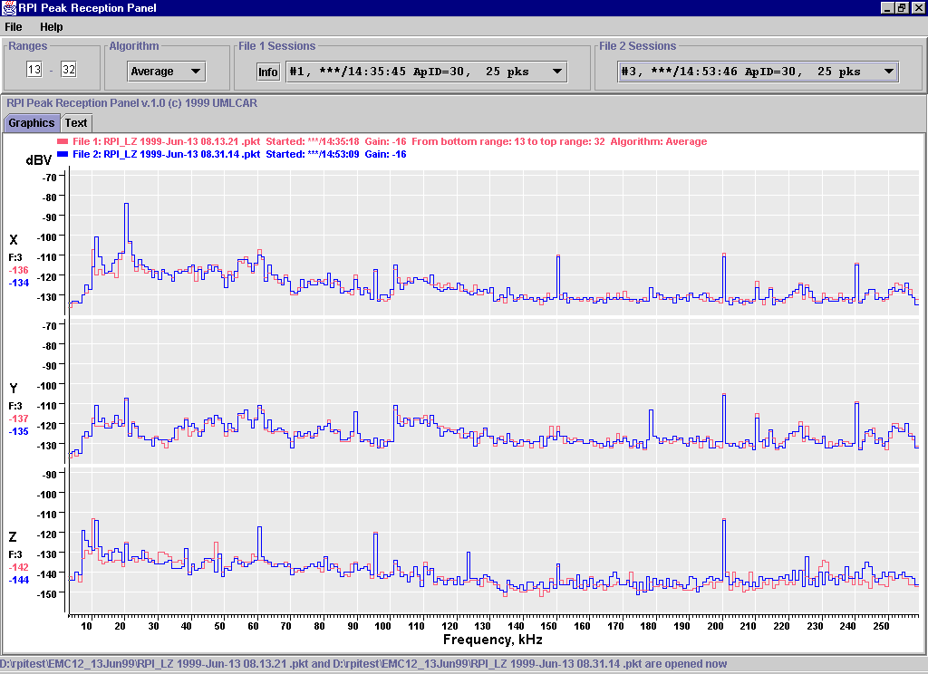
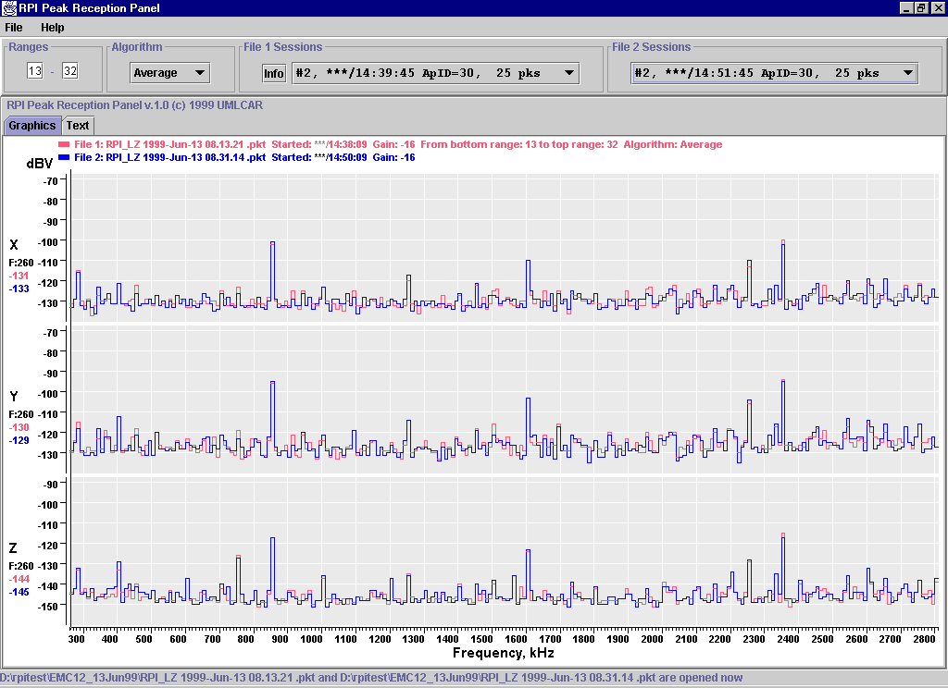
Figure 4.2 - Charging Battery with 5A from Umbilical Power (7.1.3.6)
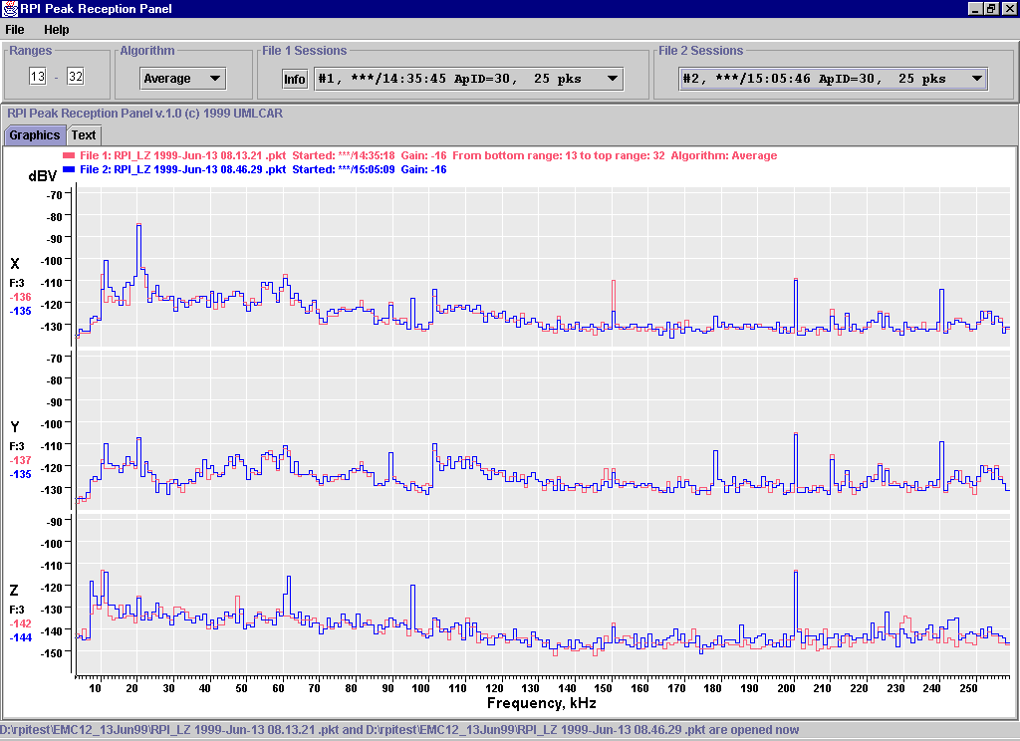
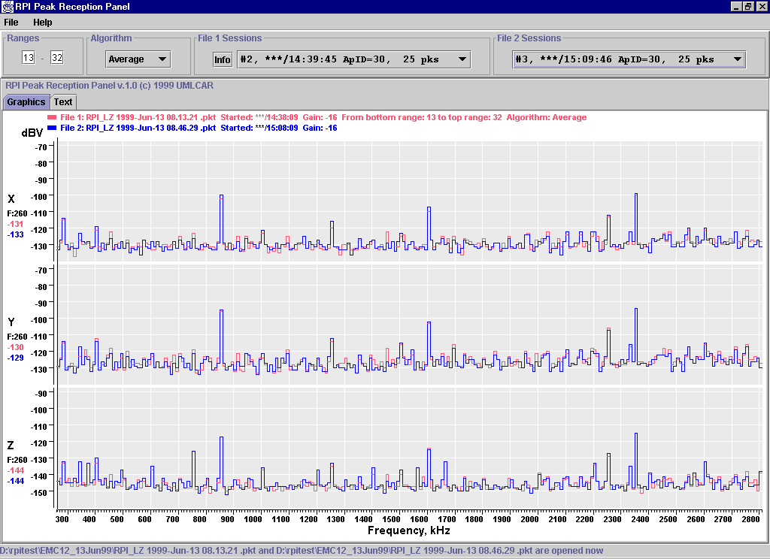
Figure 4.3 - Deckplate Heaters on, highest current, top low band, bottom high (7.1.3.2)

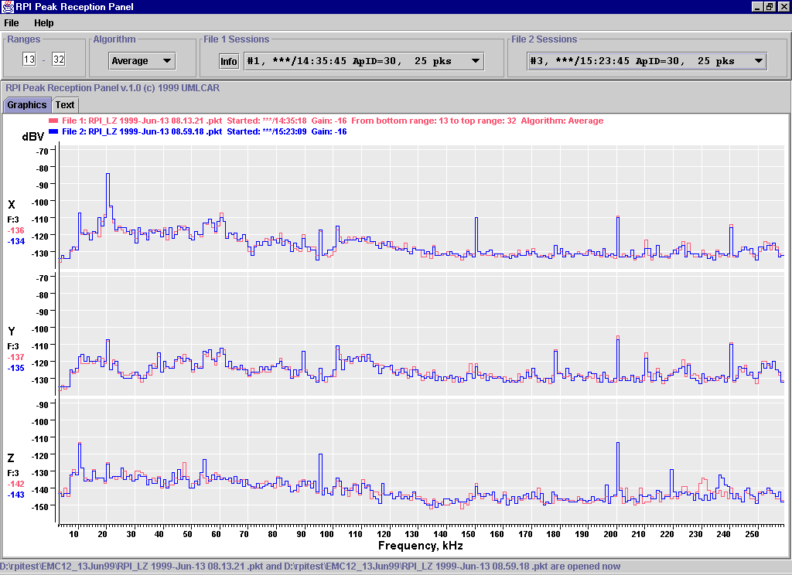
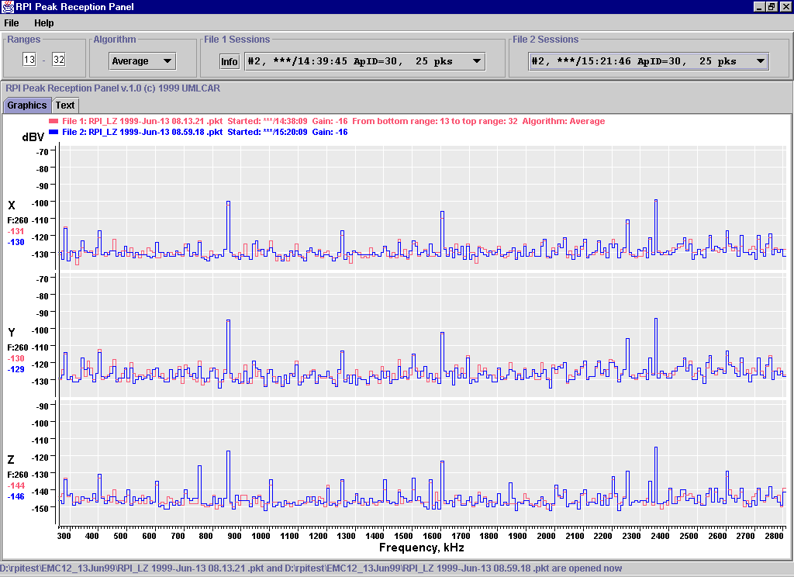
Figure 4.4 - AST on and PWM at 63% (7.1.3.3)
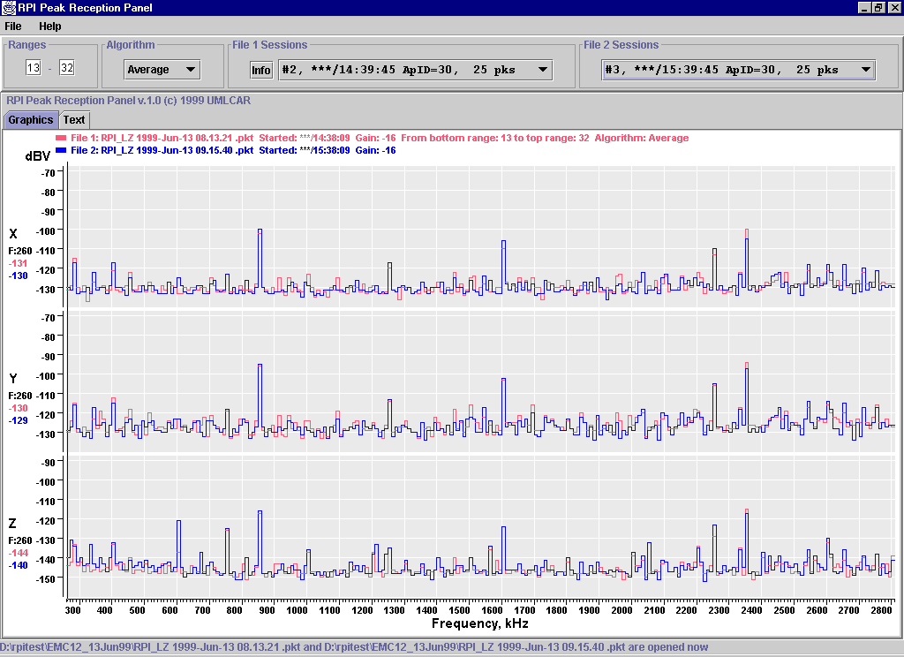
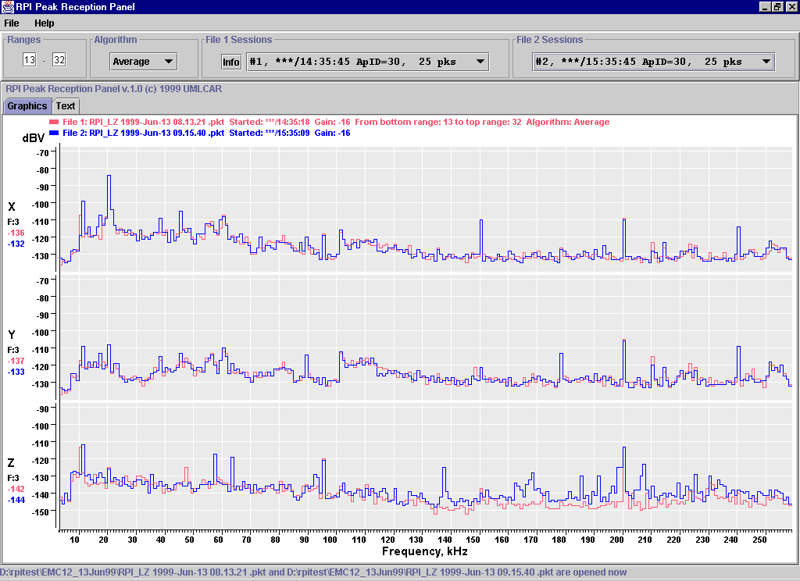
Figure 4.5 - Torque Rod Positive Current; Z axis noise, 160-200 kHz (7.1.3.4)

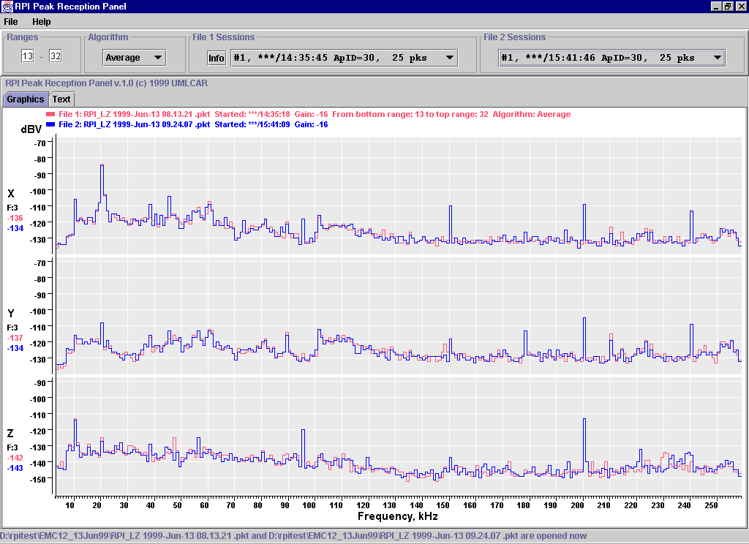
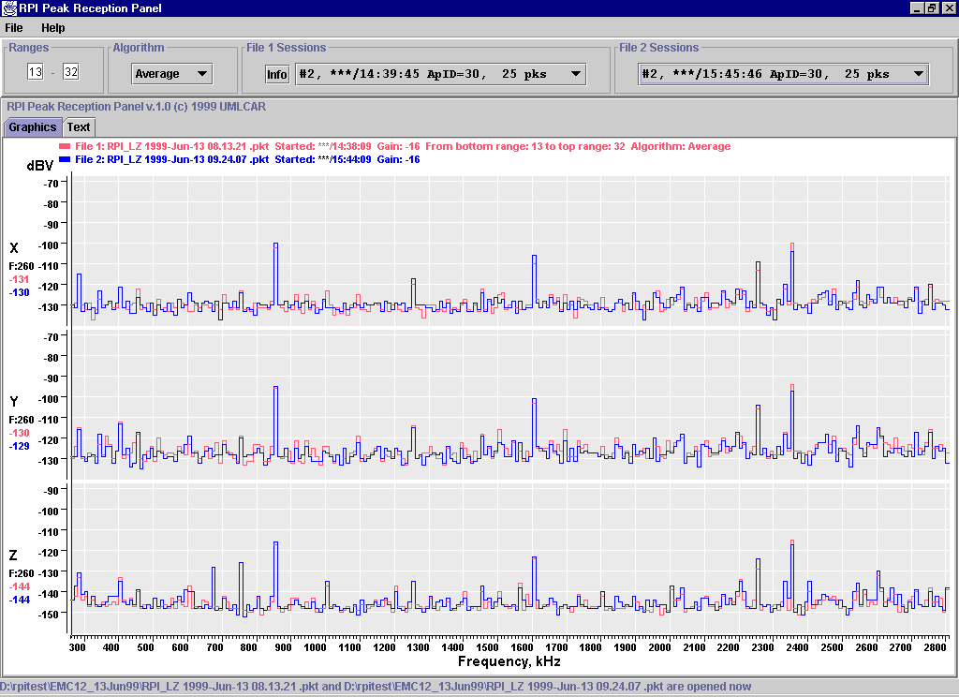
Figure 4.6 - Torque Rod Negative Current (7.1.3.4)
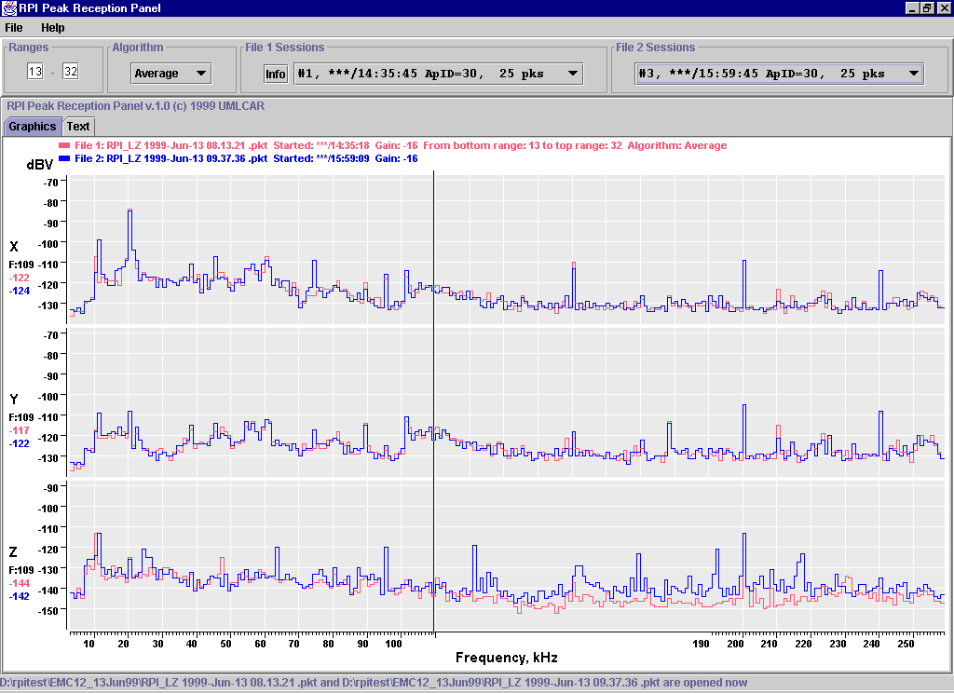
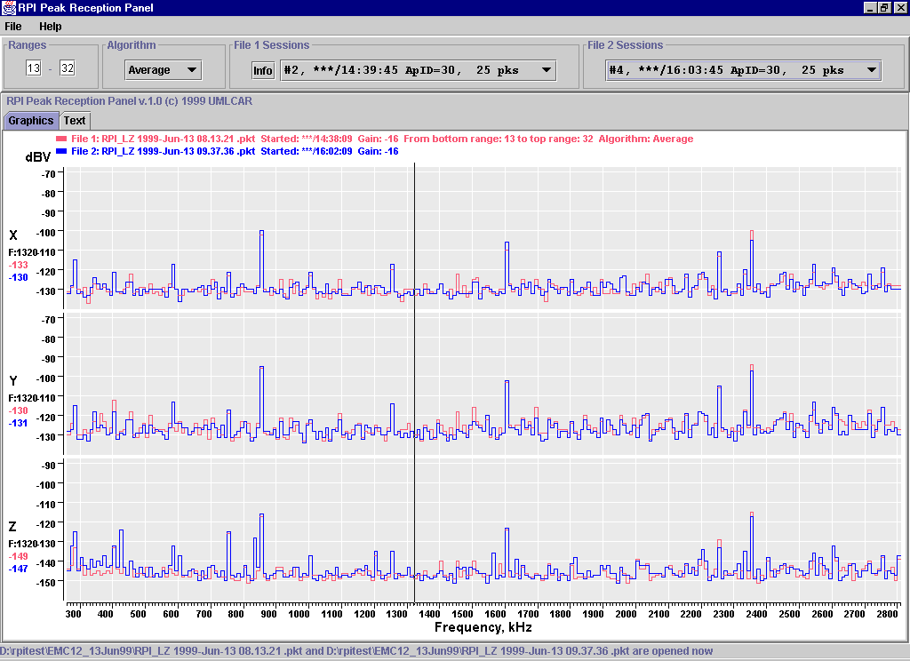
Figure 4.7 - S-Band Transponder On (5Wattts), Torque Rod still On (7.1.3.5)
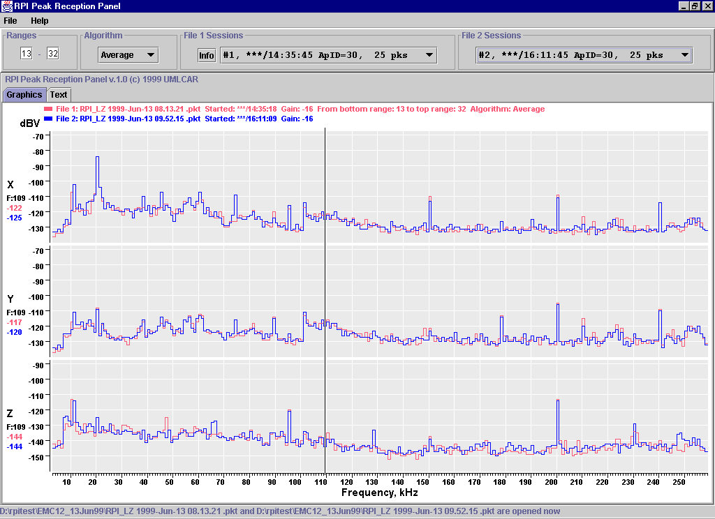
Figure 4.8 - Same as Fig 4.7, but with Torque Rod Off (7.1.3.6)

  - RPI/Science Instrument Susceptibility

We are glad to report that no spurious lines appeared when any of the IMAGE instruments were operating. The tests in Texas had discovered a series of lines that seemed to appear when the FUV instrument came on, but upon retest it was shown that these lines appeared even when the FUV was powered off. The source of the interference was never determined, and now appears to have been brought in from outside the EMC chamber, since several lines previously thought to be inherent in the RPI or CIDP were not visible during the testing in California.

The following are scans with the PDU, SCU, CIDP and RPI operating in addition to one instrument at a time, as noted.

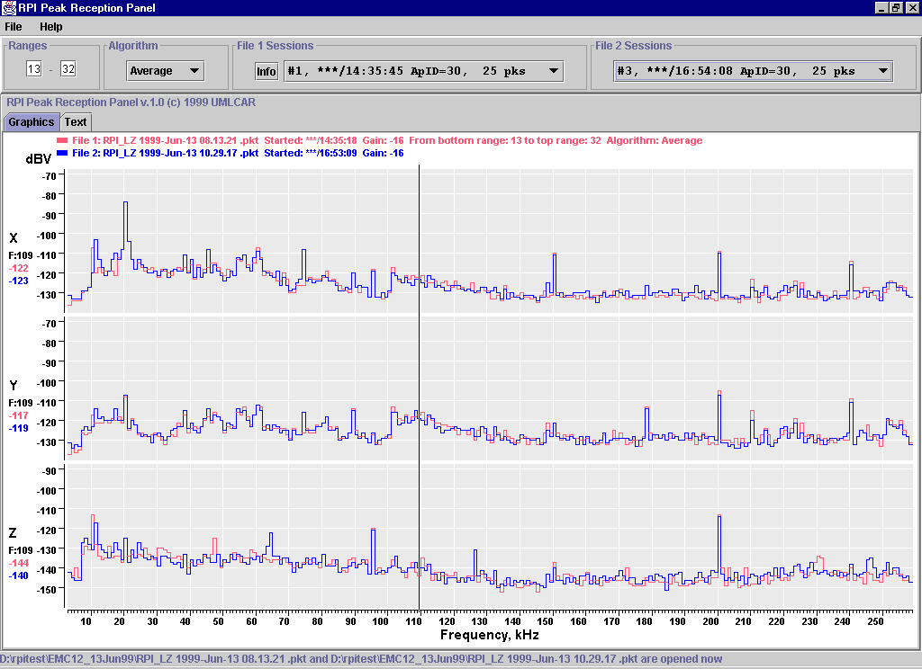
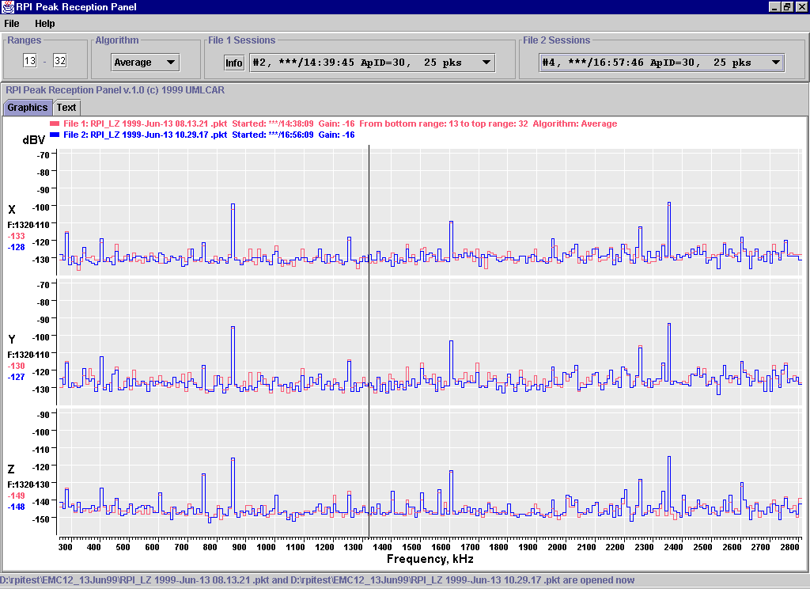
Figure 4.9 - MENA on in most active mode, low-voltage on HV supplies
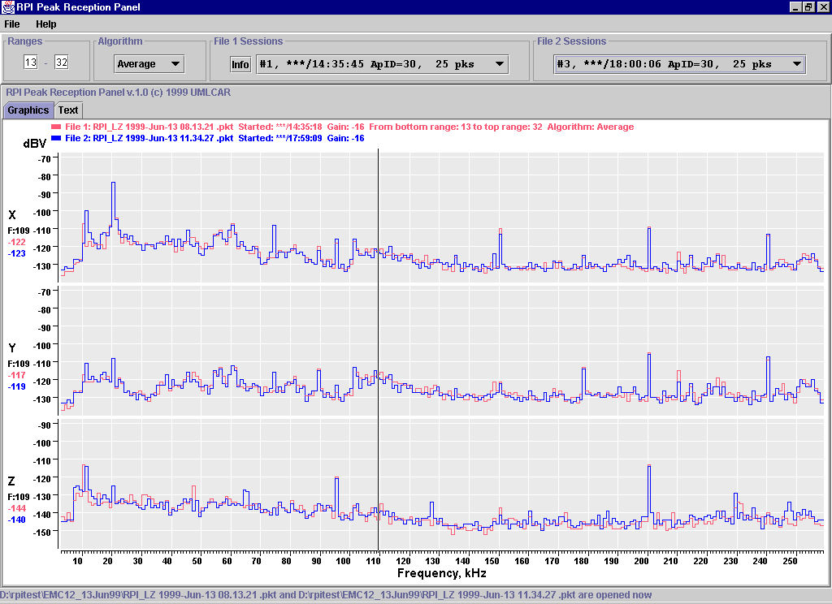
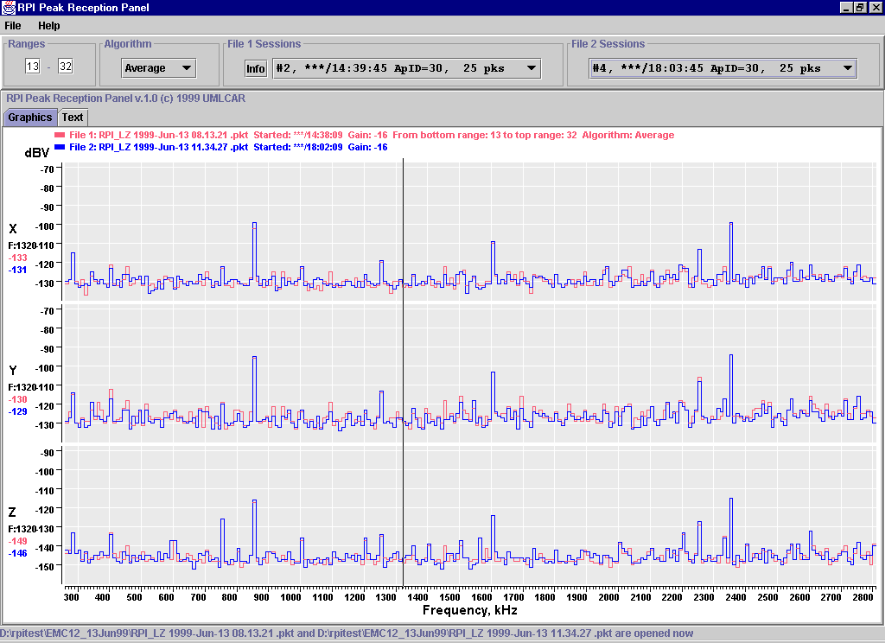

Figure 4.10 - EUV in most active mode

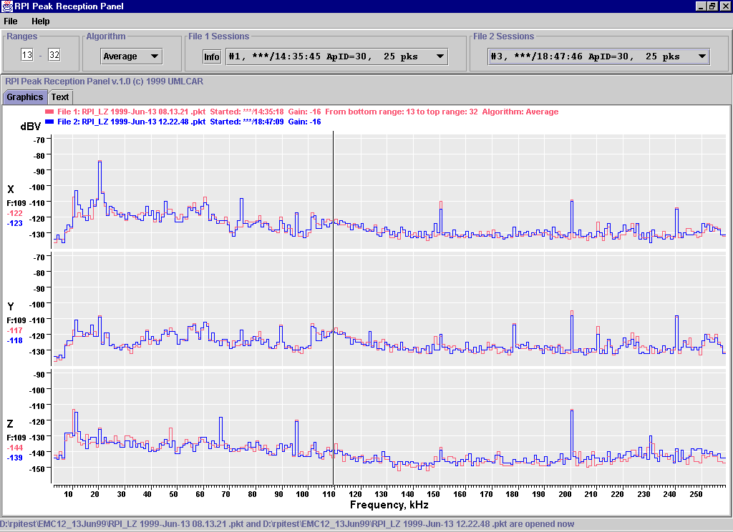
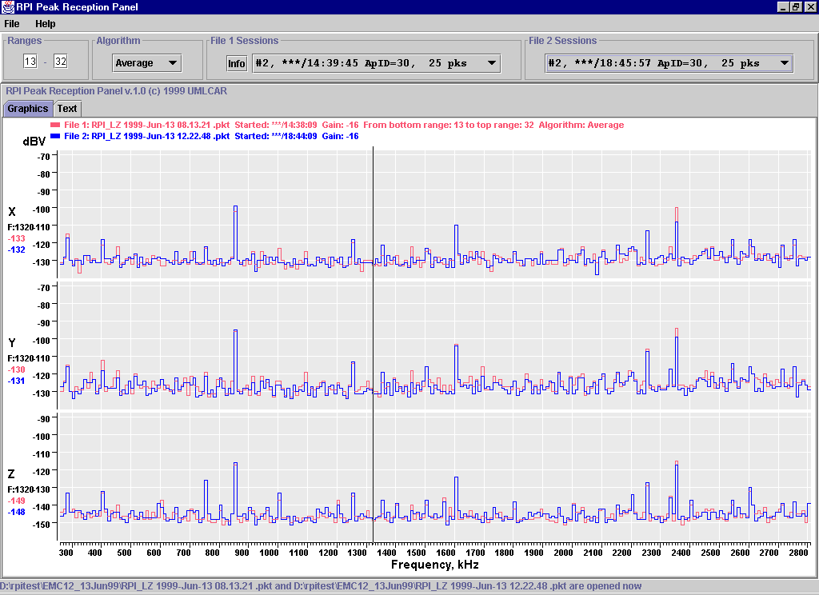
Figure 4.11 - FUV in most active mode
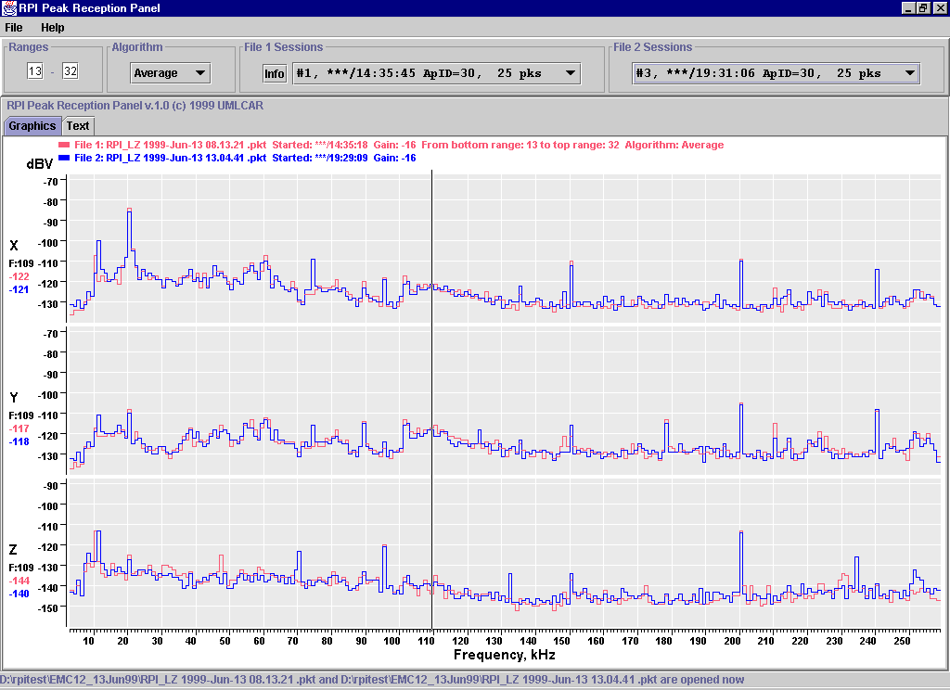

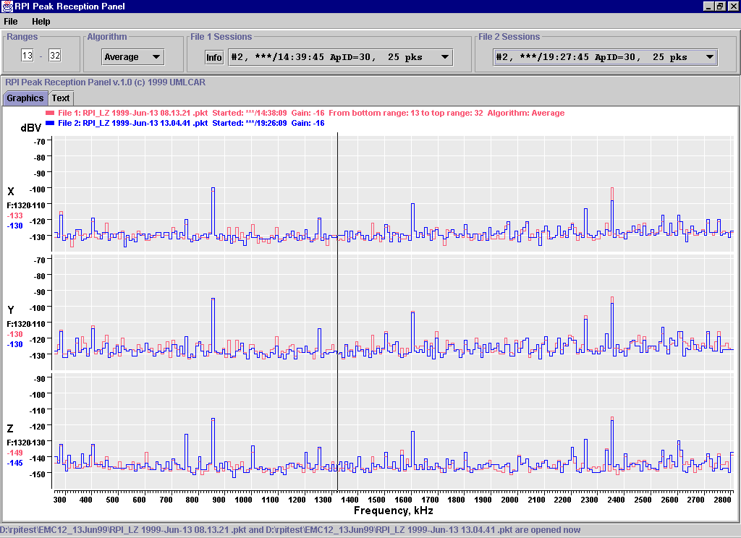
Figure 4.12 - LENA active

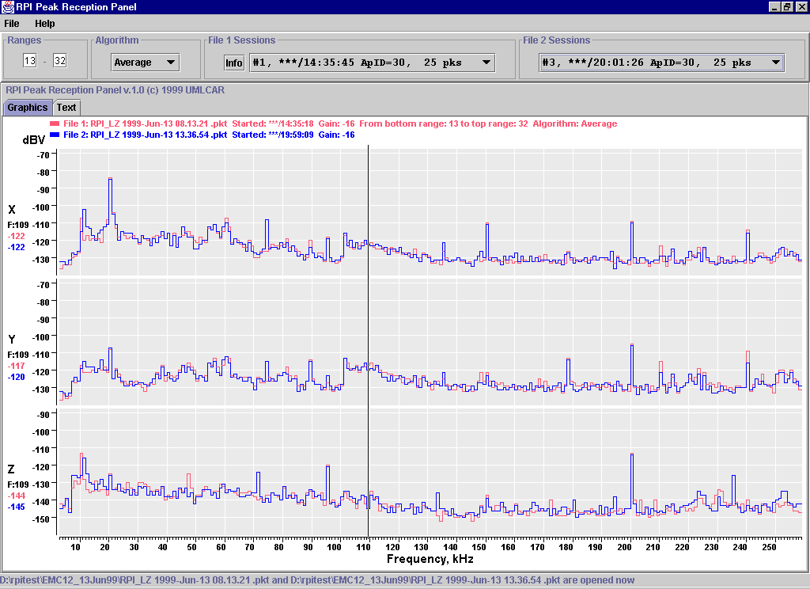
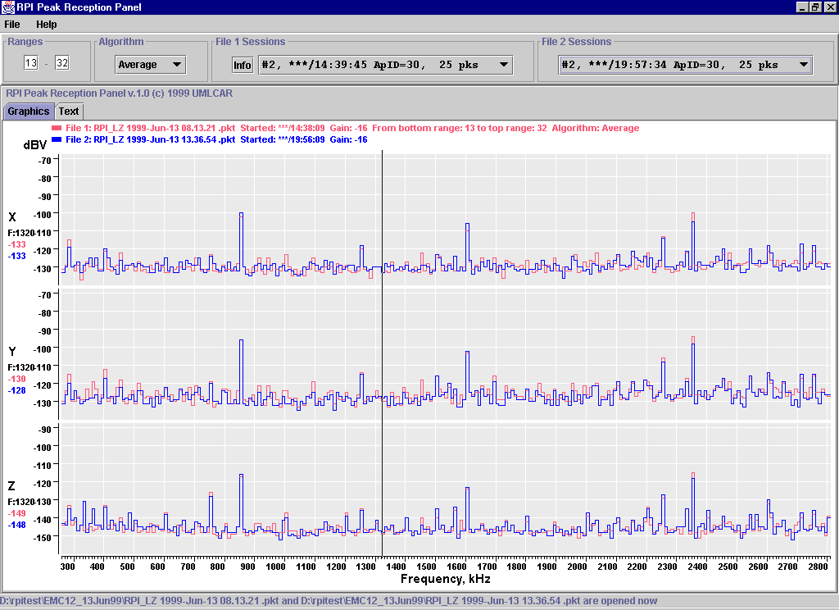
Figure 4.13 - HENA active (Low voltage on HV supplies)

