NOISE MONITORING

MANUAL

For

COMPLIANCE SUITE

DATA ENTRY

Table of Contents

Section Title

- Compliance Suite Set Up and general usage

- Entering Personal Noise Monitoring Data

- Entering Survey Information for Reports

- Entering Area Noise Monitoring Data

Compliance Suite (CS)

- The software needs to be installed on your personal computer. Installation is completed by ITD at the request of the SHSD Database Manager. You will be asked to sign an Official Use Only (OUO) memorandum.

- Each participant will be placed in a user group with specific permissions to individual aspects of the suite’s modules. Information available will be granted based on the needs of the user group (eg. Medical information is confidential and will not be accessible).

- You will be assigned a username (typically your BNL username) and a randomly generated password. The password is created by the SHSD Database Manager.

- After installation, you will have a shortcut to the software and two additional desktop shortcuts. The desktop shortcuts are for filing documents and images, which will be attached to CS samples and surveys.

  - \\bnl-apps\CS-documents
  - \\bnl-apps\CS-images

Select Sample or Survey

Entry Screens

- Open CS software using your username and password (Screen Image 1).

- On the left side of the screen will be a series of icons. Select the CS Logo (beehive) at the top of the series.

- Select the Industrial Hygiene Module (Screen Image 2).

- If you move between modules (eg. Industrial Hygiene to Safety or Audits, etc.), you will see the icons on the left margin change (Screen Image 3). The software automatically changes the available choices as you progress through various screens.

- The two primary icons used for data entry in the Industrial Hygiene module are the Sample and the Survey icons.

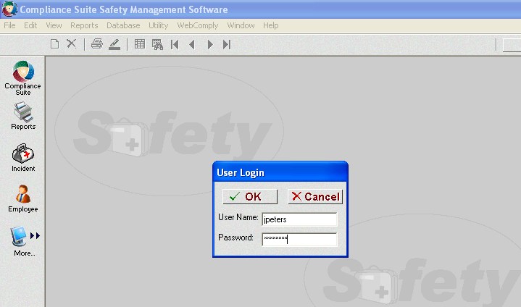
Select Compliance Suite

Screen Image 1

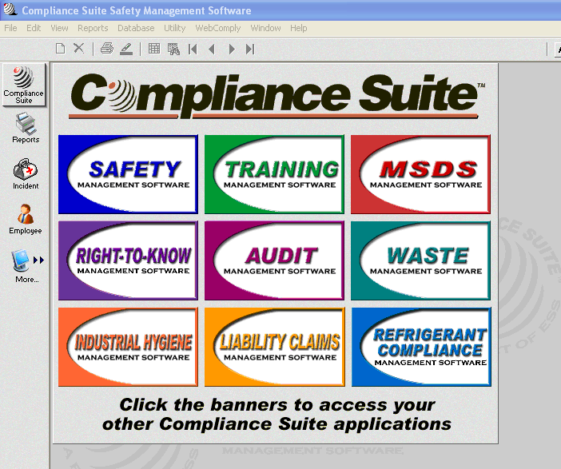
Select IH Module

Screen Image 2

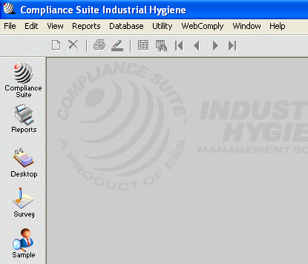
Select Survey Data Entry
Select Sample Data Entry

Screen Image 3

- Use the Sample icon to enter individual sample data (eg. one event of noise dosimetry, a single analytical result for lead exposure, etc.).

For Example:

      - When several samples are collected on the same day for the same project (ie. Five samples for chemical exposure to benzene for lab workers doing a single experiment), each analytical result is entered into the database as a unique sample.

- Use the Survey icon for Reports and to enter information for a project. Multiple sample entries may be selected and added to specific surveys.

For example:

      - The overall project description and recommendations are entered into the survey, sample information attached and an IH report generated for the entire project.

      - Example: When monitoring workers exposure to lead during the demolition of building 206/208, there may be five days of monitoring with four workers monitored each day. All of this data may be attached to a single survey to determine the exposures for this project.

Entering Noise Monitoring

Sample Data

To Compliance Suite

- Using the above steps
    - Open CS
    - Select Industrial Hygiene Module
    - Select Sample icon
    - You will need to have the field data collection sheet and the noise dosimeter printout for each sample to be entered.

- This action will open the sample screen and show the information for the first sample in the database (Screen Image 4).

- To enter a new sample, select the new record icon at the top of the screen (looks like a blank white page).

- A pop up appears and asks for the Facility, Sample # and Sample Date. The down arrows indicate a drop down table of choices.

- There is only one selection for Facility (BNL).

- The sample # is automatically filled in by CS. It adds one to the last sample number. If you are starting a new set of samples you will need to enter a new sample number.

For Example:
    - Personal Noise Samples: Building-Date-PN-#
    - Area Noise Samples: Building-Date-AN-#

- Select the sample date from the drop down calendar. Then click on OK.

New Sample Record

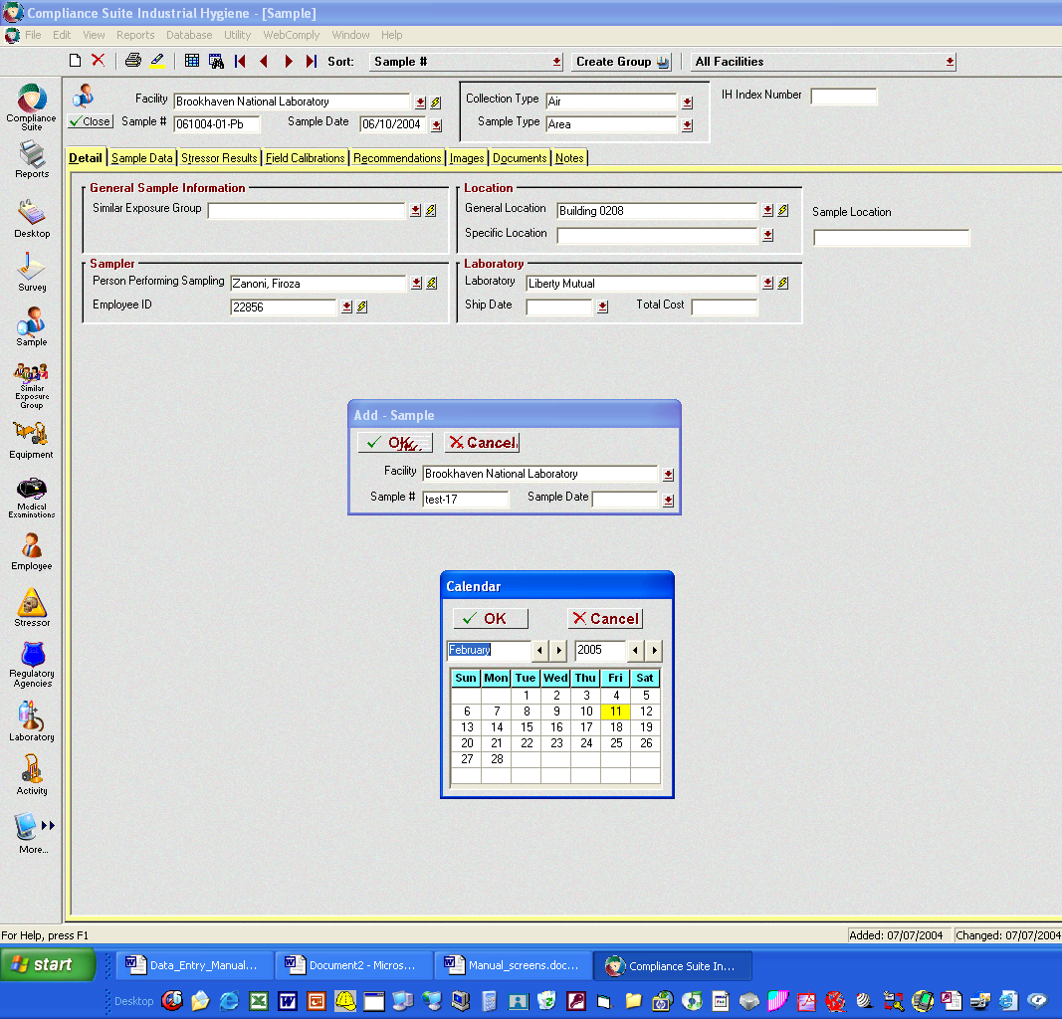

Screen Image 4

- A new sample entry sheet has been created and you may now begin entering the sample information (Screen Image 5).

- Select the Collection type “Noise” and the Sample type “Personal” or “Area”. As you make these selections the screen items will change as CS selects the appropriate fields you need to complete (Screen Image 6).

- The IH Index Number to the right is the survey number that you will assign to these samples. The IH Group has sequential project numbers assigned to all field projects. This is the number we will assign to the survey when we go the Survey entry screen later.

- Observe that there are 8 tabs across the top beginning with the Detail tab. Fill in all information on the Detail tab. Selections should be made from the drop down menus where you see a down arrow. The lightning bolt button allows you to add a record to that drop down box. However, whenever possible select from the existing choices for consistency in recordkeeping.

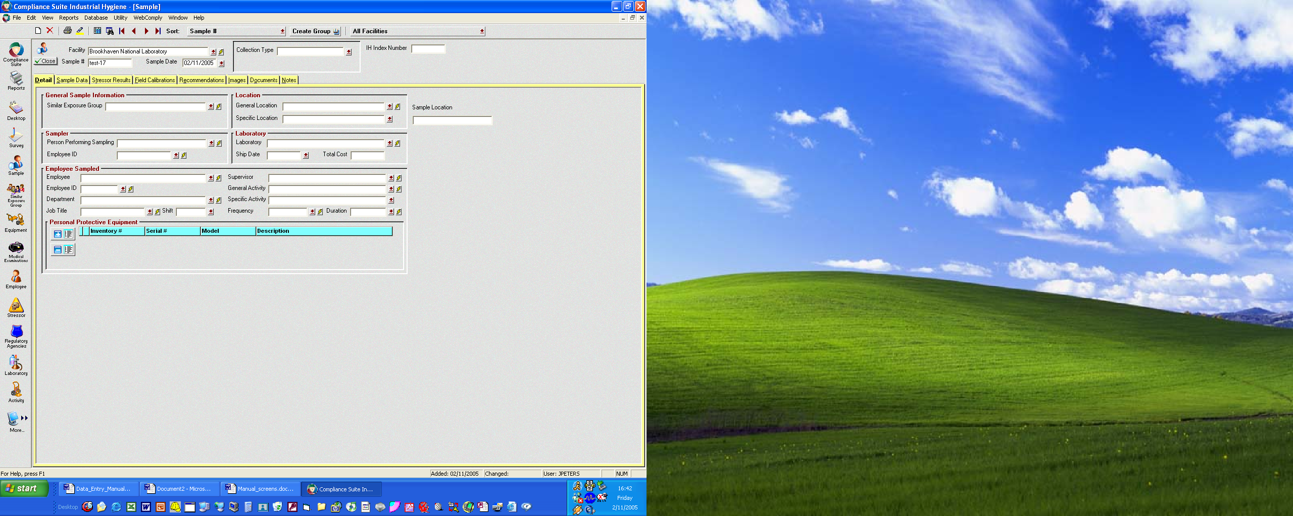
Sample Number

Screen Image 5

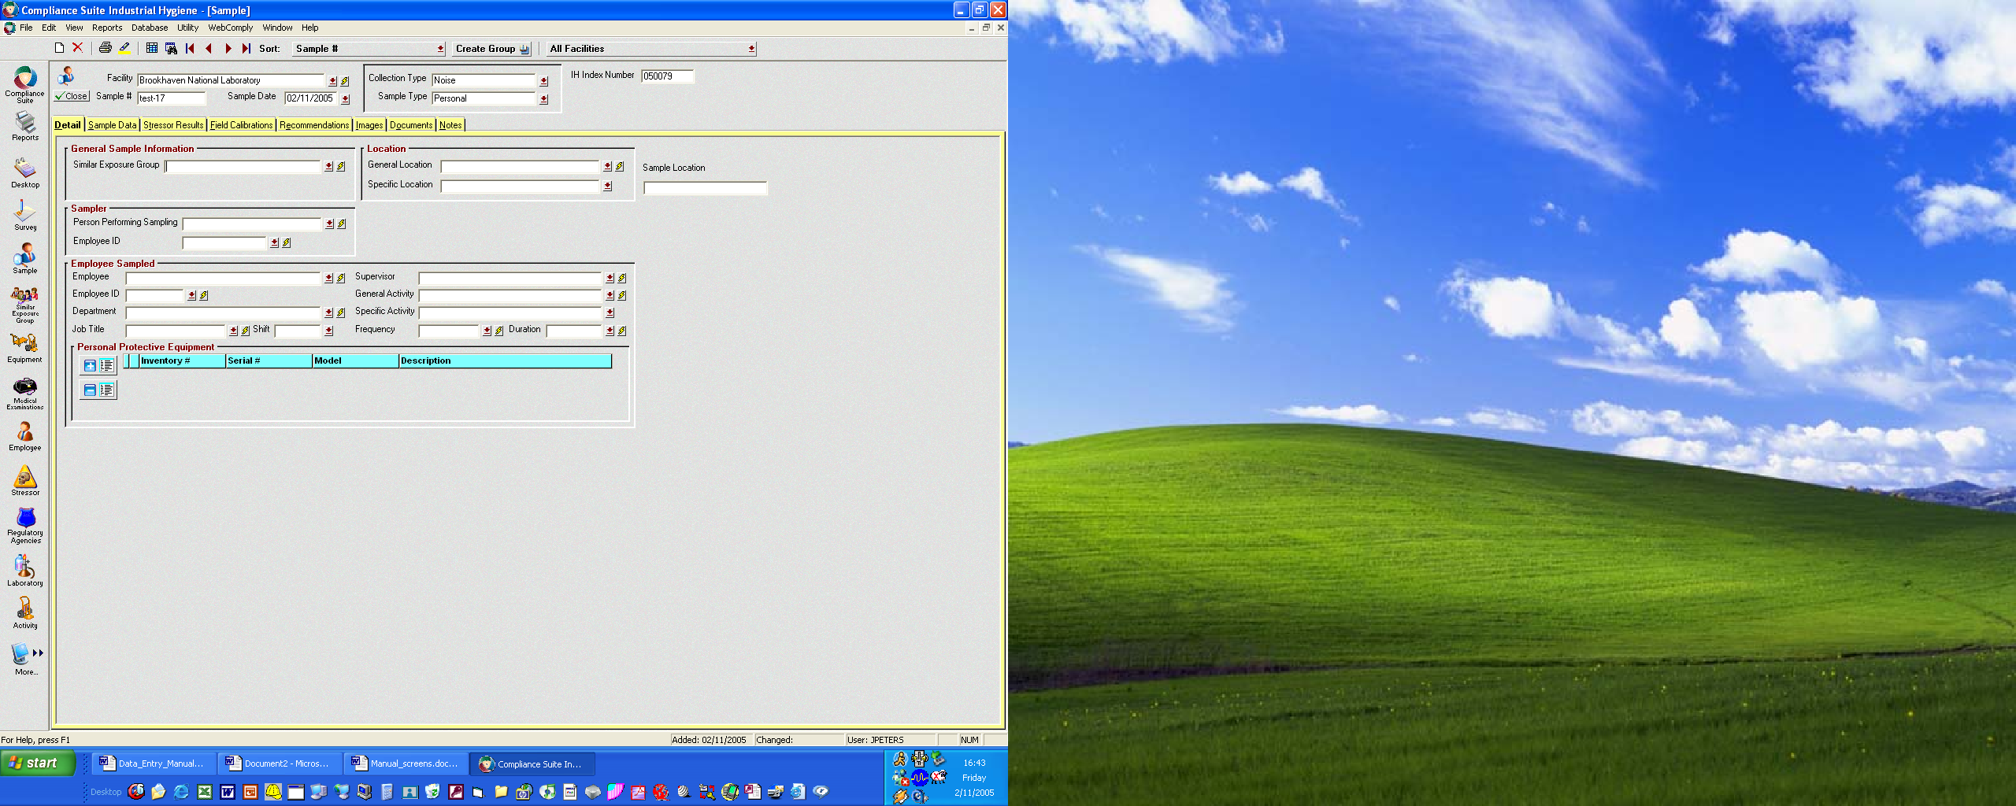
Select Noise & Personal
8 Tabs for Data Entry

Screen Image 6
- A similar exposure group is a general group of workers identified by employment title such as HEMO operators (Screen Image 7). It is anticipated that this group of individuals over the course of a year will have the same types, frequency and level of exposures.

- Select the General Location (Screen Image 8). The table for the next item Specific Locations changes depending on the General Location.

- For General Locations such as a particular building there will not be specific locations. You can use the lightning bolt to enter specific locations or enter a specific location such as a room number in the Sample location field to the right. Using the lightning bolt makes a change to the database and this location becomes available for all users.
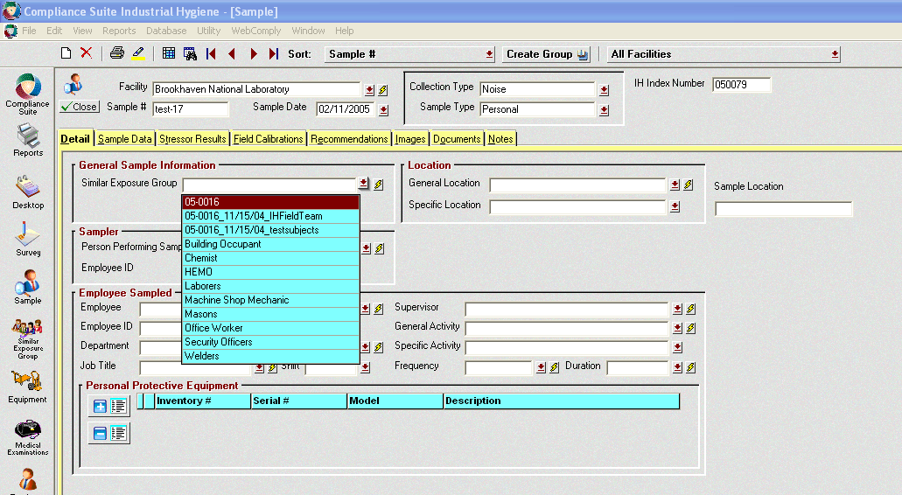

Screen Image 7

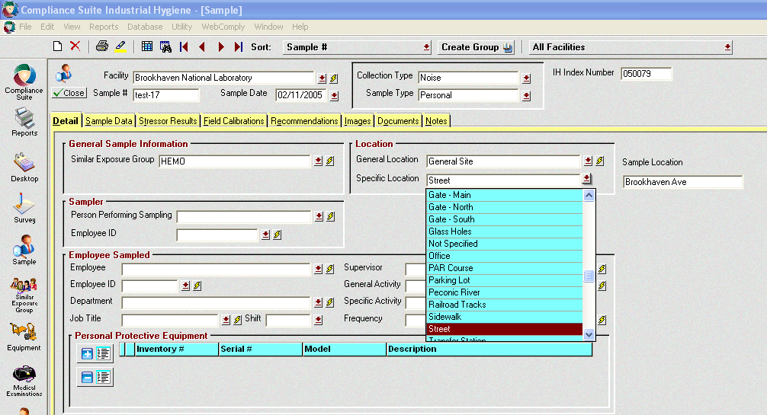

Screen Image 8

- Continue with Sampler and then select Employee Sampled. You will notice that when the employee is selected the ID, department and Job Title are automatically completed (Screen Image 9 & 10).

- The shift is 1 for days, 2 for evening and 3 for night shift.

- The supervisor needs to be selected.

- The general activity and specific activity are established to coincide with safety reporting schemes. For a HEMO operator select Construction for General Activity and then Heavy Equipment Operation for Specific activity (Screen Image 11).

- Frequency is how often this activity is completed by the employee. A HEMO operator would be expected to operate equipment daily (every shift) and for a full shift: Duration = 6-8 hours. Later you will enter the exact time of the sampling period.

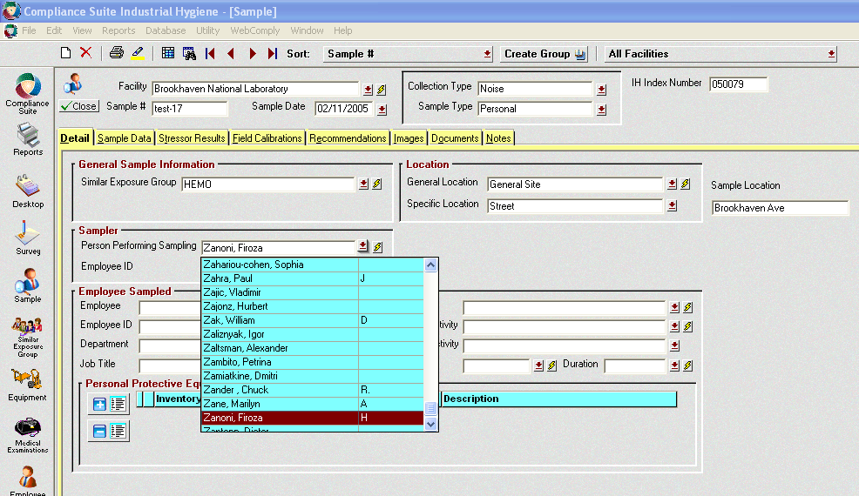

Screen Image 9

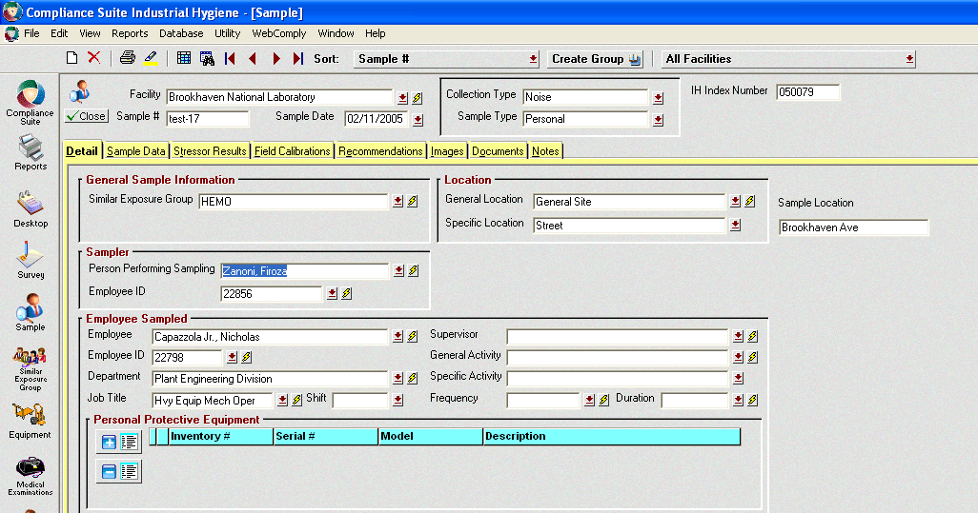

Screen Image 10

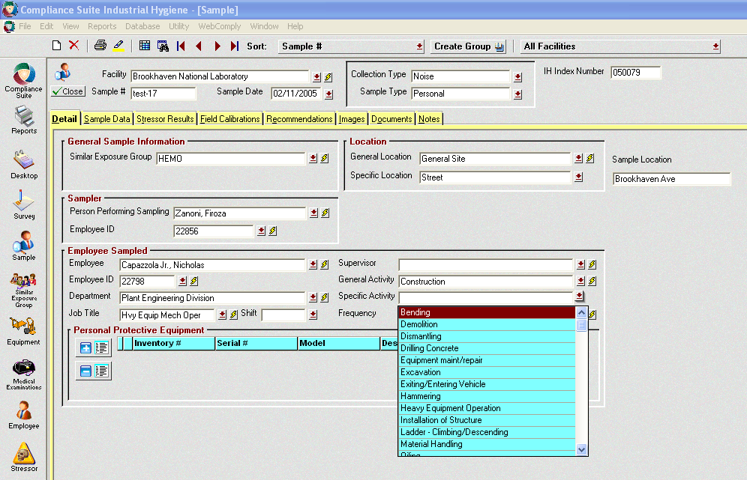

Screen Image 11
- Use the + sign under PPE to bring up the pop up of PPE (Screen Images 12 & 13). Use the drop down from description to select the PPE used. Use the + sign as many times as necessary to select all of the appropriate PPE worn. Don’t use the Serial number or inventory selection menus since these are not populated.

- You have completed the Detail tab for the sample and
may now continue to the Sample Data Tab. Click on the Sample Data Tab and the next screen shows time on/off (Screen Image 14).

- Enter the time using four characters: 12:00 or 01:00. You must also enter an A or P for am/pm. If you choose to enter military time that is acceptable but you still must enter the A or P. Click on the calculator icon and CS calculates the number of minutes sampled.
- For events where periods such as lunch are not monitored, you can use separate rows for each monitoring period.
Eg. 09:00A-12:00P
13:00P-17:00P
The calculator symbol will calculate the minutes for each period. However, it will not calculate the total sample time.

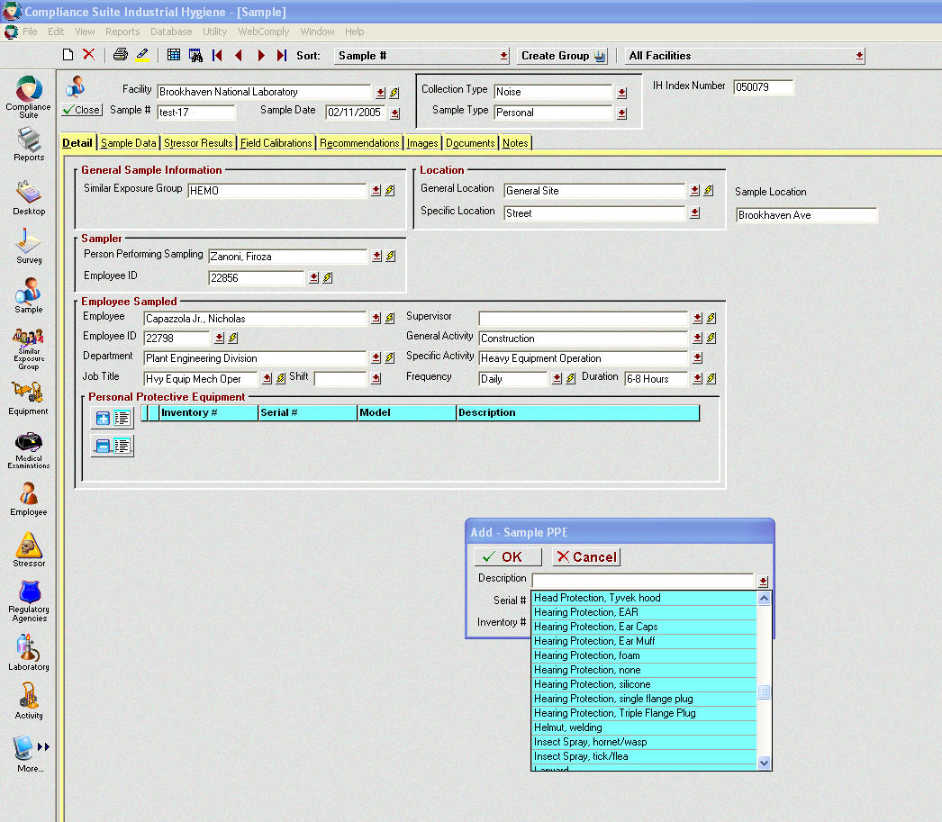
To Select PPE Use (+)
Screen Image 12

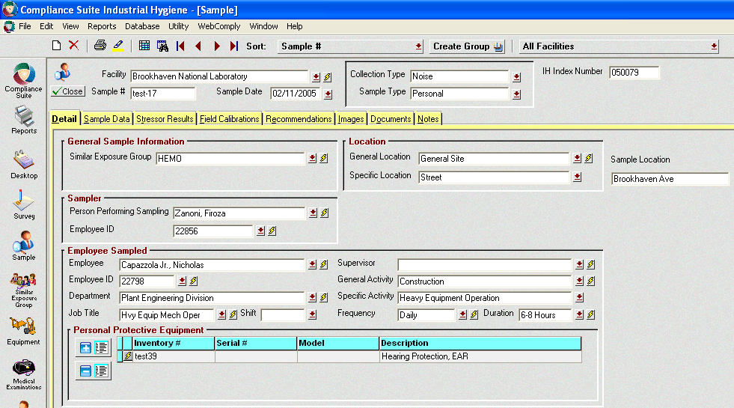

Screen Image 13
Enter Start and Stop Times
(AM/PM)
Use Calculator Button to Determine Number of Minutes Sampled
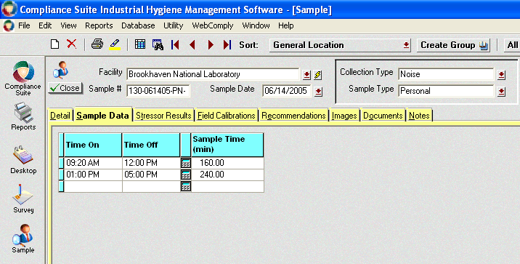

Screen Image 14
- You have completed the Sample Data tab and may now continue to the Stressor Tab. Click on the Stressor Tab and the next screen shows the entries for the exposure data (Screen Image 15). This information is found directly on the print out from the dosimeter.

- You need to enter two lines of data. First enter the ACGIH dosimeter results and select ACGIH in the Limit Source field. Note that there is no down arrow for a drop down. By clicking on this empty field the arrow appears.

- In the next row enter the OSHA compliance exposure data and select OSHA from the drop down table in the Limit Source field.

- The Field Calibration tab is not to be completed at this time. The IH Group files the field data collection form with the calibration information as the original record of calibration.

- The Recommendation Tab may be used if desired but is not mandatory. This is a text field which allows for general recommendations to be entered based on the exposure data. Entering recommendations here allows you to review them when preparing the survey report.

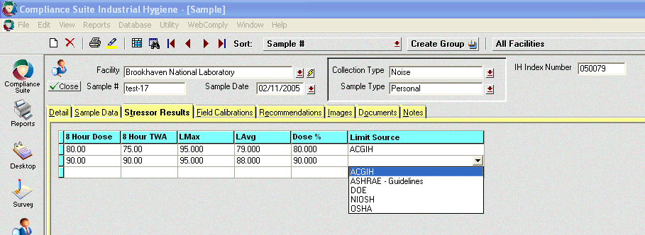

Screen Image 15
Enter Data from Dosimeter Printout
Select Appropriate Agency to Match Data
- The Images and Documents Tabs are for attaching photos and files respectively. You may attach any electronic photo file or document file (Screen Images 16, 17 & 18). It is recommended that the survey form be scanned and added as an attachment. This would be especially important for an area survey which may have been conducted during the personal monitoring. Click on the Disk icon (import image), select the file and then open. For documents, click on the paperclip and select the file to attach.

- The final Notes Tab is for any notes the sampler wishes to add to the file. These may be informational to assist creating the survey report recommendations. For example:

    - If the job is typically done all day but was only monitored for two hours; the equipment malfunctioned; SLM readings were also collected and you would like to document here; etc.

- You have completed the Sample data entry for this sample and may close this sample screen (see Close at the top of the form). If you have further samples to enter, you may select New Record on the top tool bar. Select yes to save the previous sample record and begin the next.

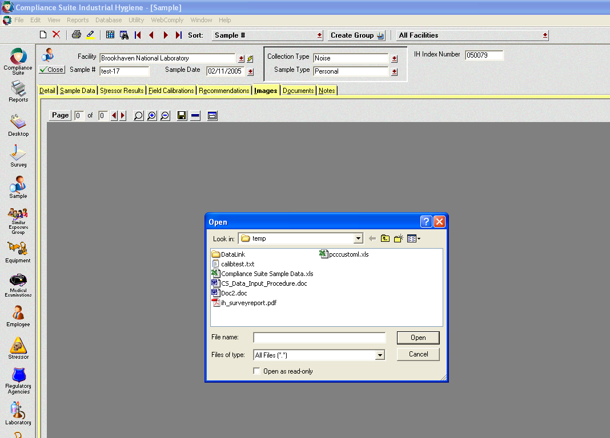
Use Disk Symbol to Browse for an Image File

Screen Image 16

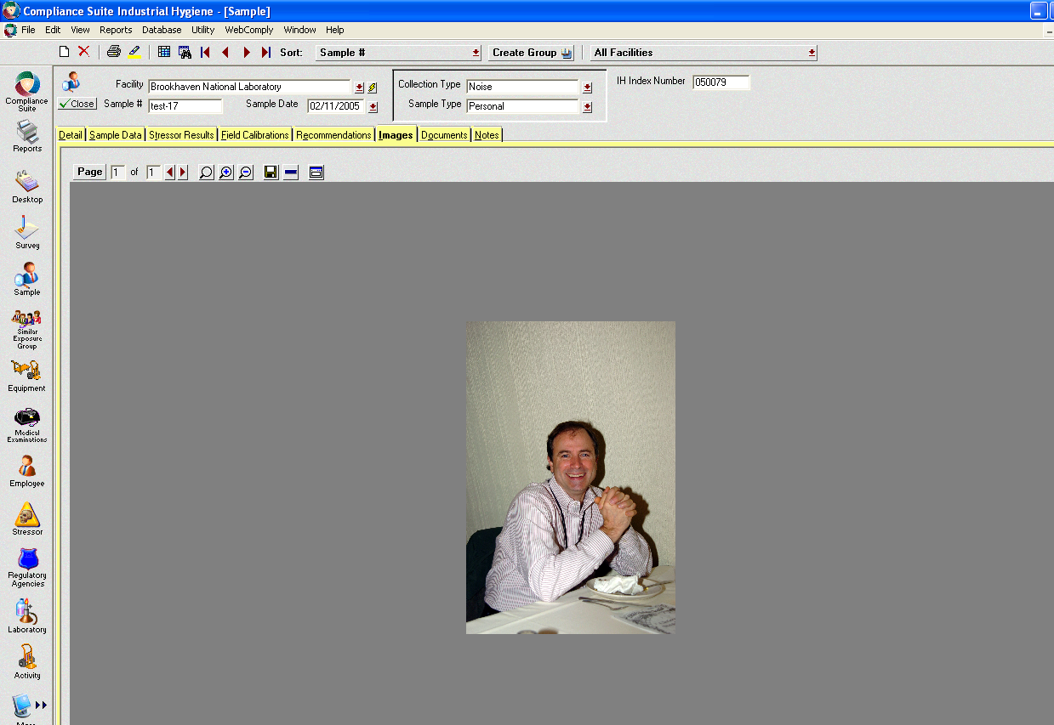
Images Show Here
Documents Are Listed Here

Screen Image 17

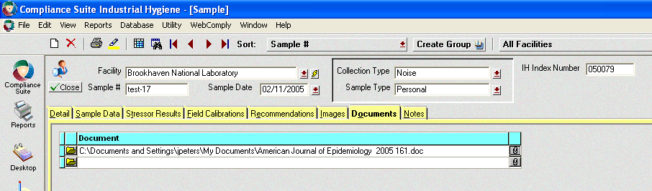

Screen Image 18

[PAGE LEFT INTENTIONALLY BLANK]

Entering Noise

Survey Information

To Compliance Suite

- If CS is not open: (see Sample entry section)
Open CS; Select IH Module; Select Survey icon

- The Survey may be started any time. It may also be used to document a visual survey with no sample data.

- To create the Survey report click on the Survey icon on the left toolbar (Screen Image 19).

- This action will open the survey screen and show the information for the first survey in the database.

- Select the new record icon at the top toolbar of the screen (looks like a blank white page).

- A pop up appears and asks for the Facility, Survey # and Survey Title (Screen Image 20). The down arrows indicate a drop down table of choices. There is only one selection for Facility (BNL).

- The survey # is automatically entered (Screen Image 21) and is not editable by the user. Enter the IH Index Number from the samples.

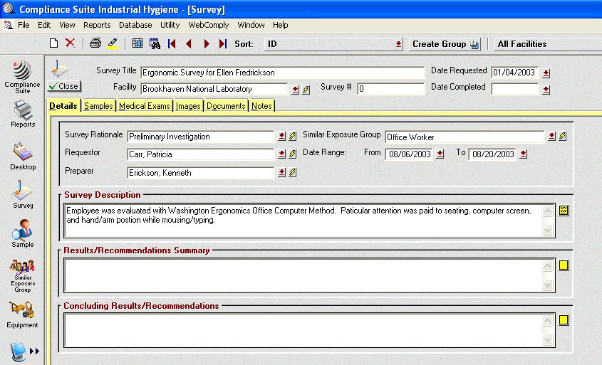
Survey Icon

Screen Image 19

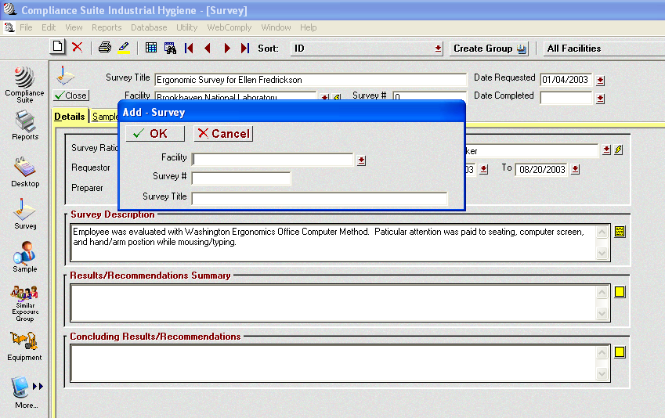
Survey Number

Screen Image 20

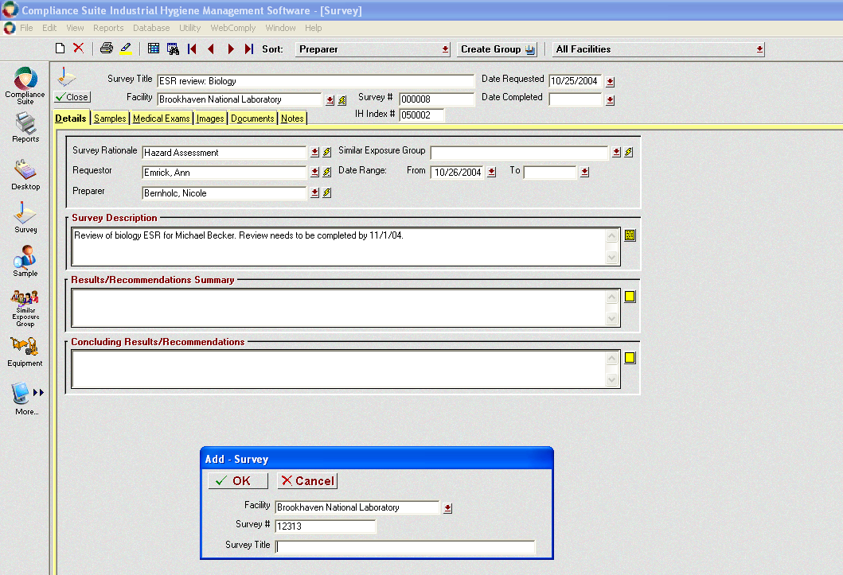
IH Index Number

Screen Image 21
- A new survey entry sheet has been created and you may now begin entering the survey information.

- You should complete all fields. When a report is generated any field not entered will be printed as blank.

- For Survey rationale you can select Compliance Assessment or Routine Monitoring depending on the intent of the survey (Screen Image 22).

- The Requester is the person who requested the survey be conducted (Screen Image 23).

- The Preparer is the person preparing the survey report. If data is entered by administrative personnel, they should enter the name of the person who is responsible for the report.

- Select the Similar Exposure Group. This should match the SEG selected for the Sample data.

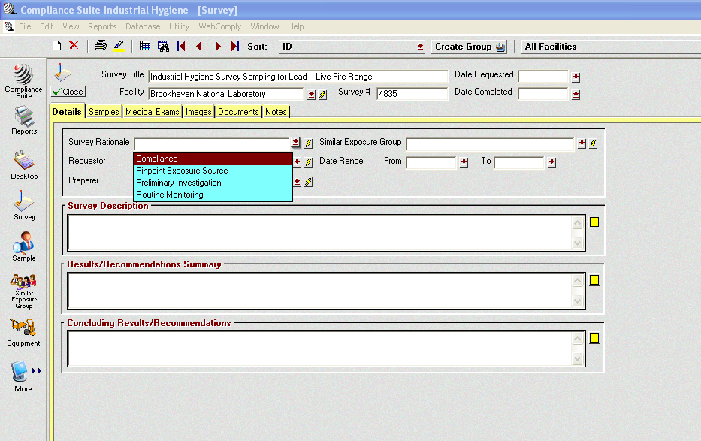
Survey Rationale - Compliance

Screen Image 22

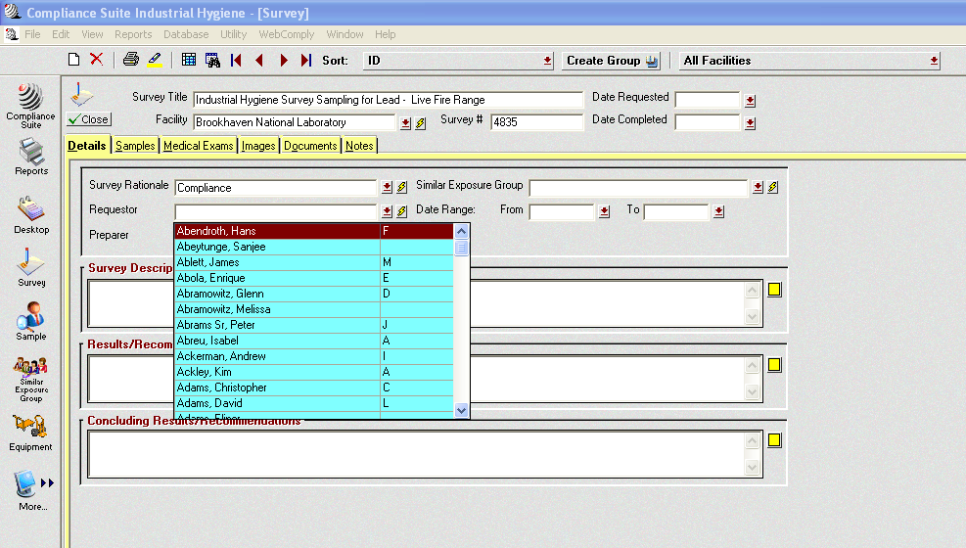
Type Name and Select From Drop Down List
Note: To Edit a Mis-typed Name - Select the Entire Name and Delete Then Retype

Screen Image 23
- When multiple Similar Exposure Groups are monitored for a particular project you should create separate surveys for each SEG.

- The date range is the range of dates the assessment covers. For example:
  - A project may be monitored for several weeks. During that period 5 events may have occurred. The date range would be from the first event to the last (eg. 1/1/05 – 2/15/05).

- There are three blank sections remaining on this page (Screen Image 24). Each section needs to be completed with sufficient information to cover the required topics in the SOP IH60500

Reporting Personnel Exposure Monitoring Results

- Observe on the right side of each blank section is a yellow box. Clinking on this box brings up a window that may be enlarged. Whatever is typed into this box will be placed in the blank section. This allows you to see more text than the blank section can show at one time.

The Print Button will prepare a short report (see next page).

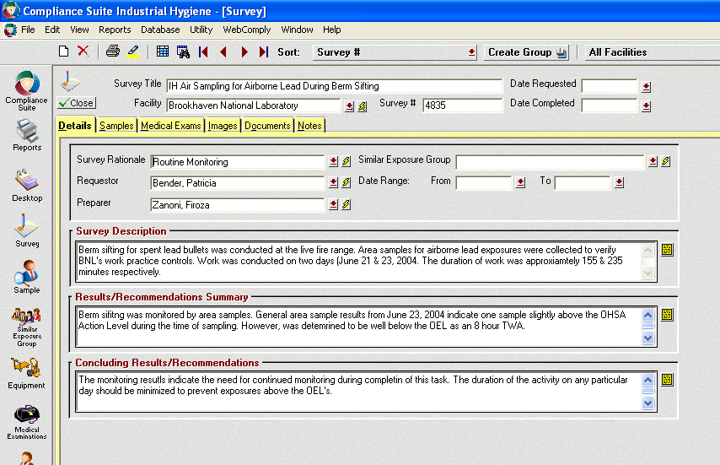

Screen Image 24
Use these text boxes to enter survey Description; Results Summary; and Recommendations. This will be the body of the report.

- If you have a word document that you use as a template you may cut and paste from that document into these windows.

- This page represents the body of the IH report. You can select a Quick Print Report (Printer icon in the top toolbar) (Screen Image 25). This will create a one page report of this window, which you can print. You can also export the Quick Print Report to Word or Excell.

- To attach sample data select the Samples tab (not the Icon on the left toolbar). Click on the (+), select sample and OK (Screen Image 26). You can not select more than one at a time so you need to do this for each sample you want added to the survey.

- You can also attach photos and documents to the Images and Documents Tabs as you did for the Sample data entry screen.

- The Medical Exams screen is not currently used.

- You may add any notes in the Notes Tab.

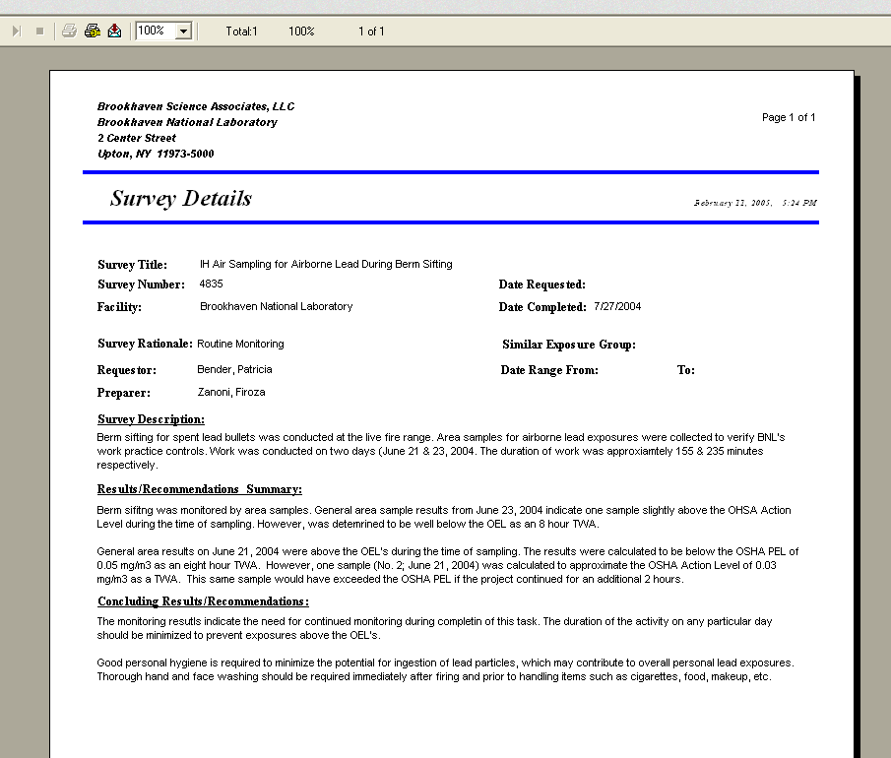

Any Fields, which are not filled will show as empty on the report.
Use the export Icon to export report to Word or Excell
Screen Image 25

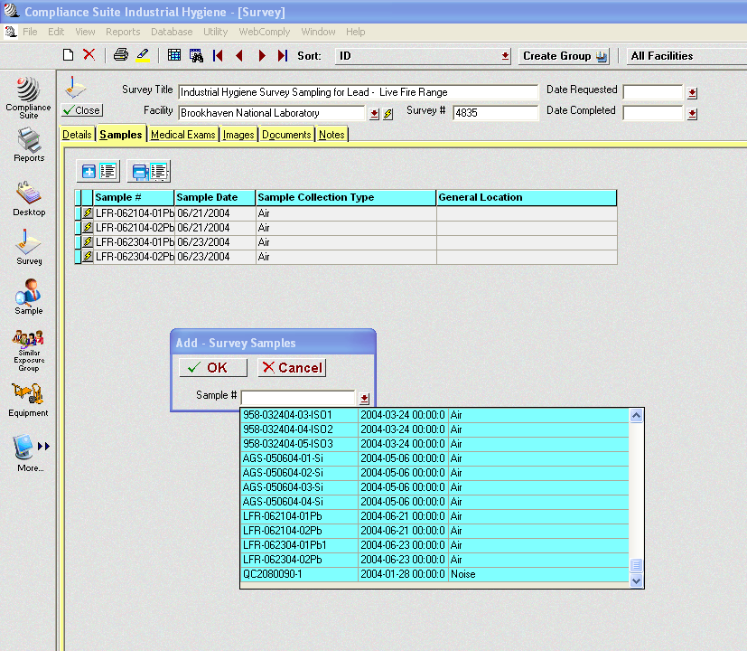
Add Samples to this survey using the (+)

Screen Image 26

AREA NOISE MONITORING

MANUAL

For

COMPLIANCE SUITE

DATA ENTRY

[PAGE LEFT INTENTIONALLY BLANK]

Entering Area

Noise Monitoring

Sample Data

To Compliance Suite

- Follow the steps in the Personal Noise Monitoring Data Entry Section to open CS; enter the IH module; and start a new sample.

- Start a new sample. The sample number should be distinctive for each area.

  - Building-Date-AN-Sequential#

    - 120-020206-AN-01

Note: a survey of a pump room is one sample. You will be entering multiple SLM readings from your diagram as one sample.

- Samples can be searched later by building, date, etc.

- Select the Collection type “Noise” and the Sample type “Area”. As you make these selections the screen items will change as CS selects the appropriate fields you need to complete.

- Enter the IH Index Number to the right. This is the survey number that you will assign to these samples. The IH Group has sequential project numbers assigned to all field projects. This is the number we will assign to the survey when we go the Survey entry screen later.

- Observe that there are 8 tabs across the top beginning with the Detail tab. Fill in all information on the Detail tab. In similar manner to Personal Samples.

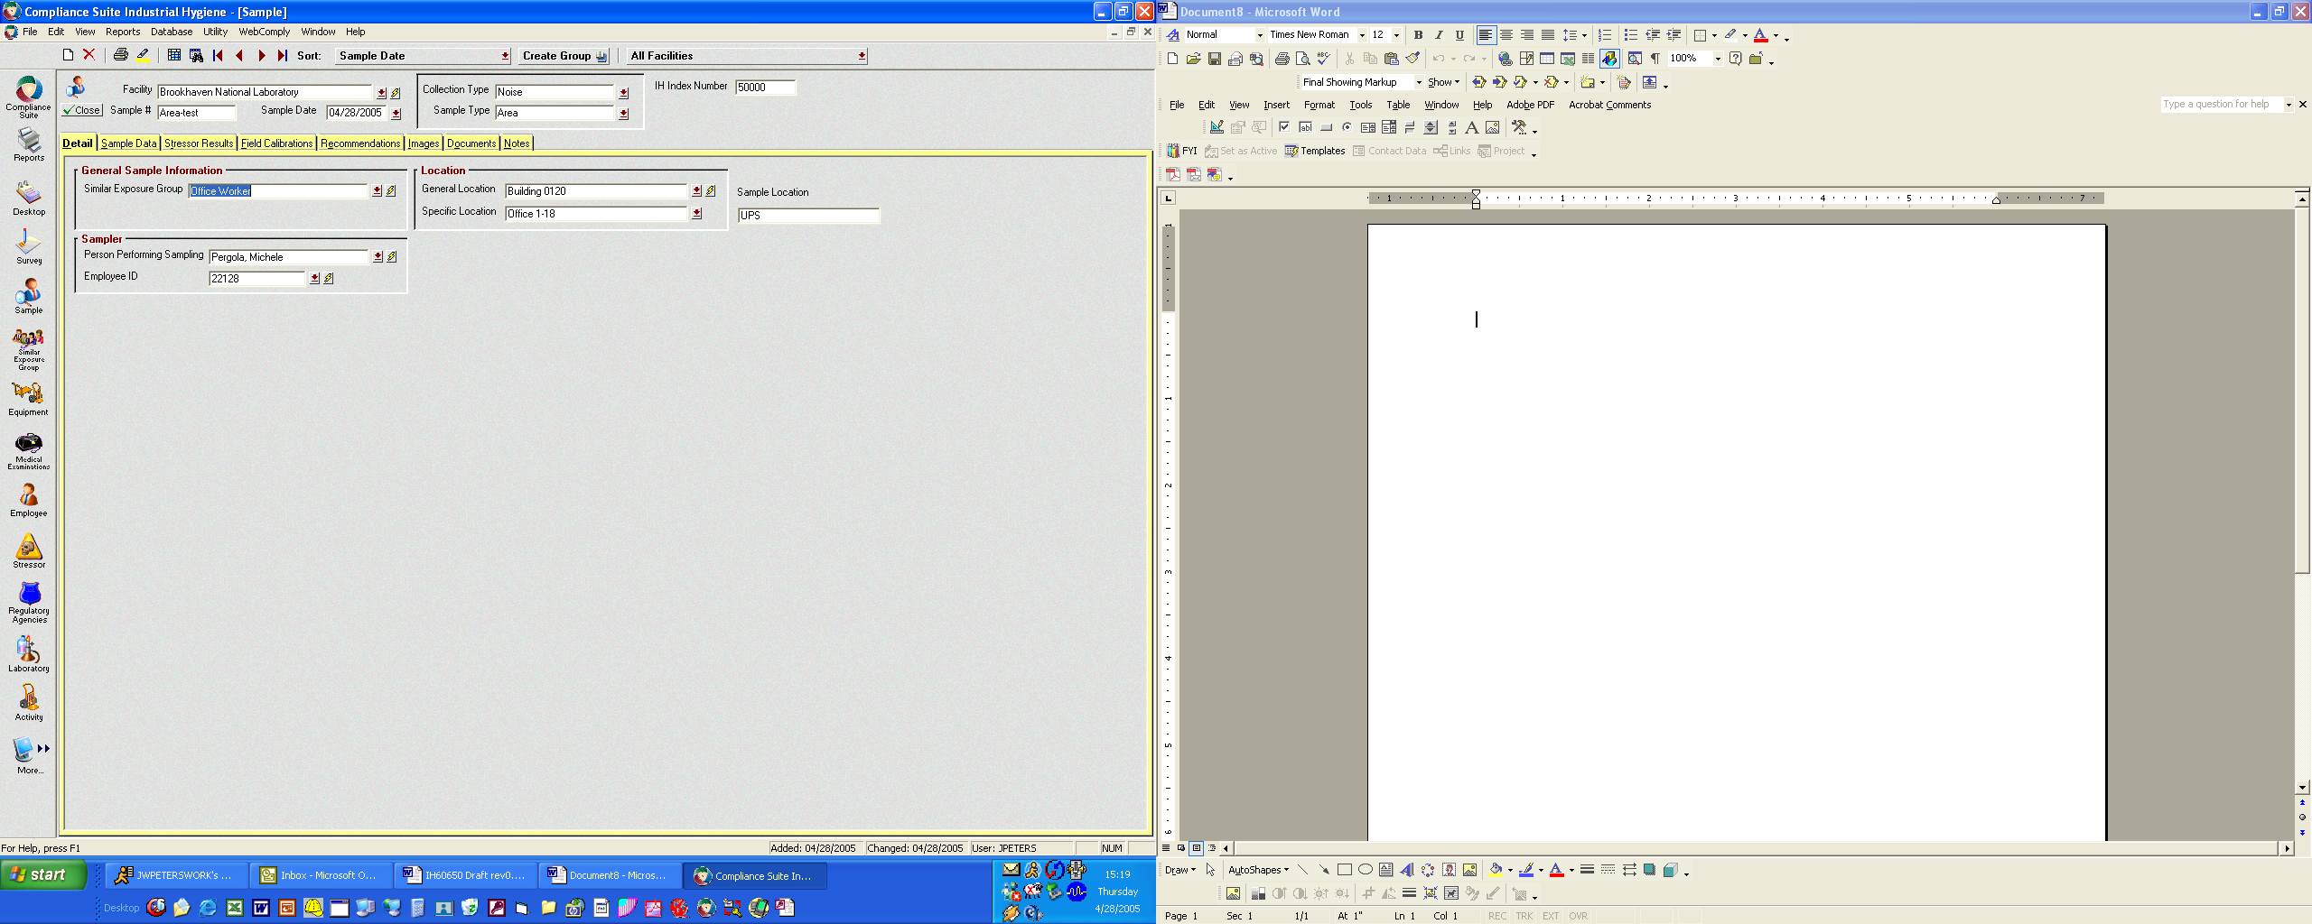

Select Noise & Area

8 Tabs for Data Entry

Screen Image 4

- Enter the Noise Source Data in the Sample Data Tab. When entering the Noise Source data, use the number of the sample location and enter the data in numerical order.

- There is a glitch in the data viewing section of Compliance Suite. Therefore, you must use a two digit number (eg. place a zero in front of single digits: 01, 02, 03, etc up to 09). The numbers should match the sample locations on the field mapping.

- After saving the data entered into the source fields, CS will alphabetize the table view. It, however, does not make the corresponding change in the results table. Thus, the data appears to be mismatched when viewed on the computer screen. It will print in the correct order but the computer view is skewed.

- Not using the leading zero for single digits will put sample number 11 immediately after sample number 1. By numbering the sample locations correctly, the tables of source data and results will match visually.

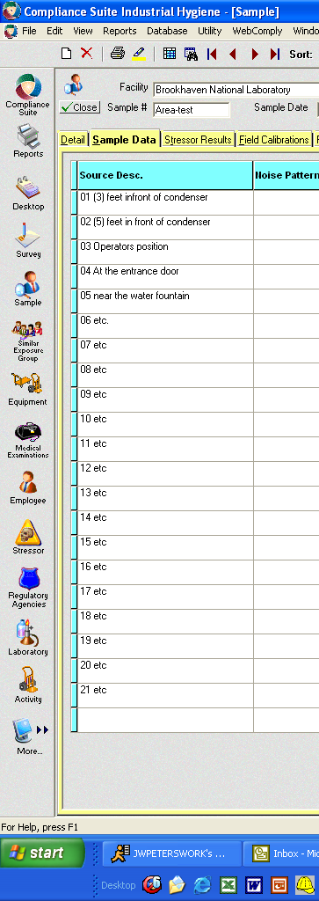
View shows correct numbering system.

Source location descriptions may be any mix of text and numbers.

Locations must match field mapping.

Screen Image 7

- Presently, Compliance Suite does not allow viewing the source location (sample number) and the results on the same screen (see screen image no. 8).

- Enter results data directly into the fields (no drop down menus) in the order corresponding to the source location table previously entered.

- Octave Band Analysis data is entered across the appropriate row with the center frequency shown at the top of the data table.

- Enter the single point data such as dBA and dBC in the correct field under that column name.

- When multiple data is collected for the same location (eg. See screen image no 8: Sample number 12 has OBA and dBA data results) these must be entered on the same row to maintain the data integrity.

- After completion of the data entry, use the quick print for both the source location and results screens. Compare the rows to ensure data has been entered correctly. To date, a report has not been configured, which would combine the source and results data into one table.

- Attach scanned copies of field sheets (see documentation under Personal Results Entry)

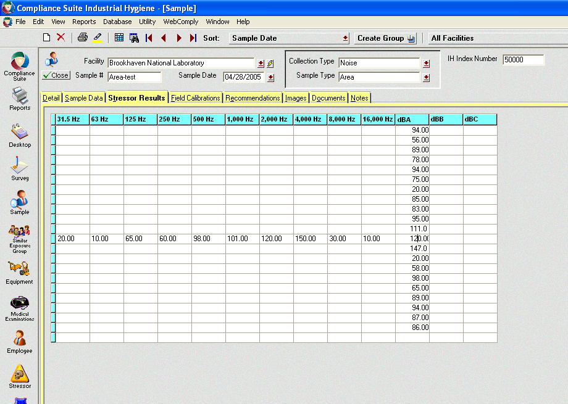

Screen Image 8
Unfortunately CS presently does not allow viewing the sample location and result on the same screen.

In this example, only one Octave Band Analysis sample was collected on sample number 12.

Data is entered directly into the fields (no drop down menus).

The data for each octave is entered as shown. You can enter all data (octave bands, dBA, dBB & dBC) for any sample in one row.

