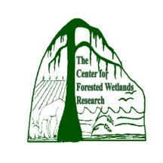

A Collaborative Study on Forest Water Management
A Drained Pine Plantation, North Carolina
Francis-Marion
National Forest
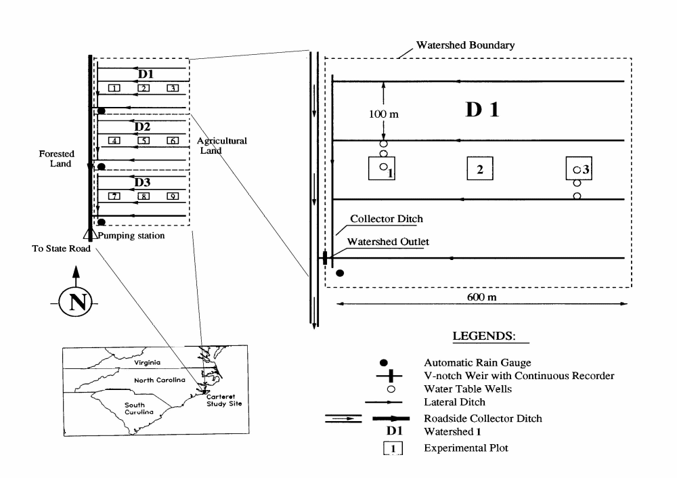

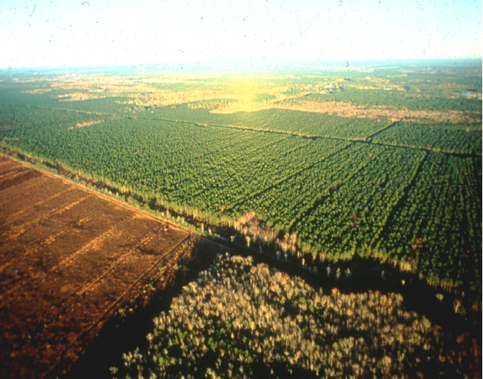
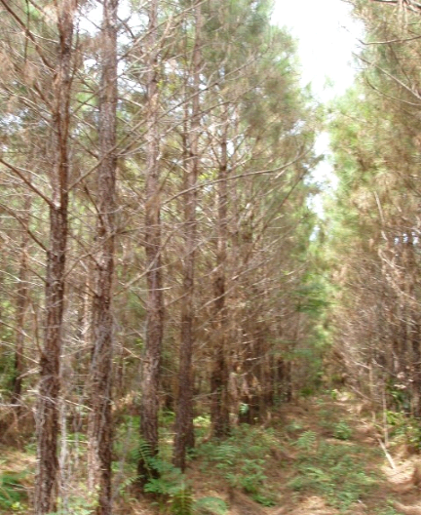

Location map and layout of three experimental watersheds at Carteret County, NC. The collaborative study with North Carolina State University has been maintained by the support from National Council of Industries for Air & Stream Improvement, Inc. and Weyerhaeuser Company.

Watershed Characteristics
- Established in 1987 within Weyerhaeuser Company’s Managed Pine Forest, NC
- A paired watershed approach on flat, poorly drained soils of lower Atlantic coastal plain
- D1: 24.7 ha, Control; D2: 23.6 ha – Treatment, D3: 26.7 ha – Treatment
- Drainage outlet to Neuse River estuary about 3 km downstream
- Surface elevations about 3 m a.m.s.l.
- Soils: Deloss fine sandy loams with about 3.2m meters depth to an argillic horizon.
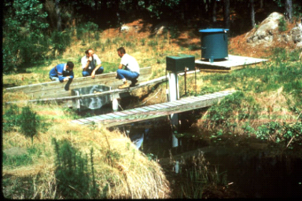
- Vegetation: Loblolly pine on drained lands
- Mean annual rainfall: 1340 mm; Mean annual temperature: 19ºC

Watershed Monitoring (Since 1988 till date)
- Automatic Rain gauges (Texas Electronic)
- Complete weather parameters (since 1988) (CR-10X)
- Automatic flow gauging stations at the outlets of D1, D2 and D3 (INFINITY)
- Water quality sampling stations at the outlets of D1, D2 and D3 (ISCO 4210)
- Automatic shallow ground water table recorders on D1, D2 and D3 ( Two per watershed)
- Manual PVC deep water table wells (For Transect water levels – midpoint to ditch)
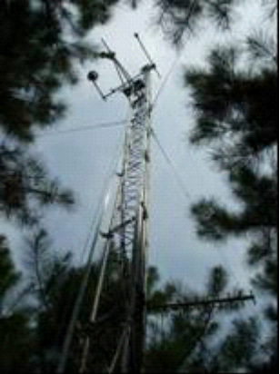
- LAI measurement (LI-COR 2000)
- Soil moisture measurements (TDR)
- Tree height, dbh and basal areas
- Throughfall and Interception (Discontinued)
Previous Studies
- Hydrology, water and nutrient balance
- Effects of controlled drainage on storm events and water quality
- Effects of an orifice-weir on hydrology and water quality
- Forest hydrologic models (DRAINLOB) and their applications
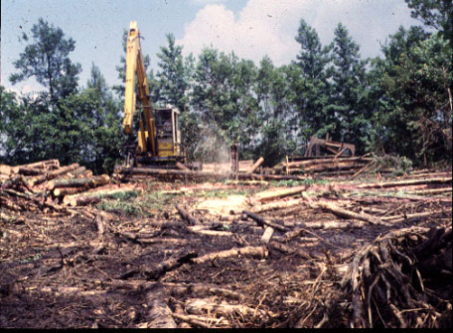
Ongoing Studies

- Effects of harvesting and regeneration
- Long-term hydrology, water quality and productivity
- Effects of Thinning
- Fertilization Effects on Water Quality

Watershed related WEB sites
http://www.bae.ncsu.edu/soil_water/watmngmnt/carteret/ (For general information)

Field monitoring is maintained by Weyerhaeuser Company in New Bern, NC and the studies are led by Biological & Agricultural Engineering Department, North Carolina State University and US Forest Service, Center for Forested Wetlands Research (SRS-4103), 2730 Savannah Highway, Charleston, SC 29. For further information about the study sites contact:
Dr. Wayne Skaggs, WNR and Distinguished University Professor, 919-515-6739; skaggs@eos.ncsu.edu
Dr. Devendra M Amatya, Research Hydrologist, Tel: 843-769-8012; damatya@fs.fed.us

