

Engaging Youth in the Peace Process
October 2007 – Nepali youth were both perpetrators and victims during the eleven-year armed insurgency, and during the April 2006 Uprising that sparked the peace process and the restoration of democracy. The youth have been marginalized from the current political discourse. Yet, youth still expect the opportunity to participate significantly in the processes launched by the signing of the Comprehensive Peace Agreement (CPA) on November 21, 2006, including the upcoming Constituent Assembly.
With USAID/OTI support, the Association of Youth Organizations Nepal (AYON) launched a campaign on March 28, 2007 to positively engage youth in the peace process in 25 Nepali districts. This grant trained 126 youth on peace building in five-day workshops, including 46 females and members from marginalized groups. The trained youth then organized 25 district-level “Youth Peace Dialogues” in their respective districts with the participation of 1,355 people, 508 of whom were female. The dialogues were attended by representatives from the government, political parties, civil society, and youth organizations. As part of the grant also, through discussions among the program’s participants, 157 murals were painted in public places and 3,000 posters were disseminated emphasizing the role of youth in the peace process. After the activities, AYON submitted a memorandum and a draft action plan on engaging youth in the peace process to the Ministry of Education and Sports and to other national and district-level stakeholders.
This activity has succeeded in creating a wide network of youth organizations who continue to work in close cooperation with each other. Tangible accomplishments to date made by involved youth include the resumption of District Development Committee (DDC) office operations in Dhanusha District which had halted due to disagreements between government staff and constituents, and the presentation of recommendations for budget allocation to the DDC in Nuwakot District. AYON remains active after the completion of the activity.

 | USAID/NEPAL
  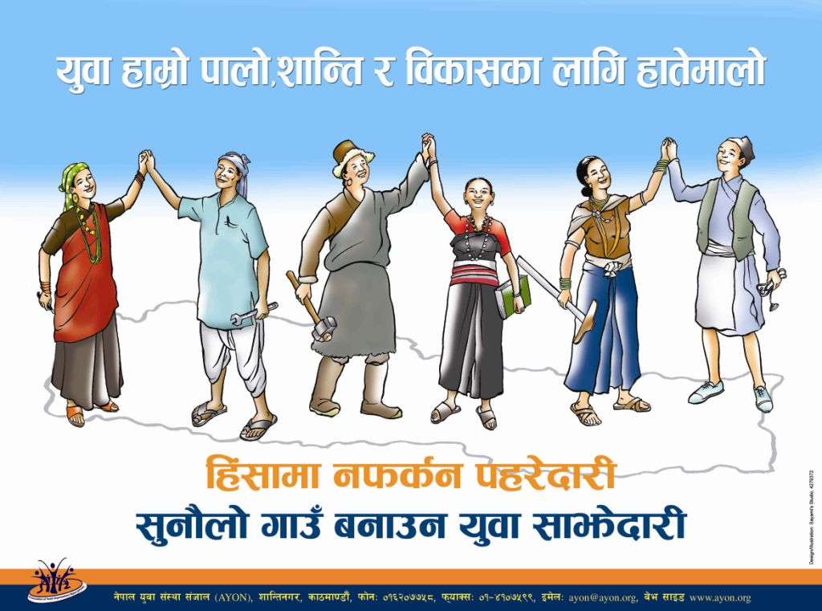
  A peace poster: Youth’s vigilance against returning to violence
  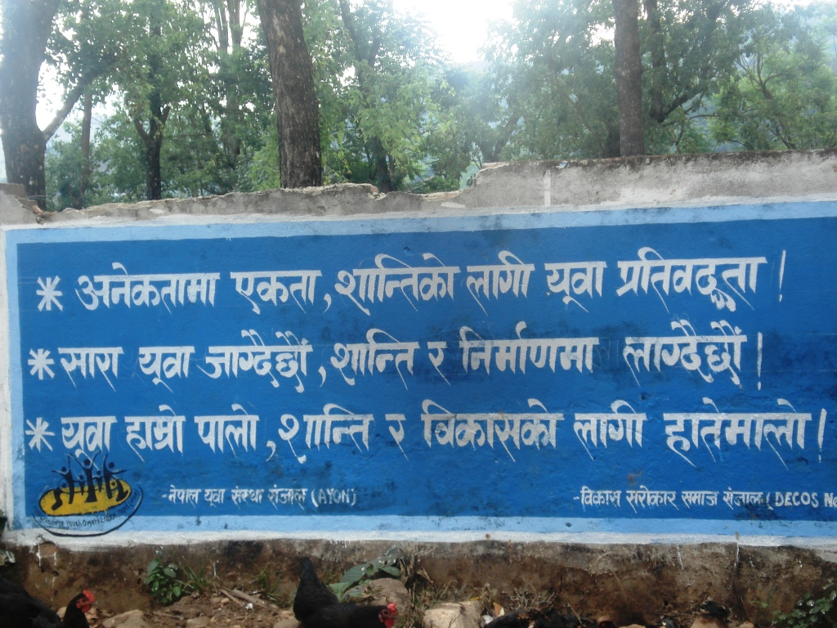
  A mural emphasizing unity in diversity among youth
In August 2006, the U.S. Agency for International Development’s Office of Transition Initiatives (OTI) began a 2-year, $15,000,000 program in Nepal to bolster the current peace process, strengthen governance mechanisms, and support positive, nonviolent community engagement in the country’s political, social, and economic future. The objectives of the program are to:

- Increase access to information and diversify public debate on issues critical to political transition, and

- To increase the effectiveness of key political transition institutions.

 |  | Contact: Gordon Shettle, OTI/ANE Program Manager  e-mail: gshettle@usaid.gov; telephone: (202) 712-1243  Internet: www.usaid.gov – Keyword: OTI

