USDA Foreign Agricultural Service
GAIN Report

Global Agriculture Information Network
Template Version 2.09

Voluntary Report - public distribution
Date: 3/1/2004
GAIN Report Number: SP4005
SP0000
Spain
Grain and Feed
Spanish Grain Market
2004

Approved by:
Lloyd J. Fleck
U.S. Embassy
Prepared by:
Diego Pazos

Report Highlights:

U.S. grain exports to Spain in MY 2003/04 are the best seen in several years: total sorghum shipments should reach 500,000 tons and wheat, around 600,000 tons. Spanish feed manufacturers have been highly critical of the EU’s calculation of the import duty on sorghum; they say that by understating freight rates, the EU is keeping the duty artificially high and discouraging imports. Looking toward next season, high levels of precipitation in Spain over the past 4 months have established conditions for an above-average grain crop in 2004. However, the size of the mostly non-irrigated crop will depend on crucial rain during the heading period in March, April and May. More winter grain is expected to be planted in the autumn of 2004, due to lower mandatory set-aside area and to current high prices for grains.

Includes PSD Changes: Yes
Includes Trade Matrix: No
Unscheduled Report
Madrid [SP1]
[SP]

Summary 2
Overview of the Spanish Feed-Livestock Sector 2
Wheat 2
Barley 2
Corn 2
Sorghum 2
Rye 2
Oats 2
Non Grain Feed Ingredients (NGFI) 2

Summary

High levels of precipitation in Spain over the past four months have established conditions for an above average Spanish grain crop in MY 2004/05. While the moisture has generally been positive for this year's grain production, about 50,000 hectares of grain area remains unplanted. In any case, current conditions point to a better-than-average crop in dryland areas and a good crop in irrigated areas. However, the size of the crop in non-irrigated areas still depends on crucial rain during the heading period in March, April and May. An expansion of winter grain area is forecast due to a lower mandatory set-aside area and higher prices for grains in MY 2003/04. In addition, Spanish farmers are shifting from sunflower to grain due to poor prices for the farmer. Pasture conditions have been excellent during last fall and this winter.

The S&D tables have been revised to reflect latest official statistics and new trade forecasts.

The current forecast for 2004/05 grain crops is presented below:

 | Area 2003/04  (1000 Has) | Production 2003/04 (1000 tons) | Area*2004/05  (1000 Has) | Production* 2004/05 (1000 tons)
Wheat | 2263 | 6300 | 2350 | 6500
Barley | 3089 | 8700 | 3200 | 9000
Corn | 472 | 4300 | 480 | 4600
Oats | 476 | 873 | 480 | 900
Rye | 110 | 185 | 110 | 185
Sorghum | 7 | 29 | 7 | 33
Total | 6417 | 20387 | 6627 | 21218
*Forecast

The Spanish feed market annually absorbs about 33 million tons of ingredients (excluding hay -other than dehydrated alfalfa-, straw and minerals). In MY 2003/04, grain use is expected to decline due to high prices for grain relative to tapioca and to good pasture conditions. Assuming an average grain harvest in 2004, the use of grain in feed consumption should rebound in MY 2004/05. The ethanol industry is emerging as a significant consumer of grains; it currently absorbs about 300,000 tons of barley and 300,000 tons of wheat per year.

The following table summarizes the Spanish Feed-Livestock Sector.

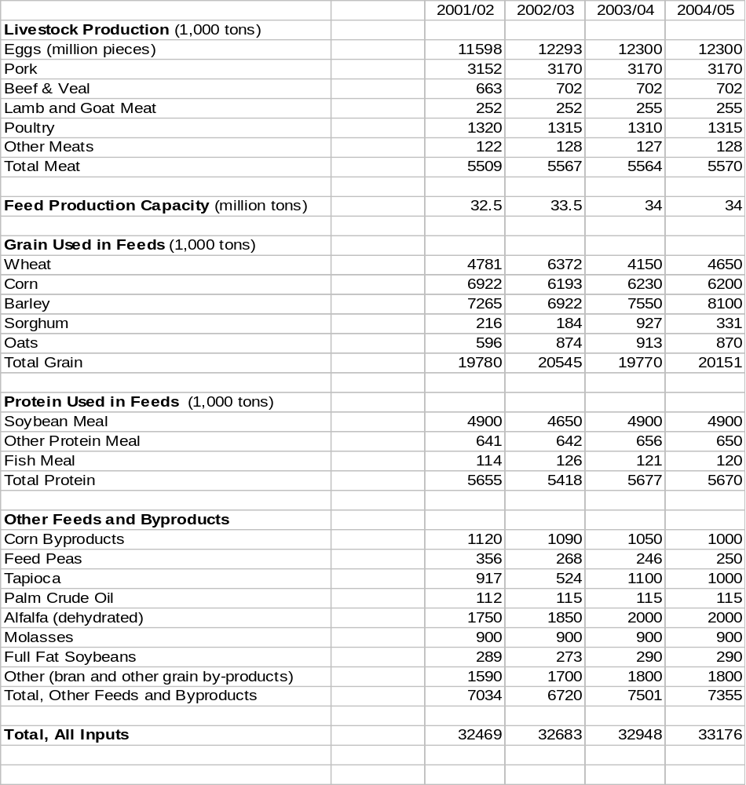Overview of the Spanish Feed-Livestock Sector

Wheat

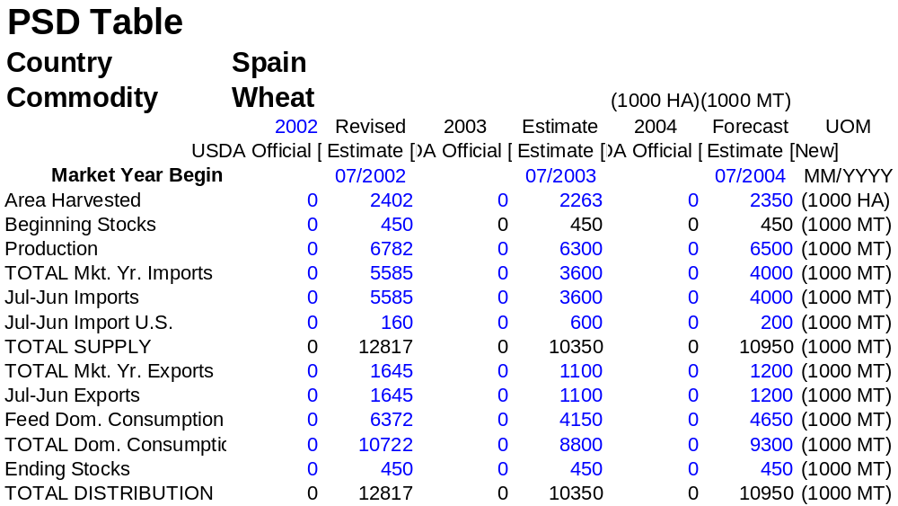

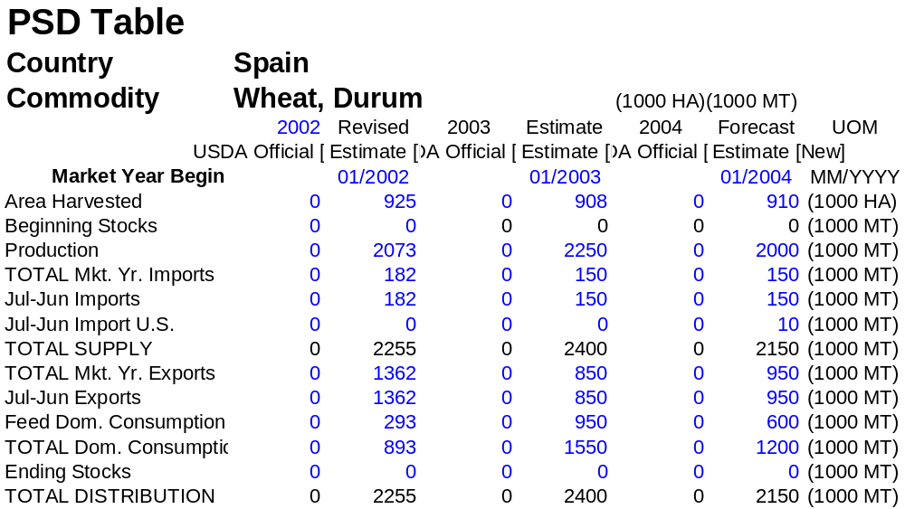

During the last few weeks, the price for wheat in production areas has been stable at around €180 per ton. The price for feed wheat is ranging about €175 per ton in production areas. These prices are expected to remain well above intervention, and no stock rebuilding is anticipated. Import and export estimates were reduced to reflect the pace of shipments over the first 6 months of the 2003/04 marketing year.

Low durum prices relative to other feed grains resulted in a greater quantity of durum entering feed channels. As such, the feed use number has been increased. Based on this pace, and the fact that there is little exportable surplus remaining, the export forecast has been reduced.

Based on current conditions, we forecast a good crop of durum for MY 2004/05.

Barley

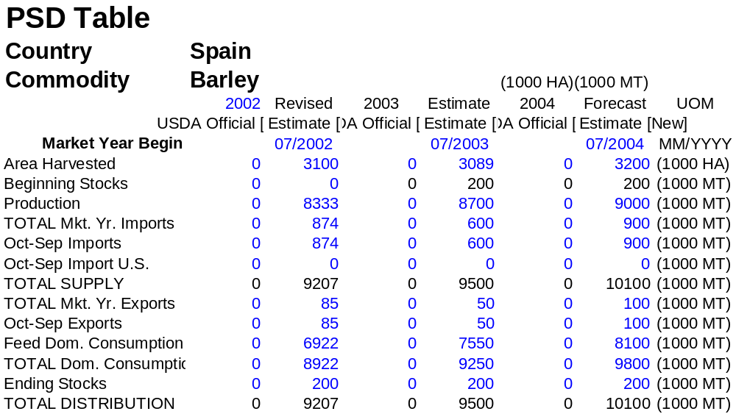

The price for Spanish barley is about €160 per ton in production areas, which is €59 above the intervention price. The lower price for barley, relative other feed grains, is resulting in a higher use in feed formulas.

Corn
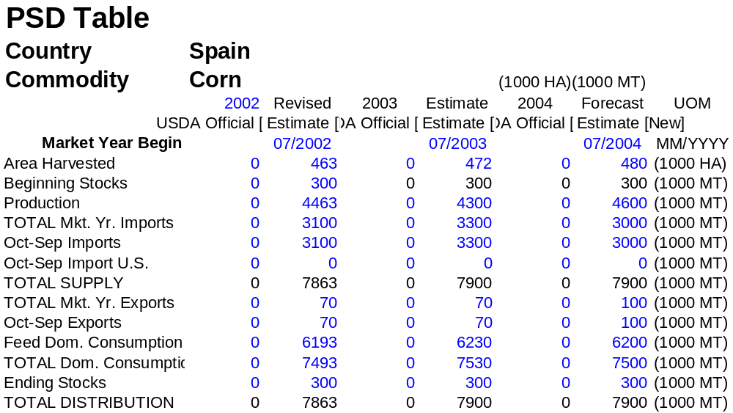

Due to heavy rains in northern areas, about 50,000 tons of corn from 2003 crop remains unharvested.

The price for corn in production areas is about €175 per ton. Reportedly, due to the current competiveness of corn relative to feed wheat, feed manufacturers are using more corn than in the previous year. This trend is expected to continue until next harvesting of winter grains; the feed use number has been adjusted to reflect the expanded use of corn.

The recent approval of nine new varieties of Bt corn for planting in Spain could increase the area planted with GMO varieties from 32,000 hectares in MY 2003/04 to about 50,000 hectares in MY 2004/05. (See SP4004 for details.)

Sorghum

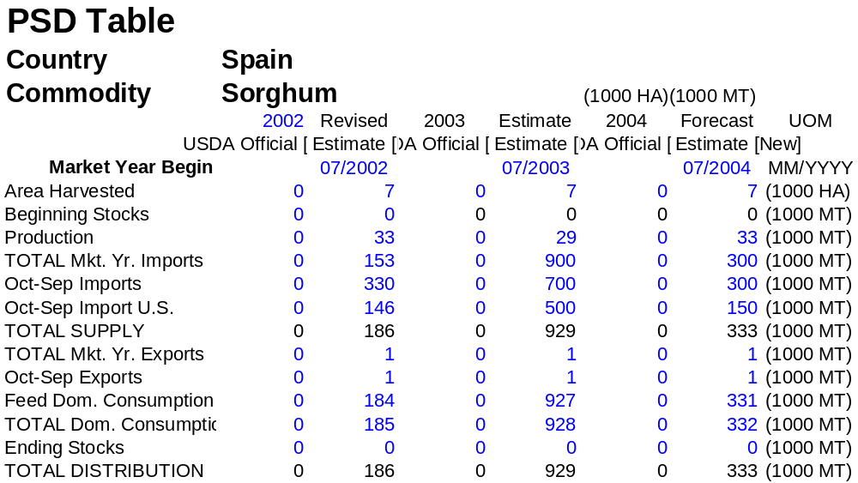

Importers say they are holding about 100,000 tons of U.S. sorghum in Spanish ports anticipating a lower duty before passing through customs. They hope that this sorghum could be imported under the new tender to import up to 200,000 tons of sorghum under the U.S./EU Enlargement Agreement during the period February /April 2004. Taking into account the new tender, we are forecasting imports of about 500,000 tons of U.S. sorghum during MY 2003/04. During the period July/December 2003, about 600,000 tons of sorghum were imported from non-EU countries at full duty.

Spanish feed manufacturers have been strongly protesting the EU Commission’s calculation of the import duty on sorghum. They say that the Commission has been slow to react to rising freight rates in calculating the import duty on sorghum. For example, the Commission’s current calculation is based on a U.S. Gulf- EU port freight rate of $40 per ton. This results in a duty of €29.60 per ton, which in turn yields a CIF price of about €182 per ton. At this price, U.S. sorghum is uncompetitive in EU grain markets.

The feed industry says that the actual Gulf-EU freight rate is around $50 per ton. If this figure were used in the duty calculation, the import duty would be around €22 per ton, which would yield a CIF price of around €174 per ton. At this price, U.S. sorghum would be able to sell in Spanish grain markets.

Some Spaniards believe that the Commission’s calculation -- or miscalculation -- of the sorghum duty is in line with a tacit policy to keep grain prices high within the EU this marketing year. This policy has been particularly harmful to Spain’s pork and poultry industries, which are being severely squeezed between high feed costs and low meat and egg prices.

Rye

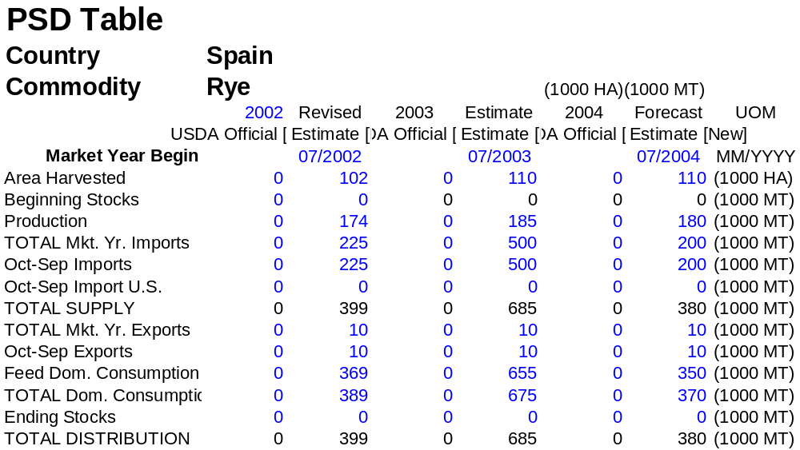

Imports of rye are up dramatically in MY 2003/04 due to sales from intervention at a price €9 higher than the intervention price; we expect the final total for the year will be about 500,000 tons. According to trade sources, the Spanish market could have absorbed as much as 1.5 million tons of rye in MY 2003/04. However, without an EU subsidy to offset the high costs of transportation between Germany and Spain, sales were prohibited in many areas of the country. With the Spanish grain harvest set to begin in less than 90 days, rye will be replaced in feed formulas by domestic barley, wheat and durum.

Oats

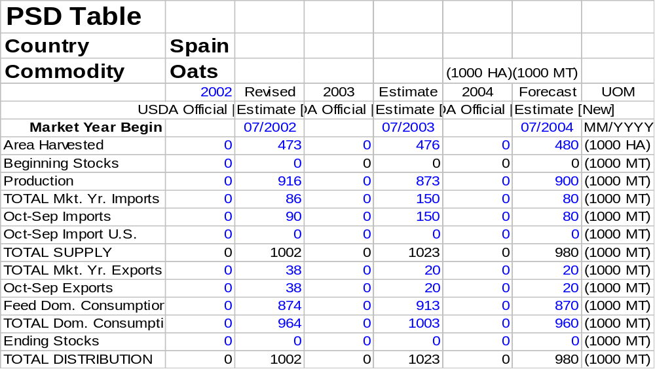

The relatively low price for oats in northern EU countries fuelled imports.

A portion of Spanish oats is harvested for hay.

Non Grain Feed Ingredients (NGFI)

During MY 2003/04, imports of tapioca rose sharply, due mainly to high prices for grains. However, imports of corn by-products have remained relatively stable.

The use of NGFI is as follows:



