Federal Communications Commission

Spectrum Policy Task Force

Report of the Spectrum
Efficiency Working Group

November 15, 2002

Spectrum Efficiency
Working Group

Richard Engelman, International Bureau, Chair
Kwaku Abrokwah, Office of Engineering & Technology
George Dillon, Enforcement Bureau
Gardner Foster, International Bureau
Gordon Godfrey, Media Bureau
Trey Hanbury, International Bureau
Charlene Lagerwerff, International Bureau
Wayne Leighton, Wireless Telecommunications Bureau
Mike Marcus, Office of Engineering & Technology
Roger Noel, Wireless Telecommunications Bureau
Jerilyn Payton, International Bureau
Jennifer Tomchin, Wireless Telecommunications Bureau
John Williams, Office of Plans and Policy
Allen Yang, International Bureau

Disclaimer

The findings and recommendations contained in this Report are those of the Spectrum Efficiency Working Group members, and do not necessarily reflect the views of the Commission, Commission management, or the Spectrum Policy Task Force.

Table of Contents

Page
I. Introduction 4
II. Efficiency Definitions and Measurement 4

III. Observations on Today’s Spectrum Use 9

IV. Issues and Findings 16
A. Improving access through power, time, frequency, bandwidth and space 17
- Fostering technologies for uniform signal strength throughout a service area 17
- Power limitations 19
- Taking advantage of time 20
- Taking advantage of space 20
  - Permitting other users or uses 21
  - Discouraging inefficient use 23
- Receiver performance 24
- Defining expectations 25
- The noise floor 25
- Digital transmissions 26
  - Grouping technically-compatible systems 26
  - Adjusting regulations as technology develops 27
- Regulatory Models and Incentives for Efficient Use of Spectrum 29
A. General findings regarding regulatory models 32
1. More flexibility 32
2. More exclusive use rights 33
3. More spectrum commons 33
4. Limited application of the command-and-control model 34
- Specific recommendations 34

I. Introduction

One of the Commission’s key spectrum management goals has been to promote efficient access to and use of the radio spectrum. The Commission’s 1999 Spectrum Policy Statement indicated that “[w]ith increased demand for a finite supply of spectrum, the Commission’s spectrum management activities must focus on allowing spectrum markets to become more efficient and increasing the amount of spectrum available for use.” Similarly, the Commission’s recently released FY 2003-FY 2008 Strategic Plan indicates that its general spectrum management goal is to “[e]ncourage the highest and best use of spectrum domestically and internationally in order to encourage the growth and rapid deployment of innovative and efficient communications technologies and services.

Demand for access to spectrum has been growing dramatically, and is likely to continue to grow for the foreseeable future. New services, such as unlicensed wireless internet access and satellite digital audio broadcasting, are being launched and are quickly reaching hundreds of thousands of consumers. Existing services continue to grow at dramatic rates, thereby creating demand for access to additional spectrum. Entrepreneurs are seeking spectrum to offer new services.

At the same time, most “prime” spectrum has been assigned, and it is becoming increasingly difficult to find spectrum that can be made available either for new services or to expand existing ones. To ensure that existing services can continue to grow and evolve to serve marketplace needs, and that new services have a chance to blossom and grow, it is important that the Commission continue to promote efficient access to and use of the radio spectrum.

II. Efficiency Definitions and Measurement

In its Public Notice, the Spectrum Policy Task Force (SPTF) asked whether the Commission should consider ways to quantify or benchmark efficiency in a way that permits fair and meaningful comparisons of different radio services. The SPTF also asked how the Commission could define and quantify “spectrum efficiency.” Based on the responses to the Public Notice, it is clear that there are many possible definitions for spectrum efficiency.

The term “efficiency” is commonly used to relate how much output can be produced based on a certain amount of input. The Random House College Dictionary, for example, defines efficiency as the “accomplishment of or ability to accomplish a job with a minimum expenditure of time and effort,” and alternatively as “the ratio of the work done or energy developed by a machine, engine, etc., to the energy supplied to it, usually expressed as a percentage.” This can be expressed generically as:

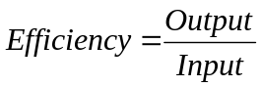

For spectrum uses, output could be expressed in terms of the amount (or bits) of information transmitted, and input could be expressed in terms of the amount of spectrum (or Hertz) impacted or made unavailable for other use. However, the Working Group recognized that discussions about efficiency also needed to consider other issues, such as the cost of improving efficiency, the number of people being served, and the value of the service that would be provided as a result of the improved efficiency.

To assist in the discussions that occurred at the Public Workshops and elsewhere, the Working Group developed three working definitions related to efficiency.

SPECTRUM EFFICIENCY occurs when the maximum amount of information (i.e., output) is transmitted within a given amount of spectrum (i.e., input), or equivalently, when the least amount of spectrum is used to transmit a given amount of information. This could be expressed as:

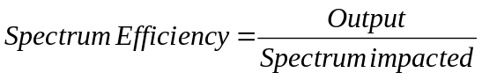

TECHNICAL EFFICIENCY occurs when all inputs are deployed in a way that generates the most output for the least overall cost in resources, including not only the spectrum but also the equipment, other capital, and labor (i.e., all inputs). This could be expressed as:

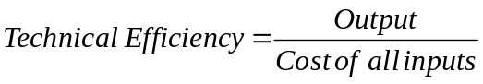

There is a difference between spectrum efficiency and technical efficiency. With technical efficiency, the focus is on all inputs, whereas with spectrum efficiency, the focus is on doing the most with the spectrum allocated. Just as it would be possible to build a car that achieves 300 miles per gallon in fuel efficiency, but only by using advanced lightweight materials that cost a million dollars per car, so might it be possible to build a radio device that can send and receive ten times more bits per megahertz, but only by using a lot more of other resources. In this case, the radio device might have excellent spectrum efficiency but poor technical efficiency.

ECONOMIC EFFICIENCY occurs when all inputs are deployed in a way that generates the most value for consumers. With spectrum, the “value” refers to the value of the information transmitted, whether that is a “911” emergency call made over a cell phone, a wireless communication between a manufacturer’s plant and its warehouse, a wireless connection to the Internet for a laptop user, or a radio or television broadcast. Economic efficiency could be expressed as:

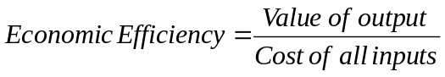

So, what is the difference between economic, technical, and spectrum efficiency? While spectrum efficiency creates the most output with the least amount of spectrum and technical efficiency creates the most output with the least amount of all inputs, economic efficiency creates the most value with the least amount of all inputs. One way to think of the differences is to look at a typical factory production line. A production line manager is focused on getting the most “widgets” produced during each job shift (i.e., maximizing the output for a given input). However, the plant foreman might be looking at getting the most “widgets” produced at the least cost, varying the number of workers, utilizing overtime, and buying the cheapest parts to make the widget (i.e., maximizing the output while minimizing the overall cost). The company president, on the other hand, might be thinking about whether the factory line might be better used to make “gizmos” instead of “widgets” (i.e., maximizing the value of the output while minimizing the overall cost).

For spectrum, the terms “spectrum efficiency,” “technical efficiency,” and “economic efficiency” allow the various aspects of efficiency to be considered. One might argue that broadcast television has a higher spectrum efficiency than mobile telephony service, which in turn has a higher spectrum efficiency than public safety spectrum use. These relationships may also be true for technical efficiency. Yet the value of a single emergency call placed over a public safety channel in the course of an hour may exceed that of any of these other uses during the same hour, and have a higher economic efficiency. Similarly, some consumers may place more value on a five-minute mobile phone call than an hour of broadcast television.

It is important to recognize how spectrum and technical efficiency feed into and become a component of economic efficiency. Business managers may consider the spectrum and technical efficiency of different services or technologies, but ultimately they must weigh the cost of each service against the value created by each. Just because a service or technology has a high level of spectrum or technical efficiency, it does not follow that it is the most economically efficient. Such efficiency may cost too much relative to the value it provides. There may be no market for very fuel efficient million dollar automobiles. Of course, continued advances in technology may lower the price of the more spectrally or technically efficient service, which in turn could change the calculation of that which is economically efficient.

While the Commission’s goal is to promote efficient spectrum access and use, other considerations also affect Commission policy. Most notably, various political considerations constrain the policy options available and thus may constrain the ability to achieve more economic efficiency. For example, bidding credits for Designated Entities have been used in some auctions. While such credits may make it more difficult for the spectrum resource to move to its highest valued use – thus constraining economic efficiency – they reflect a policy choice made by Congress or the Commission to weigh efficiency against other worthy goals. Spectrum and technical efficiency feed into economic efficiency, which can lead to a policy framework in which other considerations also are weighed. Some political or other considerations may come at a great cost to economic, technical, or spectrum efficiency, while other considerations may impose little or no cost.

The Commission can promote economic efficiency primarily by providing licensees with a significant amount of flexibility in how they use, and how easily they can transfer, the spectrum. Such “free market” approaches permit licensees to maximize the value of the services they provide within their spectrum. In addition, when warranted, the Commission can promote economic efficiency by making spectrum available for uses that have a high value to the public (such as police and fire communications).

Occasionally the Commission may find it in the public interest to constrain the flexibility that licensees have to use or trade their spectrum. In these circumstances, it may be most important for the Commission to focus on regulatory policies that can promote spectrum efficiency (as opposed to technical efficiency – the Commission cannot readily assess the cost of all inputs – or economic efficiency). However, the Working Group recognizes that in pursuing its goal to improve the efficient access to and use of spectrum, the Commission must balance the costs of imposing any improvements in spectrum efficiency against the costs of achieving that efficiency and the value of the services that will be provided.

The remainder of this Section focuses primarily on spectrum efficiency, recognizing that the Commission will rely on free markets to promote economic efficiency whenever appropriate.

Measuring spectrum efficiency. As mentioned previously, the generic definition of efficiency can be modified for spectrum, where output may be the usable information transmitted (perhaps in bits-per-second) and input is the spectrum resource impacted (in megahertz):

Spectrum Efficiency = Information Transmitted (I) / Spectrum Impacted (U)

where

Spectrum Impacted (U) = Bandwidth Impacted (B)
x Geographic Space Impacted (S) x Time (T) denied to other users

or simply

Spectrum Efficiency = I / U = I / (B x S x T)

Even this equation is missing some important variables, such as how many users are being served. It would also be difficult to accurately, consistently, and fairly pinpoint the amount of information transmitted. This equation also doesn’t reflect whether any of the three denominators (bandwidth, space, and time are more valuable than the others).

IEEE 802 tries to address one of these concerns by proposing a Wireless Efficiency (“Weff”) metric:

Weff=(C x Ns )/(B x A) Bit-Users/m²

where:

Weff is the efficiency of the wireless system having units of Bit-Users/meter²

C is the capacity of the system in delivery information bits per second, after decoding, demodulation, and including the vagaries of the network protocol and duty cycle

Ns is the number of logical connections or users in the network, within the coverage area and utilizing the allocated bandwidth B

B is the allocated bandwidth to the network in Hertz, and

A is the area covered (in units of square meters) by the wireless system over which the bandwidth B is uniquely associated.

While this equation doesn’t consider the aspect of how much time the spectrum is being impacted, it could be modified to do so. However, the difficulty in calculating some of these variables (for example, the capacity and number of users), and the assumptions behind these calculations, make measures of spectrum efficiency highly unreliable.

Other parties have suggested ways to measure spectrum efficiency. For example, ArrayComm suggests that we measure spectrum efficiency using bits/second/Hertz/cell, bits/second/Hertz/km², or subscribers/Hertz. All of the proposed equations involve the calculation of signal propagation that can vary by frequency, geographic area, and equipment. Different assumptions about acceptable interference and desired quality levels would produce different results in terms of how much bandwidth, space and time would be impacted. And different parties would likely want to make these calculations using the assumptions that work most favorably for their situation.

It is also difficult to consider the overall efficiency of a system of devices, as opposed to a single device. It is generally easiest to assess spectrum efficiency on a per-device basis, in terms of bits/second/Hertz. However XtremeSpectrum points out that this value can be misleading. Devices with individually low spectrum efficiency values may nonetheless achieve high efficiencies in combination, where many such units share the same spectrum over a given area. For example, radios used for remote reading of utility meters typically transmit only a few hundred bits per day -- very low efficiency, by ordinary standards. But a quarter-million of these devices installed over a few square miles add up to a combined use of the spectrum that could be viewed as far more efficient than ordinary radios.

After considering the comments and reviewing the record, the Working Group concludes that it is not possible, nor appropriate, to select a single, objective metric that could be used to compare efficiencies across different radio services. Any metric would provide, inherent in its assumptions, advantages to certain services and technologies, and disadvantages to others. The Working Group does conclude, however, that rough estimates of spectrum efficiency may be useful in certain situations, as they could allow for some comparisons between technologies. While not adopting a single metric, the Working Group still believes it to be possible, and prudent, to promote the efficient access to and use of spectrum.

III. Observations on Today’s Spectrum Use

There is widespread belief that radio spectrum use in the US is either crowded or becoming very crowded, and that policy changes are needed to accommodate growing spectrum demands in both the public sector and the private sector. The purpose of this section is to show that there is some evidence indicating that the shortage of spectrum is often a spectrum access problem. That is, the spectrum resource is available, but its use is compartmented by traditional policies based on traditional technologies. New radio technologies may enable new techniques for access of spectrum and sharing of the spectrum resources that may create quantum increases in achievable utilization, just like the major improvement that was made 20-30 years ago with the commercial introduction of trunking technology and then cellular-based systems.

Neither FCC nor NTIA routinely quantify actual spectrum usage by users under their jurisdiction. However, during the Summer of 2002 the FCC’s Enforcement Bureau took limited measurements of spectrum use in certain urban areas which allow a partial view of actual spectrum use. This effort was limited in duration and only used one site in each city studied, and hence generally underestimate actual spectrum use to some degree. However, the Working Group believes that the general observations made here are likely to have broad applicability and should be verified in a broader measurement program, possibly in conjunction with noise measurements

Figure 1 shows the general nature of spectrum occupancy in an approximately 700 megahertz block of spectrum below 1 GHz in Atlanta, New Orleans, and San Diego. This data was taken by FCC’s Enforcement Bureau at its offices in each city in June 2002.

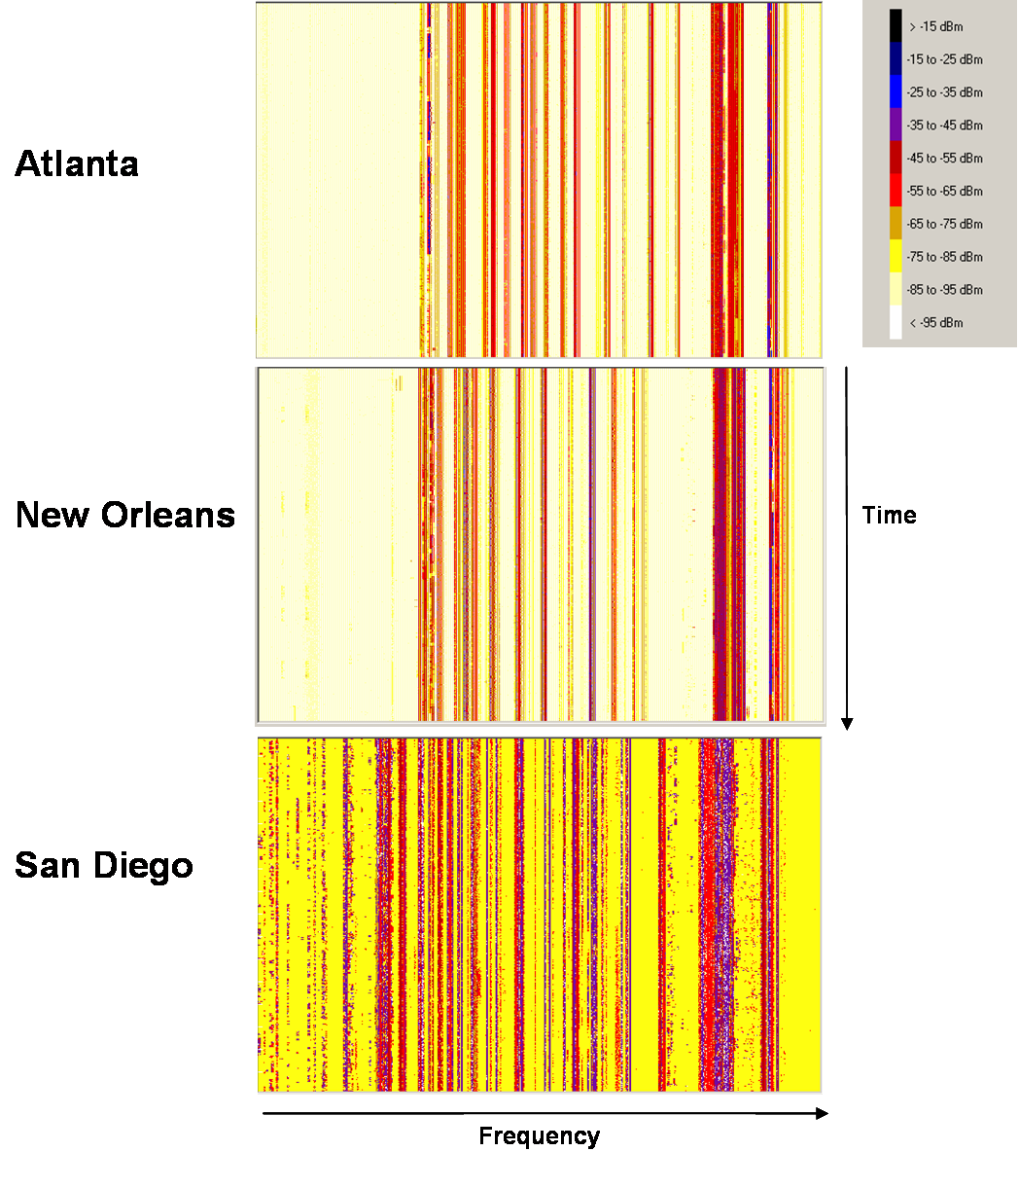
Figure 1: Occupancy of approximately 700 megahertz
of spectrum below 1 GHz
In Figure 1 it can be seen that there can be a large variation in spectrum use intensity within the spectrum below 1 GHz in Atlanta, New Orleans and San Diego. The lower frequencies in the observed spectrum tend to have lower utilization than the higher frequencies. Blocks of frequencies used by television broadcasting and cellular base stations have continuous occupancy, while other frequencies are more dynamic.

More detail about mobile radio occupancy is shown in Figure 2, which shows 7.5 MHz of a UHF land mobile band in the same three cities. It can be seen in this detailed view that land mobile demand is very dynamic, but there is still a large amount of “white space” in the band that was monitored.

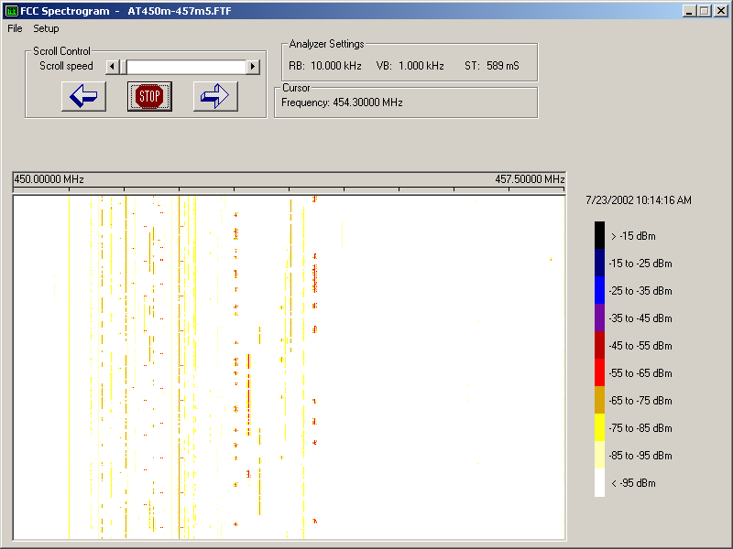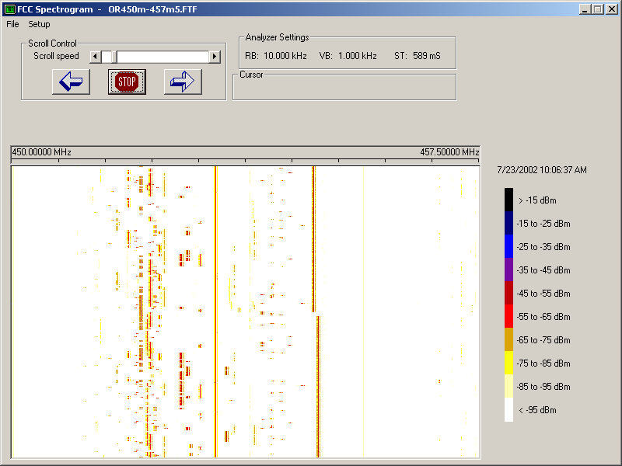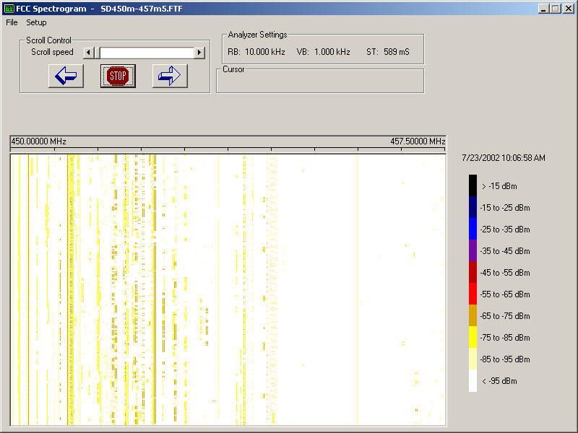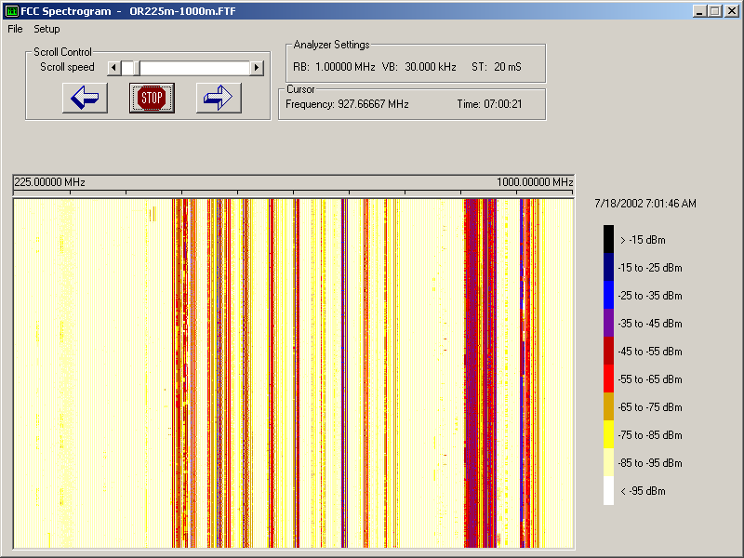
Atlanta

New Orleans

San Diego
Time
Frequency
Figure 2: Occupancy of a 7.5 megahertz UHF Land Mobile band

Single-site monitoring, such as this, tends to underestimate spectrum use somewhat and a good example is seen here as some bands are heavily used, while other bands have less use. This behavior may be due to fact that a given monitoring site is only able to receive signals that are sufficiently strong at that specific monitoring site. The signals that a nearby monitoring site is capable of receiving may be quite different. Furthermore, a given monitoring site is likely to be able to observe higher-powered broadcast transmitters and land mobile base stations more easily and at greater distances than lower-power short range mobile units, particularly hand-held units.

Limited-duration spectrum observations are only useful for estimating average spectrum use. For blocks of spectrum subject to highly peaked demand, e.g. public safety spectrum, such limited-duration monitoring may miss the demand peaks altogether. Nevertheless, the existence of such low average occupancy bands in urbanized areas with increasing spectrum demand raises interest in the possibility of matching supply and demand better with alternative technology. Several options for doing this are discussed elsewhere in this Report.

Up to this point, this Report has focused on the “raw” monitoring data. However, the data can also be processed to look at the statistics of spectrum use. For this analysis we looked at a sliding 30-second window of spectrum observations and computed what fraction of the observed frequencies were idle during each window. Figures 3 and 4 show this type of analysis for two nonadjacent 7 megahertz blocks of spectrum below 1 GHz. These data again show that while some frequencies are heavily used, there are other bands that have large parcels of time-frequency blocks of spectrum available even in high-use urban areas.

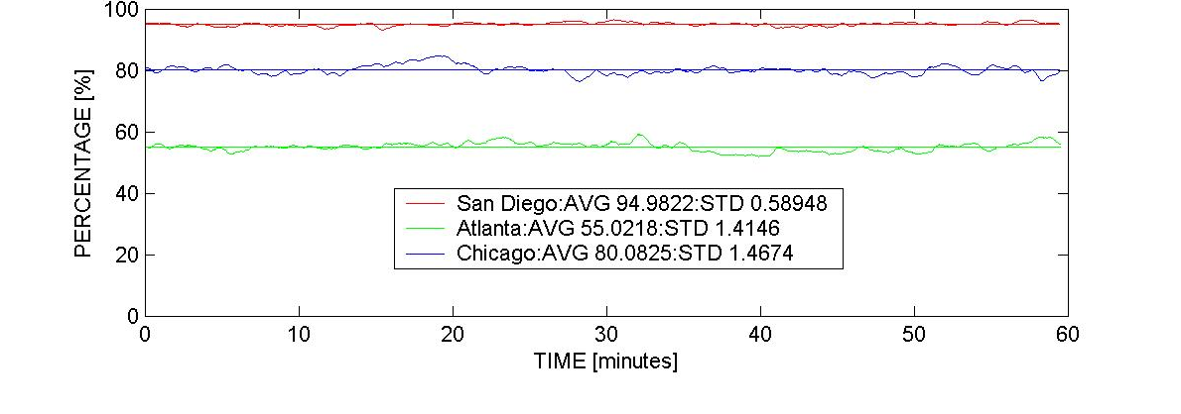
Figure 3: Use of a 7 megahertz band below 1 GHz
(percentage of a 30-second window by 7 megahertz block that was idle)

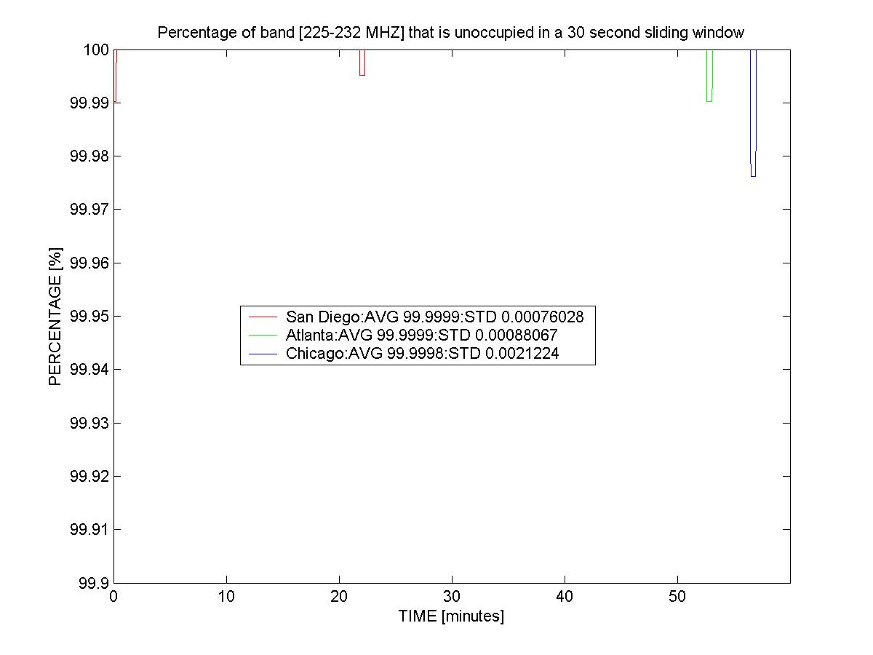

Figure 4: Use of a different 7 megahertz band below 1 GHz
(percentage of a 30-second window by 7 megahertz block that was idle)

This information cannot be used to provide a definitive statement about present spectrum use, but it can indicate some general characteristics of spectrum use. A possible conclusion from these data and their analyses is that there currently is a large untapped capacity in the spectrum. If the Commission would develop and implement policies to permit access to the presently underutilized spectrum use while preserving the legitimate needs of present users authorized to use the spectrum, it could meet many of the Nation’s growing spectrum needs for a long time.

In order to verify the above hypotheses more spectrum measurements are needed in terms of location, time duration, and frequency coverage. While such measurements usually have been taken only at one location within an area, there may be benefits of taking measurements simultaneously at several spots in a grid to minimize the number of transmissions that are missed and avoid underestimating spectrum occupancy in the area of interest.

Public Sector Spectrum Use Characteristics. In response to the Task Force’s Public Notice seeking comment on spectrum policy questions, various information were received on the nature of public sector, and in particular public safety, spectrum use. Public sector use, including Federal Government civil and military systems, and state and local public safety systems, constitutes a significant fraction of the VHF/UHF spectrum that is in greatest demand for mobile systems. This is also a category of users that has been making increased requests for spectrum to meet growing high priority requirements. Thus it is appropriate to make some general observations on the nature of public sector spectrum use.

While some public sector spectrum use is similar to commercial spectrum use, the hallmark of much public sector use is the combination of high peak-to-average traffic ratios and high societal value of the peak use. Figures 5 and 6 below illustrate peak and average traffic statistics that are typical of many types of public sector spectrum use. These data are from measurements of a single police dispatch channel in a large city in New York State.

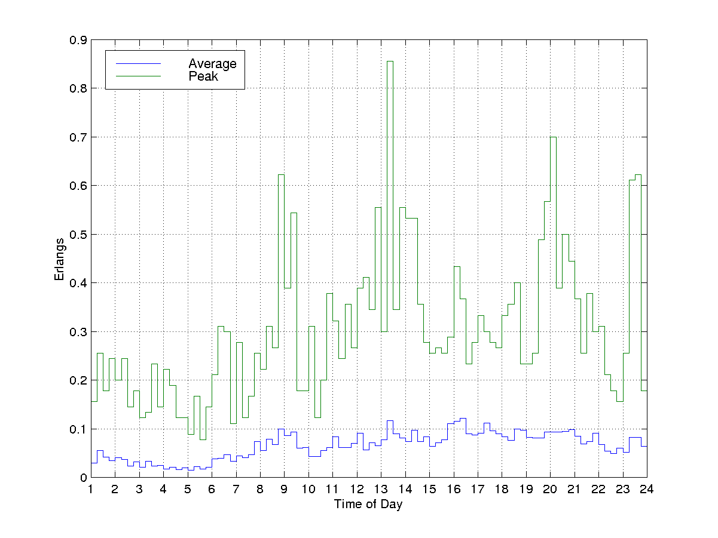

Figure 5: Traffic on a police dispatch channel measured at different times

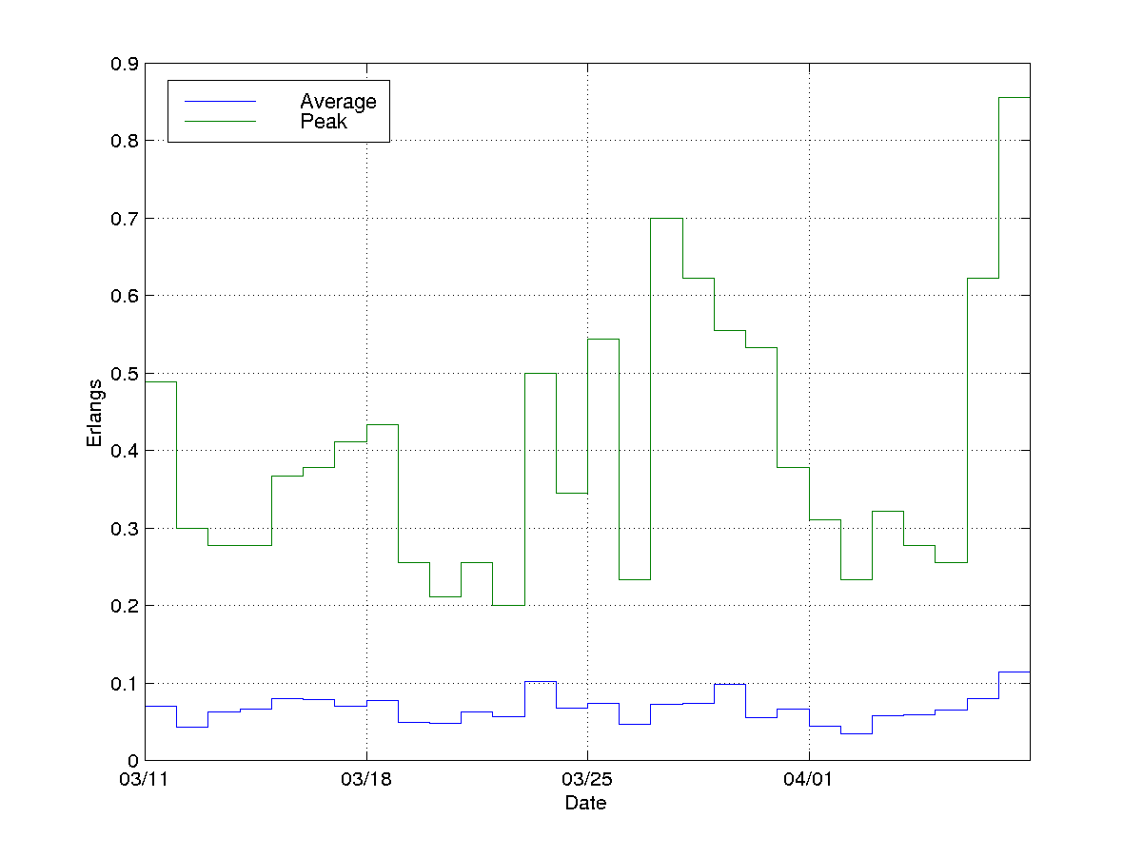

Figure 6: Traffic on a police dispatch channel measured on different days

The traffic data above is measured in Erlangs, a telephone traffic term. The traffic in Erlangs in this case can be interpreted as the fraction of time that the channel is in use. Thus it can be seen in Figure 6 that, on a daily basis, channel loading ranges from 0.05 to 0.12 Erlangs, equivalent to occupancy of 5 to 12%. However, during the same four-week period, occupancy reached a peak during the busiest 15-minute period of approximately 85% on the last day. On most days during this period, the peak was 50% or less. The hour-to-hour data in Figure 5 also show 15-minute average usages in the 10% range with occasional higher peaks. These data are for a dispatch channel that is probably in more steady use than most law enforcement tactical channels. Thus it seems likely that other public sector channels probably have lower average usage but have peaks that are just as high.

While these data imply that peaks are relatively short in duration, the data in Figure 7 show that peaks might be rather long in extreme circumstances.

0
5000
10000
15000
20000
25000
30000
35000
40000
45000
Number of Calls
12/31/97
1/1/98
1/2/98
1/3/98
1/4/98
1/5/98
1/6/98
1/7/98
1/8/98
1/9/98
1/10/98
1/11/98
1/12/98
Date
Number of Total Calls and Blocked Calls per Day
Number of Calls
Number Blocked
9
Figure 7: Calling data for a New York State county government’s radios
during January 8, 1998 Northeast ice storm

While the large surges in public sector communications in conjunction with the 9/11 tragedy seemed unusual to many, the above data show that they are not unprecedented. In this case, a large ice storm struck the Northeast and the county in question had large physical damage, including large-scale failures in wired communications. It can be seen from the data that the daily calling levels for the period December 31 to January 4 were in the range of 500-1500 calls/day. Yet on January 8, the rate was 40,000 calls/day and stayed in the 20,000-40,000 range for four days. Thus, under exceptional circumstances that occur infrequently, it is possible for public sector spectrum use to surge to high peak levels and stay there for multiple days.

The above illustrations indicate that there is significant underutilized average capacity in spectrum resources that are dedicated to public sector applications. The illustrations also indicate that peak use demands can fully use, or even exceed, the capabilities of the available spectrum. Because of the very high value society places on public sector communications, and in particular public safety communications, the Commission generally has allocated and assigned public sector spectrum more closely based on the peak demand rather than the average demand. This approach raises the possibility that public sector users might be able to allow other users access to their spectrum during average use circumstances as long as the spectrum can revert to public sector use during peak use situations.

Unfortunately, comprehensive data on the peak and average use of public sector spectrum, and appropriate statistical modeling of such usage, are not available. The above fragmentary data show that peak-to-average ratios as high as 80:1 are possible and are associated with very high public policy priorities. The detailed dynamics of these peaks are also not well understood. For example, while it is assumed that spectrum use can surge rapidly, does this correspond to a time constant of 1 second or a time constant of 10 seconds? The difference between these two values of time constants could have a large impact on the design of possible systems to share public sector spectrum subject to the non-public sector user relinquishing it rapidly in times of peak public sector demand.

There is also little available information on the frequency of occurrence of public sector demand peaks and their time distribution. Knowledge in this area could also be helpful in designing non-public sector systems that can share public sector spectrum as it would indicate how frequently the shared spectrum might be preempted by public sector use.

In summary, better knowledge of the time statistics of public sector use could contribute to both improving communications for public sector users as well as providing preemptable access to such spectrum to other users who in turn could compensate public sectors users for such spectrum access.

IV. Issues and Findings

As mentioned previously, the Working Group has concluded that a single objective metric that could be used to compare efficiencies across different radio services is neither possible nor appropriate. This Report therefore does not attempt to identify specific services that are more efficient, or less efficient, than others. Such assessments clearly would be debatable, and would depend on assumptions that may not be comprehensive. Instead, the Working Group believes the Commission should take a number of specific steps to encourage the efficient access to and use of the spectrum.

There are two basic situations that impact how spectrum efficiency can be improved:
(1) situations in which all spectrum in an area is already assigned but not fully used; and (2) situations in which all spectrum is fully used. In the first situation, which can be referred to as “access limited,” spectrum efficiency can be improved by increasing the access that other users have to the spectrum. In the second situation, which can be referred to as “throughput limited,” efficiency can really only be improved by taking steps that permit existing users to provide greater information transfer rates. One could view the first situation as increasing capacity by putting in more pipes, and the second situation as increasing capacity within the existing pipes.

This section identifies several steps that can be taken to improve the efficient access to and use of spectrum. Options include: (1) improving access through power, time, frequency, bandwidth, and space; (2) permitting other users or uses; (3) discouraging inefficient spectrum use (or encouraging efficient spectrum use); (4) grouping technically-compatible systems; and (5) adjusting regulations as technology develops. Figure 11 shows the relationship of each of these options to access-limited or throughput-limited situations. The observations on current spectrum use indicate that in many locations, on many frequencies, and at many times, the spectrum is not being fully used. The Working Group believes, therefore, that both access-limited and throughput-limited options may be suitable for improving efficiency in many situations. As access to spectrum is expanded, however, the Commission may be left only with solutions that address throughput-limited situations.

Efficiency
Permit other
users or uses
Improve access through
power, time, frequency,
bandwidth, and space
Throughput Limited
Access Limited
Adjust regulations
as technology
develops
Discourage
inefficient use
Efficiency
Group technically-compatible systems
Permit other
users or uses
Throughput Limited
Access Limited
Adjust regulations
as technology
develops
Discourage
inefficient use

Figure 11 – Steps that can be taken to improve spectrum efficiency

A. Improving access through power, time, frequency, bandwidth, and space

The examination of current spectrum use indicates that often, even though the spectrum in a general area may be licensed, the spectrum is not being fully utilized. Additional capacity, and therefore expanded spectrum efficiency, could be created by permitting access to the spectrum by other users on a time, frequency, bandwidth, or space basis. For example, new operations could be permitted at times when the current licensee isn’t using the spectrum (but shutting down when the licensee does operate). Operations that aren’t frequency sensitive could be moved to less crowded spectrum bands. Existing operations could operate with less bandwidth. And additional licenses could be issued for geographic areas that aren’t congested already (for example, rural areas). Other technical changes, such as changing the power of transmissions, could also be implemented to improve technology.

- Fostering technologies for uniform signal strength throughout a service area

Radio transmission facilities are usually designed to provide a specified “acceptable” signal level over a desired service range. Because the level of the transmitted signal decreases as one moves away from the transmission antenna, this design usually results in unnecessarily high (and therefore inefficient) signal levels near the transmission antenna. If these signals are strong enough, they can cause interference to users on other frequencies, either because the transmitting facility is radiating spurious signals on other frequencies at a high enough level to cause interference, or because the receiving facility on the other frequency cannot easily cope with the high level of the transmitted signal (“receiver overload”).

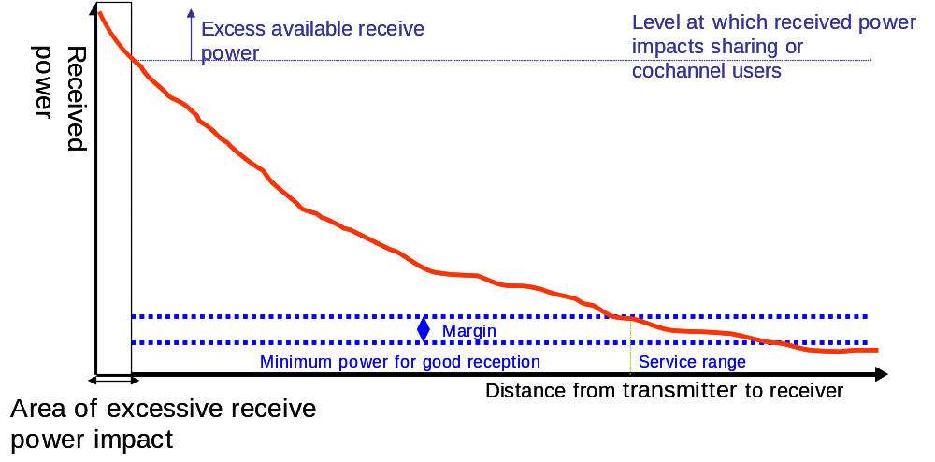

Figure 12 - Impact of Frequency and Antenna Height on Spectrum Use

While it may not be possible to completely overcome the physics of radio wave propagation, which makes signals decrease as distance is increased, it is possible to implement technologies, such as “cosecant-squared” antennas and low-power transmission networks, that restrict the radiation towards the ground near to the transmitting antennas, and increase the signals at distances. These technologies would increase efficiency by permitting operators to reduce transmitter power levels to maintain the same coverage (or provide increased coverage with the same power). They could also protect adjacent channel operations from being impacted by near-by transmissions.

Often the Commission’s rules already permit the use of such technologies. But in some services (for example, broadcasting), the Commission’s rules prohibit the deployment of low-power transmission networks. The Commission should consider changing its rules in this regard. It also may be appropriate to consider incentives that could promote the use of such technology. This Report discusses elsewhere the possibility of setting interference temperature thresholds that would establish the level of interference protection of which an incumbent operator could be assured, while potentially permitting operations by other users in the band as long as they do not cause the interference temperature threshold to be exceeded. One possible incentive that could be offered to users of uniform signal generation technology is to establish a reduced interference temperature threshold (or a more protective interference environment), as shown in Figure 13. This reduced interference temperature threshold would likely yield increased capacity, and potentially improved efficiency, to the licensee.

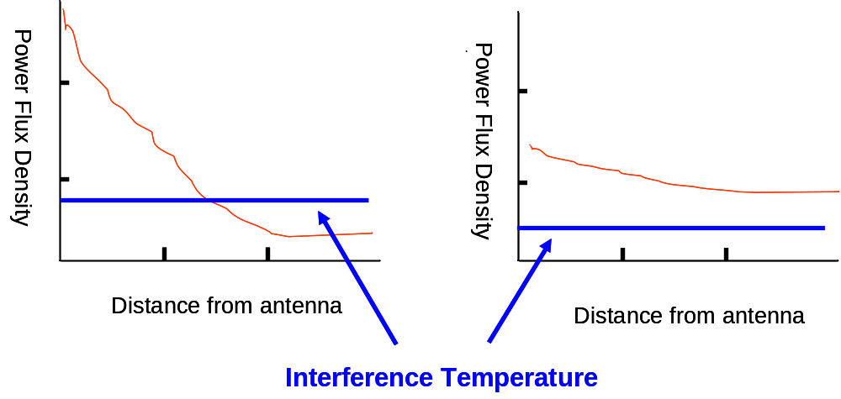
Figure 13 - Impact of Maximum Power Flux Density on
Proposed Interference Temperature

- Power limitations

There is a tension between having enough power to ensure coverage over a desired service area and not having so much power that it puts strong cost burdens on adjacent channel operations (in order to prevent receiver overload or to filter spurious emissions). High-power transmitters generally reduce the capacity (and therefore potential efficiency) for adjacent-channel users. This is a particular problem in urban areas, where the spectrum is likely to be more crowded, but is much less of a problem in rural areas, where spectrum use may be sparse.

To address this situation, it would generally be desirable for the maximum transmitted power levels to be lowered in urban environments and increased in rural environments. Power can be reduced through the deployment of low-power transmission networks, such as those currently used in cities by cellular and PCS service providers. By having more transmitters, the capacity for transmitting information can be increased (since each transmitter can only serve a limited number of users in a typical two-way environment). Power in rural areas can be increased by permitting even higher power levels. This could enable service to be provided in areas that can’t be economically justified now.
3. Taking advantage of time

Industry has developed several different technologies that can be used to exploit the gaps in time in which a particular frequency is being used. Early mobile radio systems were developed so that a group of users would share a specific, fixed radio frequency. The transmitters and receivers for each group of users were designed to operate on a fixed frequency. However, over time it became clear that there were great differences in the amount of usage, or congestion, on different frequencies. Trunked radio systems were developed to address these concerns. In a trunked system, all of the users can use any of the channels. Channels that are not currently being used are identified and an unused channel is made available to each user. Trunking in the early mobile radio systems was implemented manually. The user could select an available channel manually by switching from one channel to another and listening for an unused channel.

In the mid 1960’s a form of automatic trunking was implemented using a technique called “marked-idle,” where a tone was placed on one of the available channels. A mobile radio could then automatically select the open frequency channel by finding this tone. The advantage of a trunked system is that many more users can be supported in the same amount of spectrum with the same grade of service.

Another idea to take advantage of time is to allow a secondary party to access the spectrum when the licensee is not using it. This could involve interruptible use of the spectrum. Secondary parties (parties that could operate but had to protect the primary licensee) could use technology that would automatically monitor the channel before transmitting to ensure that it is really vacant. Also, a time limit or similar regulatory requirement could be placed on the secondary operation to ensure the licensee could access it when needed.

4. Taking advantage of space

Spectrum capacity, and hence potential spectrum efficiency, can also be improved by taking advantage of the geographic distances between radio transmitters. Existing licensees often install only enough radio transmitters to provide service in areas that they believe offer the best business potential. This can result in a lack of service (or spectrum use) in some geographic areas away from the transmitters. These holes in service, called “white areas,” can be made available to other licensees that want to provide service in that area.

The Commission already permits some geographic-area licensees to partition (or divide) their service areas and trade off the transmission rights. However, this freedom is not available in all services. In cases involving site-specific licensees, the Commission can authorize new licenses that can provide service in unserved white areas.
B. Permitting other users and uses

Commenters have made clear in written comments and during our workshops that spectrum lies fallow in certain areas, at certain times, and on certain frequencies. For example, a licensee may have exclusive use of spectrum in a particular geographic area, but choose not to make use of the spectrum over the entire area. Likewise, the licensee may use the spectrum heavily during the daytime, but have light or no usage during nighttime hours. Finally, a licensee may fully utilize spectrum during times of peak usage, but utilize only half of its spectrum during off-peak hours. The commenters observe that spectrum efficiency can be maximized by improving access to spectrum in such instances. This comports with our observations about current spectrum use.

While licensees may be aware that such efficiencies can be gained, there are at least two reasons why a significant number of licensees aren’t fully taking advantage of this opportunity. First, a licensee may wish to more fully utilize its spectrum, but is prevented from doing so by the technical or operational regulatory constraints imposed on the radio service by our rules. Such regulatory constraints may constitute a “catch-22” in many cases where development of advanced radio technology is hindered by the current rules, preventing such operation and thereby inhibiting the full utilization of the spectrum. Second, a licensee may wish to permit others to utilize its spectrum on a short- or long-term basis in certain areas, at certain times of day, or on a shared basis, but is effectively prevented from doing so because of regulatory prohibitions or high transaction costs. In this vein, third parties may wish to use the licensee’s spectrum on a secondary, non-interference basis, but are often prevented from doing so by regulatory constraints.

One of the keys to improving spectrum efficiency is through improving access to spectrum. Therefore, the Working Group recommends that the Commission take steps to promote: (1) flexible use of spectrum; (2) development and deployment of advanced technologies; and, (3) secondary markets for spectrum. First, promoting flexible use of spectrum may be in the form of relaxed regulatory requirements for existing licensees or increased access (on a secondary, non-interference basis) to spectrum by third parties. For example, licensees may be in a position to more fully utilize their spectrum if they are permitted to provide a full range of mobile, fixed, broadcast, or hybrid services. Likewise, third parties may well be in a position to utilize the spectrum on a secondary, non-interference basis by, for example, transmitting at low power, spreading the signal over a large bandwidth, or maintaining some other means of time or space diversity. There may be instances where, based on the specific circumstances of the bands or users in question, increased flexibility and access by third parties may not be desirable or result in a net gain in efficiency. The Commission will need to fully consider the potential impact to licensed users, consumers, and others in deciding whether to implement this type of policy in a particular spectrum band.

Second, access to spectrum may be increased via the development and deployment of advanced technologies. As the commenters and workshop participants point out, advanced radio technologies have been developed, and are being developed, to increase the amount of information in a radio channel, while at the same time increasing the number of independent users in a particular geographic area. Many of the commenters voice support for “smart” radio and infrastructure technologies that to some extent embed spectrum management decisions into the radio system. Such technologies are capable, for example, of real-time monitoring of a radio channel or spectrum band and limiting transmissions in terms of frequency, power, or timing in order to avoid harmful interference to other spectrum users. We recommend that the Commission provide for the development and deployment of such technologies. One way to promote development of these technologies is to provide regulatory certainty in the testing and allocation of spectrum for such devices, thereby enabling entrepreneurs and businesses to obtain financial backing for such ventures.

Third, we recommend that the Commission take steps to promote a secondary market for radio spectrum. In a Notice of Proposed Rule Making released November 27, 2000, the Commission initiated a proceeding to examine removing unnecessary regulatory barriers to the development of more robust secondary markets in radio spectrum usage rights. At that time the Commission stated that it believed enabling the development of more robust secondary markets would help promote spectrum efficiency and full utilization of Commission-licensed spectrum, thereby increasing access to spectrum for those that desire it. The commenters and workshop participants generally agree with this position and recommend that the Commission move swiftly to enable such secondary markets, thereby improving access by lowering transaction costs for licensees. Removing these regulatory barriers will go a long way toward encouraging more spectrally efficient technologies, full utilization of spectrum in all areas, and increased access to spectrum for those that wish to implement innovative, spectrally efficient technologies.

Finally, it is clear that, because of the highly variable rate of transmissions, public safety stations have a lot of additional capacity in non-peak times. This spectrum could be exploited by permitting the existing public safety licensee to authorize others to use its spectrum. Under this scenario, the public safety licensee itself would have to ensure that it gets adequate access to the spectrum when it need spectrum (but other users could operate during non-transmission time periods).
C. Discouraging inefficient use

One of the core principles of effective spectrum management is to maximize the efficient use of the radio spectrum. The FCC shares spectrum management responsibilities and functions with the National Telecommunications and Information Administration (NTIA). While the FCC has authority over commercial spectrum usage as well as that of local and state governments, NTIA manages the federal government’s use of spectrum for defense and other federal purposes.

The Working Group recognizes that in some services there currently is no stimulus for efficient spectrum use. Generally, licensees that have paid to acquire their spectrum have a marketplace incentive to use their spectrum efficiently. Potential inefficiency, therefore, is more likely to occur in narrow-use services, where spectrum can’t be easily brought to the marketplace, and among licensees who have not been forced to incur the opportunity cost of acquiring spectrum.

One way to encourage operators to employ a more efficient system is to establish a fee structure that encourages efficient use of the spectrum. Another way is to mandate improvements such as transition to digital service or narrower bandwidths. Some commenters propose that Congress provide some incentives because rural communities may not have the tax base, or the resources, to make these changes. Stricter unwanted emissions limits would also increase efficient spectrum use.

Some participants of the Public Workshop on Spectrum Efficiency suggested a shift to hybridizations, with wireline delivery whenever possible. Deploying a system that uses fiber, cable, and wireline in concert with wireless applications could reduce spectrum congestion. This would save valuable spectrum for those services that require mobility.

Another participant speculated that it is not going to be a mandate that invokes the change to efficiency, but the universal driver of profitability of special offerings. The public will choose spectrally efficient devices and services that they can use. TV viewers will choose DTV because it will have more content and more services.

1. Receiver performance

In the past, the FCC has shied away from imposing standards on receivers and has not protected their reception from new services. However, reports of adjacent channel interference to receivers, especially in older, more established services, have led many commenters to believe there is a need to adopt receiver “standards,” or performance requirements. Under the current FCC approach, many new service providers must allow for a guard band or lower power to protect the more established operation of other users, especially if they are public safety entities. This poses a cost on the new operator and is viewed by some commenters as spectrally inefficient. CTIA proposes that the FCC ensure that Public Safety first responders deploy upgraded receiver and networking equipment designed to improve intermodulation rejection characteristics. In addition, unlicensed band use may lead to devices that are inexpensive but vulnerable to interference or that cause interference.

The real problem with setting receiver performance requirements is how to approach each service. Those who design commercial mobile receivers generally have to provide a large front end to account for Doppler shift. Adding out-of-band rejection capability and more strict selectivity may make the receivers cost too much and compromise the quality of the service (because as the bandwidth narrows, so does the voice quality). Coding methods and band-limiting filtering is more efficient, however. In an urban environment, selectivity is more important, so that the receiver could pick out an individual channel without interference. In a rural area, sensitivity is more important so the receiver can employ signal processing techniques and improve the quality of the signal. System design has an impact on the receiver’s ability to perform as well. Public safety designs usually feature a single repeater that is intended to be used by all. This makes their operation vulnerable to interference from local cellular-type systems, especially if the public safety receivers are designed for sensitivity and not selectivity.

Some commenters would like to fully use the spectrum assigned for broadcasting service but because of the sensitivity of the receivers sold, they must overcompensate for theoretical interference. These “taboos” in the UHF band allow 1 out of 6 channels to be used in a market. If TV receivers were made with more selectivity, more TV channels would be able to be used in a market thus leading to greater efficiency and diversity.

2. Defining expectations

This Report contains a number of recommendations that the Commission take steps to better explain the interference protection requirements that licensees are expected to tolerate. There must be a balance between providing consistent and reasonable protection of licensee operations and enabling new use of the spectrum by systems that will not reasonably cause interference. This Report discusses the “interference temperature” concept, which would set a threshold of protection for licensees and allow other operations in the same frequency band and geographic area as long at the interference temperature threshold is not exceeded. This concept makes sense from a spectrum efficiency standpoint. Existing licensees often have to design their systems to be tolerant of “worst case” interference levels that they cannot easily project. This can result in the use of guard bands or costly filters that protect against the worst case. In can also result in demands that new entrants operate at lower power or with fewer transmitters, based on claims from the existing licensees that they are entitled to protection.

The Commission generally establishes protection requirements each time it authorizes a radio service. This can be a time-consuming and acrimonious process and can often result in different protection levels for difference services. This ad hoc approach, where protection requirements are set individually for each specific service, slows down the deployment of new services. The interference temperature approach would add certainty for existing licensees, permitting them to design their interference protection mechanisms in an economically efficient manner.

3. The noise floor

A wide variety of radio emissions create the “noise floor,” the cumulative level of radio emissions on a particular frequency at a particular location. Radio emissions that make up the noise floor include: communications signals from licensees that are transmitted within their frequency band; out-of-band or spurious emissions from licensees on other frequencies; signals transmitted on a “non-interference basis” from low power communications devices, such as cordless telephones and other intentional radiations regulated under Part 15 of the Commission’s Rules; emissions from Part 15 unintentional radiators, such as computer systems; and radiations that generated within the natural environment. These signals add together, creating a dynamically variable noise floor that can affect the performance of radio systems. The noise floor, which can be measured and monitored, has been likened to pollution and it may be difficult or impossible to track each and every contributor to the noise floor in each and every environment.

The interference temperature concept takes advantage of having a real-time knowledge of the noise floor at a specific location and point in time, potentially permitting the noise floor to be increased when it won’t cause harmful interference and decreased when a harmful interference threshold is exceeded. To establish, and maintain, interference temperature thresholds, it will be important that the Commission, or other parties, extensively monitor the noise floor, identifying potential problem areas and opportunities for new entry.

4. Digital transmissions

Most transmissions use analog technology. However, there are real advantages in many situations for licensees to convert to digital technology. For example, digital television signals are able to provide comparable service levels with far lower transmitted power. In addition, digital transmissions can avoid certain “taboos” that create inefficient use of the spectrum. Finally, it is easier to predict the interference consequences from digital transmissions.

The Working Group finds that an expansion in the use of digital technologies would lead to increases in spectrum efficiency. Therefore, the Working Group believes that the transition to digital transmission techniques should be promoted and hastened by policy, and if necessary, by rules. However, this promotion should only be done when the benefits of the use of digital technologies exceed the cost of deploying them.

D. Grouping technically-compatible systems

The Commission has generally tried to group technically-compatible transmissions together as it established its frequency allocations over the years. However, the Commission has been faced occasionally with addressing interference concerns that result from having high-powered radio transmissions located near in frequency to services that require highly-sensitive receivers. Such situations often result in one service having to constrain the power or locations that can be used, or another service having to use expensive filters or guardbands to protect against the effect of the transmissions of other services. As mentioned previously, such filters and guardbands reduce spectrum, and economic, efficiency.

The Commission has been transitioning towards allocating spectrum for broad, flexible uses. This can result, however, in a higher level of unpredictability about the potential radio interference environment (e.g., How much power will one use require? What level of protection will another use require?). It can also force the Commission to get involved in disputes between licensees.

It would be desirable, over time, that the Commission continue it efforts to group allocations together in frequency based on mutually-compatible technical characteristics (power and sensitivity to interference). The Commission should also work to improve the out-of-band interference performance of transmitters and receivers over time so as to reduce the need for this kind of grouping.

E. Adjusting regulations as technology develops
While technology advances continue to promote the efficient use of spectrum, regulatory approaches to spectrum management must adapt as well. These adaptations to the Commission’s spectrum management approach could lead to changes in rules, policies, and incentives placed on license holders. The Commission periodically should evaluate its allocation parameters as technology evolves. In addition, as discussed in Section V, the Commission should adopt regulatory models and incentives that promote efficient spectrum allocation and remove rules that create barriers to putting spectrum to its highest valued use.

Many commenters agree with this approach. One commenter asserts that rules limiting flexible use of frequencies should be removed and laws and procedures blocking access to unused or under-utilized bands by new entrants should be eliminated. Furthermore, by prohibiting only additional spectrum uses that cause “harmful interference,” and by permitting all other uses of the spectrum, the Commission can both protect current spectrum uses and allow new technologies to develop and flourish. More specifically, one commenter argues that the Commission should adopt a policy whereby parties that request new spectrum should be required to submit a “Spectrum Impact Study” that shows a demonstration of non-interference, the obstacles to efficient sharing, the cost of integration and reallocation for both new users and incumbents, and a proposed transition scheme.

Commenters argue that the determination of whether to reallocate spectrum should be guided by the market, but when market failures can be reliably predicted, it may be appropriate to modify the standard allocation and assignment process in order to achieve other goals. However, they argue that the Commission should not adopt different spectrum allocation and assignment policies for different portions of the spectrum or different geographic regions. Commenters further assert that the U.S. government should use a rolling spectrum planning process that would include both long-term goals for spectrum use, as well as short-term plans to achieve the goals through specific allocation decisions. They also argue that spectrum planning must comprehensively address all spectrum, and such planning will require a more effective coordination process between NTIA and the Commission. Another Commenter agrees but argues that the Commission should proactively address the Commission’s current allocation policies as they are in need of major reform and should intensify its search for spectrum being inefficiently used that should be candidates for reallocation.

Some commenters raise concerns about changes in Commission policy as they believe that current Commission rules optimize the efficient use of scarce resources and that the deployment of advanced technologies will continue to move forward as markets increasingly provide returns to more efficient systems. Furthermore, some commenter suggest that, with the Commission’s established flexible mechanism for coordinating within the general interference standards, there is no need for the FCC to expend any of its resources to update its rules, unless the rules are based on technologies or assumptions that are no longer valid. They argue that the Commission should not have to concern itself with spectrum efficiency in applications for which the licensee has obtained spectrum rights at auction or has the opportunity to resell or subdivide spectrum rights.

The Working Group agrees that the Commission should review and adjust its regulations over time as technology develops. Specific recommendations for changes include:

a) adjusting interference temperature threshold requirements downward over time, which would permit increased throughput and capacity within existing spectrum assignments;
b) adjusting transmitted powers downward in response to reductions in interference temperature thresholds, which would also permit increased throughput; and
c) adjusting limits on out-of-band emissions downward over time, which would reduce the noise floor and provide other users with the ability to increase throughput.

Advisory groups. The Commission often has relied on outside advisory groups to help address spectrum issues, most recently relying on the Technical Advisory Council (“TAC”). The TAC is a Federal Advisory Committee Act committee comprised of a broad array of well-known technologists. It was formed in 1998 to provide the Commission with technical insights concerning innovations in communications and related industries and to make recommendations on issues presented to it by the Commission. An ongoing effort of the TAC is the Spectrum Working Group. This Group has been tasked by the Commission to assess and report to the TAC the current state of advanced wireless technologies and suggest ways that the availability of such technologies might affect the FCC’s traditional approaches to spectrum management.

The Commission has also recently participated in other Working Groups that address spectrum policy issues such as the Public Safety National Coordination Committee (“NCC”) and the Network Reliability and Interoperability Council (“NRIC”). Both the NCC and the NRIC’s charter require that their membership should be solicited from a broad range of representation including the manufacturing, technology, public policy, network reliability, design and service provider communities as well as local, state, and federal agencies.

Industry participation in spectrum policy discussions will continue to translate into more informed policy decisions and the establishments of formal spectrum policy working groups could facilitate these discussions. Among the commenters encouraging a more comprehensive participatory approach to spectrum policy, the Information Technology Industry Council (“ITI”), in particular, asserts that greater cooperation between government and non-government entities will not only provide the government with important engineering and business expertise, but also promote understanding among competing interests.

The Commission should call on the Technical Advisory Council’s Spectrum Working Group, or other suitable advisory group, to further evaluate and collect information on the issues raised by this Report and subsequent Commission policy-making activities. The Commission should also periodically coordinate and report on recommendations of the spectrum policy working groups in which the Commission participates. These reports should focus especially on recommendations that could lead to changes in rules, policies and incentives.

V. Regulatory Models and Incentives for Efficient Use of Spectrum

The Working Group examined the Commission’s spectrum policies and rules defining spectrum usage rights in relation to three general models. The advantages and disadvantages of each model, along with the factors that favor the application of one model over the others, are mentioned here and examined in greater detail in the Report of the Spectrum Rights and Responsibilities Working Group.

- “Command-and-control” model. The traditional process of spectrum management in the United States, currently used for most spectrum within the Commission’s jurisdiction, allocates and assigns frequencies to limited categories of spectrum users for specific government-defined uses. Service rules for the band specify eligibility and service restrictions, power limits, build-out requirements, and other rules.

- “Exclusive use” model. A licensing model in which a licensee has exclusive and transferable rights to the use of specified spectrum within a defined geographic area, with flexible use rights that are governed primarily by technical rules to protect spectrum users against interference. Under this model, exclusive rights resemble property rights in spectrum, but this model does not imply or require creation of “full” private property rights in spectrum.

- “Commons” or “open access” model. Allows unlimited numbers of unlicensed users to share frequencies, with usage rights that are governed by technical standards or etiquettes but with no right to protection from interference. Spectrum is available to all users that comply with established technical “etiquettes” or standards that set power limits and other criteria for operation of unlicensed devices to mitigate potential interference.

Each of these models represents an ideal. In general, each has some characteristics that can promote efficient use of the spectrum, though the ability of each model to promote efficiency varies depending on market conditions. In addition, there is some overlap among these models as well as variations that combine elements of each. For example, spectrum users that are regulated on a command-and-control basis may have some of the same rights as spectrum users that are subject to the exclusive use model (e.g., exclusive and transferable rights, interference protection). Moreover, spectrum that is subject to the exclusive use or commons model may also be subject to some degree of command-and-control restriction (e.g., limiting usage based on international allocation restrictions). Nonetheless, the key distinction between the command-and-control approach and the other two models is that it typically imposes much greater usage restrictions on spectrum (and sometimes on the eligibility of spectrum users).

Commenters and participants in the workshops generally criticized the costs and inefficiencies imposed on spectrum users and the public by command-and-control regulation, and argued that these costs could be substantially reduced by moving to more flexible, market-oriented approaches, whether under an exclusive use model, a commons model, or a combination of the two. Some commenters, however, argued in favor of retaining a command-and-control approach for certain services (e.g., public safety) on the grounds that exclusive reliance on market-based spectrum usage models would undervalue or thwart the provision of such services. Moreover, while most commenters and workshop participants favored expanded application of flexible, market-oriented spectrum policies, there was a significant split among those who favored an exclusive use approach and those who favored a commons approach.

Commenters who favored the exclusive use model noted that it is built on the assumption that there is scarcity in the spectrum, at least at some times and in some places. They asserted that this scarcity may be the result of limited access, or an excess of spectrum use relative to capacity. They explained that the exclusive use model promotes economic efficiency because its key characteristics – clearly defined rights, exclusivity, flexibility, and transferability – are necessary for efficiently allocating any scarce resource among competing uses. They also argued that without exclusive rights and interference protection, spectrum users would face uncertainty and would lack the incentive to invest in new technologies or services. These parties also tended to express skepticism regarding the commons approach, contending that a spectrum commons would result in overuse, interference, and underinvestment.

Supporters of the commons model argued that it leads to greater technological innovation and spectral efficiency than an exclusive use approach. These parties maintained that, because no spectrum is exclusively held, spectrum commons users have the incentive to create spectrally efficient frequency-hopping technologies, whereas licensed spectrum typically sits idle when the license-holder is not transmitting. Furthermore, proponents of an open, commons approach argued that spectrum scarcity might actually be reduced under such a regime because of the efficiency-enhancing possibilities and fundamentally different spectrum demands of new system architectures such as mesh networks. Commenters also contended that even in spectrum that was otherwise subject to an exclusive use approach, a commons approach should be used to create “underlay” rights for low-power, non-interfering devices.

Despite this split, most commenters and workshop participants supported the proposition that in spectrum policy, “one size does not fit all,” and that the Commission spectrum policy should therefore strike a balance between the exclusive rights and the commons models. For example, many commenters suggested that granting flexible exclusive use rights to spectrum users did not preclude the Commission from imposing some regulatory limitations on use, analogous to zoning restrictions that are placed on property owners by local governments. Other commenters argued that unlicensed spectrum should not be seen as a replacement for licensed spectrum, but that some spectrum should be set aside for unlicensed use in the same manner that some land is set aside for public parks.

The Spectrum Efficiency Working Group agrees with the consensus view expressed by many participants in this process that “one size does not fit all” in spectrum policy. We therefore recommend that the Commission advance efficiency by basing its policy on a balance of the three spectrum rights models: an exclusive use approach, a commons approach, and (to a more limited degree) a command-and-control approach. We further recommend that the Commission fundamentally alter the existing balance among these models – which is dominated by legacy command-and-control regulation – by expanding the use of both the exclusive use and commons models throughout the spectrum, and limiting the use of the command-and-control model to those instances where there are compelling public policy reasons.

The recommendation to move towards greater reliance on the exclusive use and commons models requires that the Commission also determine the appropriate balance between these two models. There are a number of variables that may be relevant to this determination with respect to any particular band, but two of the key factors to be considered are (1) spectrum scarcity, and (2) the transaction costs associated with moving spectrum to more efficient use. By “spectrum scarcity,” we mean the degree to which demand exceeds the current supply for that particular spectrum. By “transaction costs,” we mean the expenditure of time and resources required for a potential spectrum user to obtain the spectrum access rights from one or many parties necessary to its proposed spectrum use.

The exclusive use model should be applied to significant parts of the spectrum, particularly in bands where scarcity is relatively high and the transaction costs associated with market-based negotiation of access rights are relatively low. Where spectrum is scarce but transaction costs are high, the exclusive use model still may be most appropriate, since wherever scarcity exists, there will be competing claims to this resource, and the exclusive use model is most effective at balancing these claims.

The commons model also should be applied to significant portions of the spectrum, particularly in bands where scarcity is low and the transaction costs associated with market mechanisms are high. Where spectrum scarcity and transaction costs are both low, the commons model may be the most appropriate, though it also is possible that the exclusive use model would provide comparable benefits, as the lack of spectrum scarcity means that its price will be close to zero.

Finally, the command-and-control model should be applied only in situations where prescribing spectrum use by regulation is necessary to accomplish important public interest objectives or to conform to treaty obligations. Service regulated in this manner should have to clear a high bar so as to separate public interest objectives from special interest requests for particular types of regulation.

A. General findings regarding regulatory models

1. More Flexibility

One solution to the inefficiencies associated with command-and-control regulation is to grant licensees greater authority to determine the highest valued use of their spectrum. In its Spectrum Policy Statement, issued in 1999, the Commission observed that, “(i)n the majority of cases, efficient spectrum markets will lead to use of spectrum for the highest value end use,” and “[f]lexible allocations may result in more efficient spectrum markets.” Rather than make judgments about spectrum use that are more regulatory than that required by the public interest and the international coordination process, the Commission has held that authorizing more flexible spectrum uses promises both immediate and future innovations without consuming additional spectrum resources.

We agree that authorizing more flexible uses may increase the supply of new innovations and services. Furthermore, we find that increased flexibility will be a key component of any policy that successfully promotes the efficient use of spectrum. Accordingly, we recommend that the Commission grant spectrum users the maximum possible autonomy to determine the highest valued use of their spectrum, subject only to those rules that are necessary to afford reasonable opportunities for access for other spectrum users and to prevent or limit interference among multiple spectrum uses. We find that a significantly expanded application of both the exclusive use and commons models, along with application of the command-and-control model that is limited to specific exceptions, is the most effective way to promote this flexibility.

2. More Exclusive Use Rights

Granting – to the greatest degree possible and consistent with other policy goals – rights to exclusivity, flexibility and transferability may create significant incentives for efficient spectrum use. We recognize that these are the key components of the exclusive use model and thus believe this model may be particularly effective at creating these incentives for efficient use. At the same time, we note that the spectrum commons or command-and-control model may incorporate some of these rights as well. For example, additional flexibility or transferability could be pursued to a limited extent under the command-and-control model. In addition, granting additional flexibility in spectrum use is consistent with the spectrum commons model (although, clearly, exclusivity is not).

In short, the Commission should look to strengthen the incentives for efficient use of spectrum across the board, a policy that often will be best promoted through strengthening the rights of licensees. Specifically, the Working Group recommends that the Commission apply the exclusive use model to much of the spectrum, particularly in bands where scarcity is high and transaction costs are low. These conditions primarily exist below 5 GHz, but may also occur in some higher frequency bands.

Ultimately, wherever spectrum scarcity exists, there will be competing claims to the resource, and the exclusive use model is most effective at balancing these claims. However, this observation does not preclude the introduction of unlicensed “underlays” in exclusive use bands, which may provide additional efficiency benefits.

3. More Spectrum Commons

The Working Group recommends that the Commission set aside additional spectrum for spectrum commons. Such spectrum is particularly conducive to certain types of innovation and the creation of new technologies and services. Like a national park, a spectrum commons would be open to all parties that abide by certain rules and/or etiquettes that are necessary in order to ensure efficient use of the spectrum and minimize interference. The Working Group also recommends that, in addition to allocating more unlicensed spectrum, the Commission permit unlicensed devices that can operate within licensed bands without interfering with licensees (e.g., UWB) to do so, with certain conditions (e.g., limited to particular bands).

Specifically, the Working Group recommends that the Commission apply the commons model to significant portions of the spectrum, particularly in bands where scarcity is low and transaction costs are high. These conditions primarily exist in the higher microwave bands, especially those above 50 GHz, based on their limited propagation characteristics. Continuing and expanding the use of the commons model in some lower bands also is important to encourage the development of low-power, short-distance communications and emerging technologies. Finally, the commons model also is appropriate for defining underlay rights.

4. Limited Application of the Command-and-Control Model

While most spectrum allocations may no longer be appropriate for the traditional model of command regulation, there may be good reasons for the Commission to retain this approach for certain services. For example, radioastronomy may need to have dedicated, protected spectrum bands for the foreseeable future, due to its highly sensitive applications and the fact that its benefits accrue to society as a whole and only over the long run. Public safety also may require dedicated spectrum to ensure priority access for emergency communications, though the irregular spectrum demand of public safety users may allow for additional users on a non-priority basis. Global satellite systems may require globally harmonized spectrum to operate in. Importantly, the Commission should recognize that many services will claim that they warrant special consideration and thus deserve exemption from any reform of their service allocation rules. It will be critical to distinguish between special interest and the public interest, establishing a high bar for any service to clear prior to receiving an exemption.

Therefore, the command-and-control model should be applied only in special situations where prescribing spectrum use by regulation is necessary to accomplish important public interest objectives or to conform to treaty obligations. Examples may include achievement of non-market public interest benefits (e.g., radioastronomy) and addressing policy objectives that the market fails to ensure, such as those related to global harmonization of spectrum. Legacy command-and-control bands should be transitioned to more flexible rules and uses to the maximum extent possible, whether exclusive use or commons model, with few exceptions.

The Report of the Spectrum Rights and Responsibilities Working Group provides more detailed consideration of these issues.

VI. Specific Recommendations

After considering the issues and findings that have been presented regarding the efficient access to and use of spectrum, the Working Group makes a number of related recommendations. We believe these recommendations should have a significant and positive impact on efficiency. They also may affect interference and spectrum rights and responsibilities issues, which are addressed in more detail in the Report of the Spectrum Interference Working Group and the Report of the Spectrum Rights and Responsibilities Working Group.

Fostering technologies for uniform signal strength throughout a service area. The Commission should ensure that its rules permit, and when appropriate promote, the use of technologies that provide uniform signal strength throughout a service area.

Power limitations. The Commission should investigate rule changes that enable the lowering of permitted power in urban areas and the increasing of permitted power in rural areas. High-power broadcasters, and other site-licensed services, should be permitted to convert to lower power, multi-site transmission systems as long as their service area is not expanded.

Taking advantage of time. The Commission should look at ways to expand the use of trunking and other technologies that facilitate and improve the sharing of spectrum between multiple users. The Commission should also consider authorizing the use of spectrum with typically low utilization by parties that are willing to operate on a interruption basis (i.e., suspend their operations when the primary licensee is transmitting).

Taking advantage of space. The Commission should expand the ability of licensees to partition their service areas so that others may use the spectrum in places that the current licensee chooses not to provide service. The Commission should also consider issuing “white area” licenses that would permit new services to be offered in the unserved areas between existing services.

Permitting Other Users and Uses. The Commission should expand access to secondary and unlicensed users. The Commission should expand the opportunity for spectrum to be traded on the secondary market, so that licensees can better match the amount of spectrum they have with the amount that they need. The Commission should also permit broad, highly flexible use within the necessary technical parameters of existing (and future) allocations. Furthermore, the Commission should permit traditionally narrow services, such as public safety, to lease excess capacity to other non-related services. The Commission should also permit services that may have a sporadic need for additional spectrum to deal with peak situations, again such as public safety, to reach voluntary agreements with other spectrum licensees to use additional spectrum in such peak situations.

Discouraging Inefficient Use. The Commission should consider user fees or other steps, and seek necessary legislative changes, to provide a stimulus for improving spectrum efficiency when the marketplace isn’t sufficient to do so. The Commission should promote a shift from wireless-only systems to wireless/wireline hybrid systems, or even sole wireline systems, whenever the spectrum is needed for higher valued use. The Commission should consider setting receiver performance standards whenever the marketplace isn’t adequate in promoting a reasonable level of interference tolerance (e.g., when receivers are not owned and controlled by the licensee). The Commission should better define the interference protection requirements and other expectations of licensees. This should include investigating the feasibility of establishing interference temperature thresholds for most parts of the spectrum, regularly monitoring the noise floor, and over time adjusting the Commission’s interference temperature threshold as appropriate. The Commission should promote the use of digital transmissions whenever feasible. The Commission should review Broadcast rules that provide separation criteria; many broadcasters believe that current receiver technology allows for use of more channels in an area than current rules provide especially because 70% of market uses cable.

Grouping technically-compatible systems. The Commission should look towards grouping allocations based on mutually-compatible technical characteristics (such as power and sensitivity to interference). Over time, the Commission should attempt to improve the out-of-band interference performance of transmitters and receivers so as to reduce the need for this kind of grouping.

Adjusting Regulations as Technology Develops. The Commission should periodically assess the status of spectrum use, and make adjustments to its regulations and policies to reflect changes in priorities and capabilities of new technologies. The Commission should continue to rely on Advisory Groups in this effort.

Regulatory Models. The Commission should expand the use of both the exclusive use and commons models, and move away from the command-and-control model with limited exceptions. Specifically:

- The exclusive rights model should be applied to significant parts of the spectrum, particularly in bands where scarcity is high and transaction costs are low. These conditions primarily exist below 5 GHz, but may also occur in some higher frequency bands.

- The commons model should be applied to significant portions of the spectrum, particularly in bands where scarcity is low and transaction costs are high. These conditions primarily exist in the higher microwave bands, particularly above 50 GHz, based on their limted propagation characteristics.

  - Continuing and expanding the use of the commons model in some lower bands also is important to encourage the development of low power short distance communications and emerging technologies.

  - The commons model also is appropriate for defining underlay rights.

- The command-and-control model should be applied in special situations where prescribing spectrum use by regulation is necessary to accomplish important public interest objectives or to conform to international treaty obligations. Examples may include achievement of non-market public interest benefits (e.g. radioastronomy) and addressing policy objectives that the market fails to ensure, such as those related to global harmonization of spectrum which can be particularly important for global satellite systems.

- Legacy command-and-control bands should be transitioned to more flexible rules and uses to the maximum extent possible, whether using the exclusive use or the commons model, with few exceptions.

See In the Matter of Principles for Reallocation of Spectrum to Encourage the Development of Telecommunications Technologies for the New Millennium, Policy Statement, 14 FCC Rcd 19868, ¶2 (1999) (Spectrum Policy Statement).
See Federal Communications Commission Strategic Plan FY 2003-FY 2008, available at http://www.fcc.gov/omd/strategicplan/strategicplan2003-2008.pdf.
See PART-15 Organization Comments, at 1, which indicate that there are approximately 8,000 wireless internet service providers in the United States, and that there are likely to be over one million wireless internet users by the end of this year. XM Radio, a satellite radio broadcasting service, attracted 201,500 total subscribers in its first year of operation. See XM Hits 200,000+Subscriber Third Quarter Target, XM Satellite Radio News Release, October 1, 2002, available at http://www.xmradio.com/newsroom/screen/pr_2002_10_01.html.
For example, commercial mobile radio service subscribers grew from 48.7 million to 134.6 million in the five-year period ending June 2002. See Cellular Telephone and Internet Association (CTIA) Semi-Annual Wireless Industry Survey, available at http://www.wow-com.com/industry/stats/surveys/.
See Public Notice, ET Docket No. 02-135, released June 6, 2002, at 5.
The Random House College Dictionary, copyright 1973, by Random House, Inc.
Broadcast television can transmit information to large numbers of people using a single transmitter, while mobile telephony requires lots of transmitters to reach the same number of people. Public safety provides information only to a limited number of public safety officials.
See generally, 47 C.F.R. 1.2110. See, e.g., DA 97-81, Public Notice announcing winners in D, E, and F blocks of PCS auction, with many Designated Entities receiving licenses (1997).
This is similar to the definition in the International Telecommunication Union (ITU) Radiocommunication Recommendation on Definition of Spectrum Use and Efficiency of a Radio System, ITU-R SM.1046-1, available from the ITU at www.itu.org.
For example, a transmission consisting of very high speed coding of a voice signal might result in more information (i.e., bits) transmitted than a normal voice signal, but is the higher coding really better if a lower speed coding still provides a clearly usable transmission?
See IEEE 802 Comments at 20.
See ArrayComm, Inc. Comments at 11,12
See XtremeSpectrum Comments at 11.
In this section, the term “public sector” will be used to imply all spectrum use by local, state, and Federal Government agencies encompassing law enforcement, emergency services, general government and military use and spanning the jurisdiction of both FCC and NTIA.
The addresses of the measurement locations are: Atlanta - 3575 Koger Blvd, Duluth GA; New Orleans - 2424 Edenborn Avenue, Metairie LA; and San Diego - 4542 Ruffner Street, San Diego CA
For this data, observations were made every 10 kHz.
There are presently insufficient data to generalize these observations to all frequencies or to all locations.
The Federal Government uses spectrum for both military and civil government purposes, and controls and shares a large fraction of the spectrum below 3 GHz. Federal Government frequency assignments made by NTIA are generally classified information and are not available to entities outside of the Federal Government.
An example of such a high value use is a dispatch message to send a medic to resuscitate an individual who has stopped breathing.
Statewide Wireless Network, New York State Office for Technology Comments, Docket 02-135 (July 8, 2002).
See Ryszard Syski, Introduction to Congestion Theory in Telephone Systems, North Holland, 2nd Ed. 1986.
Data provided by Sean O'Hara, Syracuse Research Corporation - Systems Technology Center, 9/17/02.
Mathematically, the time constant of a change is the amount of time it takes for the quantity to change by a factor of 2.7.
Capacity is generally related to the signal bandwidth multiplied by the signal-to-noise ratio. If the interfering noise is reduced, the signal-to-noise ratio and capacity are increased.
See, for example, 47 C.F.R. 22.948, which permits partitioning and disaggregation in the Cellular Radiotelephone Service.
See, e.g., HYPRES, Inc. Comments at 5, Jon M. Peha Comments at 8, Personal Telecommunications Technologies Comments at 2, and Mantuska Telephone Association Comments at 4.
See, e.g., Information Technology Industry Counsel Comments at 8 and CDMA Development Group Comments at 7-8
See Sprint Comments at 21 and Rural Telecommunications Group Comments at 8-9.
See, e.g., Wayne Longman Comments at 10, Citizens Media Corp. Comments at 14, Dandin Group Comments at 4-6, and John Martoccio Comments at 1.
See In the Matter of Promoting Efficient Use of Spectrum Through Elimination of Barriers to the Development of Secondary Markets, Notice of Proposed Rule Making, WT Docket No. 00-230, 15 FCC Rcd 24203 (2000).
See, e.g., Cantor Fitzgerald Telecom Services, LLC Comments at 3, Catholic Television Network Comments at 3-4, David Rhodes Comments at 2-3, Ericsson Comments at 3, Comsearch Comments at 6, Blooston Mordkofsky Comments at 6, Rural Telecommunications Group Comments at 8-9, and Winstar Comments at 10.
See FCC website, http://www.fcc.gov/connectglobe/sec7.html.
See, e.g., CTIA Summary Comments at 6. These licensees include most public safety users, non-commercial/educational entities, CMRS spectrum lottery winners, broadcasters, certain satellite system operators, and U.S. government users.
See IEEE Comments at Question 22.
Charles Trimble, Public Workshop on Spectrum Efficiency, August 5, 2002.
David Warner, Commonwealth of Virginia, Public Workshop on Spectrum Efficiency, August 5, 2002.
See Thomas B. H. Kuiper Comments at Question 21.
Paul Rinaldo, Public Workshop on Spectrum Efficiency, August 5, 2002.
Stephen Blust, Public Workshop on Spectrum Efficiency, August 5, 2002.
Adam Spitzer, Telecom Filings, Public Workshop on Spectrum Efficiency, August 5, 2002.
S. Merrill Weiss, Paul Fox (Consultant), Carl Stevenson, Public Workshop on Spectrum Efficiency, August 5, 2002
See CTIA Comments at 37
Charles Trimble, S. Merrill Weiss, Ulrich Rohde, Steve Gillig, Marc Goldberg (ArrayComm), Public Workshop on Spectrum Efficiency, August 5, 2002.
“Front end” is the frequency bandwidth that the receiver is able to receive at one time. Doppler shift is based on the Doppler effect – “a change in the frequency with which waves from a given source reach an observer when the source and the observer are in rapid motion with respect to each other so that the frequency increases or decreases according to the speed at which the distance is decreasing or increasing.” Webster’s New Collegiate Dictionary, copyright 1979 by G. & C. Merriam Co.
See Thomas B. H. Kuiper, Comments at Question 19.
S. Merrill Weiss, Public Workshop on Spectrum Efficiency, August 5, 2002. This “taboo” problem largely disappears for digital television (DTV) receivers.
Generally, radio transmissions are able to communicate only if there is an adequate ratio of desired signal to undesired radio noise. Different radio technologies require different signal to noise levels to function.
In digital television, for example, generally interference either occurs (and the television signal is completely lost) or it does not occur. In analog television, there is often a gradual decay in the quality of the received television signal as interference increased. This gradual decay is often difficult to predict, and is subject to very subjective assessments of when interference is harmful or significant, and when it is not.
See Thomas W. Hazlett (Hazlett) Reply Comments at 2.
See Cisco Systems, Inc. Comments at 8.
See Fixed Wireless Communications Coalition Comments at 2.
See AT&T Wireless Ex Parte Comments at 3-5.
See AT&T Wireless Ex Parte Comments at 9-10.
See AT&T Wireless Ex Parte Comments at 10.
CTIA Comments at ii, 6-9.
CDMA Development Group Comments at 7.
Satellite Industry Association Comments (SIA) at 15.
SIA Comments at 14. SIA also asserts that “There is a tradeoff between efficiency and robustness. Consumers and … system operators are best suited to make this tradeoff. [However,] Public safety [licensees] face weaker incentives to adopt the most spectrum efficient technologies, so it may be appropriate to impose spectral efficiency requirements [on such licensees.]” SIA Comments at 14.
Further Recommendations for adoption of regulations as technology develops are detailed in Section VI (Specific Recommendations).
ITI Comments at 2-3.
See generally Gerald R. Faulhaber and David J. Farber (Faulhaber and Farber) Comments; Hazlett Reply Comments; Statements of Thomas Krattenmaker and Peter Pitsch at the August 9, 2002 Public Workshop on Spectrum Rights and Responsibilities (Public Workshop on Spectrum Rights and Responsibilities).
See, e.g., New America Foundation et al Reply Comments; APCO Comments at 3; Statements of Ron Haraseth and David Warner at the August 5, 2002 Public Workshop on Spectrum Efficiency (Public Workshop on Spectrum Efficiency); see also SIA Comments at 4, 18; Bergen County Comments at 1-5; Private Radio Comments at 2; AIRINC Comments at 2; National Radio Astronomy Observatory Comments; Boeing Comments at 8, 9-10.
See, e.g., Gerald R. Faulhaber and David J. Farber (Faulhaber and Farber) Comments; Hazlett Reply Comments.
See, e.g., Kevin Werbach Comments; David Reed Comments
See, e.g., Statements of David Siddall and Michael Kurtis at the Public Workshop on Spectrum Rights and Responsibilities; Motorola Comments at 8; Information Technology Industry Council Comments at 3.
See, e.g., Faulhaber and Farber Comments; Hazlett Reply Comments.
See Spectrum Policy Statement, supra, at ¶ 9; Principles for Promoting the Efficient Use of Spectrum by Encouraging the Development of Secondary Markets, Policy Statement, 15 FCC Rcd 24178, 24180, ¶ 8 (2000); see also, e.g., Flexibility for Delivery of Communications by Mobile Satellite Service Providers in the 2 GHz Band, the L-Band, and the 1.6/2.4 GHz Band; Amendment of Section 2.106 of the Commission’s Rules to Allocate Spectrum at 2 GHz for use by Mobile Satellite Service, IB Docket No. 01-185, ET Docket No. 95-18, Notice of Proposed Rulemaking, 16 FCC Rcd 15532, 15533, ¶ 2 (2001) (Flexibility Notice) (“Flexibility has been the Commission’s favored approach to spectrum management and licensing in recent years.”).
Spectrum Policy Statement, supra, at ¶ 9.
Spectrum Policy Statement, id.
See Amendment of the U.S. Table of Frequency Allocations to Designate the 2500-2520/2670-2690 MHz Frequency Bands for the Mobile-Satellite Service, First Report and Order and Memorandum Opinion and Order, 16 FCC Rcd 17222, 17223, ¶ 2 (2001).

