Saving lives and the environment with improved cookstoves in Darfur, Sudan

End of Semester Report
ER291: Design for Sustainable Communities

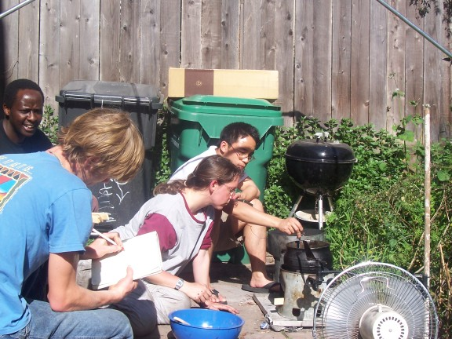

Charles Kirubi
Jesse Woo
Susan Amrose
Teddy Kisch
5/10/06

Introduction

Overview of Conflict in Darfur
Covering an area of 2.5 million square kilometers, or ¼ the areas of the US, Sudan is the largest country in Africa, located in the northeast just south of Egypt. Around 200 different languages and dialects are used by the 40 million Sudanese people. The majority of the country (93%) is desert and the per capita GDP is about $1820 (ppp US$). The nation has just recently (as of January 2005) negotiated a difficult peace after 50 years of devastating civil war between the Muslim north and the Christian and animist south. However, even as this peace was being negotiated, armed conflict broke out in the western region of Darfur.

Darfur is a very poor region about the size of France. There has been tension there for many years, mostly over land and grazing rights between nomadic Arabs and black African farmers from the Fur, Massaleet and Zagawa communities. Warfare erupted in early 2003 when the non-Arab African rebel group known as the Sudanese Liberation Army/Movement (SLA/SLM), later to be joined by the Justice and Equality Movement (JEM), attacked the Sudanese government forces and ethnic Arab militia. Their demands were for the government to bring an end to the region's chronic economic and political marginalization and to provide protection for their communities against attacks by armed nomadic groups. In response, an Arab militia known as the Janjaweed, widely believed to have been supported by the Khartoum government, began terrorizing and destroying the homes of unarmed civilians belonging to the same ethnic groups as the rebel groups. Human Rights Watch, an NGO dedicated to protecting human rights, reports that the Janjaweed focus their attacks on looting, burning, and plundering villages and killing civilians, and that they have complete immunity from any sort of criminal prosecution from the government.

As a result, about 2.3 million people (out of a population of about 6 million) have been displaced in Darfur during the past three years. Most of the Internally Displaced Persons (“IDPs”) are black Africans, but there are also displaced Arab communities whose villages were attacked by African groups and who are victims of inter-African ethnic fighting. The displacement of over 2 million people has turned into a humanitarian crisis of which supply and demand of energy for cooking is but one critical dimension of the escalating crisis.

Project overview and statement of the problem

The energy challenges arising from over 2.3 million IDPs living in dense scattered camps in Darfur unfold in multiple dimensions. First, as Darfur is an arid region with limited vegetation cover, women and children spend over 7 hours per day gathering fuelwood at the expense of other more productive activities (Galitsky et al. 2006). Second, unsustainable fuelwood harvesting contributes to severe denudation of arid land, inhibits natural regeneration of vegetation, accelerates soil erosion and exacerbates overall land degradation. Third, venturing outside the camps to collect fuelwood exposes women and children to incidents of abuse and rape by the Janjaweed militia. Doctors Without Borders issued a statement in March 2005 noting that it alone treated almost 500 rapes in a four-and-a-half-month period. When asked why only women collect firewood when they are raped, one woman reportedly explained, "It's simple. When the men go out, they're killed. The women are only raped" (Kristof 2005). According to the head of UN Humanitarian Affairs in Darfur, fuelwood collection has become the “largest security operation” in the region.

To address the energy crisis, a team from Lawrence Berkeley National Lab (LBNL) visited Darfur region in November 2005. In conjunction with CHI International (a non-profit operating in Darfur), the LBNL team visited different camps, assessed the fuelwood crisis and tested a few alternative designs of improved cookstoves from India. The team identified five principal factors that influence fuelwood consumption in a cookstove: the cook’s fire tending skills, the fuel, the stove, the pot and the food and how it is cooked. The final recommendations for the most feasible and effective way to influence fuelwood consumption were aimed at modifications of the stove (along with training of cooks). Based on their preliminary field tests, the team recommended further modifications on an Indian model known as the Tara Stove - in two key ways. The objective of the first modification was to accommodate the vigorous cooking style employed by the IDPs in Darfur. The objective of the second was to minimize convective heat loss from the stove, particularly during the breezy weather in which food is commonly prepared in Darfur. These recommendations defined the problem and scope of work undertaken by our group during the class “Design for Sustainable Communities” during the Spring Semester (January-May) 2006.

Broad Objectives
Building on the previous work by the LBNL team, our broad goal was to continue their efforts towards designing and disseminating a cookstove for the Darfurian IDPs that would save fuel, be low cost and culturally appropriate in Darfur. The best way to do this was to try to implement the two recommendations of the LBNL team. Thus our broad objectives for the semester were to design, fabricate and test mechanical modifications of the Indian Tara stove with a view to (1) make the stove stable in the presence of vigorous stirring; and (2) minimize convective heat loss from the stove during breezy weather.
In addition, we would strive to meet both objectives in a way that would not significantly increase the cost of the stove and would allow for the possibility of local manufacture.
The design was also to embody other user-friendly attributes such as portability and safety.

Specific objectives
With the aim of achieving our two broad objectives by the end of the semester, our group came up with the following specific objectives:
  - Come up with a robust design that could be fabricated and tested within the time and resource constraints of one semester (this includes evaluating design ideas according to set criteria).
  - Develop appropriate protocols to compare fuelwood savings between the modified and unmodified Tara stove for traditional IDP meals, in both windy and non-windy conditions.
  - Develop an appropriate protocol to compare the stability of the unmodified and modified Tara stove taking into account vigorous stirring of traditional IDP meals.
  - Fabricate and test the modified Tara stove according to the above protocols.

Motivation and significance of the project
Despite a disproportionately large share of security personnel involved in protecting women and children who gather fuelwood in Darfur, their safety outside the camps cannot be guaranteed. Moreover, in severely resource-poor conditions as is the case in Darfur, the more security and other resources (financial, administrative, etc) devoted towards fuelwood gathering, the less the resources available for other endless and equally important humanitarian services. Thus addressing the fuelwood crisis is of fundamental importance and priority. In addition, modifications that enable the final stove design to deliver substantial fuel savings will go a long way in mitigating land degradation in Darfur and surrounding areas.

But why did we exclusively focus on improved stoves and not other types of fuels? Alternative cooking fuels and technologies such as solar cookers, liquefied petroleum gas (LPG), and kerosene are inappropriate in Darfur for a variety of reasons. At first glance, solar cookers appear to be a suitable alternative as Darfur experiences tropical (hot) sunny weather most of the year (over 100F in summer). However, the local staple foods are vigorously stirred during cooking and require constant attention, making the solar cooker untenable. Low cost solar box cookers are more suitable for meals that do not require constant attention and/or stirring such as rice. Other fuels such as LPG and kerosene pose acute and significant fire, health, and security hazards because the IDPs’ hutments are made from straw and tarpaulin. In addition to this, the costs of importing and supplying the fuel and requisite appliances are prohibitive (Galitsky et al. 2006). Other alternative fuels such as biomass briquettes and biogas are severely constrained by the lack of sufficient and reliable supplies of feedstock or raw materials.

For these reasons, and given the limited time and resources available, improved woodstoves are the best bet for responding to the energy crisis in Darfur. That the stoves can be locally and rapidly fabricated and deployed at relatively low capital cost is another major advantage for supporting this intervention. Another critical motivation was to undertake a project that permitted hands-on learning and application of the principles underpinning designing for sustainable communities discussed in class. We selected the improved stove project because it permitted direct exploration and contending with a wide range of sustainability challenges including affordability and cultural appropriateness of the final stove design. Further, the stove project permitted and benefited immensely from the inter-disciplinary character of the class team, which included a physicist (Susan Amrose), mechanical engineer (Jesse Woo), environmental scientist (Teddy Kisch) and energy specialist (Charles Kirubi).

The Design Process

Conceptual framework
We began our brainstorming process by researching some of the theory behind woodstoves and sustainable design process. Conceptually, two principles underpinned and guided the design process in this project: (1) the theory of combustion and heat transfer in a typical woodstove, and (2) designing for sustainable and resource-poor communities.

Basic stove theory of combustion and heat transfer
The primary goal of an energy efficient stove is twofold: convert as much wood as possible into energy (combustion efficiency) and transfer as much of the released energy into cooking the contents in the pot as possible (heat transfer efficiency). An open fire is often 90% efficient at the work of turning wood into energy but only 10-40% of the released energy makes it to the pot (Aprovecho, undated). Improving combustion efficiency helps to reduce harmful smoke and emissions while improving heat transfer efficiency helps save fuel. To achieve the twin objectives of reducing emissions and saving fuel, the stove designer’s job is to first clean up the fire and then force as much energy into the pot or griddle as possible (Aprovecho, undated). In theory, both functions can and should be accomplished in a well-engineered cookstove. In practice, however, not every “improved stove” saves fuel and some can even be worse than three-stone fires. For instance, the LBNL team documents the disappointing performance of the “improved mud-stoves” introduced by ITDG (Practical Action) in Darfur (Galitsky et al. 2006). Since our group was starting from an existing Tara design, our project placed more emphasis on enhancing fuel savings (via heat transfer efficiency) than on reducing emissions (via combustion efficiency).

In wood burning stoves, a lot of heat is transferred to the pot by convection. Forcing hot flue gases to flow past the surface area of a pot in a narrow channel (flue gap) is a stove strategy promoted by both Dr. Samuel Baldwin and Dr. Larry Winiarski (Aprovecho, undated; Baldwin, 1987). Popularly known as the “rocket” stove design, Dr. Larry Winiarski created the pot skirt (or collar), which is a cylinder of sheet metal that surrounds the pot and forms a narrow channel increasing heat transfer efficiency (see Figure 1).

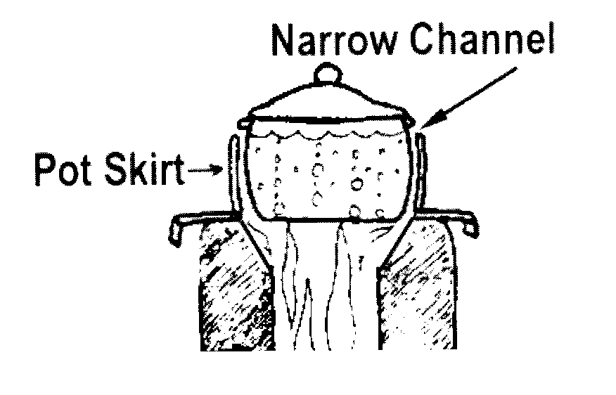
Figure 1: The narrow channel (flue gap) close to the pot increases convective heat transfer (Aprovecho, undated).

The Aprovecho Research Center on wood cookstoves identifies three key ways to increase convective heat transfer: (a) the flue gases scraping the surface to be heated should be as hot as possible; (b) the surface area of the heat exchanger (e.g., pot or griddle) should be as large as possible; c) the velocity of the hot flue gases should be increased as much as possible (Aprovecho, undated). A faster flow over the exterior of the pot disturbs the stagnant boundary layer of air that slows effective heating. To permit smooth flow of air via the flue gap, the size of the flue gap must be well balanced in relation to firepower and surface area of the firebox. This is important because narrowing the gap increases heat transfer efficiency but also decreases the flow of air through the stove. As more wood is burned per minute, more air is needed to support both the combustion and the necessary flow to avoid a back draft into the room, which would increase indoor pollution. If the gap is too small, the fire may burn well while simmering but will be short of air when operated at high power. Conversely, very large channel gaps will sustain a large fire (high power) but some amount of heat will be lost unnecessarily due to poor heat transfer, resulting in low fuel savings.

Designing for sustainable and resource-poor communities in Darfur

The overarching theme running through the class was the challenge of designing for sustainable communities with a special emphasis on resource-poor regions. The energy crisis unfolding in Darfur poses three key sustainability challenges: humanitarian, financial and ecological. With over 2 million IDPs in densely populated camps, the lack of adequate energy supply, particularly for cooking, is but one dimension of the humanitarian crisis. As in other refugee-type and resource-poor conditions, the energy crisis has both supply and demand-side components. Energy supply is particularly complicated by the fact that Darfur is an arid region with scarce supply of biomass for use as fuelwood. Moreover, supply of alternative fuels to fuelwood is (currently) unsustainable and untenable for a variety of reasons (see sec 1.5 above). From a sustainability perspective, however, we hesitate to conclude that fuelwood and improved woodstoves should be viewed as the “silver bullet” to the energy crisis in Darfur. That would be a static and limiting strategy whereas sustainability ought to embody dynamic innovation and flexibility. Thus, as more experience and capacity are established locally and (hopefully) more resources become available for energy services, additional innovation could be devoted into expanding the fuel and technology choice available to IDPs (e.g., fireless cookers, solar cookers, etc.).

The demand side presents other constraints too. As noted earlier, the traditional method in which the food is cooked has, among other factors, significant influence on fuelwood demand. This aspect represents the cultural dimension of the sustainability challenge our design had to grapple with. But who cares about culture in a humanitarian crisis of Darfur’s magnitude? Despite severe deprivations and poverty in Darfur, our advisor and part of the LBNL team, Ashok Gadgil strongly argues that the IDPs intimately value their indigenous foods (specifically mulah and assida, which will be discussed at length in section 4) as well as their cooking pots (round-bottomed pots or “Tungutungus”) and will go to great lengths to retain this culture. Studies show this cultural aspect is not unique to Darfur. Masera et al. (2000) have noted that cultural factors (such as specific cooking practices, habits and religious beliefs) constitute a wider set of complex interactions that determine fuel choice in households in many parts of developing countries.

Design Ideas
During the course of the semester, our team met for several brainstorming sessions with Ashok Gadgil in order to put our conceptual framework to use. These sessions served as a forum for discussing the feasibility and effectiveness of numerous design modifications aimed at meeting one (or both) of our two broad objectives. These sessions were invaluable in determining the final product design. This section of the report delves into examining the many ideas that were generated and considered along with an analysis of why each idea was either accepted or rejected for fabrication.

The unmodified Tara stove fabricated by the LBNL group and tested in the field was found to be 50% more efficient at burning firewood than the local three stone cooking method (Galitsky et al. 2006). However, room for improvement was obvious just from looking at the traditional round bottom pot on the stove. The size and shape of the pots used by the IDP community were never considered in the design of the original Tara stove (it was for use in India), and so it was designed to house a cylindrical flat bottom pot. This resulted in the small and large traditional pots resting slightly above the stove with a large gap (see Figure 2). This position exposed the pot’s bottom to the high winds, killing off the heat transfer from the fire to the pot. Simply reducing this gap would improve the heat transfer and save even more fuelwood. In addition the unmodified Tara had large air hole openings around the bottom as well as in the firewood door. These shortcomings were all places where we could potentially modify the stove.

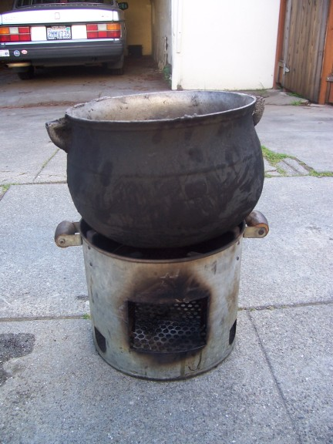
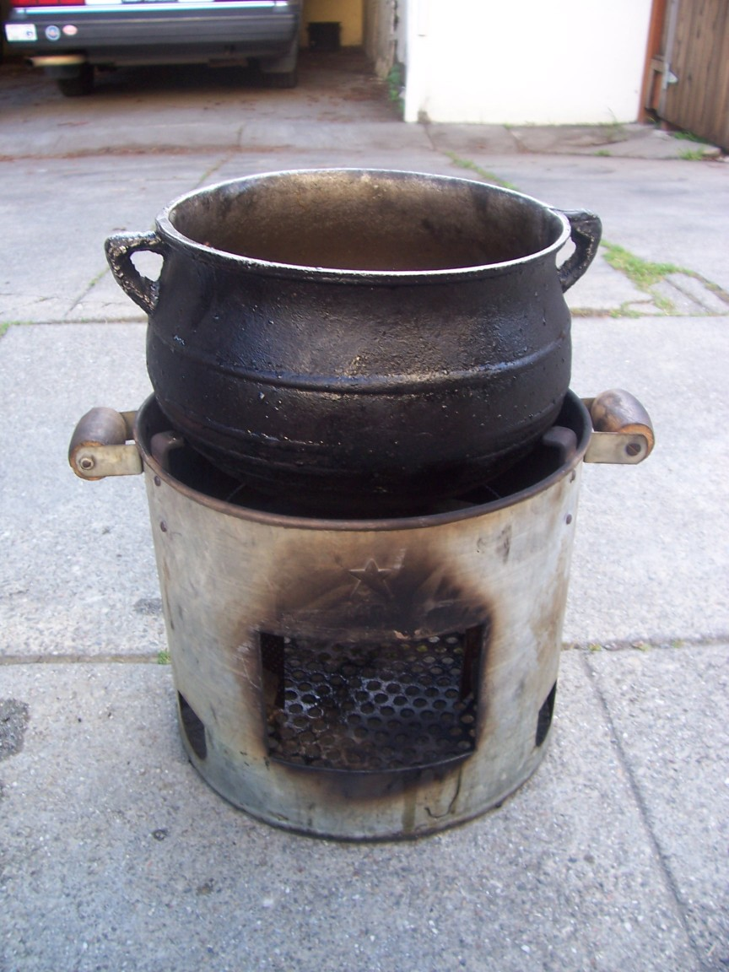
Figure 2: (Left) Small pot sitting on top of unmodified Tara stove. (Right) Large pot sitting on top of unmodified Tara stove.
In order to address the gap, our first idea was to cut down the three bracket points and thus allow the round-bottomed pots to sit further inside the stove (see Figure 3a). The brackets existed to maintain some gap between the pot and stove, so we did not was to remove them entirely. Since this was an easy modification and ill side effects were unlikely, we immediately accepted this idea and cut down the brackets by 2mm. To further shield the stove-pot gap from the wind, a metal windshield was devised to be offset from the top of the stove itself (see Figure 3b). This would further reduce the ability of the wind to blow heat away from the sides of the pot as it was rose from the hot center of the stove. Finally, we also agreed on reducing the effective air hole area that was directly in line with the wind by changing the stove’s lower air holes into air slats. That is, instead of cutting holes into the lower rim of the stove (as seen in Figure 3a and 3b), slats would be cut forming metal tabs, with each alternate tab being pressed in by hand so that air could enter from the sides (see Figure 3c). This would prevent high velocity wind from blowing directly into the stove and increasing the speed with which hot air was forced out. These three modifications were accepted as the winning ideas to fabricate and test.

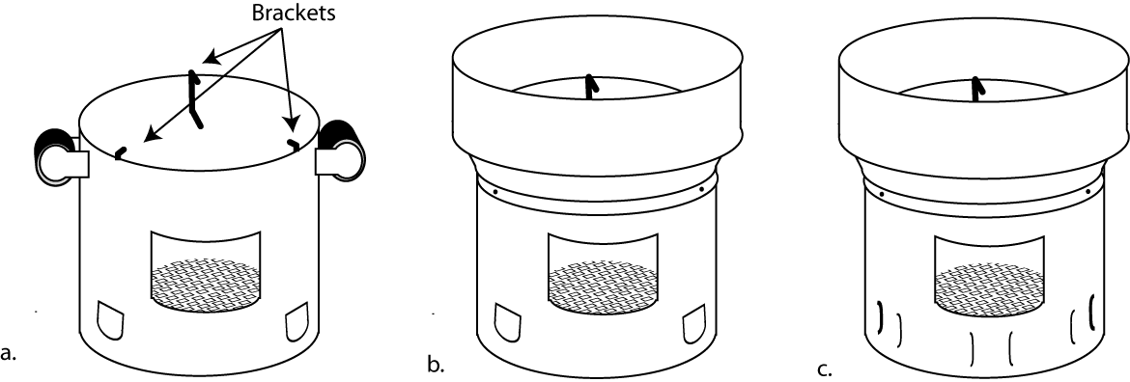
Figure 3: Accepted wind modifications: (a) shortened brackets on original Tara; (b) wind collar (note that the stove handles have been removed); (c) wind collar plus slats instead of holes around the bottom of the stove.

One idea for combating the wind that was rejected is listed below:
- Latch door to shut the stove’s opening that feeds firewood (see Figure 4).
Pro:
- The constant high winds will make the initial combustion of firewood difficult. In addition, excess air must be minimized.
Con:
- Psychologically, people find it cumbersome to have latch doors. A latch door will fail after several repetitious usages.

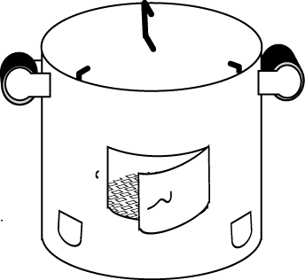
Figure 4: Rejected wind modification: a latched door to close off the firewood opening.

The second problem with the unmodified Tara was its tendency to tip during the rigorous stirring involved in IDP cooking. The LBNL team noticed some IDP women secure the instable stove-pot system with a rod either laid horizontally on top of the pot or through the bottom air feed holes. This quick fix required several people and made the stove difficult to use. We thought of many possible ways to stabilize the stove, finally settling on attaching a set of three bent steel rods (like tent stakes) to the side of the stove. The rods would be free to move within brackets, and so could be hammered into the ground several inches and prevent tipping even in the presence of strong horizontal forces (see Figure 5).

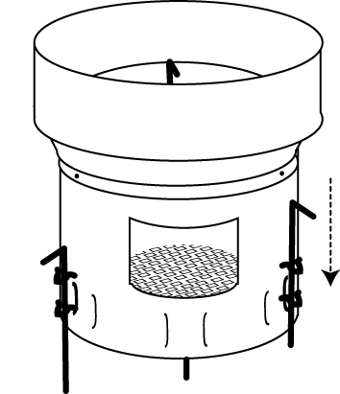
Figure 5: Accepted design for stability (after wind modifications): three bent rods attached by brackets to the stove. These rods can be pounded into the soil to create stability.

Again, we rejected numerous ideas before coming to our final design. They are listed below followed by a list of pros and cons (the cons ultimately outweighing the pros):

1) A cookstove with a wider diameter to fit the Assida pot.
Pro:
- Initially, the team believed the rod was used to secure the large Assida pot from slipping off the stove’s bracket tabs.
Cons:
- During an assessment of another Sudanese region’s test site and consultation from Christie, there was a breakthrough realization that the main problem was the instability of the stove-pot system and not isolated to the stove’s inability to secure the pot.
- If the stove’s diameter increased, the Assida pot would sink deep into the stove but it would not solve the problem of the stove-pot system from tipping over.

- Stainless steel spring loaded brackets to secure the Assida pot.
Pro:
- If installed, the brackets would press upon the surface of the pot, increasing the contact surface area between the tabs and the Assida pot.
Cons:
- The 3 point contact with the three tabs is an effective method in holding the pot in place.
- The problem isn’t the Assida pot slipping off from the bracket tabs.

- Unused stones from the three stone method used to stabilize the stove (see Figure 6a).
Pro:
- Figuring it was a stove-pot system problem, the use of stones would be a cheap and effective method of stabilizing the problem.
Con:
- There is a limited supply of stones in the Darfur refugee camps. In addition, stones could be too small to secure the stove.

- Tripod rods stabilizing the stove (see Figure 6b).
Pro:
- Easily able to withstand large lateral forces.
Cons:
- If implemented, the design would be bulky and more material would be used in the manufacturing of these stoves.
- The tripod legs can fail if bent slightly.
- There is no assurance of a leveled ground which will hinder the effective use of the tripod.

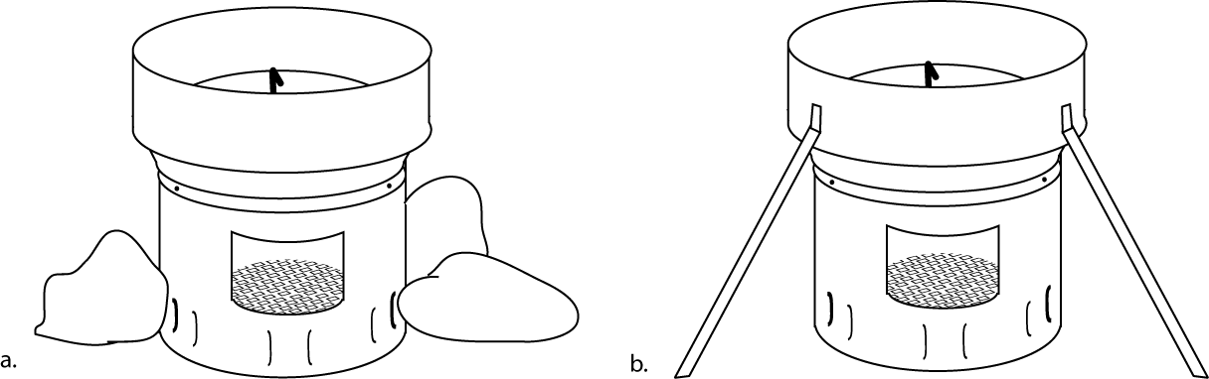
Figure 6: Rejected stability modifications I: (a) use of local rocks to stabilize stove; (b) tripod attached to wind collar (note: third leg is behind the stove).

- Hinged brackets to hold the pot in place with the upper tab limiting the movement of the pot (see Figure 7a).
Pros:
- Contained within the stove (no protruding parts).
- No directions needed - the mechanism would be triggered by normal use of the stove.
Cons:
- There is a history of products failing with the presence of moving parts in developing countries.
- Once the hinge is loose and breaks down, replacing the piece can take horrendous time in developing countries.

- Long rods run through air holes and attached to ground via bent horseshoe-shaped rods (see Figure 7b).
Pro:
- This models the design that some IDPs were already using to stabilize the stove.
Cons:
- Requires extra pieces that may be lost.
- Requires holes instead of slats around the bottom rim (incompatible with our wind modifications).

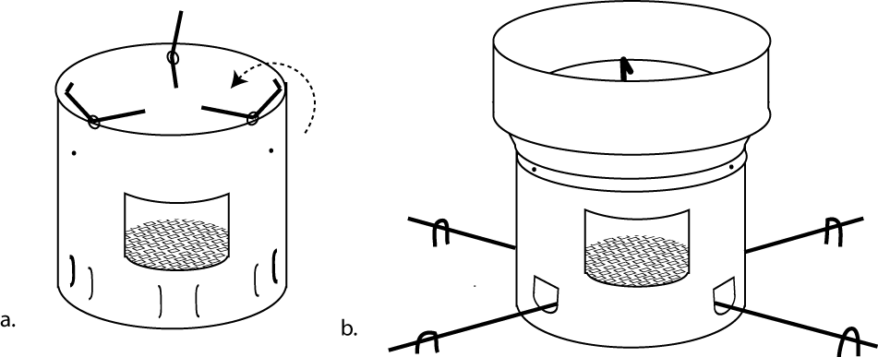
Figure 7: Rejected stability modifications II: (a) hinged brackets that grip the pot as it is lowered into the stove (wind collar not shown); (b) long rods through air holes held in place by horseshoe-shaped rods. Note that this is incompatible with the slat air hole design.

- Interior horizontally flat annular ring with point welds to the stove.
Pro:
- Theoretically, there would be a constant support if the pot is tilted for cooking purposes but again it should be emphasized that 3 points stabilizes anything.
Cons:
- The idea is an example of a ball and socket joint. The pot could actually slip off more easily than the 3 points method.
- The idea can introduce the piston-cylinder problem. It is dangerous to limit the gap between the stove and pot. There needs to be a proper size gap to optimize the heat transfer to the sides of the pot or the exit of the hot flue gases generated from the fire.

Fabrication

After the stove design was finalized, fabricating the necessary modifications was the next step. The group used the machine shop at LBL maintained by Jonathan Slack. Through his guidance, the group independently machined and assembled the additional parts to the existing Tara stove.

Approximately several millimeters of the upper bracket tabs were cut with a hacksaw. The stove was held inside a vice and after several iterations of adjustments to attain a comfortable position, the tab was sawed off with a hacksaw.

The sheet metal wind collar was bent into an open ended thin cylinder. Punched holes at the ends were fastened with a screw-nut combination. At the bottom of the sheet metal wind collar, cut out rectangular pieces were bent inward, which were then used to attach to the original Tara stove. The bottom gap between the stove and the wind collar would eventually be sealed with aluminum foil during testing. It is imperative to seal the gap because high pressure from the hot flue gases mixed with the low pressure from the ambient air will cause a decrease in heat transfer efficiency.

In addition, a thin sheet metal rectangular piece was cut, punched and installed in the region below the grate holding the firewood. The purpose of this thin rectangular piece is to block out the high winds entering into the air feed holes. This was done to simulate the slat geometry of our final design. Unfortunately, we did not have the ability to fully implement the slat design for our initial tests.

Lastly, the brackets to hold the “L” shaped 1.5 foot metal rods were installed (the stability modification). Using a power drill, the bracket’s position holes in the stove were created. The brackets were then fastened to the Tara stove with a screw-nut combination.

Figure 8 shows the final modified stove and how it holds both the large and small traditional pots.

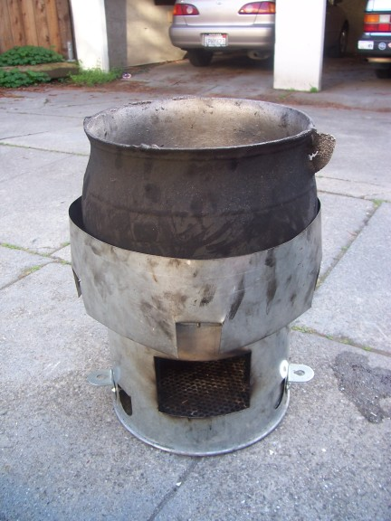
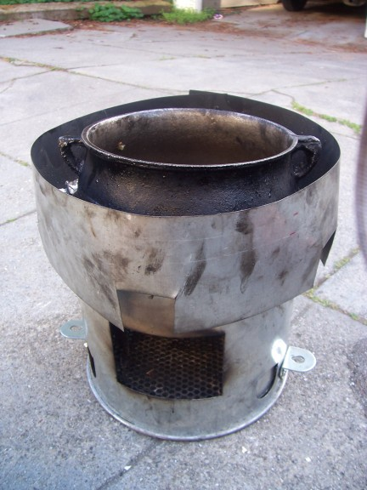
Figure 8: (Left) The modified Tara stove with the small traditional pot. Note how far it sinks into the stove. (Right) The modified stove with the large traditional pot. The wind collar effectively shields the large air gap that was present on the unmodified stove.

Methods

Fuelwood Savings Tests
One of our tasks was to design test protocols for computing the fuelwood savings between the modified and unmodified Tara stove while cooking a traditional IDP meal in traditional IDP pots. This required us to think more closely about the meal and the pots in order to simulate each in a (relatively) controlled environment. The staple meal of the IDP camps includes assida and mulah. Assida is a dense bread-like substance made from flour and water that is cooked until the water is completely absorbed and the starches coalesce. It is commonly prepared in the largest round-bottom pot and involves the vigorous stirring mentioned earlier. Mulah is the sauce poured over the top, traditionally prepared from sautéed onion, garlic, okra, dried meat, (or yogurt in place of meat), dried tomato, rock salt, and chili (Galitsky et al. 2006). It is commonly prepared in the smaller round-bottom Tungutungus pot that we were lucky enough to inherit from the LBNL group. We developed two separate protocols for simulating these meals, an Onion Test (OT) to simulate the mulah and a Water Boiling Test (WBT) to simulate the assida.

Mulah Protocol
We started with the mulah because we already had possession of the small pot that mulah is traditionally prepared in. Most of the heat used in making mulah goes to the task of frying its primary ingredient - the chopped onions. Thus we ignored the other ingredients and simulated the mulah using a mixture of corn oil and chopped white onions, both of which are readily available and can be quickly prepared. Traditionally, mulah contains about 400mL of oil and 3.5 cups of onions. Since we were interested in comparison testing and not in absolute wood use, we chose to use half of this amount (200mL oil and 1.75cups of onions) in order to decrease the total time of each test. We also knew that convective heat loss was aided by the constant stirring of the mulah and the lack of a lid. Thus all of our tests would include constant stirring and no lid.

Onions are considered fully cooked when they become translucent and begin to brown. We found that this state was hard to gauge by eye alone in a way that was consistent enough for our purposes. Some basic physics principles allowed us to establish a more accurate and reproducible end point. In order for the onions to become translucent and brown, the water in the raw onion pieces must be completely boiled off. We know from thermodynamics that as water approaches its boiling point, the energy going into the water ceases to increase its temperature and begins to go into changing the water’s phase from a liquid to a gas. When all of the water has changed phase, the heat again begins to increase the temperature of whatever is left, in our case solid onions. The dried out onions then brown and eventually burn. Having the ability to measure the temperature of the oil/onion mixture during cooking, we set out to see if we could determine by eye the point when the temperature started to increase again after flattening out during the boiling phase. We called this the elbow point because it bends upwards like an elbow on the temperature with time graph.

We first set up a series of tests using the oil/onion mixture in a standard American flat-bottomed pot on a gas stove range. For each test, we used a thermocouple taped to a wooden spoon to record the temperature of the mixture as it was heated. All of our tests spanned the time between turning the heat on and the time when the onions were clearly burned. The purpose was (1) to determine if we could see the elbow point and (2) to characterize that point either by its temperature or time of onset. We also changed the stirring speed and power level on the range to see if and how these would affect the elbow point. The results of our initial stovetop tests are shown in Figure 9.

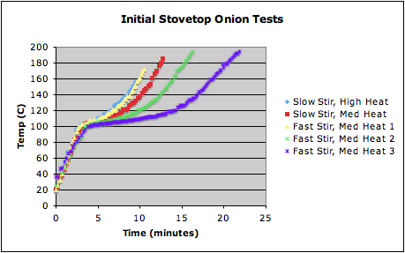

Figure 9: Heat curves from initial onion tests. The change of slope near 120°C is the elbow point. It designates that all of the water in the onions has boiled off.

The initial large slope in all of the tests occurs as the temperature of the oil/onion mix rises from room temperature to the boiling point of water (100°C). The first change in slope occurs when the boiling point is reached and the slope flattens out as heat is used to turn the water into steam. The second change in slope occurs when the water has completely boiled off (the elbow), and the heat begins to raise the temperature once again. We found that the elbow is visible in the graph (though not as sharply defined as we had hoped) and occurs around 120°C regardless of power level or stirring speed.

However, these tests were not completely satisfying. We saw the expected increase in total cooking time as the power was lowered or the stir speed was slowed, but we also saw large differences in total time between tests that were supposed to be identical (in terms of stir speed, power level and initial temperature). The most likely explanation was that the rate of natural gas coming to the burner was changing slightly with time, thus affecting the actual power produced from a given power setting. To test on a more stable power setting, we repeated the stovetop tests using an electric range. Our first attempt failed due to effects from other burners on the range that were turned on during our tests. However, our second electric range test (with all other burners off) showed the results in Figure 10. These tests show cooking times within 10% of each other (using the time to reach 120°C) for identical stirring speeds, power settings, and initial temperatures. We verified by eye that 120°C was a reasonable temperature to end our future tests.

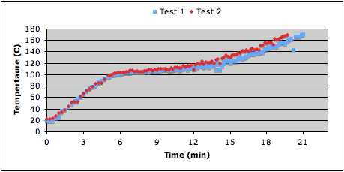
Figure 10: Identical onion tests on an electric range (<10% variation between tests).

Our final testing protocol for simulating mulah was to bring a mixture containing 200mL corn oil and 1.75 cups of onions chopped into small (~3-4 cm) pieces from room temperature to 120°C. The mixture was constantly stirred at a rate of about 1 bowl diameter per second. This protocol was dubbed the Onion Test.

The first time we tried this test in the field, we recorded the temperature every few seconds just as we had for the stovetop tests. The resulting heat curve from our first test (Figure 11) verifies that the behavior is the same over a wood fire as it is on an electric range. Note that we stopped the field tests once the temperature reached 120°C, so the behavior above the elbow is not visible. In additional, the heat curve shows that the onions take longer to rise to their boiling temperature on the unmodified stove, verifying that the modified stove does improve heat transfer to the pot.
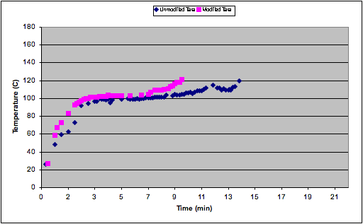
Figure 11: Heat curve for the first onion test in the field. Note that field tests are ended when the temperature hits 120°C.

Assida Protocol
To simulate the cooking of assida, we first needed to find a large pot similar to the traditional one. Specifically, we needed the pot to have a similar arc length around the bottom. It was because of this shape, and the resulting gap between the stove and pot, that the original stove was losing so much heat in the presence of a small breeze. In addition, the fit between the stove and pot was a key cause of the stability problems we were trying to fix. Ideally, we would use an actual Tungutungus pot from Darfur, however we initially felt it would take too long to arrive for it to be useful. Thus we set out to find a pot with a similar arc length and diameter. We searched ebay, flea markets, thrift stores, and both Indian and Mexican themed shops. We tried copper kettles, metal mixing bowls, woks, plastic mixings bowls (for stability tests only) and finally ordered a wrought iron pot of a remarkably similar shape from an online store. That pot never actually arrived. In the end, we were able to receive a genuine large Tungutungus pot used to make assida in Darfur through the mail from Sudan after all. Thus all of our assida tests were completed in the same pot.

The assida is mostly water and flour, which must be brought to a boil and simmered until the water is boiled away and the starches coalesce. The heat is mostly used to boil off the water, so using water alone was accepted as a good proxy. We had hoped to use the same amount of water as the IDPs use in assida (2500mL), but we found ourselves limited by the height of a hole in our assida pot. The hole limited the water to 2000mL.

Because using less wood is more efficient, the fire tender tried to use as little wood as possible when bringing the water to a boil. We found that we still needed to use more wood than we used in the Onion Test in order to make sure we could complete the tests in a reasonable (< 2 hour) time. However, the fire tender still aimed to be as efficient as possible given the time constraint. Since our goal was to compare the wood use between stoves (rather than estimate the absolute wood use for making assida), our original protocol called for only 5 minutes of simmering. We later changed this to 15 minutes of simmering to avoid the strong urge to stuff the fire for the remaining 5 minutes (we wanted to get a good idea of the simmer stage as well as the initial heating stage).

Frequently, while trying to use as little wood as possible, the fire would lose some power after boiling had been reached and so the temperature would fall below boiling for some portion of the 15 minute simmer period. We chose not to stop the clock when this happened, but rather to try to bring the water back up to boiling as quickly as possible, noting any lapses in our log. This happened more frequently with the unmodified stove than with the modified stove. However, this would only increase the wood used on the unmodified stove and so increase the fuel savings even further.

Wind
We wanted to find out the fuelwood savings both in the presence of wind and in still air (without wind). To create wind, we used a simple table fan on a low setting facing the stove. A weather station was used to measure the wind, both for tests with wind and without wind (to measure the ambient breeze). Figure 12 shows the team engaged in a wind test. Note the fan blowing towards the stove. We wanted to simulate a medium breeze, so we aimed for a wind speed near the stove of 5-6mph.

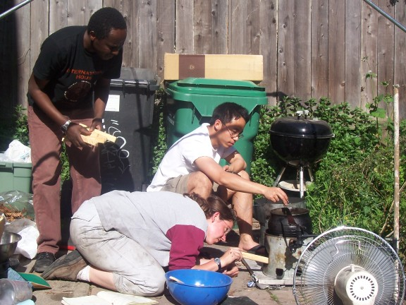
Figure 12: The team tends the unmodified stove during a mulah test with wind (note the fan in the lower right).

Doubled-Up Tests
As a group, we divided ourselves into two person teams in order to increase our total available testing time. Initially, we tried to save time as well by testing two stoves (one modified and one unmodified) side by side. One person was designated to tend the fire on both stoves and the other stirred the contents of both pots. After some time, we realized that this was compromising our test results. It was too hard for the fire tender to carefully watch and tend both fires at once. In addition, the mulah test always went faster, so we would be stuck dousing the fire on one stove and neglecting the other for a time. Because the assida test was always the neglected one, the doubling up had more effect on the assida tests than on the mulah tests (where it was not observed to have an impact). In addition, when the fan was providing wind, the neglect of the assida stove was far more disruptive than during the tests without wind. Thus we had to throw away any results for assida tests with wind that were completed during a doubled up test. This accounts for the disproportionate number of mulah tests and assida tests without wind reported in our findings.

Stability Protocol
The test the increase in stability added by our modifications, we compared the lateral force required for the stove to just begin to tip. The assida pot was filled with 3.4kg of water to simulate the 3.4kg of combined water and flour that usually fills the pot when making assida. We then tied a cord around the widest point on the pot and applied a lateral force to the cord (Figure 13). This simulated the force applied by the stirring stick while stirring assida (the stick tends to push out on the pot from the widest point). We used a hand held scale (essentially a spring balance) capable of measuring up to 12kg weight (117N of force) to measure the lateral force required to tip the stove.

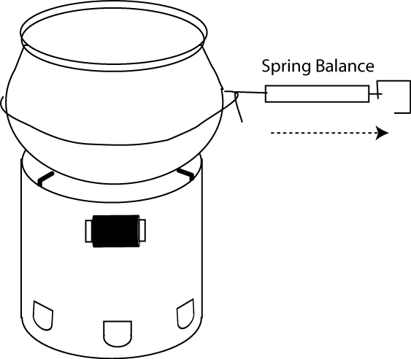
Figure 13: Schematic of the setup for stability testing (showing the unmodified Tara stove). The spring balance was pulled laterally until the stove just began to tip.

Findings

Fuelwood Savings

Mulah tests
The mulah test was repeated several different times, both with and without the wind. The resulting fuelwood savings are summarized in Tables A and B. Figure 14 compares the fuelwood savings for the test with and without wind.

Table A: Mulah test without wind: unmodified vs. modified Tara stove
 | Unmodified Tara |  | Modified Tara
Test Date | Time-reach 120C | Fire wood used (g) | Time-reach 120C | Fire wood used (g) | Relative Firewood Savings [Wood (unmodified) - Wood (modified)] x 100/ [Wood (unmodified)] *
3/10/06 |  | 171 |  | 106 | 38.01%
3/14/06 |  | 302 |  | 122 | 59.60%
4/4/06 | 23 min | 201 | 17 min | 107 | 46.77%
4/15/06 | 20 min | 215 | 12 min | 132 | 38.60%
4/18/06 | 31 min | 229 | 17 min | 156 | 31.88%
4/24/06 | 35 min | 321 | 32 min | 236 | 26.48%
 |  |  |  | Mean | 40.22%
 |  |  |  | Standard Deviation | 11.70%
*Regarding all tables, the wide range of values is due to various variables such as rainy conditions, doubled up duty of the fire tender, the absence of a consistent fire tender and stirrer, hot/cold stove, size and age of chopped onions, uneven distribution of wind generated by the fan, and periods of low level flames.

Table B: Mulah test with wind: unmodified vs. modified Tara stove
 | Unmodified Tara |  | Modified Tara
Test Date | Time-reach 120C | Fire wood used (g) | Time-reach 120C | Fire wood used (g) | Relative Firewood Savings
4/17/06 | 21 min | 354 | 8 min | 175 | 50.56%
5/1/06 | 14 min | 357 | 12 min | 152 | 57.42%
5/1/06 |  | 313 |  | 120 | 61.66%
 |  |  |  | Mean | 56.55%
 |  |  |  | Standard Deviation | 5.60%
Figure 14: Mulah test: Relative fuel wood savings “with” and “without” wind test conditions
A 40.22% relative savings in firewood under the absence of wind clearly shows an increase in heat transfer efficiency once the mulah pot is sunk deeper into the stove’s cavity. It can be attributed to how the generated heat travels a shorter distance to reach the bottom of mulah pot as well as the increase of heated surface area. The simple modification of cutting off 2 mm from the three bracket’s upper tabs, can contribute to an enormous savings in firewood.
In the presence of wind at speeds up to 6 mph, the addition of a wind collar plus the sunken pot contributed to a 56.55% relative savings in firewood. The wind collar is effective in blocking out wind currents cutting off the heat transfer path.

Testing the unmodified Tara stove in the Darfur refugee camps, scientists calculated that the stoves contributed to a 50% savings in firewood compared to the local three stone cooking method. Now with the additional modifications, the Tara stove would achieve even greater savings in firewood. With our collected experimental values and the following equation [50% + X (mean)%*50%], we can make a general calculation of how much the modified Tara stove saved on firewood compared to the three stone fires.

Under the conditions with and without wind, the modified Tara is calculated to save 78% and 70% of the firewood used in the three stones method cooking mulah, respectively.

Assida
The assida test was also repeated several different times, both with and without the wind. The resulting fuelwood savings are summarized in Tables C and D. Figure 15 compares the fuelwood savings for the test with and without wind.
Table C: Assida test without wind: unmodified vs. modified Tara stove
 | Unmodified Tara |  | Modified Tara
Test Date | Time-reach 98C | Fire wood used (g) | Time-reach 98C | Fire wood used (g) | Relative Firewood Savings [Wood (unmodified) - Wood (modified)] x 100/ [Wood (unmodified)] *
4/15/2006+ | 27 min | 521 | 27 min | 473 | 9.21%
4/18/06 | 34 min | 545 | 42 min | 490 | 10.09%
4/26/06 | 21 min | 492 | 19 min | 464 | 5.69%
 |  |  |  | Mean | 8.33%
 |  |  |  | Standard Deviation | 2.33%
* Please refer to footnote under Table A
+ 5 minutes simmer time compared to 15 minutes

Table D: Assida test with wind: unmodified vs. modified Tara stove
 | Unmodified Tara |  | Modified Tara
Test Date | Time-reach 98C | Fire wood used (g) | Time-reach 98C | Fire wood used (g) | Relative Firewood Savings
4/29/06 | 72 min | 2269 | 9 min | 460 | 79.73%
5/3/06 |  | 1459 |  | 454 | 68.88%
 |  |  |  | Mean | 74.30%
 |  |  |  | Standard Deviation | 7.67%

Figure 15: Assida test: Relative fuel wood savings “with” and “without” wind test conditions
An 8.33% relative savings in fuelwood under the absence of wind demonstrate how minor the assida pot would benefit from the cut upper bracket tabs. Since the assida pot has a greater diameter and median arc length than the mulah pot, the larger pot sunk only several millimeters, a distance that doesn’t significantly change the fuelwood savings. The collar served no purpose since there was no wind.
However, under breezy conditions, boiling the water with the assida pot with the modified Tara stove was substantially beneficial. The addition of the wind collar was the main contributor to the 74.30% relative savings in firewood. Several times during test runs, the fire slowly died out because of the constant wind currents suppressing the direct heat transfer path. When temperatures remained constant for several minutes, the fire tender improvised and overstuffed the stove cavity with firewood. The medium fire level that the fire tender aimed off was insufficient to reaching the 98ºC boiling temperature mark. Under the breezy condition without the collar, the flames that reached the bottom of assida pot swayed and drifted off away from the central concentrated zone. Under the same conditions with the collar, the observed flames focused on a central location at the bottom of the assida pot.

Under the conditions with and without wind, it is calculated that the modified Tara saved 54% and 87% of the firewood used in the three stones method cooking assida, respectively.

Stability
The stability test was carried out on both the modified and unmodified stove once. The results are summarized in Table E.

Table E: Mechanical Stability
Terrain conditions: well packed dirt
Date | Lateral Force (N)
5/5/06 | Unmodified Tara Stove | Modified Tara Stove
 | 22 | > 117

The force required to tip the unmodified Tara was quite small - only 22 N, equivalent to lifting about 2.25kg. It is not surprising that the IDPs had problems with this stove tipping during the November 2005 visit. However, once the stability modifications are added and pounded into the ground, the stove could not be tipped even when the maximum force measurable on our scale (> 117N or lifting 12kg) was applied. We were able to continue applying force beyond the capacity of the scale and found that it would not tip even with what felt like double the force applied. However, as we attempted to lean with our entire body weight (far more than one would ever push on the pot during normal cooking), the assida pot threatened to slide off of the stove and soak us with water, so we felt it was a good place to stop.

This test was completed in an area with fairly moist compact dirt. We would like to repeat this test on sandy terrain to get a lower limit of the force (Darfur is neither loose like a beach nor hard and compact like moist dirt).

Implications

The modified Tara stove has great potential for improving the safety and security of women. As indicated in Galitsky et al. (2006), women (primarily in North Darfur) are facing significant health and nutrition problems associated with the lack of fuel wood. Currently, the refugees burn a type of wood called oudar, a stick whose smoke can produce blindness (Galitsky et al. 2006). The improved efficiency will reduce the volume of oudar burned, resulting in decreased exposure to its harmful effects.
The greatest impact of the stove on the women would be its reduction in fuel needs. The women who were collecting fuel wood would have the option to only collect fuel wood a quarter of the time. They could also sell additional wood in the market. If the women only collected wood for their own family, then the new stove would result in the women going out four times less often, barring any increase in wood consumption. This could translate into a four times decrease in the incidences of rape and brutality, making the community more secure than before. Regardless of whether women continue to harvest wood or they choose to stay home, the introduction of the stoves will result in a major improvement in community health and safety.

Impact on the local environment

Galitsky et al. (2006) indicate a 260,000,000 kg wood saved per year with the Tara stove. However, the modified Berkeley Tara stove consumes on average half the wood of the original Tara. Therefore, the potential wood savings can be estimated at 520,000,000 kg wood per year with the modified stove. However, this model is based on 100% saturation and no ‘takeback’ (i.e. increased wood consumption due to the increase the number of meals per family per day) (Galitsky et al. 2006). They note that the average walk for fuel wood is one hour farther than last year. Assuming they walk 5-6 kilometers per hour, that means that the fuel source is retreating by 5-6 kilometers each year. A four-time reduction in fuel wood consumption will drastically slow down their advance on the forest, prevent soil erosion, and therefore fight the spread of desertification. It will also help to maintain the current distance from the camps to the wood area, instead of a continual increase of space between the two. This will promote plant and wildlife conservation by dramatically reducing the impact on the ecosystem, allowing it ample time to recover.

Dissemination Plans

Initially, CHF International has a plan to disseminate 10,000 stoves in a pilot study. The stoves will be disseminated through the sheiks, who are the heads of individual family groups. The current dissemination plan is to market the stoves through a micro-lending program, which allows the individuals to pay for the stove with the savings they receive from the stove’s increased efficiency. This process eliminates any extra capital that the family might need to purchase the stove. While this may reinforce the current power structure and divide the haves and the have-nots, we hope that eventually each family will be provided in with a stove. In the past, the refugees have shown resilience and co-operation against harsh conditions, so it would not be surprising to have families with stoves helping out others.

Since the average family pays USD $160 in fuel wood costs per year, it will not take long before the families have paid for the stoves. Payments for each stove will be used to manufacture additional stoves, which will allow the program to continually fund more cook stoves. Through this micro-lending program, the initial stove investment will provide funding for more stoves. In this manner, we hope to ultimately manufacture 40,000 stoves by the end of 2006.

To make sure the families get the most out of their new cook stove, our group plans to have assistants on the ground in Darfur. We will have a two-student team lead demonstrations to educate women how to efficiently operate the stove. The major points of this presentation will focus on constant feeding of the fire, avoiding the overstuffing of the stove, minimizing high power and high flame (unless in severe wind) and preventing the flame from dying. The team will also address any problems in the field that may come up.

Conclusions

Based on robust protocols we developed to simulate traditional foods and cooking habits in Darfur, our findings demonstrate that the modified Tara stove has potential to yield significant benefits in multiple and compelling ways. First, relative to three-stone fireplace, the modified Tara yields 54% and 87% fuelwood savings with and without wind test conditions, respectively. Second, using the modified stove is projected to reduce the time spent collecting fuelwood by a significant factor of four. Third, extra-polating from the fuelwood savings per capita, we estimate that if every household used the modified Tara stove, the resultant fuelwood savings would be in the order of over 500 million Kg. While additional improvements are possible, the current modified Tara stove design represents a win-win design for the IDPs and the environment.

References

Aprovecho Research Center, undated, Design principles for wood burning cook
stoves. Aprovecho Research Center, Shell Foundation Partnership for Clean Indoor Air. Eugene, Oregon.

Baldwin, S., 1987, Biomass cookstoves: engineering design, development and
dissemination. In: Aprovecho Research Center, undated, “Design principles for wood burning cook stoves.” Aprovecho Research Center, Shell Foundation Partnership for Clean Indoor Air. Eugene, Oregon.

Galitsky, C., Gadgil, A., Jacobs, M., Lee, Y., 2006, “Fuel efficient stoves for Darfur IDP
camps: Report of field trip to North and South Darfur, Nov. 16-Dec. 17, 2005.” Lawrence Berkeley National Laboratory (LBNL)- 59540. University of California, Berkeley.

Kristof, N.D., “A policy of Rape.” The New York Times, Op-Ed June 5, 2005.

Masera, O.R., Saatkamp, B.D., and Kammen, D.K., 2000, “From linear fuel switching to
multiple cooking strategies: a critique and alternative to the energy ladder model.” World Development, 28(12), 2083-2103.

This is the number cited by Africare at http://www.africare.org for 2004. The world Factbook cites per capita GDP as $2100 for 2005 at http://www.cia.gov/cia/publications/factbook.
http://www.hrw.org - 2006
Randa Hassan 2006- email communication
For about half the year, IDPs cook outside in breezy weather. The other is done indoors but their shelters do not provide sufficient protection in windy conditions (Galitsky et al 2006).
For instance, solar book cookers are widely used in refugee camps in Northern Kenya where the dominant community is Somali and rice is the staple food. Parabolic solar cookers are also appropriate for communal cooking (e.g., in schools, community centers, hospitals, etc) (Kirubi, personal observation). Communal cooking was beyond the scope of our project, however.
The “willingness to pay” for an improved stove in Darfur is $20/stove (Galitsky et al. 2006). Other factors equal, we estimate our final design could retail for approximately $15/stove.
There was no date anywhere on the pamphlet or on the website where it can be downloaded. The date must be later than 2002 based a date mentioned in the text.
Fireless cookers are insulated boxes into which food that has come to boil is transferred for simmering without additional fuel input. By keeping food warm for longer periods, these devices save fuel that would otherwise have been spent in re-heating.
For example, if each woman brings home 5 kg of wood a day and uses 2.5kg per day with the traditional three stone fire, she would need to go out once every other day. With the modified Tara stove, fuelwood consumption is reduced by a factor of four, or a consumption rate of 0.625 kg per day. This means the same 5 kg lasts eight days instead of two, reducing the number of trips by a factor of four.
Ashok Gadgil 2006 -Personal Communication

