RADIAL WIND SUPER-OBS FROM THE WSR-88D RADARS FOR USE IN THE NCEP OPERATIONAL ASSIMILATION SYSTEM

Jordan C. Alpert and V. Krishna Kumar

NOAA/NWS/NCEP, Camp Springs, Maryland 20746

ABSTRACT
The spatial and temporal densities of WSR-88D raw radar radial wind represent a rich source of high resolution observations for initializing numerical weather prediction (NWP) models. A characteristic of these observations, in terms of NWP, is the presence of a significant degree of redundant information leading to potential improvement by constructing averages, called super-obs. In the past, transmission of the radar radial wind to a central site was confined to data feeds that filter the resolution and precision of that available from each radar. We call this data feed type level 3. The precision and information content of the radial wind can be improved if data at each radar site is directly utilized at the highest resolution and precision found at the WSR-88D radar and then transmitted to a central site for processing in assimilation systems. In addition, with data compression from using super-obs, the volume of data is reduced allowing quality control information to be included in the data transmission. We call the super-ob product from each WSR88D radar level 2.5. Parallel, operational runs, and case studies of the impact of the level 2.5 radar radial wind super-ob on the NCEP operational 12-km ETA data assimilation (EDAS) and forecast system, are compared with NEXRAD level 3, radial wind observations which are spatially filtered and delivered at reduced precision. From the cases studied, we show that the level 3 super-ob make little or no impact on the EDAS variables and subsequent forecasts. The level 2.5 super-ob product show improved precipitation threat scores as well as reduction in RMS and bias height and winds particularly in the upper troposphere. Meso-scale precipitation patterns benefit from the super-ob level 2.5 product and even more so when greater weight is given to the high resolution/precision observations in the few cases studied. Direct transmission of raw level 2 radar data to a central site, and its use, is now eminent, however, this study shows that the level 2.5 product can be used as an operational benchmark to compare with new quality control and assimilation schemes.

1. INTRODUCTION

WSR-88D NEXRAD radars number 158 deployed operational Doppler devices throughout the United States and represent superior resolution and improved observation accuracy compared to past radar systems. The observations from these radars aid weather forecasters in issuing weather service Warnings and Watches to citizens about dangerous weather and its location. The spatial and temporal densities of WSR-88D raw radar radial wind represent a rich source of high resolution observations and radial wind from these Doppler radars is an observed measurement that can be assimilated in operational numerical weather prediction models (NWP). For more than a decade, the WSR-88D has played an important role in the improvement of short-range forecasts and warnings for severe thunderstorms, tornadoes and flash floods, but operational models had to wait the equivalent amount of time to obtain the benefit of these high resolution observations in real time. NOAA’s National Centers for Environmental Prediction (NCEP), where the model development for the weather service takes place, pointed out that high resolution observations were needed in real time for high resolution regional models coming online for the next millennium. The first time radar radial winds were assimilated into NOAA operational models was in a demonstration project at the 1996 Olympics in Atlanta, to aid the forecasters at the weather forecast office who had the responsibility for issuing weather warnings for various Olympic events. For this demonstration a commercial radar data feed was used from the NEXRAD Information Dissemination Service (NIDS) which delivered a truncated resolution and precision compared to the radar returns at each individual radar. That such data was not supplied at a central site, capable of operational model ingest, was more a problem with the level of information technology in the advanced weather and interactive processing (AWIPS) system. Impact from the addition of NIDS data into the regional model was not clear from the experiments that were run during the demonstrations. This provided the motivation for this report which was to compare higher resolution/precision radar returns with what was available commercially at the time. The technology available, for example, CPU resources, limited the large amount of data that the radar generated that could be transmitted as well as the computations needed to perform tasks such as locating the returns in the model’s coordinates compared to azimuth, radius and antenna tilt. A practical and cost effective way to transmit the information content of the high resolution radar observations was to use an averaging technique to reduce the data set size at the radar and utilize the computers located at each radar station to do the necessary computations. This is an early use of a parallel system of many distributed (potentially 158 across the CONUS) processors acting on the same software program independently at the same time and delivering the results to a central site.

This technique can be used because a characteristic of these radar observations is the significant degree of redundant information present in the radar returns. Redundant observations impose a burden on an operational assimilation system since each datum is processed with repetitive interpolations from the analysis grid to its location and back again. This effort is carried out for each datum regardless of the information that can be attributed to it in the overall assimilation. The time and storage expended on mutually redundant data could be better spent on improving other aspects of the assimilation (Purser, et al., 2000). Therefore, it is desirable to effect whatever data compression the ensemble of fresh observations allow while minimizing any degradation of the information content. The term for a surrogate datum which replaces several partially redundant actual data is a "super observation" or "super-ob".

Super-obs have been applied to operational analysis at the NCEP Operational assimilation system for subsets of the WSR-88D radar radial wind observations from the NIDS. NIDS was a way that public users and the National Weather Service Centers were able to receive NEXRAD data. The NIDS contract expired on 31 December 2000, and NWS now assumes the responsibility of distributing the NEXRAD data. In both cases, a truncated set of radar data products was transmitted, which we will refer to as NIDS compared to new level 2 data feed to a central site to begin in 2005. In terms of radial wind, the NIDS data transmission and the subsequent data transmission of the weather service truncated the number of antenna tilts, data precision and radial resolution to 4 antenna tilts of a possible 16, 4 bits (15 levels of amplitude) of data precision compared to 16 bits (65,536 levels of amplitude), and 1 km along a radial line of a possible ¼ km that is available at the radar site.

The precision and information content of the NIDS radial wind is improved if data at each radar site is directly utilized at the resolution and precision of the WSR-88D radar. We construct a super-ob at each radar site, acting on the complete set of radar data in several volume scans, and then deliver the reduced data set to a central site with higher precision (Alpert et al., 2003, 2004). The radar wind super-ob takes the results of radar scans and averages data points within a prescribed time and spatial 3-dimensional volume before transmitting reports to a central collection of radial wind data. One could create super-obs using the reflectivity and spectrum width in addition to the radial wind super-ob, however, use of these quantities require an independent forward model so we chose to confine this report to radial winds where the forward model is well defined. We note that beginning in 2005, with rapid improvements in information technology, direct transfer of all radar data to a central site is scheduled, so NWP models can take advantage of the complete set of radar products and antenna tilts. This data feed will include new quality control measures because the entire matrix of events will be available before averaging is done so more complex quality control can be applied (Liu et al., 2005). The super-ob product reported here will remain useful as a benchmark and backup system to compare with the level 2 data which may be ready for operations within a year. The super-ob described here-in was placed in the July 2003 (Ferrier et al., 2003) implementation of the ETA meso-scale regional model now called the North American Model (Rogers et al., 2004).

2. DESCRIPTION OF THE SUPER-OB

The full-resolution WSR-88D base radial wind data provides sufficient data amounts for statistically significant averaging. The super-ob product is programmed at each WSR-88D site using the Open Systems RPG (Radar Product Generator) to control all aspects of the calculation. The Open RPG is the system which operates between the Open Radar Data Acquisition (RDA) system and more sophisticated display devices, such as the National Weather Service's Advanced Weather Interactive Processing System (AWIPS). The Open RDA collects data from the WSR-88D radar and forwards base data products to the Open RPG. These base data products consist of reflectivity, radial wind, and spectrum width. The Open RPG creates the special purpose products from the base data and forwards them to other systems for display or for further processing. Super-ob is one of the newly enabled, enhanced products under the Open RPG. The new product will be super-obs (observations) of radar radial winds and known in this report as level 2.5. These will be compared with the NIDS radar radial winds referred to as level 3.0 returns as well as a No-radar radial wind case in analysis and forecast experiments using the NCEP ETA Data Assimilation System (EDAS) 3-dimensional variational (3DVAR) analysis and meso-ETA forecast model in its operational configuration with resolution of 12 km. Information on current and past operational analysis and meso-ETA models configurations can be found at web sites http://www.emc.ncep.noaa.gov/mmb/mesoscale.html. The 3DVAR is ideally suited for assimilating Doppler radar wind data because the radial wind super-obs are a scalar having only one component and can not be uniquely determined. To find the conventional wind (a vector), additional information is needed, for example, an overlapping second (dual-Doppler) radar beam. The variational procedure requires a forward model, which is known, to project the models winds onto the radar observation locations, a linear process. In effect this utilizes the models knowledge of dynamics and physics to project the observations onto the wind vectors.

Adaptable parameters for super-ob are the Time window, Cell Range Size, Cell Azimuth Size, Maximum Range and Minimum Number of Points. The values of these parameters, which define the super-ob averaging, are shown in Table 1. The default settings indicate that at each elevation angle, a wedge shape volume of 6 azimuth degrees by 5 km along a radius, averaged over a time of 60 minutes define each super-ob cell. Each of the super-obs contain no less than 50 points and no cell would extend past 100 km, as the radar beam width becomes too wide and returns become less certain at larger distances from the radar. These adaptable parameter values are programmed through the Open System RPG (ORPG). The range of possible values will allow for the super-ob product to adjust to different analysis resolution requirements as they occur. All the WSR-88D installations will contribute super-ob data by this process to initialize the cycling analysis system, with identical settings. The data transmission precision of the super-ob (mean) radial wind is 0.01 m/s as described in the “Interface Control Document for the RPG*”. Other improvements in the level 2.5 data over the level 3.0 are the transmission of a maximum of 15 antenna tilt levels compared to four levels in the level 3 data. The standard deviation of the mean radial wind super-ob is transmitted as well as the standard deviation in units of m/s.

___________________
* Interface Control Document for the RPG to Class 1 User prepared by WSR-88D Radar Operations Center, Document Number 262001E, 29 December 2002, 135pp.

A number of tests have been made of the radar system within the Systems Engineering Center at the NOAA/NWS Office of Science and Technology. An example of the radial wind scalar field is shown on a vector plot in Fig 1 where the arrow direction is toward or away from the radar and colors, as well as arrow length indicates the speed of the return. The Data for this example is from KATX, Seattle, WA radar, at antenna tilt of 0.4 degrees, from May 28, 2002 at 1800Z and represents a typical return. The characteristic pattern of radar radial returns is apparent and there are large areas that do not have returns. At larger distances from the radar the radial wind magnitude is seen to increase southwest and northeast of the radar. In a clear air test at station KCRI, the Norman, OK test radar, (not shown) the coverage was more complete and typically between 700 and 1000 super-ob returns out of a possible 1200 given the default parameters indicated in table 1. The number of super-ob returns near the radar has not been reduced at this time although there is code to accomplish this and may be done in the future. The radar returns close to the radar antenna can be in error due to electronic gating deficiencies so the level 2.5 super-obs shown in Fig 1 will, in their smallest radius, have averaged some of this data that should have been screened out. By the time the super-ob radius exceeds 5 km, the inner most super-ob location, the WSR88D radar will have 20 independent returns, each at ¼ km radius, at each azimuth therefore, we believe that this is not an important factor in the tests following. Fig 2a shows the height variation plotted for the super-ob data set according to the first observation which is along 0 degrees north, closest to the radar, extending out to larger radii from the radar, and then clockwise around in azimuth for the remaining returns in the report, in this case over 700 super-obs. Each point in Fig 2a is the result of the super-ob at a particular azimuth and the next 5 km of radius increasing its height as the radial distance increases and then clockwise from north around with increasing azimuth. As the radar beam extends to larger radial distances from the radar, the height of the returns increases as shown as spikes in Fig 2a until either there are no more returns along a particular radius or the radius reaches the default maximum of 100km (Table1). In the case of the super-ob radial wind shown in Fig 1 for the lowest elevation angle, the height ranges from about 250 m to 2 km as shown in Fig 2a. The radial wind standard deviation is calculated within each super-ob 6 degree of azimuth by 5 km radius and transmitted in the super-ob record as a 16 level value and shown in Fig 2b. Because this analysis was initially created to assimilate Doppler radar winds, all winds are treated as line-of-sight winds. A conventional wind observation becomes two line-of-sight observations, one along a north pointing line (earth v component) and one along an east pointing line (earth u component). All line-of-sight winds, radar or conventional, are then assigned the angle that each observation line-of-sight makes with the ETA grid x-axis. The forward model (which computes a simulated observation from model variables) is just

u_{radial} = u cos θ + v sin θ (1)

where (u,v) are the components of the real wind at the same height as the super-ob and θ is the azimuth. Fig 2c shows each super-ob radial wind plotted along a particular radius and clockwise for each 6 degrees of azimuth, therefore, a sinusoidal pattern of the radial wind results due to the radial wind definition (1). Each successive super-ob moves out alone the radii with increasing beam height causing a range of super-ob wind magnitudes along each azimuth. The super-ob radial wind returns labeled “mean wind” in Fig 2c range from a few m/s near point 200 to 10 m/s near point 650. At any radial distance from the radar, observing the returns in increasing azimuth will result in a characteristic sinusoidal pattern. The range of wind values superimposed on the sinusoid is from varying heights and location of the return as well as the result of natural variance in the winds in the radar vicinity due to synoptic conditions. However, a number of super-ob wind values in Fig 2c extend beyond the normal range as defined by its neighbors. One can scan this data set and examine values outside the expected range of wind and compare the standard deviation, height and the location of a return in question in Fig 2.

Radial wind speeds, for each radar beam elevation angle, in Fig 2a (elevation angle = 0.4), sometimes appear as outliers compared with their neighbors (Fig2c). For example, point 108 at (lat, lon), (48.85, -121.632) have a super-ob wind of 12.1 m/s at a height of 1549 m. The standard deviation corresponding to this point on Fig 2b is among the lower values that may arise from a preponderance of ground clutter. Points 458 and 474 at (47.263, -123.238) and (47.579, -123.110) respectively, located on Fig 1, show radial wind magnitudes of -14.12 m/s and -12.58m/s on Fig 2c. These are outliers that are outside the range of common values. The returns for these super-obs are expected to have larger wind magnitudes with increased elevation as they are further away from the radar. The variance for these points is low, 2 m/s, for each point indicating the influence of ground clutter. An example of a high standard deviation return is shown for point 589 at (48.039, -123.789) with a standard deviation of 12 m/s and wind magnitude of -10.33 m/s. The height for point 589 is 1572 m which makes it among the larger distances from the radar and higher height for this radar elevation angle. Fig 2b shows a moderate spike at point 589 in line with the increased height in Fig 2a and the increased negative super-ob wind. In this case, the value is suspect because of the large standard deviation in the radar radial winds making up the super-ob. One may expect a larger standard deviation of radial wind values because of the widening of the radar beam width with increasing distance from the radar as well as with increased wind speeds at higher altitudes. When the radar beam grows wider with increasing distance from the radar, the vertical position of the return can not be determined with precision. The standard deviation can be useful in determining the quality of the returns. The quality control of the super-ob data in the analysis program may also be able to utilize the reflectivity to determine locations of severe convection (and vertical motion) which could cause errors in the radial wind returns but this will not be discussed here. The standard deviation can also be large at points that have less than 1 m/s winds such as points 630, 638, and 639 and 634. In this case these were among the nearly calm values located north and west of the radar (Fig 1).

Fig 3 illustrates the location of each super-ob. The centroid of WSR-88D returns in space is calculated before super-ob averaging and made part of the transmitted header as the location in longitude and latitude of each super-ob value. This is the reason the super-ob longitude/latitude locations, shown by a “+” in Fig 3, or the tails of the vectors in Fig 1, are not orientated in exact concentric circles. A time deviation is reported as the location, in time, of a particular super-ob cell from the reported base time. Several scans occur within each time window (defaults shown in Table 1). The time deviation parameter is transmitted with each super-ob report accounting for the number of raw returns weighted in, time, during the time window. Close to the radar, the raw returns of radial wind are sufficient to create super-obs under the criterion of Table 1, even though the super-ob area grows smaller.

Analyzed regular winds at a height of 0.4 km from the NCEP Global Forecast System (GFS) Spectral Statistical Interpolation (SSI) Analysis of May 28, 2002 at 18Z are shown in Fig 4. The wind barbs are displayed over the same domain and time as the super-ob radial wind observations in Fig 1. The operational SSI, used here as an independent (low resolution) analysis, uses all available remote and conventional observations to create the analysis at a resolution (spectral triangular truncation T254) of less than 1 degree of latitude and longitude. It is plotted at 1 degree in the figure. We attempt to use the SSI analysis as a proxy for observed winds in the radar area because the number of wind observations depicted around the radar is few. This is done with the knowledge that a global 1x1 degree analysis at a particular height level is not a definitive way to verify these high resolution observations however it serves as a coarse check on the validity of the super-ob returns. The black cross hair in Fig 4 is located at the Seattle, WA radar location. The regular winds shown in Fig 4 are at a height of 0.4 km which was interpolated vertically by the SSI analysis. The super-ob radial winds located close to the radar are at or near a height of 0.4 km as shown in Fig 2a. In viewing the analyzed regular winds, composed of wind components (u,v), in Fig 2c, one must keep in mind the definition of radial wind from eq 1 is a scalar, where θ is the angle between a line from the radar directed at 0 degrees azimuth (north) and the radial wind azimuth. There is one direction where the regular wind will be identical to the radial wind and regular winds perpendicular to this will have zero radial wind. The direction of the regular wind north and west of the radar in Fig 4 is southwest at 15 knots. The radial wind along a line northwest of the radar, line up in the same direction. The radial wind speeds in the northeast quadrant vary from 5-15 knots close in as shown by the blue and green wind arrows in Fig 1. To the east of the radar, the wind magnitudes are far less, 0-5 knots. This is because of the radial wind definition and the winds in this region being more southerly and of lower magnitude (Fig 4) so their component in the radial direction will be small. The analyzed winds in the southwest quadrant tend toward larger magnitudes as do the radial winds shown on Fig 1. Plots at 1 km and 1.5 km levels of regular analyzed winds show that winds at higher elevations in this area have increased magnitudes even though the angle of the wind (southerly) and the radial wind are at large angles (not shown). The regular winds in the southeast quadrant are SSE with similar magnitudes to the radial wind. That we show consistent magnitudes of the radial wind along the SE - NW direction as the observed winds is a necessary condition for acceptance of the data by the analysis system. The analyzed regular winds in the southeast and northwest quadrants show changes that are reflected in the radial wind pattern as a turning of the regular wind direction from south to southwesterly as shown in Fig 2c.

The number of returns from radar radial wind varies with the amount of precipitation, increasing with more precipitation compared to clear air. The minimum number of returns required to make a super-ob, as shown in Table 1, is 50. Even when the air is clear, some super-obs can be created close to the radars as they are sensitive to motions in the clear atmosphere. This number of super-obs is increased with increased precipitation. Convective regions can distort the returns and these are filtered by observing the standard deviation of the returns which is transmitted with each super-ob (Fig 2b). The super-ob standard deviation is used as a proxy for the error in the radial wind measurement. The larger the standard deviation, the smaller the weight the analysis system will give to a super-ob observation.

The quality control used in the EDAS for the super-ob products (level 2.5 and 3) is very simple. One quality control element of the super-ob ingest into the EDAS analysis is the vertical component of the radar beam width is assumed to increase with radar range at a rate of 20 m km-1. This is roughly 20% larger than the actual beam width in order to account for some uncertainty in beam propagation. Winds at all model levels (in coordinates) intercepted by the radar beam are adjusted so that the observation is as close as possible to an acceptable range of wind speeds derived from straight-line fits of the radial wind observations. All winds out to the maximum range, as set in Table 1, (presently set at 100 km) of the radar are used. Quality marks of wind observations derived separately from independent VAD (velocity-azimuth display) observations are co-located in the vertical in 500-m bins with the corresponding radial winds. The radial winds are not used if there is no VAD observation or if it fails a quality-control (QC) check. This approach combines the QC algorithm for removing radial winds contaminated by birds with other checks used on the VAD winds. These quality control efforts were developed for the NIDS level 3 data and should considered preliminary. The level 2.5 super-ob also uses these same quality controls. However, more sophisticated QC algorithms developed by Zhang et al., (2005) and Liu and Xu, (2005), which are currently under development for NCEP operations with the full level 2 data set. In addition, the radial winds are not used if (1) the beam envelope extends below the ETA model terrain height, (2) the super observation error is larger than 6 m s-1, or (3) it fails the same gross checks used for conventional winds.

In addition, the analysis contains an “inflate” parameter which magnifies the observation error relative to other observation types at each model level. The weights for any observation type are proportional to the inverse of the observation errors at each model level, p as discussed by Zapotocny et al. (2000) with an added inflate factor:

Weights (p) α 1/(Inflate parameter X error (p)) (2)

The NIDS 3.0 super-ob was assigned an inflate parameter of 3. Experiments will be shown when the level 2.5 super-ob inflate parameter is reduced to 2, since this data has more precision. The level 2.5 super-ob
radial winds were operationally implemented with the same inflate parameter as the NIDS 3.0. We will show a case study in section 3 where we compare the influence of changing the inflate parameter to 2 for the level 2.5 super-ob. In addition, using the standard deviation of the super-ob as the observation error estimate, gives information for quality control to the analysis system for each observation event.

3. RESULTS FROM ETA MODEL IMPACT EXPERIMENTS

To test the impact of the level 2.5 super-ob on the regional model, three experiments were performed with the NCEP 12 km, meso-ETA regional model (Ferrier et al., 2003 and Rogers et al., 2004). Each experiment included a separate analysis of the EDAS cycling 3-dimensional variational analysis system (Parrish et al. 1996, and Wu et al., 2002) starting 12 hours before the initial condition time of 28OCT12Z, 2003. All conventional and non-conventional observations were assimilated. In addition, radar radial wind observations were assimilated over a 3-h window, centered about 12Z. Case I is the level 2.5 super-ob radar radial wind, Case II is run with the level 3 super-ob and Case III has no radar radial wind data present as indicated in Table 2.

The mean sea level pressure map in Fig 5 is representative of the synoptic situation and shows a trough of low pressure in the central US extending to northeastern US. On this same figure, the 12-hr forecast of precipitation is shown indicating the areas that had precipitation, since more returns should give a greater number of super-obs compared with clear air returns in these areas. Also seen is approaching low pressure trough into the great plains as well as associated precipitation on a northwest-southeast axis.

There are not sufficient verifying observations to directly check the impact of radial wind experiments. We are interested in comparing the impact of higher precision level 2.5 super-ob with the lower precision level 3.0 NIDS type super-obs. We show a case study which is a single experiment and as such has the limitation of not being statistically significant. We employ the case study approach to show the impact of the different super-ob generating methods. For example, our hypothesis is that the result of the lower precision super-ob from NIDS type observations will not be successfully drawn for in the analysis compared to the higher precision super-ob 2.5 observations. We first take the difference, super-ob 2.5 minus super-ob 3.0 (NIDS type), and then the super-ob 3.0 (NIDS type) minus No Radar radial wind to see the impact of both super-obs. The difference plots in Fig 6 and 7 respectively show, vector wind and magnitudes from independent EDAS analyses for Case I minus Case II and Case II minus Case III. The 2.5 minus 3.0 (Fig 6) differences are of small scale, the largest difference being generally greater than 1 m/s, are located in areas along fronts (East Coast) or low pressure (along the Northern US). The wind vector differences are shown and are large in the same areas. The larger difference value in the Southwest US is likely from extrapolation into mountains which are higher than 700 hPa. The difference vectors are sensitive to small differences between the wind field cases. In Fig. 7, the magnitude range is from -2.5 to 1.5 m/s compared to Fig 6 which shows a magnitude difference range of -4 to 1.5 m/s, excluding mountainous regions. Areas of larger magnitude and area extent are shown in Fig 6 while in Fig 7 there are smaller area size and magnitude differences between the level 3 and no radial winds. This indicates that the level 3 super-ob (Case 2) observations were not “drawn” for as much in the analysis compared with the level 2.5 super-ob. This is confirmed in the difference plot of level 2.5 minus no radial wind (not shown).

The initial condition from each of the three experiment analyses was integrated with the meso-ETA model, at 12 km resolution, producing a 48-h forecast for each case. Shown is the (36-h) forecasted wind differences between the level 2.5 super-ob and level 3.0 (NIDS) radar radial wind present (Case I - Case II) in Fig 8 and the (36-h) forecasted wind differences between the level 3 super-ob and no radar radial wind present (Case II - Case III) in Fig 9. We continue to use the 700 hPa level as representative. The largest changes appear for the level 2.5 (Case 1 - Case 2) which had magnitude differences ranging from -7 to 5 m/s compared to the level 3 minus no radial wind (Case 2 - Case 3) ranging from -2.5 to 3.5. Thus, by the 36-h forecast, the influence of the level 2.5 is double that of the level 3 super-ob. The shape of the differences appear as filament like areas in the level 2.5 super-ob while the level 3 differences appear more random. The main differences between the level 2.5 super-ob and the level 3 super-ob observations are the precision in the delivered radial wind values (0.05 m/s compared to 5 m/s, respectively) and the extra antenna tilt angles (16 compared to 4, respectively). The prominent differences seen in Fig 8 are in the vicinity of synoptically active regions as depicted by the precipitation areas in Fig 5.

The number of super-ob winds with wind error (as measured by the standard deviation within each super-ob area) within a 1 m/s range for the level 2.5 super-ob and the level 3 NIDS type wind error is shown in Table 3. The simple quality control used for the level 2.5 and 3 super-obs has a cut-off of 2 m/s standard deviation so Table 3 does not show the results for wind magnitudes less than 2 m/s. However, the number of super-obs with standard deviation less than 2 m/s is small, for example, as shown on Fig 2b. The Table shows that the wind errors, measured in this way, have increasing error of wind magnitude value as the wind speed range increases. However, most of the level 2.5 super-obs appear within 2 m/s error. If one compares this with the level 3 (NIDS) experiment one finds that the number of winds with wind error peaks at 3 m/s instead of the 2 m/s as shown in Table 2.

The radar radial wind observations that are analyzed by the EDAS system uses past forecasts as error statistics to gain the knowledge necessary for the model to project the radial wind onto the analyzed wind field. The definition of radial wind (known as the forward model) is a scalar as shown in eqn 1 and there is only one direction where the regular wind will be identical to the radial wind. We can not uniquely compose the radial winds into regular wind vectors. The EDAS analysis uses the information of how the regular winds are related to the radial winds to make an optimal decision of how the observed radial wind projects onto the regular winds.

4. VERIFICATION WITH THE ETA32-KM MODEL

The 32-km NCEP EDAS analysis with ETA parallel forecast model containing the NIDS (Level 3.0 noted as ETAW) super-ob control is compared with a super-ob (Level 2.5 noted as ETAY) integration with no NIDS super-ob data. The experiments are run twice daily at 00Z and 12Z for twelve days starting from June 8, 2004 to June 20, 2004 for 24 integrations to 60-h forecast. All the integrations are averaged and equitable threat score and bias for 24-h accumulated precipitation and RMS errors are shown for height. Precipitation is shown in Fig 10 for 48-h forecast and in Fig 11, for 60-h forecasts. The 48-h super-ob level 2.5 forecast precipitation threat scores show a small improvement at 0.01 and 0.1 inch thresholds and at the 1.5 inch threshold over the control run. It is slightly inferior at the 0.75 inch threshold. Except for the 1.5 inch threshold the number of events is significant exceeding at least 2500. The precipitation bias is unchanged, The number of events for larger thresholds is too small to be statistically significant. Extending the ETA model precipitation forecasts to 60-h, shows that there is improvement of bias and equitable threat scores for all thresholds. Precipitation is a derived quantity depending on many complex physical interactions, therefore small improvements in this quantity implies the level 2.5 super-ob precision improvement is making an impact on the EDAS analysis and forecast system.

The RMS height error of the two experiments versus RAOBS over the CONUS is shown in Fig 12 as a function of pressure level. The level 2.5 super-ob shows smaller errors at all levels compared to the level 3.0 super-ob (NIDS). The improvement in RMS is more pronounced at upper levels but this reflects the larger height values at these levels. At shorter forecast times, the low level RMS do not show improvement. The height bias error versus RAOBS over the CONUS is shown in Fig 13. Upper levels show a significant reduction in the bias but at low levels there is a small increase in the bias error. For shorter forecast times, this pattern persists but the bias differences at the lower levels are insignificant. For the cases presented, the presence of the level 2.5 super-obs provides a beneficial impact in precipitation threat scores as well as reduction in RMS and bias errors in geopotential height at all levels particularly over upper levels.

5. CASE STUDY OF EDAS ANALYSIS INFLATE PARAMETER IMPACT

The NCEP 3-D variational analysis of the EDAS performs a regional analysis adapted to the ETA model in operations at the time of these experiments. Each observation type used in the analysis has a certain weight relative to the error of other data types. For example, the errors assigned to rawinsonde temperatures at various pressure levels are approximately 1 K˚. Each competing observation type will be weighted according to its known error when the analysis system analyzes the observations. The super-ob standard deviation is calculated, at each radar, in each grid cell and provided in the transmission of the super-ob product. The standard deviation in each super-ob cell is taken to be proportional to the error in the radial wind super-ob. The analysis weight of the super-ob is set as shown in eqn 2. The inflate parameter from eqn 2 is assigned the value of 3 for the NIDS level 3 super-ob which is also used for the ETA operations of the level 2.5 super-ob when it was implemented in July of 2003. Since the level 2.5 data is obtained from higher resolution radar returns and not filtered (from ¼ km to 1km) as in the level 3 case, and maintained high precision values during level 2.5 transmission compared to the level 3 super-ob (0.01 m/s vs 9. m/s), the level 2.5 super-ob may deserve to be treated with higher confidence in the EDAS. In addition the level 2.5 super-ob benefits from the full compliment of up to 16 antenna tilt levels, which correspond with an increase in the information content of the level 2.5 observation data set relative to other data types in the EDAS. This study is the first step to motivate an extensive investigation to operationally change the level 2.5 influence through the inflate parameter. The horizontal correlation length for the super-ob are set to be several degrees, based on the NIDS level 3 errors and unchanged for the level 2.5 super-ob. More work will have to be done to find the proper setting for the level 2.5 observations.

Fig 2b shows typical standard deviations for the 0.4 elevation antenna tilt at the Seattle, Washington radar. The values range from 0 to 15 (or greater) in units of m/s and with an inflate parameter of 3 which can produce a weighting from 0 to 45. A gross toss (removal) of a super-ob is applied for standard deviation values greater than 6 m/s (weights ≥ 21). After July of 2003, the level 2.5 super-ob was implemented in EDAS/ETA operations but if the level 2.5 super-ob is not present, then the NIDS super-obs are used. However, the inflate parameter settings continue to be set at 3. Since the level 2.5 data is constructed at each radar with ¼ km radius and transmitted at higher precision to a central site, we hypothesize that the inflate parameter can be reduced so the EDAS will draw toward the level 2.5 super-ob radial wind observations. Two experiments were run to study the influence of the inflate parameter for the level 2.5 super-ob. Two consecutive days (29th and 30th, SEP2004) were integrated for 48 hours each and compared with the NIDS level 3.0 control experiment. One can not draw definitive statistical conclusions from only two experiments. However decreasing the inflate parameter will cause the EDAS to draw more closely to the radial wind observations and we can show the potential impact to the analysis.

For this case study the synoptic situation on 01OCT2005 shows that there are two light to moderate precipitation patterns or bands oriented northeast to southwest through Nebraska and South Dakota as well as on the OK-TX state line. We show an enlarged excerpt of the total ETA domain from 30-45N and 110-90W. The verifying 12-km ETA , 24-h forecast of accumulated precipitation, at 12Z 01OCT2005, is shown in Fig 14 when the inflate parameter is set to 2 (using level 2.5 super-ob winds). These precipitation patterns will be used to highlight the differences between the experiments. The level 2.5 super-ob experiment does not utilize level 3 (NIDS type) radial winds, none are present, therefore, we compare to the ETA 12-km Operational run with NIDS level 3 super-ob winds, and inflate parameter set to 3, as shown in Fig 15. Generally the lower setting of the inflate parameter, which translates to the EDAS analysis giving more weight to the level 2.5 super-ob winds, compared to the other data types, has produced enhanced precipitation for moderate amounts (1/2”). Earlier experiments showed that the NIDS level 3 impact (Figs 6 & 7 and Figs 8 & 9) by itself was negligible. The enhanced precipitation amounts seen with the inflate parameter set to 2, are small in horizontal scale and extend south of the OK-TX line as well as in the tri-section of the state boundaries of NE-CO-WY. To see this in more detail, the precipitation difference, Fig 14 minus Fig 15 is shown in Fig 16 where the enhanced precipitation values extend well into north TX and OK with smaller enhancements in the panhandle of TX, and in the northern pattern near the tri-state region (NE-CO-WY). These patterns are isolated indicating that they are from precipitation amount increases rather than from phase displacement of the banded patterns. For example, differences in the precipitation banded pattern in SD (centered at 44N,100W) arises from forecast phase error as shown by the dipole pattern in the difference plot. As forecast times lengthen the larger scale phase error of the model increases and will overcome the small scale effects we intend to study. The larger precipitation difference values in the NE-CO-WY region (41N,104W) are isolated and not in a dipole pattern like the differences found in the OK-TX area. The level 2.5 super-ob experiment enhanced the precipitation amounts in both regions.

The verification for this experiment is the observed 24-h accumulated 10-km RFC mosaic precipitation observations from rain gauges (Fulton et al., 1998) and is shown in Fig 17. The ETA precipitation forecasts (Fig 15 and 16), on 3-hr boundaries, are added to compare with the 24-h accumulated observed values. The precipitation forecasts in Fig 15 and 16 can be verified directly with the observed values in Fig 17. The patterns from the observed 10-km rain gauges are far more detailed than the 12-km ETA forecasts. This is expected as the rain gauges are analyzed from extremely high resolution data while the 12 km ETA model has various filters and other non-meteorological forcing, for example, at 2ΔX scales as well as the effects of the convective scheme, so the model may be closer to 30-km or more resolution even though the grid spacing is 12-km. However, we should still see similarities in the precipitation patterns. For example, the two banded patterns, at the OK-TX line and the northern pattern from NE-CO-WY extending northeast through SD. The main features are captured by both experiments but in both patterns the observed maximum precipitation is about double (see the 1” and ½” contour at the OK-TX line in Fig 18) that was forecasted (Fig 14 and 15) and the 2” contours in the observed TX panhandle and near the NE-CO-WY intersection are too small scale for the ETA model to resolve. The level 2.5 forecast precipitation case enhances the precipitation amount over the operational level 3 which is evident in the difference field of Fig 16, significantly, for both above mentioned precipitation areas by about a ¼” to ½”. A forecast experiment with the level 2.5 super-ob, same initial conditions with the inflate parameter set to 3 is shown as the difference field in Fig 18 (inflate 2 minus inflate 3). This shows the impact of the analysis system with more influence from the level 2.5 super-ob compared to other observation types. The precipitation amounts are positive through out most of the domain indicating that more influence from the super-ob observations produce precipitation in the direction of what is observed. This has to be taken in the context of a single case study in view of the non-linear nature of convective schemes.

A 48-h forecast started from initial conditions 24-h earlier so that the verifying times are the same, was run with the 24-h accumulated precipitation difference shown in Fig 19. This run is identical to the previous one where the inflate parameter was set to 2 and the results compared with the operational run with level 3 (NIDS) super-ob and inflate parameter set to 3. This figure (Fig 19) shows that the super-ob, level 2.5 experiment has precipitation amounts (Inflate 2) than the operational NIDS case in most regions particularly near the OK-TX border. This is in the correct direction compared to the high resolution rain gauge observations shown in Fig 17. Experiments with the inflate parameter set to 3 but with the level 2.5 super-ob (not shown) fall in between that shown by the operations and the level 2.5 super-ob with inflate 2 experiment. This is a similar result to that indicated by Fig 18 comparing an inflate parameters set to 2 and 3 for the level 2.5 super-ob. By 48 hours, the large scale phase error in the precipitation forecasts are growing as indicated by the dipole structure in the difference plot (Fig 19 compared with Fig 16).

6. SUMMARY AND CONCLUSIONS

A radial wind product at all NEXRAD radars was constructed and operationally run to reduce the degree of redundant information in the radar returns, increase the precision of the radial wind values delivered to a central site and decrease the compute burden and bandwidth needed to assimilate high resolution radar radial winds into operational NWP models. This was done simply by averaging many observations into one at the radars and transmitting the result to a central site at higher precision with ephemeris data. We have used the term super-ob for the averaging and distinguish between level 3 (NIDS type) data feed and a level 2.5 super-ob product. The level 3 super-ob has 15 levels (4 bits) of radial wind to span the ±50 m/s possible of radar wind values which are filtered from the raw radar data to 1 m/s precision and 4 antenna tilts over 1km radial distance. The level 2.5 super-ob product has the advantage of calculating the super-ob averaging at the radar with ¼ km radial distance, 9-16 antenna tilts for each radar scan and a capable precision of ±0.002 delivered to a central site. In addition the super-ob transmission includes the standard deviation within the averaging area which is used as error information for quality control in the operational analysis system.

A case study with the ETA-12km model comparing the level 3 with the level 2.5 super-ob showed that there was almost no impact to the analyzed wind fields (700hPa shown) for the level 3 data. Two weeks of twice daily runs with the ETA-32 km version showed improvement from the level 2.5 super-ob for upper level height and wind fields and precipitation threat scores. The model experiments were identical except for the operational control including the level 3 (NIDS type) winds and the level 2.5 experimental runs assimilating the super-ob calculated at the radars as described above. We think that the reason we did not see impact with the level 3 data was that the precision of the level 3 observations was not sufficient to provide winds that would project closely enough onto the analyzed wind field (from other sources) so they are rejected by the analysis system. This will happen because the observation error is larger due to lower precision of the transmitted radar observations. Also the larger number of antenna tilts in the level 2.5 radar composed super-obs will provide more observations to radial winds compared to the level 3. Improving the super-ob precision by having access to the raw radar data, appropriately filtering the redundant data which allows the communications bandwidth to transmit higher precision values and more information from the extra tilts in each radar volume scan, provides a superior information content to the analysis system.

High resolution precipitation from rain gauges were used to verify another case study comparing the level 3 and level 2.5 radial wind super-ob forecasts. Definitive conclusions can not be drawn from a single case study as one case “doth not a statistic make”, but details in the verifying precipitation field that correspond to model forecasts indicate predictive capability. We point out that the details of the precipitation patterns show improved predictability for both the orientation and amount for the level 2.5 super-ob when only the level 3 observations are assimilated over regions where heavier rain events appear. In addition, when the analysis was forced to take into account the level 2.5 super-ob, and draw more for these observations, the 24-h forecast details in level precipitation amount and location improved compared to the high resolution verifying rain gauge observations. How well the analysis system will project the radial wind information onto the analyzed wind is determined by the error in the observations. The standard deviation of the super-ob area averaging is used to calculate observational error estimates. We obtain an error estimate for each super-ob by assuming that the standard deviation is inversely proportional to the weights. We studied the result of more or less reliable super-ob observations by comparing a parameter to inflate the errors of the super-ob relative to other observation types. The results showed that a lower error estimate for the level 2.5 super-ob enhanced (improved) precipitation amount compared to the verifying independent rain gauge observations.

The indication that model forecasts might utilize more influence from the level 2.5 super-ob by lowering the inflate parameter giving these observations more weight compared to other observation types, can be tested by many experiments in an operational environment. There are no other 3-dimensional observations that can supply high resolution information for meso-scale models. The improvements in quality control afforded from having the raw radar data in one place as well as the ability to act on the entire raw radar data set will undoubtedly improve the accuracy of high resolution models. Efforts are under way at NCEP to utilize a comprehensive quality control of
radial winds as well as reflectivity with the level 2 raw radar data fro use in the north American and weather research and forecast models.

We feel the level 2.5 data is obtained from higher resolution radar returns and not filtered (from ¼ km to 1km) as in the level 3 case, and maintained high precision values during level 2.5 transmission compared to the level 3 super-ob (0.01 m/s vs 9. m/s), the level 2.5 super-ob may deserve to be treated with higher confidence in the EDAS. This study is the first step to motivate an extensive investigation to operationally change the level 2.5 influence through the inflate parameter. With the use and delivery of all the raw radar to a central site which is eminent, the super-ob 2.5 product can serve as a bench mark to test improvements in quality control and other radar enhancements.

ACKNOWLEDGEMENT

The authors wish to thank Yukuan Song for writing the OPEN RPG code now operating at the radar sites. The team from NOAA’s Office of Science and Technology: Melanie Taylor, Peter Pickard, Michael Istok and Yukuan Song were instrumental in the implementation phase of the super-ob program into the operational stream. We thank Dave Parrish for many discussions on the EDAS analysis system, Eric Rogers for conducting the ETA 32-km parallel model and William Facey for his role in the NIDS data implementation. We also need to thank Fred Toepfer for improving the manuscript and his successful efforts with AWIPS administration on our behalf. Krishna Kumar would like to thank Maxine Brown for her encouragement.

REFERENCES

Alpert, J.C.,P. Pickard, Y. Song., M. Taylor, W.B. Facey, M. Istok, and D.F. Parrish, 2003: A Super-ob for the WSR-88D radar radial winds for use in the NCEP operational assimilation system, 19 Conf IIPS, Long Beach, Amer. Meteor. Soc., P1.51

Alpert, J. C., V. K. Kumar and Y. Song, 2004: Improved super-ob radar radial wind precision for the NCEP data assimilation and forecast system, 20th Conf on Weather Analysis and Forecasting/16th Conf NWP, Seattle, WA. PJ9.2

Fulton, R.A., J.P. Breidenbach, D.J. Seo, D.A. Miller, and T. O'Bannon, 1998:
The WSR-88D rainfall algorithm. Weather and Forecasting,13, 377-395.

Ferrier, B, Y., Lin, D, Parrish, M Pondeca, E. Rogers, G.Manikin, M. Ek, M. Hart, G, DiMego, K. Mitchell, and H.-Y Chuang, 2003: Changers to the NCEP Meso ETA analysis and forecast system: Modified cloud microphysics, assimilation of GOES cloud-top pressure, assimilation of NEXRAD 88D radial wind velocity data., NWS Tech. Proc. Bull., available at http://www.emc.ncep.noaa.gov/mmb/tpb.spring03.tpb.htm.

Liu S. and Q. Xu, 2005: : Identifying Doppler velocity contamination caused by migrating birds. Part II: Bayes identification and probability tests, J. Atmos. Oceanic Technol., In press.

Parrish D., J. Purser, E. Rogers, and Y. Lin. 1996: The regional 3D variational analysis for the ETA model. Preprints. 11th Conf. on NWP., Norfolk, VA., Amer. Meteor. Soc. 454-455.

Purser R. J., Parrish D.,Masutani M., 2000: Meterorological Observational
Data Compression; an Alternative to Conventional "SUPER-OBBING",
NCEP Office Note #430, 13pp.

Rogers, E., Y. Lin, K. Mitchell, W. Wu, B. Ferrier, G. Gayno, M.pondeca, M. Pyle, V. Wong and M. Ek, 2004: The NCEP North American mesoscale modeling system: Final ETA model/analysis changes and preliminary experiments using the WRF-NMM, 11Conf. on Numerical Weather Prediction, Norfolk, VA., Amer. Meteor. Soc., 4B.5, 55-65.

Wu, W.-S., R. J. Purser, and D. Parrish, 2002: Three dimensional variational analysis with spatially inhomogeneous covariances. Mon. Wea. Rev. 130, 2905-2916.
Zapotocny, T. H. and S. J. Nieman, W. P. Menzel, J. P. Nelson III, J.A. Jung, E. Rogers, D. F. Parrish, G.J.DiMego, M. Baldwin and T.J. Schmit, 2000, A case study of the sensitivity of the Eta Data Assimilation System, W&F, 15, 603-621.

Zhang P., S. Liu and Q. Xu, 2005: Identifying Doppler velocity contamination caused by migrating birds. Part I: Feature extraction and quantification, J. Atmos. Oceanic Technol., In press.

TABLES

Table 1. Adaptable parameters for the Super-ob product

Parameter | Default | Range
Time Window | 60 minutes | [5-90 min]
Cell Range Size | 5 km | [1-10 km ]
Cell Azimuth Size | 6 degrees | [2-12 deg]
Maximum Range | 100 km | [60-230km]
Minimum Number of points required | 50 unitless | [20-200]

Table 2 Summary of Eta regional model Case Study of 28OCT12Z, 2003

CASE I | The level 2.5 Super-ob radar radial wind
CASE II | The level 3 super-ob (NIDS type feed only)
CASE III | No radar radial wind data present

Table 3: Number of super-ob for level 2.5 and level 3 (NIDS) with standard deviation in a 1 m/s range of wind magnitude for all locations:

Wind Magnitude Number of Level Number of Level
(m/s) 2.5 Super-ob 3.0 (NIDS type)

2 1055320 40352
3 230193 157944
4 158347 49268
5 116907 22451
6 81912 15160
7 54285 9809
8 33957 6141
9 21209 3533
10 13307 1953
11 8724 985
12 5679 513
13 3864 258
14 3017 164
15 2816 102
16 2748 67
17 2546 39
18 2526 30
19 2137 18
20 1750 23
21 1394 21
22 1166 20
23 965 10

FIGURES

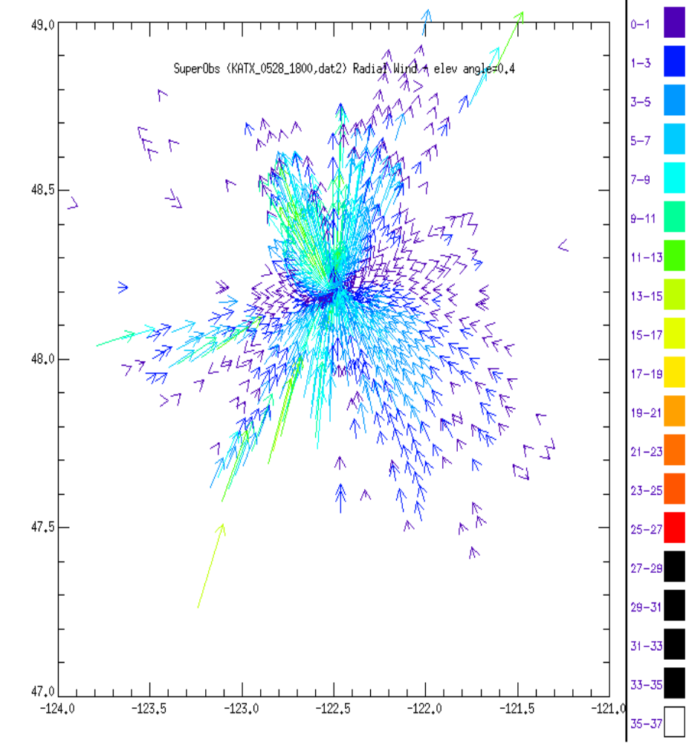

Fig 1. Radar radial (scalar) wind super-obs speed and location from station KATX in Seattle, WA on May 28, 2002. Arrows are toward or away from the radar with the color and arrow length indicating the speed of the return.

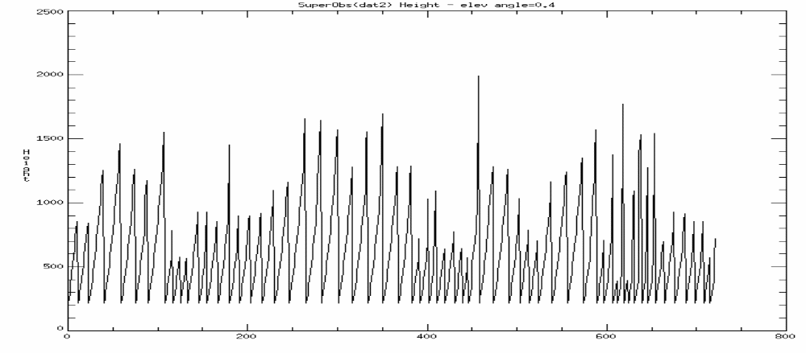
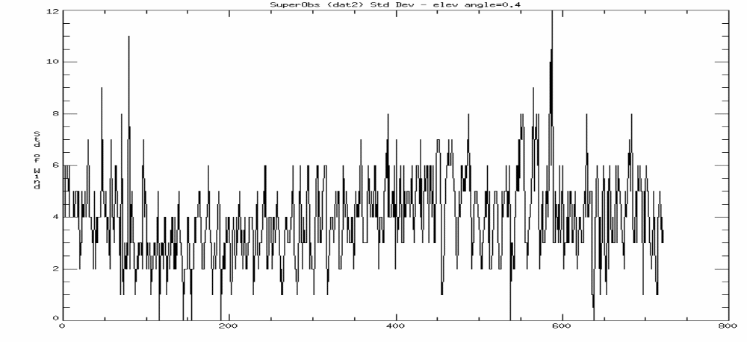
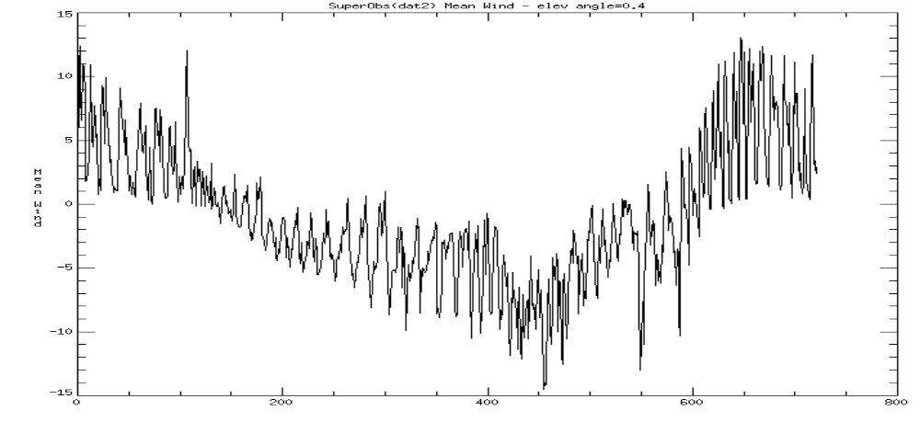
(a)
(c)
(b)

Number of Super-obs

Fig 2. (a) Super-ob height [m] for each observation beginning at 0 azimuth (north) and extending clockwise through larger radii every 6 degrees for the same time as in Fig 1, (b) Super-ob radial wind standard deviation [m/s], (c) Super-ob radar radial (mean) wind [m/s].

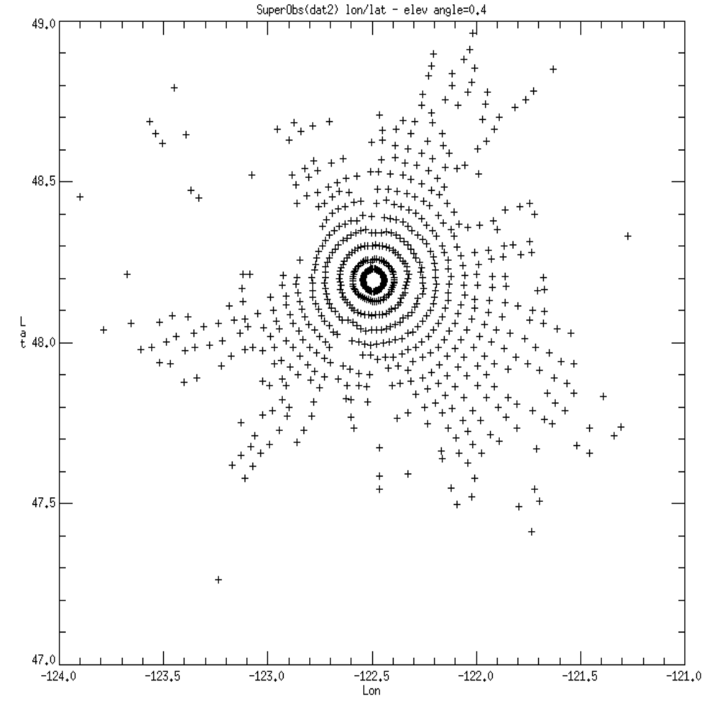

Fig 3. Super-ob radar radial wind location [longitude & latitude] for each observation the same as in Fig 1.

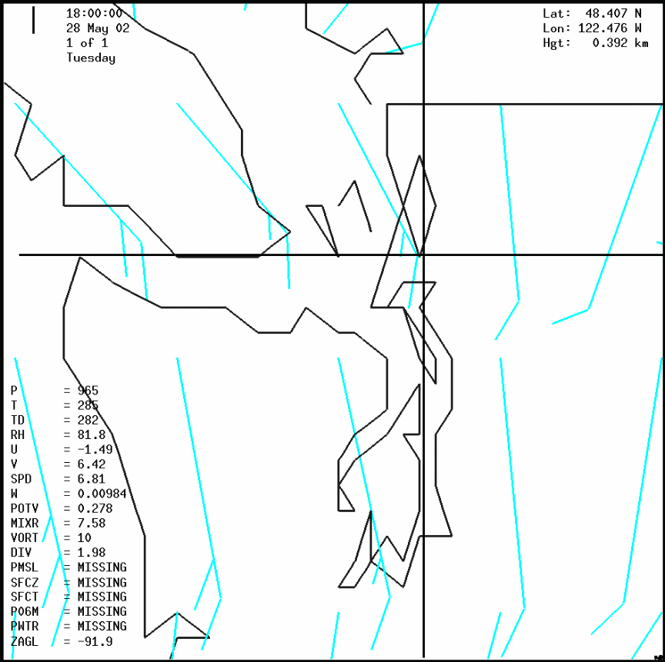

Fig 4. Analyzed regular Wind barbs (blue) at 0.4 km height from the NCEP Global Forecast System Spectral Statistical Interpolation Analysis of May 28, 2002 at 18Z. The cross is at the Seattle, WA radar location.

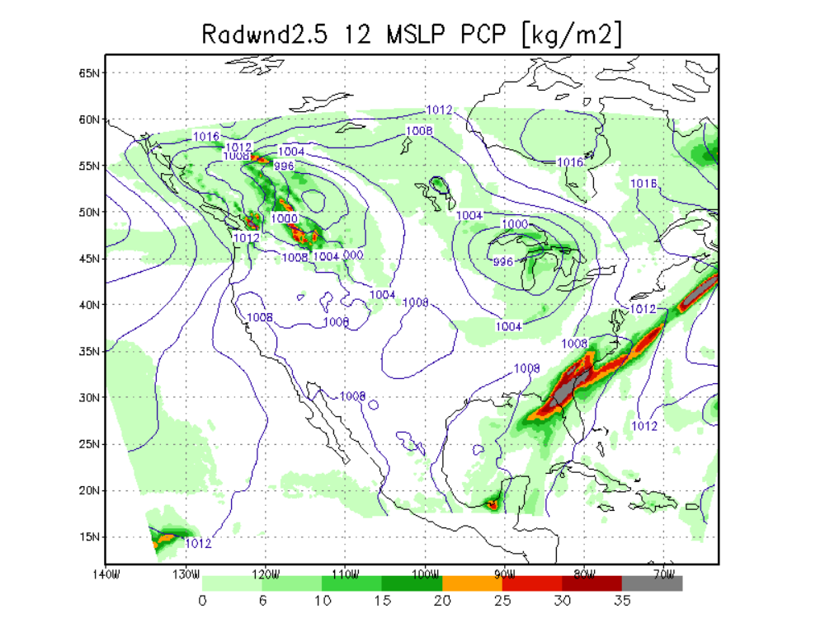 Fig 5. Eta 12-h forecast MSLP (hPa) and12 -h accumulated precipitation rate[mm/12-hr] verifying 29OCT 2003 00Z including level 2.5 super-ob (Case I).

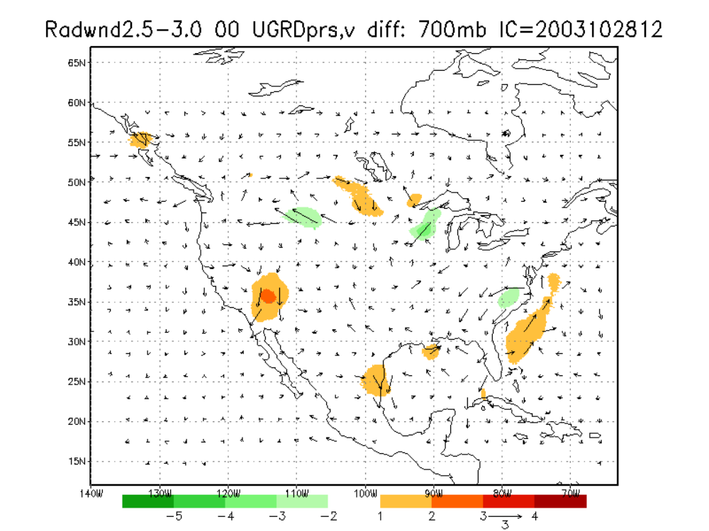
Fig 6. Difference in the analysis (00) of wind magnitude between the level 2.5 (Case I) and level 3 super-ob (Case 2) are shown in the color fill contours and the arrows show the vector difference of the wind fields at 700 hPa

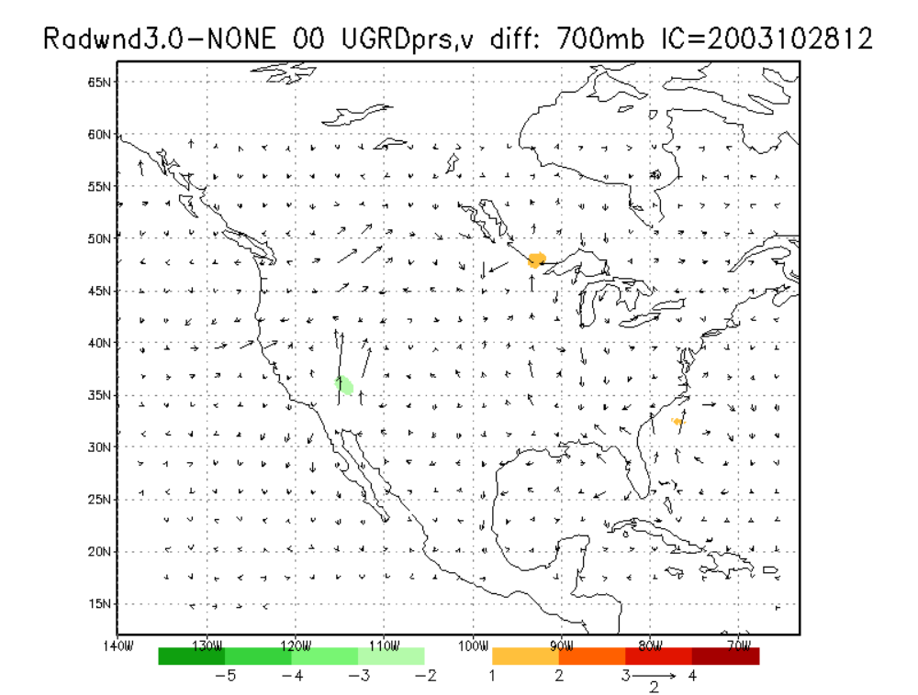
Fig 7. Difference in the analysis (00) of wind magnitude between the level 3 (Case 2) and No radial wind(Case 3) are shown in the color fill contours and the arrows show the vector difference of the wind fields at 700 hPa.

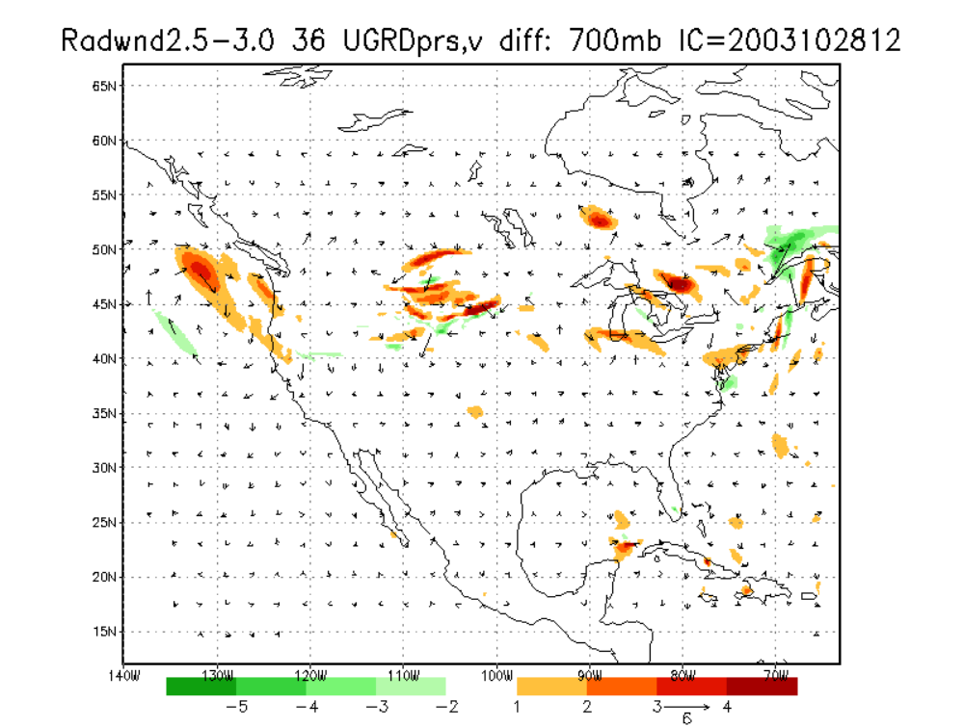
Fig 8. Difference in the Eta forecasts at 36-h of wind magnitude between the level 2.5 (Case I) and level 3 super-ob (Case 2) are shown in the color fill contours and the arrows show the vector difference of the wind fields at 700 hPa

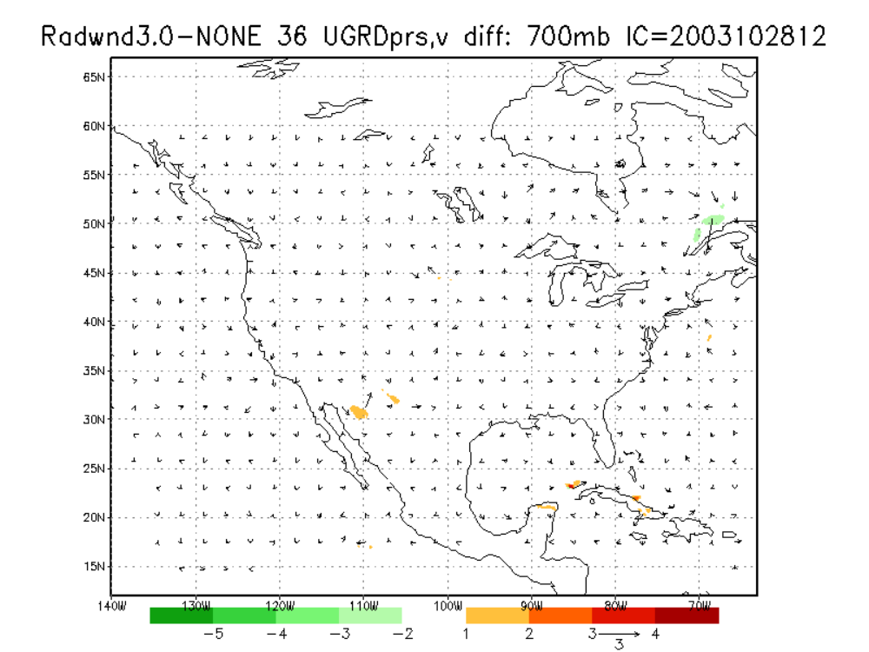
Fig 9. Difference in the Eta forecasts at 36-h of wind magnitude between the level 3 (Case 2) and No radial wind(Case 3) are shown in the color fill contours and the arrows show the vector difference of the wind fields at 700 hPa.

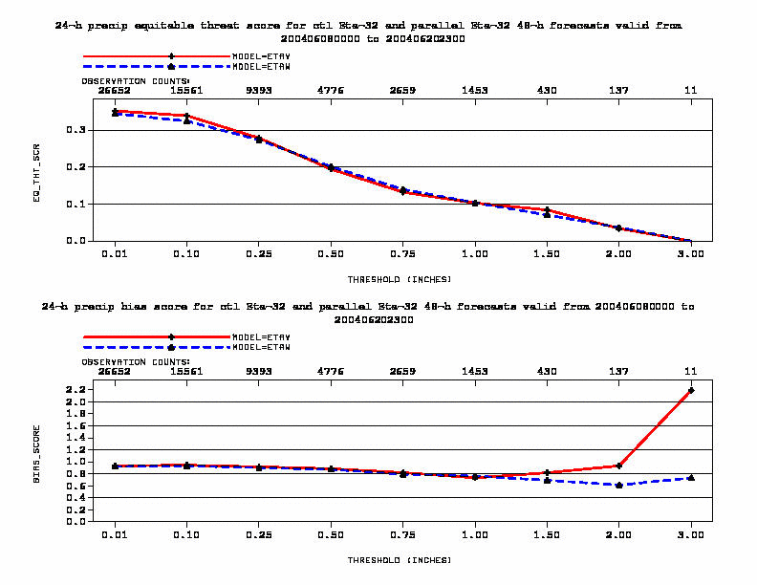

Fig 10. 24-h accumulated precipitation equitable threat score (upper) and bias (lower) from Eta 32-km 48-h forecasts from 8JUN2004 – 20JUN2004 for various thresholds in inches. The solid line (+) are the radial wind super-ob Level 2.5 experiment and the dash is the Eta control (▲) with NIDS level 3.0 super-obs.

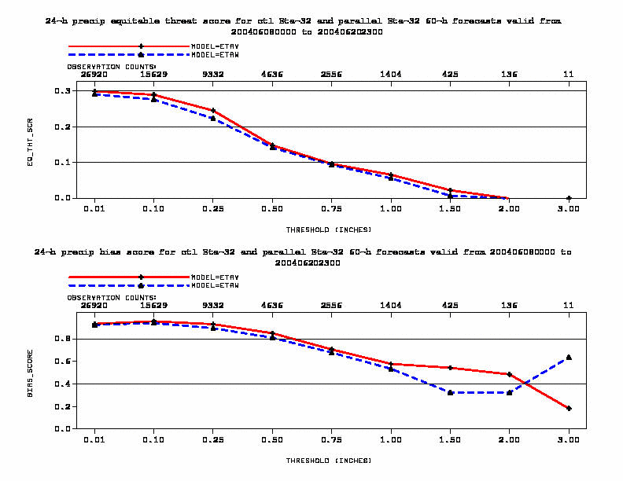

Fig 11. 24-h accumulated precipitation equitable threat score (upper) and bias (lower) from Eta 32-km 60-h forecasts from 8JUN2004 – 20JUN2004 for various thresholds in inches. The solid line (+) are the radial wind super-ob Level 2.5 experiment and the dash is the Eta control (▲) with NIDS level 3.0 super-obs.

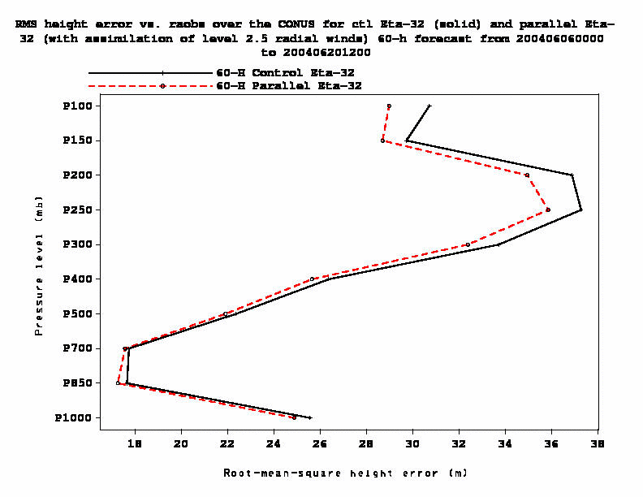

Fig 12. Root Mean Square Height errors against RAOBS over the CONUS from Eta 32-km 60-h forecasts, 8JUN2004 – 20JUN2004 (24 forecats). The dash line is the radial wind super-ob Level 2.5 with no NIDS data experiment and the solid line is the Eta control with NIDS level 3.0 super-obs.

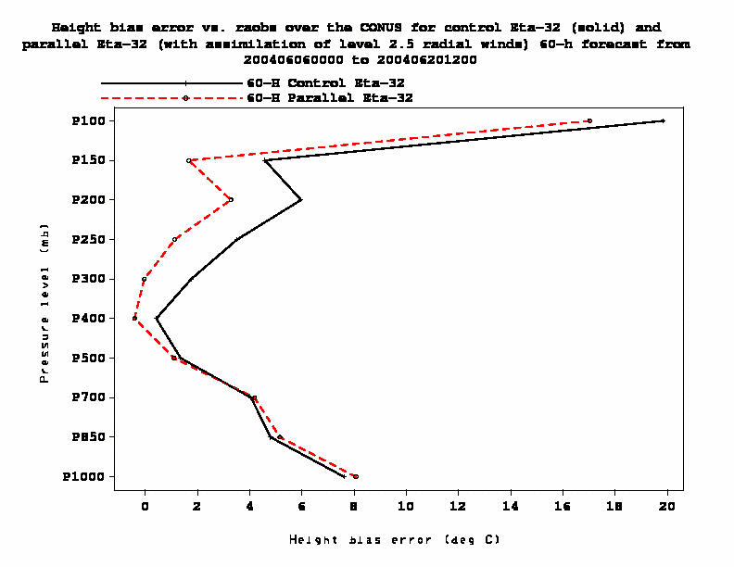
Height Bias Error (m)

Fig 13. Height Bias errors against RAOBS over the CONUS from Eta 32-km 60-h forecasts, 8JUN2004 – 20JUN2004 (24 forecats). The dash line is the radial wind super-ob Level 2.5 with no NIDS data experiment and the solid line is the Eta control with NIDS level 3.0 super-obs.

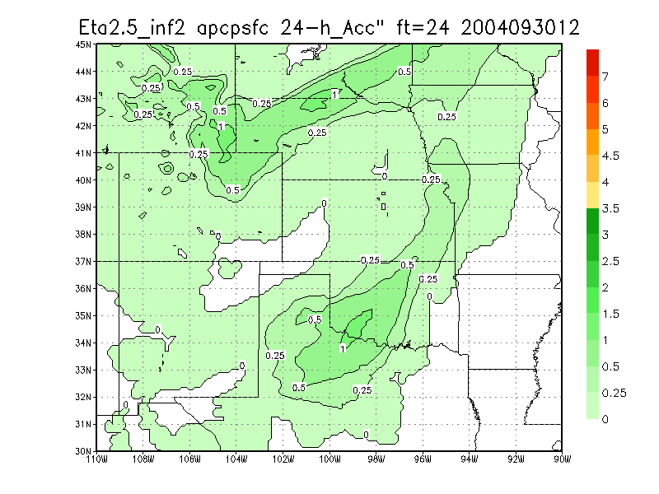

Fig 14. 12-km Eta 24-h forecast of 24-h accumulated precipitation [inches] verifying 01OCT 2004 12Z with level 2.5 super-ob and inflate parameter set to 2.

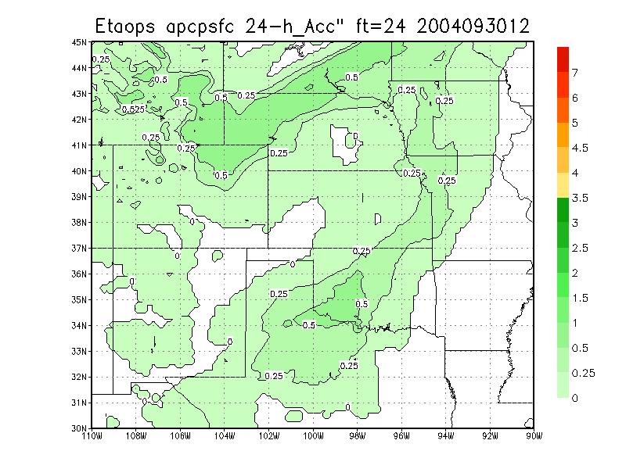

Fig 15. Operational 12-km Eta 24-h forecast of 24-h accumulated precipitation [inches] verifying 01OCT 2004 12Z (Operations at this time contains super-ob level 3.0 (NIDS type) and inflate parameter set to 3).

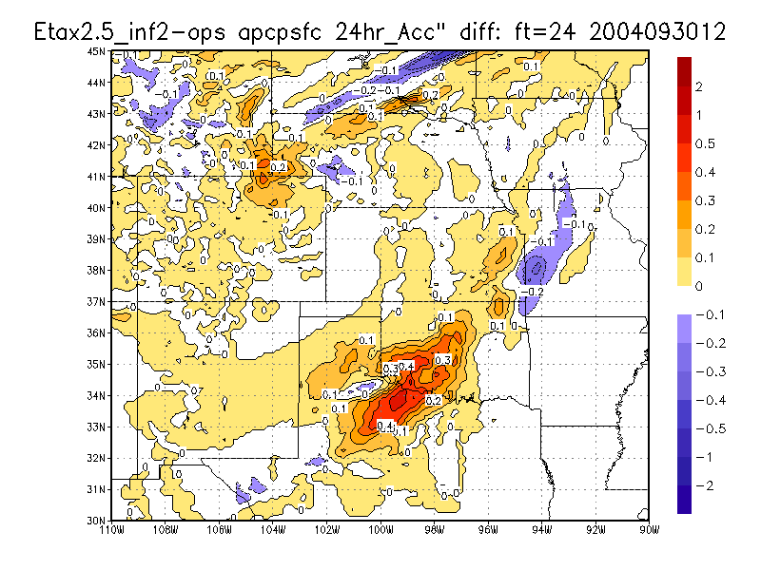
Fig 16. Difference of the Eta super-ob 2.5 and Operational Eta 24-h forecasts of 24-h accumulated precipitation [inches] verifying 01OCT 2004 12Z (As in Fig 14 minus Fig 15).

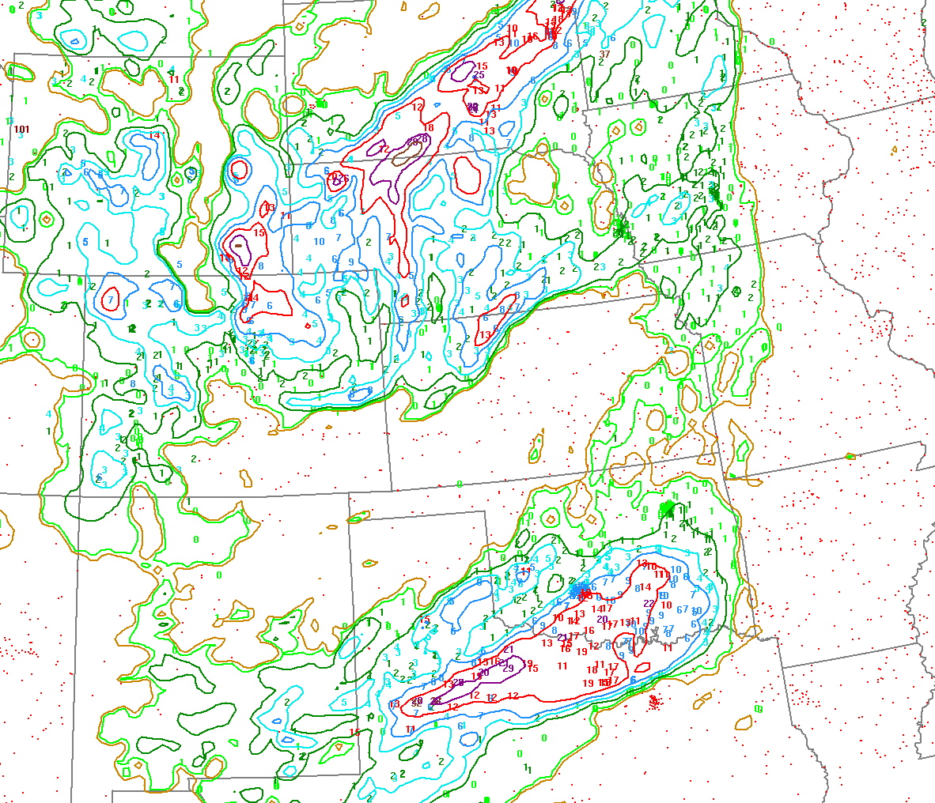

Fig 17. Observed 24-hr Precipitation from Rain Gauges for the period ending at 12Z 01 October 2004. Values are in tenths of inches.

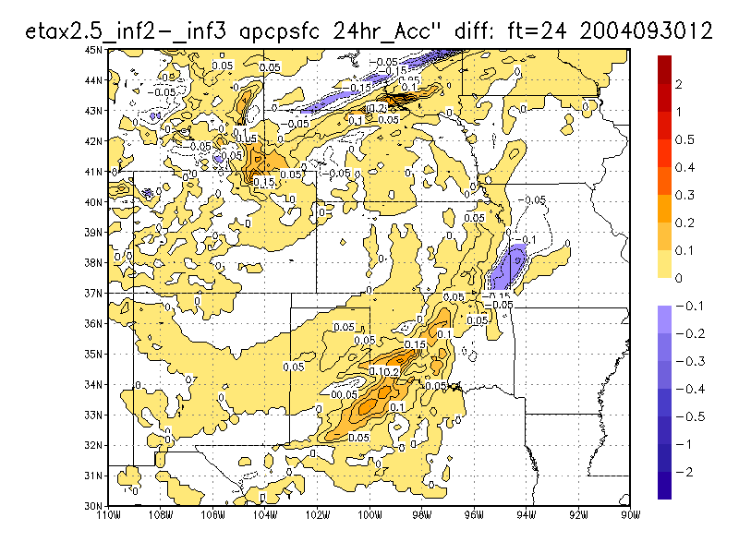

Fig 18. Difference of the 12-km Eta super-ob 2.5 with inflate parameter set to 2 and inflate parameter set to 3 of 24-h forecasts of 24-h accumulated precipitation [inches] verifying 01OCT 2004 12Z.

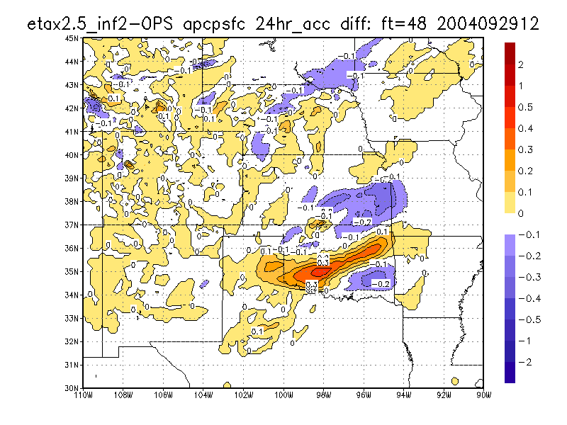

Fig 19. Difference of the Eta super-ob 2.5 and Operational Eta 48-h forecast of 24-h accumulated precipitation [inches] verifying 01OCT 2004 12Z.

