SPACEPORT CONCEPT AND TECHNOLOGY ROADMAPPING

.

INVESTMENT STEPS TO ROUTINE, LOW COST SPACEPORT SYSTEMS

FINAL REPORT TO THE NASA SPACE SOLAR POWER EXPLORATORY RESEARCH AND TECHNOLOGY (SERT) PROGRAM

Prepared by:
THE VISION SPACEPORT PARTNERSHIP
National Aeronautics and Space Administration
John. F. Kennedy Space Center
and
Barker-Ramos Associates, Inc.
Boeing Company
Command and Control Technologies Corp.
Lockheed Martin Space Systems

JSRA NCA10-0030
November 2000

This report has been prepared under the Kennedy Space Center (KSC) Joint Sponsored Research Agreement (JSRA) NCA10-0030. It has been sponsored by the NASA Space Solar Power Exploratory Research and Technology (SERT) program.

Table of Contents
Executive Summary 1
Objective 1
Summary 3
Recommendations 6
Introduction 13
Space Solar Power and Future Enterprises 13
The Vision Spaceport Partnership 14
Spaceports 15
Spaceport Functions and Attributes for Improvement 15
Spaceport Technology Portfolio Development 16
Roadmap Development Process 16
Goal 17
Customers and Stakeholders 18
Performance Requirements 20
Technology Categories 21
Challenges 25
Affordability 25
Spacelift Capability 26
Safety 26
Insight into Spaceport Investment Opportunities 27
Assessment Factors 28
Research and Development 28
Acquisition 29
Operations 31
Approach 33
Analysis and Findings 34
Roadmap 37
Opportunity Timeframes and Benefits 38
Near-Term – Within 5+ Years 40
Mid-Term – Within 10+ Years 41
Far-Term – Within 20+ Years 42
Appendix A 44
Roadmap Development Process 44
Appendix B 48
Description of Concept / Technology Improvements 48
References and Endnotes 69

List of Figures

- Space Solar Power (SSP) Suntower and Earth-to-Orbit (ETO) Vehicle.  - The Vision Spaceport Partnership  - A Graphical View of Cost versus Benefit  - Spaceport Customers and Stakeholders  - Global Spacelift Trends  - R&D Factors  - Definition and Acquisition Factors  - Benefit Factors  - Notional Example of Cost vs. Benefit 2-Dimensional (2-D) Assessment Approach  - Spaceport Technology Categories / White Paper Areas Correlated to R&D and Benefit  - Spaceport Technology Categories / White Paper Areas Correlated to Acquisition and Benefit  - Spaceport Roadmap, Areas Requiring Investment and Maturation to Goals  - Roadmap Development Process  - Derivation of Spaceport Cost Contribution to Space Transportation System  - Spaceport Concept and Technology Challenges, Functions, and Goal  - Earth-to-Orbit Transportation & Infrastructure Technology Approach and Goals | Page  13  14  18  19  26  29  30  31  33  35  36  37  44  45  46  47

List of Tables

- Spaceport Functional Breakdown Structure  - Qualitative Attributes of a Spaceport  - Spaceport Customer and Stakeholders, Perspective Sessions  - Spaceport Concept and Technology Areas and White Papers  - R&D Factors  - Definition and Acquisition Factors  - Benefit Factors | Page  15  16  20  22  28  29  31

Acronyms

ATA  CLCS  COTS  ETO  IT  JSRA  KSC  LEO  LH2  LOX  NAS  QFD  R&D  RLV  RSA  TRL  SERT  SSP | Air Transport Association  Checkout and Launch Control System  Commercial-off-the-Shelf  Earth-to-Orbit  Information Technology  Joint Sponsored Research Agreement  Kennedy Space Center  Low-Earth-Orbit  Liquid Hydrogen  Liquid Oxygen  National Airspace System  Quality Function Deployment  Research and Development  Reusable Launch Vehicle  Range Safety and Automation  Technology Readiness Level  Space Solar Power (SSP) Exploratory Research and Technology  Space Solar Power

SPACEPORT CONCEPT
AND TECHNOLOGY
ROADMAPPING
FINAL REPORT TO THE NASA SPACE SOLAR POWER EXPLORATORY RESEARCH AND TECHNOLOGY (SERT) PROGRAM

Executive Summary

Objective
The concept of collecting solar energy in space through orbiting platforms and transmitting that energy to Earth for providing electrical power is one possibility for providing clean, affordable energy for global needs in the 21st century. The realization of this concept, as well as multitudes of unimagined ideas, is constrained by a space transportation infrastructure that is costly and ineffectual for such large-scale enterprises. Recurring launch costs in the range of $100-$200 per kilogram delivered to orbit are required to enable such business endeavors. It is clear that space transportation is the bottleneck that currently constrains space enterprises to the imaginable.
It is one objective of the Vision Spaceport partnership to derive a diverse portfolio of Spaceport concepts and technologies that require investment in order to further, in the next 20 years, a space transportation infrastructure that can meet the requirements of far term, open ended growth in space activity. This Spaceport investment, in complement to necessary advances and investments in space transportation flight systems, will bring about routine, affordable access to space.
Whereas flight and vehicle specific requirements drive any resulting Spaceport infrastructure, it is still of necessity that ground systems investment occur in parallel with flight system maturation. In the same light by which airports are crucial catalysts for economic growth, creating employment opportunities and stimulating trade and commerce, so too Spaceports will become crucial 21st century elements for enhanced trade, income and prosperity. A global economy dictates the need for drastic improvements in air and space transportation.
This evolution of space transportation will lead to revolutionary Spaceports that become hubs of economic, cultural and social activity. More people will come to participate in voyages that were once the domain of a select few. Space will become accessible and routine, a commonplace destination forever growing human activity.
Toward achieving this the authors of this report have documented the needed Spaceport investment steps in the near, mid, and far term. It is also the objective of this report to provide insights toward investment within a structured, traceable, and well documented process that flows and connects the highest of objectives, such as “routine, daily flights and $100 per pound costs”, down to the actions and directions that are needed today.

Summary
This report is about Spaceports. It is about technology, investments and a vision in the not too distant future. The vision is about an open space frontier. The vision is about people participating in voyages that today are the domain of a select few. Space transportation that is commonplace and accessible will become a reality. The question is when and how?
The NASA Space Solar Power (SSP) Exploratory Research and Technology (SERT) program has directed the Vision Spaceport Partnership to identify those technologies that will enable the programs ambitious goals. These goals are ultimately economic. Technology can enable these goals, or as witnessed today, lack of maturity can hinder an open space frontier.
The Vision Spaceport Partnership has taken the charge to outline the steps that will lead to routine, low cost Spaceport systems. We have taken the task to provide insight. This partnership includes NASA, major aerospace industry corporations, and smaller businesses deeply engaged in the ideas and issues involved.
The Spaceport Concept and Technology Roadmapping report documents both process and results. The process has been documented in detail including goals, customers and stakeholders, performance requirements, areas for improvement, and assessment factors. The results include a series of white papers describing Spaceport areas and improvements in each. Insight gained from this process has resulted in recommendations and a roadmap connected to goals.
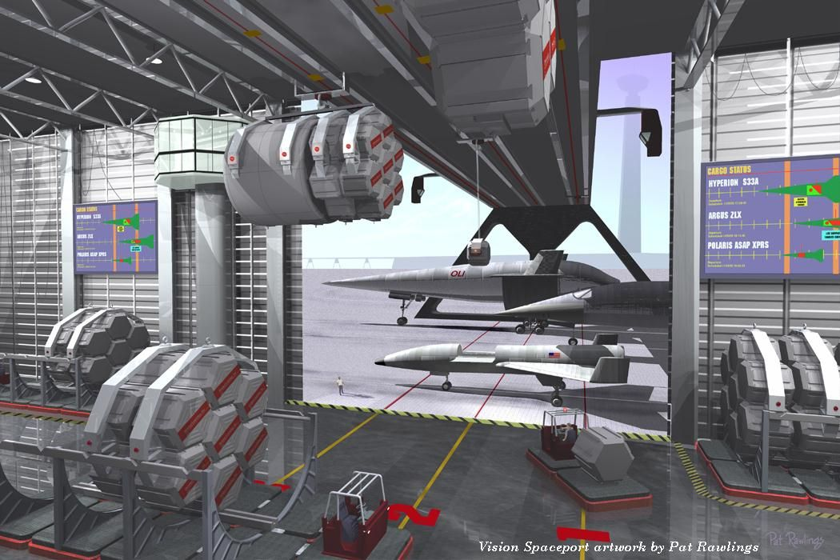
Visions yet to be…(Image © Vision Spaceport Partnership).
Next steps are also included as a recommendation. Generating insight over the time span of two to three decades, the time frame considered by enterprises such as SERT, requires continuous reexamination of progress. The need for goals is clear. A continuous and watchful eye on these ambitious goals must always enter into making decisions. Where there are no goals there can be no insight.
We recommend and conclude that investments that are goal focused can enable such enterprises as Space Solar Power. Along the way some areas will improve more quickly than others. Eventually all areas can reach the finish line, maturing a national Spaceport and space transportation capability, public and/or private, that provides open-ended economic opportunity.

Recommendations
The Vision Spaceport Partnership believes that the following recommendations will enable continued advancement toward affordable, routine, and effective transportation to space for people, goods, and future business opportunities.
RECOMMENDATION 1. A national policy of commitment to Space Transportation technology and infrastructure development is required. R&D investment and technology development toward innovating the far term technologies that enable ambitious goals is an important and appropriate role for government. Infrastructure advances will be required for Spaceport facilities, equipment and operations to one day support multiple flights per day at tens of dollars per pound of payload transported to orbit. These advances include basic research and technology development. Basic research can address fundamental challenges, whereas crucial technology development is moved forward through system wide applications of advanced technology. The later includes infrastructure modernization and advanced applications development for the specific needs of space transportation and spaceport customers and stakeholders.
Differences between basic R&D and technology development and applications can create a gap in ownership that keeps the benefits of much R&D from ever being realized. Spaceport infrastructure is one such example. As basic R&D in space transportation matures, scientific and technical interest may wane while interest migrates to newer challenges and more basic R&D. Using NASA technology readiness level (TRL) ratings, the R&D scales up in cost and becomes a possible application when ratings approach 4 or 5 on a 1 to 9 scale. At this point, scientific interest may wane, as the product is perceived as ready, with most technical difficulties resolved. At the same time, the customer perspective is to view the product as still immature, with cost and broad system level issues un-addressed. The result can be inadequate pass-off of basic R&D or inadequate maturation should the technology be pushed into operations prematurely.
Technology infusion into the commercial sector is greatly assisted when infrastructure development is used to push beyond basic R&D and toward challenging applications. National Range, or any Spaceport investments which apply basic R&D, will modernize at the same time as they innovate. Innovations must address the specific needs of the space transportation sector. Alternately, commercial products must also be applied to specific Spaceport needs to mature the system level understanding of how advanced commercial technology can be applied at Spaceports. Successful technology infusion through such a dual strategy (R&D as well as commercial products applied to specific Spaceport infrastructure improvements) can provide dramatic results toward creating Spaceports that encourage the growth of the space transportations sector.
Without increased investments in both R&D and Spaceport infrastructure development the current state of stagnation in the space transportation industry will continue. Capital flow into the sector is an appropriate role for state and federal agencies as with any transportation infrastructure. Private sector capital can be encouraged or dissuaded to the degree that commitment by state or federal agencies is shown through investment as well as a policy and enabling regulatory framework.

RECOMMENDATION 2. Investment in a modernized National Spaceport infrastructure in the areas of information systems, sensing and instrumentation, and command and control systems is required as a near term step. This will accrue benefits in evolving reduced labor and increased flight rate capabilities. An overlap of these areas into range, payloads, servicing systems, and all the direct and indirect functions within a Spaceport is inevitable and desirable.

Cross-cutting, basic investments in modernization can serve multiple customers within a focus on affordable, supportable, flexible, inter-operable, standardized systems approaches in the information arena. Broad investment in these areas that does not cater toward specific systems (but can accommodate existing requirements) is more likely to yield broad benefits to the space transportation business while avoiding issues such as anti-competitive practices.
Investments in current Spaceport infrastructure basic R&D is negligible. Investments in modernization efforts, such as the DoD Range Modernization effort (RSA) or Kennedy Space Center’s Checkout and Launch Control System (CLCS), approach hundreds and tens of millions of dollars annually. In each case, modernization is upgrading antiquated systems to more up to date hardware and software. Such investments are relatively high in a fiscal reality that constrains Federal discretionary spending. But, for comparison, airports routinely add gates in redevelopment projects at costs as high as Millions to tens of Millions of dollars per gate. This is for well know business operations accommodating and duplicating the same operations as thousands of other Airports worldwide. It is not reasonable to expect that Spaceport infrastructure can invent an entirely new generation of technology and infrastructure, and acquire it, for reaching multiple flights per day (out of possibly multiple “gates” or sites) for only a fraction of these costs. Long-term investments are required in basic R&D as well as Spaceport technology development or longer-term goals of reduced operational costs and multiple flights per day will not be achieved.
As modernization efforts in one area decline, other areas await in line to be bought from technology and processes of the 60’s and 70’s into the modern systems possible today. Ongoing efforts at modernization cannot be seen as having end-points, but rather as offering opportunities for re-investment once one area has been upgraded.
Additionally, capital influx for operations, albeit high for all parts of the National space transportation infrastructure, should not be confused with capital outlays for new, improved infrastructure, or for maturing the development of dramatically different kinds of architectures and systems. It is the later that will be required focused on the development of capabilities and the kind of economic opportunities and growth as outlined in this report. Space Solar Power is only one of innumerable possibilities on the space frontier which can be enabled by Spaceports, flights per day, and ~$100 per pound costs.

RECOMMENDATION 3. Implement effective cost accounting, information, work control and tracking systems within the Cape Canaveral Spaceport. These systems should be pervasive, useful and fully a part of the systems being operated today on the National Ranges. Such systems do not exist and greatly hamper any quantitative understanding of decades worth of operations experience in these systems. It is recommended that the system approach used by the Air Transport Association (ATA) serve as a starting point for study into the implementation of these work and cost accounting systems. Shuttle, as the world’s only semi-reusable launch system offers a particularly valuable, yet un-developed, knowledgebase resource applicable to future reusable launch vehicle development (RLV’s).

Budgetary information has been relied on in many a cost analysis of space transportation systems such as Shuttle. Reliability, maintainability and logistical type data has also been studied and used in cost and operations assessments for expendable, Shuttle and future systems. Such information is inadequate to the task of supporting costly decisions on needed improvements in space transportation. Cost information systems for space transportation are generally a generation or more behind their equivalent counterparts in the aircraft and airport sectors. This lag has no technical excuse and is solely the result of lack of investment in such systems.
It is testament to near term thinking that cripples far term knowledge, that modern, useful, data tracking and work management systems have only been sparsely implemented in operational space transportation systems. An unusual obliviousness to understanding costs, drivers and productivity impacts of launch technology is a heritage of systems and organizations created within a cold-war context. Shop floor control systems integrating processes with modern mobile hardware, database, tracking and information management techniques can provide indispensable information supporting decisions in R&D direction and needed investments.
Operations research in space transportation / spaceport processes can become a more quantifiable science by developing effective cost accounting and work management systems. This information, made publicly available, can assist in the development of business planning by private sector customers and stakeholders. This will reduce the risk to enter the space business in the areas of cost, schedule or the recurring operations costs and flight rate capabilities of ground and flight systems.

RECOMMENDATION 4. NASA and the private sector must continue to develop, understand and mature customer requirements and opportunities, only one example of which is Space Solar Power, leading to the maturation and stimulation of demand that will take advantage of increased Spaceport capabilities. R&D from these endless, as yet unexplored sectors, acting as commercial “pull” can complement technology push in the areas of space transportation and spaceport development by offering vistas to opportunities that may otherwise not be fully understood as to their benefits.

Space Solar Power is only one of many possibilities that will become viable if affordable, daily, routine space transportation is available. This opportunity also requires advances in deployable structures, solar arrays, power generation, and wireless power transmission. This complement of technology pull (R&D centered on opportunities) and technology push (centered on enabling infrastructure) can be a valuable strategy toward advancing the opening of the space frontier.

RECOMMENDATION 5. Initiate a payloads customer and stakeholder initiative as a public and private partnership that addresses standardization, automation of test and checkout, carriers and containers for flight systems. Such an effort should broadly involve NASA, satellite manufacturers, the scientific community, Shuttle and expendable organizations in the public and private sectors. Future space transportations systems developers must also play a role. Such an effort should be long term in nature, seeking to grow avenues for technology, approaches and commercialization leading to simple, generic and higher through-put, Spaceport payload and cargo operations.

The nature of payload operations in today’s Spaceport environment cannot be ignored either in the flight system or the ground infrastructure. Costly serial time operations, labor intensive test, checkout, handling, and integration onto vehicles is a major contributing factor to low productivity flight rates and high processing costs for vehicles. The cottage industry approach that treats each payload as a unique set of requirements that are catered to offers many opportunities for dramatic improvement.

RECOMMENDATION 6. Government and industry must evolve common support architectures compatible with a maximum or growing number of spaceports. There are currently no institutionalized support mechanisms within government agencies, NASA or the Federal Aviation Administration, that support the growth and development of Nation-wide spaceport capabilities. Licensing and certification authorities such as the FAA only begin to address this much broader issue of space capability evolving toward the type of infrastructure support that airports enjoy.
Encouraging the growth of space transportation through technology development has been partly addressed in previous studies. This addresses the issue of developing capabilities for use by Spaceports Nation-wide. NASA, developing a technology, approach or standard that comes into use at a National range, must also provide technology infusion mechanisms for the use of these by others in public and/or private Spaceport developments elsewhere. Eastern and Western Range organizations must function as guiding entities that encourage competitors if the industry as a whole is to grow more quickly toward independent, private, highly productive Spaceports.
This particular area requires caution so as not to pre-maturely standardize around government requirements that can be incompatible with commercial needs. Basic technology development that is diffuse and serves many customers and stakeholders avoids this pitfall. More specific infrastructure development and standardization needs to be responsive to open-ended, easily upgraded approaches that can keep pace with rapid changes in private sector needs.
Spaceport Technology Center
Kennedy Space Center’s Spaceport Technology Center (STC) initiative is designed to align and enhance existing KSC technology development product lines with the needs of future reusable and expendable space transportation systems. The Spaceport Technology Center initiative is an evolving component of KSC's Center of Excellence in Launch and Payload Processing Systems.
KSC's core business statement is to "Provide space systems processes, test, and launch techniques and develop associated technologies." As an active spaceport, KSC technology development activities encompass a wide range of technology readiness levels (TRL's). KSC has product lines for "spaceport design and systems development" which start with testing and integrating technologies at the mid-TRL ranges in order to build and deploy an operational spaceport system. KSC has also established unique development capabilities (personnel and laboratory / testbed facilities) for collaborative technology development efforts in several technology thrust areas.
Historically, the majority of the total life cycle cost for any complex system is attributed to operational and support activities. Therefore, a primary strategy for reducing life cycle costs should be to develop and infuse spaceport technologies in future space transportation systems. KSC's complementary advanced spaceport technologies will benefit current and future spaceports on the earth, moon, Mars, and beyond.

RECOMMENDATION 7. Policy and regulatory frameworks must encourage capital availability. While it is an appropriate and necessary role of government agencies to perform R&D and technology development, the actual acquisition of Spaceport capabilities by the private sector should eventually grow well beyond public capability. This will hinge on capital being readily available as with other similar infrastructure developments such as airports. This will encourage investment by states, private corporations, independent authorities or combinations of these.

Capital availability can be furthered through reduction in risk, as captured previously, when proper levels of investment occur in technology development, infrastructure commitment and support systems for developing Spaceports. Further capital availability can be enabled by the treatment of Spaceport developments in a manner similar to airports, as addressed in the recent Spaceport Investment Act. This would treat spaceports like airports under the exempt facility bond rules.

RECOMMENDATION 8. It is recommended that necessary next steps that may be performed by government and industry partnerships include a more detailed identification of impediments to the Spaceport improvements required. Further, such a process should identify candidate solutions in greater detail, group the technology candidates, evaluate the technology groups for funding profiles, and assure customer and stakeholder requirements are flowed down to the research community. Work that can be performed in pre-competitive phases as government / industry partnerships should especially be identified.

Impediments to technology initiatives may be organizational, informational, or technical, among others. Technological impediments may include the reliability (or lack thereof) of flight systems. Lack of reliability in flight systems is a significant contributor to lengthy, labor intensive, turnaround cycle times. Additionally, vehicle complexity due to lack of sub-systems integration, results in extensive ground systems. Informational impediments include poor accounting, work control and management systems, and piecemeal implementations of IT that institutionalize system sub-optimization. A full accounting of such impediments in greater detail is required. Following such an activity a gathering of specific improvement proposals complete with budget profiles connected to objectives should be immediately developed. This more detailed technology “push” assessment should be a complement to the technology “pull” emphasis included here. Tools, software and techniques for management visibility and more rapid assessment of current holdings, progress toward goals, and decision-making support for future holdings, in such a portfolio approach, should be a major area addressed in this next step.

Introduction

Space Solar Power and Future Enterprises
From 1995 through 2000, NASA has conducted a re-examination of the concept of Space Solar Power (SSP). The principal objective of this fresh look study was to:

“…determine whether a solar power satellite and associated systems could be defined that could deliver energy into terrestrial electrical power grids at prices equal to or below ground alternatives in a variety of markets, do so without major environmental drawbacks, and which could be developed at a fraction of the initial investment projected for the reference System of the late 1970s.”

Such a system is envisioned in Figure 1.0 (the Suntower). The requirement that the new concept have a “fraction of the initial investment” of the 1970’s reference SSP system is recognition of the significance that Earth-to-Orbit (ETO) transportation costs have on the overall economics of SSP. That is, transportation costs (ETO and in-space transfer vehicles) are a major contributor to the overall life cycle cost of SSP.
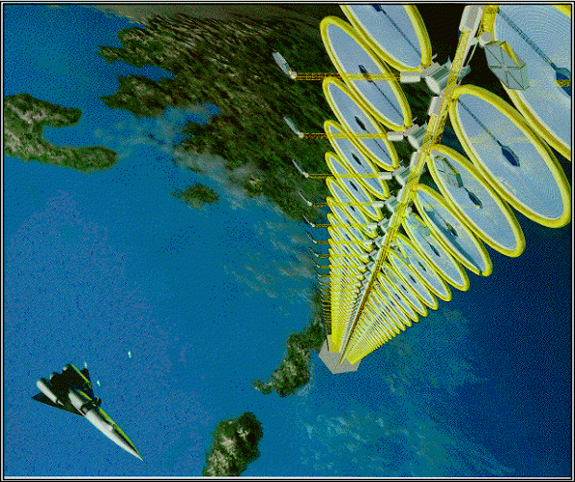
Figure 1.0 Space Solar Power (SSP) Suntower and Earth-to-Orbit (ETO) Vehicle.
While it is easy to identify the location of Spaceports worldwide and the capabilities of each of these, a more difficult task lies in defining what future improvements in those capabilities are required? What Spaceport factors need to be addressed and most improved upon to enable SSP and multitudes of other such opportunities? What is required to stimulate and complement increases in flight rate and reductions in cost of space transportation systems?
This report recommends key spaceport technology investments needed to significantly lower space access costs. The report is based on a technology investment “roadmap” that draws the path from where we are today to achieving the required advances in spaceport technology and infrastructure.
Within this context, SSP is just one of multitudes of possible business opportunities should access to space become routine, on the order of one or more flights per day out of any one Spaceport, and low cost, on the order of ~$100 per pound for transportation costs.
The results documented here are therefore:
- Generic: Applicable to any far term enterprises that will not be viable until such low cost routine access to space is available.
- Near term: Describing the necessary investment steps that connect to ambitious far term goals.
- Not location specific, such as to Florida or the Kennedy Space Center (KSC): Spaceport and space transportation maturation must necessarily evolve the technological capability to operate much as airports do today (inland). This means improvements in reliability and safety will apply to any technological approach.

The Vision Spaceport Partnership
The Vision Spaceport Partnership is a Kennedy Space Center / Industry initiative sponsored as a Joint Sponsored Research Agreement (JSRA). The function of this partnership is to provide a strategic foundation for enabling revolutionary advances in space launch architectures. Focusing and using the knowledge and launch experience of government, industry and academia in a collaborative environment enables this strategic foundation.
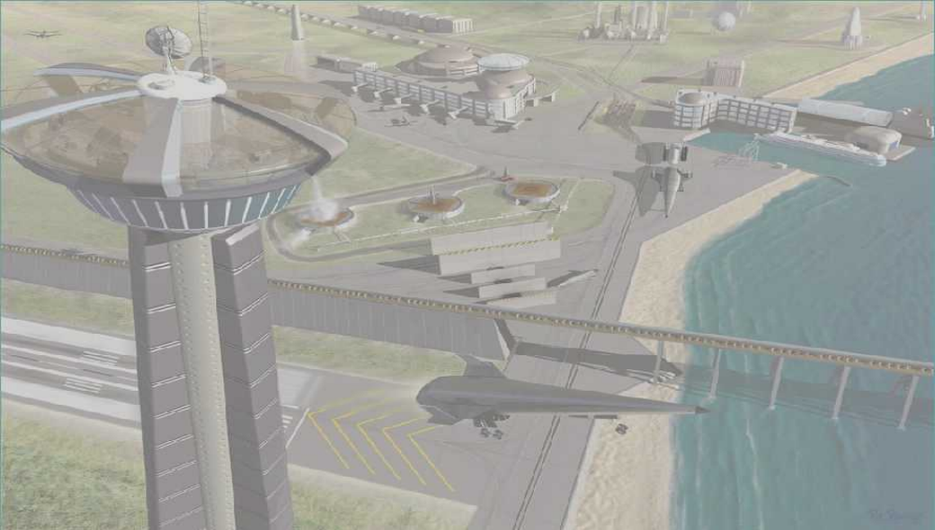
Figure 2.0 The Vision Spaceport Partnership – The vision foresees high flight rate capabilities enabled by innovative, cost effective, vehicle and spaceport systems designs that minimize operations requirements (Image © Vision Spaceport Partnership).

Spaceports

Spaceport Functions and Attributes for Improvement
What is a Spaceport?
The Vision Spaceport partnership uses the term “spaceport” to refer to the facilities, equipment, personnel, and vicinity required to prepare space-bound craft for flight, initiate and manage the flight, and receive the craft at the end of the flight. For earth-based spaceports, “vicinity” refers to the land (or sea) occupied by the facilities and equipment. For space-based spaceports, “vicinity” refers to the orbit and operations envelope of the space-based facilities. Unlike most airports, a spaceport is typically dispersed over several locations including “downrange” instrumentation facilities, abort landing sites, and space-based communications assets. Multiple spaceports may share certain resources.
Spaceport functions are listed in Table 1.0. A particular Spaceport may or may not include all these functions depending on the customers and types of systems served. In the broadest sense, however, a future Spaceport and any Spaceport planning for growth must consider all these functions for applicability and improvement.
Spaceport function
Payload and Cargo Processing
Traffic and Flight Control
Launch
Landing and Recovery
Vehicle Turnaround
Vehicle Assembly and/or Integration
Vehicle Depot Maintenance
Spaceport Support Infrastructure
Concept Unique Logistics
Transportation Systems Operations Planning and Management
Expendable Elements
Community Infrastructure
Table 1.0 Spaceport functional breakdown structure for comprehensively defining, accounting for, and understanding Spaceport functions.
To improve on these functions a Spaceport may be viewed from a series of perspectives. The potential benefits of contemplated improvements can be measured by multiple attributes that encompass the non-recurring and the recurring aspects of interest for a Spaceport. Key spaceport attributes are shown in Table 2.0.

non-recurring |  | recurring
Research, Development and Maturation - improve on: | Definition and Acquisition - improve on: | Operational - improve on:
Cost (to Develop) | Cost (to Acquire) | Cost Burden / Affordable
Benefit Focus | Schedule | Dependable
Schedule | Risk | Environmentally Compatible
Risk | Support, Local and Beyond | Public Support
Dual Use |  | Safe
 |  | Responsive / Available
Table 2.0 Qualitative attributes of a Spaceport (“what”, not “how”) that must be addressed in considering improvement and investment needs.

Spaceport Technology Portfolio Development

Roadmap Development Process
The Vision Spaceport Partnership derived key aspects of certain spaceport technologies that could lead to development and deployment of those technologies with greatest benefit potential. The resulting collection of technologies and analysis make up the Spaceport technology portfolio and roadmap. This process may also be referred to as a technology assessment process that derives aspects of technology (“what”) that lead to particular technologies as paths (“how”).
This process of developing a Spaceport concept and technology roadmap has included the following basic ground rules:
- Start with the objective – high flight rates, low costs, responsiveness to new customers and stakeholders.
- Use structured, traceable processes – avoid creating lists of concepts and technologies before defining and fully understanding needs and requirements.
- Be generic – define the needs and possible options. It is not the objective to define where geographically such capabilities will eventually evolve. Spaceport maturation will measure its success by independent and self sustained growth, no longer limited to a handful of national ranges.
- Segment into near, mid and far-term concept and technology maturation timeframes – long-term objectives are often easily defined and just as easily ignored as inapplicable to today’s challenges. Near, mid and far term connections and plans for investment directions are required.
- Provide insight into investment processes – providing insights that offer a sense of direction is crucial given the difficulties of connecting costs incurred today to benefits accrued down the road.

Goal
It is the goal of any investment portfolio to provide growth in the value of assets. The development of a Spaceport concept and technology roadmap is very similar to the development of an investment portfolio of financial securities.
The goal of increasing the value of an investment portfolio, in the context of a Spaceport, has been analyzed from various points of view. As described in Table 2.0, a Spaceport technology may be in a research, development and maturation phase, it may be in definition and acquisition, it may be operational, or it may involve all three aspects.
To best view these variables the analysis in this report:
- Separates cost from benefit (Figure 3.0).
  - The factors embodied in research, development and maturation, and the factors in definition and acquisition, are all costs in a sense. They are up-front, non-recurring expenses and represent barriers or opportunities toward activating and operating an enterprise such as a Spaceport. These non-recurring factors include consideration of the benefit, of schedule, as in time to develop or acquire, of the risk, as in being able to succeed at all within expectations, of other uses and of support, public and private. The benefit is downstream, recurring, and where the choices made up-front create consequences. These operational factors include how affordable is a system or how dependable? How safe is it or how environmentally compatible?
- Uses the concept of “technology pull” rather than “technology push”.
  - “Technology pull” originates with the customer that has a development need or requirements. “Pull” begins with the assumption that it is best to understand, define a problem and form the right questions, before proceeding to address the merits of differing solutions. The Spaceport roadmap defined with “pull” is a combination of a set of “hows” as technology recommendations and “hows” which are concepts. Concepts define the framework and sense of direction which are critical to problem solving and improvement.
  - “Technology push” originates with a developer and attempts to improve or create technology in any product area. “Push” is essential to the nature of research and development (R&D) where the exploration of any area does not always have or need a well-defined customer set of requirements.
The portfolio assets defined with an emphasis on “technology pull” have the greatest likelihood of growth in value. Growth in value is defined as the ability to accrue benefits in the long term, such as when operational, that far outweigh the up-front costs (including time and risk among other factors).
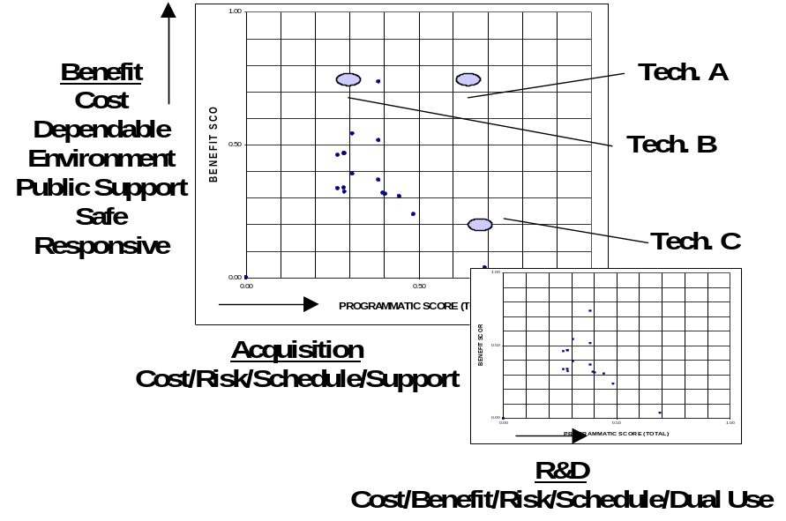
Figure 3.0 A graphical view of cost versus benefit. Such analysis using well defined attributes of a Spaceport and measurable criteria for a Spaceport lends insight into areas for investment.

Customers and Stakeholders
Any analysis of concepts and technologies in support and justification of investments must include a thorough understanding of customers and stakeholders. These may be existing or potential, as in future markets. The Space Solar Power customer / stakeholders are one example of a potential customer / stakeholder many years hence.
The term “stakeholder” broadens the notion of customer.
- Customers and stakeholders: Who is affected by the creation and successful operation of a Spaceport?
Figure 4.0 broadly describes Spaceport customers and stakeholders. All these organizations will have different roles and primary goals.
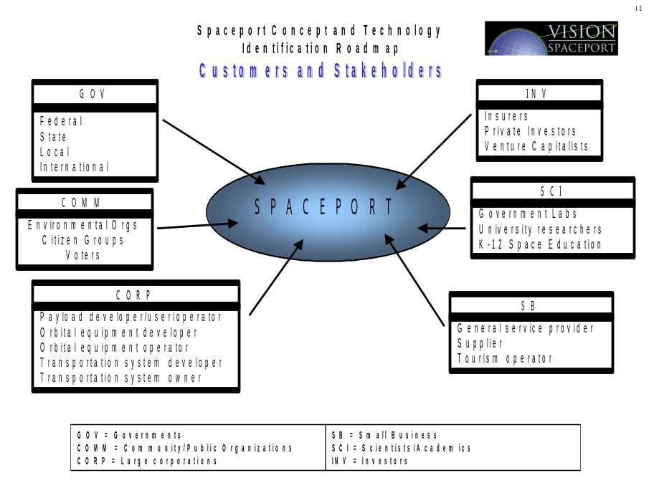
Figure 4.0 Spaceport customers and stakeholders. The introduction of stakeholders into the development of a Spaceport portfolio forces the consideration of investment factors such as environmental compatibility, regulatory issues, or public support.
The Vision Spaceport Partnership, by including government (NASA, plus the Federal Aviation Administration), large industry (major contractors Lockheed-Martin and Boeing), and small companies active in the space transportation business (Command and Control Technologies Corp., Barker Ramos Associates) brings a diverse expertise to the development of a Spaceport portfolio. This expertise includes an awareness of customer and stakeholder priorities and perspectives.
Further, as part of this report, “perspective sessions” were held with customers / stakeholders that bring relevant perspectives to the business of space transportation (Table 3.0).

COMPANY / NAME | Area
Government Financial Advisors Group - Tom Holley | Financier / Investment
Brevard Economic Development Commission - Lynda Weatherman | State Economic Authority
Kelly Space and Technology - Bob Keltner | Potential Space Transportation Operator
Spaceport Utah Authority - Steve Collins | Private Airport / Spaceport Developer
Computer Sciences Raytheon - Michael Maier | Spaceport Facilities / Technical Management
Lunar Research Institute - Dr. Alan Binder | Scientific Non-Profit Research Institute and Engineering Spacecraft Development and Design
Space Law and Policy Interest - Declan O’Connell | Legal / Law of Space
Table 3.0 A Spaceports customers / stakeholder’s definition goes beyond the notions of operators of a vehicle or payload interests. As a part of “perspective sessions” feeding into this Spaceport portfolio development the Vision Spaceport Partnership has complemented team experience with diverse other perspectives.

Performance Requirements
Spaceport performance requirements for the far term (15+ years) amount to:
- On the order of only tens of dollars per kilogram of payload delivered to Low-Earth-Orbit (LEO).
- Launch rates on the order of multiple flights per day per system (Spaceport and vehicle).
From a target of ~$400/kg (price) for a space transportation system that creates open-ended market growth, it can be derived that the infrastructure (cost) component of this market goal reduces to a mere $75/kg.
This spaceport infrastructure component of cost includes:
- Non-recurring acquisition of Spaceport Facilities and ground support equipment (GSE).
- Recurring operational costs including labor and materials.
- Recurring financial costs amortizing up-front activation and acquisition of the infrastructure.
Current costs for the same items today are on the order of tens of thousands of dollars per kilogram (Shuttle operations currently have recurring expenditures of ~$7000 per pound). The challenge, and the subject of this report, lies in identifying the investment steps that will enable these goals for the least amount of expenditure in near term R&D and later acquisition.

Technology Categories
The technology categories used in this analysis include:
- Safety Management and Control Systems
- Payload Packaging & Vehicle Integration
- Large Scale Propellant, Fluid, Mechanical & Power Systems
- Command & Control Systems & Information Networks
- Systems Health Management
- Information Systems
- Launch Assist Systems
It is not intended that this duplicate the definition of Spaceport functions as described previously in Table 1.0. Rather, these topics have been chosen so as to be:
- Defined as specific Spaceport challenges inclusive of all potential Spaceport concepts and technologies.
- High – level, affording a waterfall effect for any concepts or technologies that have not been included as of this report.
It is not possible to completely segregate technologies in one area from related technologies or applications in another area. For example, information systems technology is growing so fast that overlaps into the areas of command and control or systems health management are inevitable.
The prior areas have all been further defined in a series of white papers (Table 4.0) describing the technology challenges that lie ahead.

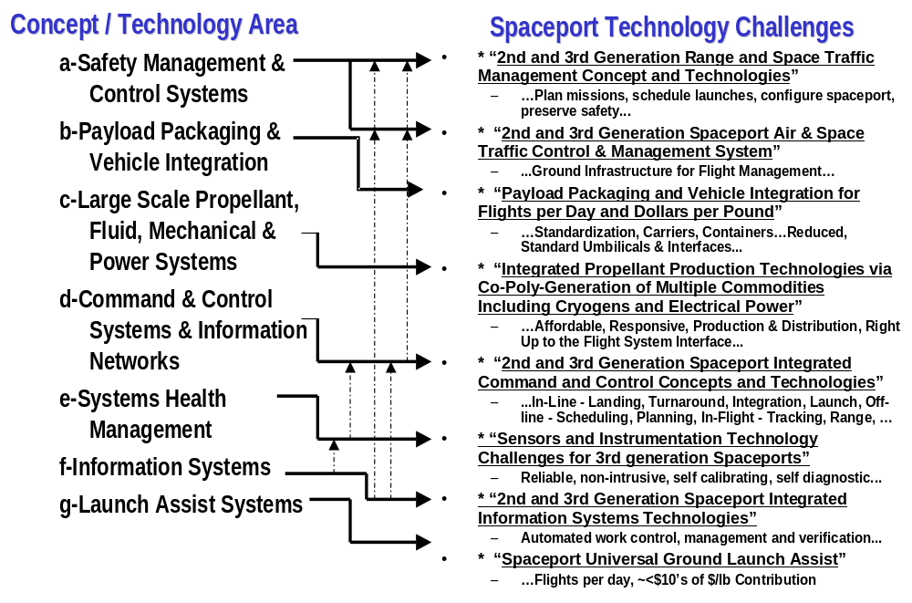
Table 4.0 Spaceport Concept & Technology Area and the Corresponding White Paper on the Spaceport Technology Challenge. White papers available at: http://science.ksc.nasa.gov/shuttle/nexgen/Task8/SpaceportTeamReports/WhitePapers/
Eight areas have been identified. Some of these areas naturally overlap into others. Complete white papers have been prepared to clarify these areas and the required improvements in detail.
- Range Systems: This area has been defined in relation to the vast network of manual activities to plan missions, schedule launches, configure instrumentation, preserve safety and support mission analysis. Current range functions include:
  - Mission Planning, Scheduling, Flight Tracking, Flight Monitoring, Flight Safety, Range Surveillance, Weather Monitoring and Prediction, Telemetry and Communications, Emergency Response, Mission Analysis.
White Paper: 2nd and 3rd Generation Range and Space Traffic Management Concepts and Technologies.
- Traffic Management Systems: Based on the anticipated evolution of the U.S. National Airspace System (NAS) an integrated aviation / aerospace infrastructure will be required to accommodate dramatic growth. This will include addressing:
  - Communications, Navigation, Surveillance, Displays and Flight / Mission Management.
White Paper: 2nd and 3rd Generation Spaceport Air & Space Traffic Control & Management System.
- Payloads: Payload and cargo ground processes include everything from test and checkout, the operation of clean-room and processing facilities and equipment, to the complex tasks of servicing, integrating, handling and installing payloads and cargo in vehicles. This area includes:
  - Payload carriers, payload containers, test and checkout, umbilicals and interfaces, handling and the processing of analytical data.
White Paper: Payload Packaging and Vehicle Integration for Flights per Day and Dollars per Pound.
- Propellants: The servicing of a space transportation system requires infrastructure on scales that contribute enormously to high costs and low flight rates. The operations and maintenance of this infrastructure, it’s complexity, and the hazards involved all require significant investment if space transportation as a whole is to progress. This area includes:
  - Energy, gas and liquid commodities, and facility and equipment infrastructure required to test, checkout, service (load propellants), and launch a space transportation system.
White Paper: Integrated Propellant Production Technologies via Co-and Poly Generation of Multiple Commodities Including Cryogens and Electrical Power.
- Command and Control: This area addresses approaches that integrate multiple technologies that must work in unison in order to create future command, control, and spaceport services that are affordable, flexible, responsive, interoperable, and easily reconfigured, modified and upgraded. This includes:
  - In-line functions such as automation and control of turnaround, servicing and launch operations; off-line functions such as planning, scheduling, diagnostics and maintenance and logistics.
White Paper: 2nd and 3rd Generation Spaceport Integrated Command and Control Concepts and Technologies.
- Sensors and Instrumentation: This area includes component and system level technology for the acquisition of data and the monitoring of essential functions at a Spaceport.
White Paper: Sensors and Instrumentation Technology Challenges for 3rd Generation Spaceports.
- Information Systems: This area includes a host of functions that cross into every other function at a Spaceport. Key areas here include: Automated Planning, Scheduling and Modeling, Learning, Reasoning and Decision Making, Data Mining and Visualization, Improved Human Machine Interfaces, Distributed/Collaborative Design and Control, Rapid, Reliable Software Engineering Processes, Methods and Tools, Procedure Generation, Tracking, Logistics and Work Control.

White Paper: 2nd and 3rd Generation Spaceport Integrated Information Systems Technologies.
- Launch Assist: This area, unlike the previous, is specific to a vehicle concept. The idea of using a ground assist technique to add margin to a space transportation vehicle is not new. The technologies have advanced in many areas in recent years requiring an assessment of this investment in relation to other areas.
White Paper: Spaceport Universal Ground Launch Assist.

Challenges
Spaceport development for the foreseeable future will remain a capital driven, infrastructure intensive endeavor. As in any industry, heavy infrastructure goes un-noticed the most when beneficiaries or users of a system are impacted on a marginal basis. Examples here include the Internet, the national highway system, railroads, or the national airport and airways infrastructures. As such, affordability only begins to address the Spaceport infrastructure and technology gap – productivity of that infrastructure must also be addressed. Productivity may be measured in flights per day, or in tonnage per year to a certain orbit from that Spaceport.

Affordability
A semi-reusable space transportation system such as Shuttle is un-affordable at ~$6000 per pound for most enterprises other than government / scientific programs. This cost does not include recovering the non-recurring funds for massive amounts of infrastructure required by Shuttle operations through first launch, as well as continuing unique investments since 1981. Marginal (actual next flight additional costs after the first few flights per year) are ~$95M per flight, sharply reducing the per pound costs depending on the payload weight.
Expendable systems, American or European, have prices reflecting costs in the range of a few thousand dollars per pound. Other systems (Russia, China) are in the same range albeit with some accounting complications generally making detailed comparisons of launcher costs matters of continuous debate. Costs to go beyond LEO to Geosynchronous transfer orbit can double the costs incurred. Without debate, no systems today provide services that are affordable and encouraging for the future growth of the space transportation industry.
"Another unknown is the true size of each market. Nearly every new player is trying to win the front-end business of producing satellites and rockets and providing launch services. That market alone is valued at a total of $31 billion or more through 2005, according to estimates by Euroconsult in Paris and U.S. industry. But to strike the motherlode, each entrant must also try to secure a share of the $130 billion they expect to flow from delivering all those voices and pictures to consumers and commercial buyers over that period." -Wall Street Journal, October 10, 1995
Consider that if the business of delivering bits and bytes is 4X the magnitude of the transportation and satellite side of the equation, – what is the benefit should the business of space grow dramatically? For this to happen affordability must increase (reduced cost) but not at the cost of decreased revenue. Revenue must also increase. This points to the need for greater Spacelift capability – flights per day, not flights per month. Flight rate is the bottleneck. A current investment requirement of $100M in communication, information or command control infrastructure may not decline in real dollars over time. The more relevant question is can that same investment result in ever increasing flight rate capability over time?

Spacelift Capability
Spacelift capability globally has been relatively static in the past 10 years (Figure 5.0). Many explanations may be offered for declining spacelift trends as measured by one metric (tonnage per year) that would be used in any other transportation industry such as airlines or ocean going shipping. Among these reasons is the decline in government expenditures in space. Nonetheless the commercial sector also shows stagnation or decline, and the trend for this metric is downward not just domestically but globally. It is clear that dramatically new approaches are required to the design, technology and systems that have served global spacelift to date if space is to be accessible, routine, and affordable - sooner rather than later.
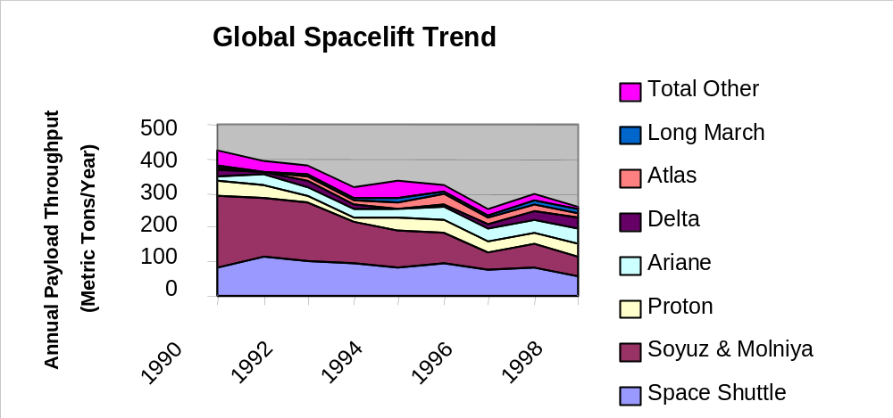
Figure 5.0 Global spacelift trends – this analysis showing a stagnant picture of launch capability is also confirmed by other studies. The recent report on the “Future Management and Use of the U.S. Space Launch Bases and Ranges” indicated a marginally increased launch rate from Eastern and Western U.S. ranges in 1998. More significantly, the broader picture is still one of stagnation, with about 100 to 150 launches per year globally for the foreseeable future. Volatility in the industry capability is common. Western Range forecasts of 30 launches per year and Eastern Range forecasts of about 40 launches per year, for the next 8 years, are in no way encouraging of growth in the industry.

Safety
Safety as a primary goal may be considered the “better” in any attempt to create systems that are also more affordable and more responsive. For Spaceports, safety has a unique connotation as range safety, the need to insure launches do not create hazards for people and property on and off the range. Spaceport safety also goes far beyond this into environmental issues, vehicle designs and technologies that may or may not eliminate hazards. This analysis has considered Safety from all these perspectives – ground, flight and throughout the processes employed at a Spaceport, not merely during flight time.

Insight into Spaceport Investment Opportunities
The analysis of this report has used structured, traceable processes such as Quality Function Deployment (QFD), in complement with technical surveys written as white papers (Table 4.0 previous).
The technology assessment process, in summary:
- Defines customers and stakeholders.
- Defines the subject, Spaceports, in detail, functionally, and as attributes (Table 2.0, e.g. cost, benefit, risk, etc) to improve.
- Defines performance requirements, in detail, within a functional breakdown structure for the Spaceport.
- Prioritizes the areas to improve (the prior attributes); further measurable criteria are derived and also prioritized for understanding the benefits desired (improved operations, safety, etc).
- Defines the “technology pull” concepts and technologies as white papers describing paths to improvements and the challenges that lie ahead in a way that is responsive to criteria.
- Assesses the “technology pull” concepts and technologies against the criteria in a methodical process that lends insight into costs versus benefit (Figure 3.0).
As part of this analysis, the variables of cost, risk, safety, etc can be altered to give insight into scenarios where one variable would be highly prized over another. For example, what would priorities be for Spaceport investment if cost were absolutely paramount? Or safety was paramount to the exclusion of all other factors? The processes used here permit this insight.

Assessment Factors

Research and Development
Factors considered in the assessment of Spaceport R&D are numerous (Table 5.0). Most such factors are generic and could apply to space transportation in general.
R&D ASSESSMENT FACTORS
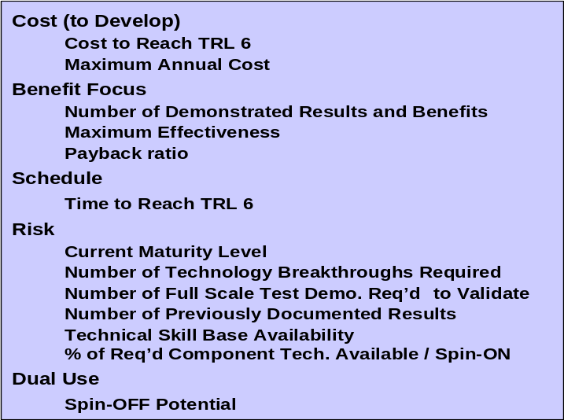
Table 5.0 R&D factors for assessing Spaceport up-front investments and gaining insight into the non-recurring merits and/or impacts of a concept, technology or investment path.
For usefulness, these factors were prioritized (Figure 6.0) to permit later assessment of particular investment choices. These priorities are not in any way intended as optimal, so much as they are a useful starting point in a process that can weigh decision making variables in infinite combinations. Insight is gained from the consideration of these variables and of changes to these variables.

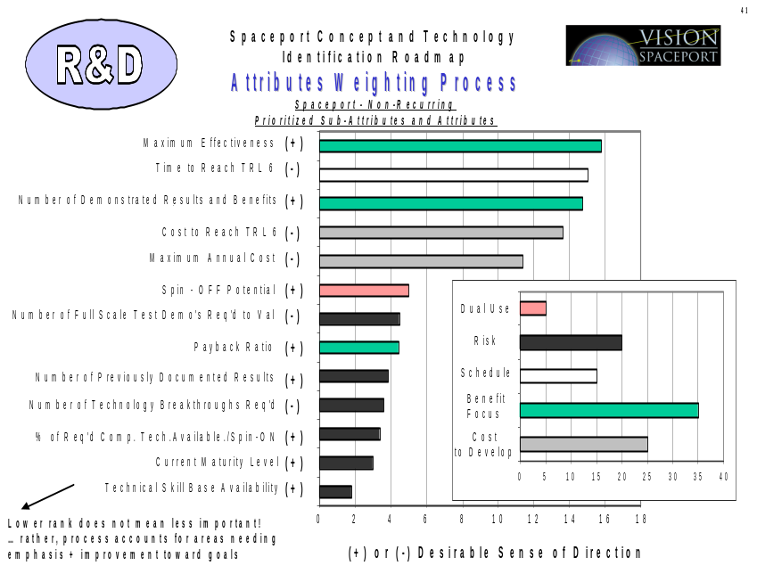
Figure 6.0 One prioritization of R&D factors to permit assessment of particular investment choices.

Acquisition
Factors considered in the assessment of acquiring a Spaceport capability are numerous (Table 6.0). Most such factors are generic and could apply to space transportation in general.
ACQUISITION ASSESSMENT FACTORS
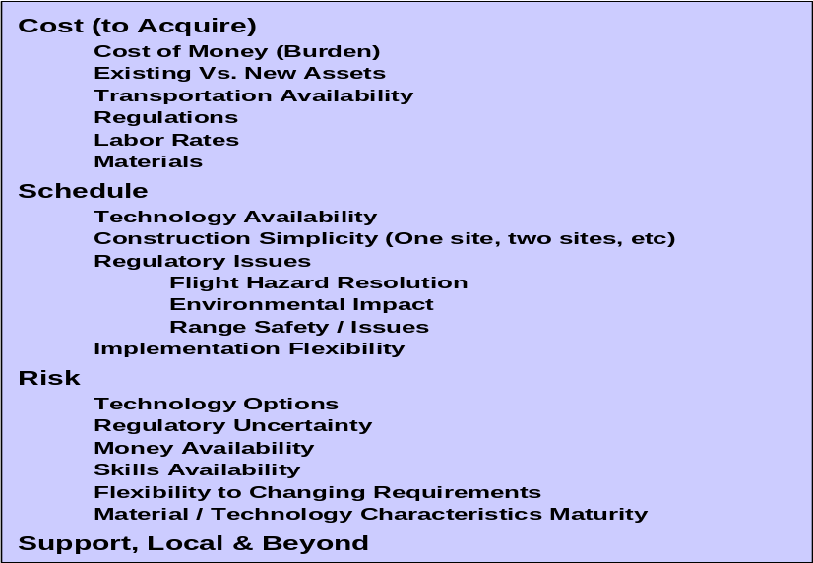
Table 6.0 Definition and Acquisition factors for assessing Spaceport up-front investments and gaining insight into the non-recurring merits and/or impacts of a concept, technology or investment path.
For usefulness, these factors were prioritized (Figure 7.0) to permit later assessment of particular investment choices. These priorities are not in any way intended as optimal, so much as they are a useful starting point in a process that can weigh decision making variables in infinite combinations. Insight is gained from the consideration of these variables and of changes to these variables.
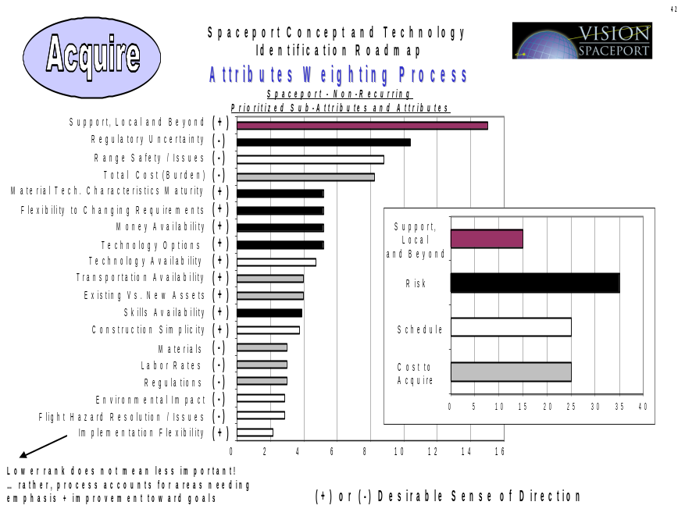
Figure 7.0 One prioritization of Definition and Acquisition factors to permit assessment of particular investment choices.

Operations
Factors considered in the assessment of a Spaceports operation are numerous (Table 7.0). Most such factors are generic and could apply to space transportation in general.
OPERATIONS ASSESSMENT FACTORS
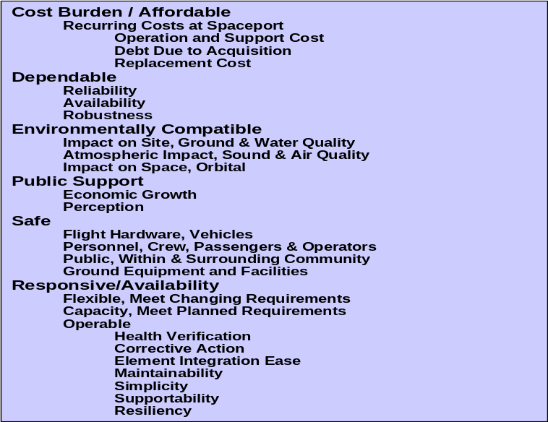
Table 7.0 Benefit factors – operations - for assessing Spaceport up-front investments and gaining insight into the eventual and desired recurring merits and/or impacts of a concept, technology or investment path.
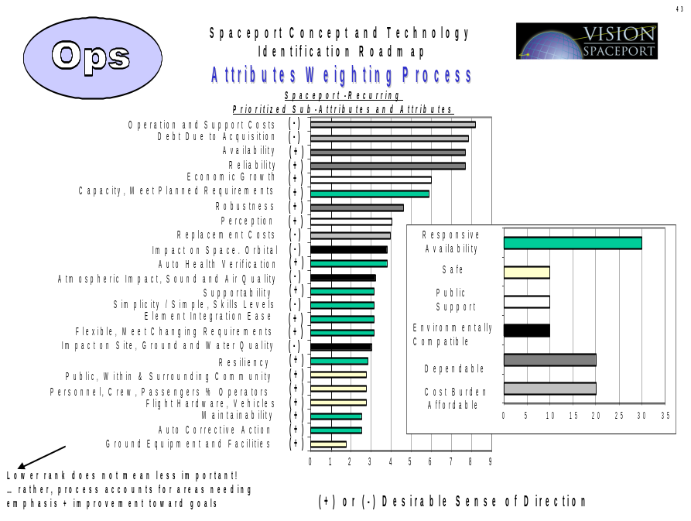
Figure 8.0 One prioritization of Benefit – operations - factors to permit assessment of particular investment choices.
For usefulness, these factors were prioritized (Figure 8.0) to permit later assessment of particular investment choices. These priorities are not in any way intended as optimal, so much as they are a useful starting point in a process that can weigh decision making variables in infinite combinations. Insight is gained from the consideration of these variables and of changes to these variables.
Further, for added depth, measurable criteria were derived related to these factors. These were also prioritized and used in the assessment process.

Approach
The analysis process relies on a cost vs. benefit assessment using the previously described Spaceport attributes and criteria. For the “technology pull” areas of Table 4.0 such an assessment can lend insight into near term opportunities as they relate to far term goals.
The results of this type of analysis are best viewed strategically (Figure 9.0). An infinite number of candidate concepts or technologies can be proposed, evaluated and compared against each other. Such an effort is likely to be unable to make easy or fair comparisons. This more strategic approach groups areas and uses the “technology pull” concept, the definition and prioritization of areas to improve, to better focus results.
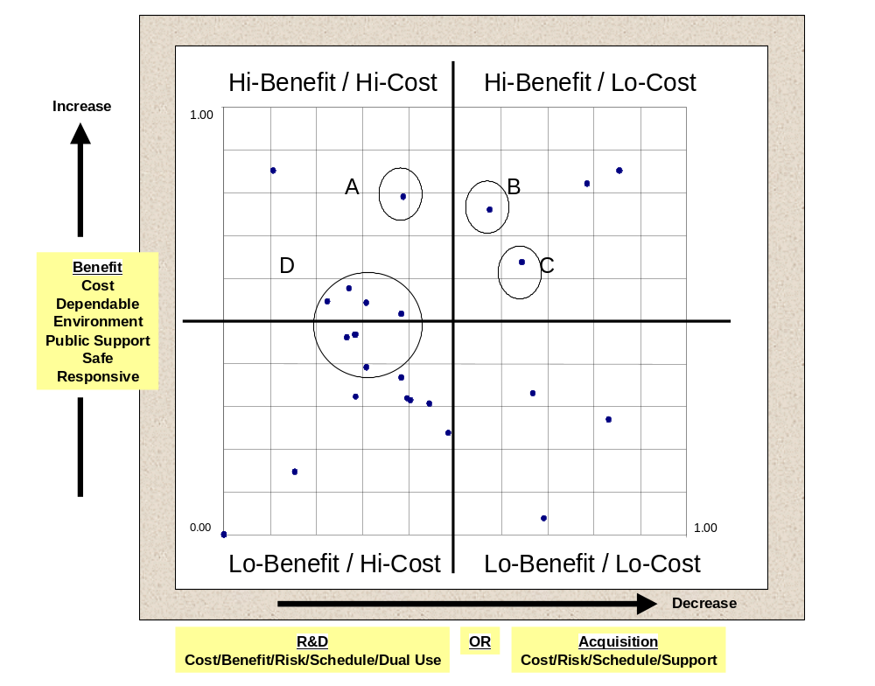
Figure 9.0 Notional Example of a Cost vs. Benefit 2-Dimensional (2-D) assessment approach.
A concept such as “A”, performing the same functions as “B”, is not as likely a candidate for investment since it is higher cost. If concept “A” and “C” perform the same function, then “A” may be recommended over “C” due to higher benefit, albeit at higher cost. If concepts “A”, “B” and “C” are all independent, as different investments within a given area, then “B” and “C” are near term, with “B” especially offering good “bang for the buck” in the near term. “A” is still required, but as a longer-term investment. A field such as “D” could represent groups of technologies where better investments at lower cost need to be identified.

Analysis and Findings
Figures 10.0 and 11.0 show the Spaceport technology categories outlined previously as assessed against the factors for R&D, acquisition (both non-recurring impacts) and benefit (a recurring consequence).
No one isolated area has been identified as being able to singly improve the affordability or productivity of Spaceports and Space Transportation today toward the goals of such enterprises as Space Solar Power. Only across the board space transportation /spaceport investments, responsive to R&D, acquisition and operational benefit factors, can enable these demand scenarios requiring flights per day at ~$100-$200 per kilogram cost to LEO.

FINDING 1:
The R&D and Acquisition factors considered tended to track each other. Often an R&D assessment (which may be government investment) may differ markedly from an acquisition assessment (which may be private sector business). For the Spaceport categories viewed here the areas needing more R&D investment also tended to need more acquisition investment. Lack of technology maturity toward goals combined with the scale of the acquisition capability consistent with goals has contributed to this tracking tendency in part while the inverse has favored other areas. Areas which are less mature and that are also impacted by the scale of acquisition include range, traffic and launch assist. Midway lies payload. More favorably, C2, information and sensing areas benefit from both greater maturity and later ease of acquiring more easily scaled systems. The only exception noted was that propellants systems, though favorable for the R&D factors, tended to be far less favorable in acquisition. This speaks to the ability to demonstrate advanced technology for propellants systems at lower costs, with less risk, but acquisition being dominated by large, unique, facility and equipment buys. All this is especially so within the unique requirements flowed into the technology “pull” areas; ambitious requirements of multiple flights per day from a single Spaceport / space transportation system with costs of ~$100-$200 per kilogram delivered to LEO. Scalability within these goals becomes a major factor in the unique case of propellants infrastructure.
FINDING 2:
Areas that take advantage of pervasive information systems advances generally show as having favorable R&D factors (less cost, risk, etc) and favorable acquisition factors. This indicates a generally positive situation in these areas in that command and control systems, information systems and sensing and instrumentation compose large parts of any capability at a Spaceport. This is even more favorable as a Spaceport reaches toward ambitious “airport” like goals of flights per day, multiple systems, and tonnage to LEO orders more than current systems. This favorable situation though, rather than indicate more mature systems, should also be read in light of the benefit assessment. Benefit factors in these last three areas were also high. It can be observed then that technology pull in these areas, responsive to areas to improve, offers a valuable, viable opportunity for near term and significant benefits.
FINDING 3:
Payload, range, traffic and propellant system investments as defined previously have a potential for significant benefit. Further candidate definition in relation to the Operations Assessment Factors (Table 7.0) should be pursued to refine concepts and technologies in these areas. Range and traffic management investments as outlined previously appear to offer significant benefit albeit at higher R&D, acquisition expense and time (further to the left). Payload investments tend to sit at the dividing line or middle of this assessment. The narrower scope and scale of investments in this area has partly contributed to this, as has the approach that has been outlined in this investment area – standardization of test and checkout, simplification, automation, carriers and containers. This area more than any other is, however, subject to market mechanisms and forces that are volatile and dispersed.
FINDING 4:
The launch assist concept defined here, attempting to broaden toward a universal launch assist capability, resulted in a lower left quadrant chart position. This is to be expected given the crosscutting nature of the other infrastructure areas as compared to the vehicle specific nature of a launch assist system. The nature of the benefit in launch assist does, however, address vehicle mass fraction and margin issues best analyzed as a complete flight and ground system. This same observation may be made for propellants servicing systems that lagged to the left in acquisition. Both represent heavy, real-infrastructure investments that can become very vehicle concept specific. This shows a clear distinction between areas boosted by information technology (IT) advances, versus real equipment and facility driven capabilities. The development and proving of technology and affordability for propellant systems, to deliver every few days what is currently needed by a system such as Shuttle every year, is a major challenge.
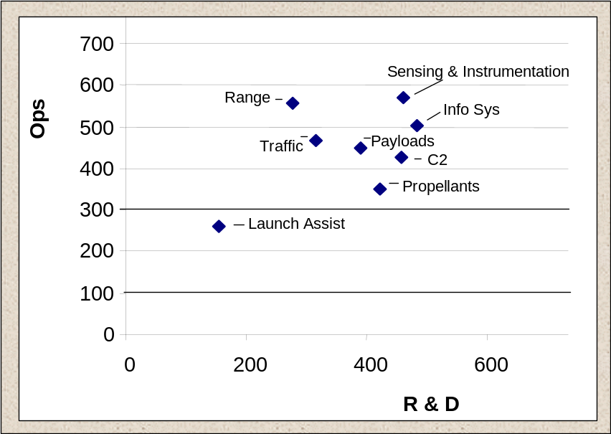
Figure 10.0 Spaceport technology categories / white paper areas correlated relatively against R&D factors (X-axis) and Benefit factors (Y-axis).
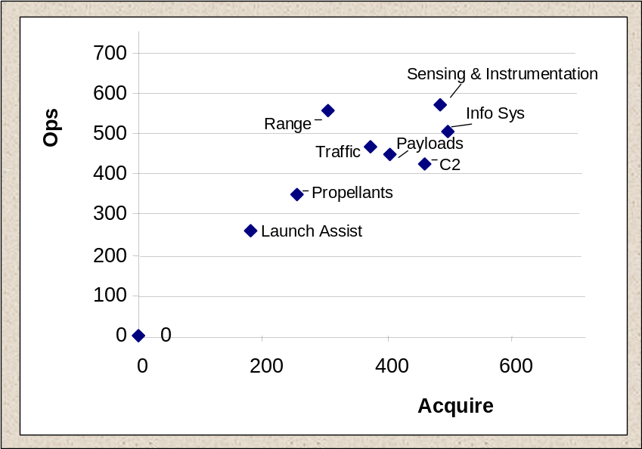
Figure 11.0 Spaceport technology categories / white paper areas correlated relatively against Acquisition factors (X-axis) and Benefit factors (Y-axis).

Roadmap
A top-level Spaceport concept and technology roadmap derived from the process outlined in this report is shown in Figure 12.0.
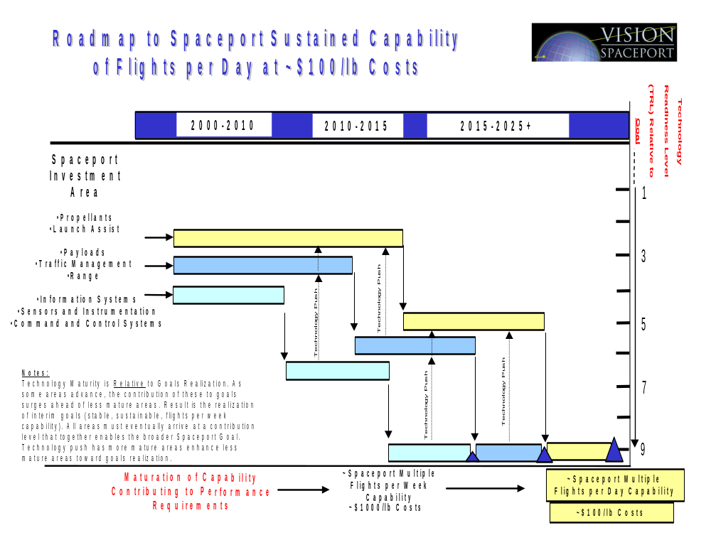
Figure 12.0 Spaceport Roadmap of areas requiring investment today and in the next 25+ years. Benefits are yielded in the near, mid and far term as measured in maturation and growth of capability enabling ambitious economic enterprises with requirements such as multiple flights per day out of a single spaceport and ~$100 to $200 cost per kilogram delivered to LEO.

Opportunity Timeframes and Benefits
The time frames near, mid and far refer to the opportunity to accrue benefits. All areas require investment in the near term to bring about more efficient, effective National Spaceport infrastructure. Continued investments are required to enable the more ambitious goals of a routine, affordable space transportation system. Vehicle systems technology advances will be a driving force. Spaceport investments in complement with flight system advances will assure that the whole space transportation system matures toward goals.

Benefits
Spaceport infrastructure and operations research investments will:
- Assure flight vehicle investments do not simply create new, unknown and unsupportable ground systems impacts. Shuttle and expendable launch vehicle infrastructure and operations are a result of a philosophy that has continuously resolved vehicle technology, up-front investment, or margin shortcomings at the expense of future operations. This has lead to the highest possible costs at the lowest possible flight rates. Future technology investments which advertise weight, or vehicle performance enhancements will re-create a similar situation if Spaceport and operations impacts, positive and negative, are not factored into assessments or demonstrations of capability (such as with X-vehicles). The presumption that spaceport infrastructures or operations will be demonstrated or improved late in an implementation is a duplication of the errors and near-sightedness that has led to massive infrastructure, costs and the low flight rates of today. This design philosophy and culture must change toward a systems view of design that truly understands and manages flight and ground systems design and technology decisions.
- Spaceport infrastructure and operations at X-vehicle levels or in support of technology demonstrators is un-representative of the actual Spaceport or operations impacts of full scale, fully functional flight systems. Spaceport and operations investments will assure that a true, scalable and realistic approach to infrastructure and operations advances is researched, developed, and demonstrated in proper scale, situations and operational environments. This will allow a wide-eyed, measurable, realistic view of advancement toward goals by technology investments.
- Provide metrics and data that can fully and inarguably support cost and flight rate estimates for the development of future space transportation. This would be invaluable to the public and private sector as they seek to acquire or develop systems within reasonable assurance that technology has not been oversold. This includes costs and schedule not being underestimated, and crucial flight rate capability per system, or vehicle, being correctly predicted.

It is assumed in the areas that follow that investments are responsive to the criteria needing most improvement. Maximizing return will depend directly on the ability of investments in these areas to respond to:
In Priority Order…Spaceport Investments must Respond to:
- Reducing engineering and management support requirements for servicing and launch systems.
- Increasing the maintainability and automation of facility and ground support equipment processes; increase the streamlining and automation of management and organizational processes.
- Increasing the overall levels of automated, remote health management and test and checkout at a Spaceport.
- Increasing the reliability of individual components, increasing the affordability of future systems, such as with commercial-off-the-shelf (COTS) systems, and standardizing hardware and software interfaces.
- Taking maximum advantage of tremendous growth of network and information systems technologies.
Pro-actively, Spaceport and operations organizations must engage with technology and future flight systems developers to communicate and assist in:
Priority Order…Spaceport Pro-Actively with Flight System Developers:
- Increase launch specific servicing systems supportability, reducing the numbers of different fluids, commodities, gases and electrical / communications requirements and accompanying interfaces.
- Eliminating environmental and safety hazards, eliminating hazardous operations, such as by eliminating the use of highly toxic propellants or pollutive substances in any quantities, large or small, on a vehicle or on payloads.
- Eliminating hazardous areas and operations introduced due to vehicle designs choices, such as by reducing vehicle purge requirements or hazardous compartments.
- Assure increases in the reliability of individual components; increase flights systems affordability and supportability. No Spaceport or operations advancement or technology can keep poor, un-reliable flight hardware from failing, increasing labor and material costs, and decreasing flight rate.
- Increase technology readiness levels through proper demonstration and understanding of whole flight and ground systems technologies.

The “ Technology Pull” candidates defined here represent (1) recommendations as specific technology investments and (2) recommendations that are intended to define a framework or sense of direction for improvement in any area.

Near-Term – Within 5+ Years
Investments that are most affordable today and which can also yield near term, high benefits include:
- Information Systems
- Sensors and Instrumentation
- Command and Control Systems
Investments in these areas can quickly diffuse into solutions at a micro-level that can collectively have little or no beneficial effect on advancing Spaceport affordability or productivity. To avoid this, solutions defined in these areas must be:
- Integrated and Process Based: Implementing broad end-to-end understanding or organizational processes, functions and interfaces. Macro-level solutions that begin and end with process definition and improvement are required. Isolated upgrades without broad architectural insight into protocols, standards, inter-operability and long-term needs are unlikely to yield measurable benefit over the long term.
Barriers to affordability and productivity that are entrenched in any process at a Spaceport can be driven by (1) vehicle design, (2) lack of vehicle technology and systems maturity (best design possible at the time) or (3) lack of investment enabling improved operations. Stringent space transportation systems requirements, extreme environments and lack of systems margin leave no room for error in any processes. The only barriers to streamlined, automated, processes fully taking advantage of information systems advances and the Internet for work and logistics control, verification, task planning, scheduling, document and drawing control, and hosts of other improvements that are required of a Spaceport are lack of investment.
Investments in systems such as the Kennedy Space Center Checkout and Launch Control System (CLCS) are minor compared to needed investments. Such infrastructure investments bringing portions of a complex command, control infrastructure up to the standards of 1990’s computing should not be confused with the needed investments, including R&D in new systems, toward reaching the more ambitious space transportation goals outlined here.

Mid-Term – Within 10+ Years
Investments that will yield benefit over a longer time frame include the areas of:
- Payloads
- Traffic Management
- Range
Particularly, for Payloads:
Areas specifically neglected in investments, but with high payoff potential, include:
- Payload test, checkout and servicing systems, including the facility and ground support equipment infrastructures - Spaceport and operations organizations must work more closely with payload, cargo, and upper stage developers and stakeholders to create new, more standardized, automated and operationally streamlined processes. This includes the entire process from manifesting to receiving, test, checkout, servicing and integration into a vehicle.
- Carriers and containers, with standardized interfaces between a payload and its carrier, and reduced or eliminated interfaces to the vehicle - Such direction requires new government and industry collaboration crosscutting companies, scientific and transportation organizations, future planners and new entrants into the field wishing to develop satellites, carriers or technology for enabling this.
Particularly, for Traffic Management and Range systems infrastructure:
- Close and continuing collaboration and research between the Federal Aviation Administration (FAA), NASA, the Department of Defense (DoD), industry and academia is required.
- National Range investments to date by the Air Force / Space Command that will modernize systems (advancing capabilities from circa 1960’s to circa 1980’s) should not be confused with needed investments to reach far term goals such as multiple flights per day out of a single Spaceport at costs of about $100 per pound. Range costs would scale, within this goal, toward amounts more in line with Airplane landing fees at airports. Investments here will accrue high benefits over the mid-term, the next 5 to 10 years.

Far-Term – Within 20+ Years
Investments with far-term effects and benefits, but which require current investment include:
- Propellants
- Launch Assist
These later areas are heavily specific to vehicle systems design, technology choices, and capability. Further, unlike previous investment areas, scaling and evolving system technology in these areas in short amounts of time, depends almost entirely on demand, flight rate, and a customer vehicle design.
Specifically, Propellants:
- Propellants technology must be developed with a view toward total servicing costs, and responsiveness, up to the flight vehicle interface. Current ground systems infrastructure approaches and technology for providing commodities such as liquid-oxygen (LOX), liquid-hydrogen (LH2), inert commodities, such as gaseous helium and nitrogen, and host of other services (such as control, monitoring, etc) are far removed from the systems, approaches, technology, reliabilities and margins of safety that will be required to enable servicing systems on a daily basis at fractions of current costs. Current systems are to tomorrows needs as far removed as the servicing systems of the German V-2 rocket are from today’s Shuttle servicing systems. Generational investment is required.
- The assumption that industry technology for energy and commodity production can address future infrastructure and operations needs should reusable vehicles be developed that can fly every day addresses only a small portion of the actual space transportation challenge at a Spaceport. This includes creating infrastructure that is:
  - Generic, shared infrastructure that can service multiple flight systems. Architecture study into central or decentralized systems will be required in the mid-term. Near term investments should be coupled to pro-active designs between Spaceport operations organizations and vehicle designers.
  - Highly integrated with other Spaceport infrastructure needs such as energy. De-regulation of the energy industry will create opportunities here that should be jointly pursued between the public and private sector.
Specifically, Launch Assist:
- Continued development and study of this area is required to make the case for ground based launch assist systems such as those using Magnetic Levitation and Propulsion. This area is ripe for near term government investment transitioning into mid-term public and private partnerships as data and understanding in this area develop. The area is too promising not to invest in considering the potential benefits to vehicle design, margin and operability should new engines and designs evolve that can take advantage of such a system.

Appendix A

Roadmap Development Process
The roadmap development process that has been used in this report has been structured and documented. In general outline Figure 13.0 captures the sequence and inter-relationship of the steps in this process.
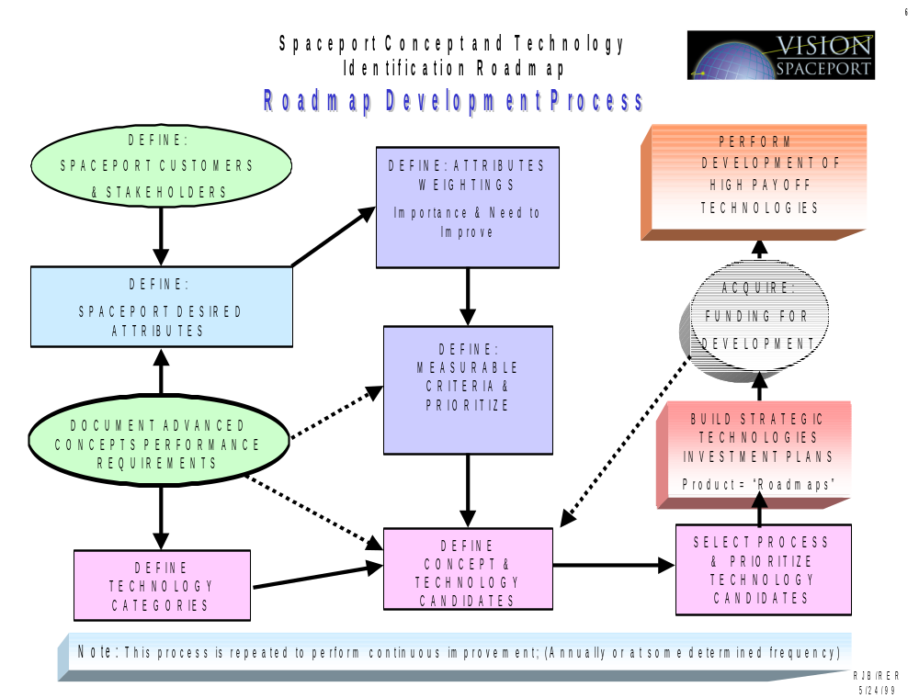
Figure 13.0 Roadmap Development Process

The roadmap development process required goals, also referred to as performance requirements in Figure 13.0. It is possible to derive a Spaceport contribution to the cost goals of a space transportation system as shown in Figure 14.0, right side (red).
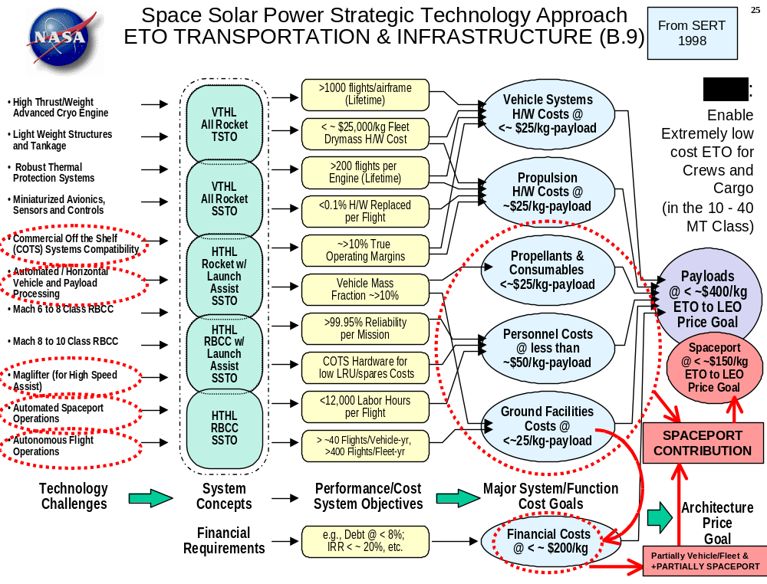
Figure 14.0 Derivation of Spaceport Cost Contribution to Space Transportation System

Adding to this version of 1998 (Figure 14.0) from the SERT program, a Spaceport specific version can be derived as outlined in the work of this report. This is shown in Figure 15.0.
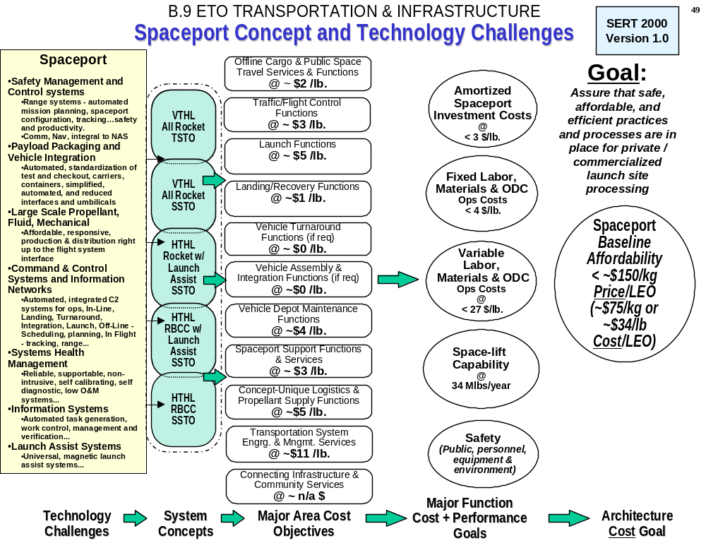
Figure 15.0 Spaceport Concept and Technology Challenges, Functions, and Goal

For completeness, the Spaceport concepts and technologies may be viewed along side the flight system investments as shown in Figure 16.0.
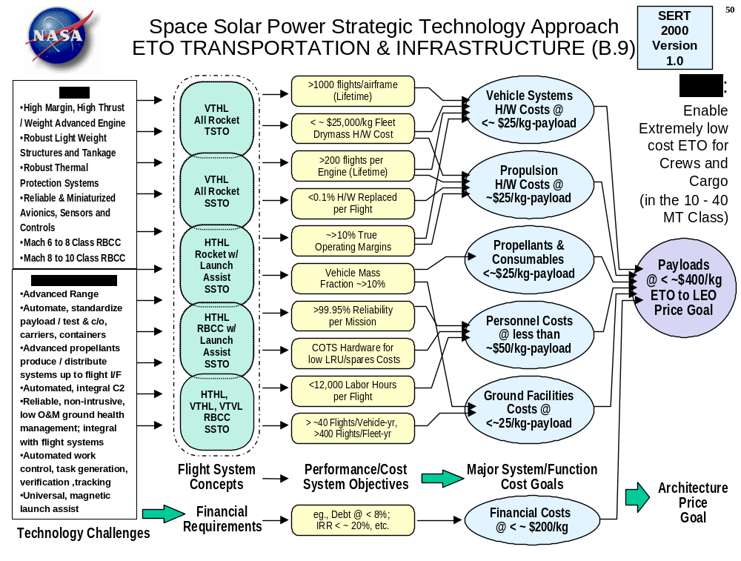
Figure 16.0 Earth-to-Orbit Transportation & Infrastructure Technology Approach and Goals

Appendix B

Description of Concept / Technology Improvements

Information Systems
Information systems in use today will not support operations required for highly efficient spaceports with high flight rates and low costs. Leapfrog improvements in information systems are required to increase safety, lower recurring costs and increase flight rate. One challenge is the automation of inter-related functional capabilities of the many disciplines that require integration at the spaceport. Some of these disciplines include logistics, process verification (quality control), manifesting, scheduling of the many activities, and the safe structured control of activities (hazardous and non-hazardous) and maintenance support. Key information technologies that must be addressed are described below.
- Automated Planning, Scheduling and Modeling
A streamlined, modern spaceport will require complex operations involving a large number of tasks and sub-tasks, facilities, tools and other resources. Automated planning, scheduling and modeling systems are necessary to reduce to the huge staffs required to plan and coordinate low-level tasks and optimize overall operations.
Planning and scheduling systems take high-level plans and commands and break them into lower level, specific tasks. They also schedule these tasks in time without resource conflicts. Modeling involves developing intelligent or graphic process models that allow simulation of a process to determine problems or optimize the process. The key challenge of spaceport function scheduling is its sheer size and diversity. Schedules and plans must be derived for thousands of tasks, 5-10 level hierarchical processes, and 10’s of thousands or resources. Re-planning must be accomplished on a daily basis. Full resource conflict resolution is also required. Advanced systems and algorithms, and extensive computer hardware is required to perform this task in a reasonable amount of time (< ½ hour of compute time). Both temporal (time based) and resource-based conflicts must be addressed.
From a long-term perspective, research is needed in the area of integrating physical or geometric modeling information with intelligent process planners and schedulers. Process simulation capabilities must be able to bring in geometric world info, simulate physical motion based on the planned process, and highlight any potential problems and automatically replan if necessary. This approach to integration and planning will be necessary for each of the standard payload packages and carriers offered by a space vehicle.
Information Systems, Continued,
- Learning, Reasoning and Decision making
Decision support systems are required to make safe, consistent decisions during process operations. This avoids costly and unsafe decisions made by over burdened human operators. It also allows for higher speed operations that generate large volumes of real-time data that must be monitored for critical operational failures. The key technical challenge in this area is to develop learning and reasoning methodologies that are able to automatically learn from past operations and data streams, and make rapid decisions to avoid catastrophic incidents during operations. This includes the ability to both identify anomalies and determine corrective courses of action. In addition to learning rules and reasoning logic or models this technology must allow for the development of structured knowledge data from expert operators or automated process systems. The magnitude of this problem includes the monitoring of hundreds of data streams and sensor values operating in the millisecond update range.
- Data Mining and Visualization
Massive amounts of system and operational data are generated while operating complex spacecraft and an associated spaceport. Because of the complexity of future systems, advanced techniques are required to visualize various trends and problems with operating systems. The ability to recognize various patterns in rapidly incoming streams of data is necessary as well. Included here is also the ability to illustrate various states and trends occurring based on 3 or more independent sets of data.
- Improved Human Machine Interfaces
The primary interface advancement required at a modern spaceport to improve efficiency is advanced devices to view procedural data and interact with GSE systems. For instance a technician inspecting and servicing complex wire harnesses in a vehicle should have a wearable device illustrating the harness and labeling of each wire to be inspected or serviced. Voice input systems to move entire large cargo items via cranes and platforms would avoid accidents by controlling orientations, speeds of movement, avoiding collisions etc.
- Distributed/Collaborative Design, Control and Communication
An efficient spaceport must provide the ability for all stakeholders to effectively communicate with each other. This communication must be accomplished from wherever each stakeholder is, with standard, available, hardware and software tools such as the internet and standard browsers. All types of information including procedures, database records, images, stored video, design data and CAD models must be viewed, manipulated and restored in this fashion. By providing the ability to manipulate and modify procedures, graphic data, video, 3D models and systems as a collaborative team from anywhere, this capability would drastically lower the number of personnel required to travel to launch sites and decrease the time to design equipment and make critical operational decisions.
Information Systems, Continued:
- Rapid, reliable software engineering processes, methods and tools
Because of the large variation in the number, types and configurations of launch vehicles, payloads and missions, and the need for quick turn-around of mission unique assets, the ability to rapidly and reliably adapt processing and launch systems to unique mission needs will be critical. This will require processing and launch systems to be software configurable. A high maturity software services organization will be required. Software Engineering Institute and industry experience tells us that it takes about 18 months to 2 years to achieve each successive SEI maturity level which would indicate a 6 - 10 year journey to develop the needed software organization and infrastructure. Tools and technologies must be developed to increase the pace of this process.
- Procedure Generation, Tracking, Logistics and Work Control
An advanced enterprise information system must be developed for a spaceport to operate efficiently. Even as space vehicles and their cargo become more airplane-like and easier to operate, they will still require extensive and complex processes to ensure they operate safely. A system of systems is required to ensure that all required work is performed correctly, and all of the needed resources and supplies are available at the proper location and at the proper time. In today’s world numerous disparate systems and a huge workforce is required to ensure this happens. Simpler processes, vehicles and standardized flows will greatly reduce this effort. However, integrated, automation systems is the key to reducing the workforce required for functions such as:
  - Shop floor management and instructions
  - Lowest level task planning
  - Control and feedback (cost, time and schedule performance tracking)
  - Data archiving
  - Accident investigation
  - System configuration and management
  - Predictive maintenance of GSE and facilities
  - Logistics planning, tracking and supply management
  - Procedure generation, tracking and distribution to worksite
Advanced techniques are needed to design, implement and distribute these systems. A new architecture must be developed so that all systems can be designed with a common framework, common objects and communication between functions, databases, users, etc.
Sensors and Instrumentation
The effect of instrument miniaturization and the use of light, sound, and radio technologies offers electrifying opportunities when applied to space transportation systems. Micro-electromechanical systems sensors, for instance, can overcome many problems with spaceport data acquisition including the problems associated with the integrated health monitoring systems needed for quick turnaround of space vehicles. The integration of vehicle and ground systems health data into the overall information system and command and control infrastructure afforded by new sensor technologies will aid in bringing about third generation space transportation architectures.
Technology advances in sensing, data acquisition, and control are needed in both flight and ground elements in order to reach third generation space transportation objectives. Spaceport operators will require accurate, precise, global, and non-intrusive instrumentation in order to enable more than one launch per day at less than $100 per pound of payload lifted to orbit.
Several capabilities are required to meet these goals, including:
- Performance, i.e. accuracy, repeatability, sensitivity, range, resolution, weight,
- Maintainability i.e. calibration, troubleshooting, reliability (in operation), dependability (throughout life), non-intrusive, standardization (interface and protocols), commonality, robustness (survive extremes of temperature as well as rapid thermal shocks, resistance to stray electromagnetic fields, corrosive environments, and radiation), and versatility,
- Standards, i.e., new sensors must comply with a standard for ease of integration into the data acquisition architecture of the spaceport infrastructure, and
- Cost i.e. to acquire, operate, and maintain.

Check out and maintenance of sensors and associated hardware is a major spaceport cost driver. Reducing the number of different types of sensors would reduce the logistics cost of stocking many sensors. In addition, the maintenance of sensors must be made easier for technicians such as non-intrusive sensors using light or sound technologies, and the use of self-calibration and self-diagnostics. A self-calibrating sensor with self-diagnostic capabilities would help relieve the enormous check out effort associated with integrated vehicle health monitoring systems.
Autonomous instruments also provide key cost-savings benefits. To achieve autonomous instruments, methods for removing power and signal communication lines from sensor must be developed, including new battery and wireless communications technologies. Advances in IVHM can also improve the reliability of a launch vehicle by reducing redundancy. In addition, such advances may be extended to ground systems to monitoring of the entire space transportation system throughout the spaceport.
Many specific application opportunities exist for ultrasonics, lasers, fiber optics, microelectronics, and nano-technologies. An enabling technology for sensors of the future is micro electromechanical systems (MEMS). MEMS are integrated micro devices or systems combining electrical and mechanical components. They are fabricated using integrated circuit (IC) batch processing techniques and can range in size from micrometers to millimeters, weigh milligrams to ounces, and cost pennies to tens of dollars. These systems can sense, control, and actuate on the micro scale, and function individually or in arrays to generate effects on the macro scale. These devices are low weight, low volume, low power, low cost sensors and instruments that enable an insight into system health that has not been available with past technologies.
Sensors and Instrumentation, Continued,
With the cost and weight of sensors coming down, the number of sensors can be increased. If the reliability and dependability of MEMS can be improved, and redundancy designed in to the system, the safety and efficiency of the spaceport workforce can be greatly improved. Instead of having multiple types of sensors, including power and signal wiring for each, multiple types of sensors can be integrated on one chip in a sensor cluster. This would reduce the maintenance by reducing the number of line tests and interface checks (power and signal), because there would be fewer wires and connections.

Command and Control Systems
Second and third generation space transportation will require Spaceport command and control (C2) systems capable of supporting flight rates one and two orders of magnitude higher than current systems. In addition to productivity, the affordability of such systems must also be improved versus current implementations. Costs to acquire implement and operate spaceport command control architectures must improve.
The fundamental needs in this are integrated technologies that work in unison to create command, control, spaceport services, and traffic systems that are affordable, flexible, responsive, interoperable, and easily reconfigured, modified, and upgraded. This includes determining requirements, technology development, standards, and multi-site integration needs for comprehensive C2 systems that control the entire spaceport.
This enables the broad and affordable implementation of industry standards for COTS (commercial off the shelf) end items / components, which would overcome barriers to affordability in current systems, such as multiple differing protocols, standards, software architectures, and information exchange formats.
A near term investment plan in this area would consist of:
- A process for identifying requirements across the entire spaceport.
- A roadmap for expanding C2 capabilities to handle all the functions identified.
- Designation of individual technology needs within the roadmap.
- Designation of standards, both existing and future, within the roadmap.
- A process for integrating C2 across multiple spaceports and spaceliners into the national airspace system.
Areas that require definition and development of integrated command and control architectures for the unique requirements of 2nd and 3rd Gen (Spaceliner) type operations offer key opportunities for near-term investment. As described more fully in the Command and Control Technology Challenges white paper, the top investment needs in this area are:
In-Line Direct Functions
- Automation of checkout and control, including turnaround, servicing and launch operations
- Process Automation Tools
- Integrated Vehicle Health Management (IVHM)
- Mobile/portable computing for command and control, including wireless technology

Off-Line Support Functions
- Integration of planning, scheduling, automated diagnostics and maintenance / logistics systems
- Real-time decision support
- Integrated mission planning and command and control

Command and Control Systems, Continued,
In-Flight Functions
- Space Traffic Control and Management
- Pre-flight flight plan/object generation, processing, and approval
- In-flight clearances and flight plan modifications
- Distributed air/ground responsibilities and data link communications
- Multi-sensor surveillance
- Satellite navigation
- Trajectory modeling and conflict probing
- Air Traffic management & control system integration
- Dynamic special use airspace allocation
- Collision avoidance & situational awareness

Common
- Operations Concepts
- Compatible interfaces, data architectures and information exchange standards
- Adaptable, flexible system architectures, open to new and unanticipated functions
- COTS systems, low acquisition costs through industry standard systems
- Software structures for ease of code generation and verification reducing lines of code for new applications or spaceport growth and modifications.
- Common launch and flight control equipment for different vehicles
- Advanced software
- Real-time object request brokers (ORB’s)
- Simulation
- Network Architectures
- Distributed systems, global presence and mobile C2. As more functions migrate beyond physical proximity to the spaceport these systems technologies / networks and standards will need to be integrated into the in-line spaceport infrastructure
- Communications (voice and data)
- Next generation internet

Major component / sub-technologies of an integrated command and control spaceport infrastructure include networks, protocols, and other standards for communications and data handling. Specifically:
- Standards: Industry-wide standards that allow multiple vehicles and spaceports to communicate with one another.
- Common communications protocols: a spaceport operations communications framework is needed to define standard communication protocols between spaceports and launch vehicles, and between multiple spaceports.
- Human factors and human-centered computing.
- Data fusion and visualization.
Payloads
Lightweight, but robust, standard payload carriers (open).
- Lightweight – accepting limitations of current system and market dynamics. This alternative allows reduced impact on single launch payload capability.
- Soft stowage systems for smaller payloads.
- Robust – offering the path to a more responsive operation increasing flight rate capability per vehicle by reducing turnaround flow time and reducing critical path interference time. Increased single vehicle payload capability throughput (tonnage per year).
- Standard – similar to robustness, but additional reliability and reduced production costs of a shared standard across multiple different space transportation systems.
- Operable - reducing interference with other vehicle work. Such interference compounds turnaround time and costs. Payload & cargo configuration and de-configuration flight to flight is a major driver of current payload & cargo work content. Carrier evolution allows efficient off-line processing and subsequent in-line integration.

Containerized, standard payload carriers (closed).
- Enclosed containers – processed at the spaceport with minimal intrusion; reduce the payload and cargo process to simple handling and integration of a container with the vehicle.
- Self contained and self sustained.
- Payload preparation on or off-site.

Umbilicals and Interfaces
- Reduction of umbilicals and interfaces – The development of simplified designs and integrated connectors (such as power and communications) is required.
- Automated umbilicals and interfaces – The development of interfaces that are easy to mate, automatically report health, and automatically and quickly diagnose any faults are required. Zero manual operations are the objective from pre-mate up to and including post mate verifications.
- Common data interface and automated system for health monitoring and checkout (i.e. self checkout and standard reporting).
- Health monitoring, test and diagnostics.
- Standardized power interfaces.
- Standardized structural interfaces.
- Standard fluid services.

Handling
- Automated, standard systems for monitoring leveling.
- Automated sensor systems for monitoring payload induced loads during handling.
- Low-cost measurement systems for accurate, no impact hand-offs.
- Single point/single body motion control system and voice interface.
- Verification of cleanliness and zero foreign debris.

Payloads, Continued,
Analytical Data
- Standard for representing analysis data such as thermal and structural analysis.
- Standard weight and CG analysis package.
- Advanced computer support for payload analysis, manifesting and mission operations analysis and computations to support mission.

Traffic Management
Several enabling technologies in the command and control arena will be needed to develop a national Spaceport infrastructure. The NAS3 Architecture document identifies future air traffic systems, in the 2008 to 2015 time frame. Some new systems, or concepts yet to be determined, will be required for specialized Spaceport operations. Based on the anticipated evolution of the NAS and the Spaceport concepts being explored by NASA and the commercial space industry, for future Spaceport design, this section presents an initial set of candidate technologies that could support the above concepts.
Communications
- NAS-wide Data Link (air/ground & air/air)
- NAS-wide Information Network (inter-facility)
- Emergency Backup Communications

Navigation
- Integrated Satellite/Inertial Navigation System (airborne)
- Wide Area & Local Area Augmentation (GPS ground stations)
- Satellite Landing System

Surveillance
- Ground-based and Airborne Radar
- Automated Dependent Surveillance
- Advanced Weather and Wake Vortex Sensing
- Strategic and Tactical Collision Avoidance

Displays
- Low-visibility enhanced reality HUDs
- Synthetic Vision
- Integrated glass avionics

Flight/Mission Management
- Automated Flight Plan Processing & Approval
- Flight Assessment Fast-time Simulation Tools
- Integrated Flight Management/ground Control System
- Trajectory Analysis Conflict Probe
- Schedule and Decision Support Tools
- Automated Range Safety and Data Acquisition System
- Data Achieving and Incident Reporting System

Range
As mentioned earlier, technology work for first generation spaceports is already underway. This work is focused largely on advanced flight tracking techniques and development of commercial off the shelf products to support the listed functions. In general, the goal of this work is to reduce the range infrastructure and its associated maintenance cost. One of the goals of creating a second generation spaceport is to eliminate as much of the existing range infrastructure as possible. New technology is required to achieve this goal; key technology challenges and suggested research areas are listed below.
Mission Planning
The flight planning process will transform mission objectives into standard flight plans. A wide range of technology and techniques will be required to automate this complex process that ust accommodate many types of vehicles, missions, and operations.
- Advanced planning systems compatible with commercial computer platforms, closely integrated with launch and mission control
- Trajectory modeling and simulation for various launch sites given mission parameters
- Multi aircraft/spacecraft simulations that predict time and location of potential congestion
- Automated flight planning
- Orbital transfer simulation
- Automated conjunction on launch assessment (COLA) models, integrated with existing orbital debris databases (NORAD) and automated rendezvous maneuvers
- 6 degree of freedom models
- 3D visual representations of mission trajectories with visual cues for altitude, heading, and predicted conflicts
- Integrated Ec analysis with flight safety planning
- Advanced planning and scheduling systems
- Integration of spaceport data into the NAS-wide area information system (NAS-WIS)
- Integrated launch and range safety systems
- Remote configuration of range and vehicle assets
- Interactive simulation for training and validation
- Multi-vehicle and multi-fleet mission planning techniques
- Collaborative environments for building joint flight plans among vehicle, payload, and spaceport operators
- Real-time flight plan updates to accommodate constantly changing orbital debris and weather databases
- Automated flight plan submission
- Integration of satellite imagery with mission modeling
- Area and regional notification plans (marine, air, land)

Scheduling
- Automated planning and scheduling techniques to allocated ground assets in a multi-mission or multi-flow environment
- Synchronization of flight profiles with mission objectives (e.g., “launch window” scheduling for nominal and abort profiles)
Range, Continued,
Flight Tracking
New cost-effective and highly reliable techniques for determining the position of launch vehicles are essential to reducing the existing range infrastructure. Current operations rely heavily on fixed radar sites, aircraft, and optical tracking devices. This area appears to be ideally suited to space-based deployment and standardization. New techniques include, but are not limited to:
- GPS tracking (eliminates specialized ground infrastructure)
- Laser tracking (reduces specialized ground infrastructure)
- Landing/re-entry tracking
- Multiple vehicle tracking (in all phases: ascent, on-orbit, re-entry)
- Advanced display techniques

Other technical challenges in flight tracking include:
- Rotating body tracking
- Elimination of dedicated downrange tracking instrumentation
- All weather tracking

Flight Monitoring
Cost-effective and highly reliable techniques are also required for determining the performance and status of space vehicles during flight. During a mission, flight status information will be continually updated and disseminated in real-time. This information will also be displayed on ATC-system and cockpit situational displays for tactical purposes. STCs and airspace sectors will be dynamically allocated and monitored to accommodate the mission and air traffic system demands. This integrated NAS/Spaceport infrastructure will provide all the necessary services and capabilities to accommodate space and air traffic operations. This area is closely related to telemetry and communications. Potential techniques in this area include:
- Dynamic airspace reconfiguration
- Satellite Communications (early proof of concept using TDRSS has been demonstrated)
- IVHM techniques that link on-board health monitors to spaceport systems
- Advanced display techniques
- Payload monitoring and information distribution to customers

Flight Safety
For expendable vehicles, flight safety is currently culminates in the flight termination decision. Other range functions, particularly flight tracking and surveillance, are support functions to this decision making process. A second generation spaceport must support transportation systems that have multiple abort profiles for reusable vehicles rather than termination devices, making the flight safety function much more complex than a single flight termination decision. Decision support tools and methods for reducing the size of ground and flight crews are needed to make this transition while avoiding increased costs. Specific technology needs include:
Range, Continued,
- Flight safety analysis
- Orbit, re-entry, and landing modeling
- Airspace modeling and prediction of flight hazards presented by orbital debris and spacecraft, and flight through commercial air corridors
- Real-time position and impact prediction calculations throughout all flight phases on standard equipment with human-centered computing techniques to improve the user interface
- Intelligent systems: tools for intelligently collecting, representing, sharing, and re-applying highly specialized flight safety knowledge to reduce the size of ground crews
- Intelligent systems: research to determine the optimal architecture, knowledge representation techniques, and human/computer interaction methods for implementing decision support tools
- Multi-vehicle and multi-fleet flight safety
- Integrated Ec analysis for potential failure on ascent, re-entry, or landing
- Multiple Ec algorithms
- Methods for calculating risk to ground traffic and shipping in the flight and re-entry corridor
- Automated landing support and landing aids

Range Surveillance
- Area and regional notification (marine, air, land)
- Automated sea surveillance and situational awareness
- Advanced display techniques

Weather monitoring and prediction
- Integrated weather monitoring, forecasting, and visualization
- Advanced local area/short term weather prediction techniques
- Integrated local, national, and global information
- Upper atmosphere monitoring
- Lightning protection

Telemetry and Communications
- Multi-vehicle and multi-fleet communications
- Next generation internet
- Satellite Communications (early proof of concept using TDRSS has been demonstrated)
- High bandwidth video and audio
- Data security
- Advanced timing techniques
- Data archive and playback

Range, Continued,
Emergency Response
- Drift pattern prediction for toxic vapor clouds
- Vehicle debris impact prediction and response
- Sonic boom considerations

Mission Analysis
- Automated performance analysis of the launch vehicle and air space model

RLV support (launch and landing)
Existing range infrastructure does not accommodate the proposed new generation of reusable launch vehicles. Increased vehicle autonomy, flight crews and passengers, multiple re-entry, landing, and abort scenarios all present challenges for existing range systems. Key technology needs include:
- RLV processing and simulation
- Integrated command and control for pre-flight, flight, and re-entry operations
- Planning tools that accommodate RLV flight profiles including ascent and re-entry/abort scenarios
- Real-time abort site selection and modeling for all phases of ascent and re-entry
- Launch vehicle models that include engine and thrust modeling, moment of inertia matrices, aerodynamic coefficients, and related parameters

Flight Control
Better integration of the flight control function with the range/spaceport control function is required to support routine operations at future spaceports. Today, crews, systems, and procedures from the vehicle manufacturer typically handle “launch” control, while the USAF provides range control. This separation of authority will likely be maintained in second and third generation spaceports, as public safety should be in the hands of an organization with no economic interest in the flight. However, the coordination between launch/flight control and range/spaceport control must be improved to reduce the vehicle-unique infrastructure and costly manual activities that pervade today’s range operations. Technologies to be investigated in this area include:
- Simultaneous operation at multiple pads, with different types of vehicles
- Rapid/automated instrumentation reconfiguration
- Interface standardization

Flight testing
An aggressive flight test program using sub-orbital and LEO launches is needed to validate new range/spaceport technologies and provide performance data. Using experimental launch vehicles to also test spaceport technology makes integration and analysis difficult. A flight test program using proven flight articles would allow a controlled stepwise approach to spaceport range technology demonstration. Such a program is also required to test flight and space-based elements of spaceport technology.
Range, Continued,
- Space-based range techniques, including GPS tracking and satellite-based TT&C
- IVHM system flight testing
- Spaceport Testbed products []
- Range Technology Testbed

Global Spaceport Infrastructure
The proposed global spaceport network would link spaceports together to enable coordinated operations and reduce duplicity []. Information exchange standards are essential to the growth of a commercial spaceport industry that supports “launch & land anywhere,” global mission tracking, and cargo/vehicle/spaceport coordination.
Several enabling technologies in the command and control arena will be needed to develop a national Spaceport infrastructure. The NAS Architecture document identifies future air traffic systems in the 2008 to 2015 time frame. Some new systems or concepts yet to be determined, will be required for specialized Spaceport operations. Based on the anticipated evolution of the NAS and the spaceport concepts being explored by NASA and the commercial space industry, for future spaceport design, this section presents an initial set of candidate technologies that could support the above concept.
Communications
- NAS-wide Data Link (air/ground & air/air)
- NAS-wide Information Network (inter-facility)
- Emergency Backup Communications

Navigation
- Integrated Satellite/Inertial Navigation System (airborne)
- Wide Area & Local Area Augmentation (GPS ground stations)
- Precision Landing System

Surveillance
- Ground-based and Airborne Radar
- Automated Dependent Surveillance
- Advanced Weather and Wake Vortex Sensing
- Strategic and Tactical Collision Avoidance
- Space-based Range

Displays
- Low-visibility enhanced reality HUDs
- Synthetic Vision
- Integrated glass avionics

Range, Continued,
Flight/Mission Management
- Automated Flight Plan Processing & Approval
- Flight Assessment Fast-time Simulation Tools
- Integrated Flight Management/ground Control System
- Trajectory Analysis Conflict Probe
- Schedule and Decision Support Tools
- Automated Range Safety and Data Acquisition System
- Data Archiving and Incident Reporting System

Propellants
Earth to Orbit space transportation systems objectives of 1+ flights per day at about $100 per pound costs will require propellant quantities roughly two full orders of magnitude greater than current capabilities.
Areas that require technology development for the unique requirements of Spaceliner type operations include:
- Energy commodity systems (electricity, steam, heat, syngas, propellants, cryogenic fuel and oxidizer, secondary products, serving multiple customers, sites/pads):
  - Production, storage and distribution (especially zero-loss transfer / distribution systems).
- Gas systems (serving multiple sites/pads):
  - Modular, scalable (especially size and affordability) production / liquefaction technologies.
- Systems architectures development:
  - Research, development and maturation of innovative combinations of architectural options.
  - Scaling for size and cost, modular, distributed, and/or centralized production capabilities.

- Multiple, affordable, high efficiency systems:
  - High flow gas / liquid / containment separation.
  - 3Hydrogen separation devices / membranes for passive, economical separation from CO2; and -
  - Air separation and liquefaction systems technologies to lower the cost of oxygen to the gasification process as well as toward liquefaction processes.
  - Low desirable fuel feedstock gasification.
  - Product distribution and recovery.
  - Highly automated, reliable servicing facilities, health management, command and control.
  - Automated feedback and control systems; monitor and initiate transfer and replenishment of propellants to user points based on activities (without user intervention).
  - Recovery and reclamation systems and architecture development (versus traditional venting to atmosphere as has been employed for relatively small, Shuttle type, quantities.)

Propellants, Continued,
Propellants / Servicing Systems Component / Sub-Technologies
- Automated Umbilicals, Servicing Systems: Ground systems to flight vehicle interface including fluids (liquids and gasses), structure, electrical (including power, sensors and communications) and mechanical (including devices for alignment, remote mating, remote demate, and remote reconnection). Hazardous commodities, such as any cryogens, as well as cost and flight rate objectives, will dictate remote, highly automated, reliable, and robust technology. This area must address total systems checkout and automation, including cleanliness, fluid and electrical systems integrity, hazardous monitoring, and structural loads in order to improve on the true cost and productivity drivers caused by such interfaces.
- Built-in, Non-Intrusive Sensing: Built in test and checkout, including (1) moisture monitoring (dewpoints), (2) non-intrusive instrumentation (pressure, temperature, flow) so as to avoid leak paths (especially cryogens) and associated maintenance, checkout and troubleshooting and (3) automatic or self calibration (of sensing / signal processing).
- Reliable, Maintainable, Flexible, Actuation and Control: Industry standard and state of the art valve controllers and software, self-calibrating, self-adjusting (timing, ease of programming, flexible to upgrade and add or modify systems). Commercial off the shelf systems (COTS) fulfill functions of unique systems while avoiding custom hardware and associated high up-front costs and high O&M. Includes safe, electric and pneumatic valve actuation and control, with reliable and/or redundant, yet simple systems, for critical, hazardous operations.

Launch Assist
Major Concept / Technologies
As has been stated above, key issues in development of a Maglev launch assist capability include levitation and propulsion mechanisms, energy storage and power delivery, separation dynamics, abort scenarios, safety, reliability, operability, and maintainability. A major issue is the scaling up of the Maglev technologies to the size of vehicles on the order of 10’s of thousands of pounds of payload capability.
- Power Generation and Energy Storage Requirements:
A scaled-up Maglev will require tremendous amounts of power to meet full-scale acceleration requirements on the order of a 1 Million pound vehicle and sled. A 10% (by mass) vehicle will require the entire output of a commercial 1200 MW power plant for 10 seconds (providing 2 G’s). A million-pound (mass) vehicle will require 10 times as much energy for the same period of time. To obtain sufficient reliability, multiple component architectures with redundancies will be required to eliminate critical failure modes.
Technology development is required in the areas of:
  - Superconducting Magnetic Energy Storage (SMES)
  - Flywheel Energy Storage
  - Super-Capacitors Energy Storage
  - Semiconductor High Speed and High Power Switching
  - Energy Storage Architecture Development: Particular technologies may be implemented within various, diverse architectures. Development of systems architectures is required for energy storage systems within a broader context of Spaceport power infrastructure. This includes synergy with power requirements of such systems as propellant production, or overall power needs at a spaceport.

Overall technology maturation will focus first on the necessary development toward the identification of scalable technologies likely to meet cost, responsiveness (flight rate, recycle rate) and performance objectives over the life cycle.
- Magnetic Levitation and Propulsion
The costs to acquire and to operate a magnetic launch assist system will be closely related to the technology maturity and type of technology used in the track and sled for developing the required lift and propulsive forces. Technologies that require maturation and understanding within the context of launch assist requirements (such as scale, performance, recycle and cost issues) include:
Launch Assist, Continued,
  - Superconducting Magnet Systems

Technology options include systems capable of withstanding the launch environment (vibration, forces) without losing superconducting properties (quench phenomenon). The use of larger gaps from sled to track (roughly 7.5 cm) versus small clearances with normal conducting systems enables the possibility of reduced costs to build the launch assist track (more robust to deviations in construction) and to maintain it (more robust to deviations over time). Further, the larger levitation forces possible reduce design constraints and design sensitivity on sled and vehicle weight and size.
  - Normal Conducting Magnet Systems

· Technology capable of developing the proper forces without the use of cryogenic superconductors offers a possibility for systems simplification that requires exploration. Passive control systems within this context are also required.
  - Electromagnetic Propulsion

Linear Synchronous Motor technology
Scalable systems capable of being acquired and operated at low cost as well as performing over a wide operating range are required.
Linear Induction Motor technology
Scalable systems capable of being acquired and operated at low cost as well as performing over a wide operating range are required.
  - Architectural Development – A Systems Approach

The trades for adjusting and understanding interactions for the combinations of previously identified technologies. Models, simulations, and tools for system trades and designs are required that quickly establish the viability of design or technology options.
- Control Operations
  - Identification of Commercial Off-The-Shelf (COTS) hardware and software
  - Integration into C2 architectures
    - The application of Integrated Vehicle Health Management (IVHM) technologies to launch assist system – supporting technologies
    - Launch Umbilical separation - supporting technologies
    - Braking - supporting technologies
    - Safe spacecraft release - supporting technologies
    - Abort - supporting technologies
    - Launch assist recycle - supporting technologies
    - Ground to vehicle and Maglev communications - supporting technologies

Launch Assist, Continued,
- Structures and Materials
  - Guideway
    - Cost to acquire and operate must be compatible with flights per day and small contributions to the cost goals.
    - Mechanical –supporting technologies
    - Electrical – supporting technologies

  - Cradle / Sled
    - Must be scaled up to Gen 2 and/or Gen 3 requirements
      - Resist vehicle engine heat during launch and separation
      - Provide levitation and propulsion capability for Gen 2 and 3

References and Endnotes

“Investing in Innovation, Toward a Consensus Strategy for Federal Technology Policy,” The Steering Committee of the Project on Technology Policy Assessment, Lewis Branscomb, Richard Florida, David Hart, James Keller, Darin Bovile, Sponsored by the Competitiveness Policy Council, April 24, 1997. Quote “The consequence of leaving out this “gray area” between science and commercial development is the facile assumption that if the work is not basic science it must be commercial development and therefore government has no business investing in it. Yet this represents a critical area which may otherwise be un-addressed.”
The Commercial Space Transportation Advisory Committee, Launch Operations and Support Working Group, has also stressed under-funding of Spaceport infrastructure in previous studies such as the May 2000 report.
“Lessons Learned, Denver International Airport,” by Paul Stephen Dempsey, Andrew R. Goetz, Joseph S. Szyliowicz, McGraw-Hill, 1997.
“NASA should designate KSC [Kennedy Space Center] as a National Center for next-generation RLV range technology development and demonstration…” from ““THE FUTURE MANAGEMENT AND USE OF THE U.S. SPACE LAUNCH BASES AND RANGES,” REPORT OF THE INTERAGENCY WORKING GROUP, February 8, 2000; Co-Chairs: Office of Science and Technology Policy, National Security Council, Working Group Member Organizations: Office of Management and Budget, Department of Defense, Department of Commerce, Department of Transportation, United States Air Force, Federal Aviation Administration, National Aeronautics and Space Administration, National Reconnaissance Office.
Mankins, John C. (1997) “A Fresh Look at Space Solar Power: New Architectures, Concepts and Technologies,” International Astronautical Federation (IAF).
Vision Spaceport Artwork by Pat Rawlings of Science Applications International Corporation (SAIC).
Spaceport Synergy Team (1997) “A Catalog of Spaceport Architectural Elements with Functional Definition,” Preliminary Modeling Definition Document, Prepared for the Highly Reusable Space Transportation Synergy Team by NASA KSC, Lockheed-Martin, McDonnell Douglas, Boeing North American, and Command and Control Technologies Corp.
CSTS Alliance (1994), Boeing, General Dynamics, Lockheed, Martin Marietta, McDonnell Douglas, Rockwell "The Commercial Space Transportation Study, Executive Summary and Final Report," NASA Contract No. NAS1-19247, 19242, 19241, 18230, 19244 and 19243.
White papers available at: http://science.ksc.nasa.gov/shuttle/nexgen/Task8/SpaceportTeamReports/WhitePapers/
Shuttle value of $6000 per pound is based on an analysis of Fiscal Year 1999 Shuttle budget, excluding non-recurring, non-operations items. Value represents operational, recurring only, budget of ~$2,487M spread over an 8 flight per year capability, with a payload capability of 53,500 pounds to 100nm, 28.5 circ. The actual number of flights flown that Fiscal Year was 4 (STS-88 and STS-95 in Calendar Year 1998, Fiscal Year 1999, and STS-96 and STS-93 in Fiscal Year 1999). By Calendar Year, 1999 had 3 flights (STS-96, 93 and 103). Accounting is further complicated by work for a launch in one year mostly being accomplished in another year. Further, the actual payload tonnage carried varies widely from flight to flight from the maximum capability indicated. Based on this analysis, the value of $6000 per pound is a semi-useful approximation of costs. The value leans toward a lower value than would be assessed taking into account more factors.
Shuttle value of ~$95M per flight marginal costs (actual costs incurred for an additional flight) is based on a modeling analysis using data from the NASA Zero Base Cost Study of 1990 and the NASA Budget of 1999. Fixed and variable costs were updated to Fiscal Year 1999 by distillation of data. The value of ~$95M occurs as a result of ~$1,728M in fixed, operations, recurring costs for Shuttle for Fiscal Year 1999 leaving a value of ~$759M in total variable costs. Total costs were budgeted at ~$2,487M in Fiscal Year 1999. Total variable costs spread over an 8 flight per year capability yields an average of ~$95M per flight. Accounting is further complicated by variations in variable costs from flight to flight such that an 8th flight is less marginal cost than a 2nd. Actual flight rate in Fiscal Year 1999 was 4. Also, such an approximation is best used only for flight rates below 12 to 15 per year above which the previous analysis would require reassessment.
Two years later, in 1997, per the “Heritage Foundation Backgrounder, Executive Summary, The New Space Race: Challenges for U.S. National Security and Free Enterprise,” (August 25, 1999) quoting “Remarks by Clayton Mowry, Executive Director of the Satellite Industry Association, at Space Technology and Business, an Aerospace Expo in Washington, D.C., 1999” the value of global commercial space activity “…generated some $51 billion in revenues in 1997, including – over $19 billion from satellite services; over $13 billion from manufacturing of spacecraft; over $11 billion in manufacturing ground based equipment to launch, monitor, track and manage spacecraft; and over $7 billion from the space launch industry”
Variations on these market values are to be found in numerous sources including “The Volpe Study Final Report, Building on Florida’s Strength in Space, A Plan for Action,” prepared by the John A. Volpe National Transportation Systems Center, Research and Special Programs Administration, U.S. Department of Transportation. Study sponsored by Executive Office of the Governor, Office of Tourism, Trade and Economic Development, December 1999.
McCleskey, C. M., Un-published, Spaceport Technology Development Office, NASA John F. Kennedy Space Center, Spaceport Technology Development Office. Sources of information include Space Launch Reference Guide, 3rd ed., American Institute of Aeronautics and Astronautics (AIAA) publication, Isakowicz, et al, 1999 and FAA AST space launch database, McCallister, et al.
Reference Annex E and Table 2.0 of “THE FUTURE MANAGEMENT AND USE OF THE U.S. SPACE LAUNCH BASES AND RANGES,” REPORT OF THE INTERAGENCY WORKING GROUP, February 8, 2000; Co-Chairs: Office of Science and Technology Policy, National Security Council, Working Group Member Organizations: Office of Management and Budget, Department of Defense, Department of Commerce, Department of Transportation, United States Air Force, Federal Aviation Administration, National Aeronautics and Space Administration, National Reconnaissance Office.
“Developing Operable Launch Systems: New Methods and Tools,” by R.A Hickman, J.D. Adams, J.P. Mayberry and M.A. Goodney, The Aerospace Corporation, 45th Congress of the International Astronautical Federation, October 9-14, 1994, Jerusalem, Israel.
More information on the Checkout and Launch Control System (CLCS) may be found at: “Upgrading the Space Shuttle, Committee on Space Shuttle Upgrades, Aeronautics and Space Engineering Board, Commission on Engineering and Technical Systems, National Research Council”. National Academy Press. Chapter 4.
[?] Brown, K., McCleskey, C., National Spaceport Testbed, 37th Space Congress, May 2000. http://www.cctcorp.com/testbed
[?] Brown, K.R., “Linking Information Systems Between Independent Spaceports,” TechEast ’99, Miami Beach, Florida. November 3, 1999.

